 |  | JOURNAL OF ISLAMIC ARCHITECTURE  P-ISSN: 2086-2636 E-ISSN: 2356-4644  Journal Home Page: http://ejournal.uin-malang.ac.id/index.php/JIA
CROSS-CULTURAL INFLUENCES ON JATTI MIRIEK GRAVE MARKERS
Yakup Mohd Rafee^{a*}
ªFaculty of Art, Sustainability and Creative Industry, Sultan Idris Education University, 35900 Tanjung Malim, Perak, Malaysia
*Corresponding Author: yakup@fskik.upsi.edu.my
ARTICLE INFO |  |  | ABSTRACT
Volume: 8  Issue: 2  Page: 569-585  Received: January 12th, 2024  Accepted: June 04th, 2024  Available Online: December 15th, 2024  DOI: 10.18860/jia.v8i2.25660 |  |  | The evolution and cultural significance of the Jatti Miriek grave markers in Sarawak, Malaysia, are examined in this paper, along with their relationships to the Bajau Sunduk from the Sulu Archipelago and the Batu Aceh markings in Indonesia. With historical research and a visual comparison analysis, it seeks to understand the complex interplay of Islamic, cultural, and architectural influences on the Jatti Miriek grave marker designs. Examining 167 markers and interviewing local experts were made possible by doing fieldwork at 13 sites in Miri, Sarawak. The detailed information on Jatti Miriek grave markers is then examined with that of Batu Aceh and Bajau Sunduk using a visual analytical comparative study. The results show that Bajau Sunduk later influenced Jatti Miriek's designs, especially concerning materials and motifs, which originated in Batu Aceh. Studies of Southeast Asian cultural heritage and art history can benefit greatly from this research's improved comprehension of the socio-cultural influences forming these artifacts.  Keywords:  Batu Aceh; Bajau Sunduk; Cross-Cultural Influences; Grave Marker Designs; Jatti Miriek

- INTRODUCTION
The introduction should clearly state the purpose of the paper. It should include key references to appropriate Investigating grave markers around Southeast Asia, especially the Jatti Miriek grave markers, provides a wealth of information on the historical and cultural context of the area. These grave markers are exclusive to the Jatti Miriek community in Sarawak, Malaysia, and are more than just mementos; they are intricately designed and adorned with motifs that reflect the region's unique blend of architectural, religious, and cultural influences [1]. The grave marker of the Bajau people in the Sulu Archipelago, known as Sunduk, and the Batu Aceh burial markers from Indonesia have had a profound cultural influence on the development of the Jatti Miriek memorial marker. The dynamic relationships, trade, migration, and religious exchanges traditionally defined by Southeast Asian communities are attested to by this fusion of design elements from several cultures [2].
This paper aims to perform a thorough comparative analysis of these three types of grave markers. The goal is to understand how the complex motifs and design aspects of the Bajau Sunduk, Batu Aceh, and Jatti Miriek grave markers represent their communities' cultural and religious narratives. To lighten Southeast Asia's larger socio-cultural and historical context, it also investigates the architectural influences that have shaped these marks.
Prior studies in this field emphasize how crucial these cultural items are to comprehending the more comprehensive historical narratives of Malaysia's ethnic groupings. Research demonstrates how vital historical markers like grave markers are for understanding how society and religion have changed [3]. The value of these markers goes beyond their immediate practical application, and this research positions them as crucial to understanding the socio-cultural evolution of the Jatti Miriek people.

  - RESEARCH BACKGROUND

- 1. Historical Context of Jatti Miriek
The Jatti Miriek community, considered one of the indigenous Bumiputera ethnic groups in Miri, Sarawak, Malaysia, has a rich historical context deeply intertwined with the region's cultural tapestry. According to Ghofur [4], their roots trace back to the migration from Apo Kayan. Legends and oral traditions, as documented by Rahman [5], suggest the role of traders from West Asia, including Arabs and Persians, in facilitating the spread of Islam in Sarawak. Moreover, Chang [6] proposes a theory of Islamic traders' migration from China, which underscores the potential connection between China and Borneo in terms of Islamic influence. Thus, the historical backdrop of the Jatti Miriek community is multifaceted, involving migration, trade, and interactions with diverse cultures and religions.

- 2. Evolution of Grave Markers in Southeast Asia
The Jatti Miriek community, considered one of the indigenous Bumiputera ethnic groups in Miri, Sarawak, The evolution of grave markers in Southeast Asia is closely tied to the region's shifting religious and cultural landscape. Before the advent of Islam, Southeast Asia was influenced by Animism, Hinduism, and Buddhism [7]. Notably, Farish and Khoo [8] highlight the pre-Islamic era when woodcarving motifs featured prominently in the Malay Archipelago, including motifs like Kala Makara, Gunungan, Stupa, Garuda, and Naga. With the arrival of Islam, as discussed by Othman [9], these motifs transformed to align with Islamic principles. This evolution reflects the region's dynamic cultural and religious shifts, with grave markers serving as tangible artifacts of these changes.
Dick van der Meij [10] offers a comprehensive examination of grave markers within the context of the Pasai Sultanate in Sumatra. Through clear photographs, the discussion meticulously categorizes various forms of gravestones, identifying six main types. These types are ogival, accolade, accolade with wings, decorated with spirals, pyramidal, and others, each with further subdivisions. The ogival style, imported from Cambay, Gujarat, India, is highlighted as an external influence. Additionally, Yatim [11] delves into the languages used in inscriptions on the stones, revealing Arabic predominance despite Malay serving as the lingua franca in the region. The inscriptions typically contain epitaphs featuring the name of the deceased accompanied by elaborate epithets, with women often described using a wider range of labels like 'the chaste' and 'the virtuous'.

- 3. Influence of Islam on Art and Culture in Southeast Asia
The influence of Islam on art and culture in Southeast Asia has been profound. Islam spread and established communities in port cities across the region [12] [1], bringing a unique artistic expression. Notably, Aceh stone grave markers from 18th century Indonesia, as mentioned by Damais [13], served as sources of inspiration for woodcarving styles. Additionally, the Bajau people of the Sulu Islands in the late 19th and early 20th centuries [12] contributed to the development of distinctive woodcarving techniques. These influences shaped the artistry of Jatti Miriek grave markers, representing a convergence of Islamic aesthetics within the local context, which this research seeks to unravel.

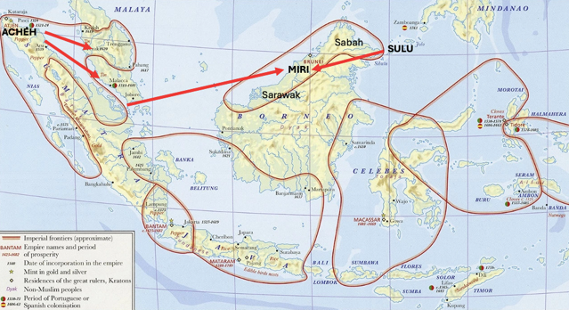

Figure 1. Muslim sultanates in Indonesia and Malaysia. The influence of Jatti Miriek grave markers in Miri is believed to have started from the basic design of Batu Aceh in the 18th century before it was being influenced by grave markers from the Sulu archipelago
The evolution of Islam in the Nusantara region is reflected in Jatti Miriek's grave marker carvings; this is especially true when considering the style of pre-18th century Acehnese stone grave markers in Indonesia. This suggests that several prehistoric elements impacted the design of Jatti Miriek grave markers during this time. Then, the materials and methods employed by the Bajau community from the Sulu Archipelago, Philippines, in constructing graves in the late 19th and early 20th centuries impacted the continuous evolution of these tombstones. In the end, this produced a distinct design character, as evidenced by the historic graveyards in Miri. It is possible that trade and the growth of Islam spread the variables affecting this evolution.

- 4. Jatti Miriek Grave Markers
Jatti Miriek, indigenous to Miri, Sarawak, are spread across various regions, including Pujut (Unan), Bakam, Lopeng (Lufieng), and areas in Brunei. Their distinct language and culture are less known today due to younger generations' disinterest and lack of records [14]. Many have assimilated with Malay culture, but efforts to revive and preserve Jatti Miriek's heritage are underway. Grave markers, known as 'Misan' or 'Bisan' in the Jatti Miriek language, bear the deceased's name and dates, aiding family identification [15]. In Sarawak, each ethnic group has unique grave marker traditions influenced by customs, beliefs, and religion. Historically, graves lacked specific markers, using simple stones or wood, and varied burial practices like tree burials or elevated sites. These markers also symbolized the deceased's social status. Today, they help researchers understand historical and familial lineages, with most old Sarawak graves using wooden instead of modern marble or granite markers.

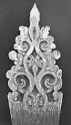 | 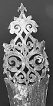 | 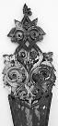
Figure 2. A few examples of Jatti Miriek Grave Markers in Miri, Sarawak

Jatti Miriek's old graveyards are unique for using durable 'belian' wood markers, intricately carved, distinguishing their burial culture from other Sarawak ethnic groups. While some groups like Melanau in Belawai and Rajang, Vaie in Bintulu, Bajau in Sabah, and Sulu Archipelago, Philippines, also use wooden markers, Jatti Miriek's have specific features setting them apart, which is further discussed here.
According to elders like Penghulu or Headman, Kipli bin Ali, from Kampung Ranchah-Ranchah, among the Jatti Miriek community, there is a belief that some of the old grave carvings were done by the deceased themselves before they passed away. This belief is supported by others like Penghulu Haji Rapa’ee bin Haji Saat from Kampung Dagang, Bekenu, and a Village Chief, Aman bin Taha, from Kampung Menjelin. They suggest that in the past, many Jatti Miriek people had the skill to carve.
However, others like Penghulu Haji Adam bin Bujang from Bakam and the Village Chief, Haji Usman bin Suleiman, from Pujut Tanjung Batu, think differently. They believe not all graves were carved by the deceased but were commissioned instead, with similar carving styles suggesting the same carver or group made them. Today, there are no longer any carvers or practitioners of this art, as it hasn't been passed down to the next generation, as shared by descendants and elders of the Jatti Miriek community.
The Jatti Miriek grave markers are identified as a unique cultural symbol representing the cultural identity and historical trajectory of the Jatti Miriek community in Sarawak. The elaborately carved grave markers showcase the fusion of indigenous beliefs from the area with Islamic patterns over time. It shows how the community's religious and cultural customs have changed. The community's historical shifts from animistic foundations to adopting Islamic influences are physically represented in this amalgamation; these shifts are reflected in the art and social structures of the community.

- 5. Batu Aceh
Batu Aceh, a renowned Islamic artifact in maritime Southeast Asia, has spread from North Sumatra to Brunei. This artifact has been a focal point of research and publications since the 19th century. The intricate calligraphy on Batu Aceh, indicative of an individual's social status, was typically reserved for high-ranking individuals like Sultans, nobility, and top government officials [16]. Made from sandstone, Batu Aceh represents a transition from older local traditions. It shares similarities with Central Javanese art from the 9th century and Siamese grave monuments. After a decline in the late 18th to mid-19th century, Batu Aceh saw a resurgence in regions like North Sumatra, Kedah, Pahang, and Penang. Recent discoveries include findings in Langkawi in 2016 [17].

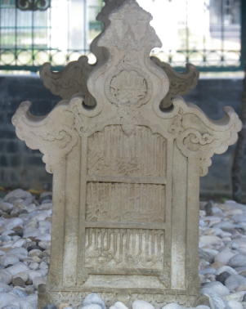

Figure 3. Headstone of Sultan Malik As-Shaleh's grave 696 H. or 1297 AD [Source: Pusat National Archaeological Research, 2007]

In Batu Aceh, calligraphy is frequently employed, including Naskhi, Thuluth, Kufi, Figural, and Samar. The calligraphy script found on Sultan al-Malik al-Saleh's gravestone, as an example (figure 3), blends Muḥaqqaq and Thuluth styles. It reflects the calligraphic developments seen in Iran, Iraq, Anatolia, and Egypt during Ibn Muqla's era in the 10th century. This suggests that the gravestone dates to Sultan al-Malik al-Saleh's death in 1297 CE, evident from the script and decorative elements like the "mihrab image" and the "knot motif," which are also linked to Islamic Eastern Iranian regions [18].
The marble grave markers of Malikah Al-Muazhzhamah (figure 4), daughter of Sultan Zainal Abidin bin Ahmad bin Muhammad bin Al-Malik Ash-Salih, feature an inscription of Surah Yasin [19]. It symbolizes Malikah Nahrasyiyah's significance as the heart of the Pasai Ocean and the Pasai Ocean's centrality among Islamic countries in Southeast Asia, akin to Surah Yasin's centrality in the Quran. Consequently, Surah Yasin inscribed on the grave markers signifies the multifaceted role of Malikah Nahrasyiyah and Samudra Pasai, encompassing worldly and spiritual aspects, safety, defense capabilities, and the prosperity and well-being of its people.

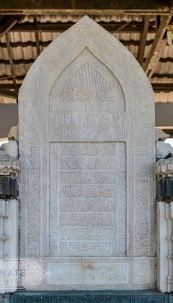

Figure 4. The grave markers of Malikah Al-Muazhzhamah, Nahrasyiyah binti Sultan Zainal Abidin bin Ahmad bin Muhammad bin Al-Malik Ash-Shalih is located in the second period Sultanate cemetery, Kuta Krueng, Samudera, North Aceh.s
The most widely used scripts in Aceh are Naskhi and Kufi, but in Batu Aceh in Perak, Kufi script predominates. In calligraphy, one can typically find Sufi poetry and passages from the Quran often feature repeated martyrdom proverbs like Allah and Laillahaillalah. According to Addini [20], calligraphy on Batu Aceh is used as a means of preaching, art, adornment, and expression of respect for the deceased as well as their identity and social standing.
Batu Aceh is generally categorized into three main types: flat, block, and elongated cylindrical ones. The size of the grave marker is believed to be influenced by the deceased's social status and age, with children typically having smaller grave markers than adults [19]. The shape of the grave marker also indirectly indicates the deceased's gender, with flat stones for females and cylindrical for males. This is a notable similarity in using Batu Aceh and Jatti Miriek grave markers. Although flat grave markers with shoulder-like shapes were initially considered for females, observations across the archipelago show that such stones are placed on male graves [21].
The influence of Batu Aceh on Jatti Miriek grave marker is seen in the incorporation of Islamic geometric patterns and calligraphy, reflecting a shared religious heritage. This similarity indicates a cultural exchange, likely facilitated by historical trade and religious connections between the Malay Archipelago and Borneo. The Batu Aceh markers, with their distinct Islamic artistry, contrast the indigenous styles of the Jatti Miriek, highlighting the adaptability and syncretism in the latter’s artistic expressions.
As political relations between Aceh and states in the Malay Peninsula and Indochina strengthened, diverse connections were also formed, between Aceh and various Eastern regions, including those influenced by Chinese culture or China itself. This influence likely extended to Aceh. Concurrently, the influence of these gravestones spread widely, in line with the rapid trade development in the Malay Archipelago. This is particularly interesting as an old Jatti Miriek burial ground in Miri is named 'Tab Sinak', marking where Chinese settlers arrived, indicating Chinese influence alongside Islamic traders [6].
Apart from the initial influence of Batu Aceh, it is believed to have spread throughout the Malay Archipelago, adapting in terms of materials and motifs to suit the culture and environment of the local community. This influence has been detected across the Malay Peninsula, Southern Thailand, the Borneo islands, and the Southern Philippines. Therefore, the origin of the Jatti Miriek wooden grave markers can also be studied from the materials used, namely belian or ironwood.

- 6. Bajau Sunduk
A more practical design can be seen in the Sunduk of Bajau, which is mostly utilized by the sea nomads of the Sulu Archipelago. The Jatti Miriek grave marker exhibits echoes of this austere style, indicating an influence that extends beyond aesthetics to pragmatic concerns. Even though they are less elaborate, these marks represent a distinct form of cultural expression by prioritizing functionality over decoration. The influence of early gravestone designs from Batu Aceh spread across the Malay Archipelago, evolving in material and motif choices to align with local cultures. This shift, notably from stone to wood like belian wood, is observed in areas like the Malay Peninsula, Southern Thailand, Borneo, and the Southern Philippines. Other ethnic groups, such as the Kedayan in Miri, the Vaie in Bintulu, and the Melanau in Rajang and Belawai, adopted similar carved wooden gravestones to those in Jatti Miriek. Noteworthy examples include Permaisuri Long Yunus's gravestone in Kota Bharu, Kelantan, and the Bajau sunduk gravestones found on various islands in Sabah and the Sulu Islands, Philippines.

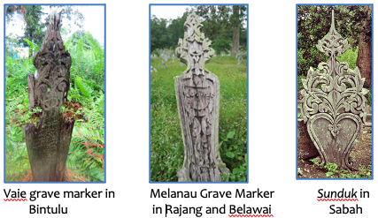

Figure 5. Other Ethnic Burial Grounds Using Carved Wooden Grave Marker.

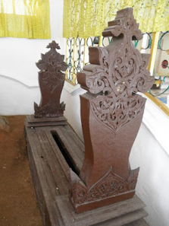

Figure 6: Grave Marker of Queen Long Yunus, Che Ku Tuan Nawi. Tomb in Raja Langgar, Kota Bharu. Mid-18th Century

The study indicates, based on Ambary [21], that the design and decoration of the Bajau's Sunduk in Sabah and the Sulu Archipelago may have been influenced by Bugis-Makassar type Batu Aceh grave markers, which have been found in the South, like the Philippines. Located along the marine trade routes that connect Borneo and the Southern Philippines, the Sulu Archipelago was once home to the Islamic Sulu Sultanate and served as a center of artistic and cultural activity. Even though the Bajau are Muslims, their artwork frequently features pre-Islamic native motifs, such as human or animal figures, which are generally forbidden in Islam [23].
The Bajau grave markers in Southeast Asia's Sulu Archipelago showcase a fusion of Islamic and native civilizations. Researchers examining the Sulu Archipelago's cultural, religious, and artistic past and the early history of Islam in Southeast Asia can learn much from its grave markers. The two primary components of these monuments are the Sunduk, which indicates the deceased's gender, and the Kubul, a low, open fence encircling the grave. The female’s Sunduk has a flat, finely carved board, whereas the male’s Sunduk is cylindrical and has a separate base styled like a boat or animal. With components like stylized lotus blossoms, traditional Malay carvings, lattice motifs highlighting the Islamic tradition, and geometric and floral patterns rooted in Islamic history, their design and decoration represent Islamic and indigenous art influences.
These Sunduks share many similarities with the Jatti Miriek grave markers, particularly in material, craftsmanship, and carving designs. As previously stated, the influence of Batu Aceh first spread throughout the Malay Archipelago, including the Southern Philippines and the Sulu Archipelago. This impact came in the form of ideas and the application of Islamic ideals to the construction of grave markers at the time. However, the construction material was changed to ironwood. The transition from river stones to ironwood was most likely caused by the abundance and accessibility of wood supplies and the faster way of cutting wood compared to stone.
The Jatti Miriek grave markers, like those in Batu Aceh, have a shape that reflects the deceased's gender. Women's wooden markers are beautifully carved panels, whereas men's are cylindrical. Sunduks, on the other hand, usually have a distinct base in the shape of a boat or stylized animal, as opposed to Jatti Miriek wooden markers, which do not utilize any motifs other than flora and geometry. Regarding the motifs of the wooden grave marker carvings, it is discovered that the art of Jatti Miriek wooden grave marker’s carvings is the finest and the most detailed one compared to other ethnic carving arts. All reported Jatti Miriek carving art themes have distinct patterns that differ from one another.
Thus, research on the grave markers of Bajau and Batu Aceh can advance the knowledge of the evolution of Islamic art in Southeast Asia. This makes it possible to examine how Islamic art changed and adapted to the various cultural contexts of the area, expressing various influences and customs that were present there before influencing and spreading the Jatti Miriek culture in Miri, Sarawak. Therefore, these two kinds of grave markers provide an intriguing illustration of how visual and material culture can aid in understanding intricate historical and cultural relationships from the past. We can learn more about social structures, cultural traditions, and religious beliefs by dissecting the patterns and designs of these markers. This helps us comprehend historical trends in a certain area.

- PROBLEM STATEMENT
The study of Jatti Miriek ancient grave markers is a vital step towards understanding the intersection of Southeast Asia's cultural history, architecture, and religious impact. These markers provide essential insights into the architectural development and socio-religious dynamics of the Jatti Miriek community. However, the dearth of written records and past research on these markers has hampered thorough academic investigation. To comprehend their significance, it is vital to grasp that such grave markers are more than just sepulchral monuments but complex woodcarving artworks intricately intertwined with Islamic architectural traditions [4]. As devotional markers, these markers demonstrate how Islamic aesthetics have been embraced and shared in the community's traditions [7]. As a result, carefully investigating these grave markers can substantially improve our understanding of Southeast Asia's narrative architectural styles and cultural essence. This is especially true when evaluating Islam's influence and manifestation in material culture. Through a contextual exploration of Jatti Miriek ancient grave markers, this research endeavour bridges a knowledge vacuum by integrating the fields of architectural studies, Islamic art, and cultural heritage preservation

- METHODS
The methodology of this research takes a multifaceted approach. It comprises the collection of 216 grave markers pictures from 13 different burial sites in Miri, Sarawak (refer to Figure 7, 8 a, b, and c), as well as field trips for direct observation and visual analysis of the designs and motifs. The fieldwork took place near Miri, including Likauh Buie, Menjelin, Song Lekang, Tanjong Lobang, Pelapi, Tab Sinak, Babutan, Lat Suran, Luheng, Siwak Jaya, Katong, Merafak, and Bakam.

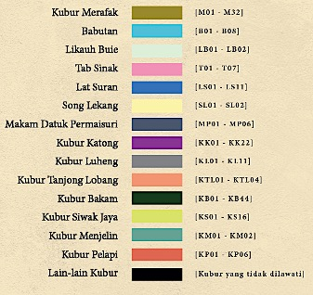

Figure 7. List of locations, color codes, and gravestone codes for documenting Jatti Miriek grave markers at the old cemetery sites identified in Miri, Sarawak.

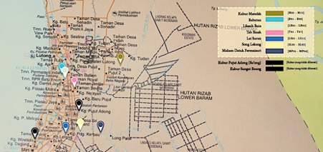

Figure 8(a). Location Plan of the Merafak, Babutan, Likauh Buie, Tab Sinak, Lat Suran, Song Lekang, and Datuk Permaisuri Burial Sites.

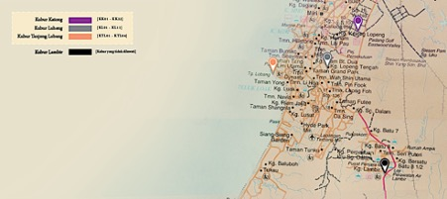

Figure 8(b). Location Plan of the Katong, Luheng, and Tanjong Lobang Burial Sites.

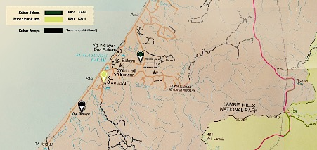

Figure 8(c). Location Plan of the Bakam and Siwak Jaya Burial Sites.

Observations found that several ancient gravesites retain well-preserved grave markers or tombstones with elaborate carvings, especially in Merafak and Bakam. In other situations, the deceased's family has replaced existing graves with new marble markers for concern that the graves may become unidentified. Furthermore, other areas, such as Lat Suran and Tanjong Lobang, have been abandoned and are no longer used by the local population for burial. There are also old graves whose owners can no longer be identified due to a lack of grave marker inscriptions, the absence of descendants, erosion, or neglect over time.

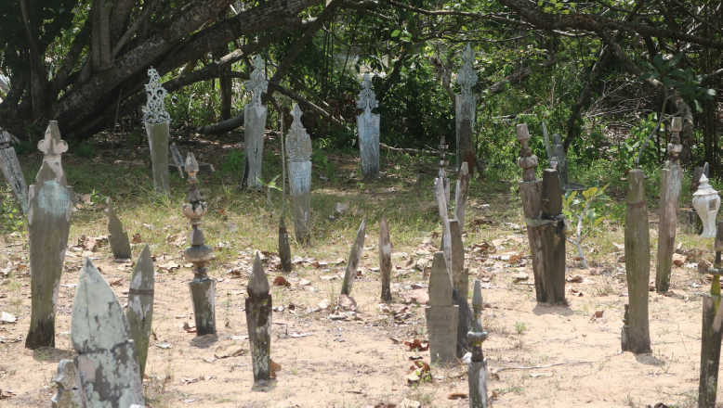

Figure 9. The historic site in Siwak Jaya, one of 13 burial sites, still contains many preserved Jatti Miriek grave markers.

Ethnographic interview and community interaction were used in conjunction with a comparative methodology to examine the Jatti Miriek grave markers against Batu Aceh and Bajau Sunduk to understand the cultural and historical context. The research intends to provide a detailed understanding of the cultural, historical, and artistic value of the Jatti Miriek grave markers through this multifaceted method, positioning it within the broader framework of Southeast Asian’s cultural history.

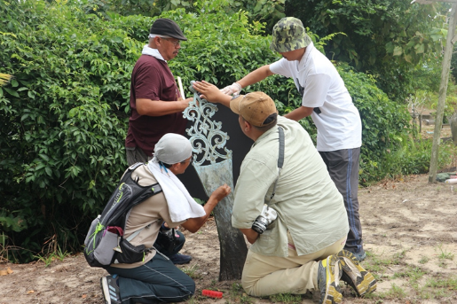

Figure 10. Direct observation and documentation were conducted at one of the old Jatti Miriek burial sites in Miri, Sarawak. Grave markers are cleaned before the documentation session begins so that the motifs can be recorded.

167 of the 216 photos of wooden grave markers from the 13 historic Jatti Miriek burial sites have been chosen for additional examination based on the compilation of data (figure 10). However, only 106 carvings could be identified because most references were too damaged or had insufficient detail to be recorded. The number of identified grave markers with carvings and Jatti Miriek ethnic identification, together with a list of historical Jatti Miriek burial places in Miri, are provided in the Table 1.

Table 1. List of Grave Markers Documentation
Burial Site | Total Documentation | Total Selected
Likauh Buie  Menjelin  Song Lekang  Tanjong Lobang  Pelapi  Tabsinak  Babutan  Lat Suran  Luheng  Siwak Jaya  Katong  Marafak  Bakam  Total | 4  6  5  11  18  7  8  22  11  18  24  38  44  216 | 2  2  2  4  6  7  8  11  11  16  22  32  44  167

- RESULT AND DISCUSSION

- TRANSITION OF JATTI MIRIEK GRAVE MARKERS
The research indicates that the Jatti Miriek grave markers initially resembled Batu Aceh, suggesting an early influence around 1800 AD. Over the 19th and 20th centuries, these designs evolved across the Malay Archipelago, including the Malay Peninsula, Southern Thailand, the Borneo islands, and the Southern Philippines, to better reflect local cultures and environments. This evolution (figure 11) involved changes in motifs and materials, notably transitioning from stone to wood, such as belian wood, culminating in the development of Bajau Sunduk markers.

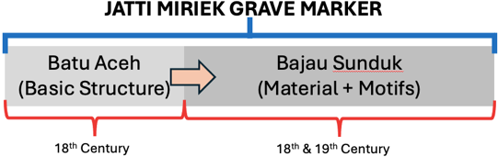

Figure 11. The development of Jatti Miriek Grave Markers Design

- CATEGORIES OF JATTI MIRIEK GRAVE MARKERS
Jatti Miriek grave markers contain distinctive elements that may be influenced by the deceased's social rank and communal functions. The carvings on each grave marker vary in complexity, size, and type. The shapes and designs of the Jatti Miriek grave markers have allowed for the identification of the categories of markers (Table 2).

Table 2. Six Categories of Jatti Miriek Grave Markers
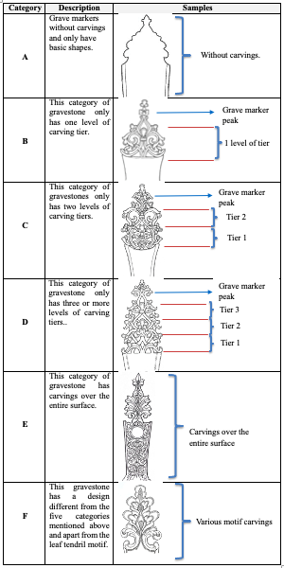

Observations show that the Islamic influence on Jatti Miriek grave markers falls into two groups of motifs: geometric and floral. Alhough certain geometric designs are also present, floral motifs predominate in most grave markers. A cross-study with themes from Acehnese carving art led to the identification of ten varieties of floral motifs and two geometric patterns. These motifs are broken down in Table 3.
The influence of Islamic art on Jatti Miriek grave markers is evident through specific symbols and motifs, reflecting cultural and religious significance. Floral motifs, such as leaves and flowers, are foundational in Jatti Miriek wood carving art, symbolizing life, beauty, and spiritual growth. They are closely aligned with their beliefs and spirituality tied to nature. Additionally, geometric motifs, although less common, represent Islamic principles like unity, harmony, and the eternal aspects of God. These motifs, along with intricate carvings on women's grave markers, showcase the influence of Islamic aesthetics, emphasizing balance and finesse in design. Moreover, unique motifs like the Bean Sprout, Jasmine Vine, and Pineapple distinguish Jatti Miriek grave markers and hold deep cultural and religious meanings specific to their community. Overall, the fusion of Islamic art elements with Jatti Miriek's cultural and religious beliefs is evident in their grave markers, reflecting a harmonious blend of aesthetics and spirituality in their artistic expression.
The evolution of Jatti Miriek grave markers reflects social and religious changes in their society over time. These markers serve as cultural artifacts, illustrating the intertwined influences of culture and religion on the community's wood carving art. Initially influenced by cultural identity and ethnic traditions, the choice of motifs and carving techniques on the gravestones mirrors the beliefs and values passed down through generations. Over time, the influence of Islam becomes apparent, as Islamic motifs and symbolism are integrated into the wood carving art, indicating the community's adoption of Islamic teachings and values. This shift demonstrates the dynamic nature of cultural expression, showcasing how Jatti Miriek wood carving art on gravestones has evolved to reflect traditional cultural heritage and the religious transformations within their society.

Table 3. Types of Motifs in Jatti Miriek Grave Markers
No | Motif | Carved Images | Burial Sites
1 | Corner Flower   |  | Bakam, Tabsinak, Siwakjaya, Babutan, Merafak.
2 | White Clover   |  | Bakam, Siwakjaya, Babutan, Merafak
3 | Pumpkin   |  | Merafak, Bakam, Katong
4 | Lotus   | 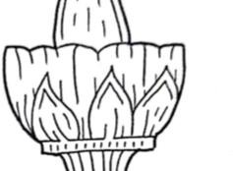 | Merafak, Bakam, Katong, Pelapi
5 | Bean Vine Leaves  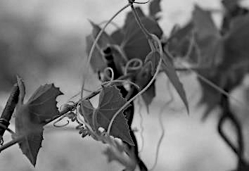 | 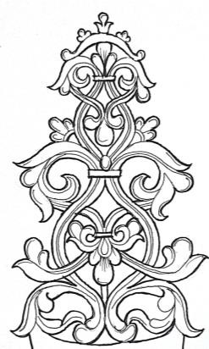 | Bakam, Siwakjaya, Merafak
6 | Turmeric Flower  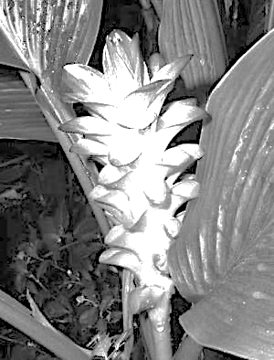 | 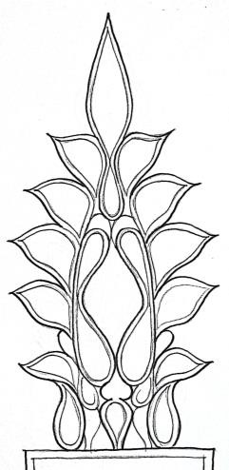 | Merafak, Tanjung Lubang, Bakam, Babutan
7 | Jasmin Flower tendrils   | 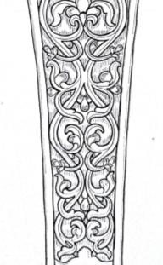 | Bakam
8 | Leaves and Shoots   | 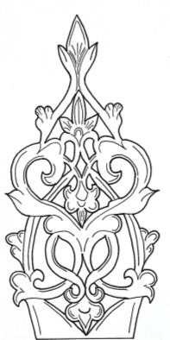 | Merafak, Bakam, Tab Sinak
9 | Rotating Rope  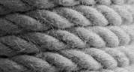 |  | Tanjung Lubang
10 | Star Anise   | 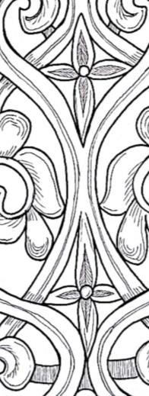 | Merafak, Bakam
11 | Geometry   | 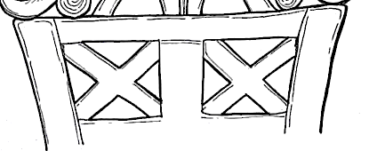 | Merafak, Bakam
12 | Pineapple  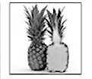 | 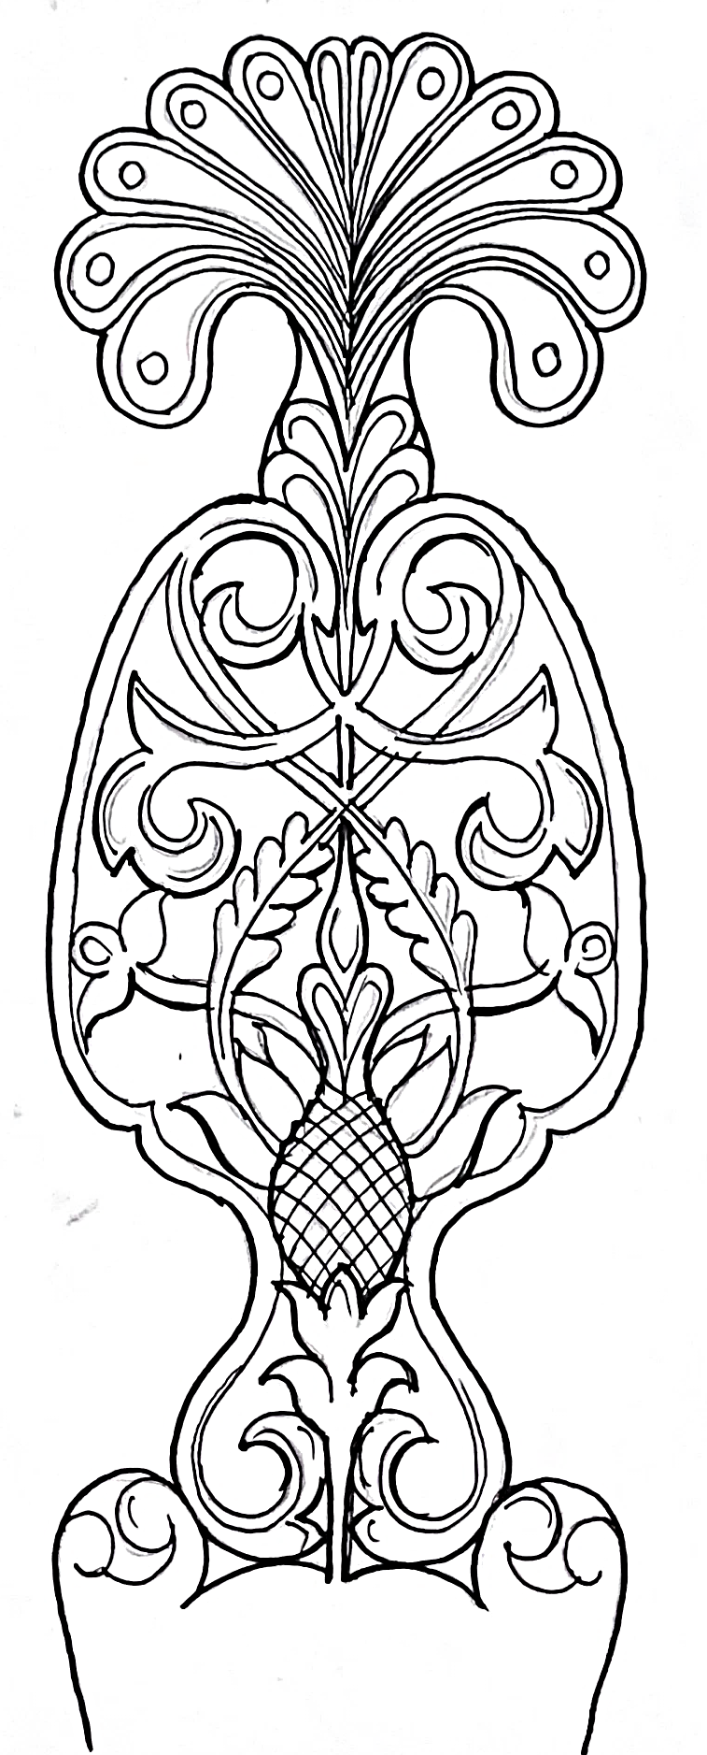 | Merafak

- A COMPARATIVE ANALYSIS OF BATU ACEH AND JATTI MIRIEK GRAVE MARKERS
Based on how the grave marker was constructed, the structure of Batu Aceh may be split into five segments: peak, head, shoulder, body, and base [14]. The structure of the Jatti Miriek grave markers likewise exhibits a similar segmentation. Both grave markers of Jatti Miriek and Batu Aceh have been compared according to their structural segments, as shown in Figure 12 and 13.

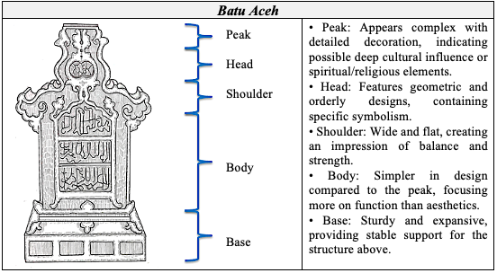

Figure 12. Batu Aceh construction according to segments

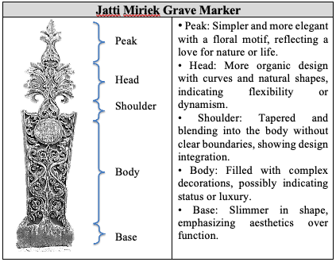

Figure 13. Miriek grave marker construction according to segments.

The comparison shows that the two grave monuments have the same basic structure—Peak, Head, Shoulder, Body, and Base—despite having different ornamental styles and purposes. This implies that the two grave markers could belong to the same system or category, like architectural features or customary markings within a society. A critical comparison of the two gravestones is provided in the Table 4.

Table 4. Comparison Segment between Batu Aceh and Nisan Jatti Miriek.
Segment | Batu Aceh | Jatti Miriek
Peak | - As the highest point of the grave marker, its summit is decorated with small, delicate pieces that give the impression of being a crown. | - The peak, which resembles a fruit crest or leaf tip, is more heavily influenced by floral patterns.
Head | - This portion of the grave marker acts as a cover and is situated over the main body. Its intricate decoration shows the influence of Islamic culture with calligraphic motifs. | - Despite the absence of calligraphy, the headstone, in this instance, is nonetheless beautifully and intricately decorated.
Shoulder | - In this section, the ornaments are less noticeable as they connect the head to the body of the grave marker. | - In contrast to the gravestones of Batu Aceh, which have richer embellishments, the shoulders of the Jatti Miriek grave markers are simpler.
Body  Base | - This is the grave marker's primary portion, which typically details the person interred there. There appear to be carved ornamentation and even inscriptions in this image.  - This grave marker's lower portion serves as a weight support. It has a straightforward but useful design. | - The grave marker's body is embellished with symmetrical and elaborate embellishments that give the impression of being elegant and well-organized.  - This gravestone's base is likewise well carved, showcasing the artistry of the craftsmanship.

Based on the description above, the differences and similarities between Batu Aceh and Jatti Miriek wooden grave markers can be summarized in Table 5 and 6.

Table 5. The differences between Batu Aceh and Jatti Miriek grave markers.
Differences
Design and Decoration | Batu Aceh has a more geometric and structured design, while Jatti Miriek grave markers are more organic and naturalistic
Aesthetic Focus | Batu Aceh shows a focus on function with decoration more centered on the top, while Jatti Miriek gravestones have complex decoration throughout
Shape and Proportion | The proportions between the elements in the Jatti Miriek grave markers appear more harmonions and integrated, compared to Batu Aceh which emphasizes the contrast between the top and bottom
Table 6. The similarities between Batu Aceh and Jatti Miriek grave markers.
Similarities
Structure | Both objects have the same structure, with five main parts specified.
Stability | Both designs feature a solid base to support a more detailed top.
Function | Both objects have the same function but represent a specific culture or architecture.
Basic shape | Both forms of grave markers are based on gender; flat shape for women and cylinder for men.

Both styles of grave markers have superb carving and intricate ornamentation. The fundamental distinction is in the decorative style and probable cultural influences portrayed in their designs. The Batu Aceh stones appear to have Islamic influences, as seen by their unique lettering and design aspects. Meanwhile, the Jatti Miriek grave markers may depict a more generic style with natural inspirations, such as flora. Overall, both grave markers are stunning examples of the art of grave carving as it has evolved across cultures, emphasizing symbolism that may reflect the beliefs or social standing of the people buried beneath them. This comparison shows that, while both objects differ in style and design features, they may serve a comparable function in different environments. Furthermore, this comparison indicates that Jatti Miriek grave markers share many traits with Batu Aceh, particularly concerning architectural structure.

- COMPARATIVE ANALYSIS OF BAJAU SUNDUK AND JATTI MIRIEK GRAVE MARKERS.
A comparison of Bajau and Jatti Miriek grave markings reveals that the Bajau grave marker, also known as Sunduk, is a carving art from the Philippines' Sulu Archipelago. The floral and geometric themes employed in the Jatti Miriek and Sunduk woodcarving crafts, notably for women's tomb markers, are comparable. This could point to a previous cultural influence or art interaction between these two places that has yet to be explained entirely.

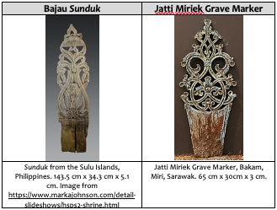

Figure 14. A physical comparison study between Bajau gravemarkers known as Sunduk and Jatti Miriek gravemarkers.

When comparing the Sunduk and Jatti Miriek grave markers (figure 14), it is clear that the Sunduk design impacts the Jatti Miriek grave markers, especially in their comparable patterns and motifs. Sunduk has a sophisticated and complicated pattern with floral motifs, which could indicate natural influences. Furthermore, the inclusion of hairbrush motifs at the head area emphasizes its significance in Bajau women's lives. These themes are symmetrical and interconnect elaborately, resulting in balanced compositions. Jatti Miriek grave markers, which also feature floral designs, have a slightly different style that is more geometric and structural. Jatti Miriek's designs, in contrast to Sunduk's, are more symbolic, maybe employing specific symbols with special or spiritual connotations. The following is a summary of the comparison:
      - Style: Sunduk's style is more organic and natural, whereas the Jatti Miriek grave marker is more symbolic and geometric.
      - Motifs: Both objects feature floral motifs but are presented in very different ways. Sunduk's grave marker emphasizes flowing and natural shapes, whereas Jatti Miriek grave marker uses more stylish and orderly shapes.
      - Design: Sunduk's design is more complicated and detailed, with many decorations resembling plants and natural elements. On the other hand, Jatti Miriek grave marker is more symbolic, with more regular use of space and emphasizing form and clear lines.
The analysis of the grave markers—Jatti Miriek nisan, Batu Aceh, and Bajau Sunduk—begins with a visual examination of their design elements as depicted in the images provided in the document. Though serving a similar commemorative function, these markers exhibit distinct cultural and artistic characteristics.
The Jatti Miriek grave marker is noted for its intricate carvings and symbolic motifs, which often reflect the natural environment and religious beliefs of the Jatti Miriek people. The designs are deeply rooted in their cultural narratives and exhibit a harmonious blend of indigenous and Islamic influences. In contrast, Indonesia's Batu Aceh grave markers display a more pronounced Islamic influence, with a prevalence of calligraphic inscriptions and geometric patterns. These markers are emblematic of the Islamic artistic tradition, merging religious symbolism with local cultural motifs.
The Bajau Sunduk, on the other hand, tends to be more simplistic in design, focusing on practicality and functionality. The Sunduk, primarily used by the Bajau sea nomads, reflects their transient lifestyle and its impermanence. The design is less ornate, focusing more on the utilitarian aspect of marking graves.

- FINDINGS
The comparison of the Jatti Miriek, Batu Aceh, and Sunduk grave markers reveals significant insights into the evolution and design approach of these grave markers. While displaying distinct Indigenous characteristics, the Jatti Miriek grave marker also bears the influence of Batu Aceh and Sunduk in its design, indicating a cultural and artistic dialogue between these communities. The comparison of the Jatti Miriek, Batu Aceh, and Sunduk grave markers reveals significant insights into the evolution and design approach of these grave markers. While displaying distinct indigenous characteristics, the Jatti Miriek grave marker also bears the influence of Batu Aceh and Sunduk in its design, indicating a cultural and artistic dialogue between these communities.
The use of floral, Islamic motifs and geometric patterns on the Jatti Miriek grave marker demonstrates the influence of Batu Aceh. This integration suggests a historical period of significant cultural exchange, most likely facilitated by trade and religious interactions. On the other hand, the Jatti Miriek grave marker incorporates these influences into its cultural context, blending them with local artistic traditions. Similarly, Sunduk's influence can be seen in the functional aspects of the Jatti Miriek grave marker. The Sunduk's simpler, more practical design reflects the nomadic lifestyle of the Bajau, implying that the Jatti Miriek grave marker incorporated these elements to meet their environmental and social needs.
These observations' synthesis reveals similarities and differences in the grave markers. The Jatti Miriek grave marker and Batu Aceh share a common Islamic influence in their designs. Yet, the former integrates more indigenous elements, making it a unique blend of two cultural worlds. The Bajau Sunduk, while distinct in its simplicity and function, underscores the diversity in the cultural practices surrounding death and commemoration in Southeast Asia.
Critically discussing these markers, it becomes evident that each type serves as a cultural artifact, encapsulating the beliefs, traditions, and artistic expressions of their respective communities. The grave markers not only signify the final resting places of individuals but also stand as enduring symbols of the cultural and historical narratives of the Jatti Miriek ethnic, the Aceh Muslim communities, and the Bajau sea nomads.
Floral motifs are fundamental in Jatti Miriek grave markers art, encompassing elements like leaves, stems, roots, shoots, and flowers, typically symmetrical and intertwining upwards. The three basic phases of motif development include elements and dotted lines, motif shapes, and motif arrangement, evident in Jatti Miriek's grave marker carvings. In contrast, geometric motifs are less prevalent, especially on men's cylindrical gravestones, while women's gravestones offer more detailed carvings due to their plankboard structure.
The Jatti Miriek grave marker is a one-of-a-kind cultural artifact that combines indigenous, Islamic, and regional artistic elements. It exemplifies the ever-changing nature of cultural heritage, in which art forms evolve and adapt, borrowing and incorporating elements from neighboring cultures while retaining their distinct identity.

      - CONCLUSION
The parallels between the Jatti Miriek grave markers and the Batu Aceh were noted at the outset of the discussion, suggesting that the Batu Aceh may have had an early effect on design circa 1800 AD. Moreover, it is thought that over the 19th and 20th centuries, grave marker designs changed throughout the Malay Archipelago to suit the local environment and culture better. These changes included modifications to the motifs and choice of materials. The Malay Peninsula, Southern Thailand, the Borneo islands, and the Southern Philippines have all been observed to be affected by this effect. Of special note is the change from stone to wood, such as belian wood, for grave markers.
The discussion then explores the intricate relationship between floral and geometric motifs in the wood carving art of Jatti Miriek community gravestones and their beliefs, Islam, and cultural identity. Firstly, these motifs reflect the community's beliefs and spirituality, emphasizing their close connection with nature and the symbolic significance of flora as representations of life, beauty, and spiritual growth. Secondly, the influence of Islam is evident in the gravestone carvings, with motifs portraying Islamic concepts like unity, harmony, and the eternal aspects of God, reflecting the community's adherence to Islamic teachings regarding order and respect for nature.
The analysis reveals that floral motifs, particularly Sulur Kacang, Sulur Bunga Melati, and Nanas, are distinct to Jatti Miriek, distinguishing their identity from other ethnic groups. This suggests that these motifs influence the production method of Jatti Miriek grave marker carvings, with floral motifs being the most prominent, followed by geometric motifs.
Additionally, these motifs serve as cultural markers, distinguishing Jatti Miriek gravestone carvings from others in the Malay Archipelago and symbolizing the cultural and historical significance embedded within their identity. Overall, the wood carving art of Jatti Miriek gravestones uniquely expresses their intertwined beliefs, Islamic values, and strong cultural heritage, showcasing their reverence for nature, adherence to Islamic principles, and commitment to preserving their cultural identity and traditions.
To summarise, the Jatti Miriek grave marker is a product of its immediate cultural environment and a testament to Southeast Asia's broader historical and cultural exchanges. Its design reflects a complex tapestry of influences, symbolizing the region's rich cultural interactions throughout history. When the design elements and motifs of the Jatti Miriek grave marker are compared to those of Batu Aceh and Sunduk, a rich tapestry of artistic expression emerges. The Jatti Miriek grave marker is notable for its symbolic depth and aesthetic complexity, with indigenous carvings intertwined with Islamic motifs. This blending of styles speaks to a larger story of cultural assimilation and artistic innovation, in which local traditions are enriched rather than overshadowed by outside influences.
The study of these grave markers is historical and has contemporary relevance in terms of cultural heritage preservation. As a cultural artifact, the Jatti Miriek grave marker provides invaluable insights into the community's past and present, physically linking to their ancestral beliefs and practices. This link is critical in today's rapidly modernizing world, where traditional practices risk extinction.

ACKNOWLEDGEMENT
This research was supported by the University Fundamental Research Scheme (GPUF) grant funded by Sultan Idris Education University (2021-0226-106-01). We also thank everyone who helped with this research, notably the Sarawak State Library and the Jatti Miriek Association in Miri.

REFERENCES
[1] E. Lambourn, "Grave markers, texts, and typologies: Seeing sources for the early history of Islam in Southeast Asia," Journal of the Economic and Social History of the Orient, vol. 51, no. 2, pp. 252-286, 2008. Doi: https://doi.org/10.1163/156852008X307447
[2]. B. W. Andaya, "Religion and Commerce in Southeast Asia," in Oxford Research Encyclopedia of Asian History, Oxford: Oxford University Press, 2021.
[3]. H. Ibrahim and M. Saidin, "Reka Bentuk Dekorasi Dan Hiasan Pada Batu Nisan Aceh Di Tapak Lamreh Aceh Besar, Aceh, Indonesia (Decorative Design and Ornamental Variety of Acehnese Grave markerss at Lamreh Aceh Besar, Aceh, Indonesia)," Jurnal Arkeologi Malaysia, vol. 33, no. 1, pp. 65-72, 2020.
[4] A. Ghofur, "Tela’ah kritis masuk dan berkembangnya Islam di Nusantara," J. Ushuluddin, vol. 17, no. 2, pp. 159-169, 2011. DOI: http://dx.doi.org/10.24014/jush.v17i2.689

[5] M. A. A. Rahman, "Sejarah dan Perkembangan Islam di Sarawak Sebelum Merdeka" in Prosiding Nadwah Ulama Nusantara II Sumbangan Ulama dan Tokoh Agama Borneo: Ulama Penggerak Pembangunan Masyarakat, Bangi, Malaysia: Fakulti Pengajian Islam UKM [Universiti Kebangsaan Malaysia], pp. 434-447, 2003.
[6] Y. Chang, "Keeping their language, culture alive," The Borneo Post, Accessed: Sep. 26, 2021. [Online]. Available: https://www.theborneopost.com/2021/09/26/keeping-their-language-culture-alive/
[7] A. Jalil, M. Noh, M. Amin, W. M. Azam, and M. Alias, "Politico-Cultural-Religious Milieu of Southeast Asia: An Examination of Pre-Islamic Structures of Authority and Syncretic Practices," KEMANUSIAAN: The Asian Journal of Humanities, vol. 26, no. 2, 2019. Doi: https://doi.org/10.21315/kajh2019.26.s1.6
[8] A. N. Farish and E. Khoo, The Art of Malay Woodcarving, Singapore: Periplus Edition, 2003.
[9] R. Othman, "The language of the Langkasukan motif," Indonesia and the Malay World, vol. 33, no. 96, pp. 97-111, 2005. Doi: https://doi.org/10.1080/13639810500281898
[10] V. D. Meij, “Les Monuments funéraires et l'histoire du Sultanat de Pasai à Sumatra”, Studia Islamika, vol. 17, no. 1, 2010. Doi: 10.15408/sdi.v17i1.471
[11] O. M. Yatim, "Batu Aceh: Early Islamic Gravestones in Peninsular Malaysia." Bulletin de l'École française d'Extrême-Orient, vol. 77, pp. 368-371, 1988.
[12] A. Reid, "Cultural adaptation and integration: Islam in Southeast Asia." In Southeast Asian Islam, pp. 189-207. Routledge India, 2024.
[13] L.-C. Damais, "The Spread of Islam in Indonesia," Journal of Southeast Asian History, vol. 6, no. 2, pp. 1–24, 1965.
[14] Y. M. Rafee, Siri Sarawakiana-Budaya Tradisi Kaum Jatti Miriek; Adat dan Budaya Perkahwinan Kaum Jatti Miriek, Kuching: Pustaka Negeri Sarawak, 2018.
[15] Y. M. Rafee, Seni Ukiran Perkuburan Lama Jatti Miriek, Kuching: Pustaka Negeri Sarawak, 2019.
[16] D. Perret, B. M. N. Arbai'yah, B. H. Jamil, and M. A. B. M. Saleh, "Makam-Makam Islam Lama di Maritim Asia Tenggara," Kuala Lumpur: Jabatan Muzium Malaysia, 2017.
[17] Z. Ramli et al., "Batu Acheh: Jumpaan Terbaharu Di Pulau Langkawi, Kedah Malaysia," J. Arkeologi Malaysia, vol. 29, no. 2, pp. 1-14, 2016.
[18] M. U. Ismail, Z. Ramli, and R. M. A. Zakaria. "Islamic Art Influences on Several Batu Aceh Gravestones in Sumatra and the Malay Peninsular: Revisited." Islamic Quarterly, vol. 66, no. 1, pp. 1-38, 2022.
[19] "Batu Nisan Malikah Nahrasyiyah: Ratu Pertama di Kesultanan Samudra Pasai." Sultanate Institute Historical Archaeology. Accessed January 1, 2022. [online] Availabe: https://sultanateinstitute.com/grave-markers/4011/batu-nisan-malikah-nahrasyiyah-ratu-pertama-di-kesultanan-samudra-pasai/.
[20] N. Addini, "Ornamen pada Batu Nisan Aceh Darussalam (Abad 15-19 M)," Ph.D. dissertation, Universitas Islam Negeri Arraniry, 2018.
[21] F. Qhairi, "Peran Pemuda Terhadap Tinggalan Nisan Bersejarah di Gampong Ateuk Jawo (Banda Aceh)," Ph.D. dissertation, UIN Ar-Raniry Banda Aceh, 2020.
[22] H.M. Ambary, Menemukan Peradaban, Arkeologi dan Islam di Indonesia, 2nd ed. Jakarta: PT LOGOS Wancana Ilmu, 1998.
[23] R. D. McAmis, Malay Muslims: The history and challenge of resurgent Islam in Southeast Asia, Wm. B. Eerdmans Publishing, 2002.

