 |  | JOURNAL OF ISLAMIC ARCHITECTURE  P-ISSN: 2086-2636 E-ISSN: 2356-4644  Journal Home Page: http://ejournal.uin-malang.ac.id/index.php/JIA
COMPARATIVE STUDY OF INTIMACY BETWEEN MILLENNIAL VERNACULAR ISLAMIC HABITAT OF M’ZAB AND STANDARDIZED MODERN HABITAT
Dahmani Krimo^{a*}
ªLaboratory of Environment and Technology for Architecture and cultural Heritage (Lab ETAP), Institute of Architecture and Urban Planning (I.A.U), University Blida 1. Algeria
*Corresponding Author: dahmani_krimo@univ-blida.dz
ARTICLE INFO |  |  | ABSTRACT
Volume: 8  Issue: 3  Page: 779-793  Received: January 13th, 2024  Accepted: May 7th, 2024  Available Online: June 30th, 2025  DOI: 10.18860/jia.v8i3.25675 |  |  | Understanding intimacy within a habitat is crucial to deciphering its human and social dynamics. Human habitation's conceptual and poetic content inspires both the creation and philosophical thinking of societies. Heidegger connected art, space, and architecture of human habitation by responding to the aspirations of their inhabitants. In this sense, private life constitutes a boundary between private and public family life. In Islamic architecture, this sustainable concept is intergenerational, translating sensory experiences into spatial design. We aim to quantify this concept by comparing Islamic and modern architecture. By integrating ophthalmology calculations, those of J. Panero and M. Zelnik, and the interpersonal communication thresholds of Hall and Moore, we calculated the dynamics of spatial and superficial intimacy based on gender. Differences have been observed between Mozabite Islamic architecture in Algeria, recognized as a UNESCO World Heritage Site, and modern architecture. According to Shannon and Weaver, the information is coded messages and measurable quantities. The internalization or exteriorization of intimacy is essential to understand its vernacular or modern typology. The resonance of gender frequencies undoubtedly forms the basis of a relatively effective strategy for protecting privacy within human habitats. This approach facilitated the development of a sensory imprint for the opulent vernacular Islamic habitat of M'Zab.  Keywords:  Habitat; Islamic Vernacular; Mathematical Calculation; Modern Habitat; Surface Intimacy; Vector Intimacy

- INTRODUCTION
The architectural design of the house ensures the privacy of the families. The separation between families' private and public life is guaranteed by intimacy, notably through visual barriers. For Heidegger, the purpose of every building is to provide space for dwelling, where the relationship between building and dwelling is referred to as "means" and "end"; primarily, "buildings house man" [1]. Privacy is a critical sociological category for understanding the collective recognition of people's emotions as it affects how emotions are considered relevant and legitimate in public discussions of social issues [2]. Muslim societies take the separation of private and public life as their primary principle of spatial organization. The architecture of the habitat embodies a language. Heidegger stresses the role of language in comprehending not only our ideas but also our surroundings. Heidegger wants to remind us that our everyday life consists of concrete things rather than the abstractions of science [3].
"Building and thinking are, each in its way, inescapable for dwelling" [1]. The exercise of thinking about spatial relations is a dwelling relation with space [4]. Our ability to form intimate connections with others is a fundamental aspect of our existence and is crucial for leading a fulfilling life [5]. Home is a collection and concretion of personal images of protection and intimacy that help us recognize and remember who we are [6]. Intimacy is seen as a solely sensory concept. Our attempt at calculating definitions was based on understanding the interactive spatial relations between the inhabitants of a vernacular and modern dwelling. This compares two design approaches to Muslim vernacular and modern European intimacy. Intimacy transcends the sphere of the physical space of private space to become a self-centered, intellectual attitude [7]. The private space is an invisible space to the eyes of others. The intimacy between oneself and the other also passes through the twisting of language to inscribe the desire for a private language within the standard and stereotyped language [8]. The feeling of the universality of intimacy has been brought about by certain novelists of the century who aimed to become the new historians of this intimate microcosm. Each of them, in their own way, defends and exploits the epistemological value of personal accounts. George Sand argues in The History of My Life that each person's intimate history is part of humanity, which makes sharing personal experiences not only legitimate but also desirable because it benefits the community [9].
In this sense, home is an expression of personality and family as well as their very unique patterns of life. The strict dissociation of public and private spaces increases the feeling of intimacy [10]. The close correlation between physical space and social order has been identified since the early days of Sociology and Anthropology as an essential key to reading human societies [11]. The Saharan and millennial habitat of the M'zab Valley is represented as a user manual whose intimacy is expressed through family organizational core under the rules of the Muslim religion. The M'Zab Valley, which was classified as a World Heritage site by Unesco in 1982, is conceived as an unspoiled, simple, and functional city perfectly adapted to the arid environment in which it has been established. The book of Neufert Ernest emphasizes privacy and home, but for a modern society. Intimacy is the key to understanding the design of their tightly packed homes. Intimacy lies in the capacity of the human being to meet himself, occupy his interior, and discover and affirm his personality better [7]. The buildings and artworks that adorn our planet are more than just impressions for human habitation. They are a reflection of our existence as autonomous arrangements of space and place [12].
In this sense, house is an appropriate space supporting the "individual" identity [13]. It promotes both intimacy and socialization [14]. In this regard, feeling being habituated is a spatial and architectural answer, studied gesture, body movement, and a social structure that puts its training unit first. Forstie's emphasis on the social context of emotions is a crucial aspect of Forstie's work [15]. The proposition is to conceive intimacy as a distinct social relationship composed of effect, knowledge, mutual action, and norm. This fourfold composition connects structural and interactive components of feelings with normative frameworks in which emotions are both felt and articulated [2].
The intimate space is a gendered space to be architected with calculations for family members and guests. An outsider (female or male) will influence this intimacy. The first contact that provokes intimacy is the visual and architectural field, then sound, adoration, touch, and taste. The eye is essential to understand the architecture of intimacy from the visual field because one can be more comfortable in front of a blind person. The intimist needs to describe himself/herself in a spatiotemporal scenographic device that he/she tends to his/her correspondent or himself/herself as the essential prerequisite to generating the effect of intimacy [9]. Intimacy has also become a central sociological concept that helps us understand the way subjective and collective levels of social action are regulated by each other [2].
Dwelling places are also pronounced and written as "Masken." in the Quran, the word "Masken" highlights a new dimension of understanding the phrase dwelling [4]. "He who created you from the soul and created from it its mate that he might dwell in security with her" [16]. In Islamic vernacular architecture, intimacy is produced by inherited practices. In the examples of Neufert's guide, as references, intimacy is scientifically created. Individual practices such as sleeping, dressing, being alone or as a couple or with children, and being with relatives represent foundations for a calculable design. For individuals and groups, to feel "at home" or to "make home" involves access to rights and resources, which are not distributed equally among all members of society [17]. Homes delineate the realms of intimacy and public life. It is frustrating to live in a space we cannot recognize or mark as our territory [6].

  - RESEARCH PROBLEM: HABITAT AND INTIMACY
Home is synonymous with intimate space. The fascination of the world of personal intimacy is so great that I recalls the AD Magazine in the late 1960s reported on a minute theatre in New York. The audience was watching the daily life of an average American family living in a rented flat through a one-directional mirror, unaware of being on stage. The theatre was open 24 hours a day and continuously sold out until it was closed by the authorities as inhuman [6].
The importance of this subject has been explained by a book published for private life and intimacy: A History of Private Life, Volumes I-IV [18]. We ask the question of calculating intimacy from the vectorial and surface understanding of the movement of the human eye. Each movement covers a surface and a trajectory when crossing with the others. In this sense, the visual field helps us in the mathematical calculations of graphic intimacy. Sound intimacy is ensured by the construction materials, the distances, and the excellent intensity of the closing and opening systems inside and outside. The issue of privacy comes before the issue of housing quality. Nomads are satisfied by the assurance of confidentiality in their tents.
The capacity for emotional intimacy is essential to genuinely fulfilling relationships and having an uncommonly vital life in which awareness, passion, love, action, and integrity function as one [19]. The gendered relationship between inhabitants/guests/habitat/intimacy is primary and complex. The family organization remains, despite many transformations it has undergone, a central pillar of contemporary social functioning [20]. The habitat must keep its particularities. The space of intimacy is the empty environment that allows people to move freely without being crossed by others. Intimacy gives the inhabitants a real sense of freedom and well-being. We approach each other with careful reserve and will only begin fully opening up to one another once we have determined that we pose no threats [21]. Intimacy can, therefore, be internalized and externalized since, 'like solitary intimacy, co-presence intimacy tends to unravel the social armor conducive to self-revelation and unveiled authenticity [7]. How can we define and mathematically calculate intimacy in the two contexts? The first is the ancient Islamic habitat of M’zab, and the second is the conventional and modern habitat. How is superficial or vector intimacy presented in the two cases of conceptualization influenced by their contexts? "In other words, we have to give thought to the thingness of things to arrive at a total vision of our world" [3].

- METHODS
Mathematical understanding aims to allow the numerical reading of realistic and physical sensory solutions. To conceive intimacy is a testing of encounter of oneself and others in a more or less defined space within which intimate friends, spouses, lovers, and parents experience affinity and sharing of thought, emotional closeness as well as self-revelation as if intimacy participates in the process of ascension to the other and to oneself [7]. For a family's private and everyday life, the house's intimate space is conceptualized in a way where "the man finds his reason for being and his nature" [22]. This paper speaks about the intimacy in the interior space. It is about the spaces that we share with family members and guests. Our usual construal of intimacy involves the projection of a horizon marking off 'us' and 'them,' the sphere of entirely open vulnerability and that of regulated self-protection [21]. The visual intimacy architected for centuries is concretized in the annoyance of walls and ceilings. The design is to be revealed through movement patterns and the use of spaces. Each society and each era has its patterns of space arrangement and dynamic patterns that are to be respected according to social aspirations.
Sustainable vernacular architecture responds favorably to the intimacy of families, which means that over time, this intimacy has changed to be materialized and mastered. It is the staging of the concept of intimacy as a guarantee of a sustainable model. Our approach is made according to these stages [Figure 1] [Figure 2]:
- In the first place, the intimate simultaneously involves the spectator and actor. He does not cease to judge and evaluate the progress of his journey towards himself. However, whatever the results of his evaluation, he generally never has any doubt about the heuristic power of this "work of the intimate" [9]. So, we took one example of vernacular architecture and another one of contemporary architecture. The movement in the space is subordinated to its gendered and delimited vocation. For this, we proposed two types of movement in the modern habitat, one is free and the other is limited by the passage to the second floor.
- Secondly, we studied space and its relation to bodily movements (vectorial, spatial, and gendered). Intimacy can be the dimensional guarantor of our dwellings.
- The third step was movements' vector, surface, and gendered geometry, representing the degree of control and intimacy design. Doors and stairs represent thresholds.
- We calculated the visual fields for the three proposed house types according to the interlocking American standards [23], the Cahiers d'Ophtalmologie 2011, N°153, which gives values on the horizontal visual field for a maximum distance, and the four thresholds of personal communication of Hall 1971 and after Moore 1996 [Figure 3].
- The last step was to put the pathways and free surfaces in harmony with the dimensions of intimacy to give another calculable definition to this concept of felt intimacy. This will be done through the proposal of mathematical equations.
- We worked with diagrams and justified graphs. Such separation of the spheres of intimacy and publicity marks the institution of a relatively effective strategy for overcoming some of the primary sources of suffering of narrative disruption [21]. The methods section describes the rationale for applying specific procedures or techniques to identify, select, and analyze information applied to understanding the research problem, thereby allowing the reader to evaluate a study's overall validity and reliability critically.

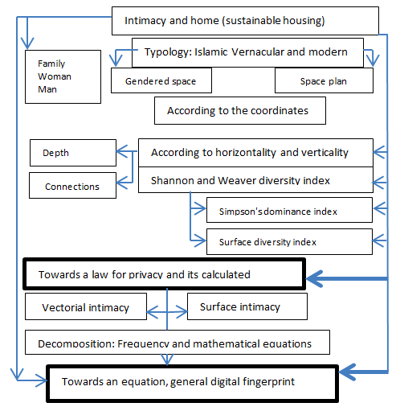

Figure 1. Graphical representation of a spatial/surface/gendered approach. Source: authors.

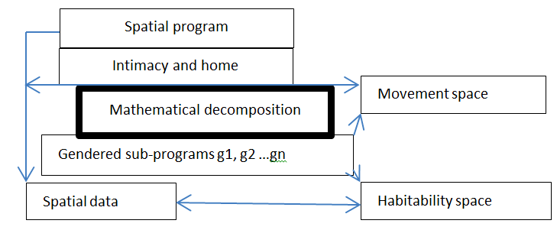

Figure 2. Design analysis and article structure. Source: authors.

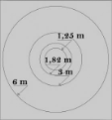

Figure 3. Circle of standards according to the three sources of information.

- CASE STUDY
The two types of architecture, popular and conventional, taught in architecture schools, represent referential plans in architecture. They are two different models made by the principle element that precedes intimacy — the referential book 'The Elements of Construction Projects' written by Ernest Neuferts is a sacred book for architects. The second context is Islamic vernacular. It is an Islamic architecture classified worldwide by Unesco, which is also ancestral, inherited, and intergenerational for over ten centuries. Architectural plans are a great way to comprehend the language of a building's design as they showcase a habitat's poetic and residential aspects. The Valley of M'zab is located in Southern Algeria. It is a set of five ksour located at 30°33' North latitude and 3°45' East latitude. For the settlement of this area, "Well before the destruction of Sedrata in 1075, Ibadites had left in search of new sites of settlement. Internal divisions and harassment from the surrounding nomads pushed some to withdraw to a more defensible location. The family is patriarchal and patrilineal, and it gathers individuals related by an economic dependence. The mother ensures the education of young children; the older girls participate in it" [24]. Heidegger suggests that humans experience 'Geoworfenheit,' or being thrown into existence, by being born into social conventions, politics, and obligations they did not choose. This idea is complemented by the Arabic word for dwelling, Masken, which also means to relieve pain. This term reflects how we seek refuge from our daily struggles by retreating into our homes, living spaces, and relationships [4]. We also have an example of a Ksar among our case study (Figure 4, 5, and 6).

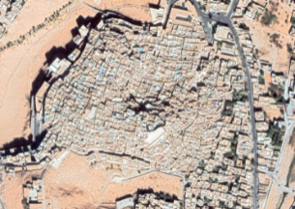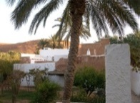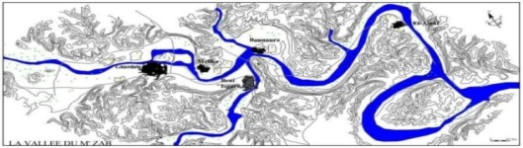

Figure 4: The ksour of the Mzab Valley (Source: OPMV (Office of Protection of the M' Zab Valley)- and Ksar of El Ateuf (case study).
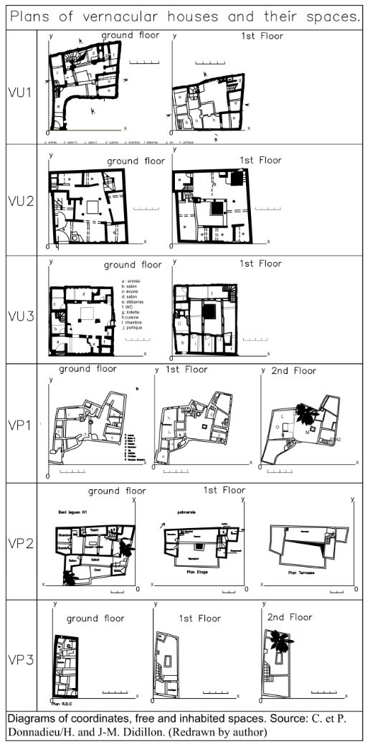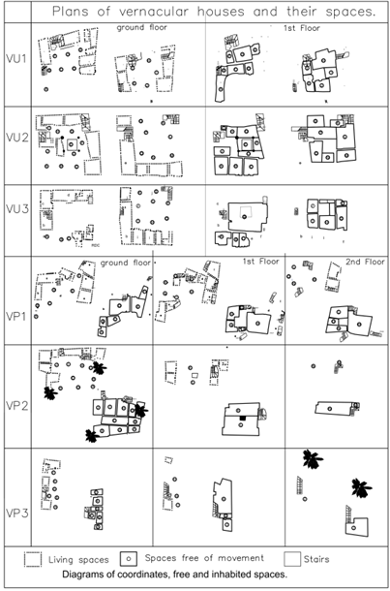
Figure 5. Plans of vernacular houses and their spaces (VU: vernacular Urban, VP: vernacular palmery, Mo: Modern). Source: C. and P. Donnadieu/H. and J-M. Dillon, Ernest Neufert (Redrawn by Author).

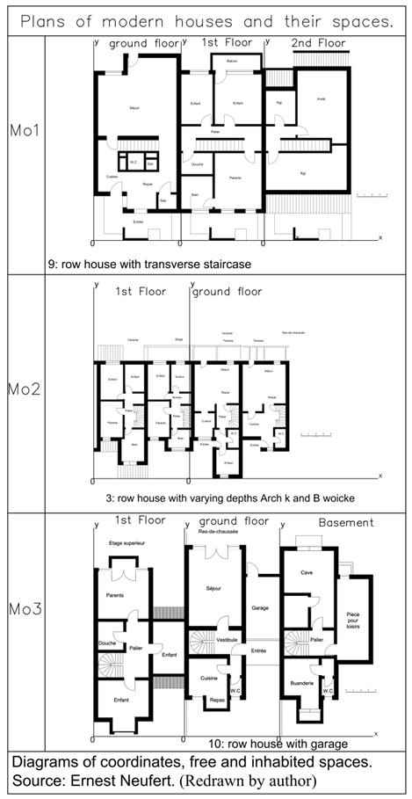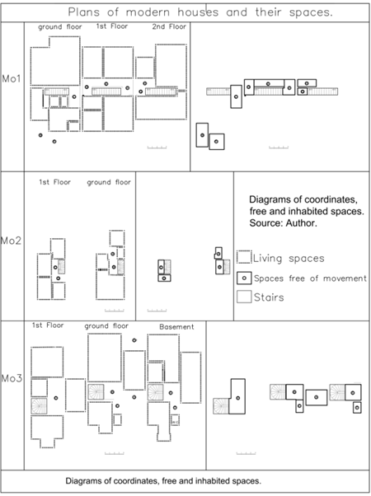
Figure 6. Plans of modern houses and their spaces (VU: vernacular Urban, VP: vernacular palmery, Mo: Modern). Source: C. and P. Donnadieu/H. and J-M. Dillon, Ernest Neufert (Redrawn by Author).

- RESULT AND DISCUSSION
Our goal is to explore the measurement of intimacy by analyzing visual cues and movements. We made the graphs using Excel software, and AutoCAD to calculate the data. The calculations are made according to the freedom of movement in space, the vector movements, and the genders that frequent the spaces.
We have started by calculating the fields of intimacy and the probabilities of encounters and gendered encounters (female, male, and family). This distribution of entities is central to the vernacular architecture. The probability of the encounter at one of the neighboring points is 1/N (of free spaces) [Table 1]. Afterward, we start the calculations of the gendered visual depths.

Table 1. Probabilities of encounters and gendered encounters
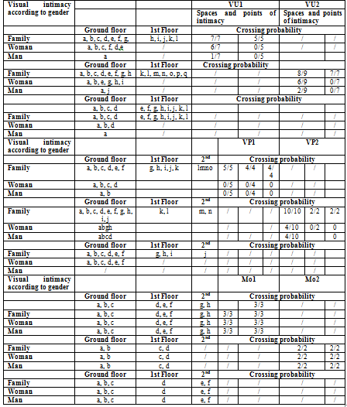

For the depths, the results are as follows:
For the X, Y, and coordinate depths:

$Dpx=\sum_{k=0}^{n}{\left({n \atop k}\right)x^{k}/Xmax}- Dpy=\sum_{k=0}^{n}{\left({n \atop k}\right)x^{k}/Ymax}$. So$, Dp=\sqrt{X^{2}+Y^{2}}$.

The displacement can be calculated from the x and y coordinates, according to the depth in the coordinate system [Figure 7].

Figure 7. Depths according to root of X2+Y2

The values of the depth average clearly explain the openness or closure in the designs through body movement. The penetration into the system is more profound in the traditional Islamic vernacular or oasis house. According to the depth charts, the design of the vernacular house allows women to penetrate deeply and freely into the interior. It limits the spaces of male guests, while in the modern home, the movement is limited and controlled by its design for all genders, including family members. According to the Pythagorean theory, movement in vernacular habitats is more flexible than in modern habitats. It is justified by the number of open spaces in the plans: 12, 14 for urban vernacular dwellings, 15, 14 for oasis vernacular dwellings, and 8, 4 for modern houses. Movement is delineated in the contemporary habitat and more unrestrained in the vernacular habitat. Privacy can take two forms in the two designs: vectorial and spatial. Shannon and Weaver's mathematical theory of communication, information, [25] and vision can measure this notion of intimacy. Claude E Shannon and Warren Weaver were first to point out that in actual practice, messages can be changed. It was based on the mathematical or mechanistic view of the communication process, in which the fundamental problem is that the message received is not the same as the message sent [26]. A cooperative system allows the movement of the observer indoors, where human communication involves exchanging information and visual contact. Modern trends wish to achieve communication systems that are flexible to the point of being able to adapt to the organization of the social system in which they are implemented [27]. We can then make our vision of communication more complex by considering the context in which it takes place [28]. In the three contexts, the results are as follows: The gender depth is calculated as follows [Table 2]:

$Dpx=\sum_{k=0}^{n}{\left({n \atop k}\right)x^{k}/Xmax}$,$Dpy=\sum_{k=0}^{n}{\left({n \atop k}\right)x^{k}/Ymax}$

Table 2. Gendered depth according to X and Y axis

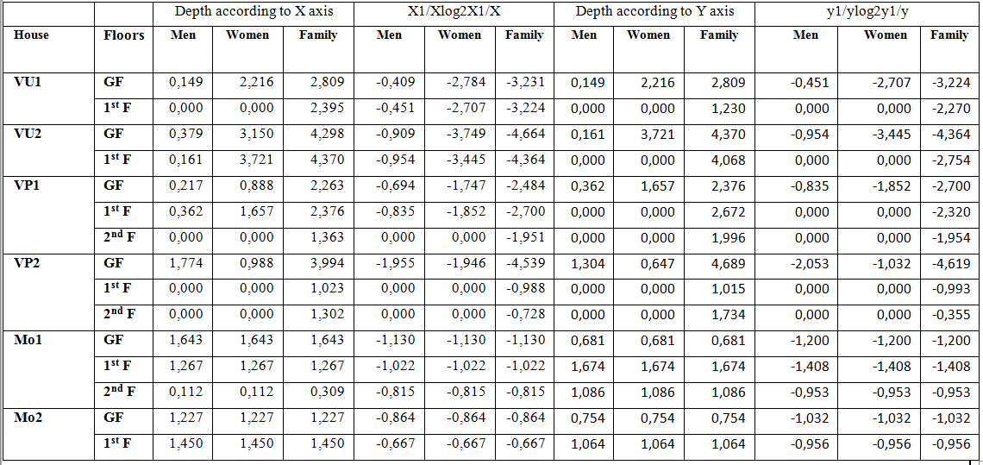

Gendered depth in the plan system (Figure 8):
$$Dp=\sqrt{X^{2}+Y^{2}}$$

Figure 8. Gendered depth in the plan system.
The Shannon-Weaver index is a form of informational coding. The higher the value of this index, the higher the diversity is. We then calculate the Simpson dominance index by counting the measured frequency of the gendered spaces. Each group of people has a value in its dominance in the spaces, which will be a strong index in the conception of intimacy.
The calculated depth of the family is more significant in the three types of conception. The inhabited space is a family space. From the graphs and data in the table above, the values are more differentiated between the genres in the Islamic vernacular habitat and very close in the modern habitat. The place of passages given to the family in both designs is the most important thing. This value is a function of the genre in the Islamic habitat, and it is also true in the other genres of the modern habitat. This means that the movement of visitors is channeled and gendered in the Islamic habitat with fewer encounters and fewer crossings. The opportunities for encounters and crossovers are higher in the modern habitat.
The man's space is close to 0 in the Islamic habitat. It is a less critical space in the house than family and female spaces. It is a more structured, more hierarchical, and more significant space. The woman's space is close to 0 compared to the man's, meaning he places less importance on delineating the woman's space than the man's. In modern design, the values are the same. This means that the vocation of spaces is variable and varied according to its use. The circulation of the family is not conditioned in all concepts, whether vernacular or modern. There is no value for visitors on the first floor of Islamic housing, meaning it is exclusively a family space. Spatiality represents a threshold for vernacular design. In contrast, in modern design, visitors have the same values as the family, where the structure and hierarchy of space remain controlled by the same thresholds for all levels.

- DOMINANCE INDEXES
This index was proposed by Simpson in 1965. It measures the probability that two randomly selected individuals belong to the same species. Gender intimacy can be an essential parameter in the design of the habitat depending on its social context. The frequency of gender (female, male, and family) differs between the Islamic vernacular and modern dwellings [Table 3]. This provides another way to define housing in terms of the presence of intimate architecture. This information on indexed dominance for intimacy is calculable by Simpson's index $D=\sum_{i=1}^{S}{{Pi}^{2}}$, and Simpson's inverse, where the higher the specific diversity, the stronger the index is:$D=1/\sum_{i=1}^{S}{{Pi}^{2}}$

Table 3. Simpson's index and gendered intimacy.

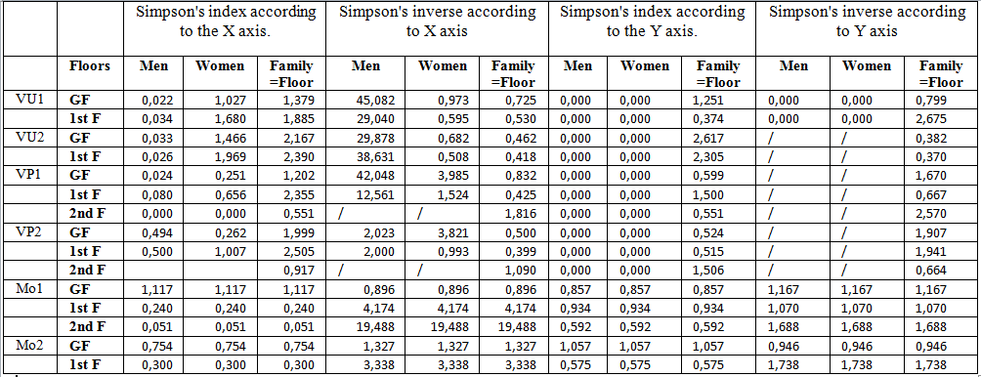

Displacement is more profound in the Islamic vernacular urban system by creating sequential displacement spaces for an architecture of intimacy. In this Islamic habitat, the interior space is more feminine than in the modern habitat. The influence of gender theory - according to the frequency measured in the vernacular space - is more straightforward than in the contemporary space. After the calculations, gender dominance in the two forms of habitat is different. Privacy through surfaces or vectors gives a gendered meaning to the architecture of the habitat, whether it is vernacular or modern. From this perspective, this index represents a possible index for understanding habitat typology.
- POSITIONAL CALCULATIONS
Visual contact is subordinated to eye physiognomy, social distances, and conventional American norms. The calculation circle is made according to the embedding of the three optical distances, medical (the notebooks of Ophthalmology 2011, No. 153, gives 1.25 exactly 1.2589 m as an optimal value), social (according to the table provided in the book "Syntax Spatial, from Phenotype to Genotype Analysis of Spatial Syntax in Minoan Architecture (MMIIIB-MRIB)" [29], which gives us a social and visual distance between 3 and 6 m, and according to the American standards mentioned in the book "Human Dimension and Interior Space", A Source Book of Design Reference Standards written by Julius Panero Martin Zelnik, the social distance is 1.6 feet and 7 feet from a sensory space. It gives us a circle of 1.82 m as a circle of vision and architectural design.
Proper visibility of displays, both from within and without, is also crucial to successfully design space. In this regard, the eye height of the small and large viewers and the geometric implications of human vision must be accommodated [23].

Figure 9. The superficial importance is given to intimacy.
- GENDERED SURFACE GRAPHS
The calculations on the gendered surfaces made on the nine plans of the three typologies (Figure 8) give the following results (table 4).

Table 4. The superficial importance is given to gendered intimacy.

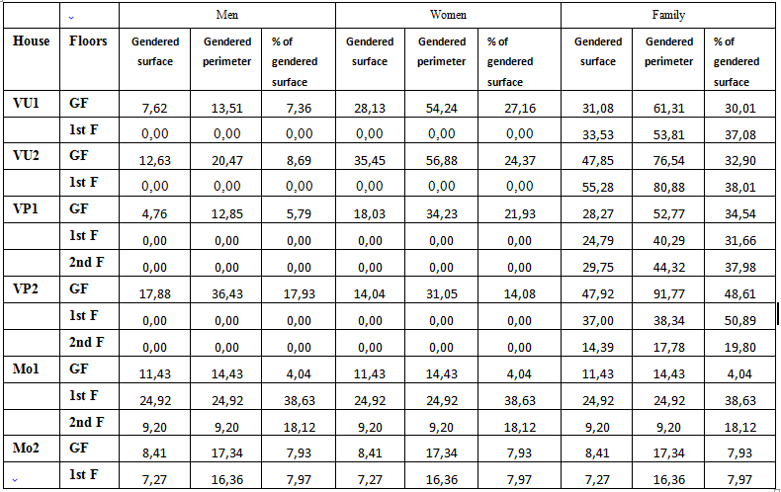

The percentage of open space compared to inhabited and enclosed spaces is more significant in Islamic vernacular housing. This allows for surface privacy by separating male and female access routes. On the other hand, modern housing has less open space and less meeting space. This does not mean privacy is not provided; thresholds and undeveloped vector spaces offer it. We also note the absence of visual relationships between open spaces in modern housing. This is a design principle of the habitat with fewer diagonal connections.
In modern housing, the vector system emphasizes passages limited by living spaces that open onto the outside. The rules of urbanism and neighborhood ensure the externalization of intimacy. This also confirms two types of intimacy: spatial and vectorial ones. On the first floor of modern architecture, there are no gendered spaces specifically for women or men, but spaces’ function can be changed. In Islamic vernacular housing, surfaces clearly define surface privacy through visible separation between the sexes. There needs to be a stronger relationship between vector intimacy and the purpose of spaces. Modern design is more flexible, concerning gendered spaces and pathways. Spaces can generate pathways, but not the other way around.
The spaces are exclusively familial in the upper spaces of the vernacular habitat. In contrast, in modern architecture, guests can access spaces according to the nature of the encounter. The delimitation of the spaces is ensured by the doors connected by corridors and vectorial spaces. This result is also more evident on the floors where connection is highly gendered and spatialized; conversely, connections are subordinated to thresholds in modern housing. The preceding results trace the conceptual imprint of privacy and housing design (figure 10).

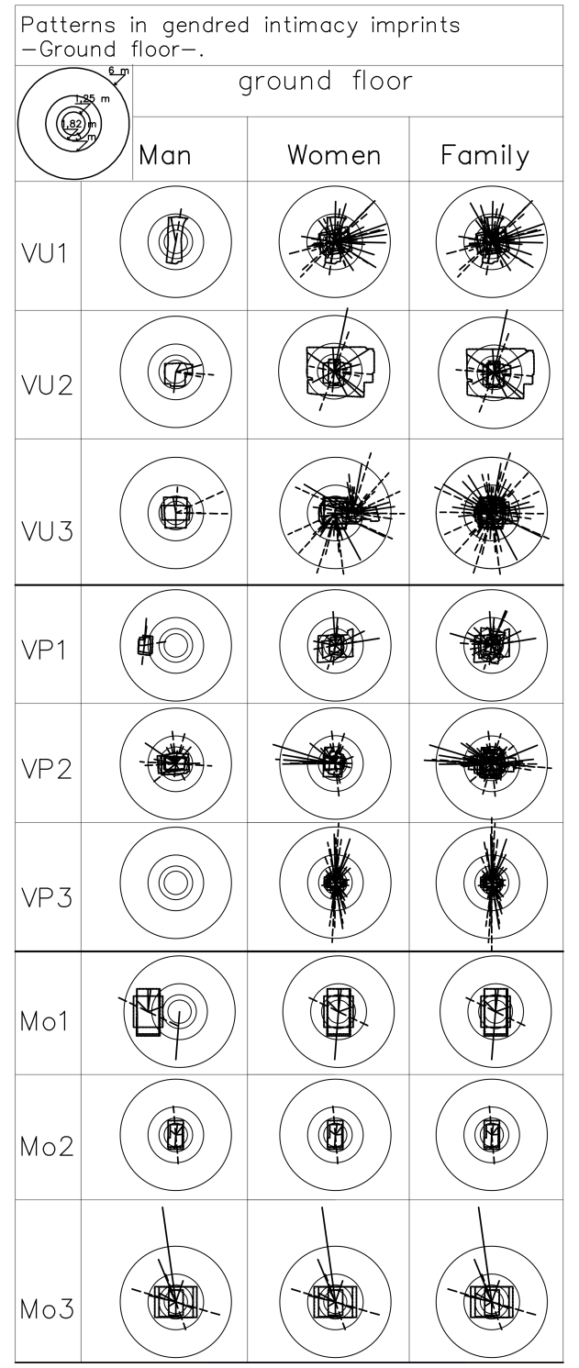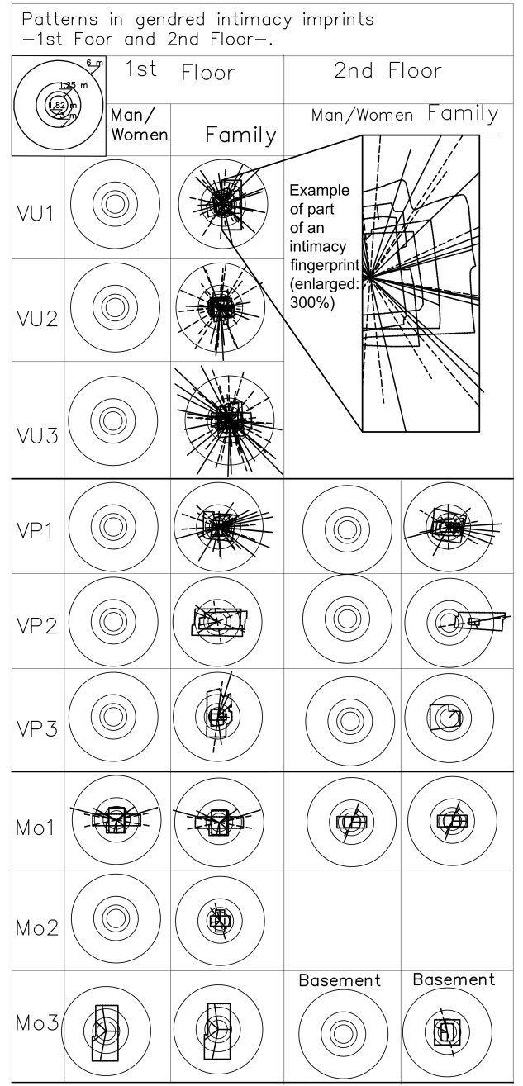

Diagram of visual crossing in the modern and Islamic vernacular habitat

Diagram vector | Threshold vector  -- --- - -- -- | Free space

Figure 10. The conceptual imprint of intimacy and design of dwellings: vector and surface.

- RESULT
Our study shows that family intimacy is an existential concept in all societies. Its definition differs from one design to another. Intimacy is related to spatial aspect in Islamic vernacular design and is related to vector in modern design. It can be defined through the following terms:
- The diversity index according to the same view of Shannon and Weaver:
$$k (x,y)=\sum_{g=1}^{g(x,y)}{(\left({1 \atop x-y}\right)(x,y)log2(x,y)}-g\left(fa\right)log2(fa))$$
When the value is close to 0: the intimacy is vectorial. In our example of Mo1 (ground floor): k=0. So, we are facing a modern case. On the other hand, for VU1 (ground floor): kx= $|$-2,82160537$|$ (men), ($|$-0,44697292$|$ (women), Ky= $|$-2,77292213$|$ (men) and $|$-0,51738324$|$ (women). The existence of an absolute value means a traditional vernacular conception.
- The depth of meeting spaces is gendered. The comparison between gendered depths is primary. There are two possible interpretations: the more significant the depth related to the x and y coordinates, the greater the intimacy of the Islamic vernacular surface is. On the other hand, the more influential the difference between the depths of the two sexes, the greater the Islamic vernacular design is. Less depth means that intimacy is vectorial, and less difference means that we are in a modern conception of intimacy.
- The percentage of meeting spaces compared to other living spaces: Ne= NE meeting/NE Inhabited. The urban Islamic vernacular habitat represents a surface form of intimacy; the modern habitat represents a vector form of intimacy. The relationship between free and living spaces is understood as follows: VU= (ground floor=1; 1,42), (1st floor=1; 1,4); VP= (ground floor=1; 1,42), (1st floor=0,63; 0,4), (2nd floor= 2; 2/0); Mo= (ground floor ( 0,5; 0,5), floor (0,6; 0,5), (^{2nd} floor=1; 0/0).
- The possibilities of diagonal connections are found only in the surface intimacy. It is rare in the conception of vector intimacy.
- The possibilities of connections through openings depend on the number of living spaces. This data is involved in the depths of the meeting spaces and the proportion of the meeting spaces to the living spaces.
Intimacy can be calculated by mathematical values as follows:

Spatial intimacy
InSur_{(kr)}= $\sum_{L=1}^{n}{*Ne*} ((\sum_{k=1}^{n}{\frac{Xk}{X max}}+\sum_{k=1}^{n}{\frac{Yk}{Y max}})*\sum_{k=1}^{n}{\frac{\left({n \atop k}\right)Sk}{S}})$ (1)

Vectorial intimacy
InVec_{(kr)} = $\sum_{L=1}^{n}{*}Ne*((\sum_{k=1}^{n}{\frac{Xk}{X max}}+\sum_{k=1}^{n}{\frac{Yk}{Y max}})$* $\sum_{Ck}^{C1}{ (Cd+Co /Cmax)}$. (2)
Cd: diagonal connection; Co: connection by openings. Ne= NE meeting/NE Inhabited

To calculate the general intimacy in an inhabited system, its singular value is:

Ig_{(kr)}=$\sum_{Gen=n}^{Gen=1}{of}\begin{matrix} \left(Gen1+Gen2+…Gen n\right)for(L1) \\ \left(Gen1+Gen2+…Gen n\right) for \left(L2\right) \\ \left(Gen1+Gen2+…Gen n\right) for \left(Ln\right)\end{matrix}…$ $*$ $|(ISur+IVec)|$
(L= Levels). (Gen= gender).

The two values in equations 1 and 2 give the intimacy footprint and an idea about whether the habitat is Islamic vernacular or modern. If InSur˃InVec, the habitat tends toward the Islamic vernacular; if InVec˃InSur, the habitat tends toward the contemporary habitat.

- CONCLUSION
In the language of modern architecture, dwellings can be interpreted through their designs and the market economy, but in vernacular architecture, dwellings are interpreted through the inhabitants and the context. In the language of modern architecture, dwellings can be analyzed through their designs and the market economy. However, in vernacular architecture, dwellings are interpreted through the inhabitants and the context. The temporal aspect of the spatial relation is also relevant... Since art is not mortal and physically static in its given location, it permanently dwells, while men dwell temporarily, as the builder and the passer-by, and then they dwell in memory and thought.… Heidegger stated that 'thinking' belongs to dwelling in the same sense as building; man dwells in thinking of space and developing spatial ideas [12].
The results of the mathematical analysis of the examples confirm the existence of the genotype aspect in the conception of intimacy in the home. In the habitat design, women, men, and family members have different social behaviors. Each society has its own rules for understanding home. Woman is associated with this space and this intimacy within which the wives can leave the conventions, the conventional hierarchies, to legitimately express their feelings by being on familiar terms [18].
To better define the approach used, this paper shares the vision of Lila Ibrahim-Lamrous and Séveryne Muller concerning the psychological spaces that warrant consideration. The dimensions of intimacy to be studied are territory and personal space, with the exclusivity of the use of space. This space is mastered and materialized by calculating the distances of visual meetings. Logically, intimacy is calculable from its spatial influence on the design of the habitat. The crossing dimensions, the depths of the visual fields of the genders, and the specificity of the family space are also calculable elements in the design. Mathematical understanding explains that the delimitation of visual encounters further complicates the habitat's architecture, giving it a social and typological imprint. This intimacy calculation guided us to another new index for the distinction of housing typology: Islamic vernacular or contemporary modern. The strength of intimacy lies in the relevance of the design of the habitat over time. Intimacy is among the keys to architectural and urban sustainability.
The separation between these spaces is based on gender distinction; everyone knows these spaces and the circulation that must lead to the house. In this sense, we propose the development of software that mathematically decomposes the spaces of habitat for a fingerprint. This software will allow the recomposition to have a vectorial and pixelated plan.

REFERENCES

[1] M. Heidegger, “Building dwelling thinking”, Poetry, language, thought. London: Harper and Row, 1971. p.143-161.
[2] A. Durnová, E. Mohammadi, “Intimacy, home, and emotions in the era of the pandemic”. Revue Sociology Copass, Vol. 15, No. 4, 2021. Doi: https://doi.org/10.1111/soc4.12852
[3] C. Norberg-Schulz, “Heidegger’s Thinking on Architecture”. Perspecta, Vol. 20, p.61-68, 1983. http://www.jstor.org/stable/1567066.
[4] M. El Moussaoui, "Rethinking Heidegger's dwelling through Arabic linguistics,", Journal of Islamic Architecture, vol. 6, no. 2, pp. 127-131, Dec 2020, Doi: http://dx.doi.org/10.18860/jia.v6i2.8454.
[5] C. E. Crowther, G. Stone, Intimacy: Strategies for Successful Relationships, Random House Publishing Group,1988.
[6] J. Pallasmaa, “The concept of Home: An Interdisciplinary View”, Symposium at the University of Trondheim, August 21 -23. 1992.
[7] I. Ibrahim-Lamrous, S. Muller, L’intimité, Presses Univ Blaise Pascal, 2005.
[8] F. Simonet-Tenant, "Pactes d'intimité: Catherine Pozzi et Helen Hessel", Épistolaire. Revue de l'A.I.R.E. , Vol. 33, pp. 193-206, 2007.
[9] J.L., Diaz, B. Diaz, "Le Siècle de l'Intime", Itinéraires. Littérature, textes, cultures. Vol. 4, pp. 117-146, 2009. Doi : https://doi.org/10.4000/itineraires.1052
[10] C. Burton-Jeangros, E. Widmer, C. L. D'Epinay, Interactions familiales et constructions de l'intimité: Hommage à Jean Kellerhals, L'Harmattan, 2007.
[11] G. Tapie, Sociologie de l'habitat contemporain: vivre l'architecture, Parenthèses, 2014.
[12] L. F. O. Valente, L. B. E Silva, “Art Dwells: Heidegger's concept of Dwelling and the Spatial Relations between Architecture and Contemporary Art in two artworks at Instituto Inhotim (brazil)“, Oculum Ensaios, vol. 16, no. 3, pp. 603-621, 2019, DOI: 10.24220/2318-0919v16n3a4087.
[13] L. Colbeau-Justin, B. De Vanssay, "Analyse psychosociologique auprès des sinistrés des inondations de la Somme". Rapport au Ministère de l’Aménagement du territoire et de l’Environnement, 2001.
[14] A. Aviotti, Réduire la vulnérabilité de l’habitat individuel face à l’inondation, Lavoisier, 2014.
[15] C. Forstie, “A new framing for an old sociology of intimacy”, Sociology Compass, Vol. 11, No. 4, 2017. Doi: https://doi.org/10.1111/soc4.12467.
[16] M. A. A. Haleem, The Qur’an. Oxford: Oxford University press, 2005.
[17] P. Boccagni, M. Kusenbach, “For a comparative sociology of home: Relationships, cultures, structures Current Sociology”, Current Sociology, Vol 68, No. 5, pp. 595-606, 2020. Doi: https://doi.org/10.1177/0011392120927776
[18] P. Ariès, G. Duby, Histoire de la vie privée, T. IV. Paris: Seuil, 1987.
[19] R. A. Masters, Emotional Intimacy: A Comprehensive Guide for Connecting With the Power of Your Emotions, Sounds True, 2013.
[20] C. Burton-Jeangros, Interactions familiales et constructions de l'intimité: hommage à Jean Kellerhals, L'Harmattan, 2007.
[21] P. D. Hershock, Liberating Intimacy: Enlightenment and Social Virtuosity in Ch'an Buddhism, SUNY Press, 1996.
[22] A. Milon, L’art de conservation, Paris: PUF, 1999.
[23] J. Panero and M. Zelnik, Human Dimension and Interior Space: A Source Book of Design Reference Standards, New York: Watson-Guptill, 1979. DOI: 10.24220/2318-0919v16n3a4087.
[24] H. J. M. Didillon, C. P. Donnadieu, Habiter le désert, les maisons mozabites. Bruxelles: Pierre Mardaga, 1986.
[25] C. E. Shannon, W. Weaver, Theory mathematical theory of communication. University of Illinois Press, 1949.
[26] P. D. Chaturvedi, Business Communication: Concepts, Cases, and Applications. Pearson Education India, 2011.
[27] T. Schael, Théorie et Pratique du Workflow: Des processus métier renouvelés. Springer Science & Business Media, 1997.
[28] D. Courbet, “Communication médiatique : les apports de la psychologie sociale (Pour une pluralité épistémologique, théorique et méthodologique en SIC HAL, sic 00001493)“, Aix-Marseille University, 2005.
[29] Q. Letesson, “Cadre théorique et méthodologique“, in Du Phénotype au génotype: Analyse de la syntaxe spatiale en architecture minoenne (MMIIIB – MRIB) [en ligne]. Louvain-la-Neuve: Presses universitaires de Louvain, 2009

