 |  | JOURNAL OF ISLAMIC ARCHITECTURE  P-ISSN: 2086-2636 E-ISSN: 2356-4644  Journal Home Page: http://ejournal.uin-malang.ac.id/index.php/JIA
PRINCIPLES OF CALLIGRAPHY PLACEMENT IN ISLAMIC PUBLIC BUILDINGS
Ziad Baydoun^{a*}, Tenku Putri^{b}, Fauzan Mustafa^{b}, Mastura Adamª, Afeerah Farooq^{c}
ªDepartment of Architecture, Faculty of Built Environment, University Malaya, Malaysia
^{b}Faculty of Creative Multimedia, Multimedia University, MMU Cyberjaya, Malaysia
^{c}School of Architecture, Kashmir University, Jammu and Kashmir, India
*Corresponding Author: ziad731@hotmail.com
ARTICLE INFO |  |  | ABSTRACT
Volume: 8  Issue: 2  Page: 356-370  Received: January 22nd, 2024  Accepted: June 1st, 2024  Available Online: December 15th, 2024  DOI: 10.18860/jia.v8i2.25772 |  |  | This study investigates the intricate connection between Islamic calligraphy and the architectural settings in which it is found. Islamic calligraphy is an extremely valued art form in the Islamic world and has historically been found in mosques, madrasas, and other Islamic buildings. Within the interior and exterior spaces of Islamic public buildings, the study gives a qualitative analysis centered on Islamic calligraphy's visual characteristics and placement principles. The study utilized chosen case studies, Al-Hambra in Spain and Al-Azem in Syria, to find and determine relevant visual features. An important understanding of the placement principles and critical visual characteristics of Islamic architectural public structures was obtained from the analytical review of these case studies. Three master calligraphers were interviewed to corroborate these results and add to the body of knowledge regarding the arrangement of Islamic calligraphy in the designated architectural contexts. The findings have important ramifications for using Islamic calligraphy in the architecture and decoration of historically and culturally significant public buildings.  Keywords:  Calligraphy; Islamic Architecture; Mosques; Palaces; Public buildings

- INTRODUCTION
Public buildings are among the most important buildings that each country and civilization gives the most value to. Public buildings are made for public use and belong to a town or state. It also refers to the building made to function as an assembly place, office, education, entertainment, or worship. They are designed to serve the public, and thus, their architecture must meet certain functional, cultural, and aesthetic criteria [1], [2]. In addition to form and some other elements like framework and materials used in a building, the aesthetics of a building also play a key role, as shown in Figure 1. These components must be carefully balanced and integrated to create buildings that serve their intended purpose and reflect a society's cultural, historical, and political context [3], [4]. Public buildings play a significant role in shaping a city's identity and enriching its inhabitants' cultural life. Their architecture must be considered a vital aspect of the cultural heritage of a society [5].
Islamic architecture was developed in the seventh century by the Mohammedans, or followers of the Islamic faith, as a material representation of the teachings of their religion. Its customs are being followed today. The mosque has the most common structure connected to Islamic architecture, which is considered a significant prayer site for Muslims [6]–[8]. Nowadays, having calligraphy in modern Islamic public buildings like mosques is very challenging due to difficulties in its application and the several authorized verifications needed. Unfortunately, those verifications have no clear standard, especially for the calligraphy placement and principles. Due to this difficulty of implementation and missing guidelines, Islamic calligraphy is not easy to use for building decoration nowadays. In addition, Islamic calligraphy is not only a decoration element but also a message with purpose and value [9]–[12].
Islamic public buildings fall into the offices of states, central government buildings or local authorities, and monumental buildings. Since palaces are one of the types of public buildings, palaces are crucial places to present the prosperity of Islam and Muslim civilization through applying calligraphy in combination with art and decoration [13]–[15]. In this regard, monuments encompass various structures, including statues, memorials, historic buildings, archaeological sites, and cultural assets, representing collective social identity [16]. These structures are often considered significant due to their artistic, historical, political, technical, or architectural importance. They may garner public interest for preservation, potentially earning recognition as a UNESCO World Heritage Site. Figure 2 shows the list of public buildings.

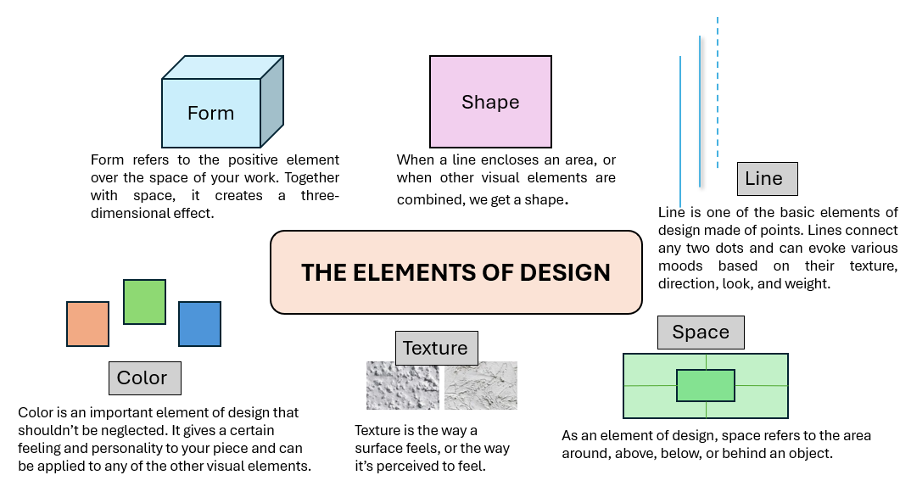

Figure 1. Important architectural elements of a building

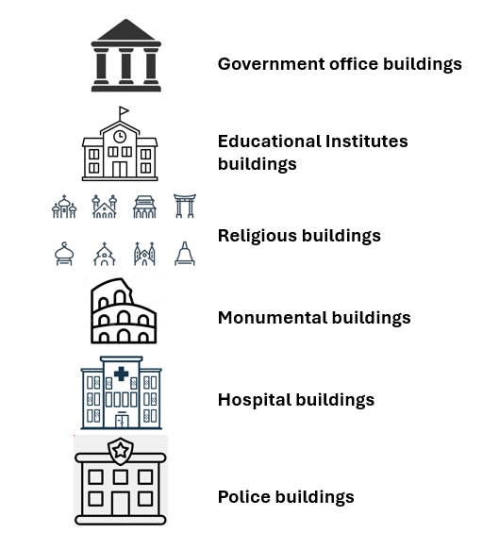

Figure 2. Important public buildings in a society

Monumental art and calligraphy are two distinct forms of visual art used for centuries to create works of great size and impact. Monumental calligraphy refers to calligraphic writing in large-scale, public artworks and architectural structures. The practice of monumental calligraphy has a long and rich history that spans several thousand years and encompasses various cultures and civilizations [17]. In recent years, monumental calligraphy has continued to evolve and adapt to new materials and technologies, with modern artists using computer-aided design tools to create large-scale works that incorporate traditional calligraphic techniques.
Calligraphy is the primary art form of Arabic letters that decorate items ranging from bowls to houses. “Kalligraphía” is the Greek word for Kallos, meaning “beauty,” and Graphos, meaning “writing.” Thus, it means beautiful writing, also known as Calligraphy [18]. Calligraphy is a wide-ranging art representing various dimensions such as styles, scripts, design elements, principles, and attributes. Calligraphy involves both the Arabic language and any other calligraphy that uses Arabic letters. Islamic calligraphy is defined as the artistic application of handwriting and Islamic content. The title Islamic was added to the word calligraphy due to the tremendous development of calligraphy performed by Muslims and the value the Muslim’s religion gave to calligraphy in encrypting the holy book of Muslims - The Quran [19]. Even though Islamic calligraphy is a religious art of writing, it is not limited to strictly religious subjects, objects, or spaces.
Indeed, Islamic calligraphy refers to Arabic calligraphy and the arts generally belonging to the Islamic world [20]. This calligraphy is an attractive text that can contain the wisdom of the Quran or a Quranic verse accompanied by an initial imagination of the calligraphy style with the realization of thought supported by features of linear composition that appear slowly to the spirit and then to the eye [21]. The Ottoman Empire, which ruled from the 14th to the 20th century CE, was the final Islamic empire to impact calligraphy's development significantly. The development of Islamic calligraphy can be traced through the various eras of Islamic history, each of which left a unique imprint on the art form. The development of the Kufic script characterized the early era of Islam. It is one of the earliest Arabic calligraphy styles, dated to the 7th and 10th centuries. It was the primary script for writing the Quran and is still used by artists today. It comes from the Iraqi village of Al-Kufa.
The second era showed the development of the Naskh and Thuluth scripts. Naskh was founded by the Abbasid calligrapher and minister “Ibn Muqla al-Shirazi” at the beginning of the fourth century Hijri, the late 9th century AD. It was derived from the Kufic script. The Thuluth script was first developed in the 11th century during the Abbasid dynasty and was refined by a calligrapher, Seyh Hamdullah, during the Ottoman dynasty. The third era marked the development of the Nastalik script. Nastalik developed in Iran from Naskh beginning in the 13th century and remains widely used in Iran, Afghanistan, India, Pakistan, and other countries for written poetry and as a form of art. Highly decorative and ornamental calligraphic works characterized the fourth era. The fifth era marked the development of new styles and techniques, while traditional calligraphic styles of the past still gave inspiration [22], [23].
The principles in design are essential to ensure that the object achieves a coherent and attractive overall composition. Inconsistent interpretation of the visual attributes and principles of Islamic calligraphy placement results in a lack of coherence and harmony in the design of public spaces, as different designers may have different interpretations of traditional styles and principles [24]. The inconsistent use and misinterpretation of Islamic calligraphy in contemporary public buildings is a major concern for preserving Islamic architecture's traditional cultural and aesthetic values [25]. This results in a lack of cultural representation and identity in modern Islamic architecture, compromising the cultural heritage and values of the Islamic community. The problem calls for a systematic investigation into the visual attributes and principles of Islamic calligraphy placement and the development of a guideline for their implementation in contemporary Islamic public buildings. It is crucial to preserve and promote traditional Islamic art forms in modern architecture.
Although Islamic art and architecture have received much attention over the years, there is not enough research on calligraphy placement in Islamic buildings. The study aims to develop a guideline for placing Islamic calligraphy in public buildings. This study uses a qualitative method because of the importance of getting reliable data from calligraphers and experts, including case studies. The case studies are documented and analyzed to achieve the study's objectives. The authors chose these case studies due to the importance, heritage value, richness of Islamic calligraphy, and the beauty of using Islamic calligraphy in those buildings.

- METHODS
In delving into the rich tapestry of Islamic calligraphy and architecture, qualitative research emerges as a powerful tool for illuminating their depth and nuance. Unlike quantitative methods focusing on numbers and statistics, qualitative research delves into the subjective experiences, interpretations, and meanings held by individuals and communities. This is crucial for understanding how Islamic calligraphy and architecture are perceived, interacted with, and woven into the cultural fabric of Muslim societies. Researchers can gain insights into these art forms' emotional, spiritual, and symbolic dimensions by conducting interviews, observations, and document analysis. To achieve the research objective, which is to determine the Islamic calligraphy styles of scripts in interior and exterior Islamic public buildings, the authors have chosen two case studies from different periods and styles based on various designs of architectural palaces.
The two chosen case studies for this study are Al-Hambra Palace in Granada, Spain, and Al-Azem Palace in Hama, Syria. Al-Hambra and Al-Azem palaces are UNESCO’s World Heritage Sites, exhibiting the most significant and well-known Islamic architecture of their era. The selected buildings are rich with calligraphy as the main decoration element with various styles, framing, backgrounds, colors, and materials. Hence, the chosen palaces are decorated to host the wealthiest people of those eras, like sultans and kings. Having two case studies from different styles and eras helps to make a broad analytical review of calligraphy placement within variable dimensions to develop more universal and reliable guidelines. Both palaces were constructed with a high degree of decorative detail, especially Islamic calligraphy, a distinctive feature of Islamic architecture and design. This demonstrates the exceptional talent of the Andalusian and Ottoman period designers, calligraphers, and architects. In addition, both Al-Hambra and Al-Azem palaces served as public buildings and are well-known for their application of Islamic calligraphy, making them valuable case studies for exploring the role of calligraphy in Islamic architectural design.
The authors analyzed the styles of Islamic calligraphy scripts of Al-Hambra and Al-Azem palaces' selected parts in link with the components and elements to come up with the findings and discussions of categorizing the design principles of Islamic calligraphy specifically. Next, they did a face-to-face interview. It consisted of semi-structured interview questions constructed based on previous research and studies as well as the findings and discussions of the case studies. Three master calligraphers who have experience using Islamic calligraphy in architectural decorations were chosen for the interview. This interview was performed to verify the visual attributes and principles of Islamic calligraphy placement. Figure 3 shows the methodology used.

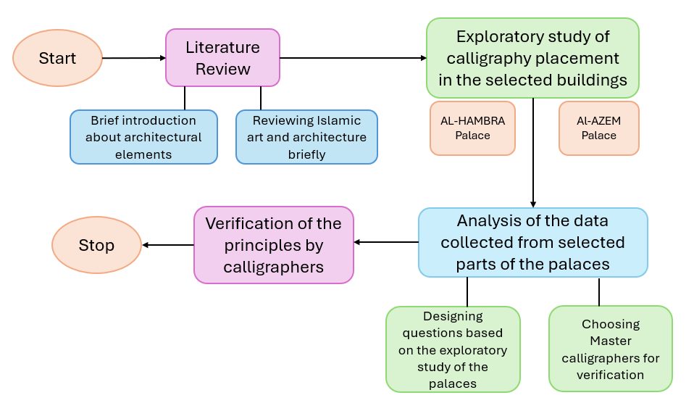

Figure 3. Flow chart of the overall methodology

  - CASE STUDY
Case studies are common research methods employed in academic research that provide detailed insights into a particular phenomenon, program, or situation. There are several types of case studies, including exploratory, descriptive, explanatory, evaluation, intrinsic, instrumental, and collective. The authors selected two specific palaces. In this study, they conducted an exploratory case study of two crucial buildings, Al-hambra in Spain and Al-Azem in Syria. These palaces were picked because they embody different Islamic architecture and calligraphy eras. The Al-hambra Palace is the start of the Islamic caliphate, and Al-Azem is the end of Islamic calligraphy.
Furthermore, the authors considered the palaces' categorization, which was decided by UNESCO and other heritage organizations. The Al-hambra Palace was selected as an Umayyad palace due to its early representation of Islamic calligraphy. On the other hand, the Al-Azem Palace represents the Ottoman era. The Al-Azem Palace in Damascus was erected in the 18th century as a dwelling for the governor of Damascus, exhibiting a Baroque architectural style that fused European elements with traditional Islamic styles.
It is crucial to note that the authors are aware that the two palaces, Al-hambra and Al-Azem, are distinct in terms of construction, era, and materials. However, the authors are not comparing the two palaces but aim to extract data from each palace to build upon an understanding of the architectural components of palaces turned into museums. These palaces hold essential cultural and historical significance, and their role in conveying cultural and political information to the public cannot be underestimated. The results of this study will contribute to the ongoing academic discussion surrounding the study of historical buildings and their significance [26].
Al-Azem Palace in Hama is particularly noteworthy, as it is one of the most beautiful monuments in the world. Overlooking the Orontes River, it is noticeable that this palace is decorated with stunning inscriptions that have captivated Arab and Western poets alike. This building is a prime example of the art of calligraphy in monumental architecture. It demonstrates the beauty and skill that can be achieved through the integration of calligraphy into the design of a building. There are two well-known Al-Azem Palaces in Syria: one in Damascus and one in Hama. Although both palaces share the same name and are located in Syria, they have distinct differences in history, architecture, and decoration [27]. The palace boasts impressive decorations, including intricate stone carvings, elaborate stonework, and vibrant tiles. At the same time, the Al-Azem Palace in Hama, also built in the 18th century as a residence for the governor of Hama, showcases a traditional Ottoman architectural style incorporating elements of Ottoman and Islamic architecture. It is renowned for its intricate calligraphy and inscriptions, considered among the finest examples of Islamic calligraphy. Al-Azem Palaces in Damascus and Hama are important examples of Islamic architecture and decoration, but each has its unique style and characteristics that set it apart [28].
The Al-Hambra, situated in Granada, is a complex of palaces and fortifications. Inside a city, it is surrounded by a wall of about 1,730 meters (1 mile). This castle was initially built in 889 AD on the ruins of Roman fortifications. It remained largely unused for hundreds of years until it was rebuilt by the Nasrid emir Mohammed ben al-Ahmar in the late 13th century. Nasrid’s additions to the castle included the construction of the current palace and its walls including the rich decoration [29]. The building was constructed in 1333 as a royal residence by Yusuf I, the sultan of Granada with rich calligraphy decoration on the walls. Charles I and V commissioned a magnificent Renaissance palace in direct contrast to the Nasrid Andalusian architecture that is distinguished by its rich decoration. The remaining Muslim emirs (leaders) in Spain constructed the Al-Hambra to stay relevant as the Nasrid dynasty, a strong Islamic dynasty. At the same time, the rule of Christianity fell apart [30]. The Al-Hambra architectural ensemble is one of Spain's top showcasing Islamic construction works from the 16th to the 20th centuries and other earlier Christian buildings, as well as garden initiatives. Al-Hambra has been cited as a significant influence in everything from paintings to tales. The elegance and exquisite flavor of the last Spanish-Moorish kings of Al-Andalus, Nazari, are contained inside its rich calligraphy decoration on the walls’ components [31]. Table 1 shows the details of building studies.

Table 1. The monuments chosen for the case study
S.No | Building | Country
1. | The Al-Hambra Palace | Granda Spain
2. | The Al-Azem Palace | Hama Syria

  - INTERVIEWS WITH MASTER CALLIGRAPHERS
This study seeks detailed information about calligraphy from the three selected calligraphers. The calligraphers will be called X, Y, and Z in this article for convenience. By conducting a face-to-face interview, the researcher can verify the data and gain more knowledge about calligraphy from experienced master calligraphers who are well-known for their calligraphy skillfulness. There are several criteria that the selected calligraphers as interviewees should have to fulfill the study objectives. The first criterion is to have an architectural background to use architectural terms and language to answer the questions of the study.
Moreover, the chosen calligraphers must be well-known and famous, proving their successful experience and knowledge. The calligraphers should be able to write several calligraphy styles, which also helps cater to comparative skills and critical thinking. Furthermore, having an academic teaching background is essential for each chosen calligrapher to have the ability to use the scholastic method of describing the architectural elements, attributes, and principles of design. Thus, each calligrapher must deeply understand the history of calligraphy, including its origin and development.
This type of interview is conducted with Master calligraphers to verify the principles of calligraphy application in building decoration. The authors chose the face-to-face semi-structured interview to collect the essential data by answering several questions. The answers were written in Arabic first, which is the mother tongue of the selected calligraphers. Later, the answers are gathered and translated into English. Interviewing professional Islamic calligraphers determines the style of scripts in Islamic calligraphy. Also, it verifies the visual attributes and principles of Islamic calligraphy placement that can be used in the interior and exterior spaces of Islamic buildings to sustain the Islamic identity of the Islamic cities.
While collecting textual information from experienced professional calligraphers, the authors also show a pictorial illustration to help the calligraphers answer the questions based on the authors’ analytical review. The interview questions include an extensive set of Islamic calligraphy discussions, giving the chance to explain the style and the scripts, with their different ornamental designs and their applications in buildings based on the calligraphers’ perspectives. Hence, the focuses more on the principles of calligraphy found through the analytical review of the case studies. Master calligraphers explain the calligraphy application rule of thumbs based on their experience in the work field. The stages of interview research are summarized and illustrated with three main headings: data collection, analysis of textual data, and evaluation of data, as shown in Figure 3. Open-ended questions support the semi-structured interview with the calligraphers, followed by their life and experience background. Figure 4 shows the procedure of interviews.


Figure 4. The stages of interview research

While the calligraphers are Arabs of different regions, the language used in the interview is Arabic in different dialects. These different Arabic dialects are translated into the formal Arabic language before translating the Arabic texts into English to ease the process of textual data analysis. The textual data is arranged into meaningful sentences by categorizing it appropriately. The authors translated the questions into Arabic to ease the interview process since the interviewees are Arabs. The interview questions used as the interview guide are divided into several sections. Each section has several specific questions. The research questions are formulated to verify and establish findings from the inspection of the chosen buildings. All these questions were straightforward and attached to the visual template, which helped the interviewees to provide their responses smoothly.

- RESULT AND DISCUSSION
Al-Hambra and al-Azem Palace display a wealth of components with Islamic calligraphy, including the wall's upper part, decoration related to openings, and the ceiling decoration panel group. This study covers all the calligraphy inscriptions in the chosen sections of Al-Hambra and Al-Azem Palace. It discovered various calligraphy components in the decoration of Al-Azem Palace in Hamah, Syria, and Al-Hambra Palace in Cordoba, Spain.

- AL-HAMBRA
The walls of Al-Hambra are full of Arabic calligraphy in Naskh and Kufic inscriptions that adorn the walls of this palace. It is full of unique symbolic, aesthetic, and intellectual dimensions through its inscriptions, motifs, and geometric designs created by the great artists of the Islamic State in Andalusia. Al-Hambra Palace is a very rich palace with decoration using words and letters; the richness of calligraphy as the main decoration on the walls’ components reflects the power of the Muslim Nasrid dynasty in the early times. This study includes the calligraphy components placed in Al-Hambra Palace in the Mexuar Palace chosen sections. Only two sections of the Alhambra Palace, specifically the Mexuar Palace and the Court of the Golden Room, were selected for study, given the immense size and vastness of the entire Alhambra complex. The reason for choosing these halls is the rich calligraphy placement in their decoration, which is the primary element of the palace decoration. The division of each hall is based on the names. Table 2 describes the selected halls in Al-Hambra Palace, which were chosen to analyze the calligraphy placement in the interior and exterior spaces of the palace decoration.

Table 2. The halls and courts of Al-Hambra Palace
S.No |  | Space | Hall | Function
1. | The Mexuar Palace | Interior | The Mexuar Hall: council meeting hall | Business and traditional meetings
2. | The Mexuar Palace | Exterior | The Court of The Golden Room | Entrance:
 | The Mexuar Palace |  |  | It forms the transition from the public area to the semi-public residence

- 1. The Placement of Calligraphy in the Mexuar Hall: Council Meeting Hall
Maexur is the hall that Mohammad the Fifth built for his throne. After he had gained control, the hall dome was demolished to create a room for the Izabel on the upper floor. The Mexuar Iwan (إيوان) was connected to the Iwan (إيوان) used for the law matters. Alicato is applied to walls aged to the 16th century, and the upper part is called the chair rail. The Arabic inscriptions the three repeated sentences to glorify Allah, which are:
(العزة لله، القدرة لله، الملك لله، الله عدة لكل شدة)
That means “Glory Is to Allah, Power Is to Allah, and Properties Are to Allah”. Allah is the most powerful for every severity, inscribed in Andalusian Naskh, a particular calligraphy style for the Andalusia region. These three sentences are placed on the linear Chair rail in a repetitive form along the four walls of the Mexuar hall. Poems and quotations decorate the walls, and the phrase “There Is No Victorious, but Allah” can be seen throughout the palace surroundings. The decoration, as shown in Figure 5, symbolizes the complexity of the infinite universe and nature, with an ultimate balance in math and art using the principles of tessellation in the overall design, which are repetition, unity, symmetry, and balance, filling all the gaps of the surface.

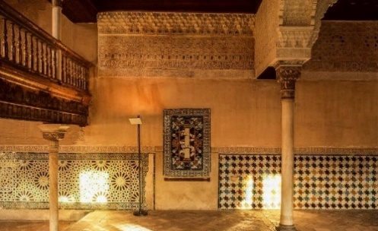

Figure 5. The Maexur interior [Source: VR360]

The four columns in this hall carry Arabic calligraphy, the famous motto of Nasrid, inscribed in Andalusian Naskh on the column capital and architrave part with a blue background, as shown in Figure 6. In contrast, the motto “No Victorious but Allah” is inscribed on the lowest part of Muqarnas, on a hanging decoration in non-framed Knotted Kufic calligraphy in a harmonious mixture of foliate decoration.

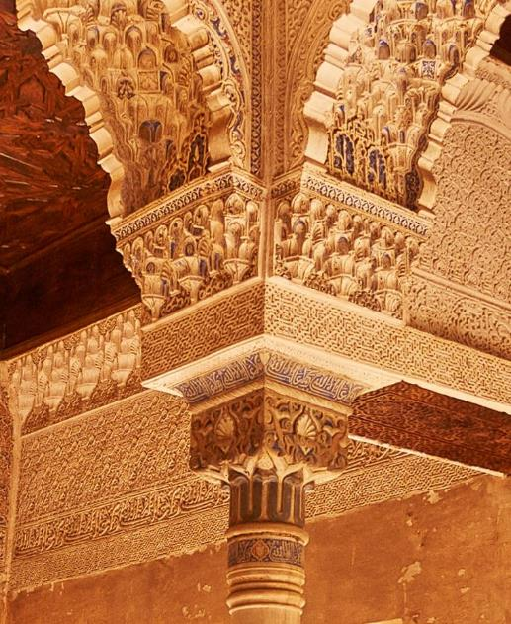

Figure 6. Calligraphy at Maexur Column capital (CC) [Source: VR360]

The picture rail is framed with the composite shape of one rectangle and two semicircles, and the calligraphy style is Naskh calligraphy of the Quran Verses. As shown in Figure 7, the structural beams that connect the four hall columns are fully decorated with Arabic calligraphy in several forms on the two sides. The middle central part of the beams has repeated sentences glorifying Allah. In contrast, the lower and upper surrounding parts have repeated sentences glorifying the sultan. The inscribed calligraphy on the cornice and the extended rectangular wall panel applies the Naskh style. Moreover, the knotted repeated Kufic style contained Zikir (ذكر) of Allah to fill the gaps within the decorated walls.

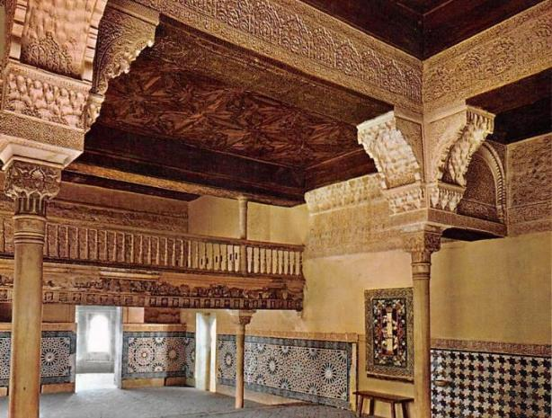

Figure 7: Repeated Kufic Style on the Beam (BS) [Source: VR360]

- 2. The Placement of Calligraphy at the Court of the Golden Room
The court of the golden room is an open yard that functions as a transitional space from the public area to the private residence. The two exterior walls are richly decorated with calligraphy, geometrical, and floral patterns. The twin doors at wall one are designed to confuse the invaders. The door on the right side is blocked, while the other door leads to the center of the palace. Since the decoration is applied on the exterior façade, the calligraphy inscriptions are placed linearly with a perfectly symmetrical organization, the Upper Cornice, located directly under the overhang. It contains the Zikir (ذكر) of the name of Allah in a repeated horizontal rectangular unframed calligraphy in the form of wood carving.
In the next level, Lower Cornice, the Andalusian Naskh is also carved on a linear strip wooden panel in an unframed form of the complex Knotted Kufic of the repeated horizontal rectangular-shaped sentence of continuous happiness. It is followed by religious poetry about Allah in the composite shape of one rectangle and two semicircles. Having Muqarnas on the wall creates a gradual and harmonious continuation between the cornice and the flat wall surface, carrying the Nasrid logo continuously over the wall with the Nasrid motto in an angular shape.
Directly under the Muqarnas, the motto “No Victory but Allah” is spread on the right and left sides. At the same time, the sentence of continuous happiness centralizes the wall inscribed in foliated knotted Kufic style. The motto is placed without frame, in a rotary repeated single image composition and a tiny Nasrid logo put in the middle. There are two twin windows in the upper wall of similar sizes and casings of vertical and horizontal rectangular inscription frames. This inscription is the Nasrid motto inscribed repeatedly in the Andalusian Naskh.
The lower part of the window is also decorated horizontally with the same calligraphy pattern, creating unity and harmony. The small central window casing is placed in a horizontal and vertically rectangular position, carrying the most sacred word, Allah's word. The placement of the verse of the throne on the central window, the false arch of the entrance, refers to the religious value and the strong connection between man and the creator.
In the next lower wall panel, a repeated Nasrid logo containing the tiny angular motto in Naskh calligraphy is used as a central point of a repeated circular pattern along with the foliated, richly decorated panel. The Nasrid motto “No Victory but Allah” is also used in framed knotted Kufic calligraphy in a horizontal linear placement dividing the wall infills. It is placed horizontally and vertically, maintaining its base to the door’s centers. Figure 8 shows calligraphy placement at the entrance of the court of the golden room.

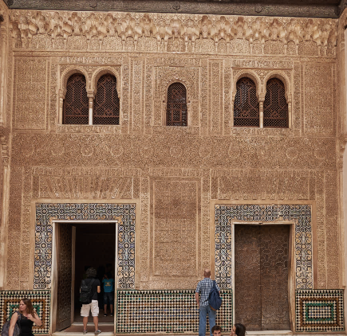

Figure 8. Calligraphy Placement at The Entrance of The Court of The Golden Room [Source: VR360, 2021]

Ayat al Kursi is placed at the central window, representing Al-Hambra as a piece of paradise on earth. The facing façade, wall four, is designed in two arches with a larger and higher arch in the middle, standing on two slim marble columns. The upper part of the façade is plain concrete, starting with a lower cornice decorated panel with two horizontally rectangular Naskh panels of the Nasrid motto in a continuous vertical rectangular alignment along the false window arch. In contrast, the central arch is decorated similarly with a different style of calligraphy and content like Zikir (ذكر) (Glorifying Allah - to praise Allah for blessing humanity with the religion of Islam). On the column’s capitals, an inscription of a circle chain with an eight-pointed star framed calligraphy of the sentence “There Is No God but Allah” can be seen, fulfilling the direct message of Islam as a religion of the palace owner. The word Yumn (يمن) is inscribed in a symmetrical mirror shape with a direct mix with the tawhid pattern in a very intricated and beautiful composition.
It was found that calligraphy placement was applied on various components found in the exterior and interior spaces in almost similar ways. The chair rail component was found in all seven spaces. Chair rail was found in all rooms because of its importance as the lowest component in height where the calligraphy placement exists. The calligraphy placement is richly distributed along the walls and cornices, from the dado level to the highest ceiling point. It was found that the most significant and heaviest amount of calligraphy is found on the wall panels component in the Al-Hambra palace, which contains an interlaced repetition of calligraphy placement. It was found that both Kufic and Andalusian Naskh are the main calligraphy styles of Al-Hambra in different forms, sizes, and compositions. The two styles are found in all halls.
Moreover, three calligraphy contents were found: Descriptive Poetry, Zikir (ذكر), and logos in all rooms of Al-Hambra palace. The Nasrid motto, “There Is No Victory, but Allah”, carries dual functions: Zikir (ذكر) and logo. The compositional category is mainly repeated Horizontal organization with rich, complex patterns. Furthermore, the material used plasterwork and wood in the interior spaces, with the minimum usage of wood, marble, and ceramic in the exterior spaces. Calligraphy placement on the plasterwork material was made due to its familiarity and spread. At the same time, the frames are mostly decorated with various compositions and forms of 2D forms, 3D medium relief, and 3D high relief. It was found that unframed calligraphy was richly found in most of the rooms, which reflects the richness of the calligraphy placement in building decoration.

- AL-AZEM
Al-Azem palace is a crucial case study illustrating Arabic calligraphy decoration elements in interior design. ‘‘Ajami” (عجمي) interior decoration is an Islamic design that existed in the Ottoman period, and it is a perfect sample using all the Islamic elements related to decoration.
Arabic calligraphy is a crucial element in the essential Syrian monuments where they spend most of their houses. The first case study is the Al-Azem Palace in Hamah, Syria, named its patron. As'ad Basha al-Azem is the Ottoman governor of the region, who resided there until being transferred to Damascus. This palace is called the older brother of the Al-Azem Palace of Damascus since it was built before the one in Damascus. It is one of the UNESCO sites from 1979 AD [32]
This study analyses the Rawaq entrance and the North side of the palace, including the North Tazar and North Shurfa. The Rawaq is the entrance to the main hall, and the Tazar is the primary public area where the sultan used to host his guests. North Shurfa is the last part of the North side. These are chosen to get a good idea of interior and exterior calligraphy patterns. Table 3 shows the details of the areas selected for this study.

Table 3. Detail of the selected areas
S.No | Space | Hall Name | Function
1 | Exterior | Rawaq (رواق) entrance | The main entrance to the golden hall faces the upper open courtyard
2 | Interior | North Tazar (طزر) | The primary public selamlik area where the sultan used to host his guests
3 | Interior | North Shurfa (شرفة) | The last part of the North side, where the walls and the high and low windows face the river

At the North entrance of the palace on the first floor, there are a few calligraphy inscriptions on the marble in response to natural factors and climate changes, especially since Syria has seasonal weather, four seasons per year. The inscribed writings are (a) Allah SWT, (b) Muhammad, and (c) Masha Allah, as shown in Figure 9, which are placed on a keystone, highlighting the importance of mentioning the name of Allah the Almighty before entering the hall, as well as confirming the strength of Islam being a keystone of the arch and the controller of its stability. The calligraphy style used is Thuluth, which is more flexible to the radial frame arrangement.

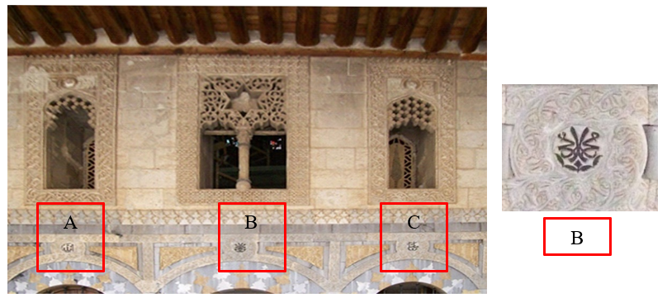

Figure 9. Marble Thuluth inscription from left to right accordingly (a) Allah, (b) Muhammad, (c) Masha Allah
The North Tazar (طزر) is the wing that faces the visitor when entering the Golden Hall. Due to that, calligraphy placement got special treatment, as did the quality of the material. As shown in Figure 10, the Tazar (طزر) is designed to create a clear vision using symmetrical and balanced principles.

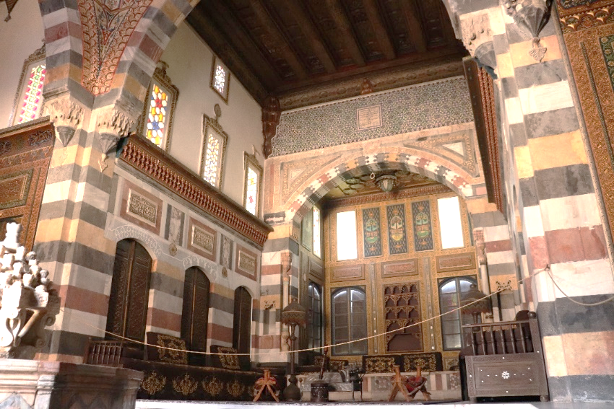

Figure 10. The North Tazar (طزر) of Al-Azem Palace [Source: VR360]

The engraving on the marble varies in types and styles because it is rooted in the Mamluk time and developed in the Ottoman time to reach its peak by the Syrian artisans. As shown in figure 11, 12, 13, and 14, the content of the marble carving in Al-Azem palace is mostly Hadith (حديث) and sacred religious content. The inscription on the mortar is applied without color or covered with golden paint in some parts. The inscription is painted in gold and surrounded by a golden frame, followed by white marble.

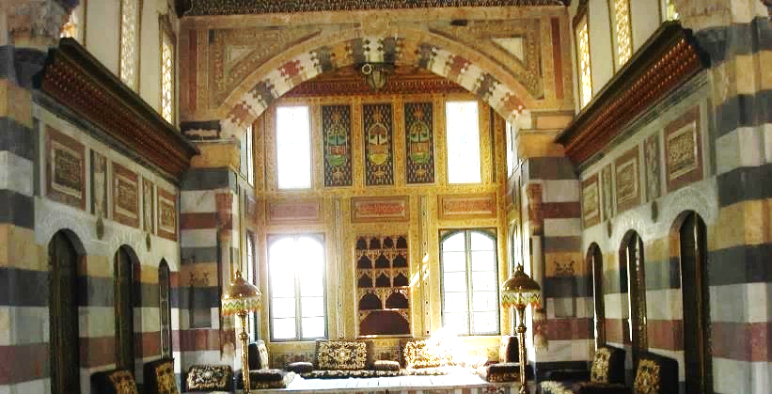

Figure 11. The Symmetrical Placement of The Marble Rectangular Horizontal Panels

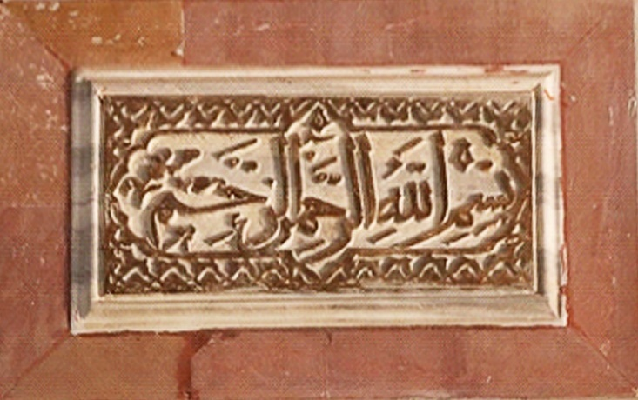

Figure 12. Basmalah (بسملة) Calligraphy on Marble Panel

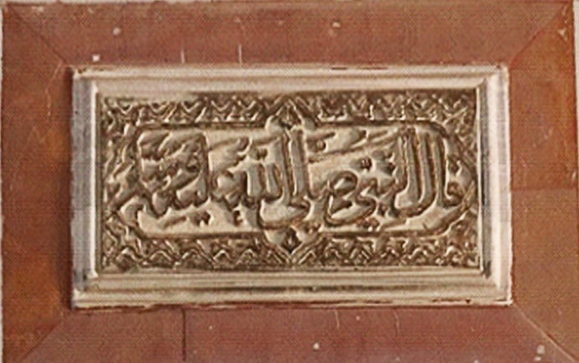

Figure 13. Hadith (حديث) of The Prophet (The Prophet Said)

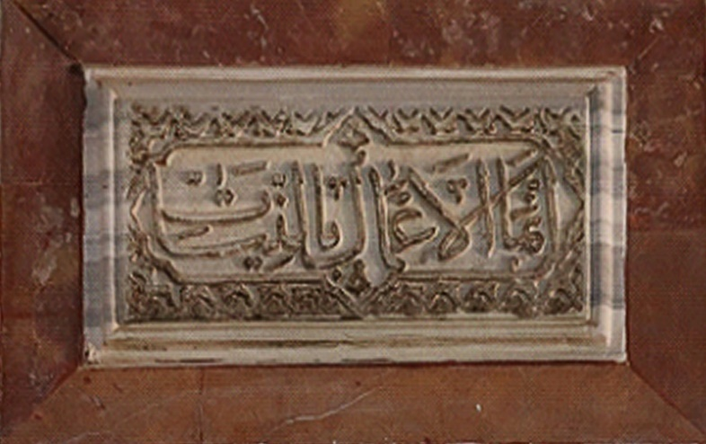

Figure 14. Hadith (حديث) of The Prophet (But Every Person Has What He Intended)

The calligraphy’s role as a decorating element at the North Tazar (طزر) is essential, while the ornamentation is minimal. As shown in Figures 12, 13, and 14, the calligraphy contents are Basmalah (بسملة) and Hadith (حديث) of the Prophet Muhammad saying using Thuluth calligraphy stating that acts are judged by what we meant to accomplish them:
Every person has what he intended. Worship God as if you see Him. If you do not see him, He sees you.
بسم الله الرحمن الرحيم: قال النبي صلى
الله عليه وسلم: إنما الأعمال بالنيات
وإنما لكل امرئ ما نوى. اعبد الله كأنك تراه
فإن لم تكن تراه فإنه يراك

- VERIFICATION FROM CALLIGRAPHERS
Based on detailed exploratory research of parts of the two buildings, the authors found a few essential visual and principal attributes of calligraphy in Islamic public buildings. These attributes include purposefulness, spiritual and moral emphasis in calligraphy, calligraphy placement and calligraphy framing. These attributes represent a vital part of the formulation of calligraphy in Islamic buildings. The results and findings from the interview were primarily derived from verifying the attributes and principles that come from the analysis of Al-Hambra and Al-Azem palace by interviewing three master calligraphers. The three master calligraphers provided important information and expertly verified the findings of the analytical reviews. Each calligrapher provided corresponding ideas and information related to the research theme apart from offering their verification. The pictorial supporting images of the interview questions were an effective solution to give a clear understanding to the master calligraphers. It helped them provide direct and profound answers and verifications of the questions. A detailed discussion of the selected parameters can be found in the following sections.

- 1. Purposefulness
The first principle is purposefulness and meaningfulness. The authors asked the three calligraphers four questions regarding this principle. Purposefulness means that each component of Islamic calligraphy is positioned for a specific reason. When asked about the purposefulness of the calligraphy, the calligraphers mostly agreed with the statement that calligraphy is a beautification element that glorifies the creator. Table 4 shows the responses where X, Y, and Z represent the calligraphers, I stands for agree, and 0 stands for disagree.

Table 4. Calligrapher’s Verification on Principle of Purposefulness in Calligraphy Placement
S.No | Purposefulness | Calligrapher’s response
S.No | Purposefulness | X | Y | Z
1 | Calligraphy is a complementary element to the other beautification elements. | I | I | I
2 | Calligraphy gives speciality to the place in terms of name, date, and historical facts. | I | I | 0
3 | Calligraphy glorifies Allah and describes the place and the owner of the place beautifully. | I | 0 | I
4 | There is a linkage between the function of calligraphy and the spatial arrangement of the place. | I | I | I

- 2. Spiritual and Moral emphasis
Another essential principle of calligraphy encompasses spiritual and moral emphasis. This principle stands for calligraphy content that should not contradict the Islamic faith and Sharia. The calligraphers were given four statements on this principle. The three calligraphers agreed that calligraphy has wisdom, quotes, and Hadith (حديث) that carry ethical value. They believe the limitations of Islamic Sharia are the best guidance for choosing calligraphy content. Table 5 shows the responses where X, Y, and Z represent the calligraphers, I stands for agree, and 0 stands for disagree.

Table 5. Calligrapher’s Validation on Spirituality and Morality Emphasis in Calligraphy Placement
S.No | Spiritual and Moral Emphasis | Calligrapher’s response
S.No | Spiritual and Moral Emphasis | X | Y | Z
1 | Each calligraphy has a sacred message from Allah | I | 0 | I
2 | Calligraphy has wisdom, quote, and Hadith (حديث) that carry ethical value | I | I | I
3 | The limitations of Islamic Sharia are the best guidance for calligraphy content choice. | I | I | I
4 | Each calligraphy has beneficial and meaningful contents and a spatial arrangement of the place. | I | 0 | I

- 3. Placement
The calligraphers were interviewed about the visual aspects and placement of verses in calligraphy. The calligraphers agreed that Quran verses, such as Ceiling and cornice, are always higher due to Allah's holiness and word. The prophet's words follow the word of Allah but are lower than it, which makes it at a lower level. The importance of this arrangement is to follow the rules of Islam in glorifying Allah and his messenger and the ethical and social values. Thus, three calligraphers agreed that the more content of the holiness found, the higher the placement is, which means the placement of calligraphy and the arrangement of its contents reflects the Islamic value of the decorated place owner. Table 6 shows the responses where X, Y, and Z represent the calligraphers, and I and 0 stand for agree and disagree, respectively.

Table 6. Calligrapher’s Verification on Hierarchy of Calligraphy Placement
S.No | Placement | Calligrapher’s response
S.No | Placement | X | Y | Z
1 | The placement of Quranic verses is always at the highest level: the dome top, ceiling (C), and cornice. | I | I | I
2 | The Hadith (حديث) content of calligraphy is lower than Quranic content in a higher position. | I | I | I
3 | The words of ordinary people, like wisdom and poetry, are always lower than Hadith (حديث) and Quran contents. | I | I | I

- FRAMEWORK
Calligraphy is bordered by a decorative frame. The calligraphers stated that calligraphy can sometimes be written without a frame, proving that calligraphy can fill the void like decoration. The framed Kufic is an earlier shape of Kufi found in the early civilization of Al-Andalus that lasted for centuries. Clarity is the secret of success in any calligraphy. It makes it readable and easy to read. The calligraphers agree that the Nastalik is in moderate background decoration. The calligraphy in the last is complex and hard to read. Table 7 shows the response of calligraphers from the placement point of view where X, Y, and Z represent the calligraphers, I stands for agree, and 0 stands for disagree.

Table 7. Calligrapher’s Verification on Calligraphy Frame as A Visual Attribute of Calligraphy Placement
S.No | Framework | Calligrapher’s response
S.No | Framework | X | Y | Z
1 | The frame that surrounds the calligraphy is an added value to it | I | I | I
2 | The non-framed calligraphy is more intricated | I | I | I
3 | Framed calligraphy is the more straightforward form of calligraphy | I | I | I
4 | The non-framed calligraphy is not easy to read | I | I | I

- CONCLUSION
In conclusion, the preliminary investigation into the Al-hambra in Spain and Al-Azem in Syria has yielded a significant understanding of the calligraphy placement principles in both historic places. Through targeted concentration and examination of factors like calligraphy's purpose, spirituality, arrangement, and framing, a sophisticated comprehension of its importance within architectural aesthetics surfaced. The results were confirmed by interviewing knowledgeable and proficient calligraphers who validated these concepts. The calligraphers' united assertion that calligraphy complements other beautifying components highlights the calligraphers' essential role in enhancing the palaces' overall visual attractiveness. The calligraphers recognized the ethical value inherent in calligraphy, which is expressed through quotations, wisdom, and Hadith. Significantly, arranging Quranic passages at the highest points became customary—the cornice, ceiling, and dome top. This deliberate placement illustrates the respect given to the Quran content, while the Hadith material is placed above common proverbs and poetry. The calligraphers' insightful comments about the significance of frames improve our comprehension of calligraphy's complexities. The idea that framed calligraphy is more complex than unframed calligraphy implies that the frame is not only a protective element but also an aesthetic aspect that enhances the relevance of the content that has been inscribed. Essentially, this study adds to the larger conversation on calligraphy's incorporation into architectural settings by highlighting its intentional arrangement, spiritual value, and the role that framing plays in amplifying its visual impact. These ideas get credibility from the endorsement of expert calligraphers, thus strengthening their base for future research and implementation in architecture, art, and cultural property conservation.

ACKNOWLEDGEMENT
The authors thank the Faculty of Creative Multimedia, CISDAC Center, Multimedia University Malaysia for supporting this article. The authors would like to extend heartfelt thankfulness towards the master calligraphers, Mohamed Adli Qabil, Muhammad Ghannoum, and Ibrahim Khalil Abo Touq for their valuable time and insights. The authors would also like to thank Dr. Azila Bt. Ahmad Sarkawi for her guidance throughout the research.

REFERENCES
[1] A. Capozzoli, F. Corno, V. Corrado, and A. Gorrino, “The Overall Architecture of a Decision Support System for Public Buildings,” Energy Procedia, vol. 78, pp. 2196–2201, Nov. 2015, doi: 10.1016/J.EGYPRO.2015.11.318.
[2] G. Semprini et al., “Energy management in public institutional and educational buildings: The case of the school of engineering and architecture in Bologna,” Energy Build., vol. 126, pp. 365–374, Aug. 2016, doi: 10.1016/J.ENBUILD.2016.05.009.
[3] D. E. Ighravwe and S. A. Oke, “A multi-criteria decision-making framework for selecting a suitable maintenance strategy for public buildings using sustainability criteria,” J. Build. Eng., vol. 24, p. 100753, Jul. 2019, doi: 10.1016/J.JOBE.2019.100753.
[4] F. Ardente, M. Beccali, M. Cellura, and M. Mistretta, “Energy and environmental benefits in public buildings as a result of retrofit actions,” Renew. Sustain. Energy Rev., vol. 15, no. 1, pp. 460–470, Jan. 2011, doi: 10.1016/J.RSER.2010.09.022.
[5] G. Herruzo-Domínguez, J. Aladro-Prieto, J. R.-P.- Architecture, and undefined 2024, “Analysis of Touristification Processes in Historic Town Centers: The City of Seville,” mdpi.com, 2023, doi: 10.3390/architecture4010003.
[6] A. M. El-Shorbagy, “Women in Islamic architecture: towards acknowledging their role in the development of Islamic civilization,” Cogent Arts Humanit., vol. 7, no. 1, Jan. 2020, doi: 10.1080/23311983.2020.1741984.
[7] S. Akkach, “Neo-Eurocentrism and Science: Implications for the Historiography of Islamic Art and Architecture,” 2021, doi: 10.1386/ijia_00040_1.

[8] H. Kamelnia, “Theory of Community Architecture in Contemporary Islamic Architecture Assessing different typologies of CA based on ‘Architect-User,’” Ferdows Art, vol. 1, no. 1, pp. 70–86, Aug. 2020, doi: 10.30508/FHJA.2020.44654.
[9] A. A. Ahmad, “Contemporary Islamic Calligraphy Learning,” pp. 232–236, Feb. 2021, doi: 10.2991/ASSEHR.K.210203.049.
[10] Q. Bai, “Calligraphy,” A Companion to Chinese Art, pp. 312–328, Jan. 2015, doi: 10.1002/9781118885215.CH15.
[11] H. S. R. Kao, M. Xu, and T. T. Kao, “Calligraphy, Psychology and the Confucian Literati Personality,” Psychol. Dev. Soc. J., vol. 33, no. 1, pp. 54–72, Mar. 2021, doi: 10.1177/0971333621990449/ASSET/IMAGES/LARGE/10.1177_0971333621990449-FIG4.JPEG.
[12] D. M. Alashari, A. R. Hamzah, and N. Marni, “Islamic Art and Language as a Source of Inspiration Leading to Traditional Arabic Calligraphy Art Article history,” 2019, Accessed: Jan. 09, 2024. [Online]. Available: http://jurnalumran.utm.my/index.php/umran.
[13] N. Göle, “Snapshots of Islamic modernities,” Mult. Mod., pp. 91–118, Sep. 2017, doi: 10.4324/9781315124872-4/SNAPSHOTS-ISLAMIC-MODERNITIES-NIL.
[14] A. Tahiri Jouti, “An integrated approach for building sustainable Islamic social finance ecosystems,” ISRA Int. J. Islam. Finance., vol. 11, no. 2, pp. 246–266, Dec. 2019, doi: 10.1108/IJIF-10-2018-0118/FULL/PDF.
[15] I. M. (Ira M. Lapidus, “Middle Eastern cities : a symposium on ancient, Islamic, and contemporary Middle Eastern urbanism,” Accessed: Jan. 09, 2024. [Online]. Available: https://books.google.com/books/about/Middle_Eastern_Cities.html?id=4Xd2EAAAQBAJ.
[16] T. Zaninović, N. Omićević, B. B. O. Š.- Architecture, and undefined 2023, “(De) Linking with the Past through Memorials,” mdpi.comT Zaninović, N Omi. B Bojanić Obad ŠćitarociArchitecture, 2023•mdpi.com, Accessed: Jan. 11, 2024. [Online]. Available: https://www.mdpi.com/2673-8945/3/4/34.
[17] F. Zahra and S. Shahir, “CHARACTERISTICS OF ISLAMIC CALLIGRAPHY: NASTA‘LIQ, PERSIAN CALLIGRAPHY INFLUENCES ON MUGHAL ARCHITECTURE OF 17TH CENTURY,” Hamdard Islam., vol. 46, no. 2, pp. 83–105, Jun. 2023, doi: 10.57144/HI.V46I2.657.
[18] D. A. AL-Nasrawi, A. F. Almukhtar, and W. S. AL-Baldawi, “From Arabic Alphabets to Two Dimension Shapes in Kufic Calligraphy Style Using Grid Board Catalog,” Commun. Appl. Sci., vol. 3, no. 2, pp. 42–59, Dec. 2015, Accessed: Jan. 09, 2024. [Online]. Available: https://www.infinitypress.info/index.php/cas/article/view/1185.
[19] Z. Kamarudin, Z. Baydoun, N. Ahmed, M. N. Mahidin, A. Mazlan, and N. Mahidin, “PROFILING OF ISLAMIC CALLIGRAPHY SCRIPTS USED FOR ARCHITECTURAL DECORATION OF MASJID IN PENINSULAR MALAYSIA,” Plan. MALAYSIA, vol. 18, no. 4, pp. 299–311, Nov. 2020, doi: 10.21837/PM.V18I14.833.
[20] Z. Baydoun and Z. Kamarudin, “’AJAMI AS PAINTED WOODEN WALL PANELLING FOR LIVING SPACES OF INTERIOR DESIGN FROM TWO MASTER ATISANTS PERSPECTIVE.”
[21] A. A. Ersoy, “Ottomans and the Kodak Galaxy: Archiving Everyday Life and Historical Space in Ottoman Illustrated Journals,” Hist. Photogr., vol. 40, no. 3, pp. 330–357, Jul. 2016, doi: 10.1080/03087298.2016.1215401.
[22] H. Zomarshidi, H. Fereidun-zadeh, and K. Khorasani, “Development of Bannaâ™i Kufic Script: from Kufic to Contemporary Logotypes,” J. Iran. Archit. Stud., vol. 5, no. 10, pp. 123–139, Jan. 2022, Accessed: Jan. 09, 2024. [Online]. Available: https://jias.kashanu.ac.ir/article_111772_en.html.

[23] H. R. Keshavarzi Myandashti and B. Faizabi, “Typology of Square Kufic Script on the Basis of Design and Execution,” J. Iran. Handicrafts Stud., vol. 1, no. 1, pp. 47–62, May 2017, Accessed: Jan. 09, 2024. [Online]. Available: https://hsi.kashanu.ac.ir/article_111644_en.html.
[24] M. Carmona, “Public places urban spaces: The dimensions of urban design,” Public Places Urban Spaces Dimens. Urban Des., pp. 1–672, Jan. 2021, doi: 10.4324/9781315158457/PUBLIC-PLACES-URBAN-SPACES-MATTHEW-CARMONA.
[25] A. Moulay, N. Ujang, and I. Said, “Legibility of neighborhood parks as a predicator for enhanced social interaction towards social sustainability,” Cities, vol. 61, pp. 58–64, Jan. 2017, doi: 10.1016/J.CITIES.2016.11.007.
[26] M. Ghasemieshkaftaki, K. Dupre, and R. Fernando, “A Systematic Literature Review of Applied Methods for Assessing the Effects of Public Open Spaces on Immigrants’ Place Attachment,” Architecture, vol. 3, no. 2, pp. 270–293, 2023, doi: 10.3390/architecture3020016.
[27] G. Fangi, “Documentation of some Cultural Heritage Emergencies in Syria In August 2010 by Spherical Photrammetry,” ISPRS Ann. Photogramm. Remote Sens. Spat. Inf. Sci., vol. II-5-W3, no. 5W3, pp. 401–408, Sep. 2015, doi: 10.5194/ISPRSANNALS-II-5-W3-401-2015.
[28] L. Awwad, “The effect of lime additives on the improvement of swelling soils in geotechnical conditions of Syrian Arab Republic,” Smart Geotech. Smart Soc., pp. 758–763, Jan. 2023, doi: 10.1201/9781003299127-101/EFFECT-LIME-ADDITIVES-IMPROVEMENT-SWELLING-SOILS-GEOTECHNICAL-CONDITIONS-SYRIAN-ARAB-REPUBLIC-AWWAD.
[29] J. Martínez, F. Ávila, E. Puertas, A. Burgos, and R. Gallego, “Historical and architectural study for the numerical modeling of heritage buildings: the Tower of Comares of the Alhambra (Granada, Spain),” Inf. la Constr., vol. 74, no. 565, 2022, doi: 10.3989/ic.86683.
[30] F. Giese and A. V. Braga, The Alhambra as a Historicist Matrix for Museum Displays. Brill, 2021.
[31] V. Gonzalez, “the Hermeneutics of Islamic Ornament: the Example of the Alhambra,” Stud. Near Middle East Inst. Adv. Study, Princeton, 1935–2018, no. December 2018, pp. 375–388, 2019, doi: 10.31826/9781463240035-049.
[32] M. M. S. A. Leila and W. Albarqawi, “The adopted urban and heritage preservation methodologies in the Arab world: a review article,” Rend. Lincei, vol. 34, no. 2, pp. 347–368, Jun. 2023, doi: 10.1007/S12210-023-01150-8/FIGURES/22.

