 |  | JOURNAL OF ISLAMIC ARCHITECTURE  P-ISSN: 2086-2636 E-ISSN: 2356-4644  Journal Home Page: http://ejournal.uin-malang.ac.id/index.php/JIA
ISLAMIC AND SCIENTIFIC PERSPECTIVES ON SHADING COEFFICIENT, CARBON DIOXIDE CONCENTRATION REDUCTION, AND COOLING EFFECT OF PRODUCTIVE FACADE
Dwi Rinnarsuri Noraduola^{ab*}, Sarwoko Mangkoedihardjoª, R. Irwan Bagyo Santosoª, Ipung Fitri Purwantiª, Laode M. Golok Jayac, Rusli Cahyadi^{d}
ªEnvironmental Engineering Department, Institut Teknologi Sepuluh Nopember, Surabaya, Indonesia
^{b}Architecture Department, Halu Oleo University, Kendari, Indonesia
^{c}Engineering Faculty, Halu Oleo University, Kendari, Indonesia
^{d}Population Research Center of the National Research and Innovation Agency of Indonesia (BRIN), Jakarta, Indonesia
*Corresponding Author: mailto_drnoraduola@yahoo.com
ARTICLE INFO |  |  | ABSTRACT
Volume: 8  Issue: 4  Page: 943-956  Received: February 1st, 2024  Accepted: July 31st, 2024  Available Online: December 30th, 2025  DOI: 10.18860/jia.v8i4.25911 |  |  | The concept of productive green space has been mentioned in Al-Qur’an, which was revealed several centuries ago. However, Productive Facade (PF), a Vertical Greening System (VGS) method, has only recently been seen as a viable solution to provide crops and a cooler atmosphere in densely populated residential areas. The purpose of this article is to examine, from both scientific and Islamic perspectives, how shading and CO2 concentration reduction from PF can help cool the outdoor air, as well as the implications of this cooling mechanism for the development of a PF system as a secondary building skin that is more responsive to increasing urban temperatures. Literature reviews and experimental studies have been conducted to provide evidence and arguments from both scientific knowledge and Islamic perspectives. It was found that PF was able to provide an outdoor cooling effect. In addition, plant shade and CO2 uptake in PF are strongly correlated with air temperature. These findings are mentioned in the Qur'an and Hadiths as a basis for constructing an Islamic perspective.  Keywords:  Al Qur’an; Hadiths; Productive facade; Air temperature; Shading coefficient; Carbon Dioxide

- INTRODUCTION
Rapid urbanization has increased the distance between rural and urban areas, raising food transportation costs [1]. At the same time, urbanization has impacted the microclimate in urban areas, leading to increased air temperatures[2]. Productive Facade (PF), a Vertically Greening Structure (VGS) approach, is a feasible solution to provide agricultural plants and a cooler atmosphere in highly populated residential areas by growing crops on building walls. Although vertical cultivation is productive [3][4], a better understanding of its efficacy in heat reduction requires further research. It is significant because the rise in urban air temperatures has made urban regions warmer than their rural counterparts, threatening the health and even the lives of city residents.
Urban Heat Island (UHI) refers to the increase in urban temperature compared to surrounding rural areas. Urban ravines, high-solar-radiation-absorbing materials, urban structural features, lack of green space, and human heat production are the primary sources of the UHI phenomenon [5]. Thermal insulation on the exterior wall surface significantly reduces UHI, according to a study of building materials by [6], which examines the effects of insulation, absorption, reflection, shade, and covering. Building wall covering using VGS has been shown in numerous studies to reduce indoor and outdoor temperatures [7]; [8]; [9]; [10] and [11]. However, research on the association between VGS and air temperature in open-air environments is scarce.
Regarding the thermal advantages of VGS, very little research has looked at the shadow [12], evapotranspiration [13], [14] [15], and wind barrier. In the case of PF, studies on PF generally concentrate on the integration of a productive facade with a building and its aesthetic value [1], farming systems as a construction method [17], food provision and energy [18], a the roof as a potential cultivation space [19]. Even so, covering walls with crop plants can alter the structure envelope's properties, which would previously have retained and stored much solar radiation during the day, and become more responsive to its environment. In this case, PF, as a wall material, can absorb the intensity of solar radiation and utilize it in the photosynthesis cycle, allowing it to absorb CO2 and produce water vapor. Therefore, understanding the relationship between the shading and CO2 absorption mechanisms of PF and the reduction of ambient temperature becomes a new approach to understanding the cooling effect of PF and its implications for further development.
The concept of productive green space is mentioned in the Al-Qur'an. Al-Janna, or paradise, is usually shown as a fruit-filled garden. The Qur'an says that gardens with beautiful flowers, fertile soil, streams, and trees are rewards for good deeds. The Qur'an also emphasizes the importance of plants by directing humanity to plant trees to benefit humans and other living things. However, as stated in Surah Al Baqarah, verse 205, Allah detests those who destroy agricultural soil. Consequently, it is undeniable that the Sunnah (the sayings and examples of the Prophet Muhammad) and the Al Qur'an offer an accurate framework for comprehending environmental issues [20]; [21]; [22]; [23]. The purpose of this article is to determine, from a scientific and Islamic perspective, how shading and CO2 absorption of PF, as a small productive green space, could aid in reducing outdoor air, as well as the implications of those cooling mechanisms for the development of PF as a building secondary skin to be a more responsive urban temperature increase.
Green open spaces can be found in variouseatures, including parks, urban forests, private gardens, trees planted in traffic lanes, and vegetated facades and rooftops [24]. Studies have offered various definitions of the VGS, including cal gardens [25], sky-rise greenery [26], green walls [27], and vertical greenery. The installation of vegetative structures on the exterior or interior walls of buildings is referred to as "vertical greening." [27]; [28].
Furthermore, the two main ideas of the vertical greening framework are “the green facade (GF)” and “the living wall (LW)” [29]; [30]. In this article, two terms provide the originality of PF. Plant type: The first is called a green facade (GF). Hanging or climbing plants supply the vegetative cover in the GF system [27]; [9]. Productive space is another phrase. The socioeconomic component of urban agriculture for food supply, as well as the environmental roles of plants in absorbing pollution, controlling flooding, reducing heat, and promoting biodiversity, are just a few examples of the diverse range of concepts associated with productive urban open spaces. In the case of food provision, productive urban green systems are formed from urban nurseries as an integral part of the city's structure [31].
The VGS provides thermal benefits to its surroundings through several processes. They include wind barriers, evapotranspiration, and shade. According to [14], the impact of the shade of the plant canopy is considered the most significant factor in reducing solar radiation. The shading effect is regulated by both canopy characteristics and exterior environmental factors, particularly solar radiation. During the peak cooling phase, the absorption of solar radiation accounts for the largest portion of the sensible heat absorbed by vegetation (79.4%) [15]. The total cooling effect is enhanced by shade by almost twice as much evapotranspiration [15]. According to [32], the shading ability of plants is expressed as the extinction or shading coefficient (k). The value of k indicates how much light at a given wavelength is absorbed by a canopy [33]. The canopy architecture, specifically Leaf Area Index (LAI), and the optical properties determine k [34]. The shade coefficient of a green facade was calculated by [35] by considering the range distribution of numerous leaf layers, leaf transmittance, and upright incident solar radiation. The spreading of numerous foliage layers on a building's skin can be ascertained using the LAI. To calculate LAI, [36] employed the Beer-Lambert equation involving solar radiation intensity at the upper and lowermost of the canopy, and the upright canopy extinction coefficient. [12] calculated the shading coefficient of facades with climbing plants. In addition, to define the ability of VGS to intercept solar radiation, [37] developed a shading coefficient (SC) model of VGS using the Beer-Lambert equation and Campbell's ellipsoidal distribution theory. Beer's law-derived k can be used to produce precise approximations of radiation interception by crops [34]. However, many researchers assume that the values of k are constant across species and geographical regions. However, solar radiation is dynamic during the day.
Furthermore, it is predicted that air temperatures will drop as a result of photosynthesis's absorption of CO2. By absorbing energy from the infrared wavelengths emitted by urban surfaces, CO2 may contribute to the warming of the atmosphere. Numerous studies have shown how to quantify CO2 uptake by VGS using several methods, including calculating the dry weight of the plant mass, canopy density, and CO2 uptake rate [38]; [39]. However, this method is limited to explaining CO2 uptake throughout the plant's growth cycle. The in-chamber method, which includes trapping CO2 in a glass box with sand around the edges, is another technique for determining CO2 absorption. The confined gas is circulated by a fan inside this glass cage. As a result, the gas sample collected from the syringe was taken from a thoroughly combined gas in the glass box [40]. CO2 readings can be obtained every three hours with this method. However, because the glass box needs to stand upright, it is challenging to employ this method for VGS CO2 measurements. Another way to obtain a picture of CO2 absorption throughout the day is to trap CO2 in a plastic container covered with a lid. In this way, CO2 can be measured using a CO2 meter to identify patterns in CO2 concentration based on time series data (in hours) throughout the [41]; [42]. This information can then be used to calculate the cumulative concentration value of CO2 over a given period, allowing the type of plant with the highest CO2 uptake [43].

- METHODS

  - LITERATURE REVIEW AND AL-QUR'AN CONTENT ANALYSIS

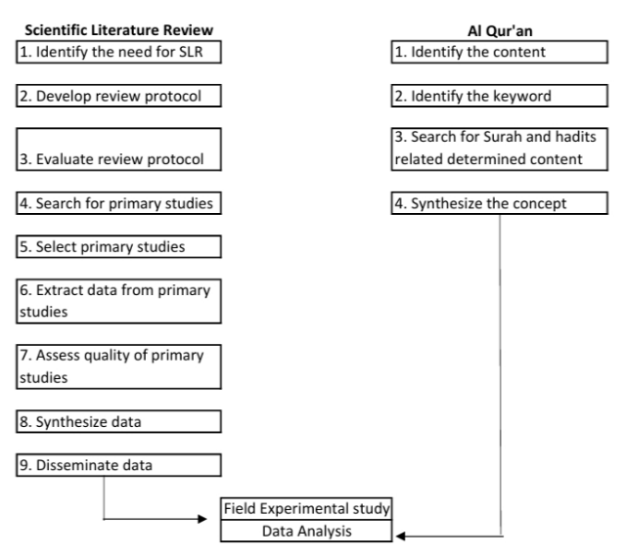
Figure 1. SLR of Scientific Literature and Content Analysis of Al Qur’an

This article will investigate the use of PF to reduce outdoor temperatures using a Systematic Literature Review (SLR), content analysis, and field experimental studies, as seen in Figure 1. The SLR was carried out as follows [44]. First, determine the needs of SLR, specifically to gain an overview of the mechanisms involved in the process of air temperature reduction by VGS and the protocol used to measure these mechanisms. The next two steps are to create and evaluate the review procedure namely identifying the types of literature sources, which include books, research reports, research articles, peer-reviewed journals, and conference papers, determining keyword search, namely, "vertical greening system", "green wall", "green facades", "vertical garden" and "vertical (urban) agriculture", and database sources, namely Science Direct and Google Scholar and selecting literature, namely only experimental studies, for further review. The fourth and fifth stages involve searching and selecting primary studies by limiting the literature to experimental studies that discuss the cooling effect of thermal reduction of VGGS, with strong validation, and the most recently dated studies. The synthesized literature was then used to conduct experimental studies and analyze the results. In addition, this research employed a content analysis approach to identify concepts in the Al-Quran related to the mechanism of the cooling effect of vegetation. Some keywords, such as “plants”, “fruit”, “vegetable”, “sun”, “water”, “humidity”, “atmosphere”, and “fresh air”, were selected to be input into Al Quran and its translation websites, such as http://en.noblequran.org; and https://quran.kemenag.go.id, while for the Hadiths is https://sunnah.com. This concept is then used to explain the cooling effect, shading, and reduction of CO2 concentration of PF found in the experimental study.

  - EXPERIMENTAL METHOD
The field experimental study was conducted in Kendari City, in the South East Sulawesi Province, Indonesia. Real climatic experiments were carried out in an open field. Before conducting the real climate test, three building models and four green facades were constructed five months earlier. The model, a one-cubic-metre building, had plastered red brick walls and a gable roof. A PF was put in front of the models' facades in each and west orientation using a wooden frame with a 20 cm cavity. For this study, pumpkin (Cucurbita pepo) and sweet potatoes (Ipomoea batatas) were chosen based on sociological studies and participatory methodologies that examined the consumption patterns of communities in high-density urban settlements [45]. PFs employing pumpkin plants will be referred to as PFP, whereas PF using sweet potato plants will be referred to as PFSP. In addition, a building model without treatment, known as Barewall, was built as a control.

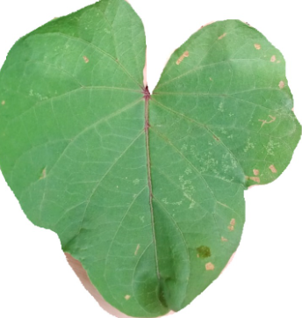 | 
Figure 2. LAI Measurement Using J-image Software

The PFs were developed until their LAI reached three. LAI monitoring was carried out using a non-destructive approach, which involved photographing the leaf sample. Examples were attained from the central of the PFs, which had been vertically divided into three sections. The field shot was then processed using J-image software to determine its area, as shown in Figure 2. The real climate test was carried out when the PF LAI reached 3.

  - FIELD DATA MEASUREMENT
Since the thermal performance of PF, both through shading and CO2 absorption, has not been extensively explored before, this study attempts to understand the diurnal patterns of these parameters. Data were collected for three days in February and March 2023. Data was gathered from 5:00 a.m. to 8:00 p.m. under clear-sky conditions. Microclimate parameters, including solar radiation, relative humidity, and air temperature, were measured every hour at a distance of 50 cm from the PF, at a height of 50 cm above the ground. The CO2 concentration was measured every 3 hours. The equipment is placed in the center of the PF to minimize the influence of the external microclimate, as shown in Figure 3.

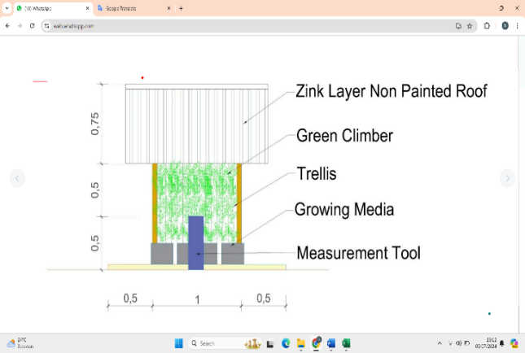
Figure 3. Schematic of building model and equipment

Real climate tests to explore the diurnal thermal performance of PF through CO2 uptake mechanisms are challenging because most previous methods of measuring CO2 uptake rely on growth rates, which are typically measured weekly. Additionally, very few alternative methods do not damage leaves when measuring CO2 using flexible equipment in the field. Therefore, a literature review of selected cases was conducted to determine the appropriate method. The in-chamber method was chosen and modified by adopting the methods of [40] and [41]. In this way, a moving plastic box was created for each PF. The box frame is made from ¾ inch-diameter PVC pipe, as shown in Figure 4. In the center of the front of the box, there is a small hole to allow the CO2 measuring sensor to enter the box. Two fans are placed in the box, one at the top and one at the bottom. The plastic box was placed 15 minutes in front of the PF before CO2 measurements were taken. A plastic layer is installed on the back and top of the PF to prevent gas from escaping. Immediately after the CO2 measurement was taken, the plastic box was removed, and the solar radiation in front of and behind the PF, as well as the relative humidity and air temperature in front of the PF, were measured.

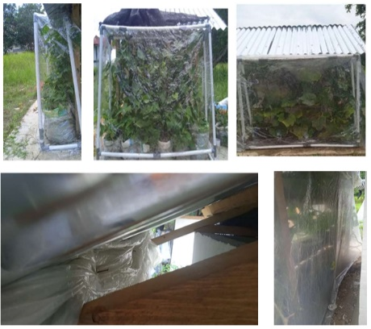
Figure 4. Modified in-chamber method to measure CO2 concentration

  - EQUIPMENT
Solar radiation was measured using a Lutron solarimeter, model SPM-1116SD. Meanwhile, air temperature and relative humidity were measured using a digital thermohyrometer, Intell Smart type AS817. This device had an accuracy of 0.1°C for temperature and 0.1% for relative humidity, with a temperature range of -10°C to 50°C and a humidity range of 5% to 98%. The Indonesian Centre calibrated all equipment for Meteorology, Climatology, and Geophysics Calibration. Furthermore, ambient CO2 was measured using a CO2 meter.

  - DATA ANALYSIS
The shading coefficient will be calculated using the Beer law equation, while the reduction of CO2 and air temperature is calculated based on the difference in CO2 concentration and air temperature in the PF and Bare-wall, regarding the notion of cooling intensity (CI, °C) demonstrated in reference [45], as a decrease in air temperature in the VGS relative to the control wall, as expressed by the equation:

C_{intensity} = Ta_{bare} - Ta_{green facade}

In addition, the Beer law equation used in this article is as follows [35]:

$$k= -(\ln{\frac{Ig}{Io })/LAI}$$
where, | k =  e =  LAI =  Io =  Ig = | shading coefficient  Euler’s number (2,7183)  Leaf Area Index  the intensity of solar radiation upper side of the foliage (W. m⁻²).  the intensity of solar radiation underside the foliage (W. m⁻²).

Pearson's correlation analysis was constructed to identify the relationship between the shading coefficient, CO2 absorption, and air temperature. Based on the findings, a comprehensive discussion will be conducted using microclimate theory and an Islamic perspective, drawing on the Al Qur’an and Hadiths.

- RESULT AND DISCUSSION
- RESULT

- 1. Cooling Effect Of PF
The cooling effect signifies a decrease in the air temperature of the PF in comparison to the control wall. Research has shown that PFs can decrease the outside temperature; however, their effects are subject to change. On the first day, the PFs had a cooling impact on the east and west orientations compared to the Barewall, since the average air temperature (Ta) of the PFs was lower than that of the Barewall. On the initial day, the greatest decrease in air temperature was recorded at 5.5 °C on the east orientation of the PFP at 10:00 a.m., and 8.4 °C on the east orientation of the PFSP, also at 10:00 a.m. These findings align with the study conducted by [46], which examined the relationship between leaf temperature and the disparity in ambient air temperature throughout the period from 09:00 a.m. to 03:00 p.m. The leaf temperature was lower than the open-air temperature.
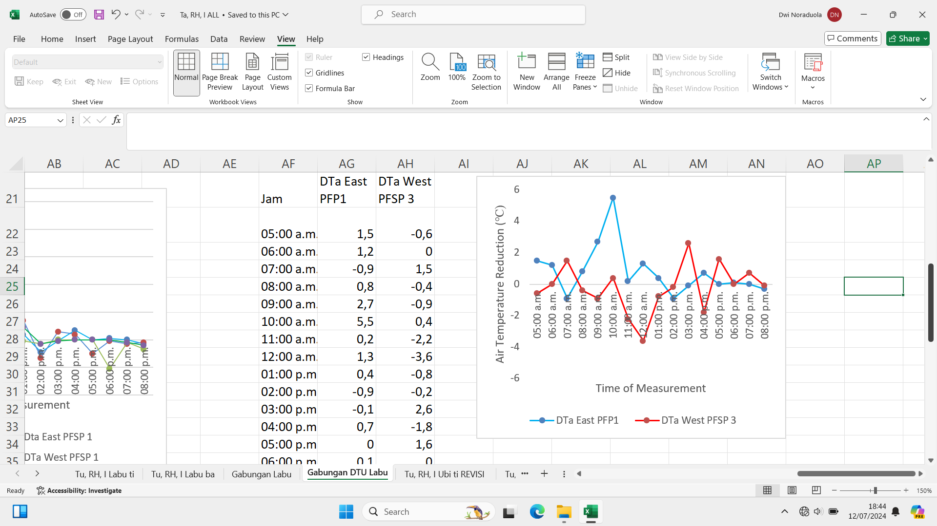
Figure 5. The Most Evidence of the Cooling Effect and Warming Effect

Furthermore, numerous studies have demonstrated that plants employ tolerance and adaptation mechanisms in response to heat stress when the temperature exceeds 30 °[46]. During the day, plants that thrive in environments with high exchange of solar and thermal radiation are frequently heated more than the surrounding air [47]. It was found that a warming effect occurred from 11:00 a.m. to 2:00 p.m. when solar radiation reached its peak points. At this time, solar radiation, humidity, and air temperature reach > 800 Watt m-2, <60%, and >30 ºC on the bare wall, respectively (figure 5).
The influence of solar radiation and air temperature on the occurrence of the cooling impact of PF is evident in the thermal performance of the green facade on the third day, when the average solar radiation was 448 Watt m-2 and the average air temperature was 33 °C. On the third day, a sequence of heating phenomena takes place. At high temperatures, the water content of the cell drops [48]. Plants adjust their water usage efficiency to cope with strong solar radiation and air temperatures on the third day, resulting in a delay in the optimal time for the most effective cooling to occur at 03:00 p.m. on both east and west orientations. In contrast, the optimal daily cooling impact is observed throughout the morning hours, specifically from 9:00 a.m. to 11:00 a.m., in both the east and west orientations on the first and second days.
Additionally, another piece of data discovered during the actual climatic test indicated a lack of change in air temperature, which was referred to as a time of stability. This evidence predominantly happened throughout the early morning or early evening. In the Qur'an, these specific moments are designated as the periods when all creatures are instructed to express reverence and praise towards Allah, as explained in Surah Al Ahzab verse 42: “And glorify Him morning and evening” or An-Nur verse 41: “Did you not see that the heavens and the earth and the birds in lines glorify Allah? They all know the prayer and their glorification. And Allah is all-knowing of what they do” or Al Isra verse 44: “The seven heavens and the earth and those who are in them glorify Him. There is not a single thing that does not glorify Him with praise. But you cannot comprehend their glorification. Surely He is Ever Forbearing, Oft-Forgiving”.

- 2. Coefficient Shading Of PF
The radiation intensity absorbed by plants will diminish when the plant's canopy approaches the wall surface. The phenomenon of radiation intensity decreasing is referred to as extinction. The extinction coefficient, also known as the shading coefficient (k), refers to a measure of the ability of a material to absorb or block light. The k value represents the ability of the vegetation to capture solar energy [33]. The fact that productive plants can provide shade to reduce solar radiation below the surface of the plant's foliage has been mentioned in the Al-Quran Surah Al Insaan, verses 13-14: “They recline on thrones there. They see in there neither the excessive heat of the sun nor the biting cold. And its (tree) shade is close upon them, and its fruits are brought closer, ready for their command”.

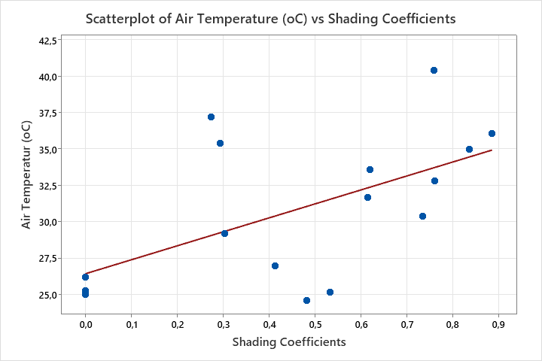
Figure 6. Scattered plot of PFP air temperature and shading coefficient (k) when the most evidence of the cooling effect occurred

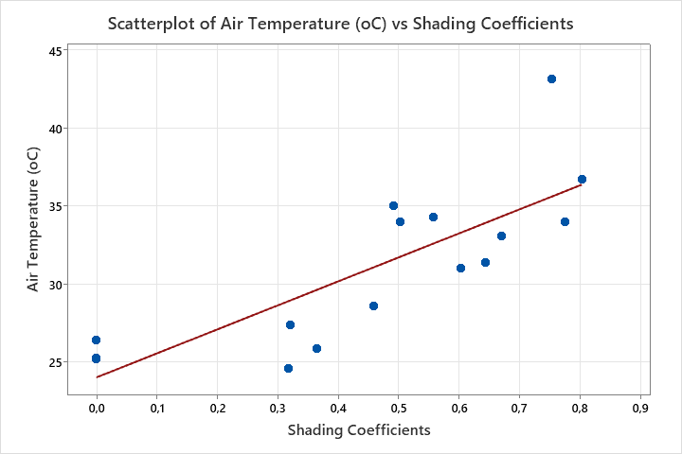
Figure 7. Scattered plot of PFSP air temperature and shading coefficient (k) when the most evidence of the cooling effect occurred

This study demonstrates that sun radiation is crucial in determining the daily shading coefficient pattern. The shade coefficient varies following the sun's elevation. The PF shading coefficient exhibited an upward trend from morning to midday, followed by a subsequent decline in the afternoon. This is in accordance with the solar altitude, where the smallest value of 0 degrees happens during the morning and evening, while the highest value of 90 degrees occurs at midday. When the sun is at a lower angle in the sky, the solar radiation has a lower intensity, as it is dispersed over a wider area, resulting in a lower air temperature.
Furthermore, it is found that the PFs' shading coefficient fluctuates within a day for both east and west orientations. When there is no solar radiation, the k value is 0. This occurs at 05:00 a.m. and starts at 06:00 p.m. As the value of the sun increases, k increases until noon, when k reaches a value of 0.8 to 1. After that, the k-value started to decrease. However, the time of the peak value of k is different between the east and west orientations. The peak value of the west orientation, at 10:00 a.m. to 01:00 p.m., is achieved 1 or 2 hours earlier than that of the East orientation. These facts in terms of shading and solar radiation have been drawn from Al Qur’an Surah Al Furqan, version 45-46: “Have you not seen how your Lord extended the shade? And if He had willed, He would undoubtedly have made it stationary. Then We have made the sun a guide (an indication) to it (shade). Then (as the sun rises higher in the sky), We withdraw it (the shadow) to Ourselves: a gradual withdrawal”.
Pearson's correlation analysis reveals a strong relationship between the k-value and air temperature, as illustrated in Figures 6 and 7. However, the degree of its relationship tends to weaken with higher average solar radiation and higher average relative humidity. The R values of PFP from the first to the third day were 0.57, 0.54, and 0.67 on the east orientation and 0.86, 0.69, and 0.73 on the west orientation. Whereas the R values of PFSP from the first to the third day, on the east orientation, were 0.80, 0.43, and 0.55; on the west orientation, they were 0.85, 0.45, and 0.76.

- 3. Carbon Dioxide Concentration Reduction of PF
The CO2 concentration around PFP forms a parabolic curve. Compared to CO2 in Barewall, there is a decrease in CO2 concentration on both the east and west orientations of the PFP. The highest decrease in CO2 arose on the second day on the East orientation, namely 41 ppmv on PFP and 59 ppmv on PFSP at 11:00 a.m. The highest average decrease in CO2 concentration also occurred on the second day, specifically for the west orientation, with values of 26.42 ppmv on PFP and 16.33 ppmv on PFSP. The control wall's average solar radiation, relative humidity, and air temperature were 278 watts.m⁻², 86%, and 30°C on the east orientation, while those on the west orientation were 176 watts.m⁻², 85%, 30⁰C, respectively. In this case, it can be assumed that the microclimate values on the second day are favorable for the photosynthesis of PFs.
Furthermore, besides providing possible signs of water stress in plants, higher solar radiation and warmth will reduce the CO2 content in the surface atmosphere [48], such as on the third day. At this event, the average air temperature and solar radiation were 33 °C and 449 watts/m² on the east orientation, while those on the west orientation were 34 °C and 390 watts.m⁻², respectively.
Pearson's correlation analysis reveals a significant relationship between air temperature and differences in CO2 concentrations at Barewall and PFP, as well as PFSP, as illustrated in Figures 8 and 9. The R values from the first day to the third day for the east orientation of PFP were 0.78, 0.61, and 0.72, respectively, and for the east orientation of PFSP were 0.98, 0.53, and 0.54. Meanwhile, on the west orientation of PFP, only on the first day does the R-value (0.89) show a close relationship. On the west orientation of PFSP, the R-values from the first day to the third day are 0.95, 0.83, and 0.75, respectively.

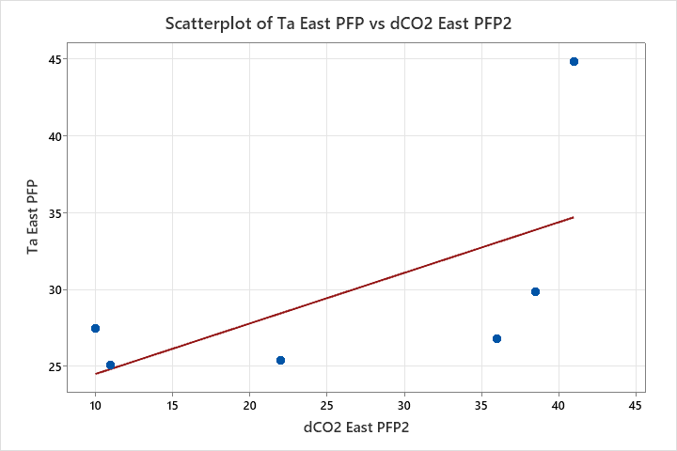
Figure 8. Scattered plot of PFP air temperature and CO2 concentration reduction when the best reduction occurred

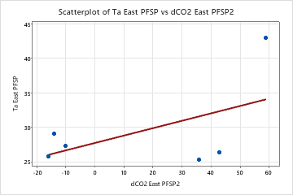
Figure 9. Scattered plot of PFP air temperature and CO2 concentration reduction, when the best reduction occurred

- DISCUSSION

- 1. Shading Coefficient and Air Temperature
The most significant reduction in air temperature occurs during the morning hours, from 09:00 a.m. to 11:00 a.m., in the eastern direction. This is when the shading coefficient reaches its lowest point, namely between 0.2 and 0.4 in PFP and between 0.4 and 0.6 in PFSP. Leaf spreading that is neither horizontal nor clustered typically results in a shading coefficient of less than 1.0 [50]. The k value of the green facade, as determined by [15], was 0.77. In this scenario, PFs with leaves that are more vertically spread out against the walls are expected to have lower air temperatures in the PFs. This is because the leaves cover the whole building wall. Vertical foliage obstructs sunlight from reaching the surfaces of buildings by absorbing shortwave radiation that strikes them effectively, resulting in the emission of long-wave infrared (LWIR) radiation from bare walls. The LWIR will heat the atmosphere when it interacts with CO2. The study by [49] points out that compared to the High Albedo Wall, the greening wall absorbs approximately 111 W/m2 more shortwave radiation and reduces net LWIR by 60 W/m2. On the other hand, the shading coefficient increases during midday, when the k value is higher. At that time, the PFs had a warming effect.

- 2. Carbon Dioxide Concentration and Air Temperature Reduction
The highest uptake of PFP and PFSP CO2 occurred on the east orientation from 08:00 a.m. to 11:00 a.m., the same time as the lowest k value, when the best cooling effect occurred. This aligns with the findings reported by [48] and [50]. The importance of this time has been mentioned in Al-Qur’an in Surah Asy-Syams version 1: The Sun and its mid-morning (its radiating brightness). In this case, solar radiation in the morning can be considered a vital component for the universe, including the process of photosynthesis.
In the case of CO2 absorption, the leaf's water content supports CO2 absorption in photosynthesis. [51] argued that the increased chlorophyll content is in line with the increase in water supply and fertilizers. All these facts are drawn in Al-Qur'an in Surah Yasiin version 99: 'It is He who sends down water (rain) from the sky. With it We produce vegetation of all kinds from which (water or plants). We produce a green substance (Khadir), out of which We produce grain in clusters. And out of date palms, from their spathes, come forth clusters of dates hanging low and near, and (We produce) gardens of grapes, olives, and pomegranates, each similar (in leaves or shape), yet different (in fruit and taste). Look at (and think over) their fruits when they begin to bear fruit, and (look at) the ripeness thereof. Behold! In these things, there are signs for people who believe”. Furthermore, facts on the water content in plants have been mentioned in the Al Qur'an surah Al Anbiya Version 30: “Do not those who disbelieve see that the heavens and the earth were joined as one united piece? Then We parted them? And we have dreamed of all living things from water. Will they not then believe?” These two verses of Al Qur’an imply that plant growth is supported by water and Al-Khadir (green substance) to produce leaves and fruit, in which the process carried out by Al-Khadir will produce glucose, which can be felt through the taste of fruit. In addition to glucose, this photosynthesis process also allows the release of oxygen and water vapor into the surrounding air, thereby improving the quality of the ambient air and its temperature. The fact that plants contain water and O2 has been conveyed in the Al-Qur'an through Surah Al-Waqiah, verses 71-73: "Have you seen the fire on your Kindle? Was it you who grew its timber, or did We grow it? We have made it a reminder and a comfort for desert dwellers”. Wood burning is a process of chemical transformation in which wood is turned into carbon dioxide (CO2), water vapor, charcoal, and ash by the application of heat and the presence of oxygen. Oxygen is the primary fuel for fire; it readily combusts and becomes highly flammable in larger quantities. Wood contains moisture. During combustion, the fire causes the water within the wood to evaporate, transforming it into a gaseous state and resulting in complete dryness.
Photosynthesis is one of the processes in plants that is most susceptible to heat because heat greatly affects leaf water content, leaf stomatal conductance, and CO2 concentration between cells [52]. High temperatures cause a reduction in the water content in plant tissue, which in turn reduces chlorophyll content and breaks down proteins necessary for photosynthesis [46]. Furthermore, plants reduce the opening of stomata in hotter conditions to conserve water, thereby reducing CO2 exchange, which in turn depends heavily on physical mechanisms, such as shedding leaves [53]. This has consequences for the process of releasing O₂ and water vapor, which also decreases. The occurrences of the warming effect were mainly observed from 11:00 a.m. to 2:00 p.m., when higher solar radiation and air temperatures were present, and a decreasing trend in CO2 reduction was also identified.

- 3. Implication of PF Design for Building A Secondary Wall
This research provides evidence that the cooling mechanism of PF, as a biobased building envelope material, through shading and reduction of CO2 concentrations, plays a role in reducing the temperature of the surrounding air, thereby contributing to UHI mitigation efforts. According to [54], green facades have become an important component in building design due to their ability to respond to environmental conditions. This demonstrates its intelligence as a building envelope material, enabling it to contribute to the construction of smart buildings.
A smart building can be defined as a building that is planned, built, and functions by incorporating knowledge-based innovations, methods, organizational aspects, and technical aspects to benefit the indoor environment and its impact on the environment and the economy [55] [56]. Concerning the discoveries made in this study, several concepts for enhancing PF as a bio-based building envelope to better adapt to higher urban temperatures have been identified.

- 3. 1. Plant Selection
As a bio-based material, green facades can not only reduce indoor air temperature. But it can also provide a cooling effect on exterior air temperature. However, selecting the right plants is crucial to achieve these benefits. The Al Qur'an has mentioned various types of plants, including vines, which are used in PF, that Allah created to provide benefits to living creatures, as stated in Surah Abasa, verses 24-32: “Then let man consider his nutrition: that We pour down the rain in showers. And We split the earth into fragments. And therein make grain grow, and vines and herbs, and olives and palms, and dense foliage gardens, and fruits and feed-provisions for you and your cattle”. In this verse, it is described that Allah has created plants with various structures, including vines, and productivity abilities that can be utilized for the welfare of living creatures, particularly in meeting their food needs. The virtues of productive plants, especially for food, are very often mentioned in the Al-Qur'an with the words garden, fruit, crop, food, eat, drink, goodly provision, and so on. These advantages can be obtained not only through trees but also through various plant structures, including vines.
Additionally, this research demonstrates that pumpkin and sweet potato plants can lower outdoor air temperatures in both east and west orientations. However, the best air temperature in PF with pumpkin plants was found on the east orientation. The virtues of the pumpkin plant have been mentioned in the Al-Quran Surah As-Saffat, verses 145-146: “But We threw him onto the open shore while he was ill. And We caused to grow over him a Yaqthin tree”. In this Surah, it is mentioned that to shield Prophet Yunus from the scorching sun, Allah caused Yaqthin trees, plants from the Curcubitae family (https://quran.kemenag.go.id,) to grow around him. He found refuge in the shelter of the tree leaves, sustaining himself with the nourishing fruit it bore. This plant offers a refreshing respite from the sun's rays, creating a soothing and comfortable environment.
Furthermore, this Surah provides valuable scientific insights into the adaptability of climbing plants from the Curcubitae family. These plants have demonstrated remarkable resilience in barren soil conditions and can thrive in hot weather, exhibiting rapid growth and proliferation. Furthermore, the Qur'an and Hadiths also refer to various other types of vines, such as grapes, cucumbers, watermelons, and bitter bottle gourds. These vines possess moist stems and delicate hairs on both the leaves and stems. Where stem temperature has an impact on water transport efficiency [47]. Water transportation from the soil through the stem helps regulate stem temperature, even when high transpiration occurs during the day, despite an increase in leaf surface temperature[47]. Moreover, the delicate hair of plants plays a crucial role in shielding against harmful UV rays [57] and enhances the effectiveness of water usage during dry spells. Furthermore, plant selection also involves considering the type of CO2 fixation that the plant exhibits. Although C4 plants are more tolerant of high temperatures, C3 plants are better able to absorb CO2.

- 3. 2. Integrated Plumbing-Irrigation System of The Building
Plants can enhance water use efficiency under high temperatures. Thus, the irrigation system plays a crucial role in preventing plants from experiencing water-stress situations. Additionally, it is widely accepted that the cooling of leaves through transpiration is significantly reduced when there is a lack of water in the soil [53]. Plants that receive ample water can mitigate stress by transpiring intensively, resulting in leaf temperatures that are cooler than the surrounding environment, typically ranging from 6°C to 15 [52]. When plants receive sufficient water, their physical traits and transpiration mechanisms enable them to safeguard themselves against heat damage and carry out photosynthesis optimally at the ideal temperature [53]. Thus, a well-designed irrigation system can offer advantages in terms of temperature regulation and promoting plant development. However, providing a water supply for irrigation systems in high-density urban settlements can be very challenging. Thus, integrating building plumbing systems, both in terms of water storage, such as rainwater harvesting and wastewater recycling, could be an option in this case.

- 3. 3. Waste Composting at Building Scale
Chlorophyll content increased markedly with increasing provision of water and fertilizer [51]. The importance of planting and caring for plants has been emphasized by the holy Prophet Mohammad: "Everyone who plants a tree and patiently takes care of it, and so it yields fruits, one charity will be bestowed by Allah in exchange for each fruit” [58]. Apart from that, the Al Qur'an has also explained that water can keep plants alive with Allah's permission, for example, in Surah Al-Hajj Version 5: “you see the earth is dry and lifeless, but when we drop the rain on it, it becomes alive, swells, and produces all kinds of fruits and vegetation” and Surah Abasa Version 24-32: “Now let the man show his food. It is we who have dedicated their abundant water (from the sky), then we split the earth with the best, and there we grow grain and wine and vegetables, and olive and palm trees, and gardens (which) are shady, and fruits and grasses. (All of it) for you and your livestock animals”. Precipitation is a vital source of nutrients for plants, since Phosphorus, magnesium, and potassium, the essential materials for plant growth, are present in saltwater in limited quantities, which evaporate into the atmosphere and then precipitate as rain. In this scenario, in conjunction with sufficient water, the use of suitable fertilizers is also crucial for reducing CO2 levels. Therefore, it presents an opportunity to implement composting at the individual building level. [59] has found that supplying carrots with compost greatly enhances their quality, productivity, and capacity to counteract free radical chemicals and inhibit the oxidation of other compounds. Additionally, it alters the makeup of soil microorganisms, affecting leaf, root, and soil metabolite levels [59].

- 3. 4. Dynamic Facade of The Building for The Inclination of The Sun to The PF.
Leaves that are positioned more vertically, with a value of k between 0.2 and 0.6, are more effective in lowering air temperature. The cooling effect is observed only at this range of k values. Nevertheless, the shadowing coefficient varies based on the sun's elevation. Thus, it is difficult to maintain the value of k within that range. PF dynamic facades can be designed to regulate the orientation of the PF towards sunlight by utilizing sensors that are programmed to react to the sun's movement or the level of solar radiation.

- CONCLUSION
The PF air temperature decreased in the east and west directions compared to walls that did not undergo VGS treatment. Nevertheless, the cooling impact of PF is expected to occur under ideal microclimatic conditions. Alternatively, a warming effect is likely to occur. Therefore, understanding the shading mechanisms, CO2 concentration reduction, and cooling effects provides a basis for developing PF designs that are highly adaptable to high temperatures. This can be achieved by controlling irrigation, fertilization, and shading coefficient, which can be integrated with building systems. This strategy not only enhances the thermal efficiency of PF but also advances building design towards the concept of intelligent building construction. Nevertheless, this authentic idea requires further research to improve the results and to be applied in the construction and function of buildings, as well as in preserving a livable surrounding environment.
This study demonstrates that the implementation of vertical greening, specifically the use of food plants, can effectively reduce the ambient temperature of the outdoor environment. The Qur'an acknowledges the beneficial qualities of food plants, especially vines like pumpkins, which possess the ability to provide shade and coolness. This study demonstrates that the plant possesses delicate trichomes and high moisture content. The selection of plants in this scenario is crucial for generating a cooling impact.
The Qur'an and Hadith are the main sources of Islamic views. The Qur'an and Hadith have conveyed scientific truths that were later confirmed hundreds of years later. These views have fulfilled humanity's need for knowledge, both from the scientific perspective of humans who lived in the 7th century, when Allah revealed the Al Qur’an, and in the 21st century, the era we live in now, and in subsequent generations.

AUTHORS CONTRIBUTION
Noraduola was tasked with investigating the bibliographies, selecting relevant references, conducting field tests, and composing and revising paper drafts. Mangkoedihardjo's responsibilities include developing design concepts, examining reference codes, and evaluating all data and documents. Santoso is accountable for developing the initial design idea and evaluating the document, particularly concerning vegetation, carbon dioxide absorption, and air temperature. Purwanti is accountable for creating work plans and evaluating all work plans and scripts. Jaya was responsible for developing the initial design idea, conducting field tests, and critically evaluating the text, particularly in relation to urban heating concerns. Cahyadi was tasked with developing the initial concept and conducting a thorough examination of the book, with a particular focus on matters of the hamlet.

ACKNOWLEDGEMENT
The authors appreciate the funding from the Institut Teknologi Sepuluh Nopember under the BRIN Degree by Research Scholarship Programme and the support of the Engineering Faculty of Halu Oleo University during field laboratory work and data collection. We also express our thanks to Prof. Dr. Ir. H. Laode Sabaruddin M. Si from the Department of Agrotechnology, Halu Oleo University, for very valuable discussions. Likewise, to Ustadz Syaiful Yusuf, Lc. M. A.

REFERENCES

[1] A. S. Putra, G. Tong, and D. O. Pribadi, “Food Security Challenges in Rapidly Urbanizing Developing Countries: Insight from Indonesia,” Sustainability, vol. 12, no. 22, p. 9550, Nov. 2020, doi: 10.3390/su12229550.
[2] B. Paramita and A. Matzarakis, “Urban morphology aspects on microclimate in a hot and humid climate,” Geographica Pannonica, vol. 23, no. 4, pp. 398–410, 2019, doi: 10.5937/gp23-24260.
[3] S. N. H. Utami, Darmanto, and R. Jayadi, “Vertical gardening for vegetables,” in Acta Horticulturae, International Society for Horticultural Science, Aug. 2012, pp. 195–202. doi: 10.17660/ActaHortic.2012.958.23.
[4] Y. Stav, “Transfunctional Living Walls-Designing Living Walls for Environmental and Social Benefits,” 2016.
[5] J. Fahed, E. Kinab, S. Ginestet, and L. Adolphe, “Impact of urban heat island mitigation measures on microclimate and pedestrian comfort in a dense urban district of Lebanon,” Sustain Cities Soc, vol. 61, 2020, doi: 10.1016/j.scs.2020.102375.
[6] K. Ornam, S. Wonorahardjo, and S. Triyadi, “Several facade types for mitigating urban heat island intensity,” Build Environ, vol. 248, p. 111031, Jan. 2024, doi: 10.1016/j.buildenv.2023.111031.
[7] R. Widiastuti, J. Zaini, W. Caesarendra, G. Kokogiannakis, and S. N. N. Binti Suhailian, “Thermal insulation effect of green facades based on calculation of heat transfer and long wave infrared radiative exchange,” Measurement, vol. 188, p. 110555, Jan. 2022, doi: 10.1016/j.measurement.2021.110555.
[8] T. A. N. T. Perera, G. Y. Jayasinghe, R. U. Halwatura, and H. T. Rupasinghe, “Modelling of vertical greenery system with selected tropical plants in urban context to appraise plant thermal performance,” Ecol Indic, vol. 128, p. 107816, Sep. 2021, doi: 10.1016/j.ecolind.2021.107816.
[9] G. Vox, I. Blanco, and E. Schettini, “Green facades to control wall surface temperature in buildings,” Build Environ, vol. 129, pp. 154–166, Feb. 2018, doi: 10.1016/j.buildenv.2017.12.002.
[10] L. Bianco, V. Serra, F. Larcher, and M. Perino, “Thermal behaviour assessment of a novel vertical greenery module system: first results of a long-term monitoring campaign in an outdoor test cell,” Energy Effic, vol. 10, no. 3, pp. 625–638, Jun. 2017, doi: 10.1007/s12053-016-9473-4.
[11] I. Susorova, M. Angulo, P. Bahrami, and Brent Stephens, “A model of vegetated exterior facades for evaluation of wall thermal performance,” Build Environ, vol. 67, pp. 1–13, Sep. 2013, doi: 10.1016/j.buildenv.2013.04.027.
[12] Mohd Khairul Azhar Mat Sulaiman, Maslina Jamil, and Muhammad Fauzi Mohd Zain, “Solar Radiation Transmission of Green Facade in the Tropics,” in Conference: Kongres Penyelidikan & Inovasi UKM2013, Universiti Kebangsaan Malaysia, Nov. 2013.
[13] P. M. F. van de Wouw, E. J. M. Ros, and H. J. H. Brouwers, “Precipitation collection and evapo(transpi)ration of living wall systems: A comparative study between a panel system and a planter box system,” Build Environ, vol. 126, pp. 221–237, Dec. 2017, doi: 10.1016/j.buildenv.2017.10.002.
[14] F. Convertino, G. Vox, and E. Schettini, “Convective heat transfer in green facade system,” Biosyst Eng, vol. 188, 2019, doi: 10.1016/j.biosystemseng.2019.10.006.
[15] F. Convertino, E. Schettini, I. Blanco, C. Bibbiani, and G. Vox, “Effect of Leaf Area Index on Green Facade Thermal Performance in Buildings,” Sustainability (Switzerland), vol. 14, no. 5, 2022, doi: 10.3390/su14052966.
[16] A. Tablada, V. Kosorić, H. Huang, S. S. Y. Lau, and V. Shabunko, “Architectural quality of the productive facades integrating photovoltaic and vertical farming systems: Survey among experts in Singapore,” Frontiers of Architectural Research, vol. 9, no. 2, pp. 301–318, Jun. 2020, doi: 10.1016/j.foar.2019.12.005.
[17] Suparwoko and B. Taufani, “Urban Farming Construction Model on the Vertical Building Envelope to Support the Green Buildings Development in Sleman, Indonesia,” Procedia Eng, vol. 171, pp. 258–264, 2017, doi: 10.1016/j.proeng.2017.01.333.
[18] A. Tablada and X. Zhao, “Sunlight availability and potential food and energy self-sufficiency in tropical generic residential districts,” Solar Energy, vol. 139, pp. 757–769, Dec. 2016, doi: 10.1016/j.solener.2016.10.041.
[19] L. Y. Astee and N. T. Kishnani, “Building Integrated Agriculture: Utilising Rooftops for Sustainable Food Crop Cultivation in Singapore,” Journal of Green Building, vol. 5, no. 2, pp. 105–113, May 2010, doi: 10.3992/jgb.5.2.105.
[20] S. Hidayatullah Jakarta, “Reflexivity of Food and Plants on Islam With Theory H Roikhan MA,” 2018.
[21] F. Mahmudah and R. Rahmatika, “SUN IN PERSPECTIVES OF SCIENCE AND AL-QUR’AN.”
[22] S. Chaudhry, “Environmental Stewardship: Perspectives from the Islamic Teachings African Journal of Sociological and Psychological Studies,” 2022, doi: 10.31920/2753-3182/2022/v1n1a5.
[23] D. Manan Cheema, “Current Global Warming Prevention in Islamic Perspective: A Research Review”, doi: 10.36755/iqan142.2022,PP.
[24] K. R. Gunawardena, M. J. Wells, and T. Kershaw, “Utilising green and bluespace to mitigate urban heat island intensity,” Science of The Total Environment, vol. 584–585, pp. 1040–1055, Apr. 2017, doi: 10.1016/j.scitotenv.2017.01.158.
[25] Peck SW, Callaghan C, Kuhn ME, and Bass B, Greenbacks from green roofs: forging a new industry in Canada. Ottawa: Citeseer, 1999.
[26] X. Wang, W. Gard, H. Borska, B. Ursem, and J. W. G. van de Kuilen, “Vertical greenery systems: from plants to trees with self-growing interconnections,” European Journal of Wood and Wood Products, vol. 78, no. 5, pp. 1031–1043, Sep. 2020, doi: 10.1007/s00107-020-01583-0.
[27] R. Fernández-Cañero, L. P. Urrestarazu, and A. Franco Salas, “Assessment of the Cooling Potential of an Indoor Living Wall using Different Substrates in a Warm Climate,” Indoor and Built Environment, vol. 21, no. 5, pp. 642–650, Oct. 2012, doi: 10.1177/1420326X11420457.
[28] L. Pérez-Urrestarazu, R. Fernández-Cañero, A. Franco-Salas, and G. Egea, “Vertical Greening Systems and Sustainable Cities,” Journal of Urban Technology, vol. 22, no. 4, 2015, doi: 10.1080/10630732.2015.1073900.
[29] M. Manso and J. Castro-Gomes, “Green wall systems: A review of their characteristics,” 2015, Elsevier Ltd. doi: 10.1016/j.rser.2014.07.203.
[30] S. A. Palermo and M. Turco, “Green Wall systems: Where do we stand?,” IOP Conf Ser Earth Environ Sci, vol. 410, no. 1, 2020, doi: 10.1088/1755-1315/410/1/012013.
[31] J. Kleszcz, “Urban Farm as a System of Productive Urban Green – Challenges and Risks,” Architecture, Civil Engineering, Environment, vol. 11, no. 1, pp. 23–36, Jan. 2018, doi: 10.21307/acee-2018-003.
[32] P. A. Zuidema, W. Gerritsma, L. Mommer, and P. A. Leffelaar, “Model description and technical program manual of CASE2 version 2.2 A physiological production model for cacao,” 2003.
[33] F. Samadiyan, A. Soleymani, and F. Yeganehpoor, “Evaluation of maximum light absorption and light extinction coefficient in different levels of nitrogen and wheat cultivars,” 2013. [Online]. Available: http://www.ijabbr.com
[34] M. A. Awal, H. Koshi, and T. Ikeda, “Radiation interception and use by maize/peanut intercrop canopy,” Agric For Meteorol, vol. 139, no. 1–2, pp. 74–83, Sep. 2006, doi: 10.1016/j.agrformet.2006.06.001.
[35] K. Ip, M. Lam, and A. Miller, “Shading performance of a vertical deciduous climbing plant canopy,” Build Environ, vol. 45, no. 1, pp. 81–88, Jan. 2010, doi: 10.1016/j.buildenv.2009.05.003.
[36] Q. Chen, Q. Ding, and X. Liu, “Establishment and validation of a solar radiation model for a living wall system,” Energy Build, vol. 195, pp. 105–115, Jul. 2019, doi: 10.1016/j.enbuild.2019.05.005.
[37] Y. Zhang et al., “Seasonal variation in leaf area index and its impact on the shading effects of vertical green facades in subtropical areas,” Build Environ, vol. 225, p. 109629, Nov. 2022, doi: 10.1016/j.buildenv.2022.109629.
[38] M. R. Seyedabadi, U. Eicker, and S. Karimi, “Plant selection for green roofs and their impact on carbon sequestration and the building carbon footprint,” Environmental Challenges, vol. 4, p. 100119, Aug. 2021, doi: 10.1016/j.envc.2021.100119.
[39] J. Othman, I. Azhar, and A. Azlan, “Assessing Plant Selection for Vertical Greenery System on Commercial Buildings in an Urban Setting,” 2018.
[40] H. P. Jaya, Y. Ludang, and S. Mangkoedihardjo, “Development of traditional medicinal plants on Peatland conditions in Central Kalimantan,” Journal of Phytology, pp. 24–30, Mar. 2022, doi: 10.25081/jp.2022.v14.7184.
[41] R. I. S. Izzah, “Studi Serapan Karbon Dioksida (CO2) Udara Ambien oleh Tumbuhan Air Menggunakan Indikator Nilai Kumulatif Konsentrasi (Net-CO2-Con).,” Institut Teknologi Sepuluh Nopember., Surabaya, 2018.
[42] Samudro G, S. Wardana, Samudro S. H, and S. Mangkoedihardjo M., “ Determination of the specific energy of mixed waste decomposition in compost solid phase microbial fuel cells (CSMFCS),” International Journal of Civil Engineering and Technology., vol. 9, no. 11, pp. 1316-1324., Jan. 2018.
[43] IR. I. B. Santoso and S. Mangkoedihardjo, “Mapping cumulative carbon dioxide concentrations at two meters above the ground for greenspace assessment in surabaya,” Middle East J Sci Res, vol. 18, no. 3, pp. 288–292, 2013.
[44] R. S. Wahono, “A Systematic Literature Review of Software Defect Prediction: Research Trends, Datasets, Methods and Framework,” Journal of Software Engineering, vol. 1, no. 1, pp. 1–16, Apr. 2015.
[45] S. A. Taridala, D. Rinnarsuri. ; Noraduola, and A. Ayisya. Annas, “Pengembangan Pertanian Perkotaan untuk Ketahanan Pangan dan Pendinginan Kawasan Pemukiman Masyarakat Berpenghasilan Rendah,” Kendari, Dec. 2021. Accessed: Sep. 09, 2023. [Online]. Available: Laporan Penelitian.The Indonesia - Belarus Research Link Joint Funding Research Scheme (Re-Link JFRS)
[46] M. Hasanuzzaman, K. Nahar, Md. Alam, R. Roychowdhury, and M. Fujita, “Physiological, Biochemical, and Molecular Mechanisms of Heat Stress Tolerance in Plants,” Int J Mol Sci, vol. 14, no. 5, pp. 9643–9684, May 2013, doi: 10.3390/ijms14059643.
[47] M.-H. Yu et al., “How the Plant Temperature Links to the Air Temperature in the Desert Plant Artemisia ordosica,” PLoS One, vol. 10, no. 8, p. e0135452, Aug. 2015, doi: 10.1371/journal.pone.0135452.
[48] Sumaryanti and G. A. Nugroho, “Pola Diurnal CO2 Permukaan di Palembang Berdasarkan Waktu Matahari untuk Pengamatan Dampak GNT terhadap Perubahan Laju Fotosinthesis.,” Prosiding Seminar Sains Antartika, Oct. 2016.
[49] E. S. Kim et al., “Quantifying outdoor cooling effects of vertical greening system on mean radiant temperature,” Developments in the Built Environment, vol. 15, p. 100211, Oct. 2023, doi: 10.1016/j.dibe.2023.100211.
[50] K. Koyama and S. Takemoto, “Morning reduction of photosynthetic capacity before midday depression,” Sci Rep, vol. 4, Mar. 2014, doi: 10.1038/srep04389.
[51] M. Farooq, A. Wahid, N. Kobayashi, D. Fujita, and S. M. A. Basra, “Plant drought stress: effects, mechanisms and management,” Agron Sustain Dev, vol. 29, no. 1, pp. 185–212, Mar. 2009, doi: 10.1051/agro:2008021.
[52] S. Mathur, D. Agrawal, and A. Jajoo, “Photosynthesis: Response to high temperature stress,” J Photochem Photobiol B, vol. 137, pp. 116–126, Aug. 2014, doi: 10.1016/j.jphotobiol.2014.01.010.
[53] H. Lin, Y. Chen, H. Zhang, P. Fu, and Z. Fan, “Stronger cooling effects of transpiration and leaf physical traits of plants from a hot dry habitat than from a hot wet habitat,” Funct Ecol, vol. 31, no. 12, pp. 2202–2211, Dec. 2017, doi: 10.1111/1365-2435.12923.
[54] T. Aung, S. R. Liana, A. Htet, and A. Bhaumik, “Implementing green facades: A step towards sustainable smart buildings,” Journal of Smart Cities and Society, vol. 2, no. 1, pp. 41–51, Jul. 2023, doi: 10.3233/SCS-230014.
[55] S. Chang, P. P. J. Yang, Y. Yamagata, and M. B. Tobey, “Modeling and design of smart buildings,” in Urban Systems Design, Elsevier, 2020, pp. 59–86. doi: 10.1016/B978-0-12-816055-8.00003-8.
[56] O. Omar, “Intelligent building, definitions, factors and evaluation criteria of selection,” Alexandria Engineering Journal, vol. 57, no. 4, pp. 2903–2910, Dec. 2018, doi: 10.1016/j.aej.2018.07.004.
[57] H. Zhang, P. Liu, B. Wang, and F. Yuan, “The roles of trichome development genes in stress resistance,” Plant Growth Regul, vol. 95, no. 2, pp. 137–148, Nov. 2021, doi: 10.1007/s10725-021-00733-5.
[58] M. Karami, M. Mostaghiman, H. Naghizadeh, and H. Fathi, “Plants rights foundation from Islamic perspective,” Health Biotechnology and Biopharma, vol. 1, no. 1, pp. 72–81, 2017, doi: 10.22034/HBB.2017.07.
[59] H. Miyamoto et al., “An agroecological structure model of compost—soil—plant interactions for sustainable organic farming,” ISME Communications, vol. 3, no. 1, Dec. 2023, doi: 10.1038/s43705-023-00233-9.

