 |  | JOURNAL OF ISLAMIC ARCHITECTURE  P-ISSN: 2086-2636 E-ISSN: 2356-4644  Journal Home Page: http://ejournal.uin-malang.ac.id/index.php/JIA
RELIGIOUS AND CULTURAL DIMENSIONS REFLECTIONS IN LEVANTINE SCHOOLS ARCHITECTURE DURING THE ZENGID, AYYUBID, AND MAMLUK PERIODS
Riad Salim Awad^{*a}
ªDepartment of History, College of Arts, University of Kirkuk, Iraq
*Corresponding Author: riadawad90@uokirkuk.edu.iq
ARTICLE INFO |  |  | ABSTRACT
Volume: 8  Issue: 3  Page: 495 – 510  Received: February 3th, 2024  Accepted: June 9th, 2024  Available Online: June 30th, 2025  DOI: 10.18860/jia.v8i3.25934 |  |  | The cities of the Levant, especially the cities of Damascus and Aleppo, witnessed the construction of hundreds of schools from the Zengid era to the Mamluk era. These schools are considered stand-alone urban cultural monuments, so this study aims to shed light on this historical urban edifice and research its religious and cultural dimensions that were reflected in its various urban elements. Those elements are the dome, the minaret, the decorations, muqarnas, symbols that adorned its walls, the pulpit (Minbar), Al-Mihrab, a description of the school courtyards and study halls (Iwan) overlooking them, and other urban elements such as libraries, the kitchen, and bathrooms. Then, in describing these urban elements, the study adopted an analysis approach for each element separately in order to know the dimensions that were reflected in the employees working in the school and the students enrolled there. The most important result reached by the study points out that these urban elements reflected several important dimensions of the school, including religious dimensions that changed the function of the school as a scientific institution and made it a religious and scientific institution at the same time. Urban elements left administrative dimensions on the school’s administrative and organizational structure as they imposed on the school’s administrative officials to appoint administrative employees in addition to the teachers who work in these schools. The other urban elements left psychological consequences on the school’s staff and students enrolled there.  Keywords:  Aleppo; Courtyard; Damascus; Dome; Minaret; School

- INTRODUCTION
Research into the history of Levantine school architecture is of great importance in proving the authenticity of this great Islamic cultural heritage, as the cities of Levant, especially Damascus and Aleppo, witnessed the construction of hundreds of scientific schools that were distinguished by their beauty and the diversity of their urban elements. Those elements are the dome, the minaret (Al-Mi'dhana), the pulpit (Al-minbar), the (Mihrab), courtyards, study halls, and others, which prompted previous historians [1] [2] [3] and contemporary researchers [4] [5] [6], who are interested in studying Islamic architecture, to write books and research about these schools. These books and research were distinguished by the fact that they focused on studying the history of schools in one city or one urban element, and their authors relied on the descriptive approach only. Therefore, this study’s importance lies in the fact that it dealt with these two cities together and studied all the urban elements of the schools that were built since these two cities represented a single political, economic, scientific, and social entity at that time.
The study aims to research the history of urban elements such as the dome, the minaret, decorations, and others during the Zengid, Ayyubid, and Mamluk eras. The study compares the urban style of the elements in each era in order to know whether there has been a development in the urban style of each element during those eras. It also explains the religious dimensions of the urban elements on the school, its employees, and students, and how these urban elements transformed the school from a scientific institution into a religious and scientific one at the same time to reach an important conclusion that religion and science cannot be separated. It also shows the political and administrative dimensions reflected in the external urban elements, especially the symbols or slogans (Al-Runuk) found on school walls. It describes them and analyzes the political dimension reflected in these slogans to explain the personal motivation of the owner of this symbol, which prompted him to place his symbol on the school wall. It explains the psychological dimensions that the urban elements left on school employees and students to show whether the builders of these schools were intentional or not in constructing these urban elements in order to take into account the psychological state of the employees and students in this school.

- METHODS
The study relied on the descriptive and analytical approach for each of the urban elements in the Levantine schools in order to demonstrate the religious and cultural dimensions reflected in these elements. In addition to adopting the comparative approach in describing the urban style of each element, including comparing the urban style of the dome between the Zengid, Ayyubid, and Mamluk eras, it is essential to find out whether the architectural style of the dome witnessed development during these eras or remained the same without development. It also includes showing whether the minaret (Al-Mi'dhana) witnessed development in its urban style during those eras, and so on, with some of the other urban elements addressed in the study. Discussions about each urban element were supported by photographs that support the conclusion reached by the researcher after discussing and comparing the urban style of some elements. The researcher also used photographs when describing all the internal and external urban elements of the school to put the readers in the true picture of the features of each urban element.
The researcher used urban design plans for schools in Damascus and Aleppo to include them in the body of the study when discussing school sites and the impact of these sites that were chosen to build schools. The researcher also used these plans when discussing the shapes or designs of each school building to show the prevailing shape or design that the Levantines were accustomed to in building their schools at that time. The researcher also relied on these designs to determine the locations of some of the school’s urban elements like classrooms, indicate their number, and determine the location of the bathrooms that were established inside the school. These designs were included in the text, specifically at the end of each discussion so that the researcher supports the opinion he reached as a result of the discussion; thus, the picture becomes clearer to the reader.
.
- RESULT AND DISCUSSION
The study was divided into three main sections. The first section dealt with discussing the sites that were chosen to build these schools, to explain the religious and cultural dimensions that were reflected in the selection of those sites. The second section of the study was concerned with discussing the external urban elements of the Levantine school, such as the dome, the minaret (Al-Mi'dhana), and the external decorations and symbols of the school, and presenting the results of the discussions of these elements. These represented the reflection of several dimensions on the school, its employees, and the students enrolled in it. The third section of the study discussed the internal urban elements of the Levantine schools, which is the prayer hall (Al-Musalla) containing the mihrab and the minbar, as well as the internal urban elements of the school. This school courtyard includes the water pool (Al-awawin) overlooking it, the classrooms, the library, the kitchen, and the bathrooms. Then, the results are presented at the end of the discussion for each element separately as these results include the religious and cultural dimensions reflected in each urban element in the school.

  - LOCATIONS OF LEVANTINE SCHOOLS AND THEIR RELIGIOUS AND CULTURAL DIMENSIONS
Before delving into presenting the features of the school sites that were built in the Levant during the era of the Zengid, Ayyubid, and Mamluk, the study explains the religious and cultural dimensions reflected in sites. It is necessary to learn about these three countries briefly. The first one, Zengid, is a name given to the Zengid state or the Zengid emirate, which is one of the Islamic emirates. Its founder was Prince Imad al-Din Zengi bin Aq Sanqar, who is one of the leaders of the Seljuk state subject to the Abbasid Caliphate. He began ruling his emirate when the Seljuk Sultan appointed him governor of Mosul and the Euphrates Peninsula (Al-Jazira) in the year of 521AH/1127AD. He was able to control most of the cities of the Levant, including the city of Aleppo. After his death in the year of 541AH/1146AD, his emirate was divided between his eldest son, Saif al-Din Ghazi in Mosul, and his second son named Nour al-Din Mahmoud in Aleppo, who was able to unify the Levant and Egypt during the reign of his minister, Salah al-din Yusuf bin Ayyub (d. 589AH/ 1193AD). When Nur al-Din Mahmoud died in the year of 569AH/1174AD, Salah al-din took control of the Levant and Egypt, thus ending the era of the Zengid emirate [7].
Ayyubid, the second one, is a name given to the Ayyubid state, which is one of the Islamic states that was established in Egypt after the fall of the Fatimid state in the year of 567 AH/1171AD. Then, its influence extended to the Levant, the Hijaz, Yemen, Nubia, and some parts of the Islamic Maghreb, and its rule continued for 81 years until its end came at the hands of the Mamluk state in the year of 648AH/1250 AD. Sultan Salah al-din Yusuf bin Ayyub (d. 589AH/1193AD) is considered the founder of this state. He initially worked as a minister for Sultan Nur al-Din Mahmoud Zengi in Egypt, so he was able to overthrow the caliphate Fatimids there so that Egypt would return under the rule of the Abbasid Caliphate once again. After the death of Nur al-Din Mahmoud Zengi in the year of 569AH/1174AD, Salah al-din al-Ayyubi headed to the Levant and took control of it [8].
The third one is Mamluk, which is a name given to the Mamluk state or the Mamluk Sultanate. It is one of the Islamic states that was established in Egypt at the end of the Abbasid era, specifically after the fall of the Ayyubid state in the year of 648AH/1250AD. Then, its influence extended to the Levant and the Hijaz, and it continued to rule for more than two centuries and a half until its end came at the hands of the Ottoman Empire. It was defeated in the Battle of al-Raydaniya in the year of 923AH/ 1517AD. The Mamluks were originally slave warriors. The Abbasid caliphs bought them from Turkestan, the Caucasus. He made them their guards and commanders of the Muslim armies. Their influence increased over time until they dominated the caliphate and the decision-making center, taking advantage of the weakness of the caliphs and the decline of their influence until they declared their state on the date mentioned above [9].
After looking at the sites of the schools that were built in the cities of the Levant, the city of Damascus for example, it became clear that most of them are located in the center of the city. It indicates that those people who built these schools were intentional in choosing their locations, and that the construction of the schools and the choice of their distinctive locations reflect two important things. The first thing is their support for the scientific movement in the Levant, and their keenness to provide the greatest service to the members of society, the service of education, which contributes to the development of their society. The second matter lies in their choice of distinctive locations for the schools and the religious and cultural dimensions that they reflected. Examples of these schools that were built in the center of Damascus are the Samisatiyya School, Al-Jaqmaqiyya School, Al-Dhahiriyya Al-Jawwaniyya School, and Al-Adiliyya Al-Kubra School [1]. The locations of these four schools had another important advantage, built next to the largest and most famous mosque in Damascus known as the Umayyad Mosque [10], which is located in the middle of the old city of Damascus. Certainly, building any school in the center of Damascus, next to this great cultural edifice (Figure 1), has its religious, scientific, and psychological dimensions for the teachers and students who belong to these schools. They feel proud that they are one of the members of these schools located in the center of the city, and that it is next to the most famous religious and scientific institution in the Levant (Figure 2). It is in contrast to the feelings of teachers and students of other schools on the outskirts of the city. The teachers of these schools located near the mosque became fond of them and competed to get the chance to teach there. They were keen to appoint their children to work as teachers there as well [11], and one of the advantages of these schools’ locations is that they are close to the commercial markets spread throughout central Damascus, so it is easier for them to shop when needed.

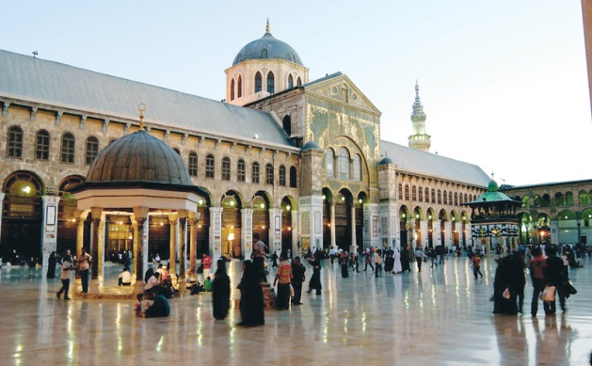

Figure 1. Umayyad Mosque in Damascus [12] [13]
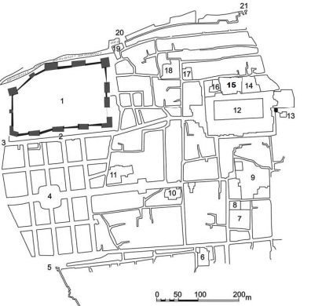 | 12. Umayyad Mosque  14. Al-Samisatiyya School  15. Al-Jaqmaqiyya School  17. Al-Dhahiriyya Al-Jawaniyya School  18. Al-'Adiliyya Al-Kubra School
Figure 2. Schools’ locations next to the Umayyad Mosque in Damascus [14]

  - THE EXTERNAL URBAN ELEMENTS OF LEVANTINE SCHOOLS AND THEIR RELIGIOUS AND CULTURAL DIMENSIONS
When school builders in the Levant were keen to choose distinctive sites for most of them, they supervised their construction with specifications that made them a unique cultural architectural masterpiece. School buildings were designed on geometric bases of various shapes to take advantage of every aspect. The most famous ones are the rectangular, semi-rectangular, and square shape. The spaces inside the school were built with strong materials, such as stone, marble, plaster, etc., to withstand the longest possible period of time in the face of natural and human challenges. Among these schools, whose building bases were in the form of a rectangle, semi-rectangle, or square, are the schools of the city of Aleppo (Figure 3), such as Asadiyya Al-Jawwaniyya school, Al-Dhahiriyya Al-Jawwaniyya school called Ayyubid Sultaniyya, and Al-Dhahiriyya Al-Barraniyya school. Meanwhile, the schools built in Damascus include (Figure 4) Al-Jaqmaqiyya, Al-Kamiliyya or Al-Tankaziyya, Al-Rukniyya Al-Barraniyya, and Al-Adliyya Al-Kubra School [15] [16] [17].
.

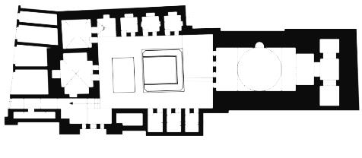
A. Al-Asadiyya Al-Jawwaniyah School [4]

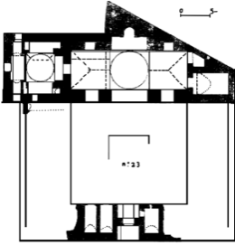 | 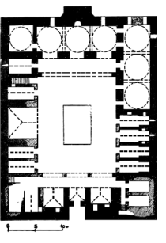
B. Dhahiriyyat Al-Jawwaniyah or Sultaniyyah Ayyubid school [18] | C. Al-Dhahiriyya Al-Barraniya School [18]
Figure 3. Design plans for school buildings in Aleppo
(A) (B) (C)

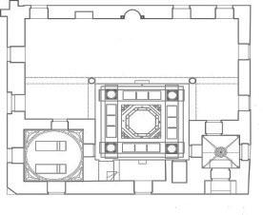 | 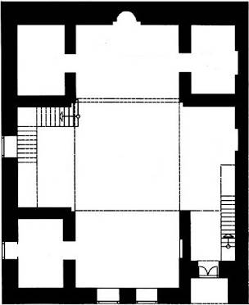
A. Al-Jaqmaqiyya school [14] [19] | B. Kamiliyya or Tanaziyya school [20]
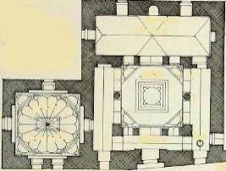 | 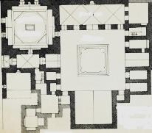
C. Al-Rukniyya Al-Barraniya school [21] | D. Al-Adiliyya Al-Kubra School [22]
Figure 4. Design plans for school buildings in Damascus
(A) (B) (C) (D)

The Levantine school building consisted of several external urban elements characterized by the Islamic style, and these urban elements reflected the religious, scientific, administrative, and aesthetic dimensions of those buildings and those working there. Among these elements are:

B. 1. THE DOME
Domes are considered the most important urban elements in Islam [23] [24] [25]. They were used in various eras of the Islamic State [26], from the Umayyad to the Mamluk era [27], and Muslims became creative in building them by using many types of building materials, such as stone and wood and covering them with plaster, or lead, and others. The style or shape of domes also developed throughout the Islamic eras. Domes appeared large and small, smooth and polygonal, and long-necked or short-necked, and they were decorated with ornaments and stalactites. They were built on mosques and over graves. When Muslims buried people in the schools they had built, they also built domes over their graves in those schools [28]. This reflected the religious dimension in the school so that, in its external appearance, it began to appear as a religious and scientific institution since the dome is considered a symbol of Islamic religious architecture. Another dimension that was reflected in the school was the urban aesthetic dimension. Its building and its external appearance, with the dome above it, became more beautiful if we compared it to another building that did not have a dome built over it.
Examples of schools over which domes were built in the Levant are the schools of Damascus (Figure 5). In the Al-Nuriyya School [1] [29] [30], two conical domes were built in the style of the Seljuk dome, which is distinguished by its length and the large number of stalactites (Muqarnas) that decorated the perimeter of the dome. We notice that each dome was built in a neck, short, and polygonal shape and contained several windows. Regarding Al-Farrukhshahiyya School [31] [32], it had two domes built on it, but the architectural style was different from the architectural style of al-Nuriyya School’s dome. We notice that the first dome was smooth, and the second one was grooved in shape, with vertical ribs. Each dome was built on a long neck consisting of two ribbed layers, containing a group of windows so that sunlight can pass through them. The architectural style of the two domes of al-Farrukhshahiyya school is considered a stage of transition from the Seljuk urban style to the Ayyubid urban style because the city of Damascus, when it was ruled by the Zengids, was built in Seljuk urban style that prevailed in building domes. Still, when Damascus was subjected to the rule of the Ayyubids, the Ayyubid urban style was applied for the domes. It was also applied to the rest of the cities of the Levant ruled by the Ayyubids at that time. Therefore, it became clear to us that the political and administrative dimension of these domes was reflected in al-Farrukhshahiyya school. Anyone who knows the types of domes and the types of urban style when looking at this school will know that it was built in the Al-Ayyubid era after observing the style of the domes that were built above them.
For the Al-Rukniyya school [1], it was also built with two domes on top of it; each of them grooved, with vertical sides. One of them was built on a short ribbed neck, different from the neck of the Farrokhshahiyya school’s dome.

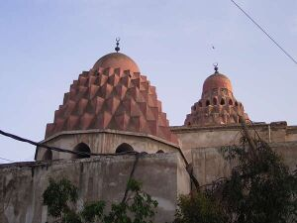 | 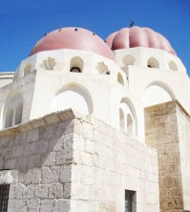 | 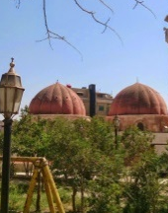
A. Al-Nouriyya School | B.Al-Farrokhshahiyya School | C. Al-Rukniyya school
Figure 5. Building domes over Damascene schools
(A) (B) (C)

B. 2. THE MINARET (AL-MI'DHANA)
The minaret (Al-Mi'dhana) is considered one of the religious urban elements that are usually built over mosques [33] [34] [35], but Muslims built it over educational schools as well. This added another religious dimension to the school, so its external appearance began to suggest that it was a religious and scientific institution at the same time. In addition, the minaret added an administrative dimension to the school as a Mu'azzin [36] was appointed in the school alongside the teachers. He would announce the time for prayers when the time came, so he would climb to the top of the minaret built in the school and raise the Al-adhan (a call to do prayer) in a loud voice, aiming to be heard by the people or Muslims so that they would come to pray [37] [38] [39].
Among the Levantine schools on which Al-Mi'dhana were built are the schools of Damascus (Figure 6), such as Al-shamiyya Al-Baraniyya school and Al-Mardaniyya school [2], and they are among the schools that were built in the Ayyubid era. Their geometric urban style was built in a square shape, except the Siba’iyya school [1], which appears in Figure 6. It was built in Damascus during the Mamluk era, and we noticed that its geometric shape was polygonal and was decorated with Islamic inscriptions and decorations, contrasted to the minarets of Al-shamiyya al-Barraniyya and al-Maridaniya schools, which were distinguished by their simplicity. Moreover, their wall appears smooth and devoid of decorations. This represents a shift in the style of Islamic architecture of the minaret from the Ayyubid style to the Mamluk style. This also has political and administrative dimensions for the school. Anyone who knows the types of minarets and their urban style when looking at the Saibai school will know that it was built in the Mamluk era after noticing the style of the minaret that was built above it.

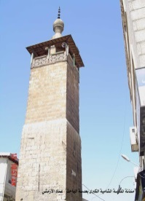 | 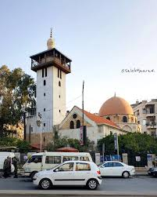 | 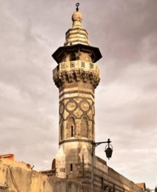
A. Al-Shamiyya Al-Barraniyya school | B. Al-Mardaniyya School | C. Al-Siba'yya School
Figure 6. Building minaret (Al-Mi'dhana) on Damascene schools
(A) (B) (C)

B. 3. EXTERNAL DECORATIONS AND SYMBOLS OF SCHOOLS
The external walls of the Aleppo and Damascene schools were distinguished by Islamic decorations [40] [41] [42] [43], written inscriptions, and symbols (Al-Rinuk) [44] [45] [46] placed inside the wall, which added a unique architectural beauty [47] [48]. For example, the decorations and writings with which they decorated the main entrance of the school [49] or the corners of the building (Figure 7), such as the Kamiliyya Al-Adimiyya School (Al-Taranta'iyya) [50], which was built in Aleppo at the end of the Ayyubid rule [51]. We can notice the decorations and stalactites (Muqarnasat) [52] [53] that were made above the main entrance of the school, in addition to drawing a square-shaped decoration above the entrance door. The same also applies for Al-Shathabkliyya Mamluk school in Damascus [54], which was done at the top of its main entrance stalactites and an inscription made directly above its door. Its wall was built with colored stone, which is white, black, and yellow, and is called Madamik. This method of construction distinguished the Mamluk era and was known as the Ablaqi style, meaning colored [55], so it increased the aesthetics of the school seen from the outside.
Besides the Al-Jaqmaqiyya Mamluk school in Damascus [1], we note the presence of decorations (Muqarnasat) in the corner of its outer wall, with Quranic verses inscribed on top of the decorations. The wall of the school was built in the Mamluk urban style, which is the planned (Ablaqi) style, and this is considered a qualitative turning point in the urban style. The Ayyubid style, which was characterized by its simplicity, and the Mamluk urban style, which was characterized by beautiful inscriptions and decorations, reflect the political and administrative dimension of the school. If a person looks at the school’s outer wall, he/she will know that this school was built in the Mamluk era after observing the Mamluk style of the school..

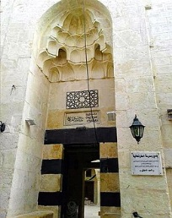 | 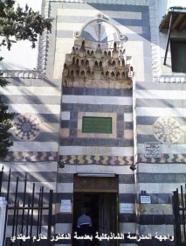 | 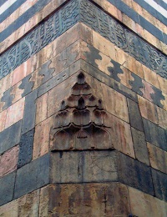
A. Al-Kamiliya Al-Adimiyya School in Aleppo | B. Al-Shathabklia School in Damascus | C. Al-Jaqmaqiya School in Damascus
Figure 7. Decorations and inscriptions on the external walls of Levantine schools (A) (B) (C)

Among the decorations that distinguished the Levantine schools, especially during the Mamluk era, were the symbols or emblems called Al-Rinuk [56] as they were installed inside the external wall of the school (Figure 8). The examples are the symbol (Al-rink) found on the wall of the Shathabkliyya school and the Siba’iyya School in Damascus. We notice that the shape of the symbol is circular, resembling a blooming flower or the sun, and a colorful Islamic decoration is engraved inside it.
When Prince Sayf al-Din Jaqmaq, the deputy of the Mamluk Sultan [1], built Al-Jaqmaqiyya School in Damascus, he placed his emblem, which represents his status as a prince, on the outer wall of his school. This had clear political and administrative dimensions that were reflected in the school, meaning that this school was built during his reign when he was the governor of Damascus. Most of the Mamluk sultans and princes had their own symbols or emblems (Rinuk) that they placed on the walls of buildings during their reign to commemorate them [47]. We note that the emblem of Prince Jaqmaq also symbolizes the shape of a blooming flower or the sun. The most important part of this emblem is its symbol, which is a circle in the center of the flower, and this circle is divided into three sections. The first section contains the symbol of Al-dawat [47], meaning the inkwell and the pens with which he writes [57], and it expresses the job of Prince Jaqmaq when he was working, taking the position of Dawadar for the Mamluk Sultan. He carries the inkwell, pens, and the rest of the Sultan’s writing tools [56]. As for the second and third parts of the slogan (Rink) of Prince Jaqmaq, the image of four cups is engraved, which symbolizes the function of water-bearer [47] [58]. These symbols (Rinuk) reflect the administrative dimension of the school in which they were placed. When a person with experience in symbols looks at them, he/she will know that the builder of this school was doing the job represented by this symbol.

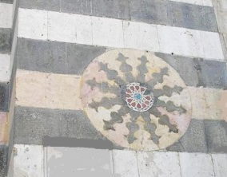 | 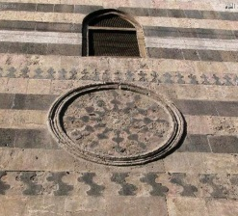
A. The rink of Al-Shathabklia School | B. The rink of Al-Sibaiyya School
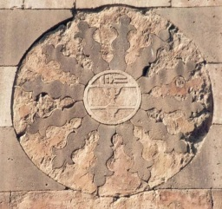 | 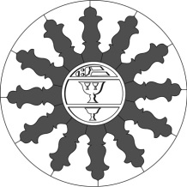
C. The symbol or emblem (rink) of Prince Jaqmaq on the wall of Al-Jaqmaqiyya School in Damascus [14]
Figure 8. Symbols (Rinuk) placed inside the outer wall of Damascene schools during the Mamluk era
(A) (B) (C)

C. THE INTERNAL URBAN ELEMENTS OF LEVANTINE SCHOOLS AND THEIR RELIGIOUS AND CULTURAL DIMENSIONS
Levantine schools contained several internal urban elements that had religious, scientific, psychological, economic, and other dimensions. Among these elements are:

C.1. PRAYER HALL (Al-MUSALLA)
It is one of the most important religious urban elements that school owners in the Levant were keen on, trying to make this urban element an essential part of the design of their schools. The prayer hall contained a minbar, the mihrab, and a beautiful school corridor [59]. The architects at that time excelled in drawing beautiful Islamic decorations on the wall of the prayer hall and the mihrab, which added architectural touches. One of the dimensions, which Al-Musalla reflects on the school as a scientific institution, is a religious dimension as teaching students is not limited to science only. Still, the school builders and teachers were keen to instill the religious values ​​and noble morals that Islam commands in the souls of the students and to teach them prayer etiquette and adherence to it at its specified times. The construction of the Al-musalla also had administrative dimensions for the school since the administrative official responsible for the school must appoint an Imam for prayer and a preacher, in addition to appointing a servant called Al-qayym whose job is to clean the prayer hall (Al-musalla) permanently [1]. We notice in Figure 9 that the large prayer hall in the Siba’iyya School in Damascus contains the mihrab and the Manbar, and the mihrab was decorated with Islamic decorations that increased its beauty. We can also notice a picture of the mihrab of the Dhahiriyya al-Jawwaniyyah (Sultaniyya) school in Aleppo in Figure 9 and how it was decorated with extremely magnificent decorations, in addition to a picture of Al-minbar of the Al-Shamiyya Al-Barraniyya School in Damascus [2].
The Musalla also reflected the scientific dimension of the school as we notice in Figure 2 that the Jaqmaqiyya school had a prayer hall built in it despite its location next to the Umayyad Mosque (Figure 2, 15. Al-Jaqmaqiyya School), and this has a very important scientific dimension, referring to the owner of the Jaqmaqiyya school when he built prayer hall. He wanted the students to devote themselves solely to learning and did not go out of school, to the Umayyad Mosque, to pray when the time came, but rather pray inside the school.

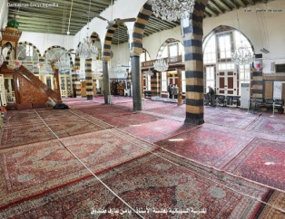 | 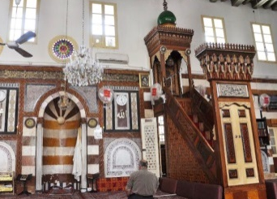
A. The prayer hall (musalla) of Al-Siba’yya School in Damascus | B. The pulpit (minbar) and mihrab in the prayer hall of Al-Siba’yya School in Damascus
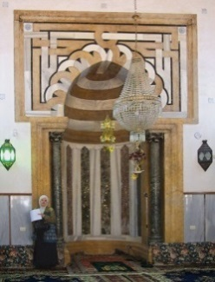 | 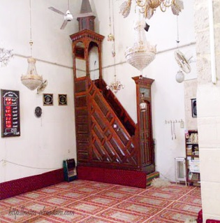
C. The mihrab of Al-Dhahiriyya Al-Jawaniyya School in Aleppo | D. The pulpit (minbar) of Al-Shamiyya Al-Baraniyya School in Damascus
Figure 9. The prayer hall, pulpit (minbar), and mihrab in schools in Damascus and Aleppo (A) (B) (C) (D)

C. 2. SCHOOLYARD
The courtyard is one of the most important urban elements in Levantine schools, and it is an essential element in the design of the school. The idea of ​​establishing the courtyard in schools is borrowed from the courtyards found in mosques built in all Islamic countries [60]. It is called the school courtyard (Al-Sahan), and a small water pool with different beautiful designs called Al-Fisqiyya or Al-Bahra is built in the middle of this courtyard. We notice, in Figure 10, the courtyard of Al-Kamiliyya School in Aleppo [3], and a water pool whose shape was designed with octagons, as well as the courtyard of the Al-dhahiriyya School in Aleppo, is located in the middle of it [3]. We can also see the water pool in it, which is rectangular, in addition to the courtyard of Al-Maridaniyya School in Damascus [2], which contains a square-shaped water pool, and the courtyard of the Al-Sayba’iyya School in Damascus [1], which has a rectangular water pool in the middle [61].AEJ

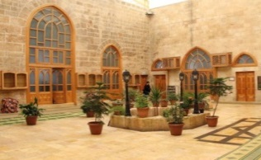 | 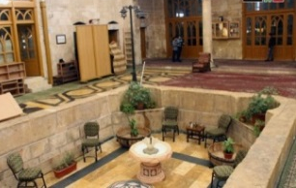
A. Al-Kamiliyya School in Aleppo | B. Al-Dhahiriyya School in Aleppo
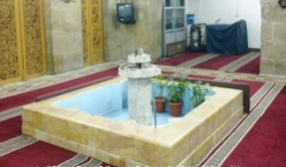 | 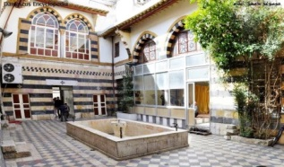
C. Al-Maridaniyya School in Damascus | D. Al-Siba'yya School in Damascus
Figure 10. Water pool in the courtyards of Levantine schools
(A) (B) (C) (D)

Then, rooms are built overlooking the school courtyard consisting of only three walls, not four, called Iwan [62] [63] [64], and we notice a picture of the Iwan in the Siba’iyya school and the Mardaniyya school in Damascus in Figure 11, which overlooks the school courtyard. These Iwans were used as teaching halls [1]. Here lies its importance when it is used as a teaching hall as the psychological impact of the courtyard, the water pool [65], and the Iwan is reflected on the psychology of the students as they sit in the Iwan overlooking the school courtyard and as they breathe in the fresh air and sunlight fills the study space. It makes them feel comfortable, calm, and free from any disturbance or pressure of studying, and it alleviates the pain of being away from their families if they are residing inside the school during the study period. From the virtual image in Figure 12, we can feel the positive psychological impact reflected on the students as they sit in front of the teacher in the Iwan overlooking the school courtyard [60] [66].

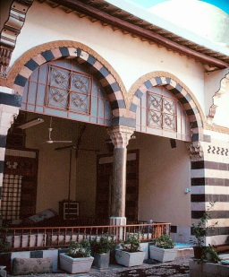 | 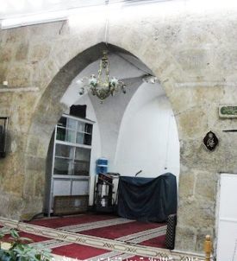
A. Al-Siba'yya School in Damascus | B. Al-Mardaniyya School in Damascus
Figure 11. Al-Iwan in Damascus schools (A) (B)

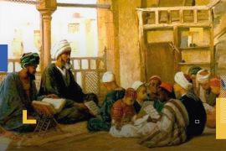
Figure 12. A virtual picture of students sitting in the Iwan of the Levantine schools, overlooking the courtyard
There are some small schools in the Levant whose courtyards are closed as a roof is built over their courtyard. The roof wall at the top contains many windows so that air and sunlight can pass through them, and the importance of this roof is to protect students, who are sitting in the school courtyard, from rain if the sky is rainy or to protect them from dust if the weather was dusty. An example of this is the roof of the courtyard of the Jaqmaqiyya school in Damascus, which appears in Figure 13. We also notice the construction of several windows at the top of the roof wall [66] [67].

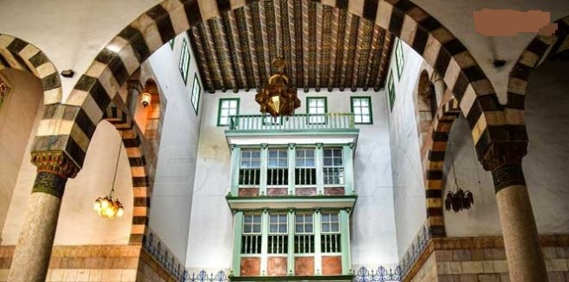
Figure 13. The roof of the courtyard of the Al-Jaqmaqiyya School in Damascus, which contains several windows at the top
C. 3. CLASSROOM
The designs of Levantine schools were not limited to building Iwans with three walls as study halls. Rather, regularly closed study halls were also built with four walls, not three. Levantine schools were of two types: large schools that contained a large number of classrooms and small schools that contained a small number of classrooms, such as two classrooms or one classroom. Examples of large schools include Al-Kamiliyya Al-Adimiyya School (Al-Taranta'yya), which contains forty classrooms in a row. Its upper floor and its lower floor are shown in Figure 14. Meanwhile, we notice in Figure 15 that Al-Shathabkliyya School in Damascus contained two classrooms [68], and Al-Farrukhshahiyya School in Damascus contained only one classroom [31].

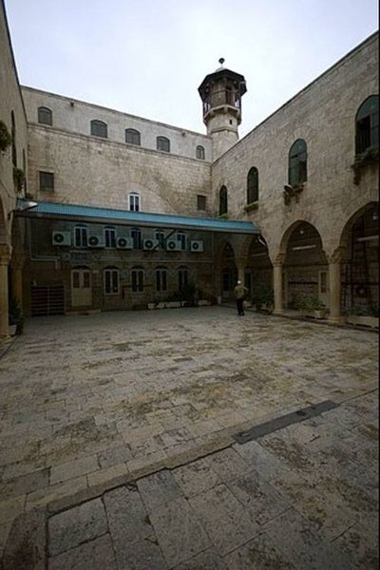
Figure 14. Classrooms in the upper and lower floors of the Taranta'yya School in Aleppo

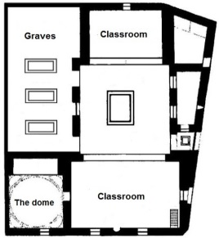 | 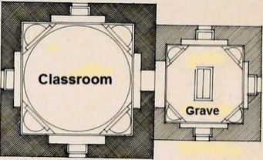
A. Two classrooms at Al-Shathabkliyya School [69] | B. One classroom at Al-Farrokhshahiyya School [70]
Figure 15. Classrooms in Damascus schools (A) (B)

The large number of classrooms in Al-Taranta'yya School in Aleppo reflects an important scientific dimension to scientific life in the Levant. Those dimensions are that Levantine society loved science, Levantine families were keen to put their children in these schools, and the number of students was large. Thus, it was necessary to provide a large number of classrooms in schools to receive these students. Historical sources indicate that Damascus contained hundreds of schools during the Zengid, Ayyubid, and Mamluk eras, and this is a clear evidence that Damascene society, in particular, and Levantine society in general, had a high demand for seeking knowledge. It prompted some members of Damascene society to build a large number of schools, in order to serve this community and achieve its desire to develop scientifically. It then led to the advancement of the scientific movement in Damascus at that time, and the emergence of many famous Damascene scientific families, which also contributed to support scientific life in Levant [71].
The size of these classrooms determined the capacity of students. In Al-Khatuniya School in Damascus, the number of students sitting in its classroom (Al-Iwan) was only ten students [1], there were only twenty students in one classroom in Al-Omariyya Al-Shaikhiyya School in Damascus [1], and the same number of students were also found in the classroom of the Tarkhaniyya School and Al-Asrouniyya School in Damascus [1]. Therefore, we notice that the supervisors of these schools have usually set the number of students at twenty students. This has an important scientific dimension, which is that they were intentional about making the number of students small in order to maintain the quality and integrity of the educational process during the lesson. The smaller the number of students in the classroom, the more teaching them has become easier for the teacher. This way, the students can have high concentration during the lesson.
C. 4. OTHER INTERNAL URBAN ELEMENTS
The Levantine schools contained other internal urban elements that made them a fully-fledged scientific institution capable of receiving students and providing them with the best scientific services. One of these elements is the library since Levantine schools have libraries that contained the scientific curricula that they taught or other scientific sources. A special employee was appointed in this library to supervise students who wanted to borrow the scientific resources they needed. This employee was called the library keeper [1], and among the Damascene schools that contained a library are Al-Tajiyya, Al-Dhahiriyya Al-Jawwaniyya, and Al-Dhia'yya Al-Jawwaniyya schools.
Levantine schools also included other internal urban elements, aiming to meet the daily needs of the students who live in these schools. The kitchen, where food is cooked for them, is one of these urban elements. An example of school that contain a kitchen is Al-Omariyya School in Damascus, in addition to building bathrooms and toilets in this school where the students live [2]. We can see the location of the bathrooms and toilets in the design of the building of Al-Siba'yya School in Damascus in Figure 16, as well as in the Al-Asadiyya Al-Jawwaniyya School in Aleppo.

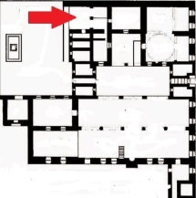 | 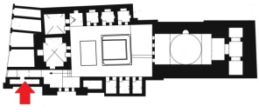
A. Al-Siba'yya School in Damascus [72] | B. Al-Asadiyya Al-Jawaniyya School in Aleppo [4]
Figure 16. Bathrooms and toilets in Levantine schools
(A) (B)

- CONCLUSION
At the end of this descriptive and analytical tour of the external and internal urban elements of schools in the Levant during the rule of Zengid state up to the Mamluk state, the study reached the following results:
The external architectural elements of the Levantine schools, such as domes and minarets, witnessed a remarkable development in their urban style, which was characterized by simplicity in the Zengid and Ayyubid eras. In contrast, the urban style in the Mamluk era was characterized by development. Features of luxury and extravagance appeared in it, so the external appearance of the school became more beautiful due to the development of architectural styles. It also appeared more Islamic after it was decorated with distinctive Islamic decorations and stalactites (muqarnas).
The urban elements of the Levantine schools were divided into several types; each type reflecting a special dimension. The religious urban elements such as domes, minarets, Islamic decorations, and prayer halls (Musalla) that contain pulpit (Manabir) and Maharib added a religious dimension to the school. Hence, the school appeared with these elements as if it were a religious and scientific institution at the same time. As a result, it is not possible to separate religion and science. Regarding the scientific urban elements, such as Al-Awawin, classrooms, and libraries, they enhanced the scientific dimension of the school. The service urban elements, such as the kitchen, bathrooms, and restrooms, reflected the personal dimension of the school owner, who was keen to provide these elements in the school to make it a scientific institution with integrated infrastructure. As for the courtyards and halls (Al-Awawin) overlooking it, they took into account the psychological state of the students.
The urban elements, such as domes, minarets, and emblems (Al-Rinuk), reflected the political and administrative dimension of the school. After its architectural style changed from the Zengid urban style to the Ayyubid urban style or the Mamluk urban style, the school became known for its external appearance in the era in which it was built. Also, when you see the symbols (Al-Rinuk) on its walls, you will recognize the personality of the king or prince who built this school as shown in Table 1 and Table 2.
Table 1. The external urban elements of Levantine schools and their religious and cultural dimensions: a comparison between the periods
Urban element | Zengid period | Ayyubid period | Mamluk period | The reflected dimension of the urban element
The dome | Its construction is simple. Its shape is conical and long, it contains stalactites, it is built on a short ribbed neck, and it contains several windows | its surface is smooth or polygonal, built on a long neck, and some of them are two stories high, containing windows |  | It reflected the religious, political, administrative, cultural, and aesthetic dimensions of schools.
The Minaret (Al-Mi'dhana) |  | Its shape is square and simple in construction. | Its geometric shape is polygonal and is decorated with Islamic inscriptions and decorations. | It reflected the religious, political, and administrative dimensions of schools.
External decorations and symbols of schools |  | Its walls and main entrance were decorated with decorations, inscriptions, muqarnas, and Islamic writings. | Its walls and main entrance were decorated with decorations, inscriptions, muqarnas, and Islamic writings. The walls were built with colored stone (white, black, and yellow), which is the Ablaqi style, and personal symbols (Al-Rinuk) were also engraved on its walls. | It reflected the religious, political, administrative, and aesthetic dimensions of schools.

Table 2. The internal urban elements of Levantine schools and their religious and cultural dimensions: a comparison between the periods
Urban element | Zengid period | Ayyubid period | Mamluk period | The reflected dimension of the urban element
Prayer hall (Musalla) |  | Its rather large areas distinguished it, and a Mihrab was built for the imam and a pulpit (Minbar) for the preacher. They were decorated with beautiful Islamic decorations. | It was distinguished by its rather large areas, and a Mihrab was built for the imam and a pulpit (Minbar) for the preacher. They were decorated with beautiful Islamic decorations. | It reflected the religious, administrative, scientific, and aesthetic dimensions of schools.
School yard (Al-Sahan) |  | The schoolyard is usually open and contains a pool of water of various shapes. Rooms are built in it, opening onto the courtyard, in addition to the construction of classrooms with four walls. | The schoolyard is usually closed with a roof and contains a water pool of various shapes, and rooms are built in it, opening onto the courtyard, in addition to the construction of classrooms with four walls. | It reflected the scientific, psychological, and aesthetic dimensions of schools.

REFERENCES

[1] A. M. Al-Nuaimi, Al-daris fi Tarikh al-madaris, Beirut: Dar al-Kutub al-Ilmiyya, 1990.
[2] A. A. ibn-Badran, Munadamat al'atlal wa musamarat al-Ikhayal, Beirut: Islamic Office, 1985.
[3] A. I. Abu-Dhar, kunuz al-dhahab fi tarikh halab, Aleppo: Dar Al-Qalam, 1996.
[4] L. Jasser, Aleppo’s Archaeological Schools, Their History and Architecture, Aleppo: Dar Radwan, 2000.
[5] Q. Al-Shihabi, The Minarets of Damascus, History and Style, Damascus: Ministry of Culture Publications, 1993.
[6] K. Weltsinger and K. Watsinger, Islamic Antiquities in the City of Damascus, Damascus: Dar Al-Muqtasab, 1948.
[7] M. Bin Shosh, "Civilizational achievements of the Alzinkia state and its effects in the East during the centuries of (6-7 AH/12-13 AD)," Journal of Historical Research, Vol. 6, No. 1, pp. 222-235, 2022. https://www.asjp.cerist.dz/en/article/193654.
[8] B. M. Kasouha, S. Hamoudi, and S. loyalty, "Salah al-Din al-Ayyubi and the Establishment of the Ayyubid State," Al-Baath University Journal -Series of historical, geographical and social sciences, Vol. 43, no. 10, pp. 59-113, 2021. https://albaath-univ.edu.sy/journal/index.php/History/article/view/465.
[9] N. A. Fathy, A. A. Salam, and R. S. Abu Zaid, "The role of establishments in Egypt in the Mamluk era (Mosque - School - Khanqah) On Segments of society 923 - 648 AH / 1250 - 1517 AD," Scientific journal of the College of Arts, Vol. 49, pp. 1203-1226, 2022. Doi: https://doi.org/10.21608/jartf.2022.277205.

[10] A. Fabrizio, "THE ROLE OF THE UMAYYAD MOSQUE OF DAMASCUS IN CONCEIV-ING THE PAVILION OF NIẒĀM AL-MULK IN ISFAHAN," Journal of Islamic Architecture, Vol. 7, no. 4, pp. 565-573, 2023. DOI: https://doi.org/10.18860/jia.v7i4.21367.
[11] R. S. Awad, "The impact of inheritance of professionalism on damascus xxxxx | [El impacto de la herencia del profesionalismo en damasco," Opcion, vol. 34 (Special Issue 17), pp. 926-940, 2018.
[12] S. Mohd and B. Jijakli, "A Historical and Architectural Comparative study of Umayyad Mosque in Damascus And Great Mosque of Hama," The Scientific Journal of King Faisal University: Humanities and Management Sciences, Vol. 0, no. 0, pp. 1-10, 2020. Doi: 10.37575/h/his/2225.
[13] M. A. Khair dan M. A. Al-Turk, “Patterns of formal diversity in Islamic architecture: The architecture of the Umayyad state in the Levant, the Umayyad Mosque as a study model,” Journal of Human Sciences, Vol. 1, no. 19, p. 47 – 62, Mar. 2018. http://search.mandumah.com/Record/960712.
[14] G. Yaghi, Monuments of Islamic Civilization in Syria, Morocco: Islamic Educational, Scientific and Cultural Organization, 2011.
[15] H. S. Jandeel and R. S. Awad, "Al-Nu'imi and his book (aldaris fi tarikh almadaris)," University of Kirkuk Journal for Humanistic Studies, University of Kirkuk, Vol. 8, No. 2, pp. 193-219, Sep 2013. https://iasj.rdd.edu.iq/journals/journal/issue/5603.
[16] Y. Q. Jaber, "Schools of princes and eyes in Egypt and the Levant during the Ayyubid era (565-648 AH / 1169-1250 AD) Study of cultural administration," College of Arts Journal, Vol. 4, no. 55, pp. 178-198, Jun. 2020. Doi: https://doi.org/10.21608/jfabsu.2020.191856.
[17] F. Z. Anizan, "An architectural vision in the book: al-thughar al-basaam fi dhikr man walia qada' al-shaam libn tulun(d. 953 AH)," Midad AL-Adab Referred Quarterl Journal, Vol. 3, no. 1, pp. 1-30, Oct. 2022.
https://digitalcommons.aaru.edu.jo/midad/vol3/iss1/15 [Accessed 27 Feb. 2024].
[18] M. A. Talas, Islamic and Historical Monuments in Aleppo, United Kingdom: Hindawi Foundation, 2022.
[19] S. A. Hussain and M. A. Al-Jbour, "The four religious schools and their role in intellectual life in The Mamluk era (700 – 850 AH / 1300 – 1446 AD)," Tikrit University Journal of Human Sciences, Vol. 25, no. 11, pp. 345-359, 2018. https://www.iasj.net/iasj/article/182372.
[20] I. Al-Armashi, "Kamiliyya or Tanaziyya school," Damascus Al-Yasmine Research in Damascene History, 17 Apr. 2020. [Online]. Available: https://naim-almadani.com/viewtopic.php?t=5. [Accessed 26 jan. 2024].
[21] I. Al-Armashi, "Al-Rukniyya school, the Ayyubid schools in Damascus," Mesothelioma and Asbestos, 12 Aug. 2018. [Online]. Available: https://labview44.rssing.com/chan-61942484/article41602.html. [Accessed 26 jan. 2024].
[22] I. Al-Armashi, "Al-Adiliyya Al-Kubra School in Damascus," Damascus Al-Yasmine Research in Damascene History, 14 Aug. 2020. [Online]. Available: http://naim-almadani.com/viewtopic.php?t=15. [Accessed 26 jan. 2024].
[23] I. S. Al-Shammari, "Highlights on the architecture of Arab-Islamic domes and their types: The Dome of the Sunrise in the city of Hilla as an example," Journal of the Babylon Center for Humanitarian Studies, Vol. 12, no. 3, pp. 449-486, 2022. https://www.iasj.net/iasj/article/241422.
[24] S. E. Sharif, "Appearances of the Influence and Effect of the Arts of Dome Architecture in Different Civilizations," Journal of Architecture, Arts and Humanities, vol. 7, No. 6, pp. 65-90, Dec. 2022. Doi: 10.21608/mjaf.2022.131897.2730.
[25] K. Sameh, “The development of the dome in Islamic architecture.,” College of Arts Journal, Vol. 1, no. 12, pp. 3 - 36, May 1950. http://search.mandumah.com/Record/502283.
[26] N. K. al-Hakim, Safar Nama, Beirut: New Book House, 1983.
[27] M. A. ibn-Jubair, Rihlat Ibn jubair, Beirut: Al-Hilal House and Library, 1852.
[28] M. H. Al-Haddad, Domes in Egyptian Islamic Architecture, Cairo: Library of Religious Culture, 1993.
[29] R. Natifa, M. Manoun and D. Trife, "The local effects on the architectural characters Of schools during the Islamic era in Syria," Tishreen University Journal for Research and Scientific Studies – Engineering Sciences Series, Vol. 36, no. 4, pp. 337- 354, jul. 2014. [Online]. Available: https://journal.tishreen.edu.sy/index.php/engscnc/article/view/1147 [Accessed 27 Feb. 2024].
[30] N. S. Mohsen, "educational institutions during the era of Nour al-Din Mahmoud and their impact on the reform process, schools as an example," Journal of Islamic Research and Studies, vol. no. 58, pp. 331-358, 2019. [Online]. Available: https://www.iasj.net/iasj/article/174024 [Accessed 27 Feb. 2024].
[31] I. I. ibn-Katheer, Al-bidaya wal-nihaya, Damascus: Dar Al-Fikr, 1986.

[32] A. R. Ahmed and T. F. Sultan, "Princess Schools in Al –sham Province During the Ayoubi Period ( 570-658 AH / 1161-1260 AD)," College Of Basic Education Researches Journal, Vol. 7, no. 4, pp. 197-219, 2008. [Online]. Available: https://www.iasj.net/iasj/article/7553 [Accessed 27 Feb. 2024].
[33] M. M. Al-Khazmi, "The Minaret: Its Origin - Its Origins - Its Elements," Academy Journal for Basic and Applied Sciences, Vol. 15, no. 1, pp. 10-14, Feb. 2016.
[34] Y. M. Salah and R. M. El Attar, "The Symbolism of Contemporary Mosques Minarets between the Content and the Heritage," MEJ- Mansoura Engineering Journal, Vol. 46, no. 4, pp. 22-34, December 2021. DOI: 10.21608/bfemu.2021.209664.
[35] S. L. Abdel Amir, "The Aesthetic Dimensions of the Minaret in Islamic Architecture," Journal of University of Babylon, Vols. 18, no. 2, pp. 549-556, 2010. [Online]. Available: https://www.iasj.net/iasj/article/37209 [Accessed 27 Feb. 2024].
[36] Z. A. ibn-Rajab, Dhayl tabaqat al-hanabila, Riyadh: Obeikan Library, 2005.
[37] J. H. Muhaisen and A. A. Abdul Hussein, "Artistic Elements of Islamic Minarets," Al-Qadisiyah Journal for the Humanities, Vol. 22, no. 4, pp. 97-120, 31 Dec. 2019. [Online]. Available: https://www.iasj.net/iasj/article/174545 [Accessed 27 Feb. 2024].
[38] A. M. Yahya, "Akram Muhammad Yahya, The multiplicity of shapes of minarets and the diversity of their names depending on their function," Wasit Journal of Humanities and Social Sciences, Vol. 18, No. 50, pp. 87-120, Feb. 2022. Doi: https://doi.org/10.31185/.Vol18.Iss50.163.
[39] M. M. Ibrahim, “Minarets: The Art of Vertical Construction in Islamic Architecture,” Al-Thaqafa journal, Vol. 6, no. 66, pp. 48-51, Dec. 2017. [Online]. Available: https://search.mandumah.com/Record/850762 [Accessed 27 Feb. 2024].
[40] S. M. Al-Mutairi dan S. Hosawi, “Contemporary Accessories Design in Textile Style Inspired by the Islamic Architectural Aesthetics in Damascus,” Saudi Art and Design Journal, Vol. 1, no. 1, pp. 88- 114, Dec. 2021. DOI: 10.57194/2351-001-001-004.
[41] A. I. Mahmoud, S. M. Ali and A. A. Desouky, "An analytical study of some complex elements in both Egypt and the Levant," Journal of Specific Education Research, Vol. 2014, no. 34, pp. 423-446, Apr. 2014. DOI: 10.21608/mbse.2014.141372.
[42] S. M. Hawass, "SYMBOL IN PLANT ORNAMENTAL TO ISLAMIC ARCHITECTURE," Journal of the college of basic education, Vol. 25, no. 104, pp. 711-742, 2019. [Online]. Available:https://www.iasj.net/iasj/article/169238
[Accessed 27 Feb. 2024].
[43] H. S. Abdel Maqsoud, "The aesthetic and functional values of Islamic art and their role in enriching the visual fabric of society in the modern era," Journal of Architecture, Arts and Humanities, Vol. 3, no. 12 (2), pp. 620-633, Oct. 2018. Doi: https://doi.org/10.21608/0048980.
[44] D. Ali, "The impact of Ronok aesthetics on Mamluki pottery," Journal of Architecture, Arts and Humanities, Vol. 2, no. 7, pp. 180-193, Jul. 2017. Doi: https://doi.org/10.12816/0038029.
[45] I. G. Saber, "Al-Ranouk in the Mamluk era and its development in the modern era," Journal of the Faculty of Arts, Vol. 2, no. 33, Oct. Dec. 2014.
[46] A. Al Tohamy, "Mamluk rinuks on archaeological tombstones and structures at the Museum of Islamic Art in Cairo," Yearbook of Arab Archaeologists, Vol. 4, no. 4, pp. 751-764, 2001. DOI: 10.21608/cguaa.2001.41456.
[47] A. A. Razek, "Al-Ranuk during the era of the Mamluk sultans," Egyptian Historical Journal, vol. 21, p. 67 – 116, May 1974. [Online]. Available: https://archive.alsharekh.org/Articles/353/22344/507011 [Accessed 27 Feb. 2024].
[48] S. A. Rizk, "Al-Ranuk: Its meanings and uses in the Mamluk era," Journal of the College of Arabic Language in Cairo, vol. No. 1, p. 1013 – 1032, 2000. [Online]. Available: https://search.mandumah.com/Record/154101 [Accessed 27 Feb. 2024].
[49] A. Shaheen, "aesthetic values and structural systems of selected Mamluk architecture. To attract tourism locally and internationally," Journal of Architecture, Arts and Humanities, Vol. 6, no. 2, pp. 44-63, Apr. 2021. Doi: https://doi.org/10.21608/mjaf.2021.47455.2031.
[50] m. aldiri' and M. Hammadh, "Al-Kamiliya School in Aleppo," Nahj Al-Islam journal, Vol. 26, No. 98, pp. 145-149, May 2005. [Online]. Available: https://search.mandumah.com/Record/353804 [Accessed 27 Feb. 2024].
[51] M. A. Al-Muhabi, khulasat al'athar fi 'ayan al-qarn al-hadi ashar, Beirut: Dar Sader, 1990.

[52] A. Ahmed, "THE SPIRITUAL SEARCH OF ART OVER ISLAMIC ARCHITECTURE WITH NON-FIGURATIVE REPRESENTATIONS," Journal of Islamic Architecture, Vol. 3, no. 1, pp. 1-13, 2 sep. 2014.Doi: https://doi.org/10.18860/jia.v3i1.2538.
[53] J. Ashtawi, "Islamic Architecture," erash for Research and Studies Journal, Vols. 23, no. 1, p. 1848 – 1866, 16 October 2022. [Online]. Available: https://digitalcommons.aaru.edu.jo/jpu/vol23/iss1/66 [Accessed 27 Feb. 2024].
[54] A. H. Al-albi, khutat dimashq, Beirut: Dar Qabis for Printing, Publishing and Distribution, 1989.
[55] M. A. Kird-Ali, khutat al-shaam, Damascus: Al-Nouri Library, 1983.
[56] A. A. Al-Qalqashandi, Subh Al-A’sha fi sina'at al'insha, Beirut: Dar Al-Kutub Al-Ilmiyya, no. d.
[57] Z. M. Al-Razi, Mukhtar al-Sahhah, Beirut: Sidon, Modern Library, Dar al-Tawdhimiya, 1999.
[58] A. R. Ahmed, Al-Rinuk Al-Islamiyya, Egypt: Al-Hariri Printing House, 2006.
[59] M. Harba, "The Mihrab and the Minbar: The Two Jewels of Islamic Mosques," Nahj al-Islam journal, Vol. 11, no. 41, p. 135 – 139, Oct. 1990. [Online]. Available: https://search.mandumah.com/Record/360361 [Accessed 27 Feb. 2024].
[60] S. Dwidar, H. Sirror, A. Derbali, D. Abdelgawad and A. Abdelsattar, "Importance of Internal Courtyards in Designing Historical and Contemporary Masjid," Journal of Islamic Architecture, Vol. 7, no. 2, pp. 356-363, 15 Dec. 2022. DOI:https://doi.org/10.18860/jia.v7i2.16065.
[61] H. Q. Moaz, "Water in the Arab-Islamic Garden between Symbolic Materialism," Aleppo University Research Journal, vol. No. 102, pp. 1-20, 21 Dec. 2011.
[62] M. A. Dahman, A Dictionary of Historical Terms in the Mamluk Era, Beirut: Dar Al-Fikr Al-Mashur, 1990.
[63] M. A. Makkawi, R. A. Abdel Tawab and J. H. Zahran, "The Light Screens and Effectiveness in the Interior Space Islamic Architecture," Journal of Architecture, Arts and Humanities, Vols. 2, no. 7, p. 418 – 439, Jul. 2017. Doi: https://doi.org/10.12816/0038043.
[64] A. A. Mahmoud and R. J. Al-Samarrai, "Iwawin house of Ziad Al-Jalili," Journal of Historical and Archaeological Studies, vol. 81, pp. 173-202, Apr. 2022. [Online]. Available: https://jcoart.uobaghdad.edu.iq/index.php/2075-3047/article/view/339.
[65] H. Abdullah, M. T. Hussien, R. M. Omar and A. M. Gawish, "The courtyard and its functional importance in religious and civil buildings during the Islamic era," International Journal of Tourism and Hotel Studies, Vol. 2, no. 1, pp. 17-35, Jan. 2022. Doi: https://doi.org/10.21608/ijthsx.2021.100273.1015.
[66] I. Karim, "a study of the effect of the inner courtyard in addressing the climatic and social conditions of Arab residential units," Babylon University Journal: Pure and Applied Sciences, Vol. 17, no. 1, pp. 446-455, 30 Apr. 2019. [Online]. Available: https://search.emarefa.net/detail/BIM-243838 [Accessed 27 Feb. 2024].
[67] F. S. Ahmed, A. H. El shafaei and M. T. Abu Gabr, "Studying The Evolution of Lighting Techniques in Islamic Art," Journal of Architecture, Arts and Humanities, Vol. 5, no. 24, pp. 332 - 346, Nov. 2020. DOI: 10.21608/mjaf.2019.16565.1313.
[68] Q. Al-Shihabi, Damascus Historical Dictionary, Damascus: Ministry of Culture Publications, 1999.
[69] I. Al-Armashi, "Al-Shathabkliyya School," Damascus Al-Yasmine Research in Damascene Historyhttps, 15 May. 2020. [Online]. Available: https://naim-almadani.com/viewtopic.php?t=195 [Accessed 27 jan. 2024].
[70] I. Al-Armashi, "Ayyubid Schools in Damascus: Al-Farrokhshahiyya School," Muntadayat wahaj al-dhikra, 13 Jan. 2019. [Online]. Available: http://wahjj.com/vb/showthread.php?t=26479 [Accessed 27 jan. 2024].
[71] R. S. Awad, "The Role of Scientific Family Traditions in Societal Advancement in the Levant and Egypt: A Focus on Ibn Saghīr’s Family (478-759 AH / 1085-1357 AD)," Journal of Islamic Thought and Civilization, Vols. 14, no. 2, pp. 28-41, 24 Dec 2024. [Online]. Available: https://doi.org/10.32350/jitc.142.03.
[72] I. Al-Armashi, "Al-Siba'yya School: schools of the Mamluk era," Damascus Al-Yasmine Research in Damascene History, 02 May. 2020.

