 |  | JOURNAL OF ISLAMIC ARCHITECTURE  P-ISSN: 2086-2636 E-ISSN: 2356-4644  Journal Home Page: http://ejournal.uin-malang.ac.id/index.php/JIA
GEOMETRIC MODELS OF ISLAMIC ARCHITECTURE FROM UMAYYAD TO THE END OF THE OTTOMAN ERA IN THE LIGHT OF SELECTED EXAMPLES
MOHAMED ENAB^{a*}
ªFaculty Of Archaeology, Fayoum University, Egypt
*Corresponding Author: Maa25@fayoum.edu.eg
ARTICLE INFO |  |  | ABSTRACT
Volume: 8  Issue: 2  Page: 318-339  Received: February 20th, 2024  Accepted: May 27th, 2024  Available Online: December 15th, 2024  DOI: 10.18860/jia.v8i2.25948 |  |  | This study explores the history and evolution of geometric models in Islamic architecture up to the Ottoman era. It seeks to understand the emergence of these models and their uses in the Islamic era, analyzing the cultural, religious, and social factors that influenced their appearance and design. The study reveals the ingenuity of early Muslims in architectural engineering as they not only depicted their architectural works in two-dimensional drawings but also created three-dimensional geometric models using precise engineering methods. This trend extended beyond Muslim architects to include foreign architects who admired and documented Islamic architecture with geometric models. The study investigates the significance, purposes, diverse forms, and materials used in producing these models, emphasizing the cultural, artistic, and engineering dimensions of the heritage. Furthermore, it underscores the importance of preserving this heritage and deepening the understanding of its impact on the present. The researcher employs several research methods, including the historical-inductive approach by tracing references in historical sources and the descriptive-analytical method for selected models remaining from these geometric models.  Keywords:  Conrad Schick; Dome of the Chain; Geometric Models; Islamic Architecture; Maquette

- INTRODUCTION
Geometric patterns are integral to Islamic architecture and arts. They are reflected in designs, ornamentation, and other creative ventures. Precision, harmony, and intricate detailing define Islamic art and architecture. Muslim architects who excelled in engineering meticulously plan and do the blueprints drafting for various structures while adhering to artistic principles and technical considerations [1]. The plans and drawings were pivotal in the artistic creative process, illustrating ideas, regulating engineering details, and guiding craftsmen as well as architects toward precise execution. Muslim Arabs, renowned for their mathematical, engineering, and mechanical sciences proficiency, utilized this expertise to implement Islamic architectural plans and intricate ornamentation precisely [2].
In this context, engineers generated a range of flat plans depicting different buildings, illustrating either the horizontal section or a specific facet of the structure. They utilized the perspective method beyond conventional two-dimensional architectural drawings, capturing architectural and artistic works in three dimensions (length, width, and height). Consequently, the concept of crafting three-dimensional geometric models of various buildings emerged, representing a significant sculptural art form embraced by Muslim rulers throughout history [3].
Some previous studies dealt with Geometric Models in Islamic Architecture. One of them is the research entitled “al-rusūmāt al-handasīya lil-ʿamāʾr al-Islāmīya” conducted by Ḥ. ʿabd al-Wahhāb. This study dealt with the general geometric design in Islamic architecture and was limited to the first period of Islam. Another research entitled “Plans and Models in 15th and 16th Century Ottoman Architectural Practice” was conducted by G. Necipoğlu. The study focuses on geometric design in Islamic buildings, specifically during the Ottoman era. The researcher aims to comprehensively understand the significance of architectural models in architectural design evolution. This entails investigating the origins, purposes, and existing museum examples of architectural models as well as exploring their historical development across various eras to underscore their importance in architectural history.
This study aims to trace the historical emergence of architectural models in Islamic architecture, elucidate their purposes, identify prominent examples and makers from the Umayyad to Ottoman eras, and examine their production context. Ultimately, it seeks to comprehend their evolution and significance within Islamic architectural history.

- METHODS
This research employs a comprehensive methodology, including a thorough literature review, selection of representative examples, historical-inductive analysis, descriptive-analytical examination, comparative study, integration of archaeological perspectives, and interpretation leading to conclusions. It ensures a holistic investigation of geometric models in Islamic architecture, spanning historical, architectural, and archaeological dimensions. The methodology aims to provide a rigorous examination, combining historical, archaeological, descriptive, and analytical approaches. The study is divided into two sections and a conclusion. The first section defines "architectural models" linguistically and archaeologically, exploring their types, forms, purposes, and applications in Islamic architecture from the Umayyad to the Ottoman eras. The second section focuses on a descriptive study of remaining examples, highlighting two prominent makers during the Ottoman era: Russian architect named Pavel Notbeck (1824-1877 AD) and German architect named Conrad Schick (1822-1901 AD). This division facilitates a detailed examination of these models, enriching our understanding of their significance in Islamic architectural history.

- RESULT AND DISCUSSION
It is worth mentioning that Linear perspective gained prominence in the Islamic civilization around the 10th century AH/16th century AD, following exposure to European principles. Interaction with European missions and their illustrated literature facilitated this exchange. Notably, the Indian Mughal and Ottoman painting schools adopted these principles, emphasizing extreme realism and adherence to perspective rules in architectural drawings and landscapes. Proficiency in engineering drawing was a key requirement for chief architects appointed by Indian and Ottoman sultans [4].

  - THE FIRST SECTION
This section aims to define "architectural models" from linguistic and archaeological perspectives, exploring their types, forms, purposes, and applications in Islamic architecture up to the Ottoman era.

- 1. Definition of the term "models"
Architectural models refer to three-dimensional shapes, derived from the Arabic root "Ǧasam," which means to give something a tangible form. In this context, "Ǧassam" means to embody an idea, giving it a tangible form, realistic appearance, and specification. In the architectural context, a model is defined as a surface composed of flat faces with two dimensions meeting at straight edges and vertices that can be called corners. Therefore, architectural models are three-dimensional counterparts of polygons [5]. So, a model is anything that has length, width, and height, and models are considered a branch of mathematics that explores three-dimensional shapes and surfaces [6].
In the Ottoman era, models were known as "form," "Maquette," or "Örnek". The word "Maquette" is a French term meaning model, and it refers to the conversion of architectural designs into miniature architectural designs to be built in nature on a smaller scale but with the same proportions and dimensions as planned. It is a visual representation of a building to show what it will look like when completed in nature before starting its construction [6]. The word "Örnek" is a Turkish term meaning a model or an example [7]. It refers to architectural and decorative designs in general, which are prepared in advance before the construction of buildings or the decoration of artistic artefacts [8].

- 2. History of Architectural Modelling
Dating back to ancient times, architectural modelling is among the oldest visual arts forms, closely linked to sculpture. Unlike two-dimensional art, it utilizes three-dimensional shapes. Ancient Egyptians pioneered this practice. They view it as integral to engineering and architecture, which is evident in the discovery of miniature pyramid models and crucial for project planning and execution [9]. The appearance and use of architectural models persisted through the Islamic period, notably increasing during the 13th century AH/19th century AD. Interaction with Europe further popularized their usage, exemplified by Egypt, where European-educated engineers and foreign architects dominated the architectural scene during this era [10].
These models were commonly crafted by a team of skilled artisans proficient in sculpting, carpentry, and plasterwork under the supervision of an architect with archaeological expertise. The architect oversaw each production stage to ensure adherence to precise drawing standards, coherence between architectural elements, and meticulous review of all architectural and decorative details. Some craftsmen developed such proficiency in model production that they were considered architects [11].

- 3. Types of these Models and their Manufacturing Materials
Models serve diverse purposes across disciplines: education, engineering, and economics. They come in various forms depending on their intended use, such as scale models depicting simplified external shapes and open models revealing internal intricacies. Disassembled models illustrate internal relationships, while longitudinal and transverse section models offer detailed insights into internal structures, among other variations [12].
The forms of architectural models varied based on their functional purposes. They could be pre-existing models for visualizing proposed constructions or commemorative souvenirs for significant buildings. These models aimed to immortalize and evoke the value of buildings, documenting renovations or additions. Some were crafted for celebrations or presented as commemorative gifts. The sizes and materials of these models varied depending on their functional purposes [13].
Various materials were employed in crafting these models, with wood being predominant for its ease of shaping and assembly. During the Fatimid era, unconventional materials like wax and candy were utilized. In later periods, stucco gained popularity, particularly during the Ottoman era, for its affordability and ease of shaping to depict the original models accurately. Additionally, luxurious materials like gold and silver adorned models presented as commemorative gifts to royalty and dignitaries [14].
In some cases, authentic archaeological materials from damaged ancient sites are repurposed to construct models depicting Islamic architectural elements. These remnants are meticulously collected, restored, and arranged to mirror the originals in appearance and size closely. Western Orientalists fascinated by Islamic antiquities often collected them and subsequently donated them to museums. Notable examples, like the Damascus Room at the Metropolitan Museum of Art in New York, dating back to 1707 AD, showcase the rich decorative creativity of their respective historical eras. Other examples include the Damascus Room at the Museum of Islamic Art in Qatar and Dresden, Germany, dating back to the 19th century [15], as shown in Figure 1, 2, and 3.

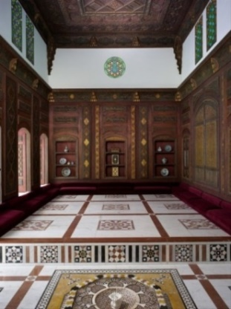 | 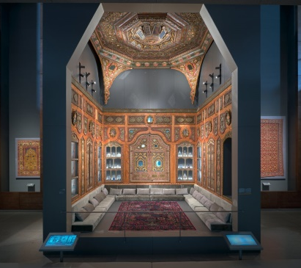 | 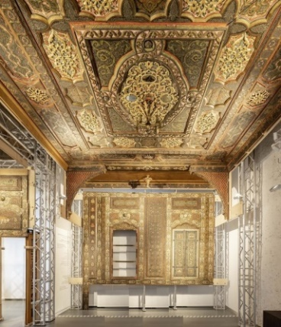
Figure 1. Damascus Room at the Metropolitan Museum of Art in New York [16] | Figure 2. Damascus Room at the Museum of Islamic Art in Qatar [17] | Figure 3. Damascus Room in Dresden, Germany [18]

- 4. Purposes of these Models
Architectural models serve diverse purposes, primarily as pre-construction representations of intended designs. They are a preliminary representation of the structures being considered for construction. They provide a visual aid for understanding complex aspects that two-dimensional drawings may not convey. Architects use them to persuade sponsors and facilitate initial discussions, especially for projects far from sponsors' residences, which is common in the expansive Islamic state [3], [19]. In this context, architectural models are crucial in comprehensively visualizing proposed projects or buildings and clarifying all architectural details. They can be adjusted multiple times to achieve final stakeholder satisfaction, reducing errors during construction and minimizing defects related to shape or decorations. The Dome of the Chain in Al-Haram al-Sharif in Jerusalem exemplifies the effectiveness of using models, being the first and oldest surviving model upon which the Dome of the Rock was based [20], as can be seen in Figure 4.

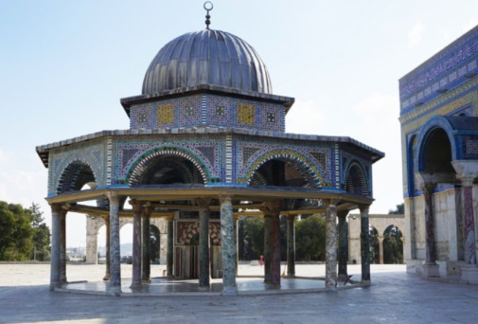

Figure 4. The Dome of the Chain in Jerusalem [21]

Before the widespread use of architectural models, Islamic-era architects relied on drawings and illustrative representations to plan buildings and their components before execution. As an example, during the Abbasid Caliph Abu Ja'far al-Mansur's reign in 141 AH/758 AD, architects created a plan for Baghdad by placing cotton seeds on the ground and burning them to form lines of ash, representing the city's map. Al-Mansur walked among these lines, approving the plan, and ordered the city's construction based on the ash foundations, completing it in four years [22].
Illustrations on leather were highly esteemed, exemplified by an incident during the construction of Ahmed Ibn Tulun's mosque in Egypt in 263 AH/876 AD. When faced with the challenge of acquiring 300 columns without taking them from churches, Ahmed Ibn Tulun sought assistance from his Christian engineer, Sa῾īd Ibn Kātib. He is known as al-Farġānī, renowned for his architectural expertise. Ibn Tulun wrote to him: "I am building it for the Amīr (leader) as he wishes, except for the two columns of the Qibla" [23]. Ibn Tulun summoned Sa῾īd to explain his plan. Sa῾īd suggested drawing it for the Amīr to see. Ibn Tulun agreed, ordering leather for the building plan's depiction. Pleased with the result, Ibn Tulun approved it and ordered its execution. This practice persisted in Islamic periods until the advent of architectural models [24].
One of the earliest instances illustrating architects' use of models to clarify their designs is the case of the builder of the minaret of the Great Mosque of Tozeur in Southwest Tunisia in 422 AH/1030 AD. He fell ill during the construction and created three wax models of its top to choose from upon completion. Subsequently, he appointed a builder from Kairouan to complete the minaret according to the selected model, showcasing the engineer's ingenuity in providing diverse design alternatives and commitment to realizing his envisioned work [25]. Many historians emphasize the importance of this mosque, focusing intensely on the minaret element, its construction year, material, and building style. Ibn Ḥaǧāǧ mentioned: "The beginning of the minaret in Tozeur mosque was in the year 418 Hiǧrī, and its completion was in the year 422 Hiǧrī. Everyone who saw it said they had never seen anything like it in any other region". Ibn al-Šabbāṭ added precise details about its construction style and material, stating: "Some elders of our city informed me that the builder who constructed it started building it until he reached a certain point near its top" [26].
Various shapes of wooden and silver models became prevalent during the Ottoman era. Sultan Mahmud I (1108-1168 AH/1696-1754 AD) reportedly hesitated to construct the Nuruosmaniye Mosque in Istanbul (1161-1169 AH/1748-1755 AD) until he saw a small model of it. Also, it was reported that Sultan Mahmud I summoned the supervisor of his projects, Darwīš Afandī, and ordered him to prepare a plan for a large mosque with a single dome without columns, taking care of its multiple floors and wings. When the proposed mosque plan was completed, it was placed on a large board and presented to the Sultan. After reviewing it, he approved it and started implementing it [27], as presented in Figure 5 and 6.

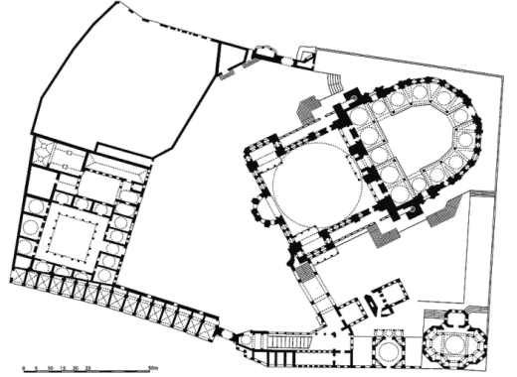 | 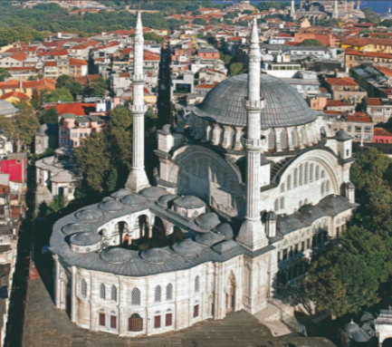
Figure 5. Plan of Nuruosmaniye Mosque [27] | Figure 6. General view of Nuruosmaniye Mosque [28]

These pre-designed models for architectural designs were also used to test any necessary modifications during the construction process. Each part of the building could be examined tangibly, enabling architects to discover design flaws that could be rectified before and during the design implementation. One such example is the design of the Selimiye Mosque in Edirne in 982 AH/1574 AD [29]. Upon completing the mosque dome, Sinan, an architect, aimed for a grandeur surpassing Hagia Sophia's. The mosque featured a single 31.5-meter dome, eschewing semi-domes. However, Sinan found its massive shape overwhelming and sought balance. His assistant suggested adding eight small minarets around the dome. To test this proposal, a scaled model was prepared and the units to be tested were installed on it. Sinan approved the idea and built it according to this model's design [30], as shown in Figure 7 and 8.

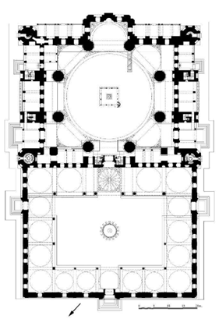 | 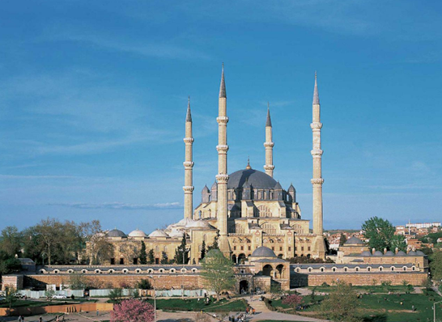
Figure 7. Plan of Selimiye Mosque in Edirne [27] | Figure 8. General view of Selimiye Mosque in Edirne [31]

The second purpose of making these architectural models was as commemorative gifts for celebrations, holidays, and receptions, exchanged among kings and caliphs to showcase the state's power, architectural splendor, and economic prosperity. These models also facilitated the exchange of architectural ideas and artistic influences between countries. Crafted from luxurious materials like gold, silver, and intricately adorned wood, these models were distinguished by their exquisite craftsmanship. Historical sources have provided us with many examples of such gifts. For instance, Ibrāhīm Ibn ʿabd al-Raḥman al-Hanafī presented Asad Ibn ʿAbdullāh al-Qasrī, the governor of Khorāsān, with two models of palaces in 737 AD, one made of gold and the other of silver [32].
Similarly, Yaʿqūb Ibn al-Līṯ al-Ṣaffār, the Amir of Khorāsān, presented a gift to the ʿAbbāsid Caliph al-Muʿtamad ʿalā Allāh in 892 AD. These models included a large mosque with two silver arcades, one accommodating fifteen people and the other a hundred [33]. The precision of executing these models was evident in a model of a village made of silver, owned by the ʿAbbāsid Caliph al-Muqtadir billāh in the fourth century AH, representing its farms, along with birds, animals, trees, buildings, and more [34].
The Fatimids were renowned for crafting sugar palaces and candy sculptures for seasonal celebrations, while during the Mamluk era, wooden models of castles and fortresses were prominent. These were showcased during sultans' receptions following victorious wars, exemplified by Ibn Taġrī Bardī's description of King Al-Nāṣir Muḥammad Ibn Qalāwūn's arrival celebration in 698 AH/1298 AD. Princes competed in setting up large wooden castle models along his route from Bāb al-Naṣr to Bāb al-Sīlsīlāh [35]. During one of the celebrations in Egypt in the year 845 AH/1441 AD, the knights of archery from Alexandria presented a model of a wooden castle as a gift to the sultan [36].
Examples of these commemorative models were widespread during the Ottoman era, especially models of the Kaʿba, the Grand Mosque in Mecca, and the Prophet's Mosque in Medina. These models were preserved in special glass cases inside the tombs of the Ottoman sultans in Turkey, including those found in the tomb of Sultan Suleiman 1 in Istanbul (Figure 9). At the Topkapi Palace in Istanbul, a commemorative model of the Kaʿba covered with an original Mecca covering is preserved in the royal cabinet. These sculptures underscored the significance of Mecca and Medina, especially the Kaʿba, for the Ottoman caliphs, representing their yearning to visit these sacred sites. For instance, Sultan Ahmed I (998-1026 AH/1590-1617 AD), who was unable to perform the Hajj, utilized these models symbolically to evoke the sanctity of these places, akin to a symbolic pilgrimage [30]. These models were later used to preserve sacred items in museums, such as the model of the Kaʿba, which was used to preserve strands of hair from the beard of Prophet Muḥammad. It is in the Sacred Relics Section at the Topkapi Palace Museum in Istanbul Number 21/556 [37]. It dates back to the Ottoman era. It is made of wood and covered with paper. The four sides are inscribed with the word "Tawḥīd" (monotheism) in white on a black background [38], as seen in Figure 10.

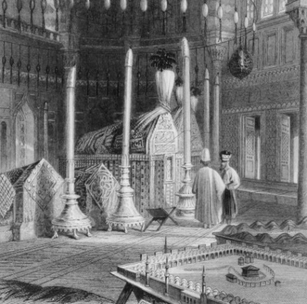 | 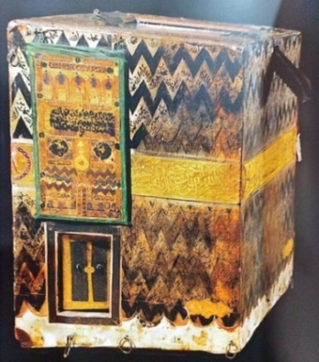
Figure 9. Model of the Holy Mosque of Mecca and the Kaʿba in the tomb of Sultan Suleiman1 [30] | Figure 10. Model of the Kaʿba at Topkapi Palace [38]

The Dome of the Rock stood out as one of the most significant commemorative models exchanged between kings and sultans, revered for its archaeological value and profound religious importance to Muslims. Patriarch Damianos Effendi gifted a model crafted from seashells to Ottoman Sultan Abdul Hamid II on his 25th accession anniversary. Crafted by Elias Sūlaymān al-Dabbab in 1901, this exquisite model, preserved in Topkapi Palace under number21/732, depicts the sacred Jerusalem sanctuary with the Dome of the Rock at its focal point, showcasing magnificence and creativity in design [37] as shown in Figure 11.

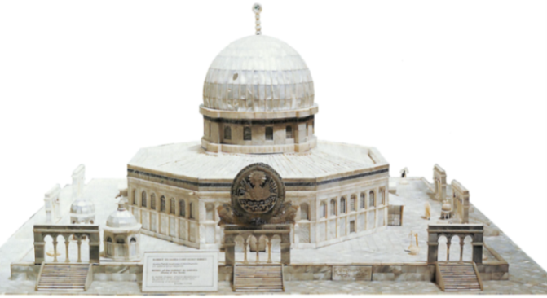

Figure 11. Model of the Dome of the Rock at Topkapi Palace (1,20 x 1,20 x 0,50 cm) [37]

Commemorative models were powerful symbols showcasing state power, stability, and architectural evolution, acting as promotional tools for new designs. A notable example is the model of the Süleymaniye Mosque in Istanbul (957-965 AH/1550-1557 AD), designed by the famous Ottoman architect Miʿmār Sinan Pasha. Featured in the manuscript "Ṣurnāma" dated 990 AH/1582 AD, preserved in the Topkapi Palace Museum under number 1344 from Sultan Murād III's era (983-1003 AH/1574-1595 AD), it reflects architectural innovation and historical significance [39]. This manuscript, also known as “The Book of Celebrations," is the first book to depict circumcision ceremonies, which the Ottomans paid great attention to [40]. The manuscript portrays a procession of architects carrying a miniature wood and ivory model of the Süleymaniye Mosque in front of Ibrahim Pasha Palace during festivities celebrating Prince Muḥammad's circumcision, son of Sultan Murād III. Craftsmen displayed their wares, serving as advertisements. Representatives from Eastern and Western nations attended, expressing admiration and documenting the event. It showcased the Ottoman Empire's strength, the grandeur of art and architecture, and its diverse cultural heritage [41], as seen in Figure 12, 13, and 14.

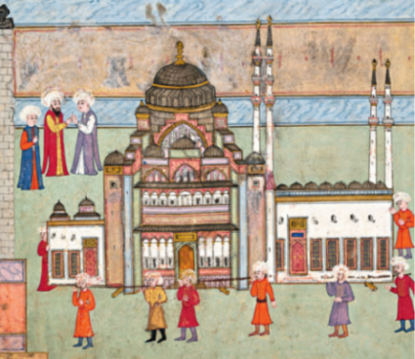 | 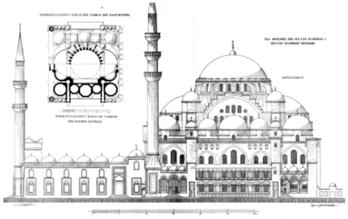 | 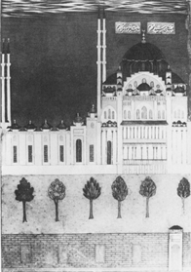
Figure 12. Model of Süleymaniye Mosque, manuscript “Ṣurnāma” [41] | Figure 13. Section of Süleymaniye Mosque [42] | Figure 14. Drawing of Süleymaniye Mosque, manuscript of Sulimān nāmah, Library of Chester Beatty [30]

One objective of commemorative models was to document restoration, renovation, or additions to a structure or archaeological site. Sultan Abū ʿInān of the Marīnid dynasty exemplified this by ordering a model representing the renovated and expanded Gibraltar Rock in 733 AH/1332 AD. Craftsmen skillfully depicted the mountain, including its fortress, towers, gates, and mosques, reflecting the Sultan's keen interest in documenting and fortifying the site [43].
A primary objective behind creating these models was to produce scaled-down replicas of significant Islamic sites and buildings, particularly those affected by disputes, conflicts, or difficult access. These replicas were intended for display in international museums, a trend that gained traction during the late Ottoman period in the 19th century. Admired by both specialists and the general public, these models offered a more accessible understanding of buildings and historical sites compared to flat drawings, serving as effective promotional tools for introducing these structures to the public [44].
One of the most famous examples of these models is those designed by the German architect Conrad Schick (1822-1901 AD), who was passionate about the history of Jerusalem and its architecture. He specialized in creating models of the Noble sacred Jerusalem sanctuary, the Dome of the Rock, and the famous Christian shrines. He produced many of these models, many of which were sent to European museums to convey the image of Jerusalem and its buildings to the West [45].
The Ottoman Caliph ʿAbd al-ʿAzīz I (1830-1876 AD) commissioned him in 1872 to create two models of the Noble Jerusalem sanctuary and the Dome of the Rock. These two models were exhibited at the Vienna International Exhibition in 1873. Conrad Schick's model of the Noble Sanctuary is considered a magnificent artistic masterpiece, reflecting its architectural unity and details, including invisible elements such as water cisterns, channels, and tunnels. This model was transferred to Jerusalem's Church of the Holy Sepulcher in 2012 [46]. This model served as an essential source for researchers and Orientalists, especially as most of them were unable to enter the Noble Sanctuary. Its precise measurements helped better understand the site and its units, both above and below the ground, including the structures and underground wells [47].
These models reflect the Ottoman Sultans' desire to document the Noble Sanctuary with its Islamic structures and units through accurate models that mimic the original prototypes. The archaeological documentation of these buildings aims to preserve them from potential destruction. Later, these models were considered tools for archaeological and topographical surveys of Jerusalem. They also serve as important and rare documents used for negotiations during regional conflicts [44], as presented in Figure 15 and 16.

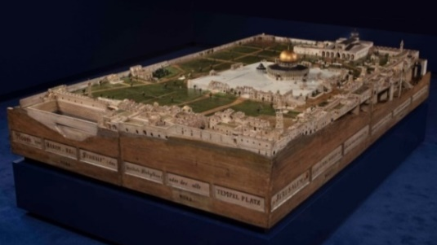 | 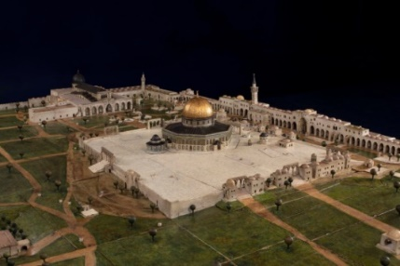
Figure 15. General view of the model of the Noble Sanctuary, Jerusalem by Conrad Schick [48] | Figure 16. model of the Dome of the Rock, by Conrad Schick (Museum Catharijneconvent in de Utrechtse binnenstad Collection, Netherlands)

  - THE SECOND SECTION
It comprises a descriptive study of archaeological models, spotlighting notable makers from the Ottoman era: Russian architect, Pavel Notbeck (1824-1877 AD) and German architect, Conrad Schick (1822-1901 AD). It also explores modern three-dimensional model design using sciences and engineering programs for archaeological documentation. The examples of some of the most famous remaining models are discussed next.

- 1. The Dome of the Chain
It is considered one of the oldest remaining realistic architectural models, situated in the East of the Dome of the Rock within the Al-Aqsa Mosque complex. Constructed during the era of Caliph ʿAbd al-Malk Ibn Marawān in 72 AH/692 AD, historians suggest it served as the prototype for the Dome of the Rock. The decision to build it followed the consultations with ʿAbd al-Malk with his subjects during his visit to the Al-Aqsa Mosque. It is said that ʿAbd al-Malk Ibn Marawān described his vision for the Dome of the Rock to architects, who then crafted the dome of the chain for him. He was impressed by the Dome of the Chain's design and ordered a larger dome over the Noble Rock, allocating substantial funds equivalent to Egypt's seven-year tax revenue for the project [49].
It is speculated that Rajāʾ Ibn Ḥayāh al-Kandī and Yazīd Ibn Salām, Palestinian experts in engineering and architecture, designed the Dome of the Chain. They later oversaw the financial and administrative aspects of constructing the Dome of the Rock, with contributions from Byzantine Empire workers and craftsmen influencing its design [50], as presented in Figure 17 and 18.

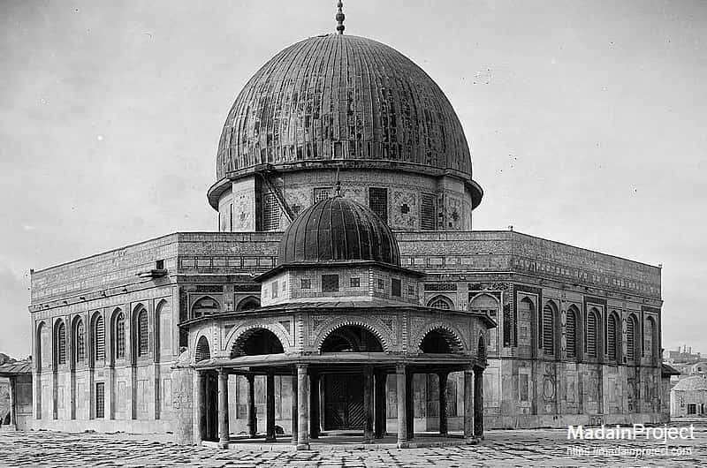 | 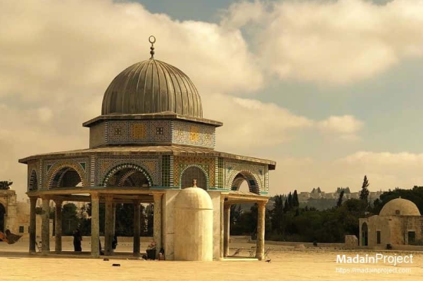
Figure 17. Archival image of the Dome of the Rock and the Dome of the Chain [51] | Figure 18. General view of the dome of the chain [51]

The Dome of the Chain, characterized by its open design, served multiple functions. It initially acted as a model for Caliph ʿAbd al-Malk Ibn Marawān to walk around and observe it from all angles without obstacles. It also served as headquarters for overseeing the Dome of the Rock construction, offering architects protection from bad weather. Also, they would gather in this place to exchange opinions and study new developments in a quiet atmosphere. It was purportedly used as a treasury where the endowment money was kept although this claim is disputed due to its open architectural structure with no enclosed walls [52]. It is not designed for this purpose, as evidenced by the lack of safes or places to store money. Throughout history, it served various functions: allegiance pledges to Umayyad caliphs, prayers led by the Imam following Šāfiʿī School, judicial councils, scholarly gatherings, including Hadith sessions, and manuscript copying [53].
Architecturally, the Dome of the Chain is an open structure except for the Southern side facing the Qibla. Its circular shape, nearly octagonal, features two concentric rows of marble columns. The inner circle comprises six columns supporting the central dome, made of wood covered with lead panels, resting on a hexagonal base (Figure 19 and 20). In comparison, the outer circle has eleven columns (Figure 21). Notably, the columns' capitals vary, supporting a sloping wooden roof surrounding the dome. Mosaics adorn interior walls and exterior facades, reminiscent of those in the Dome of the Rock [54] (Figure 22).
Over time, the Dome of the Chain underwent several renovations. Mamluk Sultan al-Ẓāhir Baybars renewed its decoration in 661 AH/1262 AD. In the Ottoman era, Sultan Suleiman I replaced its mosaics with ceramic tiles in 969 AH/1561 AD. The Crusaders later repurposed it into a prayer hall named the "Chapel of the Martyr Saint James" [55].

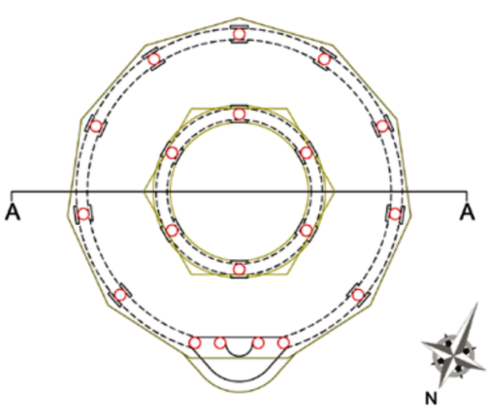 | 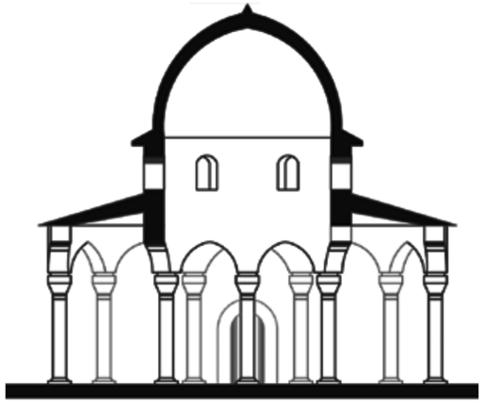
Figure 19. Plan of the Dome of the Chain [56] | Figure 20. Vertical section of the Dome of the Chain [56]
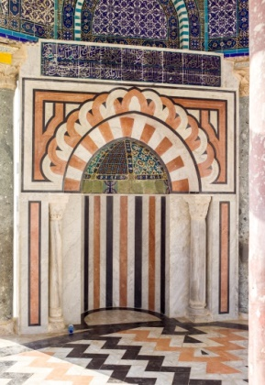 | 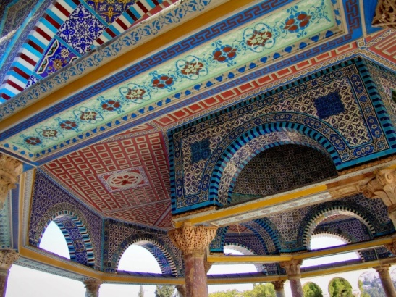
Figure 21. Miḥrāb of the Dome of the Chain [51] | Figure 22. General view of the Dome of the Chain and its decorations [51]

Comparing the Dome of the Chain to the Dome of the Rock reveals similarities in some details but also differences in their design proportions and size as Caliph ʿAbd al-Malk Ibn Marawān desired to enlarge the Dome of the Rock twelve times after seeing the Dome of the Chain. While both share general architectural elements, the Dome of the Rock is explicitly octagonal and enclosed, unlike the open design of the Dome of the Chain. Both feature a central dome, but the Dome of the Rock is significantly larger. They share Byzantine architectural influences that were predominant in the Levant and Palestine [57], [58]. In general, the Dome of the Chain served as a model and a prototype for the Dome of the Rock, which underwent modifications by its architects, as presented in Figure 23 and 24.

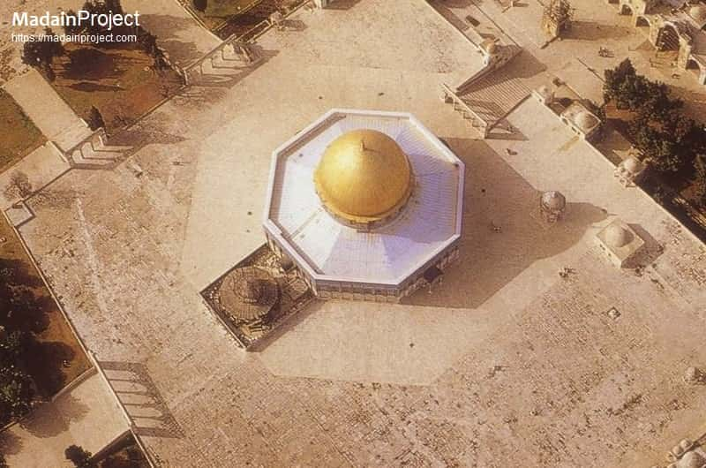 | 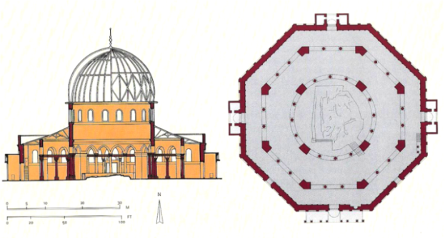
Figure 23. Aerial view of the Dome of the Rock and the Dome of the Chain [52] | Figure 24. Plan and Vertical section of the Dome of the Rock [59]

- 2. Model of the Prophet's Mosque
The Prophet's Mosque and Al-Masjid al-Haram are among the most replicated architectural structures. This model is considered one of the best remaining archaeological examples of the Prophet's Mosque, preserved in the Topkapi Palace in Istanbul under number 11/115 [34]. It is made of wood and plaster, with colors used to mimic the actual mosque. It was likely crafted by the prominent Ottoman historian, Ayūb Sabri Pasha. He is renowned for his geometric models and meticulously designed replicas of the Prophet's Mosque and the Great Mosque of Mecca, which he constructed during his time in Ḥiǧāz. These models are distinguished by their precision and meticulously designed with attention to geometric proportions. They were executed based on plans and drawings prepared by engineers during the extensive renovations of the mosques under Sultan Abdul Majid, completed in 1883. Executed on a 1:120 scale, the model mirrors the layout, including the green dome and minarets, aligning with the model [60].
The significance of this model lies in its documentation of the renovation carried out by the Ottoman Caliph ʿAbd al-Maǧīd I (1237-1277 AH/1823-1861 AD). This renovation is considered one of the most important and extensive renovations in the history of the Prophet's Mosque during the Ottoman era and the preceding period. The renovation encompassed the entire mosque, altering its exterior appearance and horizontal layout, except for the Prophet's Chamber, the three Miḥrabs, the pulpit, and the main minaret. The roof was replaced with domes covered with lead panels. The renovation began in 1265 AH/1848 AD and was completed in 1277 AH/1861 AD. The reason behind these works was the deteriorating condition of the mosque, which had significantly worsened, with many parts suffering from decay and destruction. In 1263 AH/1846 AD, the Sheikh of the Haram in the Prophet's Mosque, Dāwūd Pasha, wrote a letter to Caliph ʿAbd al-Maǧīd I, informing him of the dire situation of the mosque and requesting the urgent reconstruction of the Prophet's Mosque, especially since nearly four centuries had passed without any renovations. The Caliph then sent inquiries to assess the situation and understand the condition of the mosque [61].
Caliph ʿAbd al-Maǧīd I, keen to assess the Prophet's Mosque's structure, instructed architects known as Hāfiz Afandī and ʿAzīz Afandī to craft a wooden model in 1850. This model, depicting the mosque's current state, showcased columns, wooden roofs, and a stone dome on four pillars. A small dome made from red mountain stone was finely polished to resemble agate, impressing the Sultan. Subsequently, renovation and rebuilding of the mosque commenced, following the Sultan's approval of the model presented by the architects. This initiative gave a comprehensive understanding of the mosque's architecture and facilitated the renovation process [62].
During the Maǧīdīyya period of renovations at the Prophet's Mosque, British orientalist, Sir Richard Francis Burton, visited Al-Madīnah in 1852. He described extensive changes made by Caliph ʿAbd al-Maǧīd I, including the acts of expanding and reducing Rewaqs on the Northern, Eastern, and Western sides and adding corridors beyond the courtyard. The oil storage dome in the courtyard was removed due to contamination. The Eastern wall was extended, Bāb Ǧibrīl and Bāb al-Salām were reconstructed grandly, a large dome was built in front of Bāb al-Salām, and columns were added to support ceiling domes [63] (Figure 25 and 26).

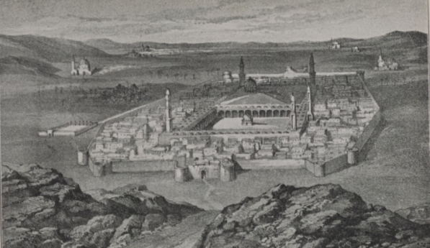 | 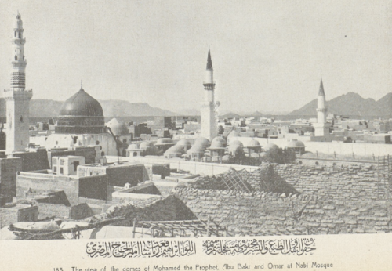
Figure 25. An archival drawing by Burton during his visit to the Prophet's Mosque [63] | Figure 26. An archival image of the Prophet's Mosque after the Ottoman renovations [61]

During the Maǧīdīyya renovations, the majestic Maǧīdīyya minaret replaced the old wooden one. The mosque boasts five minarets: the main minaret in the Southeast, Sūlaymānīyya in the Northeast, Maǧīdīyya in the Northwest, Bāb al-Salām in the Southwest, and a fifth near Bab al-Raḥmah in the West. These follow the Ottoman’s style with conical tops, except the Southeast one near the Green Dome, which is Mamluk’s style [61] (Figure 27 and 28).

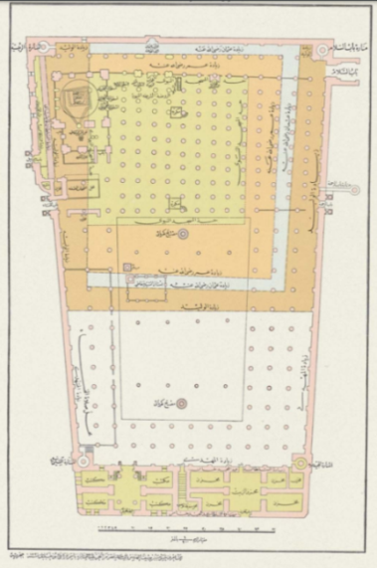 | 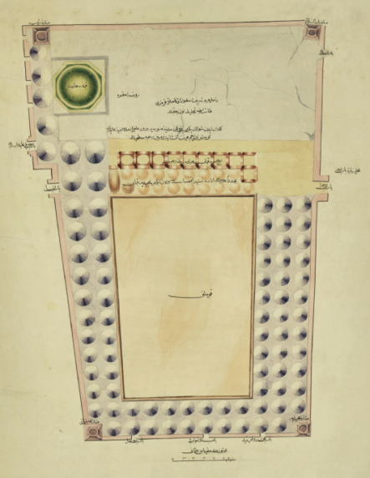
Figure 27. Plan of the Prophet's Mosque after the Ottoman renovation [61] | Figure 28. The Repair Plan of the Prophet's Mosque (14 Rajab 1275/February 17, 1859) [60]

It is a replica model of the Prophet's Mosque made of wood and gypsum, with other materials, such as lead sheets, used to cover the external surfaces of the model's domes. Various colors were used to paint the external surfaces to match the original models of these structures. This model is very important as it documents the mosque's appearance during the Ottoman period. It is drawn according to the architectural dimensions of the Prophet's Mosque, consisting of blocks and small pieces that can be assembled and disassembled. It includes a central uncovered courtyard from which the dome of the oil storage chamber was removed, as mentioned earlier in 1277 AH/1860 AD. The number of surrounding arcades and the courtyard on all four sides matches the Maǧīdīyya expansion mentioned earlier. The domes covering the Northern, Eastern, and Western arcades, added by Caliph ʿAbd al-Maǧīd I, are covered with lead. As for the Southern front arcade, there is variation in the size and height of these domes, which corresponds to the current situation of this arcade. As for the minarets, the model included five minarets, which aligns with what was mentioned in the Maǧīdīyya expansion. However, some of these minarets are the Ottoman’s style, while others are considered to be the Mamluk’s style. We find that the main minaret and the minarets of Bāb al-Salām and Bab al-Raḥmah are the Mamluk’s style, while the Maǧīdīyya and Sūlaymānīyya minarets are the Ottoman’s style. This is evidence that this model was made during the Maǧīdīyya expansion of the mosque. The designer of this model took care to inscribe the names of these minarets on their bodies for identification. Only the main minaret and the minaret of Bāb al-Salām remain from the original minarets in the modern era, with the latter having its top replaced with the distinctive conical shape of the Ottoman minaret (Figure 29).
The Green Dome atop the Prophet's Chamber in the model accurately reflects its original location and shape with the original dome. In the model, it was painted green. This dome was rebuilt during the reign of Sultan Maḥmūd, the son of Caliph ʿAbd al-Maǧīd I, in 1233 AH/1817 AD, and then he ordered it to be painted green. Before, its color was blue, the color of the lead covering it [61]. In any case, this model is also considered a commemorative model to document this blessed Maǧīdīyya addition to the mosque, helping to trace the history and architecture of the mosque during this period and its condition at that time.

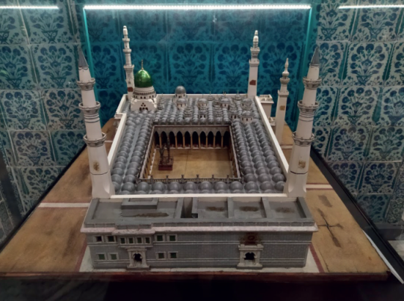 | 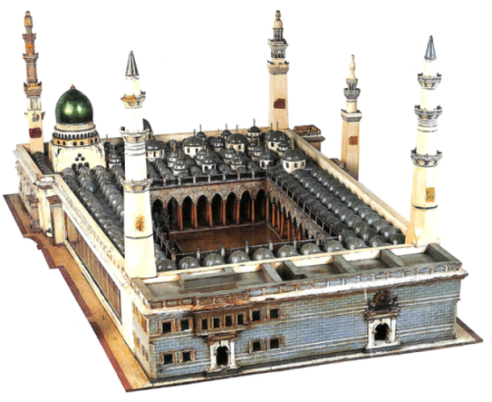
Figure 29. Model of the Prophet's Mosque at Topkapi Palace (0,98 x 1,15 cm) [37][60].

- 3. Model of the Clock Tower in Izmir
The Clock Tower in Izmir, an iconic landmark of the Ottoman era, stands proudly in Konak Square, Western Anatolia. Built to commemorate Sultan ʿAbd al-Ḥamid II's twenty-fifth accession anniversary, it was designed by a French architect, Raymond Charles Péré, in Arabic style that features a clock tower and four fountains. Governor Kāml Pasha of Izmir initiated its construction, following a meeting on August 1, 1900. A wooden model measuring 7.58 meters, illuminated and adorned to match the final design, served as an initial representation near the construction site. The foundation stone was laid on September 1, 1900, marking the beginning of this monumental project [64] (Figure 30).
Ottoman clock towers, influenced by Italian bell towers, emerged during the Ottoman era. Erected near main mosques, these tall, square, or octagonal towers housed clock mechanisms at their summits. Built from the mid-16th century AD onwards, they adorned cities across the Ottoman Empire. Notable examples include the Great Clock Tower in Edirne, Turkey, erected in 1296 AH/1879 AD [65]. Reflecting a blend of European and Islamic influences, these towers were designed by German and Ottoman architects to commemorate specific events. They served both functional and ornamental purposes as enduring symbols of Ottoman architectural prowess and cultural fusion [65].
The Izmir Clock Tower occupies an octagonal area of 81 square meters, built of white marble and carved stone. It consists of four floors and stands at a height of 25 meters, symbolizing each year of Sultan ʿAbd al-Ḥamid II's reign. Its octagonal layout features four sides adorned with small domed fountains, and the tower's summit is crowned with a small dome. The exterior surfaces of the tower on the North and South sides were embellished with ʿAbd al-Ḥamid II's monogram “al-Tughra”, while the East and West sides featured the Ottoman state emblem.
Four clocks are on each tower's four sides, reportedly a gift from the German Emperor, Wilhelm II (1888-1918). The tower's construction was completed in April 1901 and inaugurated on September 1, 1901. The tower is distinguished by its prominent location in the middle of the famous Konak Square. Islamic motifs influenced an architect known as Raymond Péré, drawing inspiration from Moroccan and Andalusian elements in the tower's decoration [67] (Figure 31).

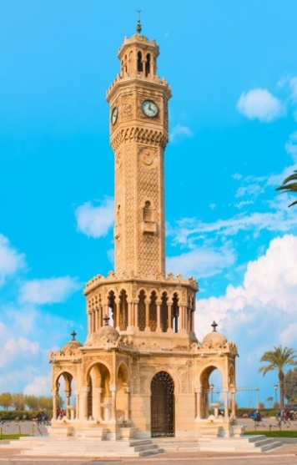 | 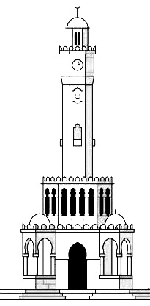
Figure 30. General view of the Clock Tower in Izmir [68] | Figure 31. Illustration of the Clock Tower in Izmir

The model of the Izmir Clock Tower, crafted with meticulous precision, was designed as a commemorative gift for Sultan ʿAbd al-Ḥamid II. Constructed in Istanbul, it cost 375 Ottoman liras and stands as a replica of the original tower. Made of silver and adorned with sapphire, emerald, and diamond, it is intricately decorated with gold threads. Measuring 90 cm in height, it features four Swiss clocks on each side. After Governor Kāmal Pasha gave his approval, the model was presented to the Sultan in March 1901, before the actual tower construction was completed. Today, it is housed in the Topkapi Palace in Istanbul under number 53/64, serving as a testament to the historical significance of the iconic Izmir landmark. A written inscription is recorded on this model, which says: "Built to display the clock tower with fountains, which was constructed in the city of Izmir to commemorate the twenty-fifth anniversary of His Majesty's accession to the throne in 1901"[64] (Figure 32, 33, and 34).

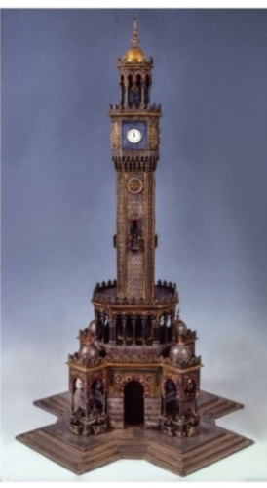 | 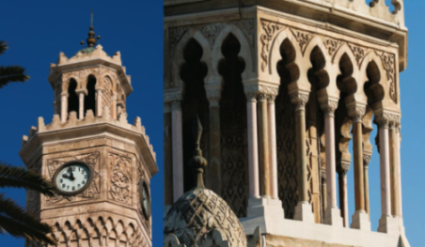 | 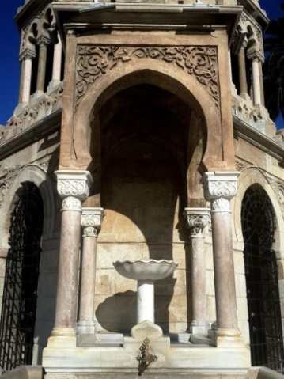
Figure 32. Model of the Clock Tower in Izmir [69] | Figure 33. Details of the Clock Tower in Izmir [70] | Figure 34. One of the fountains of the Clock Tower in Izmir [71]

- 4. Model of the Grand Valeed Šarīf Mosque, also known as the "Cavalry Brigade Mosque”
This mosque is located in the city of Simferopol, the capital of the Crimean Peninsula, and is therefore also known as the Simferopol Mosque. Its significance lies in being the first mosque constructed on the Crimean Peninsula. Constructed in 1909, it honored Muslim soldiers, primarily Crimean Tatars. Russian Colonel, N.A. Knyazevich, initiated its construction with Empress Alexandra Feodorovna (1872-1918) and her husband, Emperor Nicholas II (1868-1918), contributing financially. Their involvement underscored the recognition of religious diversity within the Russian Empire. The mosque's completion in 1909 aimed to foster unity among ethnic and religious groups. However, it met a tragic fate in 1930 when Soviet authorities demolished it as part of a campaign against religious and cultural symbols incompatible with Soviet ideology, erasing a significant piece of Crimean history. Over time, the mosque's name changed, and it became known as the "Valide Šarīf Mosque," which means "Mother of Nations" [72] (Figure 35 and 36).
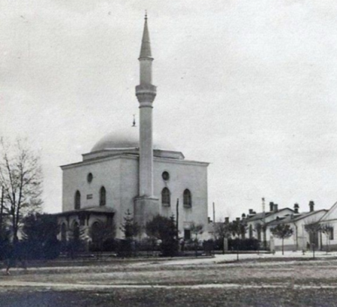 | 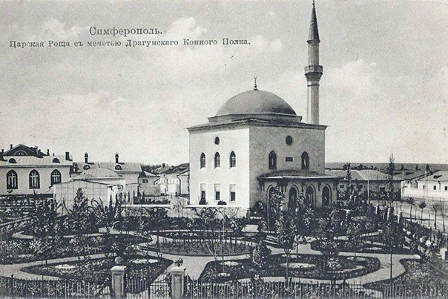
Figure 35. Archival photo of Valide Šarīf Mosque indicating the Minerat in the Ottoman style [72] | Figure 36. Archival photo of Valide Šarīf Mosque [73]

The mosque's strategic location at the junction of Beitelungovskaya and Markovskaya streets made it a prominent landmark in the city's architectural landscape, vital to the region's cultural and religious life. Beyond being a place of worship, it symbolized imperial backing for the Muslim community and celebrated the diverse cultural heritage of Crimea. Serving as a hub for the local Islamic community, it doubled as a cultural and social center. The mosque's architectural style, blending Ottoman, Islamic, and local influences, reflects the region's rich history and culture. Surrounding gardens enhance its allure, making it a cherished part of Crimea's cultural landscape.
The Grand Valeed Šarīf Mosque model is a significant artifact as it accurately documents the shape and architecture of the mosque that was demolished in 1930. This model is preserved in the Topkapi Palace Museum in Istanbul. It was donated by Ilhāmī Hussein Pasha and crafted by the renowned Russian jeweller, Fabergé family [74]. Made of silver, it serves as a replica of the original mosque, hinting at the potential for its reconstruction. The model's precision highlights the Russo-Turkish architectural influences, blending Ottoman characteristics with distinctive dome structures. Inscribed with "Qurman Mosque Valeed Sherifi," it is a testament to the mosque's historical and cultural significance, offering insights into its architectural legacy (Figure 37).

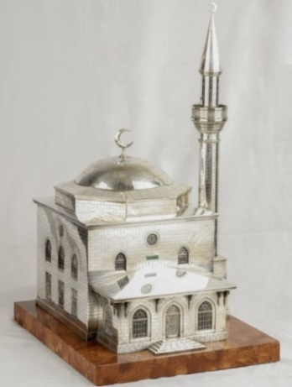

Figure 37. Model of the Grand Valeed Šarīf Mosque [69]

  - THE MOST FAMOUS MAKERS OF ARCHITECTURAL MODELS
One of the most famous foreign architects specializing in designing these models during the 19th century AD included the German architect, Conrad Schick (1822-1901 AD), and the Russian engineer, Pavel Notbeck (1824-1877 AD). Their works were mainly focused on Islamic architecture, whether in the East or the West of the Islamic world. This reflects their admiration for the East and its civilization. Their works helped promote Islamic architecture, showcasing its development and introducing it to Europe. These architectural works and models fascinated the West, leading to a rush to acquire them. Here is a brief overview of their lives and their most important works.

- 1. The German Architect, Conrad Schick (1822-1901 AD)
He was considered one of the most famous makers of geometric models in the 19th century AD. He specialized in drawing models of the Holy Sanctuary and the Dome of the Rock in Palestine. Born in Bautzen in 1822, he settled in Korntal, Württemberg, where he honed his skills in various crafts. Fascinated by the East, especially Jerusalem, he was sent there by the St. Crischona Mission in 1846, dedicating his life to studying, documenting, and designing the city's architectural landmarks. He produced remarkable works [75], including topographical and archaeological surveys of Jerusalem, academic research, the design and construction of buildings, and the creation and design of numerous models that illustrate the topography of Jerusalem and its major religious sites with their diverse identities. Schick's meticulous surveys, academic research, and meticulously crafted models garnered international acclaim, shaping Western perceptions of Jerusalem and its iconic structures through exhibitions and museum displays across Europe [44] (Figure 38 and 39).

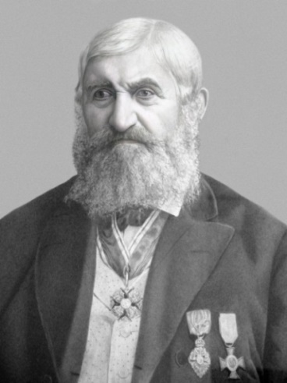 | 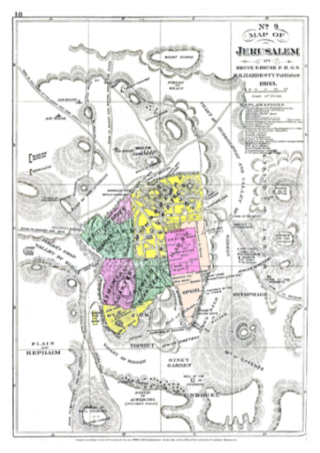
Figure 38. The German Architect, Conrad Schick [75] |  | Figure 39. A map of Jerusalem made by Conrad Schick [76]

Schick was granted a significant opportunity to visit and survey the entire site of Al-Haram Al-Šarīf of Jerusalem, which was forbidden for other European archaeologists to visit during that period [77]. One of his most famous works is the wooden model of the Jerusalem Sanctuary, commissioned by Caliph ʿAbd al-ʿAzīz I (1830-1876 AD) and exhibited at the World Exhibition in Vienna in 1873, as previously mentioned. This model holds great importance as it reveals the condition of the Jerusalem Sanctuary with its architectural units and components since ancient times. Schick also made several other models of Al-Haram Al-Šarīf in 1885, depicting the site later with the Dome of the Rock at its center (Figure 40 and 41).

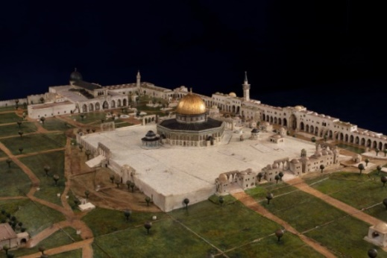 | 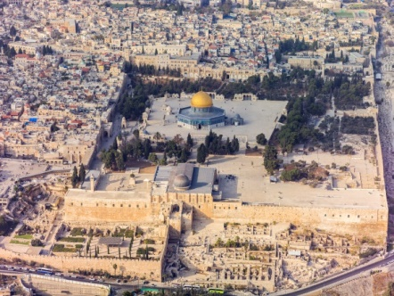
Figure 40. The model of Al-Haram Al-Šarīf in Jerusalem made by Schick measures 20,60m in length and 1.75m in width, constructed to a scale of 1:200 (Museum Catharijneconvent in de Utrechtse binnenstad Collection, Netherlands) |  | Figure 41. General Aerial view of Al-Haram Al-Šarīf in Jerusalem [78]

Schick's artistic style is marked by extreme realism, precise geometric proportions, mastery of perspective principles, and meticulous attention to architectural elements, ornaments, proportions, and harmony between them. As a result, his works and models are considered unique historical documents that document the condition of Al-Haram Al-Šarīf in Jerusalem with its units, domes, sites, and decorations. Schick also delineated the facades of the buildings and recorded the main four directions on the wooden panel. He excelled in using harmonious colors resembling the original colors of the structures, making his models extremely realistic representations of these buildings (Figure 42, 43, and 44).

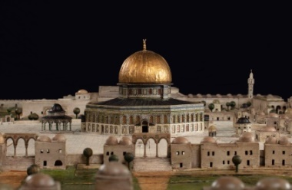 | 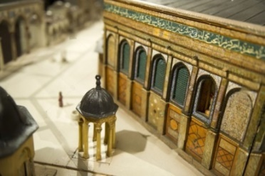 | 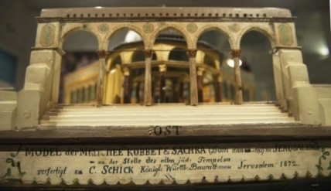
Figure 42. Details of the Model of Al-Haram Al-Šarīf made by Schick (Museum Catharijneconvent in de Utrechtse binnenstad Coolection, Netherlands) | Figure 43. Detailed of one of the facades of the Dome of the Rock (Museum Catharijneconvent in de Utrechtse binnenstad Coolection, Netherlands) | Figure 44. Details of one of the ramps and platforms leading to Al-Haram Al-Šarīf, with Schick's signature (Museum Catharijneconvent in de Utrechtse binnenstad Coolection, Netherlands)

- 2. The Russian engineer Pavel Notbeck (1824-1877 AD)
He is considered one of the most renowned Western architects who admired Arab civilization, particularly Islamic civilization in Andalusia. Indeed, Islamic architecture in Andalusia was a focal point of interest for many Western engineers who found it a fertile ground for their artistic creations and magnificent models [80]. He was a prominent creator of architectural models for Andalusian Islamic architecture, particularly the Alhambra Palace. His gypsum models are preserved in the Russian Academy of Arts Research Museum. Notbeck, born in 1824, studied architecture in St. Petersburg, earning his doctoral degree in 1849. In 1850, he traveled to Spain to study "Architectural Monuments of the Maghreb." Enthralled by the Alhambra Palace, he meticulously documented its architecture, aiming to publish illustrative drawings. Notbeck's approach combined scientific rigor with romantic admiration for Granada's Islamic heritage, resulting in detailed surveys and documentation of the Alhambra Palace, meticulously documenting its architectural units and distinctive details [80] (Figure 45 and 46).

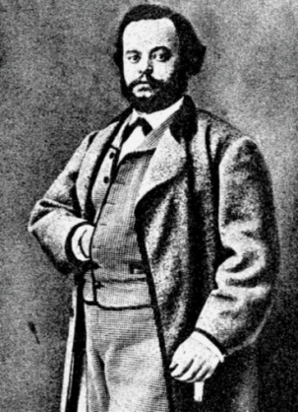 | 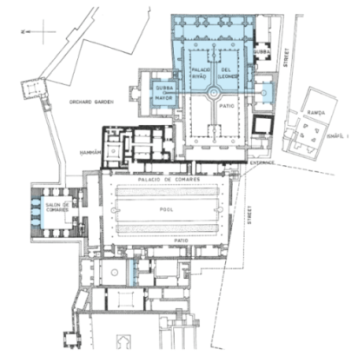
Figure 45. Russian engineer Pavel Notbeck [80] | Figure 46. Plan of Alhambra Palace made by Pavel Notbeck [80]

In addition to his illustrative drawings and plans, Notbeck also focused on producing three-dimensional models depicting the palace's details, elements, and architectural units. Notbeck collaborated with several local craftsmen and artisans to create these models, and the models were initially made to assist in the restoration and renovation of the palace's deteriorating parts. Emperor Alexander II praised the models for their artistry and comprehensive depiction of Moorish architecture. This collection, spanning ten years of meticulous work, became the largest specialized collection for studying Islamic architecture in Andalusia in Russia and throughout Europe [14].
Notbeck, along with other architects specializing in producing these models, such as Rafael Contreras and Diego Fernandez Castro, played a significant role in popularizing the trade of these models. The demand for purchasing these models turned it into a thriving trade. These models of the Alhambra Palace became highly coveted artistic souvenirs, especially among foreign visitors to Granada. Western thinkers and critics recognized the East's spirituality as enriching their material civilization, seeing it as a flourishing source of diverse civilization [79].
Notbeck's artistic style is marked by sincerity and precision, particularly in ornamentation. Notbeck excelled in highlighting details and was deeply imbued with Eastern culture, displaying a passionate interest in it. His specialization in engineering and architecture influenced his artistic style. The precision of these models allowed architecture and design students abroad to study the palace without visiting it. One of the most famous examples, meticulously designed by Notbeck, is the Two Sisters Hall, the main hall of the Court of the Lions located on its Northern side at Alhambra Palace in Granada. It is distinguished by its rich ornamentation and magnificent plaster dome, considered one of the finest Muqarnas domes in Islamic art [81]. This model crafted by Notbeck is considered a replica of the Two Sisters Hall in Alhambra Palace. It is made of gypsum components mounted on wooden supports (Figure 47 and 48).

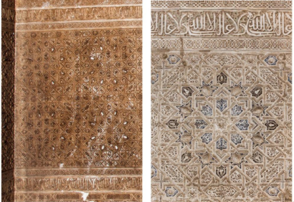

Figure 47. Various designs of the two Sisters Hall in Alhambra Palace made by Pavel Notbeck [79]

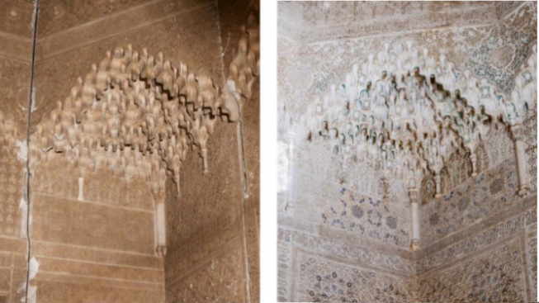 | 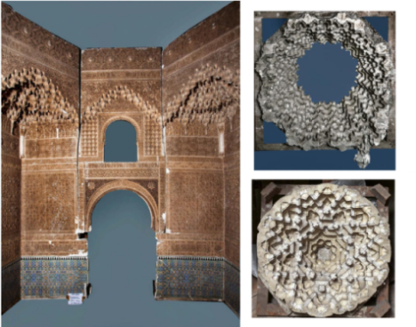
Figure 48. The architectural and decorative details of the walls of the model of the Two Sisters Hall were designed by Pavel Notbik [79].

- THE PRODUCTION OF GEOMETRIC MODELS AND MODERN SCIENCES
Geometric models play a vital role across various disciplines today, from education to archaeology, thanks to advancements in engineering and technology. Modern tools like Building Information Modeling (BIM) enable accurate documentation and restoration of artefacts by creating detailed three-dimensional models using specialized software. These models are instrumental in recording and preserving archaeological remains with precision and efficiency [82].
Three-dimensional modelling is extensively used in virtual archaeology and the digital reconstruction of buildings or archaeological artefacts on computers. This is significant in documenting complex parts of buildings, especially decorations. It is considered a modern approach to three-dimensional virtual documentation. These models are built on computers from data obtained through three-dimensional building scanning using modern methods such as photogrammetry, 3D laser scanning, geographic information systems, etc. This data is then inputted into specialized software and converted into three-dimensional models. Alternatively, these models can be constructed by engineers, architects, and scientists, including archaeologists, using information obtained through any documentation method with three-dimensional computer software such as Autocad –3d Max- Sketch Up [83]. The shape of the resulting three-dimensional model from these programs is determined based on the available data about the monument [84].
Specialized software digitally represents buildings and locations, generating accurate architectural models for virtual tours, documentation, and restoration. Three-dimensional modelling captures architectural and structural details with high accuracy. Global organizations like UNESCO document endangered heritage through virtual replicas and three-dimensional images, aiming to reconstruct and restore heritage sites while preserving their original form [85].

- CONCLUSION
This study examined the geometric models of Islamic architecture from the early Islamic period to the Ottoman era, and several important results were obtained:
- The production of these geometric models was widespread even before the Islamic era. It was fundamental to architectural design. It continues to appear in Islamic architecture.
- The purposes and objectives for which these models were executed varied, ranging from architectural purposes during pre-construction or construction stages to documentation purposes aimed at recording the status of structures and any additions or renovations made. Additionally, they served commemorative purposes as souvenir gifts, especially for structures of significant importance or those holding sacred or prestigious status. At times, these models held political significance, expressing the strength and urban development of the state.
- The production of these architectural models required artistic and engineering expertise, involving a collaborative process among craftsmen and artisans, preferably with archaeological knowledge, under the supervision of an engineer or architect.
- The study revealed that Islamic architecture and civilization fascinated numerous Western orientalists, inspiring Western engineers to create models of Islamic architectural structures from them. These models gained significant fame and widespread popularity in the West.
- These remaining archaeological models held significant historical importance, serving as historical documents providing insights into the original state of structures or renovations made. They could be corroborated with historical sources and travel accounts, serving as crucial assets in historical documentation and restoration projects for structures vulnerable to destruction and vandalism due to political conflicts, wars, and disputes.
- In the modern era, manufacturing models have become essential and necessary with advancements in technology and modern sciences. Whether executed virtually on computers or physically, these models are characterized by their precision and have become crucial in archaeological documentation. They are immensely beneficial in restoration projects and have become fundamental in virtual presentations in museums, known as virtual museums, which have proven to be optimal solutions during crises and pandemics like COVID-19.

REFERENCES
[1] F. Šāfiʿī, al-ʿImāra al-ʿarabīya fī miṣr al-Islāmīya, Vol.1, ʿAṣr al-wulāh, Cairo: al-Hayʾa al-ʿāmma liʾl-kitāb, 1994.
[2] K. Ḥaydar, al-ʿImāra al-ʿarbīya al-Islāmīya (al-ẖaṣāʾṣ al-taẖṭīṭiya li-l-muqarnaṣāt), Beirut: Dār al-fikr al-libnānīya, 1994.
[3] Ḥ. ʿAzab, fiqh al-ʿUmrān: al-dawla wa al-muǧtamaʿ wa al-ʿImāra fī ḥaḍārat al-Muslimīn, Cairo: al-Dār al-Miṣrīyya al-libnānīya, 2013.
[4] L. Qārī, ʾiḍāʾat zawāyā ǧadīdah lil-tiqanīya al-ʿarabīya al-Islāmīya. Al- Rīyād: Maktabit al-Malik Fahd al-waṭanīyah, 1996.
[5] R. Elwes, 1001: an overview of numbers, geometry, algebra, and statistics. Cairo: al-mağmūʿa al-ʿarabīya lil-tadrīb wa al-nāšr, 2018.
[6] A. Muẖtār ʿUmar, mūʿğām al-luġa al-ʿarabīya, Vol.1. Cairo: ʿālam al-kitāb, 2008.
[7] F. ʿabd al-Raḥīm, mūʿğām al-daẖīl fī al-luġa al-ʿarabīya wa laḥāğatā. Damascus: Dār al-Qalam, 2001.
[8] M. ʿabd al- Ḥafīẓ, al-Muṣṭalaḥāt al-miʿmārīya fī waṯāʾiq ʿaṣr Muḥammad ʿAlī wa ẖulafāʾuh (1805–1879A.D). Cairo: al-Muʾassāsāh al-Miṣrīyya liʾl-taswīq, 2005.
[9] M. Darwīš, manhğ al-baḥṯ fī al-aṯār al-Islāmīya. Cairo: mūʾassasat al-umah al-ʿarabīya, 2018.
[10] H. Ḥasan, “ṭawāʾf al-miʿmār fī Miṣr min al-Fatḥ al-ʿUṯmānī ḥatā nihāyat al-qarn al-ṯāsʿ ʿašar dirāsa aṯārīya ḥaḍārīya waṯāʾiqīya”, Ph.D. Thesis, Cairo University, 2009.
[11] ʿU. Ismaʿīl, tārīẖ al-ʿimārah al-Islāmīya waʾl-funūn al-taṭbīqīya biʾl-Maġrīb al-Aqṣā, Vol.4. Rabat: maṭba῾at al-Ma῾ārīf, 1993.
[12] H. al-Ğibāly, al-wasāʾl al-taʿlīmīya. Oman: Dār Usāma, 2006.
[13] T. A. Al-Maqrīzī, al-mawāʿīẓ waʾl-iʿtībār fī ḏikr al-H̱iṭaṭ waʾl-aṯār, vol.2. Beirut: Dār al-kutab al-ʾilmīya, 2003.
[14] E. Fromhmovic, Mudejarismo and Moorish Revival in Europe: Cultural Negotiations and Artistic Translations in the Middle Ages and 19th century Historicism, Vol.13. Leiden/Boston: Brill, 2021.
[15] N. N. Haidar, K. Weisbin, Islamic Art in the Metropolitan Museum of Art A Walking Guide, USA: Metropolitan Museum of Art, 2013.
[16] “Damascus Room”, The Met Museum, Accessed: Jan. 20, 2024. [Online]. Available: https://www.metmuseum.org/art/collection/search/452102
[17] A. Rizvi, and L. Zeidan, “Collection Highlight: The Damascus Room”, Qatar Museum, 2023, Accessed: Jan. 20, 2024. [Online]. Available: https://qm.org.qa/ar/stories/all-stories/damascus-room/
[18] “Damaskuszimmer im Japanischen Palais”, Museum für Völkerkunde Dresden, Accessed: Jan. 20, 2024. [Online]. Available: https://voelkerkunde-dresden.skd.museum/en/exhibitions/damascus-room
[19] P. Astrnidou, The Architect in Ottoman Period a Study of the Commemorative Book, Tunis: Attamami foundation for scientific research in honour of Michael kayte, 2000.
[20] Ḥ. ʿabd al-Wahhāb, “al-rusūmāt al-handasīya lil-ʿamāʾr al-Islāmīya”, mağalat sumar, 14th issue. Iraq: Ministry of Culture, Tourism and Antiquities, 1958. Pp.76-86
[21] H. Mostafa, “From the Dome of the Chain to Miḥrāb Dāʾūd: the Transformation of an Umayyad Commemorative Site at the Haram al-Sharif in Jerusalem”, Muqarnas Online, vol. 34, no.1, pp. 1-22, 2017. Doi: https://doi.org/10.1163/22118993_03401P002
[22] N. Maʿrūf, “ʿurūbat al-mudn al-Islāmīya”, Journal of the faculty of arts, vol. 1, pp.5-58, 1964.
[23] A. M. al-Balūy, sīrat Aḥmad Ibn Tulun, Cairo: Maktabat al-ṯaqāfah al-diniyyah, 1986.
[24] A. Taymūr, aʿalām al-muhandisīn fī al-Islām. London: mūʾassasat Hindāwī, 2010.
[25] Ṣ. A. Sūlaymān, al-miʿmār al-mamlūkī baīn handasat al-lāfẓ wa handasat al-šakl. Cairo: Maktabat al-Anǧlū al-Miṣrīyya, 2006.
[26] J. Butraʿa, “al-ǧāmʿ al-kabīr bī madīnat Tozeur aw ǧāmʿ balad al-Ḥaḍar dirāsa tārīẖīya miʿmārīya”, Mağalat al-ḥayāh al-ṯaqāfīya, April, Pp.157-185, 2008.
[27] O. A. Abā, Funūn al-Tūrk wa ͑amāʾīruhūm, Istanbul: Markz al-abḥāṯ līʾl-tārīẖ waʾl-funūn waʾl-ṯaqāfah al-Islāmīya, 1987.
[28] S. SUMAN, “Questioning an “Icon of Change”: the Nuruosmaniye Complex and the Writing of Ottoman Architectural History”, METU Journal of faculty of Architecture, vol. 28, no. 2, pp.145-166, 2011. DOI: 10.4305/METU.JFA.2011.2.7
[29] R. H. Ünal, Selimiye Camii [The Selimiye Mosque], Edirne: 1993.
[30] G. Necipoğlu, “Plans and Models in 15th and 16th century Ottoman Architectural Practice”, Journal of the Society of Architectural Historians, Vol.45, No.3, Pp.224-243, 1986, doi: https://doi.org/10.2307/990160

[31] S. Cakmak, “Discover Islamic Art”, Museum with No Frontiers, Accessed: Jan. 20, 2024. [Online]. Available: https://islamicart.museumwnf.org/database_item.php?id=monument;isl;tr;mon01;23;ar
[32] M. Al-Ṭabarī, Tārīẖ al-rusul waʾl-mulūk, Vol.7, Cairo: Dār al-maʿārif, 1967.
[33] ʿA. I, Al-Bahāʾī, Maṭālʿ al-budūr wa manāzl al-surūr. Cairo: Maṭbaʿat ʾīdārāt al-waṭan, 1300 AH.
[34] Ǧ. A. Al-Ǧawzī, al-muntaẓm fī tārīẖ al-umam wa al-mulūk, Vol.13, Beirut: Dār al-kutub al-ʿilmīya, 1992.
[35] A. Ǧ, Ibn Taġrī Bardī, al-Nuǧūm al-ẓāhira fī mulūk Miṣr waʾl-Qāhira, Vol.8. Cairo: ministry of Culture and National Guidance, 1963.
[36] Š. M. Al-Saẖāwī, al-tibr al-masbūk fī ḏaīl al-Sulūk, Cairo: Dār al-Kutub waʾl waṯāʾiq al-qawmīya, 2002.
[37] Ḥ. Āydīn, aṯār al-rasūl fī ǧanāḥ al-amānāt al-muqaddasa fī mutḥaf Topkapi Palace in Istanbul, Cairo: Dār al-nīl, 2004.
[38] D. A. ʿAbd al-ʿAzīz, Mecca and Al-Madīnah; ṣiwar wa muqtanayāt mutḥaf Topkapi Palace. Al- Rīyād: maktabat al-Malk Fahd al-waṭanīyah, 2014.
[39] N. ʿAbd al-Ǧayd, “Dirāsa li-taṣāwīr al-markabāt bi-maḫtūtāt Ṣurnāma Murād III al-mūʾrraẖ 990AH/1582AD al-maḥfūẓ bi- mutḥaf Topkapi bi-raqm 1344”, Journal of the General Union of Arab Archaeologists, Vol.21, No. 2, pp.364-399, 2020.
[40] Ş. Tamcan, "Ṣurnāma-i Hümayun (‘Book of the Imperial Circumcision Festival’)", Discover Islamic Art, Museum with No Frontiers, 2024.
[41] E. Atil, “the Story of an Eighteenth -Century Ottoman Festival”, Muqarnas, Vol.10, pp.181-200, 1993.
[42] C. Gurlitt, Die Baukunst Konstantinopels, Berlin: E. Wasmuth, 1912.
[43] ʿA. Ibn Batūta, Riḥlat lbn Batūta al-musammāh tuḥfat al-anẓār fī ġarāʾib al-amṣār wa ʿaǧāʾib al-sfār, Vol.2. Beirut: Dār al-šarq al-ʿarabī, 2022.
[44] N. Magouliotis, “Miniaturizing monuments: Conrad Schick and his architectural models of the holy sites of Jerusalem”, ABE Journal, Vol. 18, 2021, doi: https://doi.org/10.4000/abe.10216
[45] E.W.G, Masterman, “Obituary: The Important Work of Conrad Schick”, the Biblical World, Vol.20, No.2, pp.146-148, 1902.
[46] N. Magouliotis, “Miniaturizing monuments: Conrad Schick and his architectural models of the holy sites of Jerusalem”, ABE Journal, Vol. 18, 2021, doi: https://doi.org/10.4000/abe.10216
[47] N. Jubeh, “Conrad Schick Pioneering Architect Archaeologist and Historian of Nineteenth Century Jerusalem”, Jerusalem Quarterly, vol. 67, pp.7-18, 2016.
[48] P. V. D. Vusse, “Utrechts museum heeft unieke maquette van de Tempelberg in Jeruzalem”, AD, Accessed: June 6, 2023. [Online]. Available: https://www.ad.nl/utrecht/utrechts-museum-heeft-unieke-maquette-van-de-tempelberg-in-jeruzalem~a9422ea1/
[49] M. al-ʿUlimy, al-uns al-ǧalīl bi- tārīẖ al-Quds wa al-ẖalīl, Oman: maktabat Dandis, 1999.
[50] K. A. C. Creswell, al-aṯār al-Islāmīya al-mūbakra, Damascus: Dār Qutayba, 1984.
[51] “Dome of the Chain”, Madain Project, Accessed: June 6, 2023. [Online]. Available: https://madainproject.com/dome_of_the_chain
[52] Ḥ. ʿAzab, al-Haram al-Qudsī al-šarīf. Beirut: Dār al-kitāb al-ʿarabī līʾl-ṭībāʿa wa al-Nāšr wa al-tāwẓīʿ, 2010.
[53] H. Ṣ. Mannāʿ, “al-qubb al-ṯalaṯah fī al-Masjid al-Aqṣā al-mūbārk dirāsa waṣfīya”, Mağalat Ibn ẖaldūn liʾl-dirāsāt wa al-abḥāṯ, Vol.2, No. 5, Pp.626-656, 2022.
[54] I. Al-ʿUmarī, Š. A. Ibn Yaḥyā, masālik al-abṣār fī mamālik al-amṣār, Beirut: Dār al-kutub al-ʿilmīya, 2010.
[55] Ḥ. Ġāzī, Al-Quds sīrat madīnah ʿabqariyat al-makān. Cairo: wakālat al-ṣaḥafa al-ʿarabīya nāšrūn, 2016.
[56] H. Mostafa, From the Dome of the Chain to Miḥrāb Dāʾūd: the Transformation of an Umayyad Commemorative Site at the Haram al-Sharif in Jerusalem, 2017, Figure.4, p.10.
[57] A. fikrī, “Qubbat al-Ṣaḥrah”, mağalat ʿālam al-fikr, Vol.11, No. 1, Pp.13-30, 1980.
[58] M. ʿUṯmān, “Naẓaryyat ǧadīdah li-tafsīr kayfyat taḫṭīṭ Qubbat al-Ṣaḥrah”, mağalat al-ʿuṣūr, Vol.3, pp.237-264, 1988.
[59] E. ESER, “The First Islamic Monument Kubbet’üs-Sahra (Dome of the Rock): A New Proposition”, PESA international journal of social studies, Vol. 3, No. 2, p.135-147, June 2017
[60] Ö. F. Can, “Eyüb Sabri Paşa’nın Hayatı, Entelektüel Muhiti ve Eserleri Üzerine Bazı Yeni Bulgular”, Turkish Journal of History, vol. 75, pp.159-189, 2021. Doi: https://doi.org/10.26650/iutd.973070
[61] I. Rifʿat, mirʾat al-ḥaramīn “al-raḥlāt al-ḥiǧāzīya wa al-haj wa mašāʿirhū al-diniyyah muḥlāh bi- m’ āt al-ṣiwar al-šamsīya, Vol.1. Cairo: Dār al-kutub, 1935.
[62] Ǧ. Al-Barǧanjī, tārīẖ al-masjid al-nabawī al-musammā nuzhat al-nāẓirīn fī masjid sayīd al-awalīn wa al-ʾaẖrin. Cairo: maṭbaʿat al-ğamālīya, 1914.
[63] R. Burton, Riḥlat Burton ʾilā Miṣr wa al-Ḥiǧāz, Vol.1. Cairo: al-Hayʾa al-ʿāmma liʾl-Kitāb, 1994
[64] F. De Vaujany, A. Grandazzi, & R. Holt, Organization as Time: Technology, Power, and Politics. Cambridge: Cambridge university press, 2022.
[65] S. Ǧād, “ʾālāt qiyās al-waqt munḏu aqdm al-ʿuṣūr wṣūlā lī-abrāǧ al-sāʿah al-ʿUṯmānīya”, Journal of the General Union of Arab Archaeologists, Vol.20, pp.161-196, 2019.
[66] Ṣ. Kūlan, salāṭin al-dawla al-ʿUṯmānīya. Cairo: Dār al-nīl liʾl-našr waʾl-tāwẓīʿ, 2016.
[67] M. Fuhrmann, “Constructing the façade of Ottoman urban modernity; the star architects of Istanbul, Salonika, and Izmir”, architectural history conference/turkey, pp. 255-269, 2010
[68] Sailko, “Izmir Clock Tower”, Mapcarta, Accessed: June 6, 2023. [Online]. Available: https://mapcarta.com/32123936
[69] D. A. ʿAbd al-ʿAzīz, Mecca and Al-Madīnah; ṣiwar wa muqtanayāt mutḥaf Topkapi Palace. Al- Rīyād: maktabat al-Malk Fahd al-waṭanīyah, 2014
[70] “Saat Kulesi”, IZMIR PROVINCIAL CULTURE AND TOURISM DIRECTORATE, Accessed: June 2, 2024. [Online]. Available: https://izmir.ktb.gov.tr/TR-77373/saat-kulesi.html
[71] I. I. Bırakmış, saat kulesinin ve bilinan pek çok yapının mimarı Raymond Charles Pere üzerine bir inceleme, p.1.
[72] G. Babenko, Valeriy Petrovich Dyulichev, Simferopol-gorod polzy, Forma, 2007

[73] Sarjoun, “Mechet Dragunskogo Konnogo Polka”, Retro view of mankind habitat, Accessed: June 6, 2023. [Online]. Available: https://pastvu.com/p/351558
[74] “Faberge Biography”, Trevi Jewerly, Accessed: June 6, 2023. [Online]. Available: https://web.archive.org/web/20091006045331/http://www.trevijewelry.com/faberge-art/faberge-biography.html
[75] H. Goren & R. Rubin, “Conrad Schick's Models of Jerusalem and its Monuments”, Palestine Exploration Quarterly, vol.128, pp.103-124, 1996.
[76] U. Peterson, “Dr. Conrad Schick Missionary, Architect, Archaeologist, Model builder, City engineer”, Wisdom in Torah, Accessed: June 6, 2023. [Online]. Available: https://wisdomintorah.com/wp-content/uploads/2017/04/conrad-schick-cs301webb.pdf
[77] N. Magouliotis, “Miniaturizing monuments: Conrad Schick and his architectural models of the holy sites of Jerusalem”, ABE Journal, Vol. 18, 2021, doi: https://doi.org/10.4000/abe.10216
[78] R. Röhricht, Bibliotheca Geographica Palaestinae, Berlin: Legare Street Press, 1890.
[79] K. Kaufmann‏, Taking the Alhambra to St. Petersburg: Neo-Moorish Russian Architecture and Interiors 1830–1917, Berlin: Walter de Gruyter GmbH & Co KG, 2023
[80] A. V. Braga, “Moorish Architectural Models in the Musée d’Art et d’Histoire in Geneva”, historismus. ch, revue suisse de l’historicisme, vol.1, pp.66-72, 2020.
[81] I. Ḥusnī, al-talāms al-ḥaḍārī al-ʾurubī, mağalat ʿālam al-maʿrifa, issue 111. Kuwait: The National Council for Culture, Arts and Letters, 2009.
[82] G. Marcais, l'architecture musulmane d'occident Tunisie, Algérie, Maroc. Paris: Espagne ET Sicile, 1954.
[83] R. ʿaqīly, “al-tawṯīq al-miʿmārī al-aṯarī bīstẖdām Three-Dimensional Modelling”, Master Thesis, Faculty of Architecture, Aleppo University, 2013.
[84] F. M. Sarḥān, tiknulūğiā al-maʿlūmāt fī ʾīdārāt al-mašārīʿ al-ʾinšāʾiya. Oman: Dār ġaydāʾ liʾl-našr, 2017.
[85] H. Ismāʿīl, “tawṯīq wa ʾiʿādat ʾistkmā al-aṯār al-mūtahadema min al-waṯāʾiq al-qadīma bīstẖdām Three-Dimensional Modelling”, ḥawlīat al-Itiḥād al-ʾAm līʾl-Aṯārīyīn al-῾Arab, vol. 12, Pp.393-415, 2021.

