 |  | JOURNAL OF ISLAMIC ARCHITECTURE  P-ISSN: 2086-2636 E-ISSN: 2356-4644  Journal Home Page: http://ejournal.uin-malang.ac.id/index.php/JIA
THE ARCHITECTURE OF SUNAN BONANG'S TOMB: COMMODIFICATION OF SACRED ZONES IN RELIGIOUS TOURISM
Ahmad Ghozi^{ab*}, Andrik Purwasito^{c}, Warto^{d}, Wakit Abdullah Rais^{e}
ªDepartment of English Literature, Universitas Islam Negeri Maulana Malik Ibrahim, Malang, Indonesia
^{b}Department of Cultural Studies, Universitas Sebelas Maret, Surakarta, Indonesia
^{c}Department of International Relations, Universitas Sebelas Maret, Surakarta, Indonesia
^{d}Department of History, Universitas Sebelas Maret, Surakarta, Indonesia
^{e}Department of Linguistics, Universitas Sebelas Maret, Surakarta, Indonesia
*Corresponding Author: ahmadghozi@student.uns.ac.id
ARTICLE INFO |  |  | ABSTRACT
Volume: 8  Issue: 4  Page: 883-899  Received: March 03rd, 2024  Accepted: August 03rd, 2024  Available Online: December 30th, 2025  DOI: 10.18860/jia.v8i4.26328 |  |  | The significant number of visitors visiting the Sunan Bonang Tomb in Indonesia is believed to contribute to the commodification of sacred zones for religious tourism at the tomb. This study focused on exploring how sacred zones are transformed into religious tourism destinations at the Sunan Bonang tomb in Tuban, Indonesia. Qualitative research involved gathering field data through participant observation, in-depth interviews, and documentation studies. Researchers conducted data triangulation to confirm the accuracy of the gathered data. The research results were examined using Foucault's perspectives through archaeological and genealogical approaches. This study identified key factors contributing to the commodification of Sunan Bonang's tomb for religious tourism, including: 1) the established religious tradition within Islamic communities that influence the occurrence of commodification, 2) government support aimed at enhancing the attraction of cultural products for religious tourism, and 3) the role of the foundation as the holder of management authority managing the commodification of Sunan Bonang's tomb for religious tourism. Commodification focuses more on creating sacred zones at the Sunan Bonang’s Tomb.  Keywords:  Commodification; Tomb Architecture; Sunan Bonang's Tomb; Sacred Zones; Religious Tourism

- INTRODUCTION
Islam has been practiced in Indonesia for a long period of time, since the 7th century AD [1], [2]. The tomb of Sunan Bonang in Tuban, Indonesia, is one example of preserved evidence. Sunan Bonang died in 1525 AD. Sunan Bonang was an influential figure in the dakwah (missionary) activity led by Maulana Malik Ibrahim (Sunan Gresik).
The Sunan Bonang’s tomb in Indonesia is now a popular religious site and remains a sacred site for many people [3]. The Sunan Bonang Tomb is an essential part of three important sites: the Mosque, the Well, and the Tomb. The three areas are interconnected due to their spiritual significance as sites of ceremonial worship to Allah SWT [4].
Indonesian muslims believe that visiting the tomb of a saint or religious person allows them to establish a connection with God by offering specific prayers to get blessings in their lives [5], [6]. Therefore, the number of visitors to the Sunan Bonang Tomb is continuously increasing [7]. The Sunan Bonang Tomb receives 2,521,925 visitors annually, making it the top religious destination in Indonesia [7], [8].
Initially, the trip to the Sunan Bonang Tomb was intended for spiritual purposes [9]. However, the increasing number of visitors has led to a growth in travel agents, tour guides, merchants near the tomb, and transportation services to the tomb location [10].
Cemetery administrators are responsible for providing services and amenities for visitors. The management sets specific limits for visiting the tomb area to ensure visitor comfort and safety.
However, the growing number of visitors raises concerns that the commodification of religious tourism trips may dominate the sacred value of the tomb. The management overseen by the Sunan Bonang cemetery foundation addresses this issue, with the involvement of the tourism department [11]. This management establishes zoning divisions inside the tomb area. Visitors are currently prohibited from entering the central part of Sunan Bonang’s tomb. The new dome of Sunan Bonang's tomb is the only location designated for visitors to pray. Other locations in the Sunan Bonang tomb area have been reorganized to accommodate the large number of visitors to the site [12].
Many academic studies focus on the sacredness of the tombs of famous figures. The religious activities of various tombs and religious sites around the world, including Majesto Tomb [13], [14], Visits to the Wali Songo Tomb [8], Architecture of the Tomb in Ashkelon [15], Pilgrimage to the Holy City of Mecca [16], Tomb Planning with Regionalization Strategy [17], Pilgrimage to the Holy Sepulcher in India [18], Orthodox Religious Tourism in Greece [19], Scarcity of Burial Locations in Big World Cities [20], Islamic Graves during the Palembang Sultanate Period [21], Management of Graves in Polish Cities [22], Prehistoric Tombs in Bantaeng [23], Thrace Tomb Architecture in Kazanlak, Bulgaria [24], Neolithic Age Tomb Architecture in Ireland and England [25], Tomb ceiling architecture in China, Korea and Anatolia [26]. Much research on pilgrimages in different countries has not explored the shift in the meaning of visiting these sites. Therefore, this research emphasizes the architectural zoning and commodification of Sunan Bonang’s tomb.

  - THE TOMB OF SUNAN BONANG
The tomb of Sunan Bonang is a significant representation of Indonesia's religious and historical heritage [3]. The tomb serves an important purpose in preserving and passing on essential religious and cultural values to future generations [11], [14]. Furthermore, the tomb is regarded as a sacred site due to the extraordinary charisma attributed to the figures entombed within [4], [10]. The story of Sunan Bonang (Makdum Ibrahim) is also shown in Figure 1.

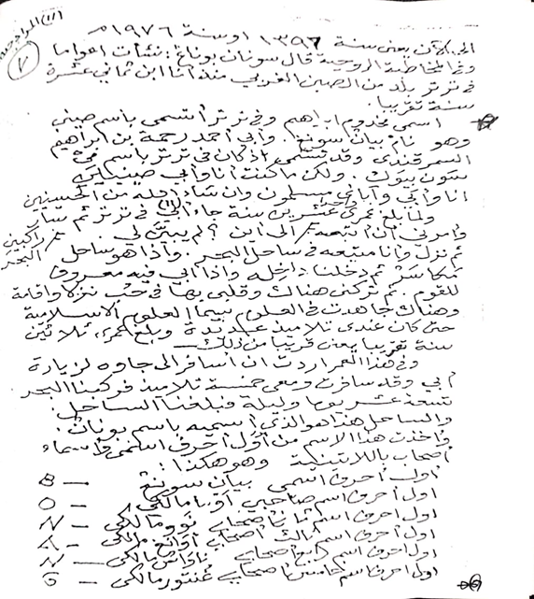
Figure 1. Makdum Ibrahim and the origin of the name Bonang [Author, 2023]

Makdum Ibrahim Sunan Bonang is believed to have been born in 1465 AD and passed away in 1525 AD [27]. Based on historical sources, Makdum Ibrahim is known by several titles, such as Sultan Khalifa. His nickname, Chin Bee, was given to him when he resided in Tartar, western Chin, with his father, Raden Rahmat Sunan Ampel [28]. Sunan Bonang's grandfather was Ibrahim al-Ghazi bin Jamaluddin Husain, an eminent scholar of Turkish Persian origin from Samarkan [4], [27], [29]. His lineage traces back to the Prophet Muhammad, being the 23rd descendant from the line of Siti Fatimah and Abi Talib, which makes him a sacred sayyid or descendant of the Prophet Muhammad through his father's lineage [29].
Makdum Ibrahim is considered one of the Wali Songo (religious figures). His tomb is the second most important of Wali Songo in East Java, following Sunan Ampel in Surabaya and Sunan Giri in Gresik [6]. Several scholars who studied with him, including Sunan Kalijaga, Sunan Kudus, Sunan Muria, Sunan Drajat, and Sunan Giri, provide evidence of this fact [12]. Among the historical cultural sites in Tuban, three important tombs are popular attractions, including Sunan Bonang's tomb [7], [14].
A large number of visitors have continued to visit Sunan Bonang's tomb for the past seven years [7]. The popular religious tradition in Javanese society originated from spiritual concepts (kejawen) that honor ancestors by visiting their graves [4].
Visiting the tombs of religious figures has undergone rapid evolution and gained widespread recognition [29]. When visiting the tombs of religious figures, people pray for the deceased. Some believe that the bodies can communicate prayers to God, while others seek blessings from the visit [19], [30]. Moreover, religious visits can stimulate economic activity for the community through business conducted around the tombs [8], [31], [32], [33].

  - THE CONCEPT OF SACRED AND PROFANE ZONING
Sacred refers to something that is more easily felt than expressed [34]. The philosopher, Mircea Eliade, believes that the sacred can be present in profane items like stones, trees, and springs [9], [35]. He contends that the core of a religion lies in the distinction between sacred and profane factors [36]. Eliade supports his theory by drawing on the experiences of religious individuals throughout history who have categorized the world into two distinct realms: the religious world associated with the sacred, and the secular world associated with the profane [25]. Therefore, all human responses to the sacred define religion [35].
Sacred refers to something experienced rather than portrayed, signifying that a location holds sacred or profane value in the perspectives of different societies [37]. Those who do not believe in the sacredness of the grave of a religious figure consider it a place of rest for ordinary people [38]. Individuals who believe that the grave of a religious person or saint is sacred may consider the tomb as a holy location [9].
Modern religious perspectives suggest that religion encompasses both sacred teaching [39] and profane teaching, which is influenced by socio-cultural factors in human life [35]. At this point, human intervention is actively involved in implementing and communicating religious principles that were once considered sacred. Due to its emphasis on historical context, the messages eventually evolve to be secular, human-centered, and lively [2].
Muhammad Arkoun is an Islamic scholar who focuses on this topic. He stated that, in reality, sacred religious teachings and profane human conceptions often overlap and are constantly evolving [39]. Arkoun proposes an intellectual approach that involves utilizing modern Western scientific methods, such as semiotics, linguistics, sociology, anthropology, and philosophy, to analyze religious texts, thereby helping to differentiate teachings considered sacred from those influenced by historical perspectives [35], [40].
Arkoun employs a historical-critical methodology based on Michel Foucault's concept of archeology of knowledge. It states that people interpret reality using a certain framework known as discourse [37]. The archeology of knowledge aims to uncover the systems of thinking present in different periods or eras. The outputs of Islamic thought are influenced to some extent by political, social, economic, and cultural factors [41]. Historically, episteme and discourse have been structured to benefit specific groups across different generations and social contexts [42].

  - COMMODIFICATION OF SACRED ZONING TO RELIGIOUS TOURISM
Adorno and Horkheimer argue that commodification is not only fundamental in transforming social relationships into economic ones but also represents a key aspect of global capitalism that has effectively amassed wealth and can convert utility values into market exchange values [43]. Cultural production shifts from use value to exchange value, indicating that its value is determined by its potential for exchange [40].
Commodification is the transformation of a non-commodity into a commoditized product [44]. Commodification encompasses both use value and exchange value. Commodification is the process of turning something into a commodity that can be purchased and exchanged [44]. Commodification is a key aspect of capitalism, where goods or services are viewed as commodities [43], [45]. Commodification is categorized into five forms: the commodification of content, the commodification of audience, the commodification of labor, the commodification of children, and the commodification of value [19]. Similarly, there has been a rise in religious visits to Sunan Bonang's tomb. Whether this religious site has preserved its sacred value or transformed into a religious tourism location, it affects indigenous values. The commodification of religious traditions involves turning a sacred location into a commercialized tourist destination [3], [44].
Numerous researchers have examined the existence of the Sunan Bonang tomb and related phenomena [3], [4], [9], [10], [44]. None of the discussions addresses the architectural zoning and commodification of the sacred area into a religious tourism site at the Sunan Bonang tomb. Their research focuses on religious traditions, cultural heritage preservation, and promoting strategies through art media. It also examines tourist area landscapes, the mysticism of Sunan Bonang, the impact of religious activities on public spaces in the Tuban City Square, and the educational values of the peace of mind mysticism of Sunan Bonang from an Islamic perspective.
While some researchers have examined the commodification of the Sunan Kalijaga Demak tomb from a socio-economic perspective [44], there is limited research on the transformation of sacred areas into religious tourism destinations, especially regarding the commodification of zoning sacred spaces for religious tourism. Furthermore, the novelty of this study lies in its focus on the commodification process at the Sunan Bonang tomb, which not only undermines the tomb's sacredness but also reveals another aspect of commodification.
The publications of various experts above do not appear to reflect the commodification of sacred areas to religious tourism at the Sunan Bonang tomb. Sunan Bonang's tomb is distinctive among the tombs of religious figures and other spiritual figures in Indonesia due to this aspect. This research aims to investigate the religious zoning architecture and commodification of Sunan Bonang's tomb.

- METHODS
This qualitative research aims to gather information directly from research subjects and then interpret it in relation to existing phenomena [46]. The research location is shown in Figure 2.

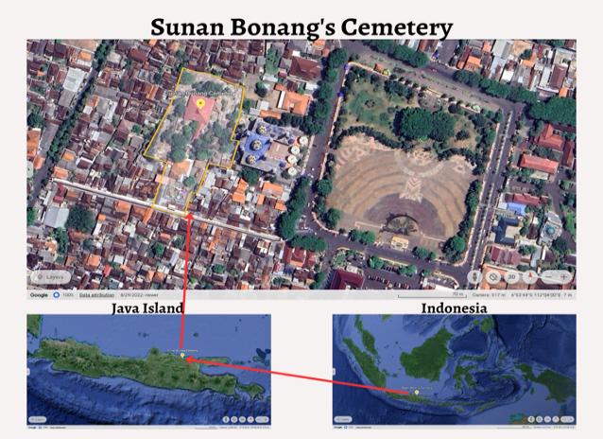
Figure 2. Research Location (Apple Maps, 2023)

Figure 2 shows that the Sunan Bonang tomb areas are located in the center of a highly populated urban area. Sunan Bonang's tomb is located in Tuban District, Tuban Regency, East Java Province, Indonesia. The Sunan Bonang Tomb is positioned at 6°53'42.0" South Latitude and 112°03'47.9" East Longitude, approximately 15 meters above sea level and 400 meters from the beach [12]. Tuban city evolved as a seaport and trading hub starting in the 11th century. The spread of Islam has been swift since ancient times [1], [28].
The research data were gathered by participant observation, in-depth interviews, and document analysis from October 2021 to March 2023. Observations were conducted to assess the condition of the research subjects and determine the informants for interviews. The informants were selected based on their expertise and direct involvement with the management of the Sunan Bonang Tomb. At the same time, visitors were chosen randomly to gather data in an unbiased way. Detailed information on the data collection techniques involving the informants listed in Table 1 is provided, and the research procedure is outlined in Figure 3.

Table 1. Research Informants
No | Status | Total | Informant
1 | Mabarrot Sunan Bonang Foundation | 2 | IL, MU
2 | Religious Figures of Tuban Regency | 1 | KH
3 | Public figures | 2 | FH, FP
4 | Caretaker of Sunan Bonang's Tomb | 1 | RT
5 | Cultural Observer of Tuban Regency | 1 | KI
6 | Tuban Cultural Heritage Conservation Center | 1 | LU
7 | Visitors to Sunan Bonang's Tomb | 1
 | Total | 24
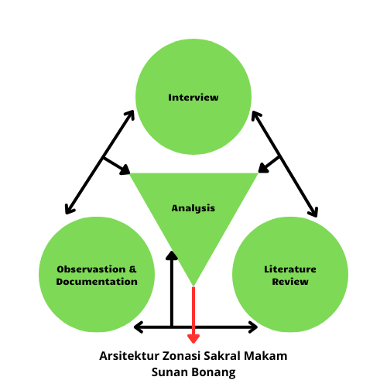

Figure 3. Data analysis using data triangulation

This study employs three phases of data collection for analysis, involving coding of the data, as illustrated in the image above. Data is collected and categorized based on its components to facilitate interpretation and make final judgments by eliminating irrelevant data [46].
This research utilized an archaeological and genealogical approach to gather primary evidence on religious zoning at the Sunan Bonang Tomb [37]. This method can clarify phenomena at any given moment, allowing them to be linked together into a cohesive system of concepts. This method was then simplified into an intellectual framework adapted to the phenomenon originating in Islam. Studying the spiritual zoning phenomenon at the Sunan Bonang Tomb necessitates the use of modern scientific methods [42].

- RESULT AND DISCUSSION

- SACRED ZONING OF SUNAN BONANG’S TOMB
Sunan Bonang's tomb is divided into separate zones. Every zone is distinct and full of value and meaning. The detail is shown in Figure 4.

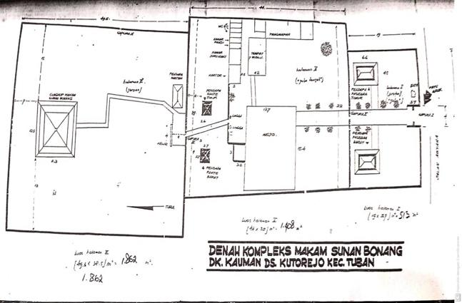
Figure 4. The layout of Sunan Bonang’s tomb areas. [12], [27]

The following explains each zoning of the sacred tomb of Sunan Bonang.
FIRST ZONE: JABA
Although named the Jaba zone, this area is distinct from zones two and three but is nonetheless classified as a sacred zone [12]. The Jaba zone contains three cultural heritage objects: 1) The first gate in the form of a regol; 2) The West Paseban gazebo; and 3) The East Paseban gazebo. The two gazebos are located on the right and left sides just before the Paduraksa gate on zone two. Visitors must pass through a Regol gate before entering the first zone, known as the Jaba Zone. The detail is shown in Figure 5.

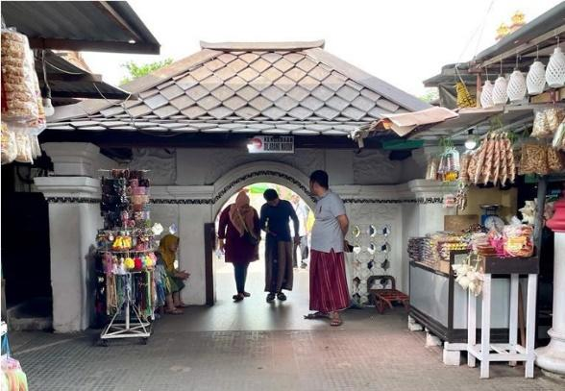
Figure 5. Gate Zone of Jaba (Regol). [Author, 2022]

Figure 5 indicates that the gate's height requires visitors to lower their heads. The symbols suggest that visitors should demonstrate a courteous manner when visiting a location [47]. It can also be observed on many entrances of indigenous houses in Indonesia [48]. This attitude is a way of showing respect to the house owner.
In addition to the cultural heritage objects in the Jaba zone, there are buildings constructed by the Mabarrot Sunan Bonang Tuban Foundation, designed as stalls for merchants. The foundation intentionally allowed businesses to set up booths in the Jaba area to accommodate the high number of people visiting Sunan Bonang's tomb. Furthermore, an increasing number of merchants began conducting business in the Central Jaba area, which was considered more sacred than the Jaba zone. One of the Foundation officials stated that;

“I joined the management of the Mabarrot Sunan Bonang Foundation around 2000; as far as I know, there are merchants in zone two, but none outside the cemetery area. Even though some are already outside the cemetery area, there are still very few of them, and I recall that at first, the sellers in the zone two area sold just a few and hung them on trees. "The more we come here, the more things are sold, not only mineral water but also accessories and various types of merchandise for sale, to the point that visitors who want to go to the mosque find it difficult to enter because of the large number of merchants in zone two.” [IL Interview, 2022]

As the number of visitors and merchants in zone two of Central Jaba increased, the chairman of the Mabarrot Sunan Bonang Foundation, Mr. AM, proposed relocating merchants to the first zone (Jaba zone) with facilities provided by the foundation at no charge. The relocation and positioning of merchants in the first zone marked the beginning of commodification in the Sunan Bonang Tomb.
Controlling and relocating traders in Zone Two (Central Jaba Zone) is necessary to maintain order and comply with laws from the Cultural Heritage Conservation Center [12]. Utilizing the first zone (Jaba zone) for business is acceptable. It is a negotiation approach based on mutual interest and social benefit. The merchants in Zone Two (Central Jaba Zone) are being relocated by the foundation to conserve, preserve, and manage the historical sites in the Sunan Bonang tomb area. Research indicated that a sacred area requires landscape and garden sections, supporting the presence of a first zone or jaba zone [49].
The movement of traders aims to help visitors navigate to the next zone. In the second zone (Central Jaba), visitors have prepared themselves to focus more on the sacredness of the tomb. It can be interpreted as a process for visitors to begin leaving worldly matters and focus on spiritual matters.

SECOND ZONE: CENTRAL JABA
The Central Jaba, also known as Zone Two, is the area located after the Paduraksa Gate in the first zone, which is part of the Jaba zone. Visitors must pass through a Gapura (gate) before entering the Jaba zone of the center. This gate is distinct from the Regol gate in the first zone. The detail is shown in Figure 6.

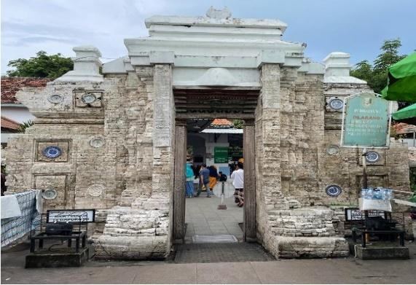
Figure 6. Gate in Central Jaba Zone. [Author, 2022)

The picture clearly showed the contrast in the building's shape compared to the previous gate. This square gate shape is commonly seen in temple structures from the Hindu and Buddhist eras in Indonesia. Additionally, a distinctive feature of this building is a decorative plate attached to the gate. The use of plates in building is a cultural influence from China that has been present throughout the archipelago for a long time. Plates are now utilized as ornaments and markings on gates instead of the animal-shaped medallion emblems commonly seen in temples from the Hindu and Buddhist eras [21]. This zone has been elevated to a semi-sacred status. This area features buildings designed to cater to the needs of visitors, including the new structures depicted in Figure 7.

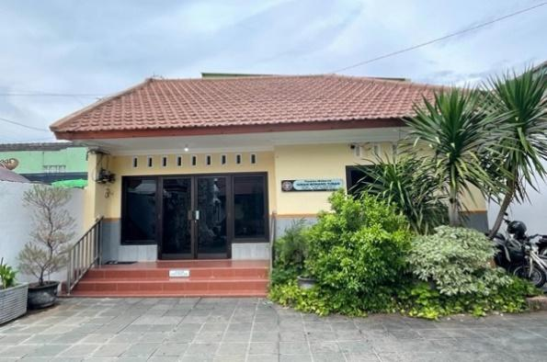
Figure 7. Mabarrot Sunan Bonang Foundation Office [Author, 2023]

The Mabarrot Sunan Bonang Foundation office is a recently constructed building under the supervision of the Regent of Tuban Regency (FH). The Foundation office was initially located north of the Astana Mosque. This office serves as the center for office operations, meetings, and the management of documents related to Sunan Bonang's tomb.
In addition to the Mabarrot Sunan Bonang Foundation office, a security post is located in Zone Two to supervise security and maintain order at the Sunan Bonang tomb areas. This security post is a newly constructed building designed to provide security against internal and external threats. Additionally, it serves to monitor and manage cleanliness and tidiness. Security officers also supervise and regulate traffic flow in the area. Security officers collaborate with the police to guarantee the security and comfort of visitors at the Sunan Bonang tomb. The security post picture is shown in Figure 8.

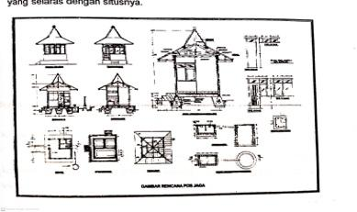 | 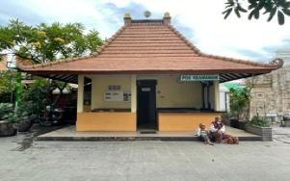
a | b
Figure 8. (a) Design of the Security Post for Sunan Bonang's Tomb [27], (b) Security Post in Sunan Bonang’s Tomb.
[Author, 2023]

The Cultural Heritage Conservation Center was involved in the construction and design of this security post to ensure that the sacred values of the Zone Two area (Central Jaba Zone) were not compromised or diminished. Following the security checkpoint, a rest area is located inside Zone Two, as shown in Figure 9a. This facility serves as a resting place for guests and visitors before they journey to Sunan Bonang's tomb. This location also serves as a temporary facility, offering comfort services to visitors before they proceed to their next destination. In addition to serving as a rest area, this location can also function as a venue for casual conversations and meetings between visitors and the administrators of the Sunan Bonang tomb. This location is conveniently close to the wudhu area, Astana Mosque, and reception area. The rest area was strategically placed near the mosque to facilitate visitors carrying out prayers. An ideal building for visitors is eco-friendly and offers comfort [50].

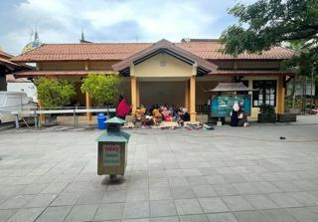 | 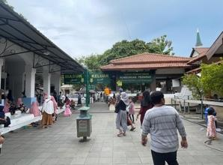
a | b
Figure 9. (a) Rest Area in the Sunan Bonang Tomb Area. [Author, 2023], (b) Information Board. [Author, 2023]

The foundation provides amenities to promote religious tourism trips to the Sunan Bonang tomb for visitors. This requirement is acknowledged as a social necessity of the community while also considering the conservation aspect [27]. Any new objects or buildings not listed as cultural assets in the Sunan Bonang tomb areas may potentially contribute to the commodification of these areas, whether intentionally or unintentionally [44]. In addition to the rest area, the second zone also features signboards and information boards, as shown in Figures 9b and 10.

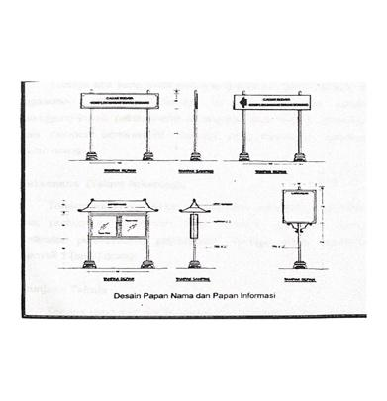 | 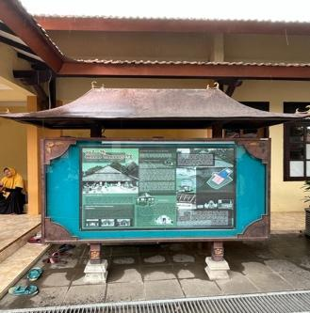
a | b
Figure 10. (a) Design of Signboards and Information Boards. Source:[12], (b) Information Board. [Author, 2023]

Information boards and signboards are essential for providing visitors with information. Additionally, it serves as a method of educating and informing visitors about the history and significance of Sunan Bonang. The information board aims to encourage religious tourism by showcasing historical sites and famous figures, such as Sunan Bonang.
It is crucial to have supporting facilities for restrooms and designated areas for wudhu (a cleansing ritual performed before prayer in Islam). Research indicated that wudhu facilities and bathrooms are essential components that should be included in a mosque area [49]. Visitors must ensure cleanliness and sanitation before visiting Sunan Bonang's tomb and praying. The Mabarrot Sunan Bonang Foundation offers toilet and bathroom facilities as a service to visitors. The presence of restrooms, toilets, and wudhu facilities in this second zone is crucial for ensuring visitors' comfort and hygiene needs are adequately addressed, as shown in Figure 11.

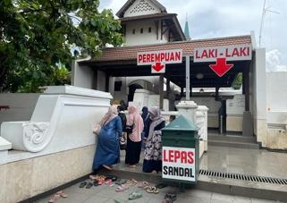 | 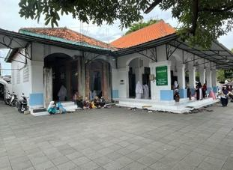
a | b
Figure 11. (a) Bathrooms, toilets, and wudhu areas. [Author, 2023], (b) Astana Mosque. [Author, 2023]

A mosque building is located directly in front of the bathroom, toilet, and wudhu facilities. The Astana Mosque, constructed in 1921, serves as a place of worship for visitors to perform their religious rituals. While the Astana Mosque structure is not classified as a protected cultural heritage object, its presence holds significant importance. The mosque structure, along with its wudhu facilities and bathrooms, displays a blend of local culture and elements of Hindu and Buddhist architectural heritage, as seen in the Sunan Ampel Mosque in Surabaya [51]. The mosque, over a century old, retains its originality. The Astana Mosque symbolizes the evolution of Islam for the community living near the tomb of Sunan Bonang. One of the managers of the Mabarrot Foundation stated that Islamic traditions are still being introduced to the local population from the Astana Mosque (Interview with MU, 2022).
Pilgrims who have entered the central jaba have made further preparations, such as cleaning themselves by performing ablution, doing Salah, and praying. It is the final preparation for the third zone (Jeroan Zone). This process signifies that the pilgrim is prepared to become a human being who focuses on worship and performing good deeds. Pilgrims must abandon worldly matters, including abandoning their wrongdoings.
In addition to serving visitors, the Astana Mosque functions as a center for socio-religious activities in the local community, including regular recitations, Quran speeches, book studies, and the preservation of religious customs passed down by Sunan Bonang [9], [29]. The contrasts with recent studies that suggest a tomb within a mosque area is not an important component [49]. The Astana Mosque plays a crucial role at Sunan Bonang's tomb, particularly for pilgrims.

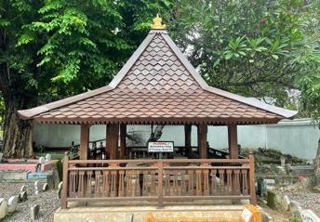 | 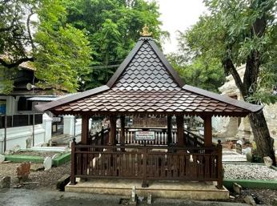
a | b
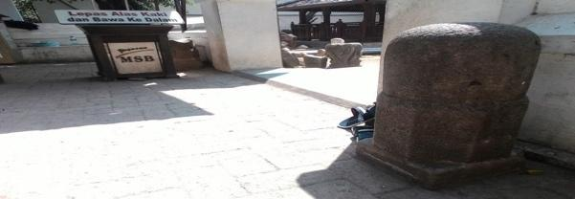
c
Figure 12. (a) Rante Gazebo 1. (b) Rante Gazebo 2. (c) Lingga. [Author, 2023]

The structures in Zone Two, except for the Lingga and two Rante gazebos, are new structures that have little archaeological value, as shown in Figure 12. Two short pillars are set up to the right and left of the entrance before entering zone three (Jeroan), and a short barrier defines the northern boundary of the Astana Mosque. Before entering zone three (Jeroan Zone), there are two gazebos in the small backyard, one on the left and one on the right. The gazebos, known as Rante gazebo by the locals, have four pillars and today serve as a storage space for old relics from the Sunan Bonang tomb area.
The Rante gazebo has been renovated using high-quality recycled materials. Regarding the building's condition, it is evident that the materials have been molded into the structure's contour. Hence, it can be concluded that the building is no longer in its original state of construction. Located in the eastern part of the Rante gazebo structure is a teak wood relief panel. The relief features two elephants with a scorpion form in the center. They are all designed in the shape of tendrils. The presence of animal themes or symbols on multiple Rante gazebo indicates the continued influence of pre-Islamic culture [23], [51].
The carvings were previously located on the entrance gate (regol), according to the Culture Department of the Tuban Regency Education Office [27]. The regol contains the number 1283 in Arabic numerals. Therefore, the carving could feature: Loro Gajah Angapit Kala (two elephants with a scorpion on either side), and the Arabic script shows resemblances to cendra sengkala.
Two Rante gazebo, identical in shape, are located on opposite sides of the road leading to the tomb of Sunan Bonang in the third zone (Jeroan Zone). The architectural form of the Joglo (house) building must be conserved from an archaeological perspective. The Saka Guru has been decorated with a floral decoration within a 28-sided frame (Greek Cross Motif) and a top resembling a king's crown. The tumpal decoration with tendrils is an evolution of decorative patterns from earlier periods.

THIRD ZONE: JEROAN
The area of Sunan Bonang's tomb in the third zone, known as the Jeroan zone, is considered a sacred area. The dome of Sunan Bonang's tomb is shown clearly in this area (see Figure 13). The dome of Sunan Bonang's tomb is designed in the style of a joglo, featuring a square shape that measures 11 meters × 11 meters and has a height of 6.65 meters. In addition to the dome of Sunan Bonang's tomb, there are other new structures in the Jeroan area.

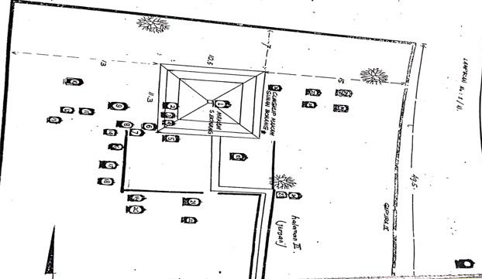
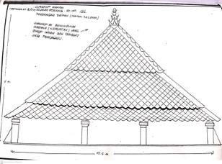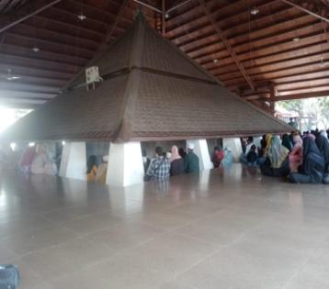
Figure 13. (a) Layout of the Sacred Area of Sunan Bonang's Tomb, (b) Dome Design of Sunan Bonang Tomb. Source:[27], (c) Dome of Sunan Bonang Tomb. [Author, 2023]

The tomb dome structure comprises the main chamber and a porch featuring a three-story pyramid roof crafted from teak wood with a width of 8/20 cm, a top sunduk (a structural stabilizer for pole construction designed to resist sway and shocks), and a bottom measuring 18/18 cm. Both sections of the structure are embellished with tendrils supported by framework poles measuring 18 cm x 18 cm and fasteners measuring 20/8 cm, as well as usuk (long wood or bamboo installed as the ribs of the structure). The pyramid-shaped tomb dome construction is a crucial element designed to control air circulation in the space [49].
The dome is decorated with teak wood shingles, which are thin pieces of wood measuring 50 cm in length, 24 cm in width, and 2 cm in thickness. The mustaka (crown) is crafted from brass. The base is covered with a tumpal shape, a decorative pattern with a triangular area with many curving shapes, enhancing its aesthetic appeal [52]. The top part is round, and the middle section is square, also embellished with a tumpal shape. The dome construction is supported by four main pillars called saka guru, made of 18/18cm teak wood, and saka rawa pillars made of teak wood. These pillars serve as supports for the roof and are located at each corner of the tomb chamber wall [53]. Additionally, there are 11 pillars and 4 additional pillars at the front terrace, measuring 75/75 cm and made of plastered brick masonry. The component is now aligned with the walls of the terrace on the north and west sides.
According to Figure 9a, the Sunan Bonang Tomb is placed centrally among other tombs in the third zone, known as the Jeroan Zone. The grave of Sunan Bonang is located in the central area, and the nearby tombs have a strong connection to Sunan Bonang. Relationships can be developed through blood relatives within a family or through emotional connections. Similar findings are evident in other tomb sites in various countries [15].
The unique feature of Sunan Bonang's tomb is its spatial architecture, which prominently features calligraphy. The Arabic calligraphy with aurad (plural of Wirid), admired by Makdum Ibrahim Sunan Bonang, is located on the north side of the dome of Sunan Bonang's tomb, as shown in Figure 14.

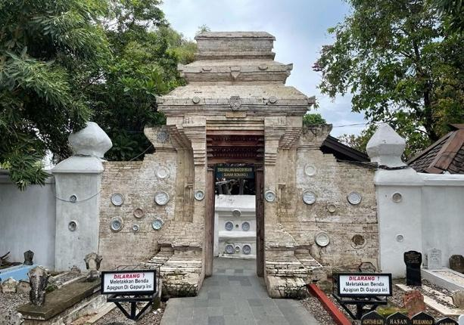
Figure 14. Wirid Calligraphy. [Author, 2023]

The first section includes the recitation of Surah Yunus, verses 62-65. The second word, written in white, details the wirid that Makdum Ibrahim Sunan Bonang favored throughout his lifetime, specifically the recitation of Surah Al-Fatiha 50 times. The next step is to recite Surah Al-Ikhlas 50 times and send prayers to the Prophet Muhammad 300 times. Sunan Bonang admires the wall decorated with this calligraphy. Thus, it is highly recommended for visitors to engage in this wirid praise. Engaging in this wirid praise is believed to foster a closer connection with Allah SWT and increase the possibility of wishes being fulfilled (Interview with RT, 2022).
In addition to calligraphy, a new guard post is being built to the northwest, and to the east, a new structure is designated for accommodating visitors. Next to the building lies an empty area that was previously used for storing wood to renovate the dome of Sunan Bonang's tomb. A new iron door on the eastern side of the dome now connects the Jami' Mosque in Tuban City with the tomb.
Visitors must pass through a gate called Gapura Paduraksa before approaching the Jeroan zone. Visitors cannot enter the Jeroan area right after passing through the Paduraksa gate. This type of gate is also present in several pagoda and temple structures, serving as barriers between different spatial zones [26], [47]. The picture of the Paduraksa gate is shown in Figure 15.

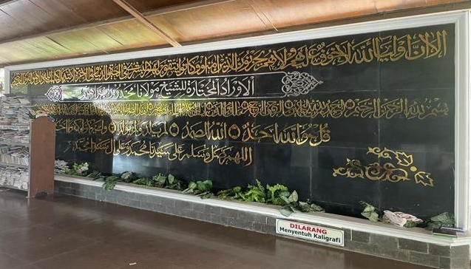
Figure 15. Paduraksa Gate [Author, 2023]

In addition to the dome of Sunan Bonang's tomb, the Jeroan area also includes a gazebo located to the east of the Kelir wall. A Kelir wall is a structure used for constructing walls, as shown in Figure 16. The local name for it is Manten gazebo, characterized by a square shape measuring 4.6 meters by 2.95 meters. It resembles a smaller version of a Rante gazebo. The floor consists of a 22 cm high plastered brick masonry supported by four pillars that hold up the building's roof. This pillar is constructed of plastered masonry and decorated with pelipit-pelipit (frames) at the top [54].
The Manten gazebo is smaller than the gazebos at the Sunan Bonang tomb, yet it features a simple shape with distinctive historical value. In the past, many brides and grooms visited the tomb of Sunan Bonang before entering the dome. They were expected to briefly stop at the Manten gazebo to get advice about the marriage. The valuable opportunity for newlyweds to receive guidance on managing their family for the future. Visiting the tomb on a pilgrimage is a method to gather knowledge and get insights into life [14].
Visitors move through a Kelir wall, located north of Gate III, which resembles a fortress, after passing through the Paduraksa gate and before entering the tomb dome. The wall is a brick construction that measures 2.5 meters in length, 2.1 meters in height, and has a thickness of 0.43 meters.
Both edges have pillars that measure 48 x 42 cm. Two porcelain plates decorate the front of the pillars, with the top plate being smaller in size. A large panel, decorated with flat seams, is set in the center of the wall, accompanied by four smaller panels embellished with porcelain plates. Porcelain plates are decorated on three sides of the huge panel. Small porcelain plates decorate the spaces between the small panels. The wall features a pyramid-shaped wall head at the top and a slightly downward-placed plate in the middle. There is a beautiful porcelain plate on the east side of the eastern pillar, and the building construction and its materials are still in fine shape. Having a gate and walls decorated with ornamentation are crucial elements of a sacred area [49].

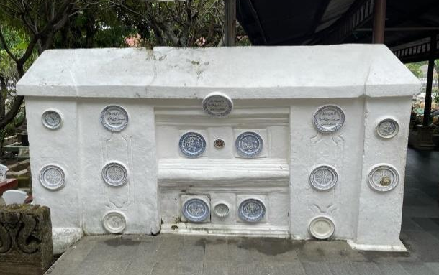
Figure 16. Kelir Wall. [Author, 2023]

The plate connected to the wall above contains a transcription of the Arabic Pegon letters, obtained from the Complete Inventory document of the Sunan Bonang Tomb, compiled by the Tuban Regency Education and Culture Department Office in 1989. The source of this information is Mr. (AS) from Tuban [27]. The writing on the bottom of the plate reads:

1. Rehing Sofyang Menanam Tamu
2. Simpan Serahi dalam Perigi
3. Sudahlah Perjanjian Kita Bertemu
4. Dimanakan Dapat Disalahi Lagi
5. Simpan Serahi Dalam Perigi
6. Hulid Memetik Jualan
7. Dimanakan Dapat Disalahi Lagi
8. Baiklah Kita Berkenal Kenalan

There are other vocabulary words in the note that have not yet been identified, so further research will be needed to understand the transcription's results. The presence of foreign terms can lead to uncertainty over potential errors in the writing or reading process, or something similar [27].
The Sunan Bonang tomb area spans from north to south and comprises three separate areas, each enclosed by a tall wall and featuring the paduraksa gate as both the entrance and exit, as shown in Figure 4. This shares similarities with many architectural zones seen in Chinese civilization, Hindu, and Buddhist cultures, all of which split an area into three zones [20], [23], [47], [48], [51]. Visitors must cross the first zone of the Jaba zone in the south, proceed north to the Jaba Jeroan zone, and finally reach the Jeroan zone, where the Sunan Bonang tomb dome is located.

- COMMODIFICATION OF SUNAN BONANG'S TOMB
The increase in visitors to the Sunan Bonang Tomb has resulted in various impacts [20]. One of the factors contributing to the increase in pilgrim visits was a comment made by a religious official, who noted that visiting Sunan Bonang's tomb was similar to visiting all the wali’s (religious figures’) graves (Interview with FH, 2022). It is believed to represent the increase in visits to the Sunan Bonang Tomb.
The high volume of visitors necessitates tomb management to offer services to visitors [17]. These kinds of services alter the significance of the Sunan Bonang Tomb (Commodification). Initially, visits to the Sunan Bonang Tomb were solely for religious pilgrimage. Public trips to the Sunan Bonang Tomb have become regulated religious tourism visitation due to enhanced administration and services (Interview with MU, 2022). Effective management also impacts the economic conditions of the nearby community, encompassing managers and officials. It aligns with the view that the commodification process is closely linked to capitalism [15].
The transformation of a sacred site into a religious tourism destination at Sunan Bonang's tomb is supported by: a) Employee management to establish a structured system for managing human resources and operations at the tomb; b) Financial transactions and employee welfare (Abdi Dalem) as evidence of the organized administration of the institution and activities to ensure well-being for Abdi Dalem, along with financial transparency regarding the contributions from pilgrims. The supervision of tomb officials supports the organizational governance of the foundation, along with government participation through the Cultural Heritage Conservation Center (Interview with IL, 2022).
Facilities and infrastructure are necessary to enable the commodification and positive experiences for visitors at the Sunan Bonang Tuban tomb, while also considering the preservation of the historical site [3]. The infrastructure and facilities mentioned are located in different zones within the Sunan Bonang tomb area. These zones are classified into three distinct areas: Jaba, Central Jaba, and Jeroan, which contains the tomb of Sunan Bonang (Interview with RT, 2022).
The evident is not only in the construction of facilities but also in the management, budgetary planning, and financial accountability of the foundation. Additionally, the purchase of goods by several supporters serves as a means of supporting the commodification of sacred sites into religious tourism. Tombs, as cultural artifacts, require proper administration and maintenance by qualified officials to prevent their sacred purpose from being overshadowed by religious tourism [6]. Effective management will create a balance between the sacred and commodification, allowing for accessibility and opportunity [23], [44].
The commodification that occurred at Sunan Bonang's tomb, with the formation of three zones, represents a gradation of values. The intended gradation is a movement from the first zone (Jaba) to the second zone (Central Jaba) and ending in the third zone (Jeroan). The presence of a gate limits movement between these zones. The purpose of this gate is to act as a gradation barrier between zones. It means that pilgrims need time to make the move (Change). The process of moving pilgrims from the first zone to the third zone is analogous to humans who initially prioritize worldly traits and then shift towards spiritual ones.
Besides the horizontal zoning symbolized by three zonings, the Sunan Bonang tomb features a mausoleum that forms a tumpang sari and is conical, culminating in one point (top of the mausoleum). The vertical zoning can be interpreted as meaning that humans are also in the process of moving towards a spiritual goal. This interpretation of the zoning of the Sunan Bonang tomb aligns with Foucault's theory, which posits that the ultimate goal involves transitioning from the bottom to the top, from the scattered to the centralized, and that the strategy employed to achieve this goal is a process [37].
The pilgrim's journey from the first zone to the second zone must have a goal. After reaching the third zone, pilgrims should uphold good values ​​, including performing good deeds for everyone. It is realized because pilgrims have passed through various zones that shape them into good people. Goals like this are what ultimately maintain the sacredness of a tomb. The commodification that occurs should also have a positive impact because it increasingly shapes people to become spiritual [29].

- CONCLUSION
This study investigated the process of commodification of Sunan Bonang's tomb, transforming it from a sacred site to a destination for religious tourism. Three key factors have contributed to the commodification of sacred space at the Sunan Bonang tomb, which is zoned for religious tourism. The first is the enthusiasm of those who view pilgrimages as a tradition passed down through generations to honor ancestors or those deemed deserving. The government perceived this opportunity as an initiative to upgrade the guardian's burial to meet tourist standards by providing various services. The foundation, with complete responsibility for cemetery maintenance, has provided services and facilitation in various forms within each sacred area of the Sunan Bonang Tomb.
The sacred space at the Sunan Bonang Tomb is zoned into three zones: Jaba, Central Jaba, and Jeroan. The zoning division has distinct limits that have developed over time through the process of commodification.
This research theoretically offers advantages for enhancing knowledge and academic understanding in the field of cultural studies. The system can offer suggestions to the tomb management foundation on focusing on signs when creating policies for developing religious tourism areas. This approach aims to preserve traditional resources important for maintaining the authenticity of the sacred site at the Sunan Bonang tomb. This study offers insights from a cultural studies perspective on how to promote religious and cultural tourism without compromising the cultural products and sacred qualities of the Sunan Bonang tomb, for policymakers.

ACKNOWLEDGEMENT
The researcher expresses gratitude to the promoters and lecturers of the Cultural Studies Doctoral Program at the Faculty of Cultural Sciences, Universitas Sebelas Maret, Surakarta, as well as the Saudi Fund for Development (SFD) through the Project Management Unit (PMU) of Universitas Islam Negeri Maulana Malik Ibrahim, Malang, and the Foundation Mabarrot Sunan Bonang Tuban for their assistance and advice in facilitating access for researchers.

REFERENCES

[1] M. Basri and A. Wilujeng, “Masuknya Islam Ke Nusantara,” Khazanah: Journal of Islamic Studies, vol. 1, no. 4, pp. 61–73, 2022.
[2] M. Abdillah, Islam & Dinamika Sosial Politik Di Indonesia. Gramedia Pustaka Utama, 2015. Accessed: January 14th, 2024. [Online]. Available: https://ebooks.gramedia.com/id/buku/islam-dinamika-sosial-politik-di-indonesia
[3] H. A. P. Putra, K. E. Sari, and W. I. Rukmi, “Tindakan Pelestarian Kawasan Cagar Budaya Makam Sunan Bonang Kabupaten Tuban,” Planning for Urban Region and Environment Journal (PURE), vol. 11, no. 2, Art. no. 2, Apr. 2022.
[4] N. Syam, Islam Pesisir, II. Yogyakarta: LKiS Pelangi Aksara, 2005.
[5] S. Syahdan, “Ziarah Perspektif Kajian Budaya (Studi Pada Situs Makam Mbah Priuk Jakarta Utara),” Jurnal Studi Agama dan Masyarakat, vol. 13, no. 1, pp. 65–99, Jun. 2017, doi: 10.23971/jsam. v13i1.550.
[6] F. Prihantoro and G. Yuristiadhi, “Behavior of Tourists and the Future of Middle-Class Tourism: A Phenomenological Study of Sunan Giri and Sunan Drajat Tombs,” KnE Social Sciences, pp. 211–238, May 2018, doi: 10.18502/kss. v3i5.2334.
[7] I. Gunawan, “Wisata Sunan Bonang Paling Banyak Dikunjungi - Radar Bojonegoro,” Wisata Sunan Bonang Paling Banyak Dikunjungi - Radar Bojonegoro. Accessed: January 14th, 2024. [Online]. Available: https://radarbojonegoro.jawapos.com/bojonegoro/711313218/wisata-sunan-bonang-paling-banyak-dikunjungi
[8] T. Handriana, P. Yulianti, and M. Kurniawati, “Exploration of pilgrimage tourism in Indonesia,” JIMA, vol. 11, no. 3, pp. 783–795, May 2020, doi: 10.1108/JIMA-10-2018-0188.
[9] F. Zarkasi, “Educative Values of Peace Mind Mysticism of Sunan Bonang In the view of Islam,” International Journal of Emerging Issues in Early Childhood Education, vol. 1, no. 2, Art. no. 2, 2019, doi: 10.31098/ijeiece. v1i2.148.
[10] L. M. Allan and M. Karmilah, “Pengaruh Aktivitas Ziarah terhadap Ruang Publik Alun-Alun Studi Kasus : Kawasan Pemakaman Sunan Bonang,” Jurnal Planologi, vol. 14, no. 2, Art. no. 2, Jan. 2019.
[11] M. Atho’Atun, “Perencanaan Lanskap Kawasan Wisata Budaya Islam Sunan Bonang.,” IPB University, 2009, Accessed: January 14th, 2024. [Online]. Available: http://repository.ipb.ac.id/handle/123456789/19297
[12] BPPP, “Studi Teknis Arkeologis Komplek Makam Sunan Bonang Kelurahan Kutorejo Kecamatan Tuban Kabupaten Tuban.” Direktorat Peninggalan Purbakala, Dirjen Sejarah dan Purbakala, Departemen Kebudayaan dan Pariwisata, 2006.
[13] Indrawati, S. Soetomo, B. Setioko, T. W. Murtini, and Nurhasan, “Edu – Religious Tourism Based on Islamic Architecture Approach, a Prelimenary Research in Majasto Cemetery – Sukoharjo Regency Central Java,” Procedia - Social and Behavioral Sciences, vol. 227, pp. 656–663, Jul. 2016, doi: 10.1016/j.sbspro.2016.06.129.
[14] I. Indrawati, N. Nurhasan, and S. Soetomo, “The Shifting of Islamic Heritage from Education Center to Worship Tomb (The Effect of The Political Policy),” Journal of Islamic Architecture, vol. 7, no. 1, Art. no. 1, Jun. 2022, doi: 10.18860/jia. v7i1.15127.
[15] J. L. Baker, “Form and Function of Mortuary Architecture: The Middle and Late Bronze Age Tomb Complex at Ashkelon,” Levant, vol. 42, no. 1, pp. 5–16, Apr. 2010, doi: 10.1179/175638010X12634804459724.
[16] A. Hassan and Mohd. Z. Ismail, “The infusion of Environmental Education (EE) in chemistry teaching and students’ awareness and attitudes towards environment in Malaysia,” Procedia - Social and Behavioral Sciences, vol. 15, pp. 3404–3409, 2011, doi: 10.1016/j.sbspro.2011.04.309.
[17] J. Putra, D. Septanti, and M. Rachmawati, “Planning of Religious Tourism Area of Gus Dur Tomb Integrated with Regionalism Strategy,” Journal of Islamic Architecture, vol. 7, no. 1, Art. no. 1, Jun. 2022, doi: 10.18860/jia. v7i1.12994.
[18] K. A. Shinde, “Religious tourism and religious tolerance: insights from pilgrimage sites in India,” Tourism Review, vol. 70, no. 3, pp. 179–196, Aug. 2015, doi: 10.1108/TR-10-2013-0056.
[19] M. Terzidou, C. Scarles, and M. N. K. Saunders, “Religiousness as tourist performances: A case study of Greek Orthodox pilgrimage,” Annals of Tourism Research, vol. 66, pp. 116–129, Sep. 2017, doi: 10.1016/j.annals.2017.06.009.
[20] V. I. W. Nalle and T. P. Moeliono, “Spatial injustice in the context of cemeteries: The case of Surabaya, Indonesia,” Land Use Policy, vol. 131, p. 106751, Aug. 2023, doi: 10.1016/j.landusepol.2023.106751.
[21] R. Purwanti, “The Medallion Design on Gravestones in Palembang,” KALPATARU Majalah Arkeologi, vol. 30, no. 1, pp. 75–86, 2021, doi: https://doi.org/10.24832/kpt.v30i1.815.
[22] K. Puzdrakiewicz, “To what extent are cities prepared for their residents’ deaths? An example of cemetery management in large Polish cities,” Land Use Policy, vol. 129, p. 106646, Jun. 2023, doi: 10.1016/j.landusepol.2023.106646.
[23] M. Makmur et al., “Tomb Architecture,” presented at the 9th Asbam International Conference (Archeology, History, & Culture In The Nature of Malay) (ASBAM 2021), Atlantis Press, Apr. 2022, pp. 102–109. doi: 10.2991/assehr.k.220408.014.
[24] D. Stoyanova, “Tomb Architecture,” in A Companion to Ancient Thrace, John Wiley & Sons, Ltd, 2015, pp. 158–179. doi: 10.1002/9781118878248.ch12.
[25] V. Cummings, “What lies beneath: Thinking about the qualities and essences of stone and wood in the chambered tomb architecture of Neolithic Britain and Ireland,” Journal of Social Archaeology, vol. 12, no. 1, pp. 29–50, Feb. 2012, doi: 10.1177/1469605311428117.
[26] D. Luo, “Yinan and Mylasa: Sino-Hellenic Exchanges in Tomb Architecture,” SCIENTIFIC CULTURE, vol. 8, no. 3, pp. 35–48, Jun. 2022, doi: 10.5281/ZENODO.6640253.
[27] B. S. Hadi, “Inventarisasi Lengkap Makam Sunan Bonang.” Departemen Pendidikan dan Kebudayaan, Kabupaten Tuban, 1989.
[28] A. Urokhim, S. Sariban, and H. Kustomo, “Cagar Budaya sebagai Peneguhan Tuban yang Multikultur,” Jurnal CANDI, vol. 22, no. 1, Art. no. 1, 2022.
[29] A. Jauharotina, “Internalisasi Tasawuf dalam Dakwah Sunan Bonang,” Journal of Dakwah Management, vol. 1, no. 1, Art. no. 1, Jul. 2022.
[30] N. Collins-Kreiner, “Pilgrimage tourism-past, present and future rejuvenation: a perspective article,” Tourism Review, vol. 75, no. 1, pp. 145–148, Jan. 2019, doi: 10.1108/TR-04-2019-0130.
[31] B. M. Wibawa, C. Pranindyasari, G. W. Bhawika, and R. R. Mardhotillah, “Discovering the importance of halal tourism for Indonesian Muslim travelers: perceptions and behaviors when traveling to a non-Muslim destination,” Journal of Islamic Marketing, vol. 14, no. 1, pp. 61–81, Jan. 2021, doi: 10.1108/JIMA-07-2020-0210.
[32] Y. D. Lestari, F. Saidah, and A. N. Aliya Putri, “Effect of destination competitiveness attributes on tourists’ intention to visit halal tourism destination in Indonesia,” Journal of Islamic Marketing, vol. 14, no. 4, pp. 937–965, Jan. 2022, doi: 10.1108/JIMA-12-2020-0368.
[33] F. Haq and H. Yin Wong, “Is spiritual tourism a new strategy for marketing Islam?” Journal of Islamic Marketing, vol. 1, no. 2, pp. 136–148, Jan. 2010, doi: 10.1108/17590831011055879.
[34] M. Pataruka and I. Santoso, “Tempat Sakral: Reinterpretasi Wisata Religi di Kota Demak,” in Kearifan Lokal dalam Keberagaman untuk Pembangunan Indonesia, Medan, Jan. 2018. [Online]. Available: https://www.researchgate.net/publication/328701801_TEMPAT_SAKRAL_REINTERPRETASI_WISATA_RELIGI_DI_KOTA_DEMAK
[35] R. Adam, “Esensi Agama dalam Fenomenologi Eliade,” https://crcs.ugm.ac.id. Accessed: February 05th, 2024. [Online]. Available: https://crcs.ugm.ac.id/esensi-agama-dalam-fenomenologi-eliade/
[36] C. Barker, Cultural studies: Teori & praktik. Kreasi Wacana, 2004.
[37] M. Foucault, Arkeologi Pengetahuan dan Pengetahuan Arkeologi. Jakarta: Obor, 2018. Accessed: January 14th, 2024. [Online]. Available: http://obor.or.id/index.php?route=product/product&product_id=816
[38] I. Imronudin and R. Muhammad, “Discourse from the Perspective of Mohammed Arkoun: An Examination of the Values of Interfaith Dialogue,” PP, vol. 27, no. 1, p. 94, Jun. 2023, doi: 10.30984/pp. v27i1.2367.
[39] M. Arkoun, Nalar Islami Dan Nalar Modern:Berbagai Tantangan Dan Jalan Baru, vol. 1. Jakarta: INIS, 1994.
[40] A. F. A. Reksa, “Tinjauan Buku Kritik Terhadap Modernitas Dialectic of Enlightenment Theodor: W. Adorno dan Max Horkheimer: California: Stanford University Press, 2002,” Jurnal Kajian Wilayah, vol. 6, no. 1, Art. no. 1, Jun. 2016, doi: 10.14203/jkw. v6i1.72.
[41] Z. Daradjat, Perbandingan Agama. Bumi, 1996.
[42] M. Misnawati, S. Bahri, and M. N. Abrar, “Pemikiran Mohammed Arkoun Dalam Penafsiran Kontemporer,” PAI, vol. 12, no. 2, p. 271, Jun. 2022, doi: 10.22373/jm. v12i2.13292.
[43] S. Jettot, Selling Ancestry: Family Directories and the Commodification of Genealogy in Eighteenth Century Britain. United Kingdom: Oxford University Press, 2023.
[44] S. Komariyah, “Komodifikasi Makam dalam Perspektif Sosial-Ekonomi (Studi Kasus di Makam Sunan Kalijaga Demak),” Solidarity: Journal of Education, Society and Culture, vol. 4, no. 1, Art. no. 1, Jun. 2015, Accessed: Jan. 14, 2024. [Online]. Available: https://journal.unnes.ac.id/sju/index.php/solidarity/article/view/6045
[45] I. W. Hidayati, W. Warto, and M. Marimin, “Production in the Commodification of the Selomangleng Cave,” International Journal of Multicultural and Multireligious Understanding, vol. 10, no. 5, Art. no. 5, May 2023, doi: 10.18415/ijmmu. v10i5.4695.
[46] J. W. Creswell, Research Design Pendekatan Metode Kualitatif, Kuantitatif, dan Campuran, 4th ed. Yogyakarta: Pustaka Pelajar, 2016.
[47] S. Kustedja, A. Sudikno, and P. Salura, “Elaborasi Makna Pintu sebagai Simbol dalam Arsitektur Vernakular Tionghoa, pada Bangunan Klenteng Tua di Pulau Jawa.,” Zenit, vol. 2, no. 2, pp. 116–130, 2013.
[48] J. Juliani et al., “Nilai Kearifan Lokal Dalam Rumah Adat Limbungan Suku Sasak,” Jurnal Dinamika Sosial Budaya, vol. 22, no. 2, Art. no. 2, Dec. 2020, doi: 10.26623/jdsb. v22i2.2832.
[49] A. Sedayu, A. G. Gautama, S. Rahmah, and A. R. Setiono, “Religious tolerance, cultural, local wisdom and reliability in the Great Mosque building of Mataram Kotagede Yogyakarta,” Journal of Cultural Heritage Management and Sustainable Development, vol. 12, no. 4, pp. 593–608, Jan. 2021, doi: 10.1108/JCHMSD-06-2020-0088.
[50] A. Sedayu, A. R. Setiono, A. Subaqin, and A. G. Gautama, “Improving the performance of construction project using green building principles,” Asian J Civ Eng, vol. 21, no. 8, pp. 1443–1452, Dec. 2020, doi: 10.1007/s42107-020-00289-1.
[51] A. Sedayu, “The priority of maintaining the reliability of sustainable construction at the Ampel Mosque Surabaya,” MATEC Web Conf., vol. 195, p. 06008, 2018, doi: 10.1051/matecconf/201819506008.
[52] R. Rosniati, A. Alim, and S. Salniwati, “Akulturasi Ragam Hias Pada Makam La Ode-Ode Dan Raja Jin Di Dalam Benteng Lipu Kecamatan Kulisusu Kabupaten Buton Utara,” Sangia Journal of Archaeology Research, vol. 5, no. 1, Art. no. 1, Aug. 2021, doi: 10.33772/sangia. v5i1.1160.
[53] A. Sope and S. Kasmiati, “Identifikasi Nilai Penting Masjid Agung Bente di Desa Ollo Selatan Kecamatan Kaledupa Kabupaten Wakatobi,” SANGIA JOURNAL OF ARCHAEOLOGY RESEARCH, vol. 1, no. 1, Art. no. 1, Jun. 2017, doi: 10.33772/sangia. v1i1.556.
[54] T. M. Istari, “Motif Hias Pada Pelipit Candi,” Berkala Arkeologi, vol. 33, p. 67, May 2013, doi: 10.30883/jba. v33i1.6.

