 | JOURNAL OF ISLAMIC ARCHITECTURE  P-ISSN: 2086-2636 E-ISSN: 2356-4644  Journal Home Page: http://ejournal.uin-malang.ac.id/index.php/JIA

Architectural Elements in Omani Residential Building Façades

| Received March 21th 2023 | Accepted June 17th 2016 | Available online June 30th 2016 |
| DOI http://dx.doi.org/10.18860/jia.v4i1.3466 |

Afsaneh Shahbazzadeh  Faculty of Architecture & Urbanism,  Imam Khomeini International University, Qazvin, Iran  afsanehshahbazzade@gmail.com  Reza Sameh  Assistant Professor, Faculty of Architecture & Urbanism,  Imam Khomeini International University, Qazvin, Iran  rsameh@arc.ikiu.ac.ir  Naima Benkari  Associate Professor, Civil and Architectural Engineering Department,  Sultan Qaboos University, Muscat, Oman  nbenkari@squ.edu.com |  | ABSTRACT  Currently, Designing the façade according the architectural values has been challenging for designers. Utilizing the patterns compatible with context in design is very efficient for designing. Utilizing the pattern in design is a very efficient and useful solution for solving and responding to these factors. Extracting the patterns from the buildings are a positive response to the design process. The aim of this paper is a way to categorize the pattern in a specific frame for expressing the solution for the design process in everywhere, and it focuses not on esthetics aspect of patterns, but on their structure how pattern work together to build a system. The paper assumes that pattern design is a system, therefore, theory about the system design and evolution underlines the patterns language. This paper has conducted research on two category patterns in vernacular buildings in Mirbat and contemporary buildings in Mutrah. This paper has researched two category patterns in vernacular buildings in Mirbat and contemporary buildings in Mutrah.  KEYWORDS:  Pattern language, Traditional Buildings, Design Process, System, Façade

INTRODUCTION
Architecture is like a mirror reflecting the civilizational developments of every society throughout time. It reflects changes in communities as a result of interaction between societal elements created by the influx of different cultures. Every society has a native, inherited culture and a cultural input, which is the indication of major changes in its history. Architecture reflects these interactions between the two cultures. At the design level, such interactions govern the general architectural form of buildings and produce what is known as the city fabric. At this point, both the planner and the designer face the challenge of combining the two cultures inputs as part of the community’s expression of its own identity, and neither of which can be overlooked [1].
Islamic societies, with their long architectural tradition, are facing two major challenges in this matter: losing parts of their culture and identity, and the emergence of new styles and requirements, which cannot be achieved through inherited know how alone. The two aspects of heritage include the physical dimension of creative formation and distinctive architecture, which are formed by interacting with the surrounding environment and the local context. Arab and Islamic societies need to bridge the gap in their architectural and urban identity between their heritage and their contemporary aspirations. Hence, the importance of heritage as a means of confirming the community’s identity and achieving the continuity of its civilization [2].
The forms of contemporary architecture must reflect the local culture and inherited identity. A community’s values, social relations, and built environment are imbibed with its culture, heritage, and past experiences. Similarly, the outcome of contemporary architecture must express the cultural diversity of every region and underpin the identity of that community through a new look which is culturally credible, while providing access to modernity, progress and new aspirations sought by society. Hence, the architectural design must be a combination of progressive elements, while safeguarding the cultural authenticity, teachings, and details, to achieve an architectural product, which meets the contemporary needs of the community and preserves its identity [1].
The present research aims to highlight the transcendence of Omani vernacular architectural elements in the contemporary architecture emerging in this country. It is a question to explore the patterns of Omani vernacular architecture in the contemporary architecture, their contrasts and interactions with patterns of modern architecture, and investigate their functions. The objective is to carry out an analysis of the structural, cultural, and formal characteristics of vernacular buildings, in order to propose a pattern for designing new buildings. To what extent is it possible to formulate an architectural language proper to a region, in modern times, based on its vernacular architecture?

1. Methodology
This research investigates three important qualifiers of the facade and are studied in a 3-D matrix, the structure, performance, and semantic elements of residential architecture in Oman (figure 2). We have analyzed these qualifiers in the three-layered system of any architectural object: setting, formation, and details. Since the research is background-oriented, it adopted a qualitative approach, using observation and field surveys on the selected case studies and Omani traditional patterns. The research relied also on a comparative approach between the façade features in each case study.
Context is the central theme in the present research the analysis of which will bring us to the main topic. By investigating the typology in the Context, set systems and patterns will be extracted and categorized to obtain the dominating layout of the patterns that make designing with the Context in mind possible (figure 2).

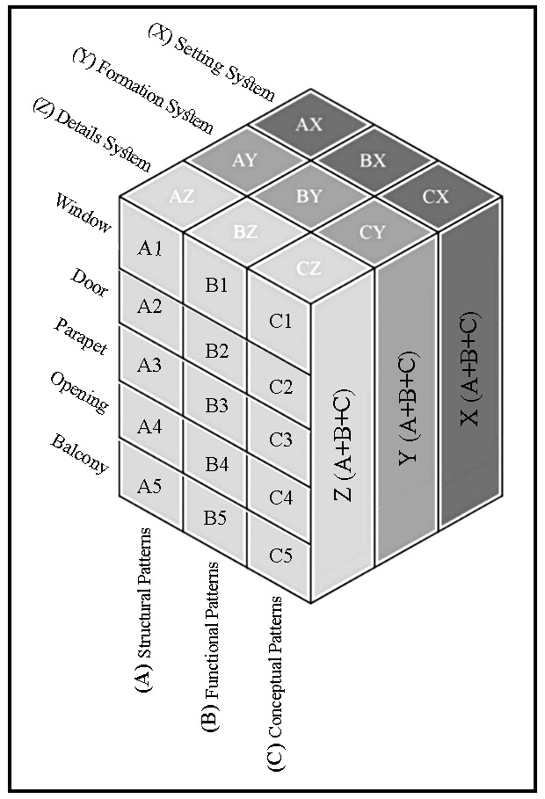

Figure 2: The Structural Model of the Research

Relationship between patterns and system: The relationship between patterns and system is shown in the figure (figure 3). The setting system of the patterns is based on their placement position, regardless of form and detail. The formation system of the general shape of the patterns has been investigated. In the system used for details, we have carefully examined the details of the pattern and combined three systems to achieve the overall system, which is the design rule. To explain the system, prioritization is given from the whole to the part. This makes the investigation more coherent and coordinated. In the present research, the statistical sample consisted of 24 houses in which all the architectural elements were analyzed.

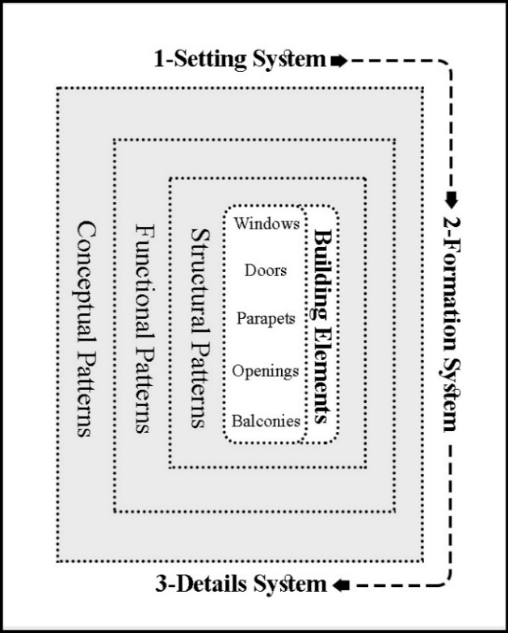

Figure 3: Patterns & the Evolution of Research Systems

For considering samples in this method the height and elements of the buildings should be considered. For instance, a wide range of samples should be analyzed and categorized according the number of floors. In addition, the selections should encompass the traditional and modern buildings. Because facades are the most important elements for defining the cities appearance, so the main focus for analyzing is about the facades of the houses. The majority of the case studies samples have been chosen from two and three-story buildings because most of them have balconies that is the important elements for shaping the façade. Selecting a wide range of data (buildings) will be more beneficial for this method as it gives more freedom to choose the best pattern for the designer. All the pictures in this research for Mutrah have been gathered by authors and Mirbat taken from the Archiam website.

Solution for Design: Using Patterns of Façade Elements
Each pattern describes a problem, which occurs over and over again in our environment, and then describes the core of the solution to that problem, in such a way that you can use this solution a million times over without ever doing it the same way twice [3]. In this paper, we intend to find new way for the combination of the patterns and sorting them together, the patterns are taken from the façades. Using pattern language in designing helps to overcome the complexity of things and achieve a desirable form. Pattern languages are disciplined abstracts of human experiences. The validity of patterns is determined through experience evolving through time.
2.Case Studies
The studied samples in this research were a selection of houses in a district of the city of Mirbat (South of Oman) and another selection of houses in the city of Mutrah (in the capital region). These two cities have been selected as case studies, because of their rich architecture, and the well-developed patterns of their facades. In total, 24 buildings have been selected: 15 of them (4,5,6,13-24) belong to the Mutrah city as a representative of the contemporary architecture and the 9 of them (1-3,7-12) belong to the Mirbat city as a representative of the vernacular architecture.
As seen in (figure1), the houses of Mirbat have the characteristics of the local native architecture, and the houses in Mutrah have the characteristics of traditional Omani architecture. The amalgamation of the two styles can be beneficial for presenting design solutions Five elements have been identified in the façade: Number 1: window, door (entrance and balconies doors), parapet, opening and balcony. People have shaped buildings for themselves, for centuries, by using what was defined by Christofer Alexander as pattern languages.
A pattern language provides the tools to create an infinite variety of new and unique designs, just as the ordinary spoken language gives the power to create an infinite variety of sentences. A building, which has a “free” form, a shape without roots in the forces or materials it is made of – is like a man whose gesture has no roots in his nature. Its shape is unauthentic, artificial, forced, contrived made to copy outside images, not generated by the forces inside [4].

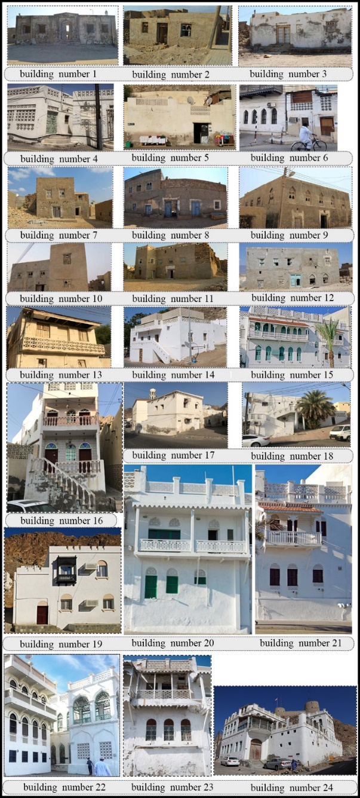

Figure 1: Buildings of the Research, number 1-3 & 7-12: www.archiam.com & number 4 & 5 &6 & 13-24 (Source: Authors)

3. Results
3.1. Patterns of residential architecture in Oman
3.1.1. Structural Patterns (A)
At first glance, the appearance of the buildings in traditional communities shows their identity, and paying attention to their structure is crucial for designers. Structural patterns encompass the designs used in windows, doors, parapets, openings, interior decorations, and eaves. In the investigations, the structure of the details, their repetition, and their layout in the whole have been analyzed in order to achieve a structure, which can be used in designing buildings in Oman.
Our focus in this analysis is the outline of the patterns and their general shape. Some elements are used in most of the buildings façades that we categorized into five sections. In this research, we ignore the trivial elements and our aim is the general bodies of the facades. Structure in this part means the general shape of the details we do not analyze the structural part of the buildings. The structural patterns used in this research include the windows (A1), doors (A2), parapets (A3), vents (A4), and balconies (A5).

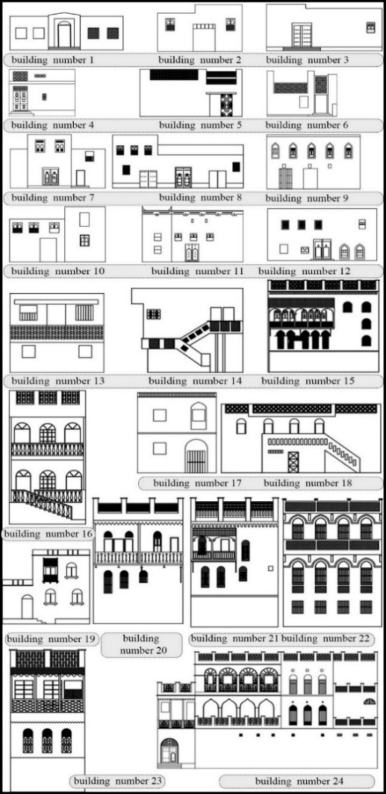

Figure 4: Patterns of Windows in Omani Houses

3.1.1.1. The Structural Patterns of Windows (A1)
General form and size of windows in Omani houses (vernacular and contemporary): Overall, the surfaces are flat and small with openings to the outside to reduce the penetration of sunlight into the building and meet other social requirements such as privacy for the female inhabitants [1].
Type 1
Most of these openings’ forms are projecting arched or semicircular windows. The elements used in Omani buildings are exclusive to this country. The more attention is paid to detail and the more these are given value in design
Type 2
Creating an arch with a rectangular border and vice versa is a popular tradition in window framing in Oman [5]. (figure 5, the windows of buildings number 2, 3, 8,9,10, and 11)
Type 3
Simple windows without any ornament. (Figure5, the windows of buildings number 13 and 14)
Type 4
These are patterned metal windows seen in urban buildings (contemporary architecture). (Figure 5, the windows of buildings number 18, 23, and 24).
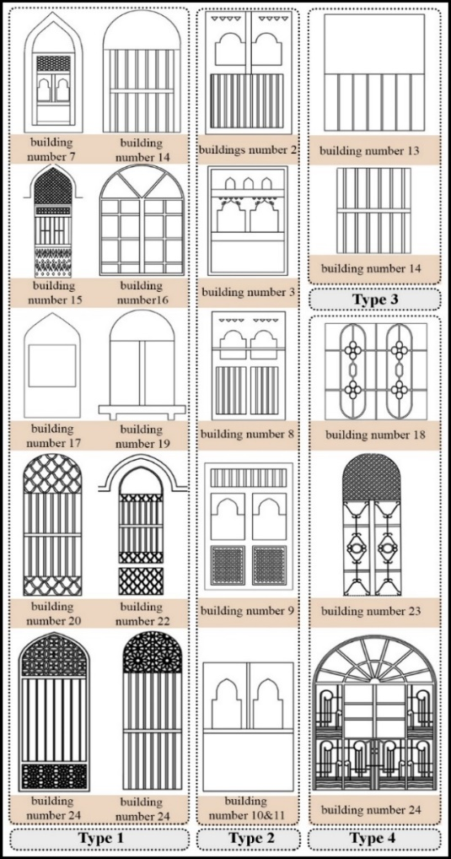

Figure 5: Patterns of Windows in Omani Houses
3.1.1.2. The Structural Patterns of Doors (A2)
These types of doors are mostly wooden, topped with a decorative semicircular arch.
Type 1
This type is represented by doors with a semicircular curved shape. They are mostly wooden, topped with a decorative semicircular arch. )Figure 6, the doors of buildings number 1, 16, and 19)
Type 2
These are double doors very similar to those found in Iran. Having double doors in Iran has religious and social reasons (to specify separate entrances for men and women). Perhaps the same reason also applies in Oman. All double doors have a semicircular element on the top, which has also been added to the frame. (Figure 6, the doors of buildings number 8, 9, 11 and 12)
Type 3
These are much simpler doors, most of which are used in rural areas. (Figure 6, the doors of buildings number 2, 3, and 7)
Type 4
These are patterned metal doors seen in urban buildings (contemporary architecture) in Mutrah. They are entirely painted and have a myriad of ornaments. Those ornaments are remarkable and have nothing in common with the ornaments on rural or wooden doors. The ornaments, like those of the windows, are Islamic patterns. As seen in the figures (building number 4), they also have other ornaments such as the moon and stars. Unlike the rural double doors, these are simple single metal doors as there is no need for double doors. (figure 6, the door of building number 5)

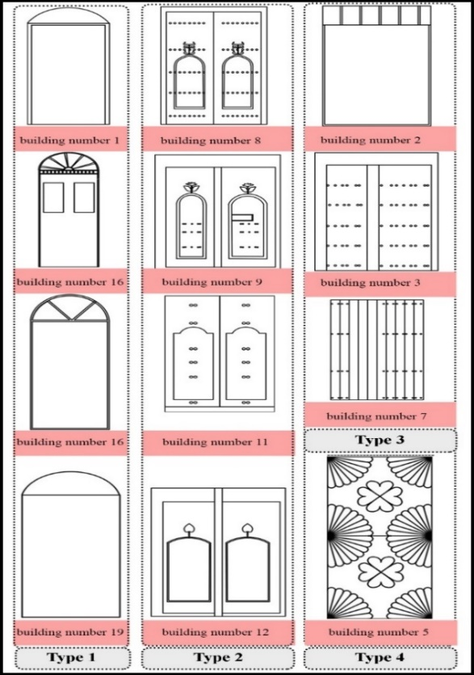

Figure 6: Doors Patterns in Omani Houses
3.1.1.3. The Structural Patterns of Parapets (A3)
Type 1
The pictures show the parapets in the city of Mutrah. Most of the buildings have U-shaped parapets. with latticed screens embedded in them. (figure7, the parapets of buildings number 5, 6, 14, 15, 16, 20, 21, 22, 23, and 24)
Type 2
Crenellations are widely used patterns in Omani architecture, but became purely ornamental nowadays [6]. The architectural style of their forts and palaces became a sort of model that the Omanis imitated in their residential architecture [7].
Motif taken from fort architecture are omnipresent in modern Oman's urban landscape. This "emulation"or "transfer" Of the Al-Ya'ariba architectural language to the civilian buildings could have been enabled by three main factors: first, the Ya'rubi style emanated from the "local" typologies and their architectural vocabulary, even if some important transformations were made after the contact with the Portuguese and the change in the artillery style. Second, the same local materials and construction techniques that the Omanis use for their residential buildings were used in these forts and palaces. Finally, as the Ibadi religious rules required, there was no excess in the size or ornamentation of the forts and palaces built by Al-Ya’ariba [9].
Until now, the contemporary architecture of Oman, including the civilian part, holds in its forms and architectonics some of the prominent references to the forts and citadels of the Ya'rubi era. Al-Busaidi sultans, successors of Al-Ya'ariba, perpetuates their predecessors' style in their mansions and other official buildings for the same reasons [9].
Even today, Oman's official buildings are characterized by this military architectural vocabulary, where crenellations crown all types of buildings, and towers punctuate their corners [5]. The Omanis are attached to this symbol, which took full shape when their country was the most powerful. It is their shared heritage, a source of pride [10] and, to a certain extent, it seems to be a symbol of the identity they want to claim [11]. An identity that links their present to their glorious past. This awareness has been continuously encouraged by the late Sultan Qaboos b. Said, who was at the top of the governmental decisions in this matter [12]. (The parapets of buildings number 11, 17, and 19)

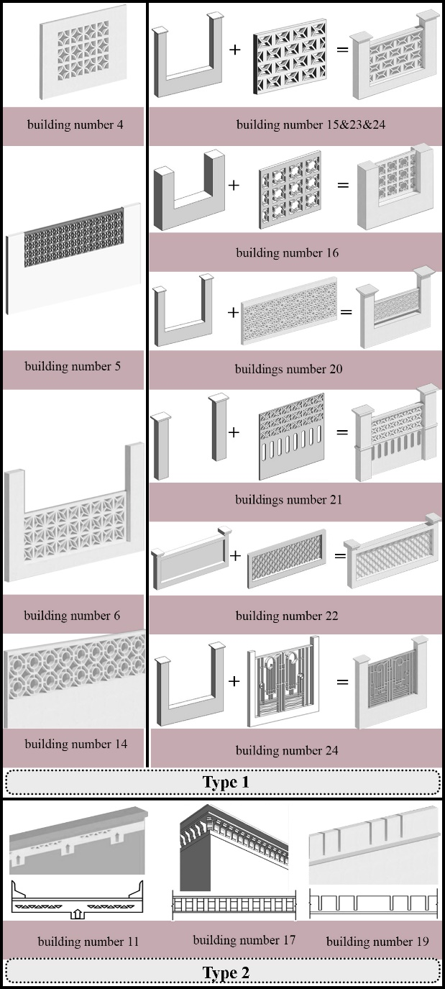

Figure7: The parapets of buildings

Therefore, crenelated rooftops are profusely used in contemporary architecture. Some of the resulting architectural features are drawn from the "dominant" architectural languages and techniques; they have been reinterpreted and reinvented with the local language. Omanis adapt their buildings to their local context, particular defense needs, and socio-political conditions. This process has allowed for a unique version of the fort fortification, which corresponds to the Omani empire in the 16th-17th centuries [9]. (figure7, the parapets of buildings number 11, 17, and 19)

3.1.1.4. Structural Patterns of Openings (A4)
The openings are elements on the building façades that are latticed like the parapets, they are mainly used for ventilation. These elements are different from windows because they do not operate like windows, they are just lattice screens and do not belong to the “windows” category. Most of the openings’ structure are compatible with the windows or parapets details, which strengthens the sense of unity in Omanis buildings facades. Based on their construction materials, two types, of openings could be identified.
Type 1
Openings made of cement or plaster. In this type, the openings are latticed exactly like the parapets. (Figure 8, the openings of buildings number 6)
Type 2
Openings are made of metal. In this case, these are painted the exact color of the windows. The malleability of the metal makes it easier to execute Islamic patterns. As a result, these patterns are seen in most metal openings. (Figure 8, the openings of buildings number 15 and 24)

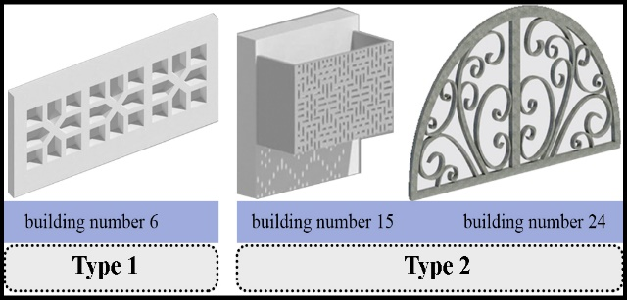
Figure 8: The openings of buildings

3.1.1.5. Structural Patterns of Balconies (A5)
Different types of materials are used in building the balconies. In houses where these are made of cement or bricks, the roof of that floor is slightly projected to cast shade on the balcony. In balconies, which are made of wood or metal, a slanting roof is added to the balcony. Hence, we witness two types of balconies in Omani houses.
Type 1
The type 1 is constructed with cement and bricks, and latticed screens in the same style as the parapets. The ornaments include either latticed or stucco designs, in the exact style of the window ornaments and other elements of the façade. In this Type 1 of balconies, harmony between the façade elements is much more evident. They are also continuous along the facade. (Figure 9, the balconies of buildings number 13, 16, and 22)
The type 2
Balconies of type 2, are constructed with metal and wood and have a painted slanting roof. These are mostly seen on Corniche Road in Mutrah. Unlike Type 1 these type 2 balconies are executed as both continuous and discontinuous. The railings are hollow and the roofs are colorful. (figure 9, the balconies of buildings number 15, 20, 21, and 24)

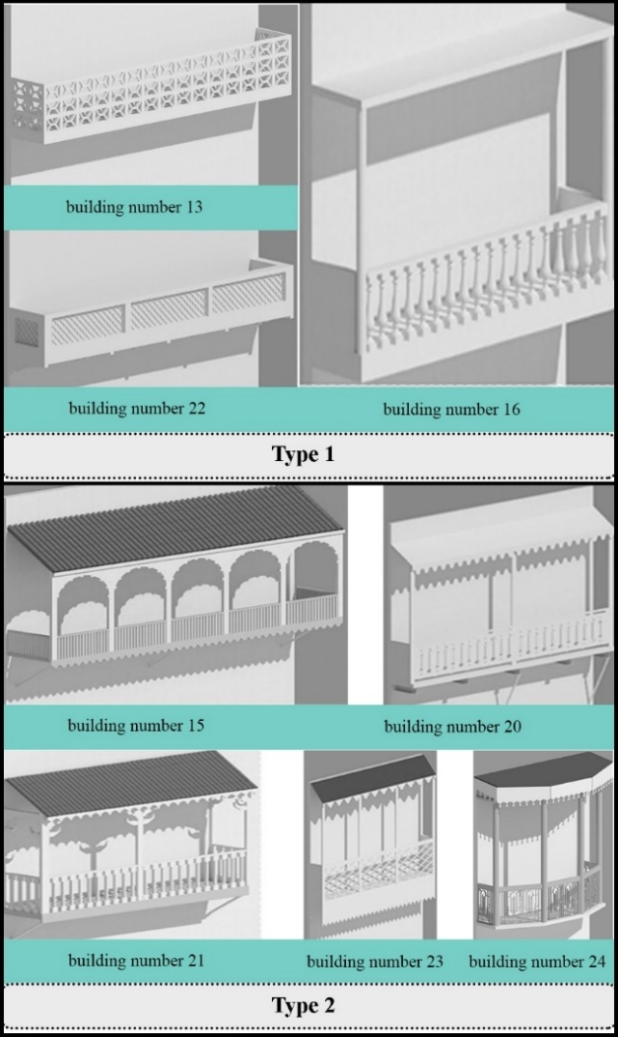

Figure 9: Balconies of Omani Houses

3.1.2. Functional Patterns (B)
The patterns used in buildings have functions such as Ventilation, Shading, and Privacy.
Ventilation: The solutions include creating openings in the upper part of the facade, such as parapets, and Mashrabiya. Such openings are also essential to allow the evacuation of the hot air accumulated near the ceiling due to convection to escape.
Shading: Controlling the light is key in Islamic architecture. Its aim is to cool and reduce the glare caused by sunlight. It also adds to the aesthetics of the structure and its ornamental elements. This is achieved by using projecting patterns and diverse texture on the surfaces, which provides shade and increases or decrease light over time [5]. As Dalu Jones writes, regulating or displaying sunlight with dynamic products and constantly changing patterns introduces a modern life [13]. In traditional Omani architecture, the windows are recessed from the main façade wall. This, creates shade and a place to sit or nap [5]. The projected components, consoles, and cantilevers provide shade on the façades and, consequently, reduce the amount of direct sunlight on the external walls of buildings. The openings and windows with indented frames which are slightly wider than the width of the window by about 0.25 meters, prevent sunlight from shining into the architectural spaces [14].
Privacy
Indirect entrance doors are an important part of providing access to the indoor sections of the house while protecting the privacy and security of these spaces [1]. Islam reveres the family space and daily life inside the home. Many of the Islamic texts related to buildings ask Muslims to respect the home privacy. Some of the provisions of the “Building Regulations for Muscat” respond to this ancient, important social tradition of the current Omani society.

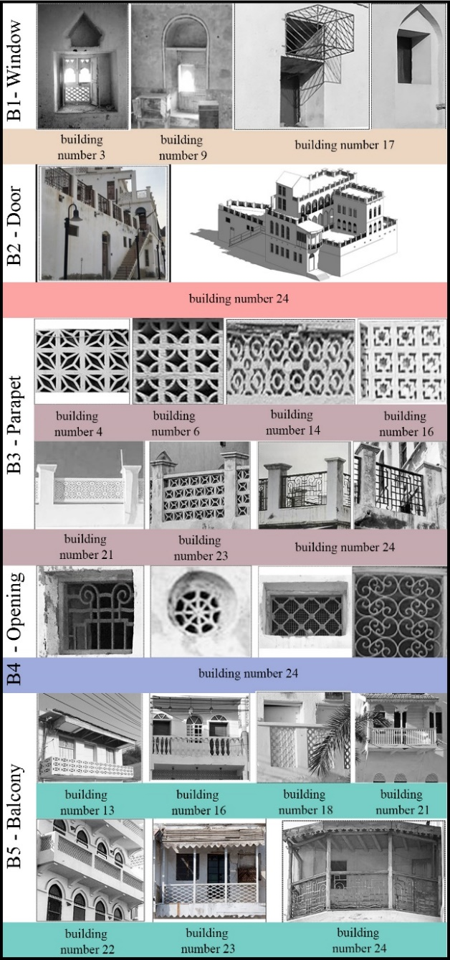

Figure 10: functional patterns
3.1.2.1. The Functional Structure of Windows (B1)
In vernacular architecture, the windows are small and placed at a high level from the ground to allow for light and ventilation. The position of the window at the top relative to the floor level creates visual privacy from passers-by. However, this has been greatly overlooked in contemporary architecture and the windows are placed at the passers-by level in plain view [15]. (Figure11)
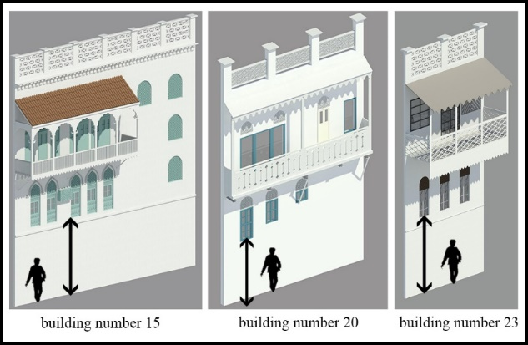
Figure 11: Visual privacy in buildings

3.1.2.2. The Functional Patterns of Doors (B2)
In vernacular architecture, the doors are heavily ornamented and made of thick, hardwood. They separate spaces while also providing access and security [15]. (Figure 10)
3.1.2.3. The Functional Patterns of Parapets (B3)
The height of most parapets is approximately one meter to provide privacy for the inhabitants. In hot climates, the shelters on and around the roofs are often made in the form of a grid so that the residents would be kept safe from the outsiders’ look and at the same time residents use the current of air on the roof to refresh the interiors during the hot season [16]. The roof is commonly used for sleeping during summer nights, and these slit openings may increase the airflow, which improves thermal comfort [17]. (figure 12)

3.1.2.4. The Functional Patterns of Openings (B4)
Every element in Omanis buildings has a reason and opening are not except. Due to the hot climate of this country, all of elements are utilized for improving the thermal comfort conditions. The openings are used mainly in building façades. Positioned high enough, they allow the hot air to escape an allow the cool air to get in through wider windows positioned in the right facades at the right height [18]. The openings in the rooms are located at two different levels in the external walls. The lower windows and small slit vents are near the floor (30-50 cm above the floor). They are the source of airflow in the room and control the thermal sensation, as the local people usually sit close to the floor [17]. This is the case of the openings in Mutrah and Mirbat. (Figure10)

3.1.2.5. The Functional Patterns of Balconies (B5)
One of the façade design features that can affect natural ventilation performance of buildings is balcony [19]. The ability of balconies to provide solar shading to the apartment below is referred to as one of the most successful solutions to achieve comfort in summer with low energy consumption [20].
Some researchers also indicate that the overhang effect of balconies can block the undesirable penetration of sunlight, protecting the indoor space from ultraviolet radiation [21]. (figure10)

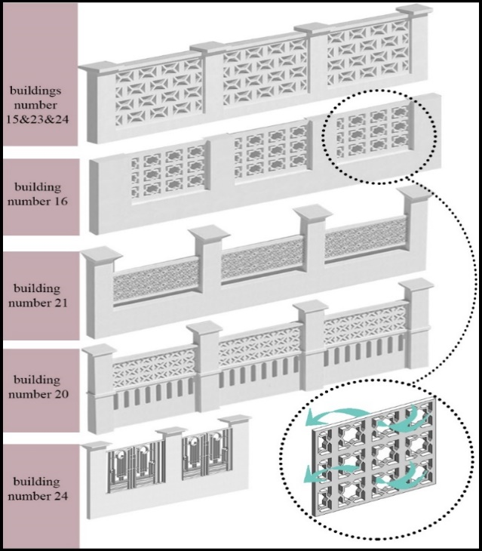

Figure 12: Patterns of Parapets

3.1.3. Conceptual Patterns (C)
Concept in the patterns can be seen in the geometry and color of patterns.
3.1.3.1. Geometry of Patterns: Pointed and Circular Arches
These arches are common in the architecture of houses in southeast Yemen and Oman [6]. The use of different arches is linked to social values [5]. Pointed and circular arches have been used in all the modern architectural spaces of religious, commercial, and residential buildings [5]. They can link columns, and serve as openings, and entrances, as well as decorative elements. In Oman, arches appear in several forms, including semi-circular, pointed, or horseshoe shapes [22] (Figure13).

Circle
Circle is the symbol of perfection and simplicity and at the same condition most complete geometrical shape that is symmetrical relative to center from each direction. Circle has even value from all sides and this means that circle does not know any direction. Therefore, its stimulating combination is most simple type [23]. [24]. (figure13, building number4)

Eight-Fold pattern & Four-Fold pattern
The two simplest geometric constructions, which form the basis for many of the patterns to be found in Islamic decorations, are the constructions of four and eight pointed geometries respectively. These relatively simple geometrical constructions are easy to develop by connecting various intersections, forming the basis for a variety of pattern making [25].

Eight-Pointed Star
The square represents the earth, or the physical elements such as earth, air, fire and water. If a square overlap another, with the second square pointing upwards, eight-pointed star is formed. The eight-pointed star is related to the symbolism of the eight bearers of the throne, from Quran and certain cosmological subjects. [26].

Arabesque shape
The arabesque or biomorphic, which symbolizes pristine nature. The Muslim artist is inspired by the multiplicity of forms, patterns, and rhythms he sees around him in nature and abstract them to the fundamental essence (figure13)

Floral pattern
The study of geometric proportions has its roots in the study of nature and matter [27]. Islamic floral patterns are an ancient form of Islamic art that is on the verge of extinction. These floral ornaments consist of flowers, leaves and curved lines that can be obtained using standard geometric or irregular methods [28].

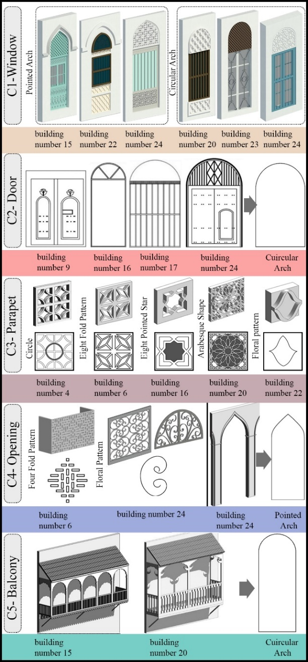

Figure 13: Conceptual Pattern

Table 1: The Analysis & Review of Patterns

Interlacing of the conceptual patterns
Most of the conceptual patterns create bigger pattern by endlessly connecting with each other. Repetition is the most useful and fundamental feature of Islamic patterns. There are few basic shapes in Islamic art, but interlocking design of these basic shapes generate different and complex patterns. Islamic patterns are usually produced by the repetition of triangle, square and pentagon. Another important feature of Islamic patterns is symmetry. Symmetry, or the series of ways in which a single motif can be repeated an exact number of times within a circle, is the most fundamental manifest aspect of Islamic geometric art [26]. (Figure 14)

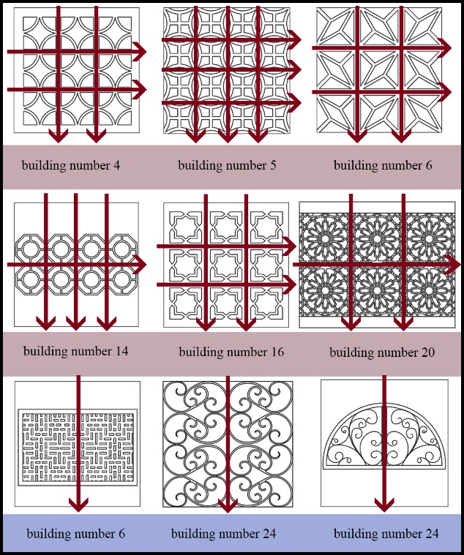
Figure 14: interlacing of the patterns in the parapets and openings

The analysis of patterns
In the opposite table (table 2), we can see the simple relation between the facade elements and their detail role. Whole part of the pattern has its own role in the building (figure16). With this method, we can see the evolution of the patterns (figure15) with this attitude shape of the patterns examined in three levels first level is so general and second level just pay attention to the whole shape of pattern and in third level detail set in the shape and these processes keep evolving.

Patterns | Structural Patterns  (A) | Functional Patterns  (B) | Conceptual  Patterns  (C)
Window (1) | A1 | B1 | C1
Door (2) | A2 | B2 | C2
Parapet (3) | A3 | B3 | C3
Opening (4) | A4 | B4 | C4
Balcony (5) | A5 | B5 | C5
4. The Analysis of the Patterns System
Having a system creates order and orderliness. The arrangement of patterns creates an order and culminates in the overall form of the building. In this research, we have three systems
Setting System
in Omani architecture, every pattern’s location is specified in this category we examine the location of the structural, functional, conceptual aspects in the building’s façade. For example, the location of the openings in most of the buildings is above the windows, or lattice elements are in the parapets.
Formation System
In this category, we examine the overall appearance of the pattern (the border of the pattern).
Details System
In the last system, the overall details are also investigated in addition to the position of the patterns and overall form. This system is the last system that all of the details of the structural, functional, and conceptual patterns of the building will be gathered and the general shape of the building will be achieved.
The Relationship between Patterns & Systems
The table 2 opposite show the relationship between patterns and systems. The classification and prioritization of the systems in the table is from whole to part. This will make the review more coherent and coordinated. At last step, the collection of whole patterns and systems create the complete Omanis façade. With this method, we can select the pattern, set them in system, and compose the façade. (table 2)

Table 2: The Relationship between Patterns & systems

Systems  & Patterns | Structural Patterns  (A) | Functional Patterns  (B) | Conceptual Patterns  (C) | Complete System
Setting System  (X) | AX | BX | CX | (A+B+C) X  The System of the Setting Patterns
Formation System  (Y) | AY | BY | CY | (A+B+C) Y  The System of the Formation Patterns
details System  (Z) | AZ | BZ | CZ | (A+B+C) Z  The System of the Details Patterns
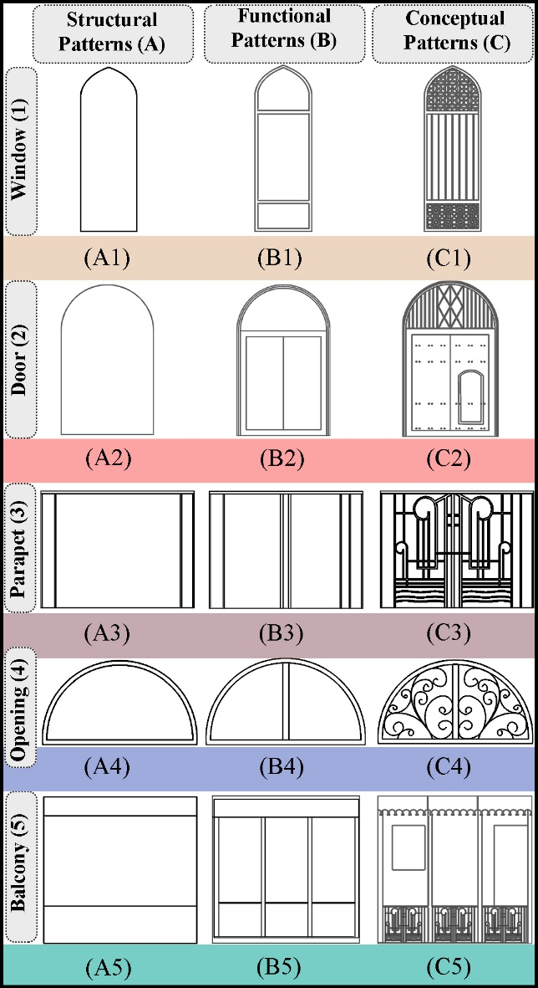

Figure 15: Patterns in building 24

4.1. Setting System (X)
4.1.1. Setting System of Structural Patterns (AX)
Each main façade has been subdivided into five structural patterns, identified with five different colors. The structural patterns have been laid out next to each other without considering the details. Significant aspects have been observed in this system. Firstly, in the setting system of the structural patterns, the façade has three parts which are: firstly, the body, secondly, the doors, windows, balconies, and openings, and thirdly the parapets and eaves.
4.1.2. Setting System of Functional Patterns (BX)
Considering the placement of functional patterns, all five elements of Omnis buildings have specific functions: windows, doors, open balconies the lattice elements of parapets and openings. The latticed elements create an air current suitable for buildings in this climate. As already seen, the position of these patterns is clear. For instance, the U-shaped parapets are latticed and the openings are usually placed above the doors and windows.
4.1.3. Setting System of Conceptual Patterns (CX)
All the conceptual patterns are placed in set locations and their position is fixed. The conceptual patterns are found in the latticed parapets of balconies, the windows and the doors. In some cases, the conceptual patterns have been carved rather than latticed. All these patterns are placed in a set rectangular or semicircular order.
4.2. The Formation System (Y)
4.2.1 The Formation System of Structural Patterns (AY)
We will refer to the figures extracted from the images in the formation system of windows, doors, parapets, openings and balconies.
4.2.2. The Formation System of Functional Patterns (BY)
The overall form of functional patterns is mainly rectangular, except in particular cases where they are semicircular or arched. Vents are visible in the façades and are mainly placed above the doors and windows. Most of the openings are made of metal except for a few examples where they are made of heavy building materials.

4.2.3. The Formation System of Conceptual Patterns (BY)
The conceptual patterns are hollow surfaces, most of which are arranged in a regular network, and repeated horizontally and vertically a cross shaped (figure15). The doors are surrounded by arches. In some cases, these are semicircular. This also applies to windows. In some cases, the patterns change to moon, star, and flower shapes. In this system, all the patterns are arranged next to each other according to their form, displaying the overall shape of the building to a certain extent.

4.3. Details System (Z)
4.3.1. The System of Structural Details (AZ)
In this section, all the details of the doors, windows, parapets, and balconies are shown. Horizontal wooden elements have been added to the structure of the windows. Although the arches are a common element in the details of the windows and openings in the contemporary local architecture of Oman, these are not functional [15].
4.3.2. The System of Functional Details (BZ)
In this section, the details of the openings, balconies railings, latticed parapets, and number of doors have been shown. The openings are mostly metal with Islamic patterns. Most of the balconies’ railings are latticed. As seen in the pictures (figure 9), most of the patterns are unique and every type of Islamic design has been used to lattice the parapets, thus avoiding monotony in the façades. As shown in the picture (figure 14), the details are arranged in a network or a symmetrical system.

4.3.3. The System of Conceptual Details (CZ)
The semi-circular arches of doors and windows have been shown in all the patterns for openings based on the Islamic design. The addition of very small patterns in the latticed part of the windows and balcony railings can be observed in the details system. In this section, the final schema of the building has been formed and we have a complete collection of all the patterns and their systems. Everything in the elements of the façade of a building which has affected its formation has been investigated and shown.

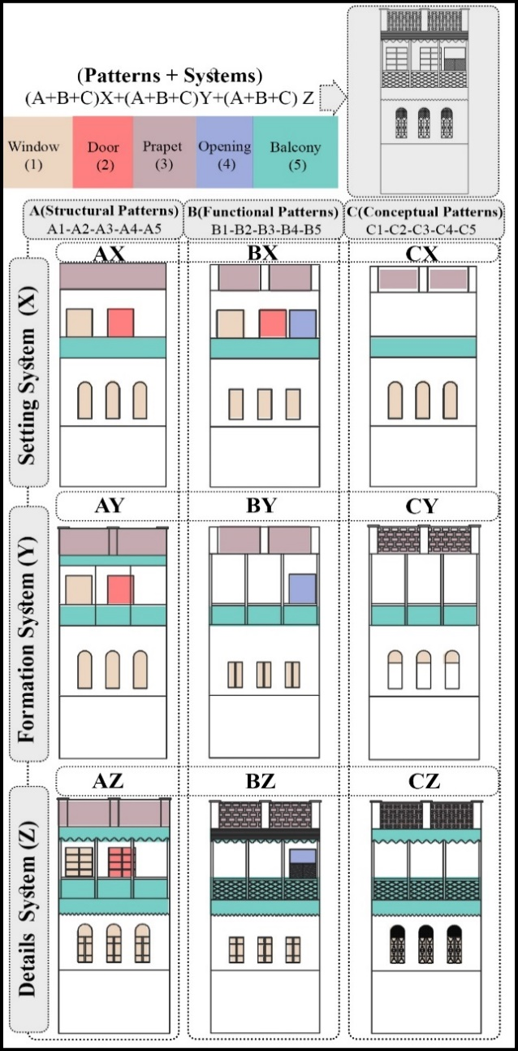

Figure 16: Patterns in building 24

5. Conclusion
By considering the method of this research, we gained an overall solution for a design house in Oman. We put the pattern beside each other and made our house shape. With this formula, we prevent messing in our design because every pattern used in our design is aligned with our context. As can be seen in picture 17 we designed three buildings one-story, two-story, and three-story building. In all of them, the doors, windows balcony, and overall shape follow the research method.

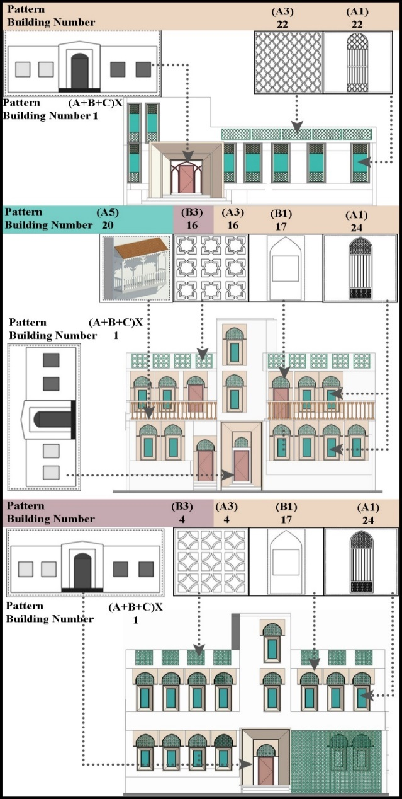

figure 17: design

References

[1] Abdelhady Mohamed Ibrahim Mohamed, 2021, An Innovative Methodology for Achieving Compatibility between Heritage & Contemporary in Architecture (Case Study: Omani Architecture), Lecturer - Civil and Architectural Constructions, Suez University

[2] Sidawi B, 2013, Understanding the Vocabulary of the Islamic Architectural Heritage. GBER vol.8, Issue 2, Page 26-39. Online publishing

[3] Alexander, S. Ishikawa, M. Silverstein, M. Jakobson, I. Fiksdahl-King, and S. Angel. A Pattern Language – Towns, Buildings, Construction. Oxford Univ. Press, 1977.

[4] A Alexander. The Timeless Way of Building. Oxford Univ. Press, 1979

[5] Al Zubair, Mohammad, 2013, Oman's Architectural Journey. Muscat: BAZ Publishing, 2013.

[6] Damluji, Salma, 1998, Rock climbing in Oman, Oman: Apex Publish in 1993, The Architecture of Oman, Garnet Publishing, London.

[7] E. D'Errico, "Introduction to Omani military architecture of the sixteenth, seventeenth and eighteenth Centuries," J. Oman Stud., vol. 6, pp. 291–306, 1983.

[8] N.Benkari, “A Document of Ibadi Fiqh Governing the Architecture of Mosques,” J. Islam. Archit., vol. 4, no. 2, pp. 56-62., 2016.

[9] N. Benkari, the Formation and Influence of the Military Architecture in Oman During AL-YA'ARIBA Period (1034-1162 AH/1624–1749 AD), 2021.

[10] M. Limbert, In the time of oil: Piety, memory, and social life in an Omani town. Stanford University Press, 2010.

[11] J. M. Willis, "History, Culture, and the Forts of Oman," Arab Study Journal- Dirosat al- Arabiyah, pp. 141-143, 1996.

[12] N. Benkari, “Oman,” in Time Frames: Conservation Policies for Twentieth-Century Architectural Heritage, pp. 162–164, 2017.

[13] Junes Dalu, 1978, the elements of decoration surface, pattern and light in architecture of the Islamic world, G .Mitchell, ed. Thames& Hudson, London,pp.161-175

[14] Farry Kazerooni, Gulf Islamic Architecture. Manama, Bahrain, 2002.

[15] Noor Hanita Abdul Majid, Hokoi Shuichib, Nozomi Takagi, Vernacular Wisdom. The basis of formulating compatible living environment in Oman

[16] M. Shokouhian, and F. Soflaee, "Environmental sustainable Iranian traditional architecture in hot-humid regions", International Conference Passive and Low Energy Cooling for the Built Environment, Greece, 2005, pp.715- 719.

[17] Hayder. M. Khan, Saleh. Al-Saadi, Naima. Benkari, and Aliya Al-Hashim Department of Civil and Architectural Engineering, Sultan Qaboos University, Muscat, Oman.

[18] Allan Cain, Farroukh Afshar, Jon Norton, Oman: the problems and potentials of the indigenous built environment in a developing country, 1975.

[19] Buys, L., Summerville, J., Bell, L. and Kennedy, R. (2008) , Exploring the Social Impacts of High-Density Living: Considering the Residents‟ Perspective.‟ In, Proceedings of Subtropical Cities 2008: From fault-lines to sight-lines Subtropical urbanism in 20-20, 3–6 September 2008.

[20] Hastings, S.R. Breaking the “heating barrier”: Learning from the first houses without conventional heating.Energy Build. 2004, 36, 373–380.

[21] Kim, G.; Kim, J.T. Healthy-daylighting design for the living environment in apartments in Korea.Build. Environ. 2010, 45, 287–294

[22] B. Ghasemzadeh, A. Fathebaghalli, and A.Tarvirdinassab, "Symbols And Signs In Islamic Architecture," Revista Europeia de Estudos Artisticos, vol. 4, No. 3, pp. 62-78, 2013.
[23] Gruter, Yurg, translated by Jahanshah Pakzad, (1997), beauty of aesthetic in architecture, Tehran, Shahid Beheshti University

[24] Genon,Rene, translated by Ali Mohammad Kardan, (200), siege of quantity and emblems of end of the world, Tehran, center of university’s publications

[25] Loai M. Dabbour ,Geometric proportions: The underlying structure of design process for Islamic geometric patterns, 2012.

[26] Critchlow, K.: 1976, Islamic Patterns: An Analytical and Cosmological Approach, Thames and Hudson.

[27] Skinner, Stephen, 2009. Sacred Geometry: Deciphering the Code. Sterling, New York, p. 7, 91,107.

[28] Sarah Haidar, Fengyuan Zou, Xinhua Li, an Analytical study of five –pointed Islamic floral patterns and experimental design using Penrose tiling, 2023.

[29] Sameh, Reza, 2014, Pattern language, design example (design experience based on native teachings including pattern navigation in the native environment of "Nayband" village), Qazvin Academic Jihad Publications

[30] Shahbazzadeh Afsaneh, “Designing residential complexes in Oman based on its vernacular architecture”, Master’s thesis, Imam Khomeini International University, 2021.

[31] www.archiam.com

