 |  | JOURNAL OF ISLAMIC ARCHITECTURE  P-ISSN: 2086-2636 E-ISSN: 2356-4644  Journal Home Page: http://ejournal.uin-malang.ac.id/index.php/JIA
INTEGRATING VERNACULAR ARCHITECTURAL ELEMENTS INTO CONTEMPORARY OMANI RESIDENTIAL DESIGN: A COMPARATIVE ANALYSIS OF TRADITIONAL AND MODERN FAÇADES
Afsaneh Shahbazzadeh^{a*}, Reza Samehª, Naima Benkari^{b}
ªFaculty of Architecture & Urbanism, Imam Khomeini International University, Qazvin, Iran
^{b}Civil and Architectural Engineering Department, Sultan Qaboos University, Muscat, Oman
*Corresponding Author: afsanehshahbazzade@gmail.com
ARTICLE INFO |  |  | ABSTRACT
Volume: 8  Issue: 3  Page: 751-770  Received: March 8th, 2024  Accepted: October 5th, 2024  Available Online: June 30th, 2025  DOI: 10.18860/jia.v8i3.26361 |  |  | This research explores the ways of integrating traditional Omani vernacular architectural elements into contemporary façade designs. It examines how these patterns are reinterpreted to create a consistent architectural language that imbibes local heritage patterns while meeting modern needs. The study investigates the structural, cultural, and formal characteristics of Omani façades through a qualitative analysis of the façades’ components in residential buildings. To identify common patterns and design rules in contemporary Omani architecture, a comparative approach was employed to analyze 24 residential buildings in Mirbat and Mutrah. The results show that vernacular elements are continuously reinterpreted in modern design, revealing that these patterns not only maintain cultural identity but also enhance the practicality of contemporary architecture. Finally, the investigation proposes a guideline for incorporating heritage elements within current design agendas, catalyzing further dialogue on architectural identity in the Islamic world  Keywords:  Architectural Identity; Contemporary Islamic Architecture; Façade Design; Pattern language; Vernacular Architecture

- INTRODUCTION
Architecture reflects the cultural identity of a society, its historical evolution, and social development. While traditional architectural forms embody native and inherited culture, contemporary designs are affected by exterior influences and new ideas, and they must also address new needs and aspirations. Such interactions govern the formation and transformation of buildings' architectural forms and city fabrics [1]. Islamic societies like Oman, with their ancestral architectural traditions, are facing two major challenges in this matter: losing parts of their local culture and identity and the emergence of new styles and requirements, which cannot be satisfied through inherited know-how alone. These societies need to bridge the gap between their architectural and urban heritage and their contemporary aspirations. Hence, the importance of heritage reflects a means of confirming the community’s identity and achieving the continuity of its civilization [2]. Similarly, contemporary architecture must express the cultural diversity of each region and reinforce its identity through new, culturally credible aesthetics, which facilitate access to modernity, progress, and the new aspirations sought by society. Hence, to reach an architectural production that meets the contemporary needs of the community and preserves its identity, new designs must be developed to integrate progressive elements imbibed with cultural authenticity [3].
The present research aims to explore the integration of Omani vernacular architectural elements and patterns into the emerging contemporary architecture of the country. The objective is to carry out an analysis of the structural, cultural, and formal characteristics of vernacular buildings in order to propose a framework for designing contemporary structures. The question is: to what extent is it possible, in modern times, to formulate an architectural language for a region based on its vernacular architecture?

  - VERNACULAR ARCHITECTURE IN OMAN
Oman's vernacular architecture is marked by unique characteristics that have evolved over millennia to reach their actual forms. The local construction materials, such as mud bricks, stones, and wood, are used to adapt this architecture to its environmental and cultural contexts. The construction materials and techniques used in the Omani vernacular architecture not only provide comfortable interiors to live in but also make the dwellings blend seamlessly with the surrounding landscapes, providing a visual continuation of the natural environment.
Research about the properties and characteristics of the vernacular architecture in Oman is still in progress. However, the state of knowledge about this topic allows us to argue that the façade design is among the defining characteristics of this architecture because it is both functional and aesthetic. Adequately sized and located windows are designed to minimize heat gain and glare while maximizing ventilation, which is crucial for comfort in Oman's arid climate [4]. The façades are distinguished with decorative features, such as carved wooden doors and elaborate plasterwork making them lavish and representing the socio-cultural identity of the inhabitants. These façades, with their simple volumes and intricate patterns, continue to imbibe contemporary Omani architecture, integrating traditional elements into modern designs. Limited studies have examined the unique architectural features of traditional Omani buildings, such as the use of crenellations, latticed screens, and specific window and door designs ([1], [5]-[11]). These elements have been identified as key components of the local vernacular architecture that contribute to the region's cultural identity. However, there is limited research on how these traditional patterns are being adapted and reinterpreted in contemporary Omani architecture [1]. Understanding this process of integration is crucial for maintaining a sense of cultural continuity while also addressing modern design requirements.
Having established the significance of preserving Omani cultural identity in architecture, the following section outlines the methodological approach used in this study to analyze the integration of vernacular patterns into contemporary design.

- METHODS
Since the research is background-oriented, it adopted a qualitative approach, using observation and field surveys on selected case studies. The research also relied on a comparative approach between the façade features in each case study. Twenty-four buildings were selected for analysis. They were chosen in the coastal cities of Mirbat, in the Southern province of Dhofar, and Mutrah, in Al Batinah region. The sample included both two-story and three-story residential structures, as these were identified as the most common building typologies in both regions. The selection criteria also ensured that the case studies encompassed a variety of façade elements, such as windows, doors, parapets, and balconies, to provide a comprehensive understanding of the integration of vernacular patterns in contemporary architecture.
The research investigated three important qualifiers of the façade and are studied in a 3-D matrix: the structure, performance, and semantic elements of residential architecture in Oman (Figure 1). These qualifiers were analyzed in the three-layered system of any architectural object: setting, formation, and details.
Context is the central theme of the present research. By investigating the typology in the context, set systems and patterns will be extracted and categorized to obtain the dominating layout of the patterns that make designing with the context in mind possible (Figure 1).

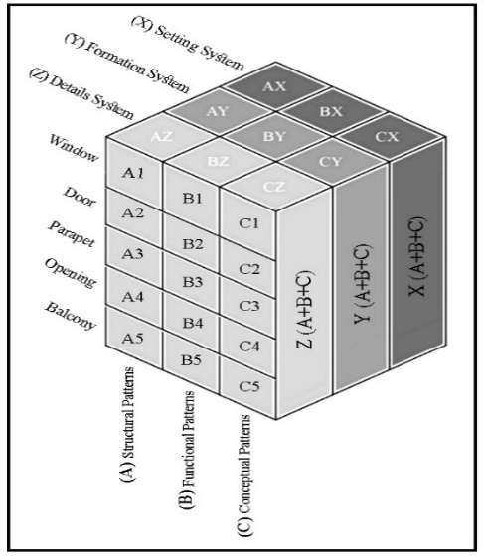

Figure 1. The Structural Model of the Research
- RELATIONSHIP BETWEEN PATTERNS AND SYSTEMS
The relationship between patterns and systems can be understood as follows: the setting system of the patterns is based on their placement within the façade, regardless of form and detail. The formation system examines the general shape of the patterns, while the detail system focuses on the specific ornamental elements. By analyzing these three interrelated systems, an overarching design framework can be established (Figure 2).
To explain the system, prioritization is given from the whole to the part. This makes the investigation more coherent and coordinated. In the present research, the statistical sample consisted of 24 houses in which all the architectural elements were analyzed.

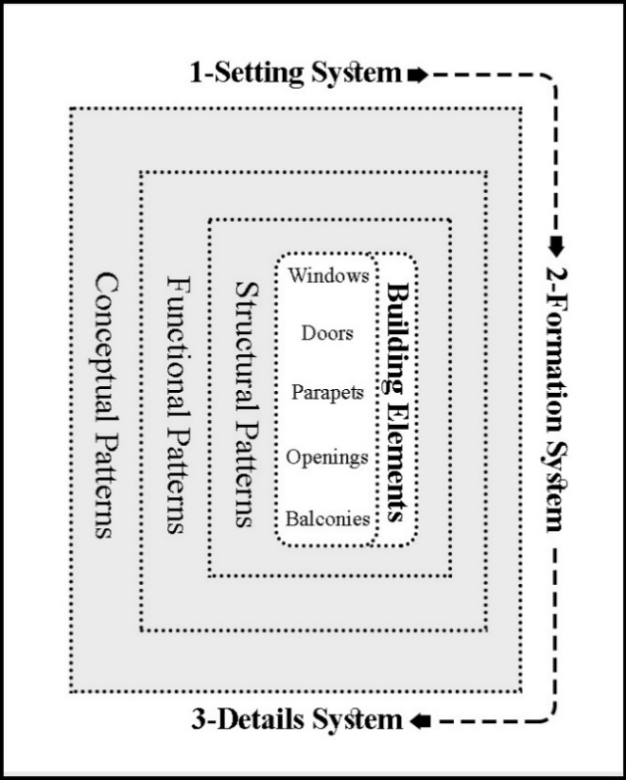

Figure 2. Patterns & the Evolution of Research Systems

For selecting the samples studied in this research, the height and elements of the buildings should be considered. For instance, a wide range of samples should be analyzed and categorized according to the number of floors. In addition, the selections should encompass the traditional and modern buildings. Because façades are the most important elements for defining the city's appearance, the main focus of the analysis is the façades of the houses. Most of the case study samples have been chosen from two and three-story buildings because most of them have balconies, important elements for shaping the façade. Selecting a wide range of data (buildings) will be more beneficial for this method as it gives more freedom to choose the best pattern for the designer. All the pictures in this research, taken in Mutrah city, have been gathered by authors, and the ones about Mirbat city are obtained from the Archiam website [12].

- SOLUTION FOR DESIGN: USING PATTERNS OF FAÇADE ELEMENTS
Each pattern describes a problem that occurs over and over again in our environment and the core of the solution to that problem in such a way that you can use this solution a million times over without ever doing it the same way twice [13]. In this paper, we intend to find a new way for the combination of the patterns and sort them together; the patterns are taken from the façades. Using pattern language in designing helps to overcome the complexity of things and achieve a desirable form. Pattern languages are disciplined abstracts of human experiences. The validity of patterns is determined through an experience evolving through time.

- CASE STUDIES
The studied samples in this research were a selection of houses in a district of Mirbat city (South of Oman) and another selection of houses in Mutrah city (in the capital region). These two cities have been selected as case studies because of their rich architecture and the well-developed patterns of their façades. In total, 24 buildings have been selected: 15 of them [4]-[6],[14]-[25] belong to Mutrah City as a representative of contemporary architecture, and 9 of them [1]-[3],[7]-[11], [13] belong to Mirbat City as a representative of the vernacular architecture.
As seen in Figure 3, the houses of Mirbat have the characteristics of the local native architecture, and the houses in Mutrah have the characteristics of traditional Omani architecture. The amalgamation of the two styles can be beneficial for presenting design solutions. Five elements have been identified in the façade: Number 1: window, door (of entrance and balconies), parapet, opening, and balcony. People have shaped buildings for themselves for centuries by using what was defined by Christofer Alexander as pattern languages.
Pattern language provides the tools to create an infinite variety of new and unique designs, just as ordinary spoken language gives the power to create an infinite variety of sentences. A building that has a “free” form, a shape without roots in the forces or materials it is made of, is like a man whose gesture has no roots in his nature. Its shape is unauthentic, artificial, forced, and contrived made to copy outside images, not generated by the forces inside [14].

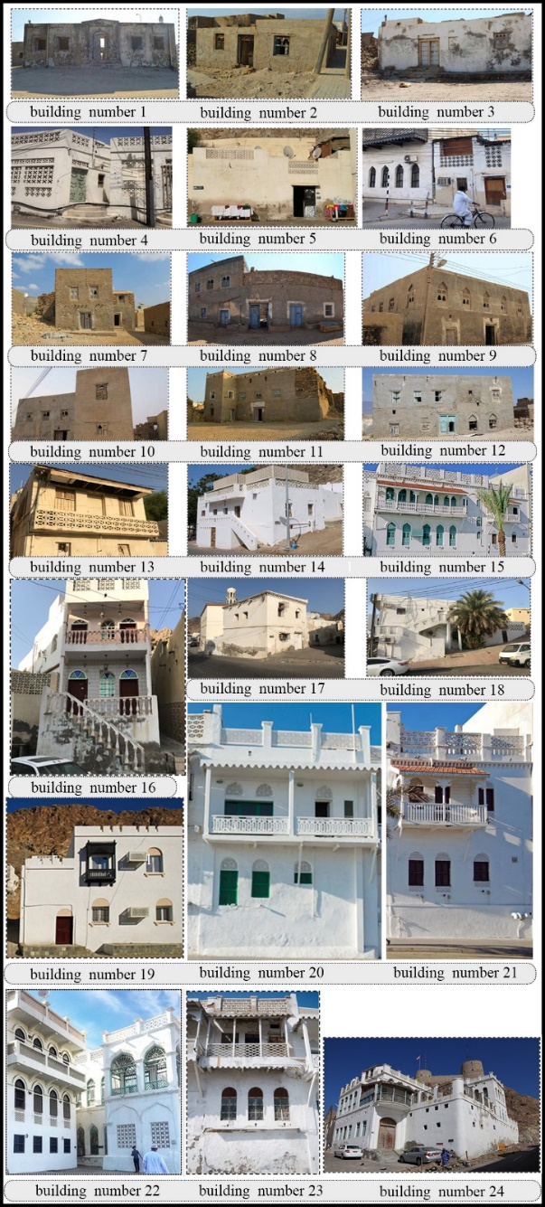

Figure 3. Selected Buildings, number 1-3 & 7-12 [12], number 4-6 & 13-24 [Source: Authors]

- RESULT AND DISCUSSION
- RESULT

- 1. PATTERNS OF RESIDENTIAL ARCHITECTURE IN OMAN

- 1. 1. Structural Patterns (A).
At first glance, the appearance of the buildings in traditional communities showing their identity and paying attention to their structure is crucial for designers. Structural patterns encompass the designs used in windows, doors, parapets, openings, interior decorations, and eaves. In the investigations, the structure of the details, their repetition, and their layout in the whole composition have been analyzed to achieve a structure that can be used in designing buildings in Oman.
Our focus in this analysis is the outline of the patterns and their general shape. Some elements are used in most of the building's façades that we categorized into five sections. In this research, we ignore the trivial elements and our aim is the general bodies of the façades. Structure in this part refers to the general shape of the details (we do not analyze the structural aspect of the buildings). The structural patterns used in this research include the windows (A1), doors (A2), parapets (A3), vents (A4), and balconies (A5).

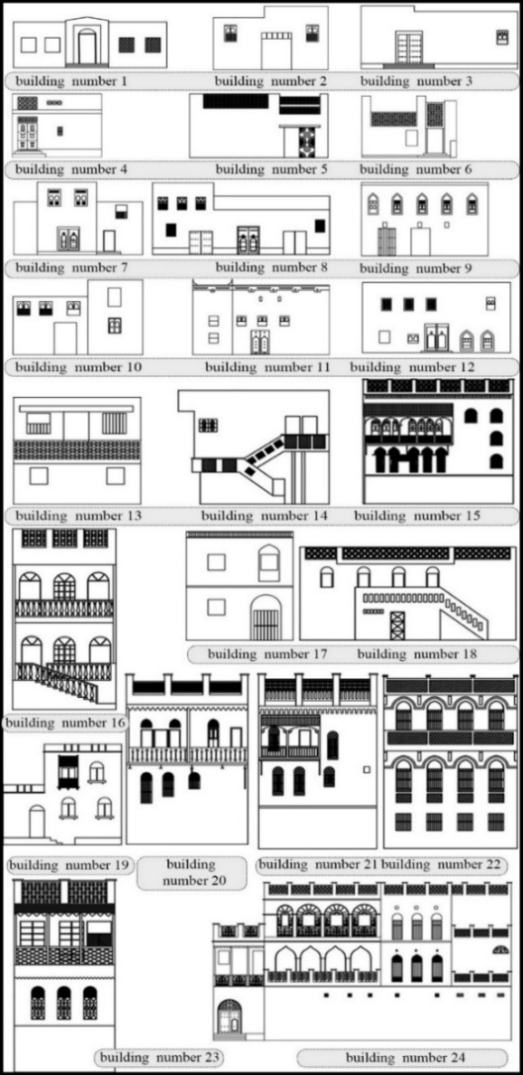

Figure 4. Windows in the selected Omani Houses

- 1. 1. 1. The Structural Patterns of Windows (A1)
Discussing the general form and size of windows in Omani houses (vernacular and contemporary), overall, the surfaces are flat and small, with openings to the outside to reduce the penetration of sunlight into the building and meet other social requirements such as privacy for the female inhabitants [3].

Type 1
Most of these openings’ forms are projecting arched or semi-circular windows. The elements used in Omani buildings are exclusive to this country. The more attention is paid to detail, the more these are given value in design.

Type 2
Creating an arch with a rectangular border and vice versa is a popular tradition in window framing in Oman [15]. (Figure 5, the windows of buildings number 2, 3, 8,9,10, and 11).

Type 3
Simple windows without any ornament. (Figure 4, the windows of buildings number 13 and 14).

Type 4
These are patterned metal windows seen in urban buildings (contemporary architecture). (Figure 5, the windows of buildings number 18, 23, and 24).

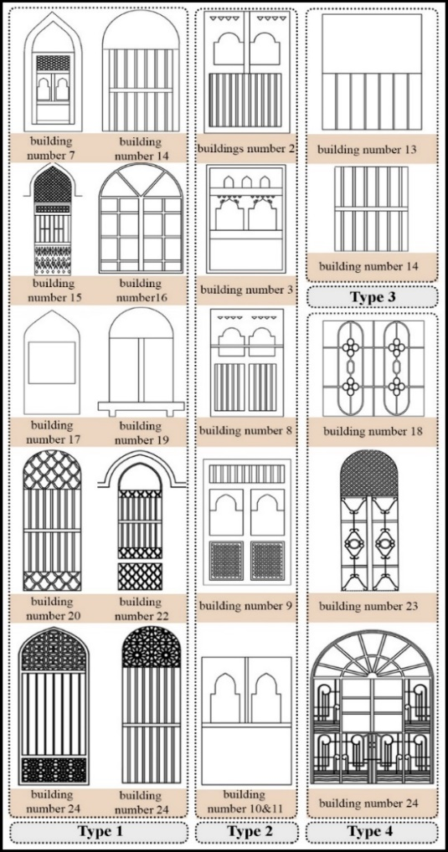

Figure 5. Patterns of Windows in Omani Houses

A.1.1.2. The Structural Patterns of Doors (A2)
These types of doors are mostly wooden, topped with a decorative semi-circular arch.

Type 1
This type is represented by doors with a semi-circular curved shape. They are mostly wooden, topped with a decorative semi-circular arch. )Figure 6, the doors of buildings number 1, 16, and 19).

Type 2
These are double doors that are very similar to those found in Iran. Having double doors in Iran has religious and social reasons (to specify separate entrances for men and women). Perhaps the same reason also applies in Oman. All double doors have a semi-circular element on the top, which has also been added to the frame. (Figure 6, the doors of buildings number 8, 9, 11 and 12).

Type 3
These are much simpler doors, most of which are used in rural areas. (Figure 6, the doors of buildings number 2, 3, and 7).

Type 4
These are patterned metal doors seen in urban buildings (contemporary architecture) in Mutrah. They are entirely painted and have a myriad of ornaments. Those ornaments are remarkable and have nothing in common with the ornaments on rural or wooden doors. The ornaments, like those of the windows, are Islamic patterns. As seen in the figures (building number 4), they also have other ornaments, such as the moon and stars. Unlike the rural double doors, these are simple single metal doors as there is no need for double doors. (Figure 6, the door of building number 5).

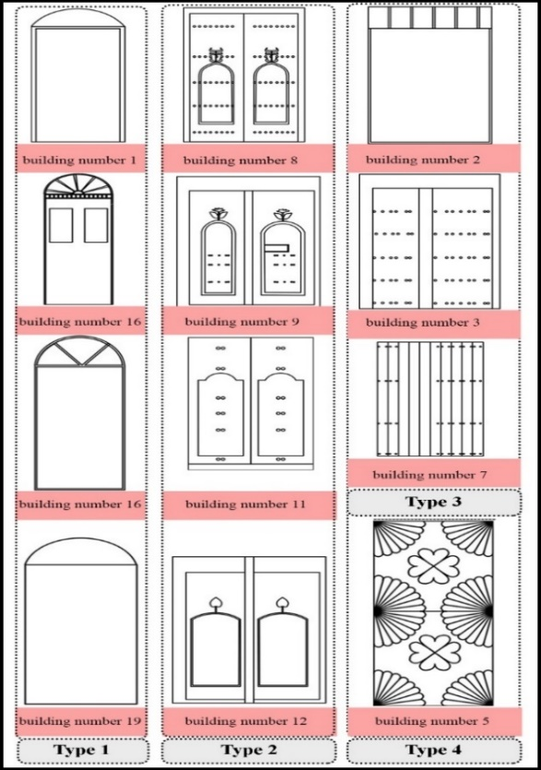

Figure 6. Door patterns in the selected buildings

A.1.1.3. The Structural Patterns of Parapets (A3)
Type 1
The pictures in Figure 7 show the parapets in the city of Mutrah. Most of the buildings have U-shaped parapets. With latticed screens embedded in them. (Figure 7, the parapets of buildings number 5, 6, 14, 15, 16, 20, 21, 22, 23, and 24).

Type 2
Crenellations are widely used patterns in Omani architecture, but they have become purely ornamental nowadays [7]. The architectural style of their forts and palaces became a sort of model that the Omanis imitated in their residential architecture [17].
Motifs taken from fort architecture are omnipresent in modern Oman's urban landscape. This "emulation" or "transfer" of the Al-Ya'ariba architectural language to the civilian buildings could have been enabled by three main factors: first, the Ya'rubi style emanated from the "local" typologies and their architectural vocabulary, even if some important transformations were made after the contact with the Portuguese and the change in the artillery style. Second, the same local materials and construction techniques that the Omanis used for their residential buildings were used in these forts and palaces. Finally, as the Ibadi religious rules required, there was no excess in the size or ornamentation of the forts and palaces built by Al-Ya’ariba [1].
Until now, the contemporary architecture of Oman, including the civilian part, holds in its forms and architectonics related to some of the prominent references to the forts and citadels of the Ya'rubi era. Al-Busaidi sultans, successors of Al-Ya'ariba, perpetuate their predecessors' style in their mansions and other official buildings for the same reasons [1].
Even today, Oman's official buildings are characterized by this military architectural vocabulary, where crenellations crown all types of buildings, and towers punctuate their corners [16]. The Omanis are attached to this symbol, which took full shape when their country was the most powerful one. It is their shared heritage, a source of pride [18], and, to a certain extent, it seems to be a symbol of the identity they want to claim [19]. It is an identity that links their present to their glorious past. This awareness has been continuously encouraged by the late Sultan Qaboos B. Said, who was at the top of the governmental decisions in this matter [20] (Figure 7, the parapets of buildings number 11, 17, and 19).

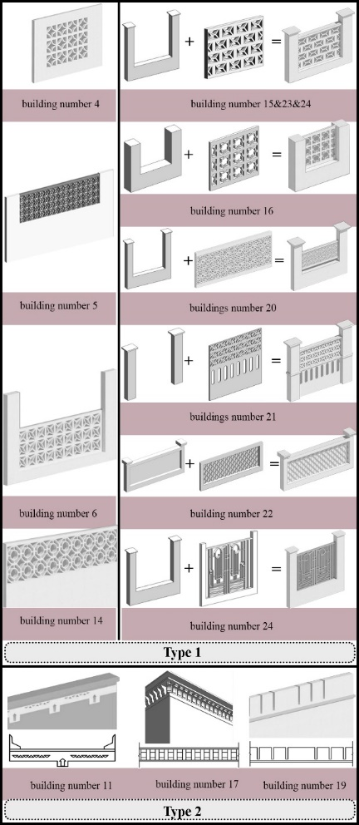

Figure 7. Parapets of the selected buildings
It is for this reason that the crenelated rooftops are profusely used in contemporary architecture. Some of the resulting architectural features are drawn from the "dominant" architectural languages and techniques; they have been reinterpreted and reinvented with the local language. Omanis adapt their buildings to their local context, particular defense needs, and socio-political conditions. This process has allowed for a unique version of the fort fortification, which corresponds to the Omani empire in the 16th - 17th centuries [1] (Figure 7, the parapets of buildings number 11, 17, and 19).

A.1.1.4. Structural Patterns of Openings (A4)
The openings are elements on the building façades that are latticed like the parapets; they are mainly used for ventilation. These elements are different from windows because they do not operate like windows. They are just lattice screens and do not belong to the “windows” category. Most of the openings’ structures are compatible with the windows or parapet details, which strengthens the sense of unity in Omanis building's façades. Based on their construction materials, two types of openings could be identified.

Type 1
Openings made of cement or plaster. In this type, the openings are latticed exactly like the parapets. (Figure 8, the openings of buildings number 6).

Type 2
Openings are made of metal. In this case, these are painted the exact color of the windows. The malleability of the metal makes it easier to execute Islamic patterns. As a result, these patterns are seen in most metal openings. (Figure 9, the openings of buildings number 15 and 24).

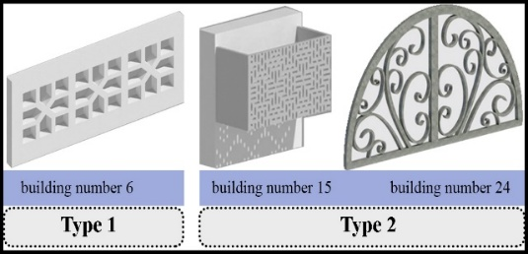

Figure 8. Other types of openings in the selected buildings

A.1.1.5. Structural Patterns of Balconies (A5)
Different types of materials are used in building the balconies. In houses where these are made of cement or bricks, the roof of that floor is slightly projected to cast shade on the balcony. In balconies, which are made of wood or metal, a slanting roof is added above the balcony. Hence, we witness two types of balconies in Omani houses.

Type 1
Type 1 is constructed with cement, bricks, and latticed screens in the same style as the parapets. The ornaments include either latticed or stucco designs in the exact style of the window ornaments and other elements of the façade. In this Type 1 of balconies, harmony between the façade elements is much more evident. They are also continuous along the façade. (Figure 9, the balconies of buildings number 13, 16, and 22).

The Type 2
Balconies of type 2 are constructed with metal and wood, and they have a painted slanting roof. These are mostly seen on Corniche Road in Mutrah. Unlike Type 1, these Type 2 balconies are executed as both continuous and discontinuous. The railings are hollow, and the roofs are colorful. (Figure 9, the balconies of buildings number 15, 20, 21, and 24).
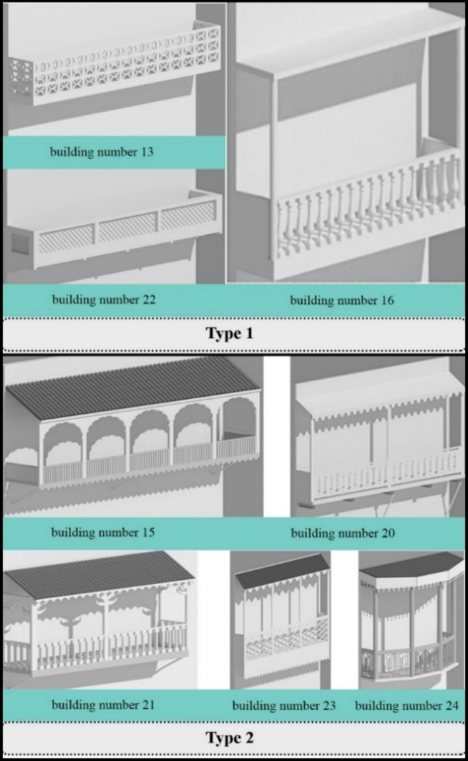

Figure 9. Balconies of the selected Houses

- 1. 2. Functional Patterns (B)
The relationship between patterns and function can be understood from their performance at the buildings. For instance, people use the roof at night for sleeping because of the airflow between the lattice parapet. Patterns used in buildings have functions such as Ventilation, Shading, and Privacy (Figure 10).
Ventilation: The solutions include creating openings in the upper part of the façade, such as parapets and Mashrabiya. Such openings are also essential to allow the evacuation of the hot air accumulated below the ceiling due to convection to escape.
Shading: Controlling the light is the key in Islamic architecture. It aims to cool and reduce the glare caused by sunlight. It also adds to the aesthetics of the structure and its ornamental elements. This is achieved by using projecting patterns and diverse textures on the surfaces, which provide shade and increases or decreases light over time [16]. As Dalu Jones writes, regulating or displaying sunlight with dynamic products and constantly changing patterns introduce modern life [21]. In traditional Omani architecture, the windows are recessed from the main façade wall. This creates a shade and a place to sit or nap [16]. The projected components, consoles, and cantilevers provide shade on the façades and, consequently, reduce the amount of direct sunlight on the external walls. The openings and windows with indented frames, which are slightly wider than the width of the window by about 0.25 meters, prevent sunlight from shining into the architectural spaces [22].

Privacy
Indirect entrance doors are an important part of providing access to the indoor sections of the house while protecting the privacy and security of these spaces [3]. Islam reveres the family space and daily life inside the home. Many of the Islamic texts related to buildings require Muslims to respect home privacy. Some of the provisions of the “Building Regulations for Muscat” respond to this ancient, an important social tradition of the current Omani society.

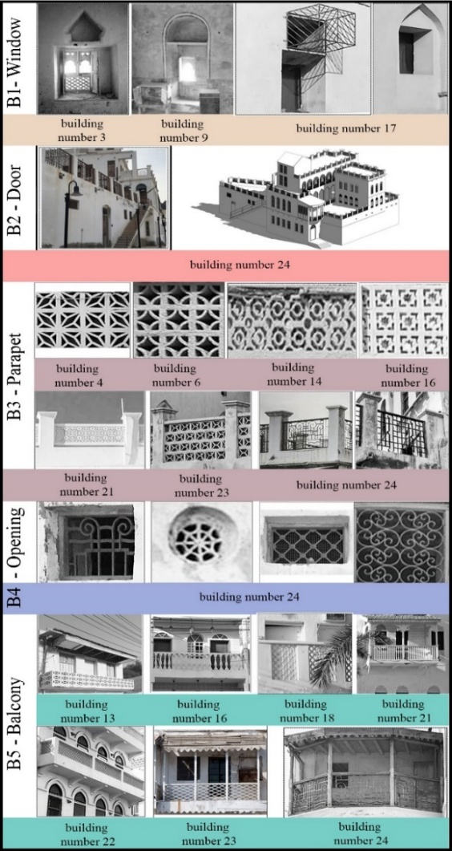

Figure 10. Functional patterns in the selected houses

A.1.2.1. The Functional Structure of Windows (B1)
In vernacular architecture, the windows are small and placed at a high level from the ground to allow for light and ventilation. The position of the window at the top relative to the floor level creates visual privacy from passers-by. However, this has been greatly overlooked in contemporary architecture, and the windows are placed at the passers-by level in plain view [23] (Figure 11).

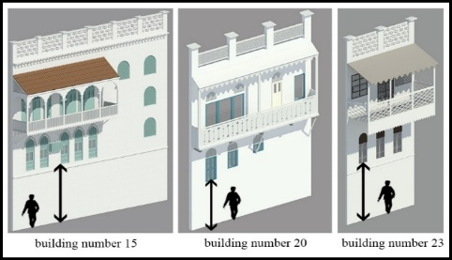

Figure 11. Visual privacy in buildings

A.1.2.2. The Functional Patterns of Doors (B2)
In vernacular architecture, the doors are heavily ornamented and made of thick hardwood. They separate spaces while also providing access and security [23] (Figure 10).

A.1.2.3. The Functional Patterns of Parapets (B3)
The height of most parapets is approximately one meter to provide privacy for the inhabitants. In hot climates, the shelters on and around the roofs are often made in the form of a grid so that the residents would be kept safe from the outsiders’ look, and at the same time, residents use the current of air on the roof to refresh the interiors during the hot season [23]. The roof is commonly used for sleeping during summer nights, and these slit openings may increase the airflow, which improves thermal comfort [24] (Figure 12).

A.1.2.4. The Functional Patterns of Openings (B4)
Every element in Omanis buildings has a reason, and openings are not an exception. Due to the hot climate of this country, all of the elements are utilized for improving the thermal comfort conditions. The openings are used mainly in building façades. Positioned high enough, they allow the hot air to escape and allow the cool air to get in through wider windows positioned in the right façades at the right height [25]. The openings in the rooms are located at two different levels. The lower windows and small slit vents are close to the floor (30-50 cm above the floor). They are the source of airflow in the room and control the thermal sensation as the local people usually sit close to the floor [24]. This is the case of the openings in Mutrah and Mirbat (Figure 10).

A.1.2.5. The Functional Patterns of Balconies (B5)
One of the façade design features that can affect the natural ventilation performance of buildings is the balcony [26]. The ability of balconies to provide solar shading to the apartment below is referred to as one of the most successful solutions to achieve comfort in summer with low energy consumption [27].
Some researchers also indicate that the overhang effect of balconies can block the undesirable penetration of sunlight, protecting the indoor space from ultraviolet radiation [28] (Figure 10).

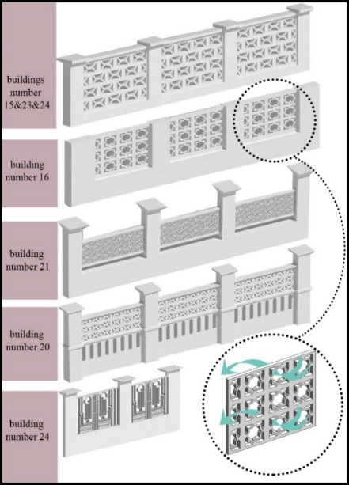

Figure 12. Patterns of parapets in the selected houses

- 1.3. CONCEPTUAL PATTERNS (C)
The concept of the patterns can be seen in the geometry and color of patterns.

A.1.3.1. Geometry of Patterns: Pointed and Circular Arches
These arches are common in the architecture of houses in Southeast Yemen and Oman [7]. The use of different arches is linked to social values [16]. Pointed and circular arches have been used in all the modern architectural spaces of religious, commercial, and residential buildings [16]. They can link columns and serve as openings, and entrances, as well as decorative elements. In Oman, arches appear in several forms, including semi-circular, pointed, or horseshoe shapes [29] (Figure 13).

Circle
Circle is the symbol of perfection and simplicity, and most complete geometrical shape that is symmetrical is relative to the center from each direction. The circle even has value from all sides, and this means that the circle does not know any direction. Therefore, its stimulating combination is the simplest type [30], [31]. (Figure 13, building number4)

Eight-Fold pattern & Four-Fold pattern
The two simplest geometric constructions, which form the basis for many of the patterns to be found in Islamic decorations, are the constructions of four and eight-pointed geometries, respectively. These relatively simple geometrical constructions are easy to develop by connecting various intersections, forming the basis for a variety of pattern-making [32].

Eight-Pointed Star
The square represents the earth or the physical elements such as earth, air, fire, and water. If a square overlaps another, with the second square pointing upwards, an eight-pointed star is formed. The eight-pointed star is related to the symbolism of the eight bearers of the throne from the Quran and certain cosmological interpretations [33].

Arabesque shape
The arabesque, or biomorphic, symbolizes pristine nature. The Muslim artist is inspired by the multiplicity of forms, patterns, and rhythms he sees around him in nature and abstracts them to the fundamental essence (Figure 13).

Floral pattern
The study of geometric proportions has its roots in the study of nature and matter [34]. Islamic floral patterns are an ancient form of Islamic art that is on the verge of extinction. These floral ornaments consist of flowers, leaves, and curved lines that can be obtained using standard geometric or irregular methods [35].

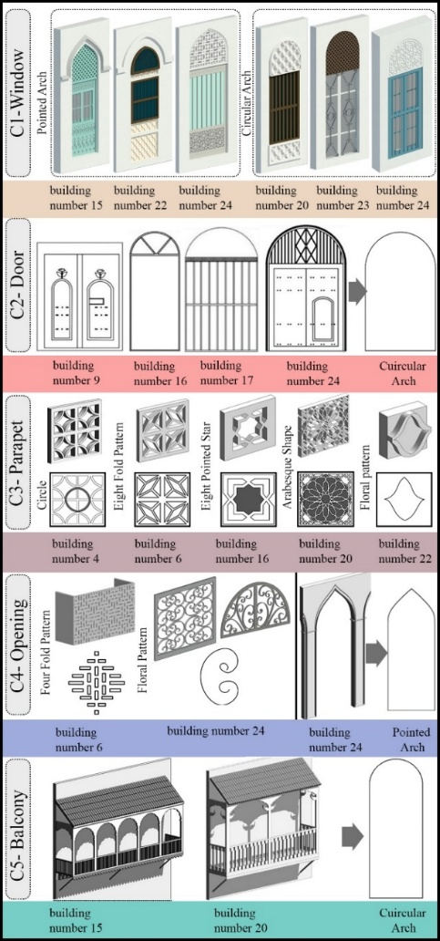

Figure 13. Conceptual Pattern

Interlacing of the conceptual patterns
Most of the conceptual patterns create bigger patterns by endlessly connecting each other. Repetition is the most useful and fundamental feature of Islamic patterns. There are few basic shapes in Islamic art, but the interlocking design of these basic shapes generates different and complex patterns. The repetition of triangle, squares, and pentagons usually produces Islamic patterns. Another important feature of Islamic patterns is symmetry. Symmetry, or the series of ways in which a single motif can be repeated an exact number of times within a circle, is the most fundamental manifest aspect of Islamic geometric art [34] (Figure 14).

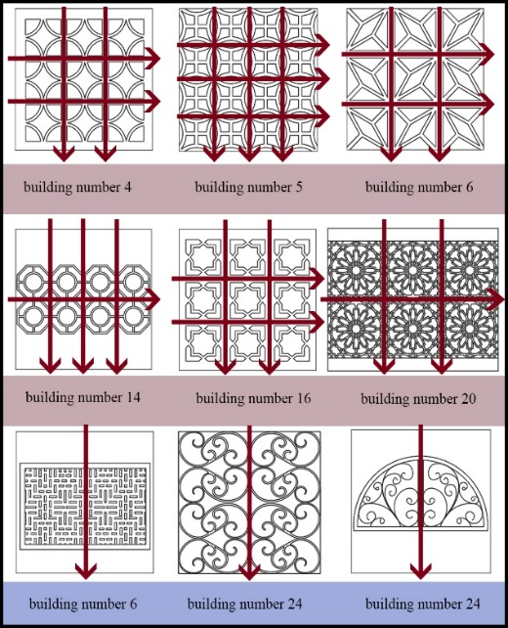

Figure 14. Interlacing of the patterns in the parapets and openings

The analysis of patterns
In the opposite table (Table 1), we can see the simple relation between the façade elements and their detailed role. The whole part of the pattern has its role in the building (Figure 15).
With this method, it is possible to understand the patterns’ evolution (Figure 14) through a three-level analysis. The first level provides a general overview, the second level focuses on the overall shape of the pattern, while the third level examines the intricate details within the shape. These processes keep evolving.

- DISCUSSION

- 1. The Analysis of the Patterns System
Having a system creates order and orderliness. The arrangement of patterns creates an order and culminates in the overall form of the building. In this research, we have three systems.

Setting System
In Omani architecture, every pattern’s location is specified in this category. We examine the location of the structural, functional, and conceptual aspects of the building’s façade. For example, the location of the openings in most of the buildings is above the windows, or lattice elements are in the parapets.

Formation System
In this category, we examine the overall appearance of the pattern (the border of the pattern).

Details System
In the last system, the overall details are also investigated in addition to the position of the patterns and overall form. This system is the last one in all of the details of the structural, functional, and conceptual patterns of the building, which will be gathered, and the general shape of the building will be achieved.

Table 1. The Analysis & Review of Patterns
Patterns | Structural Patterns  (A) | Functional Patterns  (B) | Conceptual Patterns  (C)
Window (1) | A1 | B1 | C1
Door (2) | A2 | B2 | C2
Parapet (3) | A3 | B3 | C3
Opening (4) | A4 | B4 | C4
Balcony (5) | A5 | B5 | C5

The Relationship between Patterns & Systems
Table 2 shows the relationship between patterns and systems. The classification and prioritization of the systems given in the table are from whole to part. This will make the review more coherent and coordinated. In the last step, the collection of whole patterns and systems creates the complete Omani façade. With this method, we can select the pattern, set it in the system, and compose the façade (table 2).

Table 2: The Relationship between patterns & systems
Systems & Patterns | Structural Patterns  (A) | Functional Patterns  (B) | Conceptual Patterns  (C) | Complete System
Setting System  (X) | AX | BX | CX | (A+B+C) X  The System of the Setting Patterns
Formation System  (Y) | AY | BY | CY | (A+B+C) Y  The System of the Formation Patterns
details System  (Z) | AZ | BZ | CZ | (A+B+C) Z  The System of the Details Patterns

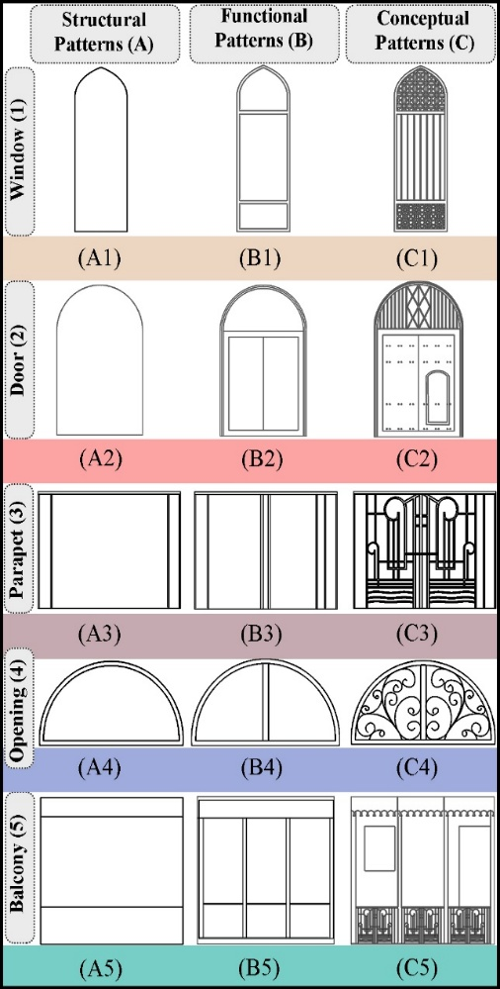

Figure 15. Patterns in Building 24
B.2. SETTING SYSTEM (X)

B.2.1. Setting System of Structural Patterns (AX)
Each main façade has been subdivided into five structural patterns, identified with five different colors. The structural patterns have been laid out next to each other without considering the details. Significant aspects have been observed in this system. Firstly, in the setting system of the structural patterns, the façade has three parts, which are: the body, then the doors, windows, balconies, and openings, and, the last one, the parapets and eaves.

B.2.2. Setting System of Functional Patterns (BX)
Considering the placement of functional patterns, all five elements of Omani buildings have specific functions: windows, doors, open balconies, and the lattice elements of parapets and openings. The latticed elements create an air current suitable for buildings in this climate. As already seen, the position of these patterns is clear. For instance, the U-shaped parapets are latticed, and the openings are usually placed above the doors and windows.

B.2.3. Setting System of Conceptual Patterns (CX)
All the conceptual patterns are placed in set locations, and their position is fixed. The conceptual patterns are found in the latticed parapets of balconies, the windows, and the doors. In some cases, the conceptual patterns have been carved rather than latticed. All these patterns are placed in a set rectangular or semi-circular order.

B.3. THE FORMATION SYSTEM (Y)

B.3.1 The Formation System of Structural Patterns (AY)
We will refer to the figures extracted from the images in the formation system of windows, doors, parapets, openings, and balconies.

B.3.2. The Formation System of Functional Patterns (BY)
The overall form of functional patterns is mainly rectangular, except in particular cases where they are semi-circular or arched. Vents are visible in the façades and are mainly placed above the doors and windows. Most of the openings are made of metal, except for a few examples where they are made of heavy building materials.

B.3.3. The Formation System of Conceptual Patterns (BY)
The conceptual patterns are hollow surfaces, most of which are arranged in a regular network and repeated horizontally and vertically, cross-shaped ones (Figure 15). The doors are surrounded by arches. In some cases, these are semi-circular. This also applies to windows. In some cases, the patterns change to moon, star, and flower shapes. In this system, all the patterns are arranged next to each other according to their form, displaying the overall shape of the building to a certain extent.

B.4. DETAILS SYSTEM (Z)

B.4.1. The System of Structural Details (AZ)
This section shows all details of the doors, windows, parapets, and balconies (Figure 16). Horizontal wooden elements have been added to the structure of the windows. Although the arches are a common element in the details of the windows and openings in the contemporary local architecture of Oman, these are not functional [11].

B.4.2. The System of Functional Details (BZ)
This section shows all details of the openings, balconies, railings, latticed parapets, and number of doors. The openings are mostly metal with Islamic patterns. Most of the balconies’ railings are latticed. As seen in the pictures (Figure 9), most of the patterns are unique, and every type of Islamic design has been used to lattice the parapets, thus avoiding monotony in the façades. As shown in the picture (Figure 14), the details are arranged in a network or a symmetrical system.

B.4.3. The System of Conceptual Details (CZ)
The semi-circular arches of doors and windows have been shown in all patterns for openings based on the Islamic design. The addition of very small patterns in the latticed part of the windows and balcony railings can be observed in the details system. In this section, the final schema of the building has been formed, and we have a complete collection of all patterns and their systems. Everything in the elements of the façade of a building that has affected its formation has been investigated and shown.

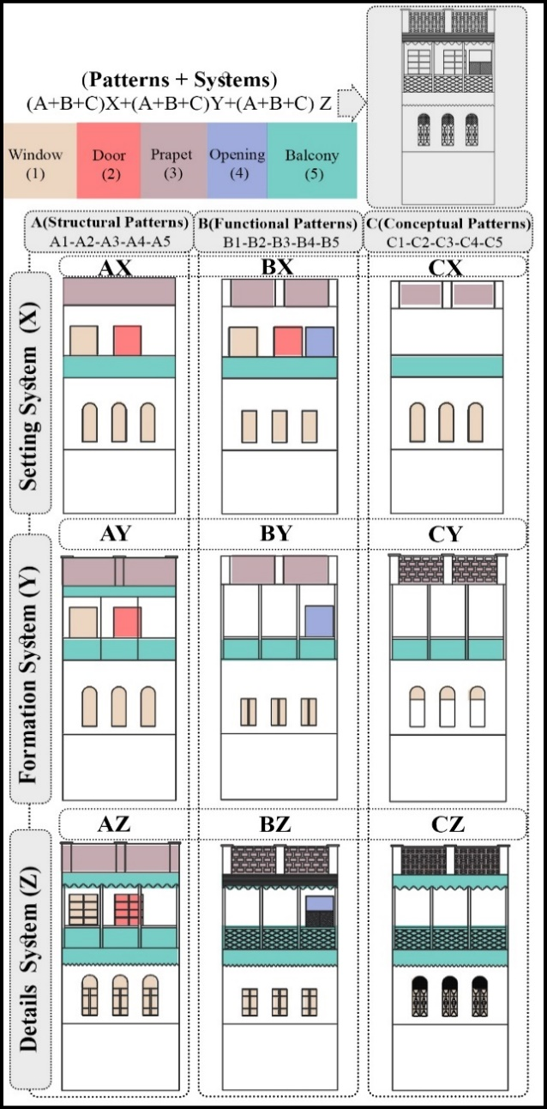

Figure 16. Patterns in Building 24

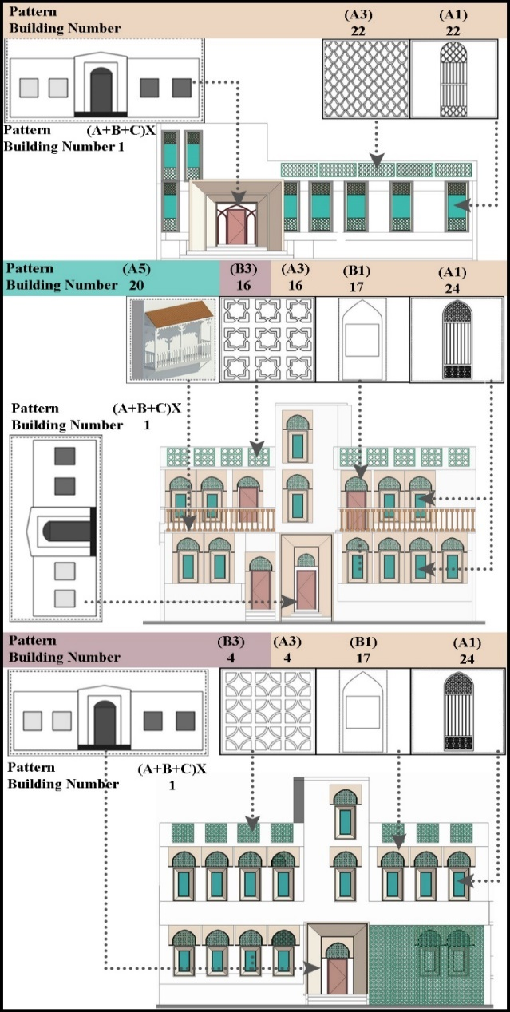

Figure 17. Design

- CONCLUSION
This research has demonstrated the impact of Omani vernacular architecture on contemporary residential architecture in the country. Through the identification and analysis of the structural, functional, and semantic patterns inherent to vernacular building traditions, the study proposes a framework for designers to integrate these features and patterns into new buildings. In addition to strengthening Oman's built environment's visual identity, the continuation and reinterpretation of these vernacular patterns help to safeguard the area's architectural legacy from the effects of rapid urbanization and globalization while offering opportunities to satisfy the new needs and aspirations of Omanis (Figure 17).
The relevance of this research is that it developed a framework for discussing how to integrate heritage elements into modern designs while exploring applicable insights for architects to integrate modernity within an indigenous architectural setting. This study can also have broader implications beyond the Omani context, as it advocates for the need to re-evaluate modern architectural design approaches and take more consideration in combining vernacular elements into contemporary architecture. It will enable the architecture of today to incarnate the cultural identity and values of people.

REFERENCES

- N. Benkari, “The Formation and Influence of the Military Architecture in Oman During Al-Ya’ariba Period (1034-1162 AH/1624–1749 AD)”, Journal of Islamic Architecture, vol. 6, no.4, pp. 217–228, 2021. DOI: https://doi.org/10.18860/jia.v6i4.12104.
- N. Benkari, Harats Qasra, Hujrat Musalmat, Al Khabt & Sayja: Documentation and Heritage management plan. Muscat: Ministry of Heritage and Tourism, 2021.
- B. Sidawi, “Understanding the Vocabulary of the Islamic Architectural Heritage”, GBER, vol.8, Issue 2, Page 26-39, 2013.
- M. Abdelhady, “An Innovative Methodology for Achieving Compatibility between Heritage & Contemporary in Architecture (Case Study: Omani Architecture)”, Journal of Architecture, Arts, and Humanistic Sciences, vol. 30, no. 6, pp. 110-133, 2021. doi: 10.21608/mjaf.2020.35186.1711.
- A. Al-Hashim, N. Benkari, and S. Al-Saadi, “Evaluating the Sustainable Features of Vernacular Architecture in Hot-Arid Regions: Field Surveys and Analysis in Two Vernacular Houses in Al Batinah Region (Oman)”, Architectural Engineering and Design Management, vol. 20, no. 5, pp. 1118-1140, 2023. Doi: https://doi.org/10.1080/17452007.2023.2232357.
- G. Eugenio, “A Masterpiece of Omani 17th Century Architecture,” J. Oman Stud., vol. 1, no. 1, pp. 167–179, 1975.
- P. M. Costa, “Bayt Na’mân, a Seventeenth Century Mansion of the Baṭinah,” J. Oman Stud., vol. 8, no. 2, pp. 195–210, 1985.
- S. S. Damluji, The Architecture of Oman. London: Garnet Publishing, 1998.
- N. Benkari, Harats Qasra, Hujrat Musalmat, Al Khabt & Sayja: Documentation and Heritage management plan. Muscat: Ministry of Heritage and Tourism, 2021.
- S. M. Hegazy, “The Omani Architectural Heritage-Identity and Continuity,” pp. 1–11, 2010.
- A. Al-Salimi, H. Gaube, and L. Korn, Islamic Art in Oman, 3rd Edition, Sultanate of Oman: Mazoon Printing, Publishing and Advertising, 2014.
- S. H. Al-Harthy, “The Traditional Architecture of Oman: a critical perspective,” The University of Arizona, 1992.
- N. H. A. Majid, H. Shuichi, and N. Takagi, “Vernacular Wisdom: The basis of formulating compatible living environment in Oman,” Procedia - Soc. Behav. Sci., vol. 68, pp. 637–648, 2012. Doi: https://doi.org/10.1016/j.sbspro.2012.12.255
- N. Benkari, Harats Qasra, Hujrat Musalmat, Al Khabt & Sayja: Documentation and Heritage management plan. Muscat: Ministry of Heritage and Tourism, 2021. www.archiam.co.uk.
- S. Bandyopadhyay, G. Quattrone, M. Goffriller, “Mirbat: Dhofar Governorate. Documentation and Heritage Management Plan,” Archiam Centre, 2017, Accessed: January 8th, 2024. [Online]. Available: https://www.archiam.co.uk/documentation-and-heritage-management-plan-mirbat-dhofar-governorate/
- C. Alexander, A Pattern Language: Towns, Buildings, Construction. Oxford: Oxford Univ. Press, 1977.
- A Alexander, The Timeless Way of Building. Oxford: Oxford Univ. Press, 1979.
- M. Al Zubair, Oman's Architectural Journey. Muscat: BAZ Publishing, 2013.
- E. D'Errico, "Introduction to Omani military architecture of the sixteenth, seventeenth and eighteenth Centuries," J. Oman Stud., vol. 6, pp. 291–306, 1983.
- M. Limbert, In the time of oil: Piety, memory, and social life in an Omani town. Stanford: Stanford University Press, 2010.
- J. M. Willis, "History, Culture, and the Forts of Oman," Arab Study Journal- Dirosat al- Arabiyah, vol. 4, no. 1, pp. 141-143, 1996.
- N. Benkari, “Oman,” in Time Frames: Conservation Policies for Twentieth-Century Architectural Heritage, London: Routledge, pp. 162–164, 2017. Doi: https://doi.org/10.4324/9781315269863.
- N. Benkari, Harats Qasra, Hujrat Musalmat, Al Khabt & Sayja: Documentation and Heritage management plan. Muscat: Ministry of Heritage and Tourism, 2021.
- J. Dalu, The Elements of Decoration Surface, Pattern and Light in Architecture of the Islamic World, London: Thames& Hudson, pp.161-175, 1995.
- F. Kazerooni, Gulf Islamic Architecture. Manama: Oriental Press, 2002.
- M. Shokouhian, and F. Soflaee, "Environmental sustainable Iranian traditional architecture in hot-humid regions", International Conference Passive and Low Energy Cooling for the Built Environment, Greece, pp.715- 719, 2005.

- H. M. Khan, S. Al-Saadi, N. Benkari, and A. Al-Hashim, “Numerical simulation of ventilation in traditional Omani house: Bait al khandaq as an example”, the journal of engineering research (TJER), Vol 18, No 2, pp. 91-100,2021. Doi: https://doi.org/10.53540/tjer.vol18iss2pp91-100.
- A. Cain, F. Afshar, J. Norton, Oman: the problems and potentials of the indigenous built environment in a developing country, Architectural Association School of Architecture, 1975.
- L. Buys, J. Summerville, L. Bell, and R. Kennedy, “Exploring the Social Impacts of High-Density Living: Considering the Residents’ Perspective‟, In Proceedings of Subtropical Cities 2008: From fault-lines to sight-lines Subtropical urbanism, 3–6 September 2008.
- S. R. Hastings, “Breaking the “heating barrier”: Learning from the first houses without conventional heating”, Energy and Buildings, vol. 36, no. 4, pp. 373–380, 2004. Doi: https://doi.org/10.1016/j.enbuild.2004.01.027
- G. Kim, J. T. Kim, “Healthy-daylighting design for the living environment in apartments in Korea”, Build. Environ, vol. 45, no. 2, pp. 287–294, 2010. Doi: https://doi.org/10.1016/j.buildenv.2009.07.018
- B. Ghasemzadeh, A. Fathebaghalli, and A.Tarvirdinassab, "Symbols and Signs in Islamic Architecture," Revista Europeia de Estudos Artisticos, vol. 4, No. 3, pp. 62-78, 2013. DOI: https://doi.org/10.37334/eras.v4i3.137
- Y. Gruter, translated by J. Pakzad, Beauty of Aesthetic in Architecture, Tehran: Shahid Beheshti University, 1997.
- R. Genon, translated by A. M. Kardan, Siege of Quantity and Emblems of End of the World, Tehran: center of university’s publications, 2023.
- L. M. Dabbour, “Geometric proportions: The underlying structure of design process for Islamic geometric patterns”, Frontiers of Architectural Research, vol. 1, no. 4, pp. 380-391, 2012. Doi: https://doi.org/10.1016/j.foar.2012.08.005
- K. Critchlow, Islamic Patterns: An Analytical and Cosmological Approach, London: Thames and Hudson,1976.
- S. Skinner, Sacred Geometry: Deciphering the Code. New York: Sterling, 2009.
- F. Zou, X. Li, S. Haidar, “An Analytical Study of Five –Pointed Islamic Floral Patterns and Experimental Design Using Penrose Tiling”, Shedet, vol. 10, no. 10, pp. 227-245, 2023. Doi: 10.21608/shedet.2023.291530

