 |  | JOURNAL OF ISLAMIC ARCHITECTURE  P-ISSN: 2086-2636 E-ISSN: 2356-4644  Journal Home Page: http://ejournal.uin-malang.ac.id/index.php/JIA
ISLAMIC ARCHITECTURAL INFLUENCE ON BAJO VILLAGE HOUSES: A CASE STUDY IN SOROPIA SUBDISTRICT, SOUTHEAST CELEBES, INDONESIA
Ahsan Hidayat Setiadi^{*1}, Andi Al Mustagfir Syah¹, Nahdatunnisa Nahdatunnisa¹, M. Arzal Tahir²
¹Architecture Department, Universitas Muhammadiyah Kendari, Indonesia
²Architecture Department, Universitas Halu Oleo, Indonesia
*Corresponding Author: ahsanhidayat686@gmail.com
ARTICLE INFO |  |  | ABSTRACT
Volume: 9  Issue: 1  Page: 18-29  Received: March 14th, 2024  Accepted: November 1st, 2024  Available Online: June 1st, 2026  DOI: https://doi.org/10.18860/jia.v9i1.26375 |  |  | This study aims to analyze the influence of Islamic architectural principles on the design of traditional houses of the Bajo tribe in Bajo Village, Soropia Subdistrict, Southeast Sulawesi. Using a descriptive-analytical method, data were collected through direct observation, in-depth interviews, and document analysis. The study involved 123 traditional Bajo houses categorized into three types: water-based, semi-water-based, and land-based. Key architectural elements, including building orientation, spatial layout, use of building materials, and roof and foundation design, were examined. The findings reveal that the orientation of Bajo houses towards the Qibla is influenced by Islamic teachings, particularly in QS. Al-Baqarah 2:143, while privacy and simplicity in spatial arrangement are aligned with QS. An-Nur 24:27-28 and QS. Ar-Rum 30:41. Islamic spiritual values are also reflected in the design of roofs and foundations, symbolizing the greatness of Allah and the balance of life as stated in QS. Al-Baqarah 2:255 and QS. Al-Hujurat 49:9. This research highlights the significance of integrating Islamic values in architectural practices, especially in preserving traditional Bajo houses, which serve not only as dwellings but also as transmitters of religious and cultural values. The study offers new insights into the relationship between religion, culture, and architecture in a local context, while providing practical guidance for the preservation and development of traditional architecture amidst modernization.  Keywords:  Islamic Architecture; Bajo Tribe; Traditional Houses; Quranic Verses; Architectural Design; Cultural Preservation; Modernization

INTRODUCTION
Islamic architecture has had a significant impact on building design worldwide, including in Indonesia, where Islamic values are deeply intertwined with traditional architecture. In particular, the traditional houses of the Bajo tribe in Bajo Village, Soropia Subdistrict, Southeast Sulawesi, represent a remarkable example of how Islamic architectural principles shape local housing. These houses, built by a predominantly Muslim population, serve as more than mere dwellings. They symbolize the cultural and religious identity of the Bajo community. This study explores the extent to which Islamic architectural principles, such as simplicity, balance, harmony, and functionality, are reflected in the design of traditional Bajo houses in Bajo Village. The geographic context of the study area is shown in Figure 1.

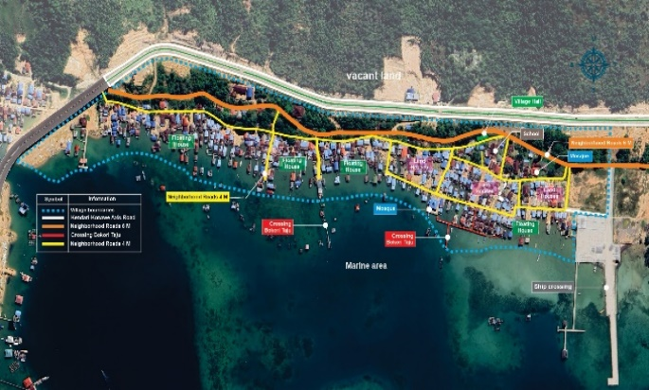

Figure 1. Map of Bajo Village

The importance of this research lies in understanding how Islamic principles are applied not only aesthetically but also influence the daily lives of Muslim communities, including the Bajo tribe. Islamic architecture emphasizes creating a harmonious environment that reflects spiritual values, and this study examines how these values manifest in the spatial organization, orientation, and material use of traditional Bajo houses. The research focuses on 123 houses categorized into three typologies: water-based, semi-water, and land-based, all of which demonstrate how Islamic values are integrated into local architectural practices. The typical floor plan of a water-based Bajo house, illustrating these spatial arrangements, is presented in Figure 2.

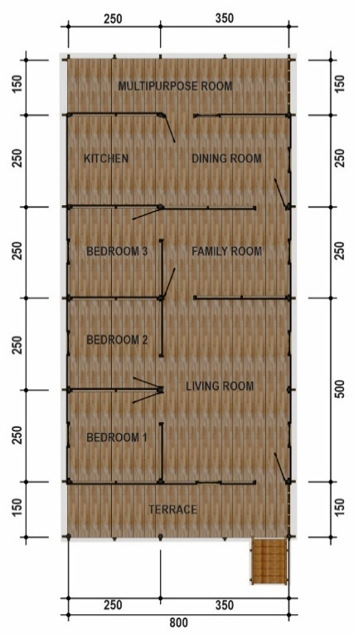

Figure 2. Layout of Water-Based Bajo House

The selection of Bajo Village as the study site is based on its rich cultural and religious heritage, as well as its unique geographical location along the coast. The Bajo tribe's long-standing connection to Islam and its efforts to preserve its identity amid modernization make this region an ideal setting for exploring the intersection of architecture, religion, and culture. Moreover, studying Bajo houses provides insights into how Islamic teachings, such as the Qibla orientation and privacy norms, influence house design in a coastal setting. The existing settlement area is documented in Figure 3.

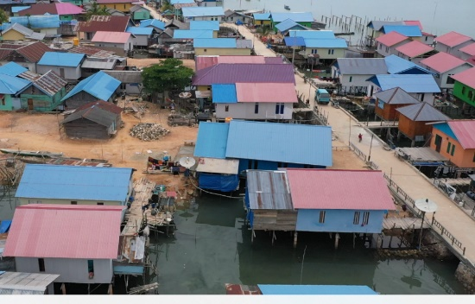

Figure 3. Existing Area

This study offers a fresh perspective by investigating not only the physical characteristics of Bajo houses but also how these structures reflect deeper religious and cultural values. Previous research has largely focused on urban or colonial Islamic architecture, whereas this study highlights how Islamic principles are adapted in rural coastal communities such as the Bajo. Studies on the photographic representation of Islamic architectural heritage have shown how monuments transmit spiritual identity across generations [1]. At the same time, research on military architecture in Oman during the Al-Ya'ariba period demonstrates the breadth of regional Islamic architectural traditions [2]. By comparing Bajo houses with traditional houses in other Muslim communities, such as Kauman Village in Yogyakarta and Wuring Village in Maumere, this research illustrates the diversity of Islamic architectural adaptations across Indonesia [3]. Additionally, it explores how these houses serve as transmitters of cultural and religious values, reinforcing the Bajo tribe's identity amidst external pressures. The architectural form of the water-based Bajo house, as illustrated in Figure 4, exemplifies this integration of functional and spiritual values.

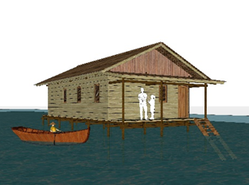

Figure 4. Bajo House Water-Based Architecture

In Islamic teachings, the Quran provides important guidance on the architectural design of homes. Surah An-Nur, verses 36-37, emphasize the importance of the home as a place where the name of Allah is raised and remembered, avoiding any activities that may disrupt the tranquility of the home. This verse supports the concept of the home as a place that reflects simplicity, purity, and spirituality. Surah At-Taubah verse 108 highlights the importance of a home built on piety from the beginning, reflecting the principles of balance and steadfastness in building a harmonious family life. These principles are reflected in the architecture of traditional Bajo houses, which prioritize simplicity, modest beauty, and wise use of space.
Soropia Subdistrict was chosen as the study location because it is one of the areas where the Bajo tribe, with a long history as a Muslim community, strives to maintain its cultural identity amid the influence of modernization. In Soropia, traditional Bajo houses stand as strong symbols of cultural and religious identity, making it an ideal location to study the interaction between local culture and Islamic values. Soropia also offers a unique geographical background, where this coastal community continues to adapt to environmental changes while preserving its traditions [4].
This study differs from previous research by focusing not only on the physical aspects of architecture but also on how Islamic values are applied in the design of traditional Bajo houses in Soropia. This research fills a gap in the literature by revealing how Islamic architectural principles are practiced in a local context that has not been widely explored. For example, a study on traditional houses in Torosiaje, Gorontalo, shows how the Bajo community maintains its connection to the sea while adapting to modernity [5], while research on Gedung Sate, Bandung, reveals the use of Islamic architectural elements in a colonial context [6]. This study provides a new perspective on the application of Islamic values in the architecture of coastal communities, differing from other research. The conceptual path of integrating Islamic values in Bajo traditional architecture is depicted in Figure 5.

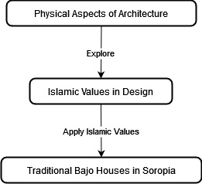

Figure 5. The Path of Integrating Islamic Values in Bajo Traditional Architecture

In conclusion, this research aims to analyze the influence of Islamic architectural principles on traditional Bajo houses in Soropia Subdistrict, highlighting their role in preserving cultural and religious values. This study is significant not only for preserving Islamic values but also for their continued ability to shape local architectural practices amid modernization. By providing a detailed analysis of the architectural and cultural dynamics at play, this research contributes to broader discussions on the role of religion in shaping the built environment of Muslim communities, particularly in coastal regions [7].

METHODS
This study employs a descriptive-analytical approach to explore the influence of Islamic architectural principles on the traditional houses of the Bajo tribe in Bajo Village, Soropia Subdistrict, Southeast Sulawesi. The methodology consists of two main phases: data collection and data analysis. Data was collected through various methods to target different aspects of the research objectives. Direct on-site observations were conducted to record and document the architectural characteristics of 123 traditional Bajo houses, categorized into three types: water-based, semi-water-based, and land-based. These observations focused on the orientation of the houses, the spatial layout, the choice of materials, and the overall design, paying particular attention to how Islamic architectural principles are reflected in these elements. In-depth interviews were also conducted with residents, traditional leaders, cultural experts, and architects familiar with Bajo culture to gain insights into how Islamic values shape the design and construction of these houses. The interviews centered on the community's understanding of Islamic teachings and how they inform architectural decisions, such as building orientation, privacy, and simplicity.
Furthermore, historical documents, architectural plans, old photographs, and research reports were analyzed to trace the evolution of Bajo architecture over time and to provide context for its historical and cultural significance, as well as the relationship between these houses and Islamic principles. Additionally, the study examined Quranic verses, such as Surah An-Nur 36-37 and Surah At-Taubah 108, to identify Islamic principles related to home design and spiritual values. These verses provided a framework for interpreting the religious significance of architectural elements found in traditional Bajo houses.
The collected data were systematically processed by first categorizing them based on house typology (water-based, semi-water, land-based), architectural elements (e.g., roof design, foundation, orientation), cultural practices, and religious influences. This categorization helped organize the findings and prepared them for analysis. Content analysis was applied to interpret qualitative data from interviews, observations, and documents, uncovering recurring themes and patterns related to Islamic architectural principles and their influence on Bajo house design. A comparative analysis of traditional architecture was undertaken to elucidate the application of Islamic architectural principles within its spatial, formal, and cultural contexts in Bajo Village with similar studies from other Muslim communities in Indonesia, such as in Kauman Village (Yogyakarta) and Wuring Village (Maumere) [7], [8]. This comparison highlighted the uniqueness of the Bajo houses while identifying common threads in the application of Islamic values across different communities.
The study focused on a sample of 123 traditional houses in Bajo Village, categorized into water-based, semi-water-based, and land-based types. This sample was chosen to represent the diversity of environmental adaptations in Bajo housing and to explore how different conditions, particularly proximity to water, influence the application of Islamic architectural principles. The spatial distribution of the study area is illustrated in Figure 6. By employing these methods, this study provides a comprehensive understanding of how Islamic values are integrated into traditional Bajo architecture and contributes to the preservation of cultural identity amid modernization.

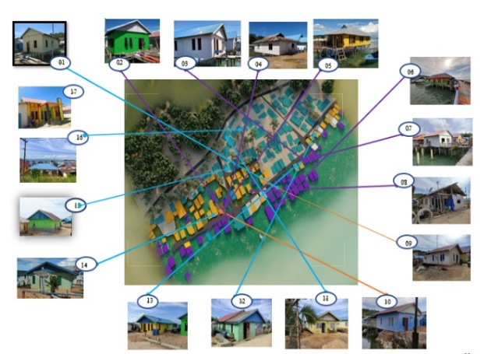

Figure 6. Map of Bajo Village

RESULT AND DISCUSSION

Analysis of Islamic Architectural Principles in Traditional Bajo Houses
This study aims to identify the influence of Islamic architectural principles on the design of traditional houses of the Bajo tribe in Bajo Village, Soropia Subdistrict, Southeast Sulawesi. Through a descriptive-analytical approach and direct observation, the study finds several architectural elements that reflect Islamic principles, including building orientation, spatial arrangement, and the use of building materials.

Building Orientation
The orientation of traditional Bajo houses facing the Qibla reflects Islamic values in architecture. This orientation principle aligns with Islamic teachings that emphasize the Qibla direction as the center of Muslim worship (QS. Al-Baqarah 2:143). In the context of traditional Bajo architecture, this orientation serves not only a religious function but also demonstrates a deep respect for spiritual and cultural values passed down through generations

Spatial Arrangement
The spatial arrangement of traditional Bajo houses emphasizes simplicity and functionality, both key principles of Islamic architecture [9], [10]. The layout carefully balances privacy, functionality, and communal space, reflecting Islamic values regarding family life and interaction with guests [11]. As depicted in the isometric view of the traditional Bajo house shown in Figure 6 (Overlay Bajoe Structure), the image showcases the structural design of the house on stilts, typical of Bajo homes situated over water. The structure is designed in layers, with an emphasis on the lightweight roof construction, which aligns with the principle of balance in Islamic architecture [12]. This roof structure, often raised high, symbolizes the community's connection to spiritual values and the heavens, a reflection of Surah Al-Baqarah (2:255), which speaks to Allah's greatness as the protector of all.
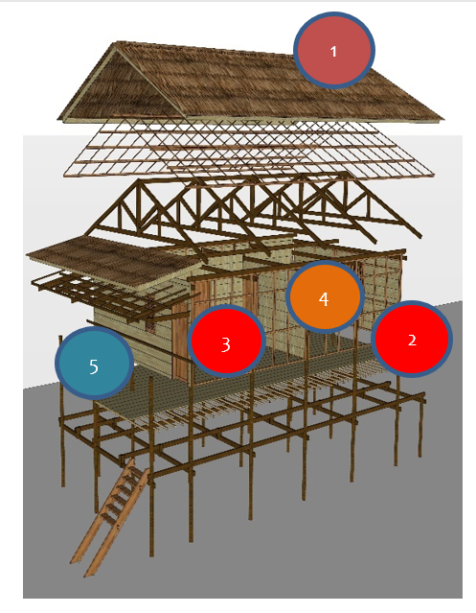

Figure 6. Overlay Bajoe Structure

Table 1 summarizes the key Islamic architectural elements identified in traditional Bajo houses. Each element is mapped to its corresponding Quranic reference, demonstrating the deep integration of religious principles into everyday domestic design.

Tabel 1. The Influence of Islamic Architecture
No. | Element | Description | Quranic Reference
1 | High Roof | The high roof ensures good ventilation and protection from coastal weather, symbolizing a spiritual connection with Allah and the sky. | QS Al-Baqarah 2:255:  Allah's greatness as the protector of all creation.
2 | House Supporting Pillars | The supporting pillars keep the house elevated above water, symbolizing simplicity and harmony with nature. | QS Ar-Rum 30:41:  Humanity's stewardship of the earth and the obligation to maintain it.
3 | Guest Room | The guest room at the front of the house ensures family privacy. | QS An-Nur 24:27-28:  Emphasizing & Privacy.
4 | Family Room | The family room, located in the center of the house, represents unity and harmony within the family. | QS An-Nisa 4:34:  The importance of harmony in family life.
5 | Terrace andBoat Access | The terrace serves as both a social space and provides access to the boat, reflecting the Bajo people's connection to the sea. | QS An-Nahl 16:14:  Blessings of the sea's resources.
6 | Traditional Materials | The use of wood and bamboo symbolizes simplicity and wise resource management, in line with Islamic teachings. | QS Al-Mulk 67:15:  The responsibility of humans to make good use of the earth's natural resources.

In line with Surah An-Nur (24:27-28), which emphasizes the importance of maintaining family privacy, the Bajo house's design features a clear separation between public and private spaces [11]. The terrace at the front of the house serves as the entry point and is often used to receive guests, ensuring that visitors do not intrude on the family's private areas. Behind this, the living room functions as the central space for family gatherings, ensuring that the most private interactions take place away from the entrance [12]. At the core of the structure is the family room, which fosters togetherness and harmony, in line with the Islamic principle of familial unity, as mentioned in Surah An-Nisa (4:34). This area is shielded from the more public spaces of the house, ensuring privacy and comfort for the family. The kitchen and dining room are located toward the back of the house, where family meals are shared, promoting cooperation and reinforcing kinship bonds [13].

Use of Building Materials
The building materials used in traditional Bajo houses, such as wood and bamboo, are chosen for their local availability and simplicity, reflecting the principle of simplicity in Islamic teachings (QS. Ar-Rum 30:41). The use of these materials not only serves to preserve the environment but also strengthens the bond between humans and nature, in line with the Islamic concept of stewardship (khilafah) over the earth [14].

Integration of Islamic Values in Traditional Bajo Architecture
In addition to structural principles, this study also finds that traditional Bajo houses integrate Islamic values through symbolic elements and the use of space that considers religious and local cultural aspects.

Roof Design
The design of the traditional Bajo house roofs, which are often high and towering, symbolizes grandeur and spirituality, reflecting the concept of divinity in Islam, which emphasizes the greatness of Allah as the protector of all creation (QS. Al-Baqarah 2:255). This design can also be seen as a form of reverence for natural forces and a symbol of connection with the sky, as seen in Mughal architecture at Gedung Sate, Bandung [13]. Grabar [14] further traces similar spiritual symbolism in South Sulawesi's mosques and mausoleums, reinforcing the presence of Islamic architectural expression in the region.

- Walls and Foundation
The walls and foundation of traditional Bajo houses are built to provide stability and protection, in accordance with Islamic teachings on justice and balance in life (QS. Al-Hujurat 49:9). A strong foundation reflects strong faith and trust in daily life, as recommended in the Qur'an to live with balance and harmony (QS. Al-Mulk 67:15).

- Interior Spaces
The interior spaces of traditional Bajo houses are designed to reflect Islamic teachings on the importance of family and household life [7]. The spacious and open family room, often used for communal activities, reflects the concept of harmony and togetherness in Islamic teachings (QS. An-Nisa 4:34). This is also reflected in research on traditional Indonesian mosques that show how architectural elements are used to reflect Islamic values [15], [8]. Comparative studies on Hausa traditional architecture further confirm that spatial morphology is deeply tied to cultural and religious conservation values [16].

- Adaptation of Traditional Bajo Architecture to Modernization
Traditional Bajo houses also show adaptation to modernization while retaining their cultural and religious values. This is evident in the use of modern building materials, such as cement and steel, in some houses while still maintaining traditional design principles [17]. This adaptation process is similar to that in Al-Najaf, where inherited historical architectural characteristics have changed dramatically, but efforts continue to preserve and revitalize the historic city center [18]. A parallel transformation is also observed in Cairo, where rapid urban development has challenged the continuity of historically Islamic built environments [15].

- Transformation of Materials and Functions
The use of modern building materials demonstrates the Bajo people's adaptability to external influences while maintaining their cultural identity [8]. Modern materials are used to enhance the durability of houses against extreme weather, but the overall design still prioritizes Islamic and local cultural principles. This is also seen in some buildings in the Middle East where modern materials are integrated with traditional designs to preserve cultural identity [16]. Figure 8 presents a sample water-based Bajo house in which wood remains the dominant construction material, illustrating the continuity of traditional building practices.

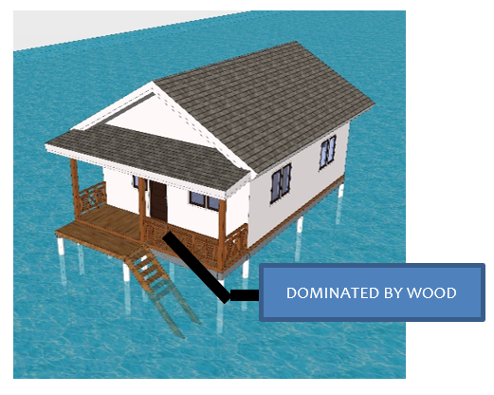

Figure 8. Water-Based Architecture As Sample

Discussion
This section explores how the research objectives identifying the influence of Islamic architectural principles on traditional Bajo houses are achieved through analysis and theoretical application. The discussion integrates Islamic architectural principles with the physical attributes of Bajo houses, as identified during field observations and data collection. The primary architectural elements, such as building orientation, spatial arrangement, and material selection, are examined in the context of Islamic teachings [19]. For instance, the house orientation toward the Qibla illustrates the influence of Islamic spirituality, aligning with religious values highlighted in Surah Al-Baqarah (2:143).

Relevance and Application of Islamic Architectural Principles in a Local Context
This discussion shows how the Islamic architectural principles applied in the design of traditional Bajo houses not only maintain cultural identity but also serve as a medium for transmitting religious and cultural values within the Bajo community [20]. The study highlights the importance of architecture as a powerful way to maintain community identity amid changing times and external influences. The application of these principles shows how Islam can be harmoniously integrated with local culture, creating a living environment that aligns with religious teachings [21].

Comparison with Other Communities
Compared to other Muslim communities, such as in Wuring Village, Maumere, where houses have transformed from stilt houses over water to more complex structures while still retaining cultural and religious elements [22], traditional Bajo houses continue to maintain strong traditional architectural elements. Studies on the Bajo Mola tribe further confirm how vernacular architecture adapts to modernity while preserving identity [23]. In Kauman Village, Yogyakarta, Islamic architecture is used to create a strong cultural identity through spatial arrangements that reflect Islamic and social values [24]. In this context, this study shows how the Bajo community in Soropia adapts Islamic architectural principles according to their geographical and social conditions.
Table 2 presents a comparative analysis of Bajo houses across two communities, Wuring Village (Image 1) and Bajo Village (Image 2), across five dimensions: cultural context, structural layout, building orientation, materials used, and religious influence. The arrangement emphasizes privacy and harmony, key Islamic values as noted in Surah An-Nisa (4:34). At the same time, the material choices reflect Islamic principles of simplicity and stewardship over nature, as outlined in Surah Ar-Rum (30:41). Through these findings, the study not only validates the application of Islamic principles but also compares the Bajo adaptation with other Muslim communities in Indonesia, drawing connections to broader cultural and religious practices. The findings reveal both unique and shared elements of Islamic influence, framing the Bajo houses within a larger narrative of cultural preservation amid modernizing forces [25].

Tabel 2. Comparison with Other Communities
Aspects | House in Wuring (Image 1)  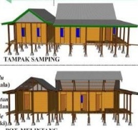 | House in Bajo Village (Image 2)  
Cultural Context | Reflects the evolution of Bajo tribal architecture, with modern extensions such as tatambe [12]. | Embodies Islamic principles, creating a balance between culture and faith [19].
Structural Layout | Complex, with additional structures for family expansion and sea access. | Simple and functional layout designed to reflect Islamic principles of modesty and privacy (QS. An-Nur: 27-28).
Building Orientation | Oriented towards the sea to facilitate fishing and maritime activities. | Oriented toward Qibla, in accordance with Islamic teachings on worship and daily life (QS. Al-Baqarah: 2:143).
Materials Used | A combination of wood and modern materials. | Focus on natural, locally sourced wood, symbolizing simplicity and connection to nature (QS. Ar-Rum: 30:41).
Religious Influence | Less explicit, though some cultural Islamic elements are present. | Strong Islamic influence, incorporating QS. An-Nur: 24:27-28 on privacy, and QS. Al-Mulk: 67:15 on balance and harmony in the household.

Implications for Preservation and Development
This research has important implications for the preservation and development of traditional architecture in coastal areas and other Muslim communities [26]. By understanding how Islamic values are applied in traditional Bajo architecture, we can develop more effective strategies to preserve this cultural heritage amid modernization challenges [27]. This study opens opportunities for further research to explore how religious values can influence architectural design in various cultural and geographical contexts. This research highlights the importance of a holistic approach in evaluating how religious and cultural values can be integrated into architecture and how this can be used to support the preservation and development of local communities. Thus, this research not only contributes to academic understanding but also provides practical guidance for future architectural practice [28].

CONCLUSION
This study successfully uncovers the profound influence of Islamic architectural principles on the traditional houses of the Bajo tribe in Bajo Village, Soropia Subdistrict, Southeast Sulawesi. The findings illustrate that key elements of Bajo architecture, such as the orientation of the house, spatial organization, building materials, and the structure of roofs and foundations, are deeply intertwined with Islamic teachings. By utilizing a descriptive-analytical approach, supported by direct observations, interviews, and Quranic references, this research shows how Islamic values manifest in the architectural design of Bajo houses.
The most prominent influence is the orientation of the houses facing the Qibla, as prescribed in QS. Al-Baqarah 2:143, reflecting a direct connection to Islamic spiritual practices. The spatial arrangement of these homes emphasizes privacy and functionality, aligning with Islamic teachings on simplicity and community interaction, as detailed in QS. An-Nur 24:27-28 and QS. Ar-Rum 30:41. Additionally, the elevated design of the roofs and supporting pillars symbolizes the greatness of Allah and highlights humanity's role as stewards of the earth, as reflected in QS. Al-Baqarah 2:255 and QS. Ar-Rum 30:41. These architectural features also embody cultural adaptations that have helped the Bajo people maintain their religious identity despite external influences.
This research offers a unique perspective by integrating Islamic principles with local traditions, presenting a nuanced view of how religious values shape architecture in a coastal Muslim community. The findings contribute to the broader field of Islamic architecture by demonstrating how spiritual values can be preserved and integrated into housing design, particularly in communities facing modernization pressures. Unlike previous studies, which primarily focus on urban or more prominent examples of Islamic architecture, this study sheds light on how smaller, less-studied communities, such as the Bajo, also uphold and integrate these principles into their architectural practices.
Furthermore, this research underscores the role of traditional Bajo houses as not only physical structures but also as carriers of religious, cultural, and spiritual values. These homes, deeply rooted in Islamic teachings, contribute to preserving the Bajo community's identity while addressing environmental challenges, offering practical insights into how religious principles can guide architectural adaptation in coastal regions. The study also highlights how cultural preservation can go hand in hand with modernization, as evidenced by the adaptation of traditional materials and designs in Bajo houses.
In conclusion, this research fills an important gap by highlighting the intersection of religion, culture, and architecture in a local context that has been rarely explored in previous studies. The findings reinforce the value of a holistic approach to understanding architecture that respects both religious and cultural values, offering a solid foundation for future research and application. This study not only enhances our understanding of traditional Muslim architecture in coastal areas but also provides a model for preserving and transmitting Islamic values through architectural design, ensuring cultural continuity amid change.

ACKNOWLEDGEMENT
We would like to express our deepest gratitude to Universitas Muhammadiyah Kendari for providing the support and resources necessary to complete this research. Your commitment to fostering an environment of academic excellence has been invaluable in guiding this study to fruition.
Our sincere thanks also go to the Bajo community in Soropia Subdistrict, Southeast Sulawesi, for their invaluable cooperation and for sharing their cultural heritage and knowledge with us. Their insights and participation have been fundamental to this research, providing a rich perspective on the traditional architecture influenced by Islamic principles.
We extend our appreciation to all the researchers, scholars, and staff who have contributed to this project with their expertise and insights. Your support has been essential in ensuring the thoroughness and accuracy of this study.
Finally, we would like to acknowledge the financial support provided by the various funding bodies and institutions that have contributed to this research. Your generosity has enabled us to explore and document the unique architectural heritage of the Bajo people, and we are deeply grateful for your support. Thank you all for your contributions and encouragement throughout this journey.

REFERENCES
- A. Behdad, "On photographic monumentalism: Nineteenth-century representations of architectural and historical sites," Journal of Material Cultures in the Muslim World, vol. 4, no. 2, pp. 153-169, 2024. DOI: https://doi.org/10.1163/26666286-12340044
- N. Benkari, "The formation and influence of the military architecture in Oman during Al-Ya'ariba period," Frontiers of Architectural Research, vol. 13, no. 3, pp. 459-486, 2023. DOI: https://doi.org/10.1016/j.foar.2024.01.003
- T. Aryanti, "Branding the Islamic village: Modesty and identity in Yogyakarta Kauman village, Indonesia," Procedia - Social and Behavioral Sciences, vol. 184, pp. 94-101, 2015. DOI: https://doi.org/10.1016/j.sbspro.2015.05.067
- Burhanuddin, Amar, and Mashuri, "Physical changes of occupancy and spatial of Bajo tribe settlement in Jayabakti Village, Pagimana District," IOP Conf. Ser.: Earth Environ. Sci., vol. 1157, p. 012013, 2023. DOI: https://doi.org/10.1088/1755-1315/1157/1/012013
- L. M. Dabbour, "Morphology of quarters in traditional Arab Islamic city: A case of the traditional city of Damascus," Frontiers of Architectural Research, vol. 10, no. 1, pp. 50-65, 2021. DOI: https://doi.org/10.1016/j.foar.2020.11.004
- T. Muhammad and B. Dwisusanto, “Arsitektur Monumental sebagai Representasi Kultural: Kasus Studi Gedung Sate,” Jurnal Arsitektur TERRACOTTA, vol. 4, no. 3, pp. 204–212, Aug. 2023. DOI: https://doi.org/10.26760/terracotta.v4i3.9131.
- A. A. K. S. Gobang, Antariksa, and A. M. Nugroho, "Perkembangan spasial hunian suku Bajo di Kampung Wuring Kota Maumere," J. Tek. Arsit. ARTEKS, vol. 2, no. 1, pp. 1-12, 2017. DOI: https://doi.org/10.30822/arteks.v2i1.37.

- A. A. Haerulloh, S. L. Nurrohmah, M. Alim, and T. Ampera, "Identitas budaya dan sejarah suku Bajo di Bajo Pulau pascanomaden," METAHUMANIORA, vol. 11, no. 1, pp. 75-90, 2021. DOI: https://doi.org/10.24198/metahumaniora.v11i1.32115.
- Z. Othman, R. Aird, and L. Buys, “Privacy, modesty, hospitality, and the design of Muslim homes: A literature review,” Frontiers of Architectural Research, vol. 4, no. 1, pp. 12–23, 2015. DOI: https://doi.org/10.1016/j.foar.2014.12.001.
- A. M. Dini, S. A. Salih, and S. Ismail, “Principle of privacy in Islamic architectural design context: A systematic literature review,” International Journal of Academic Research in Business and Social Sciences, vol. 13, no. 1, 2023. DOI: http://dx.doi.org/10.6007/IJARBSS/v13-i9/18435.
- J. Eiraji and S. A. Namdar, "Sustainable systems in Iranian traditional architecture," Procedia Engineering, vol. 21, pp. 553-559, 2011. DOI: https://doi.org/10.1016/j.proeng.2011.11.2050.
- M. M. Alnaim, G. Albaqawy, M. Bay, and A. Mesloub, "The impact of generative principles on the traditional Islamic built environment: The context of the Saudi Arabian built environment," Ain Shams Engineering Journal, vol. 14, no. 4, p. 101914, 2023. https://doi.org/10.1016/j.asej.2022.101914.
- N. Tamimi, I. S. Fatimah, and A. A. Hadi, “Identification of conditions and distribution of colonial buildings in Bandung City,” IOP Conference Series: Earth and Environmental Science, vol. 501, no. 1, p. 012006, 2020, doi: 10.1088/1755-1315/501/1/012006.
- O. Grabar, "Art and architecture and the Qur'an," Early Islamic Art, 650-1100, 1st ed. Routledge, 2005.
- G. K. Umar, D. A. Yusuf, A. Ahmed, and A. M. Usman, "The practice of Hausa traditional architecture: Towards conservation and restoration of spatial morphology and techniques," Scientific African, 2019. DOI: https://doi.org/10.1016/j.sciaf.2019.e00142
- M. Sutrisno, "Tracing Persian influences: Exploring the meaning of mosques and mausoleums in South Sulawesi as iconic Islamic architecture," J. Islamic Architecture, vol. 7, no. 4, pp. 669-685, 2023. DOI: https://doi.org/10.18860/jia.v7i4.19372
- R. P. Herwindo, "Traces of Islamic architecture in the design of the 'Gedung Sate' in Bandung," Journal of Islamic Architecture, vol. 7, no. 3, pp. 476-485, 2023. DOI: https://doi.org/10.18860/jia.v7i3.16932.
- . K. S. Aratuza, K. R. Kurniawan, and Y. N. Harahap, "Adaptation of vernacular architecture in the Bajo Mola tribe facing modernity," Potency of the Vernacular Settlements, 1st ed. Routledge, 2024.
- S. Farhan, V. Akef, and Z. Nasar, "The transformation of the inherited historical urban and architectural characteristics of Al-Najaf's old city and possible preservation insights," Frontiers of Architectural Research, vol. 9, no. 4, pp. 820-836, 2020. https://doi.org/10.1016/j.foar.2020.07.005.
- F. Karim, M. M. Sir, and A. M. Radja, "Characteristics of the Bajo tribal settlement in the Village of Torosiaje Laut Pohuwato District, Gorontalo Province, Indonesia," ISVS e-journal, vol. 10, no. 12, pp. 370-390, 2023. DOI: https://doi.org/10.61275/ISVSej-2023-10-12-26.
- N. Jarrar, "Developing digital Islamic heritage sites in Jordan", Digital Applications in Archaeology and Cultural Heritage, Vol. 32, pp. 1-13, 2024. DOI: https://doi.org/10.1016/j.daach.2024.e00316.
- Fikriyati, "Architectural interpretations of Qur'anic and hadith influences in traditional Indonesian mosques during the Walisanga era," J. Stud. Qur'an Hadis, vol. 24, no. 2, pp. 253-284, 2023. DOI: https://doi.org/10.14421/qh.v24i2.4657.
- M. Kamali, "The interaction of history and modern thought in the creation of Iran's architecture by investigating the approaches of past-oriented architecture," Frontiers of Architectural Research, vol. 13, no. 3, pp. 459-486, 2024. DOI: https://doi.org/10.1016/j.foar.2024.01.003.
- A. H. Setiadi and A. A. M. Syah, "Utilizing Metaverse technology for the preservation of indigenous houses in Southeast Sulawesi," J. Architect. Herit., vol. 12, no. 3, pp. 245-263, 2024. DOI: http://dx.doi.org/10.30659/jacee.7.1.98-108.
- D. H. I. Labib and L. Mohamed, "Cairo: An Arab city transforming from Islamic urban planning to globalization," Cities, vol. 117, p. 103310, 2021. DOI: https://doi.org/10.1016/j.cities.2021.103310.
- A. H. Setiadi, L. D. Wulandari, and D. Asikin, "The typology of coastal house functions in Bajo, Soropia Sub-District," BIRCI-Journal, vol. 4, no. 4, pp. 11985-11996, 2021. DOI: 10.36347/sjet2021.v09i11.004.
- L. H. S. Wardi, B. H. Wijayanti, A. Kurniawan, and T. Kukuh, "Model pengembangan Desa Karang Bajo sebagai desa wisata arsitektur tradisional di Kecamatan Bayan Kabupaten Lombok Utara," J. Arsit. Tradisional, vol. 2, no. 3, pp. 150-167, 2023.
- Ibrahim, K. P. Hua, N. A. Aziz, and N. A. Hanifah, “Hima as ‘living sanctuaries’: An approach to wetlands conservation from the perspective of Shari’a law,” Procedia - Social and Behavioral Sciences, vol. 105, pp. 476–483, Dec. 2013, doi: 10.1016/j.sbspro.2013.11.050.

