Results
The neglect of classical (old) houses of worship is a striking phenomenon that is easily found in various parts of Aceh. Many mosques no longer function due to their poor condition. They have been replaced by new, more modern places of worship. Three forms of neglect are widespread: some have fallen into disuse due to severe damage without conservation or are left to deteriorate; others have become dysfunctional and are no longer used as places of worship; and many older mosques have been set aside as newer places of worship are built in their place. These three forms of neglect are discussed in detail in the following sections.

4.1. Aceh's Classical Worship Spaces (Tuha Mosque, Meunasah, Balee Beut) are neglected due to lack of maintenance and conservation.

In many places in Aceh, there are mosques that are abandoned because they are not taken care of and conserved as cultural heritage. Mosques are left in a state of disrepair or unrepaired even though many parts of the mosque are ageing. The community has no concern for the conservation of cultural heritage so the mosque is left to deteriorate. Some mosques have damage to the building structure due to rotting/aging wood that should be maintained. Certain parts of the mosque have disappeared so that it is no longer intact as a place of worship. Many mosques also have damaged parts, such as leaking roofs or damaged walls. The following cases show the state of disrepair in various places (figures in table 1).
Tabel 1. Mosque Tuha of Gampong Dayah Teungku, Kuta Baro District, Pidie Regency, Aceh Province.
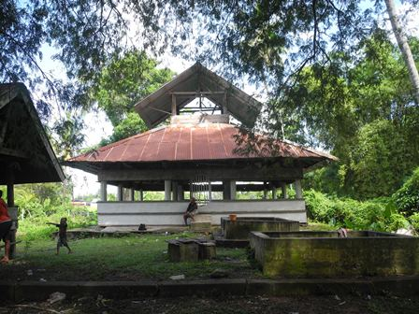 | 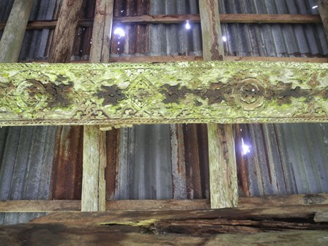 | 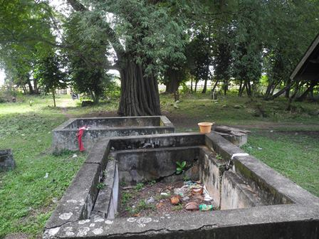
1 | 2 | 3
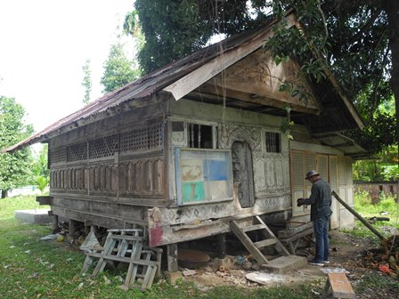 | 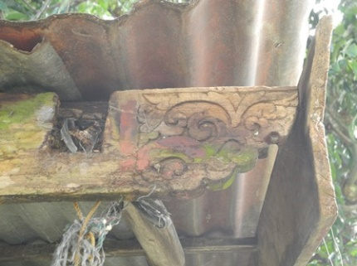 | 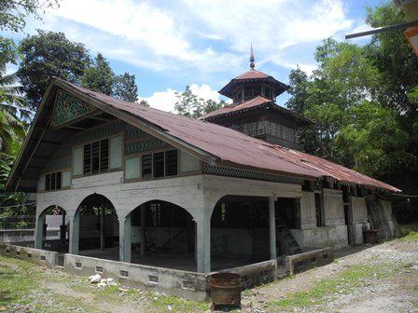
4 | 5 | 6
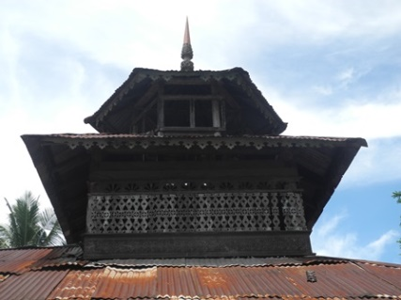 | 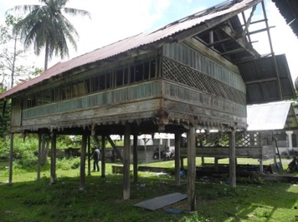 | 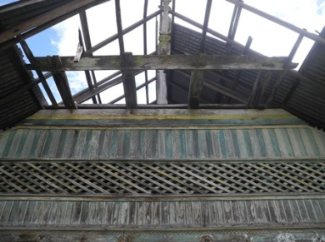
7 | 8 | 9
(Source: Researcher Data, 2022)

Description:

Figure 1. A view of the Mosque tuha Gampong Dayah Teungku in Pidie depicting a classic Acehnese worship space through the years, now a strangely familiar building in a forest dwelling. The condition of the upper supporting timber and zinc sheets with holes. Figure 3. Depicting the dried-up ablution water pool. Figure 4. An 'overall' perspective view of the Meunasah tuha gampong dayah teungku, reflecting the classic Acehnese character. Figure 5. Wooden carvings of lesplang at the end of the house of worship building. Figure 6. Perspective view of the overall view of the Paloh Kambuek Gampong tuha mosque, exuding classical Acehnese grandeur. Figure 7. The top of the mosque is full of tiers and supporting walls decorated with various motifs. Figure 8. Construction of the columns and stairs of the bale beut gampong masjid baro. Showing the wear and tear of some of the stairs in need of maintenance. Figure 9. View of the top of the bale beut building of Masjid baro showing the missing part of the roof, no maintenance has been done to this building.

Overall, the images in table 1 paint a disturbing picture of how Aceh's classical worship spaces have been neglected, deteriorating and falling into disrepair over time. It is also a reminder of the importance of cultural maintenance and efforts to preserve the historical heritage of the Acehnese people..

4.2. Aceh classic houses of worship are dysfunctional: from meunasah to warehouse.
In many parts of Aceh, classical houses of worship are experiencing dysfunction, leaving their basic functions and designations. Classic houses of worship are no longer used as places of worship but are used for purposes outside of worship activities. It is not uncommon for houses of worship to be used for something inappropriate, contrary to the interests of religion. Buildings that were once sacred and dedicated to religious activities have turned into warehouses. Many houses of worship are used to store agricultural products of the surrounding population. In some cases, mosques have also been used to store village equipment. Dysfunction in various forms, which shows the condition of the transition of functions of classical houses of worship in various places, can be described in detail in the following sections of this paper (figure table 2).

Table 2: Dysfunction of Aceh classical worship buildings.
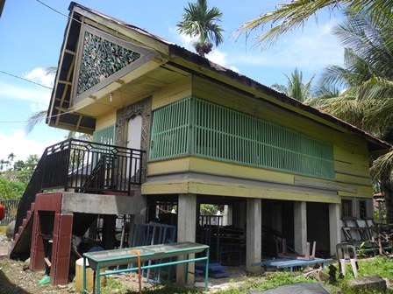 | 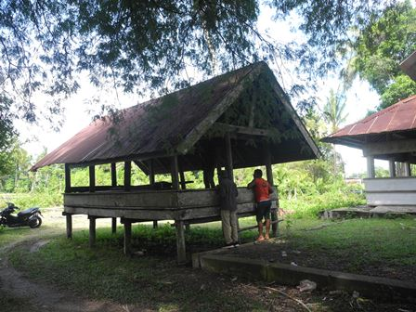 | 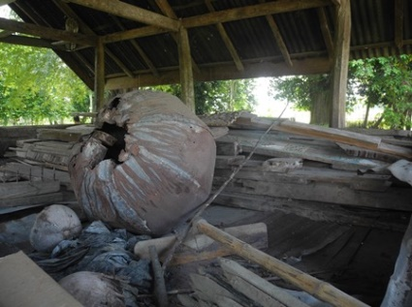
1 | 2 | 3
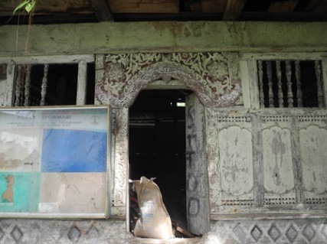 | 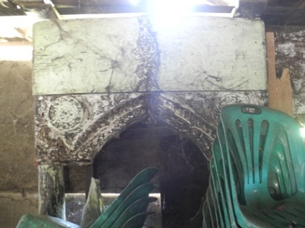 | 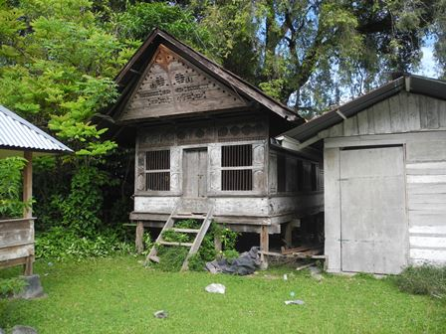
4 | 5 | 6
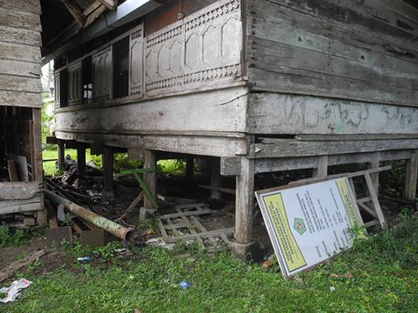 |  | 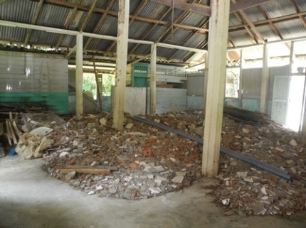
7 | 8 | 9
(Source: Researcher Data, 2022)

Description:

Figure 1. Meunasah Tuha Gampong Tidiek shows significant changes in the building structure. Wooden materials were replaced by concrete, and the stairs that used to use wood are now made of cement, ceramic and iron. Furthermore, the building has changed its function from a worship space to a warehouse, where village-owned items such as tents, tables, chairs and others are stored. Figure 2 and 3: The condition of the bale beut dayah teungku, which used to function as a place to learn the Quran, but has turned into a storage area. Unused items are piled up inside. Figure 4 and 5. Meunasah dayah teungku has changed its function to become a storage room. The stacks of chairs inside indicate that the prayer room has been converted into a storage room. Figure 6 and 7. Meunasah tuha gampong Pu Uk looks deserted, dirty and unkempt. Goods and rubbish are piled up at the bottom of the building, indicating that the worship space has lost its original function and does not get enough attention from the local community. Figures 8 and 9. Mosque tuha Kambuek gampong, showing a quiet atmosphere, has also changed its function and become a place for storing materials and rubbish.
The data in table 2 illustrates how the changing times, modernisation, and lack of maintenance have resulted in a change of function and poor condition of these historic classics.

4.3. Aceh classical worship spaces experience discredibility, their presence is not considered and they are replaced by new mosques that are considered more valuable.

In some parts of Aceh, classical Acehnese worship spaces, such as old mosques and meunasahs, can experience discredibility in line with the construction of new worship buildings. Acehnese classical worship spaces in the past that were respected and considered to have high spiritual value, now their presence is no longer considered valuable in society. The new mosque is considered more suitable as a place of worship to replace classical places of worship that actually have rich historical and cultural values. The discredibility of the mosque is seen when Aceh's classical worship buildings are no longer given their proper role. Classic Acehnese buildings full of history are replaced with new, more modern worship buildings. The phenomenon is a reflection of how valuable cultural heritage can be marginalised and forgotten in the changing values and needs of modern society. This tendency can be found in the fact that new mosques are built next to or alongside old mosques that no longer function. Others are built within the same village or region to replace old mosques that are no longer considered suitable for worship. The phenomenon of the discredibility of Aceh's classical worship spaces scattered in various places is examined in detail in the following section (Table 3).
Table 3. Aceh Classical Worship Spaces experience Discredibility.
Classical Worship Space | Modern worship space
 | 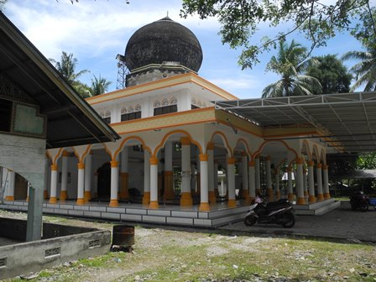
1 | 2
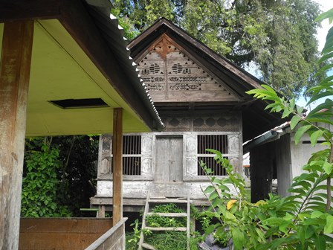 | 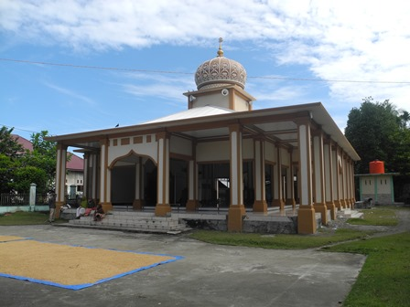
3 | 4
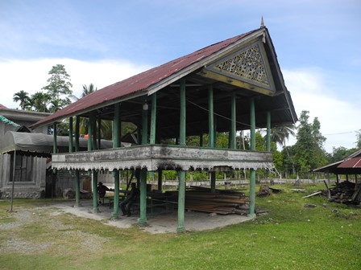 | 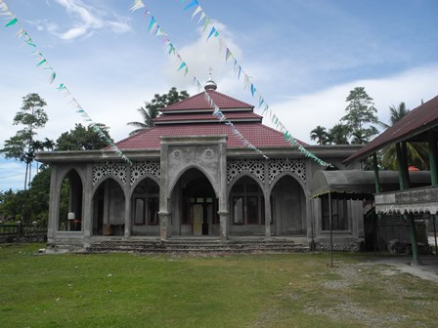
5 | 6
(Source: Researcher Data, 2022)

Description:

Figure 1. Overall perspective, the tuha gampong paloh kambuek mosque with its majestic classical Acehnese character.

The Tuha Mosque of Gampong Paloh Kambuek is a stunning architectural marvel in Aceh. This context is expressed through Acehnese cultural observers who state that:

"This classical mosque has a top pillar construction using wood material that forms a hexagon pattern and vertical and horizontal lines, this shows a strong symbolic meaning of the close relationship between humans and the Creator. this mosque is proof of the deep and valuable carving expertise in Aceh's cultural heritage" (KH, 35).

From the above statement, it can be seen that the interview reveals a classical mosque that features a wooden top-post construction, forming a pattern of hexagons and vertical-horizontal lines with a strong symbolic meaning of the relationship between man and the Creator. The design reflects the profound craftsmanship of carving, an integral part of Aceh's cultural heritage. By emphasising spiritual values and traditional art, the mosque is not only a place of worship, but also a tangible manifestation of a rich and proudly preserved cultural identity..

Figure 2. The Gampong Paloh Kambuek Mosque blends modern architectural design with traditional elements and contemporary touches..

The mosque in Gampong Paloh Kambuek is an example of modern architectural design that blends traditional elements with a contemporary twist. The building is dominated by the cement concrete structure that surrounds it. This context is expressed through Acehnese cultural experts who state that:

"The mosque is dominated by the cement concrete structure that surrounds it. At the top of the mosque is the moon and star symbol, which is an important icon in Islam. Loudspeakers are now installed in mosques. The main entrance of the mosque is equipped with a gate featuring a dome motif (TM. 50)..

From the above statement, it can be seen that the interview data provides a description of a mosque characterised by its enclosing cement concrete structure. The top of the mosque features a starry moon symbol, which is traditionally an important icon in Islam. The use of cement concrete and the starry moon symbol signify a blend of modern elements and religious symbolism. A modern touch is also seen in the installation of loudspeakers in the mosque, signalling an adaptation to technological developments for worship purposes. In addition, the main entrance of the mosque is equipped with a gate featuring a dome motif, giving the building an aesthetic touch and architectural beauty. Thus, the mosque reflects the harmonisation between traditional and modern elements in the context of architecture and worship equipment..

Gambar 3. Meunasah Tuha Gampong Pu Uk

Meunasah Tuha Gampong Pu Uk is a beautiful example of a classic Acehnese building that is both simple and alluring. This context is expressed through Acehnese cultural stakeholders who state that:

"The meunasah is surrounded with wooden materials, creating a natural and traditional feel. The walls of the meunasah are decorated with horizontally and vertically located dome motifs, The low entrance is a symbol of respect" (AJ, 35).

From the above statement, it can be seen that this interview describes the meunasah's characteristics, which are rich in traditional elements. The buildings around the meunasah neighbourhood are constructed with wooden materials, giving it a natural feel and creating a traditional atmosphere. The walls of the meunasah are decorated with horizontally and vertically arranged dome motifs, adding an artistic and aesthetic element to the building. The low entrance is not only a physical access point, but also a symbol of respect, signifying the values of courtesy and respect for places of worship. Overall, the meunasah creates an atmosphere that combines traditional authenticity with artistic beauty, demonstrating the rich cultural and spiritual values within the local community.

Figure 4. The new Mosque in Pu Uk village

The construction of the new mosque in Gampong Pu Uk is an embodiment of modern design in contrast to the more classical tuha mosque. This context is expressed through Acehnese culturalists who state that:

"The mosque has a main structure made of cement concrete, a shift from the wooden material used in Aceh's tuha mosque architecture. The top of the mosque has a star moon symbol, used as a religious icon, loudspeakers, The main entrance of the mosque is equipped with a gate featuring a dome motif. The mosque's construction features many columns as part of a modern building structure" (MZ. 40).

From the above statement, it can be seen that the interview describes the transformation of the mosque's architecture, from traditional wooden materials to cement concrete, reflecting adaptation to technological development. The mosque's pinnacle features a starry moon symbol as a religious icon that has been preserved in the modern design. The use of loudspeakers reflects the integration of modern technology in worship activities, while the entrance with a dome motif gate provides an artistic touch. The presence of many columns accentuates the structural characteristics of modern buildings, creating a unique identity that brings together traditional values and technological advances in mosque architecture.

Figure 5. Balee Beut Dayah Muara Indra Jaya.

The Balee Beut located in Dayah Muara Indra Jaya is an example of a classical Acehnese structure with wooden surrounds. This context is expressed through Acehnese culturalists who state that:

"One of the distinctive features of the bale beut is that the lower part is "grooved", giving the whole structure a special beauty. The lower part is designed as a place to relax and stay in touch, where people gather and interact socially" (MS, 33).

From the statements above, it can be seen that the interviews reveal that the bale beut is characterized by its "howling," which not only provides visual beauty, but also serves as a relaxing space and a place to stay in touch. This element not only has aesthetic value, but also acts as a social interaction center where the community can gather. The design of the bale beut not only prioritizes aesthetic aspects, but also takes into account social functions and cultural sustainability, making it a symbol of togetherness and social interaction within the community..

Figure 6. The new mosque of Dayah Muara Indra Jaya complex

The building of the new mosque in the Dayah Muara Indra Jaya complex is a manifestation of modern architecture that contrasts with the previous traditional buildings. This context is expressed through Acehnese culturalists who state that:

"New mosques now tend to opt for concrete and cement structures, replacing the wood often used in Acehnese traditional buildings. The top of the mosque has a star-moon symbol made of lightweight plate, showing modern features in its design. At the top of the gate, there is calligraphy with the words Allah and Muhammad, indicating Islamic elements" (II, 40).

From the above statements it can be seen that the interviews describe the change in construction materials in the new mosques, which have moved from traditional wood to concrete and cement, reflecting an adaptation to modern technology and a desire for sustainability. The top of the mosque features a moon and star symbol made from a lightweight plate, reflecting modern design features that remain linked to tradition. The use of lightweight materials and the symbol create a continuity between innovation and cultural heritage in the mosque's architecture. The Islamic calligraphy on the top of the gate shows the effort to maintain religious identity in modern design, confirming that Islamic values are still recognized despite changes in materials and design. As a result, these new mosques succeed in creating harmony between modernity, tradition, and religious identity in their architectural appearance..

Thus, the overall data and discussion of interview results in table 3 show a comparison between classical and modern houses of worship. Significant changes impact the establishment of new worship buildings as a substitute for the old house of worship.

