 |  | JOURNAL OF ISLAMIC ARCHITECTURE  P-ISSN: 2086-2636 E-ISSN: 2356-4644  Journal Home Page: http://ejournal.uin-malang.ac.id/index.php/JIA
OTTOMAN ARCHITECTURE: SPATIAL PLANNING AND IDEAL GEOMETRIC PROPORTIONS
(CASE STUDY: SULTAN BAYEZID II MOSQUE)
Naser Thabet Al-Mughrabi^{a*}
ªDepartment of Interior Design, Faculty of Architecture and Design, University of Petra, Amman, Jordan
*Corresponding Author: nalmughrabi@uop.edu.jo
ARTICLE INFO |  |  | ABSTRACT
Volume: 8  Issue: 4  Page: 983-997  Received: March 18th, 2024  Accepted: October 11th, 2024  Available Online: December 30th, 2025  DOI: 10.18860/jia.v8i4.26446 |  |  | One of the primary design tools Ottoman architects employed in the creation of their buildings and planning architectural spaces was geometric proportions. The Sultan Bayezid II Mosque in Istanbul, which was designed in a very distinctive geometric way but hasn't been thoroughly studied and discussed by researchers before, is a perfect example of how to apply geometric proportions. Thus, the primary objective of this study is to investigate the optimal geometric proportions that guided the construction of the mosque's plans and interior spaces. The architectural significance of the mosque in the history of Ottoman architecture is highlighted in this study, which employs a historical and analytical research method. After that, the architectural drawings were examined geometrically to demonstrate the proportions on which the mosque was constructed. The proportional shapes explored in the mosque's drawings confirmed that ideal geometric proportions were of great value in the minds of the engineers and architects who designed the mosque. The study's findings further support the mosque's architectural significance and geometric richness.  Keywords:  Ottoman Architecture; Spatial Planning; Ideal Geometric Proportions; Bayezid II Mosque

- INTRODUCTION
Geometry and architecture have been closely linked since the earliest civilizations. Architects use geometry when designing buildings for several reasons. They use geometry to measure dimensions and areas, to determine the spatial form of a building, to create forms considered harmonious, and to plan buildings and their surroundings according to mathematical, aesthetic, and sometimes religious principles [1].
Throughout its lengthy history, Ottoman Mosque architecture underwent multiple stages of development in terms of interior space planning (Figure 1), highlighting the significance of employing geometric proportions to enhance the expressive form of Ottoman Mosque architecture. These stages span from the early fourteenth century to the nineteenth century. Originally, the fundamental square or cubic spatial unit covered by a hemispherical dome served as the foundation for the Ottoman mosque's spatial organization. The 1335 construction of the Alaeddin Bey Mosque in Bursa serves as an illustration of this. To increase the mosque's interior area, architects erected one or more domed spatial units, which could have been added to the prayer hall's size or differed, as seen in the case of the 1395-built Yildirim Bayezid Mosque in Bursa. Architects used a geometric matrix of neighboring square-domed units that were open to each other lengthwise and transversely to create mosques with an enlarged horizontal interior area in order to build huge congregational mosques. The Great Mosque at Bursa, constructed in 1399 by Sultan Bayezid I, is the most notable example of this kind. Later, in the fifteenth century, the concept of integrated central spaces covered by huge memorial domes emerged, with the first example being the Uç Şerefli Mosque in Edirne, built by Sultan Murad II in 1447. This mosque was the first of its kind to feature this central spatial layout, a style that later inspired the construction of great mosques in Ottoman history, particularly those of the Sultanate [2]-[4].

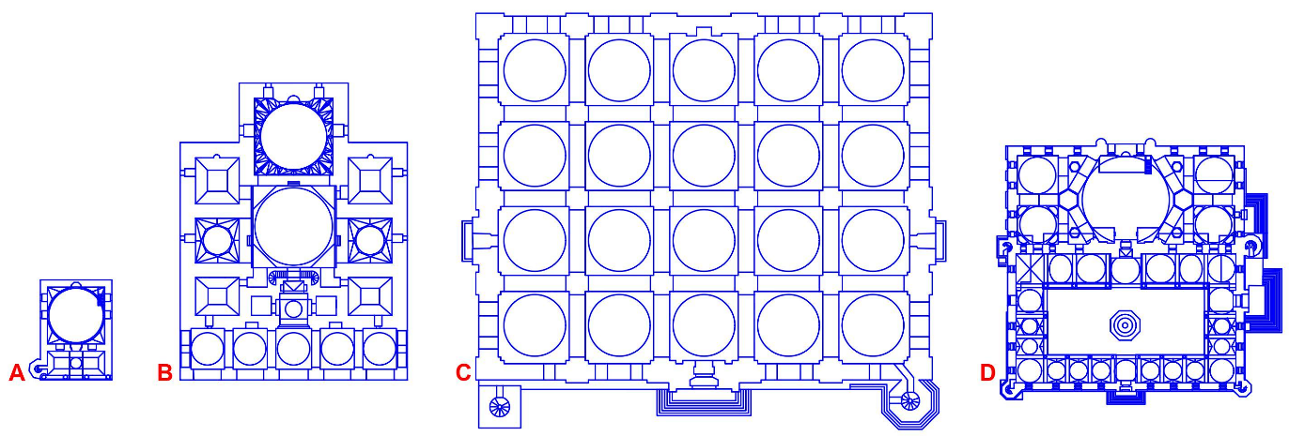
Figure 1. Stages of Spatial Development of the Ottoman Mosque, (a) Alaeddin Bey Mosque, (b) Yildirim Bayezid Mosque, (c) Bursa Grand Mosque, (d) Üç Şerefeli Mosque

The uniqueness of this research lies in its fresh perspectives on Ottoman architecture, which focus on a crucial element of architectural design — ideal geometric proportions — for a single project exclusively: the Bayezid II Mosque, rather than merely retelling or recounting events that have already occurred. The Bayezid II Mosque in Istanbul was one of the most prominent memorial buildings constructed by Ottoman architects at the beginning of the sixteenth century (Figure 2), featuring an architectural style characterized by clear geometric and constructional qualities, which constituted a unique model of architectural excellence and beauty. The mosque introduced distinctive architectural features and elements that had a significant impact on the design of Ottoman mosques, particularly the so-called classic Ottoman style of mosque architecture [5].
The motivation behind this study is the observation that, in contrast to other mosques and notable Ottoman architectural models, the Bayezid II Mosque has not gotten as much attention from scholars, despite its historical and architectural significance as a religious and social structure supported by Sultan Bayezid II, the Ottoman Sultan who ruled from 1481 to 1512. [6] Many historical narrative studies and research works also discuss Ottoman architecture; some of these studies are analytical in nature, but none of them have examined this mosque from the perspective of the ideal geometric analytical approach. The mosque features an innovative architectural plan that constitutes an important turning point in shaping the interior and exterior spaces of the Ottoman Mosque, characterized by a precise geometric arrangement and coordination. This makes studying and analyzing the mosque from a geometric perspective of utmost importance.
Although the mosques of architect Sinan have garnered much praise, scholars who constantly compare the mosques of Sinan and Hagia Sophia have not given enough credit to the Bayezid II Mosque, which is credited as the originator of Sinan's architectural style in terms of both horizontal and vertical plan design. Hence, the main objective of this research paper is to highlight the architectural and planning significance of the Bayezid II Mosque as an architectural model built at the beginning of the sixteenth century, which is considered the golden age of Ottoman architecture and its pioneer architect, Sinan [7], through the geometric analysis of the horizontal and vertical plans of the mosque. Another important objective of this research is to obtain results that clarify the type of geometric proportions used to form the spaces of the mosque, in particular, and to understand the role played by ideal geometric proportions in planning and designing the form of Ottoman architecture in general.
This study aims to address the researcher's issue, which centers on whether geometric shapes and proportions are indeed present in the Bayezid II Mosque and how to decipher the rationale behind their application in Ottoman architecture. In addition to elucidating the consequences of its application in Ottoman mosque interior space planning and architectural design.

- METHODS
The historical method is employed in conjunction with the descriptive-analytical approach as the primary research methodology in this applied study to track the historical progression of events in Ottoman architecture. The study was divided into two sections: a theoretical section that described the mosque's architecture and the background of its construction, and an applied section that examined the optimal geometric proportions of the drawings. Photographic documentation, architectural plans, geometric analyses performed with AutoCAD, references, library and web resources, and field research were all used in gathering the information.
In the theoretical part of this study, the architectural form and spatial construction methods of the Bayezid II Mosque were examined. The ideal geometric proportions of the different interior and exterior spaces of the mosque and the way they were arranged and their dimensions coordinated until the mosque took its rectangular shape extending longitudinally parallel to the qibla axis were addressed in the analysis section of this research paper, which basically expresses the spatial and architectural construction methods in the style of Ottoman architecture for hundreds of years after that. Finally, for further clarification, a table is used to display the geometric shapes and proportions explored through the plans of the Bayezid II Mosque, including the frequency of their appearance and the number of shapes they occur in.
The originality of this work lies in its approach, which aims to study the geometric architectural spaces of the Ottoman Mosque as individual basic shapes, such as a square, a circle, or a semi-circular rectangular shape, and also in their combined composition and placement within the final architectural context. Stylistically, it is noted that the various architectural trends in the Sultanate Mosques that appeared in the history of Ottoman architecture, from the beginning of the sixteenth century until the beginning of the twentieth century, adopted the geometric layout of the Sultan Bayezid II Mosque, even if the geometric proportions differed. This lends greater importance and scientific validity to this research and its methodology.
Building a large mosque bearing the name of the Sultan himself was the task assigned to Yakubşah ibn Islamşah, one of the most talented court architects during the reign of Sultan Bayezid II. Built between 1501 and 1506, the mosque was part of a vast architectural complex (Figure 2). On the summit of Istanbul's third hill, near the ruins of the Forum of Theodosius in ancient Constantinople, Sultan Bayezid II wished to build his beautiful mosque. Having been constructed between 1463 and 1470, the Fatih Mosque complex was the first significant imperial mosque complex to be completed in Istanbul following the conquest in 1453. (7) This mosque holds significant architectural value as it signifies the start of the most dense and productive classical era in Ottoman architecture, which extended for more than two centuries, the most prominent of which were the buildings of the sixteenth century. [8]

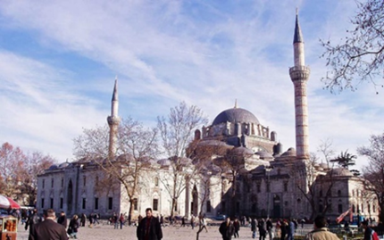

Figure 2. Bayezid II Mosque, Exterior [22]

The floor plan of the mosque is oriented along the northwest-southeast axis (Figure 3), consisting of two squares. There is a square-shaped marble courtyard in the northwest, with an area approximately equivalent to the square area of the prayer hall at the front of the building. The courtyard is encircled by four porticoes, including the main transverse porch, which has twenty-four domed bays held up by twenty columns. It features enormous entrance gates positioned centrally on three sides. The three domes over the three gates rise slightly from the others. A marble ablutions fountain in the center of the open courtyard is supported by eight marble columns and has a water feature inside that is sheltered by a massive lead-covered timber canopy. The mosque is a square with a side that is roughly forty meters long. Two half-domes support the dome in the middle, while two arches stretch along the secondary axis. The mosque was constructed entirely out of marble and colored stones that were carved to size. [9].
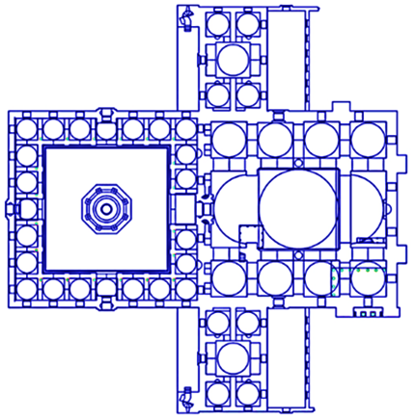
Figure 3. Bayezid II Mosque, Plan

The central dome of the mosque was constructed using a suspended construction style, featuring two semi-domes, columns, and wide arches on the sides, rather than load-bearing walls, which left the space below open on both sides. It was designed on a relatively modest scale, with a diameter of 17 metres and a height of 44 metres, compared to the dome of the Sultan Mehmed Mosque, which measured 26 metres in diameter. [10] The central inner courtyard, under the dome and the two semi-domes, retained its longitudinal meaning, although it included only one granite column between each of the two side pillars. Each side arcade is covered by four domes, each similar in size and shape within a regular and monotonous composition, giving each space a sense of separate form in contrast to the central space. Each dome is raised by four inverted triangles, which correspond exactly to the elevated form through which the central dome was raised to its traditional place at the high summit of the mosque.
Those who follow the history of the Sultan Mehmed Mosque, also known as the Fatih Mosque (Figure 4), will note that the original structure had only one half-dome above the mihrab in front of the prayer hall, and the wide central dome was subsequently built above it. The mosque was built in Istanbul between 1463 and 1470 and suffered severe damage in the 1766 earthquake, resulting in the loss of its original dome. As a result, as illustrated in the accompanying picture, the interior space of the prayer hall appears physically and aesthetically unbalanced, as though it had not yet been built [11].



Figure 4. The Fatih Mosque, Section

The interior space of the Bayezid II Mosque has become more balanced, and the exterior shape has matured, with the half-dome situated in the northern section of the prayer hall and the other half-dome positioned above the mihrab in front of the structure (figure 5). It is definitely the spatial structural solution that was inspired by the Hagia Sophia roof design, and the resemblance is too strong to overlook. The Bayezid II Mosque's central dome is supported by four large piers, unlike the Hagia Sophia. Additionally, the single-story side arcades that open widely into the central interior courtyard are not visually divided from the center area by columns. Because the fundamental concept is to create a sense of oneness in space, the side arcades in this mosque are separated by only two pillars, with a granite column positioned between them. [12].

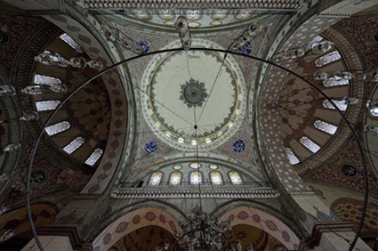

Figure 5. Bayezid II Mosque, Interior [22]

To the back of the prayer hall, flanking the northmost corners, two wings protrude outside the main building and cannot be separated from it, nor is the prayer hall accessible from them. The two minarets are located as far as possible from the central qibla axis, at the tips of the side buildings. The base of the minaret is square in plan. It rises to the level of the side wings' roof, and then the four walls of the minaret slope inward slightly so that the body of the minaret begins transcending up to the conical peak within a clear departure from the side elevations of the mosque. (Figures 2, 3)
The central hierarchical structural system, which Ottoman architects sought to achieve in the design of the prayer hall in many previous projects, was finally realized in the Bayezid II mosque (Figure 6). In this regard, Kuran highlights the scheme of the Bayezid II mosque: "The major dome rising at the center of a square structure whose outer walls encompass a bigger area than that covered by the central dome is the inevitable rational solution that the Ottoman architect was bound to reach. [13]. This is the truth about the architectural and geometric achievement of the Bayezid II Mosque, as it is the first Sultanate Mosque to feature a central pyramidal body with a completely square base, measuring four units in depth and width.



Figure 6. Bayezid II Mosque, Section

The old Ottoman mosques with a large scale were based on a domed ceiling, consisting of a series of domes, similar or dissimilar, placed on the same level. However, in the Bayezid II Mosque, a large, noticeable dome is located centrally, with different specifications from the rest of the roof domes. It sat alone at the top of the structure above the central square, marking the beginning of a distinctive model in the history of Ottoman Sultanate mosques.
The interior space of the Bayezid II mosque was constructed around the central square beneath the main dome (Figure 7). In the vertical image, the central spatial cube, bounded by the four piers on the ground level and four arches on the upper level, has become a distinctly vertical, elongated body, distinct from the surrounding spatial units on all sides. The upper part of the central cube, down from the drum of the central dome, is surrounded by two half-domes along the north-south axis of the mihrab, alternating with two perforated tympanums along the transverse axis of the dome, east-west. The purpose of this discrepancy between the half-dome and perforated tympanums is to emphasize the longitudinal body of the mosque parallel to the direction of the Mihrab axis. The main central dome and the two half-domes were raised on pendentives, and altogether constitute the central nave along the Mihrab direction. Four small domes are raised on pendentives, lined up on each side of the roof to cover the east and west side arcades.

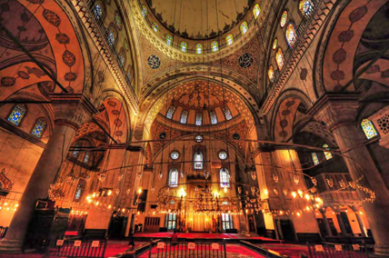

Figure 7. Bayezid II Mosque, Interior [22]

- RESULT AND DISCUSSION
In this analytical exploratory part of the research, we study and analyze the ideal geometric formations and proportions hidden in the drawings of the Bayezid II Mosque, as it is one of the most influential architectural landmarks in the history of Ottoman architecture. All the plans of the Sultanate mosques that were built in this classic architectural Ottoman style in the city of Istanbul were based on the plan of this mosque, with its two main parts, the open courtyard and prayer hall, the best example of which is the Şehzade Mosque, constructed in Istanbul in the years 1545 and 1548 by architect Sinan [14]. (Figure 8)

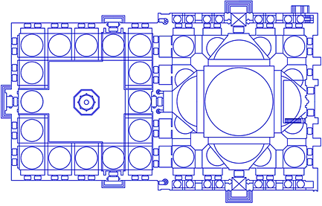

Figure 8. Şehzade Mosque, Plan

The geometric proportions on which the Bayezid II Mosque was built will be studied through several stages, based on the shape of the horizontal and vertical configurations of the interior and exterior spaces of the mosque. This is to identify the structural geometric arrangement that the architect adopted when designing the architectural form and interior space of the mosque. This is achieved through a series of sequential geometric chart analyses that examine the horizontal plan and vertical section of the Bayezid II Mosque, aiming to reveal the spatial planning method and the ideal geometric proportions employed in the mosque's architectural design. But before that, it is necessary to learn about the ideal geometric proportions through the following paragraph of the research.
The term "geometry" is generally accepted and well-known enough to be applied in any empirical, analytical research in the field of art or architecture. But the term "ideal geometry" in this paper was derived from the Author Simon Unwin. In his book "Analyzing Architecture," he mentioned this term to clarify certain characteristics of a group of pure proportion rectangles. According to Unwin: "Ideal geometry does not only include the circle and the square and their three-dimensional forms, the cube and the sphere. It also includes special proportions, such as the simple proportions of 1:2, 1:3, 2:3, or more complex proportions such as 1: √2, and that known as the Golden Section, which is about 1:1.618." [15]
In this research, ideal geometry is defined as the summary of proportional rectangular geometric shapes that can be extracted from the circle, square, and regular polygons, such as the square, pentagon, hexagon, and octagon. To illustrate, we use a research paper written by Keith Critchlow on unfolding rectangular shapes and their proportions. He explains how to form them through some exercises, which makes them easier to understand and use in design and architecture. Critchlow believes that ideal geometric ratios include the fixed proportions 1:3, 2:3, 3:5, and also include more dynamic proportions such as 1: √2, 1: √3, 1: √4, 1: √5, and that known as the Golden Section [16].

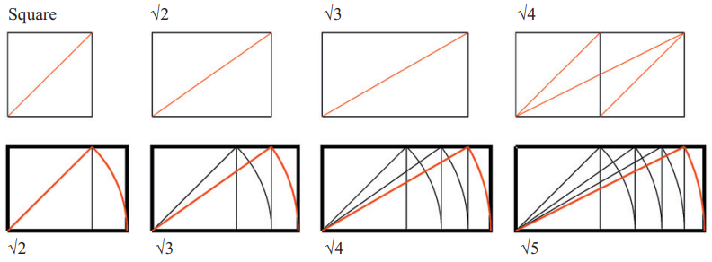

Figure 9. Ideal Proportional Rectangles Based on Square, (a) √2, (b) √3, (c) √4, (d) √5 [19]

Architectural historical studies indicate that Ottoman architects, like their predecessors among Muslim architects and designers, made good use of ideal geometric ratios in planning their buildings, especially mosques, and possessed the necessary skills to implement wonderful geometric applications in improving the shapes and plans of their buildings, and examples of this are many from Ottoman architecture [17]. In the next part of this study, we will test the quality of the proportional geometric compositions in the Bayezid II Mosque through a set of analytical drawings.

  - SKETCH I: GEOMETRIC ANALYSIS OF BAYEZID II MOSQUE, PLAN
As can be seen in Figure 10, the spatial composition of the mosque was designed according to five imaginary longitudinal axes that intersect with five transverse axes, producing the spatial distribution plan of the prayer hall in the Bayezid II Mosque (Figure 10). It is a geometric matrix consisting of sixteen square spatial units, four of which are longitudinal by four transverse. It is noted that half of the interior space of the prayer hall was geometrically positioned in the center of the design, forming a rectangular nave parallel to the qibla axis, under the central pyramidal roof, with the two opposing semi-domes topped by the central dome. The central square consisted of four combined squares under the central dome, surrounded by two squares mounted in the front and back under the semi-domes. The side arcades in the east and west became composed of four spatial units of identical size covered by hemispherical domes.

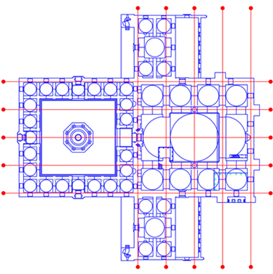

Figure 10. Geometric Analysis of Bayezid II Mosque, Plan
In fact, the axial lines pass through specific structural paths. They are composed of an integrated and sequential system of arches, columns, pillars, and walls that surround the prayer hall from four sides, supporting the domed ceiling. They suggest the strength of the regular construction and express the complementary relationship between structure and space in the mosque architecture. These intersecting lines also highlight the regular geometric rhythm of the internal space distribution while allowing the central rectangular space to gain dominance and clarity in comparison with the side spaces.
It is significant to note that the prayer hall's spatial distribution was more dynamic as a result of the rectangular nave running longitudinally beneath the central pyramidal formation, which is made up of an entirely integrated and open interior space, than it would have been if the plan had consisted of sixteen identically shaped and sized spatial units. The only areas that remained the same size and shape were the side arcades. The mosque's design is perfectly symmetrical, with eight squares on each side.

  - SKETCH II: GEOMETRIC ANALYSIS OF BAYEZID II MOSQUE, PLAN
In the following analysis chart, it is noted that the arches that support the domes in the roof of the mosque did not fully integrate with the overall geometric design of the prayer hall, because they were so deep and prominent that they formed structural partitions between the divisions of the interior spaces of the mosque, which made the mosque divided into nine geometric segments (figure 11), the central rectangular nave, surrounded by eight square spaces, four on each side that make the two side porticos. The space of the central rectangular nave, situated under the main dome and two half-domes, has become a dominant and distinctive interior space. It extends in width to the same size as the main dome and in length almost twice the distance. However, this rectangular central space is reminiscent of the plan of the Yildirim Bayezid Mosque, which was composed of a central rectangular space, also a component of the total of two squares: the prayer hall square and the central hall square (Figure 1). This arrangement style allows for the existence of a single dome in the middle of the design, flanked by two semi-domes instead of two contiguous Domes. The spaces of the side annex buildings surrounding the prayer hall remained almost independent of the interior space of the prayer hall, and were even accessible from outside the mosque.

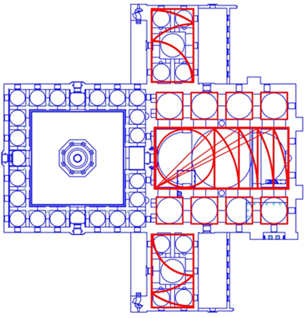

Figure 11. Geometric Analysis of Bayezid II Mosque, Plan

Based on the above, the geometric analysis of the plan of the Bayezid II Mosque shows that the combination of different spatial units under the domed covering system has not yet achieved an integrated, unified, and open spatial solution. Although the space of the central nave, in its rectangular form, was largely integrated, the side aisles appeared geometrically to be somewhat independent of the central space and of each other. The central nave has the proportion of a root five rectangle, and the side galleries consist of two side rows, each comprising four spatial units with a very basic geometric shape: a circle and a square. The side buildings attached to the side elevations of the mosque were designed in a way that is axially perpendicular to the longitudinal axis of the mihrab and within precise geometric proportions, so that each of them acquires the proportion of the rectangle root of three, as shown in Figure 11.
  - SKETCH III: GEOMETRIC ANALYSIS OF BAYEZID II MOSQUE, PLAN
The geometric analysis of the plan of the Bayezid II Mosque reveals that the mosque consists of two squares aligned along the longitudinal axis of the mihrab, the open courtyards, and the prayer hall (Figure 12). The open courtyard is composed of two diminishing squares; the central square defines the limits of the non-shaded area and is surrounded by the square of the domed arcades. The circumference of the circle that passes through the corners of the central square, through its intersection with the longitudinal and transverse axes, demarcates the centers of the sides of the exterior square of the open courtyard. The domed porticos are now confined between the two squares. The other square is the domed prayer hall, which also consists of two squares within a various spatial distribution. The exterior square contains the total area of the interior space, divided axially into sixteen spatial units of equal size, while the inner square represents the largest central spatial unit covered by the central dome, which is equivalent in size to four small units.

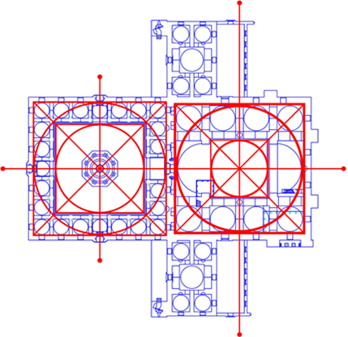

Figure 12. Geometric Analysis of Bayezid II Mosque, Plan

  - SKETCH IV: GEOMETRIC ANALYSIS OF BAYEZID II MOSQUE, PLAN
Despite the presence of annex buildings attached to the side elevations of Bayezid II Mosque, the rectangular shape extending longitudinally and parallel to the axis of the mihrab has acquired a very distinctive appearance with the presence of the prayer hall in the front of the building followed by the courtyard, this composition will become a model for the monumental Mosques that were built later in the city of Istanbul (figure 13). The geometric analysis of the outer boundaries of the rectangular building of the mosque reveals the proportion by which the large floor plan of the mosque was designed, which is the proportion of the root four rectangle, as shown in Figure 13.

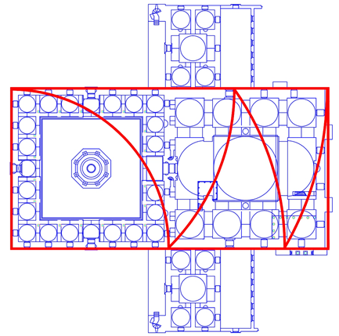

Figure 13. Geometric Analysis of Bayezid II Mosque, Plan
The rectangular composition, parallel to the axis of the mihrab, extending longitudinally, enhances the appearance of the side facades of the mosque, which are significantly higher than the level of the ceiling of the side annexes, and appear inconsistent with the architectural composition of the mosque.

  - SKETCH V: GEOMETRIC ANALYSIS OF BAYEZID II MOSQUE, PLAN
Geometric analysis shows that the general plan of the Bayezid II Mosque, which includes the central rectangle of the prayer hall with the open courtyard in addition to the buildings attached to the side elevations to the east and west, was designed within a very precise square frame as shown in the following figure, (figure 14) which also highlights a group of harmonious squares in the plan of the mosque, whether in the prayer hall, which contains a central square under the central dome surrounded by a larger square that includes the side aisles and half-domes, or the open courtyard, which has a square in the middle that is completely exposed to the sky surrounded by the square of the domed corridors on all four sides.

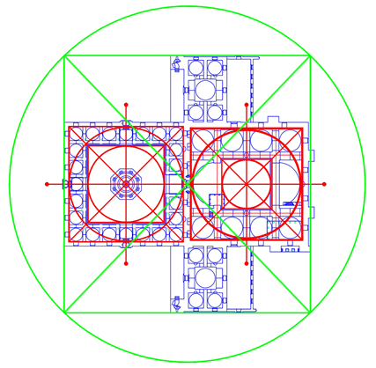

Figure 14. Geometric Analysis of Bayezid II Mosque, Plan

  - SKETCH VI: GEOMETRIC ANALYSIS OF BAYEZID II MOSQUE, SECTION
A collection of proportionate geometric shapes that defined the vertical dimension of the mosque's interior spaces is revealed by the geometric analysis of the vertical section of the Bayezid II Mosque (Figure 15). The most prominent of these shapes is the long, vertical rectangle that extends from the floor level of the prayer hall to the top of the central dome. It actually represents an ascending group of proportional rectangles surrounding the central cube of the prayer hall space. The first rectangle, extending from the floor level up to the cornice under the ring of the drum, acquired the proportion of a root two rectangle. The second rectangle, extending from the floor level up to the springing level of the dome arch, including the drum, acquired the proportion of a root three rectangle. The third rectangle, extending from the floor level up to the top of the dome, including the fully elongated central spatial cube, has acquired a very graceful proportion, the proportion of the root of five rectangles.

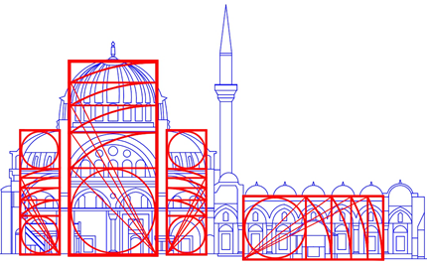

Figure 15. Geometric Analysis of Bayezid II Mosque, Section
The image above clearly demonstrates that the Bayezid II Mosque's main dome is structurally distinct from any other Ottoman hemispherical dome. This dome is composed of two sections: the upper hemispherical cover and the cylindrical drum, featuring tall windows and pillars. The architect's intention to elevate the mosque's summit to a level with the extremely lofty dome of Hagia Sophia could be the cause of this. The depth of the dome made it independent in its structural form and less integrated with the upper space of the prayer hall.
The spaces surrounding the central vertical cube, to the south and to the north, have acquired a very graceful dimension, which is composed of the proportion of a root five rectangle surmounted by a square equal to the size of the half-dome. The horizontal central space of the open courtyards also acquired the proportion of a root five rectangle, as shown in Figure 15.

  - SKETCH VII: GEOMETRIC ANALYSIS OF BAYEZID II MOSQUE, SECTION
The outside frame of the prayer hall body in front of the structure has taken on the fundamental square proportion, as can be seen from the geometric analysis of the Bayezid II Mosque's longitudinal section. The transverse portico and open courtyard feature a style that is horizontally extended and has complex rectangular proportions, comprising a square and a root two rectangle, which can be created by joining any two opposite sides of an octagon (Figure 16).

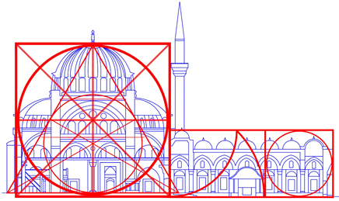

Figure 16. Geometric Analysis of Bayezid II Mosque, Section

The above figure highlights the significance of the equilateral triangle in the Bayezid II Mosque's section, which provided the mosque with its distinctive pyramidal construction that sets it apart from other previous mosques in Ottoman architectural history. The prayer hall's ground level lines up with the triangle's base, and its two opposing sides bend inward through the semi-domes to meet at the triangle's apex, which is the highest point on the central dome.

  - SKETCH VIII: GEOMETRIC ANALYSIS OF BAYEZID II MOSQUE, SECTION
A geometric examination of the longitudinal section of the Bayezid II Mosque is presented in the following figure, which also reveals the proportions that delineate the exterior bounds of the mosque's elongated side elevations, including the prayer hall and the courtyard. This side facade, which has taken on the shape of a root four rectangle that extends horizontally, is regarded as one of the most significant facades in the history of Ottoman mosque construction from the period before Architect Sinan.

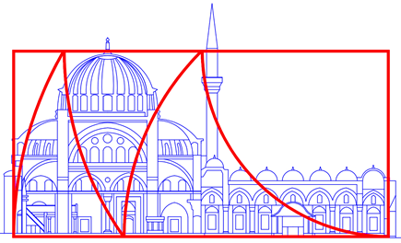

Figure 17. Geometric Analysis of Bayezid II Mosque, Section

- CONCLUSION
With its theoretical and applied components, this research study highlights the unique design of the Sultan Bayezid II Mosque and its historical significance, helping to shape Ottoman Mosque architecture and enhance the mosque's spatial planning, especially concerning the great memorial mosques attributed to the Ottoman sultans, which were further refined by renowned architect Sinan in the later stages of the sixteenth century [18]. The innovative and unprecedented architectural design of the Sultan Bayezid II Mosque in Istanbul appeared geometrically harmonious and architecturally consistent. This is due to the presence of a group of integrated architectural elements, especially the prominent central dome at the top of the building, which rests on two semi-domes and is surrounded by two regular rows of small domes, four on each side (Figure 2). Accordingly, this research came to explore the geometric design foundations upon which the architect Yakubşah designed the mosque’s horizontal and vertical plans.
Muslim architects are well recognized for their use of geometric proportions as a design tool, which aids in creating flawless architectural forms and layouts. Thus, it makes sense to conclude that Yakubşah, the architect, was already aware of the optimal geometric proportions examined in this study and incorporated into the plan and section of the Bayezid II Mosque before he began working on the project [19]. In other words, it is possible to conclude that ideal geometric proportions were a typical design tool that allowed the creation of a mosque building with regular and homogeneous interior and exterior spaces, centered around a long horizontal axis-the axis of the mihrab, and a central vertical axis-the axis of the dome.
For the Bayezid II Mosque, architect Yakubşah designed a distinctive architectural form with a powerful and strikingly expressive plan, aiming to standardize the central dome pattern in Ottoman Mosque construction. Thus, when creating the mosque, he sought to accomplish a variety of significant architectural objectives, such as a unique architectural form and expressive value. To achieve this, he positioned the prayer hall's largest dome ceiling in the center, above the mosque's pyramid-shaped roof [20]. It is also important to note that the domed structural system, free of columns and arches, in the design of the Bayezid II Mosque responded to the interior religious function of the mosque, such as the five daily prayers, where believers pray in straight, continuous rows, parallel to the qibla wall, and on Fridays they sit to listen to the religious sermon directly facing the preacher so that they are not separated from him by many structural elements. The prominent pyramidal roof in the middle of the prayer hall, featuring a large number of windows around the central dome, the semi-domes, and within the side arches, allows abundant natural light to enter the prayer hall during the day, addressing an old problem that large Ottoman mosques previously suffered from. [21].
In fact, the three factors combined geometric proportions, architectural expressive value, and interior religious function played a major role in designing the architecture of the Bayezid II Mosque and enhancing its spatial plan and domed pyramidal structure. Still, the architect's skill and intelligence enabled him to excel in creating this wonderful architectural composition, which had a profound impact on the history of Ottoman Mosque architecture from the beginning of the sixteenth century. However, the researcher believes that the architectural importance of the Sultan Bayezid II Mosque lies in the fact that it represents the pinnacle of geometric planning and design perfection in Ottoman architecture at the time, especially in the design of the Sultanate’s mosques in Istanbul before the era of architect Sinan. The geometric configuration of the mosque is characterized by two fundamental elements. The first is the elongated rectangular plan, parallel to the axis of the mihrab, which consists of two square areas: the prayer hall square at the front of the mosque, followed by the open courtyard square. The second is the pyramidal construction of the mosque’s roof at the front of the building, where the central hemispherical dome at the top of the pyramid protrudes above a magnificent cylinder composed of an interconnected series of windows and pillars, then rests on two semi-domes to cover the main central space of the prayer hall, which constitutes fifty percent of the interior area of the mosque.
The eight geometric analysis sketches that were reviewed and discussed during the applied section of this study confirm that the horizontal plan and the vertical section of the mosque were designed according to geometric principles and contain ideal proportional geometric shapes, as shown in the theoretical part of this study, which explains the characteristics of proportional geometric shapes and the method of their construction. (Figure 9). As can be seen from the analytical sketches, all the interior spatial units of the mosque acquired precise geometric proportions. Perhaps the most important of them is the main central space in the prayer hall, located under the dome and the two semi-domes in the floor plan, which has the proportion of a root five rectangle (Figures 11 and 15).
The principles of geometric design such as similarity, rhythm, balance, repetition, emphasis, harmony, etc., in employing the ideal proportions in the floor plan and vertical section have been remarkably evident in many of the analysis sketches in this study, especially the proportions of the three main central spaces of the mosque, the central rectangular space under the central dome and the two semi-domes, the sides of the vertical central cube that includes the area of ​​the dome and the space under it together, and the sides of the central open space in the open courtyard, all of which have acquired the rectangular proportion of the five-root rectangle, as shown in the following figure.

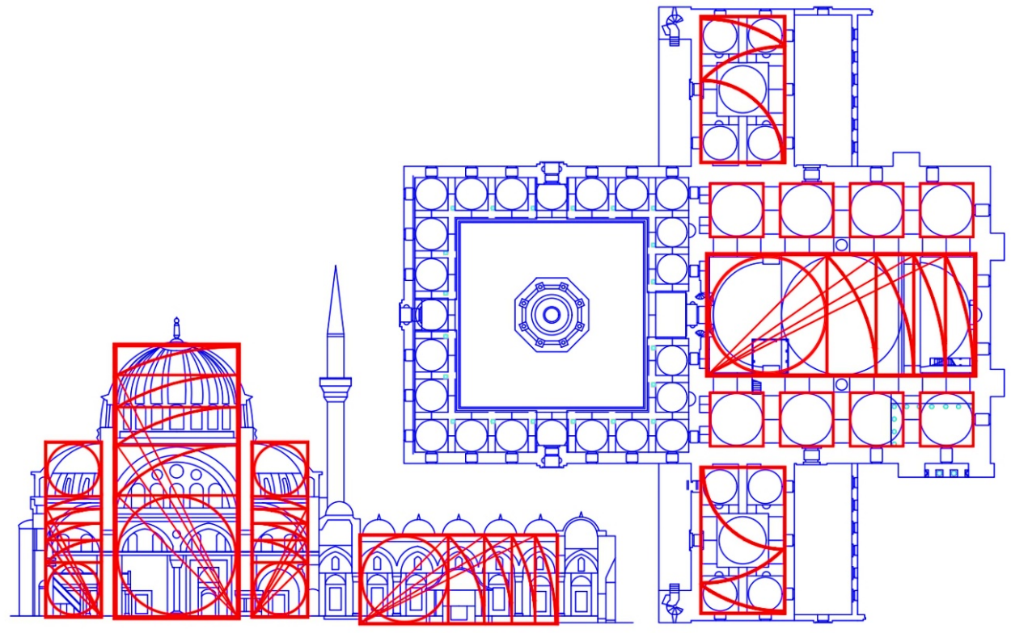

Figure 18. Geometric Analysis of Bayezid II Mosque, Plan and Section

In another place, the similarity and harmony in proportions became apparent, as the outer borders of the floor plan in the Bayezid II Mosque, without the side annex buildings, acquired the proportion of the root four rectangle, as shown in Figure 13, which is the same proportion that the outer borders of the vertical section acquired, as shown in Figure 17.
To draw more fundamental conclusions and follow up on geometric proportional design and planning approaches, the researcher presents the following analysis of the pattern table. Through this table, all the proportional geometric shapes that have been proven to be employed in designing the plans of the Sultan Bayezid Mosque and its architectural elevations are illuminated, in addition to the number of times they were repeated and the places in which they were employed. Therefore, design methods, geometric structure, repetitive proportions, and reproduction methods in constructing the interior and exterior spaces were examined and compared

Table 1. Analysis of Patterns

Ideal Geometric Shape | Application
Square   | - Spaces of the side corridors of the prayer hall (Figure 11)  - The central square space of the prayer hall (Figure 12)  - Prayer hall space (Figure 12)  - The space of the central square of the open courtyard (Figure 12)  - The open courtyard space (Figure 12)  - The general plan space of the building (Figure 14)  - The vertical space of the prayer hall (Figure 16)
Root Two Rectangle  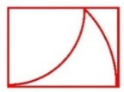 | - The vertical space of the central square of the prayer hall from floor level up to the base of the dome (Figure 15)
Root Three Rectangle  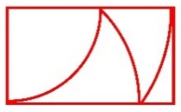 | - The exterior side attached buildings (Figure 11)  - The vertical space of the central square of the prayer hall from floor level up to the springing level of the dome arch, including the drum (Figure 15)
Root Four Rectangle  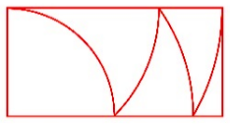 | - The outer boundaries of the mosque's rectangular plan (Figure 13)  - The external boundaries of the elongated side elevations of the mosque (Figure 17)
Root Five Rectangle  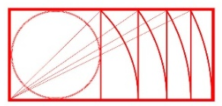 | - The space of the central rectangular nave, under the main dome and two half-domes (Figure 11)  - The vertical space of the central square of the prayer hall, from the floor level of the prayer hall up to the top of the dome (Figure 15)  - The side vertical spaces under the half-domes (Figure 15)  - The horizontal central space of the open courtyards (Figure 15)
Complex Proportion: Root Two and Square  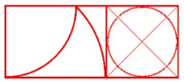 | - The outer boundaries of the open courtyard and the transverse portico (Figure 16)
Complex Proportion: Root Five and Square  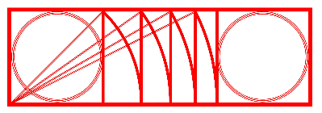 | - The side vertical spaces from the floor level of the prayer hall up to the top of the half-domes (Figure 15)

Based on the analytical drawings presented in this research, the design features of the Bayezid II Mosque demonstrate the advanced ability of architect Yaqub Shah to apply various geometric methods, benefiting from ideal geometric proportions in creating the architectural spaces of the mosque and coordinating their dimensions horizontally and vertically. The analytical sketches presented in the applied part of this study confirmed that the architect of the mosque adopted a group of proportional geometric shapes when he began developing the architectural plan of the mosque, including its shape and external elevations. This is based on several factors closely related to the project's nature and architectural significance, including its religious, functional, and expressive aspects.
This study presents an original approach to answering questions related to the use of ideal geometry and proportions in Islamic architecture, especially Ottoman architecture. Hence, this study came to highlight the design and geometric significance of the Bayezid II Mosque. Geometric applications can be utilized as an intelligent method for decorative treatments, and ideal geometric proportions can also be used as a rational tool for enhancing the form of architecture and planning interior spaces in a harmonious and distortion-free manner.

AUTHORS CONTRIBUTION
This research paper is the result of a single effort carried out by a researcher specializing in the history of Ottoman-Islamic architecture.
REFERENCES

[1] K. Williams, M.J. Ostwald, Architecture and Mathematics from Antiquity to the Future: Volume I: from Antiquity to the 1500s. Birkhäuser. 2015
[2] J. Freely, A History of Ottoman Architecture. London: WIT Press, 2011.
[3] N. T. A. Al-Mughrabi, M. A. B. AL-Karablieh, M.F. Hussein, & A. AL-Ayash, "Spatial Design Methods of Contemporary Mosques: Originality and Modernity". Design Engineering, pp. 1921-1939, 2021.
[4] H. M. Al-Qahtani, Principles of Islamic architecture and its contemporary transformations. Center for Arab Unity Studies. 2019.
[5] B. Sadan, I. Bal, & E. Smyrou, "STRUCTURAL ANALYSIS OF ISTANBUL BEYAZIT II MOSQUE RETROFITTED BY MIMAR SINAN", SHH’07: International Symposium on Studies on Historical Heritage, Antalya, Turkey, 2007.
[6] G. Ágoston, The Last Muslim Conquest: The Ottoman Empire and Its Wars in Europe. Princeton: Princeton University Press, 2023. Doi: 10.2307/j.ctv1b3qqdc.
[7] D. Kuban, Ottoman Architecture. Antique Collectors' Club, 2010.
[8] G. Goodwin, History of Ottoman Architecture. New York: Thames & Hudson. 1971.
[9] S. Yerasimos, Constantinople: Istanbul's Historical Heritage. Translated by S. M. Schreiber, U. Hoffman, E. Loeffler (English ed.). H.F.Ullmann. 2012.
[10] N. Almughrabi, J. Prijotomo, M. Faqih, "Suleymaniye mosque: space construction and technical challenges". International Journal of Education and Research, Vol. 3, No. 6, pp. 345-358, 2015.
[11] J. Freely, Istanbul : the imperial city. Internet Archive. London ; New York : Penguin Books. 1998
[12] R. C. Ostergren, M. Le Boss, The Europeans: A Geography of People, Culture, and Environment (2nd ed.). Guilford Press. 2011.
[13] A. Kuran, "The mosque in early Ottoman architecture", Publications of the Center for Middle Eastern Studies, Chicago: University of Chicago Press, 1968.
[14] N. Al-Mughrabi, "Historical Factors and Their Impact on The Formation of Architect Sinan’s Mosques", Jordanian Journal of Arts, Volume 15, Issue 4, pp. 775-794, 2022.
[15] S. Unwin, Analysing Architecture (3rd ed.). Routledge, 2009, Doi: https://doi.org/10.4324/9780203880906
[16] K. Critchlow, Proportional Rectangles, London: Kairos Press, 1995
[17] E. B. Ahmed, "Islamic Art and the Identity of the Architecture Fundamental Design". International Journal of Trend in Scientific Research and Development (IJTSRD), Volume 4, Issue 2, pp. 165-171, 2020.
[18] A. Erarslan, "Mimar Sinan Era Kulliyes in the Ottoman Urban Landscape". Belleten, Vol. 84, pp. 75-104. 2020. Doi: 10.37879/belleten.2020.75.
[19] L. Dabbour, "Geometric proportions: The underlying structure of design process for Islamic geometric patterns", Frontiers of Architectural Research, Vol. 1, pp. 380–391. 2012, Doi. 10.1016/j.foar.2012.08.005.
[20] R. Abraham, & G. Chandran, "Study of Dome structures with specific Focus on Monolithic and Geodesic Domes for Housing". International Journal of Emerging Technology and Advanced Engineering, Vol. 6, Issue 8, pp 173-182, 2016.
[21] N. Al-Mughrabi, "Employing Arabic Calligraphy in Islamic Interior Design: A Study Based on Selected Examples of Traditional and Contemporary Mosques", Al-Mishkat for Humanities & Social Studies. Vol. 10, No. 3, pp 543-578, 2023
[22] https://www.bosphorustour.com/

