 |  | JOURNAL OF ISLAMIC ARCHITECTURE  P-ISSN: 2086-2636 E-ISSN: 2356-4644  Journal Home Page: http://ejournal.uin-malang.ac.id/index.php/JIA
REDEFINE STREETSCAPE'S ROLE IN IMPROVING SUSTAINABLE TOURISM IN ARAB HERITAGE AREAS; OPEN MUSEUMS IN MUHARRAQ STREETS
Dalia Husain Eldardiry^{1*}
¹Department of Interior Design, College of Design, Imam Abdulrahman Bin Faisal University, Saudi Arabia
*Corresponding Author: deldardiry@iau.edu.sa
ARTICLE INFO |  |  | ABSTRACT
Volume: 9  Issue: 1  Page: 65-80  Received: March 22nd, 2024  Accepted: March 6th, 2025  Available Online: June 1th, 2026  DOI: https://doi.org/10.18860/jia.v9i1.26494 |  |  | Muharraq, the former capital of Bahrain, has many development projects in its heritage area that aim to balance culture sustainably. Variation in such projects will address the country's overall shortage of economic resources, particularly in the tourism industry. At the same time, there is a political desire in the Kingdom of Bahrain to make Muharraq a tourist city and seek to link commercial, artistic, and cultural development projects, creating various income sources. Consequently, the commercial streets in Muharraq can host tourism and cultural activities through the open museum concept, encouraging the tourism industry to connect with traditional handicrafts and handmade crafts. The main aim of the research is to address the topic of "the development of commercial streets in the heritage areas to be open museums" as a method to enhance Bahrain's identity and encourage the country's tourism industry. Consequently, this positively impacts the resilience and sustainability goals, which align with Bahrain's 2023 strategy and objectives. After a thorough literature review, the qualitative research method was used to achieve the research goal. In the old Muharraq, Sheik Issa Street was chosen as a case study. The research found that this concept will improve the city's cultural and heritage identity, encourage local handicrafts, especially embroidery and weaving for popular and traditional clothing with a good reputation nationally and internationally, and achieve economic development for the region in general and the city in particular.  Keywords:  Muharraq; streetscape; commercial streets; tourism

INTRODUCTION
Cities are like people. Their names, epithets, symbols, and activities are titles of their identities and means of drawing sources of their sustainable development. Most ancient areas in Bahrain have names, identities, and epithets they are proud of, and they use them to emphasize their identity. In that context, Bahrain has a rich heritage of traditional crafts and designs while embracing pearl activities, a vital part of the country's history [1]. Moreover, they work hard to create sustainable local development consistent with the comprehensive strategic plan for Bahrain 2023 [2].
On the other hand, Islamic cities have had a profound historical and cultural impact on urban patterns in Bahrain. Their exceptional morphology reflects Bahrain's morals, ideologies, and social structure. The study of Bahraini city morphologies has recently attracted interest in understanding the built environment and its connection to Bahraini cities' social, cultural, and religious practices [1].
Muharraq, the former capital of Bahrain, is known for its cultural and historical significance in the Arabian Gulf. It has many development projects that work hard to balance culture sustainably [3]. There is a political desire in the Kingdom of Bahrain to make Muharraq a tourist city that rivals towns with rich history and heritage in the Gulf. Demands began to move towards integrating cultural activities into its fabric, so the “Pearl Pass” Project was created through the Bahrain Authority for Culture and Antiquities (BACA)[4]. Other associations were formed concerned with the cultural dimension and sought to link the commercial, artistic, and cultural with the development projects and other attempts to make a cultural, touristic, artistic, and developmental activity a success, which would make the city of Muharraq distinguished by its own identity, such as festivals, seasons, and forums to revive its heritage identity and present it distinctly and making it an identity, especially for the cities of Bahrain and the rest of the Gulf cities [5]
One of the most crucial components of Muharraq city is its commercial streets, which range in scale and service area. From the beginning, these areas have served as hubs for trade, business, entertainment, and social interaction. It showcases the community's way of life, culture, and legacy, strengthening ties with the local populace [6]. Moreover, it includes many social organizations besides their economic duties, including mosques, religious schools, and religious circles in cities [7]. In addition, it includes serving as a social gathering place. These places have a distinctive vibe, and local vendors, shoppers, passersby, and people walking around go there often [8]. Their genius loci, or "collective spirit of place," makes them desirable stops for travelers and places to stay. They frequently serve as focal points for cultural heritage and historic preservation projects in rapidly growing communities [9].
The streetscape in the heritage area works in a balanced, sustainable way with culture. Variation in such streetscape projects will address the country's overall economic resource shortage, in general, and the tourism industry in particular. At the same time, there is a desire to use streetscape projects to link commercial, artistic, and cultural development initiatives and to create various income streams. Consequently, improving the streetscape of commercial streets in Muharraq can host tourism and cultural activities through the open museum concept, encouraging the tourism industry to engage with traditional handicrafts and handmade crafts. The main aim of the research is to address the topic "the development of streetscape of the commercial streets in the heritage areas to be open museums" as one method to enhance Bahrain's identity and encourage the country's tourist industry. Consequently, this positively impacts the resilience and sustainability goals, which match Bahrain's 2023 strategy and goals [10]. Figure 1 illustrates the structure of the research.

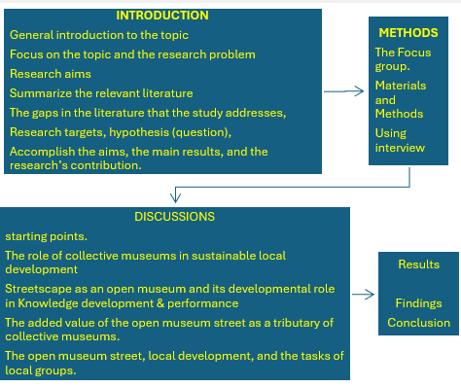

Figure 1. Structure of the research

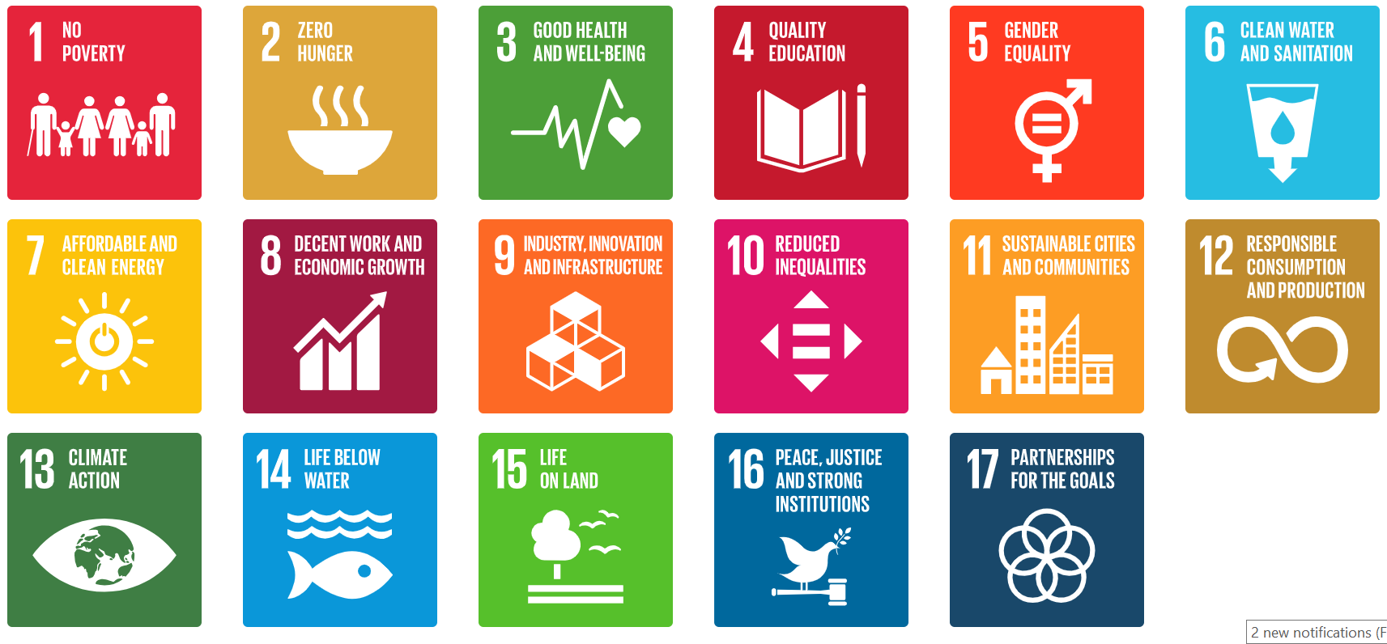

Figure 2. Sustainable Development Goals in Bahrain [11]

A significant point in this part is to specify sustainable, innovative streetscape projects for the commercial streets in Muharraq heritage areas to host open museums that can be accessed and meet all standards under study. The conceptual solutions must strengthen the functions of preventing and responding to natural and industrial disasters, including the ability to address the effects of climate change and align with the National Development Goals in Bahrain. It is vital to highlight aspects of the city's cultural and heritage identity, contribute to encouraging local handicrafts, and achieve economic development for the region in general and of the city in particular, in addition to promoting tourism and cultural activities, especially in the annual cultural season, when a large number of visitors from inside and outside Bahrain, whether from the Arabian Gulf or other countries, flock to the heritage area in the Muharraq city.

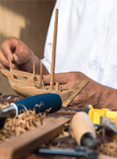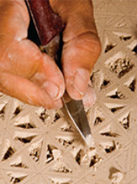
wooden work calligraphy inscriptions
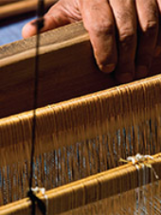
Pattern & Tissue handmade crafts

Figure 3. Famous heritage handcrafted and artisan-made in Muharraq

Therefore, the research hypothesis of transferring the commercial streets in the historical areas into an open museum using the design elements of the streetscape heritage character will perpetuate heritage memory by preserving the cultural projects located in the area, stimulating the area to become eligible for visiting tourists, creating lively streets with an artistic, heritage character, and placing different mobile service to serve the areas with the needed services. Moreover, there is an acute need to Suggest guidelines to connect spaces functionally to meet users' different needs and introduce solutions to show the site's identity and reflect the historical dimension in the streets using landscape architecture design elements (hardscape such as flooring materials, street furniture, sign designs, lighting and traffic issues, water elements ... etc and soft scape elements such as native greenery designs, native trees, palms, ground cover) [11] [12]. Similarly, the World Heritage Site recommends opening central spaces for daily visits. This space serves as a meeting point for groups and school classes (with the possibility of on-site explanations, lectures, or conferences). It may be the point of departure for all visitors and includes a film about the heritage site's history and its construction. Visitors will have a positive experience by effectively delivering information about the heritage site. A critical orientation and interpretation function allows visitor management [13]. For example, streetscape designs create spaces with statues that symbolize the past. Use updated old materials. Use ancient traditional architectural materials.
Targeting to fill the gap between theory and practicality, and based on the research hypothesis, the research methodology is divided into:
- The theoretical approach and literature review provide a foundation for understanding the relationship between the streetscape and the commercial environment, the tourism industry, and cultural and social habits in Bahrain's heritage area and the city's open museum. Moreover, they discuss the significant changes in commercial activities after the COVID-19 pandemic.
- The Qualitative Research Methods involved interviewing specialists in the tourism industry and decision-makers. Then, comprehensive focus groups from different consultants and specialists were prepared to discuss the overall outcome of the interviews and the conceptual realization of the revival to create the main commercial streets as open museums.

Understanding the role of the streetscape in introducing open museums in city open spaces, using the concept of participatory museum management through collective work, or what is known as the "open collective museum," will help define how the streetscape can be used to create an open museum. The following significant points should be highlighted when implementing this concept:
First, the starting points, intangible heritage (oral and a festival for folklore and local folk arts, such as a festival for the Malhoun Tarab to introduce traditional music, and also a folklore festival dedicated to children, such as an animation festival; a festival for theatre, a festival for Bahraini culture, a festival for reviving the heritage of local music and creative and listening arts; an educational film festival; a festival for short documentary films on local heritage. and contemporary). The desire to reach a city that combines culture, development, and tourism, thus consecrating its identity as linked to the town of Muharraq, can integrate the cultural heritage and global civilizational dimension.
Second, the role of collective museums in sustainable local development. The choice of the topic of this contribution falls within: "The role of using the street as an open museum (collective museums) in sustainable local development. Taking advantage of the design of street furnishings in a flexible way that accommodates regular commercial and cultural activities for touring, making it an open area capable of hosting various activities in the future, and making it a center of artistic, civilizational, and heritage radiation. The research poses the following question: "How can interest in Bahraini culture be a development pillar?" The answer to this question lies in the fact that development, without in-depth Analysis, global experience, and the use of historical monuments and museums, exists at the tourism entrances of Spain, Egypt, Greece, Italy, France, and others. For example, it constitutes an element of the influential role of culture in the local and even national development of those countries." It cannot be achieved for Bahrain's cultural and natural diversity if we consider the scarcity of quality museums, whether public or private. For example, if we only recall the number of private museums in France, which is more than 40,000 private museums, and at the same time recall the lack of collective museums, it is of utmost importance not only in preserving and introducing its cultural heritage but also in developing the performing knowledge of creative people in various fields, as well as in local development.
Third is the tangible heritage streetscape in the open museum and its developmental role. Within the framework of this intervention, we are concerned with how culture can serve as a pillar of development. How can "streetscape as an open collective museum," on the one hand, contribute to developing the performing knowledge of handicraft producers and, on the other hand, benefit from it for various other tourism, commercial, and other development activities? However, before answering these questions, we must note that, on the one hand, it should be noted that UNESCO, as an international authority, emphasizes the developmental function of museum activities, as its definition states that museums constitute a center for preservation, study, and reflection on heritage and culture; they can no longer remain isolated from the fundamental issues of our time. On the other hand, it is necessary to distinguish between what is meant by "collective museums" or "collective museums" or open museums and the various other recognized types of museums is that "Private museums" established and managed by private individuals; "Public museums" supervised by the Ministry of Culture or the National Museum Foundation; "Archeological museums"; "Ethnographic museums" "Art museums" such as: "Museum of Contemporary Art"; "Industrial museums"; "Eco-Museum"; "Museums of departments and ministries" supervised by ministerial sectors, such as "Museum of Water Civilization/Aman".
Fourth, it added value to the open museum street as a tributary of collective museums. The search for the added value of taking advantage of the streetscape as a suitable place, such as an open museum, in valuing heritage and investing it in development, makes us move towards finding an appropriate classification by classifying museums as follows: public museums (established by public institutions) and private museums (Musées). Private museums (established by private individuals or institutions) and collective museums (established by collective institutions such as rural or urban communities). Defining the use of the street as an open museum and then deducing it from the definition of "collective museum" (or "collective museums") is like a participatory museum among various parties brought together by a local productive activity. It is, therefore, like a collective museum project that aims, on the one hand, to preserve. It focuses on the collective memory associated with a collective activity. It seeks to link the cohesive relationship between the museum's function and the growth and development of the experiences and practices of those involved in that shared local collective activity to value the activity, integrate it into sustainable development, and ensure its continuity. It therefore represents a policy measure to value local heritage, link it to development, and view it through a cultural lens that connects local heritage to sustainable regional development. At the same time, it is connected to a rural or urban community or to a city, distinguishing it from other types of museums. It works to value the heritage in those spaces to create wealth that benefits all partners and targets.
How, for example, do artisans benefit from exhibits using the street in heritage areas as a collective museum? Through the availability of the open collective museum street, artisans can learn about the types and forms of what was produced by the pioneers before and learn about the developments of the techniques, experiences, practices, and creativity of those pioneers, and work to create better, more current, and more employable in sustainable development. On the other hand, visitors and tourists who visit these streets and collective museums will be able to purchase products from local craft activities associated with the collective museums open on the roads in the heritage areas. Thus, "those streets are a facilitating tool for marketing the sector's products, knowing that the most significant dilemma that the traditional crafts sectors suffer from, in particular, is ensuring means of marketing. When visitors to the collective museum look at the exhibits, they see how the product develops, grows, and develops its creativity. They go to marketing stores to purchase the product, thereby integrating the collective museum's function with the artisans' production. Both parties benefit, and local development benefits from that relationship as well. However, this mutual benefit and the desired sustainable development depend on positive cultural awareness. Silver, in general, and jewelry in particular, in the culture, is not only a material heritage but instead contains a rich and ancient symbolism, as well as an ancient cultural and civilizational heritage and a unique identity that neither the specialist nor the non-specialist is ignorant of and is touched by the citizen and the foreigner, especially when he can become aware of how to move from inherited local experiences and practices to renewed local experiences and practices. The open museum street should be based on an integration of administrative initiatives (involving various departments that ensure the preservation of the product, such as efforts to obtain the trademark and to integrate this heritage into sustainable development). What is my partnership (concluding partnerships with people with the same specializations nationally and internationally), And what is academic (accumulating research and studies on traditional handicraft products and the performing knowledge related to the sector in various fields of their use, with the aim of understanding, preserving and preserving this heritage, and realizing the value of traditional Yiddish craftsmanship and ornamental production, And realizing the antiquity of his methods and techniques, which are extremely precise and tightly organized throughout a long history.
Fifth is the open museum street, as local development and the tasks of local groups suppose the natural, architectural, historical, social, cultural, and artistic particularities of a region or a rural or urban community are the mission of "collective museums." In that case, one of the priorities that should be diagnosed and highlighted through the exhibits of these "collective museums" is correcting and marketing the actual image of everything local and locally specific because it will be a factor in attracting tourism and achieving sustainable regional development. This is because tourists are looking for local products, not materials from international markets, at low prices. Otherwise, he does not need to travel far to obtain materials from international markets at low prices, brought from all over the world to be displayed in front of his house or for supplies. With what he left behind from where he came from, the region deserves a "warrior's rest" after all its contributions to preserving the nation and ensuring a promising future of well-being, cultural security, and social peace for future generations. Thus, the management and protection of cultural identity and natural heritage are considered among the most critical components of local groups' work. This is not only for strengthening its resources but also for comprehensive, locally sustainable real estate development and for preserving heritage that subsequent generations will benefit from. It is also stipulated and called for by all international institutions concerned with the human rights of all generations, primarily cultural and environmental, as well as the upcoming "right to heritage ownership".

1.1 SPACE PERCEPTION AND SOCIAL SUSTAINABILITY
According to Norberg-Schulz [14], a feeling of place distinguishes a specific location from its external features. Knowledge, emotions, beliefs, and behaviors all contribute to the relationship between a person and their environment, especially when the target is to sense the heritage of space [14][15]. In heritage areas, urban spaces are vital hubs for developing and achieving social sustainability, as human behavior tends to occur in locations and sites that offer opportunities for relationships, which are more efficient, active, and interactive in commercial areas [16]. Socially sustainable streetscape design aims to design spaces that promote equity, inclusiveness, and social interaction. It includes creating environments that enhance community quality of life and support human health and well-being [16].
It is becoming increasingly clear that the built environment's social and cultural aspects must also be considered in sustainable design to ensure that improper architecture, streetscapes, and commercial spaces are created with people and communities in mind. According to George Evans (2023), creating environments that encourage social contact and connection is crucial to social sustainability in architecture and the streetscape, a challenge in heritage areas. This entails planning areas that promote gathering, mingling, and cooperation by creating opportunities for civic participation and involvement. Space is a qualitative phenomenon, according to Norberg-Schulz [14]. To him, architecture streetscape space represents the concretization of existential space. He thought that a person's experience includes their surroundings. Unlike objective assessments of the environment, he said, human cognition is wholly subjective when recognizing spaces as realities. According to him, the human reaction to space is poetic and analytical. Steven Holl stated that architecture can motivate people to live. Architecture's streetscape shapes our sensory impressions, making it more valuable than other forms of art.
Moreover, designing streetscapes is about aesthetics and other benefits, such as providing the necessary natural light, ventilation for the attached alleys on the main streets, and airflow that people need to feel refreshed and to reduce humidity. Another aspect that should be considered is the reshaping of Commercial streets Post-period COVID-19 pandemic. In the post-COVID-19 pandemic period, implementing the idea of transferring civic activities to open-air spaces is fundamental, especially for cultural, commercial, and tourism activities that attract significant users, which have been revised in the city [17]. Civic activities must navigate the impacts of COVID-19 and its variants, which are expected hazards that may occasionally appear in various forms [18] [19]. The idea of addressing street issues in historical areas and creating an open museum aligns with the World Health Organization (WHO) announcement. It should be considered a solid recommendation to rethink civic activities such as culture, trade, and tourism in open spaces rather than in closed environments. WHO recommended reviewing the design of such activities in open spaces to control the spread of various viruses [10] [20]. On the other hand, it is necessary to have spaces that respect the WHO notes [1] [21]. Moreover, the concept of replacing closed spaces, a hazard of virus transmission, and threatening trading activities, and the open commercial streets became a safe trading environment [2] [21].

1.2. STREETSCAPE SIGNIFICANCE IN FORMATTING THE TRADING ACTIVITIES
Woyo and Ukpabi wrote that the appropriate streetscape produced an intimate trading environment and provided open spaces with relaxation and different activities for users of various ages within a safe environment, offering breathing space between their significant components in commercial streets [17]
A recommendation for offering such breathing space between its significant components in commercial spaces[15]. Also, natural elements in the streetscape can provide open spaces for relaxation and various activities for adults and kids in a safe environment. It can significantly affect users' social behavior on the street, such as creating a path for people to walk along[3]. It also adds a dominant character to the area through the colors, textures, shapes, and street furniture, all of which depend on the designers' creativity. Therefore, the variation of the components in commercial streets can be supported by the flexibility of the streetscape elements [3].

METHODS
The research methodology is divided into:
- The Descriptive Analysis, based on the theoretical approach and literature review, provided a basis for understanding the relationship between the streetscape and the commercial environment, the tourism industry, and cultural and social habits in Bahrain's heritage area and the city's open museum. Moreover, they discuss the significant changes in commercial activities after the COVID-19 pandemic.
- The Qualitative Research Methods involved interviewing specialists in the tourism industry and decision-makers. Focus groups of consultants and specialists were convened to discuss the interviews' overall outcome and the conceptual realization of the revival to create the main commercial streets as open museums.

2.1. THE DESCRIPTIVE ANALYSIS
National Handmade and Traditional handicrafts in Muharraq are essential to intangible heritage and outstanding material investments. They assume each reproduction is exceptional and depends on social, geographical, environmental, and ecosystemic factors. Artistic institutions are shifting towards preserving handicrafts, safeguarding them from extinction, and recognizing them as elements of national heritage.

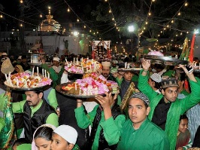

Figure 4: Traditional Festivals attract tourists.

Through the "Made in Bahrain" ambition, the Bahrain Authority for Culture and Antiquities reconsiders the visual and functional identity of Bahraini handmade outcomes as a cultural presentation that has stood the test of time and is thoughtful of national identity. The Objectives are to:
a. Establish a visual identity for the traditional crafts and creative industries.
b. Emphasize the significance of crafts and handmade outcomes as a part of the Bahraini identity.
c. Educate the audience on traditional crafts and their role in social/community growth.
d. Present facets of modernity and sustainability to the traditional handmade product and promote it nationally and internationally.
e. Deliver support to the traditional craftsmen and creative industry practitioners.
Therefore, introducing the open museum concept in the commercial streets of the heritage area of Muharraq will promote these national handicrafts and create a suitable trading environment. The open museum within commercial streets is a favorite in that. It will attract tourists to itineraries during their tour, which will include a level gallery showcasing traditional products such as handmade pottery. It can include the experience of fashioning on the spot in the heritage area, in addition to the stained-glass workshop, which designs windows for different types of buildings. It was reported that visitors to Bahrain liked the stained glass produced on the island and wanted to take back a sample. Small table lamps were created with colorful glass shades that tourists could more easily pack into things to take back home.

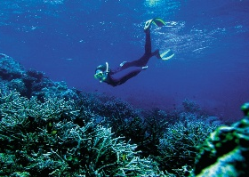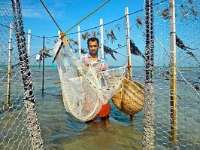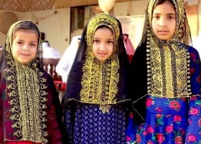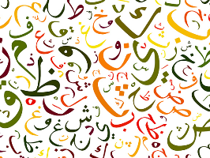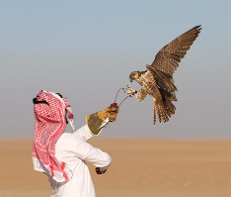
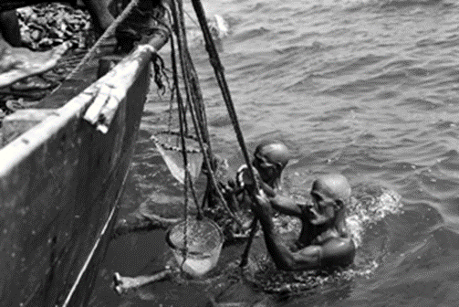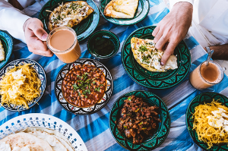

Figure 5. Traditional handicrafts, clothes, traditional tattoo (Hena), calligraphy, and artists' work

It should be noted that there are comprehensive government efforts to market the heritage areas in Muharraq. Conservation and preservation projects are significant in protecting heritage areas. These projects are used as magnets for planning and tourism activities. The Bahrain Culture and Antiquities Authority (BACA) implemented many conservation and restoration projects in Muharraq's heritage area, including Sh. Isa Commercial Street is the pilot study in this research. Users of these revitalization areas (tourists, residents, and visitors) expressed pleasure and enjoyment upon visiting their heritage treasures [4]. Accordingly, BACA initiated the Pearling Path Tour as one of the momentous projects in this field. Within this tour, visitors, while on their trips, will have to elucidate the fundamental information about the heritage of Bahrain, which aids them in collecting information about the area and enables visitors to acquire a sense of the environment of the heritage that is urgent to improve the image of the heritage part of the city [22]. Visitors of the pearling path through their movements in the streets will:
- Recognize the political, social, and economic factors of the building period in time and place.
- The history and occasions led to the realization of the heritage area.
- Having information about the occasions that took place chronologically, fleeing their impressions on the visitors [23].

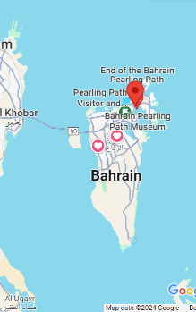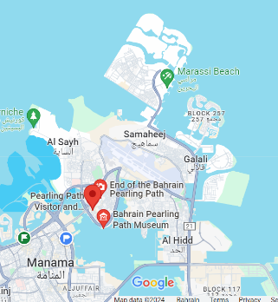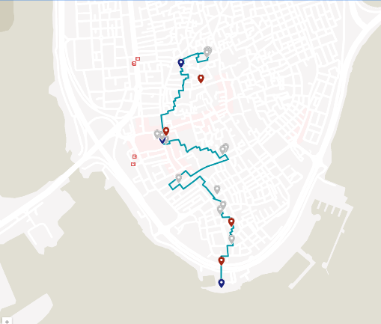

Figure 6: BACA's Pearling Path Map (Google, 2023)

2.2 THE ANALYTICAL STUDY FOR THE AREA'S "PROBLEM AND OBSTACLES":
The area's problem is that rapid urbanization has eroded Shaikh Isa Street's distinct identity, necessitating greater cohesion and visual appeal. The avenue is characterized by traffic congestion, poor pedestrian facilities, and a lack of architectural coherence. The area lacks a sense of place and fails to reflect Muharraq's cultural heritage. The Obstacles to creating an open museum on Sh. Isa Street are:
- The harsh outdoor environment (high temperatures and humidity).
- Integrating the streets' historical significance with modern design.
- Balancing modern development with preserving cultural heritage.
- Balancing the needs of different stakeholders (residents, businesses, commuters).
- Addressing traffic congestion and improving walkability.
- Create a distinct identity for Shaikh Isa Avenue that celebrates its cultural and historical significance.
- Improve the aesthetics and functionality of the road to enhance the pedestrian experience.
- Find an appropriate place to accommodate traditional handicrafts that attract visitors to the music.
- Integrate culture and social activities within the street.

The Environmental challenges of using streetscapes as open museums in Bahrain stem from the harsh climate (high temperatures and humidity) and the fact that commercial activities are confined to shopping malls. Nowadays, designing an appropriate streetscape in the commercial areas of the heritage area of Muharraq requires significant effort to achieve the desired relaxed, comfortable environment [7].
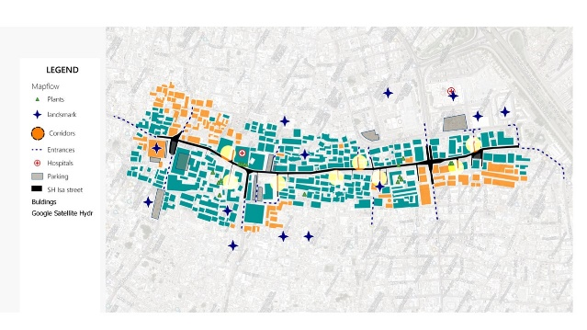

Figure 7. Sh. Isa Street base map, use QGIS prepared by the researcher's assistant group.

Time: 12:11 PM  Date: MAR. 24, 2024  Azi / Alt: -164.49° / 64.17° | Time: 4:58 AM  Date: MAR. 24, 2024  Azi / Alt: -94.05° / 10.98°
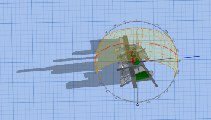 | 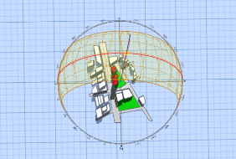
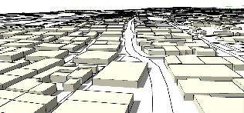 | 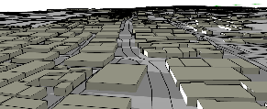

Figure 8. Sun path in the study area (prepared by the researcher's assistant group)

Therefore, using the appropriate streetscape within the commercial streets is a privilege. Discussion on the significance of proper streetscape design, with emphasis on environmental aspects and glare conditions that cause adverse visual impacts. While designing the display areas in commercial streets, an appropriate streetscape design reduces glare within the spaces. Besides, it is necessary to secure a required level of air circulation [8].

2.3 THE QUALITATIVE ANALYSIS
The data was collected using two methods. The first is the case study method for Sh. Isa Street, and the second is the focus group and interview methods. The case study selected Muharraq, Bahrain, to examine renewal projects. The cases highlight problems arising from the organic development of urban renewal projects. The chosen case studies examined stakeholders' relationships with the project's success or failure. The thematic Analysis was performed with themes inspired by the AIA guidelines: stakeholder collaboration, level of participation, and framing perspective, as discussed in the literature review. Researchers' observations and visuals were used to analyze the case studies. However, the expert focus group interview method parallels the cases studied. For the expert focus group interview, six participants with expertise in various urban renewal projects were selected. Below is the chart showing expert participants and their fields. Therefore, the researchers conducted a focus group to understand the study area better and collect data to inform a solution.

2.3.1 The Focus group
The participants highlighted problems with creating an open museum within the context of the commercial streets and the possibility of using it in city development. The discussion was about possibly including different types of products that attract local and regional tourists. Tangible and nontangible activities include artistic work, pottery, and handcrafting products. Places suitable for poetry, national songs, and folklore were proposed for inclusion, as they attract tourists and encourage social interaction. They urged architects to champion community participation and steer discussions regarding social activities and product alternatives. Community service may be provided even under more traditional crafts [9]. Some failed practices may be traced back to differences in players' identities, conflicts within organizations, and differing perspectives within the institutional structure[24]. Their divergent points of view, also referred to as frames, will be referred to as framing perspectives in this research, since this phrase suggests that the interests and beliefs of the actors shape their viewpoints [25]. As the key ingredient for understanding the nature and development of trading processes, framing views dictate how stakeholders perceive situations and form connections with other stakeholders [26]. Thus, the last objective of this research is to investigate the framing perspective with collaborative open museums within commercial street projects in a sustainable and resilient manner. Categories that can help shed light on the proposed open museum inside the commercial streets' context in the heritage areas as follows:
- The "identity frames" or how the participants (consultants) recommend their vision for including the identity elements in the areas
- The "characterization frames" or how the participants describe others.
- The "conflict management frames" or how the organizers manage social events and tourism festivals within the context, and the preferred plans to be addressed [27].
The "views of nature frames" or how beliefs about preserving nature are described. A collaborative solution may be possible if the stakeholders can identify and build new shared frameworks for the challenges and solutions [28]. As a result, there are three primary considerations when framing anything.
The first step is defining the issues at hand, such as the characteristics of implementing the open museum at Sh. Isa Street and how it could operate involve converting traditional events and festivals into concrete problems that the political system must solve.
Second, framing is an interactive process in which consultants, specialists, experts, and actors construct their own action scripts by responding to the choices made by other players in the tourism field; through this, issue setting is connected to problem-solving, allowing a jump from making sense of the current situation to what has to be done about it.
Third, the framing process reconceptualizes the arrangements for street activities. It affects patterns of benefit-sharing and modalities of engagement and communication by claiming the players' identities in a tourism environment.

2.3.2 Articles and interviews
Newspaper articles and interviews provided the necessary data and information for the study. Semi-structured interviews were conducted with an expert focus group in the field to learn more about how collaboration between the tourism specialists and the urban designer's project leaders contributed to the project's development and rollout. The focus group interview session was conducted following proper procedures to record the findings. The researcher also served as the moderator, responsible for ensuring the questions were asked and directing them to each participant while documenting the discussion digitally. Local officials, local government executives, and representatives from metropolitan tourism project organizations were interviewed to provide a broad perspective on collaborative planning for implementing the open museum in the commercial streets in the old Muharraq area. Several points were validated via interviews, including the impact of participation, the partnership between the government, BACA, and the locals, and the strategy used throughout the process.

RESULTS AND DISCUSSION

3.1 RESULT
According to participants in the conducted focus groups (P1, P3, P4, P6, and P7), there is a need for more current stakeholder participation practices and for professional coordination among all departments regarding heritage urban projects in Bahrain. The future image of commercial streets in heritage areas should aim to attract tourists and encourage local artisans to display their goods, creating multiple sources of income for residents. According to participants P4, P5, P9, and P10, there is a need for more current stakeholder participation practices and for professional coordination among all departments regarding heritage urban projects in Bahrain.

Table 1. The expert focus group interview data
No. | Participant | Participant fields
1 | P1 | Tourist consultant
2 | P2 | Senior Architect
3 | P3 | BACA (ex employer) speicales in conservation projects
4 | P4 | Member of engineering council (CRPEP)
5 | P5 | Senior Urban palnner
6 | P6 | Member of urban planning authority s
7 | P7 | Senior Landscape Architect
8 | P8 | Contractor
9 | P9 | Resident engineer
10 | P10 | Senior Civil engineer

According to participants P1, P2, P3, P4, P7, and P9, the future image of the commercial streets in the heritage areas should focus on attracting tourists and encouraging local artisans to display their goods in these streets, thereby creating multiple sources of income for residents. One adds that there might be a need for more communication or understanding regarding the implementation stage, especially when dealing with tourism activities, as this particular stakeholder has to know the site's values, and, on the other hand, in the selection criteria, a professional contractor who knows the site's values should have priority, not only the low price of the tender. On the other hand, participants explain stakeholder incorporation to implement the open museum idea from the user's perspective.
Moreover, if consultants can take the opinions of community representatives, it might help them build a strong background for the project. Ultimately, it will be a solid factor in enhancing, implementing, and operating the project, as there will be no failure. Similarly, most participants emphasize the importance of end users (traders, sellers, buyers, residents, tourists, service providers) and highlight them as essential stakeholders, incorporating them because the streetscape in such projects aims to facilitate their use (e.g., open museums, kiosks, shops, etc.). Another adds the importance of communication, which must be enhanced to achieve efficient commercial and tourism practices. Participants P1, P2, P3, P4, P6, P7, and P8 are experts who focus on technologies and ideas that can enhance professional practice, while P9 and P10 focus on communication and leadership workshops [29][25].
Regarding the interview, the first interview with Mr. A. H. A. B, a researcher and consultant in culture, presented the point of view that if we limit ourselves to assessing the feasibility of the added value of the cultural dimension. We investigated the phenomenon of festivals in the city of Muharraq and noticed that, compared to other cities, it can accommodate activities. With national heritage through the work of film festivals, a festival for tangible heritage (traditional crafts) and others related to women's fashion and handicraft products, a festival for the art of cooking Bahraini food, an exhibition of various agricultural products in Bahrain, manufacturing by recycling agricultural waste, an engagement festival/group marriage, a horse festival and exhibition, and an exhibition of dates.
According to the second interview with the expert Mr. H A. N (The Council for Regulating the Practice of Engineering Professions (CRPEP), he emphasized that each stakeholder must participate and provide insight into the project at every stage, specifically, the transition to host handcraft and artisanal products. He added that, during such a transition from regular commercial streets to open museum projects in Bahrain, there should be appropriate stakeholder participation in a respectful, structured manner. Moreover, such projects provide stakeholders with complete freedom to participate in decision-making regardless of their level, in line with the resilience and sustainability vision. He highlighted that such a project has a different nature and, depending on its nature, allows residents, workers, artists, artisans, and stakeholders to participate in decision-making. He added that the municipality would be concerned about modifying and adapting the regulations to reflect the project's unique vision and how to achieve it, not about the project in hand but about the general heritage area in Muharraq. Each stakeholder plays a role within their area of interest, and the project is in the investor's interest. Few participants agree that equal participation among stakeholders is needed. Moreover, the successful experience at Bab Al Bahrain in Manama was mentioned as well. For the third interview with Prof I E G, a staff member in the landscape architecture field, he ensured that innovative technology was used while developing the street. Moreover, he mentioned using both in the street to sell crafts and handmade products. He noted the Azrbegan experience in BACO when they designed part of Nizami Street.
The street's history dates back to Baku in 1864. It runs from the city's downtown west to east. It starts from Abdulla Shaig Street, in the mountainous territory of the town, and ends at a railroad bed on Sabit Orujov Street. An important part was dedicated to walkability and a traffic-free segment, redirecting traffic away from the heritage area. It begins at Fountains Square and ends at Rashid Behbudov Street. They used hardscape elements in a traditional theme, and he mentioned the experience of Isteqlal Square and Taksim Street in Istanbul, Turkey, when they used eco-friendly local transportation to bring tourists to the heritage area. Moreover, they create a walkable street for users with limited time, serving different types of whales in the area.
Furthermore, he mentioned the Egyptian experience in Khedive Cairo, which was the heart of Cairo during the Khedive Ismail period, extending from the Qasr al-Nil Bridge to the Ataba area. During Khedive Ismail's visit to Paris in 1867, Haussmann planned Khedive Cairo and transformed it into a cultural masterpiece, rivaling the most beautiful cities in the world. Western writers called it "the Paris of the East." The heritage area, lighting, and the general layout of Talaat Harb Square, Mostafa Kamel Square, and Qasr El Nil Street were developed and rehabilitated.

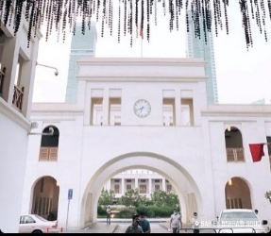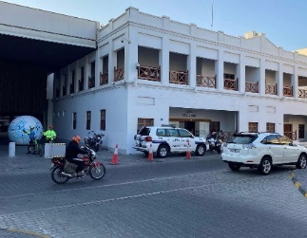

Old Manama, Bab Al Bahrain commercial area.

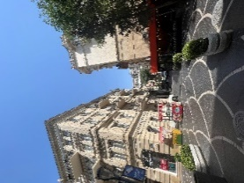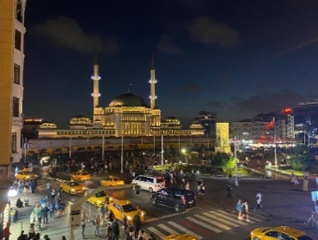

Nizami Street, Baco, Azrbegan Isteqlal Square, Istanbul, Turkia

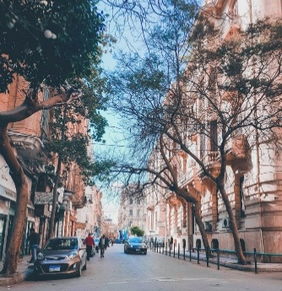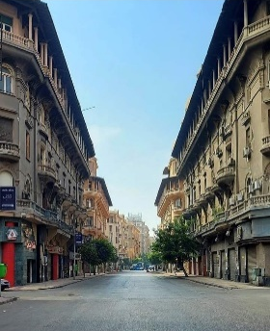

Heritage area, Alexandria, the Khedive, Cairo, Egypt

Figure 9. Open museums in commercial spaces to show the heritage of the nations.

The project's goal was to raise the efficiency of heritage buildings to preserve its wealth of distinctive buildings, especially after the government departments moved to the New Administrative Capital, and increase the functional efficiency of spaces (squares and streets) by using distinctive elements to furnish the site in a way that takes into account the architectural character and historical context of Historic Cairo. The works include removing visual distortions, unifying the colors of facades, lighting works, flooring works, benches, indicative and advertising signs, landscaping, garbage cans, and creating bicycle paths and paths for people of determination, considering pedestrian movement.

3.2 DISCUSSION
Muharraq has been known for decades for its rich history of commercial activities and trade at various levels. It is the nest of all the deep-rooted history anchored in Muharraq. Unfortunately, due to various circumstances, most of Muharraq's urban context suffered from the decay of trade and social interaction. Retail and shopping in old areas of Muharraq for a long time significantly bonded the social and economic vitality of Bahrainis and non-Bahrainis. Moreover, the evolution of commercial architectural form and function over time depends on the population's commercial, political, and cultural lives [4].
After analyzing the streetscape conditions in Sh. Isa Street in the Muharraq heritage areas, it is vital to specify that sustainability should be a priority when considering the concept of having Sh. Isa Street is an open museum with innovative ideas for trading, crafting zones, art galleries, and commercial streets to host integrating open museum network in these areas. This open museum network should be accessed comprehensively and meet all attraction development standards, which will be a reliable, scalable, secure, flexible, and adaptable ICT infrastructure to:
- Improving the quality of life for citizens in these areas after a long period of neglecting them.
- Ensuring tangible economic growth, such as raising living standards, providing citizens with job opportunities, and improving handicrafts, artisanal, and traditional handmade works.
- Attracting tourists, which creates a source of income for Bahrain at different levels.
- Improving citizens' aspirations, including medical care, freedom, physical safety, and education.
- Develop environmentally responsible and sustainable approaches that meet today's needs without sacrificing future generations' needs.
- Developing physical services such as transportation (mobility), water, utilities (energy), communications, and manufacturing sectors [3].
Regarding accessibility, adequate, controlled access at the entrance and exit is established to reduce misuse on-site, and alternative solutions are being studied to improve the situation. Accessibility criteria include the following: - Design suitable access gate panels. - Decide on the primary and secondary access gates. - Identify technical solutions to reduce the visual impact of the access gates on the heritage sites [13].
Moreover, facilities and Commercial Activities: Different types of facilities should be available at the heritage site, including staff facilities and equipment, as well as tourist facilities. The staff and equipment facilities that should be available, such as services and vehicles that facilitate staff movement within the site. The tourist facilities are defined based on an estimate of the maximum number of visitors per day. Services such as restaurants, cafés, WCs with baby-changing rooms, gift shops, first-aid shops, and boutiques should be provided [13].
In addition, the criteria for Facilities and Commercial Activities in Streetscape state that facilities serving tourists should be integrated into the heritage areas without negatively affecting them. - Gift shops for tourists should have local handmade products. - Accessible toilets with an automatic door opener. - Appropriate lighting and acoustics. - Audio guide and free orientation leaflet. - Seating is at the drop-off-pickup area and throughout the site. - Wheelchairs are available for disabled and older adults [13].
Moreover, planning the street as an open museum will involve understanding public participation in participatory museum work between multiple sects or collectives inspired by the concept of the "collective museum." As explained earlier, it will occur by implementing the following significant points.
- Starting points
- The role of collective museums in sustainable local development
- Streetscape as an open museum and its developmental role in Knowledge development and performance
- The added value of the open museum street as a tributary of collective museums
- Open Museum Street, local development, and the tasks of local groups
Therefore, it is essential to consider the tourism industry as one of the world's most important industries and a significant source of income. Tourism demands can positively impact local communities and the environment if properly developed and managed. The development process in the heritage areas is essential to maintaining heritage sites. The ideas for improving heritage tourism should be out-of-the-box. Street conditions are critical for enhancing the heritage performance of the old parts of the cities. The main purpose of this paper is to utilize street networks in heritage areas by improving streetscapes to be more sustainable, thereby positively impacting their socio-economic and environmental conditions. The method used to address this research is descriptive, followed by the deductive method, which first states the design key consideration of the development process. This paper's results present a conceptual framework for improving the Development Process of Heritage Sites.
The idea of redefining the streetscape's role in improving sustainable tourism in Arab heritage areas, in general, and in Muharraq streets as a case study, has become a demand for developing and enhancing commercial streets in heritage areas via the concept of producing open museums.
From another perspective, respecting the sustainability pillars and their main objectives is vital. Therefore, the idea of redefining the streetscape will achieve sustainability in terms of:
- Economically, in the same context, it is a chance to look for various economic resources for the country in addition to reviving traditional commercial activities. Moreover, reviving traditional handmade and heritage products is a must-issue that has several influences on the transformation of architecture. It will meet one of the Bahrain 2023 strategic plans.
- Socially, it will improve the residents' sense of belonging and identity and attract social interaction via different trading activities within the open museum.
- Environmentally, it will improve the physical environment and encourage the residents to improve the green areas using native plants in such streets.
Based on the focus group, a straightforward recommendation is to build cooperation among the organizers of the open museum's activities, such as BACA or the Bahrain Chamber of Commerce & Industry (BCCI), to support crafters from urban contexts, who are stakeholders in this concept.
Moreover, the actions and outcomes of the take are influenced by the range of powers and interests held by the many tourism and urban designer stakeholders. Stakeholders in urban development may work together more effectively if their authority to overcome obstacles is made clear [29]. Addressing these gaps, this research emphasizes the significance of the following:
a. Identify stakeholders in the tourism and urban design process.
b. Establish the importance of tourism and urban designer stakeholder collaboration for sustainable urban development.
c. Employ qualitative methods to clarify the complex interaction between stakeholders and the collaboration barrier. It may include tangible and intangible traditional activities and festivals in various forms and at different levels to attract tourists and encourage social and economic activities. For example, traditional food and conventional handicraft products, etc.
The use of appropriate landscape architecture elements, both hardscape and softscape, emphasizes the area's heritage dimension to achieve the main goal of the research. The research findings are that using the streetscape to create an open museum in commercial streets through an engaging approach that embraces the city's living heritage and emerging traditional elements with modern amenities, and offers a vibrant space where residents and tourists can immerse themselves in the city's cultural traditions by hosting annual and monthly events that take place on the street.

CONCLUSION
The research concludes that the appropriate open museum on the commercial streets should reflect Bahrain's unique identity and serve as a model for sustainable development in the region. It should also incorporate design principles and practices while infusing the essence of Bahraini traditions, customs, and architectural styles. Introducing the Sh. Isa Street project, as an open collective museum, is essential to address this topic and to invest in the diverse heritage components in Muharraq and the natural and cultural diversity that our country enjoys, while addressing the lack of collective museums and taking advantage of the streets in the historical area.
Operating civic activities in heritage areas requires a different vision that integrates tourism, culture, and commercial activities. The research concluded that using the theme of an open museum in the design of commercial streets would reshape the city's architecture. The study sought to answer the following question: What are the changing shapes of commercial spaces that host open museums where we are willing to live and work now?
Among the many things that will be different in the post-COVID-19 world are the spaces in which we live, work, socialize, shop, study, and seek shopping. Many visible additions and modifications are already taking place. The pandemic has taught us that while famous commercial streets have always been the most engaging and crowded, sharing can be possible under strict social distancing measures. As these norms of personal space evolve, public spaces become more flexible regarding physical engagement. Future architecture projects are already exploring dispersing people across larger areas and creating diverse, parallel journeys. The open museums, which have become a demand, offer an opportunity to explore various economic resources for the country and to revive traditional commercial activities. Moreover, reviving traditional handmade and heritage products is a must-issue that has several influences on the transformation of architecture. Table 1 summarizes the major goals and applied criteria to be considered for the open museum.

Table 1. Goals and criteria consideration for the open museum

Consideration | Goals | Features/Criteria
- Accessibility | Creating adequate controlled accessibility at the entrance and exit to reduce vandalism on site and study alternative solutions to improve the situation. | Deciding the primary and secondary access gates, designing suitable access gate panels, and identifying technical solutions to reduce the visual impact of the access gates on heritage sites.
- Walkability | Reduce the need and desire for cars, prioritize pedestrians, and add recreational activities that suit visitors of all ages. | This creates a sustainable, healthy, and resilient community and ensures accessibility for all, including people with disabilities, through universal design features.
- Tourism information | Guiding the tourists with informative elements without being intrusive. | Informative elements should also be available at the site, such as information panels, information materials, documents, flyers, site maps, postcards, posters, videos, CD-ROMs, etc. Official guidebooks should be available in print format.
- Facilities and commercial activities | Define the service needs (toilets, cafeteria, First Aid, etc.). -Creation of services and facilities such as restaurants, café, WCs, visitor's centers, gift shops, first aid, shops, boutiques, etc. - Foresee a meeting point for groups | Tourist facilities should be integrated. Tourist gift shops should feature local handmade products. There should be accessible disabled toilets with automatic door openers, as well as accessible staff toilets. Wheelchairs for people with disabilities and the elderly should be available. Appropriate lighting and acoustics should be provided. There should be a visitor's center.
- Infrastructure | Installing infrastructure | Transportation - Energy distribution systems. - Networks (water, sanitation, electricity, gas, telecommunications, etc.).
- Visitor circulation | Develop an easily navigated visitor routing by defining the start point and making it visible to tourists. This route should account for the climatic conditions throughout the year at the historic site. | -The visitors' route should be easily visible. - The climatic conditions throughout the year should be taken into consideration. - A motorized route is needed for long-distance walks. - Pedestrian paths that enable easy mobility.

REFERENCES

[1] M. A. Kamal, T. R. Warsi, and O. Nasir, "ISLAMIC PRINCIPLES AS A DESIGN FRAMEWORK FOR URBAN SYSTEM: ENVIRONMENTAL CONCERN AND SUSTAINABLE DEVELOPMENT," Journal of Islamic Architecture, vol. 7, no. 4, pp. 699–712, Dec. 2023, doi: 10.18860/jia.v7i4.21187.
[2] L. Frank, "STREETSCAPE DESIGN: PERCEPTIONS OF GOOD DESIGN AND DETERMINANTS OF SOCIAL INTERACTION," Waterloo, Ontario, Canada: University of Waterloo, 2010.
[3] Z. SHAFIK and M.-A. EL-HUSSEINY, "Re-visiting the Park: Reviving the 'Cultural Park for Children' in Sayyeda Zeinab in the shadows of Social Sustainability," Journal of Contemporary Urban Affairs, vol. 3, no. 2, pp. 84–94, Dec. 2019, doi: 10.25034/ijcua.2018.4704.
[4] A. Kittana and A. Abu-baker, "EXPLORING THE INTRICATE ARCHITECTURAL FABRIC OF A HISTORIC ARAB MEDINA: A STUDY OF NABLUS OLD TOWN," Journal of Islamic Architecture, vol. 7, no. 4, pp. 584–594, Dec. 2023, doi: 10.18860/jia.v7i4.23310.
[5] S. Dwidar, H. Sirror, and A. Derbali, "PRESERVING AND SUSTAINING THE ENVIRONMENTAL IDENTITY OF ISLAMIC RESIDENTIAL BUILDINGS IN THE HEJAZ REGION IN KSA," Journal of Islamic Architecture, vol. 7, no. 4, pp. 736–743, Dec. 2023, doi: 10.18860/jia.v7i4.21795.
[6] J. Milder, “Sustainable City Form,” vol. 2, M. Jenks and C. Jones, Eds., Dordrecht: Springer Netherlands, 2012. doi: 10.1007/978-1-4020-8647-2.
[7] H. A. Nia and Y. H. Suleiman, "Aesthetics of Space Organization: Lessons from Traditional European Cities," Journal of Contemporary Urban Affairs, vol. 2, no. 1, pp. 66–75, Jun. 2018, doi: 10.25034/ijcua.2018.3659.
[8] R. Tiarasari and W. Kartidjo, "Assesment of Pedestrian Walkability in the Urban Village with Urban Nework Analysis," in IOP Conference Series: Earth and Environmental Science, IOP Publishing Ltd, Apr. 2021. doi: 10.1088/1755-1315/738/1/012065.
[9] R. Rahbarianyazd, "Sustainability in Historic Urban Environments: Effect of gentrification in the process of sustainable urban revitalization," Journal of Contemporary Urban Affairs, vol. 1, no. 1, pp. 1–9, Jun. 2017, doi: 10.25034/1761.1(1)1-9.
[10] A. Alabbasi, "Pathways to Sustainable Economic Growth in Bahrain," MANAMA, KINGDOM OF BAHRAIN, Oct. 2018.
[11] M. I. Faqihuddin and A. Y. Firmansyah, "URBAN STREET CONCEPT BASED ON QURAN PERSPECTIVE: THE MOST COMPREHENSIVE SOLUTION TO STREET PROBLEMS," Journal of Islamic Architecture, vol. 7, no. 4, pp. 549–550, 2023, doi: 10.18860/jia.v7i4.17905.
[12] I. H. El-Ghonaimy, "Street Furniture Influence in Revitalizing the Bahraini Identity," Journal of Contemporary Urban Affairs, vol. 4, no. 1, pp. 11–20, Jun. 2020, doi: 10.25034/ijcua.2020.v4n1-2.
[13] A. El-Menchawy, A. Abulnour, and S. A. Shahine, "IMPROVING THE DEVELOPMENT PROCESS OF HERITAGE SITES," Journal of Al-Azhar University Engineering Sector, vol. 11, no. 41, pp. 1378-1390, 2016. DOI: 10.21608/auej.2016.19332.
[14] E. Champion, "Norberg-Schulz: Culture, Presence and a Sense of Virtual Place," in The Phenomenology of Real and Virtual Places, vol. 1, Routledge, 2018.
[15] D. H. Eldardiry and U. Konbr, "Using Phenomenological Theory for Sustainable Renovation of Historical Open Spaces in Bahrain," International Journal of Sustainable Development and Planning, vol. 17, no. 2, pp. 559–568, Apr. 2022, doi: 10.18280/ijsdp.170221.
[16] M. Lotayef, Y. A. Elkader, A. Amin, A. Taher, E. El-Kest, and M. Abdelall, "A Prospective Study of the Effect of Different Palliative Radiotherapy Fractionation Schedules on Tumor Response and Toxicity in Advanced Non-Small Cell Lung Cancer (NSCLC) Patients," J Cancer Ther, vol. 07, no. 12, pp. 924–938, 2016, doi: 10.4236/jct.2016.712090.
[17] J. L. Stienmetz, B. Ferrer-Rosell, D. Massimo, “Information and Communication Technologies in Tourism 2022”. Proceedings of the ENTER 2022 eTourism Conference, Springer International Publishing, 2022. doi: 10.1007/978-3-030-94751-4.
[18] I. El Ghonaimy and A. Habbab, "Sustainability and the recycle of the portable shipping containers in offering health care services in COVID 19 circumstances," in 2020 2nd International Sustainability and Resilience Conference: Technology and Innovation in Building Designs, Institute of Electrical and Electronics Engineers Inc., Nov. 2020. doi: 10.1109/IEEECONF51154.2020.9319984.
[19] D. A. Janahi, Z. Abdulsaheb, and I. Elghonaimy, "The use of attractive lights to encourage the public of using the outdoor areas to control the spreading of COVID 19," in 3rd Smart Cities Symposium (SCS 2020), Manama: IEEE, Sep. 2020. doi: 10.1049/icp.2021.0969.
[20] D. H. Eldardiry, "The Restoration of the Cities' Water Waterfront after the COVID-19 Pandemic, Case of Al Khobar City, Saudi Arabia," Sustainability (Switzerland), vol. 14, no. 22, Nov. 2022, doi: 10.3390/su142214775.
[21] M. Z. Abidi, and Q. Irshad, "Impact of Covid-19 on Architecture Profession," SHODH SANCHAR BULLETIN, vol. 10, no. 39, pp. 214-223, 2020.
[22] T. T. Y. Alabdullah, A. J. M. Al-Qallaf, "The Impact of Ethical Leadership on Firm Performance in Bahrain: Organizational Culture as a Mediator", vol. 2, no. 4, pp. 482–498, 2023. DOI: https://doi.org/10.55047/cashflow.v2i4.736.
[23] K. A. C. Greswell, Studies in Islamic art and architecture in honour of Professor, vol. 1. Oxford University Press, 1966. DOI: https://doi.org/10.1163/157005866X00598.
[24] G. Alkhenaizi, "Exploring Architectural Implications on Social Sustainability," Thesis, University Digital Conservancy, Minnesota, 2018. Accessed: Jul. 12, 2024. [Online]. Available: https://hdl.handle.net/11299/195381
[25] R. D. Benford and D. A. Snow, “Framing Processes and Social Movements: An Overview and Assessment,” Annu Rev Sociol, vol. 26, no. 1, pp. 611–639, Aug. 2000, DOI: 10.1146/annurev.soc.26.1.611.
[26] S. Kaufman, M. Elliott, D. Shmuelli, Frames, Framing and Reframing, 1st ed., vol. 1. 2013. Accessed: Jul. 12, 2024. [Online]. Available: https://www.beyondintractability.org/essay/framing
[27] G. Lindholm, "Land and landscape; linking use, experience and property development in urban areas," Land (Basel), vol. 8, no. 9, Sep. 2019, doi: 10.3390/land8090137.
[28] D. Follador, F. Tremblay-Racicot, F. Duarte, and M. Carrier, "Collaborative Governance in Urban Planning: Patterns of Interaction in Curitiba and Montreal," J Urban Plan Dev, vol. 147, no. 1, Mar. 2021, doi: 10.1061/(ASCE)UP.1943-5444.0000642.
[29] T. Gunton, "The theory and practice of collaborative planning in resource and environmental management." Environment, vol. 31, no. 2, pp. 5-19, 2003.

