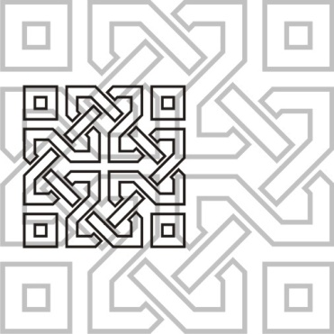 | JOURNAL OF ISLAMIC ARCHITECTURE  P-ISSN: 2086-2636 E-ISSN: 2356-4644  Journal Home Page: http://ejournal.uin-malang.ac.id/index.php/JIA
FIRST ISLAMIC BUILDINGS IN PRIZREN – ARCHITECTURAL ELEMENTS

| Received May 16th 2016 | Accepted June 17th 2016 | Available online June 30th 2016 |
| DOI http://dx.doi.org/10.18860/jia.v4i1.3466 |

Sedat Kryeziu, Phd*  Freelance in History/Cultural Heritage  Prizren, Kosovo  Qendrim Hoxha (Phd candidate)  University “St. Kliment Ohridski”  Bitola, North Macedonia  *Corresponding author:  sedatkryeziu2014@gmail.com |  | ABSTRACT  The first Islamic buildings in Prizren (Kosovo) are related to the conquest and establishment of the Ottoman administration in Kosovo; the conquest that began in the last quarter of the 14th century ended in 1455. This period marked a turning point in the history of Kosovo's architecture. The Ottomans brought their culture and architectural traditions to a country with Christian traditions. Mosques, public baths (hammams), madrassas, bridges, bazaars, caravanserais, etc. were built. This paper elaborates on the first Ottoman constructions in Prizren of the classical architectural style and, respectively, the unique Ottoman architectural and historical elements. The arguments that originate from this paper prove that the first Ottoman buildings in Kosovo carry authentic Ottoman values, and cities have begun to take oriental views. The new values were later interwoven with the local culture, and thus a distinct oriental style was created. In addition to the analysis of the synthesis, the comparative method was also used in the drafting of this paper, using the relevant literature.  KEYWORDS:  Architecture, mosque, ottoman, Kosovo, monuments, etc.

INTRODUCTION
The conquest and establishment of the Ottoman administration in Kosovo began in the last quarter of the 14th century and ended circa 1455 with the conquest of Prizren [1]. Ottoman rule in Kosovo lasted until the first decade of the 20th century. During this period, which covered almost five centuries, the Ottomans built in Kosovo a considerable number of architectural objects of sacral or profane types of utilitarian, public, and individual character, such as monumental mosques, tombs, tekkes, public baths (hammams), caravanserais, inns, bazaars, clock towers, residential houses, etc[2].
When we talk about Ottoman art in general, we think of the great achievements that were presented in the big cities of the empire: Bursa, Edirne, and Istanbul. Monuments in other provinces, including the Balkans, reflect the artistic context of a specific country or city. These changes were the result of the temporal and spatial context in which Ottoman art evolved. The Ottoman architectural heritage, created relatively far from the artistic centres of the Empire, often possesses more or less precious features of the local architectural tradition. In the provinces where the local tradition was weak, the Ottoman heritage displayed a greater, more robust purity in artistic expressions.[3] Therefore, in the Ottoman imperial provinces inhabited by Albanians, the construction of the first religious buildings was characterized by a unique Islamic style, while later they were interwoven with elements of local culture, having the artistic mosaic and creative expression of the local population [4]. Unfortunately, a large part of the first Islamic constructions in Kosovo did not survive time, climatic conditions, or were destroyed as a result of various wars and a lack of institutional care.
There are just a few studies on the first Islamic architectural constructions in Kosovo. The researcher Aleksandër Meksi, in his book "Architecture of Mosques in Albania (15th–19th centuries), claims that the first Islamic buildings in Kosovo, which were built during the 14th–15th centuries, were constructed by masters in the service of the Ottoman army and possess features of those countries where these masters came from [5]. Studies on Islamic constructions in Kosovo have also been done by researchers such as Skender Rizaj in "Kosova during the XV, XVI, and XVII centuries," in which he describes the religious, social, and urban changes. The researcher Emin Riza, in his work "Overview of the Urbanism of Albanian Cities," emphasizes the urbanistic changes as a result of the spread of Islamic culture, while finally the study of Orges Drançolli's "Domed Mosques in Kosovo" should be singled out, in which the architectural features of Islamic buildings were studied in detail. Esat Haskuka, Muhamet Shukriu, Parim Kosova, etc. also wrote about Prizren and its geographical, demographic, and cultural characteristics.
In addition to architectural and historical observation, the purpose of this paper is to raise awareness about the importance, preservation, and promotion of architecture and its role in the historical, cultural, and religious heritage of the Ottoman style in Kosovo, as well as to present architectural values to a wider audience.

METHODS

The first Islamic monuments in Prizren are the subject of this research. Using the methods of analysis and synthesis, the purpose of this paper is to deal with the history, structure, location, and features of the first architectural objectives in Prizren. Moreover, the comparative method enabled the author to make a comparative evaluation of the first Islamic constructions in Prizren with the constructions that the Ottomans carried out in other countries.

DISCUSSION
The Republic of Kosovo lies in the south-eastern part of the Balkan Peninsula and has a population of about 1,795,000 inhabitants, with over 91% of the Albanian ethnicity[6]. Prizren is the second-largest city, known for its rich and diverse cultural heritage. The objects of material culture found in Prizren prove that this city has been inhabited since ancient times. Its geographical position, connecting the East with the West or the north of the Balkans with the Aegean Sea, or the road axis Lissus-Prizren-Prishtina-Nish, and later also the road Shkoder-Prizren-Skopje-Istanbul, which connected the Adriatic with the depth of the Balkans, had transformed this city into an important commercial centre during the ancient and mediaeval periods [7].
Before the Ottoman period, the Albanian population of Kosovo belonged to the Christian faith, while the first contacts of Albanians with Islam were early. During the Middle Ages, the Albanian lands, due to their geographical position, were frequented by the missionaries of the Arab-Turkish Islamic world, either for commercial purposes or for religious or military purposes. However, in the light of historical data, the fact that the Islamization of the Albanian population as a whole process began and developed during the period of Ottoman rule is beyond doubt [8].
In the spring of 1455, the Ottoman armies entered Prizren. This act marks the first contact of Prizren with Islamic civilization. Being the centre of the sanjak and during the years 1868–1874 as the seat of the vilayet, Prizren was transformed into an administrative, cultural, commercial, craft, and religious seat throughout the period of the Ottoman Empire in Kosovo; therefore, as a result, mosques, madrassas, mosques, bridges, inns, fountains, mills, hammams, clock towers, caravanserais, shrines, etc. were constructed in Prizren. These cultural assets, which to a certain extent have been preserved until today, make Prizren the city "per excellens" in Kosovo in terms of preserving traces of Ottoman-Islamic cultural and material heritage [9].
The establishment of Ottoman administration was followed by the spread of Ottoman material culture, which generated changes in urban style in Prizren. The first Ottoman buildings present a rich content of public, individual, and traditional constructions focused on Islamic religion and tradition.[10] Initially, the Ottoman Islamic culture had spread into the Albanian lands since the second half of the XV century, when the Ottoman state, through the Imperial Office of Architecture, implemented the model of classical architecture in all the centers of the Empire, both in the East and in the West [11].
During the Ottoman period, which lasted from the end of the 14th century until 1912 [12]. 358 mosques were built in Kosovo. Of these, 13 were built in the 15th century, 37 in the 16th century, 37 in the 17th century, 72 in the 18th century, 175 in the 19th century, and 24 in the early 20th century[13]. Of this number, 29 mosques were built in Prizren [9]. covering four centuries. The oldest mosques in Prizren include: the Mosque of Namasgja (Kerek) (year 1455), which is considered the first Islamic mosque in Prizren, built on the occasion of the entry of the Ottoman army in Prizren; the Xhuma Mosque (c. XV century); the Castle Mosque (c. XV); the Jakup Bey Mosque (Arasta) (c. XV); the Mosque of Iliaz Kuka (c. XV); the Tabakhana Mosque (1505); the Mosque of Suzi Celebi (c. XVI); the Mosque of Mehmet Kukli Bey (Sarachanes) (year 1534);[9], [14]. etc. As for the cultural-historical and artistic values, they are not at the same level. A number of them are monuments and belong to mosques covered with domes. Several monumental mosques were built in Prizren: the mosque of Mehmet Pasha or Bajrak (1573), the mosque of Sinan Pasha (1615), the mosque of Emin Pasha (1832),[13] etc., which will be the object of this study.
The construction of Islamic buildings of worship in Kosovo also marks an innovation for local Albanian architecture; this was the first time Albanian architecture was introduced with the mosque, and from this moment on, the mosque also became part of Albanian architecture [15].

Mosque of Gazi Mehmet Pasha
Historical sources such as Suzi Celebi's Waqf document from 1513, Mehmed Kukli-Beg's Waqf document from 1539, and the register of the Sanjak of Prizren from 1590/91 are among the oldest testimonies about the beginning of Islamic architectural constructions in Prizren and about the period when this city began to take on the characteristics of a genuine oriental Islamic city [16].
The Mosque of Gazi Mehmet Pasha (Bajrakli) represents the central and main mosque in Prizren, the construction of which began in 1571. It is called Bajrakli because the flag was flown on the minaret during holidays. The donor of this mosque was Gezi Mehmet Pasha, a famous Ottoman soldier who, at one time, was also administrator of Shkodra Sanjak. Gazi Mehmet Pasha was the son of Ahmet bey Dukagjini, who, during the years 1514–1515, was in the position of grand vizier of the Ottoman Empire [17]. The said mosque was part of the religious-educational complex built during the years 1563–1573, which, in addition to it, also included the madrasah, the public bath (hammam), and the library. The complex rises within the surrounding walls; the exterior is characterised by the long shelter and the tiled tower, while the dome of the mosque and the library are covered with lead. The doors and windows are of the folk architecture of Prizren [16].
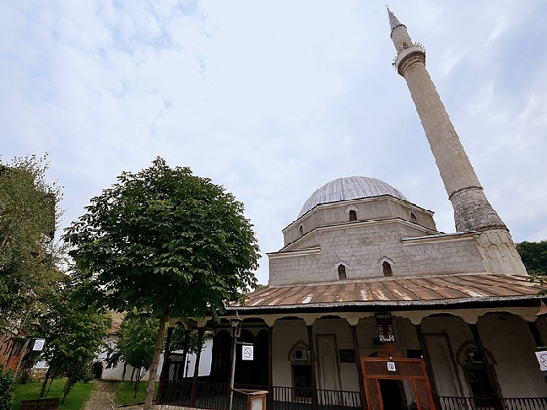
Figure 1: Gazi Mehmet Pasha Mosque in Prizren
The mosque represents an architectural object defined by its height. It has a square plan measuring 15.35x15.63. It consists of a prayer hall, a portico, and a minaret. The prayer hall is covered with a dome, which rests on four trumpets. The space of the prayer hall is illuminated by two rows of windows, while on the wall of the mihrab we have three rows of openings as well as an oculus. The windows are secured with metal railings. The second and third tiers have two arched windows. We also have eight arched windows in the upper part of the drum [13].
On the front wall, on both sides of the main gate, there is a mihrab. The minaret is constructed on the right side of the mosque and has a polygonal, cylindrical shape. Bajrakli Mosque has few pictorial decorations, mainly with repeating motifs and shapes[13].
In addition to being an educational-religious center, the mosque was also noted for its role in political events. In 1878, in this mosque and the surrounding complex, the Albanian League of Prizren was organized, a political organization of the time that aimed to create an autonomous Albanian province within the Ottoman Empire [18].
Madrasa: next to each mosque, there were usually religious schools that served the basic moral and religious education of children. Further religious education took place in madrasahs, which prepared cadres for work in the Ottoman administration. The first madrasa in Prizren was founded by Mehmet Pasha. Schooling was organized according to the Muslim-Oriental model, while lessons were held only in the Ottoman language. Reading and reciting the Qur'an were taught more. In addition, the basics of religion and mathematics were taught. At the service of the madrasah was also the library, which was rich with 200 books in manuscript or print [19].
In Prizren (as in all of Albania), the madrassas were built according to Ottoman architecture, but with some influence from the local construction tradition. Mainly, the foundations of these madrasahs were built of stone, bound with mortar (mud). In Mehmet Pasha's madrasa, the floor was built with a wood system with adobe connected with mortar (mud), while the dormitory was located inside the courtyard, where the students were provided with the necessary tranquilly [16].
The Sofi Sinan Pasha Mosque
The mosque of Sofi Sinan Pasha represents the pearl of Prizren, not only in terms of position, style, and construction material, but also as one of the most popular and important mosques of Islamic civilization not only in the Albanian lands but also in the Balkans, as well as in regard to the cultural-Islamic heritage in Prizren [17].
The mosque is located in the central area of Prizren and covers an area of 2,775 m2. The mosque was built by Sofi Sinan Pasha, who was born in a village in the Prizren region and was a scholar and soldier who, for a time, was also the governor of Budim in Hungary.[20] This mosque, built in 1615, represents a monumental religious construction and is the most beautiful in all Albanian spaces and in the Balkans. The facility is located on the left side of the Lumbardh River, near the castle and the fountain bazaar complex. Located in a slightly hilly position, the object stands out for its appearance, forms, beauty, and monumentality. In addition, the mosque has historical, cultural, constructive, architectural, functional, and artistic importance [14].
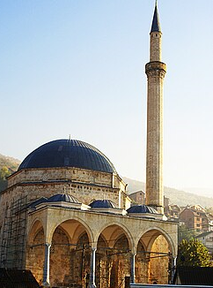
Figure 2: Sinan Pasha Mosque in Prizren

The structure of the mosque's masonry consists of brick tiles bonded with lime mortar. From the outside, like other monumental works, it is covered with square stones [14]. Functionally, the mosque has the minaret (42 m) and the dome in the western part, while inside there are the mihrab, mimbar, and mahvil. There are two minbars in the corridors. In the main mihrab, there are notes about the builder and the time of construction, with text in the Turkish language and the tulus script of the Arabic alphabet [20].
The base of the mosque consists of the surrounding walls, which cover the western and southern parts, next to which there was a market in the past. In the northern part, near the steps of the mosque, a fountain has been built from the same stones as those of the mosque [21].
In terms of composition, planning, technique, and constructive system, the prayer hall is identical but higher than Mehmet Pasha's mosque in Prizren, i.e., with a dome. The prayer hall is lighted and ventilated by four rows of windows, forty-four in all. In the first row, we have windows covered with architraves. The windows are secured with metal railings. In other orders, the windows are covered with arches. As an integral part of the building, there is also the portico of the mosque, which is covered with three small domes. The dome, apart from the frontal wall, rested on four pillars and three colonnades [13].
There is a minaret next to the southern wall. The minaret has a rectangular base, slippers, body, sherefe, polygonal petek that ends with a kylah in the shape of a sharp pencil and alem above it. The element in question, among others, is distinguished by the highest minaret in Kosovo. The entrance to the minaret is made possible by an arched doorway on the outside [13].
In addition to its historical, cultural, and religious importance, the mosque of Sinan Pasha also has values in terms of plastic and mural decorations. The mural of the mosque is located in the apse of the prayer hall. It stands out for decorations both in painting and in stone plastic. Stylized flowers mainly dominate. The pulpit is characterized by elements of the plant world and profiled geometric shapes, while the dome in the prayer hall is decorated with murals [13].
The mosque contains symbols of classical Ottoman art and rare aesthetic works in the Balkans. In addition to the classical decorations in the mosque, the baroque-style decorations of the 19th century also dominate [17].
Tendencies for the destruction of the mosque
After construction, the building experienced major damage, supposedly caused by the earthquake. But, in addition to the natural risks, the object was also subjected to the risks of the human factor. After the departure of the Ottoman Empire and the Serbian occupation, a large explosion occurred from the bombs that the Serbian army placed inside the Mosque of Sinan Pasha in November 1915, in which case the interior murals of the mosque were damaged [17].
However, the Serbian government managed to damage the mosque to some extent. Initially, the corridors of the mosque were open and covered with three domes, supported on stone pillars. The pillars had a square foundation and reinforcements of iron bars placed horizontally. All the domes were covered with lead. These domes, together with the stone pillars, were demolished by the Serbian government in 1919 in order to rebuild, with the same stones, the Monastery of the Holy Archangel at the gorge of the river Lumbardh in Prizren [20].
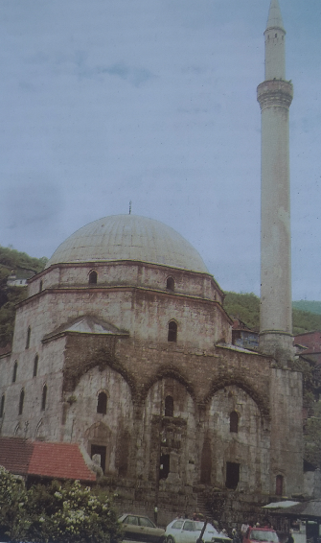
Figure 3: Demolished portico of Sinan Pasha Mosque in Prizren [20].

After World War II, in 1948, the mosque was placed under the protection of the government. The conservation of the interior began in 1952, while in 1972 the renovation of the main dome and the conservation of Arabic calligraphy that was damaged by the explosion of the year 1915 were completed [22].
The last restoration started in 2007 and ended in 2011 under the financial supervision of the Turkish governmental organization TIKA, while the restoration works were carried out by experts from Kosovo and Turkey. During this restoration, the portico and three supporting domes were built, which had been destroyed by the Serbian government at the time [17].

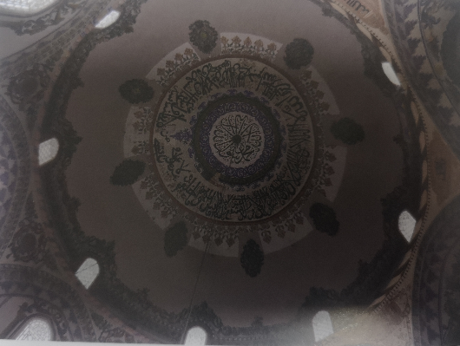
Figure 4: Sinan Pasha Mosque – dome decoration [13].
The Mosque of Emin Pasha
The Mosque of Emin Pasha was built in 1831 by Mehmet Emin Pasha, who for a time had served as administrator of Sanjak of Prizren and had built religious buildings in Prizren and in the surrounding area. In terms of importance, it is the third mosque in Prizren after that of Gazi Mehmet Pasha and Sofi Sinan Pasha. The main architectural feature is that, in addition to the main dome, there are also three small domes, thus presenting in miniature a small copy of the Mosque of Sinan Pasha, containing the same style and construction project [17].
The mosque consists of a prayer hall, a portico, and a minaret. The prayer hall has an area of 10.05 x 11.93 m. On the eastern wall, the part of the mihrab ends with an apse, which in terms of construction form is similar to that of Sinan Pasha's mosque. The prayer hall is covered with a dome, which was built using the trumpet technique. The walls of the mosque are made of square stones, while the prayer hall is illuminated by 23 windows. The windows of the first order are covered with architraves, while those of the second and third orders are covered with an arch. The minaret of the mosque is located in the southwest part of the building. The portico of the mosque is open and covered by three small domes, which are identical in height and rest on four stone pillars. The pillars have a base, a rafter, and a capital. They are connected with bows [13].

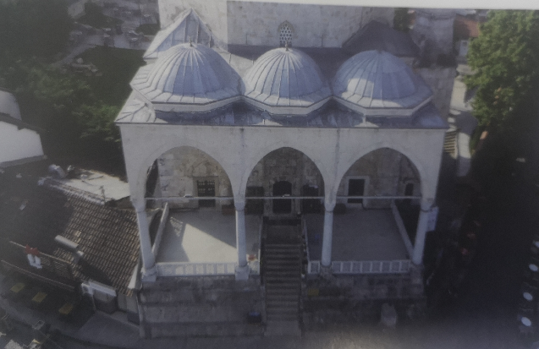

Figure 5: Emin Pasha Mosque in Prizren [20]

Emin Pasha's mosque is rich in terms of decorations, which prevail in domes, trumpets, the walls of the prayer hall, the portico, etc. Emin Pasha's mosque is appreciated for its interior decorations and still-life oriental writings [17].

CONCLUSION
In Prizren, during the period of Ottoman rule, mosques, madrassas, public baths (hammams), caravanserais, clock towers, stone bridges, residential houses, shrines, etc. were built. Construction of mosques prevailed over other objects due to the mission to spread Islam to the local Albanian population, which before the Ottoman rule had been of the Christian faith. This was also the mission of the first mosques built in Prizren, which stand out for the classic style of Ottoman architecture of the dome mosque, the same as the first mosques in Pristina and Peja (Kosovo). The Mosque of Gazi Mehmet Pasha and that of Sinan Pasha entered this category, and later, due to their characteristics, also that of Emin Pasha. Those mosques were constructed with the donations of military commanders or administrators who ruled territories inhabited by Albanians. The architectural, compositional, and functional schemes of these three mosques are the same, of course with minor changes.
The construction of Islamic buildings of worship in Kosovo also marks an innovation for local Albanian architecture; this was the first time Albanian architecture was introduced with the mosque, and from this moment on, the mosque also became part of Albanian architecture.
The Mosque of Mehmed Pasha (Bajrakli Mosque) is located in the centre of the city's historical site and has special cultural-historical value. Built within a complex together with the madrasa, library, public bath, etc., the Bajrakli mosque played a major role not only in the religious education of generations, but also in the political events of the time. The Assembly of the League of Prizren was held in this building. The flag was also raised here, where the mosque got the nickname "Bajrakli" (flag bearer).
The mosque of Sofi Sinan Pasha, built in the historical part of the city of Prizren, presents a rare architectural beauty. With its central dome, with three other domes built as a result of the restoration, and with the long minaret, it represents a symbol of the city of Prizren. The mosque contains symbols of classical Ottoman art and rare aesthetic works in the Balkans. In addition to the classical decorations in the mosque, the baroque-style decorations of the 19th century also dominate.
In terms of material culture, the five-century Ottoman rule in the province of Kosovo was accompanied by the transfer of Islamic artistic-architectural elements to Kosovo, while in later stages the interweaving of these elements with local building traditions produced a special style of architectural orientalism in the Albanian lands.

REFERENCES

[1] Malcolm Noel, Kosova një histori e shkurtër. Prishtinë: Koha, 2011.
[2] Drançolli Fejaz, “Disa ndërtime arkitektonike islame të shekullit XV në Prishtinë,” Feja Kult. Dhe Tradita Islame Ndër Shekuj, 1995.
[3] Jahic Edin, “Ottoman Mosque in the Balkans as the Legacy for the Contemporary Expression,” J. Hist. Cult. Art Res., vol. 7, no. 5, 2018.
[4] Zeneli Fidan, “The Architectural Islamic Monuments in Kosovo during XVI-XVIII centuries,” J. Islam. Archit., vol. 7, no. 3, 2023.
[5] Meksi Aleksandër, Arkitektura e xhamive të Shqipërisë (shekujt XV – XIX). Tiranë: Shtëpia Botuese Uegen, 2007.
[6] Statistical Yearbook of the Republic of Kosovo 2019. Pristina: Kosovo Agency of Statistics, 2019.
[7] Shtylla Valter, Monumente kulturore në Kosovë. Tiranë: Toena, 1998.
[8] Duka Ferit, “Momente të kalimit në islam të popullsisë shqiptare në shek. XV-XVII,” Feja Kult. Dhe Tradita Islame Ndër Shekuj, 1995.
[9] Miftari Faik, “Xhamitë e Prizrenit, dëshmi materiale e trashëgimisë kulturore osmane-islame në Ballkan,” Edukata Islame, vol. XLV, no. 111, 2016.
[10] Artkan Merve, “The Use of Ottoman Architecture and Islamic Heritage as a Consumption object in contemporary practices,” J. Islam. Archit., vol. 6, no. 4, 2021.
[11] Zekaj Ramiz, Zhvillimi i kulturës islame tek shqiptarët gjatë shekullit XX. Tiranë: AITTC, 2002.
[12] Prifti Kristaq and et.al., Historia e Popullit Shqiptar, vol. II. Tiranë: Akademia e Shkencave e Shqipërisë, 2002.

[13] Drançolli Orges, Xhamitë me kube në Kosovë. Prishtinë: Instituti i Historisë “Ali Hadri", 2023.
[14] Drançolli Fejaz, Trashëgimia monumentale në Kosovë. Prishtinë, 2011.
[15] Krasniqi Nehat, Zhvillimi i kulturës shqiptare me ndikime orientale prej shekullit XVIII deri në fillimet e Rilindjes Kombëtare. Prishtinë: Instituti Albanologjik, 2017.
[16] Kosova Parim, “Medresetë e Prizrenit,” Zeri Islam, 2024 2023. Accessed: Mar. 10, 2024. [Online]. Available: https://www.zeriislam.com/artikulli.php?id=647
[17] Miftari Faik, “Faik Miftari, Xhamitë e Prizrenit, dëshmi materiale e trashëgimisë kulturore osmane-islame në Ballkan (2),” vol. XLVIII, no. 112, 2018.
[18] Shaw J. Standford and Shaw Kural Ezel, Historia e Perandorisë Osmane dhe e Turqisë Moderne, vol. II. Tiranë: Jehona Study Center, 2006.
[19] Haskuka Esat, Analiza e funksioneve të Prizrenit gjatë shekujve. Prizren, 2003.
[20] Shukriu Muhamet, Prizreni i lashtë – Morfologjia e ecurive për ruajtjen e kulturës materiale. Prizren, 2001.
[21] Arapi Nora, “National identity expressed through religious heritage – case of Sinan Pasha Mosque, in Prizren, Kosovo,” Kathol. Univ. Leuven, vol. June, 2012.
[22] Virmiça Raif, Prizren canileri. Prizren: TDB yayinlari, 1996.

