 |  | JOURNAL OF ISLAMIC ARCHITECTURE  P-ISSN: 2086-2636 E-ISSN: 2356-4644  Journal Home Page: http://ejournal.uin-malang.ac.id/index.php/JIA
UNVEILING THE PAST: ARCHITECTURAL CHARACTERISTICS OF A FEW ISLAMIC BUILDINGS IN PRIZREN
Sedat Kryeziu^{a*}, Qendrim Hoxha^{b}
ªHistory/Cultural Heritage Prizren, Kosovo
^{b}University “St. Kliment Ohridski” Bitola, North Macedonia
*Corresponding Author: sedatkryeziu2014@gmail.com
ARTICLE INFO |  |  | ABSTRACT
Volume: 8  Issue: 4  Page: 933-942  Received: June 19th, 2024  Accepted: October 27th, 2024  Available Online: December 30th, 2025  DOI: 10.18860/jia.v8i4.26505 |  |  | The first Islamic buildings in Prizren (Kosovo) are related to the conquest and establishment of the Ottoman administration in Kosovo, which began in the last quarter of the 14th century and ended in 1455. This period marked a turning point in the history of Kosovo's architecture. The Ottomans brought their culture and architectural traditions to a country with Christian traditions. Mosques, public baths (hammams), madrasas, bridges, bazaars, caravanserais, and other structures were built. The paper examines the architectural elements of three Islamic buildings in Prizren, a city with significant historical and cultural heritage. Furthermore, the paper provides insights into its design, construction techniques, and stylistic features. The scope of this paper includes historical context, architectural analyses, and cultural significance. The outcomes presented in this paper demonstrate that the first Islamic buildings in Kosovo embody authentic Ottoman values. The new values were later integrated into the local culture, resulting in the creation of a distinct Oriental style. In addition to the analysis of the synthesis, the comparative method was also employed in the drafting of this paper, drawing on relevant literature.  Keywords:  Architecture; Mosque; Ottoman; Kosovo; Monuments

- INTRODUCTION
The conquest and establishment of the Ottoman administration in Kosovo began in the last quarter of the 14th century and ended circa 1455 with the conquest of Prizren [1]. Ottoman rule in Kosovo lasted until the early 20th century. During this period, which covered almost five centuries, the Ottomans built in Kosovo a considerable number of architectural objects of sacral or profane types of utilitarian, public, and individual character, such as monumental mosques, tombs, tekkes, public baths (hammams), caravanserais, inns, bazaars, clock towers, residential houses, etc [2].
When we discuss Ottoman art in general, we think of the great achievements presented in the Empire's major cities: Bursa, Edirne, and Istanbul. Monuments in other provinces, including the Balkans, reflect the artistic context of a specific country or city. These changes were the result of the temporal and spatial context in which Ottoman art evolved. The Ottoman architectural heritage, created relatively far from the artistic centres of the Empire, often possesses more or less precious features of the local architectural tradition. In the provinces where the local tradition was weak, the Ottoman heritage displayed a greater, more robust purity in artistic expressions [3]. Therefore, in the Ottoman imperial provinces inhabited by Albanians, the construction of the first religious buildings was characterized by a unique Islamic style, while later they were interwoven with elements of local culture, incorporating artistic mosaics and the creative expression of the local population [4]. Unfortunately, a large part of the first Islamic constructions in Kosovo did not survive time, climatic conditions, or were destroyed as a result of various wars and a lack of institutional care.
There are just a few studies on the first Islamic architectural constructions in Kosovo. The researcher Aleksandër Meksi, in his book "Architecture of Mosques in Albania (15th–19th centuries), claims that the first Islamic buildings in Kosovo, which were built during the 14th–15th centuries, were constructed by masters in the service of the Ottoman army and possess features of those countries where these masters came from [5]. Studies on Islamic constructions in Kosovo have also been done by researchers such as Skender Rizaj in "Kosova during the XV, XVI, and XVII centuries," in which he describes the religious, social, and urban changes. The researcher Emin Riza, in his work "Overview of the Urbanism of Albanian Cities," emphasizes the urbanistic changes as a result of the spread of Islamic culture. At the same time, the study by Orges Drançolli, "Domed Mosques in Kosovo," should be singled out, as it provides a detailed examination of the architectural features of Islamic buildings. Esat Haskuka, Muhamet Shukriu, and Parim Kosova, among others, also wrote about Prizren and its geographical, demographic, and cultural characteristics.
In addition to architectural and historical observations, the purpose of this paper is to raise awareness about the importance, preservation, and promotion of Ottoman-style architecture and its role in Kosovo's historical, cultural, and religious heritage, as well as to present its architectural values to a wider audience.

- METHODS
The methods used in this study consist of several points, which can be explained through a diagram:
- Scope of the study: the scope and purpose of this study is to examine architectural features of three religious buildings of Islamic provenience. It examines their design, construction techniques, and stylistic features. Geographically, these buildings are located in Prizren, a city in Kosovo, Southeastern Europe, and were built between the 16th and 19th centuries. The historical context, cultural importance, and unique artistic features are additional criteria for selecting these three buildings.
- Methodology: the methodology used in this paper includes the following approaches: (1) data collection techniques. Survey and observational studies were conducted on-site. Buildings have been surveyed and observed from all angles, from inside and outside, and historical data were collected; all data were collected according to research design and analysed accordingly; (2) comparative analyses embraced the parameters analysed and the basis for comparison. The architectural styles were identified, and dome shapes, minarets, construction materials, construction styles, and decorative elements were compared. Additionally, the historical and cultural significance of the buildings was also elaborated upon.
- The research flowchart includes: (1) Literature review: conducting a comprehensive review of existing literature; (2) Hypothesis formulation: formulation of a hypothesis based on available literature, collected data, and observations/analyses on the spot; (3) Interpretation of results: findings in this paper were presented throughout the text and in the conclusion part.

- RESULT AND DISCUSSION
The Republic of Kosovo is located in the southeastern part of the Balkan Peninsula and has a population of approximately 1,795,000 inhabitants, with over 91% of the population being of Albanian ethnicity [6]. Prizren is the second-largest city, known for its rich and diverse cultural heritage. The objects of material culture found in Prizren prove that this city has been inhabited since ancient times. Its geographical position, connecting the East with the West or the north of the Balkans with the Aegean Sea, or the road axis Lissus-Prizren-Prishtina-Nish, and later also the road Shkoder-Prizren-Skopje-Istanbul, which connected the Adriatic with the depth of the Balkans, had transformed this city into an important commercial centre during the ancient and medieval periods [7].
Kosovo's architectural heritage is indeed fascinating, reflecting its rich and diverse history. It dates back to the Neolithic period and encompasses the Copper, Bronze, and Iron Ages, Antiquity, and the Medieval period. The evolution of its architecture through various periods reveals how different civilizations and cultures have left their mark on the region. Local builders have combined traditional building techniques with the materials at hand and the existing conditions to develop their own unique varieties of dwellings [8].
Monuments that still stand are those of the Byzantine Orthodox, Serbian, and Ottoman periods, which possess historical, cultural, architectural, and artistic value. The field of popular architecture has value in its indigenous features, which are considered to have one of the most original constructive structures in the whole Balkans [8]. Therefore, the monuments in Kosovo are unique common property, and society is responsible for maintaining them to transmit their authenticity to future generations [8], [9].
Besides the monasteries and churches from the 14th century, the architectural heritage from the Ottoman period includes mosques and hamams from the 15th, 16th, and 17th centuries. Other historical architectural structures of interest include kullas from the 18th and 19th centuries. Those were traditional two- or three-storey buildings constructed entirely of locally excavated stone, though some incorporated decorative wooden elements in the upper floors. In addition to all that has been mentioned above, there were also a number of bridges, urban centers, and fortresses. Figures 1, 2, and 3 describe the architectural diversity of Kosovo throughout the ages. Today they mark an interesting site of cultural heritage. The Stone Bridge was constructed at the end of the 15th century or the beginning of the 16th century. Kulla in Junik was built sometime during the 19th century, while the castle in Novoberdo dates since antiquity. These were just a few examples to describe the richest cultural heritage of Prizren.

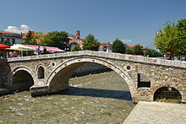 | 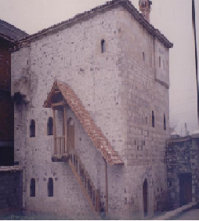 | 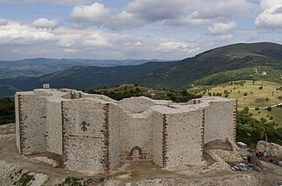
Figure 1. The Stone Bridge in Prizren [10] | Figure 2. Kulla in Junik [11] | Figure 3. The Castle of Novo Berdo

Before the Ottoman period, the Albanian population of Kosovo was predominantly Christian, while the first contacts between Albanians and Islam occurred early on. During the Middle Ages, the Albanian lands, due to their geographical position, were frequented by missionaries from the Arab-Turkish Islamic world, either for commercial purposes or for religious or military reasons. However, in light of historical data, it is beyond doubt that the Islamization of the Albanian population as a whole process began and developed during the period of Ottoman rule [12].
As everywhere, here as well, with the spread of Islam among the Albanians, the need arose for the construction of cult buildings in the late 14th century. In addition to mosques, there were also various architectural structures, including madrassas, hammams, and imarates. Among them, a special value for the history of Albanian architecture in the late medieval period is undoubtedly occupied by the mosques [13].

  - The spread of Islamic Architecture in Kosovo
In the spring of 1455, the Ottoman armies entered Prizren. This act marks the first contact of Prizren with Islamic civilization. Being the centre of the sanjak and during the years 1868–1874 as the seat of the vilayet, Prizren was transformed into an administrative, cultural, commercial, craft, and religious seat throughout the period of the Ottoman Empire in Kosovo; therefore, as a result, mosques, madrassas, mosques, bridges, inns, fountains, mills, hammams, clock towers, caravanserais, shrines, etc. were constructed in Prizren. These cultural assets, which have been preserved to a certain extent to this day, make Prizren the city "per excellens" in Kosovo in terms of preserving traces of Ottoman-Islamic cultural and material heritage [14].
The establishment of Ottoman administration was followed by the spread of Ottoman material culture, which generated changes in urban style in Prizren. The first Ottoman buildings present a rich array of public, individual, and traditional constructions, all of which are focused on the Islamic religion and tradition [15]. Initially, Ottoman Islamic culture had spread into Albanian lands since the second half of the 15th century, when the Ottoman state, through the Imperial Office of Architecture, implemented the model of classical architecture in all the centers of the Empire, both in the East and in the West [16].
During the Ottoman period, which lasted from the late 14th century until 1912 [17]. 358 mosques were built in Kosovo. Of these, 13 were built in the 15th century, 37 in the 16th century, 37 in the 17th century, 72 in the 18th century, 175 in the 19th century, and 24 in the early 20th century [18]. Of this number, 29 mosques were built in Prizren [14]. Covering four centuries. The oldest mosques in Prizren include: the Mosque of Namasgja (Kerek) (year 1455), which is considered the first Islamic mosque in Prizren, built on the occasion of the entry of the Ottoman army in Prizren; the Xhuma Mosque (c. 15th century); the Castle Mosque (c. 15th century); the Jakup Bey Mosque (Arasta) (c. XV); the Mosque of Iliaz Kuka (c. XV); the Tabakhana Mosque (1505); the Mosque of Suzi Celebi (c. 15th century); the Mosque of Mehmet Kukli Bey (Sarachanes) (year 1534) [14], [19]. As for the cultural-historical and artistic values, they are not at the same level. A number of them are monuments and belong to mosques covered with domes. Several monumental mosques were built in Prizren, including the mosque of Mehmet Pasha, also known as Bajrak (1573), the mosque of Sinan Pasha (1615), and the mosque of Emin Pasha (1832) [18], which will be the focus of this study.
Regarding what was mentioned above, it is worth noting that all mosques have their functional components, including the mihrab, minbar, mafil, minaret, etc. But architecturally, they are not the same everywhere. There are significant differences in their artistic content. The cultural level and artistic demands of local populations have influenced the architectural and artistic composition of mosques. In addition to changes in space, mosques have also undergone changes over time. As a result, the mosques built in the Ottoman Empire represent important changes from those in Saudi Arabia, not only in the first centuries of Islam but also during the time of the Turkish sultans. Even the mosques built during the Ottoman Empire's years were not the same everywhere [13].
The construction of Islamic buildings of worship in Kosovo also marks an innovation in local Albanian architecture; this was the first time Albanian architecture was introduced with the mosque, and from this moment on, the mosque became an integral part of Albanian architecture [20]

- 1. Mosque of Gazi Mehmet Pasha
Historical sources such as Suzi Celebi's Waqf document from 1513, Mehmed Kukli-Beg's Waqf document from 1539, and the register of the Sanjak of Prizren from 1590/91 are among the oldest testimonies about the beginning of Islamic architectural constructions in Prizren and about the period when this city began to take on the characteristics of a genuine oriental Islamic city [21].
The Mosque of Gazi Mehmet Pasha (Bajrakli) is the central and main mosque in Prizren, with construction beginning in 1571. It represents an Ottoman classic architectural style, characterized by domed structures. It is called Bajrakli because the flag was flown on the minaret during holidays. The donor of this mosque was Gazi Mehmet Pasha, a renowned Ottoman soldier who, at one time, also served as the administrator of Shkodra Sanjak. Gazi Mehmet Pasha was the son of Ahmet Bey Dukagjini, who served as grand vizier of the Ottoman Empire from 1514 to 1515 [22]. The said mosque was part of a religious-educational complex built between 1563 and 1573, which also included a madrasah, a public bath (hammam), and a library. The complex rises within the surrounding walls; the exterior is characterised by the long shelter and the tiled tower, while the dome of the mosque and the library are covered with lead. The doors and windows are of the folk architecture of Prizren [21].
The mosque represents an architectural object defined by its height. It has a square plan measuring 15.35 m x 15.63 m. The construction structure includes brick tiles with lime mortar. It consists of a prayer hall, a portico, and a minaret. The prayer hall is covered with a dome, which rests on four trumpets. Two rows of windows illuminate the prayer hall, while the wall of the mihrab features three rows of openings, as well as an oculus. The windows are secured with metal railings. The second and third tiers have two arched windows. We also have eight arched windows in the upper part of the drum [18].

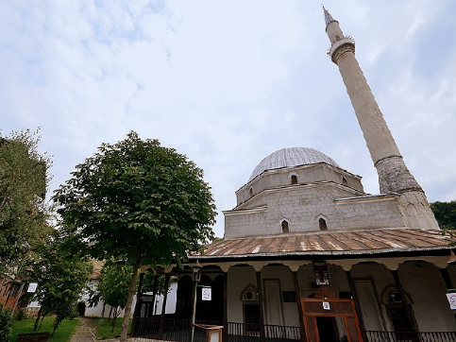
Figure 4. Gazi Mehmet Pasha Mosque in Prizren

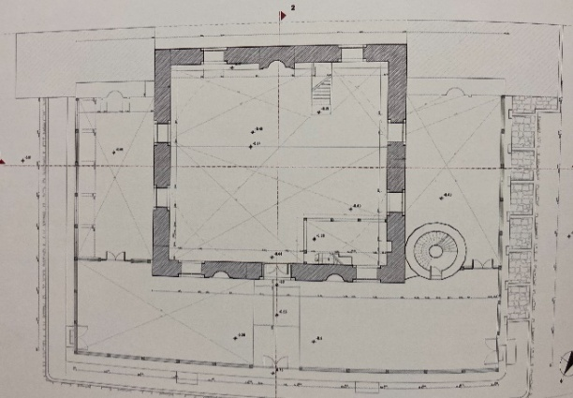 |  | 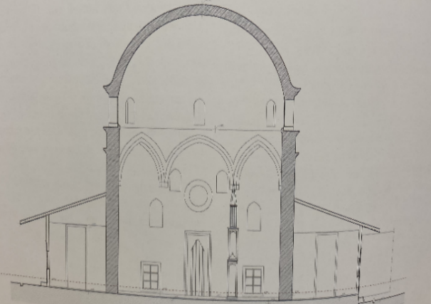
Figure 5. Gazi Mehmet Pasha Mosque in Prizren – Planning base and vertical view [18]
Table 1. Parameters of Gazi Mehmet Pasha Mosque
Parameters | Gazi Mehmet Pasha Mosque
Architectural style | Ottoman classic
Type | Domed
Year of built | 1571
Construction structure | Brick tiles bonded with lime mortar.

On the front wall, on both sides of the main gate, there is a mihrab. The minaret is constructed on the right side of the mosque and has a polygonal, cylindrical shape. The Bajrakli Mosque features a few pictorial decorations, primarily characterized by repeating motifs and shapes [18]. Between 1993 and 1994, this mosque underwent a comprehensive renovation, which, in addition to other elements, included the restoration of paintings, arabesques, and other decorative motifs. Despite the restorations, the plastic decorations retained their originality [23].
It is worth noting that on the inner side of the dome, a large number of empty tubes are placed. The purpose of these tubes is to condense the humidity of the air and prevent damage to the plastering and ornaments under the dome. Condensed air in the tubes drips in the form of water [23].
In addition to being an educational and religious center, the mosque was also noted for its role in political events. In 1878, the Albanian League of Prizren was organized in this mosque and the surrounding complex, a political organization of the time that aimed to create an autonomous Albanian province within the Ottoman Empire [24].

Table 2. Historical and cultural context of Gazi Mehmet Pasha Mosque
Parameters | Gazi Mehmet Pasha Mosque
Historical context | It was a point of political events. The Assembly of the League of Prizren was held in this building. The League aimed to claim autonomy for Albania within the Ottoman Empire.  The mosque provided education to young people.
Cultural importance | An important point of cultural heritage

Madrasa: next to each mosque, there were usually religious schools that served the basic moral and religious education of children. Further religious education took place in madrasahs, which prepared cadres for work in the Ottoman administration. The first madrasa in Prizren was founded by Mehmet Pasha. Schooling was organized according to the Muslim-Oriental model, with lessons held exclusively in the Ottoman language. Reading and reciting the Qur'an were taught more. In addition, the basics of religion and mathematics were taught. At the service of the madrasah was also the library, which was rich in 200 books, both in manuscript and print [25].
In Prizren (as in all of Albania), the madrassas were built according to Ottoman architecture, but with some influence from the local construction tradition. Mainly, the foundations of these madrasahs were built of stone, bound with mortar (mud). In Mehmet Pasha's madrasa, the floor was constructed using a wooden system with adobe blocks connected with mortar (mud), while the dormitory was located inside the courtyard, where the students were provided with the necessary tranquility [21].

A.2. The Sinan Pasha Mosque
The mosque of Sofi Sinan Pasha represents the pearl of Prizren, not only in terms of position, style, and construction material, but also as one of the most popular and important mosques of Islamic civilization, not only in the Albanian lands but also in the Balkans, as well as regarding the cultural-Islamic heritage in Prizren [22].
The mosque is situated in the central area of Prizren and spans an area of 2,775 m². The mosque was built by Sofi Sinan Pasha, who was born in the Prizren neighbourhood and was a scholar and soldier who, for a time, also served as the governor of Budim in Hungary [10]. This mosque, built in 1615, represents a monumental religious structure and is considered the most beautiful in all of Albania and the Balkans. It represents an Ottoman classic architectural style, characterized by domed structures. The facility is situated on the left bank of the Lumbardh River, near the castle and the Fountain Bazaar complex. Located in a slightly hilly position, the object stands out for its appearance, forms, beauty, and monumentality. Additionally, the mosque holds historical, cultural, constructive, architectural, functional, and artistic significance [19].
The structure of the mosque's masonry consists of brick tiles bonded with lime mortar. From the outside, like other monumental works, it is covered with square stones [19]. Functionally, the mosque features a minaret (42 m) and a dome in the western part. Inside, there are the mihrab, mimbar, and mahvil. There are two minbars in the corridors. In the main mihrab, there are notes about the builder and the time of construction, written in the Turkish language and the Tulus script of the Arabic alphabet [10].

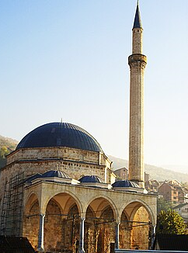
Figure 6. Sinan Pasha Mosque in Prizren

Table 3. Parameters of Sinan Pasha Mosque
Parameters | Sinan Pasha Mosque
Architectural style | Ottoman classic
Type | Domed
Year of built | 1615
Construction structure | Brick tiles bonded with lime mortar.

The base of the mosque consists of the surrounding walls, which cover the western and southern parts, adjacent to which a market once stood. In the northern part, near the steps of the mosque, a fountain has been built from the same stones as those of the mosque [26].
In terms of composition, planning, technique, and construction system, the prayer hall has a square form and is identical, but higher than Mehmet Pasha's mosque in Prizren, which features a dome. The prayer hall is lighted and ventilated by four rows of windows, forty-four in all. In the first row, we have windows covered with architraves. The windows are secured with metal railings. In other orders, the windows are covered with arches. As an integral part of the building, there is also the portico of the mosque, which is covered with three small domes. The dome, apart from the frontal wall, rested on four pillars and three colonnades [18].

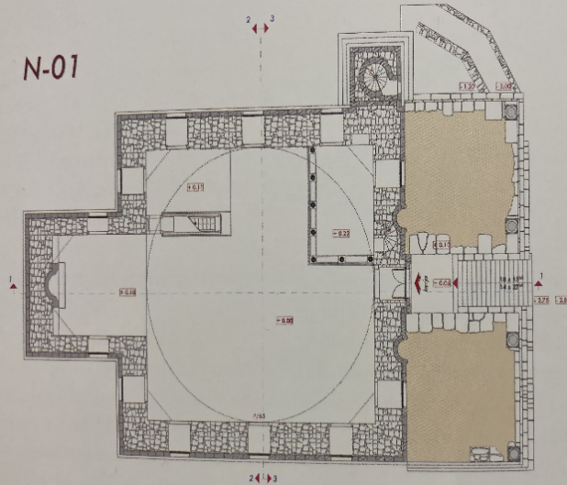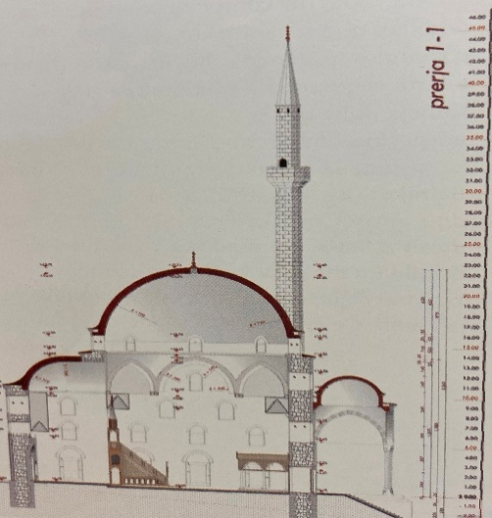
Figure 7. Sinan Pasha Mosque in Prizren - Planning base and vertical view [18]

There is a minaret next to the southern wall. The minaret has a rectangular base, a slipper, a body, a sherefe, a polygonal petek that ends with a kylah in the shape of a sharp pencil, and an alem above it. The element in question, among others, is distinguished by the highest minaret in Kosovo. The entrance to the minaret is made possible by an arched doorway on the outside [18].
In the historical context, this mosque is associated with Sinan Pasha, a renowned Ottoman administrator who was born in the Prizren neighborhood. It describes the Islamic civilization and the coexistence of Albanians in the Ottoman Empire. Today, the mosque marks a significant point in cultural heritage.

Table 4. Historical and cultural context of Sinan Pasha Mosque
Parameters | Sinan Pasha Mosque
Historical context | Its builder, Sinan Pasha, was a prominent figure in Ottoman administration. It describes the past of these lands.  The mosque provided education to young people.
Cultural importance | An important point of cultural heritage.

In addition to its historical, cultural, and religious significance, the mosque of Sinan Pasha also boasts aesthetic value in terms of its plastic and mural decorations. The mural of the mosque is located in the apse of the prayer hall. It stands out for decorations both in painting and in plastic stone. Stylized flowers mainly dominate. The pulpit is characterized by elements of the plant world and profiled geometric shapes, while the dome in the prayer hall is decorated with murals [18].
The mosque contains symbols of classical Ottoman art and rare aesthetic works in the Balkans. In addition to the classical decorations in the mosque, the 19th-century baroque-style decorations also dominate [22].

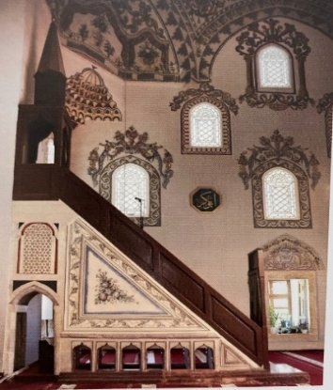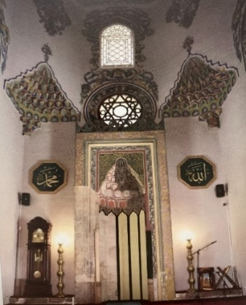
Figure 8. Sinan Pasha Mosque – Minber and Mihrab decorations

Tendencies for the destruction of the mosque
After construction, the building experienced major damage, supposedly caused by the earthquake. However, in addition to the natural risks, the object was also exposed to the risks associated with the human factor. After the departure of the Ottoman Empire and the Serbian occupation, a large explosion occurred from the bombs that the Serbian army placed inside the Mosque of Sinan Pasha in November 1915, in which case the interior murals of the mosque were damaged [22].
However, the Serbian government managed to damage the mosque to some extent. Initially, the mosque's corridors were open and covered with three domes, supported by stone pillars. The pillars had a square foundation and were reinforced with iron bars placed horizontally. All the domes were covered with lead. These domes, along with the stone pillars, were demolished by the Serbian government in 1919 to rebuild, using the same stones, the Monastery of the Holy Archangel at the gorge of the River Lumbardh in Prizren [10].

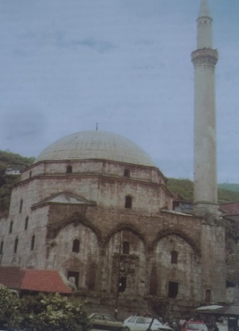
Figure 9. Demolished portico of Sinan Pasha Mosque in Prizren.
After World War II, in 1948, the mosque was placed under the protection of the government. The conservation of the interior began in 1952, while the renovation of the main dome and the conservation of Arabic calligraphy, which the 1915 explosion had damaged, were completed in 1972 [27].
The last restoration project began in 2007 and concluded in 2011, under the financial supervision of the Turkish governmental organization TIKA. The restoration works were carried out by experts from Kosovo and Turkey. During this restoration, the portico and three supporting domes were built, which had been destroyed by the Serbian government at the time [22].

A.3. The Emin Pasha Mosque
The Mosque of Emin Pasha was built in 1831 by Mehmet Emin Pasha [10], who had served as administrator of the Sanjak of Prizren at the time and had constructed religious buildings in Prizren and the surrounding area. It represents an Ottoman classic architectural style, characterized by domed structures. In terms of importance, it is the third mosque in Prizren after that of Gazi Mehmet Pasha and Sofi Sinan Pasha. The construction type includes brick tiles plastered with a facade. The main architectural feature is that, in addition to the main dome, there are also three small domes, thus presenting in miniature a small copy of the Mosque of Sinan Pasha, containing the same style and construction project [22].

Table 5.Parameters of Emin Pasha Mosque
Parameters | Emin Pasha Mosque
Architectural style | Ottoman classic
Type | Domed
Year of built | 1831
Construction structure | Brick tiles plastered with a facade

The mosque consists of a square-shaped prayer hall, a portico, and a minaret. The prayer hall has an area of 10.05 x 11.93 m. On the eastern wall, the part of the mihrab ends with an apse, which, in terms of construction form, is similar to that of Sinan Pasha's mosque. The prayer hall is covered with a dome, which was built using the trumpet technique. The walls of the mosque are made of square stones, while the prayer hall is illuminated by 23 windows. The windows of the first order are covered with architraves, while those of the second and third orders are covered with an arch. The minaret of the mosque is located in the southwest part of the building. The portico of the mosque is open and covered by three small domes, identical in height, which rest on four stone pillars. The pillars have a base, a rafter, and a capital. They are connected with bows. Walls are constructed with brick tiles, but covered with plastered facade [18].

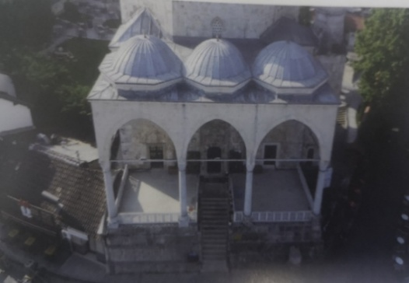
Figure 10. Emin Pasha Mosque in Prizren

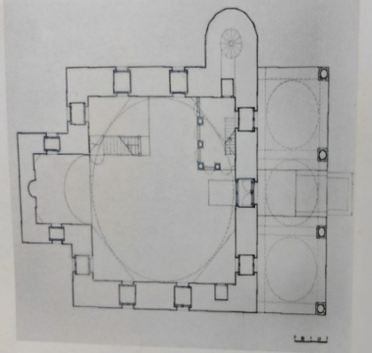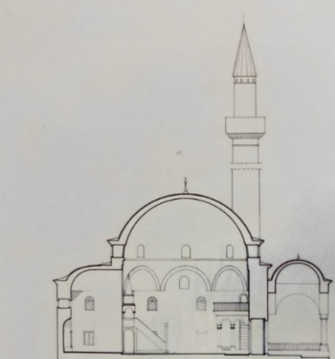
Figure 11. Emin Pasha Mosque in Prizren - Planning base and vertical view [18]
In the historical context, this mosque is associated with Emin Pasha, a famous Ottoman administrator who was born in Prizren, known for his humanitarian actions. It describes the Islamic civilization and the coexistence of Albanians in the Ottoman Empire. Today, the mosque marks a significant point in cultural heritage.

Table 6. Historical and cultural context of Emin Pasha Mosque
Parameters | Emin Pasha Mosque
Historical context | Its builder, Emin Pasha, was an important figure in Ottoman administration. Thus, it describes the past of these lands.  The mosque provided education to young people.
Cultural importance | An important point of cultural heritage.

Emin Pasha's mosque is rich in terms of decorations, which are prevalent in the domes, arches, and walls of the prayer hall, as well as the portico. Emin Pasha's mosque is appreciated for its interior decorations and still-life oriental writings [22].

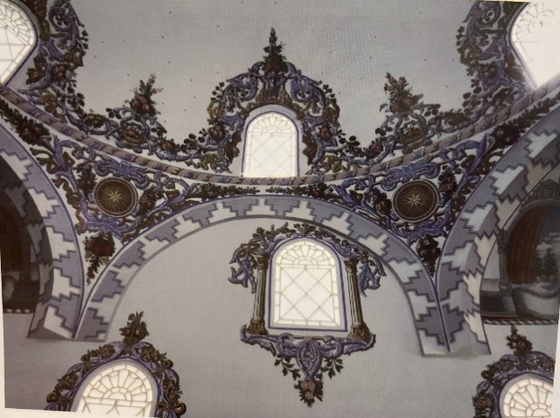 | 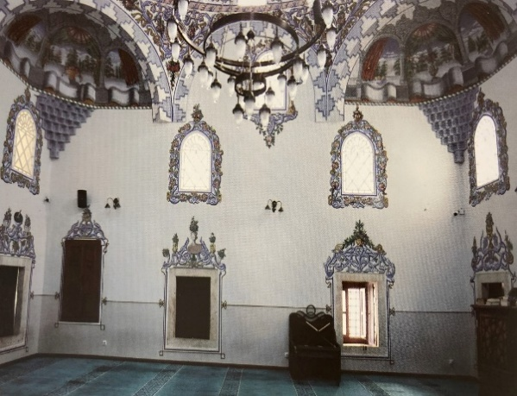
Figure 12. Emin Pasha Mosque in Prizren – stylistic decorations

- CONCLUSION
During the Ottoman period in Prizren, various structures were built, including mosques, madrassas, public baths (hammams), caravanserais, clock towers, stone bridges, residential houses, and shrines. The construction of mosques prevailed over other objects due to the mission to spread Islam to the local Albanian population, which, before Ottoman rule, had been of the Christian faith. This was also the mission of the first mosques built in Prizren, which stand out for their classic style of Ottoman architecture, exemplified by the dome mosque, similar to the first mosques in Pristina and Peja (Kosovo). The Mosques of Gazi Mehmet Pasha and Sinan Pasha entered this category, and later, due to their characteristics, also that of Emin Pasha. Those mosques were constructed with the donations of military commanders or administrators who ruled territories inhabited by Albanians. The architectural, compositional, and functional schemes of these three mosques are the same, of course, with minor changes.
The construction of Islamic buildings of worship in Kosovo also marks an innovation in local Albanian architecture; this was the first time Albanian architecture was introduced with the mosque, and from this moment on, the mosque became an integral part of Albanian architecture.
The Mosque of Mehmed Pasha (Bajrakli Mosque) is situated in the centre of the city's historical site and holds special cultural-historical significance. Built within a complex alongside the madrasa, library, public bath, and other structures, the Bajrakli mosque played a major role not only in the religious education of generations but also in the political events of the time. The Assembly of the League of Prizren was held in this building. The flag was also raised here, where the mosque earned the nickname "Bajrakli" (meaning "flag bearer").
The Mosque of Sofi Sinan Pasha, located in the historical center of the city of Prizren, boasts a rare architectural beauty. With its central dome, three additional domes built as a result of the restoration, and the long minaret, it represents a symbol of the city of Prizren. The mosque contains symbols of classical Ottoman art and rare aesthetic works in the Balkans. In addition to the classical decorations in the mosque, the 19th-century baroque-style decorations also predominate. The Emin Pasha mosque represents a miniature, small-scale copy of the Mosque of Sinan Pasha, featuring the same style and construction project.
In terms of material culture, the five-century Ottoman rule in the province of Kosovo was accompanied by the transfer of Islamic artistic and architectural elements to Kosovo. In later stages, the interweaving of these elements with local building traditions produced a distinctive style of architectural orientalism in the Albanian lands.

REFERENCES

[1] M. Noel, Kosova një histori e shkurtër. Prishtinë: Koha, 2011.
[2] D. Fejaz, “Disa ndërtime arkitektonike islame të shekullit XV në Prishtinë,” Feja, kultura dhe tradita islame ndër shekuj, 1995.
[3] J. Edin, “Ottoman Mosque in the Balkans as the Legacy for the Contemporary Expression,” J. Hist. Cult. Art Res., vol. 7, no. 5, pp: 239-253, 2018. DOI: 10.7596/taksad.v7i5.1768
[4] Z. Fidan, “The Architectural Islamic Monuments in Kosovo during XVI-XVIII centuries,” Journal of Islamic Architecture, vol. 7, no. 3, 2023, doi: 486-492, DOI: 10.18860/jia.v7i3.20784.
[5] M. Aleksandër, Arkitektura e xhamive të Shqipërisë (shekujt XV – XIX). Tiranë: Shtëpia Botuese Uegen, 2007.
[6] Statistical Yearbook of the Republic of Kosovo 2019. Pristina: Kosovo Agency of Statistics, 2019.
[7] S. Valter, Monumente kulturore në Kosovë. Tiranë: Toena, 1998.
[8] D. Flamur, Arkitektura vernakulare e Kosovës. Prishtinë: SHRTA, 2009.
[9] I. Rexhep, Kosova vështrim monografik. Prishtinë: Akademia e Shkencave dhe Arteve e Kosovës, 2011.
[10] S. Muhamet, Prizreni i lashtë – Morfologjia e ecurive për ruajtjen e kulturës materiale. Prizren, 2001.
[11] “Oda legjendare e Junikut.” Accessed: Aug. 10, 2024. [Online]. Available: https://www.zemrashqiptare.net/news/59046/rp-0/act-print/rf-1/printo.html
[12] D. Ferit, “Momente të kalimit në islam të popullsisë shqiptare në shek. XV-XVII, ”Feja, kultura dhe tradita islame ndër shekuj, 1995.
[13] F. Gjergj and D. Sulejman, “Zhvillimi i arkitekturës islame shqiptare të xhamive,” Monumentet, vol. 2, 1986.
[14] M. Faik, “Xhamitë e Prizrenit, dëshmi materiale e trashëgimisë kulturore osmane-islame në Ballkan,” Edukata Islame, vol. 111, 2016.
[15] A. Merve, “The Use of Ottoman Architecture and Islamic Heritage as a Consumption object in contemporary practices,” Journal of Islamic Architecture, vol. 6, no. 4, pp: 338-348, 2021, doi: 10.18860/jia.v6i4.11811.
[16] Z. Ramiz, Zhvillimi i kulturës islame tek shqiptarët gjatë shekullit XX. Tiranë: AITTC, 2002.
[17] P. Kristaq and et.al., Historia e Popullit Shqiptar, vol. II. Tiranë: Akademia e Shkencave e Shqipërisë, 2002.
[18] D. Orges, Xhamitë me kube në Kosovë. Prishtinë: Instituti i Historisë “Ali Hadri", 2023.
[19] D. Fejaz, Trashëgimia monumentale në Kosovë. Prishtinë, 2011.
[20] K. Nehat, Zhvillimi i kulturës shqiptare me ndikime orientale prej shekullit XVIII deri në fillimet e Rilindjes Kombëtare. Prishtinë: Instituti Albanologjik, 2017.
[21] K. Parim, “Medresetë e Prizrenit,” Zeri Islam, 2024 2023. Accessed: Mar. 10, 2024. [Online]. Available: https://www.zeriislam.com/artikulli.php?id=647
[22] M. Faik, “Xhamitë e Prizrenit, dëshmi materiale e trashëgimisë kulturore osmane-islame në Ballkan (2),” Edukata Islame, vol. 112, 2018.
[23] X. Mirije, “Xhamitë monumentale në Prizren,” Edukata Islame, vol. 81, 2006.
[24] S. J. Standford and S. K. Ezel, Historia e Perandorisë Osmane dhe e Turqisë Moderne, vol. II. Tiranë: Jehona Study Center, 2006.
[25] H. Esat, Analiza e funksioneve të Prizrenit gjatë shekujve. Prizren, 2003.
[26] A. Nora, “National identity expressed through religious heritage – case of Sinan Pasha Mosque, in Prizren, Kosovo,” Kathol. Univ. Leuven, vol. June, 2012.
[27] V. Raif, Prizren canileri. Prizren: TDB yayinlari, 1996.

