 |  | JOURNAL OF ISLAMIC ARCHITECTURE  P-ISSN: 2086-2636 E-ISSN: 2356-4644  Journal Home Page: http://ejournal.uin-malang.ac.id/index.php/JIA
ANALYZING SPIRITUAL MESSAGES IN THE GEOMETRIC AND NUMERIC PATTERNS OF SHEIKH LOTFOLLAH MOSQUE BASED ON ISLAMIC COSMOLOGY
Mehrsa Payandeha^{a*}, Azadeh Hariri^{b}, Negar Hakim^{b}
ªMaster of Architecture, Najafabad Branch, Islamic Azad University, Najafabad, Esfahan, Iran
^{b}Institute of History of Art, Building Archaeology and Restoration, Vienna University of Technology, Vienna, Austria
*Corresponding Author: M.payandeh1993@gmail.com
ARTICLE INFO |  |  | ABSTRACT
Volume: 8  Issue: 2  Page: 295-305  Received: April 2nd, 2024  Accepted: June 4th, 2024  Available Online: December 15th, 2024  DOI: 10.18860/jia.v8i2.26516 |  |  | The Safavid era marked a pivotal period in the evolution of Islamic Architecture in Iran. During this time, architectural styles moved beyond mere physical structures to embody profound spiritual concepts. These buildings conveyed specific mystical ideas through encoded messages, often using numerical symbolism, all aimed at evoking a sense of eternity. This study seeks to compare the divine concepts found in Islamic cosmology with the numerical ratios used in the design of the Sheikh Lotfollah Mosque. Through a descriptive-analytical approach, the research examined library resources and conducted field research to understand how numerical patterns in the mosque's architecture relate to philosophical concepts in Islamic cosmology. The findings reveal a consistent use of numbers such as ‘8’ and ‘9’ in various aspects of the mosque's design. These represent of mystical ideas associated with the eighth and ninth heavenly spheres, known as Ālam al-Malakūt in Islamic cosmology.  Keywords:  Geometry and Numbers; Islamic Architecture; Nine Heavenly Spheres; Islamic Cosmology; Shaykh Lotfollāh Mosque

- INTRODUCTION
The creation of works in Islamic art has been accompanied by encoding within their semantic and formal structures [1]. Architecture plays an important role in shaping human environments among the various forms of Islamic art. In Iranian Islamic architecture in the 15th century, the Isfahani style has been prevalent. In the architectural works of the Isfahani style, fundamental mystical concepts of Islamic cosmology have been encrypted in various ways [2]. One of these encryption methods is the use of numbers. Numbers are symbols that manifest deep mystical concepts in Islamic cosmology [3][4].
The Isfahani style, by employing these methods, depicts the world of Nasut (the mortal world) and the world of Malakut (the world of sovereignty) in architecture [5]. Shaykh Lotfollāh Mosque is one of the works of Islamic architecture in the Isfahani style, a prominent example of encoding cosmological concepts. The architectural structure and decorations of the Sheikh Lotfollah Mosque have been developed based on divine concepts to create a space where the worlds of Nasut (the mortal world) and Malakut (the world of sovereignty) merge, giving rise to a unique spiritual environment.
The main reason for conducting this research was the lack of previous research on the use of numbers 8 and 9 and their multiples in the geometrical and architectural foundation of the Shaykh Lotfollah Mosque, which signals the unique concepts of Islamic cosmology. The primary aim of the present study is to comparatively investigate the divine concepts arising from Islamic cosmology with the numerical ratios used in the architecture of the Sheikh Lotfollah Mosque. Moreover, the central question of this study concerns how the divine concepts arising from Islamic cosmology appear through the use of numerical ratios in the architecture of the Sheikh Lotfollah Mosque. In other words, this study attempts to discover how the Islamic cosmology concepts have been incorporated into the geometric and numerical structure of Shaykh Lotfollāh Mosque by analyzing the symbolic meaning of numbers.
Additionally, the present study employs a descriptive-analytical methodology, drawing upon library resources. This research analyzes primary sources and conducts a field study to examine the philosophical concepts of Islamic Cosmology, identifying the connection between numerical ratios utilized in Sheikh Lotfollah Mosque and philosophical concepts related to the eighth (God’s footstool) and ninth (God’s Throne) heavenly spheres.
The Safavid era is one of the most remarkable stages in post-Islamic Persian art [6][7]. This era gave rise to the Shiite ideology and marked the development of art in all artistic realms [8]. One of the most significant artistic accomplishments in this era was the development of a new style of architecture. In terms of physical structure, this style of architecture, while respecting the traditions of the previous eras, incorporates several innovative architectural patterns that represent a deeply spiritual nature that conveys a message beyond the physical aspects of the building [7][9]. This approach to architecture gave rise to many significant works of architecture during the Safavid era [10][11]. Due to its specific structural and spiritual nature, Shaykh Lotfollāh Mosque is considered one of the hallmarks of the Isfahan school of architecture during the Safavid era.
After examining the extensive research on this architectural masterpiece, the previous studies are divided into three main categories. In exploring the Shaykh Lotfollāh Mosque's architecture, scholars from the first research category adopt an orientalist lens to decipher its intricate symbolism and play of light, highlighting its profound spiritual essence [9][12]-[15]. They meticulously analyze how elements like color, light, and illustration are interwoven into Islamic architectural traditions, conveying deeper spiritual truths. Through this examination, they unravel the mosque's metaphorical dimensions, revealing the nuanced symbolism within its structural elements. This type of research aims to contextualize these symbolic elements within the broader framework of Islamic artistic expression, thereby contributing to a deeper understanding of the architectural significance of mosques in Islamic art and culture [12]-[15].
The second research category delves into the geometric aspects of Shaykh Lotfollāh Mosque, shedding light on its structural complexities and the meticulous design principles employed in its construction. Scholars in this category meticulously examine the role of geometry within Safavid architectural design, aiming to uncover the underlying principles guiding the mosque's layout and spatial organization. Through geometric analyses, they reveal symmetrical patterns and correlations between various architectural elements, offering insights into the mathematical precision and harmonious proportions inherent in the mosque's design [16]-[21].
The third research category delves into the intricate incorporation of sacred geometry and numerical symbolism within the architectural design of Shaykh Lotfollāh Mosque. Scholars in this category scrutinize the clever utilization of numbers, particularly '8' and '9', which recur throughout various architectural elements, from decorative motifs to overall spatial geometry. Through meticulous analysis, researchers such as Afshar, Golzar, and Mirzakhanian explore the significance of these numerical patterns [22][23][24]. Additionally, studies by Norouzi and Shafagh provide insights into the mosque's decoration, dome's height, and illustrations, offering a comprehensive understanding of its aesthetic and symbolic dimensions [18][25].
Scholars such as Mirzakhanian delve into the symbolic significance of the number '32'. Through their research, they unveil profound layers of meaning embedded within the architectural elements of the mosque. Furthermore, their studies illuminate the roles of the numbers '9' and '8' in shaping the geometric and decorative aspects of the mosque, thereby enriching our comprehension of the intricate numerical symbolism integrated into the architectural design of Shaykh Lotfollāh Mosque [22]. Through their interdisciplinary analyses, researchers in this category contribute to a holistic interpretation of the mosque's architectural symbolism and resonance within the broader cultural and religious context of Islamic art and architecture.
In general, Previous research on this topic has revealed that while several studies have focused on the geometric and artistic aspects of Shaykh Lotfollāh Mosque's architecture, there has been a notable absence of detailed comparative analysis regarding its numerical and geometric structure concerning mystical concepts within Islamic cosmology. Consequently, the influence of Islamic cosmology on the architectural patterns of Shaykh Lotfollāh Mosque largely remains unexplored. Existing studies have not extensively addressed this particular aspect. This study aims to fill this gap by providing the first comprehensive examination of the utilization of factors 8 and 9, along with their multiples, in the geometry and architecture of Shaykh Lotfollāh Mosque. Furthermore, it analyzes the relationship between these numbers and significant concepts, such as Ālam al-Malakūt (God's Footstool and Throne).

  - ISLAMIC COSMOLOGY
In the pursuit of understanding the world around us, humanity has long gazed upon the vast expanse of the blue sky and its multitude of stars. The ancient Greeks contemplated the universe, exploring the intricate relationship between celestial bodies, the earth, and the heavens. Concurrently, advancements such as the development of the Pythagorean Theorem fostered a mindset that logical reasoning could lead to a deeper comprehension of the physical world. Within this context, the science of cosmology began to take shape [26]. In the second century A.C., Ptolemy included these views as the remaining body of thought from Hellenistic Greece in his most recognized work, The Almagest: Introduction to the Mathematics of the Heavens in an orderly fashion and was able to introduce a comprehensive mathematical model for the universe that included all the documented information about the cosmos at the time [27]-[29]. Reportedly, Ptolemy’s book introduced the first cosmos map [30]. According to this map called the “Ptolemaic System,” the earth is fixed. It is surrounded by nine heavenly spheres, except for the ninth sphere (sphere of atlas or the starless heaven), responsible for the day and night. All have physical capacities [31]. In the 6th century, when the “Ptolemaic System” was introduced to Islamic cosmology, it was immediately challenged since it did not concord with the seven heavenly spheres introduced in the Holy Quran. Some scientists, including Shaykh Tabarsī, reflected upon this inconsistency and tried to explain this contradicting notion in The Holy Quran and Ptolemaic System while indicating that the seven heavenly spheres that were introduced in the Quran did not contradict the nine heavenly spheres that were introduced in Ptolemaic System – they just described the first seven heavenly spheres in Ptolemaic System. Moreover, the eighth and ninth heavenly spheres are referred to as “God’s Footstool” and “God’s Throne” in the Holy Quran [32]. That is why several Islamic scientists decided to expound on the eighth and ninth heavenly spheres and describe their properties in length. ‬In this regard, many theologians such as Suhrawardī and Ibn ʿArabī, etc believed, as suggested by the Ptolemaic system, that the eighth heavenly sphere is where the fixed stars or the praying angels reside, which is the final destination of the mystic once he passes the Seven Skies [33]. Additionally, it is in the eighth heavenly sphere that the angels carry God’s Throne [34],[35]. According to the existing literature, the ninth heavenly sphere is where the universe ends. It is the reason behind the creation of day and night. It has no physical boundaries and encompasses all the skies and the earth [31]. Furthermore, the ninth heavenly sphere is home to Tuba (the tree on which Simurgh resides) and God’s Archangels, where the mystic enters after going beyond the 16 rays of light ‬‬‬‬‬‬‬‬‬‬‬‬‬‬‬‬‬‬‬‬‬‬‬‬‬‬‬‬[36].

  - ISLAMIC COSMOLOGY IN ART AND ARCHITECTURE
With the emergence of Islamic mysticism, which was introduced by Suhrawardī, Ibn ʿArabī, and other Islamic scholars, many poets and artists attempted to create visions of these spheres using verbal and imaginary representations [37]. Like other types of art, architecture was influenced by Islamic cosmology. During the early centuries of Islam, an innovative method of architecture developed within the Islamic regions. While referring to Mirāj Nāmih, many mystics recognized the eighth sphere (God’s Footstool) as the stage to prepare one to enter God’s Throne (the ninth sphere). That is why several architects started to employ patterns like octagons in their designs, drawing their inspiration from numerology and mathematics. These concepts are associated with the ascension to the higher or more advanced realms of being.
Furthermore, in verse 17 of Al-Haqqa surah, it is stated that eight angels carry God’s Throne [38][3][39], indicating that the ninth sphere (God’s Throne) is placed on the eighth heavenly sphere (the angels). Therefore, if the architect describes God’s Throne geometrically as a circle placed on eight pillars of angels, he can arrive at an image that shaped the basis of Islamic architecture during these consecutive centuries based on which the mosques’ domes were designed [4].
Octagons were also used in the Hashtī (having eight angles) or Dālan-i-vurūdī (the opening hall) of the Persian houses, which was an octagonal space [40]. In addition to the domes, which follow a fluid design that was delivered from the quadrilateral shape of the ceilings to the octagonal design, octagons are used in the architecture of the minarets. Since minarets are always built within vertical forms that develop from a quadrilateral structure to octagonal and then introduce the form of a cylinder, they represent the structure of Ālam-al Mithāl because they connect the earth to the heavens [41]. Thus, the number '8' in Islamic architecture holds significant importance as it embodies the concept of "God’s Footstool" in Islamic cosmology. Consequently, geometrical octagonal designs serve as a symbolic gateway to entering a new realm of existence.

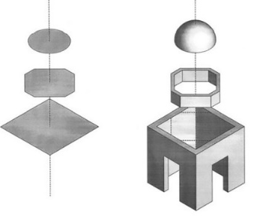

Figure 1. Changing the quadrilateral space to an octagonal space and then the dome’s ceiling to indicate transcending to higher levels of being [38]

The number ‘9’ has held a distinct significance in Islamic architecture and design due to its association with concepts within Islamic cosmology. This connection has led to creation of geometrical shapes imbued with profound mystical messages. In Islamic cosmology, ‘9’ signifies the ninth heavenly sphere. Scholars from the Safavid era believed that the number nine symbolizes God’s Throne, representing a realm of existence accessible after passing Ālam al-Mujaradāt (the realm of logic and self). God’s Throne is envisioned as the abode of God’s favored angels, who fly over the divine light of God. Moreover, the ninth sphere is the place where Sidrat al-Muntahā (Ṭūbā) tree is located; it is the place where Sīmurgh resides – it encompasses the entire universe [33].
These notions in architecture are embodied through different numbers, shapes, and geometrical functions. However, the number 9’ is set apart from other numbers because it has been employed in designing buildings in the Islamic architectural era. The number ‘9’ was primarily used in decorations through the pattern of ‘Shamse’ (The Sun) as the repeated forms of specific shapes.

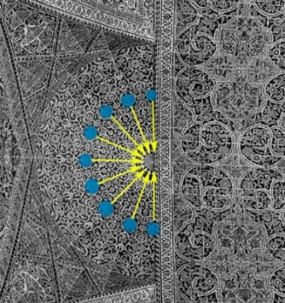

Figure 2. The decorative pattern of Isfahan’s Seyed Mosque entrance gate features the number ‘9’, highlighting the Shamse or ‘Nūr al-Anvār’

In other words, the space between Shamse and the squinches on the dome is typically adorned with patterns that exhibit repeated geometrical motifs representing various iterations of the number ‘9’. From the explanations provided earlier, it's evident that the number ‘9’ symbolizes God’s Throne, which is encircled by angels flying around the divine light of God.

- METHODS
This study aims to compare the concepts of Islamic cosmology, specifically the World of Sovereignty or Ālam al-Malakūt, and the geometric and numerical structure present in the Islamic architecture of Shaykh Lotfollāh Mosque. This research relies on two sets of data: the first set encompasses information about Islamic cosmology and philosophy gathered from primary library resources. The second set comprises data related to the physical patterns and concealed geometric nature of Shaykh Lotfollāh Mosque, acquired through a combination of library resources and field research.
The research method is qualitative, employing both descriptive and analytical approaches. Data for the research was collected from library sources and field studies. The existing body of research conducted on this historical edifice is systematically reviewed and categorized to uncover the physical and concealed geometric patterns inherent in the architecture of the Shaykh Lotfollāh Mosque. Subsequently, by examining prior studies that identify numerical symbols, notably 8 and 9, as conveying hidden messages within the architecture of Shaykh Lotfollāh Mosque, this research delves into the geometric and numerical framework of the mosque, particularly about the concept of Ālam al-Malakūt in Islamic cosmology.

- RESULT AND DISCUSSION

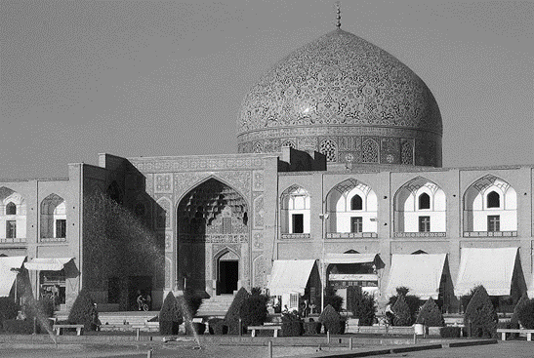

Figure 3. Shaykh Lotfollah Mosque [42]

Shaykh Lotfollāh Mosque is one of the masterpieces of Islamic architectural design in the 18th century that was built on the East side of “Naqsh Jahan Square” within 18 years at the order of Shah Abbās the First [43]. Arthur Upham Pope, in A Survey of Persian Art from Prehistoric Times to The Present (1938), indicates that one can hardly assume that Shaykh Lotfollāh Mosque is a manmade structure. He goes on to say that there is no flaw in the architecture of this building. Everything adheres to the correct proportions, following a strong and beautiful blueprint that resembles a marriage between a world teeming with life and adventure and a sanctuary governed by precious peace and solitude [44].
Drawing upon the existing body of literature and the findings of this study, it becomes evident that the allegorical use of numbers in the decorations of the Shaykh Lotfollāh Mosque conveys specific religious and mystical messages. This practice finds its roots in mystical notions embedded within Islamic cosmology [18][25][4][40]. By observing the repeated inclusion of the numbers '8' and '9' in the geometric and architectural design of Shaykh Lotfollāh Mosque, one can infer their symbolic representation of the eighth and ninth heavenly spheres. In Islamic mysticism, these spheres, known as 'God’s Footstool' and 'God’s Throne', are introduced by Suhrawardī as “The Eighth Realm.”
Corbin believes that Suhrawardī was the first philosopher to introduce a perfect realm or the eighth realm of being after the seven-fold realm that was experienced through one’s senses – a realm based in the heavens and including the eighth and ninth heavenly spheres. Therefore, in architectural and geometric contexts, these two numbers always indicate a higher realm of being that is not experienced through one’s senses but can be discovered through one’s imagination.
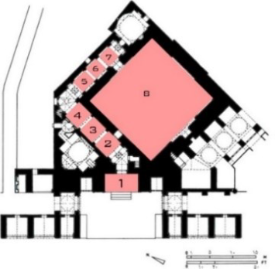

Figure 4. Seven spaces lead to the dome

Shaykh Lotfollāh Mosque is no exception to this fact as one of the masterpieces of Islamic architectural design. This mosque consists of seven consecutive spaces, having similar designs and dimensions, which lead to the dome. The dome, alongside these seven spaces, represents the eighth space that showcases an entirely different architecture that hints at a divine realm.
In other words, the architectural layout of Shaykh Lotfollāh Mosque incorporates seven distinct spaces that sequentially lead to the central dome. This architectural design symbolically represents the philosophical idea that there are nine heavenly spheres in Islamic cosmology, with the eighth symbol symbolizing God’s footstool, which serves as the entrance to the highest and most divine realm, God's Throne. The mosque's design reflects this concept by placing the dome, representing the eighth sphere, at the culmination of the seven spaces.
Additionally, the reference to mystics ascending to this realm after traversing the seven heavens suggests a spiritual journey or ascension through various levels of consciousness or enlightenment. It is a physical manifestation of this philosophical and spiritual concept within Islamic cosmology.

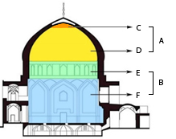

Figure 5. The several parts of the dome represent the several stages one has to go through to reach the higher realms of being. (a) God’s Throne (b) God’s footstool (c) Shamse (d) arabesque patterns (e) 16 windows encircling the dome (f) eight squinches

On the other hand, the dome, which stands at a height of 32 meters, is divided into four distinct sections, each adorned with distinctive decorative and geometric motifs. Utilizing eight squinches, the dome transforms from a quadrilateral to an octagonal one before culminating in a circular form. This architectural transition symbolizes a philosophical concept drawn from Islamic thought. According to this belief, in God's footstool or the 8th sphere, eight angels carry God’s Throne, referred to as the 9th sphere in Islamic cosmology.

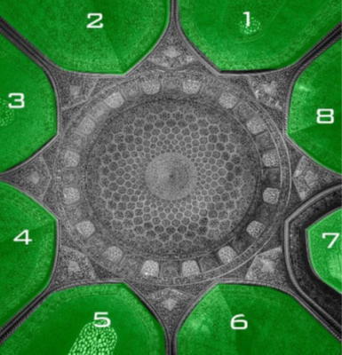

Figure 6. The dome chamber interior and its eight squinches

Moreover, it is said that the eighth heavenly sphere is surrounded by myriad stars. As previously mentioned, Sīmurgh, while descending from the ninth heavenly sphere and Espahbudī (divine) lights, arrives at the eighth heavenly sphere [36], and the 16 windows that are built around the dome reflect 16 rays of light representing the divine lights and countless stars that surround the eighth heavenly sphere. According to Dante and Avicenna, the angels worship God in the eighth sphere. When the mystic moves beyond this realm, he passes the fixed stars and enters God’s Throne and higher realms of being where Sīmurgh and the prophets reside. In other words, as the mystic enters the eighth space in the mosque and progresses beyond the 16 windows in the eight squinches of the dome, they reach the dome’s ceiling, which, according to sacred geometry, embodies God’s Throne due to its circular design.

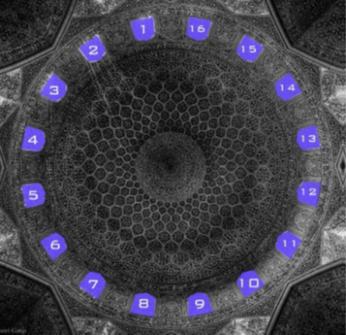

Figure 7. The 16 dome windows symbolize Espahbudī lights, guiding towards God’s Throne

The illustrations on the dome of Shaykh Lotfollāh Mosque include a Shamse, nine circles, and 32 circular parts (Wāgīre) that, as they get closer to the ceiling, become smaller and smaller in size until they ultimately become a part of the Shamse at the center of the ceiling. These illustrations, while depicting the philosophy behind the number ‘9’ in the Shamse, showcase the centrist vision of Islamic thoughts and the oneness of God [45]. On the other hand, the number of the circular parts (32) multiplied by the number of the circles (9) is 288.

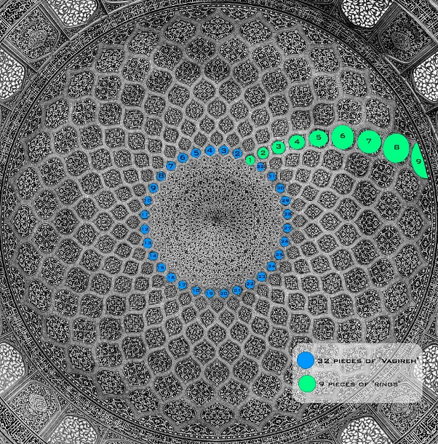

Figure 8. The illustrations of Shaykh Lotfollāh Mosque

In addition, the term ‘Karūbīn’ represents the Abjad numeral system of 288, symbolizing the number of God’s favorite angels, which concords with the analysis of Dante and Avicenna about the angels in the ninth heavenly sphere that was previously mentioned in this research [33]. Corbin and Stierlin believe that the illustrations on the dome depict the Ṭūbā tree – a tree on which Sīmurgh resides. In this regard, Stierlin states that the dome undoubtedly portrays an enormous tree on which a gigantic crown of branches is placed that rules over the Mihrāb [46]. Stierlin’s account lends support to the perspectives of Islamic scholars regarding the ninth heavenly sphere. Furthermore, the number ‘9’, as incorporated in the muqarnas of the Mihrab in the dome across the Shamse, embodies ascending to higher realms of being – the realms that start from number ‘8’, continue to number ‘9’ and end to Shamse. On the other hand, if we take a look at the peacock illustration on the dome’s ceiling when the sun lights the dome, we witness a shining Sīmurgh that is sitting on the branches of the Ṭūbā tree.

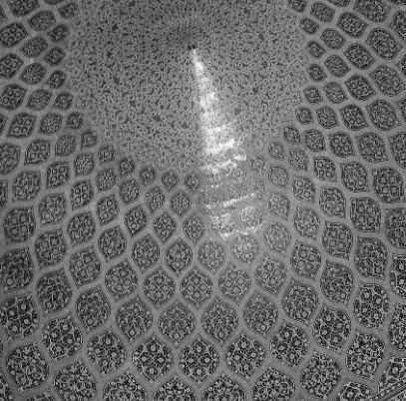

Figure 9. Dome illustrations depict Sīmurgh's Ṭūbā tree

In addition, if we consider the use of numbers 8’ and ‘9’ in the architecture of Shaykh Lotfollāh Mosque while taking into account Shamse as the representation of the highest realm of being (Nūr al-Anvār), based on the opinions of the orientalists and related literature, we understand that the dome symbolizes the ninth heavenly sphere or God’s Throne. The ninth heavenly sphere is where the Ṭūbā tree is placed on which Sīmurgh resides, and it is also the home to many angels and prophets.

- CONCLUSION
This study provides a comparative analysis of the divine concepts arising from Islamic cosmology with the numerical ratios used in the architecture of the Sheikh Lotfollah Mosque. According to the study findings, the repetitive use of ‘8’ and ‘9’ and their multiples in Shaykh Lotfollāh Mosque’s design was to showcase the mystical concepts of the eighth and ninth heavenly spheres in Islamic cosmology which are known as ‘God’s Footstool’ and ‘God’s Throne.’ Therefore, it can, without a doubt, be suggested that the Muslim architect of Shaykh Lotfollāh Mosque constantly connected with the divine source and reflected that through his work. These mystical instances are evident in the use of mathematics and numerology like a 32 meters dome, 288 illustrations that are created around the Shamse, the number of squinches, 16 windows in the dome, the order of the seven spaces that lead to the dome, the illustrations that represent the Sidrat al-Muntahā (Ṭūbā) tree, and the shining image of the peacock on Shamse; the above instances directly reflect the eighth (God’s footstool) and ninth (God’s Throne) heavenly spheres, which were discussed by many scholars of that era and were represented in the numerical and geometrical order of the architecture of the mosque. In other words, Shaykh Lotfollāh Mosque’s architect used the seven spaces that led to the dome to indicate the seven heavenly spheres the mystic should pave to enter God’s footstool and God’s Throne. The illustrations that represent the Ṭūbā or Sidrat al-Muntahā tree as represented in Islamic thoughts, 288 illustrations representing God’s favorite angels, and the peacock on Shamse that is shining in the dome as if it represents the Sīmurgh that resides on the Ṭūbā tree, all are parts of the decorative measures in Shaykh Lotfollāh Mosque which represent mystical and cosmological notions of God’s Footstool and Throne (eighth and ninth heavenly spheres). Therefore, based on the study findings, the architect of Shaykh Lotfollāh Mosque wanted to recreate the mystical notions of “The Eighth Realm,” which included the concepts of the eighth and ninth heavenly spheres represented in Islamic cosmology. By using the factors ‘8’ and ‘9’ and multiples such as 16, 32, and 288, the architect has successfully encrypted these cosmological messages in Shaykh Lotfollāh Mosque. In other words, the architect of Shaykh Lotfollāh Mosque wanted to create a masterpiece that would directly represent the eighth and ninth heavenly spheres.
Moreover, the findings of this study can provide a better understanding of the common cultural notions used in the architecture of the Safavid era since these geometric and numerical archetypes were used in other structures in the era to indicate specific encrypted notions related to Islamic cosmology. In this context, it is suggested that future research examines the impact of Islamic cosmological concepts on the numerical patterns used in the geometry and decorations of other Safavid mosques in Isfahan. This research could identify and compare patterns influenced by these concepts, enhancing our understanding of how Islamic cosmology shaped religious buildings. Such studies would deepen our appreciation of the connections between philosophy, cosmology, art, and geometry in Islamic architecture.
Additionally, we can adapt these principles for contemporary use by elucidating how Islamic cosmological foundations influenced the architectural structure of Safavid mosques in Isfahan. Future research could also propose strategies for incorporating these concepts into the design of modern mosques.

REFERENCES
[1] S. M. Tarighi, “Architectural features of Islamic mosques”, Art Quarterly, Vol. 33, pp. 534-555, 1997.
[2] T. Burckhardt, Immortality and Art. Vol. 1, Tehran: Barg Publications, 1994.
[3] A. Bidsorkhi, A. Esmaeelizadeh, K. R. Berandaq, S. Piroozfar, “An Analysis of the Reality of Throne and the Meaning of its Carriers Focusing on the Seventeenth Verse of Chapter Al-Hāqqah”. Quranic Researches, Vol.24, No. 91, pp. 29-54, 2019. Doi: 10.22081/jqr.2018.50608.1958
[4] F. Akbari, et al., “Spiritual Knowledge and Geometric Codes (extracted from the doctoral thesis: Interpretation of geometric codes in Islamic culture and art of Iran)”, Mystical Literature Researches (Gohar Goya), Vol. 13, pp. 1-21, 2010.
[5] T. Haghtalab and K. Farhad, “The Mosque, The Manifestation of Holy Architecture”, Haft Hesar Journal of Environmental Studies, vol.1, No.1, pp. 21-28, 2012.
[6] S. R. Canby, The Golden Age of Persian Art, 1501 – 1722, Tehran: Nashr-e-Markaz, 2005
[7] A. Fahimifar, “Representation of the Mystical Concepts in Architectural Form of the Safavid Era”, Theoretical Studies of Art, Vol. 2, No. 3, pp. 115-116, 2023
[8] B. Dabirinejad, “Corners of Safavid Culture and Art”, the Journal of Islamic Studies, pp. 26-27, 1978.
[9] M. Aghaeimehr, et.al., “Comparison of Light Effects in Sohrevardi´s Opinion and Safavid Architecture”, Naqshejahan- Basic studies and New Technologies of Architecture and Planning, vol. 8. No. 2. pp 123-131, 2018.
[10] M. Shajari, S. Sylvayh, “Explaining the relationship between the dome of the mosque and the levels of existence in transcendent wisdom”, Contemporary wisdom, 2019.
[11] Y. Ajand, “Innovation and modernity in Safavid art”, Honar-Ha-Ye-Ziba, vol., 7, pp. 4-11, 2000.
[12] M. Salimi, M.R. Sharifzadeh, and I. Baniardalan, “Phenomology of Sacred Places Based On Iranian-Islamic Architecture: Case study of Historical Mosque of Sheikh Lotfollah in Isfahan”, Islamic mysticism (religions and mysticism), vol 17, no. 63, pp. 251-266, 2020.
[13] M. Shahani, “Sheikh Lotfollah Mosque: A Story of Daylight in Sequential Spaces”, Space and Culture, vol. 24, No. 1, pp. 19-36, 2018. Doi: https://doi.org/10.1177/1206331218782406.
[14] M. R. Rostami, N. Yaseri, “A study on the crystallization and flourishing of the themes and principles of Shiite art in the architecture of the Timurid and Safavid eras (Case study: Goharshad Mosque and Sheikh Lotfollah Mosque)”. Architectural Survey, vol. 12, 2020.
[15] S. Z. Nayini, and S. Nayini, “Investigating the empty spaces of Sheikh Lotfollah Mosque”, Negarineh Islamic Art, vol. 2, pp. 70-82, 2014.
[16] M. Goudarzi, M. Bemanian, and M. Leylian, “Geometrical analysis of architectural drawnings in the Shah-mosque Isfahan”, Curved and Layered Structures, vol. 7, pp. 68-79, 2020. Doi: https://doi.org/10.1515/cls-2020-0007
[17] H. Rezazade, “Visual and Structural Analysis of Fractal Geometry in the Sheikh Lotfollah Mosque Ornaments (Isfahan- Iran)”, International Journal of Architecture and Urban Development, Vol. 11, No. 1, pp. 71-82, 2021.
[18] H. Anvari, Great speech culture, Tehran: Nashre Sokhan, 2002
[19] Hajighasemi, Hidden Geometry in Sheikh Lotfollah Mosque View, Soffeh, 1996.
[20] H. Karimian, and S. Seyydi, “Geometry and geometric proportions in the construction of domes of Safavid mosques in Isfahan (case example: Imam Mosque and Sheikh Lotfollah Mosque)”, Iranology ( Faslnameh), Vol. 8, pp. 23-44, 2018.
[21] A. Dahar and R. Alipour, “Geometric analysis of the architecture of Sheikh Lotfollah Mosque in Isfahan to determine the geometric relationship between the prayer hall and the entrance of the building”, Bagh Nazar, vol. 26, pp. 33-40, 2013.
[22] M. Mirzakhanian and F. Shahroudi, “The wisdom of numbers in the decoration and structure of Sheikh Lotfollah Mosque”, The Naghsh Journal, Vol. 8, no. 8, pp. 33-38, 2014.
[23] S. Golzar, “Sheikh Lotfollah Mosque, a unique monument from the Safavid era”, The development of art education, pp. 51-53, 2015.
[24] K. Afshar, “Investigating the effect of Islamic motifs in designing the dome of Sheikh Lotfollah Mosque in Isfahan”, in The Second International Conference on Architecture, Civil Engineering and Urban Planning at the beginning of the third millennium, Tehran, 2016.
[25] A. Norouzi, “Sheikh Lotfollah Mosque”, Golestane Quran, vol. 99, 2001.
[26] L. Zhmud, Pythagoras and the Early Pythagoreans. 1 ed. Oxford: Oxford University Press, 2012.
[27] V. Vorontsov, Astronomy in the New World. Tehran: Gutenberg Publishing, 1973.
[28] P. Coles, Cosmology, Tehran: Basirat, 2011.
[29] H. Q. Chanlu, Historical Geography of Islamic Countries, Tehran: Samt Publications, 2001.
[30] A. Z. Qomshaei, Islamic Astronomy, Qom: Sama Cultural Institute, 2002.
[31] S. H. Shahrashtani, Islam and astronomy, Qom: Bostan Kitab Institute.‬‬‬‬‬‬‬‬‬‬‬‬‬‬‬‬‬‬‬‬‬, 2007‬‬‬‬‬‬
[32] D. R. R. Rasol, “The Reaction of Theologians to The Raised Challenges from Ptolemaic System”, Kalam Islami, Vol. 26, No. 103, pp. 129-145, 2017.
[33] Z. Parsapur, “A comparative study of the course of the planets and its mythological foundations and astrological implications in Meraj Nameh, Siral Abad, and Divine Comedy”, Matn Pajohi Adabi, vol. 33, no. 11, pp. 22-43, 2007.
[34] R. Asadpour, “The Description of Avaz e Par e Jibrael”, Information on Wisdom and Knowledge, Vol 6, pp. 48-57, 2007
[35] A. R. Rezaei, “The seven heavens and the earth in the Qur'an”, Science, vol 2, pp. 113-134, 2008.
[36] M. Goli, “In the mystical school of Sohrvardi (Secrets of the Aql-e Sorkh)”, Persian Language and Literature Quarterly, vol. 12, no. 7, pp. 99-122, 2015.
[37] S. Jin, “Representing and Experiencing Islamic Domes: Images, Cosmology, and Circumambulation”, Religions, vol. 13, no. 6, pp. 526, 2022. Doi: https://doi.org/10.3390/rel13060526
[38] S. Akkach, Cosmology and Architecture in Premodern Islam: An Architectural Reading of Mystical Ideas. New York: State University of New York Press, 2005.
[39] M. B. Mokhtari, “God's Throne and its difference from the footpath”, Quran and Hadith Science Research, vol. 8, no. 16, pp. 54-84, 2011.
[40] M. Khalagh dost, and H. Marofi, Typology of vestibule pattern in introverted housing architecture of Iran (Isfahan, Yazd, Kashan), Shabak, 2020.
[41] V. Vusuqzadeh, M. Hosseinipanah, and B. Alikhani, “The wisdom of the number eight in Islamic art and architecture”, Javidan Khard magazine, vol. 30, pp. 175-192, 2016.
[42] N. Hadjisavvas, “Sheikh Lotfallah Mosque”, in University of The Aegean. 2003.
[43] D. H. S. Shiran, Important examples of religious buildings and architectural and decorative reliefs of Islamic civilization in Iran in the Safavid period, Mohaghegh Ardebily university press, 2010.
[44] A. Pope, ‎Persian architecture‬, Tehran: Akhtaran‬‬‬‬‬‬‬‬‬, 1986‬‬‬
[45] N. Ardalan, Iranian Architecture in the Speech of Four Generations of Expert Architects. The Abadi, 1995.
[46] H. Stirlen, Ispahan - Image du Paradis, Tehran: Forouzan Rooz, 1998

The verses of the Quran indicate that there are only seven heavenly spheres, including verse 29 of Baqarah surah
This structure formally corresponds with what has been stated about the ninth sphere in Seir al-Ebād elal-Ma'ād, indicating that in this sphere, God’s chosen angels are flying the divine light of God

