 |  | JOURNAL OF ISLAMIC ARCHITECTURE  P-ISSN: 2086-2636 E-ISSN: 2356-4644  Journal Home Page: http://ejournal.uin-malang.ac.id/index.php/JIA
IDENTIFICATION OF ISLAMIC VALUES IN THE CONVERSION OF CULTURAL HERITAGE BUILDINGS IN MALANG CITY
CASE STUDY: THE SHALIMAR BOUTIQUE HOTEL AND LAFAYETTE COFFEE AND EATERY
Arief Rakhman Setionoª*, Muhammad Bisri^{b}, Ludfi Djakfar^{c}, Abdul Wahid Hasyim^{d}, Rafidatus Sholihahª, Fifka Amalia Damayantiª
ªArchitecture Department, Faculty of Science and Technology, Universitas Islam Negeri Maulana Malik Ibrahim, Malang, Indonesia
^{b}Water Resources Engineering, Faculty of Engineering, Brawijaya University, Malang, East Java, Indonesia
^{c}Civil Engineering Department, Faculty of Engineering, Brawijaya University, Malang, East Java, Indonesia
^{d}Regional and Urban Planning Department, Faculty of Engineering, Brawijaya University, Malang, East Java, Indonesia
*Corresponding Author: arsetiono@gmail.com
ARTICLE INFO |  |  | ABSTRACT
Volume: 8  Issue: 4  Page: 967- 982  Received: March 24th, 2024  Accepted: July 16th, 2024  Available Online: December 30th, 2025  DOI: 10.18860/jia.v8i4.26525 |  |  | Islamic values encompass important principles and teachings that guide individuals on how to live their lives in this world. Islamic teachings provide guidelines as a basis for decision-making, which is considered an act of worship to Allah SWT. Heritage buildings are crucial for reflecting a society's history and the development of a city. In Indonesia, particularly in Malang City, known as the city with the best colonial planning in the Indies, preserving heritage buildings is vital to preserving their historical, scientific, and cultural values. One way to maintain these buildings is through conversion, which involves changing their functions to meet the needs of a growing city. Since Malang's majority of the population are Muslims who adhere to the principles of Islamic values as their main guide in life, converting buildings should be viewed as an act of worship and align with Islamic teachings. This study aims to identify Islamic values in the conversion of heritage buildings in Malang City and understand how these values can be applied so that the buildings are well-used and managed by the Muslim community. The research method used is a qualitative descriptive approach, which involves describing various discussions and identifying Islamic values based on sources from the Quran and Hadith. This method is applied to explore the principles of conversion through case studies of heritage buildings. The findings highlight Islamic values that can be applied in heritage building conversions, providing recommendations for the Muslim community to manage these buildings effectively in accordance with Islamic values while avoiding actions that lead to shirk (associating partners with Allah).  Keywords:  Islamic values; Conversion; Heritage Buildings; Historical; Cultural; The Quran and Hadith; The principles of conversion

- INTRODUCTION
Historical heritage buildings in Indonesia are very diverse and have varying characteristics, styles, historical values, and conditions. This is related to the identity of old colonial buildings in Indonesia, which reflects the history of Indonesian civilisation in the context of the development and growth of cities in Indonesia. Malang City, renowned for its numerous historical buildings, is the second-largest city in East Java [1]. In the early 20th century, Malang experienced rapid urban development. The city is often regarded as the best example of colonial urban planning in the Dutch East Indies, bearing witness to this historical heritage [1] [2]. Many buildings from the colonial period still stand today. The government has identified 32 buildings as cultural heritage sites, comprising 27 buildings and five structures [3] [4] [5].
In an effort to protect various historical assets, there is a legal basis regarding the preservation of cultural heritage, namely Undang-Undang No. 11 Tahun 2010 concerning Cultural Heritage, which states that cultural heritage is material cultural heritage in the form of cultural heritage objects, heritage buildings, cultural heritage structures, cultural heritage sites, and cultural heritage areas on land and/or water, which need to be preserved because they hold significant value for history, science, education, religion, and/or culture through a designation process [6]. The government and society play crucial roles in preserving cultural heritage buildings. Managing and maintaining these structures involves various parties, including business interests in their utilisation. These buildings can serve as catalysts for promoting urban sustainability, creating job opportunities, and contributing to economic growth [7] [8].
One way to address these issues is by rejuvenating old buildings through adaptive reuse, which involves altering their functions to suit the evolving needs of the city. This process is commonly known as building conversion [9] [10]. By definition, building conversion is the effort to transform and change the functions of old buildings [11]. This initiative is often led by governments to revitalise neglected old city centres and transform them into tourist destinations for both domestic and international visitors [11][12]. Essentially, conversion is chosen as a conservation strategy because the original functions of old buildings may no longer be relevant or applicable. Therefore, over time, these buildings acquire new functions [11]. In the context of heritage buildings, conversion is considered appropriate, even though the buildings undergo changes, because the character of each historical building is preserved and strengthened to maintain the authenticity of its historical architecture [11].
Building conversion offers various positive benefits, including prolonging the lifespan of buildings, revitalizing urban areas, conserving energy and materials, refreshing the surrounding environment, reducing land use for new developments, and utilizing neglected buildings that still hold significant economic value [10] [11]. Therefore, converting old buildings often proves to be more efficient than demolition and new construction [10]. In practice, as described by Pavlovsky, there are principles and criteria guiding this process, which encompass four main aspects: economic benefits, impacts on social and environmental aspects, preservation of historical and cultural values, and potential technological and architectural advancements [8].
Data from the Statistics Bureau of Malang City Centre and the Department of Population and Civil Registration of Malang City for the years 2021–2023 showed that the majority of the population in Malang is Muslim. In 2023, the population of Malang City was projected to be 847,182 people. The majority of the population adheres to Islam, comprising approximately 792,002 people, which is around 93% of the total population [13]. With such a large Muslim population, it is clear that Islamic values are the main guidelines for behaviour among the residents of Malang City. These values encompass important life principles and teachings that guide individuals in how they should live their lives in this world. They function as a source of ethics and morals, regulate the balance of human life, and provide guidelines for making decisions and taking action [14].
In Islam, the revelation of Islamic teachings aims to offer guidance for humanity, facilitating their pursuit of happiness in the afterlife. As such, Islam governs all human activities, not only encompassing matters of worship (mahdah) such as prayer, fasting, almsgiving, and pilgrimage (hajj), but also addressing non-worship activities (ghairu mahdah), including transactions and interactions in various fields, including architecture [14]. This corresponds to the word of Allah SWT in Surah Az Zariyat ayat 56: "And I did not create the jinn and human except to worship Me". According to the interpretation of Ibnu Katsir, the meaning of this ayat is that Allah created them solely for the purpose of commanding them to worship Him, not because Allah needs them, but so that they may willingly submit and worship Allah, whether willingly or reluctantly. According to As-Suddi, worship can be beneficial or detrimental. Worship is beneficial when it is free from musyrik or associating partners with Allah.
However, it becomes detrimental when worship is tainted with musyrik beliefs [15]. Meanwhile, according to Quraish Shihab, Allah did not create jinn and humans for a benefit that returns to Me, but I created them to worship Me, and that worship is very beneficial for themselves [16]. Thus, based on the interpretations of Ibn Kathir and Quraish Shihab, as well as the interpretation of Surah Az-Zariyat, Ayat 56, whatever humans do, including architecture, is solely a form of worship of Allah, and this will ultimately benefit humans themselves. However, according to Ibnu Katsir's interpretation, the value of worship may not be beneficial if human worship is accompanied by acts of musyrik, namely associating partners with Allah and contradicting Islamic values.
In the context of architectural activities related to cultural heritage conversion, Islamic values govern how buildings and their environments are constructed and managed, emphasizing the values of justice, safety, and sustainability:
- Form
The buildings should have a pleasing appearance that is functional and moderate, avoiding excess and luxury. Something beautiful is not synonymous with excessive or luxurious [15][17].
- Not wasteful or efficient
Architectural designs should be functional to optimise usage and minimise waste, thereby enhancing efficiency in materials and costs [15][17].
- Technique
Buildings must have robust construction to ensure the safety of their occupants. Utilising environmentally friendly materials and promoting recycling aligns with technological advancements [15][17].
- Safety and Comfort
Architectural works are required to ensure the safety of their occupants, particularly in preparing for and responding to disasters or calamities. This commitment to safety is seen as a proactive effort to protect lives and property. Additionally, architectural designs should prioritise providing comfort to residents, fostering a sense of gratitude for the blessings bestowed by Allah. This dual emphasis on safety and comfort underscores the ethical responsibility within Islamic values to enhance the quality of life while safeguarding individuals and communities [15][17].
- Harmony with nature
Buildings should blend harmoniously with their environment, respecting natural surroundings without causing harm [15][17].
- Local wisdom
Architectural work should respectfully integrate local cultures that align with Islamic values and principles. This approach allows architecture to serve as a form of da'wah, or invitation to Islamic principles, that resonates with society. By doing so, architecture not only respects the local community but also contributes positively to the preservation of cultural heritage and societal acceptance. Translate to Indonesia [11][19].

Based on the description above, this research is particularly intriguing because it aims to identify Islamic values in the conversion of cultural heritage buildings, specifically examining how these values can be applied to such conversions in Malang City. Previous studies have typically focused on Islamic architecture in mosques, residences, or buildings originally designed with Islamic principles. The application of Islamic values to commercial cultural heritage buildings in Malang City is relatively rare, as many of these buildings do not embody Islamic architectural styles or were not initially intended for use by Muslims. However, given that Malang City now has a majority Muslim population, there is a growing need to adapt these commercial buildings to meet current demands. This study will focus on the conversion of cultural heritage buildings with commercial functions, such as cafés and hotels. The case studies to be researched include those at the Shalimar Boutique Hotel in Malang and Lafayette Coffee and Eatery.
The results of this research will provide recommendations for converting heritage buildings to be more Muslim-friendly. By applying these Islamic values, it is hoped that future conversions can help avoid harmful actions or those that could lead to syirik, thereby ensuring that worship remains beneficial. Engaging in idolatrous actions is highly disliked by Allah and is a major sin. Therefore, as Muslims, it is important to avoid anything that can lead to harm or syirik, as stated in the hadith narrated by Imam Malik, hadith number 1234," The Prophet Muhammad (peace be upon him) said: You must not cause harm to yourself and cause harm to others." [20]. In another hadith narrated by At-Tirmidzi, number 2317, "The Prophet Muhammad (peace be upon him) said, 'Among the goodness of a person's Islam is leaving that which does not concern him" [21].

- METHODS
This research employs the qualitative-descriptive research method. Methodologically, it entails describing and analysing discussions to identify Islamic values relevant to the conversion principles observed in case studies of cultural heritage buildings. The research process consists of four stages: problem identification, data collection, data analysis, and evaluation of research outcomes [22]. Here are the steps involved in the research stage:
- Identify the problem that will be the research objective. Determining the research objective involves addressing challenges concerning cultural heritage buildings in Malang City that require adaptation to current developments and community needs. The outcome of this identification process will define the research goal: to explore Islamic values in the conversion of cultural heritage buildings to meet the needs of Malang City's predominantly Muslim population, ensuring that these conversions are considered acts of worship and align with Islamic values.
- Data collection. Data collection for this research employs two approaches. Firstly, it involves gathering primary data through field observations to study the conversion process of cultural heritage buildings across various dimensions, including economic, social, environmental, historical, and technological aspects, as well as conducting interviews with managers or public relations personnel. Secondly, it includes gathering secondary data through a literature review encompassing books, journals, articles, and other pertinent sources related to Islamic values and the conversion of cultural heritage buildings.
- Data analysis. The data analysis phase will focus on exploring Islamic values in the conversion of cultural heritage buildings, drawing on the theoretical frameworks of Islamic values. This process involves studying Islamic values derived from Quranic verses, supported by interpretations from mufassir, to ensure accurate understanding and prevent misinterpretations. Interpreting the Qur'an requires sufficient competence and skill, as incorrect interpretations can significantly influence the outcomes [23]. In addition to the Qur'an, another source of Islamic values commonly utilised is the Sunnah (Hadith). The use of these two basic sources of Islamic values is stated in the history of Imam Muslim no. 4425, "that the Messenger of Allah said, verily I have bequeathed to you two very great things. One of them is the Koran, whoever follows its instructions will receive guidance and whoever abandons it will go astray" [24]. In another hadith narrated by Imam Malik no. 1395, "that the Messenger of Allah said that I have left it for you, you will not go astray as long as you adhere to these two: the Book of Allah and the Sunnah of His Prophet" [20].
- Evaluate the results of the research carried out, and there are recommendations for converting cultural heritage buildings that can be friendly to Muslims. By applying Islamic values, it is hoped that the future will see a reduction in dangerous actions or those that lead to shirk, thereby ensuring that worship remains beneficial.

The case studies, chosen as objects for research, are The Shalimar Boutique Hotel in Malang and Lafayette Coffee and Eatery. The Shalimar Boutique Hotel Malang is located on Jl. Cerme No. 16, Oro-Oro Dowo, Klojen District, while Lafayette Coffee and Eatery is located on Jl. Semeru No.2, RW.4, Oro-oro Dowo, Klojen District (Figure 1). These two buildings are among the cultural heritage sites designated by the Malang City Government for preservation, representing the Nieuwe Bowen architectural style and reflecting the history of that time [25,26,27]. To extend the life of the buildings and preserve them, the Shalimar Boutique Hotel in Malang has been converted into a five-star hotel, while Lafayette Coffee and Eatery has been converted into a café.

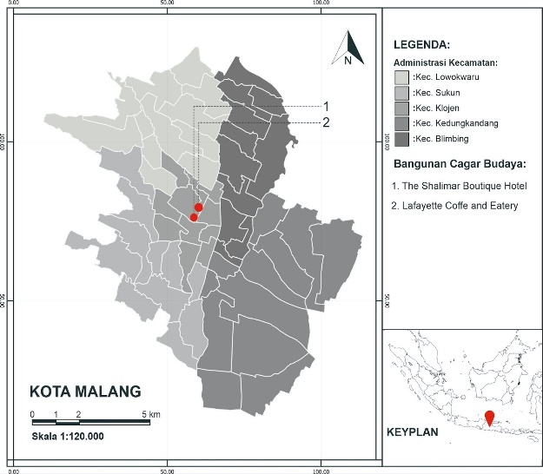
Figure 1. Location map of The Shalimar Boutique Hotel, Malang, and Lafayette Coffee and Eatery

- RESULT AND DISCUSSION

  - HISTORY AND CONVERSION PROCESS OF THE SHALIMAR BOUTIQUE HOTEL MALANG
1933-1940-an: According to interviews and articles, the Shalimar Boutique Hotel Malang was constructed in 1933 by Ir. Muller [25]. Originally, this Societeit building served as a venue for meetings, conferences, and dances for the Dutch community in Indonesia. It also functioned as the headquarters for the Freemasonry group. Freemasonry is an international fraternal organisation with a significant membership, including in Indonesia during the Dutch colonial era [28].
1950s: After the disbandment of the Freemason community and the end of the Dutch colonial period, the building was repurposed as the headquarters of RRI in Malang [25]. While the exterior remained unchanged, the Freemason symbols were removed. The interior was converted into a production and broadcasting centre for radio programmes, including news, music, and other educational and entertainment content. However, the central hall was preserved as a space for gatherings and dances.
From 2015 to the present: After RRI Malang relocated to Lowokwaru District, the building underwent significant renovation and was transformed into a five-star hotel to prevent further deterioration (Figure 2). According to observations and interviews, the original exterior of the building was preserved. However, to meet the hotel's needs, four additional floors were added around the original structure, and a café was incorporated with a design that integrates harmoniously with the original architectural elements while incorporating modern amenities for guest comfort. Inside, the original central hall was preserved and repurposed into a restaurant, maintaining its historical ambiance. Despite maintaining the building's original character, modern technology, including fire safety systems, CCTV, lighting, and artificial ventilation, was installed to meet contemporary hotel standards. This renovation successfully blends classic colonial charm with modern comforts, establishing the hotel as a significant historical landmark in Malang.

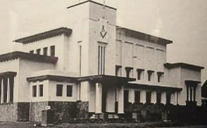 | 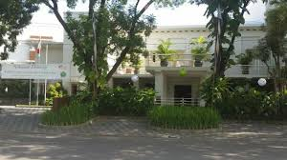
Figure 2. (a) Societeit building (1933) (b) The Shalimar Boutique Hotel Malang (2024)

  - HISTORY AND CONVERSION PROCESS OF LAFAYETTE COFFEE AND EATERY
1936-1967: The Lafayette Coffee and Eatery building was established in 1936 by Herman Thomas Karsten as part of Malang City's Bouwplan V development project. It was one of a pair of twin buildings that marked the entrance to Ijen Boulevard, a newly planned, self-contained town. Originally owned by Han Thien An, a sugar mill entrepreneur, the building to the north, now housing Lafayette Coffee and Eatery, was later sold by the Han Thiau An family and became a bookstore known as Boekhandel Slutter-C.C.T. van Dorp Co. [27,29]. The building's architecture adheres to the Nieuwe Bouwen style, emphasising functional design suited to the local climate. It features a tower at its highest point, specifically designed for observing the surrounding environment.
[27].
2018: By the Mayor of Malang's Decree Number 185.45/364/35.73.112/2018 dated December 12, 2018, this building was designated as one of Malang's cultural heritage sites. It subsequently housed the Malang branch of the Commonwealth Bank. However, over time, the building fell into disrepair due to insufficient maintenance, eventually becoming abandoned once more [27, 29].
2021-now: To prevent abandonment, the building has been repurposed as Lafayette Coffee and Eatery (Figure 3), aligning with Malang's growing trend of café establishments that reflect shifts in local lifestyles [30]. After years of neglect, substantial changes have been made both externally and internally. Externally, the upper floors had their glass windows removed, and new aluminium frames replaced the lower windows while preserving the building's overall original character [31]. Internally, extensive renovations were undertaken to accommodate the café's requirements while respecting the original architectural style, thus maintaining the historical ambiance despite significant transformations.

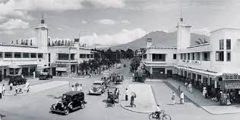 | 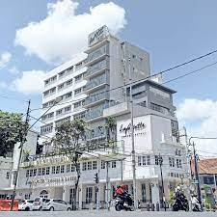
Figure 3. (a) Trade center (1935) (b) Lafayette Coffee and Eatery (2021)

Here is the analysis of identifying Islamic values in the conversion principles applied to The Shalimar Boutique Hotel in Malang and Lafayette Coffee and Eatery.

- 1. Economic Principles
In the context of ageing cultural heritage buildings that have lost their original functions, their value lies in their reuse. From an economic aspect, this drives the conversion of cultural heritage buildings to generate sustainable income for Malang City [8].
Economically, in the case studies of The Shalimar Boutique Hotel Malang and Lafayette Coffee and Eatery, both buildings have been repurposed into commercial establishments that contribute to Malang City's income while revitalising historical structures. The Shalimar Boutique Hotel Malang, originally serving the Dutch community and Freemason headquarters, later RRI station, has been transformed into a hotel that retains its Nieuwe Bouwen architectural style. Inside the Shalimar Boutique Hotel Malang, the interior seamlessly blends classic colonial elegance with contemporary comforts. The meeting space, which previously hosted Freemason activities, has been retained and repurposed as a hotel restaurant, preserving its historical atmosphere.
Lafayette Coffee and Eatery, initially a landmark in the Kayutangan area, has been converted into a café while preserving its original Nieuwe Bouwen architectural features. Despite undergoing extensive renovations to accommodate café needs, Lafayette maintains its historical character in an atmosphere that still reflects the beauty of its architectural era.

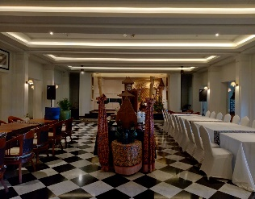  a | 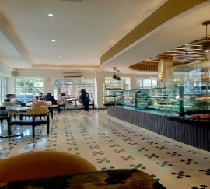  b
Figure 4. (a) The interior of the Shalimar Boutique Hotel Malang (2024), (b) The interior of Lafayette Coffee and Eatery after conversion (2024)

These two case studies demonstrate the successful repurposing of cultural heritage buildings into new functions while preserving their original architectural form and selecting interior elements. By maintaining their heritage value, The Shalimar Boutique Hotel Malang and Lafayette Coffee and Eatery offer distinct characteristics compared to other hotels and cafés, attracting local, out-of-town, and international tourists (Figure 4).
According to Ari Widyati Purwantiasning in his book, the goal of this conversion is to find practical uses for managing old historic buildings effectively, preventing neglect, and ensuring their preservation [31]. Converting buildings like The Shalimar Boutique Hotel Malang and Lafayette Coffee and Eatery can be a more sustainable and efficient option compared to constructing new buildings for hotels and cafés, thereby reducing wasteful practices. In Islamic values, waste or excessive actions are discouraged as they can cause harm to the environment, a principle emphasised by Allah SWT and the Prophet Muhammad.
This is stated in Surah Al-A'raf ayat 31,"O children of Adam, take your adornment at every masjid, and eat and drink, but be not excessive. Indeed, Allah does not love those who commit excess". According to Quraish Shihab's interpretation, "Allah SWT permits it as long as it is done without excess and not out of arrogance." In all things, humans should avoid excess. Thus, we should not fall into this category. Excessive behaviour not only leads to harm and danger but is also displeasing to Allah SWT. Any action that displeases Allah SWT will inevitably bring harm and His wrath if carried out [15].
Apart from that, the primary function of the two case studies aligns with Islamic law, as they are used for food services and trade. However, the Shalimar Boutique Hotel Malang includes a bar that sells liquor, which is haram in Islam, as both drinking and selling khamr are prohibited. This is stated in Surah Al-Maidah ayat 90, "O you who have believed, indeed, intoxicants, gambling, [sacrificing on] stone altars [to other than Allah], and divining arrows are but defilement from the work of Satan, so avoid it that you may be successful". According to Ibnu Katsir, Allah SWT says that He forbids His faithful servants from drinking khamr, which is an act that is displeasing to Allah and is an act of Satan [16].
Identifying Islamic values in the economic conversion of both case studies emphasizes the efficient and moderate utilization of existing buildings. However, functionally, the Shalimar Boutique Hotel Malang includes activities that are not fully compatible with Islamic values, particularly those involving trade prohibited by religious teachings. In contrast, Lafayette Coffee and Eatery adheres to Islamic values without violating religious laws, making it a more welcoming and inclusive establishment for the Muslim community.

- 2. Influence On Social Environment
From a social perspective, converting cultural heritage buildings can generate employment opportunities, benefit the city of Malang and private enterprises, and contribute to the preservation of cultural heritage [8]. From an Islamic values standpoint in the social context, it's crucial to respect local culture that aligns with Islamic values and serves as a form of da'wah accepted by society. The conversion of The Shalimar Boutique Hotel Malang and Lafayette Coffee and Eatery addresses the current needs of Malang City, renowned as a hub for tourism and business.
The Shalimar Boutique Hotel, originally a societeit building, Freemason headquarters, and RRI Malang, has been transformed into a hotel that caters to tourists and creates jobs for Malang residents. According to observations, the Shalimar Boutique Hotel offers a diverse range of amenities for guests, including accommodations, event spaces, meeting rooms, dining options, and additional facilities such as sports and spa services. The majority of the hotel's staff are residents of Malang. Meanwhile, Lafayette Coffee and Eatery has been converted into a café to align with the rapid proliferation of cafés in Malang City, catering to shifts in the local community's lifestyle [30]. Lafayette Coffee and Eatery offers a diverse selection of food and beverages, serving as a popular social gathering spot. The majority of the café's staff are residents of Malang.
These two case studies demonstrate how Islamic values are incorporated into conversions that cater to the needs and lifestyles of local communities without conflicting with Islamic law. In the case of The Shalimar Boutique Hotel, the transformation of a societeit building and Freemason headquarters, previously inconsistent with Islamic principles and detrimental to the people of Malang City, into a hotel has resulted in positive impacts and benefits for the community. This conversion not only enhances the utility of the two buildings but also aligns with Islamic values, thereby making a positive impact through the provision of employment opportunities and facilities that benefit the local community. Efforts to convert buildings for the benefit of others are rooted in principles of solidarity and community welfare, strengthened by Islamic values that emphasise providing benefits to others and assisting fellow humans [19].
This is stated in the hadiths, specifically in the riwayat of ath-Thabrani, which is authenticated by Muhammad Nashiruddin al-Albani, "The best people are those who are most useful to others" [32]. Becoming a useful individual is also based on Bukhari Hadith No. 2262 and Muslim Hadith No. 4677: ".. and whoever (is willing) to help his brother's needs, Allah (will always) help his needs" [24,33]. Apart from that, the benefits we give have an impact on our own good as in the word of Allah in surah al Isra' ayat 7, "If you do good (it means) you do good for yourself and if you do evil, then (evil) ) for yourselves, and when the time comes for the punishment for the second (crime), (we will bring others) to hide your faces and theirs into the mosque, as your enemies entered it the first time and to destroy them after -whatever they control is finished". Based on Quraish Shihab's interpretation, if you do good and obey Allah, then that goodness is for yourself in this world and in the afterlife. And if you do something immoral, you are actually destroying yourself [15].

B.3. Natural Environment
In the context of converting cultural heritage buildings, there is a significant connection to the environment. The actions aimed to conserve heritage areas, which involve not only protecting the buildings but also restoring neglected or degraded natural surroundings. Key criteria in these conversions include maintaining the surrounding landscape, utilizing gardens for public use and recreation, and mitigating pollution during reconstruction [8]. By adhering to these criteria, converting cultural heritage buildings not only safeguards their historical and cultural significance but also promotes the preservation of the natural environment, offering enduring benefits for society and the ecosystem.
One of the benefits of converting existing buildings through adaptation is the reduction of construction impacts and waste. At The Shalimar Boutique Hotel, the construction approach preserves the original building's structure with minor adjustments to both the exterior and interior, tailored to meet the hotel's specific needs. Additional building extensions are made behind the original structure to fulfil extra requirements without disturbing the original building or its surrounding area. Meanwhile, Lafayette Coffee and Eatery underwent minor façade improvements while maintaining the original façade form. Major renovations were made to the café's interior, ensuring it did not harm or disturb the surrounding buildings. These efforts demonstrate how the conversion of cultural heritage buildings can be carried out in a sustainable and environmentally friendly manner.
Despite the Shalimar Boutique Hotel undergoing functional changes and additional construction, it remains committed to preserving and enhancing the surrounding environment. Conservation efforts include refurbishing and expanding gardens on the south, east, and west sides of the building (Figure 5-6). These garden additions aim not only to maintain the environmental conditions but also to provide comfort for hotel guests by creating a refreshing atmosphere with a diverse range of plant varieties. Parts of the garden area are also designed to serve as an ideal venue for various outdoor events.

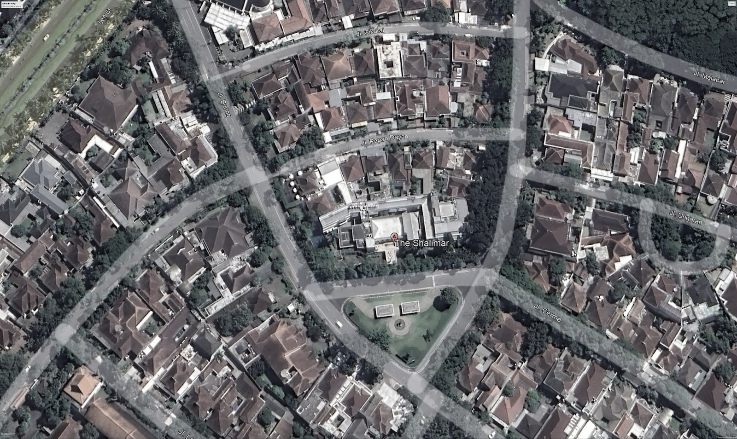
Figure 5. Adding gardens on the east, south, and west sides of The Shalimar Boutique Hotel, Malang

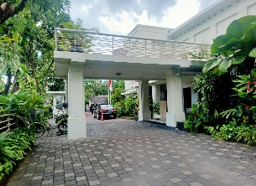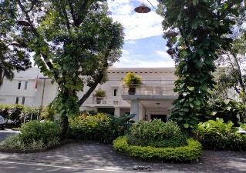

Figure 6. The gardens on the southern/front side of The Shalimar Boutique Hotel Malang serve as green open spaces and refreshment areas

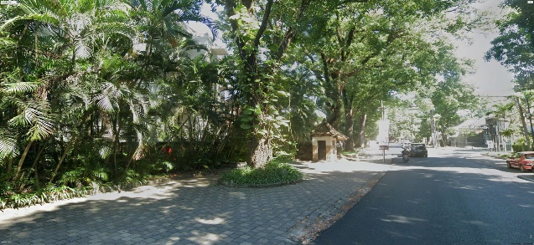

Figure 7. The gardens on the eastern side of The Shalimar Boutique Hotel, Malang, serve as green open spaces

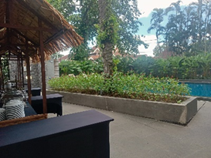

Figure 8. The gardens on the western side of The Shalimar Boutique Hotel, Malang, serve as green open spaces and recreation spaces

Additionally, gardens have been incorporated into the building. This allows natural light to enter the building, particularly in the hotel rooms, creating a healthier and more comfortable environment for guests (Figure 7-9). Through this initiative, The Shalimar Boutique Hotel has successfully struck a balance between modernising the hotel conversion and preserving the environment, adding value to both the hotel and the urban environment around it.

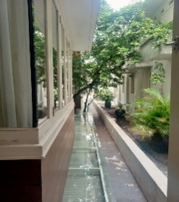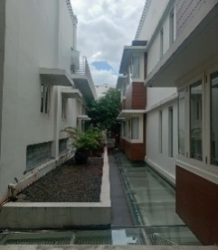
Figure 9. Adding gardens in the middle of The Shalimar Boutique Hotel, Malang

In converting Lafayette Coffee and Eatery, the building originally had only a few trees on its sides. However, to maximize environmental preservation, the café retained these trees and added greenery to the rooftop with various plants (Figures 10-11). This addition protects the café building from excessive thermal effects and helps reduce air and noise pollution from the nearby highway, considering its proximity. The rooftop garden not only serves as a green space but also enhances the experience for general visitors.

a | 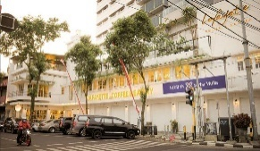  b
Figure 10. (a) Landscape of Lafayette Coffee and Eatery (1935) (b) Landscape of Lafayette Coffee and Eatery (2024)

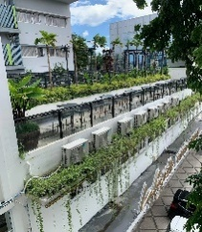  a | 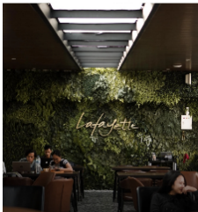  b
Figure 11. (a) Adding a Rooftop garden (b), a Green wall

In terms of the natural environment, Islam is one of the religions that pays attention to the natural environment. This is reflected in many verses of the Quran that discuss the natural environment. The environment is an integral part of human life, being one component of the ecosystem that deserves to be respected, valued, and protected. Positive actions are seen as a means to preserve the environment, whereas negative behaviours can lead to its degradation.
As Khalifah beings on Earth, we are appointed by Allah SWT as stewards of the Earth, entrusted with the responsibility of managing and developing it, including environmental management. This is reflected in the words of Allah in Surah Al-Baqarah ayat 30, "And [mention, O Muhammad], when your Lord said to the angels, 'Indeed, I will make upon the earth a successive authority.' They said, 'Will You place upon it one who causes corruption therein and sheds blood, while we declare Your praise and sanctify You?' Allah said, 'Indeed, I know that which you do not know". According to the interpretation of Quraish Shihab, the word of Allah to His angels was, "Indeed, Allah intends to place upon the earth a successive authority." They said, "Will You place upon it one who causes corruption therein and sheds blood, while we declare Your praise and sanctify You?" Allah said, "Indeed, I know that which you do not know." Thus, Allah appointed Adam and his descendants as successors to inhabit the Earth. He made them stewards to develop the Earth [15].
Nonetheless, a plethora of environmental degradation phenomena or natural disasters stemming from human activities bring about numerous adverse impacts that can be fatal or detrimental to fellow humans. Hence, as Khalifah on Earth, it becomes imperative to exercise wisdom in utilising and managing the surrounding environment to prevent harm to the Earth. Allah SWT warns against causing corruption on the Earth in His statement in Surah Al-A'raf ayat 56, "And do not cause corruption on the earth after it has been set in order. And invoke Him in fear and aspiration. Indeed, the mercy of Allah is near to the doers of good". According to the interpretation of Ibnu Katsir, Allah SWT prohibits committing destructive and endangering acts, especially after they have been rectified. For once, various affairs are running smoothly, and then destruction occurs; it is more dangerous for humanity [16].
From an Islamic values perspective, the conversion efforts of The Shalimar Boutique Hotel and Lafayette Coffee and Eatery are seen as wise actions in environmental management. Such efforts help prevent ongoing environmental damage, and conversion strategies can even facilitate the restoration of natural environments for future use, thereby benefiting users and the community.

B. 4. Technological-Architectural Possibilities
Amid rapid technological advancements, modern tools are increasingly utilised for the preservation of cultural heritage. In the context of converting historic buildings, integrating the latest technological advancements is crucial. Technology plays a significant role in adapting infrastructure to ensure user safety and comfort, especially since historic buildings are often older structures. Therefore, investments in technology are used to reinforce building structures, enhance security against potential hazards such as fires and earthquakes, and provide technology that offers user comfort in line with the conversion's objectives. This helps extend the building's lifespan [8].

B.4.1. Technological-Structural
Based on observations, the original structure of the Shalimar Boutique Hotel remains robust (Figure 12). For additions or repairs, the main structure predominantly uses iron materials. The roof partially incorporates iron structures, while the new ceiling repairs and additions utilise aluminium structures. In addition to using iron, the structure incorporates concrete and wood materials to enhance aesthetics and align with the original building concept.

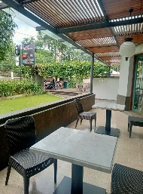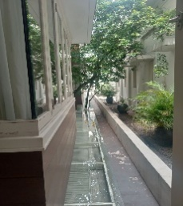
Figure 12. Renovation, adding iron structures to the skylight roof and terrace canopy ceiling at The Shalimar Boutique Hotel

Meanwhile, the main structure of Lafayette Coffee and Eatery has remained unchanged and still retains its original building. However, additions like partitions use aluminium and gypsum board structures. Aluminium structures are used for ceiling renovations (Figure 13). Significantly, the principle emphasizes the need for durable and robust structures and construction to ensure occupant safety and extend the building's lifespan. Both The Shalimar Boutique Hotel and Lafayette Coffee and Eatery retain their original structures, which remain intact. However, for renovations and repairs when damage occurs, they generally use other structures with iron material technology.

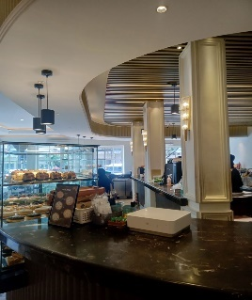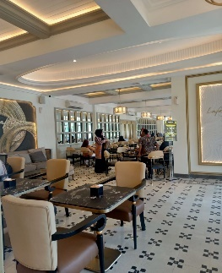
Figure 13. Renovation of the added ceiling and partition walls in Lafayette Coffee and Eatery

The use of iron material is based on its strength, durability, and sustainability compared to other materials. This is also affirmed in the Al-Quran, Surah Al-Hadid, ayat 25, "We have already sent Our messengers with clear evidence and sent down with them the Scripture and the balance that the people may maintain [their affairs] in justice. And we sent down iron, which is great military might and benefits for the people, so that Allah may make evident those who support Him and His messengers unseen. Indeed, Allah is powerful and exalted in might."According to Ibn Kathir's interpretation, the ayah explains that Allah created iron as a provision for life, possessing strength and benefits for humanity. This is intended so that Allah may know who supports His religion and His messengers in preaching, even though Allah cannot be seen [16].
Given that cultural heritage buildings are ageing structures prone to structural vulnerabilities, integrating technologies like steel can bolster the structural integrity of these buildings. Consequently, the adoption of technology can play a crucial role in safeguarding cultural heritage buildings, ensuring they remain safe and comfortable for users both inside and outside the premises.

B.4.2. Technological-Safety
Meanwhile, to enhance security, several technologies have been implemented, including 24-hour CCTV facilities. CCTV is one of the security features offered by The Shalimar Boutique Hotel and Lafayette Coffee and Eatery, with cameras installed on every floor and in every corner of the rooms (Figure 14). For fire safety, they are equipped with fire extinguishers (APAR), hydrants, sprinklers, heat sensors, fire alarms, and evacuation route signs to facilitate quick evacuations in the event of emergencies, such as fires. The effort to provide safety technology is based on Hadith At-Tirmidhi number 2441, "We have already sent Our messengers with clear evidence and sent down with them the Scripture and the balance that the people may maintain [their affairs] in justice. And we sent down iron, which is great military might and benefits for the people, so that Allah may make evident those who support Him and His messengers unseen. Indeed, Allah is powerful and exalted in might."Narrated Al-Mughirah bin Abu Qurrah As-Sadusi: I heard Anas bin Malik saying, 'A man asked Rasulullah saw: 'O Messenger of Allah, should I tie my camel and then trust in Allah, or should I trust in Allah and not tie my camel?' Rasulullah said, "Tie your camel and then trust in Allah." According to this Hadith, managers must make every effort to ensure safety services are provided during the conversion of cultural heritage buildings, acknowledging that ultimate safety lies with Allah SWT.

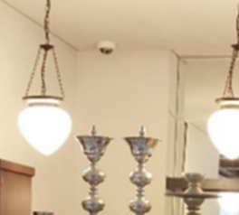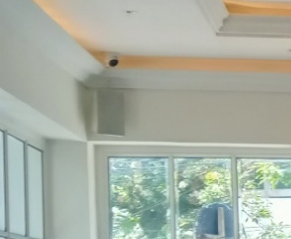
Figure 14. (a) CCTV in The Shalimar Boutique Hotel, Malang (b) CCTV in Lafayette Coffee and Eatery

B.4.3. Technological- User Comfort
In converted buildings, technology plays a crucial role in enhancing comfort, including indoor thermal comfort, optimal lighting, and ventilation. The Shalimar Boutique Hotel and Lafayette Coffee and Eatery are equipped with air conditioning to regulate room temperature and artificial ventilation for comfort (Figure 15). Lighting is adjusted with varying levels of brightness to complement the building's design concept. The Shalimar Boutique Hotel incorporates advanced smart technologies, including room control and automation systems, which centrally manage AC, lighting, humidity, and temperature throughout the hotel. Room access is automated using programmed keys, which activate upon guest entry and deactivate upon exit, allowing for efficient energy management based on demand. Automation also extends to fire safety systems at the Shalimar Hotel, where sprinklers automatically release water upon detecting a rise in temperature or smoke, with evacuation alarms activating automatically during fires. These efforts to provide comfort reflect gratitude for Allah's blessings. This is reflected in the words of Allah in Surah Ibrahim Ayat 7, "And [remember] when your Lord proclaimed: 'If you are grateful, I will surely increase you [in favor]; but if you deny, indeed, My punishment is severe. According to the interpretation, when you are told by God, saying, "If you are grateful for the blessings of salvation and others that I have bestowed upon you, such as steadfastness in faith and obedience, surely I will increase the blessings that I have given to you."

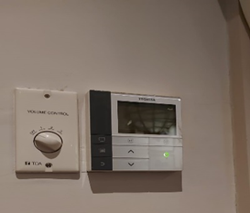  a | 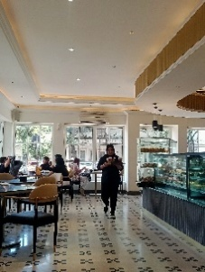  b
Figure 15. (a) Room Control in The Shalimar Boutique Hotel, Malang (b) AC and Lighting in Lafayette Coffee and Eatery

B.5. HISTORICAL-CULTURAL VALUE PRESERVATION
In accordance with the principles of historical and cultural preservation, converting cultural heritage buildings is an effort to preserve and maintain their historical and cultural values. Aspects considered in this process include preserving the building's authenticity. These activities help disseminate history and culture, provide public access to heritage and history, and highlight the architectural and compositional value of an object. By adhering to these principles, the conversion of heritage buildings can preserve and revive the historical and cultural values they embody.
Long History. During the Dutch colonial era, this building served as the headquarters of the Freemasons, an international fraternal organization. After Indonesia's independence, the building was repurposed as the headquarters of Radio Republik Indonesia (RRI), playing a significant role in disseminating information and entertainment at the time. According to observations and interviews with the public relations team at The Shalimar Boutique Hotel, it was found that over time, the building underwent various adjustments according to evolving conditions, situations, and needs. Eventually, the building was repurposed as The Shalimar Boutique Hotel, which not only retains its colonial architectural authenticity but also incorporates modern touches to meet the needs of contemporary guests. The building underwent various adjustments according to evolving conditions, situations, and needs. The exterior of the building still maintains its colonial architectural style, characterized by large doors and windows as well as classic ornaments. However, some parts have been updated with modern materials to ensure the safety and comfort of our guests.
Inside, many original elements, such as tiled floors and high ceilings, have been preserved to maintain the historical atmosphere. However, some areas have been renovated to provide modern amenities such as meeting rooms and halls, advanced lighting systems, and contemporary furnishings that offer comfort without losing the classic touch (Figure 16). Public areas, such as the lobby and restaurant, have also been transformed with designs that blend classic and modern elements, creating an elegant and warm ambiance. Additionally, to enhance knowledge about the building's history, the interior public spaces are decorated with various photos of the old Shalimar Boutique Hotel and cultural heritage sites in Malang City (Figure 17). Furthermore, various rooms are adorned with the hotel owner's collection of furniture, including vases, statues, and antique cabinets.

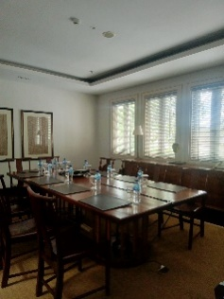  a | 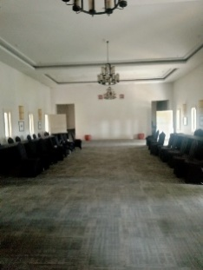  b
Figure 16. (a) Meeting room (b) Hall or Ballroom

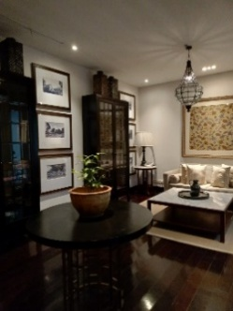  a | 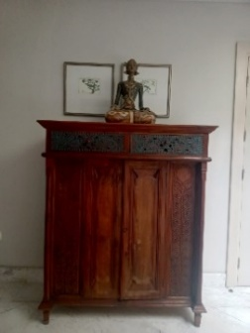  b
Figure 17. (a) The library areas are decorated with various photos of the old Shalimar Boutique Hotel building and cultural heritage sites in Malang City. (b) Decorations include old cabinet furniture and statues

Based on the survey results, Lafayette Coffee and Eatery was formerly a bustling shop located in the heart of Kayutangan, Malang City. Over time, the building has been adjusted to accommodate different uses, resulting in its transformation from a shop to a café and restaurant. The exterior has been renovated, and the façade, doors, and windows have been updated while preserving the original façade by cleaning and repairing damaged architectural details. Inside, the interior has been redesigned to align with the new concept, featuring new paint, flooring, and a rearranged space. The ambiance is made warm and inviting through the use of warm colors, lighting that highlights historical architectural features such as classic chandeliers or suitable wall lamps, and comfortable furniture (Figure 18). Additionally, the bar or coffee counter area is designed to be both attractive and functional.

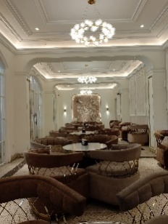  a | 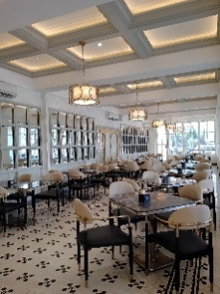  b
Figure 18. Interior in Lafayette Coffee and Eatery

This is stated in the Quran, Surah Shaad, ayat 27: "And we did not create the heavens and the earth and whatever is between them aimlessly. That is the assumption of those who disbelieve, so woe to those who disbelieve in the fire". According to the interpretation of Ibnu Katsir, Allah SWT informs that He did not create His creatures in jest, but rather He created them so that they may worship Him and declare His oneness. Then Allah will gather them on the Day of Gathering, and He will reward the obedient and punish the disbelievers [16].
Preserving the cultural value of history offers an intriguing pathway to explore the journey of the past. The conversion of heritage buildings serves as a means to retain memories or recollections of preserved structures by adapting their functions to suit the continually evolving times. This process allows for meaningful connections with history while accommodating contemporary needs and circumstances.
However, in the preservation of The Shalimar Boutique Hotel, there is an element that contradicts Islamic teachings: the placement of statues depicting living creatures as decorations. as stated in the hadith narrated by Imam Muslim, hadith number 969, "Do not leave any statue without making it shapeless, and do not leave any elevated grave without leveling it" [24]. According to this Hadith, a Muslim is not permitted to create or decorate with statues or images depicting living beings. These items resemble Allah's creations and can be considered an act of shirk. However, some opinions permit statues or images of living beings if they are used for educational purposes.

- CONCLUSION
Various historical buildings in Malang City reflect the city's and the nation's civilizational history. Beyond preserving history, well-managed heritage buildings can promote urban social and environmental sustainability. Converting heritage buildings to serve beneficial community functions, such as commercial purposes, is one way to achieve this goal. Given that Malang City is predominantly Muslim, it is crucial to convert buildings into spaces that cater to and serve the Muslim community. According to the analysis, the principles of converting heritage buildings include Islamic values that Muslims must consider when managing and using these conversions.
Economically, converting heritage buildings involves Islamic values that emphasize efficiency and avoid excess. In the social environment, Islamic values align with the local wisdom of Malang City, emphasizing the importance of benefiting and assisting others. Environmentally, Islamic values in heritage building conversions prioritize the prevention of environmental damage and harmonization with the surrounding environment. Technologically, Islamic values ensure comfort, security, and strength. Historically, converting heritage buildings has preserved cultural heritage, adapted to local wisdom, and served as a form of da'wah for the Muslim community.
According to the case study analysis, the Shalimar Boutique Hotel's conversion principles have not fully adhered to Islamic values. This is evident in the economic aspect, where alcohol is sold, and in the historical preservation aspect, where statues of living beings are used as decorations, making the hotel less Muslim friendly. In contrast, Lafayette Coffee and Eatery's conversion principles align with Islamic values, making the establishment a Muslim-friendly establishment.
The results of this research will provide recommendations for converting heritage buildings to be more Muslim-friendly. By applying these Islamic values, it is hoped that future conversions can help avoid harmful actions or those that could lead to syirik, thereby ensuring that worship remains beneficial.

REFERENCES

[1] L. Mulyadi, B. Fathony and E. Prikasari, Potensi Kampung Heritage Kayutangan sebagai Destinasi Wisata di Kota Malang, Malang: Deazha, 2019.
[2] L. Mulyadi, A. Witjaksono and B. Fathony, Karakter Kawasan dan Arsitektur, Malang: Dream Litera Buana, 2015.
[3] Handinoto, “Perkembangan Kota Malang Pada Jaman Kolonial (1914-1940)),” Dimensi, Vol. 22, pp. 1-29, 1996.
[4] A. Siswanto, “Analisis Visual Identitas Kota Malang Melalui Foto-Foto Pada Festival Malang Tempoe Doeloe 2014: Satoes Akoe 100 Lakoe,” Commonline Departemen Komunikasi, vol. 4, no. 1, pp. 26-37, 2015.
[5] W. Nurdiyanto, “Daftar dan Sejarah 32 Bangunan Cagar Budaya di Kota Malang,” Times Malang, 2023. https://malang.times.co.id/news/wisata/iw3r3p3fx8/Daftar-dan-Sejarah-32-Bangunan-Cagar-Budaya-di-Kota-Malang
[6] Pemerintah Indonesia, “Undang-undang Republik Indonesia Nomor 11 Tahun 2010 Tentang Cagar Budaya,” Undang-undang Republik Indonesia, 2010.
[7] D. Ritiduian and S. Megawati, “Implementasi Kebijakan Pelestarian Bangunan Cagar Budaya (Studi Pada Bangunan Bekas Penjara Koblen Menjadi Pasar Buah di Kota Surabaya),” Publika, vol. 9, no. 5, pp. 15-30, 2021. DOI: https://doi.org/10.26740/publika.v10n1.p15-30
[8] M. Pavlovskis, D. Migilinskas, J. Antucheviciene and V. Kutut, "Ranking of Heritage Building Conversion Alternatives by Applying BIM and MCDM: A Case of Sapieha Palace in Vilnius," Symmetry, vol. 11, no. 973, pp. 1-26, 2019. Doi: https://doi.org/10.3390/sym11080973
[9] A. R. Setiono, M. Bisri, L. Djakfar and A. W. Hasyim, "The Assessment of the Conversion of the Indomaret Building on Bondowoso Street, Malang City with Building Reliability," International Journal of Multidisciplinary Research and Publications, vol. 6, no. 9, pp. 54-57, 2024.
[10] W. D. Pratiwi, R. B. Margono, S. Zuraida, I. Kurniawati, A. Tang, and E. Dorothy, Konversi Bangunan Kantor menjadi Hunian: Komparasi Mekanisme Beberapa Negara, Bandung: Residential Housing Scientific Group Research Team-SAPPK, ITB, 2022.
[11] A. W. Purwantiasning, L. Mauliani, and W. Aqli, “Tipologi Konservasi Bangunan Tua di Pusat Kota Studi Kasus Pecinan Di Singapura dan Petak Sembilan di Jakarta,” Nalars, vol. 11, no. 2, pp. 181-198, 2012. DOI: https://doi.org/10.24853/nalars.11.2.%25p
[12] A. Siswanto, “Alih Fungsi Bangunan Tua Untuk Mendukung Pariwisata Sejarah (Studi Kasus: Kota Lama Semarang),” Cakra Wisata, vol. 18, no. 2, pp. 48-54, 2017.
[13] Badan Pusat Statistik Kota Malang, Kota Malang Dalam Angka 2024,Malang: BPS Kota Malang, 2024.
[14] N. Jempa, "Nilai-Nilai Agama Islam", Pedagogik: Jurnal Ilmiah Pendidikan dan Pembelajaran Fakultas Tarbiyah Universitas, Vol.4, No.2, pp. 101-112 2017.
[15] M. B. Edrees, “Konsep Arsitektur Islam Sebagai Solusi Dalam Perancangan Arsitektur,” Journal of Islamic Architecture, vol. 1, no. 1, 2010. DOI: https://doi.org/10.18860/jia.v1i1.1712
[16] A. Fida’, "Imaduddin Isma’il bin Umar bin Katsir al-Qurasyi al-Bushrawi,“ Tafsir Al-Qur’an Al-’Adzim dan judul terjemahannya Tafsir Ibnu Kastir, Jawa Tengah: Penerbit Insan Kamil, 2015.
[17] S. Wulandari and W. Nurjayanti, “Identifikasi Penerapan Konsep Arsitektur Islam Berdasarkan Aspek Fisik dan Nilai Pada Bangunan Kuno MAN 2 Surakarta,” SIAR III: Seminar Ilmiah Arsitektur, pp. 76-81, 2022.
[18] A. P. Jaya, M. Hanum and D. Andriyali, “Nilai-Nilai Islam Pada Arsitektur Rumah Tinggal Etnis Arab Di Kampung Al-Munawar 13 Ulu Palembang,” Jurnal Ilmiah Arsitektur, vol. 13, no. 1, pp. 31-41, 2023.
[19] Malik bin Anas, al-Muwaththa, translated by Nur Alim, Jakarta: Pustaka Azam, 2006.
[20] At-Tirmidzi, Muhammad bin Isa bin Surah, Sunan at-Tirmidzi, Riyadh: Maktabah al-Ma'aarif Linnasyri Wattauzo', 2008.
[21] A. Hamzah, “Penelitian Berbasis Proyek Metode Kuantitatif, Kualitatif dan R&D Kajian Teoritik dan Contoh-Contoh Penerapannya,” Malang: Literasi Nusantara, 2019.
[22] S. Budi, “Implementasi Syarat-Syarat Mufassir di Era Digital,” Al-Mutsla: Jurnal Ilmu-Ilmu Keislaman dan Kemasyarakatan, vol. 3, no. 1, pp. 09-17, 2021.
[23] Abi al-Husaini Muslim bin al-Hujaj al-Qasyiri an-Nasaburi, Shahih Muslim, Beirut: Dar al-Kutub al-’Ilmiyah, 1998.
[24] Red, “The Shalimar Boutique Hotel Akhirnya Diakui Sebagai Bangunan Cagar Budaya,” Malang Pagi, 2020. https://malangpagi.com/the-shalimar-boutique-hotel-akhirnya-diakui-sebagai-bangunan-cagar-budaya/
[25] L. Mulyadi, Model Pengelolaan Bangunan Bernilai Sejarah di Kota Malang Berbasis Konservasi Arsitektur, Malang: CV. Dream Litera Buana, 2018.
[26] Red, “Bangunan Eks Bank Commonwealth Kayutangan, Dulu Berjaya Kini Tak Berdaya,” Malang Pagi, 2021. https://malangpagi.com/bangunan-eks-bank-commonwealth-kayutangan-dulu-berjaya-kini-tak-berdaya/
[27] W. Fizriyani, “Menengok Loji Freemason di Hotel Kota Malang,” ReJogja, 2021. https://rejogja.republika.co.id/berita/qpzn6j291/menengok-loji-freemason-di-hotel-kota-malang
[28] R. Respati, “Gedung Kembar Rajabally tak lagi Kembar,” Terakota.id, 2020. https://www.terakota.id/gedung-kembar-rajabally-tak-lagi-kembar/
[29] Y. D. Rachmawati, N. Sari and D. A. Setyono, “Orientasi Masyarakat Terhadap Pemilihan Kafe di Kota Malang,” Planning for Urban Region and Environment, vol. 08, no. 02, pp. 67-74, 2019.
[30] A. W. Purwantiasning, Konversi Bangunan Tua Bersejarah, Jakarta: Arsitektur UMJ Pres, 2015.
[31] Abu Qasim Sulaiman bin Ahmad Al-Lakhmiy ath-Thabrani, Mu'jam Al-Ausath, Kairo: Dar-Al Haramain.
[32] Muhammad Ibn Isma’il Abu ‘Abd Allah al-Bukhari Al-Ja’fi, Sahih al Bukhari, Beirut: Dar Tauq al-Najah, 1442 H.
[33] R. Z. Harahap, “Etika Islam Dalam Mengelola Lingkungan Hidup,” Jurnal EduTech, vol. 1, no. 1, 2015. DOI: https://doi.org/10.30596/edutech.v1i01.271

