 |  | JOURNAL OF ISLAMIC ARCHITECTURE  P-ISSN: 2086-2636 E-ISSN: 2356-4644  Journal Home Page: http://ejournal.uin-malang.ac.id/index.php/JIA
ASSESSING SOCIAL SUSTAINABILITY IN MOSQUE AS RELIGIOUS BUILDING
CASE STUDY: AL-LATHIIF MOSQUE, BANDUNG-WEST JAVA, INDONESIA
Indri Astrina Fitria Indrarani^{a*}, Shaufa Salsabila Sariª, Aldyfra Luhulima Lukmanª, Sahid Sahidª
ªDepartment of Architecture, Faculty of Engineering, Universitas Katolik Parahyangan, Indonesia
*Corresponding Author: indri_astrina@unpar.ac.id
ARTICLE INFO |  |  | ABSTRACT
Volume: 8  Issue: 3  Page: 627-642  Received: April 01th, 2024  Accepted: June 30th, 2024  Available Online: June 30th, 2025  DOI: 10.18860/jia.v8i3.26570 |  |  | A mosque is a place of worship for Muslims that emphasizes the concept of Rahmatan Lil Alamin, meaning to bring blessings to all people. Based on this statement, a mosque serves as a safe and comfortable space for performing ritual prayers and as a venue for accommodating social activities for its congregants. The function of mosques evolves, especially during the month of Ramadan. It becomes more active and serves various purposes beyond prayers, including religious, political, economic, educational, commercial, social, and cultural activities. All of these activities aim to foster social interaction among Muslim communities. This research aims to uncover the behavior and movements of worshippers during both Salat ritual and non-Salat activities within mosque spaces. The study focuses on Al-Lathiif Mosque in Bandung, known for its vibrant young community, which engages in diverse and active activities. The steps taken to achieve the research objectives are as follows: (1) Identifying the indicators to reveal social sustainability through literature studies; (2) Mapping the behavior of congregants and the utilization of mosque spaces during Salat activities; (3) Mapping the behavior of congregants and the utilization of mosque spaces during non-Salat activities; (4) Distributing questionnaires related to social sustainability indicators regarding space utilization in the mosque; (4) Concluding the application of social sustainability concepts in mosque spaces. The analysis results reveal that social sustainability is optimally achieved in the flexibility of spaces in a mosque.  Keywords:  Behaviour Mapping; Mosque; Religious; Social Sustainability

- INTRODUCTION
Mosques serve as multidimensional activity hubs, a role that particularly occurs in Indonesia. Various activities are accommodated within mosques as a means of spreading religious teachings. Consequently, the functions of mosques begin to expand, especially during the month of Ramadan, as they are utilized not only to perform Salat (Islamic prayer) but for social activities such as political, economic, educational, commercial, social, and cultural events as well [1] [2]. One topic that is rarely researched is social sustainability in mosque architecture. Mosques, as significant public buildings, undoubtedly need to prioritize social sustainability alongside comfort and security. Research on social sustainability still tends to focus on a fairly diverse range of study objects. The keywords "social sustainability" and "mosque" have led to a total of 397,000 articles. However, among these articles, only 5 studies specifically address these keywords. Sequentially, by year of publication, an article titled "A Social Sustainable Assessment Model for Mosque Development in Malaysia" published in 2012 addressed the topic of assessment indicators for social sustainability in Malaysian mosques [3]. In 2014, an article entitled "Communal Mosque: Design Functionality towards the Development of Sustainability for Community" was published, addressing the shortcomings of mosque functionality in supporting its surrounding community [4]. In 2015, an article titled "Mosque as a Model of Learning Principles of Sustainable Architecture" was published, addressing the topic of sustainability through mosque facilities, particularly focusing on water sources as the primary means for ablution [5].
The 2016 study entitled "Systematic Review of Sustainability Design Approach for Mosque" prioritizes sustainability from a physical standpoint, particularly discussing the energy consumption of mosque buildings [6]. In the same year, an article entitled "Implications of Stereotypical Mosque Architecture on Sustainability" addressed the topic of mosques in Pakistan, evaluating their environmental, economic, and social aspects as indicators to support the concept of Sustainability [7]. The latest article published in 2020, titled "Enlivening the Mosque as a Public Space for Social Sustainability of Traditional Malay Settlements," addresses the finding that is social aspect, which is one of the key factors to achieve Sustainable Development Goals for mosques as public spaces [2].
Based on previous references, it appears that social aspect is a crucial factor in the sustainability of a mosque. The novelty of this research offers the development of social sustainability assessment for mosques in Indonesia. The criteria for selecting the study objects were chosen to obtain comprehensive results: [1] Mosques that are still actively used; [2] A solid community of young people supports the growth of mosques; [3] The locations are in urban areas. Thus, based on these criteria, Al-Lathiif Mosque , which is located on Saninten Street, Bandung, Indonesia, as shown in Figure 1 was selected.

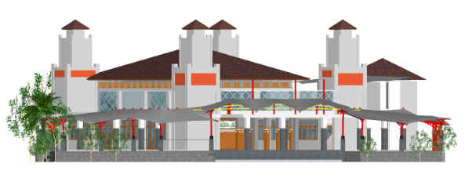 | 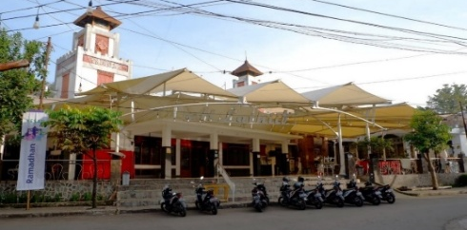
Figure 1. Photo and Image of Al-Lathiif Mosque

  - THEORETICAL FRAMEWORK
The concept of sustainability has existed since the 1960s, initially emphasizing the aspects related to energy consumption [8]. However, a new discourse on social sustainability has emerged gradually as a part of Sustainable Development and Sustainability [9]. This is because environmental and technological domains have dominated the topic of sustainability [10]. However, an approach from the social domain needs to be developed, considering that future generations require access to social resources [8]. The mosque embodies an architectural concept of Rahmatan-Lil Alamin, which bears the meaning of bringing blessings and well-being to all humanity. Based on this principle, the architecture of a mosque should be tested for its sustainability, not only in physical aspects but also in social factors. Furthermore, alongside its social principles and ritual activities, a mosque serves as an identity for its community. [11] Various studies discussing various criteria regarding social sustainability have been conducted [2] [3] [5] [7] .
The various types of criteria offered by previous studies were reclassified to obtain more specific indicators. The topic of social sustainability concerning architecture is noted to have been discussed in an academic writing published in 2014 [12]. Subsequently, there have been consecutive studies on social sustainability directly related to mosques. A study in 2016 stated that social sustainability aspects need to be considered to achieve a systematic approach to design mosques, [2] [5] [6]. The main aspect emphasized in this study asserts that social sustainability in mosques should be related to mosques as places for religious activities. Furthermore, two studies conducted in 2016 added that sustainability in architecture should represent the identity of the community and its benefits for local communities. Additionally, factors such as user safety and comfort become important indicators to fulfill [5] [7]. Specifically, spatial adaptation within buildings also requires effective and efficient spatial adaptation [5]. This is in accordance with the function of a mosque as a venue for various social and religious activities, and it is in line with the principle of Rahmatan Lil Alamin. Jaffar et al. (2020) mentioned in their article that the concept of sustainability is achieved through comfort, accessibility, availability of space, and public facilities [2]. Various assessment criteria are utilized by considering these references, although not all articles employ criteria based on personal observations but merely quote other articles. To gather all criteria offered by various research about sustainability and apply them to mosques as material objects, all areas of discussion and their relevant derivatives related to social sustainability in mosques are compiled. Diagrammatically, as seen below, all journal references used to construct the theoretical framework are as follows: (1) Mapping the dimensions or main areas of study adapted in each reference; (2) Identifying the elaboration of the dimensions used, whether the results are adopted or self-developed indicators; (3) Mapping the indicators related to social sustainability in each reference; (4) Identifying the elaboration of the social sustainability indicators used, whether the results are adopted or self-developed parameters; (5) Mapping the parameters of social sustainability used in each reference specifically applied in mosques; (6) Classifying the themes of all parameters that can be applied regarding the relationship between mosque spaces and congregants within the scope of social sustainability. These steps are described in the diagram in Figure 1. Moreover, Table 1 shows the elaboration process on how the six steps are applied.

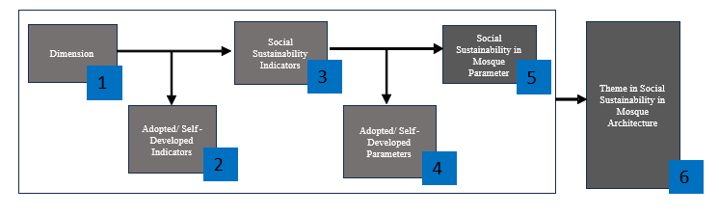
Figure 2. Steps to create a theoretical framework
Table 1. Mapping Indicators and Parameters from Selected References
REFERENCES | A Social Sustainable Assessment Model for Mosque Development in Malaysia  Mohd Hamdan Ahmad; T.A Malik; H. Lamit; A. Keyvanar; A. Shafaghat (2012) | Communal Mosques: Design Functionality Towards the Development of Sustainability for Community  Nurul’ Atiqah Baharudin; Alice Sabrina Ismail (2014) | Mosque as a Model of Learning Principles of Sustainable Architecture  Swambodo Murdariatmo Adi, Puspitasari, Chyntia  ( 2015) | Implications of Stereotype Mosque Architecture on Sustainability  Tayyab Ahmad, Muhammad Jamaluddin Thaheem (2016) |  | Systematic Review of Sustainable Design Approach for Mosque  Mohamad Ikhram Mat Sobri, Sumarni Ismail, Azmal Sabil, Hanita Yusof, Nayeem Asif, Ernaning Setiyowati (2016) | Enlivening the Mosque as A Public Space for Social Sustainability of Traditional Malay Settlements  Najiha Jaffar, Nor Zalina Harun , Alias Abdullah (2020)
Material Object, as stated in the title | Mosque | Communal Mosque | Mosque | Mosque |  | Mosque | Traditional Settlements
Dimension | Social Sustainability | Sustainable form and space | Sustainable Architecture | Environmental Sustainability |  | Social Sustainability | Social Sustainability
Adopted Indicators or Self-developed Indicators | Adopted [13] | Self-developed | Adopted [14] | Adopted [15] |  | Adopted [16] | Self-developed
Indicators | 1. Democracy and Governance  2. Quality of Life  - 3. Interconnectedness  - 4. Diversity  - 5. Equity | 1. Form  2. Space | - 1. Worker health and safety  - 2. Impact on local communities, quality of life  - 3. Benefits to disadvantaged groups | 1. User comfort and safety | 1. Functional, Aesthetic, and Innovative Design Approach | 1. Social-Equity  2. Well-Being  3. Quality of Life | 1. Comfort  2. Activities  3. Accessibility  4. Availability of space  5. Public facilities
Adopted Parameters or Self-developed Parameters | Not Defined | Self-developed | Self - developed | Adopted [15] |  | Self-developed | Self-developed
 |  |  |  | Indoor environmental quality | Usability, functionality, and Aesthetic aspects | Self-developed | Self-developed
 |  |  |  | Health and well-being | Innovations and design process | Self-developed | Self-developed
 |  |  |  | Safety | Innovations and design process | Self-developed | Self-developed
 |  |  |  | Open space availability | Architectural consideration, integration of cultural heritage, compatibility with local heritage values | Self-developed | Self-developed
 |  |  |  | Number of facility users |  | Self-developed | Self-developed
 |  |  |  | Community amenities provision |  | Self-developed | Self-developed
 |  |  |  | Accessibility |  | Self-developed | Self-developed
Specific Parameters eligible for mosques | Not Defined | A1. Façade  A2. Ornamentation,  detailing, structural elements, material usage  A3..Setting  A4.Scale  A5.Spatial Organizations | B1. Adaptation of Space  B2. Management water resources (Ablution water) | C1. Identity of community  C2 .Active and busy with different rituals, education, and service of mankind  C3. Center of personal and social aspirations  C4. Possessing specific architectural features to mark the transition from secular to spiritual aspect  C5. Clarity and transparency of space.  C6. Architectural features of mosques (e.g domes, vaults, minbar, minaret) |  | D1. Muslim religious activity | E1. Accessibility  E2 Cleanliness and Comfort  E3. Consistent program and activities  E4. Ample Sitting area  E5. Good learning center  E6. Availability of recreational infrastructure

The next step, as seen in the table, involves a classification process by determining themes from similar keywords, particularly in the section of specific parameters eligible for mosques within the context of social sustainability.
Theme selection should prioritize social activities in mosques that have a direct relationship with space and its surroundings. The method for determining themes involves creating classifications based on the social interactions between congregants within spaces in the mosque.
Based on the coding results (Table 2), it is determined that there are four major classifications related to the parameters collected from various references. [2] [3] [4] [5] [6] [7], namely: [1] Architectural Form; [2] Social Interaction and The Setting of Spaces; [3] Flexibility of Space Regarding Profane and Sacred Spaces; and [4] Social Participation in Scope of Community Surrounding. The elaboration of each classification is as follows: [1] Architectural Form: The Mosque’s shape was actually affected by the land where the mosque was built. However, mosque architecture has distinctive features that could be identified as common mosque forms by the congregants. This criterion has nothing to do with social aspects since architectural forms underline the physical aspect rather than the social one. [2] Social Interaction and the Setting Spaces: Social Interaction portrays the activities of the congregants at the mosque. Mosque was built to accommodate different activities, namely ritual activities, e.g., prayer/Salat, which is sacred and non-ritual activities, e.g., sermons, classes, break-fast, etc. [3] Flexibility of space regarding profane and sacred spaces: flexibility of spaces in mosques reflects the dynamic of activities between social life and worship. A mosque is a people’s place, so it should accommodate activities properly. [4] Social participation in the scope of the community surrounding: The existence of a mosque should provide a lively ambiance and give advantages to the community surroundings. As a conclusion, the parameters mentioned were gathered and suitable to be applied to a mosque. Nevertheless, though it was mentioned in the previous references, a parameter named Architectural Form is not attached to the social aspect, therefore, this parameter will not be considered as one of the suitable parameters.

Table 2. The coding process of indicators from selected references

Classification | Parameter 1 |  | Parameter 2 |  | Parameter 3 |  | Parameter 4 |  | Parameter 5
Architectural Form  (A1, A2, C1, E4) | A1 | Facade |  |  | C1 | Architectural features of mosques (e.g., domes, vaults, minbar, minaret) |  |  | E4 | Designated sitting area
Architectural Form  (A1, A2, C1, E4) | A2 | Ornamentation, detailing, structural elements, material usage |  |  | C1 |  |  |  | E4 | Designated sitting area
Social interaction and the setting of spaces  (A3, A4, C2, C3, C4, D1, E3, E5, E6) | A3 | Setting |  |  | C2 | Active and busy with different rituals | D1 | Muslim religious activity | E3 | Consistent program and activities
 | A4 | Scale |  |  | C3 | Center of personal and social aspiration |  |  | E5 | Good learning center
 |  |  |  |  | C4 | Possessing specific architectural features to mark the transition from secular to spiritual aspect |  |  | E6 | Availability of recreational infrastructure
Flexibility of Space Regarding Profane and Sacred Spaces  (A5, B1, C5, D1, E1, E3) | A5 | Spatial Organization | B1 | Adaptation of space |  |  | D1 | Muslims’ religious activity | E1 | Accessibility
 |  |  |  |  |  |  |  |  | E3 | Consistent program and activities
 |  |  |  |  | C5 | Clarity and transparency of space
 |  |  | B2 | Management of water resources |  |  |  |  | E2 | Cleanliness and Comfort
Social Participation  in scope of  Community Surrounding (C1) |  |  |  |  | C1 | Identity of Community

- METHODS
The research steps conducted to record congregational activities in the mosque are as follows: [1] Mapping the congregation's behavior in the mosque during prayer times throughout the week, namely: Fajr Prayer, Dhuhr Prayer, Asr Prayer, Maghrib Prayer, and Isha Prayer; [2] Mapping the congregation's behavior during the month of Ramadan, including I'tikaf worship activities; [3] Recording nonritual activities during the month of Ramadan [4]; Distributing questionnaires to the congregation of the studied mosque; [5] Calculating data using Likert scale; [6] Correlating behavior mapping results with Likert scale calculation results. The research was conducted from February to April, 2023, to coincide with Ramadan and record all activities taking place at Masjid Al-Lathiif.

- OBSERVATION WITH BEHAVIOUR MAPPING
Bryman (2012) described behavior mapping as the method through which researchers record and observe human behavior, as well as its connection to the surrounding physical environment [17]. Ittelson identified five key aspects in behavior mapping: (1) Creating a simple sketch of the observed area, (2) Describing and diagramming the types of observed behaviors, (3) Stating the time when observed behavior occurs, (4) Maintaining systematic procedures during observation, and (5) Using an efficient marking system or notation throughout the observation process. [18]. Furthermore, behavior mapping is divided into two types: "place-centered" and "person-centered" [19].
"Place-centered maps" mainly focus on observing behavior through static scenes, capturing how people behave and where they are situated within a given area, while "person-centered maps" concentrate on tracking individual activities. Considering this explanation, the behavior mapping approach used in this study follows the "place-centered maps" method. It involves mapping the behavior patterns of worshippers within a designated area of a mosque.

- VALIDATING THE BEHAVIORAL PATTERNS OF WORSHIPERS AT MASJID AL-LATHIIF
The validation process takes place after the completion of the behavior mapping process. It involves distributing questionnaires processed using a Likert Scale. The Likert scale measurement method was first introduced in 1932 through the article "A Technique for the Measurement of Attitudes.” [20].

Table 3. Scale of Answers and Score Related to Social Sustainability Questions

No | Scale of Answers | Abbreviation | Number of Respondents | Rating Scale
1 | Strongly Agree | SA | 40 | 4
2 | Agree | A | 40 | 3
3 | Disagree | D | 40 | 2
4 | Strongly Disagree | SD | 40 | 1

The purpose of providing answer scale values is to obtain criteria scores, which leads to the discovery of percentage answer results. Criteria scores are obtained by multiplying the number of respondents who choose a particular answer by the assigned value on the rating scale as shown in Table 3.
Thus, the method for obtaining the rating scale or interval is to divide one hundred by the number of answer scales, which is four, resulting in a twenty-five-point rating range per scale. The final results are achieved through calculations to determine the percentage outcome by adding up the four criteria scores from the four answer scales.
$$Result=\frac{Score SA + Score A + Score D + Score SD}{Highest scale value \left(from 4 scale answers\right) x number of respondents (40)} x 100$$
.
- RESULT AND DISCUSSION

This section explains the observations of the behavior mapping results. To ensure all activities in the mosque were classified, a method of color coding was applied, as seen in Table 4.

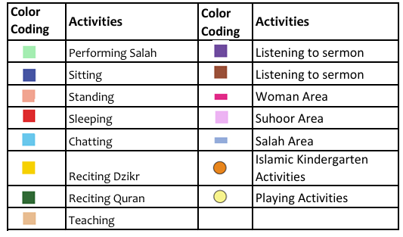
Table 4. Activities classified in color coding

- BEHAVIOR MAPPING DURING FAJR PRAYER OR DAWN PRAYER
Observation was conducted just before the dawn prayer began from 04:10 to 04:30, during the dawn prayer - from 04:35 to 04:50, and after the dawn prayer - from 05:10 to 05:30 (Table 5).

Table 5. Behavior Mapping during Fajr Prayer or Dawn Prayer

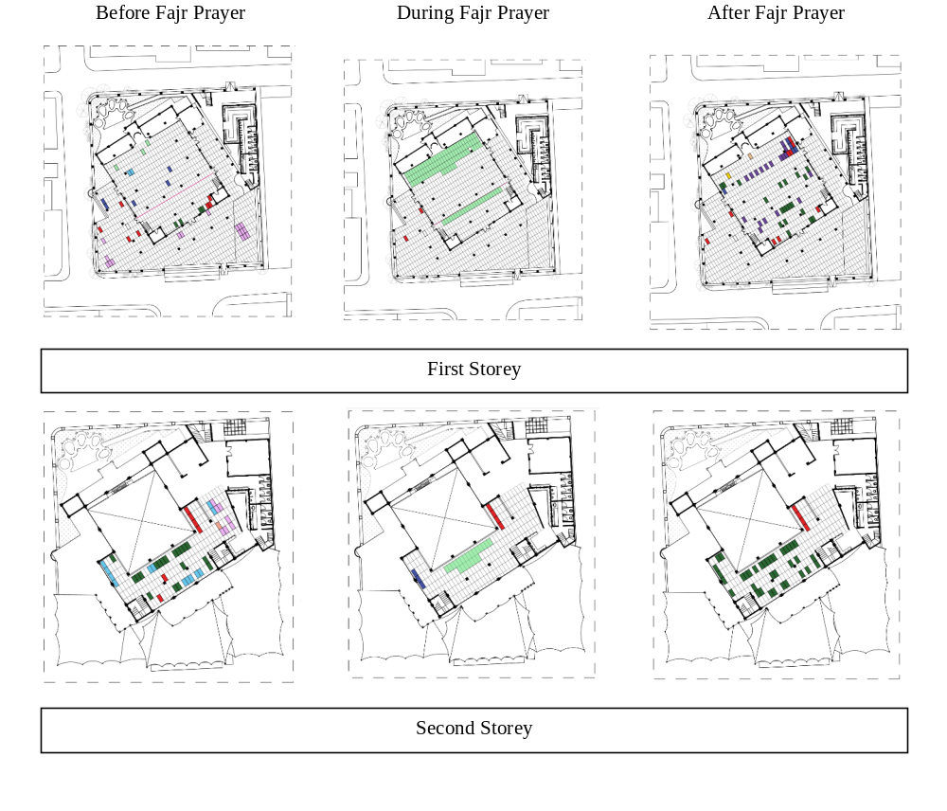

- BEHAVIOR MAPPING DURING ZUHR PRAYER OR MIDDAY PRAYER
Observation was conducted just before the noon prayer began from 11:05 to 11:40, during the Midday prayer - from 11:50 to 12:20, and after the Midday prayer - from 12:35 to 14:30 (Table 6).

Table 6. Behavior Mapping during Zuhr Prayer or Midday Prayer

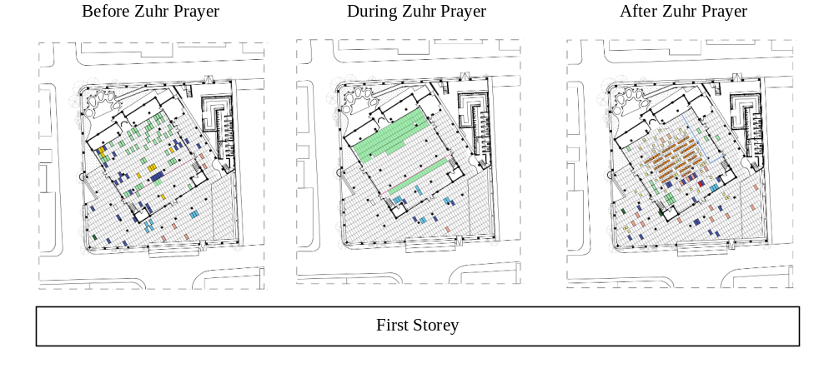

- BEHAVIOR MAPPING DURING ASHR PRAYER OR AFTERNOON PRAYER
Observations were conducted just before the afternoon prayer began from 14:40 to 14:55, during the afternoon prayer - from 15:00 to 15:35, and after the afternoon prayer - from 15:45 to 17:20 (Table 7).

Table 7. Behavior Mapping during Zuhr Prayer or Midday Prayer

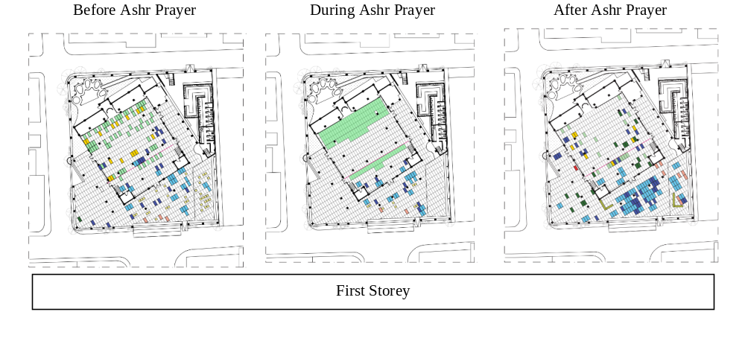
- BEHAVIOR MAPPING DURING MAGHRIB PRAYER OR SUNSET PRAYER
Observation was conducted just before the sunset prayer began from 17:30 to 17:58, during the sunset prayer - from 18:00 to 18:20, and after the sunset prayer - from 18:25 to 18:45 (Table 8).

Table 8. Behavior Mapping during Maghrib Prayer or Sunset Prayer

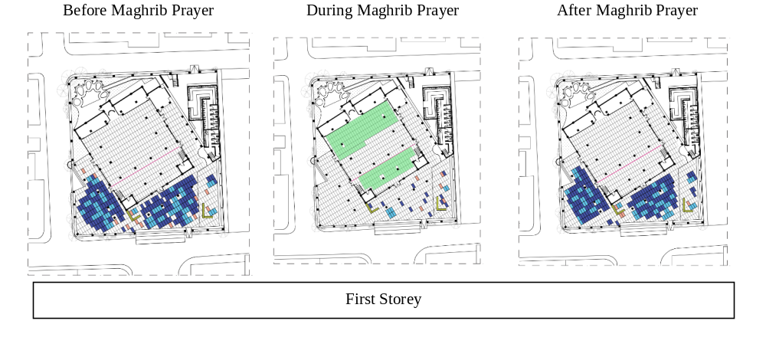

- BEHAVIOR MAPPING DURING ISHA PRAYER OR NIGHT PRAYER
Observation was conducted just before the evening prayer began from 18:50 to 19:05, during the evening prayer - from 19:10 to 19:25, and after the evening prayer - from 19:30 to 20:05 (Table 9).

Table 9. Behavior Mapping during Isha Prayer or Night Prayer

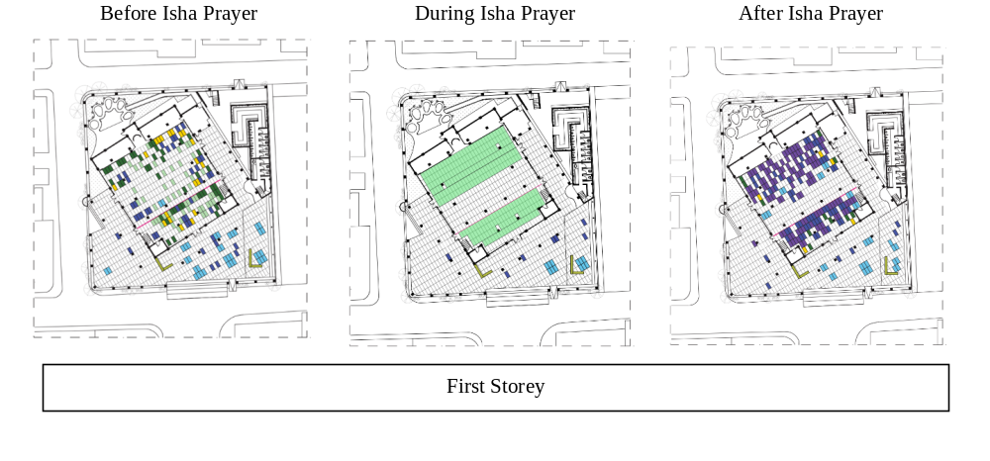

- BEHAVIOR MAPPING DURING TARAWEEH PRAYER
Observation was conducted on Tuesday, April 4, 2023, precisely during the Tarawih prayer - from 20:10 to 20:25 and after the Tarawih prayer - from 20:35 to 22:30 (Table 10).

Table 10. Behavior Mapping during Taraweeh Prayer

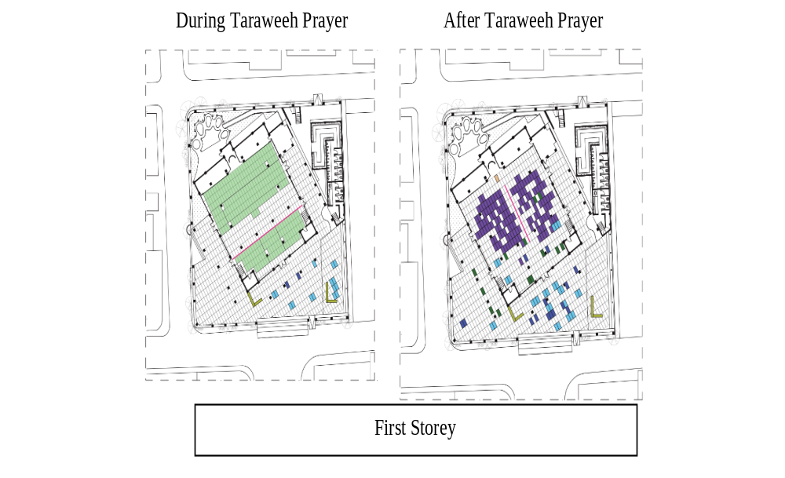
- BEHAVIOR MAPPING EID PRAYER
Observation was conducted on Saturday, April 22, 2023, just before the Eid prayer began from 06:00 to 06:30, during the Eid prayer - from 06:45 to 07:05, and after the Eid prayer - from 07:10 to 07:30. (Table 11).

Table 11. Behavior Mapping during Eid Prayer

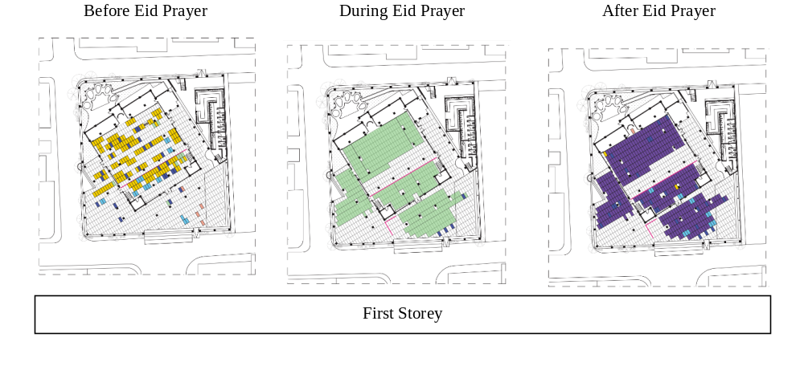

- BEHAVIOR MAPPING I’TIKAF PRAYER
Observation was conducted on Tuesday, April 18, 2023, just before the I’tikaf prayer began from 00:15 to 01:35 and during the I’tikaf prayer - from 01:40 to 03:20 (Table 12).

Table 12. Behavior Mapping during I’tikaf Prayer
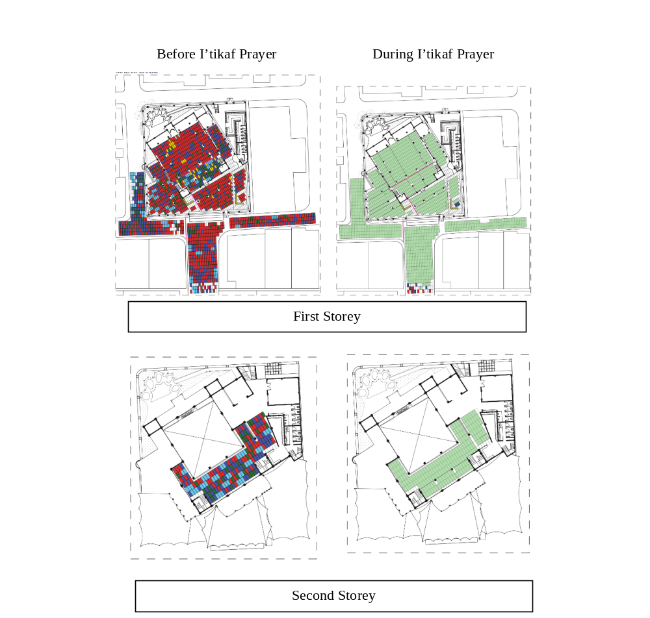

- CONGREGANTS’ INTERPRETATION ON SOCIAL SUSTAINABILITY AT AL-LATHIIF MOSQUE
The process of observation through behavior mapping around Al-Lathiif Mosque becomes essential in researching both ritualistic and non-ritualistic activities (other than Salat) that occur within the mosque. The results of observation must be validated, as each congregant has a different perspective of comfort in performing an activity. Therefore, to obtain deeper insights, this observation is further carried out by collecting data through interviews and filling out questionnaires. Furthermore, the data obtained must be processed using Likert scale methods with percentage results. The number of congregants who have responded to questions based on 3 parameters is 40 congregants, and the parameters are (1) Social Interaction and the Setting of Spaces, (2) Flexibility of Space Regarding Sacred and Profane, and (3) Social Participation in the Scope of Community. As seen in Table 13, the majority of the community in Al-Lathiif Mosque is dominated by youth. Therefore, the social activities are very vibrant and lively. The results from distributing the questionnaires are presented in table number 14 to 16.

Table 13. Respondent’s Profile
Gender | Numbers | Percentage
Man | 19 | 47,5 %
Woman | 21 | 52,5 %
Age | Numbers | Percentage
<25 Years | 21 | 52,5 %
25 – 45 Years | 19 | 47,5 %
46 – 65 Years | 0 | 0
> 65 Years | 0 | 0

Table 14. Social Interaction and the Setting of Spaces

No | Statement | Number of Respondents |  |  |  | Criteria Score |  |  |  | Rating Scale (%) |  |  |  | Result | Conclusion
No | Statement | SA | A | D | SD | SA | A | D | SD | SA | A | D | SD | Result | Conclusion
1 | The activities you engage in within this mosque involve other congregants who are also present within the mosque area | 30 | 7 | 2 | 1 | 120 | 21 | 4 | 1 | 76-100 | 51-75 | 26-50 | 1-25 | 91.25 | Strongly Agree
2 | The activities you engage in within this mosque encourage you to interact with the community within the mosque area | 18 | 12 | 8 | 2 | 72 | 36 | 16 | 2 | 76-100 | 51-75 | 26-50 | 1-25 | 78,75 | Strongly Agree
3 | The environment within the mosque area is capable of fostering a sense of security for congregants in carrying out their worship activities | 32 | 6 | 0 | 2 | 128 | 18 | 0 | 2 | 76-100 | 51-75 | 26-50 | 1-25 | 92,5 | Strongly Agree
4 | The activities you engage in within the mosque have the potential to motivate you to become a better individual. | 34 | 4 | 1 | 1 | 136 | 12 | 2 | 1 | 76-100 | 51-75 | 26-50 | 1-25 | 94,375 | Strongly Agree
5 | The activities within the mosque can support tolerance, harmony, and/or harmonious surroundings | 32 | 6 | 0 | 2 | 128 | 18 | 0 | 2 | 76-100 | 51-75 | 26-50 | 1-25 | 92,5 | Strongly Agree
 | Average |  |  |  |  |  |  |  |  |  |  |  |  | 89,87 | Strongly Agree
Table 15. Flexibility of Space Regarding Sacredness and Profaneness
No | Statement | Number of respondents |  |  |  | Criteria Score |  |  |  | Rating Scale (%) |  |  |  | Results | Conclusion
No | Statement | SA | A | D | SD | SA | A | D | SD | SA | A | D | SD | Results
1 | Each space and facility within the mosque can be utilized not only for prayer activities (sacredness) but also for other purposes (profaneness) effectively. | 35 | 4 | 0 | 1 | 140 | 12 | 0 | 1 | 76-100 | 51-75 | 26-50 | 1-25 | 95,625 | Strongly Agree
2 | You can move between different spaces/facilities in a range of sacredness (prayer area) and profaneness (other than prayer area) within the mosque with a sense of security | 34 | 5 | 0 | 1 | 136 | 15 | 0 | 1 | 76-100 | 51-75 | 26-50 | 1-25 | 95,00 | Strongly Agree
 | Average |  |  |  |  |  |  |  |  |  |  |  |  | 95,313 | Strongly agree

Table 16. Social Participation in the Scope of Community
No | Statement | Number of respondents |  |  |  | Criterium Scale |  |  |  | Rating Scale (%) |  |  |  | Results |  | Conclusion
No | Statement | SA | A | D | SD | SA | A | D | SD | SA | A | D | SD
1 | The activities within this mosque also appear to have the capability to motivate other users to become better individuals. | 33 | 6 | 1 | 0 | 132 | 18 | 2 | 0 | 76-100 | 51-75 | 26-50 | 1-25 | 95,00 |  | Strongly Agree
2 | The facilities, along with the spaces of the mosque and its surroundings (roof, walls, and floor), seem also to be capable of supporting the activities within the mosque | 31 | 9 | 0 | 0 | 124 | 27 | 0 | 0 | 76-100 | 51-75 | 26-50 | 1-25 | 94,4 |  | Strongly Agree
3 | The activities you engage in at the mosque have the potential to motivate you to enhance your involvement and contribution to the community. | 28 | 11 | 1 | 0 | 112 | 33 | 2 | 0 | 76-100 | 51-75 | 26-50 | 1-25 | 91,875 |  | Strongly Agree
4 | The activities within the mosque also appear to motivate congregants to increase their involvement and contribution to the community. | 30 | 9 | 1 | 0 | 120 | 27 | 2 | 0 | 76-100 | 51-75 | 26-50 | 1-25 | 93,125 |  | Strongly Agree
5 | The activities within this mosque contribute to enhancing the quality of life for the community in its surrounding area (socially, culturally, and economically). | 29 | 9 | 2 | 0 | 116 | 27 | 4 | 0 | 76-100 | 51-75 | 26-50 | 1-25 | 91,875 |  | Strongly Agree
6 | The mosque management effectively oversees the activities, facilities, and spaces within the mosque area. | 29 | 9 | 1 | 1 | 116 | 27 | 2 | 1 | 76-100 | 51-75 | 26-50 | 1-25 | 91,25 |  | Strongly Agree
 |  | Average |  |  |  |  |  |  |  |  |  |  |  |  | 92,92 |  | Strongly agree

- THE FINDINGS FROM BEHAVIOR MAPPING AND QUESTIONNAIRE RESULTS
Behavior mapping is divided into two categories: ritual activities, which include prayers, and non-ritual activities. During non-ritual activities, the dominant activities typically happen before and after prayer times, which are socializing, sleeping, waiting, standing, having pre-dawn meals, breaking fast, listening to sermons, and reciting the Quran and Dzikr. Based on the behavior pattern mapping, the following is a summary of the mapped activities during ritual and non-ritual times observed in the mosque (table 17).

Time of Prayer | Findings
Before | The flexibility of space is dynamic (the sacred area could turn profane due to the activities that occurred).
Exact Time | The main area in the mosque is strictly for sacred areas and performing Salat.
After | The flexibility of space turns dynamic, and dominantly, the congregants perform activities other than Salat.
Table 17. Summary of Activity Pattern Mapping

Therefore, based on Table 17, the intensity of congregants significantly influences the activities within the space of each mosque. Consequently, peak visiting times occur just before and after Maghrib prayers on holidays, before Friday prayers, and before I'tikaf prayers.
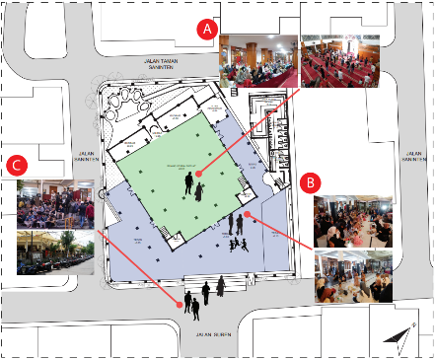
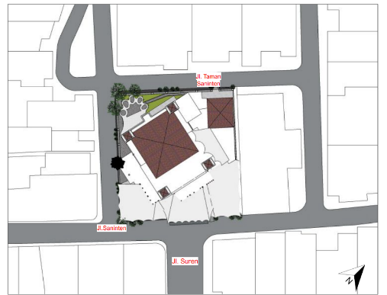
The mosque committee usually facilitates these activities. Some of the common events organized by the committee include iftar/break-fast gatherings, sharing sessions, religious sermons or talks, children's religious classes, and other religious discussions held in the main prayer area and extending to the veranda area (Figure 2, Point A & B). However, some of these activities also extend to the outdoor space (Figure 2, Point C). This indicates that non-prayer activities can fundamentally influence the transformation of sacred areas into profane areas. The isometric diagrams illustrating prayer and non-prayer activities within Al-Lathiif Mosque in Bandung is shown in Figure 3.

Figure 2. Site Plan and Isometric of Activities Mapping
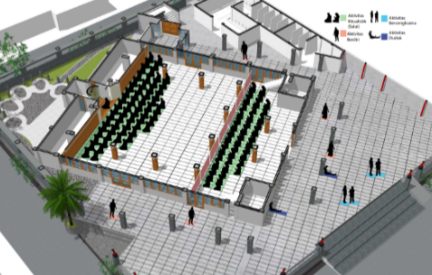

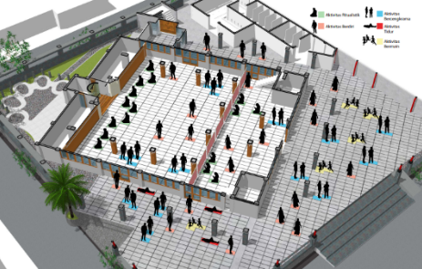

Figure 3. The Flexibility of Spaces in Mosque

- THE FINDINGS FROM BEHAVIOR MAPPING AND QUESTIONNAIRE RESULTS
The results of behavior mapping observations during Ramadan show that congregants are predominantly more active in non-ritualistic activities (interacting among individuals) before and after the five daily prayers, Friday prayers, Eid prayers, and I'tikaf prayers. These activities are also predominantly conducted around the main prayer area for men, the women's prayer area, and the mosque's veranda, and during I'tikaf prayers, activities are quite bustling on the mezzanine floor, ground floor, and even extending to the outer space. Furthermore, based on the average questionnaire responses regarding this discussion, social Interaction scores 89.87. Therefore, it can be concluded that the spaces accommodating these social activities align with user interview findings.

L. FLEXIBILITY
The flexibility of spaces in Masjid Al-Lathiif can be observed through behavior mapping, showing dynamic prayer and non-prayer activities. Activities during Ramadan lead to significant changes in space functions. These changes are usually quite busy before and after Maghrib prayers on holidays, Friday prayers, and I'tikaf prayers, which occur in the main prayer area and veranda intended for ritualistic activities. However, social activities take place before and after prayers. Thus, the main prayer area (sacred) is more utilized as a profane area before and after prayers. This is also supported by the average questionnaire response score of 95.313. It can be concluded that the flexibility of space in Al-Lathiif Mosque adequately caters to primary and secondary needs, depending on the time.

M. SOCIAL PARTICIPATION
The activities organized by the committee of Al-Lathiif Mosque are predominantly communal, attracting not only residents but also visitors from outside the area. Based on the interviews, both local and non-local residents share the same opinion that the activities are beneficial and motivate congregants to attend. This is further supported by the average questionnaire response score of 92.92.

- CONCLUSION
Social sustainability in mosques is closely tied to the activities accommodated by the mosque. Mosques facilitate activities beyond worship. Hence, social activities are closely linked to the mosque's function. The mosque dominated by the youth community should ideally provide compatible spaces for worship. The results of behavioral mapping reveal a dynamic spatial temporality, particularly during the I'tikaf activities in the month of Ramadan, where profane spaces turn into sacred ones and vice versa, which is strongly perceptible. Furthermore, the degree of sacredness of space can be temporary, as seen in the need for the main area to accommodate congregants' activities besides prayer. Referring to the cleanliness and sanctity that must be maintained in the main prayer area, mosques can provide spaces that accommodate activities other than prayer outside the main area.

REFERENCES

- S. Kurniawan, "Masjid dalam Lintasan Sejarah Umat Islam," Jurnal Khatulistiwa-Journal of Islamic Studies, vol. 4, no. 2, pp. 169-184, 2014.
- N. Jaffar, N. Z. Harun and A. Abdullah, "Enlivening the Mosque as a Public Spacec for Social Sustainability of Traditional Malay Settlements," Journal of the Malaysian Institute of Planners, vol. 18, no. 2, pp. 145-157, 2020. DOI: https://doi.org/10.21837/pm.v18i12.750
- M. H. Ahmad, T. A. Malik, H. Lamit, A. Keyvanfar and A. Shafaghat, "A Social Sustainable Asessment Model For Mosque Development in Malaysia," OIDA International Journal Sustainable Development, vol. 04, no. 09, pp. 29-33, 2012.
- N. Baharudin and A. S. Ismail, "Communal Mosque : Design Functionality Towards the Development of Sustainability For Community," in AMER International Conference on Quality of Life, Kota Kinabalu, Sabah, 2014.
- S. M. Adi and C. Puspitasari, "Mosque as a Model of Learning Principles of Sustainable Architecture," Journal of Islamic Architecture, vol. 4, no. 1, pp. 33-36, 2015. DOI: https://doi.org/10.18860/jia.v4i1.3090
- M. I. M. Sobri, S. Ismail, A. Sabil, N. Asif and E. Setiyowati, "Systematic Review of Sustainable Design Approach for Mosque," Journal of Islamic Architecture, vol. 6, no. 4, pp. 369-375, 2021. DOI: https://doi.org/10.18860/jia.v6i4.14016
- T. Ahmad, M. J. Thaheem, A. Anwar and Z. u. Din, "Implications of stereotype Mosque Architecture on Sustainability," in International Conference on Sustainable Design, Engineering and Construction, Texas, 2016.
- M. Y. MAK and C. J. PEACOCK, "Social Sustainability: A Comparison of Case Studies in UK, USA adn Australia," in 17th Pacific Rim Real Estate Societ Conference, Gold Coast, 2011.
- A. Mehan and F. Soflaei, "Social Sustainability in Urban Context : Concepts, Definitions and Principles," in Architectural Research Addressing Societal Challenges EAAE ARCC 10th International Conference, Lisbon, 2016.
- S. Woodcraft, "Understanding and Measuring Social Sustainability," Journal of Urban Regeneration and Renewal, vol. 8, no. 2, pp. 133-144, 2014.
- N. Imam, S. Muhammad, "Mosque Architecture: Formulation of Design Criteria and Standards in the Context of Bangladesh," Bangladesh University of Engineering and Technology, 2000.
- Z. Kefayati and H. Moztarzadeh, "Developing Effective Social Sustainability Indicators in Architecture," Bulletin of Environment, Pharmacology and Life Sciences, vol. 4, no. 5, pp. 40-56, 2014.
- K. Hodgson, M. C. Campbell and M. Bailkey, Urban agriculture: Growing Healthy, Sustainable Places, American Planning Association, 2011.
- TERI, Sustainable Building- Design Manual: Sustainable Building Design Practices, The Energy and Resources Institute (TERI), 2009.
- EPA, Toward Integrated Environmental Decision-Making, Washington DC, USA: Environmental Protection Agency, 2000.
- I.M.Lami and B. Mecca, "Assesing Social Sustainability for Achieving Sustainable Architecture," Sustainability, vol. 13, no. 1, p. 142, 2020. Doi: https://doi.org/10.3390/su13010142
- A. Bryman, Social Research Methods (Fourth.), New York: Oxford University Press Inc, 2012.
- H. M. Proshansky, Envoronmental Psychology: Man and His Physical Setting, New York: Rinehart and Winston, 1970.
- R. Sommer and B. Sommer, A Practical Guide to Behavioral Research: Tools adn Techniques, Oxford: Oxford University Press, 2002.
- R. Likert, A Technique for the Measurement of Attitudes, New York: Archives of Psychology, 1932.

