 |  | JOURNAL OF ISLAMIC ARCHITECTURE  P-ISSN: 2086-2636 E-ISSN: 2356-4644  Journal Home Page: http://ejournal.uin-malang.ac.id/index.php/JIA
SHEHZADE MOSQUE: THE UNIQUE HARMONY BETWEEN ARABIC CALLIGRAPHY DECORATIONS AND ARCHITECTURAL STRUCTURE
Naser Thabet Al-Mughrabi^{a*}
ªUniversity of Petra Faculty of Architecture and Design: Amman, Jordan
*Corresponding Author: nalmughrabi@uop.edu.jo
ARTICLE INFO |  |  | ABSTRACT
Volume: 9  Issue: 1  Page: 1-17  Received: April 07th, 2024  Accepted: December 03rd, 2024  Available Online: June 30th, 2026  DOI: 10.18860/jia.v9i1.26606 |  |  | One of the most prominent styles of Islamic architecture that benefited from the aesthetics of Arabic calligraphy in mosque decoration is Ottoman architecture, in which Arabic calligraphy was used mainly to enhance the mosque's interior. Hence, this research aims to demonstrate the importance of employing Arabic calligraphy as a decorative element in the interior design of the Shehzade Mosque in Istanbul and to show how it harmonizes with the mosque's unique structural system across its various forms. The study began by stating the research problem and its motivations, and by clarifying its scientific value in highlighting the position of Arabic calligraphy decoration in Ottoman arts and architecture. The study then reviewed how Arabic calligraphy decorations contributed to improving the interior appearance of the Ottoman Mosque. Then the Shehzade Mosque emerged as a distinctive and influential model in the use of Arabic calligraphy in Ottoman architecture. The researcher then analyzed the geometric pattern that developed on the ceiling of the Ottoman Mosque from Arabic calligraphic decorations. Finally, the study concluded with results and recommendations that emphasize the importance of Arabic calligraphy in the architecture of Shahzad mosques.  Keywords:  Arabic calligraphy; Interior Decoration; Ottoman Mosque; Shehzade Mosque

- INTRODUCTION
Ottoman mosques were historically famous for their distinctive architectural design, which consists of two parts: the ground floor with its cubic shape, and the upper roofing section with its ascending pyramidal shape and curved lines, including several small domes and semi-domes arranged around a high central hemispherical dome. The roof was designed in its domed form based on the strength of the building and its structural components at the ground level, especially the sturdy pillars in the center below the dome and in the perimeter through the walls that support the arches, small domes, semi-domes, and the central dome at the top of the building continuously [1]. Hence, scholars studying Ottoman architecture were influenced by this construction theory and intrigued by the size, shape, and unique construction techniques of Ottoman domes, which gave Ottoman mosques an architectural identity that distinguished them from earlier Islamic architectural forms and styles. The domes of the Benetton Temple in Rome and the Hagia Sophia in Istanbul are two examples of historical domed structures often compared with those of Ottoman mosques and churches [2]. The interior design of the mosque included Arabic calligraphy decorations that were very creative and harmonious with the architectural features, especially the ceiling, which combines domes and arches. It played a crucial role in enhancing the mosque's interior environment, but in reality, it did not receive sufficient attention from these scholars and researchers.
When Ottoman mosque architecture first emerged at the start of the fourteenth century, it was a collection of architectural and planning styles. Two primary sources inspired the great Ottoman architectural style, which reached its peak in the 16th century. The first was the relatively intricate creation of new architectural forms in Anatolia during the 14th and early 15th centuries, particularly in Bursa. Several structures known as tekkes (zawiya in Arabic) were constructed to house dervishes and other religious men who lived in community, alongside the customary mosques, shrines, and other religious institutions. Tekkes were often associated with mosques. At that time, the entire complex was referred to as a külliye. The central domed structure developed by the Seljuks in Anatolia was further developed in all of these structures. Byzantine art and architecture, particularly the Hagia Sophia, served as another important inspiration for Ottoman architecture [3].
The interior decoration of the Ottoman mosque evolved over time. The various styles of Arabic calligraphy were also modified and improved to suit the distinctive structural system of the mosque and to keep up with its flourishing architectural state, especially when the imperial architect Mimar Sinan designed and built the Shehzade Mosque, between 1543 and 1548, which is considered the pinnacle of Ottoman architecture at that time [4]. Therefore, this research will focus on the specific case of Arabic calligraphy's development and its use in the Shehzade Mosque, and demonstrate how it was crucial in validating the mosque's central and domed design.
In a unique study on Arabic calligraphy, researcher Al- Mughrabi arrived at a set of design features that confirm the aesthetic value and structural flexibility of Arabic calligraphy, and show the extent of its integration with the interior spaces of Islamic architecture, particularly the mosque's interior space with its religious significance and the structural and architectural elements it contains, such as the dome, the mihrab, the pulpit, and the qibla wall. As a result, Arabic calligraphy sets the mosque apart from secular structures and lends it the ethereal ambiance that is necessary for a place of worship. Because of its expressive value and capacity to convey the meanings of words and sentences, Al-Mughrabi also considers Arabic calligraphy a beautiful art form, with formal quality and expressive value that elevate it to a very special position among the various types of decoration and interior arts in Islamic architecture [5]. Accordingly, the significance of Arabic calligraphy's design and expressive features motivates the researcher to thoroughly examine how it might enhance the Shehzade Mosque's central, domed architectural design.
There is not a single building in the history of Islamic architecture that does not use Arabic calligraphy for improvement and beautification, underscoring the long-standing importance of calligraphy in Islamic art and architecture. But it makes sense to consider how the flat panels of Arabic calligraphy and two-dimensional decoration merged with the curved surfaces of the central domed architecture in the new Ottoman mosques of the 16th century. Moreover, since Arabic calligraphy decoration was the main decorative feature that enhanced the interior design of the Shehzade Mosque, what architectural value did these decorations provide to the arched structural elements drawn above them? Were the Arabic calligraphy decorations in the Shehzade Mosque for a purely decorative and aesthetic purpose, or were they an integrated coordination that was in harmony with the central theory in Ottoman architecture, which depicts in its central composition the Muslim community in its wrapping around the Sultan, the center of the state, and around the vertical axis of the dome facing the sky, in a way that contributes to linking all the structural elements within a specific central geometric composition with each other.
Besides the fact that it sheds light on the lack of in-depth studies on the interaction between calligraphy and structure in Ottoman mosques, this study is significant and legitimate not only because it adds a scientific perspective to the history of Islamic art and architecture by studying Arabic calligraphy as a major decorative element used in Ottoman interior design, but also because it illuminates the fact that there is a lack of such studies on ancient and contemporary models in Islamic architecture.

- METHODS
Due to its inherent value as a sacred art connected to the Holy Quran and the Hadith, historical studies on Arabic calligraphy have shown that it has predominated and been used as a major element in the decoration of buildings and mosques throughout all Islamic eras and countries, beginning with the Dome of the Rock during the Umayyad era in the seventh century AD and continuing through all Islamic eras to modern mosque projects in our time. As a result, mosque interior design would be impossible without the Arabic calligraphy accents that add character and distinctiveness. Due to long-term experience and repeated creation of Arabic calligraphy decorations in mosques, calligraphers have developed sufficient creativity to design decorations that are entirely consistent with the visual character of the architectural elements [6].
Qualitative research, by examining their vast and varied repertoires, is a useful tool for revealing the intricacy and connections between Arabic calligraphy and the structural elements of Ottoman architecture. While quantitative methods focus on data and numbers, qualitative research explores the subjective experiences, perceptions, and meanings that individuals and cultures hold. This is essential to understand how Arabic calligraphy was integrated into the construction of the Shehzade Mosque and how non-Arab Muslims, such as the Ottoman Turks, related to it. If the message of Muhammad was universal, then Arabic calligraphy went with it, spread among Islamic peoples, and became a universal identity. Wherever there are mosques in the vast universe, Arabic calligraphy is found.
Through observational documentation and analysis of written materials and building plans of the Şehzade Mosque, the researcher can learn more about the symbolic and spiritual aspects of these artistic media. The author decided to rely on historical documents and references to know the historical path of the development of the use of Arabic calligraphy in Ottoman architecture until the maturity of the experience in the Şehzade Mosque, to achieve the goal of this research, which is to analyze the prevailing decorative patterns of Arabic calligraphy in the architecture of the Shehzade Mosque in particular and to know its visual relationship with the structural elements of the mosque, especially the domed ceiling of the mosque.
Arabic calligraphy, like Islamic art and ornamentation, has a soft, balanced, and harmonious appearance that allows onlookers to integrate effortlessly with the decorative and architectural elements without disturbing them. Arabic calligraphy, in particular, has contributed significantly to the interior design of mosques, both old and new, and, when combined with geometric decorations, provides a visually striking impact. Verses from the Holy Qur'an relevant to the mosque's decorative elements, such as the mihrab, are used by mosque designers. The architectural elements, including the walls, domes, doors, arches, bands surrounding the exterior, and minarets, featured designs inspired by Quranic texts, as if to remind believers of the noble verses and invite them to contemplate their meanings. Al-Jamali emphasizes the importance of Arabic calligraphy in Islamic architecture, saying: “Islamic architecture devoid of calligraphy is deaf architecture that does not speak” [7].
The Ottoman Empire, also known as the Turkish Empire, controlled much of western Asia, North Africa, and southeastern Europe between the 14th and early 20th centuries. It was known for its contributions to science and art. Istanbul and other important cities around the empire were regarded as centers of the arts, particularly under Suleiman the Magnificent's rule. Calligraphy, painting, poetry, textile and carpet weaving, ceramics, and music were among the most popular artistic genres [8].
In many decorative arts and crafts, Ottoman artists and designers were just as talented and distinguished as their Muslim counterparts, like the Mamluk artists of Egypt. However, they were especially skilled at utilizing the beauty of Arabic calligraphy, which the Turks had been using to write their language since the dawn of Islam. Additionally, they provided it with an intellectual reference, a theory of interior design and decoration, that set it apart from its Western art counterparts in terms of aesthetic characteristics and the coherence of form with subject matter. Although it is aesthetically pleasing, scholars of Ottoman interior design and architecture have noted that, from the early fourteenth century onward, it is devoid of the forms and sculptures characteristic of Christian art. The reason was that such artwork was prohibited by Islamic law. As a result, flat ornamentation and Arabic calligraphy replaced the prohibited sculptures and images in Ottoman art, and the role of the Ottoman calligrapher changed to that of the European painter, albeit with a distinct viewpoint and aesthetic. In Muslim calligraphy, the reed replaced the brush used by Western painters, the inkwell replaced the ballerina, and the letter and geometric shapes replaced the body and worldly perception, which are the mainstays of Western painting. Islamic art has a sanctifying or religious vision in the truest sense of the word. Figure paintings were quite popular in Europe, whereas abstraction predominated in Ottoman art [9].
The adage, "The Qur'an was revealed in the Hijaz, read in Egypt, and written in the lands of the Ottoman Empire," underscores the enormous efforts Ottoman calligraphers made in Arabic calligraphy, as seen in numerous artworks and paintings. They took this ancient art form to the pinnacles of creativity and skill. [10]. As illustrated in Figure 1, Arabic calligraphy evolved into an aesthetic medium in and of itself, and calligraphic paintings and engravings became architectural features inseparable from Ottoman structures such as mosques, palaces, tombs, and fountains. The output of Ottoman calligraphy was not restricted to writing books and sacred texts, as is the case with drawing and sculpture in other cultures and civilizations [11].

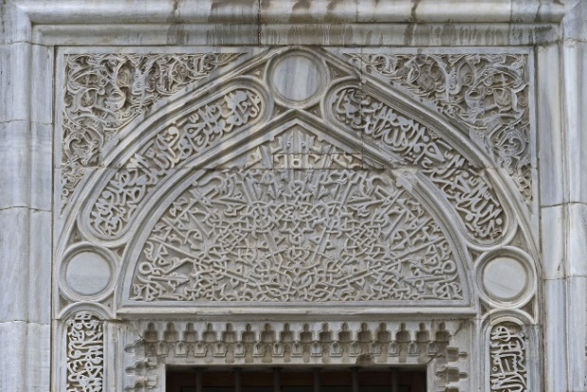
Figure 1. Ottoman Calligraphy Art, Relief on the Front of a Marble Gate [30]

Thuluth script (Figure 2), renowned for its beauty, elegance, and powerful performance, was frequently employed in Ottoman architecture. It is known as Thuluth because it is a straight line from which a third is sliced. The fourteenth century saw the development of the Thuluth script, which Ottoman calligraphers such as Sheik Hamdullah (1436–1520) and Mustafa Raqim (1757–1826) gradually refined until it reached its current form as a graceful, slanted script. The letters in this script have broad spaces between them and long vertical lines. The name, which means "third," may relate to the fact that the pen used to write vowels and embellishments is a third of the width of the pen used to create letters, or it may refer to the height of the letter, which is a third of the alif [12].

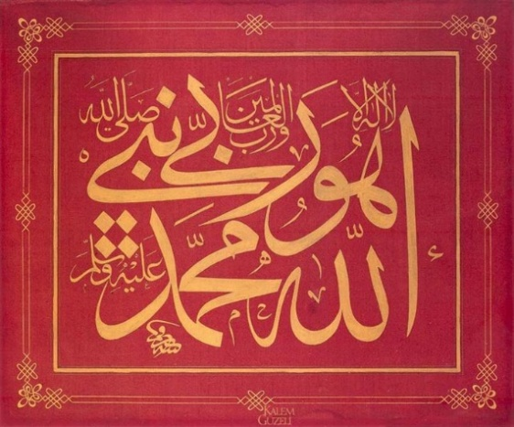
Figure 2. Ottoman Calligraphy Art, drawing in the Thuluth font of Mustafa Rakim [31]

Al-Qalqashandi mentioned that there are two types of Thuluth font: the first is the heavy Thuluth font, whose area is estimated by eight hairs, and its upright and flat parts are equal to seven points, according to what is in its pen. Figure 2 illustrates this type. The second is the light Thuluth font, which is written in half cuts, and its form is similar to the heavy Thuluth font, except that it is a little more precise and gentler than the heavy Thuluth font, and the length of its upright and flattened parts is five points [13]. Figure 3 illustrates this type. These artistic characteristics gave Ottoman calligraphers, including Sultan Mahmud II, greater creative flexibility and the ability to decorate the interior spaces of religious buildings [32].

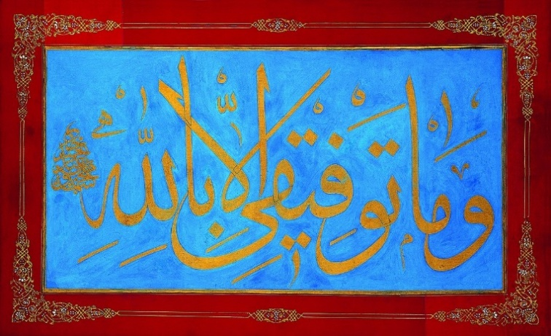
Figure 3. Ottoman calligraphy, drawing in the Thuluth font of Sultan Mahmud II, 1785 [32]

Historians of Islamic art and architecture note that numerous written records and artistic examples demonstrate the role of Arabic calligraphy in decorating and enhancing the interior spaces of Ottoman mosques, with evidence dating back to the early stages of architectural development in the early 14th century. The Green Mosque of Bursa (Turkish: Yeşil Cami), built by Sultan Mehmed I in 1420 as part of a social-religious complex (Turkish: külliye) on the eastern side of the city of Bursa, Turkey, the first capital of the Ottoman Empire, is considered one of the most important examples of the use of Arabic calligraphy in the early period of Ottoman art and architecture. Due to the exceptional degree of creative and aesthetic quality of the mosque in all its architectural and decorative details, it is considered the pinnacle of early Ottoman architecture [14].
The best illustration of Arabic calligraphy in early Ottoman architecture is found in the prayer hall in front of the Green Mosque, which is adorned with numerous unique examples of Arabic calligraphic embellishments (Figure 4). Beginning with the qibla wall, where the word "Tawhid" was written above the long mihrab in conspicuous gold on a maroon background within a horizontal rectangular frame, Arabic calligraphy was used as a decorative element in several locations throughout the prayer hall, often within geometric shapes. Arabic calligraphy also drawn in the form of multiple decorative bands, including an exquisite decorative band drawn on the upper cornice of the walls on four sides, another decorative band of Arabic calligraphy surrounding the mihrab on three sides drawn on ceramics, and the decorative bands above the tops of the casement windows on both sides of the mihrab continued to run over the blue ceramic panels covering the lower part of the side walls. In the middle of the side walls and above the casement windows, Arabic words were drawn around the circumference of a circle in a wonderful central style that highlights the calligrapher's skill, so that the overlap and intersection of the long sides of the letters form an octagonal geometric shape in the center. The walls of the prayer hall also contained some circular decorations in blue, on which were written the names of God, the Prophet Muhammad, and the four Rightly Guided Caliphs. The velvet fabrics adorning the pulpit are also adorned with Arabic calligraphy.

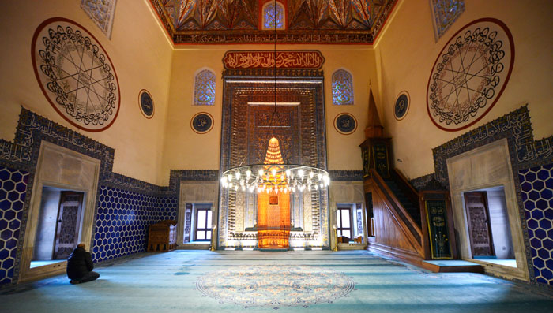
Figure 4. Green Mosque in Bursa, Interior Perspective

- RESULT AND DISCUSSION
As mentioned earlier, one of the most prominent aspects of Ottoman architecture is the use of towering domes and wide arches, which create lofty, lavish interior spaces that exude grandeur and richness. The Shehzade Mosque, also known as the “Prince’s Mosque” in English, is a prime example of this architectural philosophy and one of the most important artistic, historical, and religious references in Ottoman architecture. Constructed as a tribute to his son, Shehzade Mohammad, Sultan Suleiman the Magnificent ordered its completion in 1547. The mosque is located in the Fatih area of Istanbul and is notable for its elaborate interior decorations and unique Ottoman architectural [15].

  - SHEHZADE MOSQUE: DEVELOPMENT OF SPATIAL PLANNING METHODS
The mosque has a magnificent square plan, with a central dome and four half-domes. The hemispherical dome rests on four supports, has a diameter of 19 meters, and a height of 37 meters. The Shehzade Mosque reached the peak of Ottoman mosque architecture, in which construction and calligraphic decoration are integrated; however, before examining the Shehzade Mosque, we must first examine the development of Ottoman mosque architecture [16].
Based on the contiguity and convergence of spatial cubic spaces, Ottoman architects have used a range of geometric shapes in the design of their mosques since the early fourteenth century. These geometric planning methods are fundamentally based on the concept of adjacent cubic spatial units covered by domes. The Orhan Gazi Mosque, constructed in 1332, is an example of a single-space cube type with a semi-spherical dome. The Bursa Grand Mosque, constructed in 1399, is an example of a multi-domed space-cube model with equal-sized, regular cubes arranged in specific proportions, such as 2:3 or 4:5, to create a roomy rectangular interior area parallel to the qibla wall. Equal length-to-width ratios, such as 3:3 or 4:4, were also used to create a roomy, square interior.
Another example is the Murat Pasa Mosque, constructed in 1568 in the style of Bursa mosques and featuring a design based on a large central domed cube surrounded by a group of domed cubes of varying sizes, the largest of which is in the foreground and houses the pulpit and the mihrab. The Bayezid II Mosque, built in Istanbul in 1506, is a striking example of this style. It is based on the concept of several cubic space units in a 4:4 ratio, with a large central space of 2:2 and a large dome atop it [17]. Figure 5 shows all four of the mosque models above.

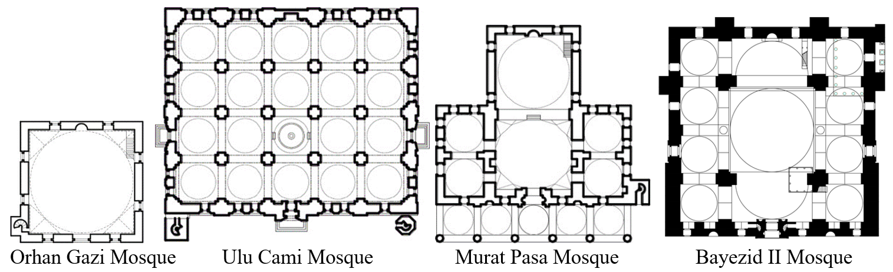
Figure 5. Geometric Shapes of The Early Ottoman Mosque Plans [16, 34]

There is no doubt that rearranging and coordinating the spatial structural system of the Ottoman Mosque was the main concern in the thought of the famous architect Sinan, who lived in the sixteenth century, due to the structural nature of the architectural design of the Ottoman Mosque, which required focusing on the accuracy and durability of construction. Thanks to his diligence and determination, he formulated an elaborate architectural form for the Ottoman Mosque in the golden age of the Ottoman Empire in the middle of the sixteenth century, through a group of diverse and integrated structural and architectural elements arranged around the hemispherical central dome. Such as inverted triangles, half-domes, arches, corner half-domes, columns, pillars, and buttresses, and walls, in addition to other architectural elements such as windows of different sizes and shapes, memorial gates, the large pulpit, and the mihrab [18].
The decisive choice made by architect Sinan in the Shehzade Mosque was to adopt the central dome as a fundamental structural and spatial element in Ottoman mosque architecture, both internally and externally, as shown in Figure 6. The architectural design of the Shehzade Mosque consists of a modular combination of structural elements arranged in a symmetrical geometric pattern around the central dome. The presence of the central dome at the top of the design makes it more expressive, both internally and externally. The circular dome in the center of the design is surrounded on four sides by semicircles representing the semi-domes, which extend the upper space in all directions and provide a smooth descent towards the ground cube of the prayer hall. This is while maintaining the space in the boundary linked to the central space, because the half-dome represents an ideal visual and geometric extension of the central dome, which bears the same spherical geometric characteristics [19].

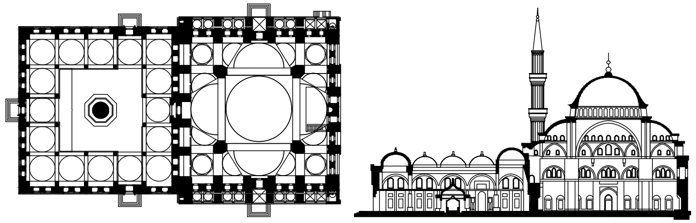
Figure 6. Shehzade Mosque, Plan & Section

Structurally, the four half-domes incline towards their opposite and non-existent halves, thus achieving the important structural advantage by providing the necessary support for the stability of the four large arches that provide the structural support required for the constancy of the central dome above the top of the building, which in turn covers the cube of the central space [20]. Visually, the spherical shape of the four half-domes seems to embrace and envelop the space extending from the center to the surrounding spaces, and this confirms the importance of the geometric shape of the four half-domes, which enhances the central planning methodology with all the spatial and geometric elements around the central dome, which architect Sinan sought to consolidate within the structural and architectural synthesis of the Ottoman Mosque.
Shehzade Mosque represents the ideal architectural model for integrating Arabic calligraphic decoration with the spatial and structural planning of the Ottoman Mosque. The ideal spatial-structural arrangement in the Shehzade Mosque, which is based on the geometric concept of the central dome surrounded by four axially symmetrical semi-domes, required the architect Sinan to integrate an impressive and diverse array of geometric and floral decorations and Arabic calligraphy in an aesthetic manner appropriate to the value of the great architectural and constructional achievement of the Shehzade Mosque. As shown in the previous figure.
Figure (7) below displays the shape of the structural elements of the domed upper part of the mosque from the inside of the prayer hall, which highlights the large structural system that dominates the architecture of the Shehzade Mosque, and which largely dictates how it is decorated and ornamented. A group of decorative themes and methods was used, drawn from many sources. One of the most important decorative achievements in this mosque is the Ottoman calligrapher's ability to adapt the letters, words, and sentences of Arabic calligraphy to the mosque's curvilinear structural elements. It deserves special mention because he succeeded in transforming the structural elements into a visual spectacle of beautiful, interconnected texts, largely taking the geometric form of the Shehzade Mosque's curved, arched, and concave elements.

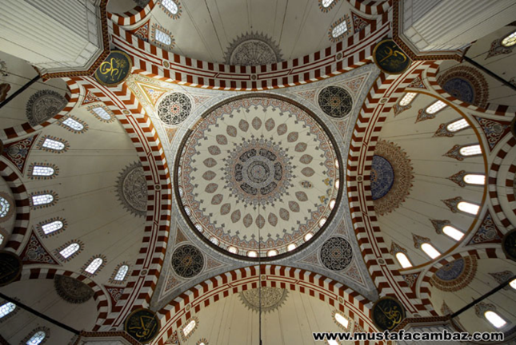
Figure 7. Shehzade Mosque, Interior Perspective

The flowing architectural form of the Shehzade Mosque, with its striking central domed structure, may appear very attractive externally and, when viewed from the inside, requires no additional modifications or decorative arrangements due to its harmonious elements and proportional geometry. However, architect Sinan adopted the same strategy as earlier Islamic architectural styles and trends, which emphasized Arabic calligraphy as the primary decorative and expressive element in the mosque's interior beautification scheme. Architect Sinan commissioned the most famous and skilled calligraphers of his time, such as Ahmed Karahisari (1468–1566) and Hasan Çeleb (also known as Cerkes Hasan Qelebi, d. 1594), to prepare and design the calligraphic decorations of the Shehzade Mosque, which were refined in harmony with the streamlined shape of the mosque's roof and its high central concave dome. The walls of the prayer hall are embellished with verses from the Holy Quran, written in beautiful Arabic calligraphy and arranged in various compositions. This mosque is considered a clear and distinctive example of the use of Arabic calligraphy in the interior design of mosques during the Ottoman era, noting that the Ottomans used Arabic script to write their language from the outset due to its association with Islam and Arabic culture [21].
The integrity of the Shehzade Mosque’s structure and its magnificent architecture indicate that the architect Sinan placed great value on the mosque's architectural form. Figure 8 below shows how the interior design elements and decorations were fully integrated and harmonized with the mosque's central domed architectural form. Necipoğlu confirms this by saying: “Sinan’s biography reveals that he (Sinan) considered decoration and calligraphy as integral components of the mosque’s architecture” [22]. Thus, it is clear that architect Sinan decorated the Shehzade Mosque with a set of harmonious Arabic calligraphic decorations designed to blend with the curved architectural forms of the prayer hall's structural and spatial elements, including the corner semi-domes, inverted triangles, the central dome, and the semi-domes.

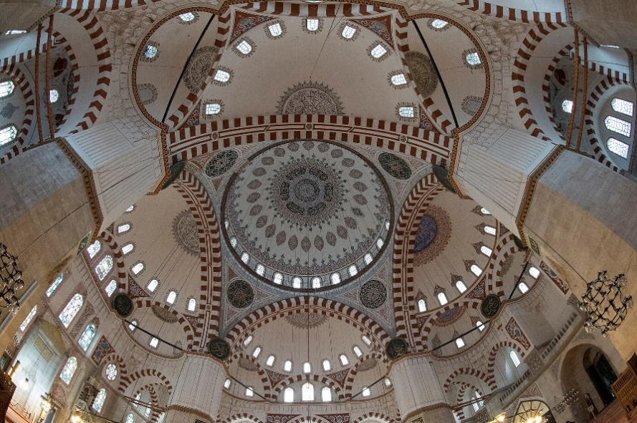
Figure 8. Shehzade Mosque, Interior Perspective

On the ground level, the mosque is square in plan and completely devoid of columns or other structural obstructions, except for the four pillars at the corners of the central cube beneath the dome. Architect Sinan made great efforts to coordinate and develop the shape of the mosque's facades, especially on the inside, distributing vertical windows and decorations across the four walls at four regular horizontal levels in an innovative style. Architect Sinan gave particular importance to the qibla wall at the front of the prayer hall, which featured the minbar and the mihrab, as well as Arabic calligraphy and stained-glass windows.

  - ARABIC CALLIGRAPHY DECORATIONS IN SHEHZADE MOSQUE
The Arabic calligraphy decorations inside the prayer hall of the Şehzade Mosque are distributed on several levels and over a variety of vital architectural and structural elements, such as the central dome, inverted triangles, semi-domes, corner semi-domes, piers, and the qibla wall, including the mihrab, all of which we will discuss and analyze in the following paragraphs.
Arabic calligraphy decorations of the central dome: From an architectural exterior perspective, Figure (9), the circle that defines the perimeter of the dome of the Shehzade Mosque, with its regular and cohesive circumference around the center, may represent the unity of Ottoman society with all its components, and the central design of the construction of the upper dome may also express the centrality of the Ottoman Empire, the strength of its administration, and the sovereignty of the Sultan.

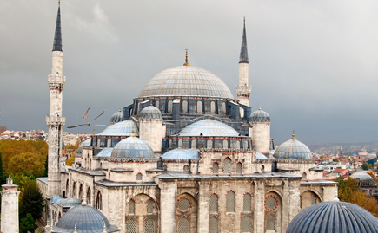
Figure 9. Shehzade Mosque, Exterior Perspective

The hemispherical shape of the dome above the ground cube of the prayer hall may represent the shape of the vast dome of heaven that covers the flat earth on which people of all races and colors live. Thus, inside the mosque, believers feel equal, as there is no distinction between the community and the clergy, or between the rich and the poor, and all worshipers take shelter under the one wide central dome in an integrated sanctuary and unified interior space. At the interior apex of the hemispherical dome of Shehzade Mosque, Arabic calligraphy and floral motifs are painted in multiple concentric rings. In the center, there is a circle of floral motifs dominated by azure. Then it is surrounded by a circular ring of Arabic calligraphy motifs on a dark black background, followed by a circular ring of floral motifs dominated by azure. A second ring of Arabic calligraphy motifs wraps around it, divided into six equal parts, with a dark black background and surrounded by a frame of floral motifs that head downwards, with forty-eight hanging heads, harmonious and closely converging.
Figure (10) below highlights the Qur’anic inscriptions drawn on the central dome, which emphasize the role of the Prophet Muhammad, may God bless him and grant him peace, in conveying divine revelation. The Arabic calligraphic ornamentation was painted in the thuluth script at the top of the dome's upper section, forming two circles. The first circle in the center depicts Surat Al-Fatiha (1:1-7), considered the opening of the Qur’an and one of its greatest chapters. It is obligatory in all prayers, and there is no prayer except with it. The outer circular frame cites verses from Surat Al-Isra, referring to the Prophet's dream, may God bless him and grant him peace, that he was carried by night from Mecca to Jerusalem, where he ascended through the seven heavens to the presence of God (17:1-2). The verses quoted here glorify the 'Creator, the hearer, and the seer, who is the only guide for the believer to salvation through the scriptures that God has revealed to the prophets [23].

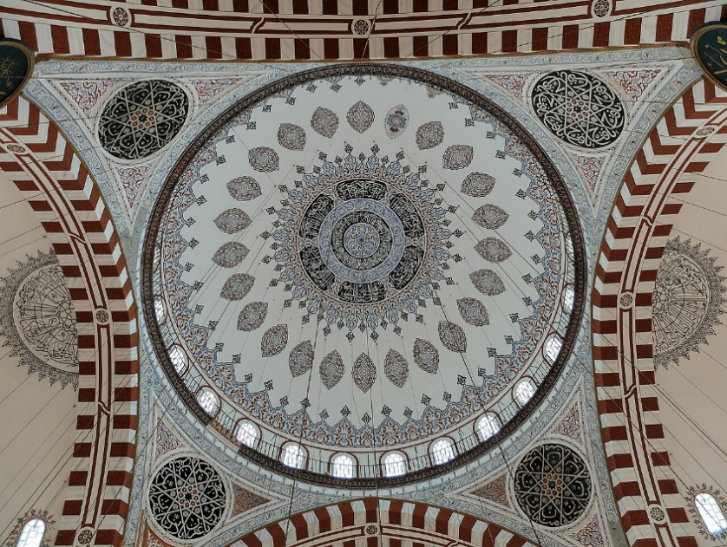
Figure 10. Shehzade Mosque, Interior Perspective

The circular ornamentation of the upper part of the dome enhances the central orientation of the mosque's interior. It also reinforces the imaginary vertical axis of the dome. At its peak, Surat Al-Fatiha is depicted at the center, surrounded by the first two verses of Surat Al-Isra, which narrate the Prophet Muhammad’s ascension to the seven heavens. [23]. Thus, this vertical axis may be considered a representation of the vertical relationship that connects people on earth to the One Creator, the Almighty, and their need for Him in prayer and supplication.
As for the floral ornamentation, it is semi-oval and consists of twenty-four decorations arranged vertically in the middle layer of the dome, which seem to float in the mosque's sky around the dome's imaginary vertical axis. At the lower part of the dome, the floral motifs continue to circle around the center and above the windows. There are twenty-four vertical windows with semicircular ends at the top, placed alternately with the dome's supports to illuminate the interior.
Arabic calligraphy decorations of the inverted triangles: The four inverted corner triangles that overlook the central vertical space of the prayer hall underneath the main central dome are adorned with rounded ornaments of Arabic calligraphy decorations with a dark background in which some supplications were written, such as Ya Hanan, Ya Manan, Ya Fattah, as shown in Figure 11. These circles were arranged centrally, making the Arabic calligraphy decorations appear to revolve continuously around the center, and the dome above them seemed lightweight, as if floating above the pyramidal summit of the mosque’s architecture.

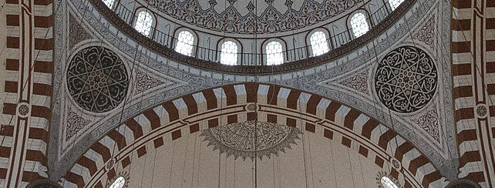
Figure 11. Shehzade Mosque, Interior Perspective

Arabic calligraphy decorations of the main half-domes: The Arabic calligraphy decorations on the four main half-domes had a semicircular shape that matched the half-domes' geometric shape, as shown in Figure 12. It appeared that the other half of the motifs was drawn in the middle area beneath the central dome. Upon closer inspection, we find that the four main half-domes collectively contain one continuous text from Surat Al-Baqara, verses 144 and 145. At first glance, the viewer may believe that each half-dome is decorated with a single ornamentation of Arabic calligraphy representing an independent verse from the Holy Qur'an. The first Verse begins at the half-dome above the mihrab and concludes at the subsequent half-dome. This Verse describes the qiblah that God selected for the Prophet Muhammad and Muslims to face toward the Grand Mosque in Mecca. The Prophet Muhammad was particularly fond of this qiblah. Drawn on a sparkling blue background, the second Verse begins at the half-dome across from the mihrab and concludes at the next half-dome. It talks about how the qiblah of Muslims differs from that of the Book, Jews, and Christians [23]. Nine vertical windows perforate each half-dome, bringing additional natural light into the interior space throughout the day. The two noble verses made the four main halves appear interconnected, as if they were another circle revolving around the dome's circumference.

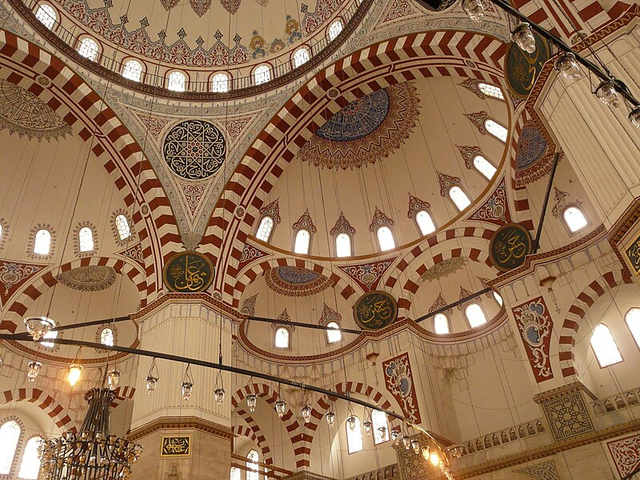
Figure 12. Shehzade Mosque, Interior Perspective

Arabic calligraphy decorations of the corner half-domes: Below the four main half-domes are the eight corner half-domes, two at the tip of each main half-dome. They are decorated with Arabic calligraphy in a semicircular shape and contain one continuous text in the same manner as the four main half-domes. See Figures (8) and (12). Upon examining the texts, we discover that they represent the last two verses of Surah Al-Baqara 285-286. The first Verse starts at the first corner half-dome in the main half-dome above the mihrab and ends at the fourth corner-dome in the next main half-dome. It states that the Messenger and the believers believe in God and His angels and His books and His messengers, and that the Messenger acknowledged what was revealed to him from his Lord in the Book, including what is permissible and forbidden. The second Verse starts from the fifth corner half-dome in the main half-dome opposite the mihrab, drawn on a sparkling blue background, and ends at the eighth corner half-dome in the next main half-dome. It informs that God does not charge a soul except what suffices it, so He does not overburden it and does not restrict it in the matter of its religion [23]. The two noble verses made the eight halves of the corner domes appear interconnected as if they were another circle revolving around the four main halves of the domes.
Arabic calligraphy decorations of the qibla wall: As for the ground level, all the walls are decorated with floral motifs, and only the qibla wall is distinguished by its decoration in Arabic calligraphy, as shown in Figure 13, where the first four verses of Surat Al-Fath are painted in the form of slightly curved triangles above the casement windows overlooking the front garden of the mosque. It is known that Surah Al-Fath is the most beloved Surah to the heart of the Prophet Muhammad, peace and blessings be upon him, as it contains conquest, forgiveness, victory, and tranquility [23]..

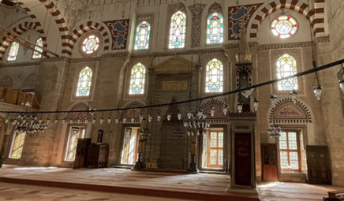
Figure 13. Shehzade Mosque, Interior Perspective

The elegant mihrab, as shown in Figure 13, is decorated with a marble panel of Arabic calligraphy, inscribed with a group of words from the noble Verse No. (37) of Surah Al Imran “Every time Zechariah entered upon her in the prayer chamber”, which is one of the verses appropriate for this central location on the qibla wall in the front of the mosque. It is a relief inscription in golden Arabic calligraphy, set within a rectangular frame above the conical top of the mihrab niche [23].

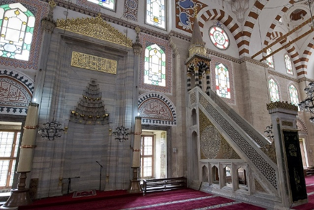
Figure 14. Shehzade Mosque, Interior Perspective

It remains to point out that six circular panels were not painted directly on the structural elements of the mosque; rather, the Arabic calligraphy ornamentation was painted in gold over black wooden panels, large in scale and clear so that it could be easily read from afar. Two of them were placed above the mihrab, on which the name of the Majesty and the name of the Prophet Muhammad were painted. Four panels bearing the names of the Rightly Guided Caliphs were placed above the large main pillars in the center. Two panels were placed above the northern gate bearing the names of Al-Hassan and Al-Hussein, the descendants of the Prophet, peace and blessings be upon him. The arrangement of these six panels confirms the direction of the north-south qibla axis, which begins at the luxurious, prominent marble mihrab at the center of the qibla wall. See Figures (7), (8), and (12).

  - THE GEOMETRIC ARRANGEMENT OF ARABIC CALLIGRAPHY DECORATIONS AND THEIR RELATIONSHIP WITH THE STRUCTURAL COMPOSITION OF SHEHZADE MOSQUE
The observer of the interior design of Shehzade mosque may believe that the noble verses were written for purely decorative purposes because of the aesthetic value and superior gracefulness of Arabic calligraphy that made it harmonize with the circular and domed shape of the mosque’s architecture, but in reality, Arabic calligraphy is not only a work of art that one should view, read, or savor, but rather it is artistically drawn scripts that must be recognized since they are quotations from the Qur'an or hadiths. Arabic calligraphy, which Muslims have used to decorate mosques for generations, is the closest thing to a message that has great aesthetic value and accurately conveys the meanings of the Qur’an and hadiths, the revelations descending from heaven.
It is often said that the letters of the Arabic script are flat, and even when arranged in phrases and sentences, they maintain that flatness, as though they were made of two-dimensional geometry rather than three-dimensional. Because the Muslim artist prefers flatness over anthropomorphism to avoid imitating God’s creatures, Arabic calligraphy was perfectly appropriate for decorating and embellishing mosques with remarkable two-dimensional geometric shapes containing religious texts from the Qur’an and hadiths, unparalleled in past and contemporary art and civilization [24].
It is noteworthy in analyzing the decorative program of Arabic calligraphy in the Shehzade Mosque, Figure (15), that the noble verses of the Holy Quran that the calligraphers employed in decorating the domed ceiling of the prayer hall were designed in the form of successive descending rings consisting of three layers, almost all of which are located on the ceiling of the mosque and share the same center, as shown as follows:
The upper layer: Starting from the highest peak of the roof structure in the center of the main dome, where the ring of Surat Al-Fatiha is located, followed by another wider ring containing verses from Surat Al-Isra.
The middle layer: Going down to the middle layer of the roofing structure, four inverted corner triangles were placed around the circumference of the central dome, decorated with types of supplications to the Almighty Creator, forming a wider ring than the two rings in the center of the dome. In the same level in the middle layer, at the tops of the four main half-domes, the verses from Surat Al-Baqarah are written in the form of one continuous text linking the four half-domes together, forming a wider ring than the previous three rings in the center and surroundings of the dome.
The lower layer: Down to the lowest layer of the roofing structure, at the tops of the corner half-domes, the verses from Surat Al-Baqara were also written in the form of one continuous text linking the eight corner half-domes together and forming a ring more spacious than the upper four rings, its diameter is approximately equal to the dimensions of the sides of the square of the prayer hall on the ground floor.

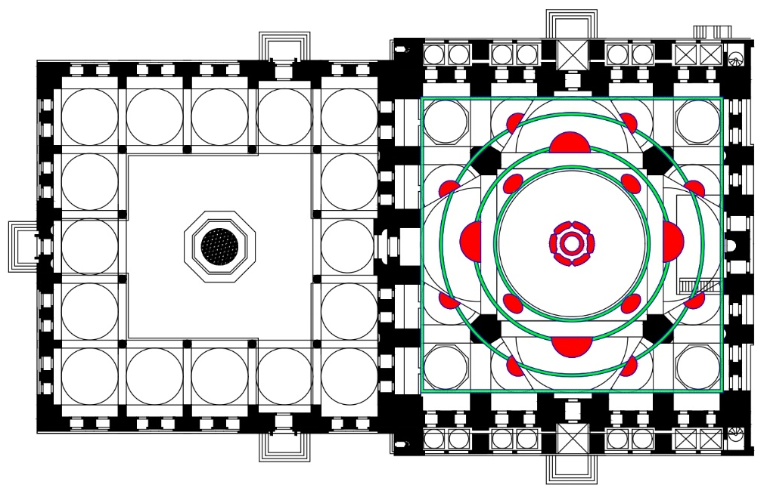
Figure 15. Shehzade Mosque, Plan Analysis

We conclude from the above that the centrally rising and interconnected decorative pattern adorning the skies of the prayer hall of Shehzade Mosque, through which the decorations of Arabic calligraphy were coordinated. Their locations determined, it was built in a manner that seemed to revolve around the imaginary vertical axis of the central dome, as shown in Figure 16. An important note here is that all the decorative calligraphy panels spread across the tops of the central dome, main half-domes, and corner half-domes were a single text from the verses of the Holy Qur’an, drawn in a central style and in a concave horizontal manner. Only the calligraphy decoration panels drawn above the inverted triangles differed slightly from the rest, as they had an oblique composition consistent with the inclination of the inverted triangles and were directed toward the central space. Its texts are also different from the rest, as they are not Qur’anic verses, but rather a supplication inherited from the Prophet Muhammad, peace and blessings be upon him. It was drawn repeatedly, eight times in each panel, to motivate believers to repeat their supplications and insist on asking for mercy and forgiveness from the Almighty Creator. This dynamic design, through the central repetition of the supplications above the four inverted triangles below the central dome, gives the viewer a sense of continuous vertical movement between the earth and the sky in two opposite and parallel directions, so that the believers direct their prayers and wishes towards the sky day and night. The Creator honors them with mercy and forgiveness.

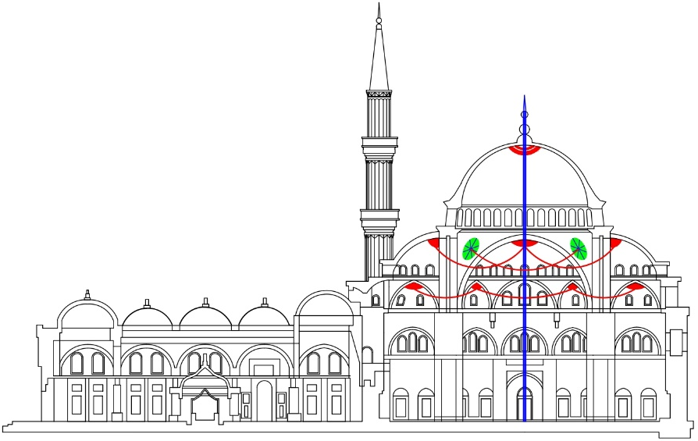
Figure 16. Shehzade Mosque, Section Analysis

It is now reasonable to say that the architect Sinan, inspired by this celestial creation, designed the Arabic calligraphy panels on the roof of the Shehzade Mosque based on the movement of the stars and galaxies in the great sky, which run along precise courses prescribed by the Great Creator. Two-dimensional geometric shapes, such as circles and squares, have been explored and employed throughout history in architecture to plan religious and secular buildings and to create various interior and exterior spaces within them [25]. These shapes have been linked to many meanings; for instance, the circle, a two-dimensional projection of the sphere, symbolizes unity. The circle also represents equality, since it has no boundaries, borders, or corners, and every point on its perimeter is equidistant from its center [26]. Thus, if the circle of the dome in the Şehzade Mosque symbolized the unity of Ottoman society, the two rings of Arabic calligraphic decorations containing continuous texts of the Holy Quran at the tops of the four main half-domes and the eight corner half-domes made the upper structure around the central dome appear as a visual echo of the circle of the dome, which symbolized the equality of all sectors of Ottoman society, both near and far from the center.
Since it draws the attention of the viewer who reads the decorative texts during worship and appreciates the beauty of the decorative composition, Arabic calligraphy stands out from other interior decorative arts in that it can both express and remind. No decorative style can match it in the architecture of mosques, which are places of worship and seclusion from the outside world. Al-Ash'ari asserts that Arabic calligraphy is regarded as the foundation of Islamic art and architecture. The Arabic phrase for calligraphy is "handast al-khatt," which translates to "the geometry way of writing the Arabic language" and is used in mosques and other places of worship. [27]. In order to create Arabic calligraphy with exact geometric proportions on paper, Ibn Muqlah (886–940) and other early calligraphers worked very hard. Ibn Muqlah (886-940) and other early calligraphers devoted considerable effort to creating Arabic calligraphy with precise geometric proportions on paper. In contrast, Ottoman calligraphers excelled in formulating Arabic calligraphy decorations on interior architecture [28].
"God is beautiful and loves beauty," according to the Prophet's hadith [29]. Glory be to the Creator, who adores beauty and man's ability to produce the perfect and lovely. A Muslim artist becomes closer to God when he produces something lovely. With great knowledge and exact mathematical order, God created the earth and the heavens, and all living things undoubtedly serve as symbols of God's Majesty and might. The artist who uses Arabic calligraphy or architectural design must therefore produce in a complex way that emphasizes the beauty and Majesty of God's creation. Divided into two main components, the Shehzade Mosque's architectural design closely mirrors this idea: the ground building, with its square design evoking the flat earth, and the upper structure, with its domed design recalling the arch of the sky. The upper structure is rich in floral and calligraphic decorative elements, arranged in a precise central manner consistent with the mosque's wonderful architectural design. The Arabic calligraphy ornamentation, primarily designed in circular and semicircular shapes and spreading across the mosque's ceiling as if celestial bodies, is interspersed with small windows that illuminate the interior space like stars in the sky. In terms of ground construction, Arabic calligraphy is used only to embellish the mihrab and the qibla wall.

- CONCLUSION
Although the aesthetic aspect was a fundamental goal that could not be ignored in the mind of the architect-designer, this study concluded that the function of Arabic calligraphy decoration in Ottoman architecture, especially in the Şehzade Mosque, was not limited to this aspect, but rather the calligraphers were able to link the structural element with the Arabic calligraphy decorations, and with each other by showing a deeper artistic level that goes beyond the decorative aspect. This will be explained through the following:
Enhancing the planning and construction: The Shehzade Mosque and many other mosques built in the Ottoman architectural style demonstrate how Ottoman-era mosques were unique in their planning, relying on a strong structural system that supports the wide hemispherical dome set high on complex square, hexagonal, and octagonal frameworks. Thus, the interior space becomes square or rectangular at ground level and almost column-free. The unique mosque model created by architect Sinan during the 16th century gave each mosque a distinctive dome and architectural challenge, as the domes rose high and expanded, and the interior space extended in length and width with the fewest columns. However, architect Sinan and his team did not diminish the mosque's aesthetic value. As a result, a variety of techniques emerged to decorate the interior of the mosque, especially Arabic calligraphy, which they found most suitable for the architectural and construction features of Ottoman architecture. Arabic calligraphy made the architectural elements of the mosque more coherent and harmonious.
Emphasis on the symbolic aspect: What can be understood from the geometric formation of these three lyers of five circles of Arabic calligraphy decoration in Shehzade mosque, which all share the same center, is the emphasis on the unity of Ottoman society and its rallying around the Ottoman Sultan, the center of the state and the symbol of its unity, in addition to the emphasis on the vertical axis of the dome and its direction towards the sky, the source of revelation and the Muhammadan message reinforced by the spiritual value of the Qur’anic verses. And its religious meanings. Perhaps these five rings also refer to the five daily prayers performed under the domed ceiling, day and night.
Great harmony between calligraphers and architects: Because of their expertise and deep understanding of Arabic calligraphic proportions, the Ottoman calligraphers who collaborated with architect Sinan on the Shehzade Mosque produced a sizable collection of Arabic calligraphic ornamentation dispersed throughout the mosque's structural and architectural components, particularly the upper domed structure. Together, the spiritual and artistic elements of these decorations are emphasized by the inclusion of religious scriptures. As the Shehzade Mosque became a significant model in Ottoman architectural history, the calligraphers refined their work in a central geometric style that is fully consistent with the mosque's structural elements. This helped improve the interior design of Ottoman mosques in general.
Understanding the Aesthetic Composition of Arabic Calligraphy: Aesthetic investigations of Arabic calligraphy at the Şehzade Mosque in Istanbul have yielded a comprehensive understanding of the principles and style of Arabic calligraphic decoration in this historical edifice. Focused attention and confirmation of the Arabic calligraphy type, the type of texts, and the geometric arrangement of the decoration led to a refined understanding of the importance of calligraphy in improving the interior environment of mosques. The results were further corroborated by an analysis of drawings, which showed that Arabic calligraphy complements other architectural features and enhances the mosque's interior space. Architect Sinan placed Qur'anic passages at the tops of the walls, on the domed ceiling, and on the dome itself because he understood the inherent importance of calligraphy, which is conveyed through verses and hadiths. Because Arabic calligraphy conveys meanings decipherable from the religious texts included in the decoration, its precise placement exemplifies the expressive value it offers as a decorative element in mosque interior design, a value no other style of decoration can match. The Shehzade Mosque's architectural style created a paradigm for Ottoman architecture that is still imitated today. Internally, the Shehzade Mosque's presentation of Arabic calligraphy gave the impression that it was an essential component of this unique, timeless architectural style. By focusing on the arrangement of letters, their spiritual significance, and the role calligraphy plays through its aesthetic impact, this study contributes to the ongoing conversation about the value of calligraphy's placement within mosque design.
The ability of Arabic calligraphy to integrate with contemporary styles: The Ottoman style in mosque architecture is currently popular and competes with contemporary global architectural styles because it relies on the strength of its construction. Due to its unique compositional qualities and greater design freedom, Arabic calligraphy decoration is superior to other types of decoration and can be integrated into contemporary architectural and artistic trends. Modern mosques in various Islamic nations are now copying the Shehzade Mosque's architectural design. The Shehzade Mosque's Arabic calligraphy style can continue to evolve and influence the interior design of contemporary mosques that adopt this unique style.
Arabic calligraphy has gained popularity worldwide in the modern era, and it is widely used in both religious and secular projects in contemporary architecture. One notable example is the Museum of the Future in Dubai, United Arab Emirates, which debuted in 2022 and features Arabic calligraphy engraved on its oval-shaped facades. The Sheikh Khalifa bin Zayed Al Nahyan Mosque in Al Ain, which opened in 2021, is another example from the United Arab Emirates. Its great dome was adorned with exterior verses from the Holy Quran in a stunning style that demonstrates the extent to which Arabic calligraphy decorations can be used to adorn contemporary structures. There are too many examples to list, but many modern restaurants and tourism projects worldwide have begun enhancing their interior spaces with Arabic calligraphy.
Additionally, some contemporary homes and villas in the Arab world have adorned their exterior and interior walls with Arabic calligraphy engravings. The researcher wishes to make it clear that the Shehzade Mosque's Arabic calligraphy decorations can serve as a significant source of inspiration for modern projects, and this study's scientific contribution can aid in that regard. Arabic calligraphy can express the unity of the Islamic nation in the modern era, and it is clear evidence of the cohesion of Muslims worldwide, body by body, hand by hand, and word by word.

AUTHORS CONTRIBUTION
This research paper is the result of great effort by the author, who specializes in the history of Islamic and Ottoman architecture, and is dedicated with thanks and appreciation to Petra University for supporting its researchers.

REFERENCES
[1] G. Öney, L. Bulut, S. Çakmak, E. Daş, A. Demir, Y. Demiralp, I. Kuyulu, R. H. Ünal. Early Ottoman Art: The Legacy of the Emirates. Islamic Art in the Mediterranean (2nd ed.). Museum With No Frontiers. 2010.
[2] R. C. Ostergren, M. Le Boss, The Europeans: A Geography of People, Culture, and Environment (2nd ed.). New York: Guilford Press. 2011.
[3] O. Grabar, J. M. Landau, R. M. A. Allen, A. Schimmel, A. Shiloah, J.T.P. de Bruijin, "Islamic Arts." Encyclopedia Britannica. Accessed: November 1, 2023. [Online] Available: https://www.britannica.com/topic/Islamic-arts.
[4] B. Özer, "The Architect of Domed Mosques as a Master of Pluralism.” Environmental Design: Journal of the Islamic Environmental Design Research Centre, Vol. 1, No. 2, pp. 146-155. 1987.
[5] N. Al-Mughrabi, "The Design Characteristics of Arabic Calligraphy and The Extent of its Influence on Islamic Interior Design". Jordan Journal of the Arts, Vol. 17, No. 2. pp. 273-290. 2024. DOI: https://doi.org/10.47016/17.2.8.
[6] N. Al-Mughrabi, " Historical Factors and Their Impact on The Formation of Architect Sinan’s Mosques ", Jordan Journal of the Arts, Vol 15, no. 4, pp. 775-794, 2022. Doi: https://doi.org/10.47016/15.4.7.
[7] A. Al Jamali, "Arabic calligraphy and Islamic architecture between the plastic dimension and spiritual depth". Yanabi` Magazine, Issue 33, 2018.
[8] S. J. Shaw and M. E. Yapp, "Ottoman Empire". Encyclopedia Britannica. Accessed: July 3, 2023. [Online] Available: https://www.britannica.com/place/Ottoman-Empire.
[9] M. Zakariya, Music for the Eyes an Introduction to Islamic and Ottoman Calligraphy, Los Angeles: Museum Associates, Los Angeles County Museum of Art c. 1998.
[10] N. A., "A Turkish saying, The Holy Qur'an was revealed in Mecca, read in Egypt, and written in Istanbul". Turk Press. Accessed: July 3, 2023. [Online] Available: https://www.turkpress.co/node/20657.
[11] W. S. Hassanein, The Art of Arabic Calligraphy - The Ottoman School, Cairo: The Egyptian General Book Authority, 2015.
[12] E. Kvernen, "Thuluth and Naskh". Calligraphy Qalam. Accessed: November 26, 2018. [Online] Available: https://www.calligraphyqalam.com/styles/naskh.
[13] A. A. A. Ibn-Ali, Subh al-asha fi sinaat al-insha' Part 3, Cairo: The Egyptian Book House. 1922.
[14] A. Ersoy, "Architecture and the Search for Ottoman Origins in the Tanzimat Period". Muqarnas. vol. 24, no. 1, pp. 117–139, 2007. DOI: https://doi.org/10.1163/ej.9789004163201.i-310.19.
[15] J. M., Rogers, Sinan. London: I.B. Tauris in association with the Oxford Centre for Islamic Studies, 2006.
[16] J. M. Rogers, Sinan's autobiographies. London; New York: I.B. Tauris in association with the Oxford Centre for Islamic Studies. 2006.
[17] F. A. Mustafa and A. S. Hassan. “Mosque layout design: An analytical study of mosque layouts in the early Ottoman period.” Frontiers of Architectural Research, vol. 2, no.4, pp. 445-456. 2013. DOI: https://doi.org/10.1016/j.foar.2013.08.005
[18] N. Almughrabi, J. Prijotomo, M. Faqih, "Suleymaniye Mosque: Space Construction and Technical Challenges", International Journal of Education and Research, Vol. 3, No. 6, pp. 345-358, June 2015.
[19] N. Al-Mughrabi, "Historical Factors and Their Impact on the Formation of Architect Sinan Mosques", Jordanian Journal of Arts, Vol. 15, no. 4, pp. 775-794, 2022. Doi: https://doi.org/10.47016/15.4.7.
[20] R. J. Mainstone, Hagia Sophia, Architecture, Structure, and Liturgy of Justinian’s Great Church. London: Thames & Hudson Ltd. 2006.
[21] E. Atıl, "The Age of Sultan Süleyman the Magnificent". National Gallery of Art. Accessed: July 3, 2023. [Online] Available: https://www.nga.gov/research/publications/age-sultan-suleyman-magnificent.
[22] G. Necipoğlu, The Age of Sinan, Architectural Culture in the Ottoman Empire. London: Reaktion Books Ltd. 2005
[23] Al-Quran
[24] S. Ghanoum, "The Aesthetics of Arabic Calligraphy and Its Impact on Architecture and Enriching Interior Space". Damascus University Journal of Engineering Sciences, vol. 30, no. 2, 2014.
[25] V. De Risi. Mathematizing Space: The Objects of Geometry from Antiquity to the Early Modern Age. Birkhäuser Cham, 2015.
[26] E. Kimberly. Geometry of Design: Studies in Proportion and Composition. Princeton Architectural Press. 2019.
[27] D. Alashari, A.R. Hamzah, N. Marni, "The Aesthetic of Islamic Calligraphy and Ornamentation in Prophet Mosque Interior of the Calligrapher Abdullah Zuhdi (Al-Masjid An-Nabawi)". UMRAN Journal of Islamic and Civilizational Studies, vol. 7, no. 2, pp. 69-80, 2022. DOI: https://doi.org/10.11113/umran2020.7n2.374
[28] N. Khokhar, M. Nawaz, "The Master Calligrapher: Ibn Muqlah", The Islamic Culture, Vol 39, pp. 17-26. 2018.
[29] Sahih Muslim 1.93:91.
[30] D. Osseman, "File:Yesil Cami 7799". Wikimedia Commons. Accessed: July 3, 2023. [Online] Available: http://commons.wikimedia.org/wiki/File:Yesil _Cami_7799.jpg
[31] M. Rakim, "Allah - Muhammed (A.S.)". Wikiart. Accessed: July 3, 2023. [Online] Available: https://www.wikiart.org/en/mustafa-rakim/allah-muhammed-a-s
[32] D. Sabah, "Istanbul’s Sabancı Museum displays calligraphy by Ottoman sultans". Daily Sabah. Accessed: July 3, 2023. [Online] Available: https://www.dailysabah.com/arts/events/istanbuls-sabanci-museum-displays-calligraphy-by-ottoman-sultans

