 |  | JOURNAL OF ISLAMIC ARCHITECTURE  P-ISSN: 2086-2636 E-ISSN: 2356-4644  Journal Home Page: http://ejournal.uin-malang.ac.id/index.php/JIA
OBSERVATIONS REGARDING THE LIME STUCCO ORNAMENTS OF THE SAFAVID AND QAJAR BATHS IN IRAN'S KURDISTAN PROVINCE
Tayebeh Hosseinpour Derakhsheshª, Habib Shahbazi Shiran^{a*}, Mohamad Ebrahim Zarei^{b}, Karim Hajizadehª
ªDepartment of Archaeology, Faculty of Social Sciences, University of Mohaghegh Ardabili, Ardabil, Iran
^{b}Department of Archeology, Faculty of Art and Architecture, Bu-Ali Sina University, Hamedan. Iran
*Corresponding Author: habibshahbazi35@gmail.com
ARTICLE INFO |  |  | ABSTRACT
Volume: 8  Issue: 3  Page: 700-713  Received: April 25th, 2024  Accepted: September 18th, 2024  Available Online: June 30th, 2025  DOI: 10.18860/jia.v8i3.26745 |  |  | In addition to furnishing insights into their aesthetic aspects, inquiry into the architectural ornaments of public buildings reveals the interests of their commissioners and the public. Lime stuccowork assumed a central place among the architectural ornaments of bathhouses due to lime’s workability and its use as a major resilient building material in such hot and humid atmospheres. The present study seeks to investigate and analyze the lime stucco ornaments at bathhouses of Kurdistan Province in the timeframe spanning the Safavid to the end of the Qajar period. This descriptive, historical-comparative research builds on both field and library research to explore the lime stuccoworks at the bathhouses of the province. Research questions tackled here include: (1) What were the themes of the main lime stucco ornaments, and what role did the local rulers play in their creation? (2) Where did these decorative elements take inspiration from? The results of the research show that the employed decorative patterns consist of geometric, Islimi, vegetal, flower, vase, and animal and bird ornaments. These decorative elements drew inspiration from nature, ancient beliefs, and archaism. In fact, local rulers and commissioners were responsible for the flourishing and spread of this art. Due to their influence in the coeval political and administrative institutions, they managed to hire skilled craftsmen from the capital or regions abroad to construct such constructions that, beside invoking those popularly used in the region, benefited from a series of indigenous ornamental patterns.  Keywords:  Kurdistan bathhouses; Sanandaj; Lime stuccowork; Ornaments; Themes

- INTRODUCTION
A principal building type in Iranian architecture is the bathhouse, which was elevated in the front rank of urban structures after the rise of Islam due to the great social position of Iranian culture accorded to it. The reason for this is water’s purity and the traditional role of washing (ablution) dating back to Zoroaster’s time (Haj Ghasemi 1996, 76). Bathhouses were placed at the center of neighborhoods or adjacent to main corridors of bazaars or main junctions. Constructing such public buildings and adding decorative elements to them became particularly popular in the Islamic period, especially under the Safavids. In the ensuing Zand period, Karim Khan’s (1209‒1163 AH) enthusiasm for the elevation of Iranian culture, coupled with contemporary artists’ concern for the revival of ancient decorative patterns, provoked their use in construction projects. This decorative art would culminate in the Qajar period, when images with literary and mythic themes, especially birds like peacocks and birds of paradise, began to mark the main spaces of public bathhouses [1]. Apart from giving insight into artistic aspects, inquiry into the ornaments of bathhouses will unveil the aspirations of their commissioners as well as the general public. During the Ardalan dynasty’s rule over Kurdistan and under the auspices of related local governors, the region witnessed the erection of large numbers of public buildings, including quite a few bathhouses. A case in point is the Khan bathhouse, which, judging from the painting at its entrance, was commissioned by Kurdistan’s governor in 1220 AH in the reign of Fathali Shah Qajar [2].
Given its distinct architectural attributes, lime stucco ornaments, and, most importantly, its location in downtown Sanandaj, the building was of conspicuous importance. The claim is justified on the basis that, instead of the Bazaar neighborhood, the governor could have easily sited it within the citadel complex that lay in the “middle fort.” Probably predating the Qajar period, the Khan bathhouse was most likely built during the Safavid dynasty, at the same time as the fort and the bazaar. Its location at the village of Qaslan, the center of Esfandabad District, a dependency of the Ardalan vassaldom, testifies to its importance for the region [3]. The bathhouse is famous for its elaborate animal ornaments. Such ornaments in the bathing contexts at the mansions of Moshir Diwan and Molla Lotfollah Sheikh al-Islam and the bathhouses of Qaslan and Shisheh draw profound influences from those of the Khan bathhouse of Sanandaj. The use of a wide array of inimitable themes in their lime stucco embellishments from the early Safavid to the end of the Qajar period has made the bathhouses in Kurdistan province, especially in Sanandaj, all the more important.
However, a comprehensive research has not yet covered the themes of such ornaments at the entire bathhouses. The present paper aims to explore and establish a thematic classification of the recorded ornaments within the timeframe of the early Safavid to the end of the Qajar period, and to describe their distinct characteristics. Attempts will be made to provide a general picture of the lime stucco ornaments adoring the provincial bathhouses and find answers to the following questions: (1) What are the main themes of the limestone stucco Ornaments and what role did local rulers play in their creation? (2) Where did these decorative elements take inspiration from? To answer these questions, the preliminary dataset deriving from fieldwork and the available documents, the illustrations and drawings in the texts, registration files, publications, and research projects will be analyzed.

- METHODS

This descriptive and historical-comparative work builds on the data that stems from field surveys and library research. To obtain accurate and sufficient information, a sample has been picked up, consisting of nine bathhouses from across the province that both contain limestone Ornaments and are in the national cultural heritage register. Further, the data resulting from our studies are classified and presented in the form of a series of tables before embarking on their analysis.

- RESULT AND DISCUSSION
  - Research History
Regarding the bathhouses of Kurdistan province, the article entitled “A Look at the Architecture with an Emphasis on the Patterning of the Ornaments of the Khan Bathhouse in Sanandaj” [2] examined the architecture and decorative elements of this structure. Razavi and Soleimani, in the book titled In Search of Urban Identity of Sanandaj [4], Zarei in his Cultural, Archaeological and Historical Heritage of Kurdistan Province [5] and The Old Houses of Sanandaj [6], and Qasri in the Sanandaj the Seat of Iranian Kurdistan Province volume [7] made passing references to or provided brief descriptions of a number of such buildings. Talebnia and Bahramzadeh, in another paper dealing with the Molla Lotfollah bathhouse, described the building and its decorative elements [8]. Sadeghi and colleagues, in the article titled “Analysis of the Presentation and Use of Qajar Bathhouses (Case study of Sanandaj: Hammam-e Khan Bathhouse and the Bathhouse of the Mansion of Mullah Lutf Allah Sheikh al-Islam,” addressed these two bathhouses [9]. As the outline above clearly indicates, no inclusive studies relevant to the subject of the present paper have so far considered the entire bathhouses of the province from this timespan. This research intends to investigate the themes of lime stucco ornaments of the concerned bathhouses by using field studies and data analysis. Such ornaments in the form of various designs are a defining characteristic of the Sanandaj bathhouses. Apart from understanding the architecture, inquiry into the patterns, ornaments, and the process of using limestone ornaments at bathhouses has the potential to reveal the importance of the ornaments and their functions and techniques.

  - Lime Stuccowork Technique
Lime (or, better say, saruj) stuccowork is a type of plaster coating that is cut and finished to receive decorative patterns. In the old days, this technique was invoked to embellish changing rooms (apodyteria) and hot baths (caldaria) in bathhouses with the figures of the Prophet Muhammad and the Shiite Imams as well as mythic, vegetal and floral ornaments and cartouches [10]. Lime stuccowork follows the same procedure as that of gypsum, and lime’s workability allows for incising and detailing. However, it lacks gypsum’s creative workability and is the only material resilient to the humid atmosphere of a bathhouse [11]. Being fully aware of lime’s properties, Iranian artists mixed it with substances like olive oil, egg white, or a mixture of water and vinegar to obtain a lime plaster with wide application in bathhouse interior designing. The lime stuccoworks at bathhouses involve two layers: the first one is a lime coat with the properties of saruj.
In contrast, the second coat is comprised of lime mixed with date and grape saps for extended curing time to allow enough time for cutting and incising [11] [12]. Mineral pigments such as lapis lazuli (indigo), soot (black), and ocher (yellow and brown spectra) were added as colorants to produce colored saruj. Organic pigments were strictly avoided in saruj plaster because of the decolorizing effects of their lime content on such pigments [10]. Lime stuccowork is mostly used to embellish vault and dome coverings because they easily lend themselves to geometric patterns to create recurrent symmetric panels and ornaments. The most elaborate and beautiful lime stuccoworks are usually found at the vault springline, below the dome, and around the central light opening [13].

  - Bathhouses with Lime Stuccowork
In terms of function, Iranian bathhouses come in public and private varieties. As one of the main neighborhood amenities, public bathhouses fulfilled social functions alongside their intrinsic sanitary role [14]. These segregated facilities would serve male and female bathers at different hours of the day. The bathhouses of Khan, Vakil, Shisheh, Do Khazineh, and Qaslan fall into this category. Asef, Moshir Divan, and Sheikh al-Islam represent the second private class. Lying inside or next to a residential building, private baths were the monopoly of the nobles. Given the main objectives of the present study, i.e., exploring the types of lime stucco ornaments and their positions within the bathhouses, only an outline of the plan and the location of the bathhouses within the city have been presented (Table 1; Figure 1).

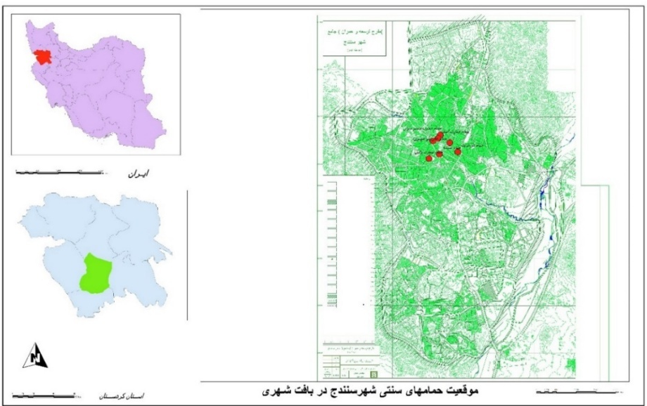

Figure 1. Location of the bathhouses within the urban texture of Sanadaj (Authors, 2023).

Table 1. General specifications and typology of the study sample ( Authors, 2023)
Bathhouse name | Plan | Date | Commissioner | Registration no. | Address
Khan | 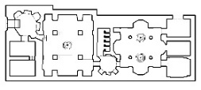 | Safavid | Amanullah Khan | 2603 | the northwestern side of the covered Bazaar, Sanandaj
Do Khazineh | 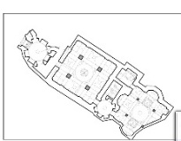 | Safavid | - | 26978 | Habibi Alley, Kurdistan Blvd, Sanandaj.
Shisheh | 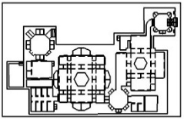 | Zand | - | 2839 | Kurdistan Blvd., Sanandaj
Qaslan | 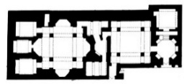 | Zand | Amanullah Khan | 2835 | Qorveh city, Qaslan village.
Vakil | 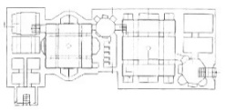 | Qajar | - | 2631 | Next to Vakil mansion, Vakil alley, Vakil St., Sanandaj
Haj Saleh | 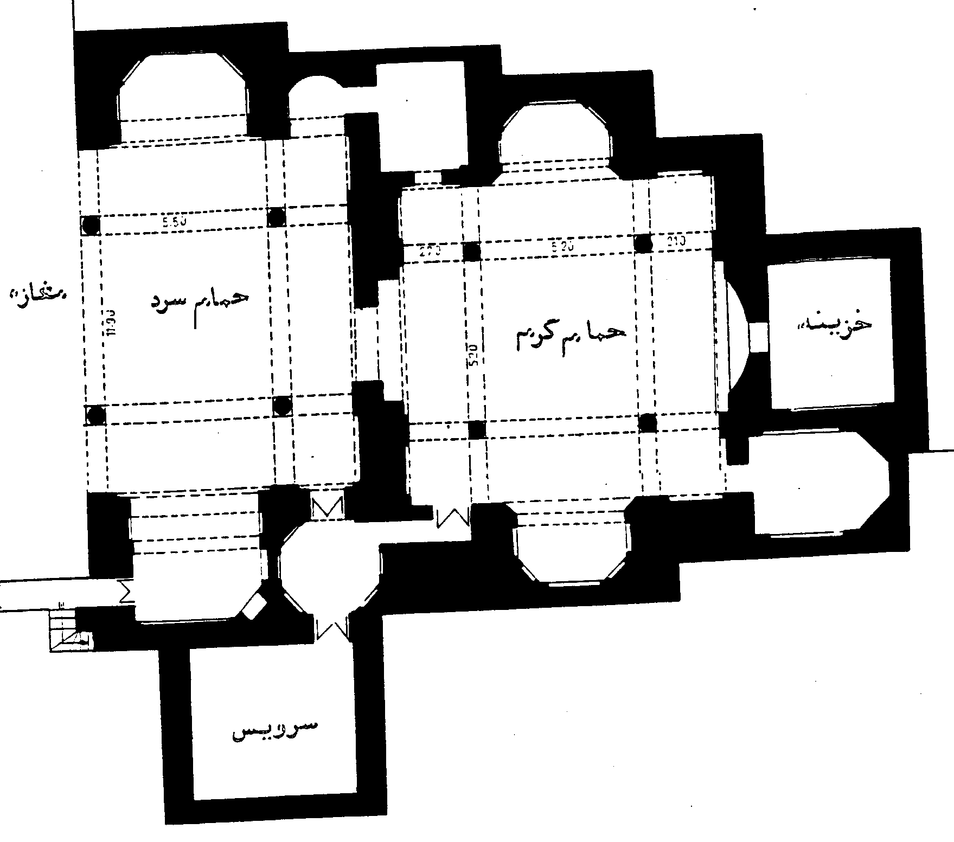 | Qajar | - | 2830 | Next to the traditional bazaar, the old texture of the city, Saqqez
Asef | 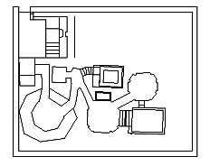 | Qajar | Mohammad Reza Wazir | 1822 | The old neighborhood of Sar Tepoule, the North side of Imam Khomeini St., Sanandaj
Moshir Divan | 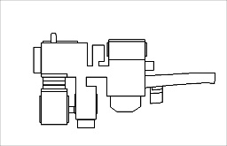 | Qajar | Mirza Yusuf | 2834 | Moshir Alley, Shohada St., Sanandaj
Sheikh al-Islam | 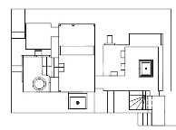 | Qajar | Molla Lotfollah Sheikh al-Islam | 1172 | Habibi St., Imam St., Sanandaj

  - Types of Lime Stucco Ornaments
Decorative patterns in lime stucco at the bathhouses of Kurdistan province include geometric, floral, and animal designs, cartouches, vases with flowers, and vases flanked by animals. These invariably two-dimensional designs lack plasticity.

- 1. Geometric Patterns
Attested designs include zigzags, dart (seh pari or Qomi), four-pointed star (chahar lengeh), ditrigon (seli), mixed ditrigon, shish dar shish, elongated band-i rumi (moʿj), indigenous geometric patterns, etc. They were used to encase the decorative panels that generally occupy the surface of the column bases, piers, and panels. Geometric ornaments generally repeat themselves and are enclosed in rectangular frames, reverberating order and dynamism. They are occasionally used as dividers to give a sense of harmony to the overall composition. At times, such recurrent ornaments in linear arrangement are used for outlining the vaults, arches, and lines of panels. The bathhouses of Khan, Vakil al-Molk, and Shisheh and the private baths of Asef, Sheikh al-Islam, and Moshir Diwan share common geometric designs as zigzags, darts (Qomi), four-pointed star, ditrigon, mixed ditrigon, shish dar shish, and elongated band-i rumi. Geometric ornaments employed at the Qaslan bathhouse include rhomboid and rectangular frames on panels and columns, and parallel zigzags in the fringes of khatai designs below the dome. Those attested at the Haj Saleh bathhouse of Saqqez consist of zigzags framed by panels outlining the arches of the changing room.

- 2. Floral Ornaments
Another liberally used category involves the floral ornaments applied either singly or in clusters. They occur in the ceiling of the changing rooms, panels, rib vaults, entablatures of the platforms, and within the friezes. Floral ornaments consist of boteh jegheh (paisley), Islimi, khatai, lotus, and dragon-fire patterns were used at the baths of Khan, Qaslan, Shisheh, Moshir Diwan, and Sheikh al-Islam. No floral ornaments occur at Asef bathhouse, where the entire designs are of geometric type. At Do Khazineh, the floral ornaments are restricted to Islimi and lotus. At Shisheh, the Islimis were modeled in a heavier form.
Cedar or boteh jegheh occur in most parts of the Khan and Qaslan bathhouses. Boteh jegheh was originated from the Iranian cedar, a symbol of Zoroastrianism, which later gained popularity in the East [15]. The name jegheh comes from a small feather attached to the Iranian kings’ headgear and represents the diminished form of the cedar tree that epitomizes Iran and the Iranians and communicates their honesty and modesty [16]. The pattern derived from the equal division of a circle, the most charming one among the various possible divisions, is the boteh jegheh [17] (Figure 2). Boteh jegheh forms a symbol within which other ornaments are added. In the Qajar period, it was the most appealing floral ornament to the artists working in lime stucco. It occupies a prominent place in Sanandaj’s Senneh carpet, known as Boteh Jogheh, and finds parallels at the Khan bathhouse. The ornament has revived through its use in the dados of many Qajar buildings as a sign of archaism. Showing inspirations from the ornaments of the Khan bathhouse, the cedar pattern is ubiquitous in the lime stucco ornaments at Qaslan (Table 2). Yet, at the former bathhouse, the floral and animal ornaments are outlined by geometric patterns, while at the latter, they have a frame of Islimi and khatai designs. With the discrepancies in the stuccowork ornaments notwithstanding, the conspicuous influences drawn from the Khan bathhouse raise the possibility that the same individual or team of artisans was perhaps responsible for the ornamentations of the two buildings.

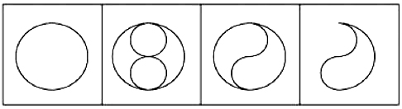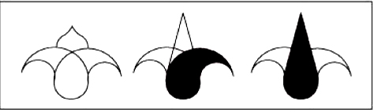

Figure 2. The base of the boteh jegheh ornaments [17]

Islimi, as a hallmark of Iranian art, is composed of spirals used in tiling, plastering, and painting with short branches whence leaves and flowers go off from the spiral stems. The decorative technique is an adaptation from the Kufic script, and the word Islimi is thought to be the “broken” form of the Persian Islamic (اسلامی). Differing from the khatai design, it was invented by the Parthian and Sassanian artists and represents an adaptation of the tendrils of the vine tree, archetypal examples of which are found in the Sassanian Silver working [18]. Being less intricate than khatai, Islimis are designed rougher, stronger, and heavier and symbolize masculinity.
Islimi ornaments at the bathhouses of Khan, Moshir, and Shiheh take the form of dragon fire, and at the bathhouse of Vakil, they terminate the bird heads. At Qaslan, the most frequent and intricate floral Islimi designs combined with dispersed (afshan) flowers occur before the entrance to the changing room. The overall design depicts a crown, indicating that this part of the platform in the room contained the alcove. Most of the combined floral ornaments at Kurdistan’s bathhouses reflect symmetricity. Islimi ornaments occur on the flower vase’ surfaces in the form of intertwined Islimi flowers at the entrances, changing rooms and caldaria. At the Khan bathhouse, the Islimis fall behind the geometric Ornaments in frequency. Islimi patterns are generally attested on the upper walls of the passageway leading to the changing room and sarbineh at Moshir Divan in lime stuccowork and on the plinths of the piers and column bases at Khan bathhouse in tilework. Those at the Moshir Divan mansion represent art masterpieces. The building is brimmed with a combination of Islimi, geometric, and animal ornaments that have created a dazzling view. Less elaborate Islimi leaves, such as swirling vine and acanthus leaves encased with rectangular border bands are attestable in the changing room of the Haj Saleh bathhouse in Saqqez. A few other Islimi forms designed on the body of vases or in the form of Islimi vases reflect influences from the more evolved Safavid forms (Table 2).
Khatai is a biomorphic pattern composed of flowers and leaves combined in a distinctive Iranian style. This imported pattern made its way to Iran through the Mongols. To fashion such patterns, artists would choose only two to six flower types, two or three bud types, and three or four leaves types from among thousands of available khatai petals and buds to combine them in their own style. The basic elements of khatai ornaments are gentle sweeping curves, each called a “band,” the sum of which encompasses the entire design [18]. Also, khatais are another group of rotating ornaments inspired by nature and formed through spiral rotation within a frame. Khatais are more elegant and intricate than Islimis, have a plant base, fill empty spaces, and are far more frequent than Islimis; they are deemed a symbol of femininity due to their prevalence, elegance, and diversity [19]. Khatai ornaments in lime stuccowork in Kurdistan province occur at the bathhouses of Khan, Qaslan, Moshir, Sheikh al-Islam, and Shisheh on panels, in the outlines of the central scene in the roofs of changing rooms and caldaria, and on rib vaults (Table 2).
Khatai flowers and lotuses in lime stucco alternate in the middle part of the changing room at the Shisheh bathhouse to create a band around the vault. The background is black, and the ornaments are white. The khatai flowers at Khan and Shisheh are analogous, and a common mold was seemingly used for them. However, those at Qaslan exhibit a distinct style and are done elegantly and exquisitely.
Lotus is associated with ancient Iranian traditions with the protection of Zoroaster’s Faravahar, a notion closely related to Mithraism [20]. As a symbol of life and creation, in ancient Iran, the lotus first appeared in Mithraism, and under the Achaemenids, it was present in official court ceremonies. In the bathhouses of Kurdistan, the ornament is found at Khan, Vakil, Qaslan, Do Khazineh, Moshir, Sheikh al-Islam, and Shisheh in the lime stucco ornaments of the roof of the changing rooms, panel, rib vaults, platform entablatures and within the friezes in the changing rooms and caldaria (Table 2). In addition to the aesthetic aspects, the reason for its application in bathing contexts that are linked with water is the consecrated character of the lotus because water was the symbol of the ocean from which the universe was created. The patterns of lotus leaves and khatais at Khan and Shisheh are closely related, possibly formed using the same molds. The same thing also applies to the bathhouses of Moshir Diwan and Mollah Lotfollah Sheikh al-Islam, while those at Qaslan are unique. The ornaments show a fairly high degree of dexterity and elegance. Their outlining and forms are particularly masterful.
Flower and bird are popular styles in Iranian painting that borrow the elements from nature and are mainly composed, as the name implies, of flowers and birds alongside insects. The Qajar period saw the incorporation into the flower and bird style of a series of novel hitherto unattested elements. In particular, the vase ornament that was associated with khatais, a common design in the Safavid and Timurid Tileworks, now began to take on a Western character. It was juxtaposed with the so-called Golfarang. The latter is very similar to buttercup in form and was influenced by the flowers depicted in Dutch paintings in the 17th century. Golfarang was usually depicted in the form of a bouquet with a red cabbage rose in the center. A characteristic of the flower and bird style is the indeterminate species of the bird, but a certain bird that found its way into the Iranian flower and bird painting was the parrot. Being native to India, it entered the Iranian court [21]. The flower and bird designs with birds like sparrow, nightingale, parrot, and partridge occur at the bathhouse of Khan (Table 2). Pertaining depictions show influences from the Qajar gypsum stuccowork and paintings. The examples for this case are those at the Khan bathhouse that draw inspiration from the works of the renowned painter, Aqa Lotfali Suratgar [22]. The flower and pot ornament on the piers, columns of the changing room, and the springers at Khan, Qaslan, and Vakil are done in a naturalistic style. The surviving instances of flower and nightingale and flower and pot Ornaments show a gradual trend towards naturalism between the reigns of Fath Ali Shah and Naser al-Din Shah.
Among the entire patterns attested in lime stucco, those of geometric and floral types predominate. Floral ornaments occur as stylized vine leaves, lotuses, tendrils, fruits, and bush and flower patterns. It was customary to use multi-petal (four, five, and six) flowers to fill the empty spaces. Golfarang thrived less in lime stucco ornaments than other fields of the Qajar art. The main space was filled with single or recurrent animal figures, pots, and Cartouches associated with afshan flowers. The linear replication of floral and geometric ornaments was common in friezes.

Table 2. Symbolic meanings of the lime stucco floral ornaments at the bathhouses of Kurdistan Province
Ornament | Bathhouse | Overall design | Illustration | Symbolic concepts
Cedar or boteh jegheh | Khan, Qaslan, and Asef | 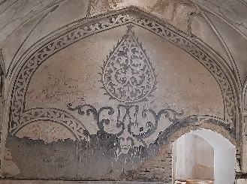 | 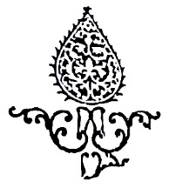  Qaslan | Zoroastrianism, honesty, and modesty
Islimi | Khan, Qaslan, Shisheh and Moshir Divan. | 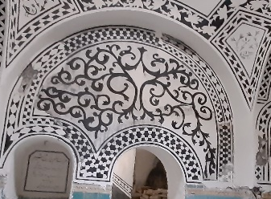 | 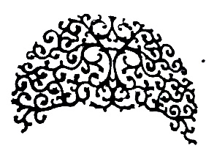  Moshir Divan | Masculinity
Khatai | Khan, Qaslan, Shisheh, Moshir Divan and Sheikh al-Islam | 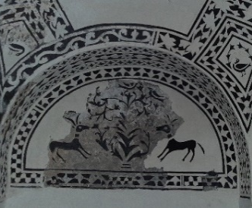 | 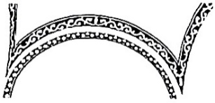  Moshir Divan | Femininity
Lotus | Khan, Qaslan, Vaki, Do Khazineh, Moshir Divan and Sheikh al-Islam | 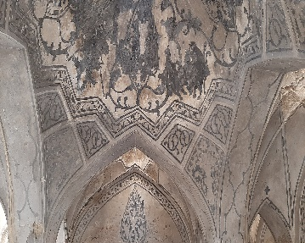 | 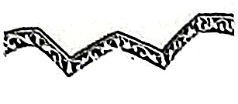  Qaslan | Life and creation

- 3. Animal Ornaments
Animal ornaments were accorded a special place in the lime stucco ornaments of bathhouses and include various bird species, among them are peacock, eagle, partridge, nightingale, pigeon, and other animals like lion and ibex. Related ornaments are generally depicted in a stylized and sometimes in a naturalistic manner on the walls and within the panels of the changing room and sarbineh. In the bathhouses of Western Iran, the use of schematic birds with long legs, elongated necks, and blowing tails is very common. These ornaments are mostly carved in parallel.
Lion is both solar and lunar. As a solar symbol, it represents the heat, grandeur, and power of the sun, vigor, bravery, courage, equality, and head of the animal kingdom. In addition, it symbolizes war and war gods. As a lunar insignia, the female lion accompanies the Great Mother or her chariot puller, signifies motherhood, and often escorts virgin warrior goddesses like Anahita [23]. Lion ornaments occur at the bathhouses of Khan, Qaslan, Sheikh al-Islam, and Haj Saleh. At Sheikh al-Islam, it is depicted singly and in two different poses: one is holding a sword with the sun rising over his back and constitutes the main theme at the center of the geometric frame. In the second one, a bird flies above the lion’s head (Table 3). At the Khan bathhouse, an animal figure on the pa-barik of the arch of the changing room represents a roaring lion judging from its large body, strong claws, and back-turned tail. The lion at Haj Saleh is indicated below the dome of the changing room as holding a sword in a realistic style. In the changing room of the Qaslan bathhouse, the animal figure’s posture and strong body hint at a possible lion, though its face is completely disturbed. The lions at the baths of Sheikh al-Islam and Haj Saleh were most likely done using the same mold. The same thing applies for those at Qaslan and Khan.
Ibex is one of the earliest animals to be tamed by humans and served as the guardian of the tree of life. Ibexes tend to be depicted as standing on their hind legs and feeding on a tree, which can convey meanings like “truth-seeking, fertility, prudence, upright standing on two legs like a human, and fecundity.” Emphasizing the “magnificence and strength of goat’s standing” and linking ibex and “Haoma,” the reproductive plant in ancient Iranian traditions, it draws a connection between “fertility, understanding, water, upright stance and leadership” [24]. At the Khan bathhouse, the entrance of the khazineh (plunge bath pool) is flanked on both sides, with ibexes facing each other on the wall of the vault. The Moshir Divan bathhouse depicts a grazing ibex (Table 3). At Haj Saleh, an isolated ibex occurs below the changing room’s arch. A noteworthy point regarding the goats on the walls of the changing room, sarbineh and khalvati (secluded room for shaving, etc.) at the Khan, Moshir Divan, Sheikh al-Islam, and Haj Saleh bathhouses is their realistic rendering (Table 3). Given ibex’s resistance to harsh climatic and ecological conditions, as well as the fact that it is a species native to Iran (it existed in and was able to live in most parts of the country), it was central to the subsistence of local nomads. The large population of the animal due to the mountainous terrain of Kurdistan province, the nomadic lifestyle of the regional population, and its resilience to the harsh weather conditions might justify the presence of pertinent ornaments at Khan, Moshir Diwan, and Sheikh al-Islam as an emblem of the government’s lasting power.
A peacock, in the bulk of Sassanian artworks, is seen flanking the tree of life. The scene is believed to signify the dual nature of a man [25]. In Iranian culture and literature, a peacock stands for beauty, glory, and worldly matters and pursuits [26]. It seems that the peacock was initially invoked because of its beauty, and the Ahl-e Haqq Kurds of Guran and Kerend conceive of the Peacock Angel (Tavus Malak) as a positive character [27]. Peacocks, as distinct bird ornaments in the lime stuccoworks of the bathhouses of Khan, Qaslan, Vakil, Do Khazineh, and Sheikh al-Islam and the bath of the Moshir Divan mansion are quite impressive. While two peacock patterns are depicted in small dimensions in the tile panel of the plinth in the changing room of the Khan bathhouse, in the lime stucco carvings, the bird occupies the main place among the animal ornaments. The bird is attested in various forms all across the bathhouses. In particular, it occurs in the four large panels in the ceiling at Khan and the ceiling at Vakil on both sides of the tree of life with its characteristic beauty, i.e., with spread feathers. Among the animal ornaments at Qaslan, the peacock is the most prominent one, and it is found in four directions under the dome, as symmetrically placed addorsed peacocks. It is very similar to those of the Khan bathhouse. The lime stucco ornaments at Qaslan closely resemble those at the Khan bathhouse in Sanandaj, one of the biggest structures across Kurdistan province. Peacock ornaments below the dome and on the walls of the changing room at Khan and Qaslan are completed in a naturalistic manner, with more details, while those in the other places are more schematic. This emulation took place in the period that followed Amanollah Khan’s tenure as the governor of Kurdistan. The peacock ornament was important for the commissioners and builders of the Khan and Qaslan bathhouses, while the ornament in the private baths of Moshir Divan and Sheikh al-Islam mansions and the public bathhouses of Vakil and Do Khazineh, constructed later than the Khan bathhouse, shows slight alterations (Table 3).
Partridge is a cherished component of Kurdistan’s folklore, with many songs and proverbs praising its beauty and graceful gait [28]. Thus, the ornament is found, singly or in pairs, on the pa-bariks of the panels and other wall surfaces of different parts of the Khan, Vakil, Moshir Diwan, and Sheikh al-Islam bathhouses. Single partridges occur on the wall of the sarbineh and below the dome of the changing room at Qaslan. Partridge is a symbol of generativeness, fertility, and the manifestation of the devil [25] (Table 3). At Moshir Divan, four partridges occurred in the upper ceiling, two with a flower in their beak and the rest without one. The sarbineh at Moshir contains two affronted partridges.
Pigeon implies love, spring, candor, sincerity, placidity, and reconcilability. It is deemed a symbol of the perpetual quintessence and the soul. It is frequently considered to denote womanhood in a metaphorical sense because of its beauty, whiteness, and sweet song [29]. In the Bible, God’s Spirit descends to Jesus as a dove: “After Jesus was baptized, he came up from the water and behold, the heavens were opened [for him], and he saw the Spirit of God descending like a dove [and] coming upon him”. In mythology, the female dove is a sign of cleanliness, purity, and candor due to its attractive and white appearance. With an olive branch in its beak, it symbolizes peace, moderation, balance, hope, and quest for bliss” [30]. Pigeon occurs on the walls at Moshir Divan and Sheikh al-Islam (Table 3). Three pigeons are carved in the changing room of Sheikh Lotfollah bath, one holding an uncertain plant in its beak, thus symbolizing peace, and the other pecking at a ball-like object. The third moving pigeon sits above the window.
Nightingale, since antiquity, has assumed a high position in oriental literature, especially Persian, thanks to its enchanting song. In Iranian literature, the nightingale is famous for its two attributes of passion and fascination; thus, the moniker is the bird of love. In A Dictionary of Symbols, the bird is closely related to love and death [29]. The nightingale is juxtaposed with flowers, pots, and vegetal patterns. The same composition is replicated in the ornaments and designs of the Qajar gypsum stuccowork at the old houses of Sanandaj, such as Khosrow Abad and Molla Fathollah Sheik al-Islam [5]. Birds at the bathhouses of Khan and Qaslan have been depicted in a naturalistic manner, along with flowers and leaves, singly and sometimes in pairs (Table 3).

Table 3. Symbolic meanings of the lime stucco animal figures at the bathhouses of Kurdistan Province
Ornament | Bathhouse | Overall design | Illustration | Symbolic concepts
Lion | Khan, Qaslan, Sheikh al-Islam, and Haj Saleh | 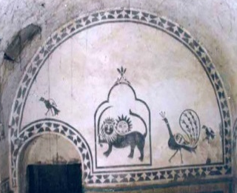 | 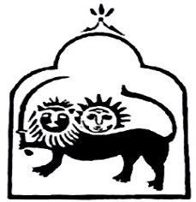  Sheikh al-Islam | Solar and lunar symbols, grandeur and power, vigor, bravery, courage, equality, head of the animal kingdom, war, and war gods
Ibex | Khan, Moshir Divan, and Sheikh al-Islam | 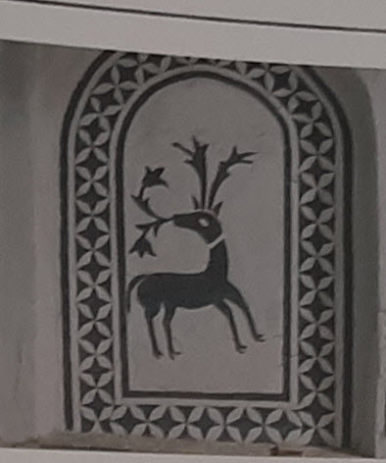 | 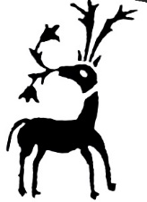  Moshir Divan | Truth-seeking, fertility, prudence, upright standing on two legs like a human, and fecundity
Peacock | Khan, Qaslan, Do Khazineh, Vakil, Moshir Divan, and Sheikh al-Islam | 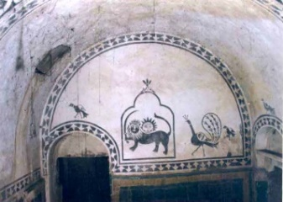 | 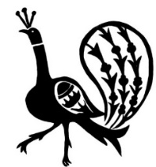  Sheikh al-Islam | Beauty, glory, and worldly matters, and pursuits
Partridge | Khan, Vakil, Moshir Divan, and Sheikh al-Islam | 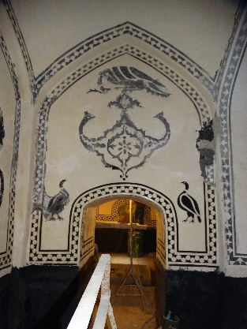 | 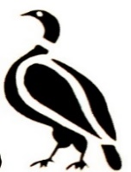  Khan | Generativeness, fertility, and the manifestation of the devil
Pigeon | Moshir Divan, Sheikh al-Islam | 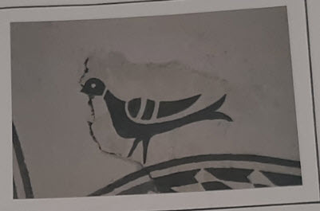 | 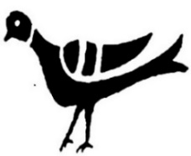  Moshir Divan | Love, spring, candor, sincerity, placidity, reconcilability, the perpetual quintessence, and the soul
Nightingale | Khan, Qaslan | 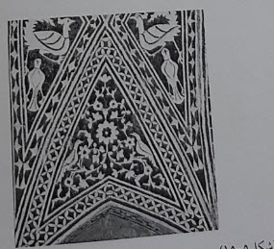 | 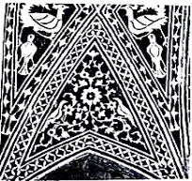  Khan | Love and death
Eagle | Khan, Sheikh al-Islam, and Moshir Divan | 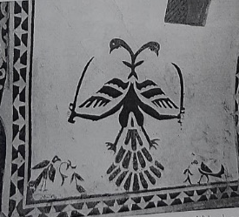 | 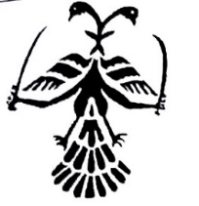  Sheikh al-Islam | The sky, light, and the abode of the baghs
Snake | Khan, Sheikh al-Islam, and Moshir Divan | 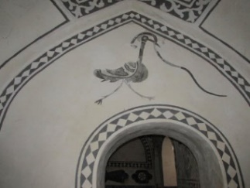 | 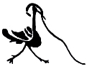  Sheikh al-Islam | Water, earth, darkness, and underground forces

The eagle is the second most prominent bird, after the peacock, in the lime stuccoworks at the bathhouses of Khan, Moshir Diwan, and Sheikh al-Islam. At Khan and Sheikh al-Islam, it holds a snake at the tip of its beak (Table 3). Many ancient cultures viewed eagle and snake as two extremes in cases very close to each other, and sometimes signifying the separation of heaven and earth. Bird is a symbol of the sky, light, and the abode of the baghs (deities), while snake stands for water, earth, darkness and underground forces [31]. Ariel Golan interprets the snake as a symbol of the earth, and the eagle is a symbol of the sky. In other words, they represent the tie between the sky and the god of the earth, which was at the core of the early farmers’ religion [32]. Snake is one of the companions of the bird-goddess (eagle); both are unequivocal symbols of water, fertility, and fruitfulness. Snakes represent heavenly water springs or rain-bringer thunders, and the goddess in the form of a bird sends down heavenly waters (snakes) to the earth to fertilize humans, animals, and plants. Therefore, one may assume that the ornament of snake and bird (eagle) at the bathhouses of Khan and Sheikh al-Islam reflects the central role and power of the goddess in the generation of water, fertility, and fecundity. Apart from these interpretations, including the sky and earth as a bird and snake, the marriage of these two opposites and their unification brings about creation, rain, fertility, and fruitfulness. The ornament of an eagle with a snake at the tip of its beak signifies a goddess who pours the blessings of water, fertility, fecundity, immortality, verdure, delight, etc., over the earth.

D.4. Human Figures
Human ornaments are carved singly on the walls and below the changing room’s dome at the bathhouses of Khan, Qaslan, and Haj Saleh. The figure at Qaslan represents a male smoking a hookah (Kalyan), of which only a few traces are preserved. The reason behind the depiction of the scene is the fact that hookah smoking was a common practice at bathhouses. A man-bird figure occurs at Khan bathhouse as a hybrid creature with the body of an eagle and the head of a human. One of these scenes is depicted alternately below the semi-domed roof of the entrance to the Khazineh (pool) and in the changing room on the dome’s drum and above the panels. Such ornaments typify the Qajar art and are attested at the Haj Agha Torab bathhouse in Nahavand [2]. The most frequent human figures in any bathing context across Kurdistan province are those found on the changing room’s wall at the Haj Saleh bathhouse, portrayed in various situations and forms, including on horseback, as a winged angel, and while picking or digging a mountain. The headgears and the physiognomy of these figures provide further support for their Qajar attribution (Figure 3). From the Safavid period onwards, animal and human figures and vegetal ornaments became popular themes in the tile panels of plinths and lime stucco ornaments of changing rooms [12].

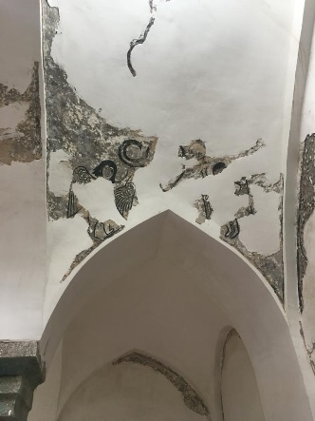 | 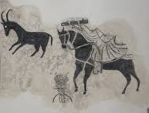 | 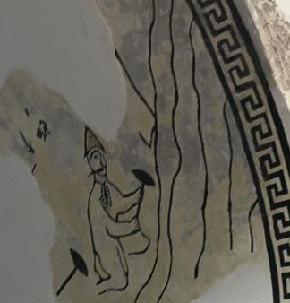
Figure 3. Human figures in the changing room at the bathhouse of Haj Saleh, Saqez (Authors, 2023).

D.5. Cartouche
The precursor of the cartouche in Iran was the swastika, mainly attested in Eastern cultures like China, India, and Iran (5th‒4th millennia BC) [33]. The symbolic aspect of the Cartouche is to be looked for in its basic features, such as point, center, circle, and square, to detect a logical relationship between the ornament and the artist’s desire. Paying attention to the center means “totality, wholeness, absolute reality, pure being, the origin of all existence, unmanifest being, the world axis, the pole, the point around which everything revolves, paradise, the potential, sacred space, a break in space and the point of intercommunication between the three worlds, the intersection of macrocosm and microcosm, [and] cosmic order” [25]. By placing a point in the center of a scene, the artist draws all the attention to the central part. Therefore, it is not unlikely that, to communicate their transcendental meaning, the lime stucco artisans chose the center of the walls and ceilings of the changing rooms and the caldaria to engender a celestial space. The cartouche in the center of the bathhouse’s wall is in transition from square to round shapes. An enigmatic aspect of the point is that it is not bound to direction and the surrounding, and to a place, like the central point of a circle serving as a hub for all the lines crossing the circle. Truth and essence are the central points of a sphere [34]. It means that the divine essence is not bound to a place or direction, the possible transcendent form of which is in evidence in the center of the cartouche, with the circulation of secondary ornaments pointing to the central “point” of the cartouche on the walls of the bathhouse.
Regarding the circumambulation or Tawaf, the round area framing the Kaba, around which concentric human circles rotate, transforms the Kaba’s square form and encourages people to move. In addition to the movement of the body, the performance involves the overall movement of the human spirit. The application of cartouche ornaments in the Zand period continues the Safavid tradition, with such ornaments at the bathhouses of Kurdistan province rarely showing any remarkable novelties in forms or composition. For example, cartouche in the form of a cypress with a vase with flowers or a vase with Islimi ornaments occur in the panels, ceiling, columns and walls of the changing room and sarbineh at the Do Khazineh, Moshir, Qaslan and Khan bathhouses. Another type of cartouche, known as the dragon-fire, and the general form of this design is in the shape of a cartouche terminating to bird heads on both ends, also attested in the earlier Safavid period, occur at the bathhouses of Khan, Vakil, and Sheikh al-Islam on the domes of the changing rooms (Figure 4).

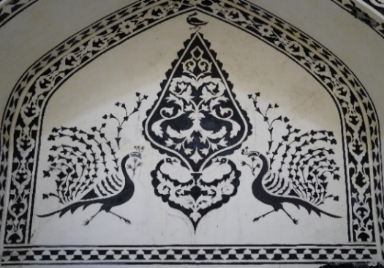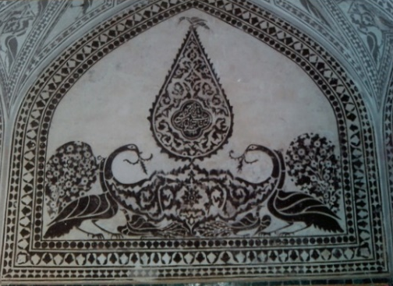
Figure 4. Cedar and dragon-fire cartouche at the bathhouses of Khan (right) and Vakil (left) (Authors, 2023)

D.6. Flower Pots Flanked by Animals
The representation of pots in the changing room and sarbineh at the Khan, Vakil, and Qaslan bathhouses in Kurdistan province, mostly associated with Islimi flowers and foliage on the walls, changing room’s columns, and the corner of the panels at the vault-spring line junctures, are replicas of the Safavid examples (Figure 5). The ornaments of flowers and vases at the Khan bathhouse display unique frames and an artistic style not attested at the other buildings considered here. The flowers and pots at Qaslan in Qorveh display high craftsmanship in performance, form, movement, and twisting of the ornaments, which are greatly appealing to the eye despite being simple. What is more, the design of most of the ornaments in this bathroom is innovative and arresting. A pattern attested in the changing room at several bathhouses in Kurdistan Province, including Khan, Shisheh, Sheikh al-Islam, and Qaslan, is the flower pot with many flowers and foliage flanked on both sides by gazelle, peacock, and other birds (nightingale and dove). Such designs in the Qajar bathhouses draw inspiration from the flower and pot patterns of the Safavid dynasty.
Regarding their origins, the scene of two animals standing on both sides of a tree, associated with both symbolic and sacred values, was adopted from Babylon and Assyria [35] and was continued in use in the Achaemenid, Sassanian, Zand, and Qajar periods. Many Sassanian artworks show peacocks flanking the tree of life. In ancient cultures around the world, the tree of life symbolizes growth and fertility or a means of bounty. The ornament was in use especially in decorative arts and symbolism of Mesopotamia since 3500 BC and Iran since the Sassanian era. Ancient legends associate the sacred tree with the same meaning and status as the tree of life [36]. The ornament of a vase surrounded by peacocks was used at many buildings during the Safavid period, including mosques, religious schools, and Imamzadehs. The Avesta also speaks of sacred trees protected by guardians [37]. Table 4 presents the classification and background of the decorative patterns of the bathhouses of Kurdistan Province.

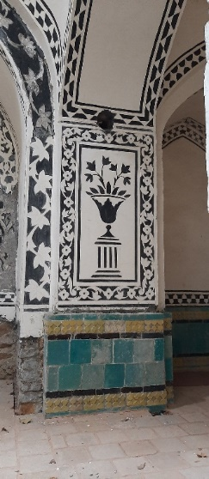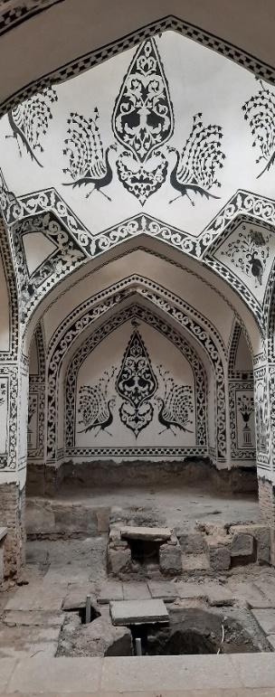

Figure. 5. Flower and vase ornament and the ornament of the tree of life flanked by animals (Authors, 2023)

E. Discussion and Analysis of Ornaments of Bathhouses in Kurdistan Province
The analysis of the ornaments patterns results of the studied samples of Kurdistan Province bathhouses is shown in Table No. 4. In general, five types of decoration are used in these bathhouses, which include: geometric patterns (dart (seh pari or qomi), four-pointed star (chahar lengeh), ditrigon (seli), mixed ditrigon, shish dar shish, elongated band-i rumi (moʿj), hexagon, five-pointed star), floral motifs (foliage, four-pointed star, vine leaf, islimi, cedar or boteh jegheh, lotus, khatai, flower and bird), animal motifs (ibex, snake, nightingale, peacock, pigeon, partridge, lion, eagle), cartouche (dragon-fire terminating to bird’s head at both ends, cedar with islimi motifs, flower pots flanked) by animals (islimi foliage flanked by two gazelles, ibex, peacocks, and birds). Most of the history of the decorative arrays of bathhouses in Kurdistan Province is related to the Mesopotamia, Achaemenid, and Sassanian periods.

Table 4. Types and position of the decorative patterns at the bathhouses of Kurdistan Province (Authors, 2023)
Bathroom | Overall design | Ornaments | Historical background of Ornaments
Qaslan, Vakil, Do Khazineh, Shisheh, Haj Saleh, Moshir Divan, Sheikh al-Islam, and Asef. | Geometric Patterns | dart (seh pari or Qomi), four-pointed star (chahar lengeh), ditrigon (seli), mixed ditrigon, shish dar shish, and elongated band-i rumi (moʿj) | Mesopotamia, Sumer, Achaemenid, and Sassanian
Khan | Geometric Patterns | Hexagon, five-pointed star | Achaemenid, Sassanian
Khan, Vakil | Floral Ornaments | Foliage, four-pointed star, vine leaf | Sassanian
Khan, Qaslan, Moshir Divan, Haj Saleh, and Shisheh | Floral Ornaments | Islimi | Parthian and Sassanian
Khan, Qaslan | Floral Ornaments | Cedar or boteh jegheh | Pre-Islamic
Khan, Qaslan, Vakil, Do Khazineh, Moshir Divan, Shisheh, and Sheikh al-Islam. | Floral Ornaments | Lotus | Mesopotamia, Egypt Achaemenid, Parthian, and Sassanian
Khan, Qaslan, Moshir Divan and Shisheh. | Floral Ornaments | Khatai | Islamic (Ilkhanid)
Khan, Qaslan | Floral Ornaments | Flower and bird | Islamic (Safavid)
Qaslan, Vakil, Do Khazine, Moshir Divan, Sheikh al-Islam, Haj Saleh, and Shisheh. | Animal Ornaments | Ibex, snake, nightingale, peacock, and pigeon | Egypt, Mesopotamia, Achaemenid, and Sassanian
Khan, Vakil, Moshir Divan, Qaslan, and Sheikh al-Islam | Animal Ornaments | Partridge | Egypt, Mesopotamia, Achaemenid, and Sassanian
Sheikh al-Islam, Khan, Haj Saleh, and Qaslan | Animal Ornaments | Lion | Egypt, Mesopotamia, Achaemenid, and Sassanian
Khan, Moshir Divan, and Sheikh al-Islam | Animal Ornaments | Eagle | Egypt, Mesopotamia, Achaemenid, and Sassanian
Khan, Vakil, and Sheikh al-Islam | Cartouche | Dragon fire terminates at the bird’s head at both ends | Mesopotamia, China, India, and ancient Persia (Sassanian)
Khan, Do Khazineh, Moshir Divan and Qaslan | Cartouche | Cedar with Islimi mitofs | Mesopotamia, China, India, and ancient Persia (Sassanian)
Khan, Vakil, Shisheh, Sheikh al-Islam, and Qaslan | Flower pots flanked by animals | Islimi foliage flanked by two gazelles, ibex, peacocks, and birds | Mesopotamia, Achaemenid, and Sassanian

- CONCLUSION
Carrying out ornaments in the humid atmosphere of bathhouses was not as easy as it was in other buildings, so the lime stucco technique was evoked due to its resistance to humidity. The relevant ornaments consist of literary themes, vegetal ornaments, and animal and human figures, not to mention the ubiquitous geometrical ornaments. This decorative art is pinnacled under the Qajars. The lime stucco ornaments of bathhouses mostly occur in the changing room, sarbineh, and in some cases, in miandar (hall). Changing rooms tend to be more lavishly ornamented than caldaria, given their wider space for ornaments, lower temperature, and function as gathering spaces. Perhaps the lower elevation of sarbineh was also a factor. The applied ornaments pertained to daily life and inspired tranquility. The most elaborate and beautiful lime stuccoworks were usually performed at the arch spring lines, below the dome, and around the central light opening in the changing room’ roof. However, their use within the portico, sarbineh, and khalvati was not uncommon. In such cases, moving down from the light opening, the ornaments get more elaborate as they become easily visible to the viewer. At the heart of the spread of this art in respective periods were most likely the local rulers and commissioners who, thanks to their financial resources, fame, and influence in political, cultural, social, and economic systems, were able to recruit skilled craftsmen from the capital or other regions to put up very sumptuous constructions that, besides the prevailing regional decorative patterns, benefited from some indigenous designs. Decorative patterns at the bathhouses of Kurdistan Province tend to draw from tileworking, nature, mythic and rarely religious stories, ancient beliefs, and archaism. Certain ornaments, two of them are islimi and cartouche, evolved. Meanwhile, many others, like cedar, lotus, four and six-petal flowers, and geometric ornaments, retained their original Achaemenid and Sassanian forms. In addition to aesthetic value, vegetal ornaments under the Qajars symbolize omen, bounty, benevolence, fertility, eternal life, longevity, and kingship’s endurance. Safavid artists used rows of recurrent vegetal and geometric ornaments to outline the vaults, arches, and lines of panels, and to fill the friezes. They also employed various tendrils and plant ornaments in the central space. Lime stucco ornaments at the Zand period bathhouses consist of the juxtaposition of animal and human figures with plant ornaments having a higher variety of colors compared to the Safavid period and the depiction of leaping animals. The Qajar period is marked by the expanded repertoire with the addition of literary and mythic themes that first came into use in the Zand period. Floral, geometric, and animal ornaments, especially birds like peacocks and birds of paradise, adorn the main spaces of the Qajar bathhouses. The lime stucco ornaments of the Qajar bathhouses put into view the developed forms of the Safavid and Zand ornaments and schemes. The bulk of the spaces on the walls and roofs in the changing rooms and caldaria are covered with animal and vegetal ornaments, and friezes of repetitive geometric ornaments adorn the fringes of the rib vaults.

REFERENCES

[1] H. Zomarshidi, “Tile-Work’s Evolution Transition in Architectural Works’, Journal of Iranian Architecture Studies, vol. 1, no. 2, pp. 65–78, 2022.
[2] M. E. Zarei, “Observation in Architecture and Emphasis on the Role Played in Stylization Sanandaj’s Khan’s Bathroom”, Journal of Fine Arts: Architecture & Urban Planning, vol. 17, no. 1, pp. 73–85, 2012. Doi: https://doi.org/10.22059/jfaup.2012.29699.
[3] P. Talebnia, and A. Najafi, “Architectural Ornaments of Qaslan”, in. National Conference on Culture, Tourism and Urban Identity, pp. 1–12, 2014.
[4] M. R. Razavi, and S. Soleimani, In Search of the Urban Identity of Sanandaj. Tehran: Ministry of Housing and Urban Development, 2005.
[5] M. E. Zarei, Archaeological and Historical Heritage of Kurdistan Province. Hamadan: Bu-Ali Sina University, 2013
[6] M. E. Zarei, Old houses of Sanandaj. Sanandaj: Kurdistan University publications., 2014
[7] M. K. Qasri, Sanandaj the Seat of Iranian Kurdistan Province. Sanandaj: University of Kurdistan, 2002.
[8] P. Talebnia, and M. Bahramzadeh, “A Research on the Architecture and Decorative Elements of the Molla Lotfollah Sheikh al-Islam Bathhouse, Sanandaj”, in National Conference of Vernacular Architecture and Urbanism of Iran, Yazd, pp. 1–12, 2015.
[9] S. Sadeghi, H. S. Shiran, and F. Feizi, “Analysis of the Presentation and Use of Qajar Bathhouses (Case study of Sanandaj: Hammam-e Khan Bathhouse and the Bathhouse of the Mansion Mullah Lutf Allah Shaykh al-Islam)”, Athar, vol. 40, no. 3, pp. 164–194, 2019.
[10] A. Pakdaman, Appended Architectural Ornaments in Iranian Architecture of the Islamic period. Tehran: Simayeh Danesh, 2013.
[11] F. Najafi, Historical Baths of Tabriz. Tabriz: Fan Azar, 2008.
[12] M. A. Mokhlesi, Ornaments and Embellishments in Bathhouse. Tehran: Research Center for Ethnology, Iranian Organization of Cultural Heritage and Tourism, 2005.
[13] M. Kian, Lime Stucco Representations at Bathhouses, in Proceedings of the Conference on Bath in Iranian Culture. Tehran: Research Center for Ethnology, Iranian Organization of Cultural Heritage and Tourism, 2005.
[14] S. Yousefifar, and M. Yadollahpour, “Historical Bathhouses of Amol”, Journal of Waqf, Eternal Legacy, vol. 76, pp. 47–68, 2013.
[15] T. Jouleh, An Inquiry into Iranian Carpets. Tehran: Yasavoli, 2002.
[16] A. A. Dehkhoda, Encyclopedic Dictionary. Tehran: University of Thran Press, 1995.
[17] H. Zu-Yavar, M. Vahdati, and M. Makinjad, “Symbolic Meanings of the Boteh Jegheh Ornament”, Kimiya-ye-Honar, vol. 15, pp. 99–113, 2015.
[18] H. A. Machiani, A Manual of Design and Illumination. Tehran: Yasavoli, 2001.
[19] A. J. Arberry, The Legacy of Persia. First Edition. Oxford: Oxford University Press, 2000.
[20] A. Shams, "A Look at Signs and Symbols in Ancient Iran", Journal of Visual Arts, vol. 8, pp. 194–209, 2000.
[21] M. Savari, and A. R. Sheikhi, " Visual analysis of Flowers and Bird Painting of Zand and Qajar periods", Journal of Islamic Crafts, vol. 6, no. 1, pp. 41–56, 2022. Doi: 10.52547/jic.6.1.41.
[22] M. Makinjad, History of Iranian Art in the Islamic Period: Architectural Ornaments. Tehran: SAMT, 2008.
[23] A. A. Geloogahi, A. B. K. Nezhad, and M. M. Hassani, "A Study of the Status and Biological Rights of Prominent Animals in the Ancient Ritual of Mehr", Bioethics Journal, vol. 10, no. 1, pp. 323–351, 2020. doi. https://doi.org/10.22037/bioeth.v10i1.31616.
[24] S. Ghanatir, "A Terminological and Genealogical Investigation of “Goat” in Indo-European Languages and Tracing its Roots in Artworks of Water and the Tree of Life", Journal of Art and Civilization of the Orient, vol. 11, no. 39, pp. 33–38, 2023. Doi: https://doi.org/10.22034/jaco.2023.366758.1272.
[25] J. C. Cooper, An Illustrated Encyclopaedia of Traditional Symbols. First Edition. London: Thames & Hudson, 1987.
[26] M. A. E. Nadoushan, Travel to China. Tehran: Enteshar, 2002
[27] M. S. Sanandji, Tohfe-ye Naseriyyeh on the History and Geography of Kurdistan. Tehran: Amir Kabir, 1987
[28] M. E. Zarei, A Profile of Kurdistan’s Cultural Heritage. Tehran: Iranian Organization of Cultural Heritage, Handicrafts and Tourism, 2012.
[29] J. Chevalier, and A. Gheerbrant, A Dictionary of Symbols. First Edition. Oxford: Blackwell Pub, 1994.
[30] M. Shayestefar, "Investigation of the Ornaments of Birds on the Pottery of the Islamic Section of the Reza Abbasi Museum", in. Second National Conference on Iranian Archeology, Tehran, pp. 1–16. 2015, Available at: https://civilica.com/doc/541106.
[31] M. Lurker, Adler und Schlange: Tiersymbolik im Glauben und Weltbild der Völker. Tübingen: R. Wunderlich, 1983
[32] M. Malek, and B. Mokhtarian, ‘The Iconography of Eagle and Snake Symbols of Jiroft Artifacts during the 3rd Millennium B.C’, Iranian Journal of Anthropology, 17, pp. 163–195, 2013
[33] J. Hall, Illustrated Dictionary of Symbols in Eastern and Western Art. 1st edition. Boulder, Colo: Perseus, 1996
[34] A. S. A. Hamadani, Asrar al-Noqta or Towhid-e Mokashefan. Translated by M. Khajavi. Tehran: Mola, 2009
[35] R. Ghirshman, Persian art, Parthian and Sassanian dynasties, 249 B.C.-A.D. 651. First American Edition. Bremen: Golden Press, 1962
[36] M. Mobini, and A. Shafei, "The role of mythological and Sacred Plants in Sassanid Art (With emphasis on relief, metalworking and stucco)", Glory of Art (Jelve-y Honar) Alzahra Scientific Quarterly Journal, vol. 7. no. 2, pp. 45–64. 2016. Doi: https://doi.org/10.22051/jjh.2016.2126. 2016
[37] A. U. Pope, A Survey of Persian Art: From Prehistoric Times to the Present. Text : architecture. Oxford: Oxford University Press, 1964.

. The term “saruj stuccowork” is preferable over lime stuccowork because lime cannot be used alone in relief ornaments as it will immediately develop craze cracks, crumble and collapse.
Sarbineh is generally made in the shape of octagons and squares, and there are sitting and dressing platforms around it, and under the platforms, there is a place to store shoes.
a space next to the hothouse that was used for the bathing of nobles and elders
The Avesta is the primary collection of religious texts of Zoroastrianism from at least the late Sassanid period.
In the bathroom, the connection between the bathhouse and the house is made through the miandar, where the toilet is usually located.

