 |  | JOURNAL OF ISLAMIC ARCHITECTURE  P-ISSN: 2086-2636 E-ISSN: 2356-4644  Journal Home Page: http://ejournal.uin-malang.ac.id/index.php/JIA
TURGUT CANSEVER’S BEYAZIT SQUARE IN THE LIGHT OF HIS THEORETICAL CONSTRUCTIONS
Yusuf Civelek^{a*}, Halil Ibrahim Düzenli^{b}
ªFatih Sultan Mehmet Vakif University School of Architecture and Design, Turkey
^{b}Samsun University School of Architecture and Design, Turkey
*Corresponding Author: ycivelek@fsm.edu.tr
ARTICLE INFO |  |  | ABSTRACT
Volume: 8  Issue: 4  Page: 1037-1055  Received: May 7th, 2024  Accepted: October 10th, 2024  Available Online: December 30th, 2025  DOI: 10.18860/jia.v8i4.26861 |  |  | This paper addresses the historical significance of Turgut Cansever’s project for the redesign of the Beyazıt Square in Istanbul owing to its effort to recreate the particularity of a place through the articulation of motion, orientation, and ornamentation. The paper argues that the Beyazıt Square project is crucial for Cansever’s construction of an aesthetic based on the Islamic ‘world-conception’ through the interpretation of texts, as well as historic and modern places and buildings. Therefore, this study aims to demonstrate that Cansever’s Beyazıt Square project, initiated in 1960, is one of the earliest and most notable manifestations of his theoretical concepts. The methodology of the study relies on investigating the correlation between the partially applied project and the architect’s theoretical ideas, which he developed through intertextual readings on architecture, philosophy, and religion.. The sources of the investigation include texts written by the architect or others on his work since 1949, the original drawings of the project, and the physical changes that the square underwent between 1505 and the present day. Personal communications with the daughter and son-in-law of Cansever, who are also architects and have collaborated with him for a long time, are valuable sources for this investigation. This study demonstrates that the fundamentals of Cansever’s theoretical ideas predate 1960, with the majority emerging in a more articulate form through his writings, interviews, and speeches after 1980. It shows that Cansever made connections between the main precepts of Modernism and his interpretation of the Islamic principles of art and architecture around 1960. It also makes clear that the recent adaptation of the unfinished project in 2023 is due to the relevance of these theoretical ideas for the popular but relatively weak pursuits of discovering and reconnecting with the principles and values of the Islamic built environment. Perhaps the most important benefit of this text lies in its presentation of the application of spatial and phenomenological concepts by a non-Western, Muslim architect in a public space.  Keywords:  Turgut Cansever; Beyazıt Square; Islamic Metaphysics; Architectural Theory

- INTRODUCTION
Turkish architect Turgut Cansever (1920-2009) began his theoretical constructions during the 1940s and 1950s, which continued well into the 1980s. Although it was largely motivated by the metaphysical interpretations of Islamic art and architecture, it also welcomed the theories and practices of Modernism. His designs reflected a nice blend of the beauty of tectonic elements, the roughness of Brutalism, and historicist referencing. Still, they were always something more than those, mostly due to his theorisations, which always allowed him to maintain a certain distance from transitory trends. Although Cansever disseminated his theoretical ideas primarily through speeches, articles, and interviews, mostly after 1980, the core of these ideas existed even before 1960, as this study will attempt to demonstrate. It is without a doubt that the three Aga Khan Awards, which he received twice in 1980 (Turkish Historical Society and Ertegün House) and once in 1992 (Demir Resort Village), helped enhance his reputation both globally and locally.
The connections between Cansever’s architectural theory and his architectural projects were studied primarily by Düzenli [1], who also published a brief history of the Beyazıt Square project [2]. Düzenli’s analyses emphasize the ‘human scale’ and ‘motion’ as the two main considerations behind the project’s conception, which relate to the question of ‘Being’ in Islamic metaphysics. However, they do not attempt to explain the theoretical background of the design in detail. Additionally, a recent study briefly introduced the architect’s theory and practice in English, but it left the project for the square outside its scope [3]. The leading Turkish architectural critic Tanyeli praised Cansever’s project for the square as “one of the masterpieces of 20th-century architecture in Turkey” [4], but also claimed that the connection between theory and practice in his oeuvre was “mysterious”. For Tanyeli, Cansever’s discourse gradually moved away from Modernism to become an Islamist-traditionalist discourse in the 1980s. Tanyeli also claimed that Cansever’s [intertextual] Islamist discourse was usually understood not by the [populist] Islamists but by others from the opposite pole, where he also found support for his relatively rare applications [5].
Bayrak, who published a book on the concise history of the Beyazıt Square, questioned the link between the project and Cansever’s “later” discourse, thus contributing to the problematisation of the project’s theoretical foundations. She supported the depth of understanding in Cansever’s project in terms of its intention to preserve the spatial memory and his fight against the concept of square as a large and empty space in the minds of Turkish bureaucrats and intelligentsia. Still, in the end, she claimed that Cansever changed his discourse about 30 years later, associating his previous works now with an Islamic perspective [6]. She claimed that Cansever owed the mnemonic and psychological ideas about urban space and artefacts to two foreign architect-planners, Gustav Oelsner and André Gutton, and implied that the originality of his project came from his application of their ideas about historic places as a design strategy, which was criticised for being “picturesque” by Eldem in 1961– one of Cansever’s opponents during the renewal of the square [7].
Ernst Diez, Nicolai Hartmann, Alfred N. Whitehead, Ibn al-Arabi, and Titus Burckhardt are the principal influences on Cansever’s thinking. Although it is impossible to know if all the literary works he later mentioned were equally relevant when he redesigned the square, it is without doubt that his works reflected at some point these influences including those of the Sufi Muhyi al-Din Ibn al-Arabi [4][7] and Titus Burckhardt [8], which he fused with the stylistic ideas about Islamic art and architecture he found in the Austrian art historian Diez, under whose supervision he wrote a doctoral dissertation on Seljukid and Ottoman column capitals in 1949 [9]. Cansever read these elements through Diez’s definitions for the ‘style-generating’ aspects of Islamic art, such as ‘static’, ‘cubistic’, ‘mechanical’, and ‘ornamental’. In his postdoctoral thesis, completed in 1960, entitled “Fundamental Issues of Architecture Today,” Cansever analysed the works of the masters of Modern architecture through the lens he had developed to understand the essence of Islamic architecture during his studies with Diez. In these two writings, his reading of tectonic forms with the metaphysical intention to imply the infinite space by means of their ‘immaterialistic’ and ‘ornamentalistic’ qualities is related to the arguments he found in Islamic metaphysics, such as the dialectical relationship between the multiplicity and unity (tawhid), ‘the love of beauty’ and the ‘eminence of individuality’ [10]. It seems that the Beyazıt Square project had a crucial impact on the crystallisation of such ideas, which he carried into his later readings, especially Ibn al-Arabi’s Fusus al-Hikam [11].
All in all, the limited scholarly attention to this particular design, the alleged ambiguity of its connection to the architect’s later theory, and the recent debate on its reapplication necessitate a closer examination of this case. Therefore, this study aims to ‘read’ Cansever’s design and explore its relationship to his own theological, ontological, and phenomenological perspectives on artistic creations. This study also argues that Cansever’s theoretical ideas, which were mostly developed after 1980, are not significantly different from those that shaped the Beyazıt Square project, which catalyzed their enrichment and crystallization.

- METHODS
The investigation method of this study largely depends on making connections between the words and images. Cansever wrote two dissertations and several journal articles before completing his design for the square. However, many texts appeared after 1980, either by him or by others who interviewed him, which helped to fully disclose his theoretical ideas and to evaluate a work like Beyazıt Square. Cansever’s explanations in such texts reveal sources of inspiration, which constitute another set of texts analysed here. The images of the drawings for this project were provided by Emine Öğün, who is one of the heirs of Cansever. Information received from Emine and Mehmet Öğün about the character, thinking, and teachings of Cansever facilitated the connections between the texts and the drawings. The evaluation of the continuous transformation of the site itself is also part of the process of making such connections.

- RESULT AND DISCUSSION

- BEYAZIT SQUARE BETWEEN FORUM AND MEYDAN
Located roughly in the middle and on the highest altitude of intramural Istanbul, the Forum Tauri, also known as the Forum of Theodosius, emerged as the largest square of Constantinople during the 4th century A.D., when the Roman emperor Theodosius built here a triumphal arch and a forum with a basilica and a victory column. The Ottoman Sultan Mehmet the ‘Conqueror’ (Fatih), who captured the city in 1453, built his palace (the ‘Eski (Old) Saray’) beside the same forum surrounded by a fortification wall. The actual name of the square (Beyazıt Meydanı) comes from the pious building complex of Sultan Beyazıt II, finished in 1505, which included a mosque, a college (medrese), a caravanserai with a soup kitchen, two hostels attached to the mosque, baths (hamam), and a primary school [12] (Figure 1 and Figure 2). The ‘natural’ (non-geometrical) morphology of a meydan adopted by Cansever as an alternative for the ‘frozen’ forum emerged at this stage. During the reign of the reformist Sultan Mahmud II, the Old Palace was replaced by the garrison of the Chief of Staff (Seraskerat) in 1827. The walls of the outer courtyard of the Beyazıt Mosque might have been demolished at this time to create space between the mosque and the walls of the Seraskerat, which gave it the character of a large square depicted in a drawing by William Bartlett [12] [13] [14] (Figure 3). This garrison later turned into the Campus of the Ministry of War during the reign of Sultan Abdülaziz, the first Ottoman sovereign to travel in Western Europe. The new constructions included an Italianesque ministry building and an eclectic, orientalist gate that looked like a triumphal arch, designed by French architect M.-A. Antoine Bourgeois, built between 1864 and 1870 (Figure 4). The site was given to the Istanbul University in 1923

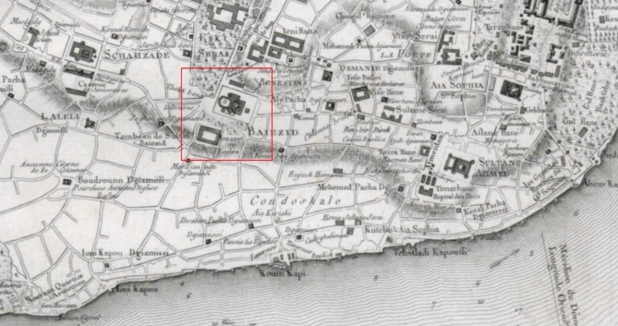
Figure 1. Beyazıt Square in the Kauffer Map of 1766 [15]. The mosque is represented by an enceinte wall and a small square in front of it, although the orientations and sizes in the map are not correct.

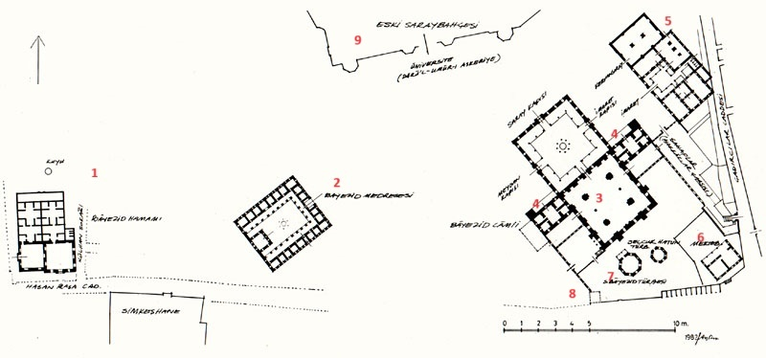
Figure 2. The elements of the Beyazıt Complex illustrated by A. Yüksel [12]: baths (1), medrese (2), mosque (3), hostels (4), caravanserai (5), primary school (6), tomb of Bayezid II (7), tomb of M. Reşit Paşa, garden of the Old Palace (9).

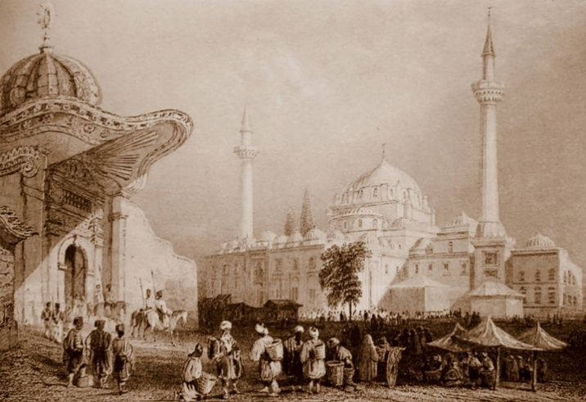
Figure 3. The Seraskerat Gate and the Beyazıt Mosque. Engraving made from an 1835 drawing by William Henry Bartlett [16].

During the 1920s, the space between the buildings of the Beyazıt II Complex and the university campus began to resemble a European square with the introduction of a large elliptical pool, which also served as the turnaround area for tramways (Figure 4). In 1956, this pool was dismantled during the urban renovation efforts – the great ambition of the administrations since the 19th century, which had relatively slowed down when Ankara became the capital city of the Republic of Turkey, established formally in 1923. The leader of the Demokrat Parti, Adnan Menderes, who came to power in 1950, hastened the modernization efforts that led to the opening of large boulevards for motorized transportation, following the footsteps of the French planner Henri Prost, who prepared the master plan of Istanbul between 1937 and 1939 [17]. As a result of such efforts, the historic main artery of the city (Mese/Divanyolu), now known as Ordu Street around the Beyazıt II Complex, underwent enlargement and correction through demolitions and ground levelling. Due to demolitions carried out between 1924 and 1957, the square gradually gained a larger space – a much-wanted emptiness, similar to that found in a major Western square [18]. However, in 1958, the square became a major automobile junction, devoid of its previous character as a meeting point around the pool (Figure 5). The public discontent with the present condition of the square prompted the administration to seek new projects, and that effort ultimately culminated in the organization of a design competition [19].

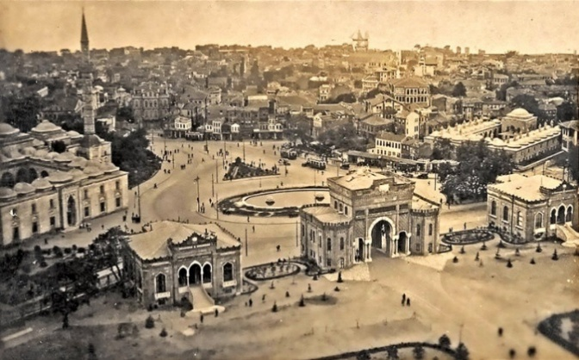
Figure 4. Beyazıt Square with the pool built in 1924 [20]. In the foreground are the triple pavilions of the campus gate; in the background are the mosque (left) and the medrese (right).
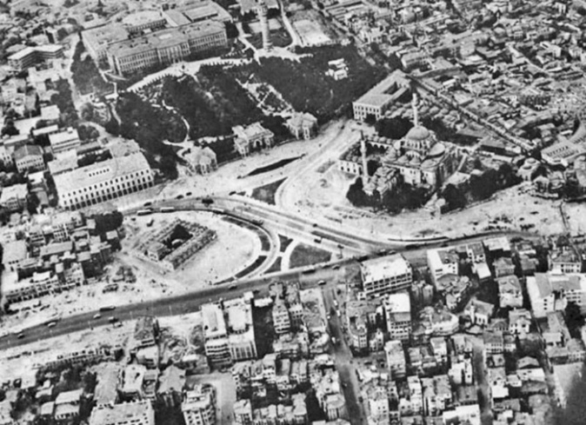

Figure 5. Aerial photo showing the square c. 1959 [20].

Sedad Hakkı Eldem, the main advocate of a modern national architectural style in Turkey and Cansever’s tutor at the Academy, was the name behind the project applied between 1957 and 1958 [7] [21] [22]. Although Eldem attempted to restore the square with a new proposal in 1958, he had lost face before the government authorities and was not invited to participate in the competition, for which Cansever prepared his project to compete against the already existing projects of Hans Högg and Luigi Piccinato [17]. His criticism of Högg’s project had already managed to stop its application, which proposed a large pedestrianised area in the shape of a platform four meters high up from the Ordu Street, sheltering 500 shops underneath as the ‘new Grand Bazaar’ [6] [14] [23]. Piccinato’s project, on the other hand, reserved a modest pedestrianized platform between the mosque and the medrese and kept the road in front of the campus just as Högg’s did. Still, it never reached the point of consideration for application. In April 1960, the three projects were presented to a heterogeneous jury [6] [24]. On March 7, 1961, the winning proposal of Cansever was discussed and voted on once again by another heterogeneous group of people, as a result of which the competition jury's decision was approved. Cansever was obliged to prepare the working drawings in a very short time before the application, which started in June 1961 [6].
Cansever’s project, which differed explicitly from the others not only for its intention to satisfy the functional needs but also for its proposal to preserve, recreate, and even re-invent the character of the place (Figure 6). The essence of Cansever’s proposal was the opposite of the image of a ‘modern square’ in the minds of educated Turks, which was a large, geometrical, orderly, and empty space surrounded by monumental buildings. With the many small constructions surrounding mostly the southern edge of the square and with the platforms that divided the square proper into many levels, he challenged the idea of forum/square with that of meydan, with the intention “to restore a large pedestrian area where one can comprehend the finitude of human products vis-a-vis the infinitude of time and space” [25].

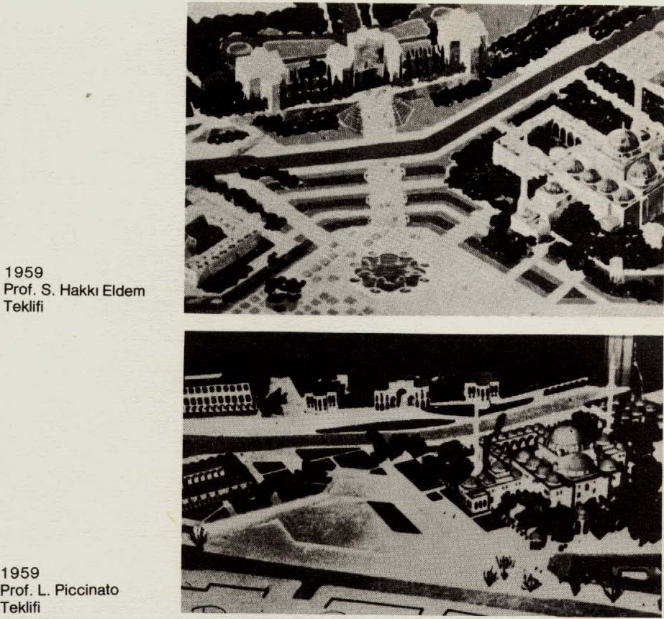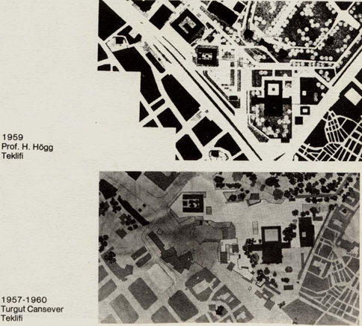
Figure 6. The four contemporaneous projects for the Beyazıt Square. From top to bottom: S. H. Eldem, L. Piccinato, H. Högg, and T. Cansever [26].
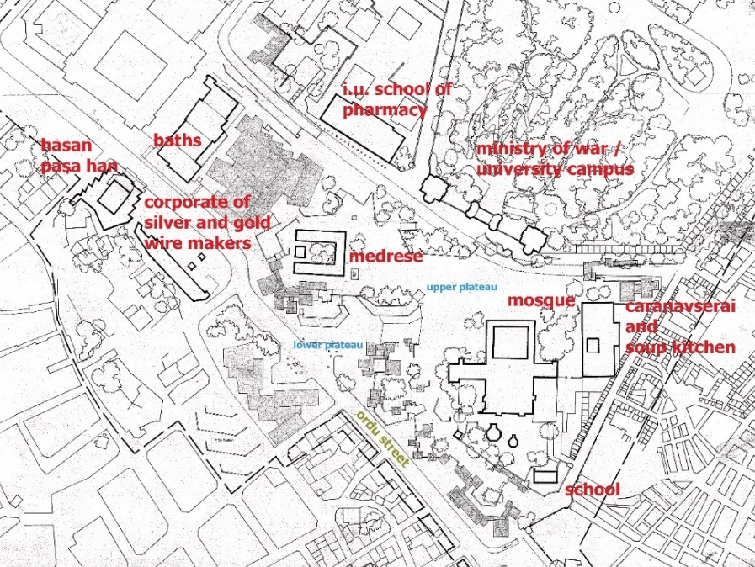
Figure 7. A portion of the revised layout of Turgut Cansever’s competition project c. 1960-61 [27].

  - THE BACKGROUND OF CANSEVER’S INTERPRETATION OF THE BEYAZIT SQUARE
Cansever believed that the disorderly, almost scattered appearance of the Beyazıt II Complex was rooted in the Islamic worldview. However, some architectural historians attributed it to the specific conditions of the site [13] [28]. In one of his speeches, Cansever compared the Beyazıt II Complex with the integrated and orderly layout of his father’s, the Fatih Complex, and claimed that Beyazıt demonstrated a change of attitude towards the understanding of space and its representation. This change, he claimed, is due to the influence of Islamic metaphysics concerning the relationship of things in space and time. In the case of Beyazıt, every architectural unit is independent from one another without an imposed hierarchical order. The collection of the units does not suggest completeness, leaving the space they create susceptible to change over time. Cansever found the clues of the motivation behind this new situation in ontological interpretations of Being, time, and space in Fusus al-Hikam. However, he probably had not made that connection in 1960 [29][4]. He continued to think on the subject and later suspected that Sheikh Ebu’l Vefa, a respected Sufi and a follower of Ibn al-Arabi who lived during the reign of both the scientifically motivated Mehmet II (the ‘Conquerer’) and his son, the pious Beyazıt II (the ‘Saint’), was the main influence concerning the change in the perception of the built environment [25] [30] [31].
The Sufi idea of ‘constant creation’ (tajalli) is a central motif in Ibn al-Arabi [11], which Cansever associated with the principle of the ‘openness’ of the built environment for future changes, as well as the dynamic composition of independent units as in the Beyazıt II Complex [4]. Accordingly, Cansever praised the philosopher Whitehead, who claimed that it was a profound mistake to investigate Being from a static point of view instead of understanding it as a dynamic process [32] [33]. Even if the influences of Ibn al-Arabi and Whitehead on Cansever occurred later, the representation of a specific worldview associated with the same issues was at the core of his understanding of the Islamic built environment. This worldview stemmed from his adoption of Diez’s categorizations, which Cansever interpreted and transformed through other influences, which remain to be investigated. For example, Hamdi Yazır, the author of a well-known Qur’an commentary, may be one such influence, as he differentiated between the creations of God and man according to mathematical/geometrical representations [4] [34]. In any case, very early in his career, Cansever saw an affinity between Islamic art and Modern art in terms of abstract expression [10]. Still, unlike Diez, who saw the sacrifice of freedom in Islamic geometric art [35] [36] [37], he interpreted ‘mechanical’ expressions of geometric forms as a conscious choice to differentiate human and divine creations.
Diez located the art and architecture of Islamic civilization in the category of ‘static’ expression of ‘cubistic’ forms. Cansever added to this categorisation the dynamic, free, and contemplative gaze of the subject moving in infinite space. Whether he associated the imperfect (‘open’) layout of the square and the dynamic accumulation of independent and static units with the Sufi concept of continuous creation (tajalli) before or after 1960 does not make a big difference concerning his unchanged motivation, which was always a search for an Islamic phenomenology of art and architecture. The passage below clearly shows the stratification of metaphysical thinking that connected Diez to al-Arabi and Whitehead through the Beyazıt Square:

The expression of Islamic unity as serenity resulting from the independence of parts as well as from the equalities and similarities, which formally creates static appearances, allows architecture to receive additions in accordance with the dynamic character of beings in time, thereby enabling a person living consciously in such an environment to be free in his decisions and actions. So, Islamic architecture generates lively, dynamic settings instead of frozen environments. Therefore, we face one of the principles of unity, which produces the basic stylistic aspect of Islamic architecture, which is the ‘openness’ of the unity, meaning that it accepts additions in time [38].

The constant change of sight in historic Muslim towns was, for Cansever, the opposite of the Classicist (Roman) static perception of space - an opposition that laid the foundation for his search for a meydan instead of a forum to allow the ‘freedom’ of perception. ‘Freedom’ as an ontological notion was also a strong motif in his postdoctoral thesis (1960), which investigated the works of Wright, Mies, Le Corbusier, Aalto, and Gropius. This unpublished and therefore largely unknown text also proves the link between the theoretical arguments published after 1980 and the time when the square was planned, for it extensively deals with the ‘matters of Being’ in many examples of Modern architecture. This thesis also demonstrates that at the time, Cansever had already integrated Hartmann’s four ontological layers of Being (material, biological, psychic, and spiritual) into his metaphysical perspective [39]. Probably the most interesting and important aspect of this study is that, while it favored Modernism over stagnant historicism in the West, it did not imply any such opposition to non-Western art, especially Islamic art [40] [41]. His postdoctoral thesis and later explanations leave no doubt that what he found in the works of the masters of Modernism was what he thought the Islamic ‘world-conception’ (Weltbegriff) - to borrow the term from Coellen and Diez - called for constructed environments, which are summarised from the thesis as follows:
- The metaphysical concept of ‘immateriality’ is achieved by honest treatment of materials;
- Criticism of dictating to man a preconditioned view of the world;
- the idea of freedom implied by the ‘additive-cumulative’ character of Cubism;
- the idea of freedom implied by the idea of non-perspectival representation (the multiple views in Cubism);
- the idea of individuality implied by ‘independent tectonics’;
- evoking infinite space through finite space;
- the difference between natural and artificial creations (abstraction);
- the ontological layers of Being;
- The importance of the constructed environment being open to change in time;
- The importance of the moving subject for the organisation of architectural space [10].

  - SYMBOLICAL AND PHENOMENOLOGICAL CONSIDERATIONS OF ORIENTATION
Cansever completely pedestrianised the square by lowering the road connecting the Saraçhane/Vezneciler (west of the campus) and the Grand Bazaar/Mercan (east of the campus) to the underground. This design was inspired by an underground tunnel he saw in the historic center of Rome, possibly the Galleria Pasa, which was constructed between 1930 and 1938 [24]. Total pedestrianisation allowed Cansever to introduce one of the most ingenious elements of his design: the various platforms above the retaining walls, which coordinated the level difference between the campus and Ordu Street, much like natural cascades (Figure 7). All these platforms, plateaus, ramps, and stairs together constituted the leitmotif of the design, reflecting the architect's theorizations about motion and perception. According to him, the multidirectional movement in space reflected the contemplative attitude of Muslims towards the infinite variety and the dynamic nature of Being.
Cansever problematised the orientation of the triple buildings of the campus entrance, which were explicitly shifted nearly 45 degrees from the orientation of the Beyazıt Mosque [23]. For him, this axis shift, along with the European historicist architectural styles, symbolised the anti-traditionalist tendency of the new ruling class of the Empire during the Tanzimat (reformation) period. This included Koca Mustafa Reşit Paşa, whose eclectic tomb, built in 1858 by Swiss architect Gaspare Fossati, was ‘misaligned’ like the tri-partite campus gate. Depending on that situation, Cansever saw a symbolic opposition between the Islamic/Ottoman worldview and that of the secular/Western progressivism, assuming that the misalignment was intentional [42]. The imposing appearance of the gate was equally important for him due to its size and position in the square, which constituted a counterweight to the mosque. Therefore, he strategically positioned the opposition between the campus gate and the mosque as the focal point of his design, taking particular care to highlight the mosque but not the gate as the square's main point of focus. He even decided to use the qibla orientation in drawings and models instead of the usual north [43] (Figure 8).

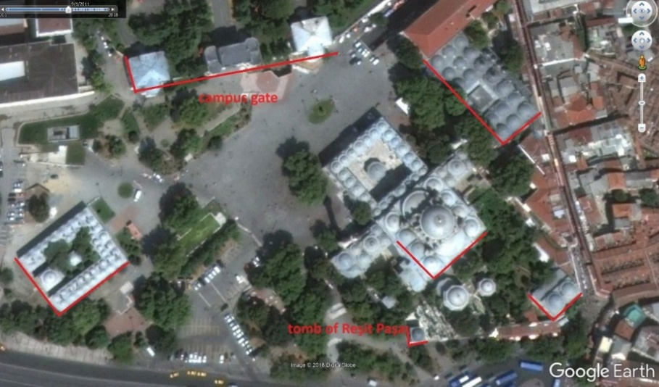

Figure 8. The Google satellite image shows Beyazıt Square before the demolition of the stairs leading to the campus gate. The highlights by authors aim to illustrate the orientation problem from the perspective of Cansever [44].

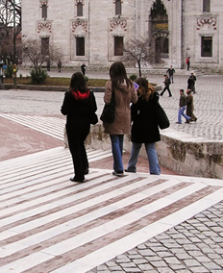

Figure 9. The courtyard gate of the Beyazıt Mosque seen from the landing of the campus gate [27].

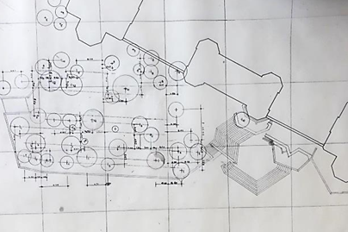

Figure 10. The final design for the stairs, platforms, and vegetation before the university campus gate. Note that the grid was produced from the position of the mosque oriented towards the qibla [27].

It seems that from the very beginning, Cansever had the idea to construct more than one staircase to connect the main plateau between the mosque and the medrese to the higher level of the campus gate, because multiple staircases would provide alternatives for movement and perception. He also attempted to divert attention from the gate to the stairs, the trees, and the historic monuments. He repeatedly clarified that descending from the main (largest) staircase in front of the campus gate directs one towards the main courtyard gate of the mosque, thereby making it a focal point of attention from the campus side (Figure 9). Planting trees on the platforms between the stairs was another solution to mitigate the exaggerated presence of the campus gate, drawing on a very common Ottoman concept: the use of trees around buildings (Figure 10).

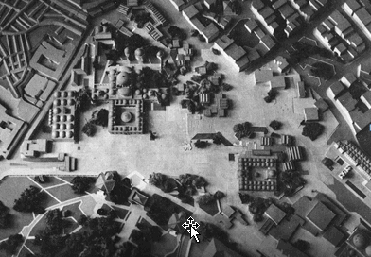

Figure 11. The model was prepared for Turgut Cansever’s project of the Beyazıt Square. Note that the upperside of the model points not to the north, but Kaaba (the qibla) [27].

The project also proposed the placement of smaller stairs around the relatively congested spaces created by the retaining walls of the platforms to the south of the mosque, where shops with narrow and curving passages and stairs would be situated. These shops were to conform with the size of civil architecture of the past, which once occupied nearly the same spot before the demolitions, covering, in Cansever’s words, the ‘back’ of the mosque, which was not intended to be seen from a distance [14] (Figure 11, Figure 12). On and around the platforms, there were to be stretches of land in irregular geometry reserved for vegetation (Figure 13). An ample opening was created at the edge of the Ordu Street below the medrese. This is the lower plateau, which was intended to serve as a preparatory area for the largest staircase leading up to the upper plateau, later converted into a ramp (Figures 7 and 12). This ramp faced the western gate of the mosque’s courtyard, while the dense vegetation over the platform that extended along the length of the ramp blocked the view of the campus gate. Those who came from the lower plateau by Ordu Street and needed to go up to the campus or in the direction of Vezneciler/Saraçhane had to turn left after climbing up to the upper square using this ramp. Right at this corner, on the left, in almost equidistant position between the medrese, the campus gate, and the mosque, Cansever located a pool to be made from the marbles of the large oval pool dismantled in 1956 [45]. The form of this new pool was like a flower in plan, but interestingly irresolute between geometric order and amorphous form (Figures 12 and 13). Since another large platform blocked the front of the campus gate, one had to change their direction several times to reach it through the stairs located on either side of this final platform.

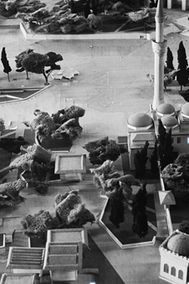

Figure 12. Model photo showing the landing of the main ramp at the upper left. To the lower right of the photo is the tomb of Koca Mustafa Reşit Paşa [27].

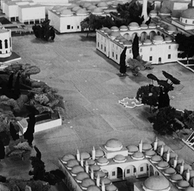

Figure 13. The pool between the mosque, the campus gate, and the medrese [27].

- INDIVIDUALITY AND ‘ADDITIVE-CUMULATIVE’ TECTONICS
The reason behind the cluster of one- to two-story buildings (restaurant, coffeehouse, patisserie, bookstore, canopies, etc.) around the historic monuments was Cansever’s uneasiness about the extra-large space that emerged after consequent demolitions [14], which negatively affected the perception of the Beyazıt Complex [46] (Figure 14). By creating a duality between the static and orderly forms of independent, small, and finite ‘tectonics’ and the dynamic and disorderly character of movement in infinite space, Cansever brought a new perspective to Diez’s understanding of Islamic architecture as a pile-up of static elements. Buildings were to be perceived in space and time by the subject in motion [47]; they were a collection of images connected through memory, invoking the dynamic nature of Being:

[...] the Beyazıt Square exists with the buildings in it. A person who is willing to discover it physically has to move inside and outside of these buildings. The life of a walking person is the totality of the sequence of events encountered during the act of walking. In this totality, the moments of stops are especially significant. For our investigation, we must take into account that the person who arrives at the square will comprehend the mosque and other elements in relation to the moments experienced shortly before [1].

For Cansever, a constructed environment should reflect an awareness of the polarities of Being. Consequently, new buildings in the square also needed to be designed in an ‘additive-cumulative’ manner, invoking the dialectic relationship between the visible and invisible, finite and infinite, as well as single and multiple [25]. The legibility of the tectonic language of these buildings was also part of the ‘additive-cumulative’ logic, and their Brutalist structural rationalism, with reinforced concrete frames and stone infills, showed that they were meant to blend in with the existing masonry structures of Ottoman buildings. For instance, the sawtooth-shaped roofs of these modest buildings bore a slight resemblance to the constant repetition of Ottoman domes, while their concrete eaves bore a more direct resemblance to traditional houses and palatial pavilions (Figure 15). Conversely, the planarity of these buildings’ surfaces aimed to mirror the ‘immaterial’ and ‘ornamentalistic’ aesthetics of Ottoman structures [25].

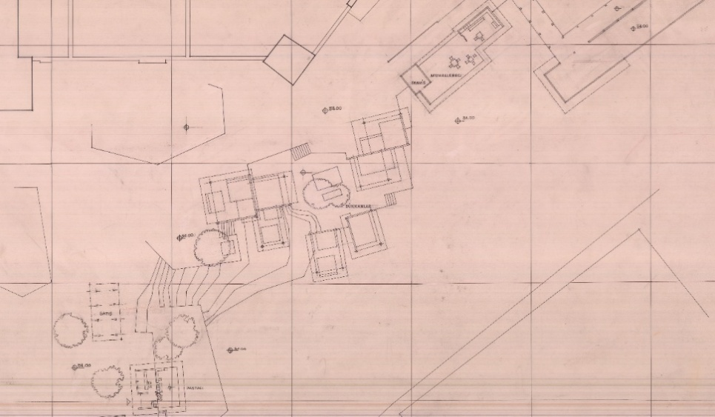

Figure 14. A portion of the plan of the shops along the southern end of the Beyazıt Square. The square building at the top of the image is the tomb of Koca Mustafa Reşit Paşa, attached to the enceinte wall of the mosque [27].

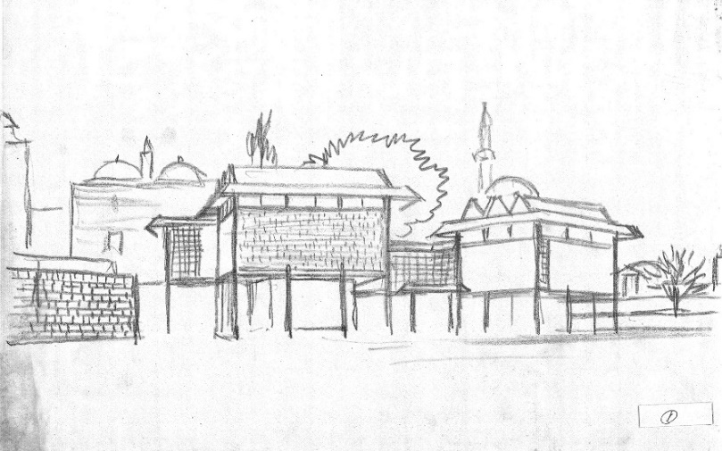

Figure 15. A sketch of some of the shops [27].

Cansever’s interest in the ‘ornamentalistic’ attitude, which is linked to ‘immateriality’ [47], can be seen as the motivation to overcome the sheer materiality of artefacts with an insight into an upper-level ontological category of Being. It is an “attempt to mirror consciousness in the world of forms” [32], corresponding to Hartmann’s ‘spiritual layer’ of Being, which concerns the human being’s self-consciousness of their existential condition [29] [41]. Cansever claimed that the concept of ‘immateriality’ in Islamic-Ottoman architecture influenced architects like Le Corbusier and Louis Kahn. He mentioned names like Kandinsky, Picasso, and Giacometti as the painters who broke the “frozen” vision of the world that Western art had been representing since the Renaissance [48].

- THE ‘ORNAMENTALISTIC’ PAVEMENT
Cansever’s sketches and scaled drawings prove that he attached great importance to the pavement. The predilection for pure forms, static tectonic objects, and planarity stemmed from the intention to represent the infinite process of Being as in Islamic art [47], which most likely inspired his efforts to give the square’s pavement an ‘ornamentalistic’ quality. Although the large flat area constituting the upper plateau required attention to prevent the collection of rainwater, Cansever’s care apparently went beyond the Ottoman practicality on such matters [4] [49]. The sketches and Mehmet Öğün’s recollections testify that Cansever approached the ground like a canvas, to the extent that he even had the painter Ömer Uluç make sketches for the pattern of the pavement, who is known for vibrant compositions with flowing contours in vivid colours [45]. Therefore, Cansever’s pavement design had three main objectives: 1) creating a pattern that is artistic and meaningful at the same time; 2) creating a walkable surface with patches of greenery; and 3) creating inclinations within a network of lines and points to collect and canalize the rainwater.

Figure 16. Technical drawing showing the concentration of slopes and level areas at the upper plateau [27].

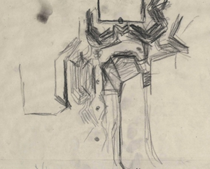

Figure 17. Sketch showing the study of slopes, platforms, and stairs between the mosque (above) and the campus gate (below) [27].

Based on a dimensional drawing, Cansever produced a plan that depicted the precipitation of the slopes with parallel contour lines, thereby defining the shape of the upper-plateau (Figure 16). These contour lines, which oscillate between the natural and the artificial, may have served as the real inspiration for the shapes of the platforms, which are the central elements of the design. The drawings of a feverish hand from this phase of the design illustrate how Cansever attempted to reconcile the physical reality of the site with his solutions for the platforms, plateaus, and water drainage points (Figure 17). At this point, the design begins to take on an organic character, suggesting a continuous generative process through the totality of forms, at least from an artistic perspective. The positions and sizes of the platforms and stairs take shape during this process like a play with the forces of chaos and order, interestingly recalling the “eternal geometry of creation” explained in a passage of the Qur’an commentary (1935-39) by Hamdi Yazır, whom Cansever met in his youth as a person from his father’s entourage. Yazır stated that while human artefacts receive their characters by the measurability of perfect geometry, God’s creations are not exactly measurable because of the endless fractions testifying to the eternal character of creation [34]. In the next step, the natural and chaotic reality of the topography culminates in imperfect hexagons around the marble drainage points. The intentional distortions of the perfect geometry give them a dynamic quality, making them appear like frozen moments in continuous change (Figure 18).

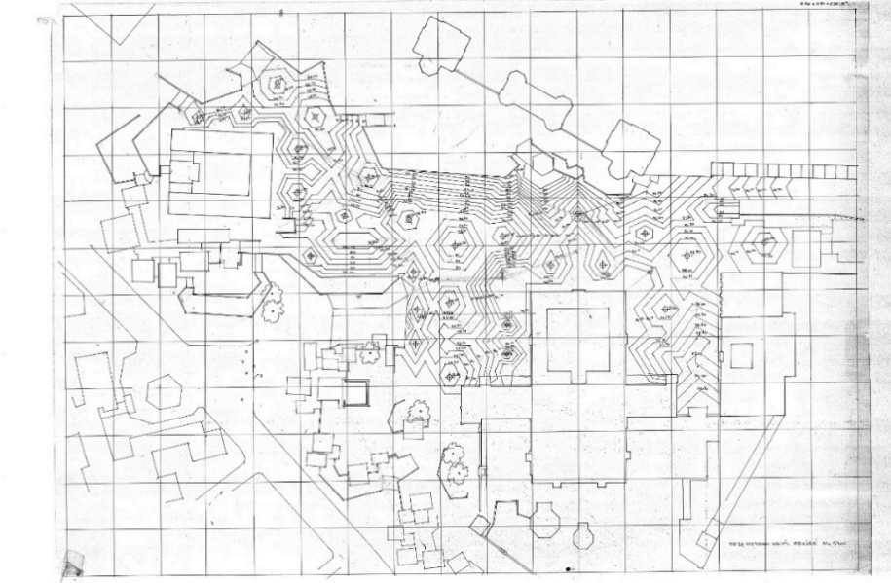
Figure 18. Technical drawing showing the emergence of hexagonal shapes serving both the drainage system and the pavement form [27].
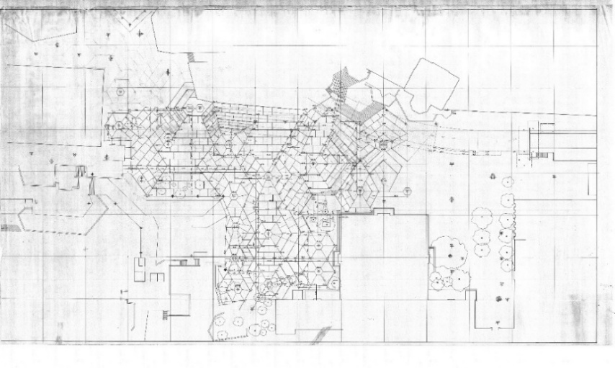

Figure 19. Technical drawing showing that the hexagonal shapes are evolving into ornamental patterns on the pavement [27].
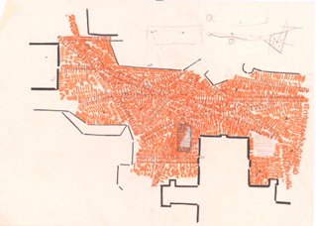

Figure 20. An alternative sketch showing Cansever’s preference for the colour and texture of the upper square [27].

In the next step, Cansever divided the parallel and concentric lines into smaller parts, roughly representing the pattern of the pavement (Figure 19). A few colour sketches of the upper square reveal that he had envisioned small grey granite cubes and slender, baked red bricks, similar to those found in the Piazza del Campo in Siena (Figure 20). These colour drawings seem to contradict the hexagons in evolution, although they might precede them in the design process. The detailed drawings of the lower square reveal that Cansever primarily used square granite cobbles, with some parts entirely composed of red bricks (Figure 21). In both cases, large strips of marble bordered the granite and brick areas (Figure 22). The platforms and staircases built in front of the campus gate, along with the project model, testify to the architect's final decision for the upper square, which appears to be extensive patches of red brick in polygonal shapes with marble manholes at the centre (Figures 23 and 24). Cansever himself stated that the “carpet-like” pavement with red bricks would make the historic buildings stand out in the square [25]. The handling of materials and patterns with meticulous detail, which could change randomly anywhere in the entire square, helped to tone down the effect of the time difference between the old and new constructions. The possibility of a connection between the pavement pattern and Cansever’s study on Turkish column capitals is also interesting, because in his doctoral thesis, he argued that the “immaterialising function of ornamentation” intended to suggest infinity, and the so-called ‘Turkish triangles’ constituted the bulk of his examples [9] (Figure 25). All in all, Cansever apparently worked hard to imbue the pavement with an ‘immaterialistic’ quality as an ‘ornamentalistic’ work of art, without sacrificing the realities of its material conditions, in accordance with different ontological layers of Being.

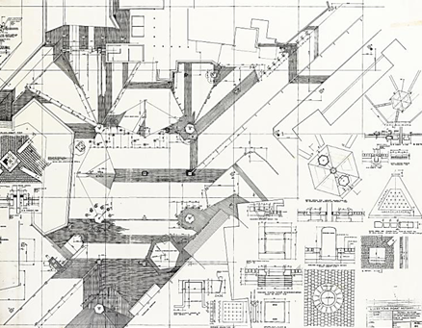

Figure 21. A collection of detail drawings for the pavement and manholes in the lower square [27].
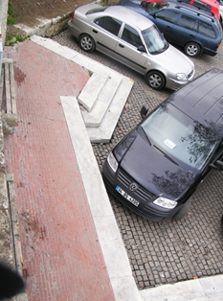

Figure 22. An original piece of the pavement made of brick, granite, and marble at the lower square [27].

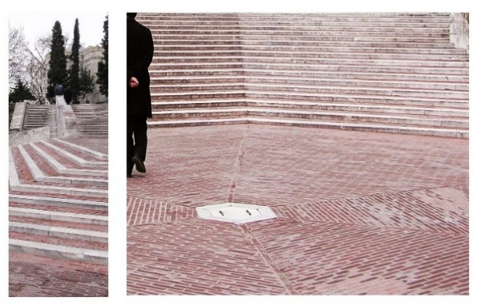

Figure 23. The main stairs before the campus gate [27].

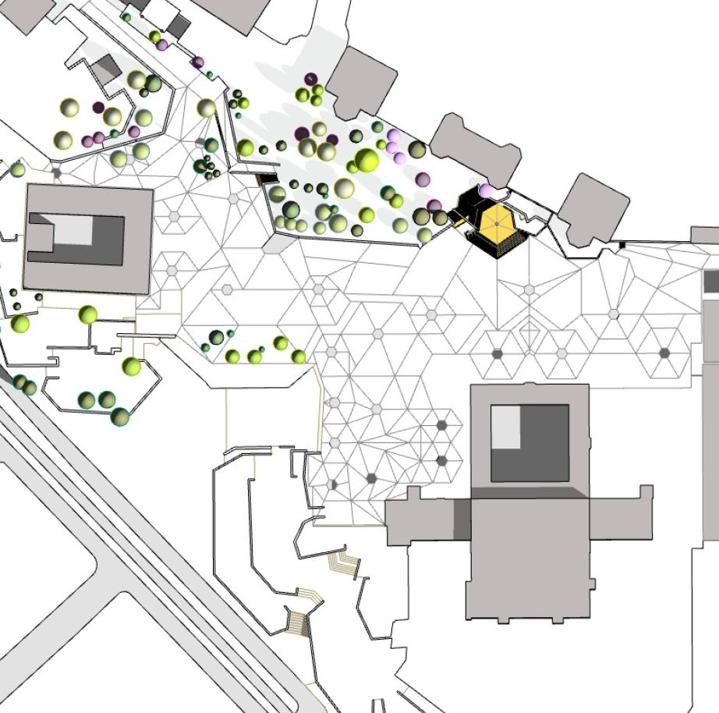

Figure 24: Bird’s-eye-view from the presentation model prepared for the restoration of Cansever’s project for the Beyazıt Square by Öğüns [27].
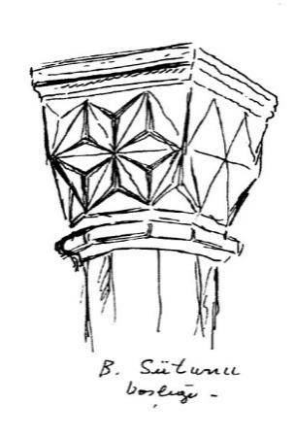
Figure 25. A sketch of a Turkish column capital by Turgut Cansever made during his doctoral studies [9].

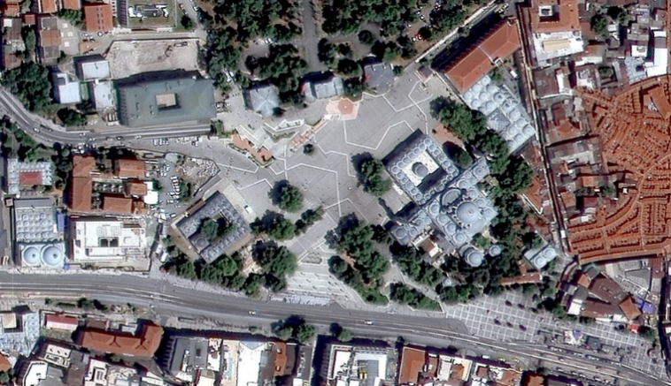

Figure 26. Satellite image showing the current state of the square in 2024 [50].

Cansever’s Beyazıt Square project continued even after the military coup that overthrew the Menderes government on May 27th, 1960. Still, the work halted a short while after its start in June due to changes in certain administrative positions both in the city and the country, after which the campaign of certain circles against Cansever’s project gained influence [51]. Finally, Cansever declared his resignation from the project publicly in a letter published in the daily newspaper Milliyet on March 22, 1964, in which he claimed that the people who hindered its realisation were the same as those who destroyed the historic city [52]. Meanwhile, the underground tunnel and most of the platforms and stairs between the mosque and the medrese had been completed. However, Cansever claimed they did not exactly match their original design. Particularly, the inclinations of the main (upper) plateau were made arbitrarily, and instead of baked bricks and small granite cubes, only coarse granite blocks were paved. They built none of the small constructions intended to enliven the square, such as the coffeehouse or the bookstore. The areas that these buildings were supposed to occupy became somewhat empty and desolate, with their platform walls exposed, and the lower plateau by Ordu Street was converted into a parking lot. The pool and flower beds were never made [26], although a rectangular pool was later constructed over the ramp. Despite a new competition held in 1987, the square remained nearly unchanged until 2014, when the height of the tunnel required an increase.
To achieve this, they demolished the stairs before the campus gate and rebuilt them without marble borders in 2015. In 2017, a new project, which once again prioritised the campus gate within the square, led to the demolition of the stairs and the laying of a concrete base for the new extensive stairs. However, protests from the heirs of the architect, as well as the architectural circles, forced the Istanbul Metropolitan Municipality to halt this project. After meetings between Emine and Mehmet Öğün and the municipal officials, the previous mayor of Istanbul Metropolitan Municipality decided in 2018 to reapply Cansever’s design after a project prepared by the Öğüns. The current mayor also publicly announced his agreement with this decision during his visit to the square on August 15, 2019. However, the implementation of the new project persisted for some time, leading to the appearance of extensive parallel lines of concrete stairs along the campus gate. However, at the end of 2021, these stairs were also demolished, and a new project was started. This new project, which is almost complete today, resembles Öğüns’ restoration of Cansever’s original project, but with considerable differences (Figure 29).
- CONCLUSION
The history of Beyazıt Square over the last two hundred years is the history of a competition between two distinct spatial concepts: forum and meydan, belonging to two successive civilizations. Cansever’s involvement in the redesign of the square aimed to revive the concept of meydan, serving as a resistance to not only copycat Westernization but also to the global lack of understanding about matters of Being due to the influence of modernity. Therefore, the real significance of his project lies as much in the role it played in the history of a place in Istanbul as in its concretisation of Cansever’s theorisations about formal and spatial phenomena. These theorisations depended on intertextual readings that extended over time. However, those unfamiliar with these theoretisations criticised the design vehemently for being arbitrary and inconvenient, and managed to stop its application. The square remained incomplete until recently due to the conflict that occurred around 1960, which is also connected to the political issues of the time, as well as the cultural fault lines of Turkish society.
Even if one can argue that Cansever’s works and discourse around 1960 do not reflect a complete formulation of an architectural theory, there is ample evidence to suggest that he did not devise theoretical arguments later in life to imbue the works he had done before with metaphysical thoughts. Although Cansever’s thinking indeed deepened in time and his discourse appeared to be worthy of an architectural theory with publications after 1980, its core never changed. The project for Beyazıt Square served as a medium for integrating the art historical and metaphysical aspects of that core with the fundamental tenets of Modern architecture. The intertextual nature of this core, which began to crystallise in the Beyazıt Square, enabled the architect to carry his conclusions about human and divine creations into Sufi metaphysics, especially Ibn al-Arabi’s Fusus al-Hikam, and to deduce from them the notions of individuality and a loving duty to all beings, whether they are natural or artificial.
Due to these main concerns, Cansever fought against the undialectical and rigid spatiality of Classicist architecture, which featured perfect and fixed views. Inspired by the scattered, independent structures of the Beyazıt II Complex, he came up with the idea of ‘additive-cumulative’ tectonics. These ‘tectonics’ were independent in terms of both their physical dispositions and the way they shaped the space around them, thereby implying the oppositions between the man-made and natural as well as finite and infinite. The immaterialized expressions, which he found in most of the works of the great masters of Modern architecture, appeared in his design as a reinterpretation of the almost abstract ornamental effects of Ottoman buildings, composed of concrete, stone, brick, and glass, allowing each element to retain its individuality. The ornamental beauty of the pavement, with its endless variations of hexagonal patterns and their various derivations, particularly expressed the dynamic nature of Being, as did the platforms, which were the antithesis of static geometrical abstractions.
Finally, Cansever’s project for the square is essentially unique in its integration of a ‘world-conception’ that links the present with the past by honoring both the historicity and modernity of a public place. Therefore, the random distribution of the forms in the Beyazıt Square could not simply be a reformulation of an aesthetic pleasure of the ‘picturesque’, which is the imitation of the experience of discovery through idle promenades, which became popular in Britain in the 18th century. It was rather a manifestation of a modern reformulation of intellectual, aesthetic, and spiritual pleasures of a civilization by connecting them to the essential matters of Being. While Islamic metaphysics and the Ottoman built environment helped sustain the cultural roots of this reformulation, Modern architecture and philosophy helped prove its contemporaneity and universality.

REFERENCES

[1] H. E. Düzenli, İdrak ve İnşa: Turgut Cansever Mimarlığının İki Düzlemi (Comprehension and Construction: The Two Grounds of Turgut Cansever’s Architecture). İstanbul: Klasik, 2009.
[2] H. E. Düzenli, “Türkiye’de Bir Meydanın Uzun Yaşanmış, Kısa Yazılmış Hikâyesi. Beyazıt Meydanı ve Turgut Cansever (A Long-Lived, Short-Written Story of a Square in Turkey. The Beyazıt Square and Turgut Cansever)”, Hendese, no. 9, pp. 15-31, 2020.
[3] B. F. Üstün, Ö. G. Ulusoy, G. Şensoy and F. Kolsal, “A Designer in the Intersection of Islamic-Ottoman Architecture: the Architectural Concept of Turgut Cansever (1920- 2009)”, Journal of Islamic Architecture, vol. 5, no. 4, pp. 229-242, 2019. doi: https://doi.org/10.18860/jia.v5i4.5346
[4] U. Tanyeli, A. Yücel, Ed., Turgut Cansever: Düşünce Adamı ve Mimar (Turgut Cansever: Thinker and Architect). Istanbul: Osmanlı Bankası Arşiv ve Araştırma Merkezi, 2007.
[5] U. Tanyeli, Mimarlığın Aktörleri. Türkiye 1900-2000 (The Actors of Architecture. Turkey 1900-2000). Istanbul: Garanti Galeri, 2007.
[6] S. Bayrak, Bir Meydan Öyküsü: Beyazıt (1914-1964) (The Story of a Square: Beyazit (1914-1964)). Istanbul: Türkiye İş Bankası, 2008.

[7] S. H. Eldem, “Bayezit-Hürriyet Meydanına Ait Y. Mimar Turgut Cansever İmzalı 1/500 Ölçekli Proje Hakkında Görüşlerim” (My Ideas on the 1/500 Project for the Beyazit-Hurriyet Square signed by the Architect (M.Arch) Turgut Cansever), 1960. SALT Research Archives, Edhem Eldem Collection, Folder: ‘Meydan Düzenleme Projesi 1957-1959, Beyazıt, İstanbul: evraklar’, code: TSHEPA04605, URI https://archives.saltresearch.org/handle/123456789/86499.
[8] E. Öğün, personal communcation, May 9, 2021.
[9] T. Cansever, Sonsuz Mekânın Peşinde: Selçuk ve Osmanlı Sanatında Sütun Başlıkları (In Search of the Eternal Space: Column Capitals in Seljukid and Ottoman Art). İstanbul: Klasik Yayınları, 2010.
[10] T. Cansever, Bugünkü Mimarlığın Temel Meseleleri (Fundamental Issues of Architecture Today). Unpublished manuscript, 1960.
[11] M. Ibn al-Arabi, The Bezels of Wisdom. Trans. R. W. J. Austin, New York: Pauls, 1980.
[12] S. Eyice, “Beyazıt II Camii ve Külliyesi (The Beyazıt II Mosque and Pious Complex)”, TDV İslâm Ansiklopedisi, vol. 6, Istanbul: TDV, pp. 45-49, 1992.
[13] D. Kuban, “Beyazıt”. Dünden Bugüne İstanbul Ansiklopedisi, vol. 2, Istanbul: Ekonomik ve Toplumsal Tarih Vakfı, pp.180-188, 1993.
[14] T. Cansever, “Beyazıt Meydanı Projelerini Tetkik Toplantısı Zabtı (1961) (The Official Report of the Meeting for the Examination of the Beyazıt Square Projects)”, in T. Cansever, İstanbul’u Anlamak (Understanding Istanbul). İstanbul: Timaş. pp. 320- 328, 2011.
[15] F. Kauffer, “Plan de la ville de Constantinople et des ses faubourgs tant en Europe qu'en Asie levé géométriquement en 1776 par Fr. Kauffer verifié et augmenté en 1786”. SALT Research Archives. Fr. Kauffer Collection. https://archives.saltresearch.org/handle/123456789/116051
[16] J. Pardoe, The Beauties of the Bosphorus. London: George Virtue, 1838.
[17] M. Gül, Modern İstanbul'un Doğuşu: Bir Başkentin Dönüşümü ve Modernizasyonu (The Birth of Modern Istanbul: Transformation and Modernisation of a Capital City). Istanbul: Sel, 2015.
[18] Ö. S. Durhan, “Erken Cumhuriyet İstanbul’unda Kentsel Değişim (1928-1950) (Urban Transformation in Early-Republican Istanbul)”. Unpublished dissertation (PhD), Yıldız Teknik Üniversitesi, 2009.
[19] B. Ayvazoğlu, Üçüncü Tepede Hayat: Beyazıt Meydanı’nın Derin Tarihi (Life on the Third Hill: The Deep History of the Beyazıt Square). İstanbul: Kubbealtı, 2012.
[20] https://birartibir.org/ihya-adina-imha/
[21] E. Martinelli, “Turgut Cansever e la Scuola di Sedad Eldem: Unità e tettonica nel progetto per Istanbul (Turgut Cansever and the Sedad Eldem School: Unity and tectonics in the project for Istanbul)”. Unpublished thesis (PhD), Università IUAV di Venezia, 2017.
[22] S. H. Eldem, “Drawings for the Redesign of the Beyazıt Meydanı”. SALT Research Archives, Edhem Eldem Collection, Folder: ‘Meydan Düzenleme Projesi 1957-1959, Beyazıt, İstanbul: çizimler III’, code: TSHEPA04603, https://archives.saltresearch.org/handle/123456789/89293.
[23] T. Cansever, “Şehir Nasıl Korunur? (How to Preserve the City?) - Interview by B. Sağdıç (1991)”, in T. Cansever, Kubbeyi Yere Koymamak (Not to Put the Dome on the Ground). İstanbul: İz, pp. 253-278, 1997.
[24] T. Cansever, “Beyazıt Meydanı Hakkında (On the Beyazıt Square)” (n.d.). Interview by N. A. Artun, A. Orbay, P. Soğangöz [Video]. Youtube. https://www.youtube.com/watch?v=BJfbctvoPbs.
[25] T. Cansever, “Dünden Bugüne Beyazıt Meydanı (1991) (Beyazit Square from the Past until Today)”, in T. Cansever, İstanbul’u Anlamak (Understanding Istanbul), İstanbul: Timaş, pp. 285-295, 2011.
[26] T. Cansever, “Beyazıd Meydanı Düzenleme Projesi – İstanbul 1958-61 (Project for the Redesign of the Beyazit Square – Istanbul – 1958-61)”, Mimar: Çağdaş Mimarlık Dergisi, no. 11, pp. 5-67, 1981.
[27] E. and M. Öğün, Turgut Cansever Archive.
[28] N. Erkal, “İstanbul'da Erken Dönem Osmanlı Mimarisi (Early Ottoman Architecture in Istanbul)”, Büyük İstanbul Tarihi, vol. 8, Istanbul: TDV ISAM, p. 133, 2015.
[29] H. İ. Düzenli, “Turgut Cansever (1920-2009)”, İslâm Araştırmaları Dergisi, no. 22 pp. 160- 173, 2009.
[30] T. Cansever, Vefa Semti: Dünü, Bugünü, Yarını Sempozyumu (The Symposium of the Vefa Neighbourhood: Yesterday, Today, Tomorrow), İstanbul, 3-5 November, 2006 [Video]. Youtube. https://www.youtube.com/watch?v=6LLPU0o3IsE.

[31] A. Doğanay, “Şeyh Vefa Külliyesi (Sheikh Vefa Pious Complex)”, Divan, vol. 20, no. 1, pp. 75- 98, 2006.
[32] T. Cansever. “Mimarî Felsefesi (Philosophy of Architecture) - Interview by Ö. Madra and F. Şahinler (1989)”, in T. Cansever, Kubbeyi Yere Koymamak (Not to Put the Dome On the Ground), İstanbul: İz, pp. 15-41, 1997.
[33] A. N. Whitehead, Process and Reality: An Essay In Cosmology. New York: The Free Press, 1978.
[34] H. Yazır, Hak Dinî, Kur’ân Dili (The Language of the Qur’an, the True Religion), vol. 1, İstanbul: Huzur, 2003.
[35] E. Diez, “A Stylistic Analysis of Islamic Art: General Part”, Ars Islamica, vol. 3, no. 2, pp. 201- 212, 1936.
[36] E. Diez, “Simultaneity in Islamic Art”, Ars Islamica, vol. 5, no. 4, pp. 185-189, 1938.
[37] E. Diez, “A Stylistic Analysis of Islamic Art”, Ars Islamica, vol. 5, no. 1, pp. 36-45, 1938.
[38] T. Cansever, “Mimaride Türk Millî Üslûbu (1984) (Turkish National Architectural Style)”, in T. Cansever, İslâm’da Şehir ve Mimari (Islamic Town and Its Architecture). İstanbul: Timaş, pp. 73-88, 2006.
[39] N. Hartmann, “Almanya’da Yeni Ontoloji Cereyanı (New-Ontology Movement in Germany)”, Felsefe Arkivi, vol. 1, no.1, pp. 202-254, 1945.
[40] A. Yücel, “Söyleşi: Mimarlık, Çevre ve Anlam (A Talk: Architecture, Environment and Meaning)”, Mimarlık, no. 11-12, pp. 26-34, 1982.
[41] T. Cansever, “İslâm Mimarisi Üzerine Düşünceler (1996) (Thoughts on Islamic Architecture)”, in T. Cansever, İslâm’da Şehir ve Mimari (Islamic Town and Its Architecture), İstanbul: Timaş, pp. 13-54, 2006.
[42] T. Cansever, “Beyazıt Meydanı (Beyazit Square)”, Mimarlık ve Sanat, no. 2, pp. 74-76, 1961.
[43] E. Öğün and M. Öğün, personal communication, Istanbul, February 25, 2018.
[44] Google Earth Satellite Image of the Beyazıt Square (2010).
[45] E. Öğün, personal communication, Istanbul, February 20, 2018.
[46] M.B. Uluengin, Ö. Turan, “İmparatorluğun İhtişam Arayışından Cumhuriyet’in Radikal Modernleşme Projesine: Türkiye’de Kentsel Planlamanın İlk Yüz Yılı (The First Hundred Years of Urban Planning in Turkey)”, Talid, vol. 3, no. 6, pp. 353-436, 2005.
[47] T. Cansever, Thoughts and Architecture. Ankara: Türk Tarih Kurumu, 1981.
[48] T. Cansever, “Rönesans’ın Sonuçları (Outcomes of the Renaissance)- Interview by Mustafa Kutlu (1991)”, in T. Cansever, Kubbeyi Yere Koymamak (Not to Put the Dome on the Ground). İstanbul: İz, pp. 63-76,1997.
[49] E. Kortan, Kaybolan İstanbul’um (My Istanbul Which is Lost). İstanbul: Boyut, 2009.
[50] Google Maps satellite image of the Beyazıt Square (2024).
[51] T. Cansever, “Ustaların İlk İşleri: Turgut Cansever (the First Works of Masters: Turgut Cansever)”. The 1st İstanbul Architecture Festival, 4-9 October 2004 [Video]. Youtube. https://www.youtube.com/watch?v=nA0RIff11zc.
[52] T. Cansever, “Beyazit Meydanı Meselesinin İçyüzü (The Real Issue about the Beyazıt Square)”, Milliyet, p. 2, March 22, 1964.

