 |  | JOURNAL OF ISLAMIC ARCHITECTURE  P-ISSN: 2086-2636 E-ISSN: 2356-4644  Journal Home Page: http://ejournal.uin-malang.ac.id/index.php/JIA
CULTURAL DYNAMICS REVEALED: AESTHETIC EXPLORATION OF SYMBOLS AND MEANINGS IN THE DESIGN OF THE NINE GATES OF ASTANA SUNAN GUNUNG JATI CIREBON
Imam Santosa^{a*}, Husein Hendryana^{b}
ªVisual Art and Design Faculty, Institut Teknologi Bandung, Bandung, Indonesia
^{b}Visual Art and Design Faculty, ISBI, Bandung, Indonesia
*Corresponding Author: imamz@fsrd.itb.ac.id
ARTICLE INFO |  |  | ABSTRACT
Volume: 8  Issue: 4  Page: 913-932  Received: May 13th, 2024  Accepted: July 26th, 2024  Available Online: December 30th, 2025  DOI: 10.18860/jia.v8i4.26924 |  |  | Astana Sunan Gunung Jati is a royal burial complex and religious leadership site located in Cirebon, West Java-Indonesia, representing a unique model of acculturation and adaptation from diverse cultures and traditions. This research aims to examine a masterpiece of 14th-century architecture to understand the adaptation processes involved in its construction and uncover the aesthetic contributions from various sources to the design of Astana Sunan Gunung Jati. The primary challenge lies in harmoniously integrating diverse cultural elements and the influences of various religions that shape its design and aesthetics. This study focuses on the representation of different cultural elements interacting and contributing to the Islamic cultural richness in Cirebon, particularly in the visualization of the nine symbolic gates of Astana Sunan Gunung Jati. Employing a qualitative approach, the research delves into cultural adaptation into visual forms, utilizing historical data, literature, and in-depth interviews with relevant parties knowledgeable about Astana Sunan Gunung Jati. The findings reveal that the design of Astana Sunan Gunung Jati adopts a pluralistic and multicultural approach, blending models of 'native cultural preservation' and 'cultural contact synergy'. This reflects the cultural convergence from sources including Sundanese, Javanese, Islamic, Buddhist, and Hindu traditions, contributing to the visual richness of the structure. Moreover, this research significantly shapes the cultural identity of Cirebon. The cultural adaptation process in the design of Astana Sunan Gunung Jati, which has endured for approximately 700 years, holds profound insights into the aspects of maintenance, preservation, and conservation, serving as a role model for cultural heritage. It offers valuable insights into how cultural identity forms and is preserved in complex and diverse environments, particularly concerning design and aesthetics.  Keywords:  Cultural Adaptation; Cultural Convergence; Design and Aesthetics; Nine Symbolic Gates of Astana Sunan Gunung Jati

- INTRODUCTION
Research on the Astana Sunan Gunung Jati cemetery complex has been extensive, with a primary focus on its function as a pilgrimage tourism destination. Previous studies have explored its social [1], [2], intangible heritage [3], historical [4], and tourism aspects [5]. However, there has been a lack of in-depth discussion on aesthetics, design, ornamentation, and supporting elements. This study, therefore, focuses on how cultural elements and beliefs influence the visual concept of Astana Sunan Gunung Jati. The Astana Gunung Jati cemetery holds a wealth of ancient knowledge about burial sites.
Astana Sunan Gunung Jati is a site with profound cultural and spiritual significance, transcending its role as a public cemetery [3], [4], [5]. Located at the peak of Mount Sembung in Astana Village, Gunung Jati District, Cirebon Regency, West Java Province, Indonesia, this mausoleum complex holds great cosmic importance for the people of Cirebon, granting it special cultural and spiritual significance [6]. The placement of these graves within the local belief system is carefully articulated through respected physical and social arrangements, making it the final resting place for religious leaders and sultans of the Cirebon Sultanate.
Rooted in traditional Islamic burial customs, Astana Gunung Jati reflects the journey from worldly life to the afterlife through a hierarchical spatial arrangement symbolized by its nine gates. Initially, a makam was a sacred site during the Hindu-Buddhist era. Still, the mausoleum concept evolved with the advent of Islam, transforming into a transcendent space for communal meditation and reflection on one's relationship with the Creator. Astana Sunan Gunung Jati, as a representation of revered kings and religious leaders, embodies symbols of power and spiritual depth akin to palaces [1], [2]. This holistic perspective in Astana Sunan Gunung Jati is deeply rooted in a cosmos-centric worldview [7], [8]. Astana Sunan Gunung Jati symbolizes the level of Islamic civilization in 14th-century Cirebon, representing grandeur and reflections of the teachings of Pondok Pesantren Gunung Jati (traditional Islamic Boarding house) [9]. Its sanctity is closely linked to its historical role as the final resting place of esteemed figures such as Sultan Syarif Hidayatullah, who is considered a 'manifestation of the gods' in the 'Dewaraja' concept [10].
Astana Sunan Gunung Jati is a masterpiece of Islamic architecture from the past in Cirebon, utilizing aesthetic approaches, visual styles, ornamentation, and materials from the 14th century. Its design integrates orderly spatial patterns, guided by ethical and moral narratives, exemplified by its nine gates [1], [2]. Astana Sunan Gunung Jati also integrates natural resources, preserves a rich cultural institution, and harmoniously unites Hindu-Buddhist traditions with Sundanese and Javanese influences [11]. This represents a critically important body of knowledge that must be developed for substantive study in the present. Additionally, the physical manifestation of Astana Sunan Gunung Jati combines pragmatic functions with symbolic meanings. The specific orientation system of the building, the determination of space through nine gates, and various visual attributes contribute to its multicultural and spiritual significance, making it tangible evidence of profound cultural adaptation and religious synthesis.
This research aims to explore one of the masterpieces of Islamic cultural products, Astana Sunan Gunung Jati, and seeks to understand the adaptation process that occurred during its construction. The study reveals artistic contributions from various sources, examines the challenges in harmoniously integrating diverse cultural elements and religious influences that shaped the design and aesthetics of Astana Sunan Gunung Jati, particularly its nine gates, and provides ideas for preserving and managing this cultural site. This study contributes to the knowledge of the functions, values, spatial meanings, and visual culture of past burial designs and supports efforts to conserve and preserve Astana Gunung Jati as a sustainable high cultural heritage.
Astana Sunan Gunung Jati symbolizes heritage, tradition, and belief, strengthening the connection between individuals and their ancestors. In the context of preservation, it becomes very important as it represents cultural heritage and reinforces values through rituals. The symbolism of Astana reflects cultural motifs, historical events, and spirituality. The terminology 'makam' (tomb) reflects the spiritual atmosphere sought by the Sufis (practitioners of Sufism, a branch of mysticism in Islam focusing on the spiritual and esoteric aspects of Islamic teachings). The terminology 'kuburan' (grave) symbolizes an eternal resting place in the view of Indonesian society, respected as 'Pesarean' in ancient tradition.
The relationship between the aesthetics of Astana Sunan Gunung Jati, cultural adaptation, and cultural convergence is as follows:
- The process of Cultural Adaptation and Cultural Convergence utilizes the Cultural Adaptation Theory (Berry, 2002), which explains how individuals or groups adjust to a new culture through stages, starting from the honeymoon phase to adaptation [12]. This involves adopting new values and behaviors while maintaining their original cultural identity.
- Cultural convergence describes how interactions between two or more cultures can lead to similarities in certain aspects while maintaining differences in others [13], [14]. It is often influenced by globalization, technology, migration, urbanization, education, and tourism.
- The aesthetics of Astana Sunan Gunung Jati are explored through an examination of the cultural and spiritual meanings behind the physical structure of the tomb, closely linked to the formation of perceptions of form and beauty [15]. Visualization of design and architecture represents culture and tradition, reflecting the importance of preserving and reinforcing ritualistic values [16]. Visual attributes, as symbols, can connect individuals to their cultural and spiritual origins and beliefs, relating to cultural motifs and historical events.
- Astana Sunan Gunung Jati symbolizes heritage, tradition, and belief, strengthening the connection between individuals and their ancestors. As a cultural site, Astana Sunan Gunung Jati exemplifies how local aesthetic values and traditions are adapted and preserved despite the influence of foreign cultures. This aligns with the concept of cultural adaptation, where the local community undergoes stages of adaptation when interacting with these external influences [17]. The process of adaptation and adjustment will be examined through the visual elements present in the nine gates of Astana Sunan Gunung Jati.
- In the context of city planning, Astana Sunan Gunung Jati is included in the Catur Gatra complex. The urban planning system using Catur Gatra is a system that organizes spatial layout based on the four primary cardinal directions: north, south, east, and west [18]. This concept is employed in traditional Indonesian architecture and city planning to determine building orientation and spatial arrangement following these four directional patterns. It reflects a philosophical understanding and belief in the balance of nature and life. In more technical terms, the use of Catur Gatra in urban planning involves: (1) Determining the North Direction: The north direction often serves as a reference point in organizing buildings and green open spaces, considering the sun's and wind's movement. (2) Building Orientation: Major buildings or significant places in urban planning are positioned with consideration of orientation towards the directions of Catur Gatra. For instance, places of worship or government buildings may face north or east. (3) Astana Sunan Gunung Jati symbolizes heritage, tradition, and belief, fostering a connection between individuals and their ancestors [19]. Its preservation is crucial, as it represents cultural heritage and reinforces values through rituals. The symbols within Astana play a significant role in linking individuals to their cultural and spiritual origins, embodying cultural motifs, historical events, and spirituality. The term 'makam' reflects the spiritual ambiance sought by the Sufis, while 'kuburan' symbolizes an eternal resting place in Indonesian society, revered as 'Pesarean' in ancient tradition. (4) Spatial Arrangement Pattern: Urban spatial planning follows these four directions, often accommodating rituals or traditional activities associated with cardinal orientations. (5) Symbolic and Spiritual Meaning: This concept not only influences functional aspects of city planning but also holds deep symbolic and spiritual meanings within the Indonesian cultural context.
- The preservation and evolution of cultural values at Astana Sunan Gunung Jati demonstrate the dynamics of cultural preservation amidst changing times. It illustrates how the original culture at Astana adapts and integrates new influences without losing its essence. In this context, in-depth research into the design of the nine gates at Astana Sunan Gunung Jati provides insights into how architectural knowledge from the 14th century is applied and how cultural values are transmitted across generations.
- Beyond exploring the past, it is crucial to evaluate the relevance of Astana Sunan Gunung Jati's aesthetic and cultural values in contemporary contexts [20]. How are these values reflected in cultural practices and the everyday life of today's society? Are there innovative efforts to convey these values to the younger generation? These are critical questions that can be addressed through thorough and critical research, demonstrating how culture can endure and evolve through intelligent adaptation and convergence over time.

- METHODS
Research Context: This research was conducted at Astana Sunan Gunung Jati in Cirebon, a 14th-century masterpiece of design and architecture that has been well-preserved and maintained. The study focuses on the Nine Gates of Astana Sunan Gunung Jati, approached through qualitative methods and a case study. Literature reviews and field observations were conducted to integrate physical and non-physical aspects and understand the historical background related to the manifestation of the Nine Gates of Astana Sunan Gunung Jati [21]. This research took place from March 2022 to February 2024.
Data Collection Procedures: Data were collected through in-depth interviews and observations. Interview data were obtained from various sources, including tomb guards, members of the Sultanate, experts, architects, artists, and cultural observers. The collected data included history, socio-cultural aspects, visual styles, ornamentation, building design, and the current function and structure of the buildings [22]. Building visualizations were gathered by recording with a camera, re-measuring, and redrawing the nine gates.
Data Analysis: The data analysis employs a case study method, an empirical study originating from the social sciences, which is then applied in architecture to address the primary research questions of "knowing," "understanding," and "discovering" [17]. In the case study analysis, the research is expounded upon using standard methodological approaches applied to architectural heritage, with a focus on the Nine Gates, dating back to the 14th century.
Historical data is derived from bibliographic sources and artifacts present at Astana Sunan Gunung Jati itself. Geometric surveys were conducted using measuring tools and following triangulation and trilateration survey methods. The aspects of form, ornamentation, construction materials, and techniques were surveyed through visual investigation, supplemented by data from previous studies. Past interventions were reconstructed through the analysis of several historical photographs, while signs of damage or visual changes were surveyed on-site and discussed with relevant informants. Additionally, data were categorized and analyzed to identify patterns and themes that provide a deeper understanding of the historical and cultural significance of the Nine Gates. This comprehensive approach ensures a holistic understanding of the site, integrating both its physical attributes and cultural context. The analysis steps undertaken were: (1) Collecting theories from the studied cases, (2) Selecting cases with specific limitations, namely the 9 gates of Astana Sunan Gunung Jati, (3) Incorporating all information into the data, (4) Classifying the obtained information, (5) Analyzing the data for consistent patterns and triangulating data from multiple sources, and (6) Providing explanations both descriptively and visually in chronological order.

- RESULT AND DISCUSSION
The process of adaptation extends beyond abstract theories to tangible artifacts, such as architecture, as observed in the case of Astana Sunan Gunung Jati's nine gates. Cultural adaptation is evident in their design, revealing four key factors: the conceptualization of gates and buildings, the origin of gate forms, tiered orientation along the axis, and the inherent meanings of each gate. This exploration unveils the complex nature of adaptation, blending historical elements into an evolving structure of cultural expression

  - ACCULTURATION FRAMEWORK ON THE ANALYSIS OF ECLECTIC PHENOMENA IN ASTANA SUNAN GUNUNG JATI
The "Acculturation Framework" by John W. Berry offers insights into the diverse aesthetics observed in the nine gates of Astana Sunan Gunung Jati. [13] Understanding acculturation categories and influencing factors lays a robust foundation for analyzing cultural changes. The gate design reflects both acculturation and local identity, serving as a bridge between past and present cultures. Evaluation of local stakeholders, including the community and government, is essential for understanding the acculturation process and ensuring the successful preservation of cultural heritage. Strategies involving community participation can foster engagement and minimize tensions, while long-term planning and adaptability are crucial for maintaining cultural identity amidst societal changes.
Astana Sunan Gunung Jati, constructed in 1454 AD, showcases early Islamic architecture blending with Cirebon culture. Influenced by Hindu and Islamic traditions, the architecture evolved, as seen in the distinctive Candi Bentar gates. The term 'punden berundak' (stepped terrace) reflects sacred spaces for religious study, symbolizing spiritual enlightenment. These structures in historical sites, such as Borobudur Temple, embody cultural richness and religious tolerance. The nine gates of Astana represent a spatial hierarchy, symbolizing spiritual development and growth. They serve as symbolic checkpoints in an individual's journey toward enlightenment, complemented by communal courtyards. The division of punden berundak into tiers symbolizes human settlement, the significance of Astana, and reverence for ancestors. The spatial arrangement of chambers embodies this cultural narrative, reflecting settlement and spirituality.

  - ARCHITECTURAL LAYOUT CONCEPTS: NAVIGATING CULTURAL ADAPTATION
The architectural design of the building embodies stages of Islamic mysticism and the transformative journey towards a transcendent relationship, reminiscent of Javanese culture's concept of 'tapa brata mepeti babagan kang hawa sanga'. Featuring nine gates, each symbolizing a stage of spiritual growth —repentance, patience, poverty, asceticism, piety, reliance, love, gnosis, and sincerity or contentment —the spatial arrangement integrates spiritual symbolism into physical space, showcasing the profound influence of Islamic mysticism and Javanese culture (Figure 1). The courtyards at each gate serve as guides through stages of spiritual enlightenment, fostering a deeper connection between architecture and spirituality. Overall, the building epitomizes the unity between God and humanity, reflecting the richness of Islamic mysticism and Javanese heritage.

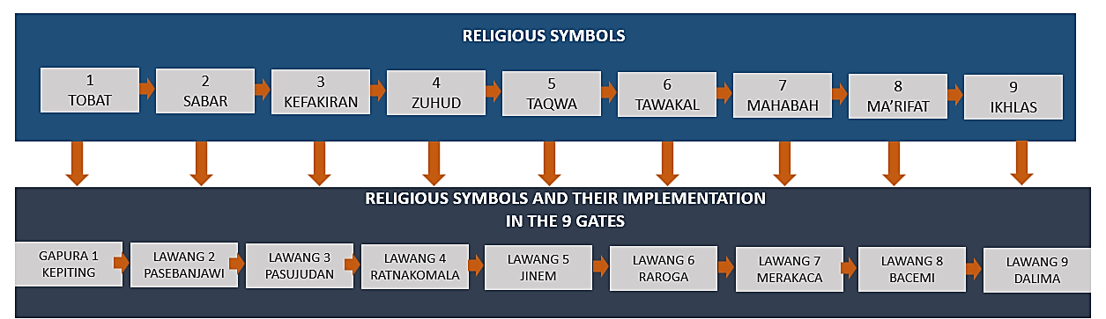
Figure 1. Religious Symbols and Their Stages in the Nine Meaningful Gates

The architectural framework of Astana intricately intertwines with the city's historical and cultural elements, integrating with key landmarks such as the Grand Mosque, Town Square, Sultanate, and Market. This integration forms a cohesive unit within the Catur Gatra system, representing a comprehensive concept that encompasses form, pattern, structure, shape, and unity, alongside its numerical significance. The concept of Dualism in the spatial arrangement of Astana Sunan Gunung Jati symbolizes a dynamic unity between the palace (Sultanate) and Astana, reflecting deeply rooted primordial beliefs. This relationship encompasses fundamental dualities such as material-spiritual, inner-outer, spiritual-physical, salvation-suffering, and life-death, transcending mere architectural placement. The urban landscape of Astana encapsulates these contrasts, showcasing sophisticated interactions between tangible and intangible aspects of existence within its cultural ethos. The spatial sequence of Astana is structured around relationships between the 'Upper World', 'Middle World', and 'Under World', which are manifested in various forms, as shown in Figure 2.

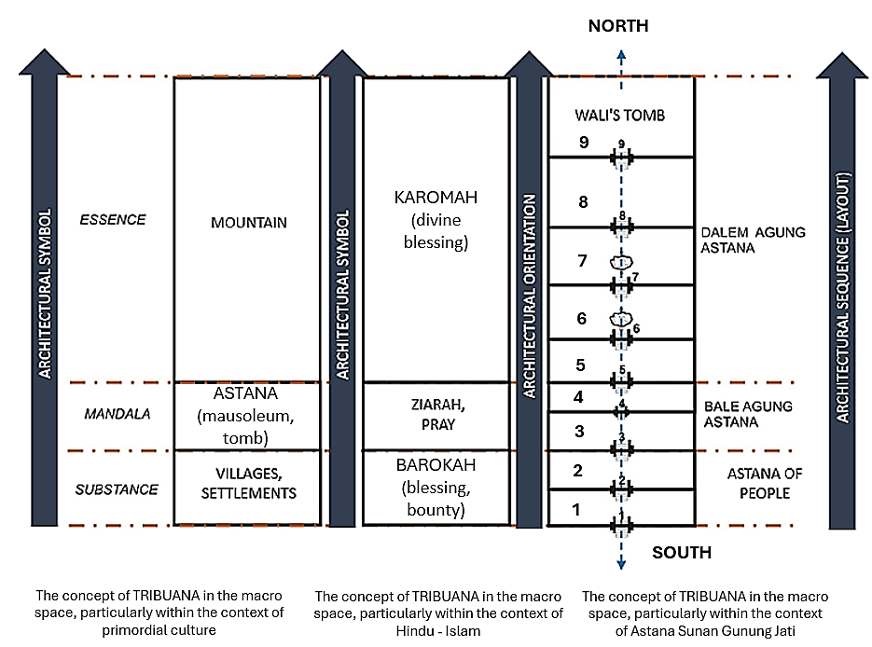
Figure 2. The relationship between the Upper World, Middle World, and Lower World influences the application of Symbols in Spatial Sequences.

  - CULTURAL ADAPTATION TO THE AXIS OF THE ARCHITECTURAL IMAGINARY
The design of the Astana complex harmoniously combines the maritime traditions of the Cirebon people with Hindu-Buddhist culture. The first axis, 'Nyingkur wukir mangadep jaladri' (translated to'Turning one's back to the mountain, facing the sea'), not only physically orients the palace but also symbolically relates to the sea, symbolizing renewal and prosperity for the community. The 'mountains' symbolize cultural, spiritual, and material wealth, forming a sacred crossroads of life's aspects. The second axis follows the Hindu-Buddhist Mandala pattern, facing north to signify timeless philosophical traditions. The strategic placement of the southern gate fosters activities influenced by maritime culture, facilitating interaction between internal life and the outside world. Overall, the North-South axis symbolizes unity and connection across layers of tradition, spirituality, and cultural exchange.

Table 1. Concept of Orientation and Implementation
Concept Of Orientation | Implementation
The first concept is Nyingkur wukir mangadep jaladri. | The North-South orientation (Sea-Mountain) of Astana holds profound significance in the Cirebon community. Facing the sea symbolizes abundant blessings, signifying prosperity, cultural richness, and opportunities. This orientation blends cultural beliefs with spiritual principles, underlining adaptability and rejuvenation.
The second concept, as Giri-Jalanidhi | The Mountain-Sea orientation in Astana represents the convergence of agricultural and maritime cultures in Cirebon. The 'Mountain' symbolizes stability and fertility linked to farming, while the 'Sea' signifies dynamism and cultural exchange. Together, they embody unity and harmony within Cirebon's diverse cultural fabric.
  - CULTURAL ADAPTATION IN VISUALIZING THE NINE GATES OF ASTANA SUNAN GUNUNG JATI

Astana Sunan Gunung Jati Gate presents a rich variety of gate types:
1. Koriagung Gate: Rooted in Hindu-Buddhist traditions, this gate embodies the sanctity of the temple within the Javanese cultural context.
2. Padurekso Gate: Drawing inspiration from the Sufi Islamic concept of 'Gunungan' this gate signifies spiritual exploration.
3. Candi Bentar Gate: A hallmark of Javanese architecture heavily influenced by Hindu-Buddhist culture, serving as a transitional gateway between realms.
4. Lawang Gandek Gate: Reflecting a harmonious fusion of Sundanese, Javanese, and Cirebonese cultures, adorned with the symbolic representations of 'Kala' and 'Makara'.
5. Kori Agung Gate: Adding to the sacred aura of Jinem Agung, this gate, embellished with Kala and Makara symbols, delves into spiritual profundity.

Research findings unequivocally reveal that the gate designs at Astana Sunan Gunung Jati seamlessly integrate influences from Hindu, Buddhist, Islamic, Sundanese, and Javanese cultures. This integration is visualized through the intricate symbolism embodied in the gates, representing the profound connection between humanity and the metaphysical realm.

Table 2. Astana Gates, Types of Doors and Visual Elements
Gate/Gate Type | Visual Elements | Leaf Doors
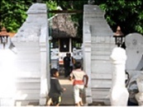  Gate I: GAPURA KEPITING/ Candi Bentar | Ornament: Part of the gate wall. Ceramics: Part of the gate wall. Jug/Jar: At the top of the gate, there is a kendi (a container for holy water). Motif (Liman, Garuda, Makara, Candilaras): The gate is characterized by visual elements, including wing-shaped structures resembling 'gelung' coils, with the Makara motif serving as decoration, and crab motifs at the base. The design of this gate is influenced by the form of Candi Laras (an archaeological site located in the village of Laras, Laras district, Kebumen Regency, Central Java, an ancient Hindu temple complex estimated to date back to the 8th or 9th century AD).
Gate II: LAWANG PASEBANJAWI/ Kori Padureksa  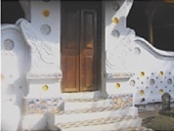 | Ornament: Part of the gate wall, Ceramic: The middle and bottom of the gate, Motif (Liman, Garuda, Makara, Candilaras): This gate features a roof at the top, with the middle portion shaped like wings adorned with the 'lar garuda' motif, the sanga mandala motif, and geometric decorative motifs. In the middle, there are two doors for entry, flanked by five steps on each side. | Padureksa-type door area
Gate III: LAWANG PASUJUDAN/ KRAPYAK/ Kori Padureksa  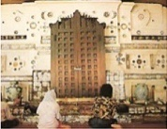 | Ornament: Part of the gate wall, Ceramic: The middle and bottom of the gate, Jug/Jar: At the bottom beside the gate, there is a gentong containing holy water. Motif (Liman, Garuda, Makara, Candilaras): This gate has a roof at its top. Above the roof, there are wings, parallel to which are eye-shaped motifs, sanga mandala motifs, five-mandala motifs, and geometric decorative motifs. In the middle, there are two entrance doors (krapyak doors), each with a set of stairs. | Padureksa-type door area
Gate IV: LAWANG RATNA KOMALA/ Candi Bentar  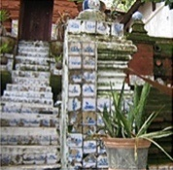 | Ornament: Part of the gate wall, Ceramic: The middle and bottom of the gate, Jug/Jar: At the top of the gate, there is a kendi (a container for holy water). Motif (Liman, Garuda, Makara, Candilaras): This gate has no particular shape. The body is decorated with Chinese porcelain motifs, and there are nine steps.
Gate V: LAWANG JINEM / PANDAN/ Kori Padureksa  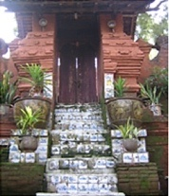 | Ornament: Part of the gate wall, Ceramic: The middle and bottom of the gate, Motif (Liman, Garuda, Makara, Candilaras): This gate has a roof at the top. On the roof, there are wings, a sanga mandala motif, a five mandala motif, and a geometric decorative motif. In the middle, there are two entrances, and the staircase has nine steps. | Padureksa-type door area
Gate VI: LAWANG RARAROGA/  Candi Bentar  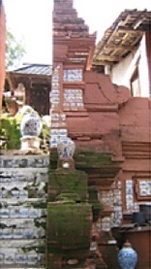 | Ornament: Part of the gate wall, Ceramic: The middle and bottom of the gate, Jug/Jar: At the bottom beside the gate, there is a gentong containing holy water, Motif (Liman, Garuda, Makara, Candilaras): This gate is in the shape of a momentary temple, at the top there is a crown shape, a makarabyuha (sumping) shape with wings, and eight steps. | Padureksa-type door area
Gate VII: LAWANG KACA/ Kori Padureksa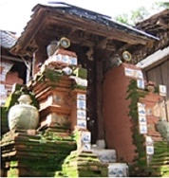 | Ornament: Part of the gate wall, Ceramic: The middle and bottom of the gate, Jug/Jar: At the bottom beside the gate, there is a gentong containing holy water, Motif (Liman, Garuda, Makara, Candilaras): This gate has no particular shape; The body is decorated with Chinese porcelain motifs, and there are nine steps. | The door area has gunungan (mountain) motifs and single doors.
Gate VIII:  LAWANG BACEM/ Kori Agung Padureksa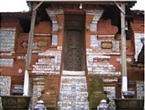 | Ornament: Part of the gate wall, Ceramic: The middle and bottom of the gate, Jug/Jar: At the top of the gate, there is a kendi (a container for holy water), Motif (Liman, Garuda, Makara, Candilaras): This gate has a roof at the top. Under the roof, there are wings, five mandala motifs, white stone reliefs, patterned Chinese parcels, and geometric decorative motifs. In the middle, there are two entrances and two stairs, each with two steps and seven steps. | Padureksa-type door area
Gate IX:  LAWANG TERATAI; DELIMA/ Kori Padureksa Dalem Agung  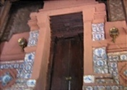 | Ornament: Part of the gate wall, Ceramic: The middle and bottom of the gate, Motif (Liman, Garuda, Makara, Candilaras): This gate has a roof at the top. At the bottom of the roof, there are wings, a kala motif, a tumpal motif, a five-mandala motif, and a sanga mandala motif. In the middle, there are two entrances and one staircase with five steps. | Padureksa-type door area, and teratai motif (lotus)

The layout of Astana Sunan Gunung Jati uses the Sanga Mandala principle, which is arranged through nine gates arranged hierarchically. The spatial concept is created in the zoning system as follows:
- The First Tri Mandala (Upper Mandala Zone) divides space into three zones: middle (sacred), middle (ordinary), and lower (profane).
- The Second Tri Mandala (Central Mandala Zone) forms a spatial arrangement that contributes to overall harmonization.
- The Third Tri Mandala (Lower Mandala Zone) completes the Sanga Mandala concept.

The arrangement of Lawang Sanga and its architectural layout are shown in Figure 3.

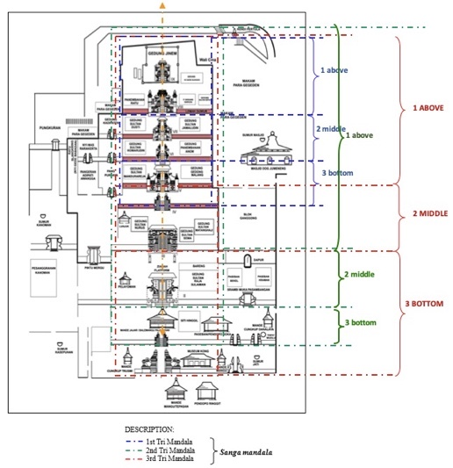
Figure 3. Architectural Sequence and Stages of the Nine Gates in Astana Sunan Gunung Jati

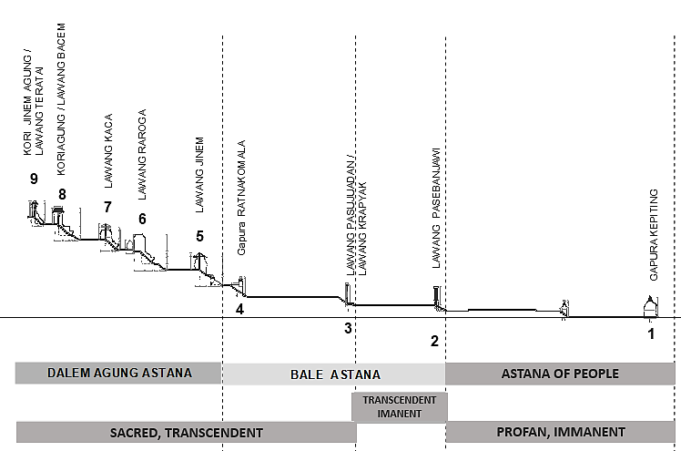
Figure 4. Implementation of Punden Berundak (terraced architecture) in the Architectural Layout of Astana Sunan Gunung Jati

  - VISUAL ANALYSIS OF THE NINE GATES OF ASTANA SUNAN GUNUNG JATI
To analyze the aesthetics of the gates, Table 2 presents the visual forms of the first through ninth gates as follows:

- 1. FIRST GATE: GAPURA KEPITING (CRAB GATE)
To enter the Astana complex area, one must first pass through the initial gate, as depicted in Figure 5:

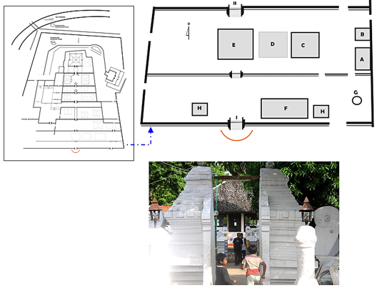
Figure 5. Part of the First Gate Courtyard: Gapura Kepiting / Makarabyuha

Notes:
- Padasan (a place for ablution/purification)
- Mande Danalaya Cupola
- Paseban Soko is a place where deliberation is held.
- Siti Hinggil (no longer available as Siti Hinggil due to being filled with graves)
- Balemangu Pajajaran is a large pavilion gifted by Prabu Siliwangi as a sign of appreciation during his coronation.
- Gedong Jimat/Museum Kong serves as the storage for ancient Chinese Jars from various dynasties.
- Sumur Jati, one of the sacred wells in the sequence of “semur pitu” (seven wells).
- Balemangu Trusmi is a small pavilion that the people of Trusmi Village have repaired; Guard Post Pavilion.

In the gateway courtyard, two teakwood structures stand: one in the rectangular Balemangu style, influenced by the terraced Bale architecture of the Demak Kingdom, and the other, a Majapahit-inspired Balemangu, presented as a wedding gift to Sunan Gunung Jati and Nyi Mas Tepasari. Positioned before the Crab Gate is the Kalinga, characterized by its Lingga-Yoni-derived form.

- 2. GATE SHAPE STRUCTURE
The Kepiting Gate, as illustrated in Figure 6, carries profound significance for several reasons. Firstly, its name, derived from "ghafuro," denotes forgiveness. Secondly, in Javanese culture, the term "crab" or "piting" (meaning "grasping" or "clutching") conveys the notion of a firm grasp, symbolizing resilience and determination. Thirdly, the crab represents the various stages of life, emphasizing the importance of continuous repentance, as echoed in the Javanese proverb "menunga iku wis kepithing issue".

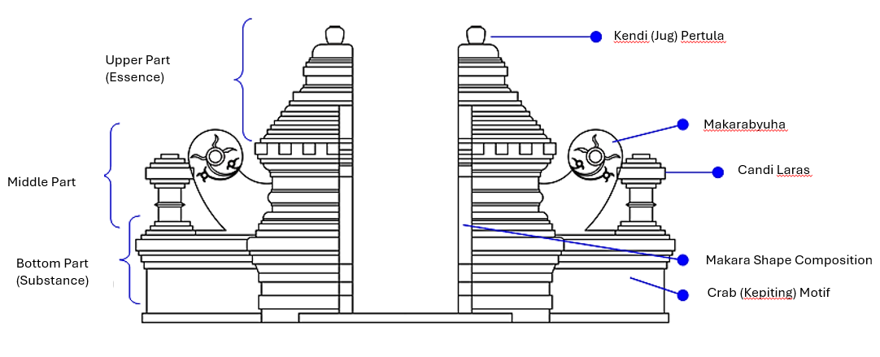
Figure 6. Gate I Type: Candi Bentar Gate - Crab Gate (Schematic diagram, non-scale)

This gate embodies the essence of "repentance (taubat)", encouraging deep introspection and unwavering devotion amidst life's tribulations. The pristine white walls, known as "bajralepa”, likely symbolize purity or serve as a blank canvas for introspection and self-reflection within repentance. Another specificity of the Crab Gate includes:
- Kalinga, symbolizing glorification and fertility, originates from the Kalinga Kingdom, featuring the Lingga-Yoni form in Hindu and Buddhist beliefs.
- Pitchers arranged atop the gate resemble the Lingga-yoni imagery representing Lord Shiva and Parvati, emphasizing fertility.
- Fertility symbolism is depicted at the crab gate with a shorter yoni statue and a taller lingga statue placed higher.
- A tall pole lamp named 'damarsela' symbolizes enlightenment.
- Kendi Pertula, a traditional Javanese water container, symbolizes profound wisdom, often representing knowledge acquired from wise and esteemed sources. Sapodilla trees on either side of the gate symbolize continuous effort and virtuous deeds.

- 3. SECOND GATE: LAWANG PASEBANJAWI
To enter the courtyard area beyond the second gate (figure 7), visitors must pass through the Lawang Pasebanjawi gate. Within the courtyard area stands the Pelayonan building (F), a structure dedicated to prayers for the souls of the palace family members. Additionally, located in this area is the tomb of Sultan Raja Sulaiman (E).

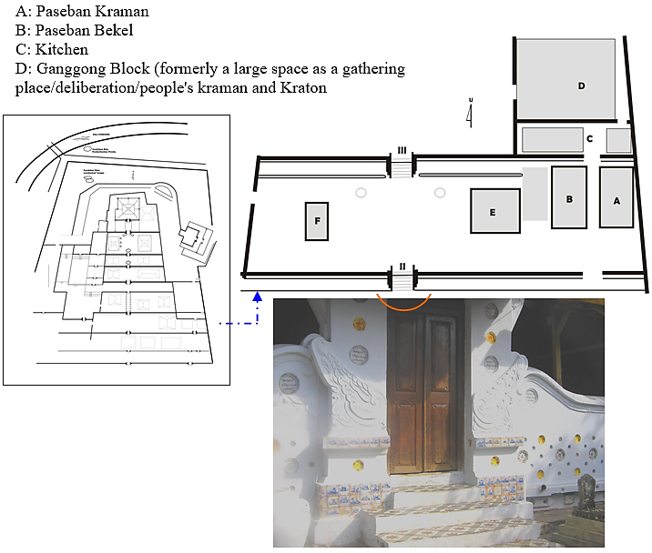

Figure 7. Part of the Second Gate Courtyard: Gerbang Pasebanjawi

- 4. GATE SHAPE STRUCTURE
The visual form of this gate features a wooden roof with shingles, characteristic of the Padurekso type (Figure 8). At the center of the gate, an eagle wing motif represents the intermediary world. Named Pasebanjawai (Paseban, seba=sowan; facing; njawi=outside), it comprises the Paseban bekel and Paseban kraman rooms at the front, leading to the public space (Pasujudan room), where the pilgrimage tradition (praying together) takes place. Serving as the 2nd gate, Pasebanjawi acts as an intermediary between profane and sacred areas. Essentially, individuals face choices between good and bad, or right and wrong, in the world. As an intermediary space, it symbolizes qualities every human should possess: patience and introspection.

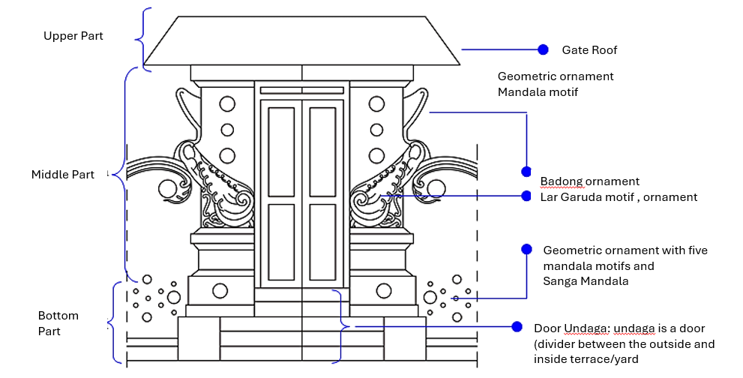
Figure 8. Gate II Gate Type: Padureksa Gate - Lawang Pasebanjawi Non-scaled schematic diagram
- 5. THIRD GATE: LAWANG PASUJUDAN
Entering the third courtyard area, pass Lawang Pasujudan (figure 9), inside which there is a building called Karas or Ljuk (the resting place for the royal family after climbing to the Astana complex). In the third gate area, there are three tomb complexes: (27) Sultan Nurbuat's tomb complex and (28) Sultan Sena Moh's tomb complex. Jamiuddin Tomb Complex, and (29) Sultan Syaifuddin Matangaji Tomb Complex.

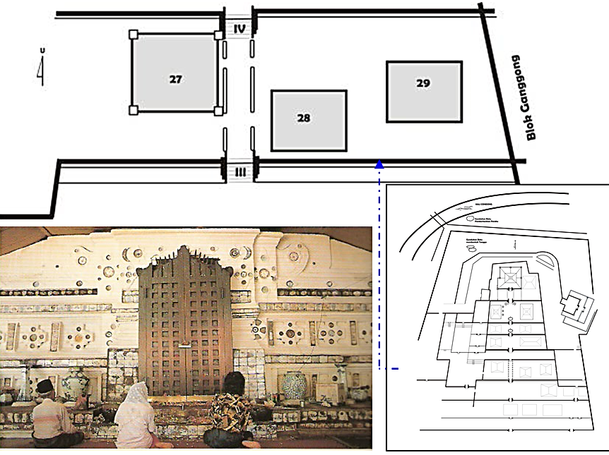
Figure 9. Part of the Third Gate Courtyard: Lawang Pasujudan

- 6. Gate Shape Structure
The Pasujudan (worship) Gate (Figure 10), also known as Lawang Krapyak (fence or barrier), symbolizes the spiritual practice of "manembah," which integrates worship from Hindu, Islamic, and Javanese spiritual traditions [28]. This gate embodies the Koriagung style, characterized by its symmetrical design on both sides and decorated with various ornaments, such as eye motifs, marakabyuha (crocodile-like war position), Sanga mandala (nine mandalas), and mandala Lima (five mandalas).

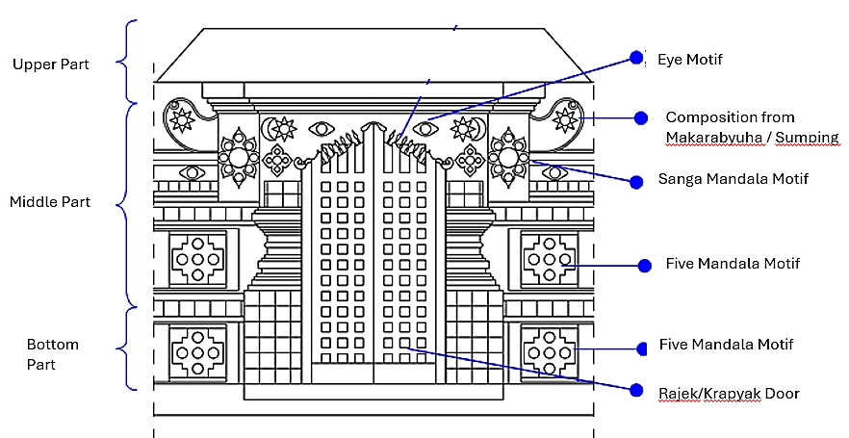
Figure 10. Gate III Gate Type: Lawang Pasujudan Non-scaled schematic diagram

The gate features a teak wood construction roof covered with tiles. Its door leaf showcases geometric decorations consisting of eight vertical wooden strips, symbolizing Hastabrata, which represents behavior or character. This design not only enhances aesthetics but also carries a cultural message regarding the character traits expected of a leader, reflecting the values encapsulated in the symbolism of the number eight (Hastabrata).

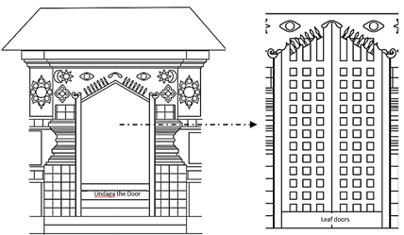
Figure 11. Pasujudan Grand Kori Door and Undaga Door at the Third Gate

The door, as illustrated in Figure 11, is adorned with square-shaped holes totaling 36, symbolically representing the foundational elements of Islam, including the Pillars of Islam (Rukun Islam=5), Pillars of Faith (Rukun Iman=6), and the collective number of Prophets and Apostles (5 + 6 + 25 = 36). Both sides of the door feature a total of 72 square holes, derived from 36 on the left side and 36 on the right side. When the number 72 is separated into 7 and 2, the sum of 9 (representing the Wali Sanga) is obtained. The Wali Sanga consists of 7 Wali characterized by their Islamic Kaffah (puristic) character and 2 Wali distinguished by their strong Islamic identity with their local cultural identity (utilizing a cultural approach in preaching). Additionally, the number 72 signifies Islam being divided into 72 different groups. Thus, the door's design not only honors the basic principles of Islam but also conveys a deeper narrative, intertwining spirituality, culture, and forward-looking perspectives.

- 7. Fourth Gate: Lawang Gandek Ratna Komala
Entering the fourth gate area of ​​Lawang Ratnakomala (figure 12), there is a courtyard with no shelter. To the west of the courtyard lies the tomb complex of Adipati Awangga (Arya Kemuning).

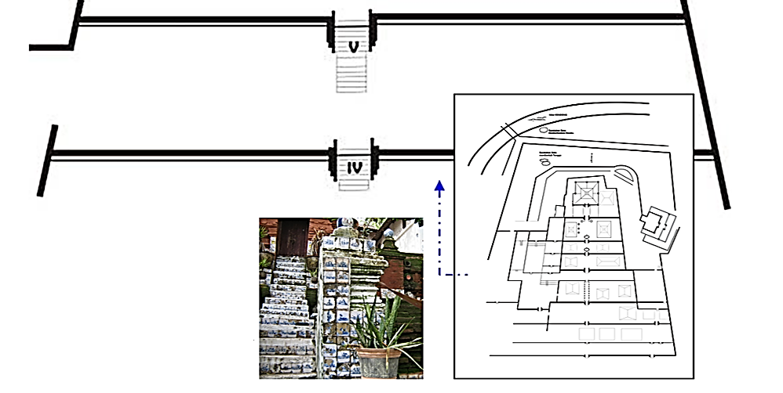
Figure 12. Part of the Fourth Gate Courtyard: Lawang Pasujudan

- 8. Gate Shape Structure
The fourth gate, Lawang Ratnakomala (Ratna=diamond, Komala=smooth, soft), serves as the boundary between the Astana Bale Agung and Astana Jinem Agung areas (figure 13). This gate holds significant importance as it connects Pesanggrahan Kanoman, Bale Ganggong, and the Astana Mosque. Unlike the gates found in other types of Bentar temples, the Ratnakomala gate is relatively smaller. After passing through the preceding three gates, there is a symbolic area representing 'asceticism' or a 'hermitage' called 'Zuhud' (avoidance of excess, characterized by gentleness in behavior). This area marks an important phase, indicating that world affairs should be approached with care, advocating for harmony with nature and the environment. The process of passing through the Ratnakomala gate symbolically guides individuals to embody the principles of harmony and care for the surrounding world.

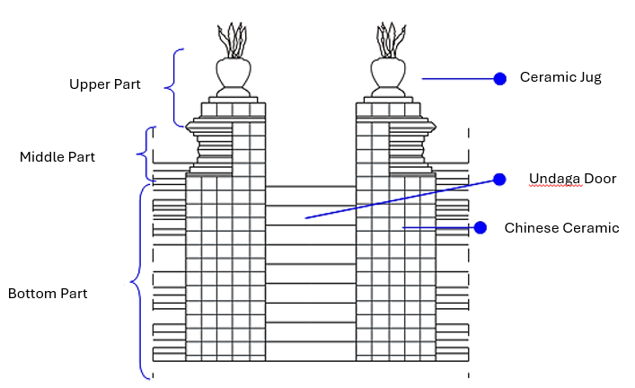
Figure 13. Gate IV Gate Type: Lawang Ratnakomala Non-scaled schematic diagram

- 9. Fifth Gate: Lawang Jinem
To enter the fifth gate courtyard area, one must pass through Lawang Jinem (figure 14), where two tomb complexes are located: the Tomb of Sultan Mandurareja (25) and the Tomb of Sultan Moh. Tajul Arifin (23).

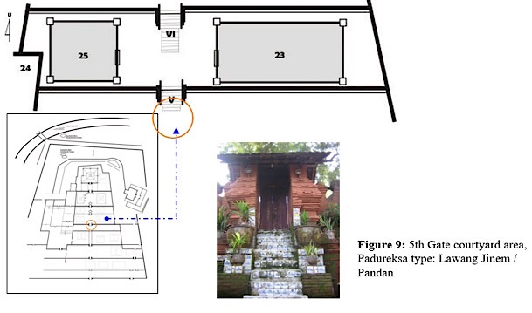
Figure 14. Part of the Fifth Gate Courtyard: Lawang Jinem

- 10. Gate Shape Structure
The gate, resembling Candi Bentar, features a wooden roof covered with shingles. In the center, there is a door, hence it is named "padurekso" ('padu' = unified; together. ’raksa’ = to cover, protect, and preserve). The gate structure is made using red brick material. In the middle, there is a makarabyuha motif on the left and right sides, symbolizing the middle world. At the base of the gate, there is an "undaga door" decorated with a mandala motif. "Lawang Jinem" (meaning "inner room"; sentong = hidden, and jinem = siji kang in gunem), illustrated in Figure 15, serves as the first grand gate leading to the Astana Dalem Agung area, showcasing a consistent style from the fifth to the ninth gates.

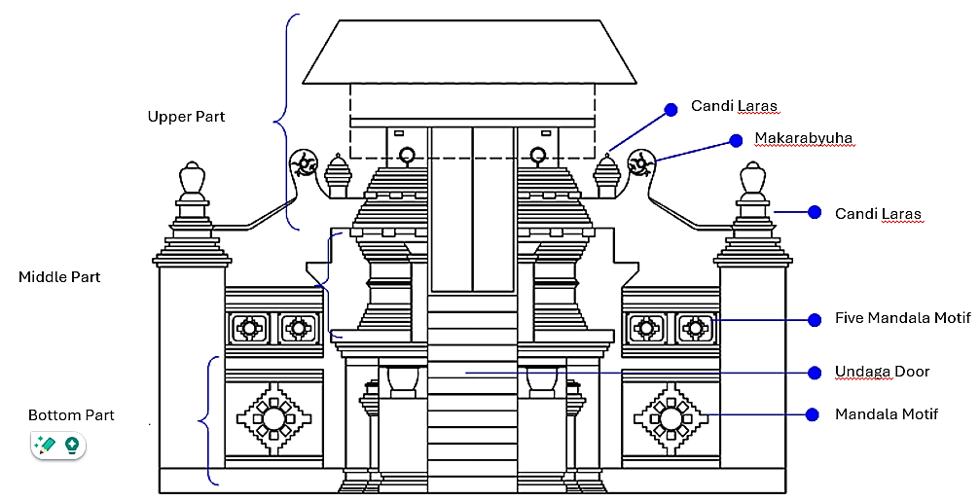
Figure 15. Gate V Gate Type: Lawang Jinem/ Pandan Non-scaled schematic diagram
- 11. Sixth Gate: Lawang Rararoga
At the sixth gate courtyard (Lawang Rararoga), there is a courtyard containing three tomb complexes: (21) the tomb of Nyi Mas Rarakerta, (22) the tomb of Sultan Moh. Komarudin, and (23) the tomb of Panembahan Anom Ratu Sesangkan. The layout of the Lawang Rararoga gate courtyard is illustrated in Figure 17.

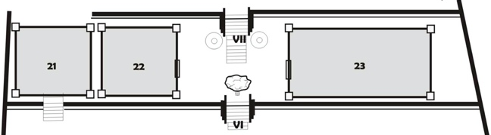
Figure 17. Part of the Sixth Gate Courtyard: Lawang Rararoga

- 12. Gate Shape Structure
The sixth gate is Lawang Rararoga (rara = girl; roga = sick), with a supporting component of selokelir (an entrance gate without a door). Lawang Rararoga, as shown in Figure 18, symbolizes the attitude of tawakal (belief in the six components of the Pillars of Faith in Islam: faith in Allah SWT, Angels, the Holy Qur'an, Rasulallah, the Day of Judgment, and Qodlo/good destiny). Tawakal represents gentle, cautious, caring, and self-aware behavior.

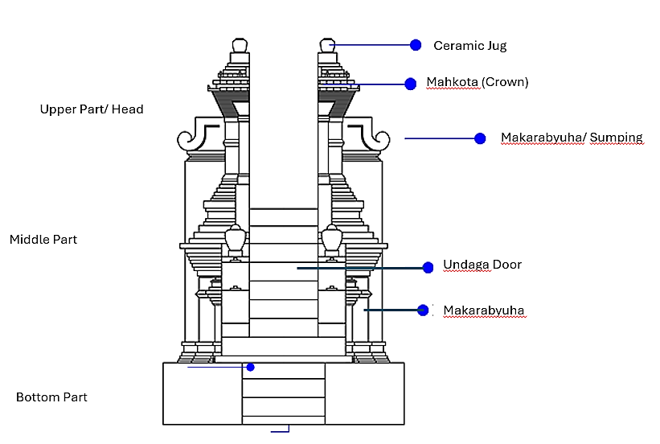
Figure 18. Gate VI Gate Type: Lawang Rararoga Non-scaled schematic diagram

- 13. Seventh Gate: Lawang Kaca
Upon entering the area of the seventh gate (Lawang Kaca), there is a courtyard featuring three tomb complexes: (18) the tomb of Adipati Anom Carbon or Prince Mas, (19) the tomb of Sultan Moh. Badridin, and (20) the tomb of Sultan Jamaludin (figure 19).

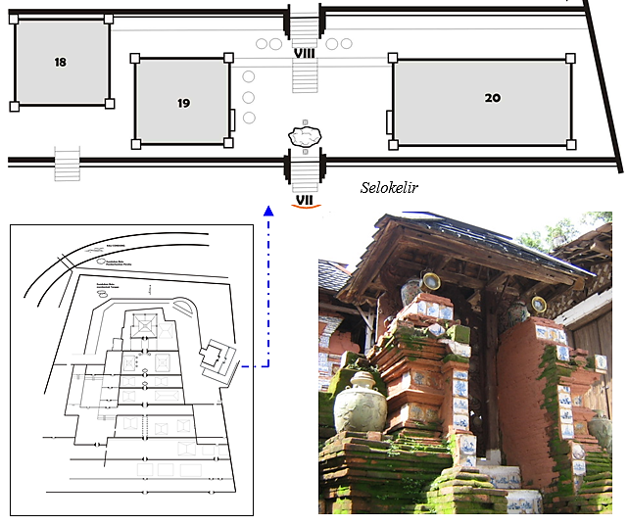
Figure 19. Part of the Seventh Gate Courtyard: Lawang Kaca

- 14. Gate Shape Structure
The seventh gate, illustrated in Figure 20, Lawang Kaca, resembles a Candi Bentar, with the addition of a roof and a door akin to those of a temple. Functioning as Padureksa, its door is intricately crafted from wood, with floral motifs reflected on the mirror glass installed above it. Lawang Kaca symbolizes 'Mahabah' (love for Allah SWT), representing obedience, surrender, and devotion to Allah SWT. The gate, as the seventh in the order, symbolizes passing through seven paths known as 'Sapta Wiwara Wirid' (Sapta = seven; Wiwara = paths; Wirid = contemplation of the Divine).

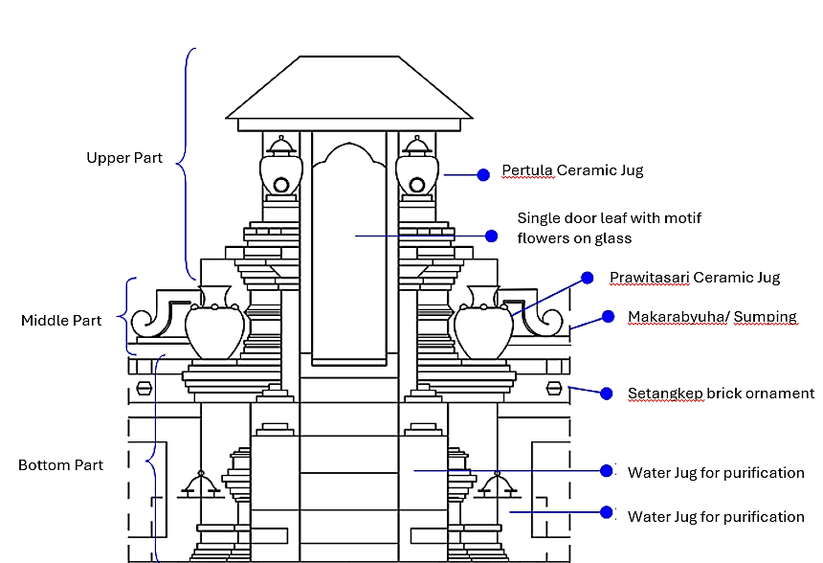

Figure 20. Gate VIIGate Type: Lawang Kaca Non-scaled schematic diagram

E.15. Eight Gate: Lawang Bacem
In the eighth gate area of significance, Lawang Bacem (figure 21), there is a courtyard containing six tombs: the tomb of Prince Cakrabuana (6), the tomb of Nyi Ong Tien, the wife of Sunan Gunung Jati from China (7), the tomb complex of Sultan Panembahan Ratu (13), the tomb of Adipati Keling (14), the tomb complex of Prince Sindang Garuda (15), the tomb complex of Sultan Raja Syamsuddin, Sultan Sepuh I (16), and the tomb complex of Ki Gede Bungko (17).

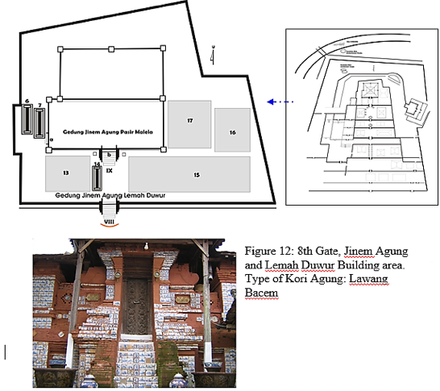

Figure 21. Part of the Eighth Gate Courtyard: Lawang Bacem
E.16. Gate Shape Structure
The eighth gate, Lawang Bacem, also known as Koriagung, signifies a sacred and enclosed space (figure 21). 'Kori' refers to a gate or entrance, while 'Agung' means grand or sacred. Kori Agung thus denotes a grand gate often found within Hindu temple complexes. In its center, there are two small carved teak wood doors (depicting the tree of life motif) with a 'bacem' finish and white stone reliefs adorned with Wadasan and Pandan leaf motifs. The gate structure is crafted from red bricks, with a rectangular roof made from stacked red bricks. Simplified Makara motifs adorn both sides, resembling designs found at historic sites such as the Sunan Kudus Mosque and Tomb Complex and the Plumbangan Temple. This gate symbolizes 'Makrifat', an Arabic term meaning 'arafa, ya'rifu, 'irfan, ma'rifah', signifying knowledge or recognition. 'Makrifat' also implies knowing something as it truly is or knowledge that no longer harbors doubt [24]. Lawang Bacem, with its symbolic representation of 'makrifat', embodies the second-highest level of Sufi teachings, representing the essence of knowledge and self-control towards life's perfection, following the concept of Dewaraja, where leaders adhere to the teachings of Hastabrata.

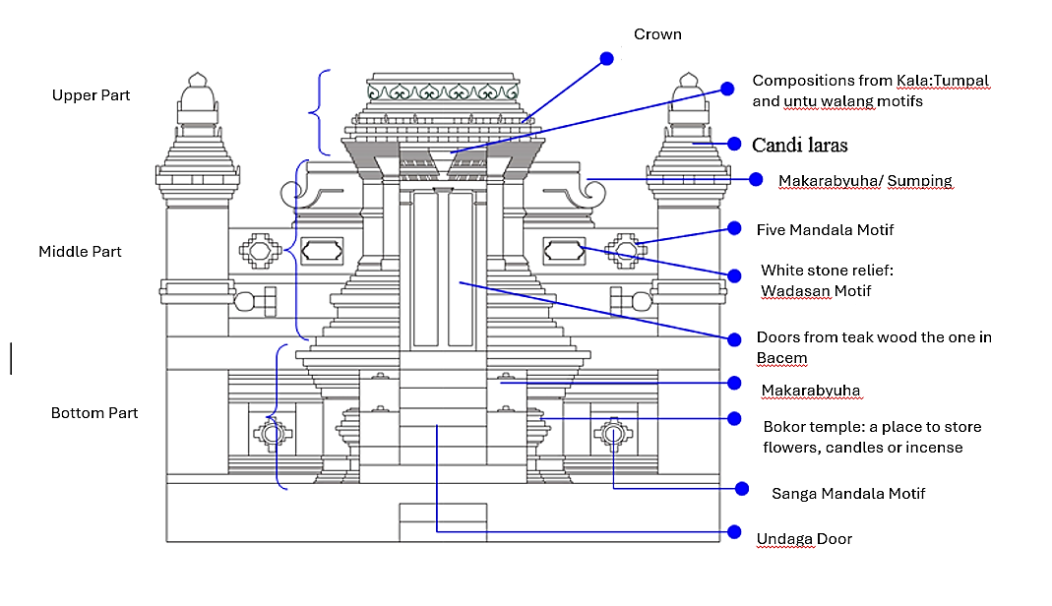
Figure 22. Gate VIII Gate Type: Lawang Bacem Non-scaled schematic diagram

E.17. Ninth Gate: Lawang Delima
The ninth gate, Lawang Teratai or Dalima, as illustrated in figure 23, leads to the Sunan Gunung Jati Tomb Complex, which comprises ten family tombs of the Pakungwati Palace, each holding significant historical importance: Tomb of Sunan Gunung Jati: The final resting place of Sunan Gunung Jati, Tomb of Tubagus Pasai Fattahillah (Fattahillah), Tomb of Syarifah Muda'im (Nyi Mas Rara Santang), Tomb of Nyi Gedeng Sembung (Nyi Quraisyin), Tomb of Nyi Mas Tepasari, Tomb of Prince Dipati Carbon I (Prince Swarga), Tomb of Prince Jakalelana, Tomb of Prince Pasarean, Tomb of Queen Mas Life, Tomb of Prince Sendang Lemper. This sacred complex serves as a guardian of the history and heritage of the Pakungwati Palace, significantly influencing the cultural development of Cirebon.

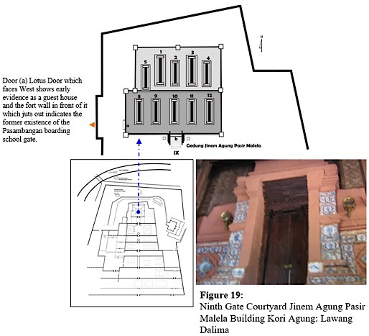

Figure 23. Part of the Ninth Gate Courtyard: Lawang Delima
E.18. Gate Shape Structure
The ninth gate, Lawang Delima (figure 24), adorned with similar decorative elements as the eighth gate, holds a paramount position as the highest-stepped punden within the Astana complex. It stands approximately ±15.63 meters higher than the floor level of the first gate. Constructed from red bricks using the "rubbing" technique, the gate features two teakwood doors at its center, devoid of carvings. At the top, a crown ornament adorns the rectangular roof with a stacking pattern. Functioning as a crucial divider leading to the sacred space, this Kori Agung-type gate is guarded to restrict access to visitors seeking pilgrimage (requiring special permission from the authorities). On both sides, simplified Makara motifs are present, inspired by the original Makara forms found in Hindu-Buddhist temples (Makara is a legendary creature in Hindu mythology often depicted in the art of South and Southeast Asia. Makara is associated with water and is depicted as the vehicle of the gods Varuna and Ganga). The simplification of the Makara motifs adheres to the Islamic teachings of that era, which prohibit depicting living creatures. Lawang Delima symbolizes the highest level of Sufism, 'Ikhlas' or sincerity, signifying the purity of the heart and the hope for Allah's approval (as stated in Surah Al-Ikhlas, also known as Surah at-Tauhid in Arabic, which discusses the concept of the Oneness and Unity of Allah).

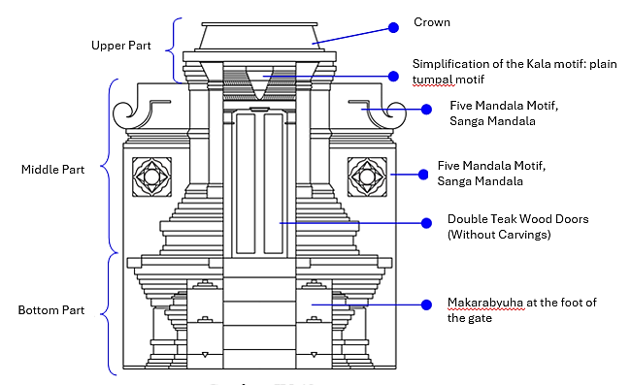

Figure 24. Gate IX Gate Type: Lawang Teratai Non-scaled schematic diagram

E.19. THE SYMBOLIC MEANING OF THE NINE GATES IN THE CONTEXT OF JAVANESE ISLAMIC MYSTICISM
In the context of Javanese Islamic Mysticism, the significance of the Nine Gates, as revealed through research findings, pertains to spiritual experiences in life. Mysticism entails realizing personal enlightenment, guidance, and the path toward spiritual unity with Allah SWT. Mastery in mystical pursuits involves various stages towards union with the Divine.
The division of space within the Astana into nine main gates represents the evolution of the concept of 'wahdatul wujud' ('wahdah', meaning unity, and 'al-wujud', meaning existence, also signifying the unity of existence), in Sufi doctrine referred to as 'wirid babagan kang nawa sanga' ('wirid' being the performance of specific recitations to attain enlightenment from God). This doctrine, passed down by revered saints, is known to the Cirebonese community as "makrifatulinsan warabrata kang nawadwara" (understanding humanity that comprehends the significance of the nine openings). During the reign of Panembahan Ratu Pakungwati I, these principles were immortalized through the nine main gates of Lawang Sanga, serving as the conceptual axis of the Astana Sunan Gunung Jati, a sacred site for ritual practices. These rituals aim for introspection, understanding one's existential role, and comprehending the essence and purpose of life.
The nine gates represent the concept of nine stages as a unified whole, based on the evolution of spiritual teachings at Pesanggrahan Giri Nur Sapta Rengga, symbolized by the ritual of hidayat jati, "nggayuh kasampurnaning dumadi wahana memepi babagan kang nawadwara" (striving for spiritual perfection to reach the point of origin, amidst the realm of the nine apertures). The symbolic journey through these rituals is depicted through nine spiritual stages, originating from the teachings of Wahdatul Wujud [30] (explained by Imam Al-Ghazali and propagated by Sufi figures in Aceh and Java) [31], [32]. Thus, the symbolism embodied by the number nine at the Nine Gates of Astana Sunan Gunung Jati encapsulates the profound philosophical essence of wahdatul-wujud teachings at Pesanggrahan Giri Nur Sapta Rengga. These nine primary gates converge as an abstract axis, embodying the unity inherent in the teachings of Islamic Sufism as imparted by the saints (Wali).

- CONCLUSION
The purpose of this research is to describe one of the masterpieces of Islamic cultural products at Astana Sunan Gunung Jati and to understand the adaptation process that occurred during its construction. The conclusions are as follows:
- Astana Sunan Gunung Jati is a pyramid-shaped building divided into nine distinct areas, with each gate marking the transition of Wali's spiritual journey, guided by an imaginary axis from South to North. The overall architectural design of Astana follows the stages and sequences of the Wali's spiritual journey. Its visual concept ranges from the worldly (the first gate) to the most sacred (the ninth gate). The visual idea of these nine gates can be observed through architectural features such as Koriagung, Padurekso, Candi Bentar, and Lawang Gandek, which blend elements from various cultures. Three symbolic spaces representing Humanity (karomah), Astana (pilgrimage), and the Wali's Tomb (blessings) are embodied through the concepts of Settlement, Astana, and Tomb.
- The architectural complexity of Astana Sunan Gunung Jati is evident in the visual elements and ornaments of each gate, which are a fusion of diverse cultures, combining eclectic elements while adhering to Islamic principles that prohibit the representation of living beings. The blend of Sundanese, Javanese, Hindu, Buddhist, and Islamic elements symbolizes the spiritual journey from immanence to transcendence in Islamic mysticism (the unity between man and God). Similar transformative changes, previously found in Hinduism, transition from the human realm to the transcendent realm through stages such as Advaita, Ansha, Avatar, Aradhana, and Pratistha [33].
- In the context of acculturation, Berry's theoretical approach to cross-cultural psychology and cultural adaptation emphasizes two main dimensions: maintaining the original culture and interacting with a new culture, resulting in four adaptation strategies: assimilation, separation, integration, and marginalization [13]. The eclectic architectural pattern in Astana Sunan Gunung Jati enriches Berry's theory by adopting a pluralistic or multicultural approach. The broader cultural adaptation process encompasses general theories that highlight human efforts to adapt to their environment, incorporating biological, social, and cultural aspects. Lazarus and Folkman's Stress and Coping Model, in the context of cross-cultural psychology, examines how individuals assess and respond to stress within their environment. The design of Astana Sunan Gunung Jati responds to cultural tension through a communication approach that incorporates an Islamic aura, where architecture not only forms physical regulations but also internalizes meaning, symbols, and significance. This model represents the unique local wisdom of Islamic renewal in Cirebon, which was not found elsewhere in Indonesia at that time.
- The relevance and sustainability of the Astana Sunan Gunung Jati design, amid cultural and social value changes during the reign of Sunan Gunung Jati from 1479 to 1568 AD, demonstrate an extraordinary capacity for long-term planning and cultural adaptation within the design. The ability to incorporate various visual elements into its design and reflect its influences in ways that not only preserve the original culture but also develop a cultural identity for progress at that time. These findings can be an important knowledge model in supporting efforts to preserve and sustain Astana Gunung Jati as a cultural heritage. This knowledge model can also serve as an initial framework for involving stakeholders in formulating preservation policy directions, while considering risk management aspects and their development in the context of tourism.

ACKNOWLEDGEMENT
We extend our gratitude to the Bandung Institute of Technology for facilitating this research project.

REFERENCES

[1] A. Afghoni, "Makna Filosofis Tradisi Syawalan (Penelitian Pad[a Tradisi Syawalan di Makam Gunung Jati Cirebon)", J-SAM, vol. 13, no. 1, p. 48, Jun. 2017, doi: 10.23971/jsam.v13i1.549.
[2] A. G. Muhaimin, The Islamic Traditions of Cirebon: Ibadat and Adat Among Javanese Muslims. Canberra: ANU E Press, 1995.
[3] I. H. Agustina, H. Hindersah, I. Chofyan, K. A. Sevila, and C. Matondang, "Intangible heritage in Astana Gunungjati Tomb Complex, Cirebon", Jur. Reg. Jur. Pemb. Wil. dan Perenc. Part., vol. 19, no. 1, p. 55, Jan. 2024, doi: 10.20961/region.v19i1.60310.
[4] I. H. Agustina, H. Hindersah, and I. Chofyan, "Study of the Astana Gunung Jati Heritage Tomb, Cirebon, Indonesia", the 4th Social and Humanities Research Symposium (SoRes 2021), Bandung, Indonesia, 2022. doi: 10.2991/assehr.k.220407.072.

[5] D. Supardi, N. Karlina, H. Bekti, and E. Susanti, "Agile Governance Through Public Private Partnership: The Sunan Gunung Jati Tomb as a Religious Tourism Hub", KSS, Oct. 2023, doi: 10.18502/kss.v8i17.14117.
[6] F. Abdillah, I. Santosa, Y. Y. Sunarya, and H. Hendriyana, "Utlizing Ancient Manuscripts in Making Gates and Branding Cities: Design of the New Gate of Cirebon Indonesia", ISVS e-journal, vol. 11, no. 1, pp. 1–18, 2024, doi: https://doi.org/10.61275/ISVSej-2024-11-01-24.
[7] Khairudin, Filsafat Kota Yogyakarta. Yogyakarta: Penerbit Liberti, 1995.
[8] Y. Sumardjo, Arkeologi Budaya Indonesia. Yogyakarta: Penerbit Kalam, 2002.
[9] Muhaimin AG, Islam dalam bingkai Budaya Lokal potret dari Cirebon. Jakarta: Penerbit Kogos Wacana Ilmu, 2001.
[10] G. Assilmi, "The Concept of The Devaraja In Leadership At The Royal Palace of Yogyakarta", irhs, vol. 9, no. 1, Jan. 2024, doi: 10.7454/irhs.v9i1.1285.
[11] P. J. Zoetmulder, Manunggaling Kawula Gusti. Jakarta: Penerbit Gramedia, 1990.
[12] C. Ward, S. Bochner, and A. Furnham, Psychology Culture Shock. Routledge, 2020.
[13] J. W. Berry, Cross-Cultural Psychology: Research and Applications. Cambridge University Press, 2002.
[14] J. W. Berry, Theories and Models of Acculturation, vol. 1. Oxford University Press, 2017. doi: 10.1093/oxfordhb/9780190215217.013.2.
[15] N. Cooper, E. Brady, H. Steen, and R. Bryce, "Aesthetic and spiritual values of ecosystems: Recognising the ontological and axiological plurality of cultural ecosystem 'services'", Ecosystem Services, vol. 21, pp. 218–229, Oct. 2016, doi: 10.1016/j.ecoser.2016.07.014.
[16] M. Kuipers and W. de Jonge, Designing from Heritage: Strategies for Conservation and Conversion. TU Delft, 2017.
[17] L. N. Groat and D. Wang, Architectural Research Methods. John Wiley & Sons, 2013.
[18] B. Suryomurtomo, Tata Kota Berbasis Kearifan Lokal. Yogyakarta: Penerbit Ombak, 2010.
[19] Danisworo, Filsafat Bangunan dan Tata Kota Tradisional Nusantara. Sleman: Kanisius, 1995.
[20] L. Frankel and M. Racine, "The Complex Field of Research: for Design, through Design, and about Design", the Design and Complexity - DRS International Conference 2010, 7-9 July, Montreal, Canada. https://dl.designresearchsociety.org/drs-conference-papers/drs2010/researchpapers/43, D. Durling, R. Bousbaci, L. Chen, P. Gauthier, T. Poldma, S. Roworth-Stokes, and E. Stolterman, Eds., Montreal, Canada: Design Research Society, 2010.
[21] D. Seamon, "A Way of Seeing People and Place: Phenomenology in Environment-Behavior Research", in Theoretical Perspectives in Environment-Behavior Research, S. Wapner, J. Demick, T. Yamamoto, and H. Minami, Eds., Boston, MA: Springer US, 2000, pp. 157–178. doi: 10.1007/978-1-4615-4701-3_13.
[22] K. Havik, "Writing atmospheres", in The Routledge Companion on Architecture, Literature and The City, 1st ed., J. Charley, Ed., Abingdon, Oxon; New York, NY: Routledge, 2018.: Routledge, 2018, pp. 270–282. doi: 10.4324/9781315613154-17.
[23] C. Geertz, The Religion of Java. University of Chicago Press, 1976.
[24] S. A. Munandar, M. Mursalat, and E. Malikhaturrahmah, "Pemaknaan Makrifat oleh Para Sufi dari Zaman ke Zaman", J.Kaca, vol. 11, no. 1, pp. 1–29, Feb. 2021, doi: 10.36781/kaca.v11i1.3176.
[25] A. Wahyudi, Ngelmu sangkan paran untuk memaknai ajaran Syekh Siti Jenar. Lingkaran, 2009.
[26] J. A. A. Khan, "The Infinite Space Manifestation of bindu and mandala in architecture", School of Architecture and Design College of Design and Social Context RMIT University, Melbourne, 2017.
[27] A. H. Tsabit and S. P. Eni, Arsitektur Kuno Kerajaan-kerajaan Jawa Timur (Kediri, Singasari, dan Majapahit) di Indonesia. PT. RajaGrafindo Persada - Rajawali Pers, 2023.
[28] R. S. Widjayanti, "PERBANDINGAN SHALAT DAN LAKU MANEMBAH ALIRAN KEBATINAN PANGESTU DAN SUMARAH", Jurnal Studia Insania, vol. 3, no. 1, p. 63, Apr. 2015, doi: 10.18592/jsi.v3i1.1104.
[29] A. Dzikran, Hasta Brata: Classic Javanese Symbolic, Spiritual, and Ethical Leadership Teaching. Amazon Digital Services LLC - Kdp, 2016.
[30] M. N. Jabir, Samudra Wahdatul Wujud: Ibnu ’Arabi dan Mulla Sadra. IRCISOD, 2022.
[31] M. Kurdi, Fikrah Ulama Aceh : kontribusi karya pengkajian keislaman. CV. Naskah Aceh, 2021.
[32] S. Harini, Tasawuf Jawa : Kesalehan Spiritual Muslim Jawa. Araska Publisher, 2019.
[35] K. K. Klostermaier, The Wisdom of Hinduism. Oneworld, 2000.

In wayang kulit (shadow puppet) performances, the "Gunungan" is a crucial element. Shaped like a mountain, it is typically placed at the center of the screen to open and close the performance. The Gunungan is often adorned with various symbols representing the universe, life, and divine power, reflecting the Javanese cosmological view of the relationship between humans, nature, and God. In Sufi tradition, the concept of "Gunungan" can be interpreted as a symbol of the spiritual journey towards unity with God [23]. Here are some key elements of this Sufi concept: (1) Spiritual Journey (Sulūk): The Gunungan can be seen as representing a Sufi's journey to reach the highest spiritual maqam (station). This journey involves various stages of purification and introspection. (2) Unity with God (Tauhid): The peak of the mountain symbolizes the union with God, the goal of every Sufi. This reflects the concept of Tauhid, or the oneness of God, where a Sufi attains full awareness of the divine presence in everything. (3) Cosmological Symbol: The towering shape of the mountain represents humanity's quest to reach the transcendental realm and understand the mysteries of the universe [24]. This aligns with the Sufi view that the universe is a manifestation of God's will and that through knowledge and love, one can draw closer to Him. (4) Symbol of Life and Death: In some interpretations, the mountain also symbolizes the cycle of life and death, indicating that the spiritual journey involves the death of the ego (nafs) and rebirth in divine consciousness [25]
The word mandala in Sanskrit means a circle. It can be explained as a cosmic diagram that possesses radial symmetry[26].
Bajralepa (vajralepa), a yellowish-white plaster to smooth and beautify the temple walls as well as to protect the walls from damage. Bajralepa is made from a mixture of volcanic sand and fine lime[27].
Hasta Brata or Hastabrata itself originates from the Sanskrit. Hasta means eight, and Brata refers to behavior or self-control. Hasta Brasta Brata symbolizes the qualities and characteristics of leadership with the eight elements of nature: earth, sun, fire, ocean, sky, wind, moon and stars [31].

