Confidential Supplementary Materials (Please note that these materials are confidential, for the validity purposes only, and not intended as publication materials)

The scale, context, and data types of the six Islamic housing projects studied in this research
Scale and Context of the Projects: Medium scale, Urban

- DE PRIMA RESIDENCE (A)
Data Types

- Interview with the owners and management (Text):
- Owner (Bapak Rendra)
- Management (Bu Rani, Pak Margo)

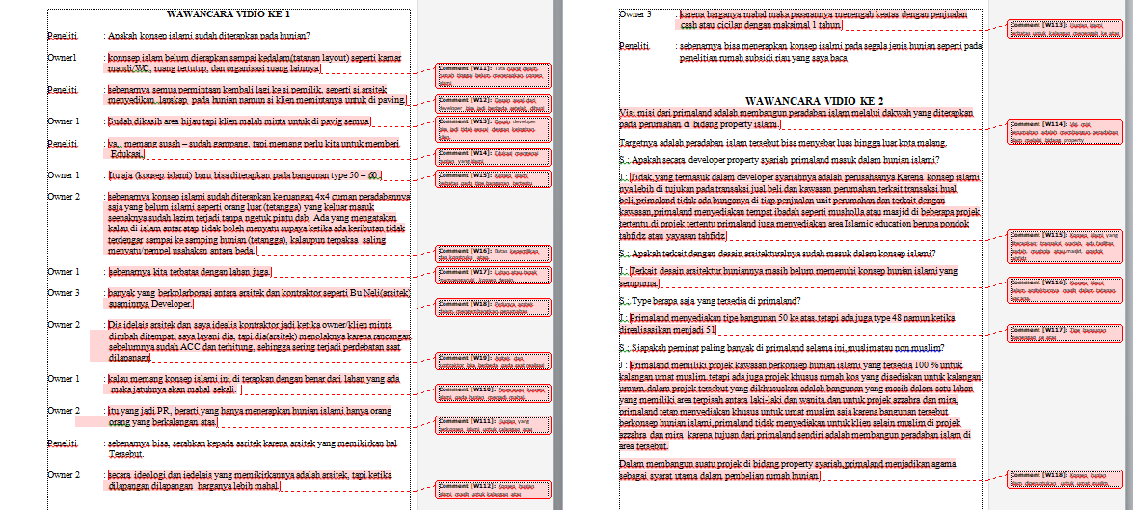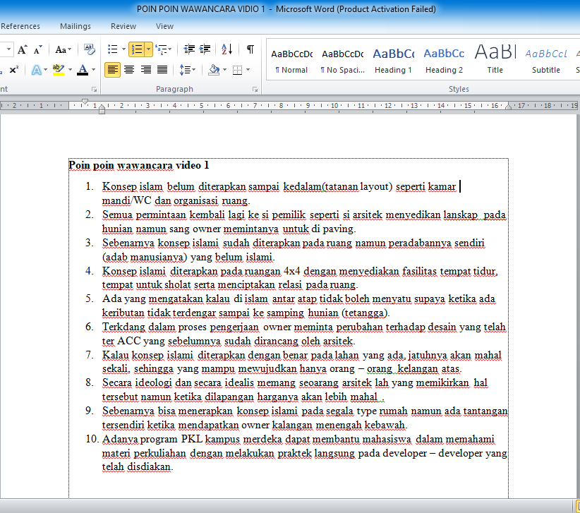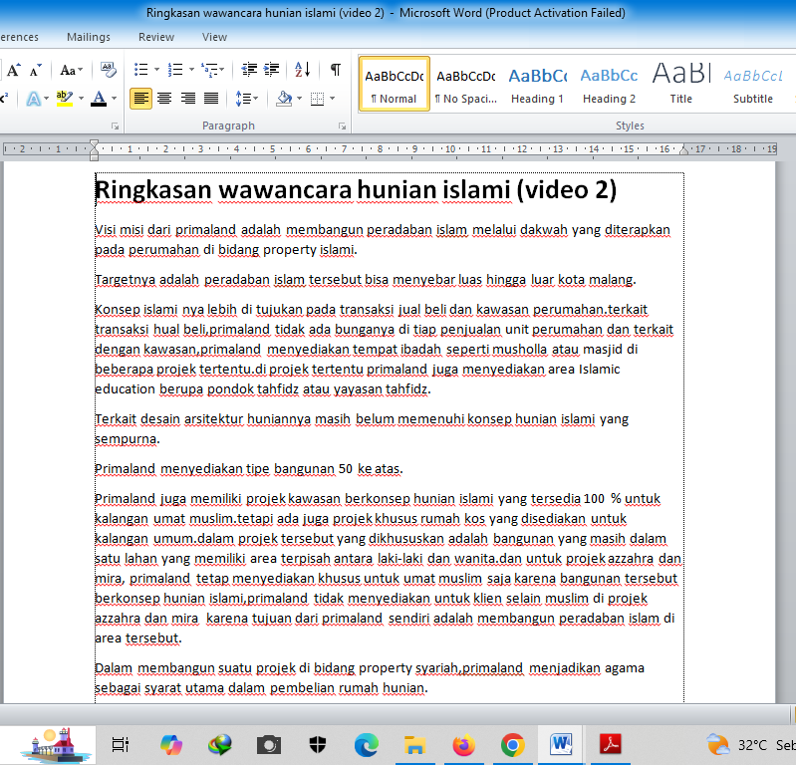

- Conceptual Book (Text)
Buku: Membangun Peradaban dengan Hunian Islami, karya Rendra MS

- Marketing Materials (Text and Visual)
Brosur, Sosial Media (Website, Instagram),

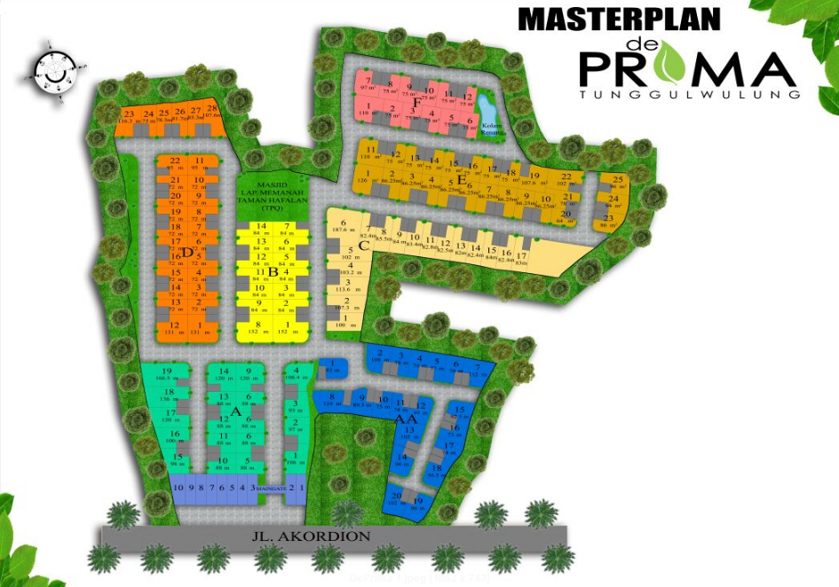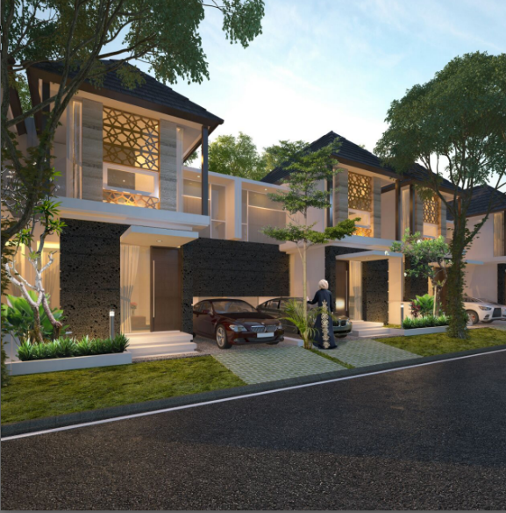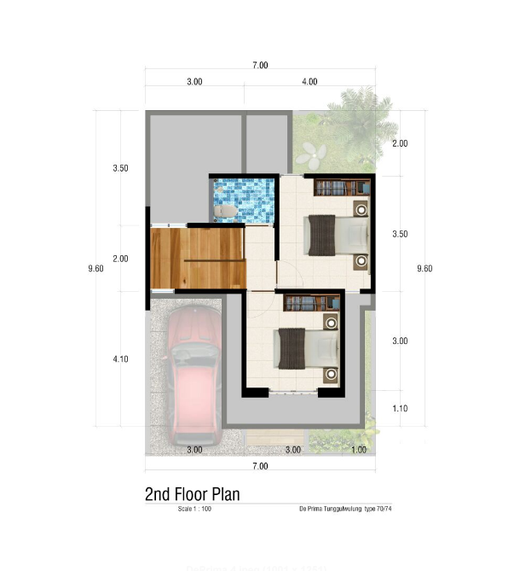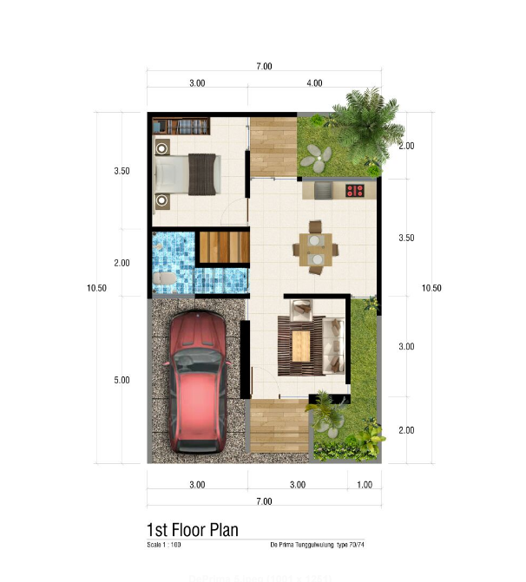

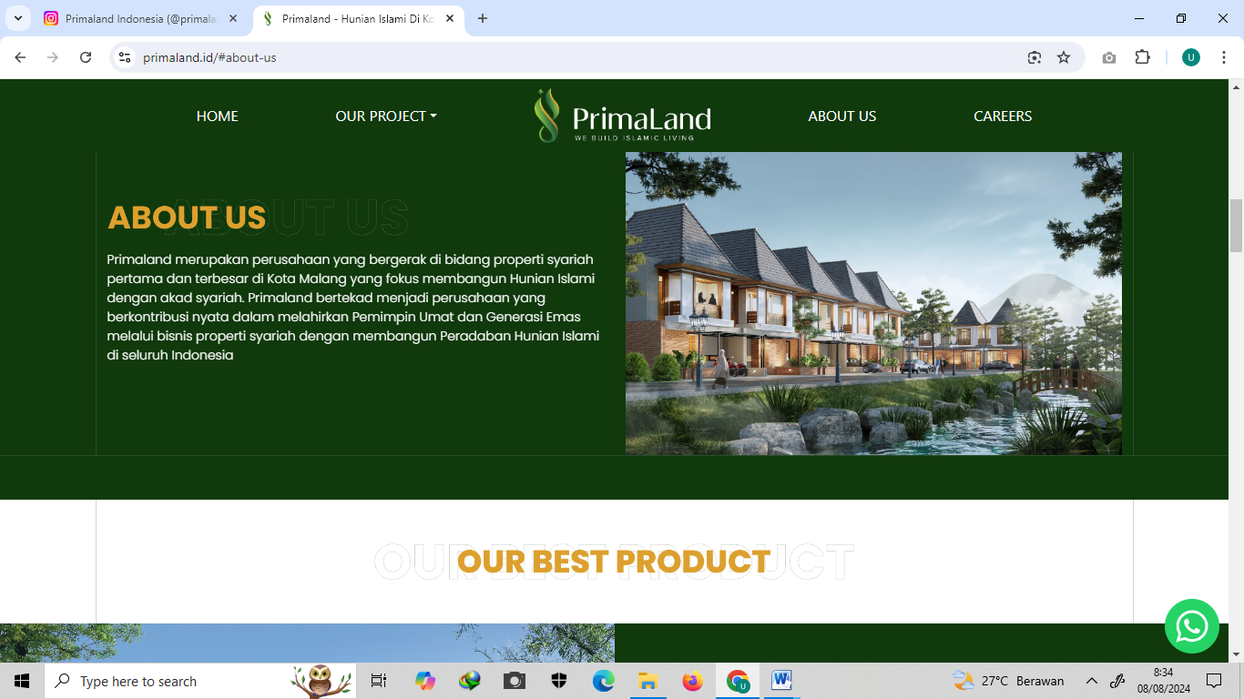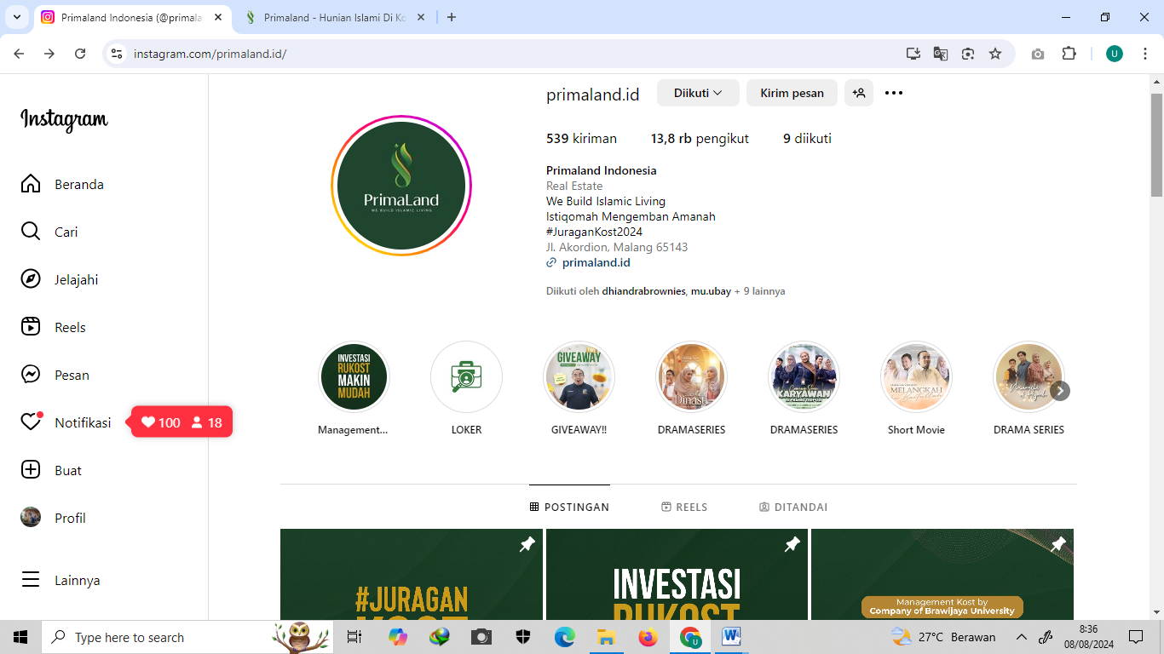

- Observation’s Field Notes (Text)
Checklist Pengumpulan Data

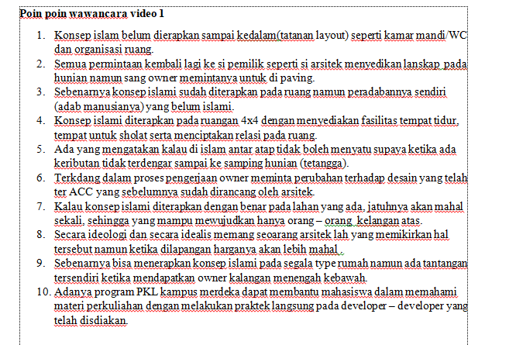

- Documentation (Visual)

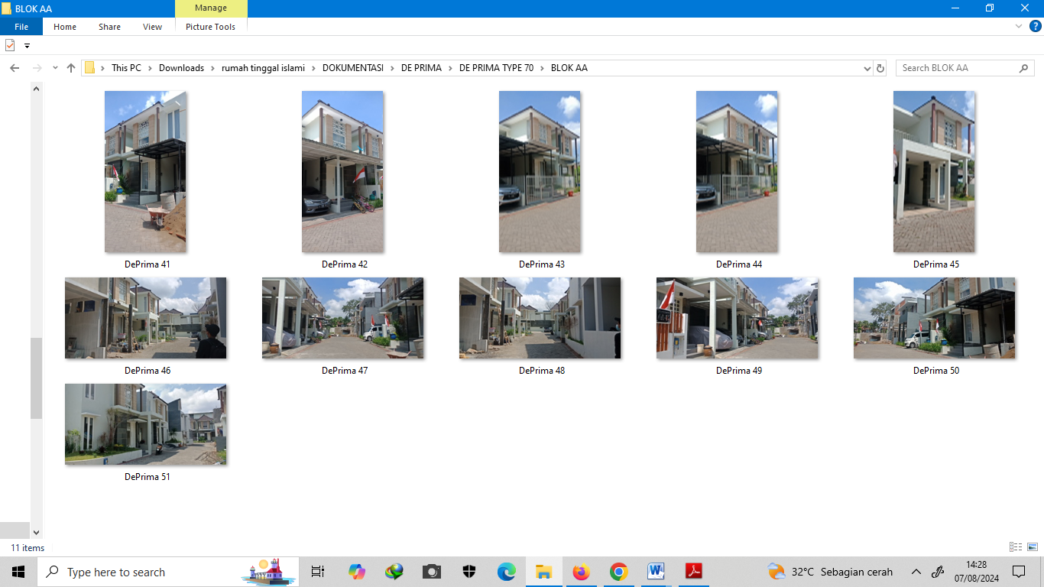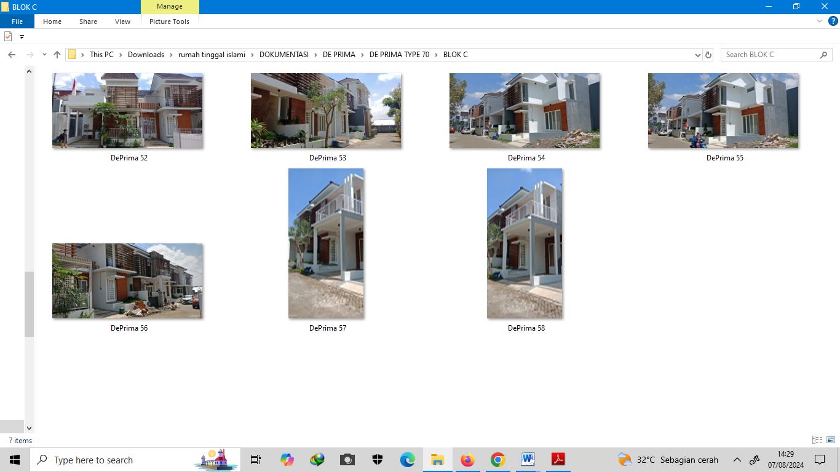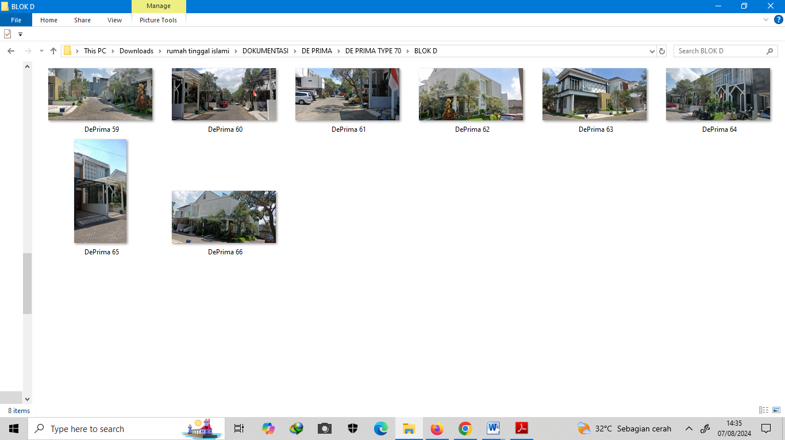

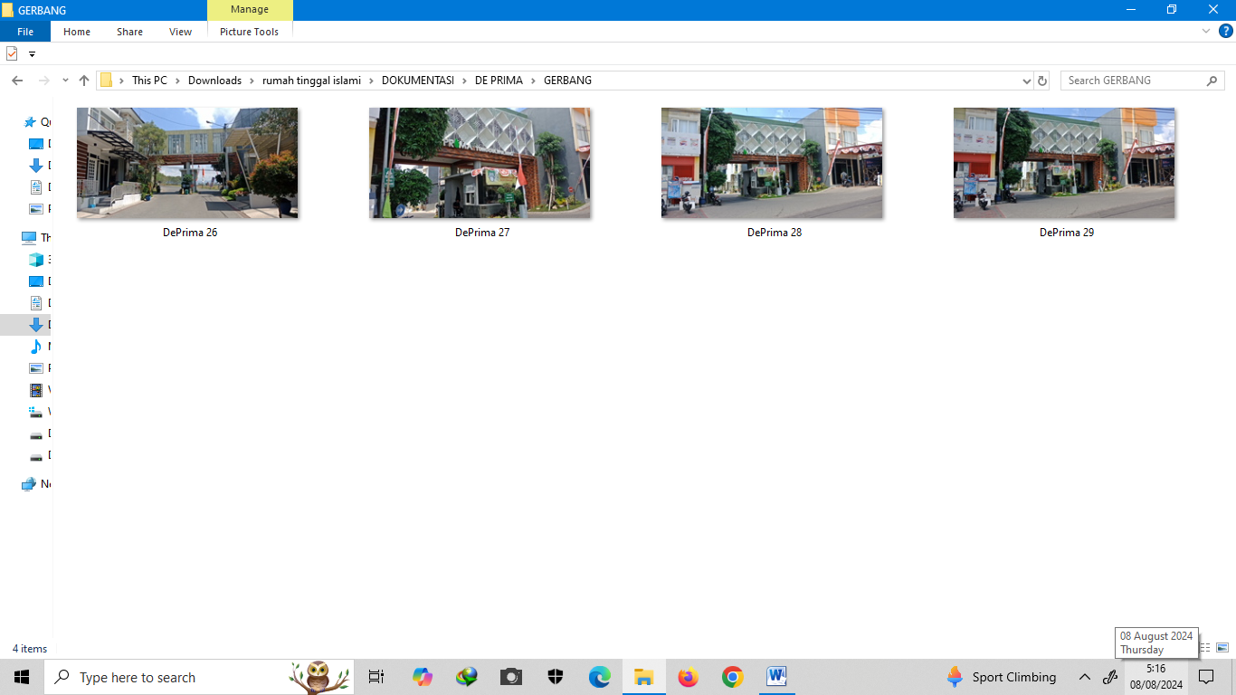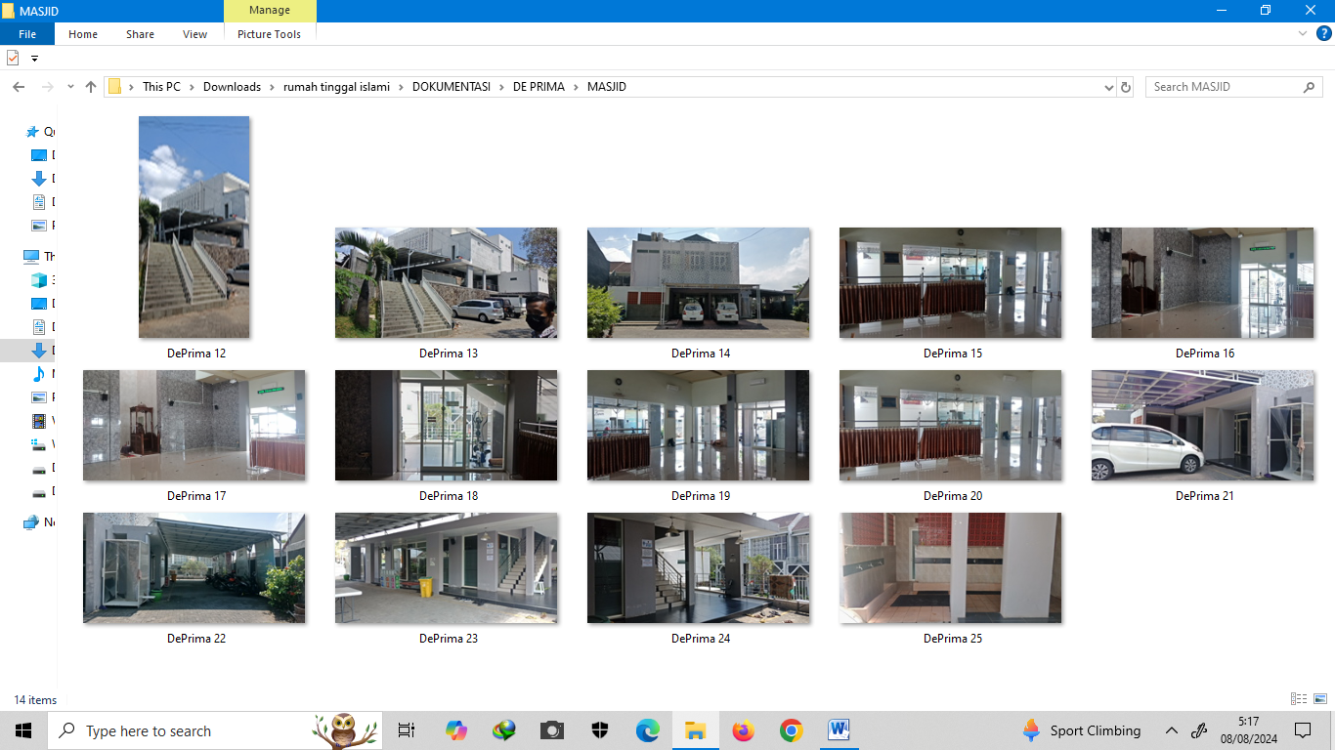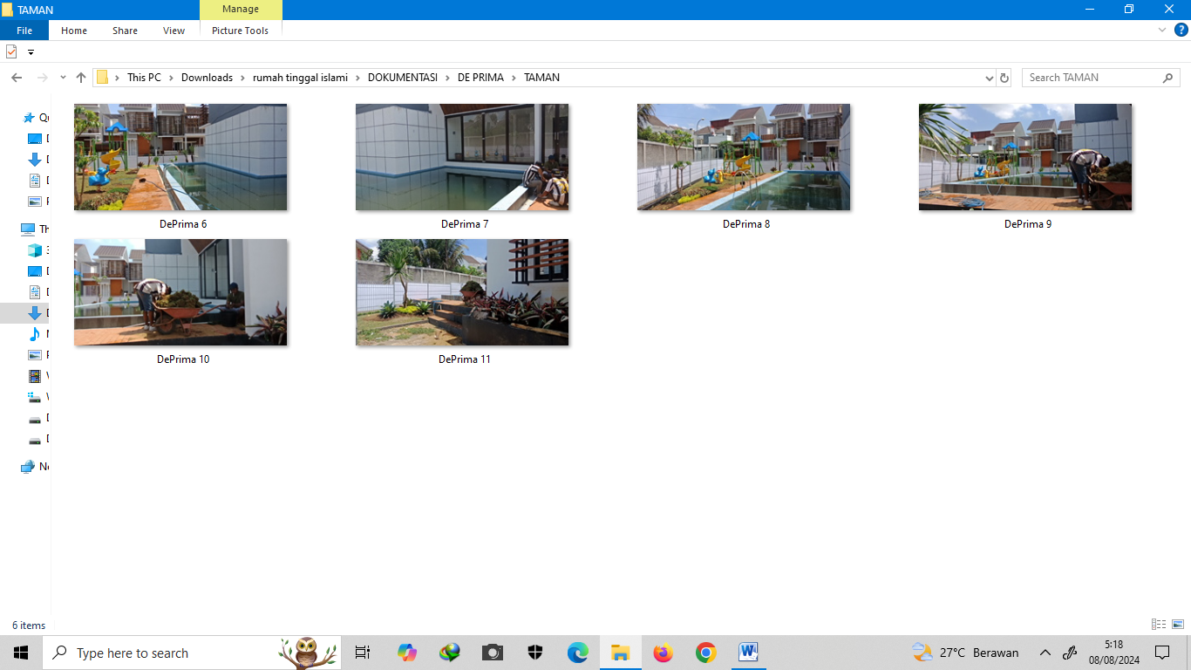

- GIS Mapping (Visual)
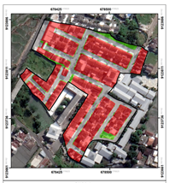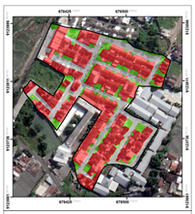
Master plan Project implementation

- MYRRA RESIDENCE (B)
Data Types
- Interview with the owners and management (Text):
- Owner (Bapak Rendra)
- Management (Bu Rani, Pak Margo)
- Marketing Materials (Text and Visual)
Brosur, Sosial Media (Instagram),

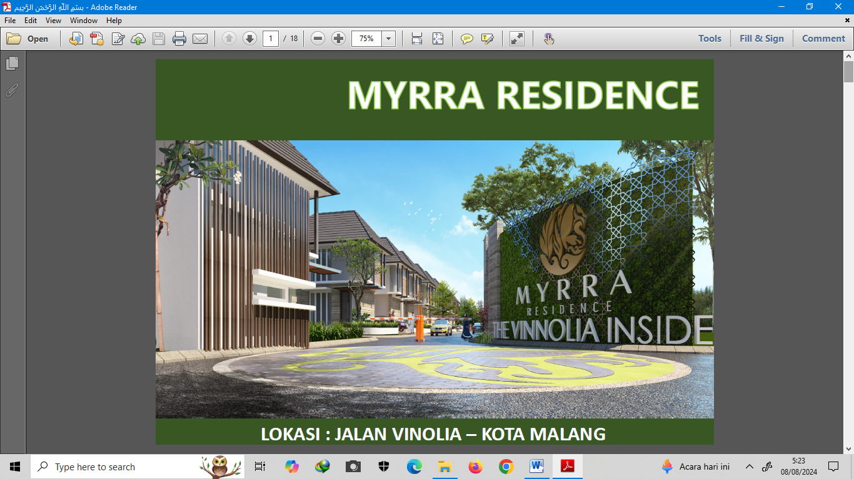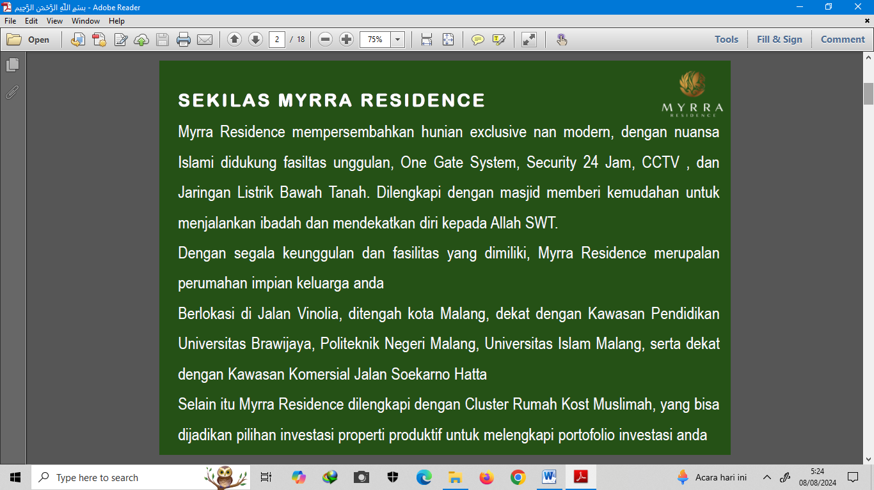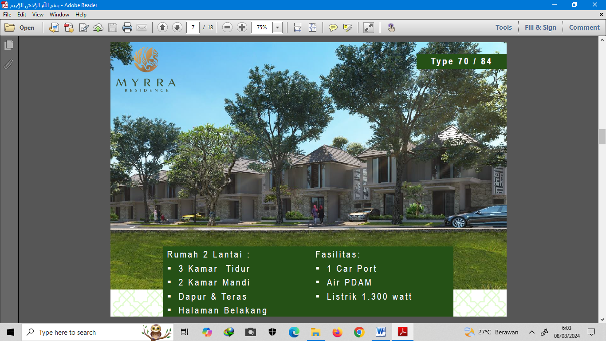

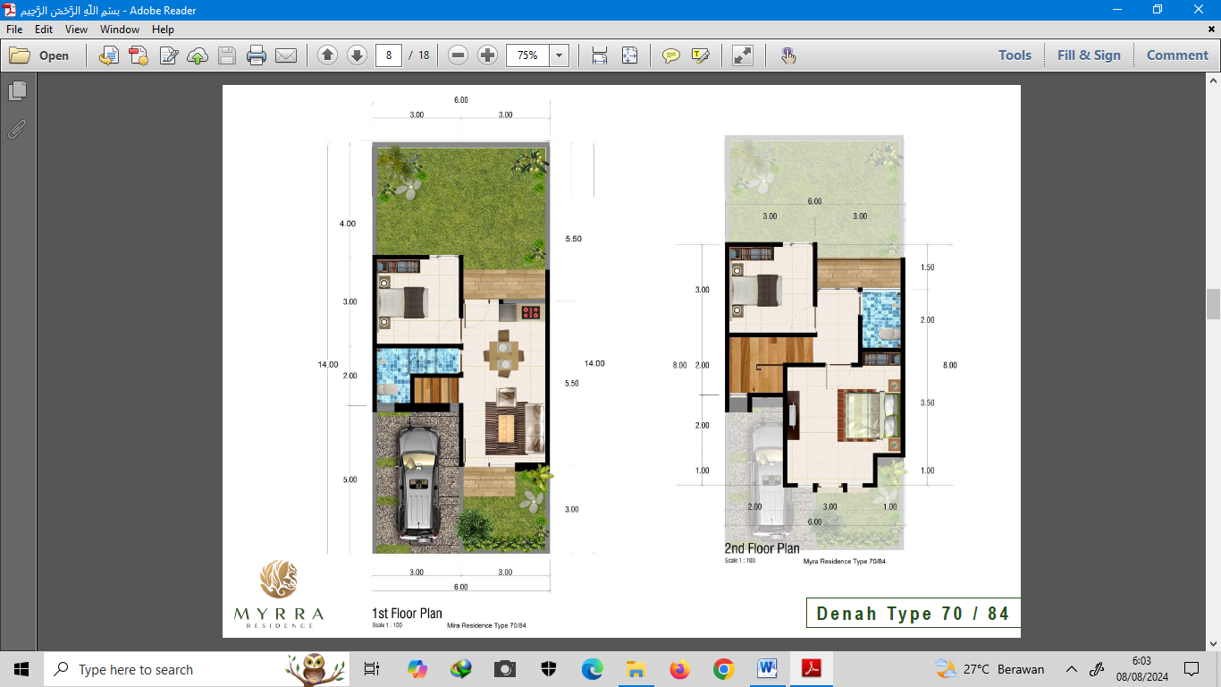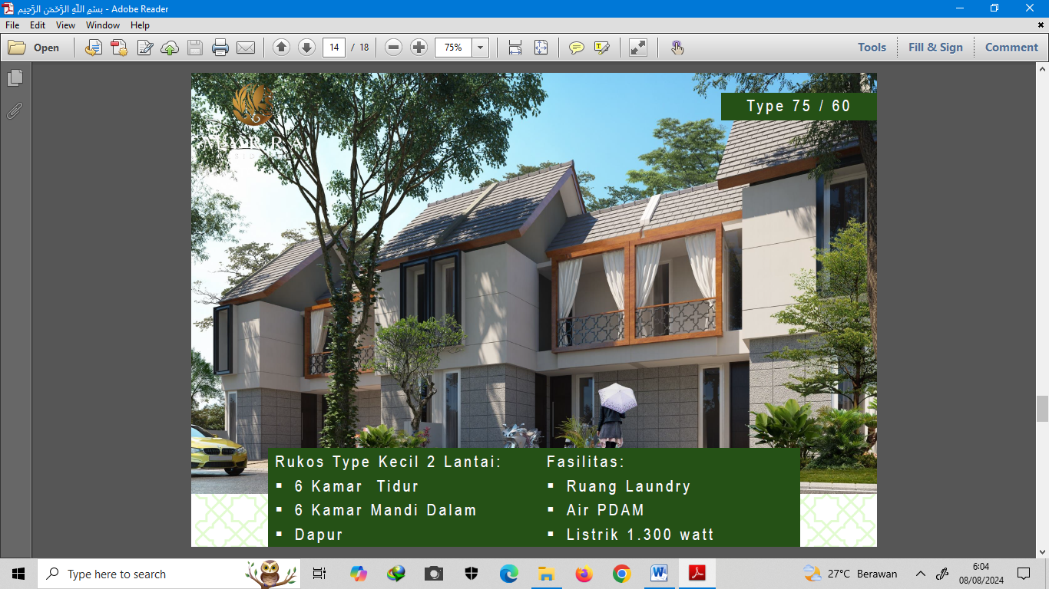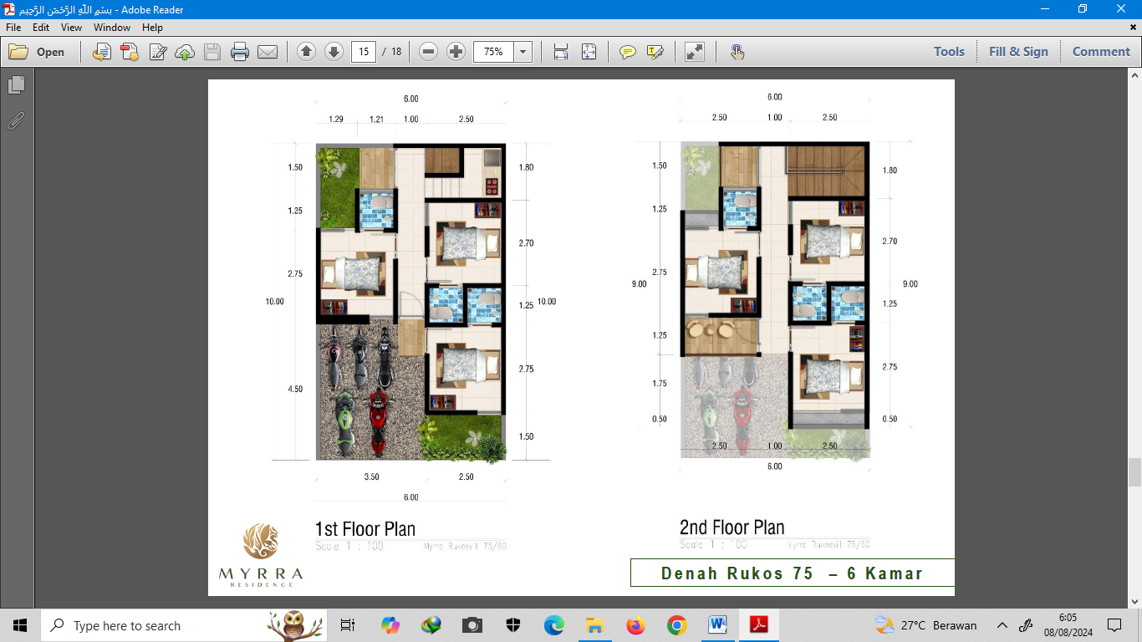

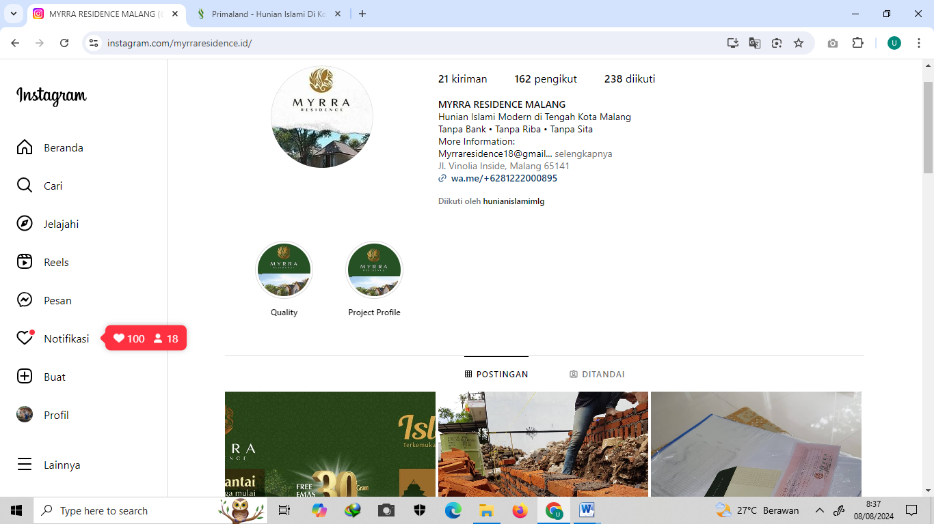

- Observation’s Field Notes (Text)
Checklist Pengumpulan Data

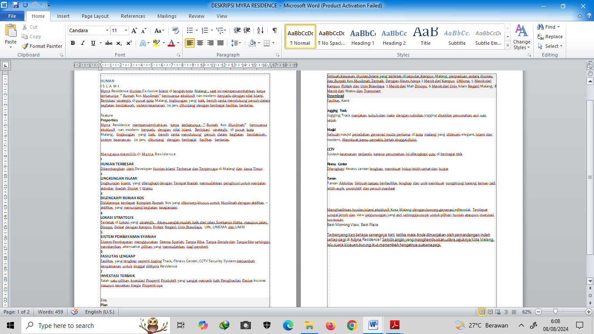

- Documentation (Visual)

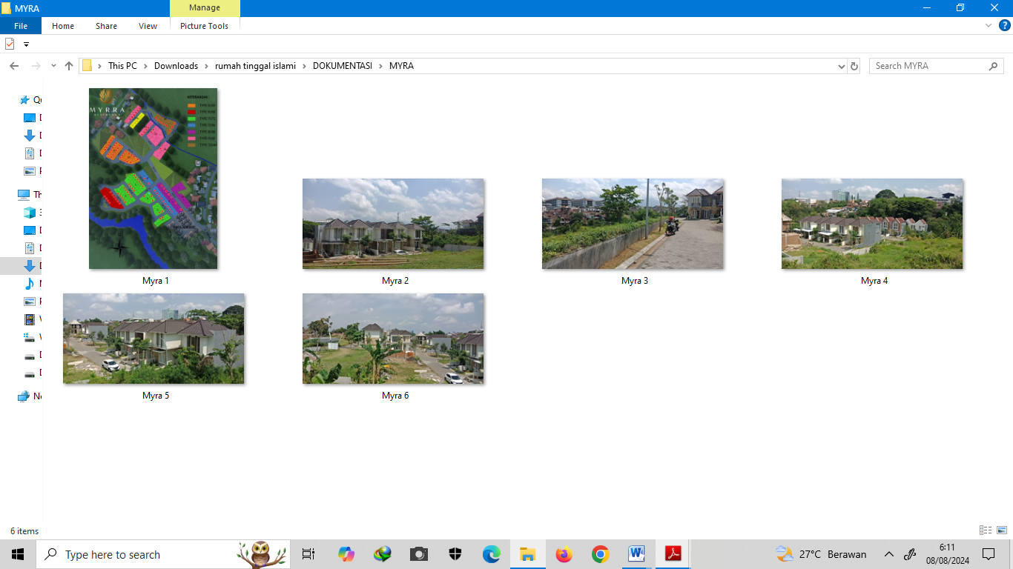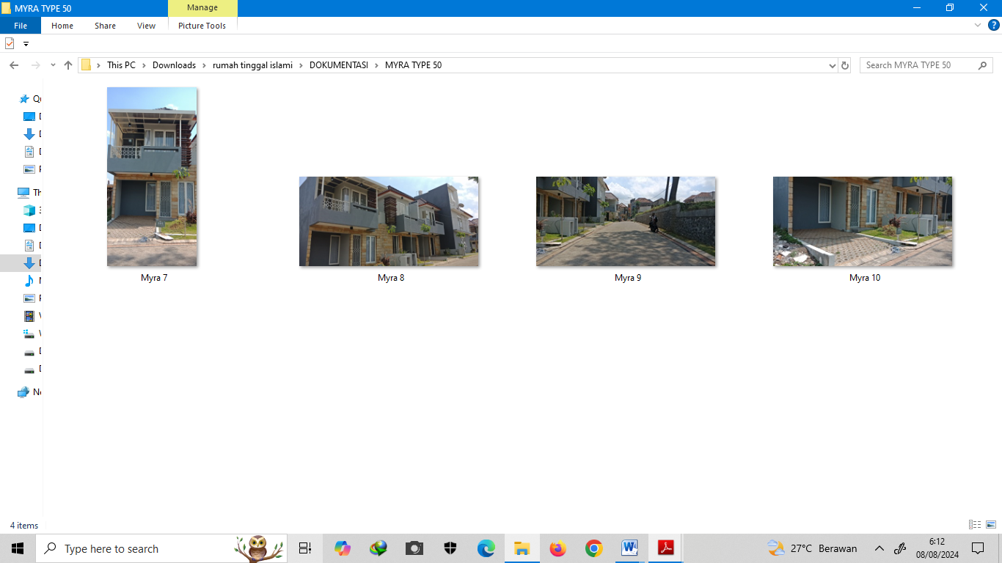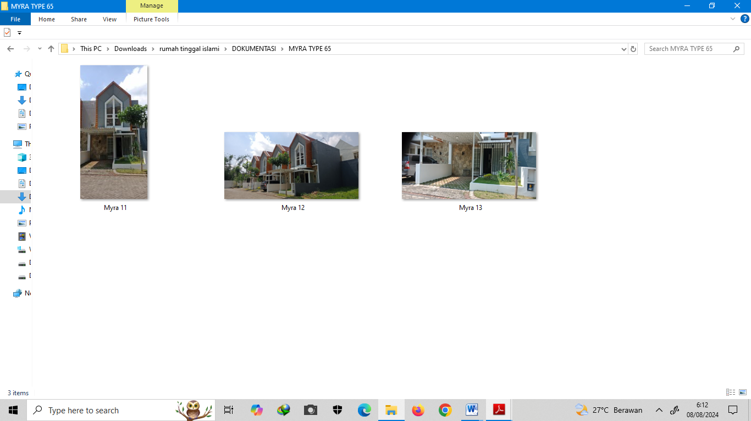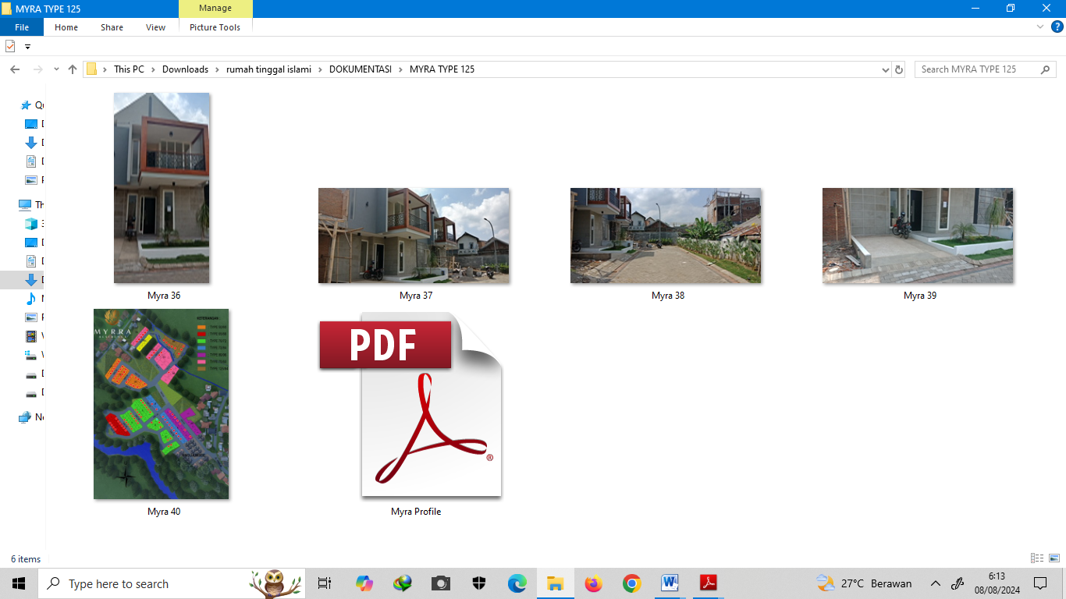

- GIS Mapping (Visual)

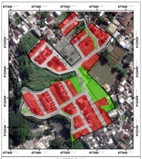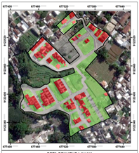
Master plan Project implementation

- ADYNA RESIDENCE (C)

Data Types
- Interview with the owners and management (Text):

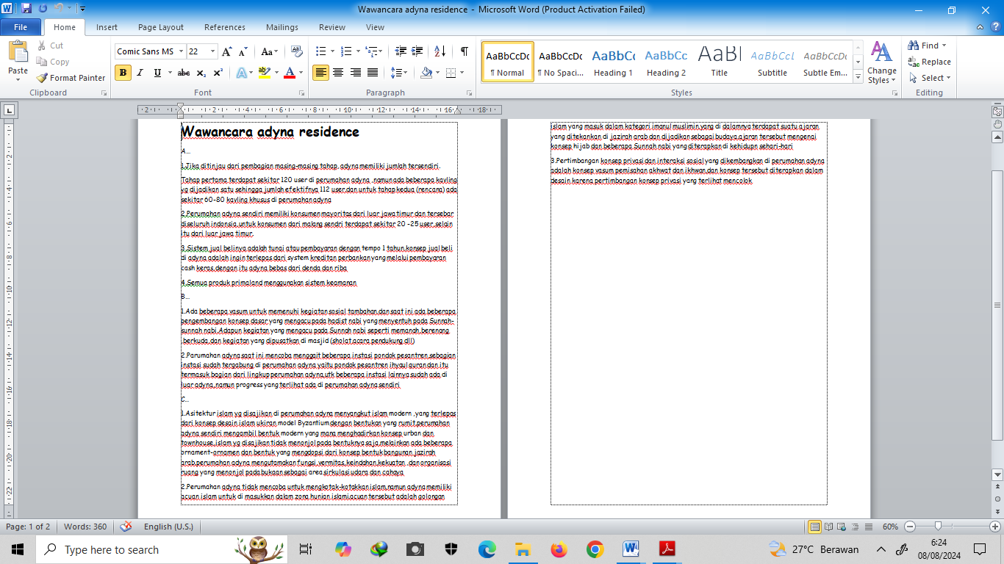

- Marketing Materials (Text and Visual)
Brosur, Sosial Media (Instagram),

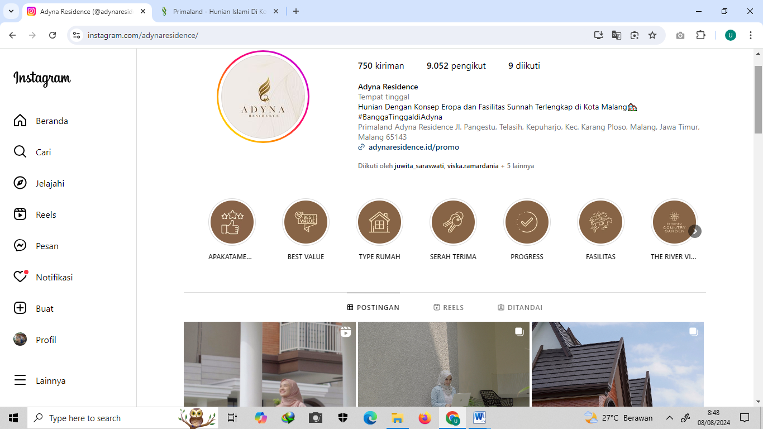

- Observation’s Field Notes (Text)
Checklist Pengumpulan Data

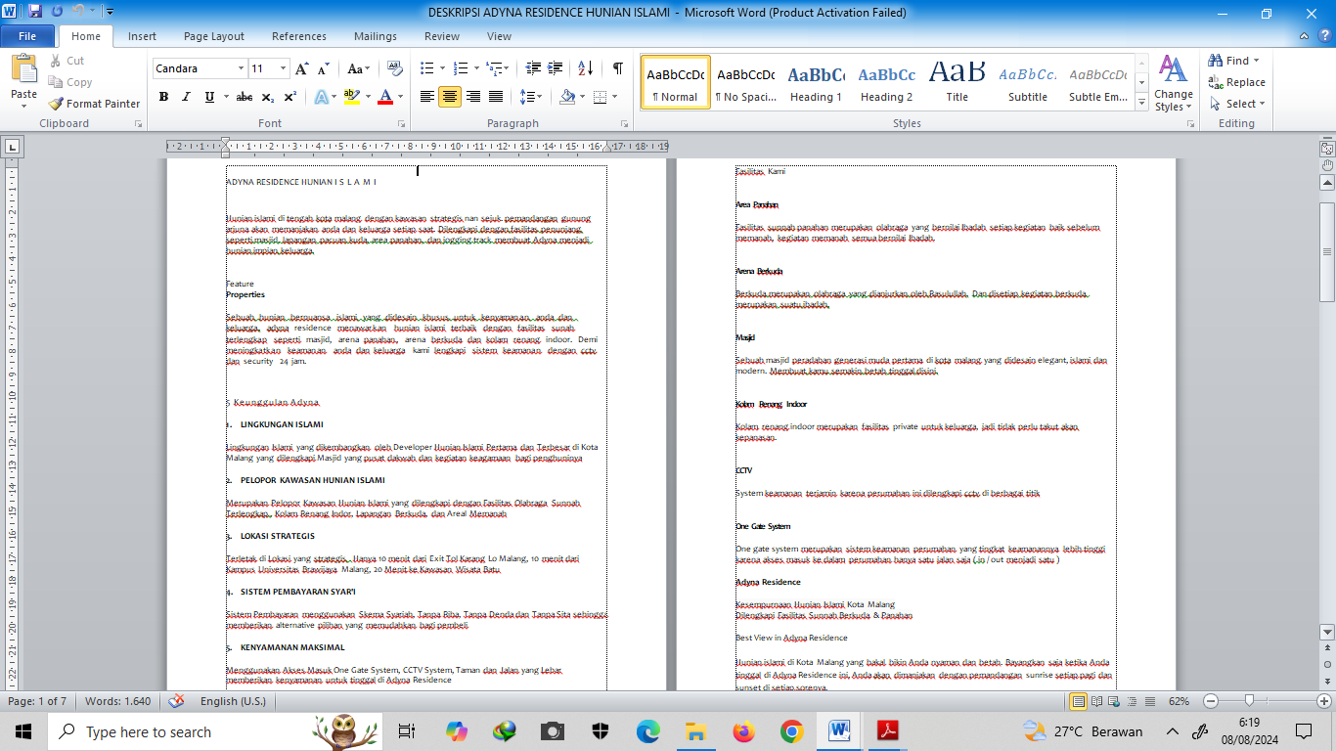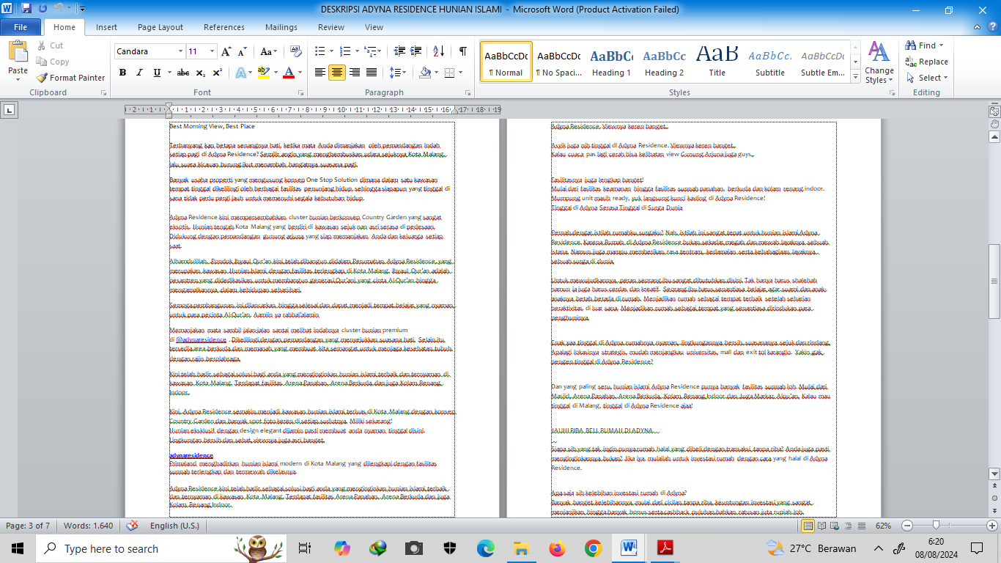

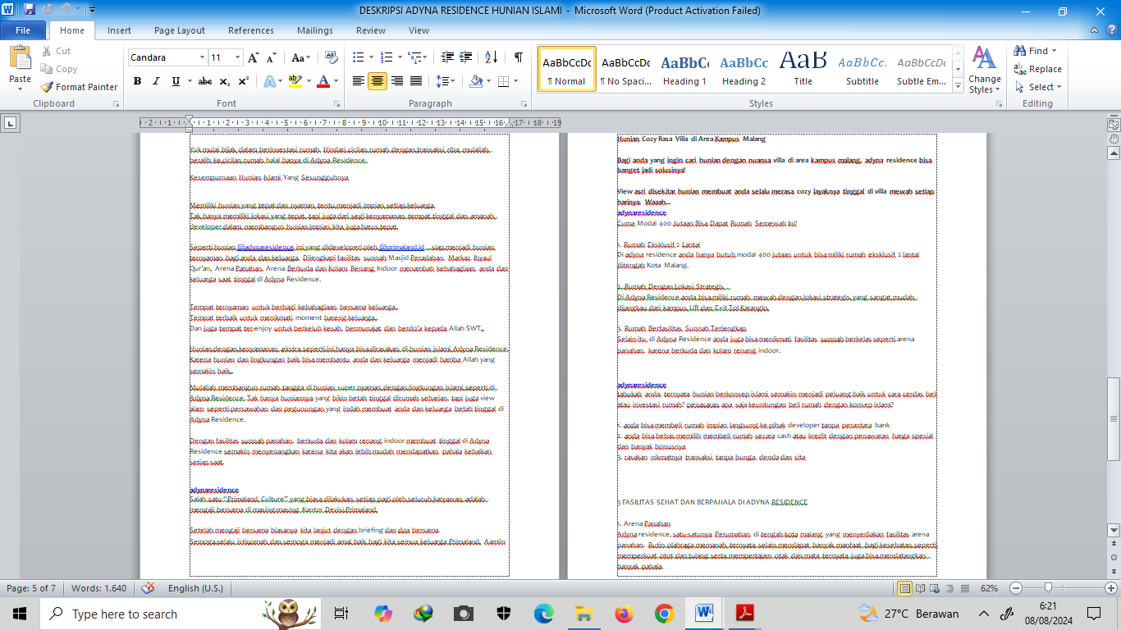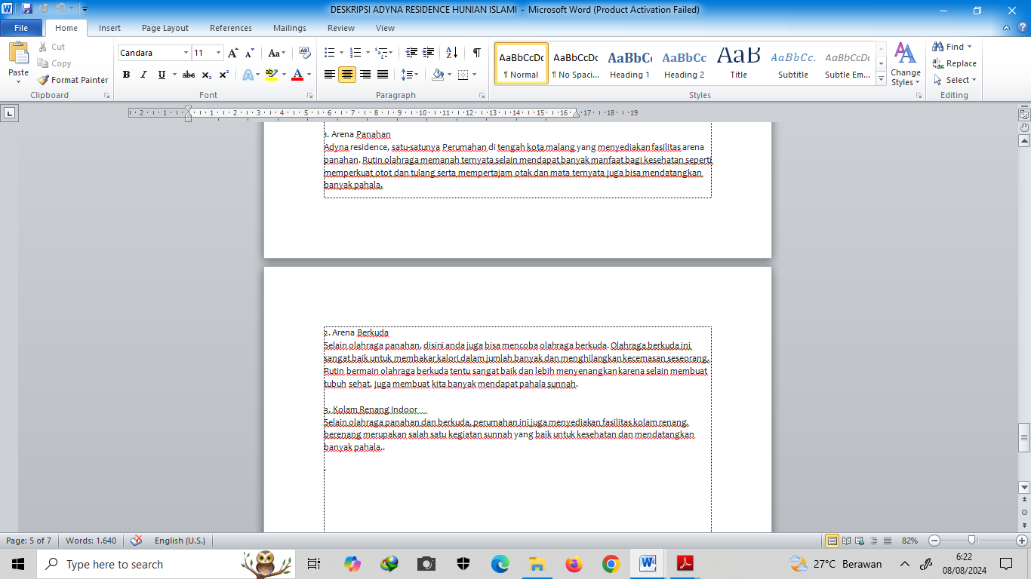

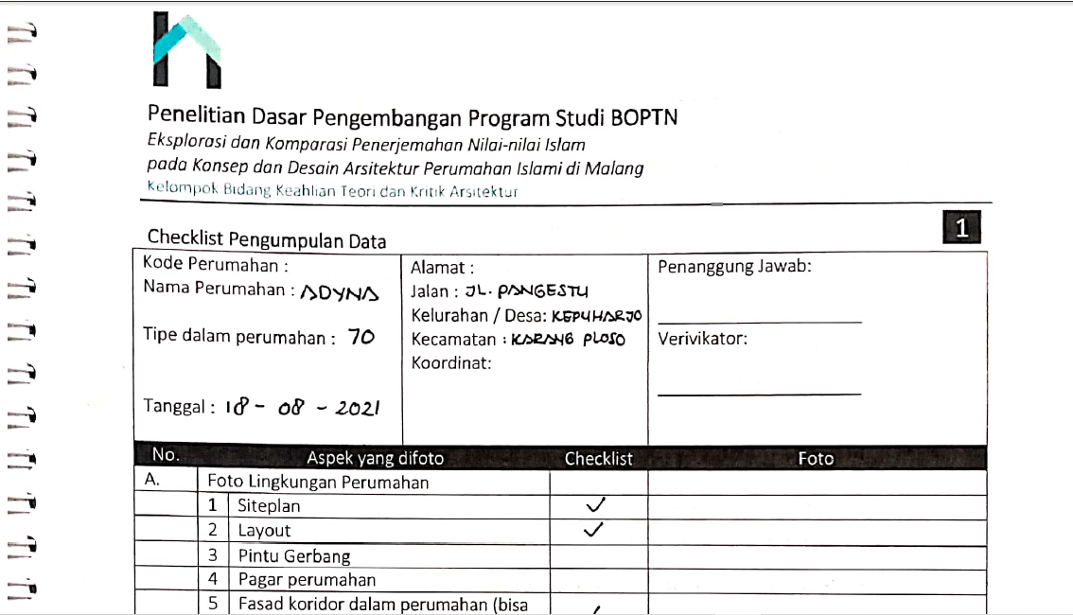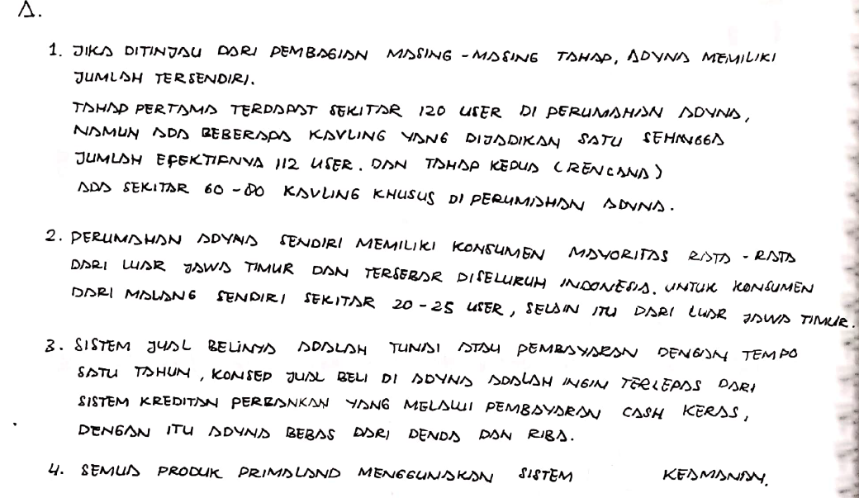
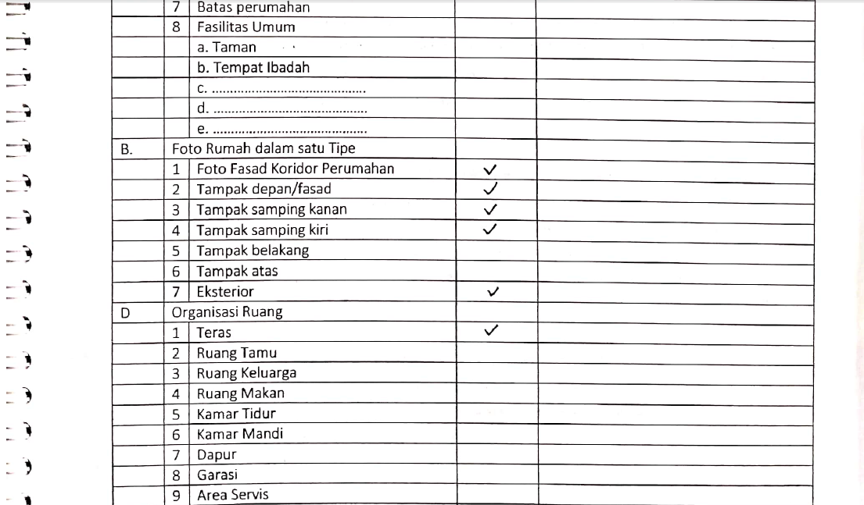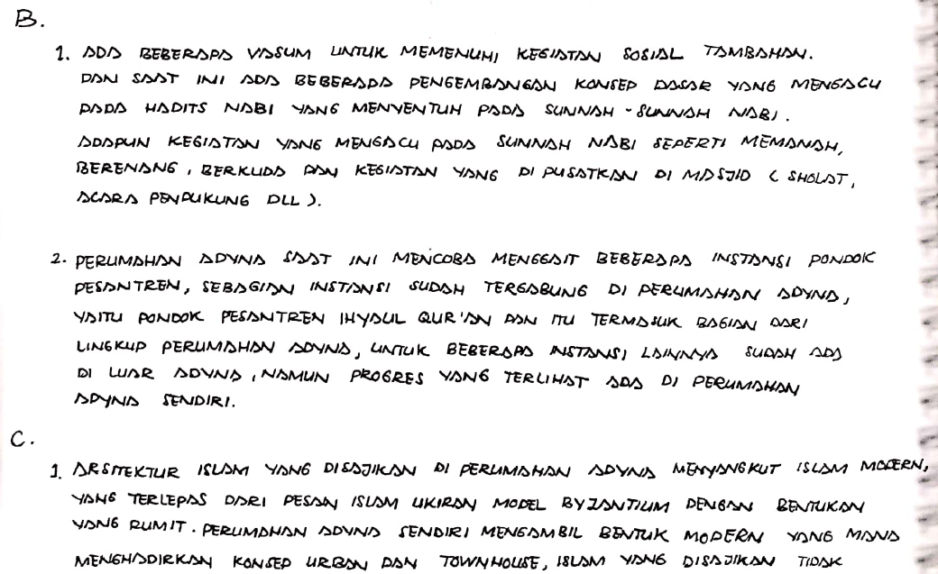

- Documentation (Visual)

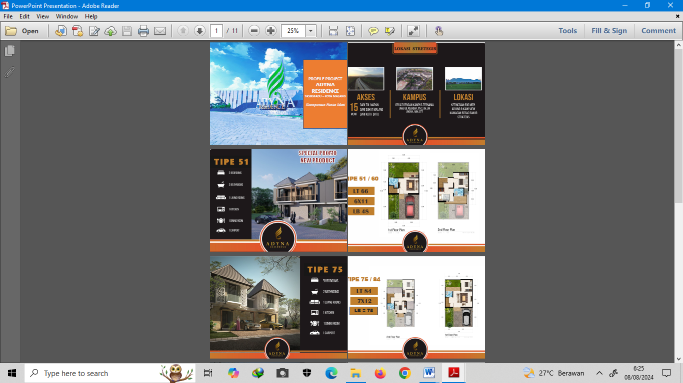

- GIS Mapping (Visual)

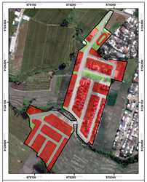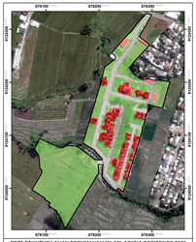
Master plan Project implementation

- AZZAHRA RESIDENCE (D)
Data Types
- Interview with the owners and management (Text):

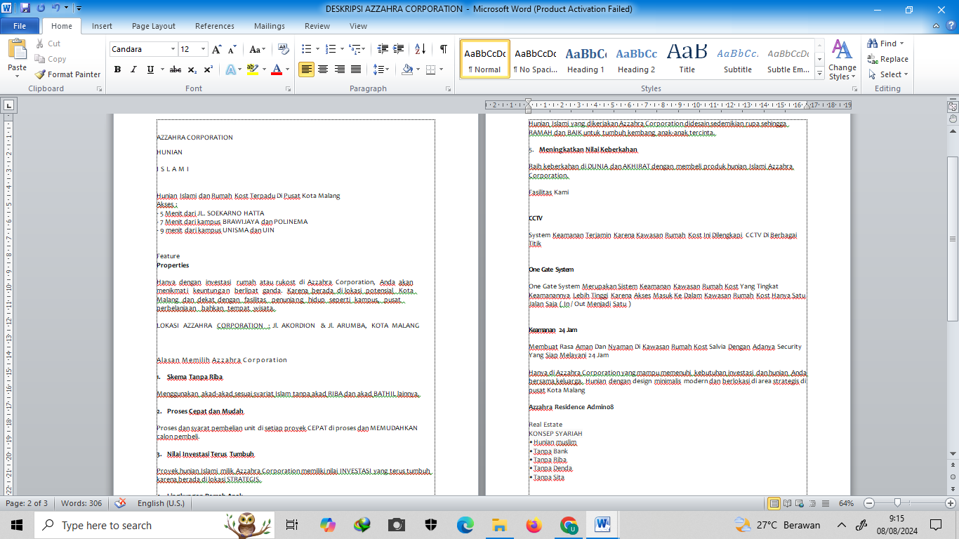

- Marketing Materials (Text and Visual)

Brosur, Sosial Media (Instagram),

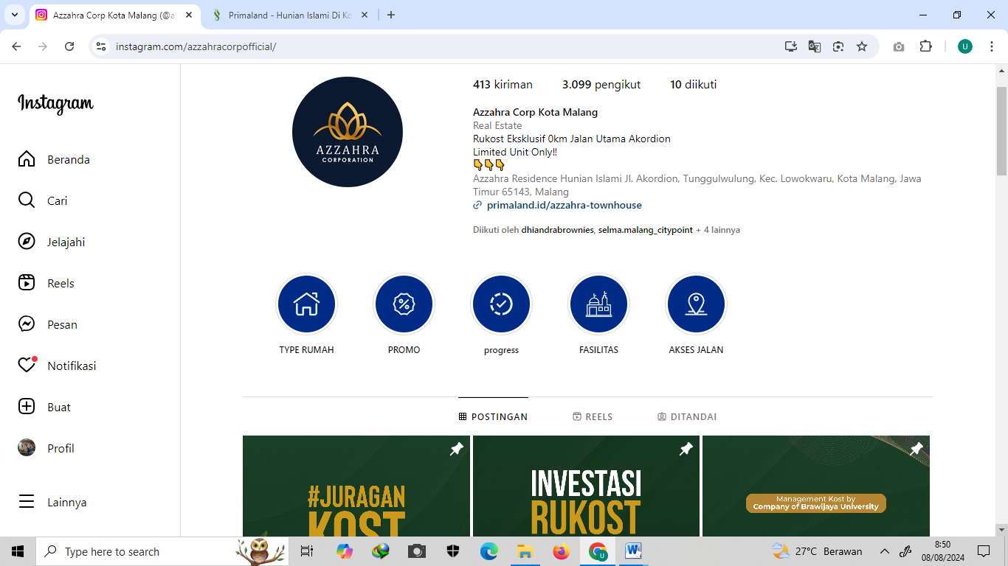

- Observation’s Field Notes (Text)
Checklist Pengumpulan Data

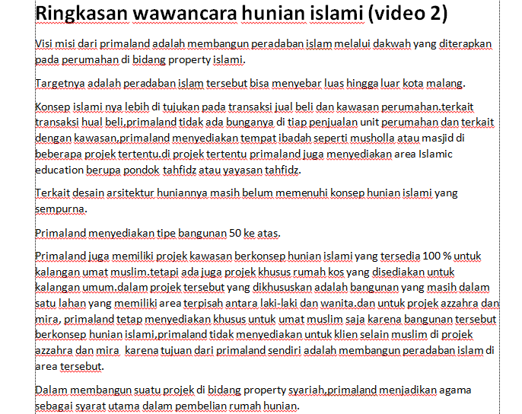

- Documentation (Visual)

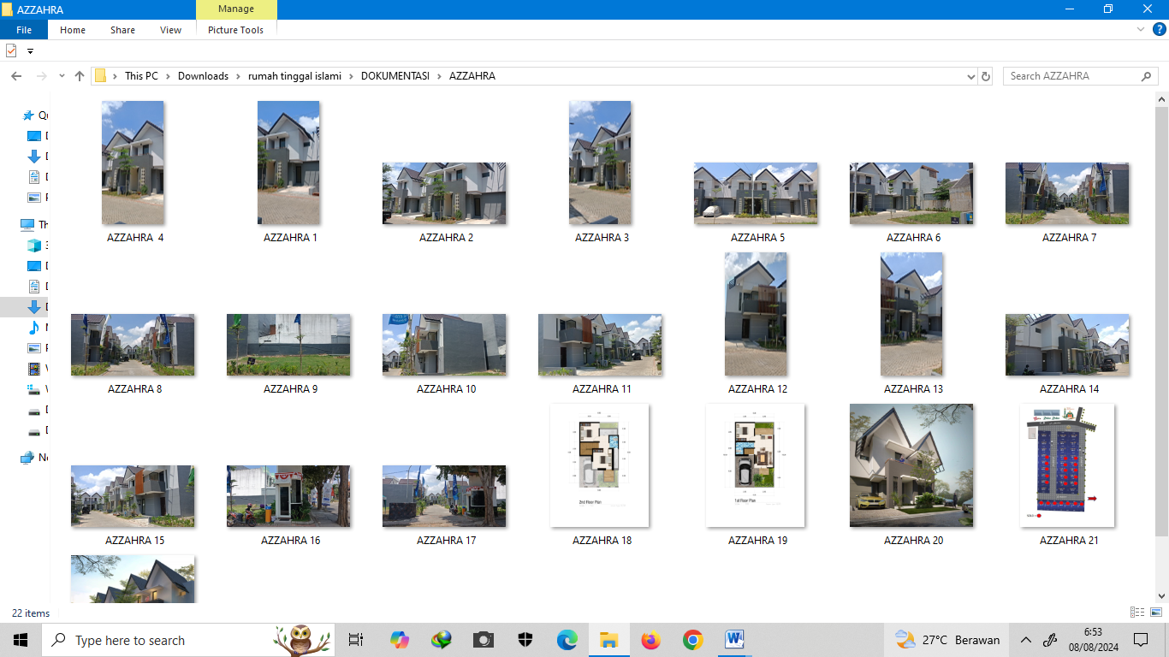

- GIS Mapping (Visual)

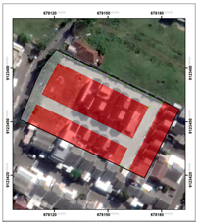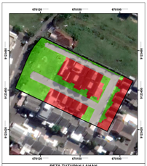
Master plan Project implementation

- GRAND ALEENA (E)
Data Types
- Interview with the owners and management (Text):
- Marketing Materials (Text and Visual)
Brosur, Sosial Media (Instagram),

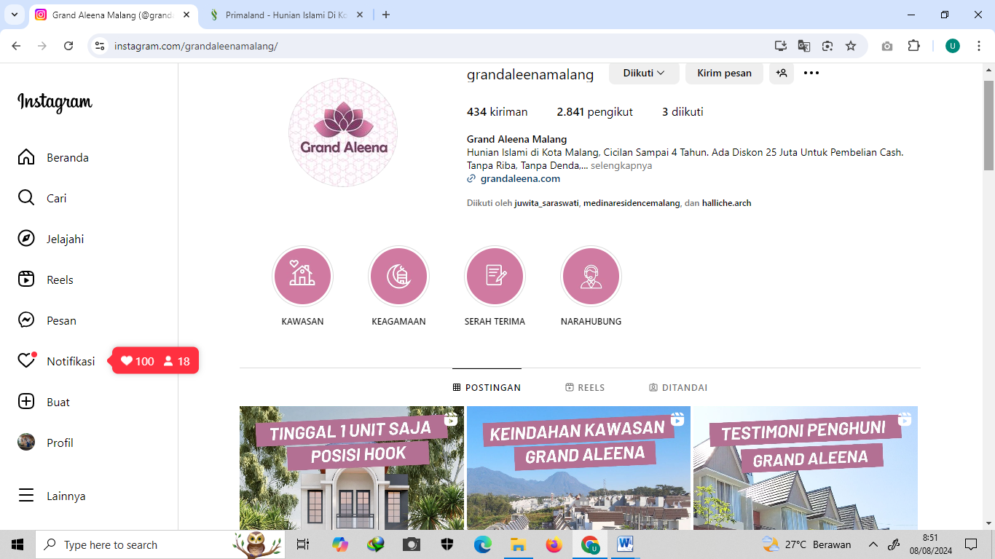

- Observation’s Field Notes (Text)
Checklist Pengumpulan Data

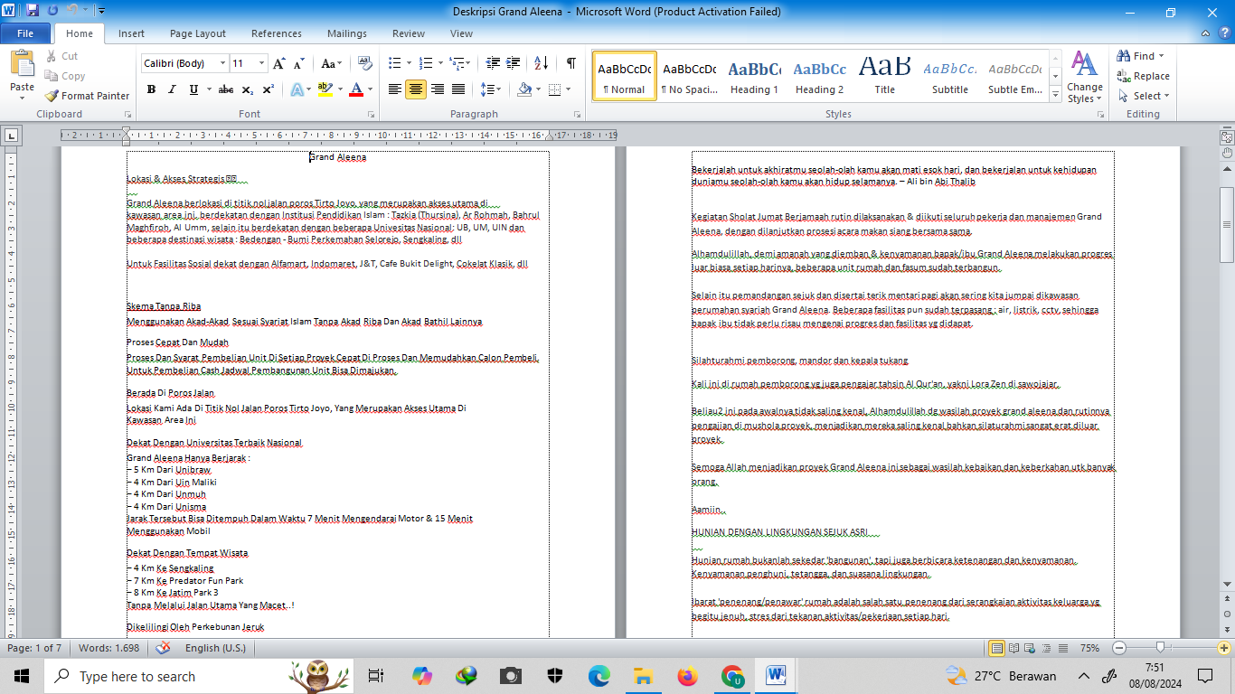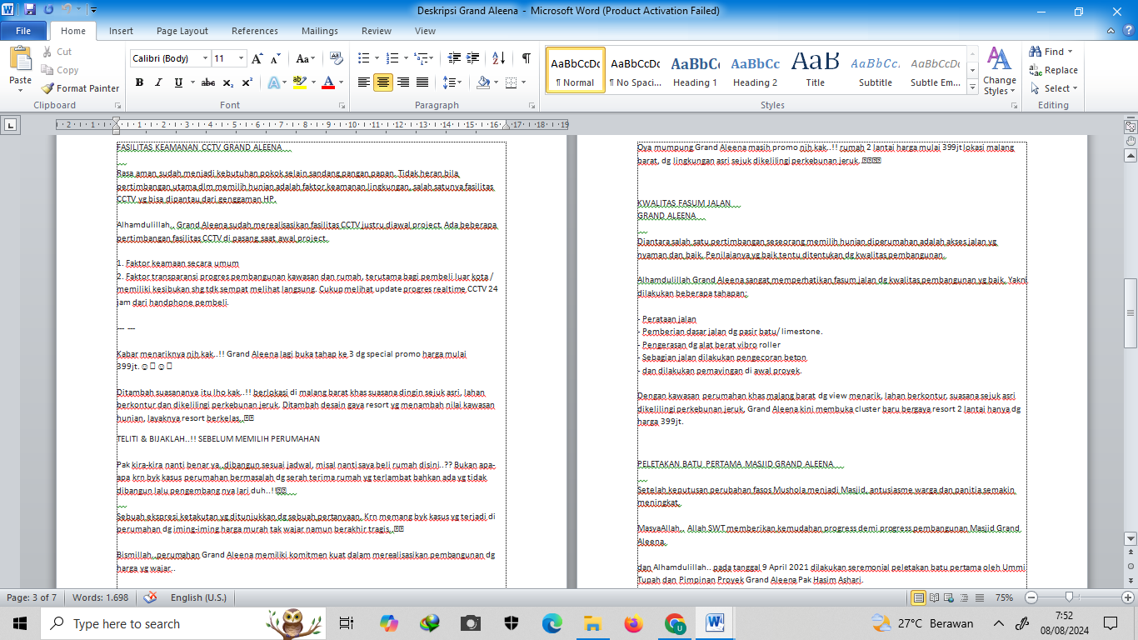

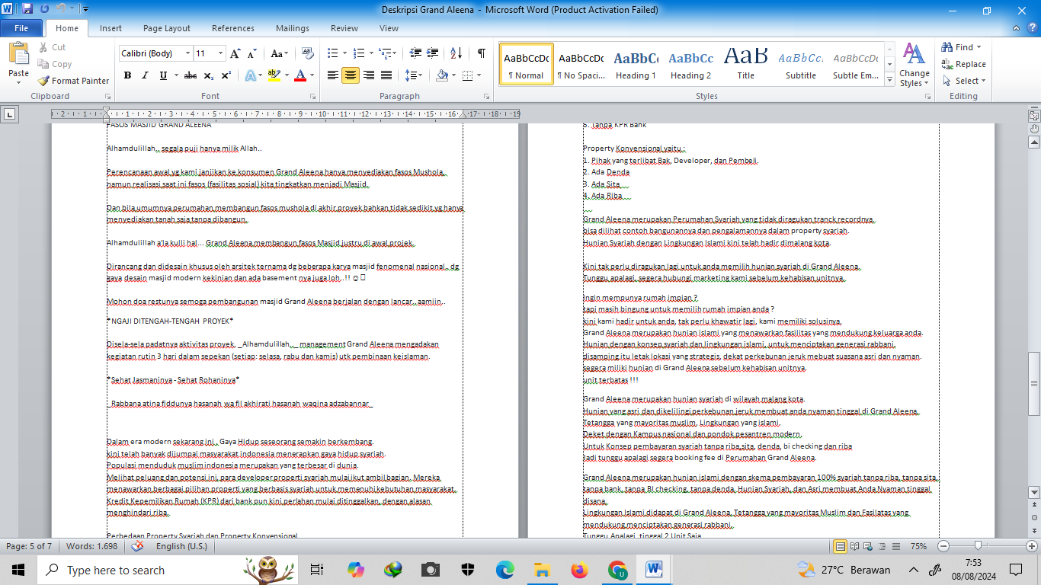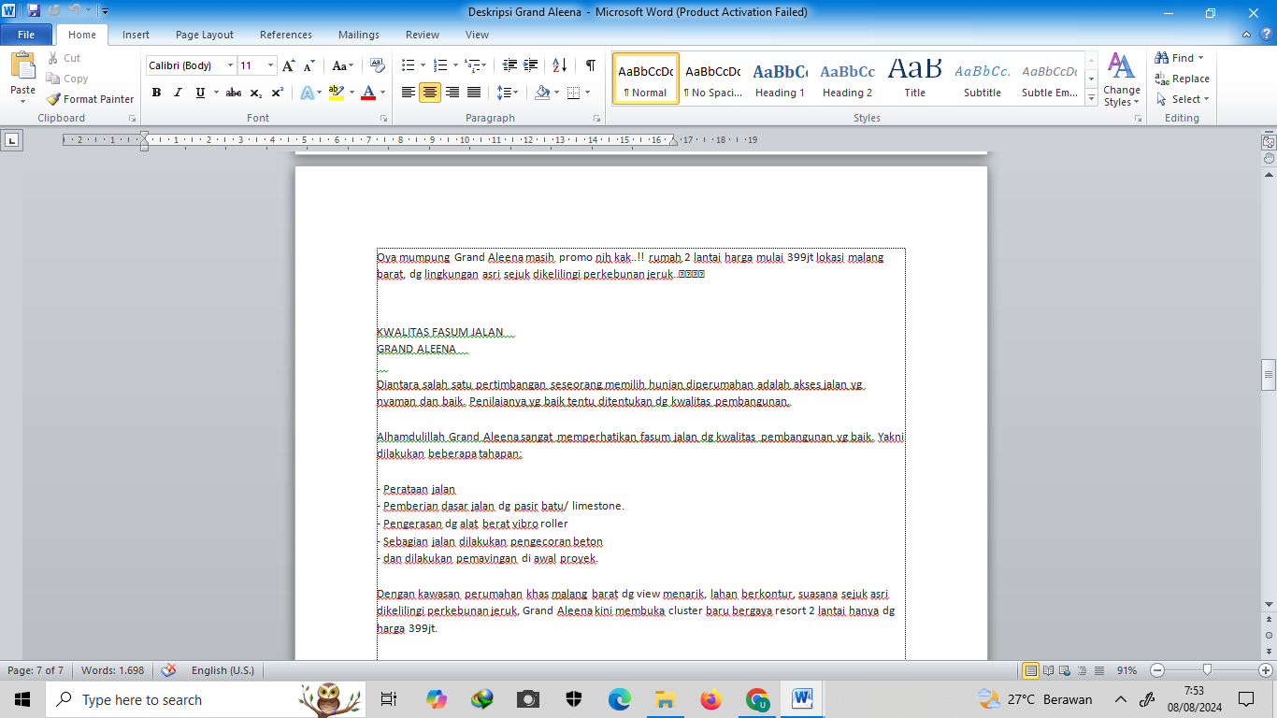

- Documentation (Visual)

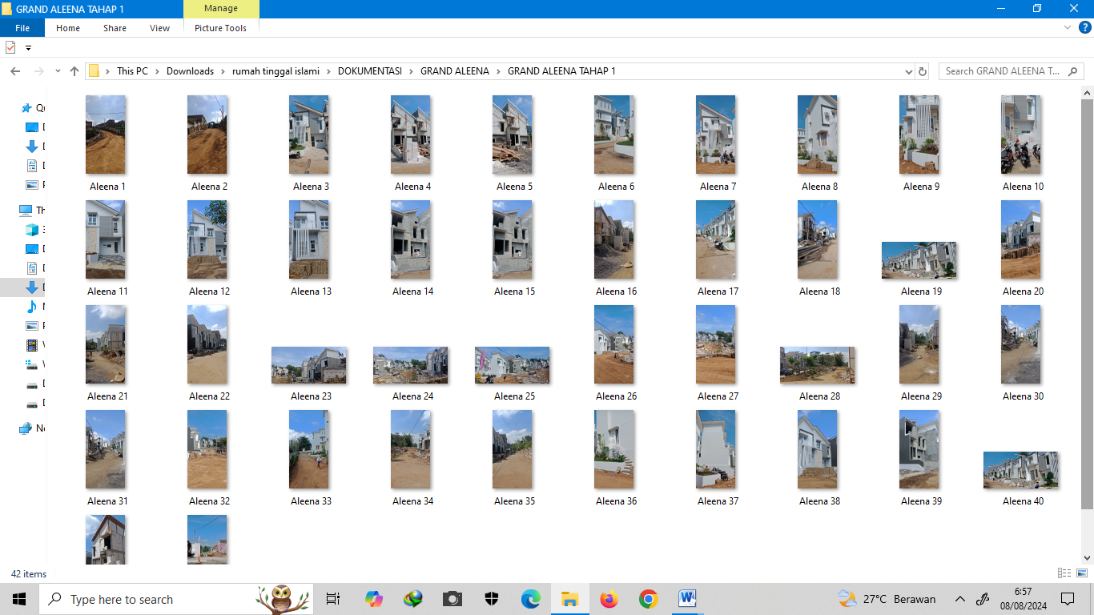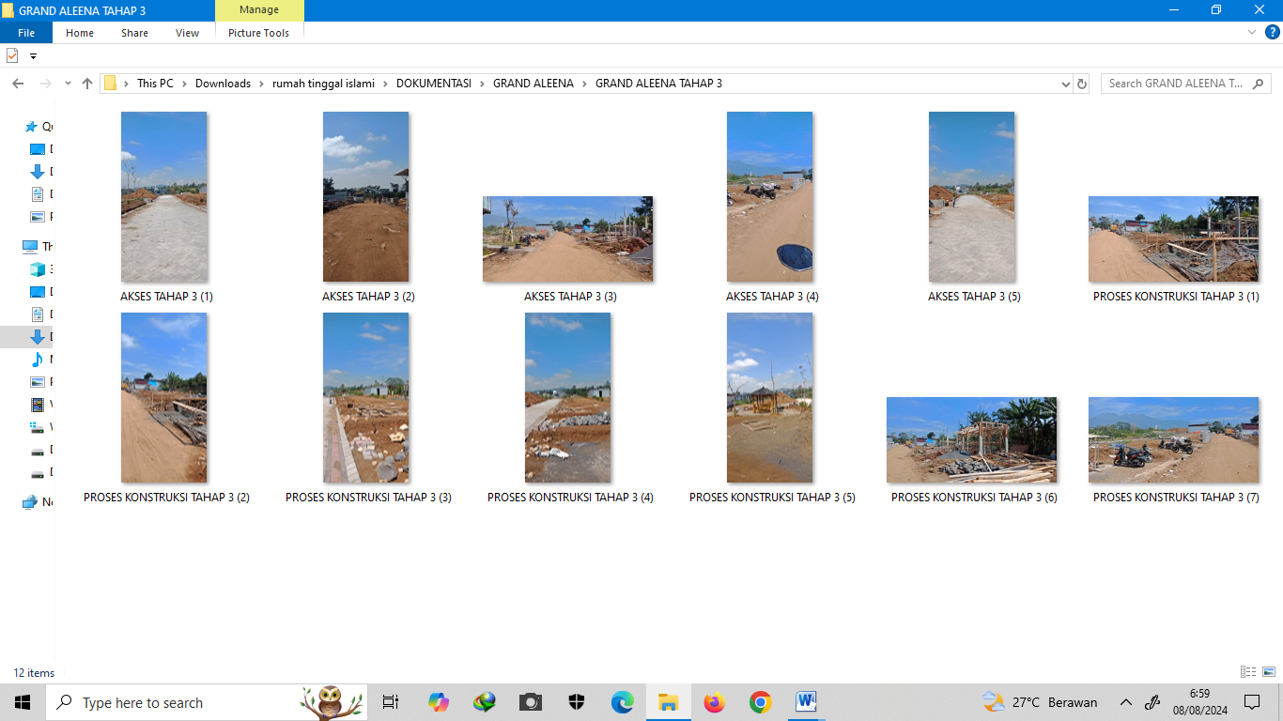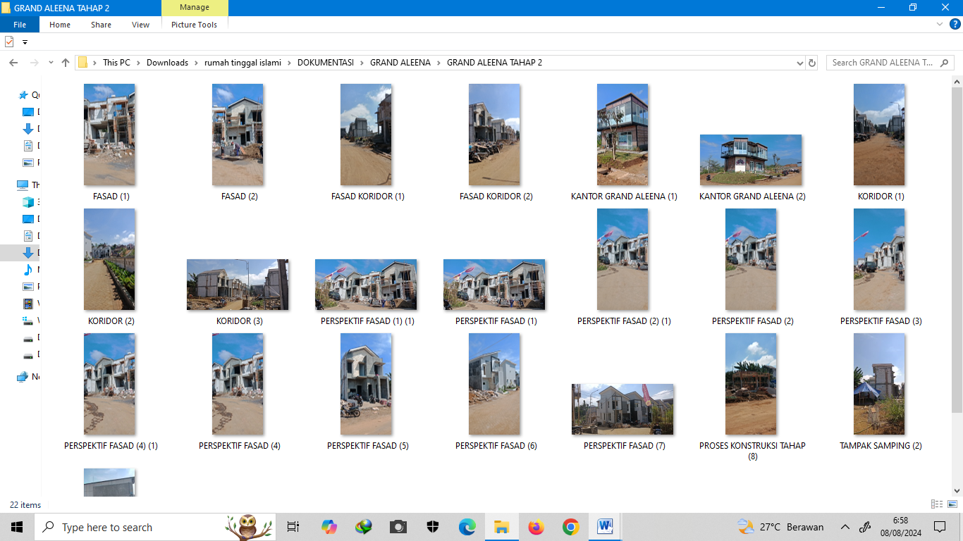

- GIS Mapping (Visual)

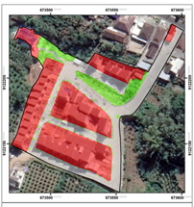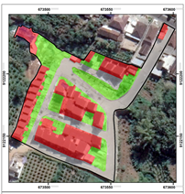
Master plan Project implementation

- GRAND VILLAGE AS-SALAM (F)

Data Types
1. Interview with the owners and management (Text):

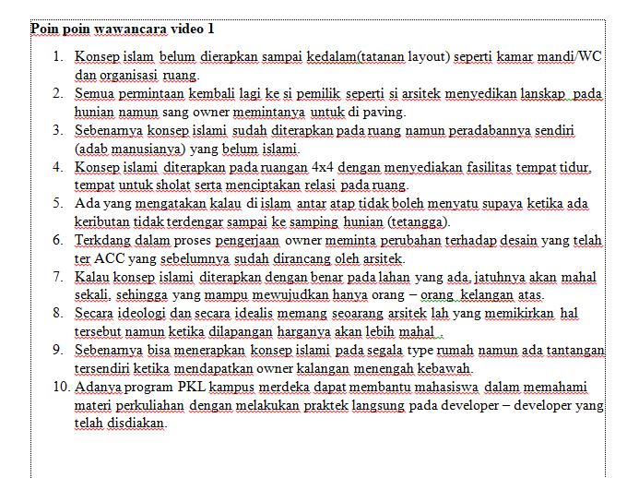

- Marketing Materials (Text and Visual)
Brosur, Sosial Media (Instagram),

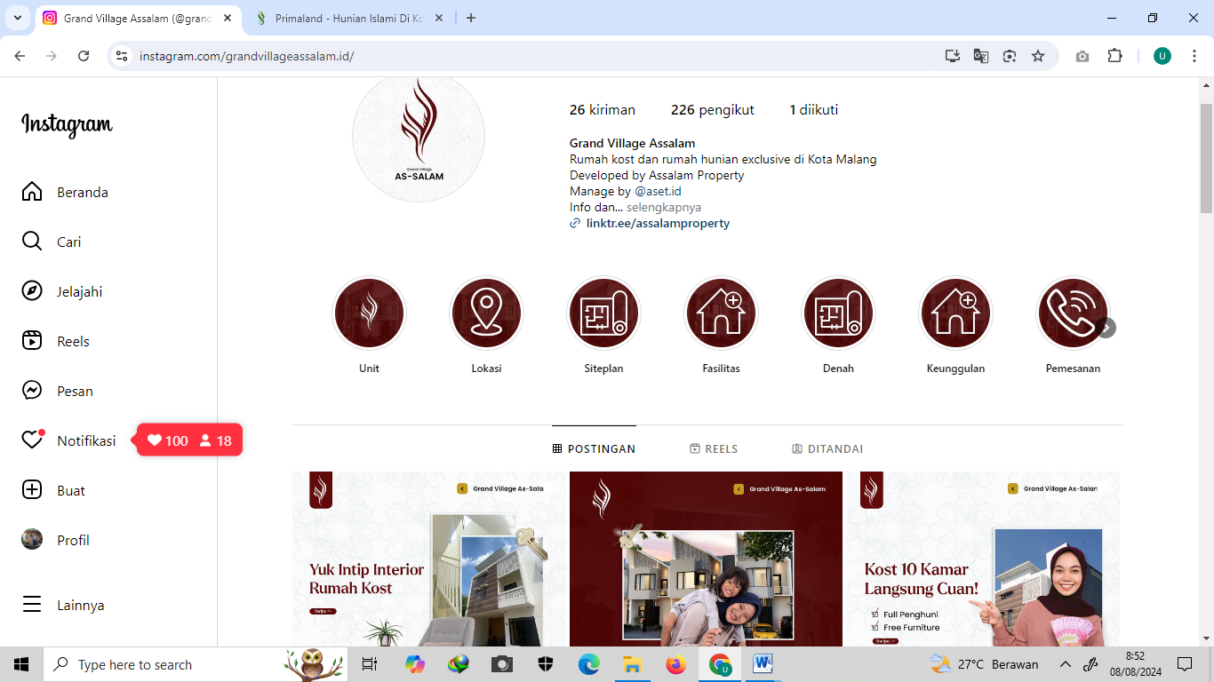

- Observation’s Field Notes (Text)
Checklist Pengumpulan Data

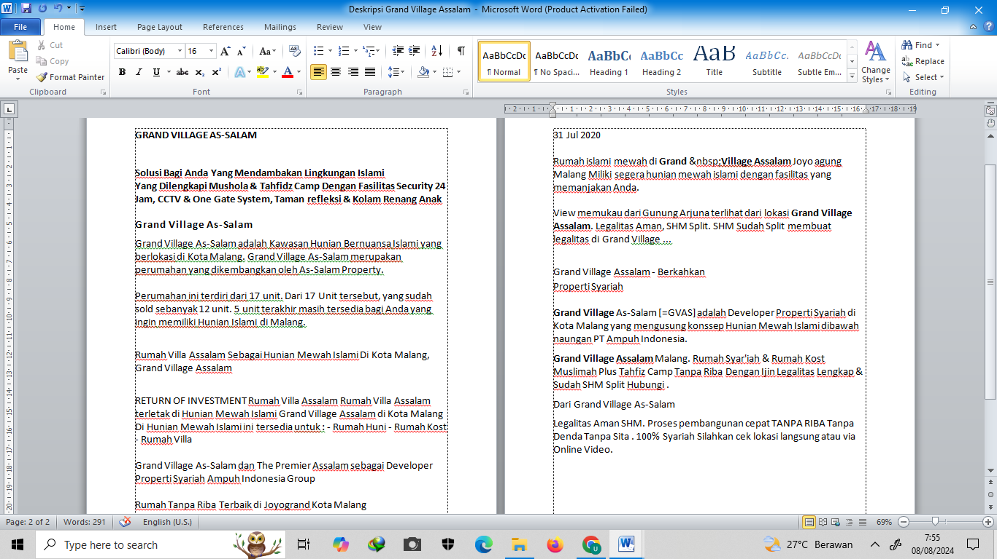

- Documentation (Visual)

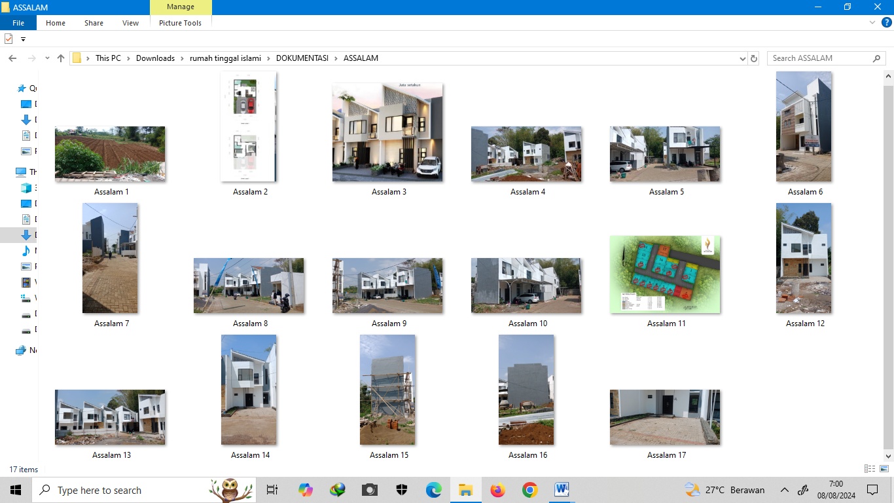

- GIS Mapping (Visual)

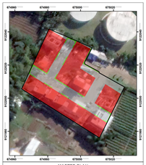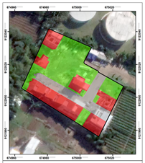
Master plan Project implementation

