 |  | JOURNAL OF ISLAMIC ARCHITECTURE  P-ISSN: 2086-2636 E-ISSN: 2356-4644  Journal Home Page: http://ejournal.uin-malang.ac.id/index.php/JIA
LIMINALITY THROUGH EID AL-ADHA IN HIGH-DENSITY SETTLEMENT KAMPUNG CIKINI
Nathasya Lintang Ayasha^{1*}, Evawani Ellisa¹, Achmad Hery Fuad¹
¹Department of Architecture, Faculty of Engineering, Universitas Indonesia, Indonesia
*Corresponding Author: nathasyalintang@gmail.com
ARTICLE INFO |  |  | ABSTRACT
Volume: 9  Issue: 1  Page: 233-246  Received: May 20th, 2024  Accepted: December 15th, 2024  Available Online: June 30th, 2026  DOI: https://doi.org/10.18860/jia.v9i1.27028 |  |  | This study explores the spatial dynamics of liminality in a densely populated informal settlement in Kampung Cikini, Central Jakarta, during the Eid al-Adha ritual. As in many urban kampungs, in Kampung Cikini, streets and alleys serve as multipurpose spaces where residents extend domestic activities into the public realm, reflecting their adaptability in navigating spatial constraints. The study uses qualitative methods, such as participant observation and interviews, to examine how this unofficial urban setting fosters rituals and social connections. The idea of liminality is used to comprehend how Kampung Cikini's spaces change during Eid al-Adha, demonstrating how small lanes foster intimacy and group ritual attention, thereby fortifying bonds within the community. Streets and alleys, regarded as transitory spaces, can present concerns with mobility ambiguity and environmental sustainability when they become ritual settings. The study suggested that this group's festivity should incorporate eco-friendly customs. The study adds to a larger conversation about the significance of informal spaces in influencing social practices and urban experiences by using the spatial analytic technique of liminality.  Keywords:  Eid al-Adha; Spatial Transformation; Urban Kampung, Liminality

INTRODUCTION
The persistent challenge of providing sufficient public spaces in densely populated informal settlements, in Indonesian cities referred to as "kampungs", remains an ongoing struggle. In a kampung, the streets or alleys initially intended for vehicles and pedestrians morph into multipurpose public spaces that accommodate many activities. In these areas, the absence of formal regulations and clear delineations between the private and public domains fosters fluidity in the use of space. It is commonplace for residents to extend their domestic activities beyond the confines of their homes, utilizing the alley's immediate surroundings for a myriad of purposes. These include washing clothes, storing belongings, cooking, and eating meals [1]. This adaptability and spatial transformation reflect residents' ingenuity and resilience in navigating their environment's spatial constraints to meet their daily needs, even on joyous occasions like weddings or sorrowful rituals like funeral ceremonies [2]. Urban public spaces are no longer excessively restricted and controlled, allowing people to regulate themselves according to their needs. Nevertheless, not all public spaces can spontaneously bring together various interests of everyday life. The space where these interests can meet is the liminal space between[3].
The concepts of liminality and transformation in architecture are intricately intertwined and pertain to transitional spaces. Liminal spaces serve as thresholds, representing a transition between two distinct states. Liminal spaces are ambiguous [4], act as extensions of dominant spaces [5], and mark a productive step toward a new state [6]. Liminal spaces can also be identified through deterritorialization, where signs of adjustment to spatial boundaries are found [7]. Both liminal and transformational spaces play crucial roles in fostering interactions and experiences that can alter perception [4]. Liminal spaces invite users to confront the unknown, challenging their preconceptions and assumptions.
Meanwhile, transformational spaces are designed to promote new behaviors and adaptations, enabling dynamic uses that serve the evolving needs of their occupants. In the temporary transition zone, human movement and response to movement can be studied as liminal [8]. To understand liminal conditions in a spatial transformation, it is necessary to involve experiences or rituals that bring humans to a different reality [9].
This research identifies spatial factors contributing to the development of liminal spaces in densely populated urban kampungs. The festival of Eid al-Adha in Kampung Cikini is examined as a means of representing liminality in high-density settlements. Kampung Cikini represents an urban kampung in big cities in Indonesia, with a population of 4,492 (based on 2024 demographic data for RW 01) living on 1.5 hectares. As in typical informal urban kampungs, the inhabitants live in solidarity and are excluded from the making and targeting of urban planning development plans [10].
Eid al-Adha, a festive occasion in the Islamic calendar, is rooted in the tradition of commemorating the profound lesson of sacrifice exemplified by Ibrahim, reflecting themes of obedience and devotion. In Indonesia, the jubilation of Eid al-Adha has been adapted to local cultures; thereby, its procedures are incorporated into indigenous cultural values and are spatially linked to local community culture and habits.
This study aims to elucidate the spatial factors related to liminality by analyzing the unique features of urban kampung and their adaptation to the requirements of the Eid al-Adha procession. Drawing on theories of liminality, field observations will scrutinize the ritual of Eid al-Adha in Kampung Cikini, a densely populated kampung in central Jakarta. It should be noted that the scope of this inquiry is limited to Kampung Cikini as the case study, which may constrain the generalizability of findings regarding liminality during the Eid al-Adha procession. However, it is envisaged that this analysis will offer fresh insights into the distinct characteristics of kampung and their spatial responses to religious rituals. Research questions included: (1) How does the theoretical concept of liminality enhance our understanding of the liminal characteristics of Kampung Cikini during the religious festival of Eid al-Adha? (2) What spatial factors shape the liminal nature of Kampung Cikini during Eid al-Adha festivities? (3) How does Kampung Cikini adapt and transform during Eid al-Adha celebrations, as influenced by the principles of liminality and spatial dynamics?

  - LIMINALITY AND TRANSFORMATION OF SPACE
Urban transformation is a frequently addressed phenomenon in planning and design as cities constantly evolve and adapt. A transformative, adaptable design approach is necessary for a thriving city to allow for correction [11]. Spatial transformation can occur for desired or undesired reasons[12]. The emphasis on power holders in a top-down design approach has resulted in numerous urban space transformations based on guerrilla movements [13] to bridge the gap between social and spatial interactions in the city [14].
Temporary transformations in public spaces can arise from community interventions with minimum and short-term intervention, known as tactical urbanism [15][16][17]. The objective is to reorganize public space in an innovative and revolutionary way by the community [18]. Alongside tactical methods, appropriation is frequently employed as a strategic and tactical technique [19]. The first is inflexible and regulated, whereas the second is impulsive and cooperative. Using areas for purposes other than their original intent is also considered an act of appropriation [20][19].
The discourse on spatial transformation and the creation of space beyond planning intersects with the concept of liminality. Turner [21] was the first to express this idea, noting that group members symbolically change from one status to another during a ritual process. The transitional state is called liminality. The transformation process entails alterations in space, time, and meaning, establishing a close relationship between liminality and experience [22]. Physical and mental transformations enable individuals to perceive distinctions between unfamiliar situations. Liminality possesses two defining characteristics: constructive and destructive [23]. Constructive liminality entails negotiation and adaptation, as transitional spaces retain existing values. Constructive transitional spaces create adaptable environments [24] and foster a dynamic spatial experience [25]. Destructive change occurs when the transitioning space abandons its previous value, which is deemed inconsistent with the intended values.
Liminality synthesizes opposing traits by allowing them to coexist [6]. It makes forming new configurations easier, improving the space's functionality. In urban design, the pursuit of inclusive spaces remains a fundamental objective. The liminal properties in urban spaces facilitate spatial transformation, creating opportunities to expand dominant spaces [5]. The liminal properties present in urban spaces promote the development of more inclusive and flexible environments [26][27][9][7]. Liminal properties in urban spaces facilitate ongoing transformation, creating diverse, participatory spaces within the city.

  - ROOTS OF EID AL-ADHA
In his book The Lawful and the Prohibited in Islam, Qaraḍāwī [28] stated that Eid al-Adha has its roots in the story of Abraham, who, in a solemn vow, pledged to sacrifice his son to fulfill God's will. Upon the birth of his son Ismael, Abraham remained steadfast to his vow. The narrative unfolds as Abraham repeatedly receives visions commanding him to sacrifice his son, showcasing his unwavering devotion to divine obedience. In recognition of his steadfastness and fidelity to his promise, God gave Abraham a beautiful ram from heaven, which he then offered as a sacrifice. Following this divine intervention, Abraham and his companions prepared the ram's liver as a meal, sharing the remaining parts with those in need. To commemorate this significant occasion, Muslims engage in the practice of sacrificing animals, symbolizing their commitment to faith and obedience [29].
Animal sacrifice occurs during the 10th, 11th, 12th, and 13th days of Dhu al-Hijjah, the 12th month in the Islamic lunar calendar. In the Gregorian calendar, these dates vary annually, advancing roughly 11 days earlier each year. These days coincide with the Hajj, the pilgrimage to Mecca, during which pilgrims converge to perform religious rituals [30]. The Quran emphasizes this religious duty, and the Prophet Muhammad also sacrificed animals throughout his life. The sacrifice in Islam aims to get closer to Allah, whether in the form of slaughtered animals or anything else. Imam Malik, Asy Syafi'i, said that the Qurban is not obligatory but sunnah for people who can afford it (wealthy) [31]. If someone still needs money to meet their basic needs, they are not required to perform the sunnah of sacrificing. The Prophet Muhammad recommended dividing the meat into three parts and distributing it among the needy, neighbors, and relatives. By doing so, the meat can be distributed to many poor homes.
Since Islamic tradition centers on Mecca as a focal point, the Eid al-Adha celebration is particularly grand, coinciding with the Muslim community's conclusion of the Hajj pilgrimage [32]. The jubilation of Eid al-Adha in various locations has been adapted to local cultures, incorporating local cultural values into its celebration. Egypt shares a celebration similar to Indonesia's, with neighborhood streets serving as gathering places for qurban animals. The slaughtering procession in Egypt is typically carried out and witnessed by men, while wives prepare feasts and children visit neighbors for socializing [33]. In Saudi Arabia, the Eid al-Adha celebration centers on the ritual of sacrificing animals in urban areas [30]. The urban animal slaughter process is carried out by the head of the family, with family members present as witnesses. After the animal is sacrificed, wives cook the traditional 'Al-Hamis' dish and enjoy the meal together. In Mauritania, Eid al-Adha celebrations also take place in households. The qurban animals to be sacrificed are raised in each household and slaughtered in their home courtyards [34]. This practice is linked to their belief that the soul of the sacrificed animal will protect their homes. In contrast, in Malaysia, mosques are customary to oversee Qurban ceremonies on behalf of the Qurban participants [35].

  - EID AL-ADHA IN INDONESIA
In Indonesia, where the Muslim population constitutes 95% of the country, observing Eid al-Adha holds immense significance, transcending mere religious observance to embody a deeply ingrained cultural tradition [36]. During each Eid al-Adha, the media consistently reports on the number of sacrificial animals contributed, particularly by government officials or local authorities [37]. Even in Eid al-Adha's smallest community gatherings, disclosing the number of sacrificial animals remains imperative, serving as a testament to transparency and accountability in performing sacrificial services. The celebration of Eid al-Adha in Indonesia also carries distinct characteristics that inject local culture into the festivities. Across different provincial cities in Indonesia, there are diverse ways to commemorate Eid al-Adha that resonate with local religious and cultural traditions [38]. These distinct customs exemplify how Eid al-Adha is not merely a religious observance but an occasion to fortify communal bonds [39].
Individuals seeking to perform a sacrifice begin searching for a suitable sacrificial animal several weeks or even months before Eid al-Adha. These animals are commonly procured from animal markets, specialized sacrificial animal traders, or zakat amil institutions coordinating urban programs. Typically, the animals purchased are cows and goats, with selection dependent on financial capacity and the quantity required to fulfill the sacrificial obligations. The sunnah encourages those who undertake the sacrifice to carry out the slaughter or witness the process personally. Conducting sacrifices within one's community is recommended, fostering closer ties with neighbors while facilitating the sharing of meat with relatives and nearby residents [40].
The sacrificial ritual can be conducted in any suitable and permissible location, such as a mosque, an open field, or a designated area arranged by the sacrificial committee. However, Islamic tradition advises that the slaughter take place in open spaces, particularly in areas where Eid al-Adha prayers are performed. Regardless of location, utmost attention should be given to cleanliness, health, safety, and animal welfare. The designated slaughtering area should be dry and segregated from public facilities. Additionally, it is essential to provide a separate space for meat cutting and handling offal, ensuring proper hygiene and sanitation practices throughout the process [32].
The Eid al-Adha ritual traditionally requires a spacious, open area to enable the community to participate in the activities in a conducive setting. Eid al-Adha in Indonesia commences with the Eid prayer, usually performed collectively in mosques or public spaces such as fields, town squares, and even streets. While numerous guidelines exist, the specifics of how these rules are applied, such as the accommodation of the Eid prayer on the street, are not strictly dictated. This flexibility allows the community to interpret their religious duties, local customs, and spatial constraints in ways that foster traditions that persist to the present day. Spatial limitations are seen not only as an isolated condition but also as part of everyday life and as an attempt to adopt a community perspective on the living environment [41].

  - PROCEDURES OF QURBAN
The tradition of publicly slaughtering sacrificial animals dates back to ancient times and has been observed across diverse cultures and religions worldwide as a form of worship or religious expression [42]. However, during Eid al-Adha, while the sacrificial slaughter is also conducted in public, the primary objective is to demonstrate transparency in the execution of the sacrificial service [40]. Beyond technical and spiritual considerations, the exposure to sacrificial rituals offers a valuable opportunity to impart moral education, particularly to the younger generation, including children. In detail, to ensure compliance with the technical requirements for proper slaughter and food safety, specific guidelines dictate the facilities and equipment that must be made available, including: (1) A shaded area or roofed structure to provide protection from the elements during the slaughter process; (2) Blood collection hole, with dimensions vary based on the number and size of animals to be slaughtered; for every 10 goats/sheep: width 0.5 m, length 0.5 m, depth 0.5 m; for every 10 cows/buffalo: width 0.5 m, length 0.5 m, depth 1.0 m, (3) A sturdy wooden block measuring 7 cm x 15 cm x 75 cm to support the neck during slaughter; (4) A durable rope with a diameter of 2 cm for securing the animal during the process; (5) A high-quality, sharp stainless steel knife, along with a cutting board, meat container, and plastic mat for cleanliness and hygiene; (6) Equipment for sharpening the knife to maintain its cutting efficacy; (7) Adequate clean water for washing and sanitising hands, equipment, and the slaughter area; (8) Soap for handwashing and maintaining hygiene standards throughout the process [43].
Eid al-Adha celebrations in Indonesia tend to be democratic, in that Muslims are allowed to determine how qurban is implemented based on each community's comfort and capabilities[44]. The spaces around settlement areas are reinterpreted and rearranged to facilitate the implementation of activities. It involves open spaces such as streets, fields, or vacant lots, as well as private spaces such as homes, which undergo territorial negotiations and arrangements to support execution. The temporary functions that fill everyday spaces in these settlement areas then become the subjects of this study regarding the flexibility of urban spaces, particularly in the specific morphology of the kampung, and the factors that influence this flexibility.
In most urban kampungs in Indonesia, spatial transformations are readily discernible through shifts in daily routines leading up to the Eid al-Adha festivities [45]. Preparations for the celebration engender heightened interaction among residents, infusing the kampung spaces with vibrancy as the community transitions towards the qurban event. Evidence of this transition is apparent in the storage of sacrificial animals, the cleaning of yards and roads, and the adornment of the area with banners and street lights. These subtle alterations in daily practices signify the ongoing period of transformation. In this sense, the daily activities and rituals during Eid al-Adha held in Kampung Cikini are studied in detail to understand the spatial transformation tendencies of urban kampungs in Indonesia.

METHODS
The basis of this study is Turner’s theory that liminality is foundational for understanding transformative social processes in rituals [21]. It employs a qualitative research methodology that emphasizes both participation and observation. Researchers engaged with local residents in dual roles [46]: as active participants in the Eid al-Adha festival and as observers precisely recording events and descriptions for a comprehensive perspective A carefully designed methodological strategy guided the data collection, which included: (1) one researcher observed and documented interactions between residents and their environment into logbook; (2) another researcher captured photographs and videos focusing on the spatial adaptations made during the celebration; and (3) the integration of findings from (1) and (2) accelerated a distinction understanding of social interactions among residents and the spatial patterns that emerged throughout the ritual. This structured approach allowed for a richer depiction of the dynamics process during the Eid al-Adha celebration.
Data analysis for this study utilized a combination of visual [47] and narrative methodologies. The data from the logbook, video, and photographs were examined in detail to understand how the spaces in Kampung Cikini were transformed in the context of liminality during Eid al-Adha. To mitigate potential biases stemming from the research team's dual role as participants and researchers, interviews were conducted with residents who actively participated in the ritual. This approach aimed to validate the researchers' analyses by incorporating community members' perspectives, thereby minimizing the influence of the researchers' subjective experiences on the findings. The interviews were carefully structured to elicit residents' insights regarding the rituals and the spatial dynamics during the celebration. The data from the interviews were analyzed using thematic coding [48], which facilitated the identification of recurring motifs and narratives. This comprehensive analytical framework enriched the understanding of the complex interactions between space and social practices during the Eid al-Adha ritual. According to Lefebvre [49], space and its implications are socially produced. The study's analytical framework included examining movement patterns, spatial use, spatial interpretations, and spatial elements. These factors contributed to the process of spatial transformation, revealing how they are catalyzed by liminality during the ritual of Eid al-Adha. By framing the methodology within established qualitative research practices, the potential for bias was minimized, enabling a rigorous and valid exploration of the spatial dynamics of this significant cultural event.

RESULT AND DISCUSSION

RESULT
The discussion in this section covered the parameters that have been explained previously, which are based on three criteria that form liminal space: (1) the chance to overlap, (2) the transition of experiences, and (3) the act of having to pass through. To examine how Kampung Cikini's limited spaces are converted into liminal spaces, observations assessed against these three criteria were paired with unstructured interviews with all parties involved in the Eid al-Adha ritual activities.

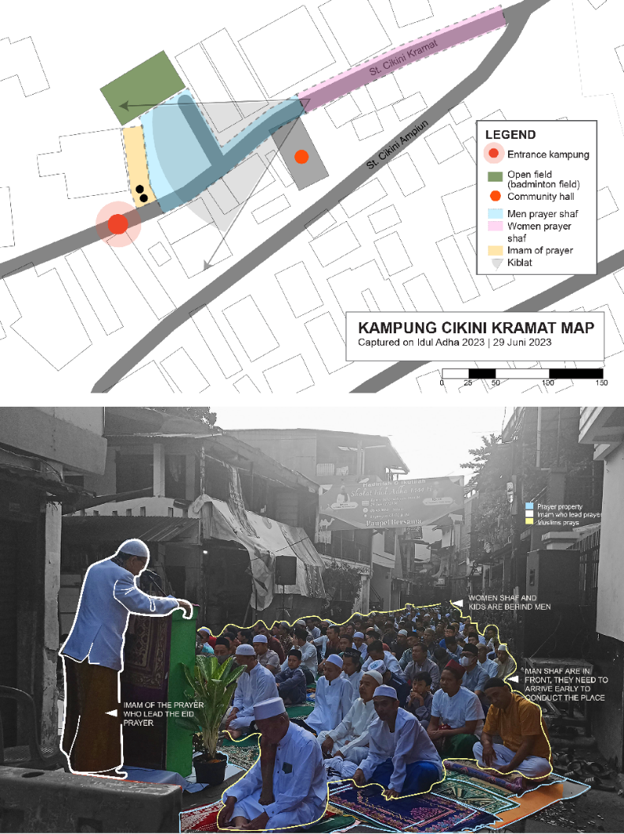

Figure 1. The condition and settings of the Eid al-Adha Prayer held in Cikini Kramat St.

3.1.1 Preparation of Eid-Al Adha in Kampung Cikini
Kampung Cikini is located in the city's central region and accessible via several entrances. The Central Jakarta government formally recognizes Kampung Cikini's leadership structure, which is assigned to Kampung Cikini as RW 01 from the Pegangsaan subdistrict (Menteng District). Thirteen RT Heads and one RW Head oversee RW 01's operations. Like many urban kampungs, Kampung Cikini features a labyrinth of slender streets and alleys lined with compact, tiny houses. High building density, limited access, and open space are part of this area's identity. Within this kampung runs the Kali Keroncong, a five-meter-wide canal constructed during the colonial period primarily as a city drainage channel, which ultimately flows into the Ciliwung River. Additionally, the kampung is equipped with rainwater drainage sewers along the alleys, which collect rainwater and household wastewater and eventually direct it into the Kali Keroncong before flowing into the Ciliwung River (Fig. 1).
The Eid al-Adha celebration begins with Eid prayers, which must be performed before Dzuhur. It commences with a collective takbiran, where the community chants the glorification of Allah after the morning prayers, continuing until the sun ascends. At 07:20, the congregational Eid prayer started. Hence, its implementation requires a space large enough to accommodate all Muslims living in Kampung Cikini. The location was around the RW center (Bale Kini) and the Badminton Field on the kampung's main street, Jalan Cikini Kramat. This field is used daily as a gathering place for kids to play, for men's security patrols, or for other public activities. The Eid prayer itself is a sacred activity; when performing prayers, Muslims must keep themselves clean and perform ablution (wudu). Because of this, the prayer location must also ensure sacredness and purity. Jalan Cikini Kramat was transformed into a dedicated space for Eid prayers through a meticulous process. The street was adorned with repurposed banners, protective tarpaulins, and personal mats, creating a comfortable and hygienic prayer area. Each individual's prayer mat (sajadah) was carefully placed, ensuring a sacred, organized environment. This setting adjustment creates a different ambience rather than everyday realms. The Eid prayers commenced under the guidance of an imam positioned on the pulpit before the congregation. Adhering to the tradition of shaft formation, worshippers were segregated by gender, fostering a sense of unity and reverence (Fig. 1).

3.1.2 Qurban Procession in Kampung CikinI
The RW Head conducted a democratic deliberation among the management of RW 01 Kampung Cikini to determine the location of the sacrifice. This procedure was chosen because, in the past, several RTs made their own sacrifices, which complicated management of both distribution and sanitation afterward. Based on discussions with all residents, three locations have been designated as permanent locations for the past ten years.

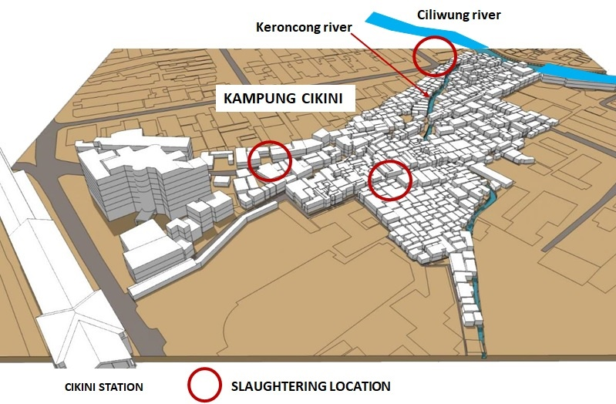

Figure 2. Kampung Cikini and the three-slaughtering locations
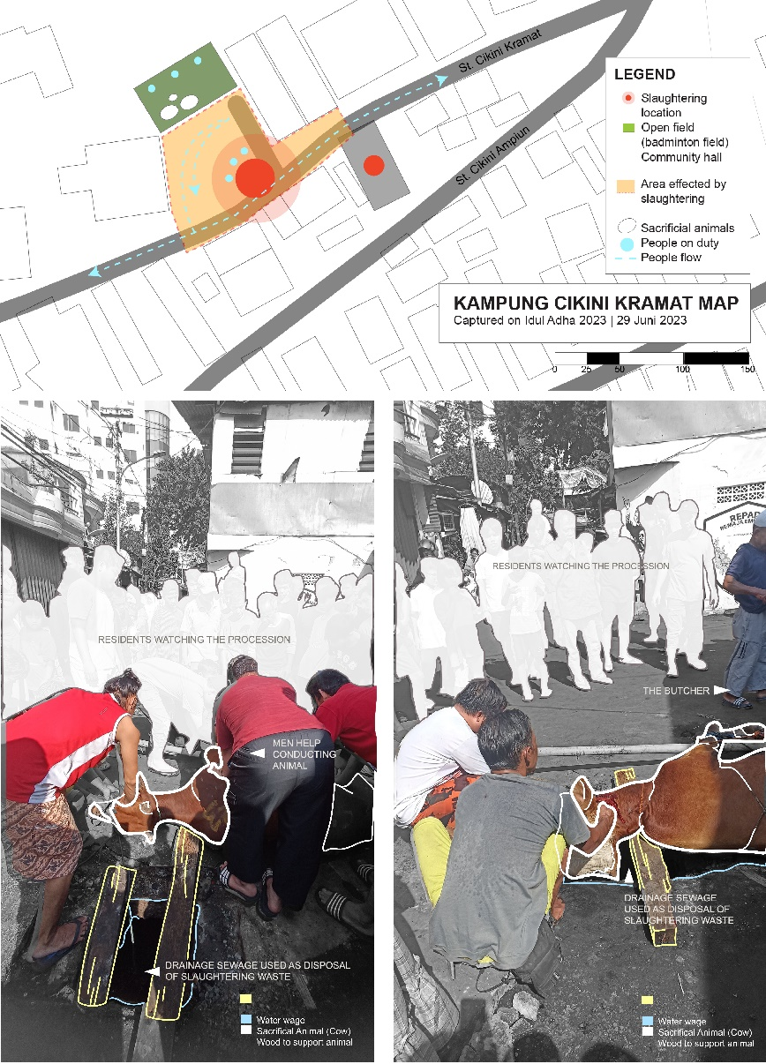
The first location is the same for Eid Prayers (Fig. 3 and Fig. 5a). Here, they sacrificed two cows and four sheep. As shown in Figure 3, the street's drainage sewage was repurposed as a disposal area. The sewage also served as a marker for delineating where slaughtering activities can take place. As shown in Figure 3, the street’s drainage sewage was repurposed as a disposal area. In addition to this practical use of the drainage sewage, the location conveniently borders the badminton field, providing ample space to place sacrificial animals temporarily. This spot proved to be the optimal choice for slaughtering due to its convenient accessibility and sufficient capacity to allow spectators to observe comfortably. Vehicular traffic of motorbikes and bicycles continued to flow through the area, mainly because Cikini Kramat Street serves as a primary thoroughfare for local residents and functions as a vital shortcut connecting east-west access routes. It also illustrated that the activity did not necessitate the street's closure.

Figure 3. The slaughtering process at Cikini Kramat Street

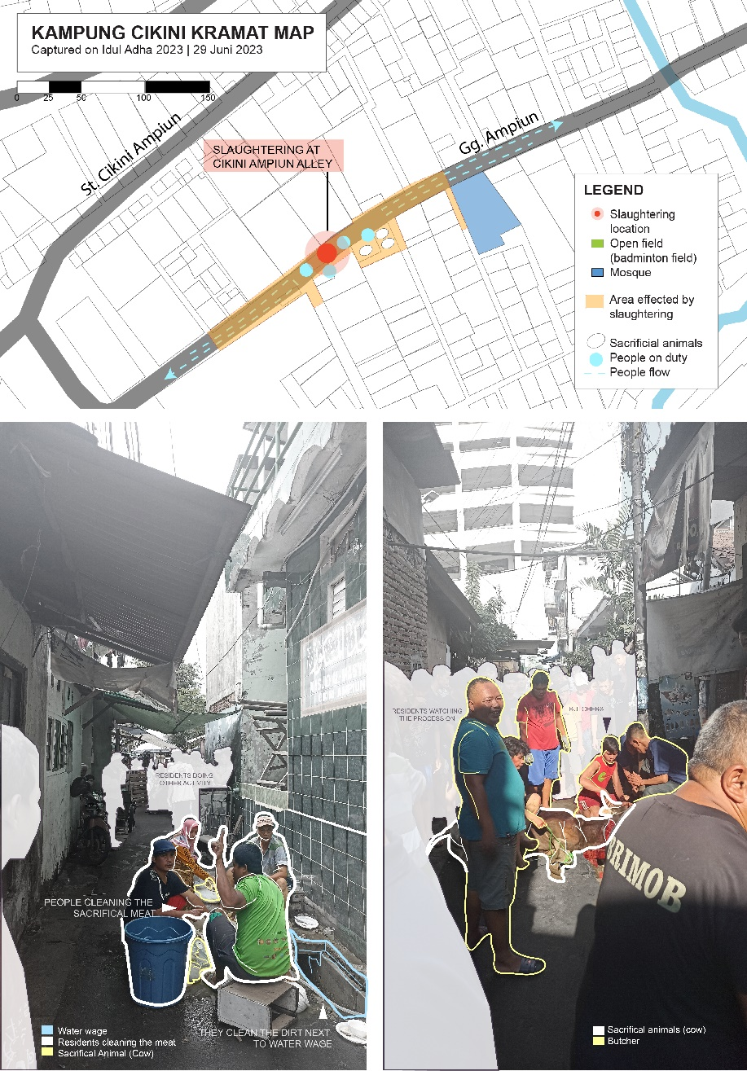
The second location was in Gang Ampiun, a bustling alley lined with houses and home-based petty businesses, which served as the primary access for motorbikes. Although just an alley, this space meets many needs, thanks to its intimate public spaces compared to other areas. The façades of houses facing the alley are used for business and activities that invite interaction. It supports the emergence of intersecting interests that yield flexible, adaptive interpretations of space, enabling spontaneous transitions in experience during the sacrifice. Here, the community sacrificed four cows and four goats. During the Qurban period, the community closed the alley because it could only accommodate two to three people at a time. Limiting motorbike access means residents will hardly be able to go anywhere during the Qurban procession. Some residents generously offered to use their yards as temporary storage space for sacrificial animals for several days. Given the alley's dimensions, the slaughtering process was significantly quicker and more efficient than the previous location. The sacrificial animals were promptly transferred from the residents' yards to the alley, where prayers were immediately recited before the sacrifice. Notably, the size of a sacrificial animal, especially a cow, nearly matches the alley's width. It presents a challenge for the butchers to maneuver the animal to ensure its head is correctly positioned on a wooden beam or above the ditch for disposing of animal blood. The slaughter process becomes notably simpler once the animal is correctly positioned and allowed to fall. At this site, four cows and four goats were sacrificed (See Fig. 4 and Fig. 5b).
Figure 4. Slaughtering at Ampiun Alley and how people deal with the waste
The third location was at the intersection of Cisadane Street and Cilosari Street. The location connects with two distinct settlements: upscale high-class housing and a kampung. Although the location is significantly larger than the previous two, it presented a unique challenge: the intersection lies outside Kampung Cikini's administrative boundaries, requiring more stringent permits and adjustments. Consequently, residents were required to maintain higher standards of hygiene and cleanliness at this site to prevent visual, olfactory, and environmental contamination. The residents confined the area designated for slaughtering to street sections delineated by plastic banners. This measure is intended to prevent direct contamination of the street surface by slaughtering waste, such as blood. Moreover, since this road intersection connects directly to Cikini Raya Street, an effective waste management plan was imperative. As at the other two sites, the entire slaughtering procedure and distribution of sacrificial meat were conducted on-site. Consequently, optimizing the process's efficiency was essential to ensure that the ritual activities did not disrupt other uses of the space, such as vehicular traffic (Fig. 5c).
Based on observations conducted at three locations where the sacrifice was implemented, several similarities emerged in the criteria for the required space: legibility and flexibility. Legibility is a criterion that directly influences ease of access, public participation, and the festivity of activities, and it indirectly responds to religious obligations that must be carried out gracefully and collectively. Putting aside limitations of movement and environmental issues, residents' efforts to perceive and organize space with various properties that support sacrificial activities are significant aspects of liminality in spatial transformation.
Another similarity was the sanitation challenge. Kampung Cikini arises from narrow alleyways, where slaughterhouse blood waste is disposed of by using the existing sewage along the alley's edge. This practice, prompted by space constraints and the complete paving of surfaces, results in waste being funneled into the sewage system without adequate treatment. According to Islamic guidelines, such waste should be buried in soil, but the lack of available ground in Kampung Cikini makes this impossible. Consequently, the drainage system discharges into Kali Keroncong, contaminating the Ciliwung River. However, this situation has not raised concerns among residents, as the drainage channel has long been regarded as a conduit for sewage, and pollution of the Ciliwung River has been an ongoing issue for years.
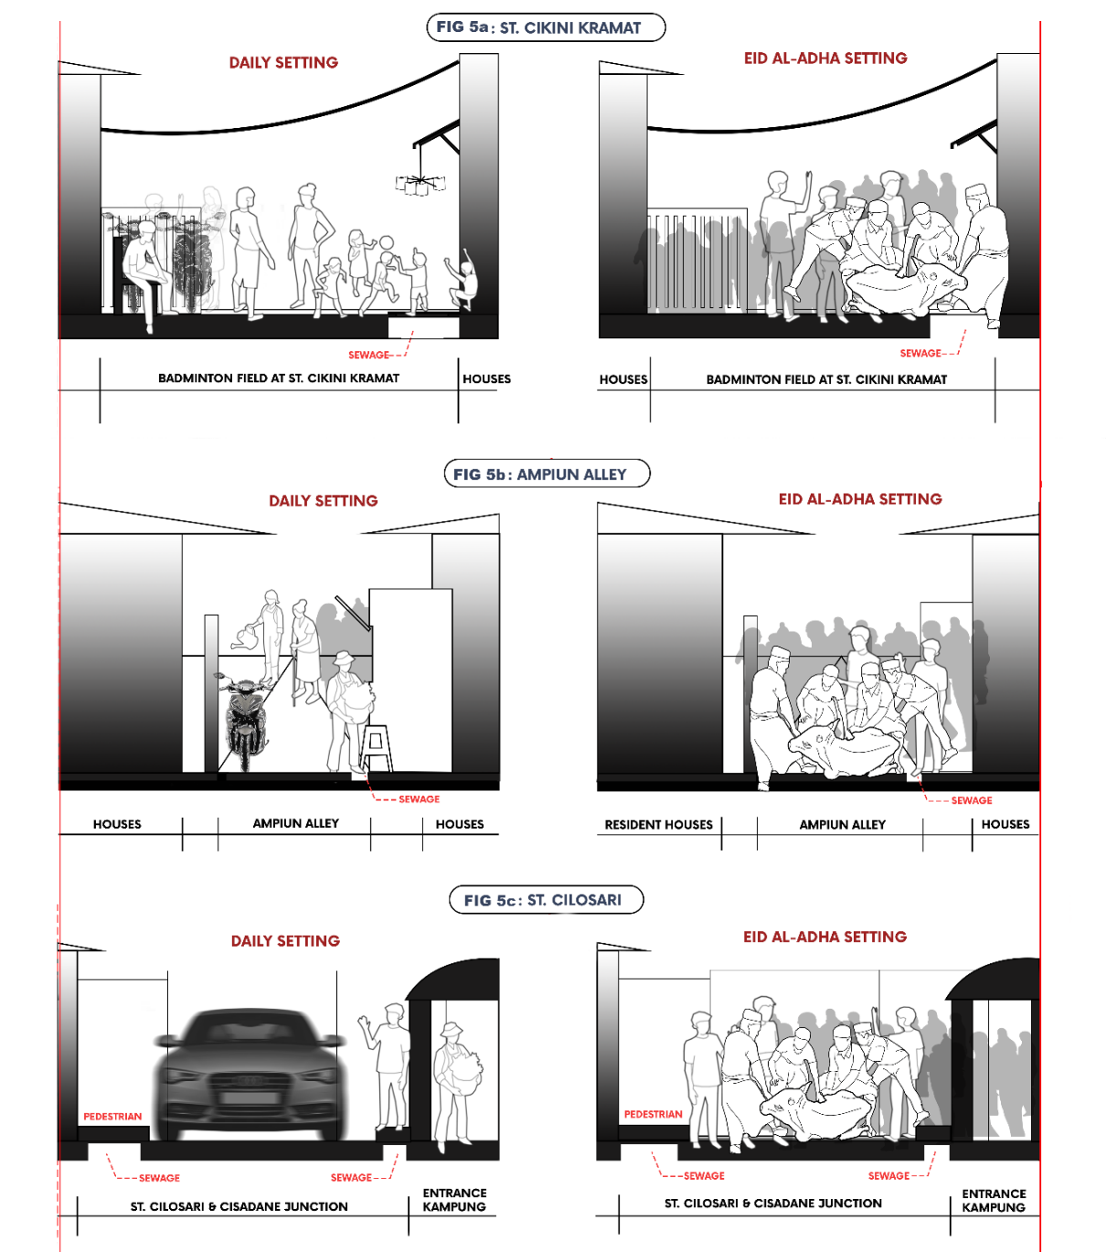
Figure 5. (a) Transformation of setting before and during qurban in Cikini Kramat St (b) Transformation of setting before and during qurban in Ampiun alley (c) Transformation of setting before and during qurban in Cilosari St.

3.1.3 Post-Qurban Celebration
After the slaughtering process, residents began cleaning up the mess. Generally, cleaning and cutting meat must be done in a separate hygienic place. However, due to limited space, the people of Kampung Cikini clean and cut meat at places deemed appropriate by their preferences. They used the same place where they slaughtered the animals, but before that, they cleaned the mess, especially the blood. By continually using the drainage channels to dispose of animal blood without proper treatment, the community inadvertently contributes to a cycle of pollution that affects not only the immediate environment of Kampung Cikini but also downstream areas connected to the Kali Keroncong and Ciliwung Rivers. After the slaughtering, the meat was divided into bags containing 1 kilo of mixed meat (lamb and beef). The community members returned to the slaughterhouse and collected their portions of meat.
In Kampung Cikini, as is the case with many urban kampungs throughout Indonesia, residents often gather to cook and share the qurban meat with their immediate neighbors. Collaboratively, they prepare meals for their families: fathers clean the meat in sewage at the alley's edge, while mothers prepare the cooking spices while keeping an eye on their children. Since Kampung Cikini is a densely populated area with limited space, neighbors who gather to cook and eat are prominently observed along all the alleys. This tradition of communal cooking is also a longstanding practice in other kampungs and serves as a form of communal entertainment, enhancing the community spirit.
During the Eid al-Adha procession, from preparation, Eid Prayers, and the slaughtering, distribution, and communal celebration, the street and alleys were transformed into places for rituals, making the area's accessibility increasingly limited. There is much human congestion, but it is also another attraction. People passing by can then be involved in the festivity and camaraderie of residents. This event is also seen as an opportunity for street vendors to sell before and after the ritual, which creates a sense of liminality [22] that engages the ritual spectator.

3.2 DISCUSSION
During Eid al-Adha, every slaughterhouse in Kampung Cikini serves as a transitional space, where locals move from everyday activities to more intense social and spiritual interactions. The ground that has been transformed for sacrifice on Jalan Cikini Kramat acts as a barrier between the holy rite of animal slaughter, everyday activities that do not involve ritual, and the sacred activity of Eid al-Adha. It exemplifies the concept of a transitional area that enables people to face the unfamiliar and question their preconceptions about public space [21] [22]. Similarly, Gang Ampiun was converted from a little alleyway into a ritual place that was centered on the slaughtering process and the community.
In all sites, community members negotiate and modify existing spaces to accommodate the action of sacrifice through constructive liminality. In Gang Ampiun, the proximity of residences and warungs, or local retail establishments, led to varied interpretations of public space and facilitated encounters that promoted the ritual process. Adaptive behavior in transitional zones is further demonstrated by residents' cooperation in using their yards as makeshift animal storage sites [24][25]. The slaughter demonstrates a more controlled form of constructive liminality at the third location, the junction of Cisadane and Cilosari, where locals must follow more stringent management and hygiene procedures because it lies outside the kampung boundary and is adjacent to upper-class housing.
The liminal space in sacrificial activities encouraged deterritorialization, transforming commonplace locations to accommodate the community's evolving demands [6]. Through shared rituals, the urban landscape's new arrangements foster communal relationships and dynamic involvement with the environment. The physical layout of the slaughtering areas at each location and the use of drainage basins for waste disposal represent significant changes to spatial boundaries.
The ritual has promoted inclusion and adaptability in urban planning by converting public areas into hubs for interaction and cooperation. The liminality that permeates these rituals makes a range of experiences and interactions possible, thereby promoting identity among residents [5][26]. Street areas' flexibility demonstrates their capacity to support a range of uses depending on the community's needs, enhancing both public life and cultural identity.

CONCLUSION
As the concept of liminality continues to evolve, the discussion surrounding the Eid al-Adha ritual in Kampung Cikini offers new insights into how rituals manifest within the unique confines of a densely populated urban kampung. Traditionally associated with transformation and threshold spaces, the ties between liminality and spatial-cultural dynamics warrant deeper exploration. By examining how space is reconceived and utilized during this significant religious event, valuable insights emerge into the symbiotic relationship among the physical environment, the unfolding ritual practices, and the communal life animating these spaces. This perspective enriches perceptions of liminality and emphasizes the adaptive and collaborative nature of community practices amid urban spatial constraints.
This preliminary finding suggests that residents perceive streets and alleys as transitional boundaries that facilitate rituals in their communal spaces, thereby introducing a sense of liminality into the celebration. However, further analysis reveals that these thoroughfares serve as essential elements for transformation, not merely by chance, but because they are integral to community engagement. Due to the densely populated environment, residents adapt to limited living areas by utilizing streets as extensions of their communal space. Consequently, significant activities, including the entire Eid al-Adha procession, take place predominantly in these areas.
Specific spatial characteristics of the streets profoundly influence the ritual transformation. The narrowness and confined layout of these pathways, along with limited visibility, enhance sensory experiences and foster a heightened sense of intimacy among residents. This confinement directs collective attention and energy towards the Eid al-Adha rituals, reinforcing communal bonds. Furthermore, the streets act as dynamic conduits of life, facilitating a continuous flow of activities. However, spatial constraints introduce movement ambiguity as residents navigate, shift, and engage in various activities within the compact confines of streets and alleys. This blending of movement and function underscores adaptability and communal harmony, transforming everyday pathways into arenas of shared cultural expression.
Ultimately, the Eid al-Adha ritual in Kampung Cikini exemplifies how communal spaces serve as platforms for shared experiences and activities that reinforce community ties and cultural identity. The rituals bring people together and transform the urban landscape, infusing it with purpose and a collective spirit. In this context, the practices surrounding Eid al-Adha provide a lens through which to examine the dynamics of communal life, environmental stewardship, and cultural continuity. However, these practices also pose challenges, such as the environmental impact of ritual waste disposal, highlighting the need to re-evaluate traditional practices towards sustainability. The call for alternative waste management solutions underscores the importance of integrating environmental consciousness within these significant rituals.

AUTHORS CONTRIBUTION
Author 1: Conceptualization, Methodology, Investigation, Data curation, Visualization, Writing the original draft. Author 2: Supervision, Conceptualization, Methodology, Writing–review & editing, Project administration. Author 3: Supervision, Writing Review. All authors discussed the results and contributed to the final manuscript

ACKNOWLEDGEMENT
This research was funded by the Universitas Indonesia Program of Hibah Publikasi Terindeks Internasional (PUTI) Q1 2024-2025, with contract Number NKB-486/UN2.RST/HKP.05.00/2024.

REFERENCES

[1] E. Ellisa, “COPING WITH CROWDING IN HIGH-DENSITY KAMPUNG HOUSING OF JAKARTA,” International Journal of Architectural Research: ArchNet-IJAR, vol. 10, no. 1, p. 195, Apr. 2016, doi: 10.26687/archnet-ijar. v10i1.790.
[2] W. H. Fijriah and E. Ellisa, “Space of Worship in High-Density Informal Settlements: Case Study of Kampong Cikini Kramat, Jakarta,” The Journal of Social Sciences Research, no. SPI6, pp. 591–598, Dec. 2018, doi: 10.32861/jssr.spi6.591.598.
[3] P. Aelbrecht, Fourth Places: Informal Social Life and Interaction in New Designed Public Spaces. Cham: Springer International Publishing, 2022. doi: 10.1007/978-3-031-07946-7.
[4] E. Bottalico, A. Kortbaek, and G. Ottolini, “A Study of Urban Liminal Space and Creativity,” 2013.
[5] H. Shortt, “Liminality, space and the importance of ‘transitory dwelling places’ at work,” Human Relations, vol. 68, no. 4, pp. 633–658, Apr. 2015, doi: 10.1177/0018726714536938.
[6] J. Banfield, “From liminal spaces to the spatialities of liminality,” Area, vol. 54, no. 4, pp. 610–617, Dec. 2022, doi: 10.1111/area.12791.
[7] B. Sletto and J. Palmer, “The liminality of open space and rhythms of the everyday in Jallah Town, Monrovia, Liberia,” Urban Studies, vol. 54, no. 10, pp. 2360–2375, Aug. 2017, doi: 10.1177/0042098016643475.
[8] T. Ingold, “The Perception of the Environment,” in Livelihood: Dwelling and Skill, London: Routledge, 2000.
[9] J. Liedgren, P. M. A. Desmet, and A. Gaggioli, “Liminal design: A conceptual framework and three-step approach for developing technology that delivers transcendence and deeper experiences,” Front Psychol, vol. 14, Feb. 2023, doi: 10.3389/fpsyg.2023.1043170.
[10] E. Ellisa et al., “Community appropriation of communal sanitation,” Indonesia Malay World, vol. 51, no. 149, pp. 1–26, Jan. 2023, doi: 10.1080/13639811.2023.2170085.
[11] J. Lerner, “DISTURBING THE ORDER OF THINGS,” in Tactical Urbanism: Short-term Action for Long-term Change, M. Lydon and A. Garcia, Eds., Washington: Island Press, 2015, ch. 1.
[12] T. Elmqvist et al., “Sustainability and resilience for transformation in the urban century,” Nat Sustain, vol. 2, no. 4, pp. 267–273, Apr. 2019, doi: 10.1038/s41893-019-0250-1.
[13] J. Hou, Insurgent Public Space. New York: Routledge, 2010.
[14] S. Vallance and S. Edwards, “Charting New Ground: Between Tactical Urbanism and Strategic Spatial Planning,” Planning Theory and Practice, vol. 22, no. 5, pp. 707–724, 2021, doi: 10.1080/14649357.2021.1966081.
[15] M. Lydon and A. Garcia, Tactical Urbanism: Short-term Action Long-term Change. Island Press, 2015.
[16] P. N. G. Akbar and A. Jachnow, “The permanency of temporality: how grassroots festivals in Indonesia create places in informal settlements,” Journal of Place Management and Development, vol. 15, no. 4, pp. 533–550, Sep. 2022, doi: 10.1108/JPMD-06-2020-0062.
[17] P. Silva, “Tactical urbanism: Towards an evolutionary cities’ approach?” Environ Plann B Plann Des, vol. 43, no. 6, pp. 1040–1051, Nov. 2016, doi: 10.1177/0265813516657340.
[18] K. Iveson, “Cities within the City: Do‐It‐Yourself Urbanism and the Right to the City,” Int J Urban Reg Res, vol. 37, no. 3, pp. 941–956, May 2013, doi: 10.1111/1468-2427.12053.
[19] J. A. Lara-Hernandez, “Temporary appropriation: Theory and Practice of the Street,” 2019.
[20] H. Lefebvre, “The Right to The City,” in Writing on Cities, Oxford: Blackwell, 1996, pp. 147–159.
[21] V. Turner, “Betwixt and Between: The Liminal Period in Rites de Passade,” in The Forest of Symbols, 1967, pp. 93–111.
[22] F. Cangià, Liminal Moves: Travelling along Places, Meaning, and Time, 1st ed. Oxford, New York: Berghahn Books, 2021.
[23] T. Bjorn, “The Uses and Meaning of Liminality,” International Political Anthropology, vol. 2, no. 1, pp. 5–28, Mar. 2009.
[24] A. Szakolczai, “Liminality and experience: structuring transitory situations and transformative events,” International Political Anthropology, vol. 2, pp. 141–172, 2009.
[25] H. Andrews and L. Roberts, Liminal Landscapes: Travel, experiences, and spaces in-between. Taylor&Francis, 2012.
[26] S. L. Brandt, “The City as Liminal Space: Urban Visuality and Aesthetic Experience in Postmodern U.S. Literature and Cinema,” 2009.
[27] P. Hasdell, “Liminal Urbanism: The Emergence of New Urban ‘States,’” 2016.
[28] Y. Al-Qaraḍāwī, The Lawful and the Prohibited in Islam (Al-Halal Wal Haram Fil Islam). American Trust Publication, 1994.
[29] A. S. Mainiyo and M. M. Sule, “Impact of Qur’anic Moral Excellence on the Lives of Muslim Society: An Exposition,” Demak Universal Journal of Islam and Sharia, vol. 1, no. 3, pp. 188–205, Dec. 2023.
[30] R. Firestone, “Journeys in Holy Lands: The Evolution of the Abraham-Ishmael Legends in Islamic Exegesis,” 1990.
[31] T. W. Hidayati, “REFORMULATION OF THE SOCIAL SAFETY NET: A CONCEPTUAL APPROACH BASED ON QUR’ANIC VALUES,” Analisa: Journal of Social Science and Religion, vol. 7, no. 1, pp. 1–18, Jul. 2022, doi: 10.18784/analisa. v7i1.1590.
[32] S. A. Khalīl, Atlas of the Prophet’s Biography: Places, Nations, Landmarks. Darussalam, 2004.
[33] N. Sewidan, “Eid al-Adha, Festival of Sacrifice,” Oregon Humanities.
[34] M. Sajad, “Prayer, henna, charity: Eid al-Adha traditions around the world,” Al Jazeera Media Network, Qatari, 2023.
[35] J. Md Salleh, N. A. Kedin, S. B. Sulaiman, and M. A. Mahat, “The Muslim Community’s Understanding of the Basic Laws of Qurban Distribution,” International Journal of Academic Research in Business and Social Sciences, vol. 13, no. 1, Jan. 2023, doi: 10.6007/IJARBSS/v13-i1/15132.
[36] A. Tarlam, Zaenudin, and Jamali, “Unique Tradition of Eidul Adha Celebration In Indonesia (Thematic Study Of The Qur’an),” Risalah: Jurnal Pendidikan dan Studi Islam, vol. 9, no. 3, pp. 1293–1297, Sep. 2023.
[37] A. Widya, “President Jokowi Gives Sacrificial Cows to 38 Indonesian Provinces,” https://www.viva.co.id/english/1612251-president-jokowi-gives-sacrificial-cows-to-38-indonesian-provinces, Jun. 24, 2023.
[38] R. Andika, “Pawai takbir semarakkan perayaan Idul Adha di Kota Palangka Raya,” Antara News: https://kalteng.antaranews.com/berita/643581/pawai-takbir-semarakkan-perayaan-idul-adha-di-kota-palangka-raya, Kalimantan Tengah, Jun. 28, 2023.
[39] D. Daniswara, “Tradisi Kaul dan Abda’u, Prosesi Penyembelihan Kambing Saat Idul Adha di Tulehu,” https://regional.kompas.com/read/2022/07/01/175416978/tradisi-kaul-dan-abdau-prosesi-penyembelihan-kambing-saat-idul-adha-di?page=all, Maluku, Jan. 17, 2022.
[40] C. Mahfud, “TAFSIR SOSIAL KONTEKSTUAL IBADAH KURBAN DALAM ISLAM,” HUMANIKA, vol. 14, no. 1, Sep. 2014, doi: 10.21831/hum.v14i1.3331.
[41] M. S. al Janabi, N. F. Aziz, and J. B. Motlak, “Methods and Challenges of Community Participation Practices in Planning Public Open Spaces: A Review,” International Society for the Study of Vernacular Settlements, vol. 11, no. 2, pp. 192–209, Feb. 2024, doi: 10.61275/ISVSej-2024-11-02-13.
[42] N. Chaachouay and L. Zidane, “The importance of animals in sacrificial rituals and socio-religious occasions practised by the indigenous communities of Morocco and strategies to conserve them from extinction,” Biologia (Bratisl), vol. 79, no. 3, pp. 753–773, Nov. 2023, doi: 10.1007/s11756-023-01548-7.
[43] B. Gandapurnama, “Panduan Lengkap Menyiapkan Tempat Menyembelih Hewan Kurban,” Detik.com, Bandung, Jun. 28, 2023.
[44] R. Swandaru, “Performing Qurban during Idul Adha: Know and Mitigate the Risks,” The Jakarta Post. Accessed: Oct. 31, 2024. [Online]. Available: https://www.thejakartapost.com/paper/2021/06/25/performing-qurban-during-idul-adha-2021-know-and-mitigate-the-risks.html
[45] N. Azizah and M. Fauzi, “Pembentukan Identitas Sosial dalam Perayaan Idul Adha: Studi Kasus di Desa Ngampungan, Kabupaten Jombang,” Al Qalam: Jurnal Ilmiah Keagamaan dan Kemasyarakatan, vol. 15, no. 1, Jan. 2021
[46] K. M. DeWalt and B. R. DeWalt, Participant Observation: A Guide for Fieldworkers, 2nd ed. AltaMira Press, 2011.
[47] E. Margolis and L. Pauwels, The SAGE Handbook of Visual Research Methods. 1 Oliver’s Yard, 55 City Road, London EC1Y 1SP United Kingdom: SAGE Publications Ltd, 2011. doi: 10.4135/9781446268278.
[48] V. Braun and V. Clarke, “Using thematic analysis in psychology,” Qual Res Psychol, vol. 3, no. 2, pp. 77–101, Jan. 2006, doi: 10.1191/1478088706qp063oa.
[49] H. Lefebvre, D. Nicholson-Smith, and D. Harvey, The production of space. Blackwell Oxford UK & Cambridge USA, 1991.

RW: Rukun Warga (Community Unit)
RT: Rukun Tetangga (Neighbourhood Unit)

