 |  | JOURNAL OF ISLAMIC ARCHITECTURE  P-ISSN: 2086-2636 E-ISSN: 2356-4644  Journal Home Page: http://ejournal.uin-malang.ac.id/index.php/JIA
CORRELATION BETWEEN ISLAMIC ARCHITECTURE AND SUSTAINABLE ARCHITECTURE AT THE GRAND MOSQUE AND ISLAMIC CENTER SIDENRENG RAPPANG
Mursyid Mustafa^{a*}, Aris Sakkar Dollah^{a*}
ªArchitecture Study Program, Faculty of Engineering, Bosowa University Makassar, Indonesia
*Corresponding Author: mursyid@universitasbosowa.ac.id, arisdollah@universitasbosowa.ac.id
ARTICLE INFO |  |  | ABSTRACT
Volume: 8  Issue: 4  Page: 1109-1120  Received: July 9th, 2024  Accepted: August 1st, 2024  Available Online: December 30th, 2025  DOI: 10.18860/jia.v8i4.27093 |  |  | In Islamic architecture, the embodiment of building works of art radiates from both physical and metaphysical aspects, drawing on Islamic thought concepts originating from the Al-Qur'an and Hadith. The idea of sustainable architecture is an environmentally design approach that makes use of and pays attention to the balance and resources of the environment. This research aims to examine the correlation between Islamic architecture and sustainable architecture in the Grand Mosque and the Islamic Center in Sidrap. A qualitative method was used in this study to provide descriptive data in the form of written descriptions and visual representations of the research object. Through a case study, this descriptive qualitative method was employed to analyze and compare how the two mosque buildings, the Sidrap Great Mosque and the Sidrap Islamic Center, incorporate sustainable architecture in conjunction with Islamic architecture. The research found that both the Sidrap Islamic Center Grand Mosque and the Sidrap Great Mosque have implemented sustainability aspects through their mosque designs, although improvement might be needed in some aspects to achieve a more sustainable design.  Keywords:  Islamic Architecture; Sustainable Architecture; Sidrap Great Mosque; Islamic Center Grand Mosque

- INTRODUCTION
Architecture plays a role in revealing the function of a building, making it a characteristic of the building [1], [2]. In Islamic architecture, the embodiment of building works of art radiates from both physical and metaphysical aspects, drawing on Islamic thought concepts originating from the Al-Qur'an and Hadith. The essence of Islamic architectural lies not in the manifestation of its physical form, but rather in its intrinsic value and moral spirit [3], [4], [5]. The idea of sustainable architecture is an environmentally design approach that makes use of and pays attention to balance and natural resources [6], [7], [8], [9], [10]. Sustainability is given priority in Islamic architecture, both in theory and in reality. It is possible to argue that Islamic architecture is consistent with the idea of sustainable architecture because the Al-Qur'an states that humans have an obligation to conserve energy and not to harm the environment. In fact, the concept of sustainable architecture has been a part of Islamic thought from its inception [4], [11], [12].
Islamic architecture made various forms of architectural products, including mosques. Mosques, as an architectural subject and centers of worship, are public spaces that embody Islamic values [4], [11], [12]. In Indonesia, particularly in a district, large mosques are often referred to as grand mosques or great mosques. In Sidrap Regency, South Sulawesi Province, there are two large mosques: the Sidrap Great Mosque and the Islamic Center Grand Mosque. Founded in 2004, the Sidrap Great Mosque is a prominent Islamic religious landmark in the Sidrap Regency.
In contrast, the Islamic Center Grand Mosque, established in 2006, serves as the hub of Muslim activity in the Sidrap Regency. The two mosque structures differ from one another in terms of their physical characteristics. The Grand Mosque features a Middle Eastern dome-shaped architectural style, while the Great Mosque employs a double-tiered or roof-shaped top architectural style infused with local culture. This research aims to examine the correlation between Islamic architecture and sustainable architecture in the Islamic Center and the Sidrap Grand Mosque.

- METHODS
A qualitative method was used in this study to provide descriptive data in the form of written descriptions and visual representations of the research object [13], [14]. Through a case study, this descriptive qualitative method was employed to analyze and compare the application of sustainable and Islamic architecture in the two mosque buildings—the Sidrap Great Mosque and the Sidrap Islamic Center Grand Mosque.
The primary data collection technique was conducted through field surveys, which included site documentation at each mosque. Secondary data were obtained from journals, scientific publications, and other literature studies. The data are then analyzed critically to yield research results and conclusions [15], [16].
The two aspects of Islamic architecture that are examined are the physical and the intangible. The physical components of the mosque building, including its dome, minaret, pulpit, mihrab, interior of the mosque's main roof, restroom, and ablution area, will be examined. The intangible components will be examined from the perspectives of simplicity, efficiency, cleanliness, and humanism [17], [18], [19].
Two key elements of researching the application of sustainable architecture are its macro and micro aspects. The land or construction site, Building Coverage Ratio (BCR), and availability of green open space are considered macro aspects, while material maintenance, water efficiency, and energy efficiency are the micro factors [20], [21], [22].

- RESULT AND DISCUSSION

  - ISLAMIC CENTER GRAND MOSQUE
The physical components of the Islamic Center Grand Mosque building will be the subject of the first discussion in this inquiry into Islamic architecture. The Grand Mosque's external design incorporates a Middle Eastern architectural style, featuring a central dome, four corner towers with domes apiece, and a single dome at the main entrance, as depicted in Figure 1.

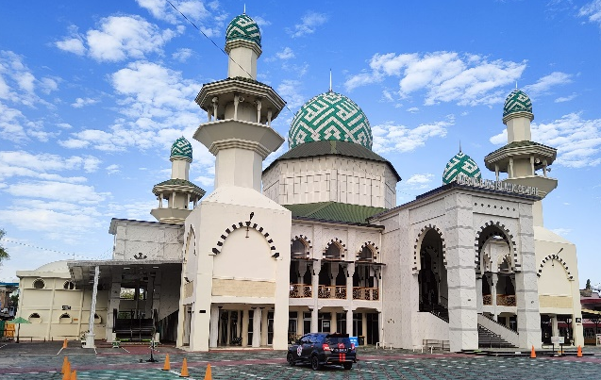

Figure 1. Exterior view of the Islamic Center Grand Mosque with a Middle Eastern style facade concept in the form of a dome

The primary material of the dome construction is heavy steel or metal, which is covered in an enamel dome that has Kufi calligraphy in hues of white and green, vividly depicting the lafadz Allah. This is plainly evident in Figure 2(a). The Grand Mosque's prayer activities take place on the 2nd floor, with a multipurpose space located on the first floor. Upon entering the mosque, the main roof, which serves as the primary framework of the dome, features an interior that resembles a half-dome, following the main dome. The material for the pipe structure is organized in a geometric form that resembles a dome, as seen in Figure 2(b).
The mihrab features a modern classical architectural style, characterized by black and white accents and the use of golden yellow decorative screens with Islamic designs. This mihrab is paired with a teak lecture pulpit that features calligraphy and traditional carvings at the top to create a dynamic design with a hint of Islam, as shown in Figure 3(a).

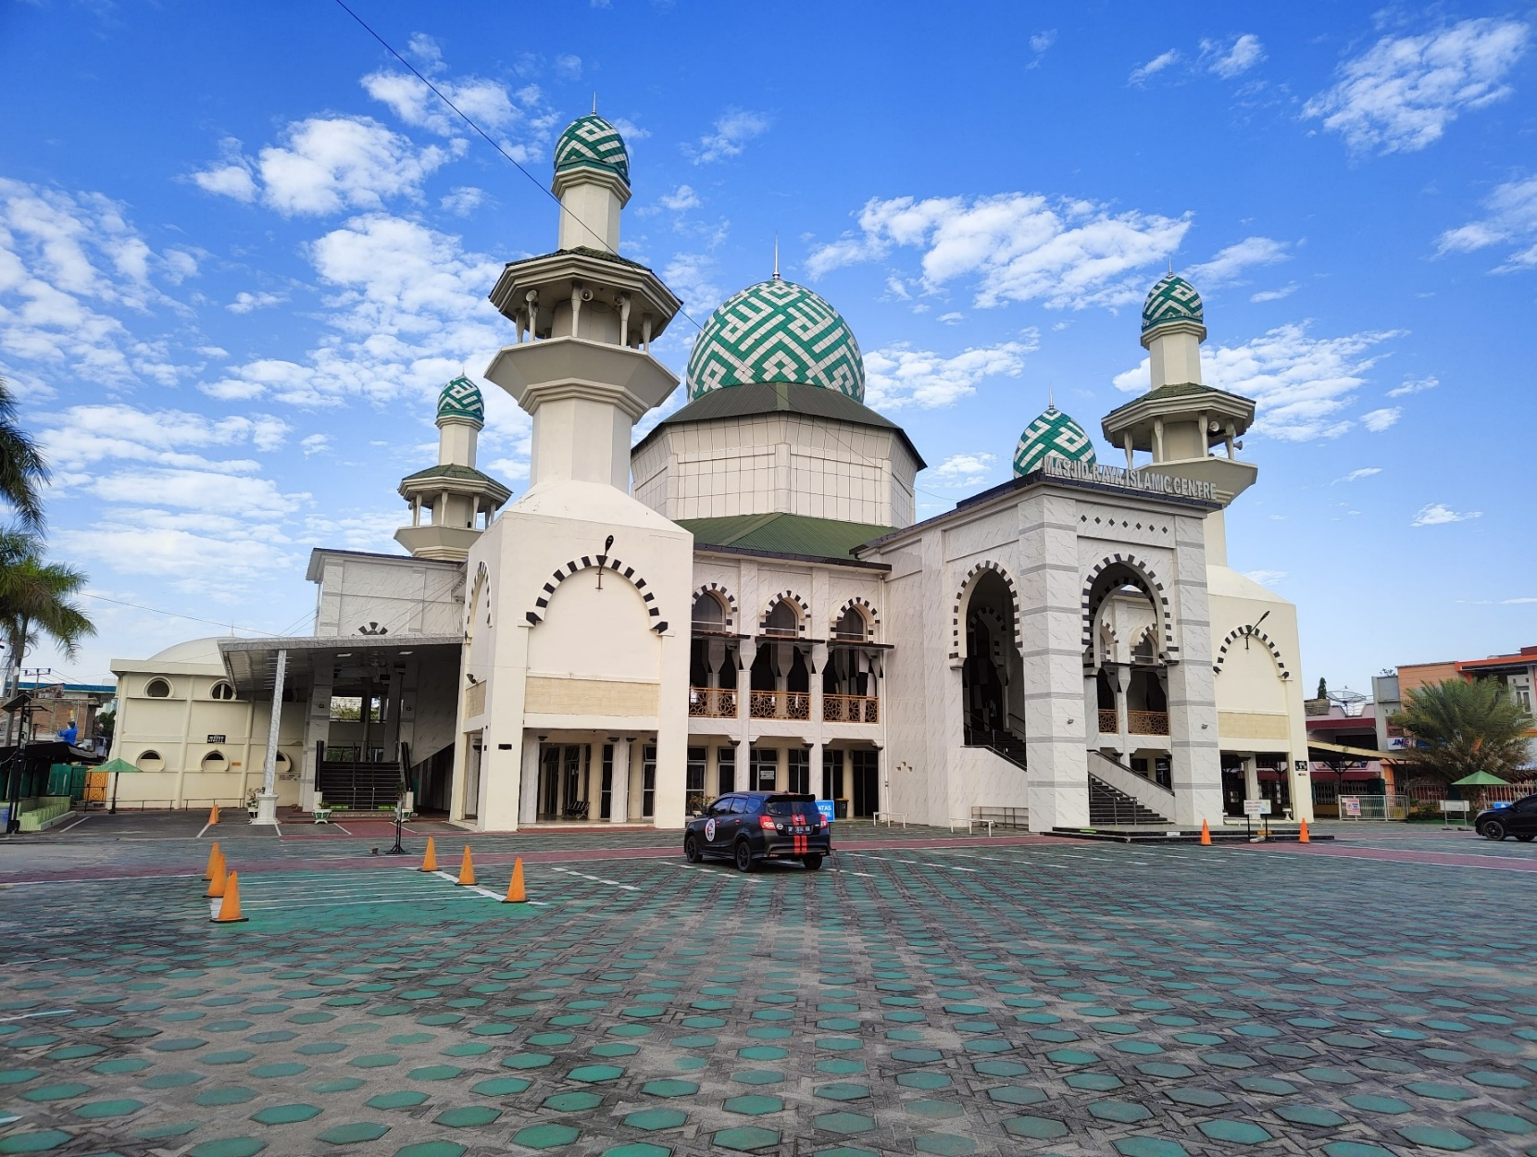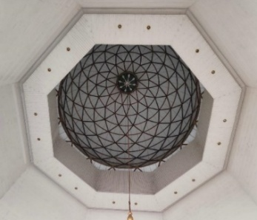
- (b)
Figure 2. (a) Various decorative lafaz Allah decorate the main dome and other domes. (b) Interior of the dome of the Islamic Center Grand Mosque, which uses a geometric pattern
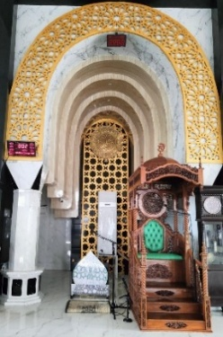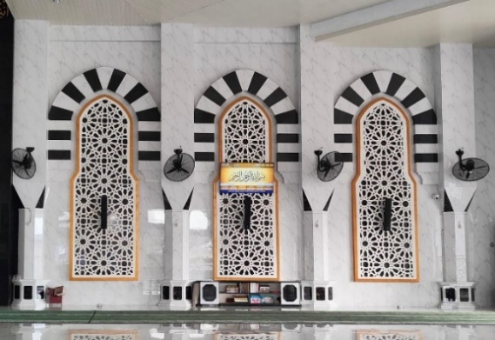
- (b)

Figure 3. (a) Photo of the mihrab and pulpit of the Grand Mosque (b) Mosque ornaments in the form of a black and white curved pattern in the area of ​​the front of the mosque

As shown in Figure 3(b), the top features alternating black and white curving designs, while the decoration or ornaments on each module combine white with Islamic patterns framed in gold. Regarding the toilets and ablution facilities for men and women, they are located on both the 1st and 2nd floors. However, the main prayer room is situated on the 2nd floor, allowing the congregation to choose which toilet or ablution facility to use freely. Regarding the overall orientation of the toilet, it is not placed facing or facing away from the Qibla.
The Islamic architectural perspective encompasses more than only the structural aspects of building planning and design. Islamic teachings should be the foundation for any vision of Islamic architecture; in this instance, utility and benefits must be taken into consideration. Mosques should exhibit characteristics of efficiency, cleanliness, simplicity, and humanism as the primary components of the Islamic mind [23], [24] The Grand Mosque's design of its structural modules and recurring artistic facades on its east, south, north, and west faces, which take inspiration from the Nabawi Mosque in Medina's arch module (see Figure 4), exemplify the idea of simplicity. There are no variances in room heights, and the space design is straightforward. Offers the sensation of space and demonstrates the simplicity of the vast mosque's design.
Apart from that, Figure 6 also shows that the main prayer room utilizes natural ventilation with a cross-ventilation concept, eliminating the need for artificial ventilation, such as air conditioning. Fans are only installed on certain sides. Additionally, the Grand Mosque's interior and courtyard are kept in reasonably good condition.

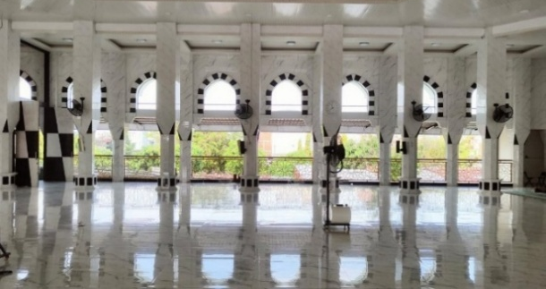

Figure 4. Repetitive aesthetic structural and facade modules that adopt the arch module of the Nabawi Mosque in Medina, while also functioning as natural lighting and ventilation
Regular cleaning service officers and the mosque in Takmir provide support for this. The materials utilized to construct this mosque are also supportive of cleanliness; these materials are water-resistant and easy to clean. Figures 5(a) and 7(b) show the cleanliness of the mosque both inside and outside.

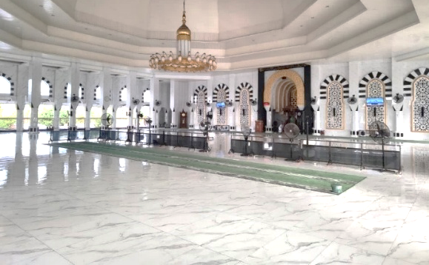  (a) | 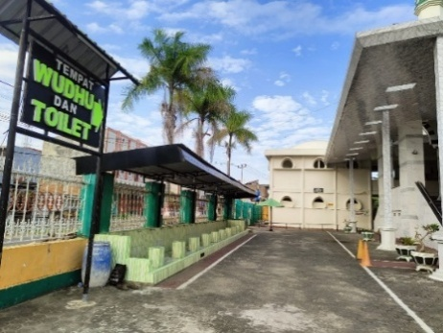  (b)
Figure 5. (a) The atmosphere inside the Grand Mosque with white ceramic floor material that gives a clean and simple impression (b) The relatively clean atmosphere of the main mosque courtyard

The elegant mosque was created with inclusivity and humanism in mind [18]. As illustrated in Figure 6, it is visible from the designated ramp that leads to the 2nd floor, which is intended for worshipers with physical limitations. However, since only regular restrooms are available, the Grand Mosque has not established special facilities for worshippers with specific needs.

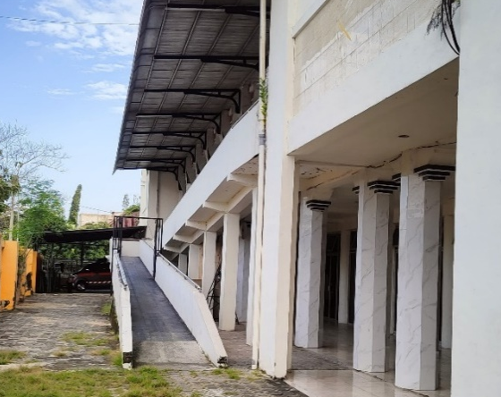

Figure 6. Ramp leading to the 2nd floor for pilgrims with physical disabilities

Next, we will discuss both the macro and micro aspects of sustainable architecture. The macro aspect starts from the land or building of the mosque. The Grand Mosque was built on an area of 4,160 m², with a built area of ​​1,450 m² and an unbuilt area of 2,710 m².
A sustainable concept must consider the building's coverage ratio. The Building Coverage Ratio (BCR) is the percentage difference between the area of a building's complete ground floor and the land area governed by the site plan, building layout plan, and building and environmental layout plan. One aspect of sustainable architecture is maintaining the fundamental building coefficient to ensure energy efficiency [25].
The BCR of the Grand Mosque is estimated to be 35% based on statistics comparing built-up and unbuilt land in the complex. This demonstrates that the BCR Grand Mosque is adequate for building environmentally friendly structures. The success of sustainable architecture was hindered by the improper arrangement of the landscape, as the undeveloped ground was allocated for parking lots, roads, mosque complexes, and other features such as grass, trees, and flowers. Since the bulk of undeveloped land is used for parking, as shown in Figure 7, the 35% BCR presented here makes it challenging to achieve acceptable levels of green open space.
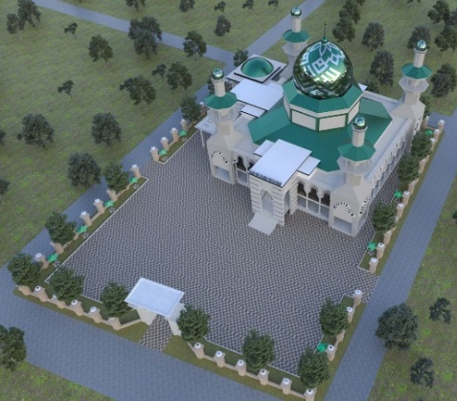

Figure 7. 3D Image of the Existing Site of the Grand Mosque

Efficiency in water, energy, and building materials is the micro-aspects of sustainable architecture [20], [26], [27]. The Grand Mosque utilizes the National Electricity Company (PLN) as its primary electricity source. Energy efficiency can be implemented as shown in Figure 8 by using natural lighting and ventilation in the Grand Mosque's main prayer area. By doing this, it may reduce the amount of energy used during the day and maintain the room's temperature and quality even when it's not in use. Additionally, as Figures 9(a) and 9(b) illustrate, natural lighting and ventilation are employed in the Grand Mosque's restrooms and ablution areas.

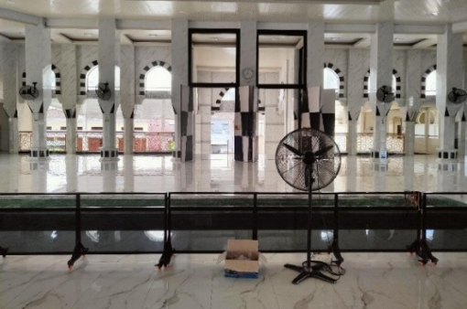

Figure 8. Design of the main prayer room, which makes optimal use of natural lighting and ventilation

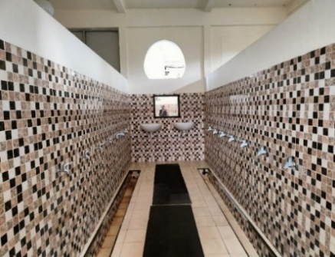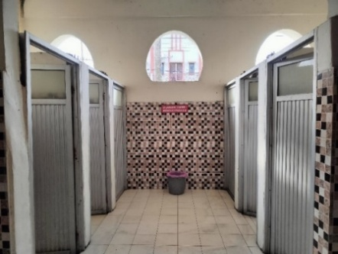
- (b)

Figure 9. (a) The ablution area of the Grand Mosque (b) The toilet of ​​the Grand Mosque

Reducing water use is the next sustainable architectural concept [20], [27], [28]. One of the major problems with water consumption is the vast amount of untreated wastewater that is dumped straight into municipal channels without being treated beforehand, making the wastewater a waste for the environment.
Water sources for the Grand Mosque are drilled wells and PDAM. Meanwhile, the Grand Mosque's water efficiency has not been fully implemented, as rainfall that collects in the yard from the roof is discharged directly into the municipal drainage system. Notice boards urging the congregation to use enough water are one of the mosque management's initiatives to conserve water.
Material efficiency is the next item. Using building materials that require little to no upkeep is referred to as material efficiency. There are two categories of materials utilized in large mosque constructions: exterior and interior materials. In general, low-maintenance materials are used for the exterior, such as weather-resistant ceramics, aluminum composite panels, and enamel materials for the dome. Interior materials are often minimal maintenance. For example, double-coated ceramic floors, ceramic walls, and PVC ceiling panels eliminate the need for frequent painting.
The materials used outside the mosque building are more environmentally friendly because they are made of pavement blocks, which allow for the absorption of water. Although they are still restricted to the site's exterior, as seen in Figure 10, plants and trees have also been planted in the region to serve as both an embodiment of environmental friendliness and a cool atmosphere. Thus, using low-maintenance and ecologically friendly materials turns this into one way to put the idea of sustainable design into practice.

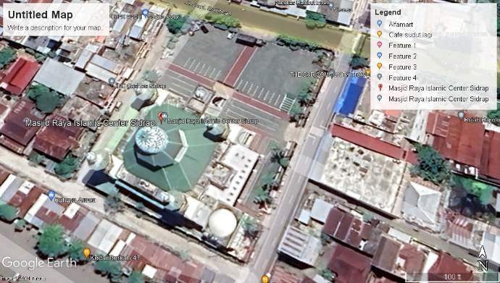

Figure 10. Plants and trees in the courtyard area of ​​the Grand Mosque (taken from Google Maps on 18 July 2024)

  - SIDRAP GREAT MOSQUE
The Sidrap Great Mosque features a two-layer pyramid roof designed in a tropical style. As shown in Figure 11, the first-tier pyramid is four-sided in shape. The structure is composed of amaranth wood and is coated in green metal spandex. The northeast and southeast corner towers, which also served as corner tower steps, were the only two corner towers that the Sidrap Great Mosque was intended to use. The Sidrap Great Mosque spans two floors. The 1st and 2nd floors of the Sidrap Great Mosque are used for prayer activities.

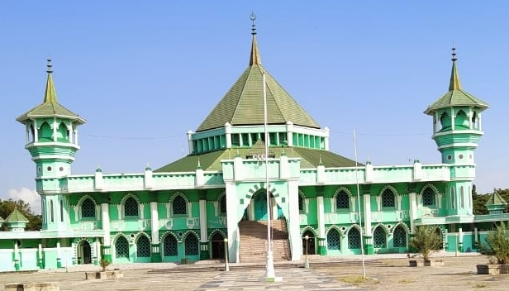

Figure 11. Existing Sidrap Great Mosque Building

The architectural style of the mosque's mihrab is a tropical Mediterranean style. As shown in Figure 12(a), the mosque's facade and interior are both ornamented with gold Islamic ornamentation and a green color scheme. Meanwhile, the interior of the main roof at the Sidrap Great Mosque is octagonal, framed in an Islamic pattern with a cloud image in the center as seen in Figure 12(b).

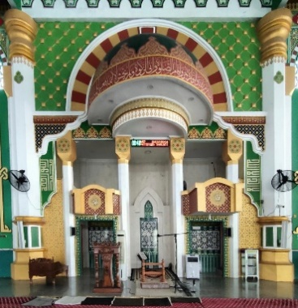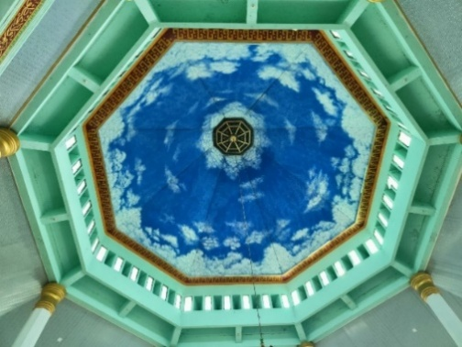
(a) (b)

Figure 12. (a) Mihrab and pulpit of the Great Mosque with shades of white, green, and golden yellow (b) Interior of the main roof of the Great Mosque

The decoration and ornaments in the Grand Mosque employ curved patterns in a combination of white and green, as well as calligraphic decorations that surround the interior of the mosque, as seen in Figure 13. The toilets and ablution areas in the Grand Mosque are separated by gender, located on the 1st and 2nd floors, and accessible from the prayer area. Apart from that, the toilet orientation is no longer facing or facing away from the Qibla.

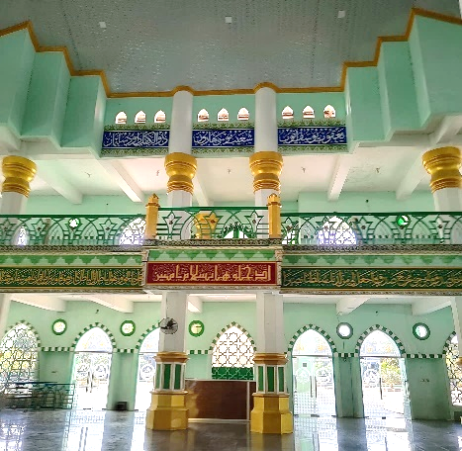

Figure 13. Mosque interior that uses various decorations or ornaments with curved patterns combined with calligraphic decoration

Regarding the Great Mosque's philosophy of simplicity, it is evident in the design of its recurring arch modules on all sides, which creates a simple impression. However, as Figure 13 illustrates, the interior appears more lively due to the calligraphic embellishments, which feature a variety of color changes. In addition, Figure 13 also illustrates how the large mosque minimizes the need for air conditioning and fans by utilizing cross ventilation to provide natural ventilation and lighting. The high ceiling creates space that isolates heat, making it more comfortable for mosque users.
Figures 14(a) and 14(b) illustrate the Grand Mosque's immaculate condition, both inside and in the courtyard. The mosque management had attempted to clean the floor, but stains remained that were impossible to remove. The vast expanse of the mosque yard makes it impossible for the mosque management to maintain strict hygiene standards due to several constraints.

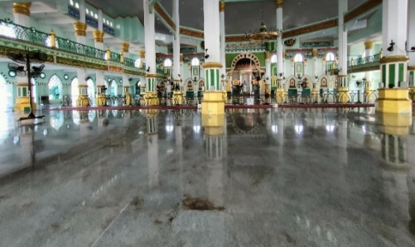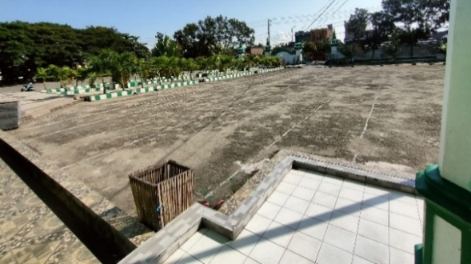
(a) (b)

Figure 14. (a) The interior of the grand mosque, that used as a prayer area (b) The mosque courtyard area

Examining the application of sustainable architecture from both macro and micro perspectives, it is evident that the Great Sidrap Mosque was constructed on a plot of land measuring 30,733 m², of which 3,284 m² was used for the building and 27,449 m² was left undeveloped. This means that the mosque's BCR is 10%. This indicates that, to fulfill the requirements of sustainable architecture, the BCR Grand Mosque of Sidrap is proportionate. As demonstrated in Figure 15, undeveloped land is utilized for multipurpose open spaces, parking lots, roadways, and landscaping.

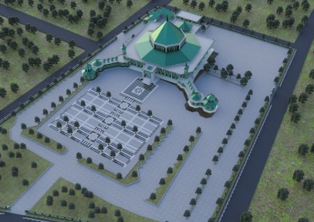

Figure 15. 3D image of the Existing Site of the Great Mosque

Aside from that, the parking space that is accessible aligns with the mosque's rather substantial capacity demands due to the undeveloped terrain. Furthermore, as Figure 16 illustrates, the placement of additional trees and plants expands the Grand Mosque's green area, contributing to the realization of sustainable architecture.

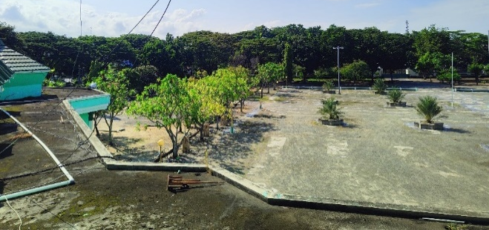

Figure 16. Large parking area with trees and plants arranged

The Sidrap Great Mosque has not utilized renewable energy sources, such as solar panels, because PLN remains the primary source of electrical energy used for the mosque's operational purposes, including lighting and the sound system. The semi-open facades of the Sidrap Great Mosque demonstrate the utilization of natural ventilation, allowing for cross ventilation that keeps the space cool even in the absence of artificial ventilation, such as air conditioning. Nonetheless, some areas of the Sidrap Great Mosque still have fans installed.
In addition, the Grand Mosque features translucent openings, such as glass doors and decorative facade windows, which help maintain the natural lighting of the room without the need for numerous lights to be on, while also enhancing the mosque's security, as seen in Figure 17. Therefore, electrical energy can be used more efficiently by using natural light.

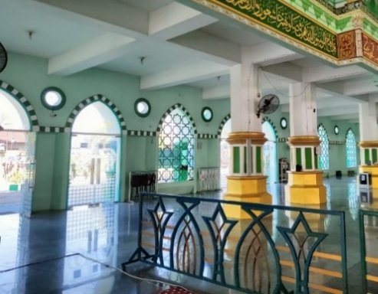

Figure 17. Natural lighting and ventilation in the prayer room of the Great Sidrap Mosque

Additionally, the toilets and ablution areas of the Grand Mosque feature natural lighting from ventilation, as shown in Figures 18(a) and 18(b). Two sources of clean water are used at the Sidrap Great Mosque, which are drilled well water and tap water (PDAM). There are no sustainable measures for water efficiency because the water management system remains conventional, disposing of spent ablution water and rainwater that falls from the roof onto the yard directly into the city's drainage system.
It is anticipated that materials will require minimal to no maintenance to fulfill the sustainability principle. The painted plaster used for the Grand Mosque's siding, particularly for the roof and walls, needs to be repainted regularly to prevent fading and weather damage. This means that regular painting is necessary. Because the floor is made of polished natural granite, it is very simple to clean.

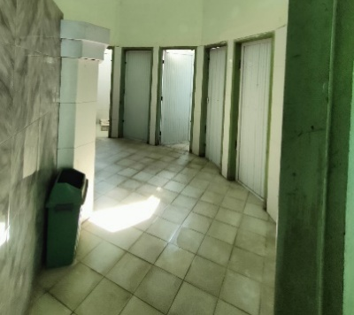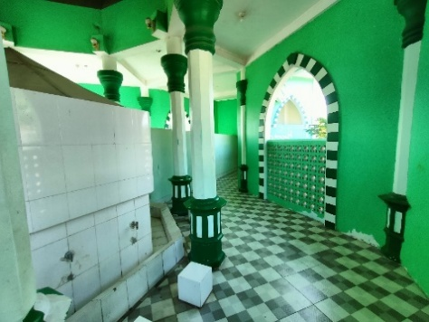
- (b)

Figure 18. The toilet of the Great Mosque (b) The ablution area of ​​the Great Mosque

It is very challenging to turn the courtyard/parking area outside the mosque building into a rainwater collection place because the material there is made of cast cement. Although there is ample space outside the mosque and possibly additional green space, this does not align with ecological principles. However, as you can see in Figures 19(a) and 19(b), the parking area's environment is filled with a variety of plants and trees that serve to provide a shaded space and contribute to the realization of the desired sustainable qualities.

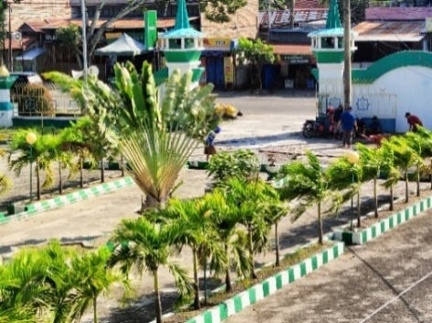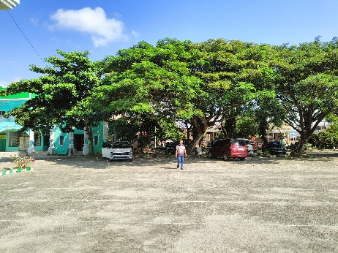
- (b)

Figure 19. (a) Plants and trees in the parking area of ​​the Sidrap Great Mosque (b) Trees on the corner of the Great Mosque’s site

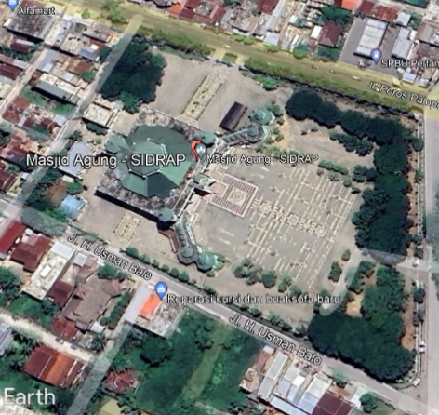

Figure 20. The landscape in the parking area is heavily planted with plants and trees (taken from Google Maps on July 18, 2024)

  - COMPARISON OF THE ISLAMIC CENTER GRAND MOSQUE AND THE SIDRAP GREAT MOSQUE IN THE SYNERGY OF APPLYING ISLAMIC ARCHITECTURE AND SUSTAINABLE ARCHITECTURE
Following an analysis of the Sidrap Great Mosque and the Sidrap Islamic Center Grand Mosque's applications of Islamic and sustainable architecture, the researcher looked at how the two mosques under examination compared.
The research findings revealed that the two mosques have distinct architectural styles: The Great Mosque employs a tropical architectural style characterized by a roof, while The Grand Mosque utilizes a dome-shaped architectural style. Both the Grand Mosque and the Great Mosque have 2 floors used as prayer areas. However, the Grand Mosque's primary prayer area is located on the 2nd floor. Therefore, the Grand Mosque features a unique ramp that allows worshippers with physical limitations to enter the prayer area without difficulty, eliminating the need for them to climb stairs.
Based on fundamental building coefficients, the Grand Mosque exhibits a BCR percentage of 35%, whereas the Great Mosque has a very optimal KBD of 10%. This difference demonstrates that the Great Mosque is more suitable for implementing the Sustainable Architectural Concept, as its expansive undeveloped land allows for greater flexibility in arranging trees and plants, and its parking area can be adjusted to accommodate the mosque's sizable congregation [25], [27].
The most basic similarities can also be found in physical terms. Through physical studies, it was confirmed that these two mosques had successfully saved energy. Both mosques utilized natural ventilation through cross-ventilation, thereby minimizing the need for air conditioning and maximizing the use of natural lighting, which reduced the need for lamps. Both demonstrate that the savings achieved reflect the principles of sustainability when implementing Islamic architectural concepts [27], [29], [30], [31].
Two water sources, drilled wells and PDAM, are used by both mosques to provide clean water for ablutions and toilets, which is another obvious similarity. Nevertheless, the two mosques still employ traditional techniques for managing water, which prevents them from achieving the water efficiency that sustainable architecture requires.
According to researchers, the simplicity aspect is more pronounced in the Grand Mosque, which features a design characterized by simplicity, dominated by white, black, and golden yellow. This is different from the Great Mosque, which features many variations in color decoration, giving a dynamic impression.
The Grand Mosque has superior material maintenance compared to the Great Mosque. It is evident from the use of low-maintenance building materials in the Grand Mosque, as opposed to the Great Mosque, which necessitates frequent painting, coating, and other forms of high care. This also relates to the two mosques' building and land areas; the Great Mosque's building area is twice that of the Grand Mosque.
In terms of how the two mosques have arranged their trees and plants to be environmentally friendly, it is evident that the Great Mosque has more green space overall than the other, with more trees and plants in the parking lot and in the corner of the mosque yard. The Grand Mosque's green space is confined to the outside of the building. This is still connected to the Great Mosque's 10% BCR, which allows for greater adaptability in the arrangement of the landscape[32].

- CONCLUSION
Based on an in-depth study of the two mosque cases studied, several things can be concluded, including:
- There is a correlation between the application of Islamic architecture and sustainable architecture, particularly in the implementation of values such as simplicity, cleanliness, and energy efficiency.
- The basic coefficient of the ideal Sidrap Great Mosque building, with a presentation of 10%, enhances the realization of the concept of sustainable architecture by allowing for larger green open spaces.
- Both mosques have succeeded in implementing electrical energy efficiency, where the use of air conditioning, fans, and lights can be minimized through natural ventilation and natural lighting obtained through the Islamic pattern-style mosque's open facade during daylight.

The researcher suggests that, going forward, mosque management and architects should focus more on the sustainable features of mosque architecture, while also incorporating Islamic architecture as its core from the outset. Installing eco-friendly equipment or using solar cells as a backup energy supply are two ways to improve energy efficiency as a form of sustainability. This indicates that the realization of Islamic architecture can be achieved through the use of sustainable architecture, resulting in the creation of environmentally friendly and Islamically significant architectural designs.
Researchers recognize that the limitations and insufficiencies of the study's results have the potential to undermine generalizations. Therefore, more thorough research is needed on mosques with varying architectural styles, by examining other areas of Islamic architecture related to sustainable building that have not been covered in this study, and exploring the potential of combining Islamic and sustainable architectural elements for designing mosques and other structures.

AUTHORS CONTRIBUTION
Author 1 and Author 2 presented the idea. Author 1 develops the theory and collects all the data regarding the work. Author 1 & Author 2 verified the method and supervised the findings of the work. All authors discussed the results and contributed to the final manuscript.

REFERENCES

[1] S. Dixit, A. Stefańska, and A. Musiuk, “Architectural form finding in arboreal supporting structure optimisation,” Ain Shams Engineering Journal, vol. 12, no. 2, pp. 2321–2329, 2021. DOI: https://doi.org/10.1016/j.asej.2020.08.022
[2] E. Ismagilova, L. Hughes, Y. K. Dwivedi, and K. R. Raman, “Smart cities: Advances in research—An information systems perspective,” Int J Inf Manage, vol. 47, pp. 88–100, 2019. DOI: https://doi.org/10.1016/j.ijinfomgt.2019.01.004
[3] W. Nurjayanti and F. T. Nugrahaini, “SUSTAINABLE ISLAMIC ARCHITECTURE IN SETTLEMENTS AND THEIR ENVIRONMENT IN SURAKARTA,” Journal of Islamic Architecture, vol. 7, no. 4, 2023. DOI: DOI: https://doi.org/10.18860/jia.v7i4.19204
[4] H. Alomari and N. T. Alqimaqche, “SUSTAINABLE ARCHITECTURE THROUGH ISLAMIC PERSPECTIVE A case study in old Mosul residence area,” in The International and Middle East Conference on Sustainability and Human Development, 2013, p. 35.
[5] R. R. Fanjan and H. S. Alboadam, “The role of the bonding strategy in the identity of Islamic architecture,” International Journal of Design & Nature and Ecodynamics, vol. 18, no. 2, pp. 269–278, 2023. DOI: https://doi.org/10.18280/ijdne.180204
[6] J. Wu, “Linking landscape, land system and design approaches to achieve sustainability,” J Land Use Sci, vol. 14, no. 2, pp. 173–189, 2019. DOI: https://doi.org/10.1080/1747423X.2019.1602677
[7] F. J. Idan, S. F. AL-Nuaimi, and I. J. K. AL-Yousif, “The Power of Architect’s Thoughts in Creating Appropriate Environmental Responses through Architecture: An Islamic Perspective,” Journal of the International Society for the Study of Vernacular Settlements, Vol. 10, No. 5, pp. 79-96, 2023.
[8] M. Philokyprou and A. Michael, “Environmental sustainability in the conservation of vernacular architecture. The case of rural and urban traditional settlements in Cyprus,” International Journal of Architectural Heritage, vol. 15, no. 11, pp. 1741–1763, 2021. DOI: https://doi.org/10.1080/15583058.2020.1719235
[9] A. S. Attia, “Learned Lessons from Traditional Architecture in Yemen-Towards Sustainable Architecture,” International Journal of Sustainable Development and Planning vol. 17, no. 4, pp. 1197–1204, 2022. DOI: ttps://doi.org/10.18280/ijsdp.170418
[10] S. S. Ravhee and S. Ahmed, “Understanding historic buildings from an environmental perspective: Finsbury Health Centre–as an environmental rhetoric of modernism,” Archnet-IJAR: International Journal of Architectural Research, Vol. 19, No. 1, pp. 269-285, 2024. DOI: https://doi.org/10.1108/ARCH-10-2023-0273.
[11] A. Fikriani, “Arsitektur Islam: Seni Ruang dalam Peradaban Islam”, el-Harakah, vol. 12, no. 3, 2010. DOI: https://doi.org/10.18860/el.v0i0.452
[12] M. B. Bakri, “Sustainable Architecture throough Islamic Perspective”, Conference Proceedings – ARICIS I, 2017, 491-499.
[13] J. W. Creswell and J. D. Creswell, Research design: Qualitative, quantitative, and mixed methods approach. Sage publications, 2017.
[14] L. J. Moleong, Qualitative Research Methodology, Bandung: PT, Youth Rosdakarya, 2000.
[15] S. J. Taylor, R. Bogdan, and M. DeVault, Introduction to qualitative research methods: A guidebook and resource. John Wiley & Sons, 2015.
[16] A. Bryman, Social research methods. Oxford university press, 2016.
[17] G. Michell, Architecture of the Islamic World, Thames and, Hudson Ltd, London: 1995
[18] D. N. Awaliyah, “Islamic Architecture: Shaping Cultural Identity, Fostering Community Cohesion, and Promoting Inclusivity”, Journal of Islamic Art and Architecture (JIAA), Vol. 1 No. 1, pp. 11-19, April 2023.
[19] Qomarun, “Eksplorasi Tentang Islam, Arsitektur dan Arsitektur Islami: Studi Kasus Pada Lingkungan Binaan Di Kampus UMS”, Prosiding Simposium Nasional Arsitektur Islam UMS, Surakarta: 2004
[20] Sudarman, M. Syuab, and Nuryuningsih. “Green Building: Salah Satu Jawaban Terhadap Isu Sustainability Dalam Dunia Arsitektur”, Jurnal Tekno Sains, vol. 15, no. 3, 2021.
[21] A. C. Engineers, ASHRAE Greenguide: The Design, Construction, and Operation of Sustainable Buildings. Butterworth-Heinemann, 2006.
[22] S. Hidayatulloh, A. Anisa, “Kajian Prinsip Arsitektur Berkelanjutan pada Bangunan Perkantoran (Studi Kasus: Gedung Utama Kementrian PUPR)” Vol. 5, No. 3, pp. 520-530, Oktober 2022, DOI: https://doi.org/10.17509/jaz.v5i3.31467
[23] R. P. Herwindo, “TRACES OF ISLAMIC ARCHITECTURE IN THE DESIGN OF’GEDUNG SATE’IN BANDUNG.,” Journal of Islamic Architecture, vol. 7, no. 3, 2023. DOI: DOI: https://doi.org/10.18860/jia.v7i3.16932
[24] N. Utaberta, “Permasalahan dan pendekatan studi tentang arsitektur islam,” Jurnal Ilmiah Desain & Konstruksi, vol. 6, no. 2, 2012.
[25] A. B. Purnomo, “Koefisien Dasar Bangunan (KDB) dan Koefisien Lantai Bangunan (KLB) sebagai Dasar Gubahan Massa”, METRIK SERIAL HUMANIORA DAN SAINS, Vol. 2, No. 2, 2021
[26] E. E. Atamewan, “Application of Sustainable Architectural Design Principles to Enhance Ecotourism in Cross River State, Nigeria,” Journal of Studies in Science and Engineering, vol. 3, no. 2, pp. 1–13, 2023. DOI: https://doi.org/10.53898/josse2023321
[27] J. Yudelson, Green building A to Z: Understanding the language of green building. New Society Publishers, 2007.
[28] M. Bakri, “SUSTAINABLE ARCHITECTURE IMPLEMENTATION OF VERNACULAR MOSQUE IN ACEH, INDONESIA,” Journal of Islamic Architecture, vol. 5, no. 2, p. 77, 2018. DOI: https://doi.org/10.18860/jia.v5i2.4812
[29] F. Khan and M. A. Haneef, “Religious responses to sustainable development goals: An islamic perspective,” Journal of Islamic Monetary Economics and Finance, vol. 8, no. 2, pp. 161–180, 2022. DOI: https://doi.org/10.21098/jimf.v8i2.1453
[30] R. F. Irawan, S. Sumaryoto, and M. Muqoffa, “Penerapan Arsitektur Islam Pada Perancangan Islamic Center di Kabupaten Brebes,” Senthong, vol. 2, no. 1, 2019.
[31] A. Ragheb, H. El-Shimy, and G. Ragheb, “Green architecture: A concept of sustainability,” Procedia-Social and Behavioral Sciences, vol. 216, pp. 778–787, 2016. DOI: https://doi.org/10.1016/j.sbspro.2015.12.075
[32] Y. M. Ardiani, Sustainable Architecture: Arsitektur Berkelanjutan, Jakarta: Erlangga, 2015.

