 |  | JOURNAL OF ISLAMIC ARCHITECTURE  P-ISSN: 2086-2636 E-ISSN: 2356-4644  Journal Home Page: http://ejournal.uin-malang.ac.id/index.php/JIA
MOSQUE FOR ALL
SOCIO-SPATIAL INCLUSION IN MOSQUE ARCHITECTURE: THE CASE OF TÜRKIYE
Ahmet Gün^{a*}
ªFaculty of Architecture, Istanbul Technical University, Turkey
*Corresponding Author: ahmetgun@itu.edu.tr
ARTICLE INFO |  |  | ABSTRACT
Volume: 8  Issue: 3  Page: 643-660  Received: May 29th, 2024  Accepted: July 29th, 2024  Available Online: Juni 30th, 2025  DOI: 10.18860/jia.v8i3.27138 |  |  | Today, the design and management of the mosque are subject to criticism in many ways, like not being responsive to the needs of different user groups and causing socio-spatial justice problems between genders and generations. This study examines the extent to which mosques provide socio-spatial inclusion by analyzing problems experienced in mosques, user satisfaction, and user perceptions of the socio-spatial inclusiveness of mosques. Methodologically, an online survey was conducted with 521 participants living in Türkiye. In addition, a workshop will be held with 17 participants who are currently involved in research on mosque design to develop proposals at a strategic level to address the identified issues. This study reveals that there are critical socio-spatial problems faced by users in mosques: (1) problems of representation inequality in decision-making about the design and management of mosques (the gaps of representation equality), (2) limited responsiveness to users' spatial expectations due to the neglect of the needs of important stakeholders such as women, children and youth in society (3). Only a very limited group of users (18.4%) are satisfied with the spatial experience in mosques. Additionally, almost one-third of the respondents (30.1%) perceive mosques as 'middle-aged or elderly male-dedicated spaces,' with this perception being more prevalent among women and young people. At the end of the study, we discuss the socio-spatial dimensions that will form the basis for a “Mosque for All”.  Keywords:  Socio-Spatial Inclusion; User Experience; User Satisfaction; Perception; Mosque Architecture; Türkiye

- INTRODUCTION
Mosques are one of the primary public spaces in the Muslim world. They provide a space not only for praying but also for sustaining social, communal, and educational activities. Throughout history, mosques have guided the development of Muslim life and have served as the focal point of Muslim religious and social life [1]. In this sense, to enable social sustainability in the mosque spaces, it is very crucial to design and manage these buildings by considering the needs of all kinds of community groups, including the disabled, women, elderly, children, and youth. To ensure socio-spatial justice in mosques, all the community groups should be provided with an equal opportunity to pray and participate in mosque activities. These spaces are also expected to incorporate a friendly and welcoming atmosphere for all community groups [2]. This approach can be conceptualized as a “Mosque for all,” which can be defined as “a mosque that meets the needs and expectations of all community groups”.
However, the mosque’s mission to provide this approach began to lessen. The design and management of the mosque are subject to criticism in many ways, as follows: (1) not responsive to the needs of disabled and elderly people [3][4][5], (2) causing socio-spatial justice problems between genders: not providing spatial quality to the women’s space as men’s space and ignoring and exclusion of women’s needs and desires [6], (3) being a male-dedicated building [7] or “a gendered space” [8], (4) not being children & young friendly [9][10].
To address the issues and overcome the socio-spatial inequalities in mosque architecture, several studies evaluate the requirements for accessibility in mosques [4][5][6], reveal spatial challenges/issues encountered by women in mosques[11][12][13], propose design guidelines to enable children-friendly mosques [14] or youth-friendly mosques[15], and address design standards for prayer facilities [16].
In Türkiye, due to the impact of top-down modernization and radical reforms initiated in the last century, all educational, cultural, and social solidarity functions within mosques were replaced by modern institutions, and mosques became exclusively places for religious activities [17]. This situation has led to mosques in Turkey being used differently from other Islamic countries. While in other Islamic countries, mosques are used as public spaces for gathering and socializing, in Türkiye, mosques are used only as religious spaces. As a result of this policy, women are discouraged from attending mosques, and homes are solely used by women as places for worship and socialization [18]. This situation contributes to the spatial segregation of homes as "feminine spaces of worship & socializing" and mosques as "masculine spaces of worship & socializing”.
In recent times in Türkiye, there have been several developments in the context of "socio-spatial inclusivity" regarding mosque design and management. The official governing body for mosque management, the Directorate of Religious Affairs (DRA), issued a design guideline titled "Cami Planlama ve Tasarım Kılavuzu" (Guide for Mosque Design and Planning) based on workshops conducted with experts. Within the scope of this guideline, a series of recommendations are provided to ensure a comfortable and efficient spatial experience for women, children, and individuals with disabilities in mosques [19].
Additionally, various studies are being conducted in academic and civil life to enhance the socio-spatial inclusivity of mosques. In this regard, since 2017, a number of university students have been working to improve the mosque experience for women through an awareness campaign titled 'Women in the Mosque' [20]. In 2013, under the project titled "The Place of Women in Mosque Architecture and the Beautification Project of The Women's Section in İstanbul Mosques (3T Project)," led by the Istanbul Mufti's Office, a team of 60 people examined in detail the areas allocated for women in 3000 mosques in Istanbul, preparing a comprehensive report to enhance the spatial quality of women’s section in mosques [21].
In this study, we critically examined the inclusive characteristics of mosques by analyzing the problems experienced, user satisfaction, and user perceptions of socio-spatial inclusion in mosque spaces. In this context, our objective is to present a comprehensive overview of the diverse challenges faced by different user groups. Furthermore, the study aims to elucidate how the issues encountered in mosques, users' perspectives on spatial satisfaction, and users' perception of socio-spatial inclusiveness provided by mosques vary according to the personal and usage characteristics of the users. In this sense, our objective is to address a significant gap in the existing literature on mosque architecture.
Within this context, we studied Türkiye as a case by conducting an online survey with 521 participants and carrying out a workshop with 17 students (13 graduate and 4 undergraduate) who currently have research agendas on mosque design. The survey involves addressing problems and issues of users in mosque experiences, and it also seeks to capture users’ perceptions regarding socio-spatial inclusion. The objective of the workshop was to identify priority problem areas in terms of socio-spatial inclusivity and to develop strategic-level proposals.
In the second section of the study, we present our research methodology by providing detailed information on the reviewed sources and analyzed data. Then, the findings of the study are presented under the headings of “Challenges Encountered in Mosque Experiences” and “Socio-spatial Inclusion in Mosques” accompanied by a discussion. In the fourth section, we make the discussion corresponding to the results. In the final section, we analyze our findings and identify potential directions for future research.

- METHODS
Our research methods include three phases of investigation: a literature review, a survey, and a workshop. We first conducted a systematic literature review focusing on the current state-of-the-art overview of the conceptual and theoretical framework related to socio-spatial inclusivity within mosque spaces. We also reviewed the previous research addressing the problems and issues faced in mosques and the studies giving suggestions to provide socio-spatial inclusion. In this context, we reviewed several databases (Scopus, Web of Science) and some proceedings books concerning mosque architecture, e.g., the conferences on mosque architecture organized by the Al Fozan Award, ICMA Conferences series, the national mosque architecture symposiums realized in Türkiye, such as 1st National Mosque Architecture Symposium (2012) and International Symposium on New Paradigms on Mosque Architecture (2016). We also did a textual analysis of official documents released by responsible actors for mosque management, e.g., DRA, concerning the design, construction, and management of mosque spaces, such as “Guide for Mosque Design and Planning” and “Minimum Elements and Outbuildings Required in Mosque Projects to be made throughout the Country" (Figure 1).

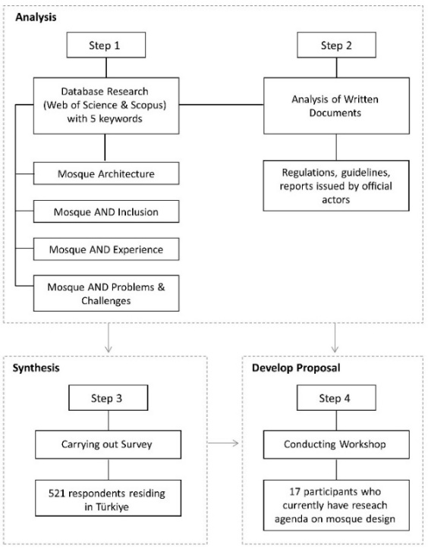
Figure 1. The steps of the research methodology

As primary data, we conducted an online questionnaire with respondents (521 participants) residing in Türkiye. Due to the pandemic threat, the survey was conducted only through online channels. The survey participants were randomly selected, and efforts were made to ensure the inclusion of diverse groups in the research process to achieve representation equality. To do this, we consider Türkiye’s diverse geographical regions and the potential differences in mosque usage and perceptions. In this sense, we collaborated with an architectural research association, with members from each region contributing to the survey, and we identified sample sizes based on population proportions. The personal attributes of respondents (age, gender, education level, etc.), problems & issues they encountered in mosques, and the perception of users on mosque architecture regarding socio-spatial inclusion were surveyed (Table 1).
Table 1. Test variables
First Variable | Second Variable
Personal characteristics (categorical)  Age  Gender  Education level  Usage characteristics (categorical)  Frequency of using mosque spaces in general  Whether using other facilities aside from the prayer room | User problems encountered in mosques  What types of problems that users encounter in mosques  Opinions of users regarding the socio-spatial inclusiveness of mosques  Whether participate in mosque design and management actions  To what extent do users find their mosque experiences satisfactory in terms of socio-spatial inclusivity

These datasets were then analyzed through statistical methods to interpret differences between respondents’ answers according to personal characteristics. In this regard, we utilize various statistical methods, such as the Chi-Squared Test, to investigate the presence of significant relationships between variables, such as observed issues and gender or age. We presented the framework of cross-inquiry that is measured within the scope of this research. We investigated the usage pattern of mosque spaces, encountered problems, and users’ perceptions regarding the socio-spatial inclusiveness of mosques by three sets of questions as follows:
• General attributes of the respondents (personal attributes and usage characteristics)
• The type of experienced problems in mosques
• The opinions/perceptions of users regarding the socio-spatial inclusiveness of mosques
Finally, to develop strategic-level proposals for the identified issues, we conducted a workshop with the participation of 17 students (13 graduate and 4 undergraduate students), all of whom are currently engaged in research on mosque design and management. In collaboration with a research agency, an agency conducting studies with the municipality and university, and academics from the field, we first carried out a 4-week long educational program themed “Living Mosque”. Within the context of this program, we explained the critical points that need to be addressed regarding socio-spatial inclusion in light of previous research results and our findings. Then, participants formed thematic research groups and prioritized topics for investigation. They engaged in brainstorming sessions to generate questions and issues. After that, they visualized their conceptual designs as mind maps and presented them to workshop facilitators.

- RESULT AND DISCUSSION
  - FINDINGS
Table 2. Personal and usage characteristics of the respondents.
Personal Characteristics | Frequency |  | Percent | Usage characteristics | Frequency | Percent
Gender  Female  Male  Total  Age  Under 18  18-25  26-35  36-45  46+  Total  Education Level  High school and below  Undergraduate & Associate  Graduate & postgraduate  Total |  | 250  271  521  18  243  123  83  54  521  70  371  80  521 | 52.0  28.0  100  3.5  46.6  13.6  15.9  10.4  100  13.5  71,2  15.3  100 | The frequency of using mosque spaces in general  Less frequently  Occasional (Several times a week)  Frequently (Several times a day)  Total  Whether the use of other facilities aside from the prayer hall*  Yes  No  Total | 209  229  83  521  272  249  521 | 40.1  44.0  15.9  100  52.2  47.8  100
* The answer is listed out of the respondents who select «Yes» to the choice of «the use of other facilities aside from the prayer hall.»

Türkiye consists of seven different geographical regions where the mosque usage patterns and perceptions concerning the socio-spatial usage of mosques vary among the inhabitants of these regions. To ensure equal representation, our survey study was conducted in these regions, considering the distribution of their population. In the study, we also consider equal representation in involving the experience of different usage groups according to their personal and usage characteristics, e.g., gender, age group, and frequency of usage. The main descriptive statistics derived from the questionnaire are summarized in Table 2.

- 1. PROBLEMS FACED BY USERS IN THEIR MOSQUE EXPERIENCE
The initial question asked to the survey participants was: "What spatial problems do users encounter in mosques?". We grouped answers into thirteen categories. As seen in Figure 2, the most prevalent spatial issues encountered by users in mosques are as follows: a lack of spatial atmosphere for cultural and educational activities (57.5%), a lack of socialization areas and facilities (46.8%), a lack of spaces and an atmosphere for children to spend time in (45.9%); a lack of an inclusive and welcoming atmosphere (38.5%); privacy-based issues (37%); physical environmental problems (e.g., heating-cooling, sound, smell) (33.3%). The results revealed that people mostly suffer from the lack of spatial atmosphere and facilities to carry out social, cultural, and educational activities in mosque spaces. Users stated that they had experienced relatively fewer problems related to the lack of quality outdoor and open spaces, landscape deficiency (27,6%), and accessibility problems (23,7%). It is noteworthy that despite the primary focus of architectural media and academia in Türkiye being on aesthetic aspects such as form, symbols, scale, and material in mosque design, users’ reported problems related to aesthetic elements in mosques are notably low (24,6%).

Figure 2. The spatial problems encountered by users in mosques.
We also inquired whether there are significant differences in encountered problems in mosques regarding users’ personal and usage characteristics. Our findings reveal a significant increase in privacy-related problems and physical environmental issues among women compared to men. On the other hand, men demonstrate a significant increase in reported problems related to the lack of inclusive & welcoming atmosphere and aesthetic problems compared to women (Table 3). Based on the responses of users, it is observed that women encounter significant problems related to spatial comfort elements in mosques, like hygiene, as well as physical environmental components such as ventilation, sound, and smell. Notably, there is a significant disparity in the experiences of spatial comfort elements in mosques based on gender.

Table 3. The changes in encountered problems of the survey respondents according to personal and usage characteristics.
N (Valid cases): 521 | The encountered problems of the users in mosques
Personal Characteristics | Lack of spatial atmosphere for cultural & educational activities | Lack of socialization areas & facilities | Lack of spaces/atmosphere for children to spend time in | Lack of inclusive and welcoming atmosphere | Privacy-based issues | Physical issues (e.g., heating-cooling, sound, smell) | Quality of outdoor space and landscaping deficiency | Lack of social atmosphere | Aesthetic problems  (e.g., design quality & scale) | Accessibility problems | Issues arising from the materials used in the mosque | Security problems
Gender  Women  Men  Pearson  Age  Under 25  26-35  36-45  46+  Pearson  Education Level  High school & bel.  Associate & underg.  Graduate & postgr.  Pearson  Using spaces within the prayer hall  Yes  No  Pearson  The frequency of use  Less frequently  Occasionally  Frequently  Pearson  * Significant at 0.01  ** Significant at 0.05 | 60.2%  55.7% | 44.2%  50.2% | 46.2%  45.4% | 32.3%  44.6% | 50.6%  24.7%  .0001* | 40.6%  25.8%  0.02** | 29.9%  26.6% | 23.1%  29.5% | 17.5%  30.6%  0.03** | 21.1%  26.9% | 12.7%  15.9% | 11.2%  12.9%
 | 70.1%  54.5%  51.8%  48.1% 0.01** | 52.5%  38.2%  45.8%  46.3% | 42.1%  46.3%  55.4%  48.1% | 38.7%  33.3%  42.2%  46.3% | 35.6%  40.7%  39.8%  33.3% | 31.8%  35.8%  28.9%  38.9% | 28.4%  26.0%  31.3%  27.8% | 29.1%  16.3%  27.7%  35.1%  0.02** | 24.9%  20.3%  25.3%  29.6% | 26.8%  21.1%  21.7%  22.2% | 14.6%  16.3%  10.8%  14.8% | 13.4%  10.6%  10.0%  9.3%
 | 48.6%  56.9%  71.3%  0.002* | 48.6%  47.2%  47.5% | 40.0%  45.0%  55.0% | 44.3%  34.8%  52.5%  0.03** | 30.0%  38.0%  40.0% | 37.1%  30.5%  41.3% | 28.6%  25.9%  38.8% | 28.6%  24.3%  35.0% | 18.6%  21.8%  41.3%  .0007* | 25.7%  19.4%  45.0%  0.002* | 17.1%  10.0%  28.8%  0.002* | 14.3%  11.3%  13.8%
 | 62.1%  53.4% | 48.2%  46.6% | 47.1%  44.6% | 37.9%  39.8% | 41.2%  32.9% | 34.6%  31.3% | 26.8%  29.7% | 28.7%  24.1% | 27.9%  20.5% | 27.5%  20.5% | 16.5%  12.0% | 11.4%  12.9%
 | 56.5%  62.0%  50.6% | 46.9%  48.9%  44.6% | 45.9%  46.3%  44.6% | 35.9%  42.8%  34.9% | 43.1%  31.9%  37.3% | 40.2%  30.1%  22.9%  0.032** | 28.2%  29.7%  24.1% | 21.5%  33.2%  20.5% | 16.7%  31.0%  25.3% | 21.1%  28.4%  20.5% | 11.0%  17.0%  15.7% | 15.3%  12.2%  3.6%  0.03**

Another notable finding is that there is an increasing trend in encountering the lack of a spatial atmosphere for cultural and educational activities as the age group decreases. Additionally, it has been observed that the lack of an inclusive and welcoming atmosphere tends to increase parallel to age. The results indicate a tendency for younger individuals to engage in cultural and educational activities in mosques. Additionally, with the increasing age of mosque users, the spatial atmosphere of mosques increasingly fails to meet their expectations. Furthermore, it highlights that mosques cannot fulfill the early youth (under 25) and middle-aged and older (over 46) groups’ expectations regarding the socializing atmosphere. Another noteworthy finding from the study is the higher incidence of encountered problems among the group that uses mosques occasionally compared to those who use them frequently or less frequently.
Our study also revealed that there are significant differences in the encountered problems among mosque spaces based on variations in education levels. A positive correlation has been identified between users' educational level and the problems they encounter in mosques. As illustrated in Figure 3, there is a discernible upward trend in the incidence of issues in mosques across nearly all domains as the educational level of the users increases.

Figure 3. Encountered problems according to education level

To offer comprehensive insights into users’ experiences regarding mosque usage, we also integrate open-ended questions within the surveys. For this purpose, we also inquired about the experienced problems regarding privacy, gender and age in mosque environments. As seen in Table 4, the respondents who encounter privacy-based problems expressed that they encounter accessibility problems (Access of women and men through the same door) most frequently. Physical and visual contact issues are the other issues that people are suffering from in mosques. Lastly, users also complained about auditory contact problems in prayer halls and wet areas. At this point, users, especially women, have expressed that they feel discomfort with their voices being heard by men while using these spaces in mosques.

Table 4. The user experience problems regarding privacy*
Experience problems regarding privacy
- Access of women and men through the same door
- Physical & visual contact when entering the mosque
- Visual contact issue in the mosque
- Visual contact during access and use fountain & WC
- Auditory contact issue in the Prayer Hall
- Auditory contact issues in the Fountain & Wet Areas
*Ranked by frequency of answers.

It has been determined that the privacy-based problems experienced by the users in mosques are interrelated with the gender-based challenges they face. At this point, in the next stage of the research, the users who stated that they experienced gender-based problems in mosques were asked what kind of problems they experienced and the open-ended answers of the users were coded and grouped in certain themes. It has been determined that the users who experience gender-based problems in mosques mostly encounter the lack of quality of wet areas (WC, ablution area) and prayer areas allocated for women.
Following this response, users stated that their most significant problems were with societal perceptions about the presence of women in mosques and the behavior of other users. At this point, users stated that several groups of mosque users adopt the perception of a "mosque as a male-dedicated space." For this reason, they encounter situations that disturb women in the actions and behaviors of users. In Türkiye, although contemporary and historic mosques generally include spaces for women, some users have reported that the prayer rooms designated for women in mosques are inadequate in terms of space. In some cases, women are unable to use these facilities because the prayer area allocated for women in mosques is locked or in use by men. (Table 5).

Table 5. The user experience problems regarding gender*
Experience problems regarding gender
- Lack of quality in wet areas designated for women
- Lack of quality in women's prayer areas (harim)
- Shortage of wet areas designated for women
- Perception and behavior of male congregation towards women (perception of “mosque as a male-dedicated space)."
- Inadequacy of women's prayer areas
- Lack of space allocated for women & exclusion of women in mosques
- Accessibility issues for reaching the women's section
- Women's prayer areas being closed/locked
*Ranked by frequency of answers.

We also inquired whether users encountered age-related problems in mosques. The young generation especially complains about the attitudes of elders to children and youth, and they said that users behave as if mosque areas are allocated for just the middle-aged and elderly, and so they feel that there is "no space for children and youth" in mosques. The users also stated that there is a lack of suitable spatial environments for children and youth in mosques. Moreover, young people are ignored in the organization of activities and programs. At this point, the expectations of middle-aged and elderly users are prioritized in the organization of activities and spatial organization in mosques, as seen in the right of use and perception of the mosque (Table 6). This situation may result in the loss of the sense of belonging of young people and children, who are already mosque users, with mosques and the loss of "spatial inclusiveness" that will only respond to the expectations of a limited segment of society soon.
Table 6. Age-related issues encountered in mosques*
Age-related problems in mosque
- Attitudes of Elders to children & youth
- Lack of suitable facilities for children
- Lack of spatial atmosphere for children
- Lack of activities and programs organized for youth

- Middle-aged and elderly-focused activities & spatial organization
*Ranked by frequency of answers.

Within the scope of our survey’s next phase, we first asked respondents “whether they are satisfied with the spatial experience in mosques”. Only 18,4% of the survey respondents stated that they were satisfied with their mosque experience (Table 7). We also cross-inquired whether there is a significant difference in satisfaction of users’ experience according to personal and usage characteristics of respondents. As seen in Table 7, it is determined that user satisfaction in mosque spaces varies significantly according to the change in age level, education level, and frequency of use. At this point, it is observed that the level of spatial satisfaction decreases with increasing age and education. For example, while the level of spatial satisfaction in mosque experiences of respondents in the 26–35 age group was 22.8%, this rate decreased to 15.7% in the 36–45 age group and to 14.8% in the 46+ age group. A similar trend was also observed in the educational level of the users. In this context, while the spatial satisfaction level of the group with "high school and below" education level was 27,1%, this rate decreased to 17,8% in the group with "associate & undergraduate" education level and to 13,8% in the group with "graduate & postgraduate" education level.

Table 7. The change in satisfaction with spatial experience in mosques according to personal and usage characteristics
Personal and Usage Characteristics | Whether respondents satisfy their mosque experience  18.4% (Overall)
Gender  Women  Men  Age  Under 25  26-35  36-45  46+  Education Level  High school and below  Associate & undergraduate  Graduate & postgraduate  The frequency of use  Less frequently  Occasionally  Frequently  The use of a mosque other than a prayer hall**  Yes  No | 20.4%  16.6%  18.0%  22.8%  15.7%  14.8%  27.1%  17.8%  13.8%  14.4%  20.4%  22.9%  24.3%  12.0%  p: 0.02

Furthermore, it is notable that spatial satisfaction among mosque users varies significantly according to their usage characteristics. At this point, it was determined that the level of spatial satisfaction decreased as the frequency of use decreased. In addition, it was observed that the spatial satisfaction level of the users (24,3%) who use mosque spaces other than the place of worship showed a significantly increasing trend compared to the spatial satisfaction level of the users (12,0%) who only use the prayer hall (harim) of the mosques. This situation shows that using multiple facilities in mosques can play a positive role in spatial satisfaction.

- 2. SOCIO-SPATIAL INCLUSION IN MOSQUE EXPERIENCE
In Türkiye, the implementations observed in mosque design and construction demonstrate that mosque building associations and individuals play a pioneering role in the supply of land for mosques, the determination of aesthetic and functional attributes of the mosque, and the identification of activities realized in the mosque following construction. Among the individuals comprising the mosque association management, there is no obligation to have a design professional to carry out the processes related to the decisions taken regarding the aesthetic and functional aspects of the mosque nor to guide the design process comprehensively. Such a situation can result in the delegation of design responsibilities to individuals who lack the necessary competence to fulfill them.
Users who are the main actors in experiencing mosques have almost no role in designing mosques and determining the facilities and programs to be included in mosques but can indirectly participate in the process by making donations during the construction process after the completion of the design process (Figure 4). In addition, the DRA, which is officially responsible for the management of mosques in Türkiye, is only involved in the process after the completion of construction activities. This leads to a lack of participatory and collaborative processes in the design and management of mosques.

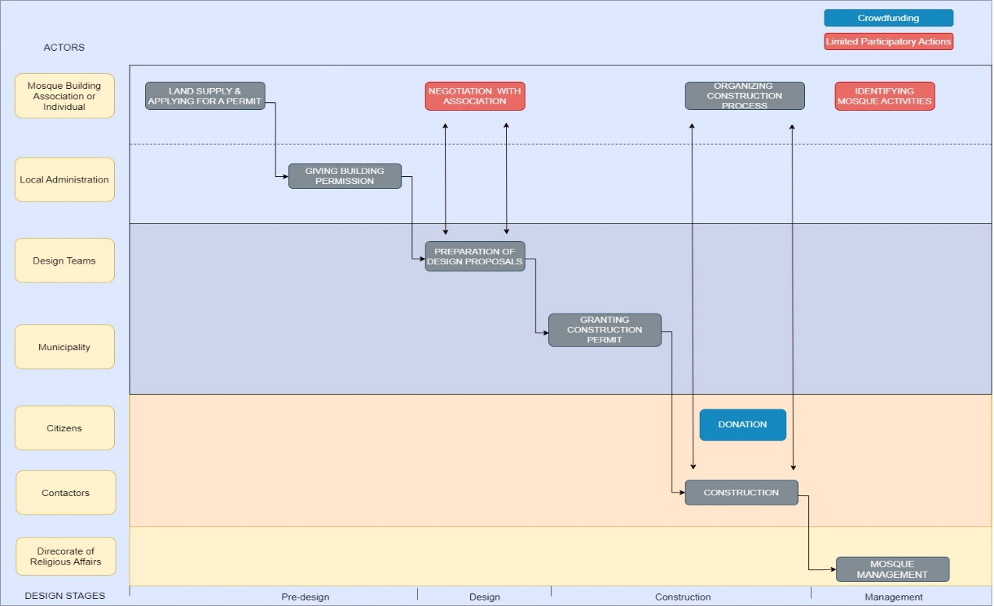

Figure 4. The current process for the design and construction of mosques in Türkiye (prepared by the author(s) based on the related laws and regulations).

In the final stage of our survey, we aimed to explore users' experiences and perceptions of socio-spatial inclusivity in mosque design and management. In this context, we first asked respondents whether they had "participated in any stage of mosque design and management". Only 2% of respondents indicated that they had participated in construction (8 respondents), design (3 respondents), and management (2 respondents) (Figure 5). These figures show that the absence of any participatory mechanism in the design and management of mosques in Türkiye is a de facto situation..

Figure 5. Involvement of users in the design and management of mosques

The last investigation of this study reveals the perception of users regarding socio-spatial inclusion. This investigation is crucial since it provides clues about users' thoughts about the socio-spatial inclusiveness of mosques and their thoughts and perceptions about the extent to which mosques provide socio-spatial justice. Only one-sixth (17,3%) of survey respondents expressed that they think mosques meet the socio-spatial expectation of "all user groups". At this stage of the research, the issue was approached from the perspective of "socio-spatial justice," and the question of whether mosques "only" meet the socio-spatial expectations of a specific group was asked. In this context, the group of "middle-aged or elderly men", which has been identified as a dominant group in similar studies in the literature [6],[7] and mosque design and management processes in Turkey, was presented as a separate option. A notable proportion of survey respondents (30.1%) stated that they perceive mosques to primarily serve the socio-spatial needs of "middle-aged and elderly male" groups. Conversely, almost half of the respondents (49.1%) indicated that mosques do not meet the socio-spatial needs of any group. (Figure 6).

Figure 6. The perception of users regarding the socio-spatial inclusiveness of mosques

We also cross-inquired whether there is a significant difference in the perception of users concerning the socio-spatial inclusion of mosques according to the personal and usage characteristics of respondents. As seen in Table 8, the perception of socio-spatial inclusion of mosques is significantly different in terms of gender, age, education level, and usage characteristics. It is observed that there is a tendency to perceive a perceiving mosque as a “middle-aged or elderly male” dedicated space significantly increased women (38,9%) compared to men (22,9%). The same situation is observed among different age and education groups. While 35% of the users who are under the age of 25 stated that they think that mosques only meet the expectations of this "specific" group, this rate decreased to 25.2% in the "26-35" age group and to 13.0% in the "46 and over" age group. A similar trend of change was also observed based on the change in education level. As the educational level of the users increased, the percentage of those who think that mosques meet the expectations of a "specific group" increased. In addition, the rate of those who think that mosques provide opportunities for a "specific" group in socio-spatial terms has shown a significant increase trend as the frequency of use decreases (Table 8).
Table 8. The change in the perception of users regarding the socio-spatial inclusion of mosques according to personal and usage characteristics
Personal and Usage Characteristics | The mosques do not meet the socio-spatial expectations of any user groups  49.1% (Overall) | The mosques meet the socio-spatial expectations of “only” specific (middle-aged or elderly men) group  30.1% (Overall) | The mosques meet the socio-spatial expectations of all user groups  17.3% (Overall)
Gender  Women  Men  Age  Under 25  26-35  36-45  46+  Education Level  High school and below  Associate & undergraduate  Graduate & postgraduate  The frequency of use  Less frequently  Occasionally  Frequently  The use of mosques other than prayer hall  Yes  No | 40.4%  57.2%**  p:0.016  44.1%  50.4%  48.2%  72.2%*  p: 0.0002  42.0%  50.1%  50.0%  46.4%  52.0%  48.2%  37.1%*  62.3%  p: 0.004 | 38.9%**  22.9%  p: 0.014  35.0%*  25.2%  34.9%  13.0%  p: 0.0008  25.2%  30.2%  33.8%  37.8%  24.5%  26.5%  35.3%  24.5% | 18.8%  15.9%  17.6%  21.1%  14.5%  11.1%  24.3%  17.3%  11.3%  13.4%  19.2%  21.7%  22.1%  12.0%

  - DISCUSSION
Following a structure based on our research objectives outlined in the introduction part, this section interprets each of our findings as relevant to users' experience and perceptions regarding mosque architecture. The anomalies and possible explanations are discussed in the light of our research findings and the reports of other researchers. Then, we propose key factors for enhancing socio-spatial inclusion in mosque spaces by proposing strategic-level solutions to the identified issues based on our workshop results.

- 1. CRITICAL DISCUSSION ON SOCIO-SPATIAL INCLUSIVITY OF MOSQUE
Firstly, we found mismatches between the current mosque experience and the ideal usage of the mosque. One of the results of this study addressed socio-spatial problems encountered by users in their mosque experience. The most common problems are, respectively, lack of necessary spatial facilities, lack of spatial atmosphere elements such as inclusive, welcoming, and socializing environment, lack of privacy and spatial comfort elements such as ventilation, air conditioning, and sound, and problems with aesthetic elements such as form, shape, and material. When the problems experienced by the users are cross-inquired according to their personal and usage characteristics, it is revealed that female users have problems with physical facilities such as fountains and prayer halls in women's spaces, poor quality of space, and serious problems with one of the most fundamental elements of Islam, privacy.
This situation leads to the inability of mosques to play a crucial role as significant hubs for education and worship for Muslim communities, sustaining the "sense of community" and the "spatio-practical production of identities" [18]. The findings of the study indicate that the problems reported in previous studies, such as inadequate functionalities provided for female users, lack of privacy, and deficiencies in spatial quality [13], are also experienced in Türkiye. Many female users face challenges using mosque spaces that are not safe, hygienic, and comfortable [12]. This situation demonstrates that even the most fundamental elements are problematic for women, who constitute half of society, in mosques.
Additionally, the experience problems encountered by users in mosques vary according to the users' age. Particularly noteworthy are the complaints of young people about the lack of cultural and educational activities in mosques, as well as deficiencies in spatial atmosphere elements such as the lack of a socializing atmosphere. The findings indicate that mosques in Turkey are designed and used in a manner that disregards the spatial elements necessary for the education, culture, and socialization of children and young people. This situation results in mosques being unable to fulfill their role in instilling Islamic knowledge and shaping the spiritual development and personalities of children and youth [10,14]. All of these findings highlight that mosques in Türkiye fail to meet even the most basic expectations in terms of spatial facilities, quality, and comfort (Figure 7).

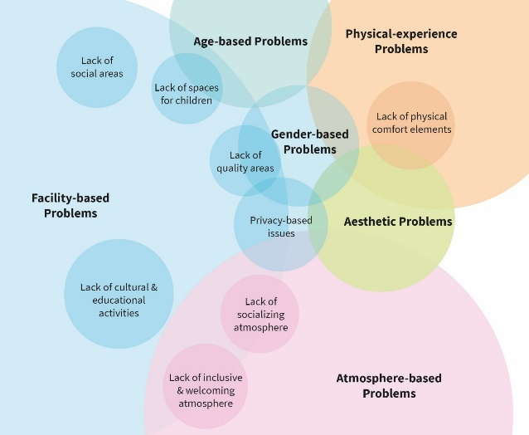
Figure 7. The distribution of encountered problems in mosques by categories

Our study reveals that there is a significant gap between the proportion of those who use mosques and those who make decisions about the design and management of mosques. Although 60% of the respondents indicated that they use mosques occasionally (15.9%) or frequently (44.0%) (see Table 2), only 1% of the respondents participated in any of the decision-making processes in the design (3 respondents) or management (2 respondents) of mosques (see Figure 5). This reveals a representation gap in the design and management of mosques due to the lack of participation (Figure 8). This confirms the previous research findings [6,22,23], which argue that there is a lack of participatory approach or low level of participation in the design and management of mosques.

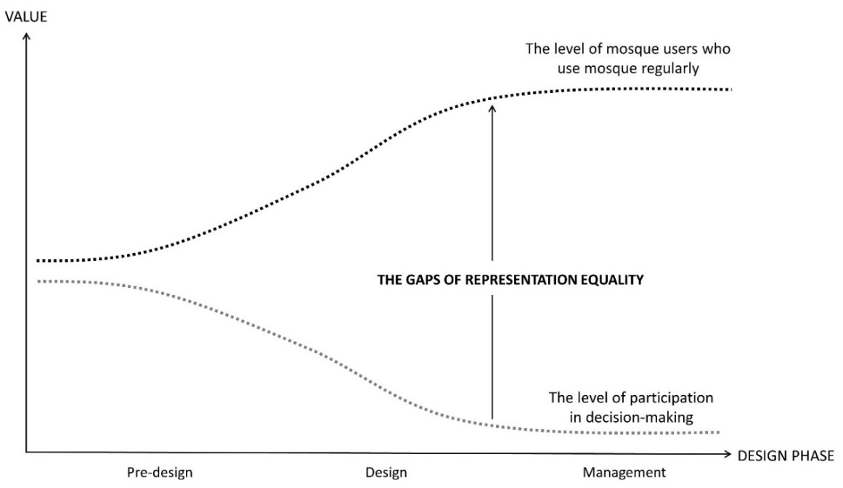

Figure 8. The gaps of representation equality in the decision-making process of mosque design and management.

In addition, the involvement of the Directorate of Religious Affairs (DRA), which is the responsible official institution for the long-term maintenance, sustainability, and management of mosques in Türkiye, is disregarded in decisions concerning the planning, design, and construction processes of mosques. This disregard leads to many problems in the mosque management process. Moreover, it creates an issue of "expert participation" due to the lack of involvement of relevant experts in the process. The research results also indicate that the mechanisms in the mosque design and management process in Türkiye (see Figure 4) require updating with a participatory and collaborative approach involving both the public and experts.
Another essential outcome of this study is the perception of socio-spatial justice in users’ mosque experience. Previous research asserts that mosques have not met the expectations of the community groups regarding socio-spatial inclusivity. These studies focus on the neglect of individuals from different segments of society and the exclusionary nature of mosques for various genders, ages, and physical aspects [9][10]. Megahed [7] asserts that all of these problems “bring with claims of inequality in terms of spatial quality, functional inefficiency, and a broader challenge to the idea of Islamic social inclusion.” Those problems lead to the perception that mosques are “a gendered space” [8], “masculine space of worship & socializing” [18], “male-dedicated buildings” [7], or “a space of exclusion”.
Our study findings confirm the results of these studies. As seen in Table 8, about one-third of the users (30.1%) stated that they perceive mosques as "middle-aged or elderly male-dedicated spaces", and this rate is even higher among women and young people. In addition, when the problems experienced in mosques are analyzed, it is found that women experience many problems in mosques based on gender and privacy (see Table 4 and Table 5). Young people stated that there is a lack of spatial facilities and atmosphere sensitive to their needs and that the spatial organization and programs in mosques are carried out by focusing on the needs of middle-aged and elderly groups and that they are excluded in these processes (see Table 6). These results contradict Islamic belief that mosques should accommodate all types of communal activities and that all diverse community groups, including disadvantaged people and even blind people, have “equal” and “just” rights to participate in these activities and every type of discriminatory behavior and action is prohibited [24,25].
When evaluating the overall findings of the study, it is concluded that there is a low level of participation in the design and management of mosques in Türkiye, leading to limited responsiveness to users' spatial expectations due to the neglect of the needs of important stakeholders such as women, children, and youth in society. In parallel, there is a decrease in user satisfaction with the spatial experience in mosques, resulting in the exclusion of certain groups' needs from a socio-spatial perspective. This situation gives rise to many problems in mosques in terms of "socio-spatial justice" (Figure 9).

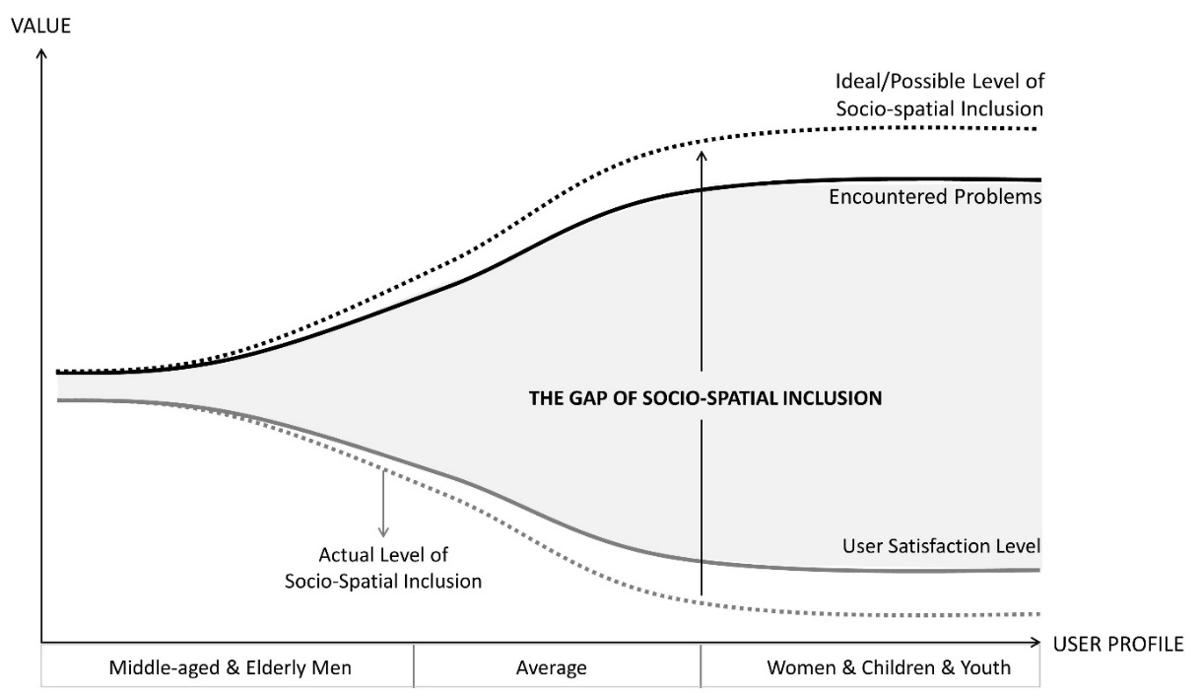

Figure 9. The gaps of socio-spatial ınclusion in users’ mosque experience

- 2. SOCIO-SPATIAL DIMENSIONS OF “MOSQUE FOR ALL”
In light of the information obtained from the literature review, survey findings, and workshop results, we propose interrelated socio-spatial dimensions that contribute to the conceptualization of a 'Mosque for All'. At this point, four interrelated dimensions have been identified as the main elements that will form the basis for a 'Mosque for All': 'responsiveness for all', 'atmosphere', 'provided facilities', and 'design approach' (Figure 10).

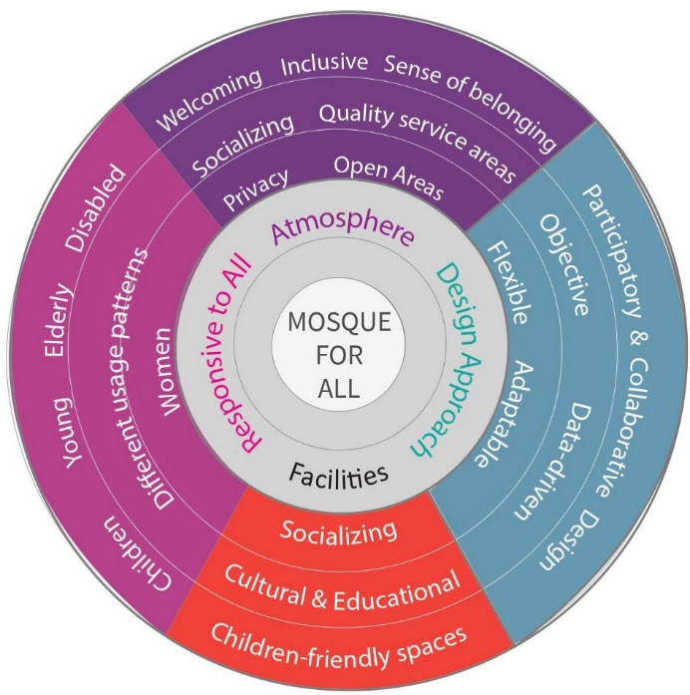
Figure 10. Socio-spatial dimensions of “Mosque for All”.

The research findings indicate that there are general issues with the utilization of mosques, with these issues exhibiting "significant" variations according to demographic characteristics, such as age, gender, and usage patterns. At this point, the design and management of mosques should be "responsive" to the needs of all different user groups. Within the framework of this dimension, which we refer to as "responsive to all", it is suggested that both the design and management of mosques should meet the expectations from the perspective of "socio-spatial justice" and thus focus on the problem of "the gap of socio-spatial inclusion" identified in the previous section. Concerning this, there is a need to consider the atmosphere provided to users in mosque spaces with a holistic approach.
It is crucial that the spatial environment in mosques not only be welcoming and inclusive but also foster socialization and a sense of belonging. This is essential for meeting the 'inclusive spatial atmosphere' dimension. In parallel to this, within the dimension of "provided facilities", it is suggested that privacy, which is one of the fundamental elements of Islam, should be ensured. It is necessary to adopt a fair approach to the spatial atmosphere, quality of space, and the facilities provided, especially in the spaces reserved for women in mosques. In addition, mosques should provide service areas such as toilets, ablution areas, and prayer halls with a "just" approach to "all users," and there should be social, cultural, and educational facilities where needed.
The findings of the study reveal that mosques do not meet expectations in terms of socializing, cultural & educational, and child-friendly spaces and lack the spatial facilities needed to carry out these activities. In this direction, by adopting a "flexible design" approach, it is suggested that certain spaces or unused facilities of mosques, which are currently used at full capacity in very limited periods (Friday prayers, tarawih prayers, etc.), be used in line with spatial facilities and actions (educational, cultural, social) that will meet the spatial expectations of users [26]. In addition to being designed in accordance with "functional flexibility" scenarios, new mosques should be designed in a scenario that will respond to the needs of users (population growth, new spatial requirements, etc.) over time with an "adaptive" approach.
Furthermore, our study revealed that the younger generation is uncomfortable with the attitudes and behaviors of the elderly towards them, and this situation caused them to lose their sense of belonging to the mosques. They felt that there was "no space for children and youth" in mosques. This situation, which creates a problem in the behavioral context, can be eliminated through a number of solutions to be developed spatially and actionally. At this point, recreation and education areas for the elderly and playgrounds and activity rooms for children can be developed within the mosque. A good acoustic design can be organized specifically for these areas in order to control the noise level arising from the areas where children play in the mosque. In addition, activities and programs can be organized to integrate children and the elderly in the mosque community and to strengthen the bonds between them. This can lead to the development of solidarity and mutual understanding between the elderly and the young.

There is no communication mechanism in Türkiye to report the experiential problems encountered in mosques to the relevant authorities. Therefore, the problems experienced by mosque users often remain unresolved. At this point, a mobile application is suggested that would enable two-way communication between mosque users and the actors responsible for the management of mosques (DRA, associations, etc.) (Figure 11). First, citizens will be informed about mosques in terms of attributes, spatial quality and facilities of mosques on maps. Second, they can report problems about their mosque experience in different categories, such as facility-based problems, atmosphere-based problems, physical experience problems, aesthetic problems, or gender-based problems, by adding descriptive text, photos, or videos. They can also leave feedback regarding their spatial experience or rate it, all of which can be seen by other users based on the mosque attributes, users' reports, and feedback. The mosque can be categorized according to the identified categories: responsiveness to users, spatial atmosphere, and provided facilities. In this way, mosques can be visualized and represented on the map with techniques such as heat maps, etc. according to whether they meet these features or not. Thus, users can make preferences by viewing mosques according to these features. Thanks to the two-way communication, feedback mechanism, and categorization of mosques according to their socio-spatial inclusion dimensions, authorities can observe the problems experienced in mosques with a "data-driven" approach and carry out studies to solve these problems and improve the services provided in mosques.
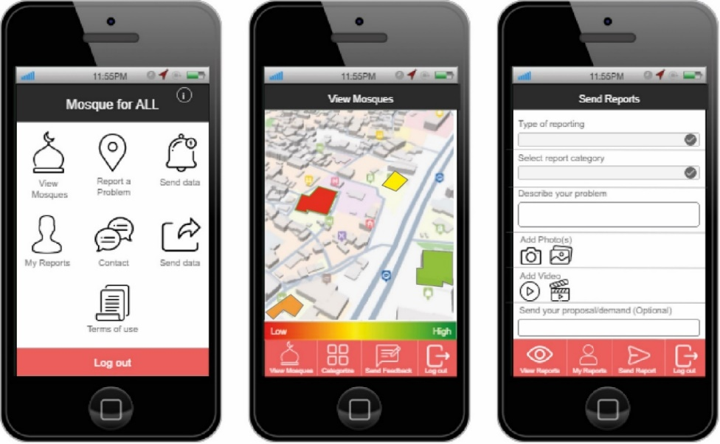

Figure 11. The user interface mobile application is called “Mosque for All”

As seen in Section 3.2, there is a lack of participatory and collaborative processes in mosque design and management in Türkiye (see Figure 4). A participatory and collaborative design approach in both design and management is necessary to meet the expectations of users in terms of spatial quality, facilities, and spatial atmosphere, ensuring responsiveness to the needs of all users in mosques. In this context, we have identified several participatory actions involved in the current process of design and management of mosques in Türkiye (Figure 12). We propose participatory actions for different phases: actions supporting the pre-design phase (1), the design phase (2), and the management phase (3). In addition, we categorize the proposed actions according to the type of participation: participatory actions and expertsourcing actions. At this point, it is suggested that the public should participate in the current process through participatory design actions such as negotiation in the pre-design phase, public inquiry on design alternatives produced in the design phase, and identifying mosque activities in the mosque management phase. The design negotiations to be carried out with the participation of the public can be carried out with the mobile proposed in this study application (Mosque for All), or different user groups who do not have access to this application can be involved in the design process by conducting a questionnaire. In addition, "expertsourcing activities" are proposed in which the DRA, as the responsible official actors in the mosque management process, are collaboratively involved in all phases. At this point, it is suggested that the DRA should play an active role in the 'identification of needs and requirements' by negotiating with the public at the pre-design stage and being involved in the building permission process, while it is suggested that it should be involved in design negotiations at the design stage (collaborative design approach).

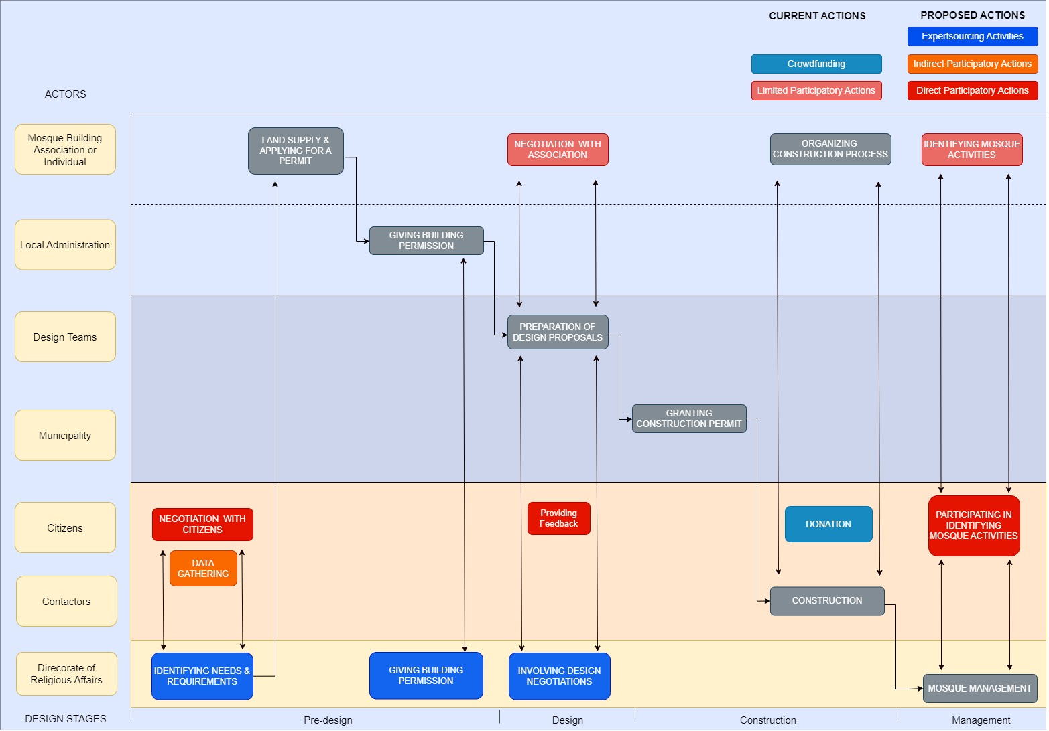

Figure 12. Proposed action flow model for mosque design and management
- CONCLUSION
This study aimed to explore what kind of spatial problems are encountered in mosques, how users' views on spatial satisfaction, and users' perceptions of socio-spatial inclusiveness provided by mosques vary according to users' personal and usage characteristics. The study involved a comprehensive analysis of a survey conducted with 521 participants residing in Turkey. Additionally, a workshop was conducted with 17 participants currently engaged in research on mosque design.
This study has revealed that users of mosques encounter several critical socio-spatial problems. These include issues of representation inequality in the decision-making processes surrounding the design and management of mosques. This can be defined as the gaps in representation equality. Furthermore, there is a lack of responsiveness to users' spatial expectations due to the neglect of the needs of important stakeholders, including women, children, and youth in society. Consequently, only a minority of users (18.4%) are satisfied with the spatial experience in mosques. Furthermore, almost one-third of respondents (30.1%) perceive mosques as spaces that are primarily for middle-aged or elderly males. Then, to address these problems, we identify socio-spatial dimensions contributing to the conceptualization of a “Mosque for All”.
The author hopes that the results and proposals identified in this study will advance the field beyond the current state of knowledge, as it is based on original research that examines the problems encountered by users and their perceptions of mosques within the scope of socio-spatial inclusion, considering varying personal and usage characteristics. This study contributes to the global discussions at the intersection of 'socio-spatial justice' and 'spatial inclusion' by providing perspectives aimed at deepening the existing research and debates in the context of mosques, which are among the most comprehensive public spaces in terms of both quality and quantity in the Muslim world. The socio-spatial dimensions proposed for the resolution of experience issues identified in this study and the solutions proposed for the collaborative design and management of mosques provide a unique forum for discussion in relation to conceptual and theoretical considerations of the "Mosque for All" literature.
One of the primary limitations of this study is its focus on a single country from a geographical and cultural perspective: Türkiye. The socio-cultural differences between this country and other Islamic countries are likely reflected in the research findings. Conducting similar research in different cultural regions (e.g., Indonesia, Malaysia, Bosnia, and Gulf Countries) and discussing the results holistically will provide a 'generalizable' discussion and conclusions. The study is subject to certain methodological limitations. The methodology is based on a comprehensive study of the variety of actors and the quality of the data collected. This includes the actors included in the user survey, official actor interviews, and seeking solutions with participants in the workshop. However, this study has not fully addressed the issues, as it is based solely on declarative information. In order to develop a more meaningful research design and to obtain more in-depth results, it is necessary to address this issue within the framework of more comprehensive field research and to cross-examine the findings derived from declarative and experiential sources.
Therefore, our future research direction is to carry out in-depth field research with the collaboration of official actors in Türkiye, e.g., DRA, and experts who have practical knowledge regarding the subject. To achieve this, we are currently negotiating with officials from the DRA and other relevant stakeholders. Another future avenue for exploration involves developing and implementing pilot projects on the dimensions of 'Mosque for All' in a more in-depth manner. This would require medium- to long-term studies that incorporate feedback from these pilot applications.

REFERENCES

[1] S. Omer, “Studies in the Islamic built environment”, International Islamic University Malaysia, 2013.
[2] N. Asif, N. Utaberta, S. Ismail, and M. I. Shaharil, “The Study on the Functional Aspects of Mosque Institution,” Journal of Islamic Architecture, vol. 6, no. 4, pp. 229–236, Dec. 2021, doi: https://doi.org/10.18860/jia.v6i4.11749.
[3] A. N. Fawzi, “Universal Mosque/Masjid Design,” Studies in Health Technology and Informatics, pp. 293-298, 2018, doi: https://doi.org/10.3233/978-1-61499-923-2-293.
[4] R. Firmansyah, N. Utaberta, N. Shaari, S. Ismail, and Ratri W, “Evaluation of Universal Design Requirements Application in Public Mosques in Bandung,” Malaysian Journal of Public Health Medicine, vol. 20, no. Special1, pp. 238–242, Aug. 2020, doi: https://doi.org/10.37268/mjphm/vol.20/no.special1/art.692.
[5] H. Stetieh, “Are Persons Who Use Wheelchairs Able to Access Existing Mosques?,” Journal of Islamic Architecture, vol. 7, no. 3, pp. 445–453, Jun. 2023, doi: https://doi.org/10.18860/jia.v7i3.18132.

[6] N. Utaberta, F. S. Omi, S. B. Roslan, and N. F. Mohd Ariffin, “An analysis of women’s access and participation in the mosques in the contemporary world,” IOP Conference Series: Materials Science and Engineering, vol. 401, p. 012032, Oct. 2018, doi: https://doi.org/10.1088/1757-899x/401/1/012032.
[7] Y. Megahed, “Is the mosque a male-dedicated building?! A Critical View on Women Praying Space in Contemporary Mosque Design,” in The Mosque: a Cross-cultural Building, pp. 499-512, Kuwait: Kuwait University, 2022, doi: https://orca.cardiff.ac.uk/id/eprint/155327/1/Paper%20-%20Mosque%20Book%20Y.pdf.
[8] L. Nyhagen, “Mosques as Gendered Spaces: The Complexity of Women’s Compliance with, And Resistance to, Dominant Gender Norms, And the Importance of Male Allies,” Religions, vol. 10, no. 5, p. 321, May 2019, doi: https://doi.org/10.3390/rel10050321.
[9] R. Reffat, "Reshaping the architectural design and ICT considerations of mosques for improving youth presence," in Proc. 1st Int. Conf. Mosque Architecture, Dammam, Saudi Arabia, 2016.
[10] Y. Fazaqa, “What is keeping the youth away from the Masjid,” AMJA/NAIF 6th Imams Workshop Houston TX, 2009. Accessed: Mar. 13, 2025. [Online]. Available: https://www.amjaonline.org/wp-content/uploads/2019/04/2009-7-addressing.pdf
[11] L. Safi, “Toward Women-Friendly Mosques,” American Journal of Islam and Society, vol. 22, no. 3, pp. 148–157, Jul. 2005, doi: https://doi.org/10.35632/ajis.v22i3.3024.
[12] A. H. Mokhtar, “Design guidelines for female Muslim prayer facilities in public buildings,” Facilities, vol. 38, no. 3/4, pp. 252-267, 2020, doi: https://doi.org/10.1108/f-04-2019-0052.
[13] N. F. A. M. Razif, N. M. Isa, and R. N. R. Shahminan, “Women Friendly Mosque: an Overview,” Journal of Tourism, Hospitality and Environment Management, vol. 7, no. 27, pp. 121–129, Mar. 2022, doi: https://doi.org/10.35631/jthem.727011.
[14] A. A. Bakar, “Children Friendly Masjid: Physical Layout and Perspective of Children and Families,” Journal of Architecture, Planning and Construction Management, vol. 9, no. 1, 2019, doi: https://doi.org/10.31436/japcm.v9i1.331.
[15] Q. M. Asim, Mosques and Youth Engagement, Guidelines and Toolkit, London: Mosques and Imams National Advisory Board, 2011. [Online]. Available: https://salaam.co.uk/mosques-youth-engagement-guidelines-toolkit/
[16] L. A. Kahera, Abdulmalik, and C. Anz, Design Criteria for Mosques and Islamic Centres. London: Routledge, 2017.
[17] S. Özaloglu and M. Ö. Gürel, “Designing Mosques for Secular Congregations: Transformations of the Mosque as a Social Space in Turkey,” Journal of Architectural and Planning Research, vol. 28, no. 4, pp. 336–358, 2011, doi: https://doi.org/10.2307/43030951.
[18] B. Batuman, "Appropriating the Masculine Sacred: Islamism, Gender, and Mosque Architecture in Contemporary Turkey," in The Routledge Companion to Modernity, Space and Gender, London: Routledge, 2018, pp. 270–287. doi: https://10.1201/9781315180472-20.
[19] Directorate of Religious Affairs (DRA), Guide for Mosque Design and Planning, 2021. [Online]. Available: https://yonetimhizmetleri.diyanet.gov.tr/Documents/Cami+Planlama+ve+Tasarimi+Kilavuzu+2021.pdf
[20] A. Yazan, "'Kadınlar Camilerde': Kadının camideki mağduriyetini ortadan kaldırmak istiyoruz," BBC News Türkçe, Apr. 2018. [Online]. Available: https://www.bbc.com/turkce/haberler-turkiye-43632887
[21] K. Avcı-Erdemli, "Cami Mimarisinde Kadınların Yeri ve İstanbul Müftülüğü Camilerin Kadınlar Bölümünü Güzelleştirme Projesi (3T Projesi)," Din ve Hayat: İstanbul Müftülüğü Dergisi, vol. 20, pp. 66–71, 2013.
[22] A. F. Kılıç and S. Ağçoban, "Kadın ve çocuklara verilen hizmetler açısından camiler," Diyanet İlmi Dergi, vol. 49, no. 4, pp. 61–77, Dec. 2013. [Online]. Available: https://dergipark.org.tr/tr/pub/did/issue/34677/383312
[23] N. Ghafournia, “Muslim Women’s Religious Leadership: The Case of Australian Mosques,” Religions, vol. 13, no. 6, p. 534, Jun. 2022, doi: https://doi.org/10.3390/rel13060534.
[24] H. Othman, M. Yazid, M. Yunos, and N. A. Ismail, "Issues and Problems of Modern Mosques Design in Malaysia: A Critical Analysis," Advances in Environmental Biology, vol. 9, pp. 330–337, 2015.
[25] M. D. Niya, N. Utaberta, and S. Maulan, “Significance of the Application of Universal Design in Mosque Buildings in Malaysia,” Applied Mechanics and Materials, vol. 747, pp. 72–75, Mar. 2015, doi: https://doi.org/10.4028/www.scientific.net/amm.747.72.
[26] A. Gün and A. Çavuş (2023). "Cami Tasariminda Esneklik Kurgusunun İncelenmesi (A Proposal for an Approach to Flexibility Concept in Mosque Design)." XIII International Sinan Symposium, 541–557. https://www.researchgate.net/publication/375421524_Cami_Mimarliginda_Esneklik_Yaklasimina_Iliskin_Bir_Oneri

