 |  | JOURNAL OF ISLAMIC ARCHITECTURE  P-ISSN: 2086-2636 E-ISSN: 2356-4644  Journal Home Page: http://ejournal.uin-malang.ac.id/index.php/JIA
THE VISUAL IMPACT OF COLORS IN OTTOMAN INSCRIPTIONS: A CASE STUDY OF THE SULTAN BAYEZID II MOSQUE IN DIDYMÓTEICHON, GREECE
Ahmed Ameen^{a*}, Yassmin Youssef Kasem^{b}
ªCollege of Arts, Humanities and Social Sciences, University of Sharjah, UAE
^{b}Faculty of Archaeology, Fayoum University, Fayoum, Egypt
*Corresponding Author: ahmed.ameen@sharjah.ac.ae
ARTICLE INFO |  |  | ABSTRACT
Volume: 8  Issue: 4  Page: 1012-1021  Received: June 13th, 2024  Accepted: October 14th, 2024  Available Online: December 30th, 2025  DOI: 10.18860/jia.v8i4.27523 |  |  | This study undertakes a comprehensive examination of color as a distinctive and impactful feature in the artistic and architectural expressions of the Ottoman Empire, with a specific focus on its visual impact on historical inscriptions in Greece. By delving into the reasons and motivations underlying the Ottomans' extensive use of color, this research elucidates the effect it had on the viewer's perception and interpretation. Applying this analytical lens to the oldest extant Ottoman Mosque in Greece, the Sultan Bayezid II Mosque in Didymóteichon, the paper presents a nuanced exploration of the visual impact generated by color within the inscriptional elements of this significant edifice. The findings demonstrate how the Ottomans' strategic deployment of color, mainly through the skilful juxtaposition of contrasting hues and harmonious combinations, enhances the aesthetic appeal of the inscriptions, conveying a tangible sense of authority and captivating the viewer's attention. This research provides a novel perspective for understanding the sophisticated visual communication strategies employed in Ottoman epigraphy, underscoring the pivotal role of color as a crucial element in shaping the inscriptions' visual resonance and symbolic import. This study offers valuable insights into the cultural, aesthetic, and communicative dimensions of Ottoman visual culture by illuminating the multifaceted significance of chromatic expression within this artistic tradition.  Keywords:  Ottoman Greece; Sultan Bayezid II Mosque in Didymóteichon; Islamic Epigraphy; Visual Impact; Colors; Red Color

- INTRODUCTION
The Ottoman Empire's historical footprint in present-day Greece dates back to 1361 AD, when it gained control of the town of Didymóteichon. Over the course of nearly three to five centuries, the Ottomans governed various Greek territories, including Thrace, Macedonia, and Thessaly. They oversaw the construction of numerous buildings across the region. Despite the loss of a significant portion of this architectural heritage due to various factors, the remaining Ottoman structures in Greece stand as a testament to one of the most well-preserved and diverse collections of Ottoman architecture in the Balkans [1], [2], [3], [4], [5], [6], [7], [8].
A defining feature of Islamic art and architecture is the extensive use of calligraphy, and the Ottoman tradition was no exception. Although many Ottoman inscriptions in Greece have been lost over time, the surviving examples represent a significant and diverse collection of Ottoman epigraphy in the Balkans. During the early Ottoman period, which spanned from the inception of their rule until the early 16th century, Arabic served as the primary language for the foundation and historical inscriptions found across Greece and the broader Balkans region [9], [10], [11], [12], [13]. Of particular importance are the so-called "foundation" inscriptions, which offer valuable insights into the contemporary Ottoman communities. In Greece, 367 full or partial foundation/restoration inscriptions from Ottoman buildings have endured, 54 of which are in Arabic [13]. Among these, the inscriptions adorning the Sultan Bayezid II Mosque in Didymóteichon are especially noteworthy for their exceptional artistry, complexity, and historical significance.
While the existing body of literature has addressed Ottoman inscriptions in Greece from the perspectives of linguistic analysis and content interpretation –a common approach in the study of Islamic epigraphy– there remains a dearth of dedicated research examining the pivotal role of color and its visual impact on these inscriptional works. Except for Ameen's insightful observations regarding the crucial contextual influence of visual elements in enhancing our understanding of architectural inscriptions [11], [12], [13], [14], this specific dimension has yet to be systematically explored.
The significant works by Roxburgh (2008) [15] and alQaḥṭānī (2009) [16] have brought to light the artistry of Arabic calligraphy and its visual representations. It is worth mentioning the insightful analysis of the visual effects of inscriptions embellishing Mamluk structures in Cairo as presented by Ahmed in 2019 [17]. Although the current case study diverges in terms of sponsorship, origins, regional influences, and the broader historical period, it still builds upon the valuable precedent set by Ahmed's study [17].

- METHODS
This research tackles two central inquiries: To what extent did color play a pivotal role in the visual landscape of Islamic inscriptions? And did the Ottomans make specific chromatic choices for symbolic purposes? By conducting a thorough analysis of relevant inscriptions, with a specific focus on those adorning the Sultan Bayezid II Mosque in Didymóteichon, a significant case study due to its historical and cultural importance, this paper adopts a multifaceted methodological approach, encompassing descriptive, analytical, and inductive frameworks to unravel the answers to these pertinent questions.
The paper employs an interdisciplinary approach to demonstrate and analyze the visual impact of colors in Ottoman epigraphy, with a focus on the Sultan Bayezid II Mosque in Didymóteichon, Greece. This approach includes field visits, analyzing the inscription's photographic material, and revising related historical and contextual research. , and an analytical and interpretive approach. Field photographic documentation helps in recognizing script styles, color tones, materials, and their connection to the architectural context. Also, the authors revised extensive historical and contextual studies to understand the motivations and meanings behind the Ottomans' chromatic preferences.

- RESULT AND DISCUSSION

  - THE SULTAN BAYEZID II MOSQUE IN DIDYMÓTEICHON
- 1. Architectural Analysis, Historical Significance, and Context and Preservation
The Sultan Bayezid II Mosque in Didymóteichon is a remarkable example of early Ottoman architectural and artistic achievement in the Balkans. This grand edifice, commissioned by Sultan Mehmed I and completed around 1420-1421, exhibits a striking blend of Byzantine, Seljuk, and emerging Ottoman design elements. Its central plan, featuring a rectangular prayer hall articulated around four central piers supporting a wooden dome, represents a significant step in the evolution of the classical Ottoman mosque typology. The juxtaposition of domed, vaulted, and pyramidal roofing systems further reflects the mosque's architectural sophistication and the Ottomans' mastery of integrated spatial planning [18], [19], [20], [21], [22], [23], [24], [25], [26], [27], [4].
In the evolution of the classical Ottoman mosque typology. The juxtaposition of domed, vaulted, and pyramidal roofing systems further reflects the mosque's architectural sophistication and the Ottomans' mastery of integrated spatial planning [19], [21], [4].
The mosque's exterior is equally impressive, featuring a lavishly ornamented main portal that ranks among the finest examples of stone carving from the early Ottoman period in the region. The delicate interplay of geometric patterns, arabesque motifs, and Arabic inscriptions adorning the portal and façade demonstrates the Ottomans' keen aesthetic sensibilities and their strategic use of color and ornament to enhance the structure's visual impact and symbolic authority. The presence of the mosque's towering minaret, with its distinctive Turkish triangular base, further underscores the building's vital role as a prominent landmark in the urban fabric of Didymóteichon. As one of the largest and most impressive Ottoman mosques in the Balkans, the Sultan Bayezid II Mosque stands as a testament to the Ottoman Empire's cultural and architectural legacy in the region [4].

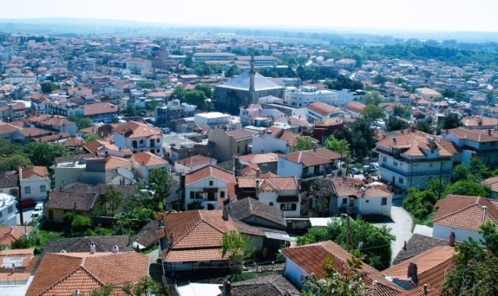

Figure 1. A panoramic view of the historic city of Didymóteichon from the citadel, the Sultan Bayezid II Mosque forms its core [4]

The construction of the Sultan Bayezid II Mosque is deeply intertwined with the Ottoman conquest and subsequent rule of the Greek territories, which began in 1361 AD. As one of the earliest and most significant Ottoman architectural commissions in the Balkans beyond modern-day Turkey, the mosque's origins can be traced back to the reign of Sultan Bayezid I. However, it was under the patronage of his successor, Mehmed I, in the early 15th century that the mosque was completed. The mosque's impressive scale, ornamental program, and the prestigious architect, Hadji ʿAwaḍ (عوض) “Ivaz” Paşa, highlight the strategic importance of Didymóteichon within the broader Ottoman sphere of influence during this period [21], [4].

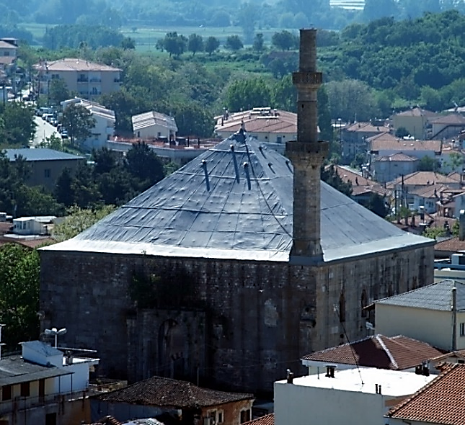  a. The Sultan Bayezid II Mosque from the western corner where the minaret is located [4] | 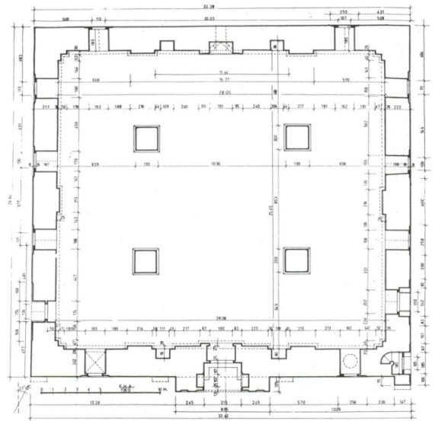  b. The Sultan Bayezid II Mosque, a plan [20]
Figure 2(a&b). 1: The main Arabic foundation inscription; 2: The secondary Arabic foundation inscription

Despite the challenges it has faced over the centuries, including its use as a grain depot that caused significant interior damage, the Sultan Bayezid II Mosque has stood the test of time as a remarkable testament to the Ottoman architectural legacy in Greece. In recent decades, concerted efforts have been made to protect and conserve this monument, which is now under the custodianship of the 15th Ephorate of Byzantine Antiquities of the Greek Ministry of Culture [28]. This preservation work highlights the historic and cultural significance of the mosque, which remains a notable landmark, providing visitors with a unique glimpse into the artistic and architectural achievements of the Ottoman Empire in the Balkans.
The mosque's unique monumental pyramid-shaped wooden roof was one of the most significant and rare wooden monuments in the world before it was entirely burned due to a massive fire during the last restoration project in 2017 [4].
- SEEING IS BELIEVING? THE CENTRAL ROLE OF VISION IN ART AND ARCHITECTURE
The realm of "visual arts" represents a relatively modern term encompassing a wide range of artistic disciplines that are perceptible to the human eye. This conceptual framework gained prominence in the Western world during the early to mid-20th century, coinciding with the emergence of modernist architecture. The visual arts encompass a diverse array of media, including painting, printmaking, advertising, and multimedia, all of which underscore the centrality of the visual in evaluating artistic worth, regardless of the subject matter. Furthermore, this term can be extended to encompass the decorative elements and calligraphic traditions prevalent in Islamic art and architecture [15], [16].
At its core, the visual arts serve as a mode of communication that depends on the function and limitations of the human eye in perceiving and comprehending visual stimuli. For effective visual communication, the artwork must convey a clear and concise visual message that embodies a specific idea. The interpretation of the artwork varies based on its nature; for instance, music communicates through sound, sculpture through form, painting through color, and written messages through calligraphy. The substance of any artistic work is its essence, while its external appearance embodies its form. In the realm of art, there exists a tight, often inseparable bond between content and form, particularly in the case of calligraphy [29], [30], [31].
Inscriptive panels in art and architecture often function on two levels of visualization. The first operates as a direct verbal system, exerting influence primarily on those who can read and comprehend the textual meaning. The second, which could be argued to be more potent, involves the inscriptional content functioning as a nonverbal, symbolic system. This visual impact is directed at a broader audience, transcending linguistic barriers, and conveying a universal message of power, supremacy, and identity. Recognizing the composition of inscriptional art and its visual resonance is often more accessible and enduring than deciphering the textual content, as visual memorization is influenced by factors such as color, design, scale, placement, and repetition [14].

- THE RICHNESS OF COLOR IN HUMAN EXPERIENCE AND ISLAMIC ART
- 1. Color as a Sensory and Symbolic Dimension in the Qur'an
Colors are fascinating and diverse in human life, enriching our experiences and adding beauty to our surroundings. In the Qur'an, colors are often mentioned in both symbolic and sensorial ways. For instance, the "saffron-colored, bright in hue" description of the yellow cow in Surah Al-Baqarah (2:69) evokes a vivid visual image. The distinction between white and black threads during fasting in Surah Al-Baqarah (2:187) employs color to convey a clear conceptual distinction. Similarly, the references to the "green and ripe ears of corn" in Surah Yusuf (12:43) and the "blue color associated with the Day of Judgment" in Surah Taha (20:102) leverage color to heighten the sensory and metaphorical resonance of the Quranic passages [32].
Furthermore, Surah Fatir (35:27) celebrates the diversity of creation, including "fruits of varying colors" and "mountains... white and red of varying shades and [some] extremely black." Surah Ar-Rahman (55:37) paints a vivid image of the sky "splitting open and becoming rose-colored like oil." These verses highlight the beauty and wonder of Allah's creation, imbuing color with profound symbolic and sensory meanings [32], [33].

- 2. Color as a Fundamental Characteristic of the Visual World
Color is one of the primary ways through which humans understand and engage with their surroundings. It is closely related to form and can sometimes be a fundamental characteristic or identity of an object or substance. As shapes have dimensions and measurements, colors also possess inherent physical properties. Like shapes, colors have relationships and organizational systems, adding depth and nuance to our visual experiences [34], [35].

- 3. The Physiology of Color Perception
The term "color" refers to the perceptual experience resulting from the interaction of light with our eyes and nervous system. From a physical perspective, color is the property of an object or substance that determines how it appears when light is reflected from its surface. Different materials absorb and reflect light in varying ways, leading to the perception of diverse colors. From a physiological standpoint, color perception is a complex phenomenon related to the functioning of the human visual system. The light-receiving devices in the eye, such as the retina, interact with the reflected light to transmit color-related information to the brain through a network of specialized optical fibers [36], [37].

- 4. The Role of Color in Visual Art and Architecture
Color is pivotal in shaping visual artwork, significantly achieving aesthetic values and depth. It is a fundamental means of achieving beauty and expressiveness in various artistic disciplines, including engraving and calligraphy. Color is no less important than form; the two are intricately linked, often conveying deep meanings in our subconscious minds stemming from inherited and acquired experiences [38], [39].
In Islamic art and architecture, colors have been strategically employed for functional and symbolic purposes. Foundational texts inscribed on buildings utilize color to enhance visual communication, attracting the viewer's attention and conveying messages. Aesthetically, the careful use of color in these inscriptions increases the beauty of the calligraphic forms, significantly influencing the audience's perceptions and reactions to their surroundings. Additionally, the use of colors played a crucial role in guiding the viewer's interpretation of an inscription. In some cases, colors – with the help of the frames’ styles and forms – establish what is referred to as a "map of reading an inscription." This suggests that the perfect employment of color played a significant role in determining the viewer's engagement and understanding of the inscriptive content. Color, thus, becomes a powerful tool for the Ottomans to control signaling, express their identity, and persuade their diverse audiences, including foreigners and Arabic speakers [40], [41].

- FOUNDATION INSCRIPTIONS OF THE SULTAN BAYEZID II MOSQUE IN DIDYMÓTEICHON
The Sultan Bayezid II Mosque in Didymóteichon contains two notable Arabic foundation inscriptions. The primary inscription is situated above the main portal on the NW façade, while the secondary inscription is located above the side door in the western section of the SW façade [4]. These inscriptions, along with the minaret, offer an overlooking view of the city and the citadel. Both inscriptions are crafted in a vibrant, colorful, and artistically pleasing manner, serving as prominent focal points that capture the viewer’s attention.
The main foundation inscription (Figures 3 & 4) originates from (almutamem=the last day) 30/3 (Rabīʿ al-Awwal)/823 H (Sunday 14/4/1420). It is a rectangular stone plaque measuring 1.25 meters in height and 2.15 meters in width, featuring three lines separated by red lines. The text is composed in the complex Thuluth (Celî Sülüs) script, with the third line being particularly intricate. The inscriptions are in relief, with dark blue lettering set against a pale yellow backdrop. Additionally, a decorative border with red arrows surrounds the inscribed panel [4], [9].

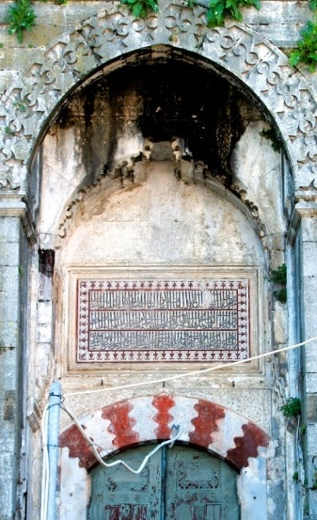 | 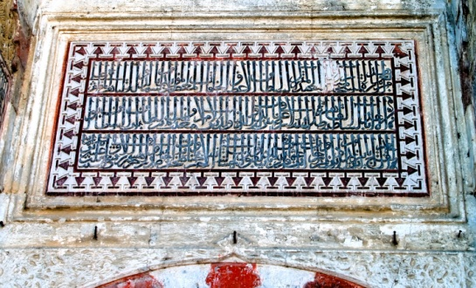
 | Figure 4. The main Arabic foundation inscription [4]
 | 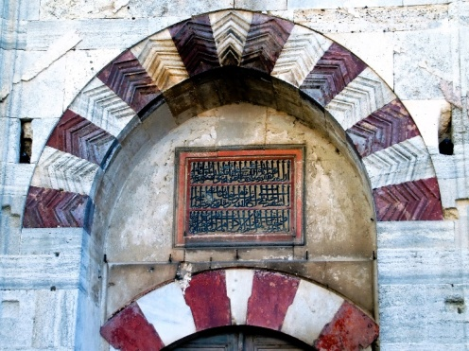
Figure 3. The Sultan Bayezid II Mosque, featuring its main portal with an Arabic foundation inscription [4]. | Figure 5. The secondary door with its Arabic foundation inscription [4]

The secondary dedicatory inscription (Figure 5, 6, 7) of Sultan Bayezid’s Mosque in Didymoteichon, located above the western entrance of the SW façade, dates to the year 824 H (6/1/1421- 25/12/1421). This inscription, carved onto a rectangular stone plaque measuring 80 centimeters in height and 130 centimeters in width, features, almost as the main inscription, three lines delineated and separated by red lines. The script employed is Thuluth, presented in a complex manner. The text is in relief, with dark blue lettering against a pale-yellow background [4], [9].

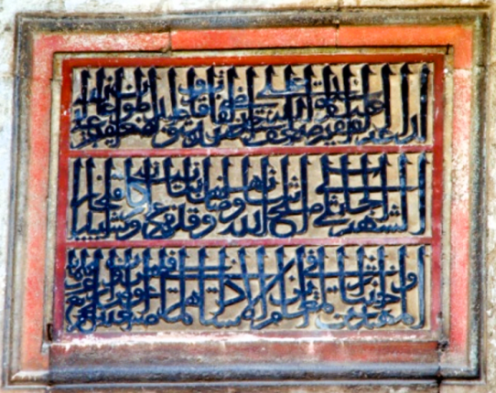 | 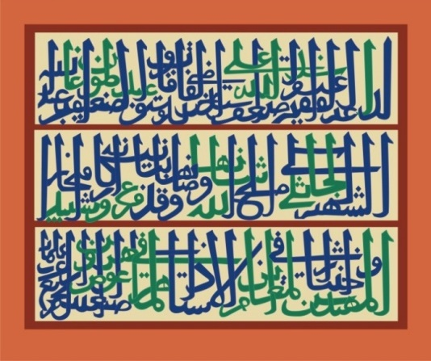
Figure 6. Bayezid II Mosque, the secondary Arabic foundation inscription [4] | Figure 7. Bayezid II Mosque, transcription of the secondary Arabic foundation inscription. ©Yasmin Kasem 2022

The remarkable visual representation of both inscriptions corresponds to the significant importance of the information they convey. The primary inscription conveys details about the building's function, the full name and titles of its founder, Sultan Mehmed Çelebi, who oversaw the construction of the mosque, and the precise date of the building's completion. The secondary inscription lists the city's name, the qadi, the supervisor, and the architect, along with their respective titles, and the exact date of the mosque's completion [4], [9].
Numerous significant contributions have been made with respect to the interpretation, transliteration, and translation of the inscriptions. Βαφείδης (1937) presented a Greek translation based on a Turkish translation by the Mufti of Evros at the time, which contains numerous errors, particularly regarding the dating [42]. Subsequently, Ayverdi (1956; 1972; 1982) published an Arabic reading and a Turkish translation of the inscription, which contained misreadings of certain words and consequently led to an inaccurate corresponding Gregorian date [18], [19], [20]. All subsequent studies have followed Ayverdi's reading and translation, including Türkoğlu (1998) [23], Bıçakçı (2003) [25], and Yapar (2007) [26], all of whom reproduced the same errors in their full readings and Turkish translations. A new reading and English translation have been provided by Ameen (2012) [9].

- DISCUSSION
The Sultan Bayezid II Mosque in Didymóteichon stands as a testament to the rich cultural, linguistic, and artistic legacy of the Ottomans in Greece. The Arabic inscriptions on the mosque's exterior serve as powerful visual expressions of Ottoman identity and authority, notable for their skilful use of color to capture the viewer's attention and convey a sense of grandeur and permanence.
The calligraphers strategically employed a color palette primarily featuring dark blue lettering against a pale yellow background to create visual contrast and enhance the legibility of the intricate thuluth script. This deliberate use of color aimed to convey authority, power, and mystery, qualities integral to the Ottomans' visual communication strategies. The red outlines and borders surrounding the inscriptions further accentuate their prominence, signifying strength and commanding the viewer's focus.
The calligraphers demonstrated mastery in maintaining a harmonious balance between the colors. The repetition of red and blue hues, along with the careful gradation of shades, creates a visually appealing and interconnected composition. This measured approach ensures that the viewer's eye is drawn to explore the calligraphy's artistic merits without being overwhelmed by the chromatic elements.
The strategic placement of the inscriptions, overlooking the city and citadel, underscores their role as visual landmarks within the urban fabric. Despite the small scale of the engravings, the calligraphers' skillful manipulation of color gradients and ability to create a harmonious composition further exemplify their mastery of the medium.
The interplay of form and ground in the calligraphy achieves visually captivating and authoritative effects. The contrast between the dark blue lettering, the pale-yellow background, and the dynamic use of red outlines creates a visually compelling presence. This careful balance of colors and the calligrapher's attention to visual harmony are essential for ensuring clear legibility and a cohesive aesthetic experience for the viewer.
The calligraphic inscriptions on the Sultan Bayezid II Mosque serve as a testament to the Ottomans' sophisticated visual communication strategies, where color played a crucial role in enhancing the symbolic significance and aesthetic appeal of these epigraphic works. By examining the strategic use of color in these inscriptions, this study provides valuable insights into the cultural, linguistic, and artistic dimensions of Ottoman visual culture in Greece.
The utilization of color in Ottoman architectural inscriptions carries deep cultural, religious, and artistic significance, reflecting the sophistication of the Ottoman Empire. Through an analysis of the calligraphic inscriptions adorning the Sultan Bayezid II Mosque in Didymóteichon, Greece, this research delves into the intricate meanings of color within the realm of Ottoman visual communication and identity formation.
The Ottoman preference for specific colors in their inscriptions was not purely a matter of aesthetics, but rather a deliberate expression of the profound symbolic and spiritual associations entrenched in Islamic tradition. In this regard, we must note that medieval understandings of colors differed from our modern perceptions, and even within the same culture and religion, there were variations from one sect to another. For example, the historian al-Masudi (4th H/10th c.) expressed a particular fondness for the color red, stating that it was associated with children, women, and joy. He also noted that red is considered visually appealing as it enlarges the pupil, in contrast to black, which narrows it. Al-Masudi's account is exemplified in the context of Ottoman Ghadames, Libya. In Seljuq and Ottoman Turkey, red was the color for brides. Still, it was favored by prostitutes in Mamluk Egypt. Notably, Didymóteichon, the city under study, gained widespread recognition for its red glasses, dishes, bowls, and ewers, as documented by Evliya Çelebi [46].
In the same context, the strategic use of red evoked notions of passion, sacrifice, and religious fervor, reaffirming the Ottomans' unwavering Islamic identity and their role as protectors of the Muslim faith [40], [41]. Several indications support this belief, as documented in Evliya Çelebi’s book. For instance, the name of Yâvedûd Sultân (Sheikh Abdülvedûd Efendi, who took part in the siege and conquest of Istanbul) was inscribed on the mihrab of Hagia Sophia on red fabric, emitting a divine light [47]. Additionally, Evliya Çelebi mentioned that the sea turned red from the blood of numerous martyrs during the conquest of Istanbul and noted that the sea's color turned into a blood-red hue at the same time every year [47]. Moreover, the incorporation of dark blue was laden with implications of authority, power, and the divine, symbolizing the Sultan's legitimacy and celestial connection [40].
The interpretation of the symbolism of colors in Sufism varies, and there is no single consensus on the meaning of each color. However, it is interesting to consider the Sufi perspective on the symbolism of colors, particularly in light of the presence of Sufi verses in the same colors, such as dark blue (or black), pale yellow (or white), and red, adorning the sides of the main portal. One of the most well-known interpretations comes from Al-Suhrawardi (d. 1191), who described the soul's progression through colors, starting from black (representing the lowest state), then moving through red, and finally reaching white. Other Sufi scholars, such as Al-Ansari (11th century) and Najm al-Din Kubra (1145-1221), used a broader color palette to classify different aspects of the soul and levels of the universe [41].
Color served as a potent tool for visual communication, enabling the Ottomans to employ strategic contrasts and harmonies to direct the viewer's focus and establish visual hierarchies within the inscriptions. The juxtaposition of dark blue lettering against a pale-yellow backdrop, accentuated by dynamic red outlines, created a visually compelling composition that immediately captured the observer's attention. This adept manipulation of color allowed the Ottomans to prioritize specific textual elements, such as the names of the ruling Sultan or significant Quranic verses, thereby reinforcing their political and religious authority [43].
The juxtaposition of dark blue and lightened "white" or pale yellow, accompanied by dynamic red, is not only aesthetically pleasing but also visually delightful. This contrast is further exemplified in the mosque's architecture, as seen in the arches of the doors, portals, and windows, underscoring its significance. An intriguing instance of the mix of white and red hues can be observed in the execution of the Kufic inscription of the Shahada, particularly on the balcony of the minaret of the Kara Mehmet Agha Mosque in Istanbul [47].
The refined use of color in Ottoman inscriptions is indicative of the empire's artistic sophistication and its ability to seamlessly integrate visual elements into a harmonious and aesthetically pleasing whole. Careful attention to color balance, gradation, and the interplay of form and background showcases a nuanced comprehension of color theory and its application in the visual arts. This aesthetically refined approach, coupled with the consistent use of a distinct color palette, facilitated the establishment of a visual identity that was unmistakably Ottoman and Islamic, thereby reinforcing the empire's cultural hegemony in its domains [44].
The Ottomans' strategic employment of color in their inscriptions extended beyond symbolism and aesthetics, incorporating the emotional and psychological impact of color on the observer. By selecting hues that inspired awe, reverence, and a sense of the divine, the Ottomans were able to shape the viewer's experience and amplify the overall influence of the inscriptions. This sophisticated comprehension of color's capacity to evoke specific emotional responses underscores the Ottomans' profound understanding of visual communication and its ability to shape cultural perceptions and affiliations [45].
The deliberate and meaningful use of color in Ottoman inscriptions stood as a testament to the empire's cultural and artistic legacy. Through the thoughtful selection and integration of hues, the Ottomans conveyed their distinct identity, projected their authority, and engaged observers on multiple levels – whether symbolic, aesthetic, or emotional. This sophisticated approach to color in architectural inscriptions reflects the Ottomans' profound understanding of the power of visual communication and their adeptness in utilizing it to further their cultural, religious, and political ambitions.

- CONCLUSION
This study has illuminated the pivotal role of color as a crucial element in shaping the visual impact and symbolic resonance of Ottoman inscriptions, as exemplified by the exceptional calligraphic works adorning the Sultan Bayezid II Mosque in Didymóteichon, Greece. The strategic deployment of a sophisticated color palette, predominantly featuring dark blue lettering, pale yellow backgrounds, and vibrant red accents, enhanced the visual communication strategies employed by the Ottomans in this significant architectural monument.
The calligraphers' masterful handling of color achieved a harmonious balance, capturing the viewer's attention while ensuring the intricate thuluth script remained legible. This measured approach underscores the Ottomans' deep understanding of color theory and its application in the visual arts, reflecting their artistic finesse and cultural refinement.
Beyond the aesthetic dimensions, the strategic use of color in these inscriptions was imbued with profound symbolic and spiritual significance. The dark blue hues conveyed a sense of authority, power, and divine connection, while the red accents evoked notions of passion, sacrifice, and religious fervor. This judicious chromatic selection enabled the Ottomans to project their distinct identity, reinforce their political and religious legitimacy, and engage the observer on multifaceted levels.
The findings of this study provide significant insights into the multifaceted role of color in Ottoman visual culture, demonstrating its ability to shape perceptions, convey hierarchical structures, and establish cultural affiliations. By revealing the intricate interplay between form, color, and symbolic meaning in the calligraphic inscriptions of the Sultan Bayezid II Mosque, this research deepens our understanding of the Ottomans' sophisticated visual communication strategies and their enduring legacy in the Balkans.
As a compelling case study, the inscriptions of the Sultan Bayezid II Mosque exemplify the Ottomans' mastery of color as a crucial element in their architectural and artistic expressions. This research highlights the need for further scholarly investigation into the visual aspects of Ottoman epigraphy, which has the potential to reveal new layers of meaning and deepen our understanding of the empire's cultural and artistic achievements.

AUTHORS CONTRIBUTION
Author1 conceived the presented idea. The theory was developed, and the related data were collected, by Author1 and Author2 in collaboration. Author 2 verified the analytical methods employed and provided oversight for the findings of this work. Both authors engaged in discussions of the results and contributed to the preparation of the final manuscript.

REFERENCES

- A. Ameen, “The Mehmet Khalil Agha Mosque in the Greek city of Drama”, SHEDET, Vol. 1, No.1, pp. 19-34, 2014. DOI: 10.36816/shedet.001.02
- A. Ameen, “Travelers' Works as an Important Source in Studying Archaeology in Light of the ‘Hadji ‘Ali Mosque’ of Athens,” SHEDET, Vol. 2, No. 2, pp. 6-22, 2015. DOI: 10.36816/shedet.003.07
- A. Ameen, “The Küçük Cami of Athens: Some considerations in the light of the Travelers' works,” Turcica, Vol. 47, pp. 73-97, 2016. DOI: 10.2143/TURC.47.0.3164942
- A. Ameen, Islamic Architecture in Greece: Mosques. Alexandria: Bibliotheca Alexandrina, 2017.
- A. Ameen, “Patrons of Ottoman Mosques in Greece reconsidered in light of the Ierapetra Mosque of Crete,” Journal of Islamic Architecture, Volume 5, Issue 3, pp. 137-144, June 2019. DOI: 10.18860/jia.v5i3.5365
- A. Ameen, “The Ottoman architecture in Greece then and now: Quantitative approach,” SHEDET, Vol. 6, No. 6, pp. 93-115 2019. Doi.10.36816/shedet.006.06
- A. Ameen, “The Ottoman bedestens in Greece,” SHEDET, Vol. 7, No. 7, pp. 115-144, 2020. DOI: 10.36816/SHEDET.2020.32863.1021
- A. Ameen, “Ottoman Waqf–Medreses in Greece “Archival & architectural study,” Journal of Architecture, Arts and Humanistic Science, Volume 6, No. 25, pp. 566-597, 2021. DOI: 10.21608/MJAF.2020.25255.1534
- A. Ameen, “The meaning of the Arabic dedicatory inscriptions of the Ottoman monuments of Greece, Journal of the Faculty of Archaeology-Cairo University, 2012, 1-16.
- A. Ameen, “Ed. Halit Eren; Prepared by Halit Eren, Mustafa OğUz, and Zekai Mete. Balkanlar’da Osmanli Vakiflari, Vakfiyeler Yunanistan.” SHEDET, Vol. 5, No. 5, pp. 224-229, 2018. Doi.10.36816/shedet.005.15
- A. Ameen, “Bilingual and trilingual inscriptions of the Ottoman buildings in Greece: a search for the history of late Ottoman period.” Abgadiyat, Vol. 14, pp. 208-243, 2019. https://doi.org/10.21608/abgad.2019.140483
- A. Ameen, “The significance of the Qur’anic quotation ‘Mā shā' Allāh’ on both Ottoman and Greek heritages in the Balkans, with a special reference to the extant inscriptions on Ottoman buildings in Greece,” EJARS, Vol. 10, No. 1, pp. 73-85, June–2020. DOI: 10.21608/ejars.2020.98963
- A. Ameen, “Towards a corpus of the inscriptions of Ottoman buildings in Greece,” Journal of Anthropological and Archaeological Sciences (JAAS), Vol. 1, No. 2, pp. 36-46, 2019.
- A. Ameen, “Mamluk Ranks: Motives of usage and their visual impact,” Abydos annual peer-reviewed journal issued by the faculty of archaeology, Sohag University, Vol. 1, pp. 5-19, 2019, DOI: https://doi.org/10.21608/abidus.2019.223391
- D. J. Roxburgh “"The Eye Is Favored for Seeing the Writing's Form": On the Sensual and the Sensuous in Islamic Calligraphy,” Muqarnas, Vol. 25, pp. 275-298, 2008.
- H. M. alQaḥṭānī, “Calligraphy and Architecture: A Visual and Historical Analysis of the Most Important Manifestations of Arabic Calligraphy in Islamic Architecture.” Journal of Quranic Research and Studies, Vol. 4, No. 8, pp. 279-357, 2009.
- A. M. A. Ahmed, “Calligraphic Inscriptions on Cariene Architectural Heritage during the Mamluk Sultanate of Qalawūn (678-784 AH / 1279-1382 CE): A Visual and Artistic Study”, MA Thesis, 2019, Department of Islamic Archaeology, Faculty of Archaeology, Sohag University.
- E.H. Ayverdi, “Dimetoka'da Çelebi Sultan Mehmed Camii”. Vakıflar Dergisi 3, pp. 13–16, 1956
- E.H. Ayverdi, Osmanlı mimarisinde Çelebi ve II. Sultan Murad Devri, 806-855 (1403-1451). II. Istanbul: Baha Matbaası, 1972.
- E. H. Ayverdi, Avrupa'da Osmanli Mimari Eserleri IV: Bulgaristan, Yunanistan, Arnavutluk. Istanbul: Istanbul Fetih Cemiyeti, 1982.
- S. Eyice, “Çelebi Sultan Mehmed Camii. Yunanistan’da Dimetoka’da XV. yüzyıl başlarına ait cami.” TDV İslâm Ansiklopedisi’nin, Vol. 8, pp. 262-263, 1993.
- M. Kiel, “Dimetoka. Yunanistan’da Trakya kesiminde eski bir Osmanlı kasabası”. TDV İslâm Ansiklopedisi’nin 9, 1994, 305-308.
- M. Türkoğlu, “Meriç (Evros) vilayetindeki tarihi Türk eserleri,” Batı Trakya'nın Sesi, Vol. 7, No. 2, pp. 29-38, 1989
- A. Gouridis, To Istoriko Didymóteicho: Symvoli stin istoria kai tin topographia tis poleōs tou Didymoteichou. Didymoteicho, 1999.
- İ. Bıçakçı, Yunanistan'da Türk mimari eserleri. İstanbul: Ircica, 2003.
- B. Yapar, Yunanistan’daki Türk Eserlerinde Kitabeler (Dedeağaç, Dimetoka, İskeçe, Gümülcine, Selanik, Kavala, Yenice-Karasu), Mimar Sinan Üniversitesi Sosyal Bilimler Enstitüsü,Yüksek lisans tezi, İstanbul, 2007.
- D. E. Koutroulas, Mousoulmanika temeni kai tekkedhes sti Thraki: Istoriki kai vivliographiki proséngisi, Postgraduate Thesis, Aristotle University of Thessaloniki, Thessaloniki, 2009.
- E. Brouskari [ed.], Ottoman Architecture in Greece. Athens: Hellenic Ministry of Culture, Directorate of Byzantine; Post-Byzantine Antiquities, 2008.
- A. Riyāḍ, Formation in Visual Arts: A Study on the Psychology of Vision and Its Role in Eliciting Aesthetic Sensations, 3rdEd. Cairo: Dār alNahḍa alʿarabiya, 1995.
- M. M. Quṭb, et al. “Designing Advertisements: Between Visual Rhetoric and Visual Knowledge,” Journal of Architecture, Arts, and Humanities, Vol.11, No. 2, pp. 420-422, 2018.
- M. A. M. Sa’id, “Fundamentals of Aesthetics in the Design of Calligraphic Bands in Islamic Architecture,”Afaq Al-Thaqafah wa Al-Turath, Vol. 5, No. 20-21, April 1998.
- J. alḤanbalī, “Colors in the Noble Quran,” Al-Bayan, No. 42, October 2006.
- H. A. Motawea, “Colors and their significance in the Islamic civilization with application to the models of Arabic manuscripts,”Journal of the General Union of Arab Archaeologists, Vol. 18, pp. 418-450, 2017
- A. S. Faḍel, Colors, Qualities, and Characteristics, Faculty of Fine Arts, University of Babylon, 2015.
- H. Ṣ. Ḥāmid, “Color in Islamic architecture and its impact on interior design,” Journal of Architecture, Arts and Humanistic Science, Vol. 4, No. 4, pp. 582-598, 2019.
- H. Ṣ. A. AlMaʿddāwī, “The aesthetic and expressive values of the color element in Islamic mosaics (13th – 17thc.) and its impact on contemporary Arab Art”, MAThesis, Photography Department, Faculty of Fine Arts, Helwan University, 2009.
- M. R. A. Abdul Raḥmān, "The color and its use in modern photography", MA Thesis, 1983, Faculty of Fine Arts, Helwan University.
- D. N. Wilber, “The Role of Color in Architecture.” Journal of the American Society of Architectural Historians, vol. 2, no. 1, pp. 17–22, 1942.
- L. S. S. AlJuhani, Design of Visual Materials: Techniques and Applications, Riyadh: Al-Obekan Publishing, 2018.
- F. B. Flood, The Great Mosque of Damascus: Studies on the Makings of an Umayyad Visual Culture, Brill, 2019.
- R. Irwin, Islamic Art in Context. Laurence King Publishing, 2021.
- A. N. Vafeidis, “To en Didymoteichō Temenos Bayezid I tou Keravnou kai ai epigraphi autou,” Thrakiká Chroniká 10 (1937): 35–51.
- G. Necipoglu, The Age of Sinan: Architectural Culture in the Ottoman Empire. Princeton University Press, 1995.
- D. J. Roxburgh, Turks: A Journey of a Thousand Years, 600-1600. Royal Academy of Arts, 2005.
- Y. Tabbaa, The Transformation of Islamic Art During the Sunni Revival. University of Washington Press, 1988.
- E. Çelebi, Seyahatnâme. Vol. 8. Istanbul: Bagdat Köşkü, 1680
- E. Çelebi, Evliyâ Çelebi Seyahatnâmesi. Edited by S. A. Kahraman, Y. Dağlı, and R. Dankoff. vol. 1. İstanbul: Yapı Kredi Yayınları. 2003.

