 |  | JOURNAL OF ISLAMIC ARCHITECTURE  P-ISSN: 2086-2636 E-ISSN: 2356-4644  Journal Home Page: http://ejournal.uin-malang.ac.id/index.php/JIA
EXPLORING THE “LIVING MOSQUE”: USAGE PATTERNS, USER PREFERENCES, AND FUNCTIONAL EXPECTATIONS IN MOSQUE ARCHITECTURE
Ahmet Gün^{a*}
ªIstanbul Technical University, Istanbul, Türkiye
*Corresponding Author: ahmetgun@itu.edu.tr
ARTICLE INFO |  |  | ABSTRACT
Volume: 8  Issue: 4  Page: 859-882  Received: June 14th, 2024  Accepted: September 28th, 2024  Available Online: December 30th, 2025  DOI: 10.18860/jia.v8i4.27627 |  |  | Mosque spaces and facilities traditionally serve as places where Muslim communities can pray, gather, and socialize. However, the functional role of the mosque in social life has begun to decline. This study addresses the question: How are mosques currently used, and to what extent do these spaces meet users' expectations? To explore this, an online survey was conducted with 521 participants from Türkiye, examining their usage patterns, preferences, and functional expectations regarding mosque experiences. Additionally, a workshop was conducted to develop strategic-level proposals on the identified issues. The findings highlight a disjuncture between how mosques are currently used and their potential utilization. The study also identifies discrepancies between the priorities of academia and architectural media compared to those of the general community, as well as gaps between the socio-spatial functions offered by mosques and those desired by the public. Notably, only 18.2% of respondents feel that mosques adequately meet their functional needs. Moreover, mosque usage patterns, as well as functional expectations, were found to vary significantly based on users' gender, age, and education levels. The public wishes to experience the mosques as the center of education, culture, and social life. This study contributes to the field by introducing the "Living Mosque" concept, providing a comprehensive analysis of mosque usage and perceptions in Türkiye, and shedding light on the gaps between existing practices and user expectations. It also proposes strategic-level solutions for enhancing mosque facilities, providing valuable insights for future research, and practical improvements in mosque design and management.  Keywords:  Living mosque; Mosque usage; User preferences; Functionality; Socio-spatial facilities; User experience; Mosque architecture; Türkiye

- INTRODUCTION
Mosques are one of the most important public spaces in the life of Muslim populations. Muslim communities, living in Muslim-majority countries or other parts of the world, can pray, gather, socialize, and tie brotherhoods through mosque spaces and facilities. According to Islamic thought and order, Muslims should gather and pray “together,” meet and know each other’s situations, share their feelings, and help each other. Within this perspective, mosques are considered not only a “space for praying” but also a “space for community building,” which hosts all different groups (men, women; children, young, elderly; healthy and disadvantaged groups) in the community. However, the mosque's function for strengthening the community members' solidarity has been in decline, and these spaces have not met the needs and desires of society [1]. This happens for various reasons as follows: (1) treating mosque spaces as object-centered buildings by focusing just on aesthetic values instead of their functionality [2] (objectifying mosques); (2) contemporary sociological and political changes in urban life [3], [4]; and (3) functional institutions that have been developed to replace mosque facilities to adapt changing socio-political context. In this sense, mosques are generally interpreted and evaluated based on their aesthetic and monumental values rather than their functional roles in community development processes [1]. All of these trigger us to reconsider mosques and their roles in the community.
To address these issues and overcome some of the challenges of mosque design, several studies propose design guidelines to provide criteria for mosques and Islamic Centers [5]; design mosques as community development centers [6]; address design standards for mosques in ranging facilities [7]; and offer a design framework for mosques in compact urban contexts [4]. In this study, we focus on the functional role of mosques and their accompanying facilities in people's daily lives by tracing the current usage patterns of mosque spaces, preferences, and functional expectations of the users.
In this sense, this research is conducted within the context of Türkiye for several reasons and motivations. First of all, as a pioneering role in producing knowledge about mosque architecture throughout history and the transition to secular political regimes in the last century, Türkiye has gained significant experience in understanding the evolving role of the mosque in community life. Thus, the discussion over the role of mosques in this context can be inclusive and representative of understanding the intricacy of the subject. Besides, within the Turkish context, debates over the role of mosques in social life by considering the needs and expectations of users are rarely realized, the quality over critiques on mosque design is low [8], and academia and the architectural society are criticized due to their neglect of the real issues and problems of mosque architecture [9] and their tendency to reduce the subject to only one dimension: form and symbol. We aim to partially address and fill these gaps by elaborating on the experiences of users and their functional expectations towards mosques.
This study aims to investigate how individuals use mosques and facilities, how people prefer mosques, and to what extent these spaces fulfil user expectations in terms of functional aspects. Within this context, we studied Türkiye as a case by conducting an online survey with 521 participants. The investigation involves the usage of mosque spaces for multiple purposes (praying, socialization, education, etc.). The questionnaire also seeks to capture users’ expectations regarding the functions offered by mosques.
In the next section of our study, we offer a state-of-the-art critical overview of the conceptual and theoretical framework related to mosque architecture, and we review the previous studies on the utilization of mosques and users’ expectations. The third section presents our research methodology, providing detailed information about the analyzed data and reviewed sources. Subsequently, the primary findings of the study are presented under the headings of “Mosque Usage Pattern,” “User Preferences”, and “User Expectations from Mosque Design,” accompanied by brief discussions. In the concluding section, we discuss our findings and outline potential directions for future research.

A. MOSQUE ARCHITECTURE: DEFINITIONS AND CONTEMPORARY DISCUSSIONS
Mosques are a prominent element within the Islamic built environment. Within Islamic belief, mosques serve as congregational spaces where religious and social responsibilities are performed. Thus, studies on mosque architecture should take into account Islam's principles, traditions, and beliefs. In Islamic tradition, religion is described as “a complete way of life,” providing a complete set of spiritual, physical, and social guidance [10]. From this perspective, two aspects shape Muslim communities [11]:

(1) The spiritual elements that guide human relationships to their creator (Habluminallah)
(2) The relationship with a fellow human being (Habluminannas)

To establish these relationships, on the one hand, Islam generally prohibits any value or behavior that does not align with the shari’ah (Islamic rules), grounded in the belief that Islam can address all the behavioral and social requirements of Muslims (ideological aspect). On the other hand, Islam encourages Muslims to embrace technological advancements by pursuing and adopting knowledge and science produced in various contexts, and this approach is considered a religious duty aimed at benefiting the community (in terms of technology) [12]. Throughout Islamic history, the mosque has been the most important institution for Muslims to host their spiritual and social life, maintaining the aforementioned relations (with their creator and with fellow human beings). Mosques have been used as spaces where Muslims come together to interact and undertake responsibilities for the benefit of Islam, rather than being viewed solely as monumental buildings designed for singular ritual worship [13].
No specific aesthetic, formal, or symbolic values are defined in the Holy Quran or the Hadiths of the Prophet Muhammad (pbuh) [4, 13]. Rather than focusing on fixed formal and symbolic references in mosque design, Islamic architecture embraces the principles of “unity in diversity”. This principle reflects the unity of message and purpose combined with diverse styles, methods, and solutions [2]. Accordingly, these characteristics make mosque architecture highly dynamic, flexible, and adaptable to the social and physical contexts in which it is built. Consequently, mosque architecture encompasses a wide range of styles influenced by cultural and geographical contexts, as well as by the intentions of patrons. Each mosque may thus be viewed as a manifestation of specific cognitive systems [14].
Islamic tradition emphasizes meeting the needs of local communities with a focus on functionality [15], and the architectural form serves a supportive and complementary role to these functions [2]. In this regard, the mosque institution has historically played a central role in both religious and social activities within the lives of Muslims [16], facilitated by its functional amenities. The Prophet’s (pbuh) mosque, a prominent prototype of mosque architecture, was deeply embedded in community life by hosting study circles and intellectual discourses involving all segments of society, including women and children [11].
Following the construction of the first mosque, various community functions emerged in and around the mosque, including facilities for education, healthcare, and commerce [17]. From the beginning of Islam, mosques have served various purposes, including hosting political pledges of allegiance, providing education, collecting taxes, making announcements, and accommodating functions related to social and political life [18].
Ariffin (2015, p. 40) categorized the main functions of mosques as follows: (1) social place; (2) a place for da’wah (invitation & preaching in Islam); (3) a place for celebration; (4) aplace for meeting; (5) a place for medical care (especially during the wars); and (6) place for education [15]. Asif et al.(2021) identified six categories of mosque activities: (1) educational programs; (2) social programs; (3) economic programs; (4) welfare programs; (5) judicial programs; (6) miscellaneous programs [11]. In this regard, contemporary socio-spatial facilities of mosques can be grouped into three main categories: (1) educational & cultural facilities; (2) social & resting facilities; (3) economic & welfare (social assistance and solidarity) facilities [Figure 1]

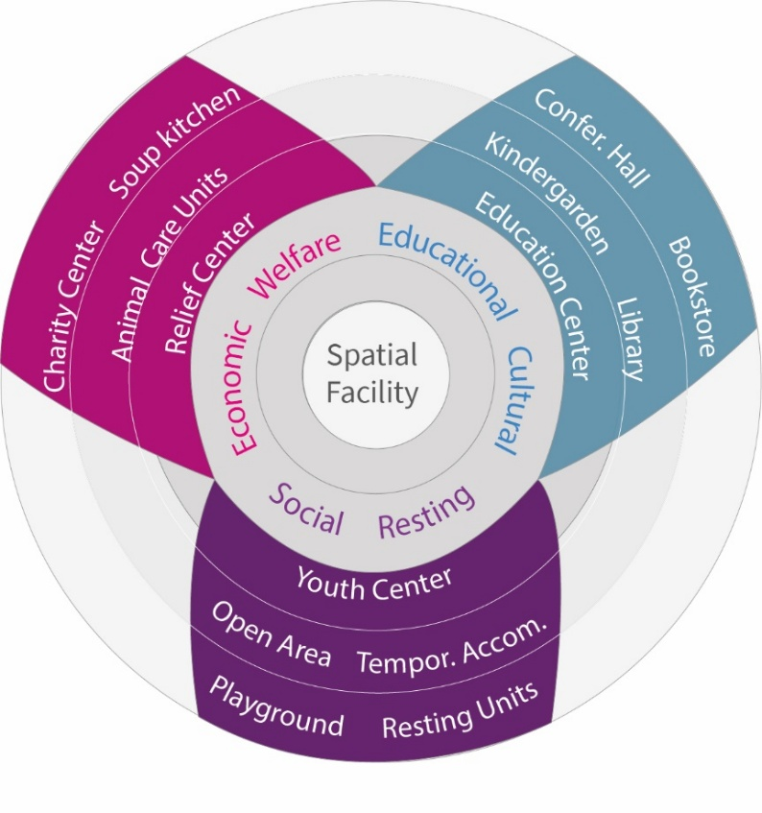
Figure 1. Socio-spatial facilities in mosques.

All diverse community groups, including disadvantaged individuals and even blind people, are encouraged to participate in communal activities held in mosques, and every type of discriminatory action is prohibited [19]. Thus, through its facilities, mosques emerge as vital components of the built environment, promoting social sustainability by providing equal opportunities for all groups to participate in community life [20]. We can deduce from these experiences that mosques transcend their role as mere spaces for prayer; they have served as hubs for sustaining community affairs and consistently remain at the core of public life. For instance, the Süleymaniye Mosque was constructed as a kulliyah and is located at the center of the city. It incorporates not only a prayer hall for worship, but also provides social areas, including interior and exterior courtyards. In addition, it houses social assistance services such as tabhane (accommodation units for travelers and those in need), a soup kitchen (a place providing free meals for those in need), a bimarhane (mental health facilities), and educational facilities like madrassah (Islamic school providing education in religious sciences, philosophy, linguistics, medicine, mathematics, and similar fields) [Figure 2].

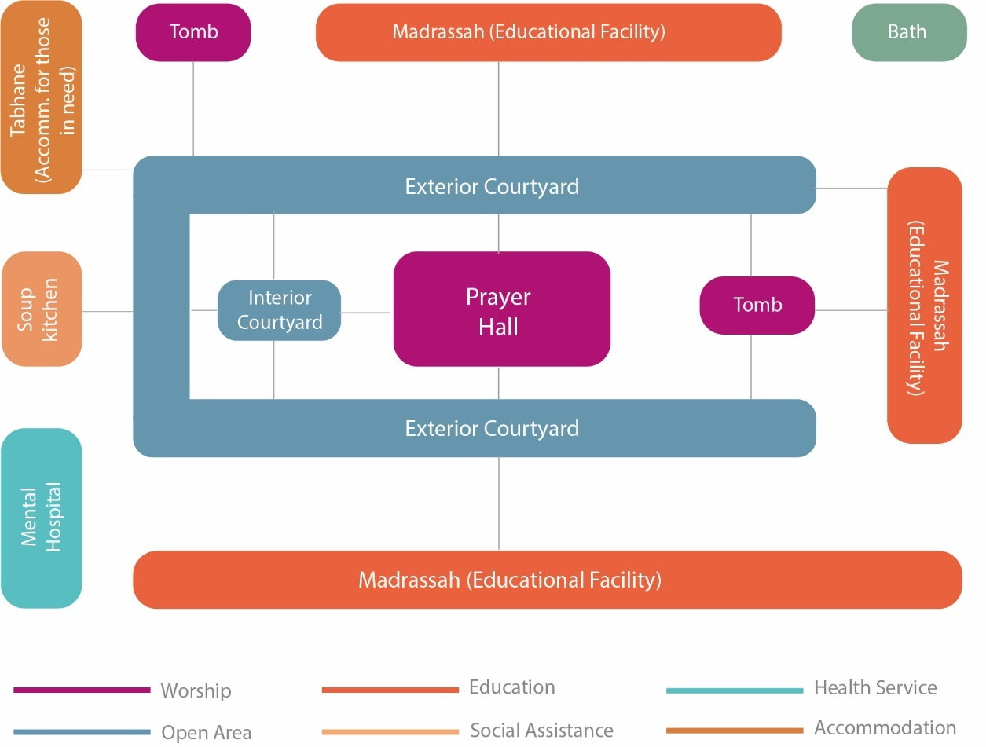
Figure 2. Functional diagram of Süleymaniye Mosque and its facilities.

However, with the impact of the modern era and the ideological and socio-political factors observed in Islamic geography in later periods, the functional role of the mosque in community life began to decline. Similarly, the facilities provided in and around the mosque have diminished, and in many countries, the role of mosques has been reduced to “spaces solely for praying”.
During this period, mosques are often used to demonstrate power, wealth, and glory [10]. Furthermore, aesthetic values are often overemphasized in mosque design, overshadowing the consideration of the diverse groups' functions and needs within the community [21]. Architectural criticism and research on mosque architecture mainly focus on form [22] while neglecting the socio-spatial dynamics [3]. Moreover, the over-sanctification of mosques has damaged the functional role of mosques in fostering community development in Islam [15].
The changing role of the mosque in public life is criticized from many perspectives. The reductionist point of view that considers the mosque institution only as “a space solely for praying” has brought a dilemma. As we mentioned above, the practice of praying is not inherently dependent on any built space, by following the principle of “every clean surface on the earth is suitable for praying”. Without the communal activities taking place within mosque space, the needs of society cannot be met [1]. Consequently, one of the goals of Islam, which is “strengthening the bonds within the community,” can not be achieved. After this paradigm shift, several questions arise as follows: (1) whether the contemporary mosque meets the socio-spatial needs of diverse community groups and (2) how mosque facilities are used by citizens, and (3) what are the users’ expectations regarding the functional aspects of the mosque.
In Türkiye, the socio-political transformation that occurred in the last century directly impacted the role of mosques in community life and the built environment. With the radical reforms, modern institutions and governmental organizations replaced the public services related to education, culture, and social solidarity that had traditionally been organized around mosques. As a result, mosques lost all supplementary social facilities and were reduced to providing only religious services [3]. These reforms were implemented in various fields, including specific spatial elements in daily life. One such reform was the establishment of Türk Ocağı (Turkish Hearts), aimed at promoting Turkish nationalism and culture. This represented a republican spatial practice aimed at creating secular public spaces with cultural, educational, and entertainment functions, rather than mosque complexes [23]. On the other hand, starting from the second half of the 20th century, Islamism began to rise again in Türkiye. As a manifestation of this, all cultural signs, symbols, and performances of Islam gained visibility in the public sphere [24].
Today, in Türkiye, there are diverse socio-cultural perspectives on the use and perception of mosques. These views generally vary based on the individual's region of residence, social environment, and religious practices. However, religion in Türkiye is often examined solely as a matter of belief rather than as a sociological issue [25]. This situation limits the discussion of mosque architecture from a socio-cultural and socio-spatial perspective, including societal diversity. Discussions on mosque architecture in Türkiye tend to emphasize form, shape, and symbolic values while neglecting their sociological foundations, which prevents the issue from being comprehensively and deeply addressed. The narrow evaluative scope of mosque architecture discussions risks producing shallow knowledge both theoretically and practically. In this study, the aim is to contribute to the expansion of the evaluation field regarding mosque architecture by examining the user perspective, particularly within the context of Türkiye, and exploring the socio-spatial perspectives related to users' spatial usage and perceptions of mosques.

- METHODS
The present study examines the usage patterns of mosque spaces and the functional needs and expectations of users in mosque experiences. Within this scope, our research methods include three phases of investigation: a literature review, a survey, and a workshop. We first conducted a systematic literature review (Section 2) focusing on the current state-of-the-art overview of spatial usage and functional/programmatic aspects of mosque institutions. In this context, we reviewed several databases (Scopus, Web of Science), proceedings books concerning mosque architecture, including conferences organized by the Al Fozan Award and national symposiums held in Türkiye.. We also conducted a textual analysis of official documents released by responsible actors, such as the Directorate of Religious Affairs (DRA), on the construction of mosque spaces. Additionally, we analyzed written documents published in the National Thesis Archive (YÖK) and special issues on mosque architecture in Türkiye by reviewing periodicals such as Mimarlık and Arredamento Mimarlik [Figure 3].

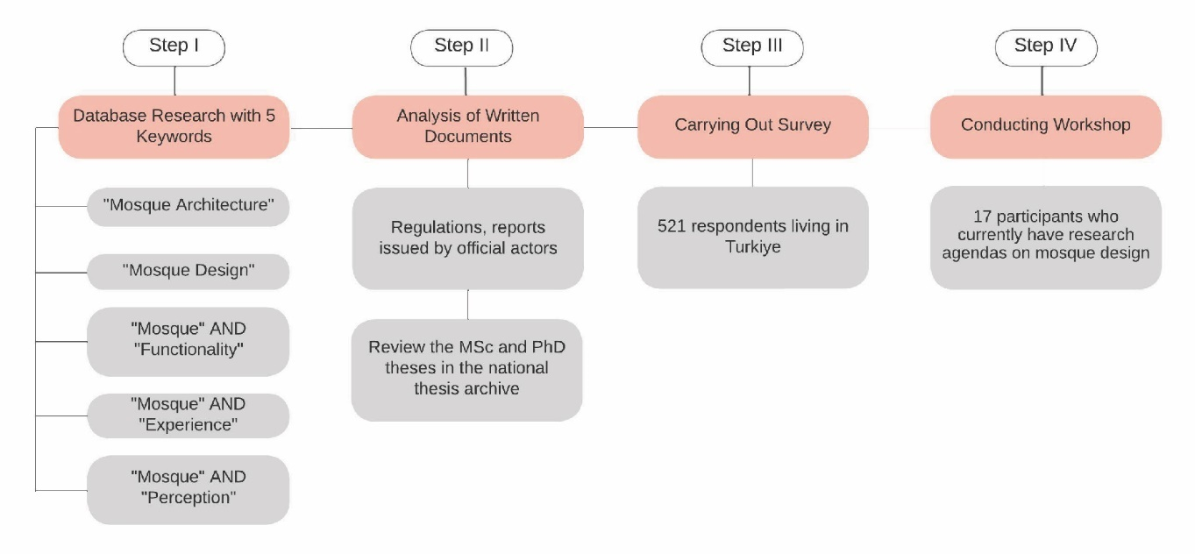
Figure 3. The framework of the research methodology.

As primary data, we conducted an online questionnaire with 521 participants living in Türkiye. This research survey was conducted exclusively online, as it took place during the pandemic period. The survey participants were selected randomly, and attention was paid to include all diverse groups in the research process to ensure equal representation.
It is essential to provide details regarding the sample size, selection criteria, and key factors that represent the larger population in the conducted survey. Türkiye consists of seven geographical regions, and the patterns of mosque usage and perceptions regarding the socio-spatial utilization of mosques may vary among the inhabitants of these regions. Within this context, as the research presents results for the whole of Türkiye, survey studies were conducted in these seven regions, ensuring equal representation.
By considering these factors, a stratified random sampling method was used to investigate mosque usage and experiences across Türkiye. The seven geographical regions of Türkiye were considered separate strata, each representing the diverse mosque experiences and expectations of individuals living in those areas. Additionally, gender ratios were included as a stratum to ensure equal representation of both genders. The number of participants from each region was determined proportionally based on population size and gender distribution. A random selection of participants within these strata was then surveyed online. This approach aimed to achieve a balanced representation that reflects Türkiye's demographic structure.
However, due to the pandemic conditions, the survey was conducted only through online channels, which may have resulted in the underrepresentation of groups with limited internet access or a lower likelihood of participating in such research. Moreover, certain segments of the population, such as those who are illiterate or non-Turkish speakers residing in Türkiye, may also be underrepresented. This limitation may have led to the sample’s underrepresentation of certain groups, potentially affecting the generalizability of findings on mosque experiences for these groups. Therefore, this limitation should be considered when interpreting the study's results.
Accordingly, to maximize reach and inclusivity, the research was conducted in collaboration with a research association comprising members from different regions, ensuring representation from all seven regions through these members. In determining the number of respondents for the survey, population proportions of the regions were taken into account. In this regard, the sample distribution by region was determined based on the population map prepared by the Ministry of Interior Affairs of the Republic of Turkey (2021) [26]. The highest sample size was obtained from the Marmara Region, which has the largest population, whereas the lowest sample size was obtained from the Eastern Anatolia Region, which has the smallest population.
To calculate the minimum sample size for a study on mosques in Türkiye, we used Cochran's formula, a common method for calculating sample sizes in surveys or studies of proportions in large populations. For a 95% confidence level, which is commonly used, the Z-score is 1.96, yielding a minimum sample size of 375. In this regard, the sample size obtained for the study (n = 521) is sufficient to meet the required threshold for conducting the research.
The personal attributes of respondents (age, gender, education level, working status, etc.) [Table 1], their usage patterns of mosque spaces (e.g., frequency of usage prayer areas and other facilities, use of mosque for praying or attending other activities), their preferences regarding mosque architecture (e.g., reasons behind selecting specific mosques) and their programmatic expectations from mosque spaces were surveyed. During this process, we not only relied on quantitative data; we also integrated open-ended inquiries within the survey to offer deeper qualitative insights into individuals' experiences and perceptions concerning mosque environments. This blended methodology offers a more comprehensive perspective on the topic.

Table 1. Test variables.
First variable | Second variables
Personal characteristics (categorical)  Age  Gender  Education level  Working status  Usage characteristics (categorical)  Frequency of using mosque spaces in general  Whether the use of other facilities aside from prayer room  Most preferred facilities in mosque spaces | User preferences regarding mosque spaces  Whether the users prefer any mosques in particular  What scale of mosques that users prefer  Satisfaction with mosques that have traditional form  Opinions on the use of innovative forms instead of traditional forms  Whether the use of sustainable, natural materials in the mosques make a difference in users’ perception  Functional expectations  Whether satisfied with the provided facilities/programs in mosque spaces  Which functions desired to be incorporated in mosque spaceskal

These datasets were analyzed using statistical methods to interpret differences between respondents’ answers in terms of personal and usage characteristics. In this sense, we employed various statistical methods, such as the Chi-Squared Test, to determine whether statistically significant differences exist in selected categories, including gender, age, education level, and usage characteristics. We presented the framework of cross-inquiry applied within the scope of this research. We investigated the usage pattern of mosque spaces, preferences, and users’ expectations through four sets of questions, as follows:

• General attributes of the respondents
• Current usage patterns of mosque spaces
• Reasons for selecting specific mosques for praying & attending activities
• Desired functions/facilities to be incorporated within and around mosque spaces.
To interpret the findings in depth and develop strategic-level proposals addressing the identified issues within the research scope, we conducted a workshop with 17 students (13 graduate and 4 undergraduate students) who had research agendas in mosque design and management. In collaboration with a public agency, an agency conducting studies with a municipality and university, and several academics from the field, we conducted a 4-week-long educational program (December 9-31, 2023) themed “Living Mosque”. Within the context of this program, we identified problems encountered by users in mosques. We highlighted the critical points that need to be addressed regarding socio-spatial inclusion in mosque spaces, drawing on previous research results and our findings.
Then, participants organized themselves into groups, each focusing on specific thematic research areas, and identified the topics to be prioritized for research. A brainstorming session was then conducted on these focused topics [Figure 4]. After the initial session aimed at identifying questions and issues, students visualized their proposals as mind maps and presented them to the workshop facilitators

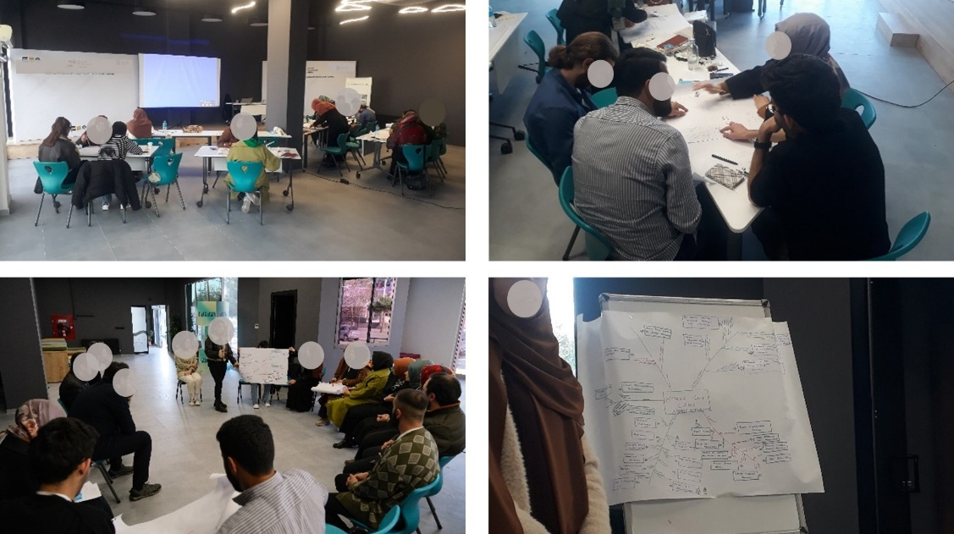
Figure 4. Scenes during the workshop.

- RESULT AND DISCUSSION

  - RESULT
- 1. CURRENT USAGE PATTERNS IN MOSQUES
The usage characteristics of the community vary based on the personal attributes of the individuals. To be able to figure out how people use mosque spaces, we firstly asked “the frequency of using mosque spaces”. 44% of the respondents specified that they use mosque spaces “several times a week” (occasionally), and 40.1% of the respondents spend time in a mosque less frequently (once a month or less). In comparison, only 15.9% indicated that they use mosques more than once a day (frequently). Then, we asked respondents whether they use spaces within the mosques other than prayer areas. While 52,2% of the survey participants specified that they use spaces within the mosque other than the prayer area, the remaining participants stated that they “only” use the prayer hall.
The second question of inquiry was “Which facilities, other than the prayer hall, do you most prefer to use in mosque spaces?” posed to the survey participants. We grouped 272 answers into ten categories: open areas/courtyard, library, civic center, conference room, accommodation/resting space, cafe, bookstore, playground, soup kitchen, and other. As shown in Table 2, the most preferred facilities in mosques are the courtyard (72.4%), library (47.8%), civic center (27.2%), and conference room (21.7%). The results revealed that people generally prefer to use open areas and cultural and educational facilities within mosque spaces.

Table 2. Personal and usage characteristics of the survey respondents.
Personal characteristics | Frequency | Percent | Usage characteristics | Frequency | Percent
Gender |  |  | The frequency of using mosque spaces in general
Female | 250 | 52.0 | Less frequently | 209 | 40.1
Male | 271 | 28.0 | Occasional  (Several times a week) | 229 | 44.0
Total | 521 | 100 | Frequently  (Several times a day) | 83 | 15.9
Age |  |  | Total | 521 | 100
Under 18 | 18 | 3.5 | Whether the use of other facilities aside from prayer hall
18–25 | 243 | 46.6 | Yes | 272 | 52.2
26–35 | 123 | 13.6 | No | 249 | 47.8
36–45 | 83 | 15.9 | Total | 521 | 100
46+ | 54 | 10.4 | The most preferred facilities in mosque spaces other than prayer hall* (Out of selected one+ option)
Total | 521 | 100 | Courtyard | 197 | 72.4
Education Level |  |  | Library | 130 | 47.8
High school and below | 70 | 13.5 | Civic center (cultural & education units) | 74 | 27.2
Undergraduate & Associate | 370 | 71 | Conference room | 59 | 21.7
Graduate & Postgraduate | 81 | 15.5 | Accommodation / Resting space | 51 | 18.8
Total | 521 | 100 | Cafe | 41 | 15.1
Working Status |  |  | Bookstore | 41 | 15.1
Working | 247 | 47.5 | Playground | 33 | 12.1
Not working / Student | 222 | 42.6 | Soup kitchen | 12 | 4.4
Not working / Housewife | 30 | 5.7 | Other  (animal care/breeding units; touristic facilities) | 22 | 8.1
Not working or looking for job | 22 | 4.2
Total | 521 | 100
* The answer is listed out of the respondents who select “Yes” to the choice of “the use of other facilities aside from the prayer hall”.

Within the scope of our study, we also investigate the change in mosque usage according to personal characteristics. To do this, we cross-inquired whether mosque space usage patterns show statistically significant differences across personal characteristics. As shown in Table 3, our study revealed that the frequency of usage differs significantly between genders and age groups.

Table 3. The changes in usage of the survey respondents according to personal characteristics
N (Valid cases): 521 | Usage Characteristics
Personal Characteristics | Frequency of mosque usage |  |  | Whether the use of spaces within the mosque in addition to the prayer hall
 | Less Frequently | Occasionally | Frequently | Yes | No
Gender
Women | 66.4% | 28.4% | 5.2% | 56.0% | 44.0%
Men | 15.9% | 58.3% | 25.8% | 48.1% | 51.9%
Pearson |  |  | p: 0.000* |  | p: 0.096
Age
Under 25 | 34.9% | 53.2% | 15.9% | 61.3% | 38.7%
26–35 | 50.4% | 30.1% | 19.5% | 57.7% | 42.3%
36–45 | 47.0% | 37.3% | 15.7% | 31.3% | 68.7%
46+ | 31.5% | 40.7% | 27.8% | 27.8% | 72.2%
Pearson |  |  | p: 0.001* |  | p: 0.000*
Education Level
High school and below | 45.7% | 42.9% | 11.4% | 45.7% | 54.3%
Associate & undergraduate | 38.4% | 45.1% | 16.5% | 54.1% | 45.9%
Graduate & postgraduate | 43.2% | 39.5% | 17.3% | 49.4% | 50.6%
Pearson |  |  | p: 0.632 |  | p: 0.378
Working Status
Working | 39.7% | 41.7% | 18.6% | 45.3% | 54.7%
Not working | 40.5% | 46.5% | 13.0% | 58.4% | 41.6%
Pearson |  |  | p: 0.259 |  | p: 0.003**
* Significant at 0.01 level
** Significant at 0.05 level

A sharp decrease is observed in the frequency of women using mosque spaces compared to men. While 25.8% of men report going to the mosque several times a day, this ratio decreases to 5,2% for women [Figure 5]. Similarly, the frequency of mosque usage increases as users’ ages increase. This indicates that the most frequent user groups of mosques are middle-aged and older men.

Figure 5. The distribution of the frequency of mosque usage by gender

Additionally, there is a notable difference in the use of spaces within mosques, including the prayer hall, in terms of users’ age and occupational status. While the frequency of using mosque spaces, in addition to the prayer hall, decreases with age, an increase is observed in the frequency of working groups using these spaces compared to non-working groups (Table 3). 61.3% of respondents under the age of 25 reported using spaces in mosques other than the prayer hall; this rate decreases to 57.7% in the 26-35 age group, 31.3% in the 36-45 age group, and 27.8% in the 46+ age group [Figure 6]. This indicates that, although middle-aged and older people are the most frequent users of mosques, they generally use them just for praying. On the other hand, young people tend to spend time in mosque spaces (e.g., library, education center) in addition to the prayer hall.

Figure 6. The distribution of usage patterns of mosque spaces by age

We further inquired whether there are significant differences in preferred spaces within the mosques regarding users’ characteristics. The results of our study show a significant increase in the use of the civic center, conference hall, and playground by women compared to men [Table 4]. Additionally, there is a significant difference in the use of the library and conference room according to age, and the use of the cafe and bookstore changes significantly by educational level. According to the results, the age groups most frequently using the library in mosques are those under 25 and above 46. Additionally, a significant difference is observed in the use of library space based on usage characteristics. While the group of frequent mosque users shows a significantly higher preference for the library, those who use mosque spaces less frequently tend to prefer spending time in other types of spaces, like animal care/feeding units, tourist facilities, and shopping units.

Table 4. The most preferred spaces in mosques.
N (Valid cases): 521 | The most preferred spaces in mosques other than prayer hall
Personal Characteristics | Courtyard | Library | Civic Center (Culture & Educ.) | Conference Hall | Accommodation/ Resting Space | Cafe | Bookstore | Playground | Soup Kitchen | Otherᵇ
Gender
Women | 75.7% | 52.9% | 34.3% | 20.3% | 19.3% | 17.1% | 20.0% | 18.6% | 4.0% | 10%
Men | 81.1% | 46.2% | 23.5% | 16.7% | 18.2% | 18.2% | 13.6% | 10.0% | 6.1% | 5.3%
Pearson |  |  | 0.049** | 0.013** |  |  |  | 0.040*
Age
Under 25 | 69.3% | 55.0% | 26.9% | 21.3% | 20.6% | 15.0% | 14.4% | 10.0% | 4.4% | 8.1%
26–35 | 84.5% | 38.0% | 31.0% | 26.8% | 18.3% | 19.7% | 18.3% | 16.9% | 4.3% | 11.2%
36–45 | 61.5% | 26.9% | 23.1% | 19.2% | 7.7% | 7.7% | 15.4% | 15.4% | 0.0% | 0.0%
46+ | 66.7% | 53.3% | 20.0% | 6.7% | 20.0% | 6.7% | 6.7% | 6.7% | 13.3% | 6.7%
Pearson |  | 0.013** |  | 0.000*
Education Level
High school & bel. | 78.1% | 31.3% | 12.5% | 12.5% | 21.9% | 21.9% | 3.0% | 18.8% | 0.0% | 12.5%
Associate & underg. | 69.5% | 49.5% | 28.5% | 20.5% | 19.5% | 11.5% | 14.5% | 11.0% | 5.0% | 7.0%
Graduate & postgr. | 82.5% | 52.5% | 32.5% | 35.0% | 12.5% | 12.5% | 27.5% | 12.5% | 5.0% | 10.0%
Pearson |  |  |  |  |  | 0.018* | 0.015**
Working Status
Working | 74.1% | 38.4% | 30.4% | 26.8% | 17.0% | 17.0% | 17.9% | 13.4% | 5.4% | 12.5%
Not working | 71.2% | 54.4% | 25.0% | 18.1% | 20.0% | 13.8% | 13.1% | 11.2% | 3.8% | 5.0%
Pearson |  | 0.009* |  |  |  |  |  |  |  | 0.026*
The frequency of use
Less frequently | 67.7% | 38.5% | 28.1% | 21.9% | 15.6% | 15.6% | 15.6% | 15.6% | 5.2% | 15.6%
Occasionally | 74.8% | 50.4% | 27.6% | 29.3% | 16.5% | 11.5% | 16.5% | 8.1% | 4.4% | 9.6%
Frequently | 75.5% | 58.5% | 24.5% | 18.9% | 13.2% | 18.9% | 15.1% | 15.1% | 3.8% | 9.4%
Pearson |  | 0.048** |  | 0.044** |  |  |  |  |  | 0.006*
ª The answer is listed out of the respondents who select «Yes» to the choice of «the use of other facilities aside from the prayer hall
^{b} Including animal care/feeding units, touristic facilities, shopping, etc.
* Significant at 0.01 level
** Significant at 0.05 level

52.4% of the survey respondents expressed a preference for a specific mosque for prayer. Our study reveals no significant differences in terms of age, education level, and working status. However, there is a significant difference in specific mosque preferences in relation to users’ gender and usage characteristics (frequency of use and the use of mosque spaces beyond the prayer hall) [Table 5]. The ratio of men who prefer specific mosques is higher than that of women. Similarly, a positive correlation is observed between the frequency of mosque usage and the preference for specific mosques.
Table 5. The change in preference for mosques varies according to personal and usage characteristics
Personal and Usage Characteristics | Whether respondents specifically choose a mosque 52.4% (Overall)
Gender
Women | 46.8%
Men | 57.6%
Age
Under 25 | 52.1%
26–35 | 51.2%
36–45 | 54.2%
46+ | 53.7%
Education Level
High school & below | 47.1%
Associate & undergraduate | 52.6%
Graduate & postgraduate | 56.3%
Working Status
Working | 53.4%
Not working | 51.5%
Frequency of use*
Less frequently | 34.9%
Occasionally | 63.8%
Frequently | 65.1%
Use of mosque other than prayer hall
Yes | 59.9%
No | 44.2%
* Significant at 0.01 level
** Significant at 0.05 level

- 2. USER PREFERENCES REGARDING MOSQUE ARCHITECTURE
As we mentioned in the introduction section, architectural criticism and research on mosque architecture mainly focus on aesthetic values such as scale, form, and material. To determine the reasons for preferring specific mosques for prayers and whether the aesthetic characteristics of mosques influence users’ preferences, we asked several questions to the respondents. In this sense, we first asked respondents, in an open-ended question, about their reasons for choosing mosques.. We grouped respondents’ answers into 11 categories: location, design attributes, characteristics/attributes of an imam/preacher, story and sacred features of the mosque, physical environmental factors, mosque designer, interaction opportunities with the community, tomb visit, founder of mosque, sect to which they belong, and other. As can be seen in Figure 7, the reasons for preferring the mosques are ranked as follows: location (ease of access) (79,1%), design attributes (46,5%), the characteristics of an imam/preacher (43,2%), the story of mosques (42,9%), and physical environment conditions (40,7%). Notably, the location of mosques (easy to access) takes precedence over all aesthetic, functional, and human-centric factors in the mosque preferences of respondents. These results highlight the importance of accessibility to mosques and site selection criteria, which are key decisions in the urban planning and urban design phases.

Figure 7. The reasons to prefer specific mosques (s) for praying and attending activities.

Scale is one of the aesthetic attributes of mosques that can play a role in users’ preferences for mosques. In this regard, we asked the survey participants, “What scale of mosque do you prefer?” Nearly two-thirds (63.7%) of the respondents stated that the scale of the mosque does not significantly influence their preferences [Figure 8]. In addition, among respondents who indicated that the scale is important in mosque preferences, there was an increase in preferring the larger scale (19.4%) compared to the medium scale (9.8%) and the small scale (7.1%).

Figure 8. The distribution of preferred mosques by scale.

We also inquired about the reasons for choosing a particular scale from those respondents who indicated that the scale is important in their preferences. As seen in Table 6, the respondents who specifically preferred small-scale mosques for praying and attending activities expressed that functional (the ease of use, convenient access, and ease of maintaining hygiene), emotional (the feeling of calm and sincere relations), and economical (being budget-friendly, avoiding extravagancy) factors play a role in their choice. The reasons participants gave for preferring large-scale mosques are generally related to atmospheric and functional factors. Participants’ preferences for large-scale mosques are primarily due to the factors such as “the awe of magnificence”, “providing fresh and huge atmosphere”, “being able to pray with a larger congregation”, “the sense of freshness/spaciousness provided by a larger area”, “the ability to facilitate women-friendly access and activities” and “the ability to provide more place for different user groups”.
Table 6. The reason to choice a particular scale
Why respondents select specific-scale mosques for praying & attending activities?
Small Scale | - Ease of use;  - Their location (providing convenient access thanks to being between the neighborhoods);  - Easy to maintain hygiene; their modesty;  - Having calm and sincere relations;  - Feeling peaceful as it provides fullness;  - Being budget-friendly & avoiding extravagancy in terms of construction costs;  - Less demand for tourist attention/cultural trips than large mosques;  - Provide the opportunity to study;  - Visiting/touristic excursions, etc. seen in large mosques commodification of mosques, and this is not encountered at small-scale mosques
Medium Scale | - Neither crowded/nor calm;  - Sense of intimacy with people;  - More appropriate size than large-scale mosques and usability of functions;  - Against extremism/arrogance seen in large buildings;  - Many of the spaces designed are out of use in large-scale mosques during the day.
Large Scale | - The awe of magnificence.  - We are seeing mosques as an indication of the spirit and grandeur of that society and that culture.  - They give peace of mind.  - Worshiping with more people makes me pray with more awe.  - Providing a more spacious environment to move around.  - Having more congregation and more airy.  - The atmosphere provided in big mosques.  - Feeling of freshness.  - Large mosques offer a wider space to isolate from the world.  - Allowing for different uses.  - Allocating more places for facilities such as youth centers.  - Having toilets and ablution places for women.  - Women can access & go in and out easily.

As previous research highlights, architectural criticism, reviews, and research on mosque architecture have generally focused on form, often criticizing the use of traditional Ottoman-style forms (e.g., domes) and architectural elements (e.g., minarets) in contemporary mosque design.. In this sense, to examine the alignment of the current agenda in architectural media and research with the community desires and preferences, we asked “whether they are satisfied with the use of traditional form in designing contemporary mosques” and “what they think about the use of innovative and modern forms”. Almost three-fourths (73.3%) of the respondents stated that they were satisfied with using the traditional form (Table 7). This result supports the previous research findings that reveal (1) users prefer Ottoman period mosques more and they find them to be more effective and stimulating [27] and (2) classical mosque forms, such as dome and minaret, are prominent elements in the perception of users [28].

Table 7. The change in satisfaction with the traditional form and views on the use of modern/innovative form
p-value: 0.000* | The use of innovative/modern forms
Satisfaction with traditional form | Support | Neutral | Not Support | Total
Yes | 44.5% | 29.8% | 25.7% | 73.3%
No | 67.6% | 15.8% | 16.6% | 26.7%
Total | 50.7% | 26.1% | 23.2% | 100%
* Significant at 0.01 level

These results reveal a dilemma between the agendas of architectural media and criticism and the preferences of users. Besides, the use of innovative/modern forms in mosque design is supported by half of the respondents (50,7%). These results reveal that a significant portion of the community supports the use of traditional forms in contemporary mosques. In contrast, there are hesitations among the people concerning the use of modern/innovative forms. These findings show that, contrary to architectural media and criticism in Türkiye, there is no significant interest or expectation in this regard from the community perspective.
Within the scope of examining the role of aesthetic values in users’ perception, we inquired whether using sustainable and natural materials (such as wood, natural stone, and compacted soil) in mosques changes users’ perception. Of the survey respondents, 62.2% indicated that using sustainable materials in mosques has a positive impact on their perception [Table 8].

Table 8. The users’ perception regarding using sustainable/natural materials in mosques.
Whether the use of sustainable/natural material change users’ perception
Yes | 62.2%
No | 37.8%
Total | 100%

The survey participants who reported a change in their perception thanks to the use of sustainable and natural materials were asked about the reasons behind this change. As shown in Table 9, the respondents generally highlighted the distinctive sensory characteristics of these materials, including visual, olfactory, and tactile features. Respondents expressed that using sustainable and natural materials directly influenced their souls and mental well-being. These results revealed that using sustainable materials increases the sense of belonging, helps people feel in harmony with other human beings and with nature, and connects them with their historical values and Islamic character.

Table 9. The reasons to change perception concerning materials.
The reasons for the changes in respondents’ perception regarding the use of sustainable/natural materials
- Making users feel more warm and peaceful/calm & peaceful atmosphere
- Increase a sense of belonging
- Strengthening the relationship with the context
- Being more in line with the nature of the human & being in line with the soul
- Having a nice view
- Textural & Tactile & Sensory (smell, visual, touch) character
- Providing historical feeling
- Avoiding feeling unfamiliar & cold encountering with concrete material
- Integrating with its surroundings
- The feeling of being at peace with nature
- Sincere, unpretentious, healthy character (Islamic character)
- Reminding historical era (People and places) and creating historical authentic atmosphere

- 3. THE FUNCTIONAL EXPECTATIONS FROM MOSQUE DESIGN
Within the scope of our survey's third and final phase, we first asked respondents whether they found mosques sufficient in terms of their spatial functions. Only 18.2% of the survey respondents expressed that they find the mosques, whether historical or modern, functionally sufficient [Table 10]. We also cross-inquired whether there is a significant difference in functional satisfaction among personal and usage characteristics of respondents. There is no significant difference in functional satisfaction based on personal characteristics. Inherently, only the group using spaces within mosques, in addition to the prayer hall, shows a sharper increase in functional satisfaction compared to those who use only the prayer hall. In addition, it is observed that there is a tendency towards a decrease in functional satisfaction of mosques as the educational level of user groups increases. The results of this question revealed that most participants are not satisfied with mosques in terms of functional aspects. Therefore, according to survey results, it is possible to say that the public can not experience mosque spaces as they should be experienced. Thus, the public facilities incorporated into mosque spaces should be reconsidered for both existing and new mosques, taking into account the socio-spatial needs of diverse community groups.

Table 10. The distribution of respondents’ answers regarding whether they find the mosques functionally adequate..
Personal & Usage Characteristics | Wheter respondents find the mosque functionally adequate 18.2% (Overall)
Gender
Women | 20.0%
Men | 16.6%
Age
Under 25 | 18.0%
26–35 | 23.6%
36–45 | 14.5%
46+ | 13.0%
Education Level
High school & below | 27.1%
Associate & undergraduate | 17.6%
Graduate & postgraduate | 13.6%
Working Status
Working | 18.2%
Not working | 18.2%
Frequency of use
Less frequently | 14.4%
Occasionally | 20.5%
Frequently | 21.7%
Use of mosque other than prayer hall
Yes | 23.5%
No | 12.4%
Specifically prefer mosque
Yes | 18.7%
No | 17.7%
* Significant at 0.01 level
This study's last investigation reveals the functional expectations of users regarding mosque spaces. This investigation is crucial, as it provides insights into user desires and enables stakeholders involved in mosque design decision-making processes to reassess existing and future mosques in terms of their functional aspects. In this sense, the respondents were asked what spatial functions they desired to be incorporated into mosques. Nearly two-thirds (65,2%) of the participants desired to integrate a library into mosques. Youth centers (52.0%), open spaces (47.8%), and other cultural and educational-related functions (such as education centers, conference halls, and bookstores) follow these options [Table 11].
Interestingly, nearly half of the respondents desired the presence of a soup kitchen (45,2%) in mosques. In contrast to the general trend in Türkiye, it is noteworthy that one of the least desired functions to be incorporated into mosques was a cafe (20.8%) and commercial units (11.3%). This question reveals unprecedented results. Respondents also desired to integrate accommodation and resting units into mosques. While 41.3% of the respondents desired the presence of a guesthouse, 36.5% of them desired to incorporate resting units and a therapy center (28.8%) in mosques. The results obtained from this question revealed users’ tendency to use mosques for multifunctional purposes. Although many alternative functional spaces exist in contemporary public life, the public still perceives the mosque as the center of education, culture, and social life, as it has been in the past. They want to experience mosques as multifunctional community centers.
We also cross-inquired whether there are significant differences in desired functions in terms of personal and usage characteristics among the respondents. As the distribution of desired functions in mosques was examined, it is noteworthy that women show a higher tendency towards all functional spaces than men [Figure 9]. In addition, as seen in Table 11, there are statistically significant differences between women and men in their desire for therapy centers, animal care units, and kindergartens.

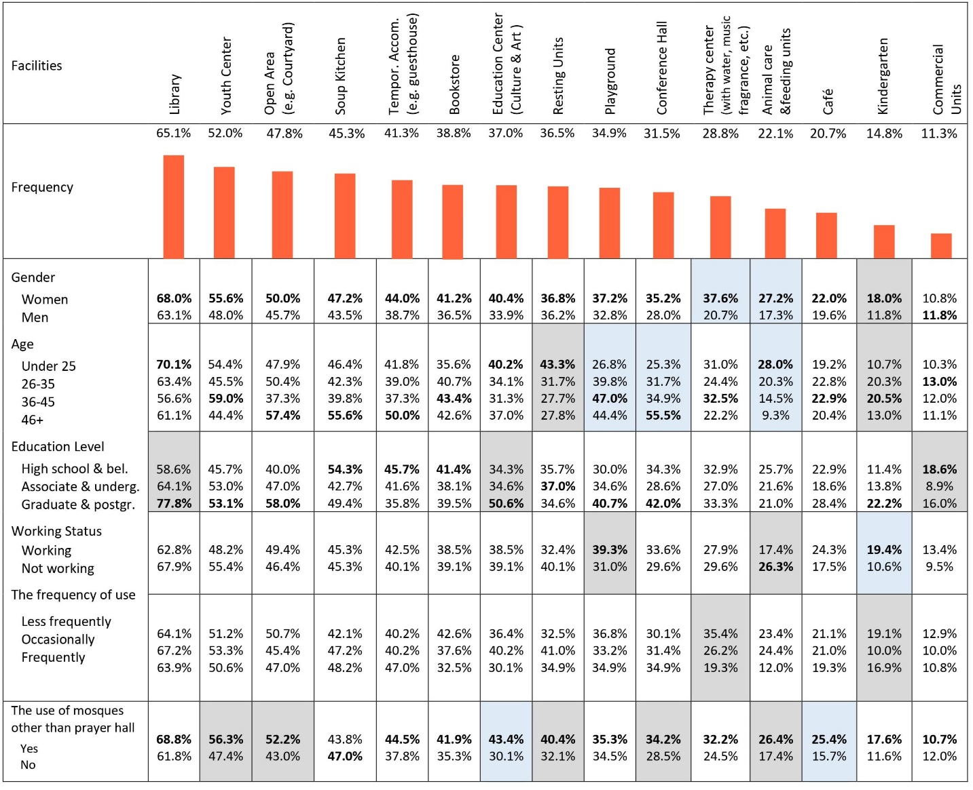
Table 11. The most desired functional spaces/facilities incorporated in mosques*
* In the table, the blue-shaded areas show significance at the 0.01 level and the gray-shaded areas at the 0.05 level.

Figure 9. The distribution of the desired space incorporated in mosques by gender.

Additionally, it is observed that education-related functions, such as libraries and education centers, are most desired by the group under 25. There is a significant difference in the distribution of desired functions, such as playgrounds and conference halls, among different age groups. Additionally, it is noteworthy that while the user group over 46 is the most desired group for recreational and cultural-related functions, such as open areas, soup kitchen, and conference hall. On the other hand, the age groups of 26-35 and 36-45 display the most significant interest in child-related facilities, such as playgrounds and kindergartens [Figure 10].

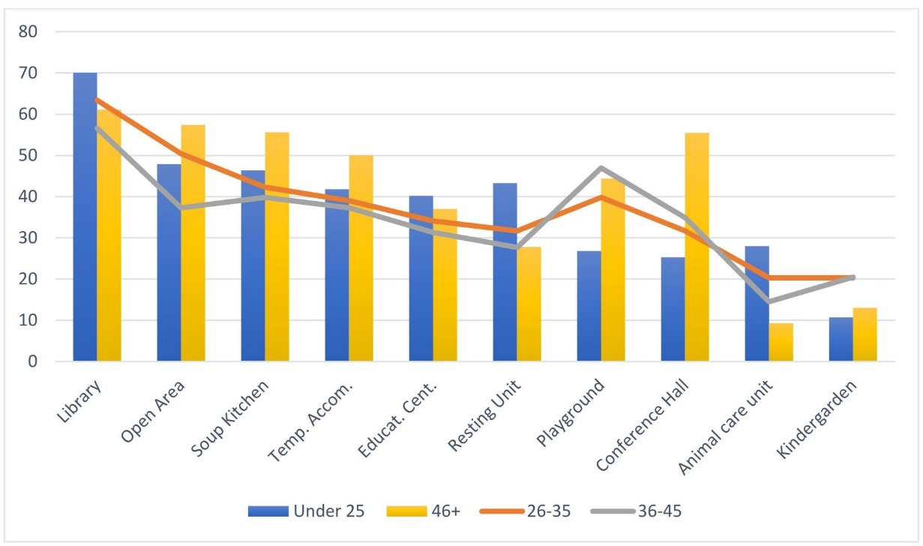
Figure 10. The distribution of desired functions by age.

When it comes to education level, it is observed that as the level of education increases, a significant increase is noted in spatial preferences regarding educational functions, such as libraries and educational centers. The statistical analysis and cross-tabulation of this question also revealed that working groups show a significant increase in demanding functions related to childcare (playground and kindergarten) compared to non-working groups. Regarding the investigation of the results based on usage patterns, except for the therapy center and kindergarten, there is no significant difference in desired functions among mosques based on frequency of usage.

- CONCLUSION
Following the structure outlined in the introduction, this section critically discusses the key findings relevant to mosque usage patterns and functionality. We also explore patterns, anomalies, and possible explanations by cross-checking the usage patterns of mosques, users’ preferences, and functional expectations regarding mosque design. Then, we discuss key factors for enhancing socio-spatial facilities in mosques by proposing strategic-level solutions to the identified issues in light of our findings and workshop results.

- 1. A CRITICAL EXAMINATION OF SOCIO-SPATIAL FACILITIES IN MOSQUE DESIGN
Firstly, we identified a disjuncture between current mosque usage and the ideal/possible utilization of mosques. The results of this study address socio-spatial justice issues in users’ mosque experiences. According to our survey results, young people tend to spend time in socio-spatial facilities within mosque spaces (e.g., libraries, education centers) in addition to the prayer hall (see Tables 3-4). In addition, when examining the distribution of desired functions in mosques (see Figure 9), women showed a higher tendency in all functional spaces than men. However, mosques are frequently used by middle-aged and older men, and this group primarily utilizes mosques for a single purpose (praying) rather than attending multiple activities held in mosques (see Table 3). This shows a reductionist perspective that considers the mosque institution solely as “a place for worship” and that these spaces are predominantly designed for & used by specific demographics (middle-aged & elderly men) for limited activities (praying). This result contradicts Islamic belief, which suggests that mosques are not only “space for praying” but also “space for community building,” hosting all different groups [Figure 11].

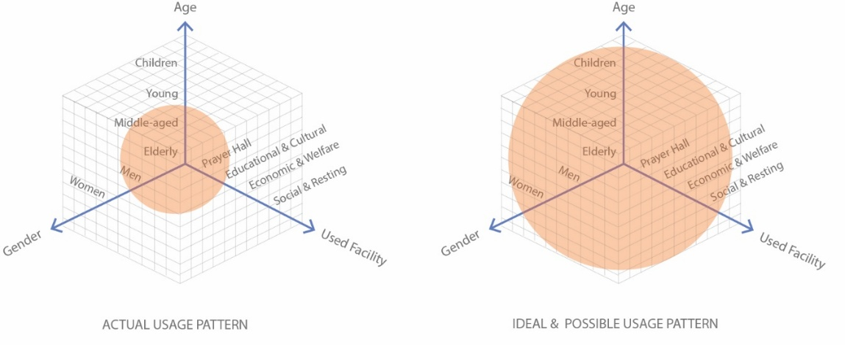
Figure 11. Actual vs. ideal and possible usage patterns of mosques, highlighting differences in demographic coverage and functional diversity

The second important finding concerns the mismatches between the general tendency of academia & architectural media and community priorities. While the former focuses more on aesthetic values rather than socio-spatial aspects of facilities, the latter prioritizes functional subjects like ease of access. Moreover, in Türkiye, while the aesthetic characteristics of mosques—such as scale, form, and innovative approaches—have been the primary focus of architectural media and academia, we revealed no significant interest or expectation regarding this agenda from a community perspective. A significant portion of the community supports the use of traditional forms in contemporary mosques, and many people hesitate to use modern/innovative forms (see Table 7). In addition, nearly two-thirds of participants stated that the scale of the mosque does not significantly influence their preferences (see Figure 8). On the other hand, our study reveals that using sustainable and natural materials alters users’ perceptions and positively impacts their spatial experience (see Tables 8 and 9). This situation also highlights the dilemma between recent practices in Türkiye, where reinforced concrete structures and the use of unnatural materials are common, and the public’s preferences.
Our study reveals the gap between the socio-spatial functions provided in mosques and the functions demanded by the public [Figure 12]. The majority of participants (82%) are dissatisfied with mosques regarding their functional aspects (see Table 10). This shows that mosque spaces may face the risk of losing their inclusive and welcoming characteristics. This situation conflicts with one of the leading suggestions of Islamic belief, which encourages the incorporation of facilities that “strengthen the bonds within the community” in mosques [1].

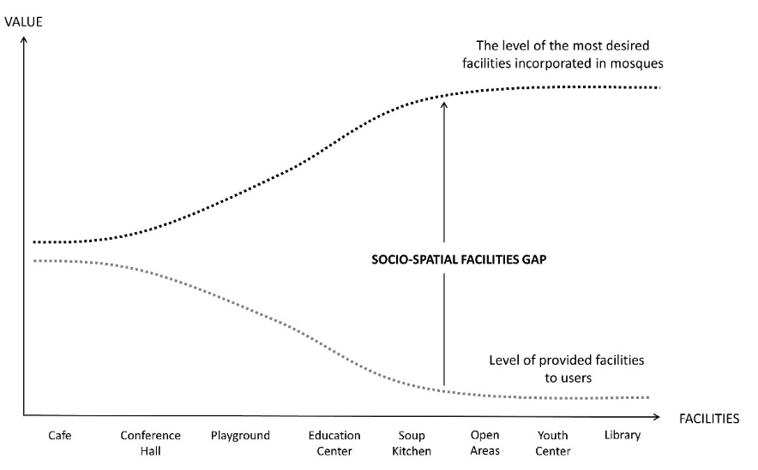
Figure 12. The disparity between desired and provided facilities: Unveiling socio-spatial gaps in mosque facilities

Another essential outcome of this study is the public’s expectations/desires regarding mosque usage in terms of socio-spatial aspects. Contrary to the common assumption that mosques are only places of worship and, in some cases, host educational activities, users desire to utilize mosques for social, resting, and welfare purposes besides these activities. As seen in Table 11, users not only desire to integrate educational and cultural-related facilities but also social facilities and resting areas, such as soup kitchens, therapy centers, and resting units, within mosque spaces [Figure 13]. Even though many alternative functional spaces exist in contemporary public life, the public still perceives mosques as and desires to use them as the center of education, culture, and social life, as they were in the past. This demonstrates that most of the community wishes to experience mosques as “multipurpose congregational centers.” This situation highlights the necessity of considering the functions to be provided in mosques not only within the realm of faith but also from a sociological perspective.

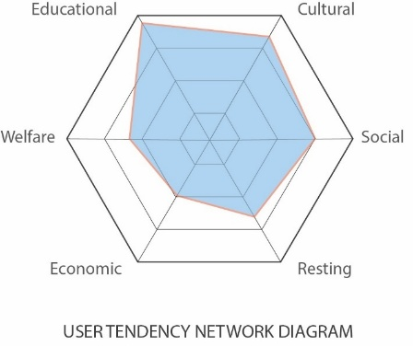
Figure 13. The user tendency network diagram shows the weight of the type of facilities desired by users.

- 2. KEY FACTORS IN RETHINKING MOSQUE ARCHITECTURE FROM A SOCIO-SPATIAL PERSPECTIVE
After integrating the knowledge from our literature review, our survey findings, and workshop results, we identified several interrelated factors contributing to the discussion of the mosque from a socio-spatial perspective: (1) addressing socio-spatial justice in mosque facilities, (2) rethinking decision-making mechanisms, and (3) embracing the “Living Mosque” approach.
Socio-spatial justice in mosque facilities: The results of this study highlight socio-spatial justice issues in users’ mosque experience. Users are deprived not only of educational and cultural spaces but also of social, resting, and economic welfare activities in socio-spatial facilities. To meet these needs, it is necessary to consider mosques not only from a religious perspective but also from a sociological standpoint.
This study presents a general framework for the socio-spatial facilities needed in mosques across Turkey (see Table 11). However, the socio-spatial facilities may vary not only based on parameters directly related to mosque usage, including regional usage habits, frequency of mosque attendance, and religious attitudes, but also based on individual demographic characteristics such as age, gender, education level, and employment status [Figure 14]. Therefore, allocating socio-spatial facilities requires objective, neighborhood-specific methods. In this regard, participatory techniques should be integrated to involve users in identifying and building facilities and spatial configurations from the earliest stages of the design process, whether for newly constructed mosques or the upgrading of existing mosques.

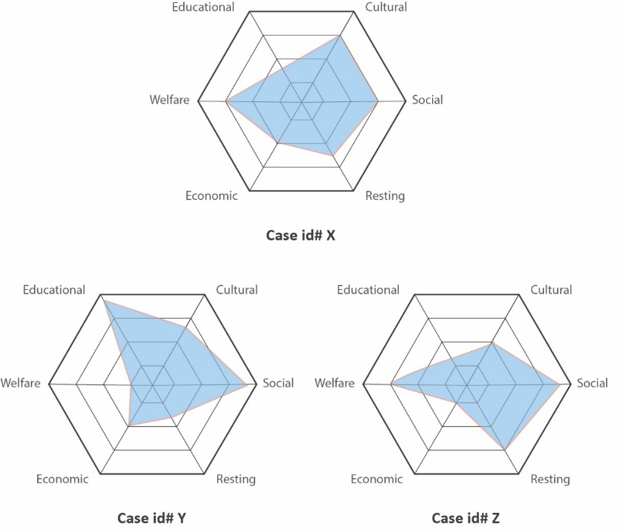
Figure 14. The user tendency network diagrams in different neighborhoods (visuals prepared independent of survey data for illustration purposes).

The identification of socio-spatial facilities requires an approach that goes beyond focusing only on current needs. Türkiye is highly vulnerable to natural disasters such as earthquakes, floods, and landslides, and also hosts one of the world’s largest refugee populations [29]. Following the earthquakes that occurred in Türkiye on February 6, 2023, it was observed that mosques in various cities, such as Adıyaman and Kahramanmaraş, served as emergency accommodation spaces. These mosques provided essential facilities such as toilets and served as hubs for distributing aid. Considering these factors, mosques in Türkiye should be planned and designed with a flexible and open-ended approach to meet socio-spatial needs, such as storage, logistics, and emergency accommodation. This flexibility becomes particularly crucial during unforeseen circumstances such as natural disasters or sudden population increases due to migration [Figure 15].

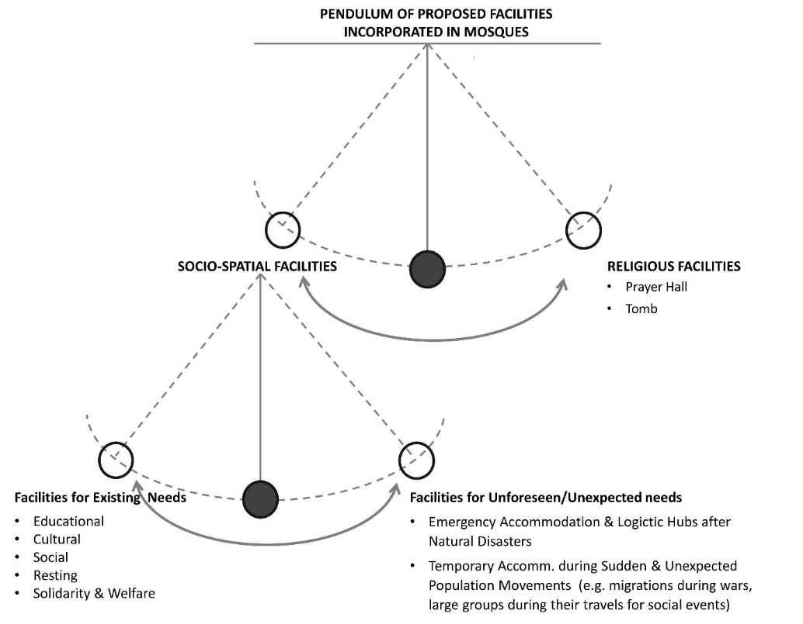
Figure 15. The proposed facilities incorporated in mosques: The pendulum moving between socio-spatial facilities and religious facilities..

In this regard, to directly address the identified gaps in mosque functionality and respond to diverse user needs, it is essential to propose specific architectural features that enhance both flexibility and inclusivity in mosque design. One such recommendation is the integration of flexible multi-use spaces within the mosque complex. For example, the last row and side aisles of the prayer hall, as well as underutilized annexes, can be adapted with movable and lightweight partition panels, allowing these areas to be reconfigured for socio-spatial activities when not in use for prayer, particularly outside peak times such as Friday prayers or Ramadan nights [30, 31]. This approach not only maximizes space efficiency but also ensures acoustic comfort and privacy for various activities. Additionally, enhancing outdoor areas such as courtyards can provide communal spaces for social interactions, gatherings, and emergency accommodations, especially in regions prone to natural disasters.
Moreover, despite women's inclination to use mosques for multiple purposes (Figure 9), mosques are predominantly used by middle-aged and elderly men solely for worship (Table 3), raising the potential for socio-spatial exclusion of women in these spaces [32]. To address this, it is crucial to design gender-segregated facilities that are both functional and responsive to user needs, ensuring all demographic groups can fully benefit from the mosque's spaces. By implementing these design strategies, mosques can better fulfill their role as multifunctional community hubs, adaptable to both daily needs and extraordinary circumstances.
Rethinking the Actors, Roles, and Responsibilities in the Decision-Making Mechanism: As seen in Table 3 and Figure 6, mosques are primarily used for prayer purposes by middle-aged and elderly men. It is important to investigate the reasons behind this outcome and analyze the decision-making process regarding the facilities to be included in mosques in Türkiye.
In Türkiye, the majority of mosques in cities are constructed by mosque construction associations. Individuals in these associations are responsible for activities such as collecting donations, making decisions regarding mosque design, and obtaining construction permits from relevant institutions, including the governor’s office. The local community, on the other hand, generally becomes involved in the process only through financial contributions, often lacking any role in design-related decisions. This situation leads to representational inequalities in the decision-making participation of mosques in the planning and design processes. Therefore, it is necessary to thoroughly discuss socio-spatial justice in mosques in the context of who makes the decisions and how they are made. This underscores the need for the development of a new governance system that enables fair participation in decision-making processes.
There is currently no decision-making mechanism in Türkiye that can address the deficiencies and problems in the socio-spatial facilities of mosques, enabling the development of objective, data-driven solutions to these issues. On the other hand, the Directorate of Religious Affairs Information Management System, a database which documents mosques in Türkiye in terms of their facilities, provides information on the average congregation size according to prayer times, and presents information on the location and structural elements of mosques. However, this information system is accessible only to personnel of the Directorate of Religious Affairs.
To enhance community involvement, one of the initial steps that could be taken is to make the data on existing mosques on this platform open-source. By doing so, the socio-spatial deficiencies and problems in mosques can be revealed by cross-checking mosque facilities with the socio-cultural fabric of the neighborhood, thus highlighting these issues. Therefore, creating awareness about the improvement of these deficiencies will be facilitated, and spatial interventions in existing mosques can be carried out using objective criteria. Access should also be provided to this platform through a user module, allowing assessments and requests regarding experiential problems and facilities in mosque spaces to be recorded. This participatory approach would help address the socio-spatial inequalities currently present in mosque design, fostering a more equitable and representative process.
In addition, given the current decision-making structure, it is crucial to propose policy changes that promote more inclusive and participatory mosque design processes. The involvement of the local community should be formalized in the decision-making process, and the role of users should be expanded beyond financial contributions to ensure their active participation in design decisions. This could be achieved through the establishment of local mosque committees that represent diverse community members, including women, youth, and other underrepresented groups. These committees should collaborate with mosque construction associations and the Directorate of Religious Affairs to ensure that identified facilities and design features reflect the needs and expectations of all community members.
Embracing the “Living Mosque” Approach: As mentioned in the previous section, there is a mismatch between the priorities of architectural research and media and those of the community. This creates uncertainties and dilemmas regarding the approach to be taken in the inclusion of facilities and design decisions for mosques. At this point, there is a need to define strategic-level dimensions to guide evaluation criteria in mosque architectural decision-making mechanisms in Türkiye. As Mortada (2003) asserts, Islam addresses all behaviors and social requirements of Muslims (ideological aspect), encouraging the Muslim community to embrace technological advancements by adopting knowledge produced in any context, which is considered a religious duty (technological aspect). Additionally, our study reveals that people utilize mosques not only for worship but also for educational, cultural, social, and welfare purposes (sociological aspect) [12].
In this sense, we argue that instead of approaching mosque design decisions from an "either this, or that" perspective that contrasts architectural and academic priorities with public ones, we should adopt a "both this and that" approach by discussing these differences within a complementary framework. At this point, when approaching mosque architecture, on the one hand, new form and design experiments should be carried out in line with new technological and structural developments. On the other hand, the public's perceptions and demands regarding mosques should be taken into consideration.
In this regard, we propose a new conceptual approach titled "Living Mosques. This approach can be defined as mosques inspired by Islamic thought and principles (ideological aspect), enabling diverse Muslim groups to come together not only for prayer but also for socializing, exchanging experiences, and providing mutual support (sociological aspect). At the same time, it incorporates and adapts global advancements in design knowledge (technological aspect). [Figure 16].

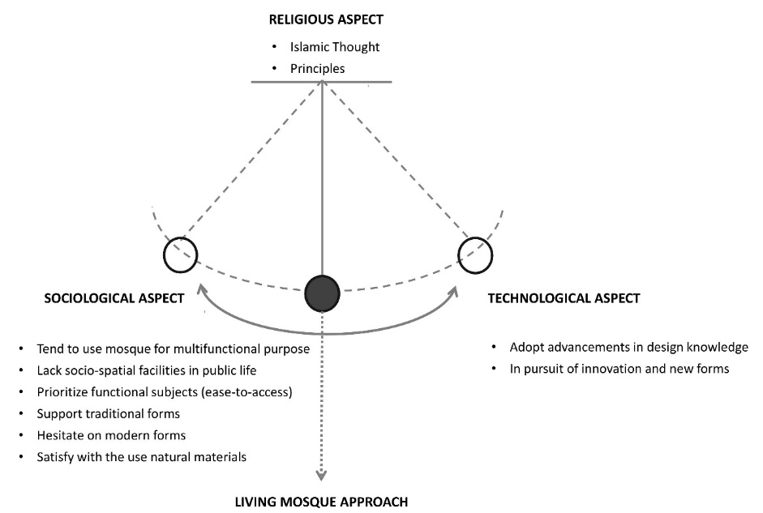
Figure 16. Conceptual Visualization of 'Living Mosques' - A Harmonious Integration of Islamic Thoughts, Sociological Interactions, and Technological Advancements in Mosque Architecture.

- CONCLUSION
This study aims to investigate how individuals use mosques and facilities, how people prefer mosques, and to what extent these spaces fulfill user expectations in terms of functional aspects. It involves an in-depth analysis of an online survey conducted with 521 participants living in Türkiye and workshop results.
This study reveals the disjuncture between current mosque usage and ideal/possible utilization of mosques (1), the mismatches between the general tendencies of academia & architectural media and community priorities (2), the gap between the socio-spatial functions provided in mosques and the functions demanded by the public (3) and the public's expectations and desires regarding mosque usage in terms of socio-spatial aspects (4). Then, we discuss key factors for improving socio-spatial facilities in mosques by proposing strategic-level solutions to the identified issues.
The author hopes that the results and suggestions identified in this study will guide future research aiming to enhance the quality of mosques in terms of socio-spatial aspects. The study's limitations were primarily due to the research's scope, which specifically focused on the situation in one country: Türkiye. Thus, similar studies should be conducted in other contexts to investigate how cultural, regional, and societal differences impact mosque usage and expectations. Moreover, this study only addresses the issues to some extent because it is based on declarative knowledge, including survey findings, written documents, and workshop results. There is a need for a comprehensive evaluation study that analyzes users’ actions and their interaction with the spatial environment within the scope of an in-depth field study.
Further research should consider expanding the scope of investigation to other countries to compare mosque usage patterns across different cultural and regional contexts. Such comparative studies could provide valuable insights into how various social and cultural factors influence the role and functionality of mosques worldwide.
Additionally, longitudinal studies that examine mosque usage and community needs over time are essential for understanding the evolving role of mosques in society. These studies can examine how changes in communities, urban development, and the socio-cultural patterns of users influence mosque usage. There is also a need for qualitative research that enables a deeper understanding of the expectations of different user groups. By employing methods such as interviews, focus groups, and ethnographic studies, researchers can gain a deeper understanding of the emotional, spiritual, and social dimensions of the mosque experience that are often overlooked in quantitative studies.
A promising area for future research is the examination of critical variables, including economic factors, regional differences, and the potential for technological integration in mosque design. These factors have the potential to offer innovative solutions to enhance the functionality and inclusivity of mosque spaces in response to contemporary challenges.
Another future avenue for exploration is the development of an effective participatory decision-making mechanism for upgrading socio-spatial facilities in mosques. Conducting a national research project in collaboration with the Directorate of Religious Affairs (DRA) would be beneficial in this regard, aiming to customize and improve the currently used Mosque Management Information System (MMIS) in a community-oriented approach. This project could also serve as a model for other countries, where similar systems could be developed to reflect the diverse needs and expectations of their communities.

REFERENCES

- N. ‘A. Baharudin, and A. S. Ismail. “Communal Mosques: Design Functionality towards the Development of Sustainability for Community.” Procedia - Social and Behavioral Sciences, vol. 153, pp. 106-120, 2014. Doi: https://doi.org/10.1016/j.sbspro.2014.10.046.
- S. Omer. "Some lessons from Prophet Muhammad (SAW) in architecture: The prophet’s mosque in Madīnah." Intellectual Discourse, vol. 18, No. 1, pp. 2010. DOI: https://doi.org/10.31436/id.v18i1.140
- S. Özaloglu and M. Ö. Gürel. "Designing mosques for secular congregations: Transformations of the mosque as a social Space in Turkey." Journal of Architectural and Planning Research, vol. 28, no. 4, pp. 336-358, 2011.
- N. Asif, N. Utaberta, A. Sarram, and S. Ismail. “Design Framework for Urban Mosque in The City Of Kuala Lumpur: A Qualitative Approach.” International Journal of Architectural Research: ArchNet-IJAR, Vol. 12, No. 3, pp. 170, 2018. Doi: https://doi.org/10.26687/archnet-ijar.v12i3.1586.
- A. Kahera, L. Abdulmalik, and C. Anz. Design criteria for mosques and Islamic centres. London: Routledge, 2009.
- M. T. H. M. Rasdi. The mosque as a community development centre: Programme and architectural design guidelines for contemporary Muslim societies. Kuala Lumpur: Penerbit UTM, 1998.
- A. Mokhtar. “Design standards for Muslim prayer facilities within public buildings”. ARCC Leadership in Architectural Research, Between Academia and the Profession, pp. 163–169, 2009.
- K. Piker, “Special Dossier on Mosque Architecture”, in Cami ve Güncel Mimarlık: Bu Konuyu Ne Kadar Tartışabiliyoruz? (Mosque and Contemporary Architecture: How Much Can We Discuss on This Subject?), Arredemento Mimarlık, 2018.
- S. Uygur, “Special Dossier on Mosque Architecture”, in Cami ve Güncel Mimarlık: Bu Konuyu Ne Kadar Tartışabiliyoruz? (Mosque and Contemporary Architecture: How Much Can We Discuss on This Subject?), Arredemento Mimarlık, 2018.
- N. Utaberta, N. Asif, M. T. M. Rasdi, M. Y. M. Yunos, N. A. Ismail, S. Ismail. “The Concept of Mosque Based on Islamic Philosophy: A Review Based on Early Islamic Texts and Practices of the Early Generation of the Muslims”. Adv. Environ. Biol., Vol. 9, No. 5, pp. 371-374, 2015.
- N. Asif, S. Ismail, and M. I. Shaharil. “The Study on the Functıonal Aspects of Mosque Institution.” Journal of Islamic Architecture, Vol. 6, no. 4, pp. 229-236, 2021. Doi: https://doi.org/10.18860/jia.v6i4.11749 p. 236.
- H. Mortada. Traditional Islamic Principles of Built Environment. London: Routledge, 2003.
- M. T. M. Rasdi, and N. Utaberta. "The design of Mosques as community development centers from the perspective of the Sunna and Wright’s organic architecture." Journal of Islamic Architecture, Vol. 1, No. 1, pp. 1-7, 2012. Doi: https://doi.org/10.18860/jia.v1i1.1710

- M. Z. M. Taib and M. T. Rasdi. “Islamic Architecture Evolution: Perception and Behaviour.” Procedia - Social and Behavioral Sciences, Vol. 49, Pp. 293-303, 2012. Doi: https://doi.org/10.1016/j.sbspro.2012.07.027.
- M. Ariffin, "A critical review on society’s perception on the usage of mosque." Research Journal of Fisheries and Hydrobiology, Vol. 10, No. 14, pp. 38-41, 2015.
- S. Omer. Studies in the Islamic built environment. Kuala Lumpur: International Islamic University Malaysia, 2013.
- N. Asif and N. Utaberta, Masjid-The Spiritual and Physical Hub for Community Development (First Edit). Kuala Lumpur: WARIS Research Group, 2016.
- O. Grabar. “Art and Culture in the Islamic World.” In Islam: Art and Architecture, pp. 40, 2004.
- H. Othman, M. Yazid, M. Yunos, and N. A. İsmail. “Issues and problems of modern mosques design in Malaysia: a critical analysis”. Adv. Environ. Biol, vol. 9, pp. 330–337, 2015.
- M. D. Niya, N. Utaberta, and S. Maulan. “Significance of the Application of Universal Design in Mosque Buildings in Malaysia.” Applied Mechanics and Materials, Vol. 747, pp. 72-75, 2015. Doi: https://doi.org/10.4028/www.scientific.net/amm.747.72.
- M. H. Masridin, and A. S. Ismail. “Critical Regionalism Approach for Djami Mosque Design Towards the Aesthetics of Sustainability.” Journal of Islamic Architecture, No. 7, no. 2, pp. 220-232, 2022. Doi: https://doi.org/10.18860/jia.v7i2.17135.
- D. Tekeli, “Special Dossier on Mosque Architecture”, in Cami ve Güncel Mimarlık: Bu Konuyu Ne Kadar Tartışabiliyoruz?” (Mosque and Contemporary Architecture: How Much Can We Discuss on This Subject?), Arredemento Mimarlık, 2018.
- S. Bozdoğan. Modernism and Nation Building. University of Washington Press, 2001.
- B. Batuman, “Appropriating the Masculine Sacred Islamism, Gender, and Mosque Architecture in Contemporary Turkey.” In Routledge Companion to Modernity, Space and Gender, Routledge, 2018.
- İ. Türkeri, “Türkiyedeki İslam tapınma mekanı tasarımları ve mimari tasarım paradigmalarının mimari proje yarışmaları üzerinden değerlendirilmesi.” PhD Thesis, Gebze Technical University, Institute of Science, 2016.
- Ministry of Interior Affairs of the Republic of Turkey. Türkiye’nin Nüfus Haritası. Accessed at: https://www.icisleri.gov.tr/turkiyenin-nufus-haritasi-10072021. Accessed date: 15.03.2022
- H. D. Arslan and K. Yıldırım,“Perceptual Evaluations of Different Period Mosque Facades: Preference, Complexity, Impressiveness and Stimulative.” MEGARON, Vol. 12, No. 4, pp. 511-523, 2017. Doi: https://doi.org/10.5505/megaron.2017.34635.
- F. Z. Sarıhan, “Türk Mimarisinde Cami İmajı Algısı: Biçim-Form Üzerinden Bir Yaklaşım”, Master's thesis, Fatih Sultan Mehmet Vakıf University, Institute of Engineering and Natural Sciences, 2015.
- UNHCR, “Bilgi Dokümanları ve Tablolar”. Accessed at: https://www.unhcr.org/tr/bilgi-dokumanlari-ve-tablolar. Accessed date: 15.03.2024.
- A. Gün and A. Çavuş, “Cami Tasarımında Esneklik Yaklaşımına İlişkin Bir Öneri”, XIIIth International Sinan Symposium, p. 541-557. Edirne, Türkiye, 2023.
- A. Gün, Cami Mimarlığını Yeniden Düşünmek Düşlemek. ITU Press, 2023
- A. Gün, “Mosque for All, Socio-Spatial Inclusion in Mosque Architecture: The Case of Türkiye”. Journal of Islamic Architecture, vol. 8, no.3, pp: 643-660. 2025. DOI: https://doi.org/10.18860/jia.v8i3.27138

