 |  | JOURNAL OF ISLAMIC ARCHITECTURE  P-ISSN: 2086-2636 E-ISSN: 2356-4644  Journal Home Page: http://ejournal.uin-malang.ac.id/index.php/JIA
REIMAGINING URBAN PUBLIC SPACES: A STUDY OF SPATIAL RIGHTS AND COMMUNITY INTERACTION IN JABAL AL-HUSSEIN, JORDAN
Ayat Alkhreasat^{a*}, Sarinaz Suleimanª
ªThe University of Jordan, Jordan
*Corresponding Author: A.Khreasat@ju.edu.jo
ARTICLE INFO |  |  | ABSTRACT
Volume: 8  Issue: 3  Page: 832-848  Received: June 26th, 2024  Accepted: August 6th, 2024  Available Online: June 30th, 2025  DOI: 10.18860/jia.v8i3.28036 |  |  | The paramount determinant of open space's success lies in the harmonious fusion of its design and environmental context. Considering people's environmental experience is crucial for implementing user-friendly spatial planning. This can be achieved by acknowledging the concept of "The Right to the City", which has two aspects: the right of residents to occupy, use, and enjoy specific city public spaces. And the right of residents to participate in decision-making at various stages in the urban planning process. (Middleton, 2018), this paper will focus on the first point only. The paper’s hypothesis emerged from the lack of POS in the study area, so streets are a public space where the community interacts, and does different activities. This paper studies the interactions between the physical setting of streets and open spaces with users. It traces all possible social, religious, and physical activities to reveal the level of spatial justice through the concept of spatial rights includes five dimensions. It comes out with three alternatives based on the conception of public spaces associated with mosques that emerged from a careful analysis of the needs of the residents of the study area (part of the Jabal Al-Hussein neighborhood)  Keywords:  Public Open Spaces; Spatial Rights; Spatial Justice; Urban Policies; Right To City

- INTRODUCTION
In an era of unprecedented urbanization, cities have become the crucible of human existence. The inescapable migration from rural to urban areas has led to most of the global population living in cities. While cities offer opportunities, they also pose profound challenges. Among these challenges, the allocation and use of urban land, particularly for public open spaces, has come to the forefront.
As urban areas grapple with exploding populations and higher urban densities, the competition for space intensifies. The reduction of distances to essential destinations, often regarded as an advantage of compact city living, paradoxically leads to the diminishment of available public open spaces. Burton summarizes this tension between urban density and the need for public recreational spaces [1]. It is becoming increasingly important to understand the connection between Public Open Spaces (POS) and people's experiences, both in terms of scientific research and urban policy and planning. The accessibility, safety, and inclusivity of POS have also been highlighted in Sustainable Development Goals (SDGs) 11.7. [2].
This paper delves into how the community finds its way to use any available open space, especially streets besides understanding the pivotal role of Public Open Spaces (POS) by addressing community activities and interactions within urban space. The purpose is to thoroughly analyze the relationship between public open spaces in urban areas and the surrounding community. It emphasizes the considerable influence of urban environments on city residents' overall health and happiness. It provides a convincing argument for the need to reimagine cities as spaces that enable all inhabitants to achieve their aspirations and goals with the most outstanding prospects of success. The importance of that is to make a base for informed urban planning and design decisions based on the observation and analysis of public life in cities, besides emphasizing the role of data-driven decision-making in enhancing the quality and vitality of public spaces. It considers built environment boundaries, public-private space interactions, movement, playing, and community safety and collaboration. Through thematic coding and analysis, it provides a deeper understanding of the research topics and the data collected.
This research paper was conducted to study the interactive relationship between urban spaces (POS) and the behavior of the Jabal Al-Hussein neighborhood residents in Amman, Jordan. The study involved observing and documenting the behavior of the residents in the area and monitoring the surrounding environment with its built and physical factors. The study also discussed the following urban concepts: Spatial justice, Urban justice, The right to the city, and (POS). Furthermore, the following research literature will be reviewed on these concepts to gain a better understanding. The literature review for this search will cover two main topics: public open spaces and the Right to the City, focusing on spatial justice.

A- PUBLIC OPEN SPACES
Public Open Space (POS) is a physical location for public use, mainly for recreational, social, or similar activities. It comprises parks, plazas, and waterfront promenades. POS is essential to urban land use and provides a venue for various public activities [3]. It is open to all members of the community. It should be accessible to everyone [4], as it plays a vital role in moderating the adverse effects of urbanization on health [5].
Public spaces are created by people, not just by physical structures. They can be found in many locations, such as street corners, restaurants, or social media platforms. Any place that holds social significance for city residents can become a public space, regardless of its physical shape or official recognition [6].
These spaces promise to allow individuals to engage in activities such as conservation, recreation, and communion with nature within the urban milieu, as articulated by Lynch [3]. Moreover, the significance of POS extends beyond the physical realm; they are recognized for their contributions to the physical, social, and psychological well-being of urban denizens and for fostering social interaction and communication [7] [8]. In addition to socio-economic factors, POS (public open space) also involves ecological variables [9]. Therefore, urban design should be based on the specific characteristics of the site rather than on general standards [10].
The design elements of the New Urbanist built environment consider streets and public spaces as significant components.; ‘Streets have an overt social purpose. They are considered public spaces and ‘are designed to encourage street life since any increase in pedestrian activity is thought to strengthen community bonds and promote a sense of place’ [11]. The links between walking encounters and urban sociability can be thought about more closely concerning the ‘right to the city’ and the everyday tactics of urban pedestrians [12].

B- RIGHT TO THE CITY, SPATIAL JUSTICE, AND SPATIAL RIGHTS
Henry Lefebvre introduced the book "Le Droit à la Ville" in 1968. The original idea was not to implement a new level of institutionalized human rights but to propose some framework for a utopia of urban social struggles [13]. In recent years, the discourse on urban justice has gained momentum, reflecting the seminal work of Lefebvre (1996) and his resounding call for "the right to the city." Lefebvre's concept underscores the notion that urban residents possess specific spatial rights, comprising four cardinal aspects: the right to participate equitably in the creation of urban spaces, the right to access the benefits engendered by the city, the right to evade spatial segregation, and the right to avail essential public services [14]. Lefebvre's ideas elevate not only the importance of access to urban resources but also the imperative of democracy and public participation in the urban planning and development process [4].
Within academic literature, the concept has been drawn upon in contexts ranging from social movements and protest [15], segregation and gentrification [16], race and racial identities [17], gendered and feminist perspectives on new forms of citizenship [18]; and in public urban spaces [6] young people involvement in planning [19] [20] and surveillance and social control [21]. Streets as livable spaces in sociological exploration [22]. In the writings [23], he proposes that the struggles of the urban crisis should be addressed by adopting the ‘right to the city’ as a ‘working slogan and political ideal’ [12].
Central to spatial justice is the equitable distribution and accessibility of POS. The assessment encompasses vital factors such as quantity, quality, and accessibility, echoing Rigolon's conceptual framework for assessing access to urban parks [24]. At the same time, many cities establish "minimum standards" to guide POS planning, and disparities in POS coverage persist, leading to the emergence of a phenomenon referred to as "park poverty" [25] [26] [27]. Especially in densely populated areas, the scarcity of suitable POS due to limited available land exacerbates issues of inaccessibility [28].
In examining spatial justice, Spatial rights come to the front. Carr et al. have reframed Lynch's five dimensions of spatial rights, labeling them as "access, freedom of action, claim, change, and ownership and disposition [29]." This reevaluation highlights the significance of ensuring access for everyone, aligning with Harvey's proposition for population management within urban areas [14]. Moreover, academics such as [30] and Rigolon, Fernandez, Harris, and Stewart have emphasized the significance of procedural fairness in offering recreational spaces and parks, emphasizing the value of inclusive decision-making procedures [31].
The study of Izzy Yi Jian employs factor analysis to examine the multifaceted nature of spatial justice concerning POS. Five relational constructs, namely Access and Management, Sociability and Diversity, Demand and Provision, Social Stratum and Information, and Social Inclusion, are derived from data analysis. Access and Management emerge as the most critical factors within this framework, followed by Sociability, Diversity, Demand, and Provision. These constructs capture the complexities of spatial justice and inform our understanding of the challenges and opportunities related to public recreational spaces in urban areas [4]. In this context, Wolfe offers valuable insights in his book "Seeing the Better City". He advocates using observation and photography to explore, understand, and enhance urban spaces, emphasizing the importance of urban diaries in capturing individual experiences and emotions related to the city [32].

- METHODS
The research methodology of this study is based on the public life study approach, which supports the term "urban mirrors". Subsequently, the acquired data underwent analysis employing the thematic coding technique. The public life-study approach observes and analyses how people use and interact with public city spaces, such as streets, squares, parks, or plazas. The approach aims to understand people's patterns, preferences, and needs in the built environment and to use this knowledge to inform urban planning and design decisions that enhance the quality and vitality of public life [33].
The public life-study approach involves various tools and techniques, such as counting, mapping, tracking, interviewing, or photographing people and their activities in public spaces. The approach also requires a systematic and comparative analysis of the collected data and a clear communication of the findings and recommendations to relevant stakeholders [33].
Urban mirrors help researchers investigate urban spaces from a human behavior perspective to understand how people interact with their surroundings, how they use space, and why. By conducting a comprehensive observation of people's behavior and physical traces, valuable data is collected to figure out patterns of use and interaction [32].
Coding is mechanistic, and instrumentalist distances the researcher from his data [34]. Thematic coding is used to analyze qualitative data by identifying common themes, topics, ideas, and patterns within the data through Data Preparation, Familiarization, behavioral mapping, Open Coding, Generating Themes, Reviewing and Refining, and reporting findings through behavioral mapping and tables [34].
Photographs were understood as objects that mediate the production of ‘knowledge’ within a specific urban space context [12]. To generate concepts, the themes process must generate questions and search for keywords that best depict the situation [34].

A- AREA OF THE STUDY
Nestled within the heart of Amman, the capital city of Jordan, Jabal Al-Hussein emerges as one of the earliest neighborhoods shaped by the city's urban expansion during the latter half of the 20th century. It has been considered one of the most elegant and beautiful neighborhoods since the sixties and seventies of the last century, according to aerial photos and maps from the Royal Jordanian Geographic Center and Greater Amman Municipality (GAM). Jabal Al-Hussein, characterized by residential pockets interspersed with commercial thoroughfares, underpins the imperative to establish a square catering to the residents and the vibrant commercial population. Currently, 85.0 % of the population of Jordan is urban, with 543.5p/km2 in Amman city [35]. Jabal Al-Hussien has one of the highest densities in Amman, reaching 15000 p/km2 [35]. The middle-class population inhabits a vibrant neighborhood [36].

B- SITE CHARACTERISTICS
The study area is part of the Jabal Al-Hussein neighborhood in Amman City, Jordan. It is administratively affiliated with the Abdali area, Figure 1. The study area, a specific section of this neighborhood, encapsulates the essence of Jabal Al-Hussein. It is intricately framed by major thoroughfares that define its boundaries:
• Istiklal Street and Jordan Street: These bustling major arterial streets.
• Khaled Bin Al-Waleed Street and Al-Jalil Street: These bustling streets are flanked by vibrant commercial markets and office complexes, forming a bustling longitudinal strip within the neighborhood. Khaled Bin Al-Waleed Street and Al-Jalil Street pulsate with high vehicular and pedestrian traffic volumes, reflecting the neighborhood’s dynamic nature.
• This zone of Jabal Al-Hussein has no public park or children’s playground; the nearest park takes 15 minutes of walking time. Besides crossing Khaled Bin Al-Waleed Street and Al-Jalil Street

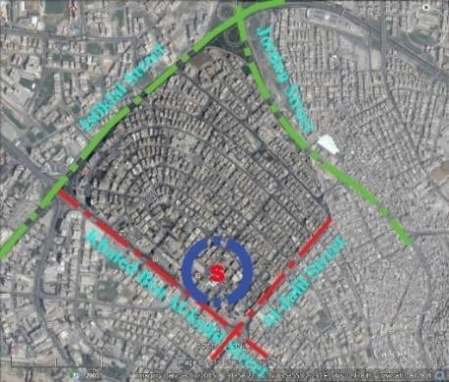 | 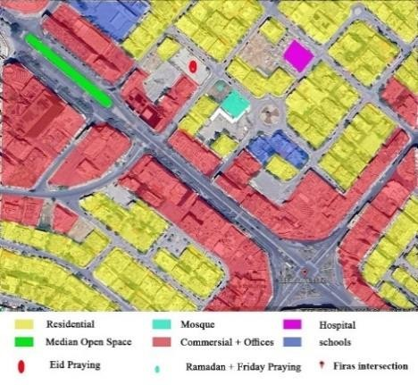
Figure 1. The study site within the urban  Context [Author] | Figure 2. As existing land use  [Author]

- RESULT AND DISCUSSION
The central hypothesis of the research is to achieve spatial justice through the following two points:
- The hypothesis emerged from a lack of public parks and insufficient open spaces; streets play as public space where the community interact, communicate, and do different activities.
- Urban Observation Enhances Policy Relevance: Using urban observation data to inform policies ensures that they align closely with the community's behaviors, needs, and preferences. This alignment enhances the effectiveness of policies in addressing urban challenges.
The investigation's framework was based on the five dimensions of spatial rights proposed by Lynch [3] and discussed by Carr et al. [29] are as follows:
Access: Access refers to the ability to enter and use public spaces. It is a fundamental component of the right to the city. It involves physical access, ensuring that spaces are physically available to the public. Issues related to access include whether a space is open to the public and whether there are any physical barriers or restrictions to entry.
Freedom of Action: Freedom of action encompasses the right to behave freely in a place or to use its facilities without appropriating them entirely. It involves reconciling competing interests, rules, and regulations to ensure that individuals and groups can use public spaces without disturbance or interference.
Claim: The claim represents the right of individuals or groups to appropriate spaces for personal use. It goes beyond mere access and freedom of action by asserting a proprietary interest in a space. Claiming a space can be essential for individuals and groups to achieve their goals in public spaces.
Change: The right of modification allows individuals or groups to change a space as they see fit, temporarily or permanently. It includes the freedom to add, remove, or alter elements within a space. However, there are limits to this right to prevent permanent damage or nuisances to others.
Ownership and Disposition: Ownership and disposition encompass the ultimate right of possession and control over a space. While the public owns all public spaces, legal ownership may involve a bundle of rights that can be sold or transferred. This right allows owners to make changes when a space no longer meets their needs.
These themes reflect the various dimensions of spatial rights and control over public spaces. They highlight the complex interplay between access, freedom of action, claim, change, and ownership and disposition in shaping the use and management of urban environments. These rights are crucial for ensuring equitable access to and enjoyment of public spaces, and they involve a balance between individual and collective interests, as well as considerations of privacy and territoriality. Understanding these themes is essential for facilitating and protecting the rights of individuals and communities within the urban context [3] [29].
The primary focus of our study within Jabal Al-Hussein is the public zone, as shown in Figure 2., where the heartbeat of community life thrives- In terms of size, the demographic study site spans a total area of 1 square kilometer- where the type of housing varies from private homes to apartment buildings, and the heights of the existing housing vary from one to four floors. The vacant lands are used as car parking, serving the commercial area and offices.
The Greater Amman Municipality (GAM) carried out in 2019 a rehabilitation project for a 650-meter strip of the Khalid bin al-Walid Street in the city’s Jabal al-Hussein district, extending from the Sukaynah bint al-Hussein School to the Firas Intersection (or what is also known as Firas Square because of the roundabout that used to exist there). The project includes the median (the only POS in this study) and sidewalk on each side of this stretch of the street. It is presented as the first phase of an “exemplary neighborhood” project that GAM plans to implement. It aims to facilitate safe pedestrian movement and prioritize the rights of pedestrians with visual impairments. In addition, the project aims to improve vehicular traffic flow along Khalid bin al-Walid Street by creating drop-off/pick-off set lanes parallel to it [37].

A- DATA COLLECTION
The field notes were collected through 13 years of observation by being one of the residents, which helps to cover various times in the day and occasions; from this observation, researchers noticed the following:
Jabal Al-Hussien is a busy district. It consists of mixed land use, where residents interact with district visitors who come for shopping, working, consulting services, and medical services. The peak time for people to visit the market is before religious holidays, especially on summer nights. During peak time, the traffic authority usually turns Al- Jaleel Street only into pedestrian streets. This has a positive point; it reduces traffic accidents and makes the street a public space where visitors to the area interact with the market. All private cars turn to the internal roads that cannot accommodate the massive traffic volume. The sounds of horns start to rise, and often, some men get out of their cars to find a solution to the traffic jam by asking someone to move forward, and another person pushes his car into a private parking lot of one of the houses or on the sidewalks so that they can pass each other. During that period, the horn did not stop, and narrow residential neighborhoods had insufficient capacity to hold. Usually, this scene is around 7 to ten each year.
A central small median (1500m²) was designed for sessions with fountains still in good condition. The visitors often use it; they eat snacks in the shade of trees. It is the only public space within the study area where the community can sit, chat, and interact with the commercial street. However, being a Central Island in a high-traffic-density street, it is an unsafe place for children to play. Visitors park their cars on local streets connected to the commercial street (Khalid bin al-Walid and Al-Jalil streets), photo B01, on vacant lands photo B14, or on paid parking lots. From interviews and observation, people wait for each other near the mosque before starting the shopping area (S) in Figure (1). After revising Ariel's photos of the district, many old houses- built before 1985- are now for sale; this will change the architectural image from family one to two-story houses to multi-family housing (8-12 apartments). One to two houses are demolished per year. Car parking started in 1985 to be in GAM regulations, but it became obligatory for housing type (C) in 2018. This causes a significant lack of private houses and car parks, but changing the architectural identity from tiny houses to apartments with new regulations may reduce the parking problems. Residents added elements to occupy car parking A11, C12, and A13.
Residents used to go to work, shopping, or other destinations on foot or by bike; photo B04. Daily walking makes neighbors’ faces familiar to each other, exchanging welcoming phrases such as good morning or, in Arabic -Salam Alikom. When one was absent for two days, others would ask about him, knock on the door, telephone, or open the door through civil defense if there was no answer. Mini-shop sign image and product arrangement on pavements differ depending on the Tenant and lease term. According to observation findings, mini-shop tenants have changed 2-3 times in the last ten years, but this is not constant.
The Greater Amman Municipality (GAM), through the Abdali region, the authority responsible for the neighborhood, has made many attempts to plant this roundabout with plants of several types (shrubs and flowers); photo C04. As observed, the children consider the roundabout a playground with no alternative, and only one palm tree can withstand; photos A01. All notes are summarized in the next photo’s table with the following categories: physical activities, religious and social activities, and physical setting.

Table 1. Study area activities
Category one: Physical activities
 | A | B | C
01 | 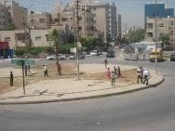 | 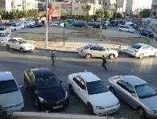 | 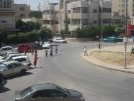
02 | 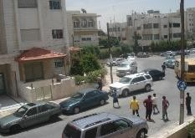 | 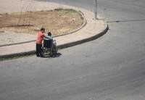 | 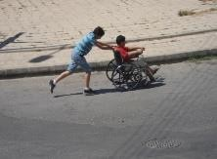
03 | 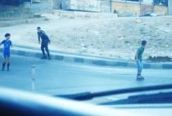 | 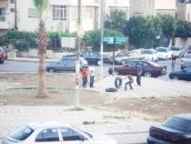 | 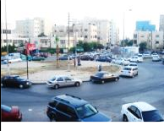
04 | 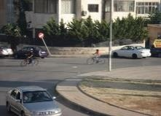 | 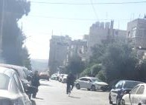 | 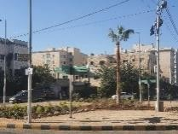
Category Two: Religious and Social Activities
 | A | B | C
05 | 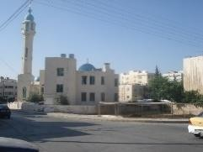 | 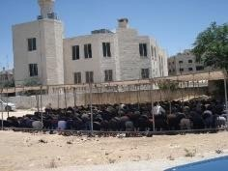 | 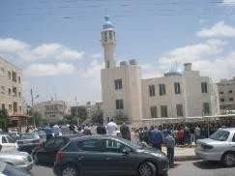
06 | 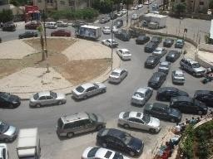 | 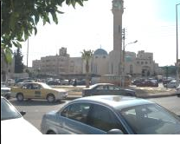 | 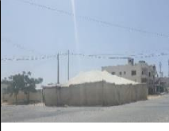
Category Four: Physical setting
 | A | B | C
07 | 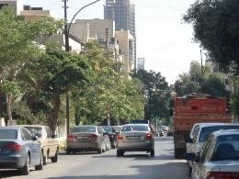 | 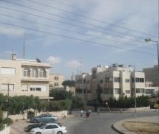 | 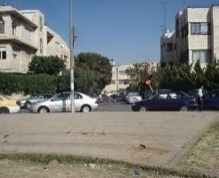
08 | 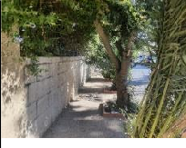 | 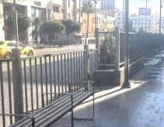 | 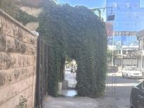
09 | 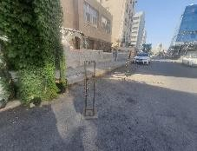 | 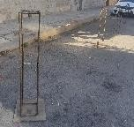 | 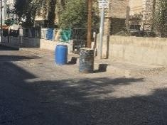
10 | 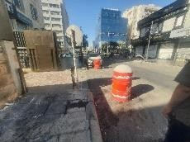 | 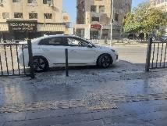 | 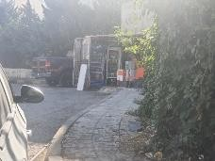
11 | 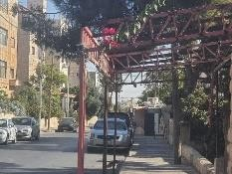 | 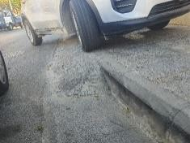 | 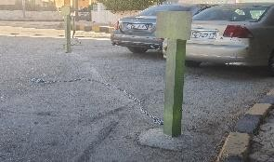
12 | 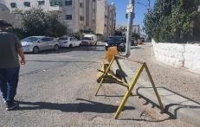 | 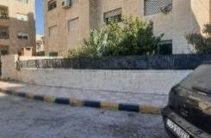 | 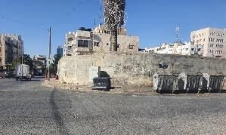
13 | 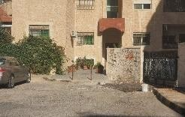 | 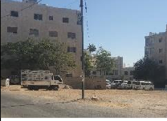 | 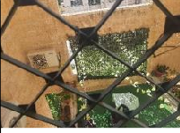

B- DATA DISCUSSION
To understand community actions within an urban space, many questions must be addressed regarding space user identity, activity, duration, time of day, repetition of activities (frequency), specific means and strategies they use, and users' aim. Writing these notes, derive researcher more questions: assumptions about what users are making, refining notes, comparing notes with other researcher field notes, the significance of this incident, and intrigued, surprising or unexpected behavior, which all help to derive assumptions and related values, attitude, and belief systems [34] [32] [33].

Table 2. Data Discussion
Category one: Physical Activities
Sub-category: Children playing
Image | Code |  |  | Description |  | concepts |  | Time pattern
A01  B01 | Playing ball |  |  | Children playing ball in the street. They consider streets and roundabouts to be their fields. |  | Feel Safe, Friendship Freedom |  | Almost Daily
A04  B04 | Bicycles |  |  | Playing with bicycles, usually around the roundabout, |  | Feel Safe Joy Friendship  Freedom |  | Once to twice a week
A02 | Playing, talking |  |  | Three groups of children playing next to each other in the street and the roundabout after leaving the classroom next to the roundabout during the exam period (around 10:00 am) |  | Friendship  Learn social interactions. Free time |  | School days
B03 | Playing with tiers, |  |  | Children playing with car tires were found lying next to garbage containers. Jumping, scrolling, and stirring |  | Discovering elements |  | Once they found any
A02  C01 | Chasing |  |  | Children playing in the streets |  | Joy Friendship |  | School days
B02  C02 | Playing around circle |  |  | children playing with a wheelchair (found on one of the sidewalks) are not disabled; they take turns. |  | Joy  Discovering new ways of playing |  | Once they found any
A03 | Skating |  |  | Kids in skates were getting ready to cling to any car as it passed on the street.  The car driver - whom children cling to his car - is often forced to line up, get out of the car, scold the children, and then continue walking. |  | Take risks.  Speed their movement |  | When available
Sub-category: Adults Physical Activities
B03 C03 | Walking |  |  | Home to work, shopping, as a sport for health/ diet. For praying and visiting neighbors and relatives. |  | Social security |  | Daily activities
B04 | Cycling |  |  | Home to work, shopping delivery |  | Lack of safety |  | Countable  (4-5 persons) but growing through time
 | Car Drifting |  |  | Irresponsible and illegal car drifting was noticed on summer nights between 24:00 and 2:00 a.m.  Duration less than 5 minutes, then flee. |  | Illegal Risky Unsafe |  | 2 to 3 times per week
Category Two: Religious Activities
Image | Code |  |  | Description |  | Theme |  | Occurrence
C05 A06 | Friday prayers |  |  | Performing the noon prayer  Closing the streets at the time of prayer |  | Limited-Time occupation |  | Once a week for one hour (Friday)
C05 | Ramadan prays |  |  | Tarawih praying is held for about 2 hours at night throughout Ramadan. Praying is held inside the mosque and on a vacant land adjacent to the mosque. The mosque committee takes permission from the landowner by interview. |  | Limit interventions are fixed all through the year. |  | One month
B05 | Eid |  |  | Eid dawn praying is held on paved land with a high gate and external wall. The owner allows the event with a mobile sound system and praying carpets. |  | No interventions |  | Twice a Year,  Two hours each
A06 B06 | Daily |  |  | Five daily prayers inside the mosque. |  | Social interactions Familiarity |  | Five times per day
 | Vending |  |  | From noon to E’eshaa’ praying time, vendors sell seasonal fruits, sometimes Dates, and Muslim prayer beads. Amman Municipality law does not accept vending; from time to time, Amman Municipality stops them from selling. |  | occupation |  | Daily (for 8 hours)
Category Three: Social Activities
Image | Code |  |  | Description |  | Theme |  | Occurrence/ pattern
C06 | Social private events |  |  | The vacant land. Residents rent temporary shelters for their events such as weddings and funeral homes, engagements (Jaha) (3 hours)  Funeral homes (for three days, around six hr./day) |  | Permanent structure (tent) |  | Seasonally
 | Chatting |  |  | Setting and chatting (noisy at night / merging with other daytime noise) |  | Noisy
 | Dancing |  |  | Traditional Dancing for graduation (15 min.) |  | Social interactions
A07 | Eating snacks |  |  | Sharing meals  Children after school and shopping visitors rest and eat near their parked cars.  Youth at night (summer days for an hour between 20:00 to 2:00) |  | Sharing  Friendship,  Family time |  | Daily
A07 | shopping  activities |  |  | The commercial market and office visitors park in winter between 11:00 a.m. and 8:00 p.m. It extends to 2:00 a.m. during the summer. And in the last week of Ramadan and Eid al-Adha, until the dawn prayer. |  | Heavy traffic  Lack of parking |  | Seasonal events
Category Four: Physical setting
Image | Code |  |  | Description
A07 | Public areas |  | Green | The Roundabout has one tree in the middle.  Sabotage due to lack of public space that fulfills public needs within inclusive urban design |  | Sabotage |  | Three attempts by GAM within 20 years
A08  A09  C09 | Public areas |  | Green | private household gardens,  This gives local streets a better scene and provides shadows on pavements |  | High care, Privacy  Beautiful visual appearance Less accessible  Disturbance |  | Almost permanent
A08  A09  C09 |  |  | Green | Plants on pavement disturb pedestrians who walk on the pavement. The width is insufficient, or the space under plants is less than 1 meter. Pedestrians prefer to walk on the streets. |  |  |  | Almost permanent
B08 | Buildings |  |  | The heights of the existing housing vary from one to four floors. Each plot accommodates seven families on average |  | Architectural Change |  | Changeable
B11  B12  A06  C03 | Car problem | Parking |  | Visitors used to park at any space; there is no available parking for visitors and clients in most commercial and office buildings |  | Occupying pavement | pedestrian | Lack of Car Parking
B11  B12  A06  C03 | Car problem |  |  | For housing: 80% of housing does not have car parking because it was built before parking regulations. |  | Occupying pavement | pedestrian | Lack of Car Parking
B06 | landmarks |  |  | The mosque can be considered a landmark.  The round about is the most common, well- known urban element for visitors in the area. Especially with his blue dome |  | Social meetings |  | Known
Sub-category: Added features
C09  B09  A12 | private property |  |  | Raised fences. | Raise fence (privacy, avoiding noisy youth chatting, avoid youth playing football) | Privacy  Noise
A12  A05 |  |  |  | Shelter | They are adding shelter for praying. The landowner accepts this. Funding was donated from the residence. Weak maintenance and the temporary structure are standing all year day for ten years. This causes inferior quality. | Temporary structure  Inferior quality | shelter | All the year
C11 | public streets |  |  | mini shops | fixed fences around product holders, refrigerators, coffee machines, tables, and chairs. | Permanent occupation | pavement | Changeable
B09  A10  B10  C10  A11 |  |  |  | Street vending | moveable boxes and stands) | Temporary occupation |  | Temporary
A12  C12  A13 |  |  |  | parking signs | Signs for entrances to avoid immoral  behavior from those who park and close the underground parking entrance or gate for on-ground parking | Use temporary elements  for permanent action |  | Permanent  And  Temporary
A12  C12  A13 |  |  |  | parking signs | Occupying a space for private car parking on a public street |  |  | Permanent  And  Temporary
A12  C12  A13 |  |  |  | parking signs | Occupying a space for Drop off (hospital) loading goods for small local shops |  |  | Permanent  And  Temporary
B12 |  |  |  | Concrete ramps | Concrete small ramp so cars can park on high pavements (pavement height reaches 25 cm) | Fixed concrete  Occupying |  | Permanent  And  Temporary
A14  C13 | Text on the outer side of the walls |  |  | Names and dates of visit |  | Social expressions  Commercial announcements |  | On vacant walled land
A14  C13 |  |  |  | Announcement for technical services, renting apartment, Jobs |  |  |  | On vacant walled land

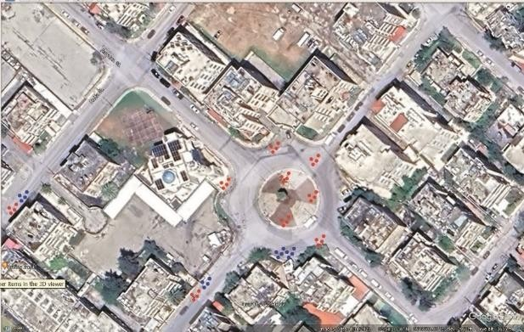 | 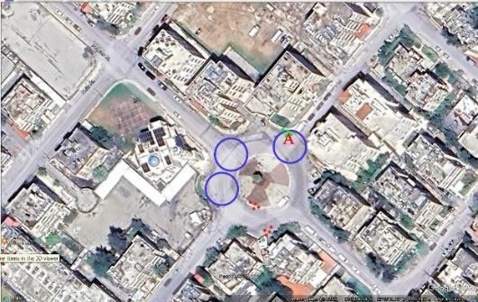
Figure 3. The pattern of children playing | Figure 4. Mid-Night Activity [Author]
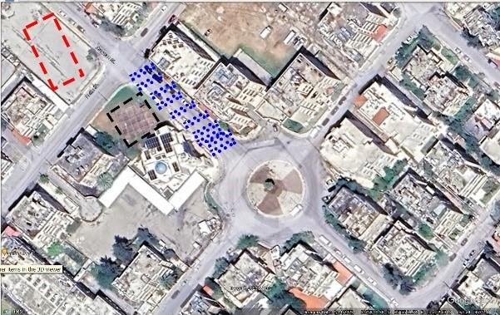
Figure 5. Religious Activities [Author]

Typically, children opt for one of the locations depicted in Figure three for play. However, all positions, whether marked in red for playing and chatting or in blue for grabbing snacks from nearby small shops, become bustling after school hours. The movement patterns are highly spontaneous, with many students often playfully chasing each other as they make their way home. These activities typically last for half an hour, although one or two groups may continue playing for 1 to 2 hours after school. This is illustrated in Figure 3. The owner of a vacant land raised an external wall to prevent noise from children who play football there; photo C13.

At night, a group of 3-5 youths used to sit, eat, and chat at red spots; usually, on summer days, they sit for around one hour between 23:00 and 1:00 a.m. Figure 4., at position A, and red spots. If neighbors asked them to leave, they apologized and left from one spot to another (red spots). The dialogue between youth and neighbors was through their bedroom windows. Blue circles are the location of irresponsible car drifting, usually heard at 2:00 a.m. once a week. Position A, where the youth sat before the fence every night, was added as in the photo (13B). Blue circles are the spots where youth do car drifting around midnight. Youth never did irresponsible car drifting When police were on the scene. Private house security cameras catch them; they stop for a week or two, then drift again. Next, new youth try drifting. Designing wide streets near a roundabout encourages such unruly behavior. Two accidents within ten years happened (not recorded at GAM). Neighbors found a way to agree to fix the damage. Besides, the distance for speeding up was less than 80 meters, which may have helped speeds not reach high velocity. Youth want to try something new.
The street blue location Figure 5. is typically employed weekly for Friday prayers, with residents closing the street for about one hour. The black dashed square serves as a prayer area for about one month during Ramadan, accommodating those unable to find space inside the Mosque, with a prayer duration of approximately one and a half hours. This area is only partially sheltered and is not adequately prepared for prayer, often causing discomfort due to stones, sand, and dust. The red dashed rectangle is utilized twice a year for Eid prayers, with a prayer duration of 3 hours. This land is under the authority of a mosque social committee, which seeks permission from the landowner to host these events.

C- RESEARCH RESULTS
The results of this research will come in the form of points of what was concluded from the study of the area. Afterwards, a proposed solution for a square in the study area will be reviewed, presenting three solutions.

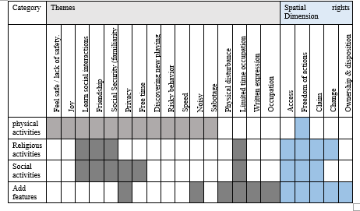
Table 3. summarizes the relationship between activities with corresponding themes and spatial rights witnessed and analyzed after the observation

    - Access: The absence of urban parks where residents can have a space to do physical and social activities in their free time gave streets, roundabouts, and any vacant land the role of POS (Public et al.). All users access streets and roundabouts, but vacant land has a different limitation, which depends on the owner. The roundabout attracts many residents and visitors to do many activities, although it is not designed to serve community needs as POS. Streets are unsafe for kids to play, cycle, or skate; there are no records of accidents across the streets [38].
    - Freedom of action: Streets, roundabouts, and surrounding open spaces witness many Physical activities covering all themes. Users of the site have access to do whatever they want to play, walk, cycle, have fun with any element they possibly found around the site, discover a thing to play learn to have friends, walk to work and pray, make residents know each other ask about absence ones which raise social security in a place that is opened to all Amman residence for shopping. They make noises that bother others, especially at night, and the greening of the roundabout does not survive in front of children playing. All of this makes the site have the dimension of freedom of action.

Regarding landscaping, although GAM made several attempts to landscape the roundabout, their efforts were unsuccessful due to children playing in the area. On Khalid bin Al-Walid Street, GAM took measures to protect small plants by installing a fence around them, ensuring their safe growth. These plants have thrived for approximately three years, as depicted in photo B09.
Vacant lands, all privately owned, are utilized in varying ways across the five dimensions, depending on the landowner. For instance, as shown in photo B14, a vacant lot is transformed into a public car parking area, which can be viewed as a form of claim. On the other hand, some landowners choose to enclose their properties, as seen in photo C13. In this case, the wall is initially constructed using stone as the base and later raised using concrete to deter children from playing football on the premises. Another vacant piece of land has been repurposed as a paid public car parking facility.
A change had occurred to the land adjacent to the mosque, which is vacant and prime and is used in special religious events as a photo B05 after the mosque committee takes the approval of the landowner. The mosque committee, with donations gathered from residents, made a temporary structure shelter for praying purposes. Residents help each other by arranging praying carpets on the soil, and others bring their carpets, especially after the coronavirus pandemic.
On public streets, one can observe both enduring and transient alterations along the sides of the streets at specific locations designated for activities such as drop-offs, product loading, and vending. Vendors employ mobile carts or boxes to display their merchandise. The landowners utilize various elements to signify their ownership or claim to these side street spaces. Mobile elements, as depicted in photos A10, B10, and A13, and stationary fixtures like those seen in photos C10, B12, and C12, are utilized for this purpose.
Alterations and adaptations can sometimes escalate to the level of disposition, where individuals employ the pavement for purposes such as parking cars or expanding their shops and greenery, as shown in photos A09, C09, C11, and A12. These modifications obstruct pedestrians who typically use the sidewalks and compel them to walk on the streets. While these practices may lack legal authorization, they persist because the local community does not object. This leniency is primarily because these shops fulfill the daily requirements of the community, and they regard the streets as an extension of their walking path.
Public open spaces are one of the main components of contemporary cities and one of the most important indicators of the city's development and advancement, where social interactions are clearly shown. Well-designed POS benefits society and may represent cultural and traditional values.
The harmony between the design of the POS and its environmental content is the most crucial factor for its success. The environmental content includes the urban setting, vegetation, road network, activities, and the economic/ social characteristics of the community.
An effectively planned public open space (POS) should meet the community's requirements and promote spatial justice. The observations and analyses detailed earlier provide insights into urban policies for designing public spaces associated with mosques. A residential neighborhood, Jabal Al-Hussein, is separated by commercial streets into smaller districts. The objective behind creating these POS is to cater to the needs of residents and visitors to the commercial area.

D- URBAN POLICY PROPOSAL
The concept of linking public open spaces (POS) with mosques is evident in Amman. One significant example is Al- Al-Husseini Mosque, located in the city center, which serves as a vital POS within Amman. The area around this mosque is usually bustling with pedestrians, passers-by, and street vendors, especially when the adjacent commercial area is open for business. Figures 6, 7, and 8. showcase Al-Husseini Mosque, Abu Darwish Mosque, And Al-Nnourain Mosque, all of which host a variety of activities. These activities include prayer (when the main mosque is crowded), vending, seating, socializing, enjoying snacks, and shopping. These insights are drawn from a study conducted by Aljafari in 2014.

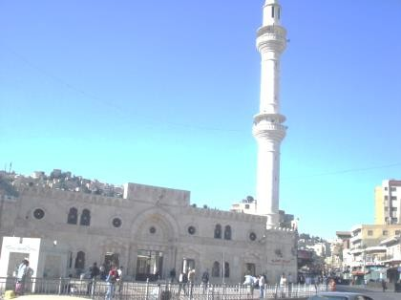 | 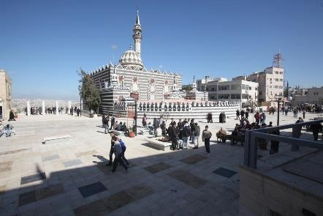
Figure 6. Al-Husseini Mosque open space, downtown, Amman [Author] | Figure 7. Abu-Darwish Mosque Square, East Amman [40]
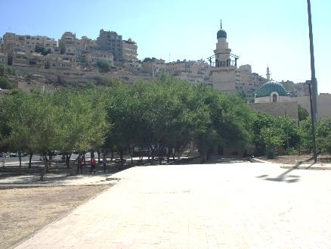
Figure 8. Al-Nnourain Mosque, GAM – Amman [Author]

Regarding the Al-Husseini Mosque Plaza downtown, it is important to mention that this particular public area is located within a mixed-use area rather than a residential neighborhood. As a result, pedestrian traffic in this area is often associated with shopping and economic activities. However, the level of pedestrian activity in this location, even for shopping, has declined over the past few decades due to the city's expansion and new centers in other parts of Amman. Interestingly, the peak of pedestrian activity in the Al-Husseini Mosque Open space is typically buzzy during the afternoon, with youth visiting for recreational and shopping purposes [39]. Besides the physical layouts and design features that might discourage walking in public spaces in Amman, cultural factors also discourage specific individuals, causing them to feel uneasy or unsafe when traversing specific public areas, as exemplified by the situations in Abu Darwish Plaza and Al-Husseini Mosque Plaza [39].
In the context of Al-Husseini Mosque open space, management is under the purview of the public sphere, primarily represented by (GAM). The GAM has been involved in these projects from the conceptual stage to the management phase, making it responsible for overseeing management and maintenance [39]. In the case of Abu Darwish Mosque Plaza, management of the space is lacking across all dimensions. Formal regulation is absent, resulting in the use of the space and conflicts between users being governed by the specific cultural norms of the social group that appropriates it. Furthermore, the new investments in this area, such as commercial stores, cultural centers, and libraries, have not been effectively utilized or integrated with the local community. The high rental prices imposed by GAM for this traditional area have deterred businesses from renting the developed shops. Additionally, many plaza users are unaware of the purposes of the adjacent public buildings. Therefore, there is no functional mechanism to coordinate interventions by various actors in the public space to ensure that their practices and interests align effectively [39].

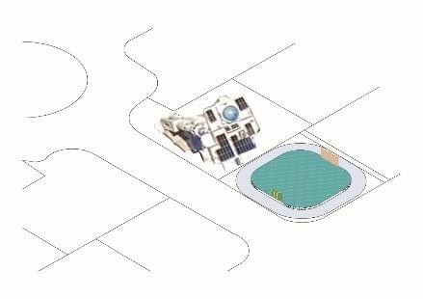 | 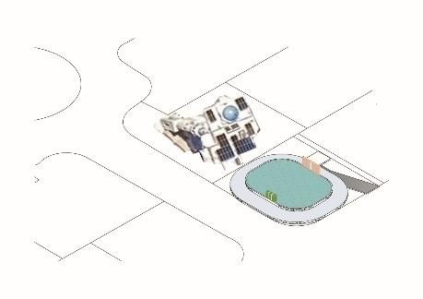
a. Alternative 1 | b. Alternative 2
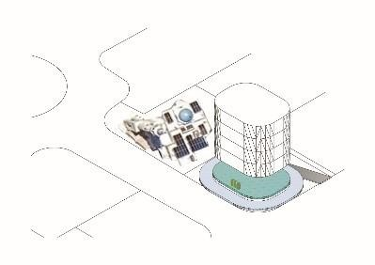
c. Alternative 3

Figure 9. (a) Alternative 1, (b) Alternative 2, (c) Alternative 3 [Author ]

Three design alternatives were presented, each with its policies. The space will include a track for cycling and skating, a multipurpose square for children, Friday and Eid prayers, and temporary tents for cultural or social activities. Visitors can sit, snack, and chat while disposing of waste in recycling bins. An announcement board and a small store for renting items such as tents and chairs will be available, with rental income going towards maintenance. The design alternatives involve the official authorities, local society, and landowners.

- The first alternative is POS owned and marinated by GAM and maintained and taken care of.
- The second alternative, underground parking, is added to the design; POS will increase income.
- The third alternative is a public space provided by the land owner as a service to the community in return for the state giving him financial and tax facilities, for example, or allowing him to build an additional floor instead of the donated void. This alternative is based on a partnership between the public and private sectors, and an elected committee from the neighborhood will sponsor it.

Table 4. Alternatives comparison

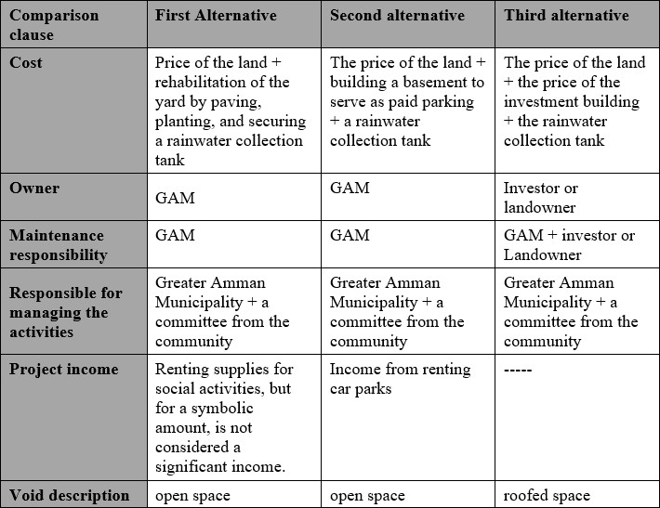

Design and management are vital in shaping and maintaining the human environment. Design plans and directs changes, while management oversees use and adapts to new needs. They complement each other. The design needs resources to make significant changes and provide guidance. Management is ongoing and adjusts the space to new requirements. To effectively manage the complex relationships between people and public spaces, designers and managers rely on the human dimensions of public space as a framework. However, certain rights related to land control, such as permanent change, ownership, and disposition, often lie beyond the designer's influence. The advocated approach emphasizes involving people directly in the design and management of public spaces, bridging the gap between theory and practice. Engaging users empowers and deepens their understanding of a specific space's most suitable human dimensions, fostering a user-centric approach to creating vibrant and enduring public environments.

- CONCLUSION
“The lesson here is that a living city is always becoming. It is a process that issues both breathtaking advances and deep disappointments. As such, a city cannot be perfect, efficient, or ideal—or preserve able, because you cannot preserve something still alive” [40].
Understanding how daily life may help urban planners and designers cure errors and write future visions.
Success in public spaces happens when matching the user's needs, comfort, and ambitions. This research tries to find out these needs. Three distinct design proposals were presented for this square, each emphasizing its potential as a multifunctional hub. These proposals universally endorse the ability of neighborhood residents to engage in diverse activities, including cycling and skating on a dedicated track, children's play area, Friday prayers, Tarawih, and Eid prayers in an arena, and the erection of temporary tents to host cultural or social gatherings such as funerals and ceremonies. Furthermore, designated seating areas provide spaces for relaxation, snacking, and social interaction.
Institutionalized management and community involvement are indispensable in ensuring these spaces' sustained upkeep, cleanliness, and orderliness, rendering them receptive to many initiatives. The concept of “Neighborhood Self-Administration" should be examined in future research, not only in maintaining these areas but also in fostering a sense of place, mitigating fear, rebuilding trust, and enhancing social cohesion among residents.
In conclusion, this research has emphasized the importance of tracking people's behavior and actions to improve the development of public spaces. It is not the presence of people that brings them together in public areas, nor even the provision of physical needs. It is their needs which is the most essential thing for urban planners when providing these spaces.
Finally, this paper tries to part to many other voices to raise the sound of public participation in urban planning decisions. Besides, it shows the varying degrees of official involvement and societal participation in the suggested design alternatives. So, policies derived from a deep understanding of community needs and behaviors are more likely to promote social cohesion. When public spaces are designed for the community's well-being, they become natural gathering points, strengthening social bonds.

AUTHORS CONTRIBUTION
Author1 and Author2 collaborated on the initial concept of this study. Author1, Ayat Alkhreasat was responsible for developing the research methodology and framework. Author2, Sarinaz Suleiman contributed by gathering and organizing the necessary data. Both authors jointly crafted the initial manuscript, with subsequent revisions and refinements made collaboratively.

REFERENCES

- E. Burton, "The compact city: just or just compact? A preliminary analysis. " Urban studies, vol. 37, no. 11, pp. 1969-2006, 2000. Doi: https://doi.org/10.1080/00420980050162184
- UN., "THE 17 GOALS | Sustainable Development/ SDG Good Practices-A compilation of success stories and lessons learned in SDG implementation (First Edition)," UNDESA, 2020.
- K. Lynch, Good city form, MIT Press, 1984.
- Y. Jian, J. Luo, and E. H. Chan, "Spatial justice in public open space planning: Accessibility and inclusivity," Habitat International, vol. 97, 2020. Doi: https://doi.org/10.1016/j.habitatint.2020.102122
- E. Skinner and J. R. Masuda, "Right to a healthy city? Examining the relationship between urban space and health inequity by Aboriginal youth artist-activists in Winnipeg," Soc Sci Med., vol. 91, pp. 210-218., 2013. Doi: https://doi.org/10.1016/j.socscimed.2013.02.020
- R. Kyus, Public Spaces and Gender in Amman, Amman Jordan: Deutsche Gesellschaft für Internationale Zusammenarbeit (GIZ) GmbH, and Greater Amman Municipality (GAM), 2020.
- Y. Chen, T. Liu, and W. Liu, "Increasing the use of large-scale public open spaces: A case study of the North Central Axis Square in Shenzhen, China," Habitat International, vol. 53, pp. 66-77, 2016. Doi: https://doi.org/10.1016/j.habitatint.2015.10.027

- V. Jennings, L. Larson, and J. Yun., "Advancing Sustainability through Urban Green Space: Cultural Ecosystem Services, Equity, and Social Determinants of Health," International Journal of Environmental Research and Public Health, vol. 13, no. 2, p. 196, 2016. Doi: https://doi.org/10.3390/ijerph13020196
- K. Krellenberg, J. Welz and S. Reyes-Päcke, "Urban green areas and their potential for social interaction – A case study of a socio-economically mixed neighbourhood in Santiago de Chile," Habitat International, vol. 44, pp. 11-21, 2014. Doi: https://doi.org/10.1016/j.habitatint.2014.04.004
- E. H. Yung, S. Conejos and E. H. Chan, "Public open spaces planning for the elderly: The case of dense urban renewal districts in Hong Kong," Land and Policy, vol. 59, pp. 1-11, 2016. Doi: https://doi.org/10.1016/j.landusepol.2016.08.022
- E. Talen, “Sense of Community and Neighbourhood Form: An Assessment of the Social Doctrine of New Urbanism”, Urban Studies, vol. 36, no. 8, p. 1361–1379, 1999. Doi: https://doi.org/10.1080/0042098993033
- J. Middleton, "The socialities of everyday urban walking and the 'right to city," Urban Studies, vol. 55, no. 2, pp. 296-315, 2018. Doi: https://doi.org/10.1177/0042098016649325
- U. Knut , "Right to the City” as a response to the crisis: “Convergence” or divergence of urban social movements?," The Struggle for the City, 2009. Accessed 25 Sep. 2023, [Online]. Available: https://housingstruggles.wordpress.com/2009/02/18/%e2%80%9cright-to-the-city%e2%80%9d-as-a-response-to-the-crisis-%e2%80%9cconvergence%e2%80%9d-or-divergence-of-urban-social-movements/
- D. Harvey, "The Right to the City," International Journal for Urban and Regional Research, vol. 27, pp. 939-941, 2003.
- M. De Souza, "Which right to which city?In defence of political-strategic clarity," Interface, vol. 2, no. 1, p. 315–333, 2010.
- N. Smith, The New Urban Frontier: Gentrification and the Revanchist City, London/ NewYork: Routledge, 1996.
- E. McCann, "Race, protest, and public space: Contextualizing Lefebvre in the US City," Antipode, vol. 31, no. 2, p. 163–184, 1999. Doi: https://doi.org/10.1111/1467-8330.00098
- T. Fenster, "The right to the gendered city: Different formations of belonging in everyday life," Journal of Gender Studies, vol. 14, no. 3, p. 217–231, 2005. Doi: https://doi.org/10.1080/09589230500264109
- G. B. Watson, "Young people and the built environment," Town planning Review, vol. 80, no. 3, pp. 1-5, 2009.
- A. J. Heinrich and A. Million, "Young People as City Builders, Youth Participation in German Municipalities," The Planning Review, vol. 52, no. 1, pp. 56-71, 2016. Doi: https://doi.org/10.1080/02513625.2016.1171049
- P. Hubbard, "Cleansing the Metropolis: Sex Work and the Politics of Zero Tolerance," Urban Studies, vol. 41, no. 9, pp. 1687-1702, 2004.
- P. Hubbard and D. Lyon, "Introduction: Streetlife – the shifting sociologies of the street," The Sociological Review, vol. 66, pp. 937 - 951, 2018. Doi: https://doi.org/10.1177/0038026118771281
- D. HARVEY, "The right to the city," New Left Review, vol. 53, p. 23–40, 2008.
- A. Rigolon, "A complex landscape of inequity in access to urban parks: A literature review," Landscape and Urban Planning, vol. 153, pp. 160-169, 2016. Doi: https://doi.org/10.1016/j.landurbplan.2016.05.017
- J. Macedo and M. A. Haddad, "Equitable distribution of open space: Using spatial analysis to evaluate urban parks in Curitiba, Brazil," Environment and Planning B: Planning and Design, vol. 43, no. 6, pp. 1096- 1117, 2016. Doi: https://doi.org/10.1177/0265813515603369
- C. Sister, J. Wolch, and J. Wilson, "Get green? addressing environmental justice in park provision.," GeoJournal, vol. 75, p. 229–248, 2010. Doi: https://doi.org/10.1007/s10708-009-9303-8
- F. Wei, "Greener urbanization? Changing accessibility to parks in China," Landscape and Urban Planning
vol. 157, pp. 542-552, 2017. Doi: https://doi.org/10.1016/j.landurbplan.2016.09.004
- G. Lee and I. Hong, "Measuring spatial accessibility in the context of spatial disparity between demand and supply of urban park service," Landscape and Urban Planning, vol. 119, pp. 85-90, 2013. Doi: https://doi.org/10.1016/j.landurbplan.2013.07.001
- S. Carr, M. Francis, l. G. Rivlin and A. M. Stone, Public Space, London, New York: Cambridge, 1992.
- S. Low, "Public space and diversity: Distributive, procedural and interactional justice for parks," The Routledge Research Companion to Planning and Culture, pp. 295-309, Routledge: 2016.

- A. Rigolon, M. Fernandez, B. Harris, and W. Stewart, "An ecological model of environmental justice for recreation," Leisure Sciences, vol. 44, pp. 655-676, 2022. Doi: https://doi.org/10.1080/01490400.2019.1655686
- C. R. Wolfe, Seeing the Better City: How to Explore, Observe, and Improve Urban Space, Washington DC: Island Press, 2017.
- J. Gehl and B. Svarre, How to Study Public Life, Washington, DC: Island Press, 2013.
- J. Saldana, The Coding Manual for Qualitative Researchers, London: Sage, 2016.
- M. Ababsa, "The Evolution of Upgrading Policies in Amman," in The Second International Conference on Sustainable Architecture and Urban Development, CSAAR, MPWH, Scotland, 2010.
- D. Abu Thiab, Mind the Gap: Mapping the Urban Divide in Amman (MSc.), Amman: German Jordanian University, 2012.
- (CSBE), "The Khalid bin al-Walid Street Rehabilitation Project in Jabal al-Hussein," 15 Sep. 2023. [Online]. Available: https://www.csbe.org/jabal-al-hussein.
- G. A. Municipality, "GIS Department," 2023. Accessed 2023 OCT 2023. [Online]. Available: http://www.ammancitygis.gov.jo/ammancitygis/Pages/Default.aspx?ok=1.
- M. Aljafari, “Emerging public spaces in the City of Amman, Jordan: An analysis of everyday life practices”, Dortmund: Dortmund University, 2014.
- S. Ikeda, "The Mirage of The Efficient City," in What We See : Advancing the Observations of Jane Jacobs, New Village Press, 2010, pp. 24-33.

