 |  | JOURNAL OF ISLAMIC ARCHITECTURE  P-ISSN: 2086-2636 E-ISSN: 2356-4644  Journal Home Page: http://ejournal.uin-malang.ac.id/index.php/JIA
SEMANTIC AND SYNTACTIC DIMENSIONAL ANALYSIS: THE CASE OF SÜLEYMANİYE MOSQUE
Birgül Çakıroğluª, Reyhan Akat^{b*}
ªFaculty of Art and Design, Department of Architecture, Artvin Coruh University, Artvin, Turkey
^{b}Faculty of Engineering and Architecture, Department of Architecture, Yozgat Bozok University, Yozgat, Turkey
*Corresponding Author: reyhan.akat@yobu.edu.tr
ARTICLE INFO |  |  | ABSTRACT
Volume: 8  Issue: 4  Page: 1174-1197  Received: August 5th, 2024  Accepted: October 30th, 2024  Available Online: December 30th, 2025  DOI: 10.18860/jia.v8i4.28055 |  |  | In this study, it is acknowledged that sacred concepts influence the formation of sacred spaces and serve as a non-verbal language of expression. Accordingly, the research examines how the concrete manifestations of sacred concepts in Islam are reflected in the design principles shaping mosque architecture. The scope of the study is limited to five sacred concepts in Islam: wahdaniyet (unity), beka (eternity), ilim (knowledge), might, and the hereafter. The effects of these five concepts on the architectural design of the Süleymaniye Mosque, selected as the case study, were investigated. Data were collected through literature review, on-site visual observation and examination, and photography. The semiotic method was employed to conduct semantic and syntactic analyses of the obtained data. As a result, sub-concepts derived from the main sacred concepts were identified, and both the semantic dimensions of these sub-concepts and the design principles reflected in their syntactic dimensions were presented in separate tables. The findings indicate that the fundamental design principles reflected by each sacred concept in the semantic dimension predominantly embody the principles of unity and appropriateness. This study is significant as it provides a reference for the tangible expression of abstract sacred concepts that shape religious buildings, ensuring their design aligns with their intended spiritual functions. Moreover, the proposed analytical model is expected to make a valuable contribution to the literature and to architectural design education by offering a semiotic framework for interpreting sacred meanings, thereby facilitating the design of religious spaces.  Keywords:  Religion; Semiotics; Basic design principles; Wahdaniyet; Beka; Ilim; Might; Hereafter; Süleymaniye Mosque

- INTRODUCTION
The primary objective of this study is to examine the influence of beliefs, as one of the cultural factors shaping architecture, on architectural design. In the Islamic world, despite local differences in materials, construction techniques, and similar elements, architectural works are perceived as part of a common artistic and spiritual universe. It can be argued that the origins of this unity lie in Islam’s worldview, which organizes perceptions of creation, existence, and humanity [1]. Indeed, the institutions and principles shaping Islamic architecture are derived from the Quran, the Sunnah of the Prophet Muhammad, and the written and oral teachings of Islamic jurists [2]. In Turkey and globally, research on architectural space has generally focused on visible, measurable, tangible, and concrete factors. This study, however, aims to analyze how the semantic dimensions of sacred concepts in Islam are reflected in the fundamental design principles that shape mosque architecture. The lack of sufficient scientific research on the formal and chronological development and transformation of the influence of beliefs and belief-based architectural understanding on space, structure, ornamentation, and art constitutes the starting point of this study. In the formation of religious structures, there are certain factors that we cannot define, see, or directly perceive, but whose existence we can infer. This research aims to identify and interpret these influential factors in mosques, a type of religious architectural structure. For this purpose, an analytical model has been developed.
This analytical model will make a significant contribution to both the literature and fundamental design education by expressing the meanings of sacred concepts through semiotics. It will greatly assist designers in concretizing these abstract concepts during the project phase of religious spaces. This research is also significant as a reference for the tangible expression of sacred and abstract concepts that influence the design of religious structures [3], [4].

- ISLAMIC RELIGION
The Islamic religion, rooted in divine revelation, presents a monotheistic belief system and a universal worldview. The term "Islam," meaning "submission" and "surrender," serves as both the general name for all Abrahamic faiths and the specific name of the final religion perfected through the revelations to the Prophet Muhammad over twenty-three years, intended to address humanity's needs until the Day of Judgment [5]. This faith centers on the Supreme Creator as the sole origin and organizing principle of the entire hierarchy of existence. This concept instills a profound sense of peace and tranquility into its dynamic character [6]. For a Muslim, all realms of existence, including nature, art, science, and architecture, are perceived as ayat (signs) pointing to the presence, unity, and infinite power of the Creator [7]. The understanding of sacred space is nourished by this holistic perspective; a centrally positioned space (such as a mihrab niche or a dome) integrates all peripheral points, allowing the individual to experience the omnipresent divine at every place and time [8]. Historically, religions have served the dual function of providing spiritual solace to the individual and guiding society. In the architecture of societies bound by the same faith, it is possible to discern reflections of a common cultural language, despite local variations in conditions [9]. Over time, societies can evolve beyond their religious molds. In such cases, reforms—like those of Protestantism—may adapt the religious order to contemporary needs, or the societal guiding role of religion may give way to more rational doctrines, reducing religion to a more private, individual matter[10]. However, Islamic architecture developed an enduring and magnificent language, nourished by religious texts (the Quran and Sunnah) and the interpretations of jurists, which translates abstract principles of faith into concrete spatial forms[11]. Islamic architecture is thus a unique mode of expression built upon these religious and philosophical foundations, uniting form, function, and symbolism. The mosque is the typology in which this expression is most concentrated, translating core Islamic concepts such as tawhid (the oneness of God), revelation, and communal unity (ummah) into physical space. In this context, architecture is not merely a functional structure but also a three-dimensional manifestation of a system of belief and thought [12].

- ISLAMIC PHILOSOPHY
Islamic architecture is widely regarded as a spatial reflection of the religious beliefs, philosophical outlook, and social order of Muslim communities. Faith, Sharia, and the concept of communal responsibility are embodied in architectural forms such as inward-looking courtyards, modular spatial schemes, and geometric ornamentation that emphasize simplicity and humility [13]. Recent scholarship highlights that the development of Islamic art and architecture has been shaped not only by religious foundations but also by interactions with neighboring civilizations, climatic and material conditions, technological progress, and local aesthetic traditions [14], [15]. Within this framework, Islamic architecture seeks to remind humanity of the transience of worldly life and the eternity of God, while simultaneously dissolving barriers between nature and the sacred [16]. Contemporary studies describe Islamic cities in terms of ideals such as the “city of justice,” the “city of knowledge,” and the “city of ecological harmony,” which represent the spatial manifestation of Islamic social philosophy [17]. Core theological concepts—unity (wahdaniyyah), eternity, divine knowledge, power, and the hereafter—are reflected in both the functional and aesthetic dimensions of Islamic architecture [18]. Thus, Islamic architecture is not limited to the design of mosques or religious buildings but extends to the entire urban fabric, shaping social life through principles of balance, humility, and transcendence [19], [20]. Recent research also connects Islamic architecture with modern concerns such as sustainability, environmental adaptation, and community participation. For example, mosque design increasingly incorporates energy efficiency, natural lighting, and ecological materials, aligning traditional values with contemporary environmental ethics [21]. Furthermore, ornamentation and geometric abstraction are interpreted not merely as decorative elements but as metaphysical expressions of divine order and infinity [4].

- PHILOSOPHY IN ISLAMIC ART ARCHITECTURE
In Islamic thought, the divine essence of Allah is considered beyond the full grasp of human knowledge. Instead, believers seek understanding through His Asma al-Husna (Beautiful Names) and attributes, which reflect His transcendence and perfection [22]. Classical and contemporary scholars emphasize attributes such as wujud (existence), beka (eternity), qiyam bi nafsih (self-subsistence without dependence), and wahdaniyyah (absolute unity), which distinguish God from all created beings [23]. These attributes are not merely theological concepts but also influence the symbolic and aesthetic dimensions of Islamic art and architecture, where unity and transcendence are expressed through geometric abstraction, symmetry, and the avoidance of figurative representation [20]. Furthermore, attributes such as divine knowledge (ilm) and power (qudra) illustrate the relationship between Allah and the universe, thereby shaping the philosophical foundation of Islamic aesthetics. Architectural forms such as domes, courtyards, and calligraphic ornamentation are designed to embody the infinite nature of God’s knowledge and the encompassing strength of His will [13]. Thus, Islamic art and architecture become a medium through which metaphysical principles are translated into spatial and visual language, reinforcing the inseparability of faith, philosophy, and artistic expression.

C.1. The Concept of Wahdaniyet
In Islamic philosophy, wahdaniyyah (oneness) affirms that Allah is absolutely unique in His essence, attributes, and actions, without any equal or partner. The opposite of divine unity, plurality or shirk (associating partners with God), is considered theologically impossible [24]. The Qur’an consistently emphasizes that Allah alone is the Creator and the only being worthy of worship, highlighting His transcendence and incomparability [13]. Islamic art and architecture embody this principle of unity through abstraction, geometry, and repetition rather than figurative representation. These aesthetic strategies symbolize the eternal presence of the divine and the infinite nature of His attributes [14]. The principle of tawhid (unity of God) thus becomes the organizing foundation of Islamic civilization, binding together materials, structures, and social relationships into a coherent whole. One of the most striking architectural manifestations of wahdaniyyah is the orientation of all mosques toward the qibla, marked by the mihrab pointing to the Kaaba in Mecca. This unified direction creates a collective spiritual fabric, as millions of Muslims daily turn their gaze and intention toward the same sacred center, embodying divine unity in lived practice [25].

C.2. The Concept of Beka
In Islamic philosophy, beka (eternity) refers to the everlasting nature of Allah, who transcends mortality and temporality. Unlike created beings, whose existence is finite, Allah’s being is eternal and absolute, without beginning or end [23]. This concept is reflected in Islamic art and architecture, where visual forms are designed to evoke infinity and continuity. In mosque decoration, for example, uninterrupted lines, circular motifs, and geometric repetitions symbolize the eternal presence of the divine [14]. The circle, often regarded as the most perfect geometric form, represents unity and endless motion around a central point, embodying the idea of eternity within multiplicity. Similarly, star motifs and polygonal compositions interlock to create complex arrangements that challenge the human eye, suggesting boundlessness and divine transcendence [20]. Domes, with their symmetrical and repetitive structures, reinforce the perception of divine order and power, reminding worshippers of Allah’s eternal existence. Because Allah is understood as an abstract and incomparable being, Islamic art avoids figurative representation, favoring abstraction, geometry, and stylized ornamentation. Humans, by contrast, are seen as temporary beings whose value lies in their humanity rather than glorification. Thus, Islamic art evolved into a distinctive tradition characterized by muqarnas, intricate arabesques, and modular compositions that evoke infinity and direct contemplation toward the eternal Creator [25].

C.3. The Concept of Knowledge
In Islamic philosophy, ilm (knowledge) is regarded as one of Allah's eternal attributes. Divine knowledge encompasses all realities, past, present, and future, in their most subtle details. Unlike human knowledge, which is limited, partial, and subject to change, the knowledge of the Almighty Creator is absolute, unchanging, and infinite [23]. Nothing lies outside of His awareness; He knows what will occur and the states that will be experienced even before creation itself. Ignorance, as the opposite of knowledge, is inconceivable in relation to Allah [2]. This theological principle also shapes Islamic art and architecture. Mosques, beyond serving as places of worship, historically functioned as centers of learning, debate, and the dissemination of knowledge. They became spaces where religious education was offered, community affairs were discussed, and intellectual exchange was fostered [26]. The architectural design of mosques, with open courtyards, lecture halls, and libraries, symbolizes the integration of worship and knowledge, reflecting the belief that faith and intellect are inseparable dimensions of Islamic civilization [14].

C.4. The Concept of Power
In Islamic philosophy, qudra (power) signifies that Allah possesses infinite strength and might, encompassing all creation. The opposite of divine power, weakness or incapacity, is inconceivable in relation to Him, for nothing exists beyond His will or command [23]. Everything in the universe, from the smallest particle to the vast cosmos, is sustained by His power and authority [2]. This theological principle is reflected in Islamic art and architecture, particularly in the monumental mosques of the Ottoman period. The union of the square (symbolizing the earth) and the circle (the dome, symbolizing the heavens) represents the harmony of the universe under divine order. These mosques, often commissioned by sultans, are not merely symbols of worldly authority but also embody the transcendence of divine power above all human rule [20]. Within the luminous, spacious interiors, the central dome dominates the architectural composition, with subsidiary spaces arranged in its dependence. This spatial hierarchy evokes the sense of divine order, reminding worshippers that all existence is subject to Allah’s infinite might. The grandeur of Ottoman mosque architecture thus becomes a visual and experiential manifestation of the concept of qudra, reinforcing the inseparability of faith, philosophy, and artistic expression [25].

C.5. The Concept of the Hereafter
Within the framework of Islamic thought, the hereafter (al-ākhirah) is a central concept that complements belief in God and provides meaning to human existence. It emphasizes that earthly life is temporary and that every individual will ultimately be held accountable for their actions. This accountability shapes moral order, encouraging moderation, justice, and responsibility in both personal and social relations [23]. The Qur’anic vision of the hereafter describes Paradise (jannah) as eternal life without death, a realm of reward for those who live righteously, while Hell (jahannam) is depicted as a place of punishment for disbelief and wrongdoing. These contrasting destinies reinforce the importance of ethical living and adherence to divine guidance [6]. The concept of the hereafter also finds symbolic expression in Islamic art and architecture. Gardens, for instance, are designed as metaphors for Paradise. Water channels, cultivated trees, and symmetrical layouts create timeless spaces that transcend ordinary nature. Rather than imitating wilderness, Islamic gardens present an ordered vision of eternity, evoking the Qur’anic imagery of rivers and shade in Paradise [21]. In this way, art and landscape design become vehicles for spiritual reflection, reminding believers of eternal life and strengthening their connection to divine truth [4].

- METHODS
The research method encompasses the processes of collecting and analyzing data for the semantic and syntactic study of sacred concepts, focusing on their reflection within the sacred spaces of the Süleymaniye Mosque, one of the most representative religious buildings of the Ottoman period. The aim is to transform abstract values into concrete architectural forms and meanings. To obtain the data, on-site observation and examination, visual analysis techniques (including photography), and literature review were employed as part of the fieldwork [27]. In this study, the two dimensions of semiotics, semantic and syntactic, were utilized to reveal the place of fundamental concepts of Islamic belief within architectural structures and the meanings they have acquired. The semantic dimension was analyzed through Qur’anic verses, scholarly literature, and expert interviews, focusing on the core concepts of Islamic faith: Allah and the hereafter. The attributes of Allah examined include wahdaniyyah (oneness) and beka (eternity), which define His essence, as well as ilm (knowledge) and qudra (power), which describe His relationship with the universe [14], [20]. Five concepts from Islamic belief, oneness, eternity, knowledge, power, and the afterlife, were examined in the Süleymaniye Mosque. To identify their architectural indicators, semantic concepts, and fundamental design principles were applied. Building on Çakıroğlu’s semiotic model [28], [29], which links Islamic concepts to architectural reflections, this study expanded the framework by incorporating recent scholarship on Sinan’s design philosophy and Ottoman mosque symbolism [25], [30]. Sub-concepts were derived from Qur’anic verses, expert interviews, literature-based explanations, and emotional response categories adapted from Michelson’s environmental design methodology [31]. The sub-concepts identified include worship, congregation, gathering, togetherness, knowledge, spaciousness, peace, trust, power, cleanliness, mutual aid, sharing, friendship, love, respect, tolerance, guidance, grandeur, and resilience. In total, 26 sub-concepts were examined to investigate how religious values are embedded in the architecture of the Süleymaniye Mosque. The sub-concepts derived from the concept of belief (iman) in Islam, along with their antonyms, are presented in Table 1 and are based on information gathered from the literature review, expert interviews, and dictionaries.

Table 1. The concept of faith in Islam and the sub-concepts related to this concept
CONCEPTS RELATED TO FAITH (BELIEF)
Concepts |  | Sub-concepts |  | Opposite concepts
GOD | Wahdaniyet | - unity, uniqueness |  | - shirk, associating partners, pluralism
GOD | Beka | - eternity  - immortality  - continuity  - persistence |  | - finiteness  - mortality  - finiteness, discontinuity  - transience, mortality
GOD | Knowledge | - to know |  | -ignorance, lack of knowledge
GOD | Power | - power, authority |  | -weakness, powerlessness, impotence
HEREAFTER |  | - resurrection  - armageddon (gathering place)  - account, inquiry |  | - world
 |  | paradise | -unique  -beauty, goodness, happiness, affection, love  -peace  -reward  -eternal, permanent, permanent, everlasting, everlasting, immortal, perpetual life  -eternal comfort  -good deed  -bright, spacious, open | - world
 |  | hell | -unique  -ugliness, evil, unhappiness  -restlessness, distress, sadness  -punishment  -eternal, permanent, permanent, everlasting, everlasting, immortal, perpetual life  -discomfort  - sin  - dark, gloomy  - off, stiffness, dullness | - world

Basic design principles were employed to express the semantic dimensions of the selected concepts of divinity, eternity, knowledge, power, and the hereafter in the sequential spaces of Süleymaniye Mosque. Symmetry, sovereignty, rhythm, balance, contrast, correspondence, conformity, and unity were the principles of basic design used to evaluate these five sacred concepts [29], [32]–[34]. After the spatial analyses, a visual presentation was prepared, including a diagram that illustrated the basic design principles and represented each sacred concept.

- BASIC DESIGN PRINCIPLES
The analysis of basic design principles involves examining the structural relationships between signs. Within an architectural composition, signs are defined by their connections to other signs. Detached from their immediate meanings, they are studied in terms of formal appearance and relational structure. In art and aesthetics, signs are evaluated within systematic frameworks, where design principles provide order by organizing elements both individually and in relation to the whole. Architectural objects, even when they appear to convey no explicit message, remain functional. This functionality generates an architectural code that produces a visual representation, allowing the architectural image to communicate purpose even when its practical function is not directly enacted. In this sense, the signifier of the architectural sign is inseparable from the function it enables in practice. In this study, the syntactic dimension of religious concepts in Islam was analyzed through the lens of basic design principles. These principles are interpreted as structural fictions expressed in the plan, façade, interior space, and physical environment of sacred architecture. The criteria identified include symmetry, sovereignty, rhythm, balance, contrast, harmony, unity, and chorality, all of which serve as evaluative tools for understanding how religious meaning is embedded in architectural form.

- 1. Symmetry

Table 2. Bilateral view (symmetry), radial view (symmetry) (Süleymaniye Mosque)
Symmetry Principle
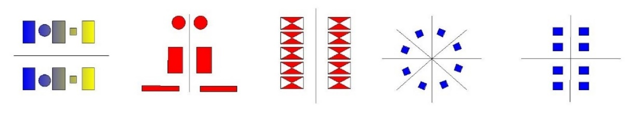
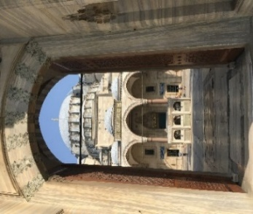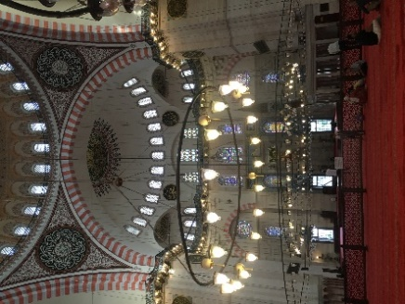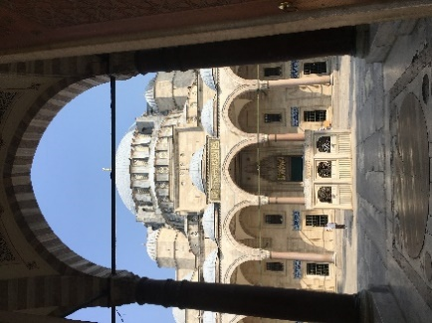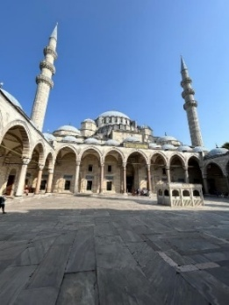
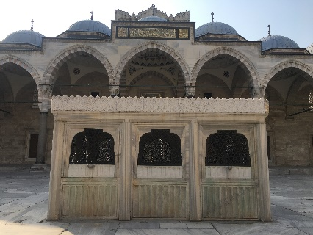

Symmetry in architectural design refers to the balanced arrangement of equivalent forms and spaces around a common axis or central point, creating visual order and harmony. Recent research on Mimar Sinan’s classical Ottoman architecture highlights the multilayered nature of his design approach, which combines form, ornamentation, and materials. Using fractal analysis, scholars examined the façades of the Şehzade, Süleymaniye, and Selimiye mosques to quantify visual complexity and trace Sinan’s architectural evolution. The study demonstrates how computational methods can reveal both the aesthetic strategies and the cultural legacy embedded in Sinan’s works [27]. Contemporary scholarship distinguishes between bilateral symmetry, in which elements are mirrored along a single axis, and radial symmetry, in which forms radiate from a central point along multiple intersecting axes [20]. In Islamic and Ottoman mosque architecture, symmetry is not only a formal design principle but also a symbolic one, as the repetition of geometric patterns, the alignment of domes and arches, and the orientation toward the qibla embody both aesthetic order and spiritual meaning [14], [25], (Table 2).

A.2. Sovereignty
The architectural trajectory of Mimar Sinan is increasingly understood as a narrative of increasing formal and symbolic sovereignty, meticulously analyzed through both historical and computational lenses. The tripartite sequence of his major imperial mosques, the centralized plan of the Şehzade, the hierarchical complex of the Süleymaniye, and the sublime unified space of the Selimiye, constitute a deliberate project of aesthetic and ideological refinement, thoroughly documented in the archival and stylistic studies of Necipoğlu (2005)[35].
Research in computational design history argues for the generative potential of architectural typologies. As demonstrated in the ontological approach to Sinan's classical period mosques, formal typological descriptions can serve as powerful guides for generation when implemented through description grammars [36], [37]. This method allows a historical study to be compiled into an ontology, which then drives a generative grammar, enabling a direct link between analytical scholarship and creative procedural modeling. The authors specifically applied this to generate a schematic instance of the Şehzade Mosque, acknowledging the model's current spatial limitations and proposing that future work integrate such ontological guides with compound shape grammars, citing the foundational grammar by Şener and Görgül [38] as a key example for this synthesis [36]. Complementary studies on surface ornamentation trace how Sinan and his workshop abstracted and reconfigured traditional Anatolian and Byzantine geometric motifs into a distinct Ottoman syntax. This process can be algorithmically modeled [22].
The synthesis of these aspects, structural geometry and surface patterning, defines the unique "Sinanian" sovereign aesthetic. As Sibel Bozdoğan notes in Modernism and Nation Building, this aesthetic served a dual purpose: it manifested universal Islamic principles of geometric harmony while asserting a distinct, centralized Ottoman imperial identity [39]. Therefore, contemporary scholarship, by marrying art-historical inquiry with digital analysis, reveals Sinan's legacy as the systematic architect of an empire's visual dominion, where every proportion and pattern served to articulate a new, confident architectural sovereignty.

Table 3. Sovereignty by special size, sovereignty by difference in form, sovereignty by favorable, strategic location (Süleymaniye Mosque)
Principle of sovereignty
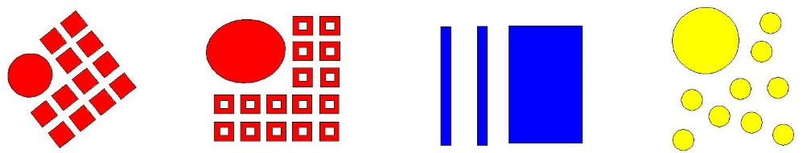
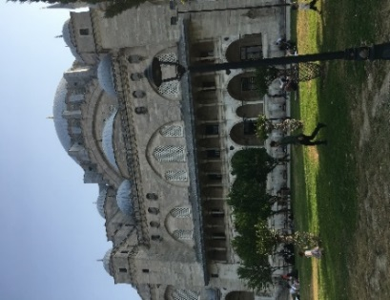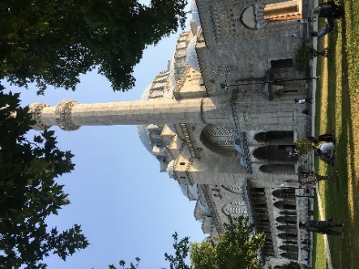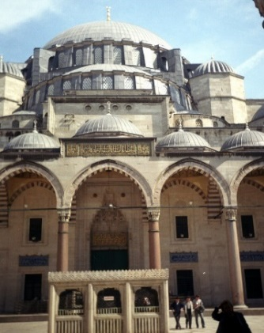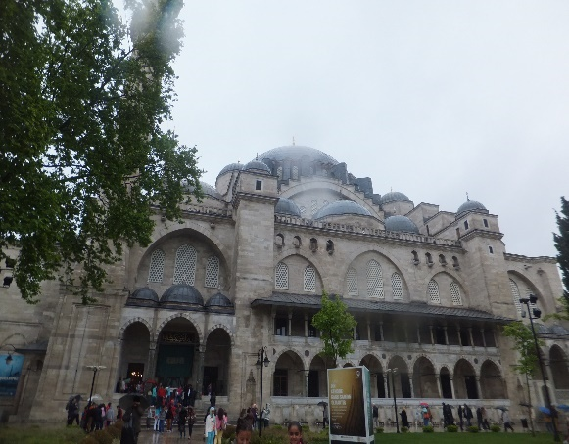

A.3. The principle of repetition and recursion
In classical Ottoman architecture, repetition and recursion form a fundamental structural and aesthetic grammar. This principle is defined as the systematic, hierarchical repetition of core architectural modules, such as domes, semi-domes, arches, and geometric units, that are recursively scaled and combined to generate complex, unified compositions. The principle operates at multiple scales, from the macro to the micro. At the structural level, it is embodied in the central baldachin system, a standardized domed unit supported by piers. In Sinan's mosques, like the Süleymaniye, this primary unit is elaborated through the recursive addition of smaller, self-similar semi-domes, creating a rhythmic, cascading hierarchy that organizes vast interior space [35]. This modular logic extends to the façades through the serial repetition of arched windows, establishing a measured visual cadence, and down to the ornamental scale, where intricate, infinite geometric patterns (girih) are generated from the recursive application of a finite set of rules [40]. Therefore, repetition transcends mere decoration to become a method of spatial and perceptual order. The regular intervals and sequential progression of elements create a harmonious rhythm that guides movement and perception, inducing a sense of ease and contemplative serenity within the monumental whole [41], [42].

Table 4. Examples of organizations created with the repetition principle (Süleymaniye Mosque) [31]
The principle of repetition and recursion
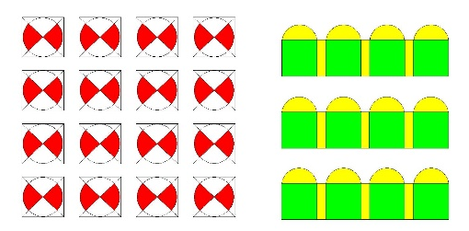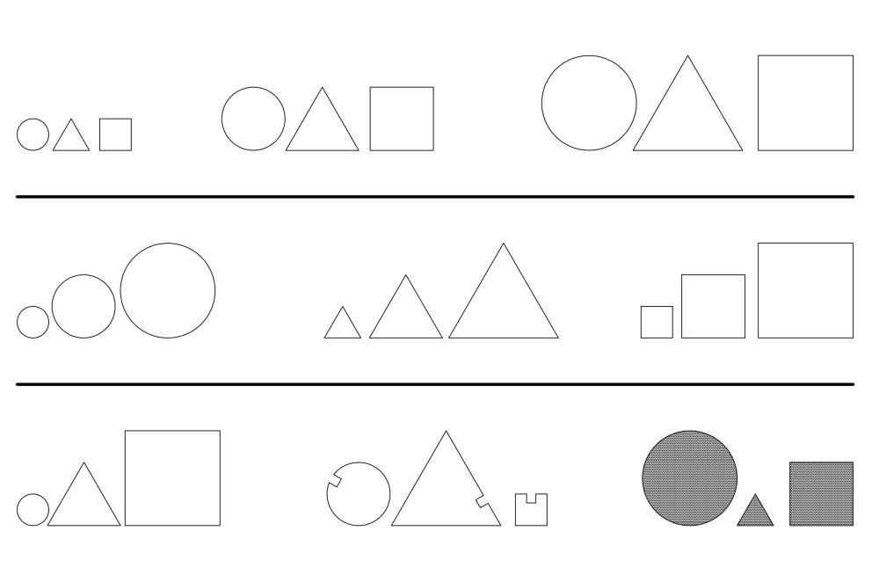
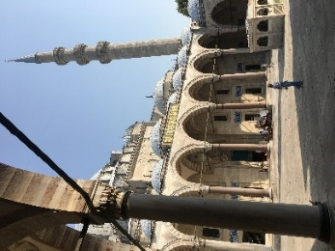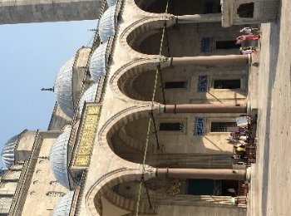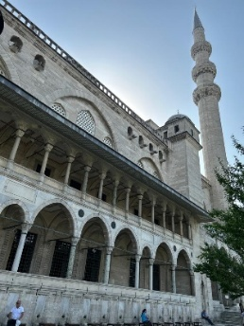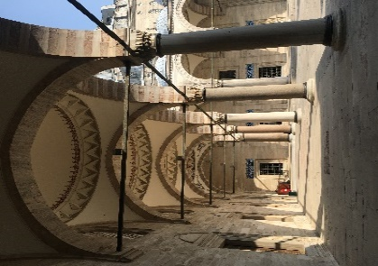

A.4. Balance
To create a successful design, there must be a sense of balance when the elements are compared. Unity arises through the careful use of design components such as scale, color, texture, proportion, spacing, volume, form, direction, light, and shadow, combined with repetition. When opposing forces are equal in strength and spatial power, a static equilibrium is achieved. This type of balance conveys stability but may appear rigid and lifeless. By contrast, dynamic equilibrium occurs when elements differ in direction, weight, or visual quality yet maintain an overall equality of spatial force. This creates vitality and movement, allowing the design to feel both stable and alive.
In sacred architecture such as the Süleymaniye Mosque, balance is expressed in two primary ways. Symmetrical balance is achieved through the arrangement of equivalent elements along a central axis, most clearly seen in the alignment of the main dome and its supporting structures. Asymmetric balance, on the other hand, emerges from the interplay of unequal but visually balanced elements, such as subsidiary spaces, decorative motifs, and varying volumes. Together, these two forms of balance (Table 5) create a spatial experience that is both orderly and dynamic, reinforcing the building's spiritual and aesthetic impact.

Table 5. Symmetric balance, asymmetric balance (Süleymaniye Mosque)
Principle of balance
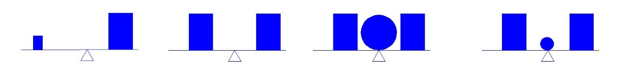
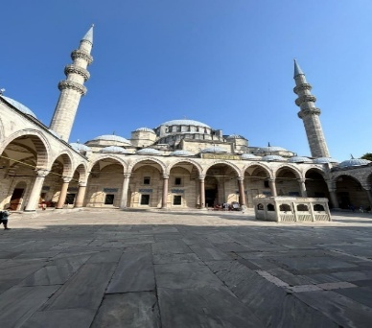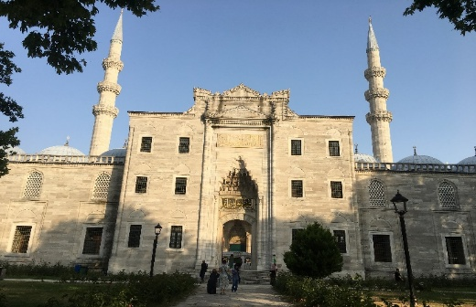

A.5. Contrast
Contrast in architectural design emerges when objects or groups of objects within a composition lack similarity or a common criterion for basic design elements. It is one of the key expressions of diversity, and when applied consciously, it generates unity rather than chaos. In architectural practice, contrast enlivens the design, making the product visually engaging and memorable. Interest is often expressed through contrasts such as vertical versus horizontal elements, solid versus void, or light versus shadow. By introducing these opposing qualities, façades and interior spaces gain vitality and attract attention. In the Süleymaniye Mosque, contrast is achieved through the interplay of monumental domes and slender minarets, as well as the alternation of open courtyards and enclosed prayer halls. These applications demonstrate how contrast, when balanced with other design principles, enhances both aesthetic richness and spiritual meaning (Table 6).

Table 6. The concept of contrast (Süleymaniye Mosque) [30]
Principle of opposition
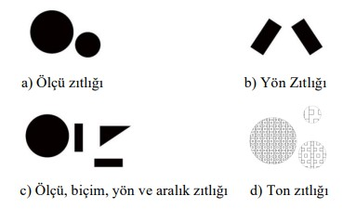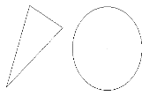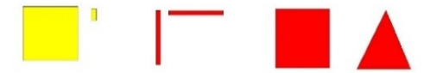
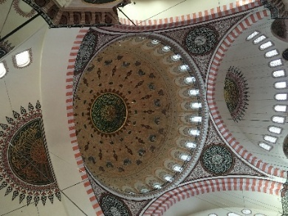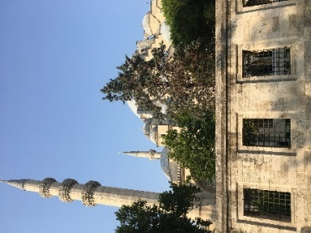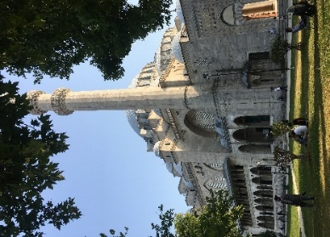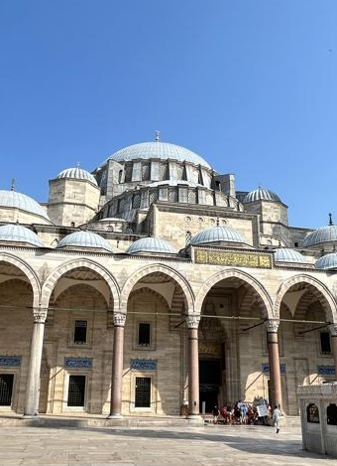

- 6. Koram
The use of koram strengthens a design's integrity and impact by providing a clear sense of visual balance and order. When applied correctly, it organizes elements within a composition, guiding the viewer’s perception and enhancing spatial coherence. There are three primary types of koram: axial koram, which is formed along an axis that may be straight, curved, or broken; central koram, which is established around a focal point or center; and peripheral koram, which arranges elements around the edges or boundaries of a composition. Depending on the design, one or more types of koram can be used together to achieve unity and variation. In sacred architecture such as the Süleymaniye Mosque, these forms of koram are evident in the alignment of domes and arches (axial), the dominance of the central dome (central), and the distribution of minarets and courtyards around the periphery (peripheral), all of which contribute to the overall harmony of the structure (Table 7).

Table 7. Axial measure coram, central measure coram (Süleymaniye Mosque) [30]
Axial measure coram, centric measure coram
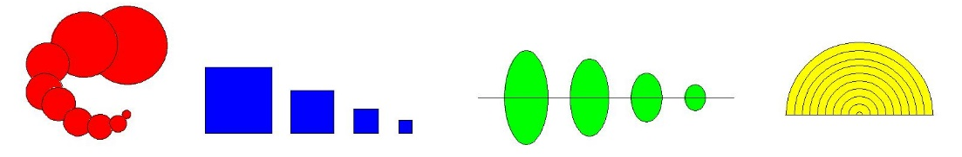

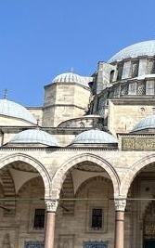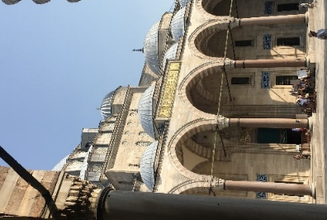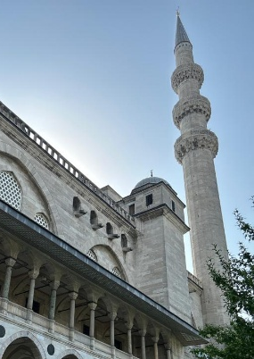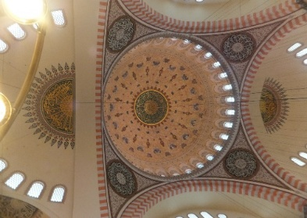

A.7. Conformity
Conformity, often described as harmony, refers to the presence of shared or comparable qualities among elements within a composition. Unlike strict repetition, these elements do not need to be identical; rather, shared features enhance visual unity and strengthen coherence. At the level of a single building, harmony can be achieved through recurring forms in windows, doors, and façade details, consistent orientations, proportional dimensions, or color palettes based on warm or cool tones and their variations. At the scale of a settlement, conformity is perceived when neighboring structures, or those arranged at regular intervals, display similarities in size, shape, texture, and color, either among themselves or with their surroundings. Likewise, consistency in style and proportion across the arrangement contributes to a sense of order and integration. In this way, conformity ensures that both individual buildings and larger urban environments achieve visual harmony and a unified character (Table 8).

Table 8. Conformity (Süleymaniye Mosque) [30]
Conformity
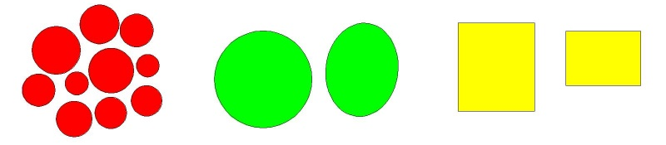
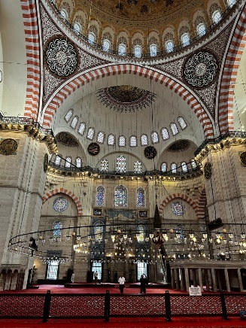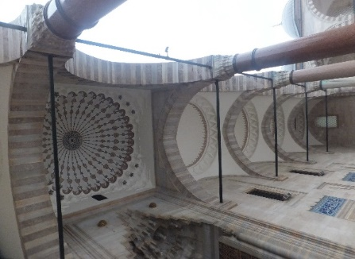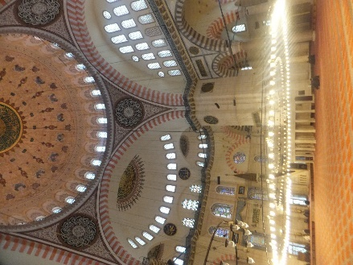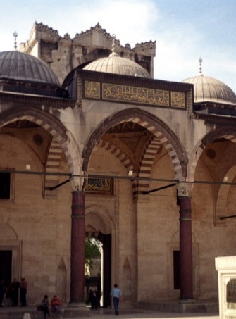

- 8. Unity
Unity in architectural design emerges when diverse objects, spaces, or structural components are perceived as parts of a coherent whole. The formation of unity does not necessarily require identical or strictly harmonious shapes, sizes, colors, or textures; rather, it can also be achieved through the balanced integration of contrasting elements that collectively convey a sense of completeness. Within this process, factors such as appropriateness, contrast, and dominance play a decisive role, while repetition reinforces the overall effect. Unity established through asymmetric balance and varied forms is often regarded as visually engaging and dynamic, whereas unity based on strict symmetry and repetitive measurements may appear more rigid and monotonous. In monumental architecture such as the Süleymaniye Mosque, both approaches coexist: the central dome and axial arrangements reflect symmetric unity, while the interplay of subsidiary spaces and decorative variations introduces asymmetric unity, creating a composition that is both stable and vibrant (Table 9).

Table 9. Diagram showing the routes to the union (Süleymaniye Mosque) [35]
Principle of unity
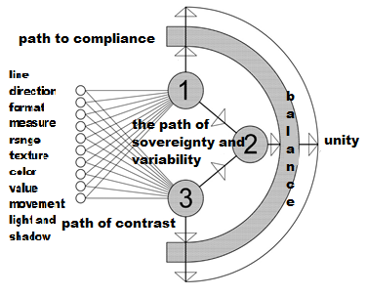
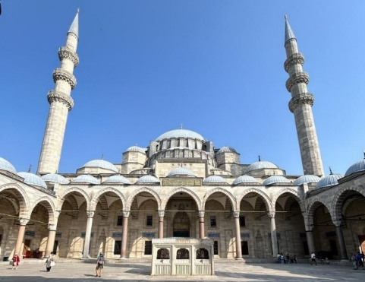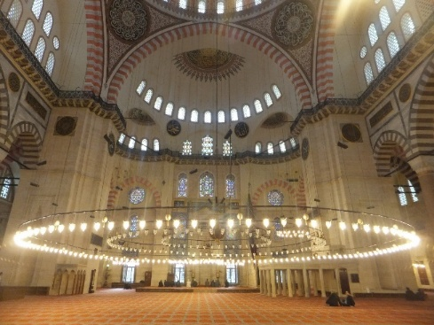

The 26 sub-concepts of the semantic dimension of the examined Islamic religious belief and faith concept, and the 8 basic design principles addressed in the structural dimension are shown in Table 10.

Table 10. Sub-concepts-principles in the semantic and syntactic dimensions
STYLING PRINCIPLES
SEMANTIC DIMENSION |  |  |  | SYNTACTIC DIMENSION
Sub-Concepts |  |  |  | Basic Design Principles
1 | Unity, oneness/ Shirk, associating partners, pluralism | 14 | Community, cohesion, togetherness / Loneliness | 1 | Symmetry
2 | Eternity, immortality, permanence/ Transience, mortality, finitude | 15 | Orientation / Disorientation | 2 | Sovereignty
3 | Infinity/Finality | 16 | Discipline, order, balance/Chaos | 3 | Rhythm
4 | Continuity, continuity/ Finiteness, discontinuity | 17 | To submit, to surrender/ Rebellious | 4 | Balance
5 | Warm, welcoming/ Cold, inhospitable | 18 | Knowledge, wisdom/ Ignorance, ignorance | 5 | Contrast
6 | Power, authority / Powerlessness, helplessness | 19 | Bright, spacious, open/ Dark, gloomy, closed | 6 | Koram
7 | Beauty, goodness, love, respect,  happiness/ugliness, evil, unhappiness | 20 | Sacred, religious, spiritual/ Unholy | 7 | Conformity
8 | Peace, soothing, restful/ Restlessness, unsettling | 21 | Heavy/Light | 8 | Unity
9 | Answer/Sin | 22 | High/Low
10 | Effective, potent, assertive/ Ineffective, ineffective,  unpretentious | 23 | Empty/Full, whole
11 | Free space, unlimited, void/ Limited, enclosed space | 24 | Dynamic/Flat, boring, monotonous
12 | Durability/Indurability | 25 | Mystical, mysterious/not mysterious
13 | Rhythmic, harmonious/Rhythmic, dissonant | 26 | Inwardly oriented/ Outwardly oriented

Studies have been conducted using a semiotic approach, focusing on the Süleymaniye Mosque and religious architecture in Istanbul Province. The literature guiding this analysis is provided below. In Tekeli [43]'s study titled "Semiotic analysis of Istanbul", historical, cultural, artistic, and religious concepts expressing Istanbul from a semiotic point of view were analysed as indicator, signifier, and signified. In the study conducted by Kalpaklı [44], formal transfers from history and their meanings were analysed in the context of semiotics. Okuyucu [45] used the semiotic analysis technique in his research on the courtyards of selected sample educational buildings. Peker [46] investigated the reading of the design philosophy of the period and the messages they contain through the façade features of Russian buildings in the Baltic architectural style. In the study by Özsoy [47], the semantic and syntactic perceptions of city dwellers were determined using a semiotic method. In the study titled "The place of symmetry in visual expression" by Reisoğlu [48], the effects of symmetry in visual expression were tried to be determined.

- RELIGIOUSLY ORIENTATED
In a study by Ülger [49], the meaning-space relations among religious forms of worship were determined, and a typological analysis was conducted. In a study conducted by Altun [50], Hagia Sophia-I Kebir and Sultan Ahmet Mosque, two of the most visited cultural heritage buildings in Istanbul, were analyzed in terms of signifier and signified within the semantic dimension using the semiotic method. The plain and connotative meanings of each structure, space, etc., were revealed. In a study conducted by Güneş [51], the Divriği Great Mosque and Darüşşifa were evaluated in terms of their plain and connotative meanings as architectural structures. In the study conducted by Çetin [52], in addition to providing historical and architectural information about Süleymaniye Mosque, he attempted to convey an aspect of it enriched with visual elements in a visual manner using the semiotic method. In the research conducted by Demirci [53], an analysis is presented on the variations (with different combinations of basic design principles) that religious space arrangements create in human perception. Within the scope of the thesis, the connection between physical elements, such as the semiotic aspects, meanings, and expressions of sacred spaces, and archetypal images in people's minds is discussed. In a study conducted by Çakıroğlu [54], he sought to examine the reflection of 11 concepts in tomb architecture using the semiotics method. In this study, using the example of Süleymaniye Mosque, it was investigated which basic design principle(s) refer to the effects of sacred concepts on spatial shaping in the syntactic dimension.

- ABOUT SÜLEYMANİYE MOSQUE STRUCTURAL PROPERTIES

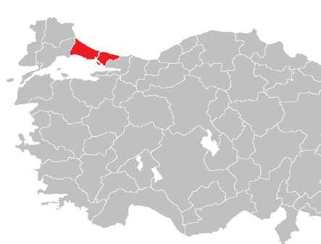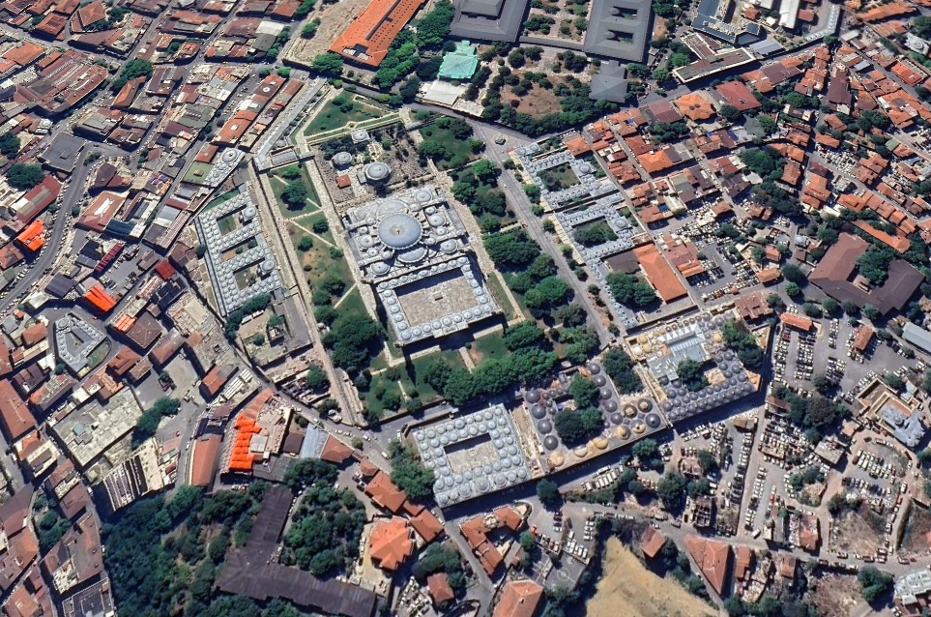

Figure 1. İstanbul city location map, Location Map of Süleymaniye Mosque /Google Earth, 2024

Süleymaniye Mosque is the largest mosque of its period, built in Istanbul between 1551-1558 by Sinan the Architect on behalf of Sultan Süleyman the Magnificent (Figure 1) [55], [56]. While placing the Süleymaniye complex on the highest hill of the city, attention was paid to the unevenness of the land, the existing parcel boundaries, the harmony of the building with the streets, and the utilisation of the view. While the community buildings of the complex, other than the mosque, are arranged on a street layout, the mosque, together with its inner courtyard and hazire, is placed in the centre of a large square. Thus, the necessary distance was provided for the mosque to be perceived in its entirety. Located on a hill, the silhouette of the Süleymaniye Mosque has become the symbol of Istanbul. The axis of the mosque, the outer courtyard gate, the inner courtyard gate, the fountain, the sentence gate, the mihrab, the tomb of Süleyman the Magnificent, and the Darülkurra form a strong direction pointing towards the qibla [57]. Süleymaniye Mosque has a pyramid-shaped appearance [58]. There is a perfect harmony between the interior and exterior.
The exterior reflects the structure of the interior with all its subtleties. With its high dome and incredible harmony in the space, a mystical feeling of spaciousness and width has been created, impressing people with its sense of grandeur. In the space illuminated by windows, four large columns and pillars have an elegant appearance, despite their considerable weight [59]. The other surrounding buildings are crushed and flattened at its foot and gradually rise upwards in harmony with its minarets [60]. The dominance of the dome is ensured by the maximum opening of the peripheral spaces to the central space. The continuous use of the same form creates a sense of unifying the architectural image. The main dome of the mosque and the domes of the small openings exemplify the image of the design family in the external shaping of the building, bringing an emphasis specific to the Ottoman world to the urban landscape. The big dome is embracing.
As the number of similar elements increases, the phenomenon of rhythm gains strength, and the variations of rhythm increase as the size of the domed square varies. Süleymaniye shows an organic settlement order by adapting to the urban texture and topography. The streets within the complex are separated from the mosque by a wall with windows. While creating a landscape for the city, it also benefits from the landscape. The view of the Golden Horn, Galata, and Bosphorus from the terrace-shaped square is very magnificent. Architectural drawings (plan, section, elevation) of the Süleymaniye Mosque, taken from the Ülgen archive [61], are given in Table 11. Images of the interior of Süleymaniye Mosque are given in Table 12, images from the inner courtyard are given in Table 13, and images from the outer courtyard are given in Table 14.
Table 11. Architectural drawings of Süleymaniye Mosque [54] /From Ali Sami Ülgen archive
Plans
Site plan | Complex plan | Mosque ground floor plan
Section | Section | View

Table 12. Interior images of Süleymaniye Mosque
Interior photos
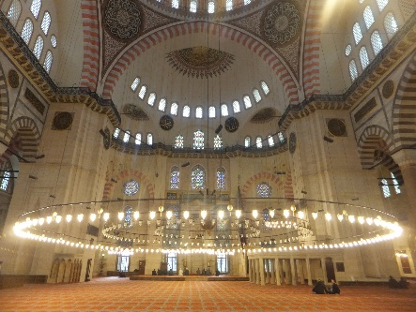 | 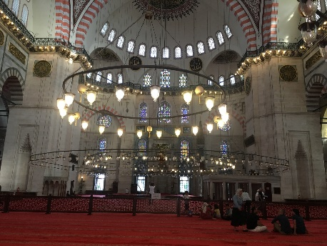 | 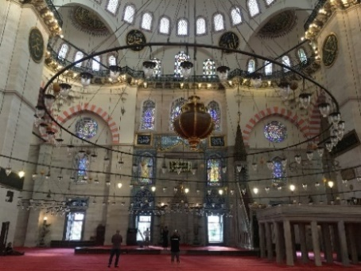
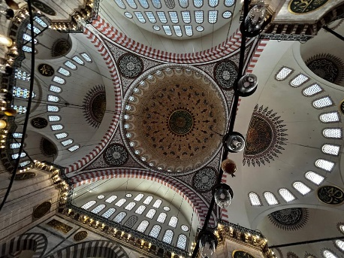 | 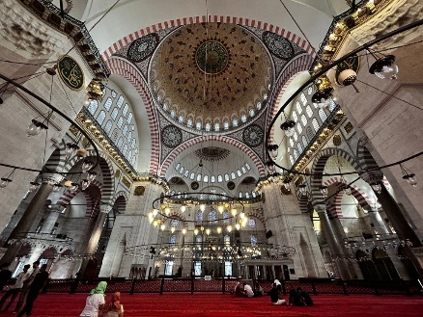 | 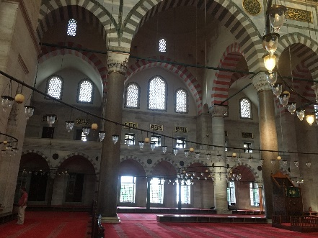

Table 13. Süleymaniye Mosque from the inner courtyard
Photos from the inner courtyard
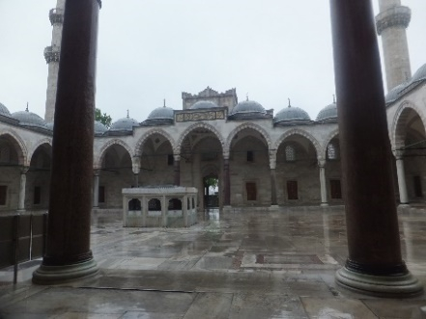 | 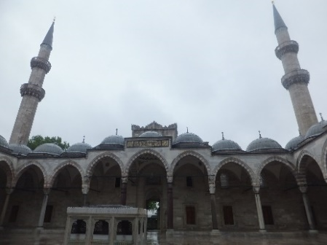 | 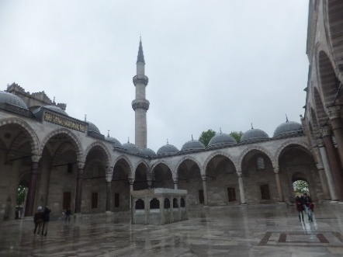
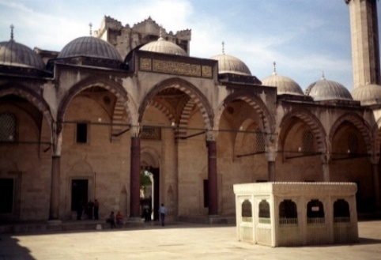 | 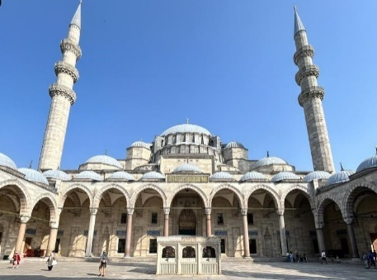 | 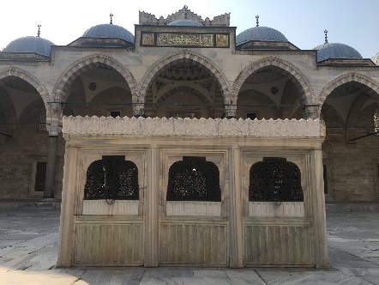

Table 14. Views of the Süleymaniye Mosque from the outer courtyard
Photos from the outer courtyard
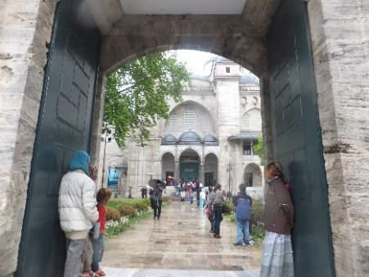 | 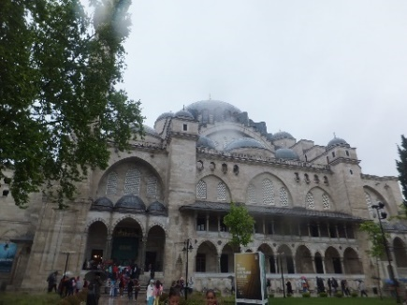 | 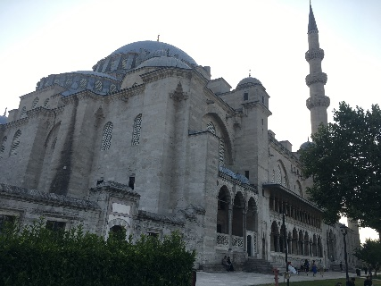
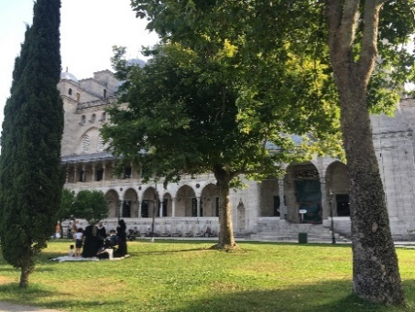 | 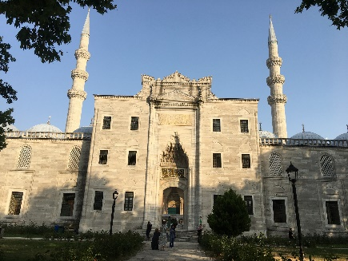 | 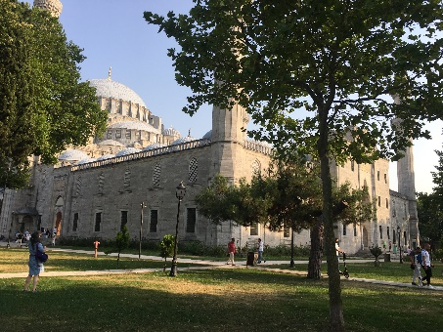

- RESULTS AND DISCUSSIONS
In this section, the architectural reflections of the concepts of wahdaniyet, beka, ilm, might, and the hereafter in the Süleymaniye Mosque are examined in detail. These five theological notions were first explored within the semantic dimension, focusing on how their doctrinal meanings and symbolic interpretations contribute to the intellectual framework of the architectural design.
Subsequently, the influence of these concepts on the mosque’s architectural composition was analysed through the syntactic dimension, in which the building's structural and formal organization was evaluated. This syntactic assessment employed a set of fundamental design principles, symmetry, dominance, rhythm, balance, contrast, correspondence, conformity, and unity, as analytical tools. Each principle was used to reveal how the selected religious concepts are embodied in spatial arrangements, geometric order, proportional relationships, and aesthetic strategies within the monument. Through this two-tiered approach, the study aims to demonstrate how abstract theological ideas were translated into architectural language and how the Süleymaniye Mosque achieves a coherent expression of these concepts both visually and experientially.

- FINDINGS ON THE SEMANTIC AND SYNTACTIC DIMENSION OF THE GENERAL FEATURES OF SÜLEYMANİYE MOSQUE
Examination of the Süleymaniye Mosque reveals that symmetry plays a decisive role across the building’s massing, façade composition, ground plan, and interior organisation. The mosque asserts a clear architectural and visual prominence at the centre of the complex, a condition reinforced by the hierarchical arrangement of its structural components. This sense of dominance is particularly shaped by the differentiation in scale and form between the central dome, the minarets, and the surrounding subsidiary spaces.
A pronounced rhythmic order emerges through the repetition of arches, windows, domes, and decorative elements visible in the portico of the last congregation area, the courtyards, and both the interior and exterior sections of the mosque. The alternation of large and small domes in the side courtyards enhances this rhythmic articulation, creating a structured harmony that underscores the design’s dynamic yet cohesive character.
When evaluated collectively, these visual and structural strategies generate a strong sense of balance. This balance not only reflects the precision of the building’s static engineering but also contributes to the tranquil and contemplative atmosphere experienced by visitors, reinforcing the spiritual dimension of the monument.
Elements of contrast are observed in the interplay between domes and supporting columns, in the articulation of solid–void relationships, and throughout the plan organisation. The gradual transition from the monumental central dome to the smaller surrounding domes produces a hierarchical spatial movement, corresponding to the design principle of gradation (choram), which guides the observer’s visual flow from large to small volumes.
When the mosque is analysed in relation to its broader urban and topographical context, it becomes evident that the structure maintains a notable harmonious relationship with its surroundings. This harmony continues at the building scale, where the arrangement of windows, portals, and domes on the façades exhibits a coherent order, reflecting the design principle of conformity. Similar compatibility is observed between the textures and materials used in both interior and exterior spaces, reinforcing unity across the entire complex.
Overall, the compositional relationships among forms, materials, proportions, and spatial sequences contribute to a profound sense of unity. The integration of diverse architectural elements into a coherent whole exemplifies the Süleymaniye Mosque's balanced, unified expression, both visually and conceptually.

- FINDINGS ON THE SEMANTIC AND SYNTACTIC DIMENSION OF THE CONCEPT OF WAHDANIYET
The spatial organisation of the Süleymaniye Mosque embodies wahdaniyet, the principle of divine oneness, through its overall plan and structural hierarchy. The integration of the middle-space plan with a centralised layout beneath a single dominant dome visually and symbolically expresses unity. The circular geometry of the main dome reinforces this meaning; its unbroken, continuous form evokes completeness, submission, and the cyclical understanding that all beings originate from Allah and ultimately return to Him. Through this form, the structure conveys both the unity and sovereignty embedded in fundamental design principles. The orientation of the worship space further strengthens this notion. The alignment of the congregation towards the Kaaba via the mihrab reflects the architectural principles of sovereignty, conformity, and unity, guiding all worshippers toward a single spiritual and physical focal point. This collective orientation produces an intense mystical atmosphere as shared gazes and intentions converge in a single direction, reinforcing the conceptual foundation of monotheism. On the interior surfaces, geometric abstractions, constructed as endlessly repeating, interconnected patterns, create a visual sense of infinity and boundlessness. Their continuous and rhythmic repetition, with no identifiable beginning or end, accentuates the transcendental qualities associated with divine unity. These motifs relate directly to the design principles of symmetry, rhythm, and sovereignty, offering a symbolic visual language that supports the theological concept of oneness.
The architectural envelope of the mosque also contributes to the expression of wahdaniyet. The building is encircled by porticoes with small domes of varying scales and heights, including those surrounding the last congregation area. This arrangement creates a dynamic perimeter that contrasts with the monumental central dome. The interplay between these domes of different proportions introduces notions of strength, hierarchy, and gradation, corresponding to the design principles of sovereignty, contrast, and choram (gradation). While the monumental dome is carried by massive piers, these supports are visually softened through recessed niches and carved ornamental details, reducing their perceived heaviness. Inside the prayer hall, the structural system is deliberately concealed: columns, piers, and load-bearing walls do not dominate the architecture. By covering or disguising these structural components, the design intentionally prevents the eye from focusing on material presence. Instead, attention is directed toward the divine, abstracting the created world and enabling an uninterrupted spiritual orientation. This design strategy embodies the principles of conformity and unity, reinforcing the mosque’s overarching narrative of monotheism (see Table 15).

Table 15. The semantic dimension of the concept of vahdaniyet and the basic design principle(s) it refers to
The basic design principles reflected in the concept of wahdaniyet as seen in the semantic dimension of the Süleymaniye Mosque.
The concept of Wahdaniyet | Sub-concepts in the semantic dimension | Design principles reflected in the syntactic dimension
The concept of Wahdaniyet | Oneness-unity | Unity
The concept of Wahdaniyet | To submit - to surrender. | Sovereignty
The concept of Wahdaniyet | Discipline-order-balance | Symmetry, balance, conformity, unity
The concept of Wahdaniyet | Orientation | Koram, conformity, unity
The concept of Wahdaniyet | Unlimited-space-free | Symmetry, dominance, rhythm
The concept of Wahdaniyet | Mystical-mysterious | Sovereignty, conformity, unity
The concept of Wahdaniyet | Rhythmic-compatible | Rhythm, conformity, unity
The concept of Wahdaniyet | Dynamic | Sovereignty, opposition, coram
The concept of Wahdaniyet | Holy-spiritual | Conformity, unity
The concept of Wahdaniyet | Inward orientated | Contrast, conformity, unity

- FINDINGS ON THE SEMANTIC AND SYNTACTIC DIMENSION OF THE CONCEPT OF SURVIVAL
The use of stone as the primary construction material in the Süleymaniye Mosque symbolizes permanence and endurance, thereby expressing the design principles of unity, sovereignty, and conformity. Across the interior surfaces, geometric abstract ornaments extend in multiple directions, parallel, symmetrical, diagonal, and interlaced, forming continuous bands that create a rhythmic, harmonious visual structure. Through this ordered repetition, the decorative program reflects the principles of rhythm, conformity, and unity. The lightweight and visually permeable character of these motifs, which appear to float and expand infinitely, conveys a sense of boundlessness. This perception of spatial and decorative infinity aligns with the design principles of sovereignty, gradation (choram), conformity, and unity. The immersive feeling of endless continuity experienced by visitors within the mosque reinforces notions of order, discipline, and balance, corresponding to the principles of symmetry, balance, conformity, and unity.
Many of the stylized forms and abstracted figures within the mosque move away from naturalistic representation. By suggesting supernatural or metaphysical ideas rather than realistic imagery, they foster a mystical, contemplative atmosphere. Through this symbolic abstraction, the principles of sovereignty, conformity, and unity reemerge as defining design elements.
The hierarchy of domes, ranging from the monumental central dome to smaller domes in the courtyard, last congregation area, and prayer hall, extends the meaning of infinity through their graded arrangement. These varying dome sizes express the design principles of sovereignty, gradation (choram), conformity, and unity. Their repeated placement produces a consistent rhythmic pattern and reinforces the ideas of continuity and flow, corresponding to the principles of rhythm, choram, and conformity. Lastly, the mosque’s symmetrical plan enhances the sense of stability and order within the architectural composition. This balanced layout embodies the fundamental design principles of symmetry, balance, conformity, and unity, which together contribute to the structural and spiritual coherence of the building (Table 16).

Table 16. The semantic dimension of the concept of beka and the basic design principle(s) it refers to
The basic design principles reflected by the concept of survival in the semantic dimension related to the Süleymaniye Mosque
The concept of survival | Sub-concepts in the semantic dimension | Design principles reflected in the syntactic dimension
The concept of survival | Eternity, immortality, permanence | Unity, sovereignty, conformity
The concept of survival | Infinity | Sovereignty, protection, conformity, unity
The concept of survival | Continuity, continuity | Rhythm, choram, conformity
The concept of survival | Discipline, order, balance | Symmetry, balance, conformity, unity
The concept of survival | Rhythmic, harmonious | Rhythm, conformity, unity
The concept of survival | Mystical, mysterious | Sovereignty, conformity, unity

- FINDINGS ON THE SEMANTIC AND SYNTACTIC DIMENSION OF THE CONCEPT OF SCIENCE
The Süleymaniye Mosque serves not only as a place of worship but also as a centre for the pursuit and transmission of knowledge, integrating religious learning and intellectual activity. In this context, knowledge is associated with wisdom, equilibrium, and order, reflecting the fundamental design principles of balance, appropriateness, and unity. The construction materials selected for the mosque exhibit high resistance to environmental and climatic effects, enabling the structure to maintain its integrity over centuries. This enduring durability, evident in both the building’s exterior expression and its internal performance, symbolizes resilience. Such structural steadfastness aligns with the design principles of sovereignty, harmony, and unity, underscoring the mosque’s role as a lasting centre of both spiritual and intellectual life (Table 17).

Table 17. The semantic dimension of the concept of ilim and the basic design principle(s) it refers to
The basic design principles reflected by the concept of science in the semantic dimension related to the Süleymaniye Mosque
Concept of ilim | Sub-concepts in the semantic dimension | Design principles reflected in the syntactic dimension
Concept of ilim | Knowledge, wisdom | Balance, harmony, unity
Concept of ilim | Durability | Sovereignty, conformity, unity

- FINDINGS REGARDING THE SEMANTIC AND SYNTAGMATIC DIMENSIONS OF THE CONCEPT OF POWER
The monumental scale and visually heavy massing of the Süleymaniye Mosque express durability and strength, reinforced by the extensive use of stone. Upon entering the mosque, the dominance of the central dome is immediately perceived, serving as a powerful focal point within the spatial hierarchy. The portico domes and the rhythmic repetition of columns and smaller domes intensify this sense of structural authority. The building’s geometric precision also contributes to the perception of power, as every architectural component, inside and outside, rises visually toward the unified volume represented by the central dome. The four minarets further strengthen the upward movement, enhancing the symbolic sense of ascension (Table 18). The unification of the middle-space plan and the centralised plan under a single large dome conveys the idea of uniqueness and unity, reflecting core principles of oneness and sovereignty. The circular dome form symbolizes submission and the belief that all beings originate from and ultimately return to the Creator. Worship practices conducted according to established religious rules embed principles of discipline, order, and balance, which correspond to fundamental design principles such as symmetry, balance, conformity, and unity. The orientation toward the Kaaba through the mihrab reinforces harmony, conformity, and unity, creating a shared spiritual direction. This collective focus generates an intense mystical atmosphere defined by unified gazes and intentions.
The openness of the central space allows worshippers to detach from worldly concerns, enhancing the sense of spiritual unity. Endless geometric motifs, without a defined beginning or end, impart a feeling of infinity and limitless continuity, reflecting symmetry, rhythm, and sovereignty. The cloisters with small domes surrounding the mosque on all four sides, including the narthex, introduce dynamic variations in scale and height. This arrangement conveys strength and movement while embodying the principles of dominance, contrast, and harmony. The massive dome supports are visually softened through carved niches, giving them a refined character. Inside, structural elements are deliberately subdued; columns and walls do not dominate the spatial experience. By concealing the primary structural material, attention is directed toward the divine, abstracting the created world and reaffirming the principles of conformity and unity (Table 18).

Table 18. The semantic dimension of the concept of kudret and the basic design principle(s) it refers to
Basic design principles reflected by the concept of power in the semantic dimension regarding the Süleymaniye Mosque
Concept of power | Sub-concepts in the semantic dimension | Design principles reflected in the syntactic dimension
Concept of power | Power, authority | Dominance, opposition, unity
Concept of power | Effective, influential, assertive | Dominance, opposition, unity
Concept of power | Full, whole | Dominance, opposition, unity
Concept of power | Heavy | Dominance, opposition, unity
Concept of power | High | Dominance, opposition, unity
Concept of power | Durability | Dominance, opposition, unity

- FINDINGS REGARDING THE SEMANTIC AND SYNTAGMATIC DIMENSIONS OF THE CONCEPT OF THE HEREAFTER
In the Süleymaniye Mosque, the separation of interior spaces from the external environment enables worshippers to detach from worldly concerns and develop an awareness of the hereafter. This transcendent experience conveys the notion of eternity and aligns with the design principles of sovereignty, conformity, and unity. The sense of being sheltered within a defined yet protective space evokes a sense of peace and spiritual security, reflecting the principles of symmetry, rhythm, balance, harmony, and unity. Acts of mutual assistance among worshippers symbolize good deeds and express the principles of conformity and unity. Likewise, cultivating compassion, respect, love, and tolerance within the mosque's shared spaces enhances social cohesion and reinforces a sense of community. These values correspond to the design principles of symmetry, balance, harmony, suitability, and unity. The functional purpose of the mosque, providing a setting for fulfilling religious obligations, infuses the space with the meaning of spiritual reward. This orientation towards moral responsibility embodies the principles of conformity and unity, while also reflecting the collective nature of worship. Communal prayer, which brings diverse individuals together in a single act of devotion, resonates with the principles of symmetry, balance, harmony, conformity, and unity. Architecturally, the inclusion of a courtyard within the mosque enhances the atmosphere of hospitality and openness. The presence of the ablution fountain reinforces this welcoming quality and corresponds to the design principles of symmetry, rhythm, balance, harmony, suitability, and unity. Additionally, the abundance of windows within the interior creates a bright, spacious, and expansive environment, embodying the principles of conformity and unity (Table 19).

Table 19. The semantic dimension of the concept of the afterlife and the basic design principle(s) it refers to
The basic design principles of the Süleymaniye Mosque are reflected in the concept of the afterlife, as seen in the semantic dimension.
Concept of the afterlife | Sub-concepts in the semantic dimension | Design principles reflected in the syntactic dimension
Concept of the afterlife | Beauty | Symmetry, sovereignty, rhythm, balance, harmony, harmony, unity
Concept of the afterlife | Peaceful, tranquil, relaxing | Symmetry, rhythm, balance, harmony, harmony, unity
Concept of the afterlife | Eternity, immortality, permanence | Sovereignty, conformity, unity
Concept of the afterlife | Good deed | Conformity, unity
Concept of the afterlife | Bright, spacious, open | Conformity, unity
Concept of the afterlife | Cohesion, community, Togetherness-community | Symmetry, balance, harmony, harmony, unity
Concept of the afterlife | Warm, welcoming | Symmetry, rhythm, balance, harmony, harmony, unity

- CONCLUSION
In this study, the influence of religious concepts on the formation of sacred spaces was examined by considering the strong semantic communication inherent in holy places. Accordingly, the research explored how sacred concepts in Islam manifest in the architectural shaping of mosque structures, assuming that these concepts function as a non-verbal language of expression. The scope was limited to five fundamental sacred concepts: unity, eternity, knowledge, power, and afterlife, and their effects on the architectural design of the Süleymaniye Mosque, chosen as a representative religious structure. The findings were evaluated at two levels: first, by generating conceptual knowledge regarding these five sacred notions, and second, by identifying results and practical implications that may contribute to contemporary religious architectural design and practice. Through the analyses, the basic design principles corresponding to the sub-concepts of each belief concept were determined, and the relationships among these principles were visually illustrated in Figures 2 through 9. Each figure provides a concise narrative explanation of the design principles used to represent the sub-concepts associated with the respective sacred concept.

- WHEN THE CONCEPT OF UNITY IS CONSIDERED
The sub-concepts associated with the notion of unity in its semantic dimension, along with the fundamental design principles that reflect these sub-concepts, have been analyzed (Table 20). Accordingly, the ideas of singularity, unity, discipline, order, balance, orientation, direction, boundlessness, emptiness, freedom, mysticism, mystery, rhythm, harmony, sacredness, spirituality, and introspection most closely correspond to the principle of unity. In the design of new sacred spaces, addressing the principle of unity through the formal and spatial expression of these sacred concepts would constitute an appropriate design strategy. Similarly, the principle of appropriateness is reflected in concepts such as discipline, order, balance, orientation, mysticism, mystery, rhythm, harmony, spirituality, sacredness, and introspection, all of which signify submission to the majesty of God and reverence for all living beings. Incorporating the principle of appropriateness into the spatial-formal representation of unity will therefore contribute positively to the design of contemporary sacred spaces. Conversely, the concepts of bowing down, surrendering, and dynamism are not directly represented by the principle of unity. For this reason, placing less emphasis on the principle of unity when expressing the concepts of surrendering and bowing down in new sacred space designs may offer a more accurate design approach.

Table 20. Süleymaniye Mosque, sacred place indicators, and basic design expressions of the concept of vahdaniyet
The concept of vahdaniyet | Symmetry | Dominance | Rhythm | Balance | Contrast | Korum | Harmony | Unity
Unity-Unity
Submitting-Surrendering
Discipline-Order-Balance
Orientation
Unlimited-Space-Free
Mystical-Mysterious
Rhythmic-Harmonious
Dynamic
Sacred-Spiritual
Introverted

- CONSIDERING THE CONCEPT OF BEKA
The sub-concepts associated with the concept of Beka in its semantic dimension, along with the fundamental design principles that represent these sub-concepts, have been analyzed (Table 21). Accordingly, the notions of eternity, immortality, permanence, infinity, discipline, order, balance, mysticism, mystery, rhythm, and harmony most strongly correspond to the principle of unity. The expressions' continuity' and 'permanence,' however, do not directly reflect the principle of unity. The principle of harmony is interpreted similarly across the concepts of eternity, immortality, permanence, infinity, continuity, consistency, discipline, order, balance, mysticism, mystery, rhythm, and harmony, suggesting that eternal life, immortality, order, and balance can be attained through a state of harmony and collective cohesion. Notably, the principle of opposition is not reflected in any of the concepts related to eternity, immortality, permanence, infinity, continuity, consistency, discipline, order, balance, mysticism, mystery, rhythm, or harmony. For this reason, in the design of new religious structures and spaces, it may be proposed that the principle of unity will serve effectively in the spatial and formal expression of the concept of permanence, which encompasses the ideas of eternity, immortality, infinity, discipline, order, balance, mysticism, mystery, rhythm, and harmony.

Table 21. Süleymaniye Mosque, sacred place indicators and expressions of the concept of beka

Concept of Beka | Symmetry | Dominance | Rhythm | Balance | Contrast | Korum | Harmony | Unity
Eternity, immortality, permanence
Infinity
Continuity, continuity
Discipline, order, balance
Rhythmic, harmonious
Mystical, mysterious

- CONSIDERING THE CONCEPT OF İLIM
The sub-concepts of the sacred concept of İlim in its semantic dimension, along with the fundamental design principles that correspond to these sub-concepts, have been analyzed (Table 22). Accordingly, the notions of knowledge, wisdom, and resilience are most effectively conveyed through the principles of appropriateness and unity. In the semantic interpretation of the concept of knowledge, the design principles of symmetry, rhythm, contrast, and harmony are also reflected. Therefore, in the design of new religious structures and spaces, it is deemed more suitable to resolve the principles of appropriateness and unity in the spatial-formal expression of the concept of İlim, which encompasses the sub-concepts of knowledge, wisdom, and resilience.

Table 22. Süleymaniye Mosque, sacred place indicators, and expressions of the concept of ilim

Concept of İlim | Symmetry | Dominance | Rhythm | Balance | Contrast | Korum | Harmony | Unity
Knowledge, wisdom
Durability

- CONSIDERING THE CONCEPT OF İLIM
The semantic sub-concepts of the notion of power and the fundamental design principles that correspond to these meanings have been analyzed (Table 23). Accordingly, concepts such as power, authority, effectiveness, influence, assertiveness, integrity, mass, height, dominance, and resilience are most strongly expressed through the principles of sovereignty, contrast, and unity. The semantic interpretation of might is also reflected in the design principles of symmetry, rhythm, balance, appropriateness, and harmony. Therefore, in the design of new religious structures and spaces, giving greater emphasis to the principles of sovereignty, contrast, and unity in the spatial and formal articulation of the concept of might may lead to more successful design outcomes.

Table 23. Süleymaniye Mosque, sacred place indicators, and expressions of the concept of kudret

Concept of power | Symmetry | Dominance | Rhythm | Balance | Contrast | Korum | Harmony | Unity
Power, authority
Effective, influential, assertive
Full, whole
Heavy
High
Durability

- CONSIDERING THE CONCEPT OF İLIM
The sub-concepts of the sacred notion of the afterlife in its semantic dimension, along with the fundamental design principles that reflect these meanings, have been analyzed (Table 24). Accordingly, the concepts of beauty, peace, tranquility, immortality, virtue, spaciousness, harmony, togetherness, and warm hospitality are most effectively interpreted through the principles of appropriateness and unity. Additionally, the principle of contrast is reflected in the semantic expression of the afterlife. Therefore, in the design of new religious structures and spaces, emphasizing and successfully integrating the principles of appropriateness and unity may offer a more meaningful and effective way of expressing the concept of the afterlife.

Table 24. Süleymaniye Mosque, a sacred place indicator and expression of the concept of the afterlife

Concept of the afterlife | Symmetry | Dominance | Rhythm | Balance | Contrast | Korum | Harmony | Unity
Beauty
Peaceful, tranquil, relaxing
Eternity, immortality, permanence
Good deed
Bright, spacious, open
Cohesion, community, togetherness-community
Warm, welcoming

When the basic design principles used to express the semantic dimensions of all sacred concepts in spatial formation are examined, it becomes evident that the syntagmatic expressions of the concepts of unity, permanence, power, knowledge, and the afterlife are predominantly conveyed through the principles of conformity and unity, as exemplified in the Süleymaniye Mosque. The principle of contrast is not fully represented in the concepts of afterlife, permanence, and knowledge; however, it is strongly and effectively manifested in the concept of power. This indicates that the principle of contrast plays a dominant role in expressing the absolute supremacy of the Almighty Creator over His creations. In the syntagmatic dimension, the principles of dominance, contrast, and unity were found to exert a 100% influence on the expression of the concept of power, which semantically represents the power of Almighty Allah. The principle of contrast was found not to influence the syntagmatic expression of the concepts of permanence, knowledge, and the afterlife, whereas it did demonstrate a 20% influence on the expression of the concept of unity. The degree of influence of the principle of sovereignty ranged between 40% and 50% for the concepts of unity, permanence, knowledge, and the afterlife. In conclusion, during the architectural design stages of religious structures, employing basic design principles whose degrees of influence have been identified in relation to the spatial expression of sacred concepts can provide significant guidance and facilitate the design process. Accordingly, the following criteria outline how abstract concepts, whose meanings are experienced in new religious architecture, can be concretely and legibly expressed through basic design principles within the syntagmatic dimension, as illustrated in Figures 2, 3, and 4.

Figure 2. Wahdaniyet-basic design relationship, Beka-basic design relationship, ilim-basic design relationship

Figure 3. Kudret- basic design relationship, afterlife-basic design relationship

Figure 4. Readable expression of the meanings of sacred concepts with basic design principles

In the design of religious buildings, this analysis model can be employed to examine the spatial and formal strategies that shape the concrete expression of abstract sacred concepts. The model developed within this study offers significant advantages for designers and researchers by providing a systematic framework for interpreting sacred meanings through basic design principles. Furthermore, the findings of this research constitute a valuable reference for basic design courses in architecture, interior architecture, landscape architecture, urban planning, and visual communication programs, contributing both conceptually and methodologically to educational and professional practice.

REFERENCES

[1] T. Burckhardt, Art of Islam: Language and meaning. World Wisdom, Inc, 2009.
[2] S. H. Nasr, Islamic art and spirituality. Suny Press, 1987.
[3] N. Ardalan and L. Bakhtiar, The sense of unity: the Sufi tradition in Persian architecture, University of Chicago Press, 1973.
[4] O. Grabar, The Mediation of Ornament, Princeton University Press, 1992.
[5] A. K. H. Solihu, “Revelation and Prophethood in the Islamic Worldview,” J. Islam Asia, vol. 6, no. 1, p. 167, 2009, doi: 10.31436/jia.v6i1.5.
[6] S. H. Nasr and A. Demirhan, Islam sanatı ve maneviyatı. Insan yayinlari, 1992.
[7] T. Burckhardt, Fes: Stadt des Islam. CH Beck, 2015.
[8] M. Eliade, Rites and symbols of initiation: The mysteries of birth and rebirth. Spring Publ., 2003.
[9] D. Kuban and C. Emden, Osmanlı mimarisi. Yapi-Endustri Merkezi, 2007.
[10] M. Weber, Protestan ahlakı ve kapitalizmin ruhu. 2015.
[11] S. Omer, “Islamic Architecture and the Prospects of its Revival,” J. Islam. Thought Civiliz., vol. 01, no. 02, pp. 103–121, 2011, doi: 10.32350/jitc.12.07.
[12] O. Grabar, “İslam Sanatının oluşumu, çev,” Nuran Yavuz, İstanbul, 1998.
[13] M. Kashef, “Critical analysis of design paradigms in Islamic architecture: A study of interiority, versatility and cellularity,” Islam. Hist. Lit, vol. 3, pp. 5–26, 2025.
[14] O. Şimşek, “Sustainability Aspects in Mosque Architecture: From the Beginning to the Present,” Diyanet İlmi Dergi, vol. 60, no. 3, pp. 1175–1206, 2024.
[15] A. Alnajjar and T. E. Dinçel, “Changing Forms and Functions: The Transformation of Mosque Architecture from The Early Islamic Period to The Present,” Mekansal Çalışmalar Derg., vol. 1, no. 2, pp. 94–106, 2024.
[16] S. Salem, “Defining without Essences: Ibn Taymiyya’s Critique of Aristotelian Logic,” Logica Universalis, 2025. DOI: https://doi.org/10.1007/s11787-025-00404-3.
[17] S. Hamza, “Tajriba: An interview with Dr. Zarin Fatima on experiential knowledge in medicine,” postmedieval, pp. 1–11, 2025. DOI: https://doi.org/10.1057/s41280-025-00380-3.
[18] Z. Nazar, B. Ali, P. Rutter, and N. Barnes, “Islamic reasoning and the use of prohibited medicines among Muslim patients: a qualitative study,” Int. J. Clin. Pharm., Vol. 47, pp. 2083–2093, 2025. DOI: https://doi.org/10.1007/s11096-025-02046-3
[19] J. Faradis and M. Y. Afandi, “Continuance intention of Islamic internet-only banks: lessons learned from Indonesian users,” J. Financ. Serv. Mark., vol. 31, no. 1, pp. 1–15, 2026. DOI: https://doi.org/10.1057/s41264-025-00333-8
[20] G. Necipoğlu, The Topkapi scroll: geometry and ornament in Islamic architecture. Getty Publications, 1996.
[21] D. F. Ruggles, Islamic gardens and landscapes. University of Pennsylvania Press, 2008.
[22] N. Nasser, “Sacred Geometry: The Spiritual Meaning of Islamic Architectural Technologies,” Acsf, 2024.
[23] S. M. N. Al–Attas, Prolegomena to the Metaphysics of Islam. UTM Press, 2014.
[24] A. Bokhari, M. T. M. Hammad, and D. Beggas, “Impact of Islamic values and concepts in architecture: A case study of Islamic communities,” Proc. Sustain. Dev. Plan. XI, vol. 241, pp. 383–396, 2020. DOI: 10.2495/SDP.200311.
[25] M. TATAR, “Reflections of the Belief in Tawhid in Mosque Architecture through the Examples of Damascus Umayyad and Selimiye Mosque Şam Ümeyye ve Selimiye Cami Örnekleri Üzerinden Cami Mimarisinde Tevhîd İnancının Yansımaları,” Osmanli Medeni. Arastirmalari Derg., vol. 24, 2025. DOI: https://doi.org/10.21021/osmed.1547812
[26] H. S. Almamoori, “Courtyard is basic pattern in tradition Islamic architecture: as prototype,” in 12th International conference on Standardization, Porotypes and quality a means of Balkan countries collaboration (Turkey), Vol. 12, 2015.
[27] E. Kuruçay and Ö. Ediz, “Computational analysis of visual complexity in architecture: Şehzade Mosque, Süleymaniye Mosque and Selimiye Mosque,” J. Fac. Eng. Archit. Gazi Univ., vol. 40, no. 3, pp. 1495–1507, 2025. DOI: 10.17341/gazimmfd.1476466
[28] R. İzol, M. A. Gürel, Ç. Mollamahmutoğlu, and F. Avcil, “Evaluation of the Buttress System of a Great Ottoman Mosque Against Gravity Loads and Horizontal Seismic Forces: The Case of the Istanbul Süleymaniye Mosque", Buildings, vol. 15, No. 8, pp. 1360, DOI: https://doi.org/10.3390/buildings15081360
[29] B. Çakıroğlu, R. Akat, E. O. Çakıroğlu, and T. Taşdemir, “Semantic and Syntactic Dimensional Analysis of Rural Wooden Mosque Architecture in Borçka,” Buildings, vol. 15, no. 2, p. 297, 2025. DOI: https://doi.org/10.3390/buildings15020297
[30] F. D. K. Ching, Architecture, Form, Space and Order (7th ed.), YEM Publications, 1979.
[31] W. M. Michelson, Behavioral research methods in environmental design, New York: Halsted Press, 1975.
[32] L. K. GÜRER, TEMEL TASARIM (Basic Design) EĞİTİMİNDE FORM’UN ELEMANLARI. ITU Press, 2023.
[33] Z. Kuban, “Introducing Doğan Kuban’s Istanbul Bibliography.” YILLIK: Annual of Istanbul Studies, Vol. 3, pp. 203 - 211, 2021. DOI: https://doi.org/10.53979/yillik.2021.14.
[34] C. Tavsan, F. Tavsan, and E. Sonmez, “Biomimicry in architectural design education,” Procedia-social Behav. Sci., vol. 182, pp. 489–496, 2015. DOI: https://doi.org/10.1016/j.sbspro.2015.04.832.
[35] I. H. Güngör, Basic Design (2nd Edition), AFA Matbaacılık, 1983.
[36] R. Stouffs and B. Tunçer, “Typological Descriptions as Generative Guides for Historical Architecture,” Nexus Netw. J., vol. 17, no. 3, pp. 785–805, 2015, doi: 10.1007/s00004-015-0260-x.
[37] R. Stouffs, “On shape grammars, color grammars and sortal grammars,” Proc. eCAADe 2012, vol. 1, pp. 479–487, 2012.
[38] S. M. Şener and E. Görgül, “A shape grammar algorithm and educational software to analyze classic Ottoman mosques,” A| Z ITU J. Fac. Archit., vol. 5, no. 1, pp. 12–30, 2008.
[39] S. Bozdoğan, Modernism and nation building: Turkish architectural culture in the early republic, Washington: University of Washington Press, 2001.
[40] A. Özdural, “Mathematics and arts: Connections between theory and practice in the medieval Islamic world,” Hist. Math., vol. 27, no. 2, pp. 171–201, 2000. DOI: https://doi.org/10.1006/hmat.1999.2274
[41] S. E. Rasmussen, Experiencing Architecture, Cambridge, Massachusetts: MIT Press, 1959.
[42] D. Kuban, “The style of Sinan’s domed structures,” Muqarnas, vol. 4, pp. 72–97, 1987.
[43] S. Tekeli, “Examining Istanbul from a Semiotic Perspective”, Master's Thesis, Istanbul Arel University, Institute of Social Sciences, İstanbul, 2016.
[44] U. Kalpaklı, “A Study on Architectural Indicator-Object Relations (Sign-Symbol-Symbol)”, Master's Thesis, Yıldız Technical University, Institute of Science and Technology, İstanbul, 1998.
[45] S. E. Okuyucu, “Semiotic Evaluation of the Courtyard in Contemporary Educational Buildings”, Doctoral Thesis, Selçuk University, Institute of Science and Technology, Konya, 2011.
[46] G. Peker, “Analysis of the Façade Character of Russian Period Buildings in Kars with a Semiotic Approach”, Master's Thesis, Necmettin Erbakan University, Institute of Science and Technology, Konya, 2021.
[47] A. B. Özsoy, “A Semiotic Method Proposal in the Context of Communication in Architecture: Edirne Example”, Doctoral Thesis, Trakya University, Institute of Science and Technology, Edirne, 2022.
[48] O. O. Reisoğlu, “The Place of Symmetry in Visual Expression, Master's Thesis”, Anadolu University, Institute of Fine Arts, Eskişehir, 2010.
[49] G. Ülger, “Reading the Relationship Between Worship Ritual and Place of Worship in a Semiotic Context: Cemevi Structures”, Master's Thesis, Istanbul Technical University, Institute of Science and Technology, İstanbul, 2013.
[50] O. Altun, “Semiotic Analysis of Touristic Buildings of Istanbul: Examples of Hagia Sophia and Sultan Ahmet Mosque”, Unpublished Master's Thesis, Istanbul University, Institute of Social Sciences, İstanbul, 2021.
[51] A. Günes, “Reading the architecture of a work with a semiotic approach or architectural semiotics: Divriği Ulucami and Hospital”, Erciyes İletişim Magazine, Vol. 3, No.2, 2013.
[52] M. Çetin, “Examination of Süleymaniye Mosque in Terms of Semiotics”, Master's Thesis, Istanbul Arel University, Institute of Social Sciences, İstanbul, 2015.
[53] C. Demirci, “Semiotic Analysis of Contemporary Sacred Places within the Scope of Sacred Space Archetypes and Basic Design Principles”, Master's Thesis, Marmara University, Institute of Fine Arts, İstanbul, 2023.
[54] B. Çakıroğlu, “Reflections of the Basic Concepts in the Islamic Religion on the Religious Architecture of the Ottoman Period (13th-17th centuries)”. Doctoral Thesis, Karadeniz Technical University, Institute of Science and Technology, Trabzon, 2006.
[55] D. Borden, J. Elzanowski, C. Lawrenz, D. Miller, A. Smith, J. Taylor, Reference Books Architecture, İstanbul: NTV Publications, 2010.
[56] H. D. Yıldız, Anatolian Turkish History, Anatolian Civilizations Visual Encyclopedia of Anatolian History, 3 Volumes. İstanbul: Visual Publications, 1982.
[57] R. Günay, Why Mimar Sinan is a Design Genius, İstanbul: Yem Yayın, 2019.
[58] R. Günay, Mimar Sinan and His Works, 1st Edition, İstanbul: Yem Yayın, 2002.
[59] O. Aslanapa, Ottoman Era Architecture, İstanbul: Revolution Bookstore, 1986.
[60] S. K. Yetkin, Turkish Architecture, 1st Edition, Ankara: Bilgi Publishing House, 1970.
[61] A. S. Ülgen, Architectural Drawings of Süleymaniye Mosque, from Ali Saim Ülgen Archive, 1944.

