 |  | JOURNAL OF ISLAMIC ARCHITECTURE  P-ISSN: 2086-2636 E-ISSN: 2356-4644  Journal Home Page: http://ejournal.uin-malang.ac.id/index.php/JIA
ARCHITECTURAL AND CULTURAL PRESERVATION: A COMPARATIVE STUDY OF MOSQUES IN AUSTRALIA AND TURKEY
Khilda Wildana Nur^{12*}
¹Universitas Muhammadiyah Makassar, Indonesia
²RMIT University, Australia
*Corresponding Author: khildawildananur@unismuh.ac.id
ARTICLE INFO |  |  | ABSTRACT
Volume: 9  Issue: 1  Page: 318-322  Received: July 3rd, 2024  Accepted: January 8th, 2025  Available Online: June 30th, 2026  DOI: https://doi.org/10.18860/jia.v9i1.28292 |  |  | The architectural landscape of mosques dynamically reflects cultural identities and societal needs. This study compares Turkish mosque architecture, focusing on the Sunshine Mosque in Melbourne, Australia, and mosques in Istanbul and Antalya. Using mixed methods, including observations and spiritual experiences, and an interpretive approach, the research examines how Ottoman-influenced designs diverge from traditional mosque designs. The study aims to reveal the architectural, spatial, and spiritual differences between Turkish mosques in Australia and those in Türkiye. The findings highlight the Sunshine Mosque's adaptation to the Australian Muslim community, including the incorporation of outdoor amenities and its redefinition as a spiritual and social hub. The use of climate-adapted materials and increased inclusivity for elderly worshippers is emphasized. Turkish mosques in Melbourne tend to be minimalist, less bulky, and spacious, lacking inner courtyards due to land constraints and a lack of regional planning standards within a multicultural, secular system. The Sunshine Mosque and iconic Turkish mosques are critical landmarks in urban planning and public transportation, sharing architectural elements inspired by Ottoman design. Both are vital community hubs for religious, social, and cultural activities and incorporate significant Islamic symbols. In secular countries, places of worship face minimal spatial-planning regulations, with the community focus often shifting toward engineering concerns.  Keywords:  Turkish architecture; multicultural community; Melbourne Mosque; Islamic values; design adaptation

INTRODUCTION
In Australia, perceptions of Australian Muslims have been influenced by global events and policies over time. Muslims migrated to Australia mainly for economic purposes, and they generally felt comfortable and free without experiencing direct racism in the community, with some episodic exceptions [1], [2]. Australia’s secular, multicultural society, minority Muslims enjoy religious freedom, with inter-religious tolerance generally prevailing over conflicts and tensions [3]. Living and interacting with diverse neighbors, especially between Muslims and non-Muslims, has assisted in normalizing ethnic and religious differences and reducing prejudice towards often marginalized groups [4]. The introduction of a multicultural policy in 1973 in Australia aimed to promote equality regardless of ethnicity or religion, signaling a shift toward inclusivity [1], [2]. Efforts to counter negative perceptions of Muslims and the existence of mosques have emphasized portraying them as moderate, tolerant, peaceful, and integral parts of local communities in Australia. However, these efforts often face challenges due to entrenched stereotypes in national media that influence local opposition to mosques. This interplay between regional and national discourses creates a symbolic web where local opposition to mosques reflects broader national narratives about Islam. This underscores the socio-spatial impacts of identity constructions, illustrating how perceptions of minority groups and dominant communities are shaped by spatial contexts and media representations [5]. Australia's oldest extant mosque, in Adelaide, was established by Muslim camel drivers recruited during the nineteenth century to support exploration and development across the vast Australian wilderness. The initial Muslim population consisted of a diverse group from Afghanistan and various parts of British India, collectively known as "cameleers" or "Afghans” [6].
The migration of Turks began in the nineteenth and early twentieth centuries. However, few people migrated to Victoria due to the ‘White Australia’ policy and legal restrictions after World War I, which directly privileged northern and western European migration. Initially, during World War I, Ottoman Turks and sympathizers were viewed with suspicion due to geopolitical tensions. This historical trend continued, with Australian Muslims facing negative perceptions post-9/11, as they were associated with international security threats. The first significant wave of Türkiye-born migrants occurred in the 1960s and 1970s, when Australia began accepting more migrants from Türkiye amid a decline in European arrivals. Türkiye was one of the first nations to sign an assisted passage agreement with Australia, leading many Turkish migrants to stay permanently. The Turkish community in Victoria grew through family reunification in the 1970s and 1980s. Turkish Cypriots were the first large Muslim community to immigrate to Australia, followed by people from Türkiye and Lebanon. In 2021, 67.6% of the 38,586 Turkish Australians identified as Muslim. Turkish Australian Muslims are known for practicing a "moderate Islam" and are largely secular. Turkish Cypriots are typically less religious and hold strong secular Kemalist principles.
The Turkish community is the third largest among Turkish-born migrants. Mosques constructed by immigrant communities abroad often serve as visible symbols of Muslim presence in Western societies, distinct from mosques built primarily for local community use. In new urban or rural settings, mainly when Muslim communities reside in non-Muslim countries or among other religious groups, mosques play a crucial role in affirming cultural and spiritual identity [7]. Over half of Victoria's mosques feature contemporary designs, including classic Islamic, contemporary Islamic, and modern Australian-Islamic styles, such as at the Australian Islamic Community (AIC) in Newport. Traditional designs adapt Islamic, Ottoman, and Australian Christian elements [8], [9].
The Turkish community is evident in several mosques in Melbourne, Australia’s second-largest city, with the Sunshine Mosque among the most iconic and popular. The Sunshine Mosque is a testament to the accomplishments and contributions of the earlier generation of Muslims. For the Turkish-Cypriot community, this mosque is a place of worship and a cultural heritage site that needs to be preserved and maintained. Previous research often discusses the multicultural interactions within the Muslim community in Melbourne, focusing on principles of Islamic practice and issues of Islamophobia. These studies typically examine mosques from an architectural perspective.
Furthermore, no academic article compares the Sunshine Mosque to its original counterpart in Türkiye. First, comparing the Sunshine Mosque in Melbourne with its counterpart in Türkiye provides insight into how immigrant communities preserve or adopt cultural and architectural elements. This research highlights architectural differences and similarities, offering insights into the evolution of Islamic architecture in a diasporic context. Additionally, examining the mosque's role within the Turkish community addresses social issues such as Islamophobia and community cohesion, aiding policymakers and leaders in fostering a more inclusive society.

METHODS
This research employed a methodological framework centered on direct observations and visits to mosques, integrating photography and archiving to meticulously document architectural elements inside and outside the mosques. Material exploration involved tactile inspections to assess texture, quality, and construction techniques. A primary objective was to explore the intricate relationship between spatial configuration, human interaction, and the use of referenced cosmology and spirituality. Immersive experiences within mosques, including repeated participation in prayer, were pivotal to understanding how architectural design shapes spiritual experience.
The data collection methodology encompassed several techniques:
- Photography and Archiving: Comprehensive visual documentation of mosque architecture.
- Direct Observation and Material Interaction: Hands-on examination of structural materials and techniques.
- Spiritual Experience and Intangible Observation: Immersive engagement in mosque activities to discern their spiritual significance.
- Recording and Sketching: Detailed documentation and architectural sketches.
- Interpretative Reasoning: Analytical synthesis of data to elucidate relationships between observed elements. This integrative approach facilitated a nuanced exploration of mosques as multifaceted spaces for worship and communal interaction.
The study focused on mosques in metropolitan Melbourne, notably the Sunshine Mosque in suburban Sunshine, located approximately 12 km from central Melbourne. In Turkey, observations were conducted at Kuyulunoru Mosque in Alanya, Antalya, alongside Sultan Ahmed Mosque (Blue Mosque) and Al-Fatih Mosque in Istanbul's Fatih district.

RESULT AND DISCUSSION

TURKISH MOSQUE ARCHITECTURE
In the 13th to 15th centuries, Turkmen Principalities in Anatolia enriched Seljuk architecture, laying the foundations for classical Ottoman architecture. They pioneered features like pierced walls, cloistered courts, and galleries, influencing later Ottoman masterpieces in Istanbul. This period emphasized harmony between open and blank spaces, integrating exterior and interior designs seamlessly [10]. Throughout the twentieth century, mosque architecture has been a political endeavor, particularly for nation-states in the Islamic world. Nation-building involved varying tensions between modernist aspirations and Islamic identities. In Turkey, mosques were initially rejected as national symbols during the early republican era. It was only after World War II that mosques were used to represent national identity, influenced by complex power dynamics between a secular state, a government seeking reconciliation with Islam, and a rising nationalist conservative worldview within Cold War geopolitics [11]. The architectural confusion reflected Türkiye’s situation from the fall of the Ottoman Empire through to the establishment of the Republic in 1923 by Mustafa Kemal and continues today [12], [13]. Turkish architecture has drawn from Western influences and its rich heritage of Ottoman, Byzantine, Seljuk, Classical Hellenistic, and Roman styles. This mix of sources has led to a unique hybrid Turkish architecture [13].
Ottoman architecture initially focused on social and religious buildings within the Islamic tradition, embodying rich cultural and public significance. However, the influence of Westernization movements from the 18th century onwards sparked a shift towards combining traditional Ottoman elements with modern architectural approaches [14], [15]. This evolution led to a contemporary interpretation of architecture that often prioritizes visual aesthetics over authentic traditional references, neglecting the holistic and contextual nature of Islamic architectural forms [14]. Despite this, Ottoman architecture continues to be revered for its perceived authenticity and ethnic identity, albeit sometimes at the expense of adapting to contemporary social and environmental needs. The Islamist movements in Türkiye seek legitimacy, power, and prestige that have historically been monopolized by the republican elite. They challenge secular and global symbols to restore Islamic authenticity, primarily through the conquest of Istanbul by Mehmet II in 1453. They view Westernization during the late Ottoman and early republican eras as diluting Türkiye’s Turco-Islamic identity. This struggle between Islam and secularism traces back to Turkey's nation-building phase after the Ottoman collapse, when it sought to unify diverse religious and cultural identities under a Western-style unitary state [16].
The modernization of mosques in Türkiye highlights a tension between reviving the mosque's historical role as a social complex and the secularization efforts of the Republican period. The secure position of mosques as the center of daily life has shifted due to social and political changes. The Republican reforms of the 1920s, which replaced the Ottoman religious monarchy with a secular state, significantly altered the role of the mosque. These changes initiated after 1923 led to the abolition of the Caliphate and Islamic law, and to the reassignment of many social functions previously centered around mosques to modern institutions. With these transformations, the idea of restoring the mosque's social significance persists, reflecting ongoing cultural and political dynamics in Türkiye [17].

COMPARISON OF SUNSHINE MOSQUE TO THE TURKISH MOSQUES IN TURKEY
The Sunshine Mosque, located in a Melbourne suburb, was founded by a community of Muslim immigrants from Cyprus. These immigrants came to Australia from the Mediterranean island nation, but their roots trace back to Turkey. Therefore, their group is named The Turkish Cypriot Islamic Community of Victoria. Mosques constructed by immigrant communities abroad often serve as symbolic representations of Muslim presence in Western contexts, such as in Melbourne, amid issues surrounding decolonization; this sets them apart from mosques built primarily for daily worship and community activities [7]. As with the Turkish Cypriot community in Melbourne, before a building officially becomes a mosque, worship places share space with other public buildings or operate in rented retail spaces due to challenges in locating places of worship. Generally, these mosques are strategically located within the urban planning context, usually near residential areas of their respective communities. These communities predominantly consist of immigrants from the Middle East, Eastern Europe, and Southeast Asia. Initially, the Turkish Cypriot community established a modest prayer room in the inner suburbs of Richmond, Clifton Hill. Over time, this place of worship became insufficient to accommodate the growing number of worshippers.
After deliberation, local Muslim leaders relocated the building to Ballarat Road in Sunshine in 1985. Building a place as small as the previous prayer room was no longer feasible. Therefore, the Muslim community raised funds to support the construction of a large mosque. This amount served as the initial capital for the Turkish Cypriot Muslim community. After that, they began constructing a new mosque on this site. The construction process had its ups and downs, including periods of stagnation.

    - Spatial Connections
Mosques in Türkiye are primarily designated as places of worship and often feature expansive exterior spaces, making their proportional scale visible from afar. Mosques serve as focal points in their surrounding landscapes. The Sultan Ahmed Mosque, known as the Blue Mosque, exemplifies this with its grand scale and has become a significant tourist attraction. It is a prominent landmark and a central stop for trams and buses. Similarly, the Kuyularonu Mosque in Alanya is integrated into the urban landscape, with its name used as a stop on public transportation in the city center. Aside from being places of worship, the status as tourist destinations is closely associated with the Fatih Mosque and the Sultan Ahmed Mosque in metropolitan cities. However, this status does not apply to the Kuyularonu Mosque in Alanya, Antalya. Despite this, located in the heart of Alanya, the central business district, the mosque serves as a landmark and a bus stop, acting as a bus shelter. During major events at Cleopatra Beach and Alanya Port, the Kuyularonu Mosque serves as a spatial boundary, restricting access to the beach area. Popular tourist mosques in Turkey are often complemented by shopping stalls and tourism centers, either within the mosque grounds or along the corridors and access roads leading to the mosque. These stalls typically include food vendors, merchandise sellers, and coffee or tea shops where visitors can relax, complete with seating areas. This highlights the mosque's importance within the community and its central role in the city.

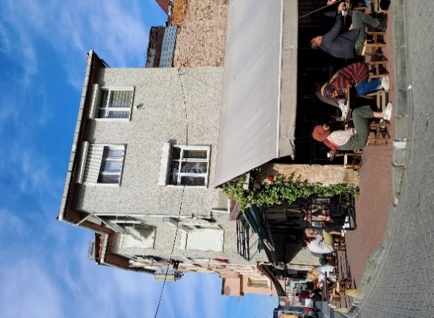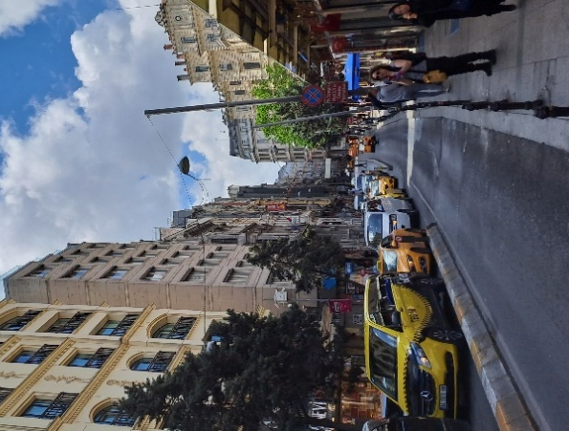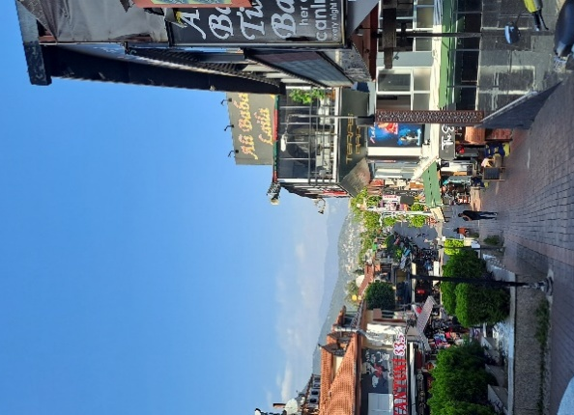

Figure 1. Spatial Linkage Around Fatih Mosque, Sultan Ahmed Mosque, and Kuyularonu Mosque

In contrast, the Sunshine Mosque in Melbourne stands alone, with no activities besides religious practices. The surroundings of the mosque consist of buildings spaced far apart, with no signs of bustling crowds. In front of the mosque is Ballarat Road, a main road with heavy vehicle traffic. Although there are residential areas near the mosque, these neighborhoods are multicultural settlements with mixed land use that are not directly connected to the broader Islamic or Turkish Cypriot communities.
Planning's demand for cultural or religious neutrality often implicitly reinforces dominant norms for public and private spaces. Such conflicts are complex and cannot be easily categorized into legitimate or illegitimate concerns. They reflect broader multicultural tensions and manifest in nuanced spatial practices and representations [18]. Victoria, Australia, has 67 mosques, with the first purpose-built mosque erected by Albanian immigrants in Shepperton, an agricultural region, in 1969 [6], [8]. Establishing places of worship in Melbourne, such as mosques, is sporadic because their development is not based on general spatial planning regulations and is not explicitly included in Victoria’s Precinct Structure Planning (PSP) rules. In countries with Islamic governance, urban planning for mosques typically considers factors such as the number of users, travel distance from residential areas, and connections to other supporting facilities. However, as a secular country, Australia does not strictly regulate the location of places of worship. Ordinary buildings can easily be converted into places of worship. This is because Australian societies prioritize noise, traffic circulation, and parking when establishing a place of worship, which affects their residential environment. The concern is more about these practical aspects than religious issues, as religion is viewed as a personal matter of individual faith. The Sunshine Mosque, for instance, was established through donations from the community, initially starting from the rental of a multi-purpose building.
In Melbourne's urban and transportation landscape, the Sunshine Mosque serves as a bus stop, making it a key reference point and landmark for the surrounding area. This has positive implications for spatial planning, especially with the increasing number of Australians converting to Islam. The establishment of mosques has become a concern in accommodating multicultural and diversification issues. The similarity between the Sunshine Mosque and iconic mosques in Turkey is that both function as spatial benchmarks for urban planning and public transportation.

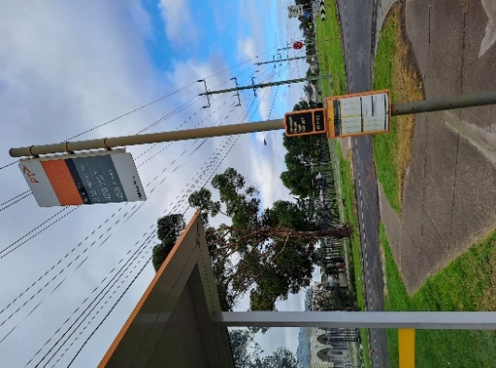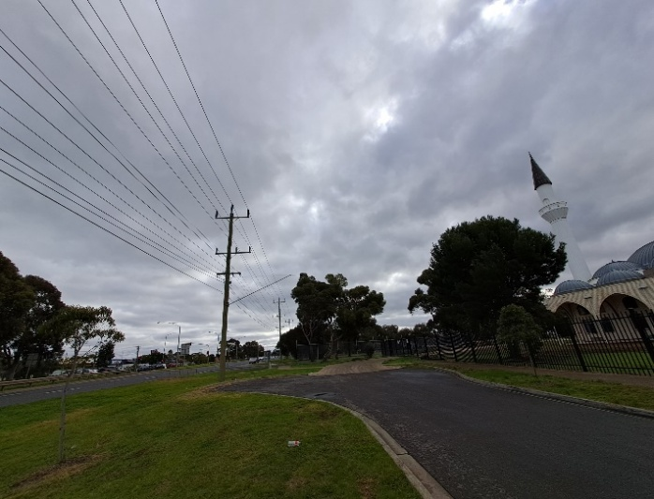

Figure 2. Spatial Linkage around Sunshine Mosque

3.2.2 Structure Construction
Diverse cultures, from Central Asia to Europe, influenced the reinterpretation of dome architecture in Ottoman mosques. This evolution, from the pre-Istanbul era to the peak of the Ottoman Empire, is connected by distinct architectural links. The Karakhanids and Ghaznavids of the 9th and 10th centuries introduced central domes, chambers, and courtyards with multi-column hypostyle and iwan structures [12]. Various factors influenced the construction of mosques in Ottoman regions. Ottoman regulations required settlers in newly occupied areas to have places of worship, leading to the proliferation of Jami Mosques (Cami in Turkish) to accommodate growing Muslim populations. Economic prosperity also played a role, as wealthy towns sought to enhance their status through impressive mosque architecture. This blend of indigenous and Ottoman architectural styles integrated local climate and materials with Islamic Shariah regulations, showcasing Ottoman power and religious identity. The fundamental unit of early Ottoman architecture is the domed square. The primary objective of architects during this period was not to find an ideal upper structure but to create the most significant uninterrupted interior space with minimal vertical structural elements within the prayer hall. This approach showcases an architect's understanding of the distinctive features of Ottoman spatial conception. Different mosque layouts evolved, including single-dome, pendentive, multiple-dome, rectangular form, courtyard, and earring-dome courtyard layouts, each reflecting architectural and cultural transformations [13], [19] (see figure 3). Another scholar argues that there are six types of pendentive dome configurations: single-dome layout (nuclear dome layout), earring layout (pendentive layout), multiple-dome layout, duplication dome, courtyard dome layout, and earring dome layout [19] despite similarities to Byzantine architecture and the borrowing of structural features such as alternating brick-and-stone coursing, early Ottoman buildings aimed for a different effect. While Byzantine architecture adhered to a rigid cruciform plan, Ottoman structures were characterized by a non-directional containment of the inner space by four walls.
The old Fatih Mosque in Constantinople (Istanbul) marks a departure from the prevailing ground plans of the time, introducing new artistic features that were crucial to subsequent development. Moreover, Ottoman-Turkish mosque architecture, contrary to common belief, draws more on Islamic-Persian madrasa architecture than on Christian Byzantine churches [19]. While the Kuyularonu Mosque exhibits distinctive Turkish mosque characteristics by not prominently featuring large, numerous domes, it possesses a spacious courtyard and a monumental spatial design. Even without many large domes, minarets symbolize the place of worship.

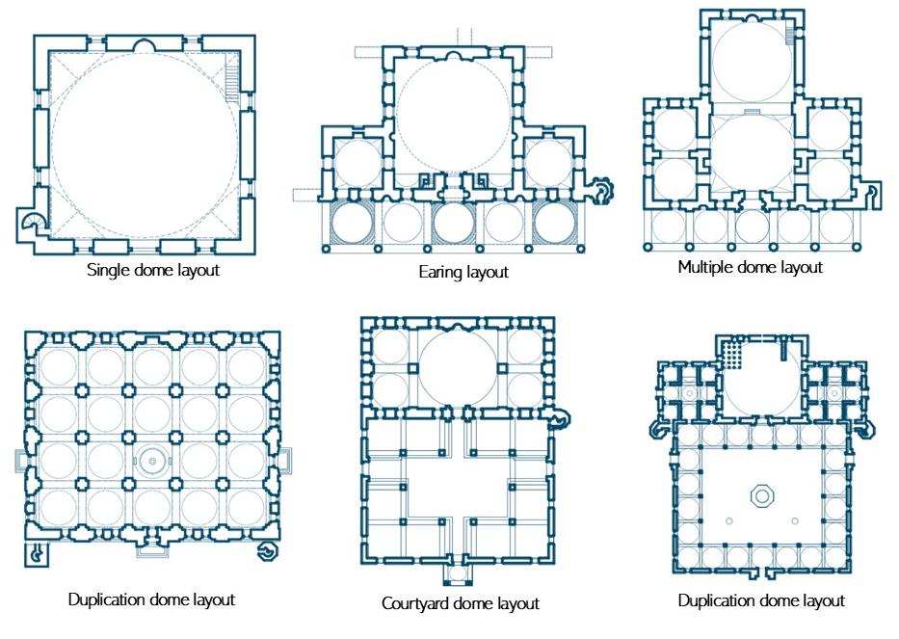

Figure 3. Typology of Turkish Mosques [19]

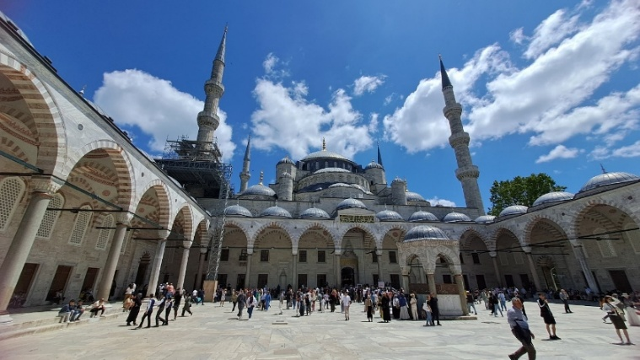

Figure 4 (a). The Façade of Sultan Ahmed Mosque

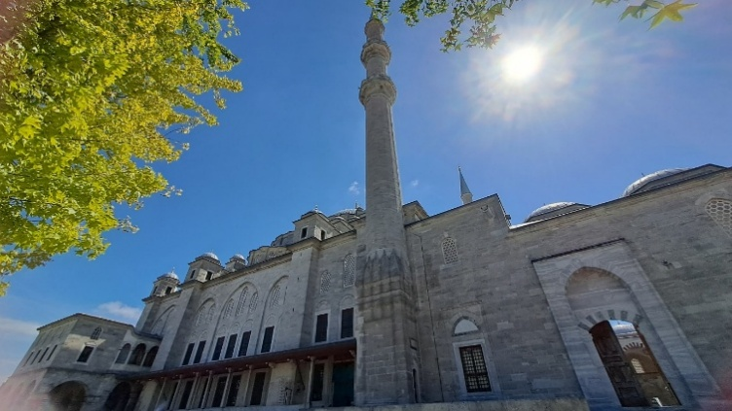

Figure 4 (b). The Façade of Fatih Mosque

From the outside, the Sunshine Mosque is characterized by eight symmetrical arches along the outer corridor that encircle the mosque, showcasing a layout that combines multiple domes and duplication dome patterns. Each arch is supported by columns that form mini domes, complementing the larger dome above. This geometric repetition is strongly reminiscent of Ottoman architecture. The dome is accompanied by a minaret that rises above its height. The appearance of the Sunshine Mosque's dome undoubtedly resembles a replica of the Sultan Ahmet Mosque in Istanbul. The curved lines and symmetrical distribution of the domes are distinctive features of Ottoman legacy mosques. While the Blue Mosque has 13 domes, the Sunshine Mosque boasts 17, all arranged harmoniously in the classical architectural style of Mimar Sinan.

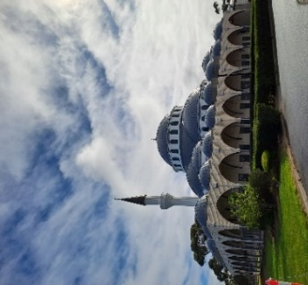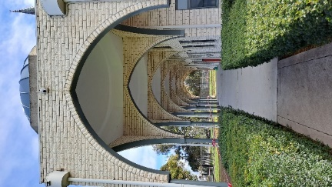

Figure 5. The Façade of the Sunshine Mosque

3.2.3 Minarets
Masonry minarets represent significant architectural elements inherited from the Seljuk and Ottoman Empires, symbolizing imperial dominance over territories and the broader influence of Islamic culture worldwide. Turkish minarets, characterized by slender, tapered shafts that may be cylindrical or polygonal, typically feature multiple galleries, distinguishing them from their Persian counterparts. Originating in Anatolia after the Battle of Malazgirt in 1071, early Turkish minarets followed styles from Turkestan and Khorasan, regions east of Iran. In the Ottoman period, minarets evolved into slim cylindrical or polygonal shafts with conical roofs, with specific rules governing their placement and number, particularly in mosques built by sultans. Standard components of a Classical Ottoman minaret include the footing, pulpit, transition segment, shaft, balcony, upper body section, spire, stairs, and end ornament [20]. Ottoman mosques are distinguished by tall, pointed minarets and lead-covered domes, with larger mosques featuring multiple minarets, a privilege reserved for reigning sultans [21].
The construction of minarets in Australia is an adaptation of Islamic architectural features. The minarets of the oldest mosque in Adelaide were constructed 14 years after this regulation was implemented, using local materials and technologies [8]. A significant difference between the Sunshine Mosque and mosques in Turkey is the way the minaret is used: in Turkey, the adhan, or call to prayer, is regularly broadcast from the minaret for the five daily prayers. However, at the Sunshine Mosque, the minaret is not routinely used for the call to prayer or to announce public news. Instead, it serves primarily as an aesthetic accent and a spatial marker indicating the building's function as a place of worship within the district. The Sunshine Mosque has a single minaret.

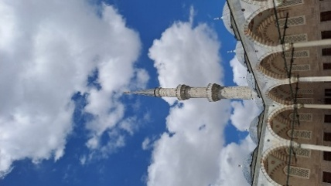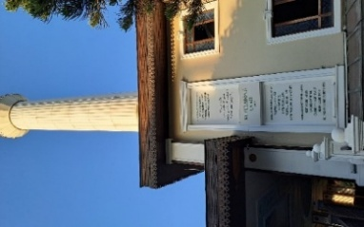

Figure 6. The Minaret of Sultan Ahmed Mosque and Kuyularonu Mosque

3.2.4 Layout of Transition Space
Architectural trends from Istanbul during the Westernization period spread throughout Anatolia, reflecting traditions that draw upon Islamic visual culture. These architectural forms may also incorporate elements from ancient local Anatolian cultures, highlighting the development of Ottoman popular culture through architecture and illustrating how visual elements and cultural traditions interplay within mosque designs, such as wooden ceilings and vibrant interior decorations on white plaster [14]. Visual elements were also articulated through users' habits in spatial activities, such as the placement of objects and the circulation of goods and people, including the positioning of stairs and transitional spaces in buildings that blend Western and Islamic cultural practices.
Before entering the prayer hall, there are designated areas for storing shoes. When entering a mosque, it is required to remove footwear, especially if worshippers have performed ablution (wudhu). Provision of shoe storage is common in Turkish mosques, including the Al Fatih Mosque and the Sultan Ahmed Mosque. Another similarity between the Sunshine Mosque and typical Turkish mosques is the presence of a foyer directly connected to a staircase. The staircase is located on the right or left of the entrance, linking to other functional spaces within the mosque, such as the women's prayer area, the mosque management office, or storage rooms. The staircase typically takes an L-shaped form with wooden or iron railings.

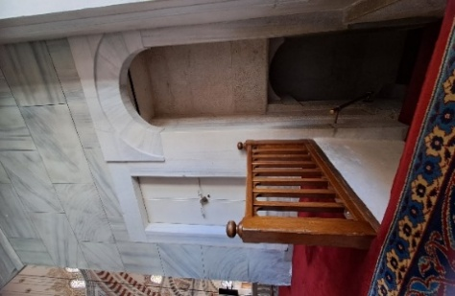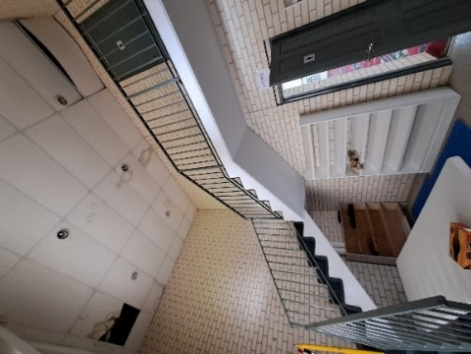

Figure 7. The Similarities of the stair shape of Sultan Ahmed Mosque and Sunshine Mosque

3.2.5 Ornament Decorations
- Ceilings
The ceiling is a significant element in Turkish mosques, with the height between the floor and ceiling symbolizing the spatial distance between humans and God. However, this height paradoxically brings worshippers closer to God during prostration in prayer. This classic concept of height is applied in nearly all places of worship, creating a psychological pressure that makes individuals feel humbled and small in the presence of the divine. On the ceilings, decorations often involve different height levels displayed in the mosque's dome. The ceilings usually feature a crystal chandelier, the center of attention, and a geometric divider.
The motifs and reliefs in the Al Fatih Mosque and the Blue Mosque are highly detailed, featuring floral carvings and typical geometric patterns. In contrast, the Kuyularonu Mosque in Alanya has simpler decorations. One minor difference from the Turkish mosques is that the Sunshine Mosque does not feature many hanging lamps. Instead, it has a single crystal chandelier hanging in the middle of the ceiling, serving as the axis of the building's layout. This decorative pattern is visible in the three mosques studied, and this repetition is also observed in the Sunshine Mosque. Windows have been integrated into the ceiling installation, especially those with stained-glass motifs, and serve as ornamental decorations that let natural light in. The ceiling layout of Turkish mosques is typically symmetrical, with Quranic calligraphy adorning the walls, prominently featuring the names of Allah and Muhammad. These large inscriptions are symmetrically placed to evenly divide the space within the mosque.

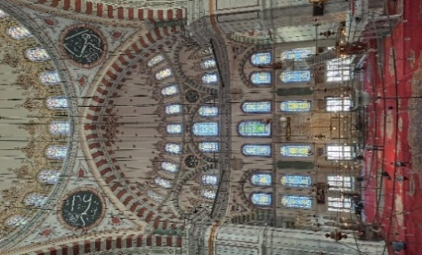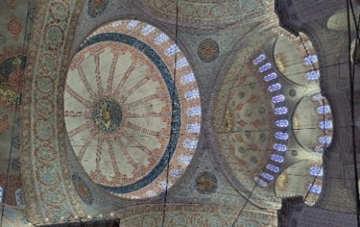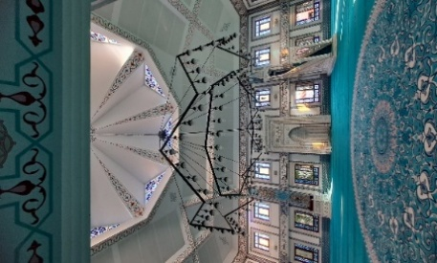

Figure 8 (a). Ceiling ornament in Fatih Mosque, Sultan Ahmed Mosque, and Kuyularonu Mosque (from left to right)

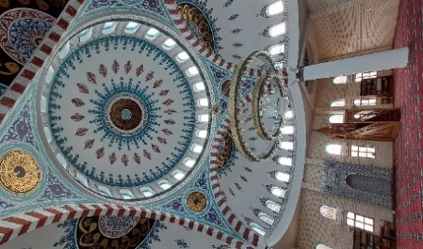

Figure 8 (b). Ceiling ornament in Sunshine Mosque

- Walls and Windows
For at least 10,000 years, various stones, mainly carbonate rocks like limestone, have been extensively used in Anatolia's construction due to their quality and availability, especially in Istanbul. Many Islamic monuments in Istanbul and Turkish Thrace are now endangered by stone weathering, exacerbated by air pollution, rising water tables, and poor sewage systems. In contrast to the high-quality stonework of the 16th century, the 18th and 19th centuries saw a decline in attention to stone quality. Ancient quarries, crucial for early Ottoman architecture, were lost to urban expansion by the 1930s, leading to ongoing restoration challenges for later architectural elements [20]. The elements of the mosque wall determine the direction of prayer, with the Minbar typically positioned to the right of the qibla wall. On the left side of the qibla wall, which is generally made of limestone or a modified form, there are often built-in shelves or racks attached to the wall for storing Qurans.
Naturally, the materials used in Türkiye differ from those used in Australia. The materials used in the Sunshine Mosque have been adapted to suit Melbourne's climate. In their native Türkiye, these mosques traditionally feature stone construction suited to the Mediterranean climate, offering thermal stability and a natural aesthetic. Conversely, the Sunshine Mosque employs modern construction techniques while maintaining the distinctive characteristics of Turkish mosque architecture. This adaptation includes materials that enhance insulation and manage humidity levels, addressing Melbourne's diverse weather conditions. Despite these modern adjustments, the mosque preserves the essential visual and cultural elements that define Turkish mosque design. The walls typically consist of Quranic calligraphy in various styles, with the main focal point being the calligraphy of "Allahu Akbar" or "Allah and Muhammad." Other calligraphic decorations include the Asmaul Husna, the names of Allah, excerpts from the Quran, and Hadiths.
Islamic architecture has historically served to document the experiences of the Islamic diaspora across time and place. Its character in any given location reflects the emergence of Islam there and its profound impacts on local social, political, and cultural life. This dual process involves a deliberate creation of spaces imbued with religious and symbolic significance alongside an implicit understanding rooted in local worldviews, cultural values, and attitudes toward spatial use [6]. As can be seen, the Sunshine Mosque incorporates design elements tailored to Melbourne's climate, including enhanced insulation, improved ventilation, and larger, more numerous window openings. These features are designed to optimize thermal comfort and energy efficiency in a region with variable weather, often experiencing both hot summers and cool winters. Unlike traditional Turkish mosques, which are typically designed for Mediterranean climates with more moderate temperatures, the Sunshine Mosque's design reflects consideration of Melbourne's distinct climate challenges, aiming to provide a comfortable environment for worshipers year-round.

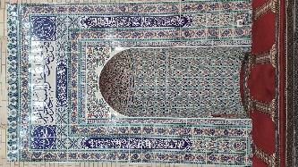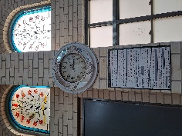

Figure 9. Ornament Decoration in Sunshine Mosque

- Floor Surface
Carpets are a standard feature of mosque interiors, where their patterns, colors, motifs, and materials can create different impressions for Muslim and non-Muslim visitors. Carpet serves multiple functions in mosques, including reducing noise to facilitate worship, symbolizing cleanliness and hygiene, adding aesthetic elements, and even marking the direction of the qibla and the location of the mihrab. On the floors, apart from carpets, intricate tile patterns indicate markers for spatial transitions and boundaries, such as the division between male and female areas and the transition between indoor and outdoor spaces. The material of carpets usually reflects their region of origin and other Middle Eastern countries. At the Sunshine Mosque, the carpets are red, with typical patterns delineating the spacing between worshippers in each row.
In contrast, in mosques in Turkey, such patterns for spacing are not visible, and the carpets often have dynamic variations and improvisations in their designs. For instance, in the Kuyularonu Mosque in Alanya, the dominant carpet color is blue, with transitions and degradations of blue shades. In the Al Fatih Mosque, the carpets are a magnificent red. The Blue Mosque features orange carpets, which appear to balance the highly detailed yellow and cream-colored ceiling.

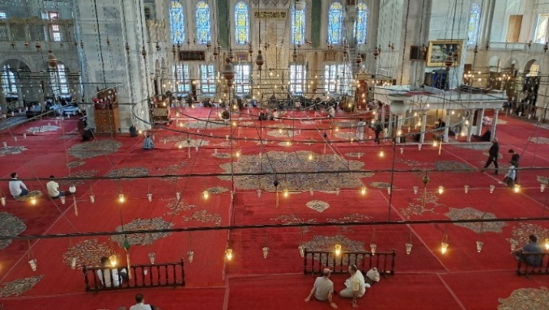 | 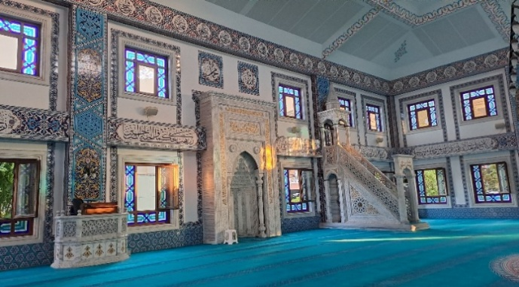
Figure 10 (a). Carpet Display in Fatih Mosque | Figure 10 (b). Carpet Display in Fatih Mosque and Kuyularonu Mosque

The carpet also functions as a divider between the mihrab, the rows for men and women, the rows for adult and children’s worshippers, and those preparing to join congregational prayers or simply waiting in the mosque. The most essential aspect of the prayer space, particularly in the women's section, is that the Sunshine Mosque is equipped with rows of chairs used by elderly or disabled congregants. Such furniture is rarely found in mosques in Türkiye. There is a greater provision of chairs in Melbourne mosques, reflecting a trend where regular attendees of worship services are often elderly or disabled, especially in secular countries, and mosques are particularly busy during Ramadan, frequented by elderly congregants.

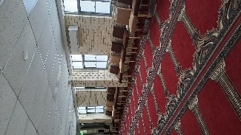

Figure 11. Women's Prayer Area Carpet at Sunshine Mosque

- Furniture and Furnishing
The Minbar, where the khatib delivers sermons and individuals recite the Quran, is an essential element in Turkish mosques. Its placement is consistent across all four mosques studied. The Minbar is located to the right of the Imam, who leads the prayers. Meanwhile, the area for the Imam, Quran reader, or leader of Islamic studies typically consists of a pulpit without stairs. It is usually placed to the left of the prayer space or behind the women's section, near the mosque's exit. The materials used in the mihrab's structure are typically wood, with intricate carvings. Wood is considered vital in construction and maintains a natural balance with the stone walls surrounding the prayer hall. On the supporting pillars of the dome, ornamental wooden furnishings are often installed, sometimes serving dual purposes, such as storing the Quran.

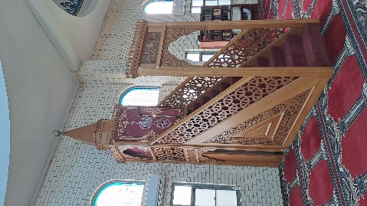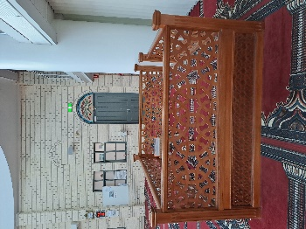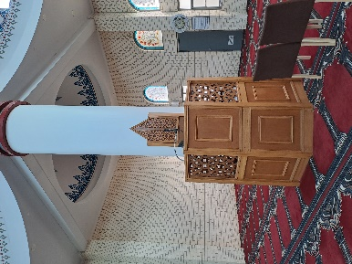

Figure 12 (a). Minbar in Sunshine Mosque

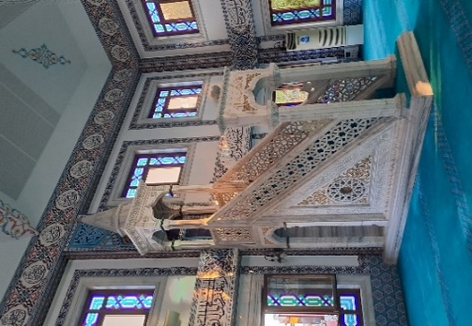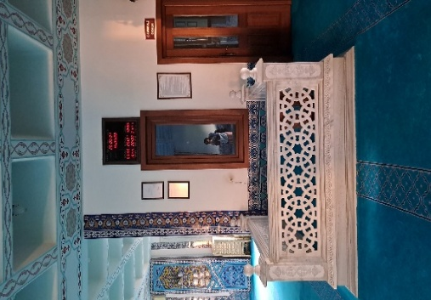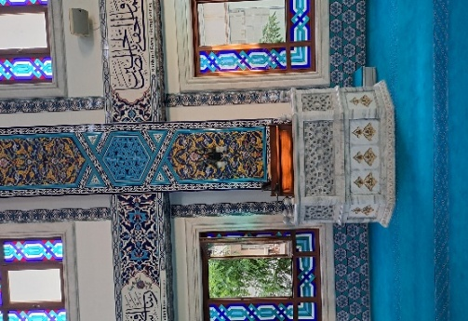

Figure 12 (b). Minbar in Kuyularonu Mosque

- Outdoor and Landscape
Regarding layout, the Sultan Ahmet Mosque and the Fatih Mosque feature inner courtyards surrounded by covered corridors or pillars. These courtyards serve as transitional spaces from public or semi-public areas to the semi-private areas of worship. The Kuyularonu Mosque, however, does not have a large courtyard due to its location in a central business district, where it is directly accessible from public spaces such as roads and pedestrian pathways in the Alanya shopping center area. The limited space and functional linkage with surrounding activities influence the presence of a courtyard. Similarly, the Sunshine Mosque does not have an inner court, but it can be accessed directly from the parking area within the building's premises or by worshippers arriving from the highway in front of the mosque.
The outdoor environment is the most fundamental difference between the Sunshine Mosque and its counterparts in Türkiye. Even with the establishment of secular principles, mosques remain popular tourist attractions in Türkiye, both in Istanbul and Alanya. Visitors often come for sightseeing, and Muslims for prayer. The secular impression is not very prominent. In contrast, visitors primarily come to worship at the Sunshine Mosque in Melbourne. The mosque is bustling mainly during Islamic events, especially during Ramadan and occasional festivals. During these times, the Muslim community, not just the Turkish community, gathers and uses the outdoor space for socializing and sports. This is evident in a football field, which can be converted into other play or sports areas, as well as various playground facilities for children. In Türkiye, such facilities are less noticeable and not typically provided. The Sunshine Mosque offers added value as a community gathering place for social functions.
The external elements of Turkish mosques typically include fountains, ponds, and spacious gardens, unlike the Sunshine Mosque. This absence can be attributed to various factors, including design preferences, spatial constraints, and local vegetation considerations. Sunshine Mosque may prioritize other architectural features or landscaping elements that fulfill its functional and aesthetic needs while adapting to Melbourne's urban context.

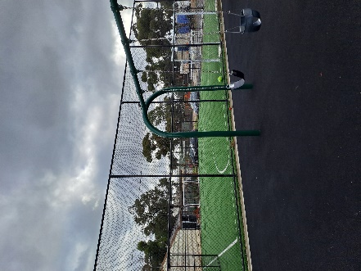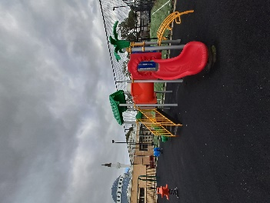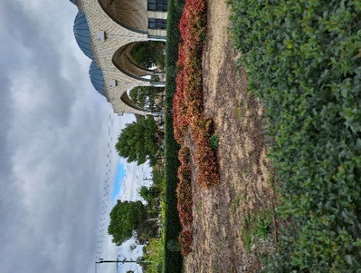

Figure 13. Outdoor Functional Space surrounding the Sunshine Mosque
The architectural landscape of mosques intricately reflects and adapts to cultural identities and societal needs, showcasing a dynamic interplay between tradition and contemporary demands. This evolving design highlights the unique cultural elements of the communities they serve and addresses modern society's changing requirements and challenges. To summarize the discussion of each component, comparing the Sunshine Mosque in Melbourne with Turkish mosques, the following matrix illustrates the key similarities and differences in Table 1.

Table 1. The Similarities and Differences of Sunshine Mosque and Turkish Mosques
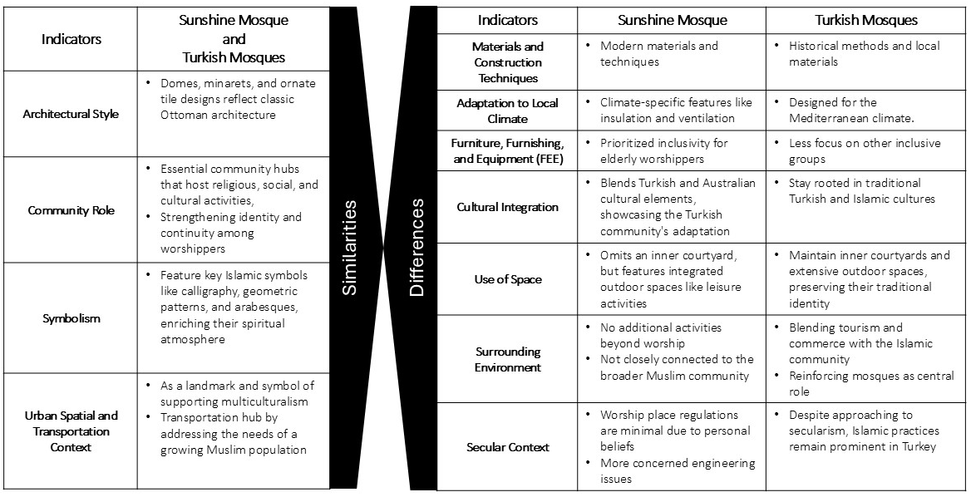

CONCLUSION
Islamic architecture worldwide showcases a diverse and rich array of forms, articulations, and expressions. In this study, the Sunshine Mosque, built by immigrants in a secular context, shares similarities and differences with Turkish mosques in their home country. The Sunshine Mosque in Melbourne and Turkish mosques share several architectural and cultural similarities, including domes, minarets, and intricate tile work influenced by traditional Ottoman architecture. Both serve as vital community centers, hosting religious, social, and cultural activities and incorporating significant Islamic symbols, such as calligraphy and geometric patterns. In urban contexts, both serve as landmarks and public transport stops, aiding spatial planning, particularly as the number of Australians converting to Islam rises.
Despite these similarities, there are key differences. The Sunshine Mosque uses modern materials and techniques suited to Melbourne's climate, blending Turkish and Australian cultural elements, unlike Turkish mosques that rely on historical methods and local materials. It lacks an inner courtyard but features outdoor spaces integrated with the parking lot, serving as a landmark rather than a bustling community hub. In contrast, Turkish mosques often have vibrant surroundings with shopping stalls and food vendors, reinforcing their central role in the community. Additionally, the regulation of places of worship in Melbourne is minimal, with concerns mainly focused on noise, traffic, and parking.
Further research opens the possibility of exploring how architectural and cultural adaptations of mosques impact other Islamic communities in Melbourne and across Australia. Examining modern adaptations to local climates and materials, as well as the effects of cultural integration on social cohesion and identity among Muslim populations, could provide valuable insights into accommodating multicultural needs and fostering inclusive environments. This research would provide essential insights into optimizing mosque design and functionality to serve the diverse needs of Islamic communities in Australia, a multicultural and secular nation, and beyond.

AUTHORS CONTRIBUTION
Conceptualization: K.N., A.B., Formal analysis: K.N., A.B., Funding acquisition: K.N., Direct Observation: K.N., Methodology: K.N., Project administration: K.N. Writing—original draft: K.N., A.B. Writing-review-editing: K.N., A.B. All authors have reviewed and approved the final version of the manuscript for publication.

ACKNOWLEDGEMENT
The fieldwork for this study was supported by the Future Earth Australia Opportunities Fund: Seizing Opportunities grant stream in 2024.

REFERENCES

[1] N. A. Kabir, “A Study of Australian Muslim Youth Identity: The Melbourne Case,” Journal of Muslim Minority Affairs, vol. 31, no. 2, pp. 243–258, Jun. 2011, doi: 10.1080/13602004.2011.583518.
[2] N. Kabir, “Muslims in Australia: The Double Edge of Terrorism,” Journal of Ethnic and Migration Studies, vol. 33, no. 8, pp. 1277–1297, Nov. 2007, doi: 10.1080/13691830701614072.
[3] S. Arifin, H. Bachtiar, A. N. Fuad, T. Tongat, and W. Wahyudi, “Minority Muslims and freedom of religion: Learning from Australian Muslims’ Experiences,” Indonesian J. Islam Muslim Soc., vol. 9, no. 2, pp. 295–326, Dec. 2019, doi: 10.18326/ijims.v9i2.295-326.
[4] V. Colic-Peisker, M. Mikola, and K. Dekker, “Religious visibility: perceptions and experiences of residents in two Muslim concentration suburbs in Melbourne, Australia,” Ethnic and Racial Studies, vol. 42, no. 15, pp. 2743–2762, Nov. 2019, doi: 10.1080/01419870.2018.1557729.
[5] K. M. Dunn, “Representations of Islam in the politics of mosque development in Sydney,” Tijd voor Econ & Soc Geog, vol. 92, no. 3, pp. 291–308, Aug. 2001, doi: 10.1111/1467-9663.00158.
[6] M. M. Rashid, K. Bartsch “Architecture of the Adelaide Mosque: Hybridity, Resilience and Assimilation,” Traditional Dwellings and Settlements Review, vol. 25, no. 2, pp. 65-75, 2024.
[7] H.U. Khan, “The Architecture of the Mosque, an Overview and Design Directions,” The Mosque. pp. 109-127.
[8] J. Rudner, F. Shahani, and T. Hogan, “Islamic Architectures of Self-Inclusion and Assurance in a Multicultural Society,” Fabrications, vol. 30, no. 2, pp. 153–175, May 2020, doi: 10.1080/10331867.2020.1749220.
[9] F. Shahani, T. De Cotta, and J. Rudner, “An Imagined Islamic Space in Multicultural Melbourne: A Focus on Lefebvre’s Representational Space,” Spaces and Flows: An International Journal of Urban and ExtraUrban Studies, vol. 9, no. 1, pp. 1–14, 2018, doi: 10.18848/2154-8676/CGP/v09i01/1-14.
[10] S. K. Yetkin, “The Evolution of Architectural Form in Turkish Mosques (1300-1700),” Studia Islamica, no. 11, p. 73, 1959, doi: 10.2307/1595151.
[11] B. Batuman, “Architectural mimicry and the politics of mosque building: negotiating Islam and Nation in Turkey,” The Journal of Architecture, vol. 21, no. 3, pp. 321–347, Apr. 2016, doi: 10.1080/13602365.2016.1179660.
[12] S. Moustafa, “Contemporary Mosque Architecture in Turkey”. Master's Thesis, the American University in Cairo, 2013.
[13] N. Ozaslan and A. Akalin, “Architecture and Image: The Example of Turkey,” Middle Eastern Studies, vol. 47, no. 6, pp. 911–922, Nov. 2011, doi: 10.1080/00263206.2011.621758.

[14] M. Artkan, “A Research on The Use of Ottoman-Islamic Heritage As A Consumption Object In Contemporary Architectural Practice,” Journal of Islamic Architecture, vol. 6, no. 4, pp. 338–348, Dec. 2021, doi: 10.18860/jia.v6i4.11811.
[15] A. Erarslan, “Reflections of the Ottoman Period of Westernization in Religious Architecture: Façade Arrangement of the Balyan Mosques,” Journal of Islamic Architecture, vol. 7, no. 3, pp. 518–528, Jun. 2023, doi: 10.18860/jia.v7i3.20630.
[16] S. Şimşek, Z. Polvan, and T. Yeşilşerit, “The Mosque as a Divisive Symbol in the Turkish Political Landscape,” Turkish Studies, vol. 7, no. 3, pp. 489–508, Sep. 2006, doi: 10.1080/14683840600891166.
[17] S. Özaloglu, M. O. Gürel, “Designing Mosques for Secular Congregations: Transformations of the Mosque as a Social Space in Turkey,” Journal of Architectural and Planning Research, vol. 28, no. 4, pp. 336-358, 2011.
[18] J. Rudner, A. Butt, and M. Lobo, “Adjudicating Faith: 20 Years of Secular Decision-Making for Religious Spaces”. 8th State of Australian Cities National Conference, Adelaide, Australia, 2018.
[19] F. A. Mustafa and A. S. Hassan, “Mosque layout design: An analytical study of mosque layouts in the early Ottoman period,” Frontiers of Architectural Research, vol. 2, no. 4, pp. 445–456, Dec. 2013, doi: 10.1016/j.foar.2013.08.005.
[20] M. Aga-Oglu, “The Fatih Mosque at Constantinople,” The Art Bulletin, vol. 12, no. 2, pp. 179-195, 1930.
[21] A. Doğangün, O. I. Tuluk, R. Livaoğlu, R. Acar, “Traditional Turkish Minarets on the Basis of Architectural and Engineering Concepts”. 1st International Conference on Restoration of Heritage Masonry Structures, Cairo, Egypt, 2006.
[22] O. Urey, “Transformation of Minarets in Contemporary Mosque Architecture in Turkey,” ISSCS, vol. 1, no. 4, pp. 95–95, Jan. 2013, doi: 10.14486/IJSCS36.

In 2021, of the 38,586 Turkish Australians, 67.6% identified as Muslim, 20.6% as atheist, 1.7% as Oriental Orthodox, 1.6% as Eastern Orthodox, and 8.5% identified with other religions (https://en.wikipedia.org/wiki/Turkish_Australians)

