 |  | JOURNAL OF ISLAMIC ARCHITECTURE  P-ISSN: 2086-2636 E-ISSN: 2356-4644  Journal Home Page: http://ejournal.uin-malang.ac.id/index.php/JIA
EVALUATION OF THE LEGIBILITY OF WAYFINDING SIGNAGE IN MOSQUES THROUGH THE DESIGN OF ERGONOMIC SIGNAGE
Bambang Suhardi^{1*}, Afiq Ramadhan¹, Rahmaniyah Dwi Astuti¹
¹Department of Industrial Engineering, Universitas Sebelas Maret, Surakarta, Indonesia
*Corresponding Author: bambangsuhardi@staff.uns.ac.id
ARTICLE INFO |  |  | ABSTRACT
Volume: 9  Issue: 1  Page: 81-96  Received: July 12th, 2024  Accepted: January 11th, 2025  Available Online: June 30th, 2026  DOI: https://doi.org/10.18860/jia.v9i1.28423 |  |  | Mosque visitors often struggle with poorly designed wayfinding signs. Small fonts, unappealing color combinations, illogical placement, and dazzling materials contribute to this frustration. Common complaints involve signs for toilets, ablution areas, prayer halls, and holy boundaries. This study aimed to improve signage legibility by applying ergonomic principles. The visual display cognitive ergonomics approach was chosen, with a focus on human-system interaction and acknowledgment of human limitations. An experimental design was used to evaluate the effects of font size, typeface, and color combinations on legibility. Additionally, symbol comprehension tests and assessments of familiarity, compatibility, and standardization were conducted to inform the design of effective symbol signage. The experimental data were analyzed using the Friedman test. Spearman’s rank correlation test was used to assess the relationships among the three ergonomic factors: familiarity, compatibility, and standardization. Data analysis revealed that only font size significantly impacted legibility. However, a positive correlation was found between ergonomic factors and participant understanding of the signage symbols. This suggests that these factors collectively affect overall legibility. After introducing the newly designed signage, the study successfully increased sign legibility. Future research can explore additional factors that influence legibility to develop more comprehensive guidelines for mosque signage design.  Keywords:  Ergonomic; Legibility; Mosque; Signage; Symbol

INTRODUCTION
Mosques play a vital role as places of worship, community centers, and symbols of Muslim identity. The development of mosques as public spaces requires careful consideration of the necessary facilities and infrastructure, including signage. Signage is defined as signs or other materials used to provide information, directions, warnings, or prohibitions [1]. Wayfinding is the process by which an individual identifies their current position and determines the direction to their intended destination [1]. Signage plays a crucial role in ensuring comfort, safety, and security within a spatial environment. Legibility is paramount in ensuring effective comprehension of signage [2].
Legibility refers to an individual's ability to read, comprehend, and respond to the information displayed on signs [3]. Legibility is a widely recognized ergonomic criterion used to evaluate visual displays [4]. According to [5], legibility is influenced by a combination of factors, including font size, font type, and leading [6]. Legibility is further affected by the sign's color, color contrast, and ambient lighting conditions [7].
Extensive research has been conducted on the legibility of signage in various public spaces, including hospitals [8], metro stations [9], [10], and highways [11]. Mosques, by contrast, have received relatively little attention as significant public spaces. Consequently, this study focuses on mosques as the primary object of investigation. Four mosques in the Solo Raya region were selected for analysis: Masjid Raya Sheikh Zayed Surakarta (Gilingan, Surakarta), Masjid Agung Al-Aqsha Klaten (Jonggrangan, Klaten), Masjid Agung Madaniyyah Karanganyar (Badran, Karanganyar), and Masjid Agung Baiturrahmah Sukoharjo (Johosari, Sukoharjo).
Findings from interviews and observations conducted at the four mosques indicate that signage legibility is generally low. A majority of visitors expressed dissatisfaction with the signage for toilets (70%), ablution facilities (45%), purity boundaries (20%), and prayer areas (15%). His dissatisfaction stems from several factors: Small font sizes often require visitors to approach the signs closely to decipher the information. Inconspicuous color combinations make the signage difficult to locate. Inconsistent color use within the same space creates a visually chaotic, confusing environment. Unsuitable placement often leads visitors to miss important signs, such as those indicating purity boundaries. The use of materials that reflect excessive glare causes visual discomfort, further hindering legibility.
Word processing speed with larger fonts is generally smoother than with smaller fonts [12]. Legibility is enhanced when the font size is increased by 20% [13]. Researchers have investigated the impact of typeface on the legibility of signs that employ alphanumeric characters [3]. Serif and sans serif are the two most common typefaces currently used for mosque signage. Several studies have evaluated the extent to which typeface influences legibility, with findings indicating no significant difference between serif and sans serif [6][13]. Serif outperforms sans serif in terms of readability by 5% [14]. On the other hand, Bailey [15] asserts that sans serif is more legible than serif.
Color is the most sensitive attribute in human visual perception [15]. It not only influences aesthetics but also guides the observer's behavior [16]. Color combinations impact legibility and visual search performance [17]. Huang [18] suggests using achromatic colors due to their high preference. In contrast, Lin [19] asserts that chromatic colors are visually preferred over achromatic ones, although the difference is not statistically significant.
According to ISO 2227:2007, a symbol is a visually perceived figure that conveys specific meaning to an individual, regardless of language barriers. Graphic perception is faster than reading and comprehending text [8]. However, non-informative symbols can lead to ambiguity.
This study aims to assess the legibility of mosque signage and design ergonomic signage to improve it. Previous research has primarily employed experiments [9], [10], [11], [20]. In this study, experiments were conducted in a laboratory setting to minimize the influence of external factors, such as lighting and noise, thereby reducing distractions during data collection. Signage legibility experiments were conducted to determine the effects of font size, typeface, and color combinations on legibility. Subsequently, a questionnaire-based sign symbol comprehension test was administered, encompassing a comprehension test and a test of familiarity, compatibility, and standardization [8], [21]. This research resulted in a proposed signage display design that can be universally implemented in mosques.

METHODS
Initial data collection was conducted through semi-structured in-depth interviews with 20 mosque visitors at 4 predetermined mosques. Interviews were conducted during the daytime (March 1, 2024 - March 8, 2024) to identify the most common legibility and signage issues faced by visitors. Observations were conducted to document the physical characteristics of existing signage. The findings from the preliminary data analysis served as the basis for the experimental design. According to [22] and [23], the experimental study involved 15 participants. Participants were selected purposively from the population of mosque visitors aged 19-59 years. The inclusion criterion was a minimum visual acuity of 20/30, whereas the exclusion criterion was the absence of color vision deficiency. The experiment will be divided into three stages: respondent criteria testing, signage legibility testing, and symbol comprehension testing.

  - RESPONDENT CRITERIA TESTING
Respondent criteria testing is employed to ensure that participants meet the pre-established inclusion and exclusion criteria. Respondent criteria testing comprises two parts: a visual acuity test using the Snellen Chart and a color-blindness test using Ishihara's Color Blind Test. The Snellen chart was chosen due to its accessibility and straightforward procedure for assessing literacy skills [24]. Ishihara's Color Blind Test is a rapid method for identifying color blindness disorders [25]. The acceptance criteria for respondents in the visual acuity test are a minimum visual acuity of 20/30. In contrast, the acceptance criteria for Ishihara's Color Blind Test are the ability to correctly answer > 7 plates in an average time of < 3 seconds. Respondents who meet the criteria can proceed with the experiment.

  - SIGNAGE LEGIBILITY TESTING
Signage legibility testing is conducted to determine the impact of the independent variables (font size, typeface, and color combination) on the dependent variable (total correct answers (TCA)). Total response time (TRT) serves as a mediating variable, strengthening or weakening the relationship between the independent variables and the dependent variable [26].
Three hypotheses will be tested in this experiment. These hypotheses were formulated in light of previous research findings. Sheedy et al. explicitly stated that font size and typeface have a significant impact on legibility [27]. Franken et al. mentioned that the selection of color combinations affects legibility [28]. The following are the hypotheses employed:
H1: Font size has a significant impact on the legibility of signage, as represented by total correct answers (TCA).
H2: Typeface has a significant impact on the legibility of signage, as reflected in total correct answers (TCA).
H3: Color combination has a significant impact on the legibility of signage, as represented by total correct answers (TCA).
Font size is divided into four test groups (2 cm, 3 cm, 4 cm, and 5 cm), typeface is divided into two test groups (serif and sans serif), and color combination is divided into two test groups (chromatic and achromatic). Times New Roman represents a serif typeface, while Copperplate Gothic represents a sans-serif typeface. The chromatic color combination is white text on a green background, while the achromatic color combination is black text on a white background. As a result, 16 testing schemes comprising 240 data-collection processes were created.
Signage legibility testing was conducted in the Human Factors Design and Ergonomics Laboratory at Sebelas Maret University on May 2, 2024. The lighting level was maintained between 100 and 300 lux. Participants were positioned 6 meters from the test field, and two observers were placed to the right and left of the participants at 30 cm. The observers were responsible for recording TCA and TRT. The test field was constructed from thick cardboard measuring 80 cm in length and 26 cm in width and was laminated with a matte finish to minimize light reflection.

  - SYMBOL COMPREHENSION TESTING
Symbol comprehension testing aims to evaluate participants' understanding of current signage symbols following the introduction of the proposed symbols. Symbol comprehension testing is questionnaire-based and consists of a comprehension test and a test of familiarity, compatibility, and standardization.
The comprehension test categorizes correct answers as correct (score of 2), partially correct (score of 1), and incorrect (score of 0). The correct or incorrect categories are based on participants' ability to identify the sign's meaning and the appropriate action to take when they see the sign.
The test of familiarity, compatibility, and standardization uses a 1–10 Likert scale. Point 1 indicates that the sign symbol is "very not" (familiar, compatible, and standardized), while point 10 indicates that the sign symbol is "very" (familiar, compatible, and standardized).

  - ERGONOMICS FOR DESIGNING WAYFINDING SIGNAGE
Ergonomics aims to create compatibility between human needs, capabilities, and limitations [29]. Cognitive ergonomics, a branch of ergonomics, focuses on analyzing human mental processes [30]. Cognitive ergonomics research areas include perception, categorization, memory, knowledge representation, numeracy, language, and thinking [30]. The process of information processing is divided into three main stages: understanding the type of information provided by the environment, processing the information, and taking appropriate actions [31].
A display is a medium for providing information to humans so that the information seen can be conveyed to facilitate an activity [32]. Salvendy [29] states that in designing displays for human-machine interaction, correspondence and coherence are important. According to Berrio et al [33] ergonomic concepts in display design include (a) familiarity, how often users encounter the sign in their daily lives, (b) standardization, the consistency of codes (e.g., color, shape) used across different signs, (c) concreteness, how clearly the sign represents a real-world object or situation, (d) compatibility, the match between the sign and the message it conveys, (e) meaningfulness, the perceived meaningfulness of the icons within the sign, (f) simplicity, fewer elements or details, and (g) semantic closeness, closeness of the relationship between the symbol and its meaning. Three ergonomic design concepts: familiarity, compatibility, and standardization were referenced in designing new wayfinding signage symbols for this research. Patel & Mukhopadhyay [8] also employed a similar approach. Nonetheless, the final design incorporated all seven ergonomic display design concepts.

RESULT AND DISCUSSION

RESPONDENT CRITERIA TEST RESULTS
Respondents were selected through random sampling, meeting inclusion and exclusion criteria, and providing informed consent. Of the 15 participants, 4 were male, and 11 were female. The higher proportion of female participants is attributed to (a) a majority of consenting respondents being female, (b) women's tendency for more detailed assessments [34], and (c) previous research [8] underrepresenting female participants. Sixty percent of the respondents were aged 39–48 years, 27% were aged 49–59 years, and 13% were aged 19–28 years. The junior high school (SMP) level accounted for the largest share of respondents' education levels (47%). Thirty-three percent were high school graduates, and 20% were elementary school graduates. Respondent criteria testing was conducted alternately. The visual acuity test results showed that all respondents had a minimum visual acuity of 20/30. 20% of respondents had a visual acuity of 20/15 feet, 20% had a visual acuity of 20/20 feet, 47% had a visual acuity of 20/25 feet, and 13% had a visual acuity of 20/30 feet. The color blindness test results showed that all respondents passed, with an average correct answer of 10.2 plates and an average response time of 1.89 seconds. Therefore, the 15 respondents who were tested were eligible to participate in the next experiment.

SIGNAGE LEGIBILITY TEST RESULT
The test results showed that the scenario with a 5 cm font size, a serif font, and an achromatic color combination had the highest average TCA (3.00) among the scenarios. The lowest average TCA (1.53) was observed in the scenario with a 2 cm font size, serif typeface, and chromatic color scheme. Table 1 shows the results of the signage legibility test.

Table1. Sign Legibility Test Result
Color Combination | Typeface | Letter Height | Mean TJB (point) | Mean TRT (s)
Chromatic | Serif | 2 cm | 1,53 | 3,60
 |  | 3 cm | 2,33 | 3,51
 |  | 4 cm | 2,80 | 3,48
 |  | 5 cm | 2,80 | 3,43
Chromatic | Sans Serif | 2 cm | 1,60 | 3,73
 |  | 3 cm | 2,40 | 3,80
 |  | 4 cm | 2,67 | 3,70
 |  | 5 cm | 2,87 | 3,59
Achromatic | Serif | 2 cm | 1,60 | 3,52
 |  | 3 cm | 2,33 | 3,44
 |  | 4 cm | 2,73 | 3,42
 |  | 5 cm | 3,00 | 3,35
Achromatic | Sans Serif | 2 cm | 1,60 | 3,62
 |  | 3 cm | 2,40 | 3,65
 |  | 4 cm | 2,67 | 3,57
 |  | 5 cm | 2,87 | 3,51

The following is a visualization of the distribution of the signage legibility test data. The relationship between font size and total correct answers (TCA) is illustrated in Figure 1. The box plot shows that larger font sizes tend to produce higher TCA values, indicating better legibility performance. The relationship between font size and total correct answers (TCA) is illustrated in Figure 1. The box plot shows that larger font sizes tend to produce higher TCA values, indicating better legibility performance.

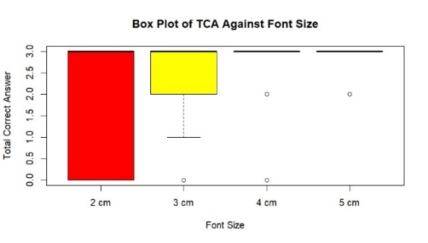

Figure 1. Box Plot of TCA Against Font Size
The comparison between serif and sans-serif typefaces in relation to TCA is presented in Figure 2. The distribution indicates that both typefaces produce results that are relatively similar. Figure 3 shows the distribution of TCA across chromatic and achromatic color combinations. The difference between the two color schemes appears relatively small.

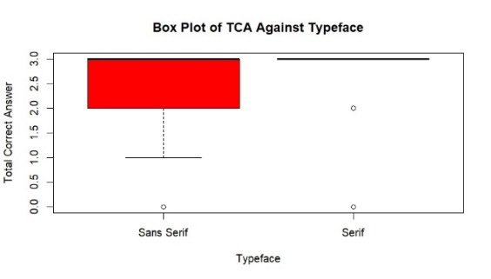

Figure 2. Box Plot of TCA Against Typeface

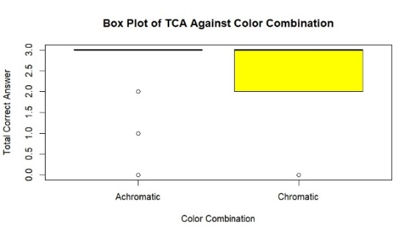

Figure 3. Box Plot of TCA Against Color Combination

The average TCA for font sizes of 2 cm, 3 cm, 4 cm, and 5 cm were (1.58), (2.37), (2.72), and (2.88), respectively. The average TJB for serif fonts was (2.39), and for sans serif fonts, it was (2.38). The average TCA for chromatic color combinations was 2.38, and for achromatic color combinations was 2.40. TCA is a maximization function, meaning that the higher the average, the greater the legibility. Figure 4 illustrates the relationship between font size and total response time (TRT). The results indicate that larger font sizes tend to reduce response time. The comparison of TRT values between serif and sans-serif typefaces is shown in Figure 5. Meanwhile, Figure 6 presents the distribution of TRT values for chromatic and achromatic color combinations.

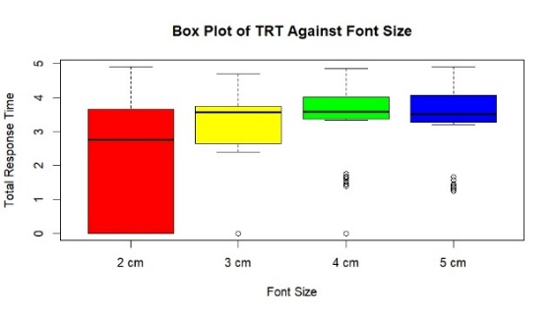

Figure 4. Box Plot of TRT Against Font Size

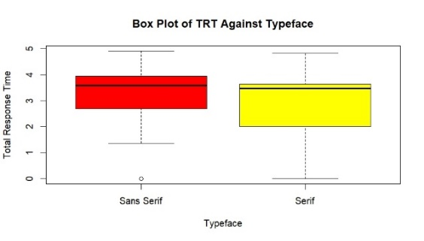

Figure 5. Box Plot of TRT Against Typeface

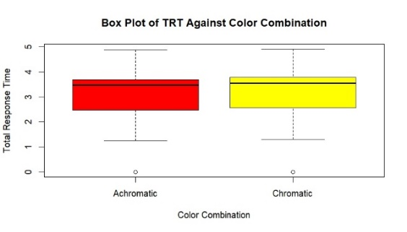

Figure 6. Box Plot of TRT Against Color Combination

The average TRT for font sizes of 2 cm, 3 cm, 4 cm, and 5 cm were (3.61), (3.60), (3.54), and (3.49), respectively. The average TRT for serif was (3.47), and for sans serif it was (3.63). The average TRT for chromatic was (3.61), and for achromatic it was (3.50). TRT is a minimization function, meaning that the lower the average value, the higher the legibility.
The Friedman test results showed that the significance value for font size on TCA was 0.000 (<0.05), indicating a significant effect. H1 was accepted. The significance value for typeface on TCA was 0.637 (>0.05), so H2 was rejected, indicating no significant effect. The significance value for the color combination on TCA was 0.405 (>0.05), so H3 was rejected, indicating no significant effect.
The Friedman test results only show differences between groups without specific identification. Further analysis using a post-hoc test is needed to identify specific inter-sample groups that differ significantly. According to the Friedman test results, only font size was significant; therefore, it was tested using a post hoc test. The post-hoc results obtained from pairwise comparisons showed significant differences between groups 2 cm - 4 cm (sig. 0.002) and 2 cm - 5 cm (sig 0.001). There were no significant differences between groups 2 cm - 3 cm (sig 0.142), 3 cm - 4 cm (sig 1.000), 3 cm - 5 cm (sig 0.623), and 4 cm - 5 cm (sig 1.000). The pairwise comparison results of font size groups are presented in Figure 7. The analysis indicates significant differences between the 2 cm – 4 cm and 2 cm – 5 cm groups.

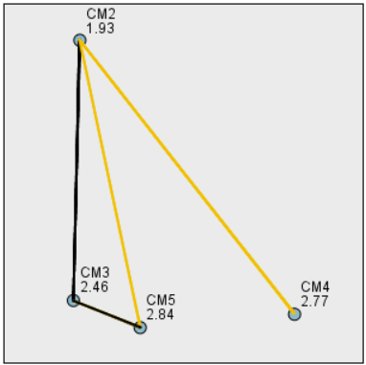

Figure 7. Pairwise Comparison of Font Size

3.3 SYMBOL COMPREHENSION TEST RESULT
The results indicate a 29.78% increase in respondent comprehension levels after the introduction of new symbols. A comparison of respondent comprehension levels between existing and proposed symbols is presented in Table 2.
Table 2. Comparison of Symbols Comprehension Levels
Signage | Existing Symbol |  |  |  | Purposed Symbol
 | X(%) | Y(%) | Z(%) | CL(%) | X(%) | Y(%) | Z(%) | CL(%)
Toilet | 13,3 | 0.0 | 86,7 | 13,3 | 46,7 | 0,0 | 13,3 | 66,7
Toilet Disabilities | 13,3 | 0,0 | 86,7 | 13,3 | 40,0 | 46,7 | 13,3 | 63,3
Ablution | 66,7 | 6,7 | 26,7 | 100 | 100 | 0,0 | 0,0 | 100
Ablution Disabilities | NA | NA | NA | NA | 100 | 0,0 | 0,0 | 100
Prayer Hall | 100 | 0,0 | 0,0 | 100 | 100 | 0,0 | 0,0 | 100
Purity Boundaries | 60,0 | 33,3 | 6,7 | 76,7 | 73,3 | 6,7 | 20,0 | 76,7
* X(Correct Answer), Y(Partially Correct), Z(False Answer), CL(Comprehension Level)
* NA (No Symbol Available)

The results of the familiarity, compatibility, and standardization tests indicate a positive correlation between comprehension level and the application of ergonomic principles in signage design. The more symbols are designed with ergonomic principles in mind, the more likely they are to improve user comprehension [8]. The relationship between comprehension level and ergonomic principles is illustrated in Figure 8.

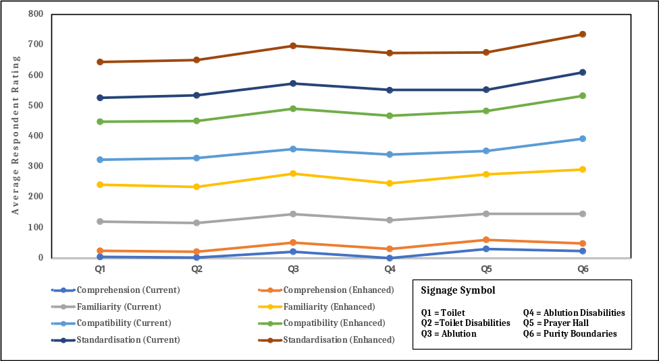

Figure 8. Relationship between Comprehension Level and Ergonomic Principles

Spearman's correlation test results indicate a positive correlation between the three ergonomic principles of familiarity, compatibility, and standardization for both the pre- and post-improvement conditions of wayfinding signage symbols. The results of the Spearman correlation test for familiarity, compatibility, and standardization are presented in Table 3.

Table 3. Comparison of Spearman’s Correlation Test Results
 |  | Existing Symbol |  |  | Purposed Symbol
 |  | X | Y | Z | X | Y | Z
X | r | 1,000 | 0,621 | 0,703 | 1,000 | 0,972 | 0,899
 | Sig. |  | 0,041 | 0,016 |  | 0,000 | 0,000
Y | r | 0,621 | 1,000 | 0,605 | 0,972 | 1,000 | 0,933
 | Sig. | 0,041 |  | 0,049 | 0,000 |  | 0,000
Z | r | 0,703 | 0,605 | 1,000 | 0,899 | 0,933 | 1,000
 | Sig. | 0,016 | 0,049 |  | 0,000 | 0,000
* X (Familiarity), Y (Compatibility), Z (Standardization), r (Correlation Coefficient)

The prototype wayfinding signage display employs a 5 cm font size, a serif typeface, and an achromatic color scheme. The calculation of letter width, spacing, kerning, and leading is based on Grandjean's recommendations.

$$Letter Width=\frac{2 (Letter Height)}{3}= \frac{2 (5 cm)}{3}=3,33 cm$$
$$Stroke Width=\frac{(Letter Height)}{6}= \frac{(5 cm)}{6}=0,83 cm$$
$$Spacing=\frac{2 (Letter Height)}{3}= \frac{2 (5 cm)}{3}=3,33 cm$$
$$Kerning=\frac{(Letter Height)}{5}= \frac{(5 cm)}{5}=1 cm$$

Margin sizes of 2.5% and 5% are found to be more legible, image block sizes of 30% and 40% are more easily visible, and horizontal arrangements are considered more legible than vertical arrangements [35]. Location and evacuation route signs should display their information visually using raised letters and Braille [36]. The use of Braille is intended to create an inclusive design. The proposed sign display design is presented in Figure 9. A comparison between current signage symbols and the proposed symbols is presented in Table 4.

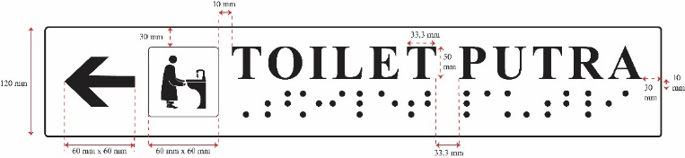

Figure 9. Proposed Wayfinding Signage Display Design

Table 4. Comparison of Current and Proposed Wayfinding Signage Symbols
Current Wayfinding Signage Symbols |  |  |  |  |  |  |  | Proposed Wayfinding Signage Symbols
Signage | Grand Mosque of Sheikh Zayed Surakarta | Great Mosque of Al-Aqsha Klaten | Great Mosque of Madaniyah Karanganyar | Great Mosque of Baiturrahmah Sukoharjo | Mosque of Siti Aisyah Surakarta | Mosque of Miftahul Jannah Sukoharjo | Respondent’s  Suggestion | Purposed Symbol
 |  |  |  |  |  |  |  | Male | Female
Toilet | 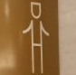 | 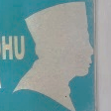 | 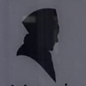 | 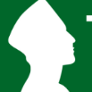 | 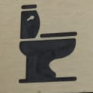 | 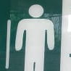 | Gender (LK/PR), Toilet Facilities |  | 
Toilet Disabilities | 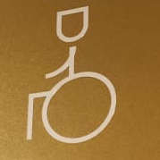 | NA | 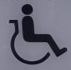 | NA | 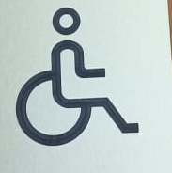 | NA | Gender (LK/PR), Toilet Facilities, Wheelchair |  | 
Ablution | 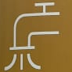 | 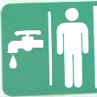 | 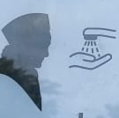 | 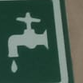 | 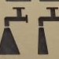 | 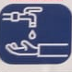 | Gender (LK/PR), Water Faucet, Wudhu |  | 
Ablution Disabilities |  | NA |  | NA | NA | NA | Gender (LK/PR), Water Faucet, Wudhu, Wheelchair |  | 
Prayer Hall | 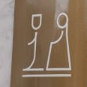 | NA | 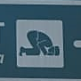 | NA | 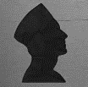 |  | Gender (LK/PR), Pray Activity |  | 
Purity Boundaries | 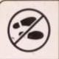 | NA | NA | NA | NA |  | Sandals/ Shoes Prohibited | 

The sink symbol visually represents the object and activity commonly associated with toilets. This symbol adheres to the public information symbols guideline [37], incorporating cultural adjustments such as the addition of a pecis (Muslim cap) and hijab (headscarf). The signs specifically for people with disabilities (toilet and ablution area signs) retain the wheelchair shape in accordance with international standards.
The ablution activity depicted on the ablution area sign explicitly conveys the symbol's meaning, whereas simply presenting a water faucet and visual representations of male and female bodies would require visitors to infer its meaning.
Praying in the prayer hall is associated with worship. This symbol is simpler, and the body shaping is clearer compared to the prostration movement. This symbol refers to the public information symbols guideline [37].
Sandals are chosen because there is a hadith from HR Abu Daud about wearing sandals to the prayer area [38]. Sandals are more commonly worn when entering the mosque than shoes, so the cultural context makes it easier to interpret the symbol of the sacred space boundary.
Recommendations for the placement of signs in mosques are based on the normative references SNI 03-6574-2001 [39] and ANSI A117.1 (1998) [40]. Sign height is determined based on anthropometric data for the Indonesian body, including body height, standing eye height, standing hand-grip height, and shoulder height. The data was obtained from Antropometri Indonesia's official website, with body data criteria for ages 19–47 [41].
The 50th percentile is used for body height so that all groups can reach the signs. The 95th percentile is used for eye height to ensure visitors' movement does not obstruct the signs. The 5th percentile is used for standing hand grip height [41] so that it can be reached by all visitors, especially for tactile Braille. For shoulder height, the 95th percentile is used to ensure the signs are not too low. Based on the 4 dimensions above, the minimum height for installing the signs is 165 cm.
Based on anthropometric considerations and accessibility standards, several recommended placements for wayfinding signage in mosque environments were developed. These placement configurations are illustrated in Figures 10–14, which show examples of signage installation on different types of walls and door configurations commonly found in mosque buildings.
Figure 10 shows the recommended placement of wayfinding signage on a wall in a mosque environment. The approximately 165 cm installation height from the floor is determined based on anthropometric data for the Indonesian population. This height ensures that the signage is easily visible to users while remaining accessible for tactile elements such as Braille. The placement also minimizes visual obstruction caused by pedestrian movement and improves overall signage legibility.

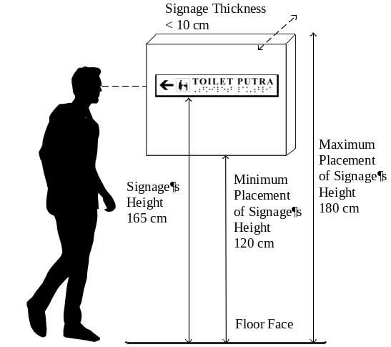

Figure 10. Placement on Walls

Different door and corridor configurations may influence the optimal placement of wayfinding signage in mosque environments. To address these variations, several recommended configurations for signage placement were developed. These configurations are presented in Figures 11–14.

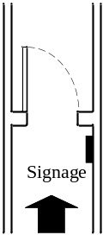  Figure 11. Placement on the Corridor Wall Single Push Door | 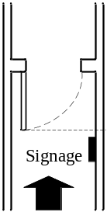  Figure 12. Placement on the Corridor Wall Single Pull Door
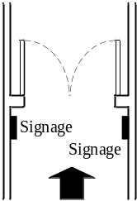  Figure 13. Placement on the Wall Double-Push Door | 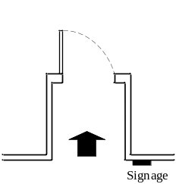  Figure 14. Placement on the Wall Sliding into the Single Push Door

3.4 EVALUATION OF WAYFINDING SIGNAGE LEGIBILITY IN MOSQUE
Legibility is defined as the ease with which the eye can detect words or letters to obtain the information contained in them [6]. The results of interviews and observations indicate that the legibility of current wayfinding signage is relatively low. This is due to the font size being too small, the color combinations being insufficiently striking, the placement of the signs being non-strategic, and the sign material being glaring.
Smaller font sizes lead to longer observation times. Text that is too small makes it difficult for observers to identify letters [42]. The font size of current wayfinding signage is around 1.5-2 cm, which visitors consider too small.
Color is an important element for attracting attention, conveying meaning, and enhancing aesthetics [43]. The color combinations used on current wayfinding signage are diverse and irregular. Diversity occurs not only between mosques but also within mosques themselves. The diversity of colors encourages visitors to adapt to each mosque they visit constantly.
The non-strategic placement of signs makes it difficult for visitors to find them. Yu et al. state that there is a correspondence relationship between sign height, readability distance, and font size [44]. Respondents suggest installing signs separating men and women at the mosque entrance.
The materials used for current wayfinding signage include metal plates, acrylic, and glossy-laminated stickers that reflect light. Signs with increased reflectivity will be less legible [43]. Visitors report reduced readability due to glare from the sign material, particularly under nighttime lighting.

3.5 ANALYSIS OF SIGNAGE LEGIBILITY TEST RESULTS
This study found that reading speed for correct words increases with font size. This finding is in line with [45], who state that the speed and accuracy of visual processing, such as identifying characters in printed displays, is systematically influenced by contrast, size, and field luminance. The Friedman test results demonstrate that font size has a significant impact on the legibility of wayfinding signage (sig 0,000 < 0,05). This finding is consistent with [11] and [46]. The primary cause of a sign's lack of legibility from a distance is its font size [3]. Inappropriate size affects subjective judgements that are worse in terms of perception, such as legibility, sharpness, and general preference [35]. Too small font sizes make it difficult for people to identify letters within words' internal patterns. Font sizes that are too large will occupy display space, resulting in less information visible within a single eye fixation. The 5 cm size was chosen because it has the highest average accuracy for correct answers.
This study found that typeface does not significantly affect the legibility of wayfinding signage. This finding is consistent with the findings of [14], but contradicts the findings of [15], who stated that there is a significant difference in typeface legibility. Although serif and sans serif typefaces were not significantly different in this study, the accuracy rate of correct answers for serif was higher (2.39) than for sans serif. Therefore, serif was chosen for the proposed wayfinding signage display design. The reading time for words on serif printed surfaces is faster than that of sans-serif [13]. Serif is 5% more legible than sans serif, and visual acuity is slightly improved when serif is used instead of sans serif [14]. Serif reading speed is faster than sans serif, although this effect disappears with increasing font size [47]. There are two reasons why serif can improve legibility. First, serifs can increase credibility by creating special codes for more complex letters. Second, the serif characteristics that give the ends of strokes can create a horizontal illusion that can guide the reader's eye movement [48].
This study found that color combinations do not significantly affect the legibility of wayfinding signage. This finding is consistent with [9], who stated that there is no significant effect between chromatic and achromatic colors, but this finding contradicts [49], who stated that several color combinations have different effects on legibility. Achromatic colors in this study achieved higher correct-answer accuracy (2.40) than chromatic colors; therefore, achromatic colors were selected for the proposed sign display. Black font on a white background achieves optimal legibility [28]. The contrast of the chromatic color combination (white-green) is 88.2%, while the achromatic color combination (black-white) is 100%. Both meet ADAAG standards (minimum 70%), so the effect of the significant difference in their influence is not significantly visible.

3.6 ANALYSIS OF SIGNAGE SYMBOL COMPREHENSION TEST RESULTS
This study found an increase in understanding of wayfinding signage symbols after the introduction of new symbols. This finding is consistent with [28] and [21]. Correct answers on the comprehension test were divided into 3 categories: correct, partially correct, and wrong. This is in line with [21], [50], [51]. However, this model differs from [52], which considers only right and wrong answers. The correct-answer variation model enables deeper exploration of the level of understanding.
The level of understanding of current wayfinding signage symbols in mosques is relatively low, especially for toilet signs (13.33%) and toilet signs for people with disabilities (13.33%). This does not meet the ISO 3864-3:2006 standard, which requires a minimum of 67%. The low level of understanding is due to two reasons: the presence of ambiguity, which leads to the interpretation of symbols not in accordance with their original meaning [21], and the lack of contextualization of symbol design [52].
Rousek & Hallbeck state that to redesign symbols appropriately, respondents' feedback needs to be considered [53]. This study also compares existing wayfinding signage symbols across the four mosques identified to expand the reference base in the creation of new symbol designs. These new symbols were then tested with respondents, and the results showed increases in understanding of toilet signs (53.34%), toilet signs for people with disabilities (50.01%), and ablution areas (30%). All respondents understood the new symbol for the ablution area for people with disabilities. The symbols for prayer areas and sacred boundaries did not increase understanding, as they already convey the true meaning and are therefore easy to interpret and unambiguous. This statement aligns with [54], which states that ambiguity is one of the characteristics that negatively affect a person's performance in understanding symbols.
Ben-Bassat & Shinar [50], Siswandari et al. [50], and Patel & Murkhopadhyay [8] found that the more symbols are designed with ergonomic principles in mind, the more likely users who have never seen them before are to understand them. The three principles studied in this research are familiarity, compatibility, and standardization. Familiarity is described as the frequency of encounters between the symbol and the user. Compatibility is the correspondence between a symbol and the message it represents. Standardization is described as the consistency of a homogeneous representation of shape, color, symbols, direction, and so on [50]. The results of this study show that the three ergonomic principles are significantly interrelated, with positive relationships among them. The three of them make a unique contribution: the more frequent the encounters between users and the symbol, the more opportunities there are to learn its meaning and store it in memory. The ease of learning symbols is supported by standardization, which creates order in processing information.

CONCLUSION
This study aimed to evaluate the legibility of wayfinding signage in mosques and design a more ergonomic wayfinding signage display. The design process involved a preliminary study (interviews and observations), experiments, and the exploration of symbols. The expected output of this study is a prototype wayfinding signage display ready for use in mosques to improve the legibility of wayfinding signage. This is important because good wayfinding signage will create a sense of comfort, safety, and security for visitors during their time in the mosque area.
The findings of this study are that (1) font size has a significant effect on the legibility of wayfinding signage. (2) Typeface and color combinations do not have a significant effect on the legibility of wayfinding signage. (3) New symbols designed with an ergonomic approach (based on the principles of familiarity, compatibility, and standardization) can improve the level of understanding of respondents. The three are positively correlated. (4) There was an increase in the legibility of wayfinding signage after the proposed wayfinding signage was introduced to respondents.
Further research is expected to consider cognitive tools such as EEG, GSR, and eye tracking to determine the body's response to the stimuli provided. This relates to the more complex cognitive-visual abilities of humans. In addition, exploring other factors related to the legibility of wayfinding signage in mosques, such as lighting levels, sign material, field luminance, and viewing angle, will enrich the scientific knowledge base.

ACKNOWLEDGEMENT
The authors would like to express their sincere gratitude to all the individuals and institutions that contributed to the successful completion of this research. Special thanks to LPPM Universitas Sebelas Maret for funding the research with contract Number: 371/UN27.22/PT.01.03/2025.

REFERENCES

[1] V. Dharmawan and N. Rachmaniyah, “Kajian Signage dan Elemen Wayfinding di Kampus Perguruan Tinggi (Studi Kasus : Kampus ITS Surabaya),” Arsitektura, vol. 19, no. 2, p. 205, 2021, doi: 10.20961/arst.v19i2.49152.
[2] P. Sari and D. P. Bomo, “Desain Wayfinding Dalam Keterbacaan Dan Pelaksanaan Studi Kasus Jakarta International Stadium,” J. Ilm. Arsit., vol. 12, no. 2, pp. 116–130, 2022, doi: 10.32699/jiars.v12i2.3585.
[3] J. D. Bullough, “FACTORS AFFECTING SIGN VISIBILITY, CONSPICUITY AND LEGIBILITY: REVIEW AND ANNOTATED BIBLIOGRAPHY,” Interdiscip. J. Signage Wayfinding, vol. 1, no. 2, pp. 2–25, 2017, DOI: https://doi.org/10.15763/issn.2470-9670.2017.v1.i2.a9.
[4] C. Piepenbrock, S. Mayr, I. Mund, and A. Buchner, “Positive display polarity is advantageous for both younger and older adults,” Ergonomics, vol. 56, no. 7, pp. 1116–1124, 2013, doi: 10.1080/00140139.2013.790485.
[5] M. A. Tinker, Legibility of Print. Iowa State University Press, 1969. doi: 10.1097/00006324-196402000-00008.
[6] D. A. Tarasov, A. P. Sergeev, and V. V. Filimonov, “Legibility of Textbooks: A Literature Review,” Procedia - Soc. Behav. Sci., vol. 174, pp. 1300–1308, 2015, doi: 10.1016/j.sbspro.2015.01.751.
[7] B. T. Kuhn, P. M. Garvey, and M. T. Petrucha, Sign Legibility The Impact of Color and Illumination. United States Sign Council. 1998.
[8] G. Patel and P. Mukhopadhyay, “Ergonomic analysis and design intervention in symbols used in hospitals in central India,” Appl. Ergon., vol. 94, no. November 2019, p. 103410, 2021, doi: 10.1016/j.apergo.2021.103410.
[9] Y. Shi, Y. Zhang, T. Wang, C. Li, and S. Yuan, “The effects of ambient illumination, color combination, sign height, and observation angle on the legibility of wayfinding signs in metro stations,” Sustain., vol. 12, no. 10, 2020, doi: 10.3390/su12104133.
[10] T. Yanagihara, K. Omori, and K. Hiroshi, “Legibility of Japanese Characters in Graphic Floor Signs for Elderly People,” J. Access. Des. All, vol. 12, no. 2, pp. 335–353, 2022, doi: 10.17411/jacces.v12i2.357.
[11] M. P. Vidal-ribas and B. J. Katz, Effects of Font Design on Highway Sign Legibility Effects of Font Design on Highway Sign Legibility, Virginia Tech, 2023.
[12] L. Werth and F. Strack, “An inferential approach to the knew-it-all-along phenomenon,” Memory, vol. 11, no. 4–5, pp. 411–419, 2003, doi: 10.1080/09658210244000586.
[13] J. T.E. Richardson, The Legibility of Serif and Sans Serif Typefaces: Reading from Paper and Reading from Screens. Springer, 2022.
[14] A. Arditi and J. Cho, “Serifs and font legibility,” Vision Res., vol. 45, no. 23, pp. 2926–2933, 2005, doi: 10.1016/j.visres.2005.06.013.
[15] C. Innes-Parker, “University of Prince Edward Island,” Florilegium, vol. 20, no. 1, pp. 120–122, 2003, doi: 10.3138/flor.20.036.
[16] N. Bonnardel, A. Piolat, and L. Le Bigot, “The impact of colour on Website appeal and users’ cognitive processes,” Displays, vol. 32, no. 2, pp. 69–80, 2011, doi: 10.1016/j.displa.2010.12.002.
[17] Y. Y. Yeh, D. S. Lee, and Y. H. Ko, “Color combination and exposure time on legibility and EEG response of icon presented on visual display terminal,” Displays, vol. 34, no. 1, pp. 33–38, 2013, doi: 10.1016/j.displa.2012.11.007.
[18] S. M. Huang, “A study of reading time and viewers’ preferences for a variety of combinations of character-background chromaticity for small traditional Chinese characters,” Percept. Mot. Skills, vol. 103, no. 3, pp. 887–895, 2006, doi: 10.2466/PMS.103.3.887-895.
[19] C. C. Lin, “Effects of screen luminance combination and text color on visual performance with TFT-LCD,” Int. J. Ind. Ergon., vol. 35, no. 3, pp. 229–235, 2005, doi: 10.1016/j.ergon.2004.09.002.
[20] J. Dobres, S. T. Chrysler, B. Wolfe, N. Chahine, and B. Reimer, “Empirical assessment of the legibility of the highway gothic and clearview signage fonts,” Transp. Res. Rec., vol. 2624, no. 2624, pp. 1–8, 2017, doi: 10.3141/2624-01.
[21] Y. Siswandari, W. Kim, and S. Xiong, “Comprehension and redesign of recently introduced water-sport prohibitive symbols in South Korea,” Int. J. Ind. Ergon., vol. 50, pp. 196–205, 2015, doi: 10.1016/j.ergon.2015.09.018.
[22] M. D. Gall, J. P. Gall, and W. R. Borg, Educational Research: An Introduction. Pearson/Allyn & Bacon, 2007.
[23] I. Alwi, “Kriteria Empirik dalam Menentukan Ukuran Sampel Pada Pengujian Hipotesis Statistika dan Analisis Butir,” Form. J. Ilm. Pendidik. MIPA, vol. 2, no. 2, pp. 140–148, 2015, doi: 10.30998/formatif.v2i2.95.
[24] P. Gordon, “Visual acuity-DYOP® versus Snellen acuity charts: A review.,” J. Clin. Ophthalmol, vol. 6, no. 1, pp. 500–503, 2021.
[25] F. Lombu and E. Panggabean, “Membangun Sistem Testing Buta Warna Menggunakan Metode Ishihara,” J. Comput. Networks, vol. 2, no. 1, pp. 218–221, 2020.
[26] S. Nasution, “Variabel penelitian,” Raudhah, vol. 05, no. 02, pp. 1–9, 2017, DOI: http://dx.doi.org/10.30829/raudhah.v5i2.182
[27] J. E. Sheedy, M. V. Subbaram, A. B. Zimmerman, and J. R. Hayes, “Text legibility and the letter superiority effect,” Hum. Factors, vol. 47, no. 4, pp. 797–815, 2005, doi: 10.1518/001872005775570998.
[28] G. Franken, M. Pangerc, and K. Možina, “Impact of typeface and colour combinations on lcd display legibility,” Emerg. Sci. J., vol. 4, no. 6, pp. 436–442, 2020, doi: 10.28991/esj-2020-01243.
[29] T. M. Bisbey, R. Grossman, K. Panton, C. W. Coultas, and E. Salas, "Design, Delivery, Evaluation, and Transfer of Effective Training Systems". In Handbook of Human Factors and Ergonomics, Wiley, 2021. doi: 10.1002/9781119636113.ch16.
[30] E. B. Sulistiarini and U. Widyagama, Kognitif Ergonomi dan Beban Kerja --- Buku Referensi, STRADA Press, July. 2020.
[31] F. Ishartomo, B. Suhardi, and J. M. Rohani, “Ergonomic principles in traffic signs comprehension: A literature review,” AIP Conf. Proc., vol. 2217, no. April, 2020, doi: 10.1063/5.0000701.
[32] D. Junaedi and A. Cholisana, “Perancangan Visual Display Informasi Dengan Pendekatan Ergonomi,” J. Penelit. dan Apl. Sist. Tek. Ind., vol. 15, no. 2, pp. 137–146, 2021.
[33] S. Berrio, L. H. Barrero, L. Zambrano, and E. Papadimitriou, “Ergonomic factors affecting comprehension levels of traffic signs: A critical review,” Int. J. Transp. Sci. Technol., vol. 12, no. 3, pp. 848–861, 2023, doi: 10.1016/j.ijtst.2022.08.004.
[34] M. U. Setyoningrum, “Cara Pemimpin Perempuan Dalam Mengelola Konflik Di Organisasi Kemahasiswaan,” Borneo J. Islam. Educ., vol. I, no. 2, 2021,
[35] T. Kurushima et al., “A study on legibility with pairwise comparison in simultaneous multilingual display on digital signage,” CHIRA 2019 - Proc. 3rd Int. Conf. Comput. Interact. Res. Appl., no. Chira, pp. 112–119, 2019, doi: 10.5220/0008162101120119.
[36] A. Arditi, “Rethinking ADA signage standards for low-vision accessibility,” J. Vis., vol. 17, no. 5, pp. 1–20, 2017, doi: 10.1167/17.5.8.
[37] The Study Committee of Public Information Symbols, Public Information Symbols Guideline 2021. 2021.
[38] A. Halim, “Dialektika Hadis Nabi dengan Budaya Lokal Arab,” DINIKA Acad. J. Islam. Stud., vol. 4, no. 1, pp. 65–82, 2020, doi: 10.22515/dinika.v4i1.2060.
[39] Badan Standardisasi Nasional, “SNI 03-6574-2001 tentang Tata Cara Perancangan Pencahayaan Darurat, Tanda arah dan Sistem Peringatan Bahaya Pada Bangunan Gedung,” Badan Standarisasi Nas., pp. 1–22, 2001.
[40] American National Standard Institute, Accessible and Usable Buildings and Facilities. 2013.
[41] Norfiza and Infi, “Kajian Antropometri & Ergonomi,” vol. 5, no. 2, pp. 449–459, 2011.
[42] E. Crundall, D. R. Large, and G. Burnett, “A driving simulator study to explore the effects of text size on the visual demand of in-vehicle displays,” Displays, vol. 43, pp. 23–29, 2016, doi: 10.1016/j.displa.2016.05.003.
[43] E. Meyer, P. Atchley, A. Professor, L. Hoffman, and I. Ahmed, “Assessing the Effect of Glare on Sign Legibility,” no. 785, 2011.
[44] H. Yu, T. Akita, T. Koga, and N. Sano, “Effect of character contrast ratio of tablet PC and ambient device luminance ratio on readability in low ambient illuminance,” Displays, vol. 52, no. November 2017, pp. 46–54, 2018, doi: 10.1016/j.displa.2018.03.002.
[45] M. S. Rea and M. J. Ouellette, “Relative visual performance: A basis for application,” light. Res. Technol., vol. 23, no. 3, pp. 135–144, 1991, doi: 10.1177/096032719102300301.
[46] Z. J. Khan, “Wayfinding experience in healthcare: Investigation of the factors contributing to visitors’ wayfinding experience within a hospital complex,” SEU J. Sci. Eng., vol. 13, no. 1, pp. 13–21, 2019.
[47] R. A. Morris, K. Aquilante, D. Yager, and C. Bigelow, “P‐13: Serifs Slow RSVP Reading at Very Small Sizes, but Don’t Matter at Larger Sizes,” SID Symp. Dig. Tech. Pap., vol. 33, no. 1, pp. 244–247, 2002, doi: 10.1889/1.1830242.
[48] S. Beier, Reading Letters: Designing for Legibility. Amsterdam. Bis Publishers. 2011.
[49] T. Nilsson, Legibility of colored print International Encyclopedia of Ergonomics, 2nd Edition, New York: CRC Press , 2006.
[50] T. Ben-Bassat and D. Shinar, “Ergonomic guidelines for traffic sign design increase sign comprehension,” Hum. Factors, vol. 48, no. 1, pp. 182–195, 2006, doi: 10.1518/001872006776412298.
[51] Y. K. Ou and Y. C. Liu, “Effects of sign design features and training on comprehension of traffic signs in Taiwanese and Vietnamese user groups,” Int. J. Ind. Ergon., vol. 42, no. 1, pp. 1–7, 2012, doi: 10.1016/j.ergon.2011.08.009.
[52] S. Lee, S. S. Dazkir, H. S. Paik, and A. Coskun, “Comprehensibility of universal healthcare symbols for wayfinding inhealthcare facilities,” Appl. Ergon., vol. 45, no. 4, pp. 878–885, 2014, doi: 10.1016/j.apergo.2013.11.003.
[53] J. B. Rousek and M. S. Hallbeck, “Improving and analyzing signage within a healthcare setting,” Appl. Ergon., vol. 42, no. 6, pp. 771–784, 2011, doi: 10.1016/j.apergo.2010.12.004.
[54] R. S. Goonetilleke, H. M. Shih, H. K. On, and J. Fritsch, “Effects of training and representational characteristics in icon design,” Int. J. Hum. Comput. Stud., vol. 55, no. 5, pp. 741–760, 2001, doi: 10.1006/ijhc.2001.0501.

