 |  | JOURNAL OF ISLAMIC ARCHITECTURE  P-ISSN: 2086-2636 E-ISSN: 2356-4644  Journal Home Page: http://ejournal.uin-malang.ac.id/index.php/JIA
BUILT HERITAGE AS A SUSTAINABLE SOURCE OF CONTEMPORARY DESIGNS THROUGH POSTMODERN ARCHITECTURE: KHANS OF MOSUL
Emad Hani Ismaeel^{a*}, Hassan Mahmood Kasimª, Raghad Akram Abdel Rahman^{b}
ªDepartment of Architecture, Faculty of Engineering, University of Mosul, Iraq
^{b}Department of Construction and Project, University Presidency, University of Nineveh, Iraq
*Corresponding Author: emad.hani.ismaeel@uomosul.edu.iq
ARTICLE INFO |  |  | ABSTRACT
Volume: 8  Issue: 4  Page: 1093-1108  Received: July 7th, 2024  Accepted: January 4th, 2025  Available Online: December 30th, 2025  DOI: 10.18860/jia.v8i4.28534 |  |  | Urban heritage is a vital repository of cultures and is often protected through various methods. Postmodern architecture emerged as a response to modern architecture, aiming to return to nostalgia. It has varied in its approach to heritage and differs from place to place, resulting in a diversity of its products. This paper aims to use postmodern architectural methods to revive heritage and local architecture in Mosul, linking new additions to the old city's history and heritage. The research employed a quantitative method, with a semi-structured questionnaire on proposed designs inspired by postmodern architectural trends. The results showed that many postmodern architectural trends offer varying degrees of opportunity to preserve the spirit of the city's heritage and history. The principal trends of the postmodern movement, such as neo-realism, Neoclassicism, and neo-rationalism, have the potential to provide innovative modern designs that reflect the spirit of history and preserve the Islamic architectural heritage of the city in varying ‎ratios that can be further developed. Future studies could investigate the potential of presenting designs that reflect the architectural characteristics of historic buildings to yield more comprehensive, generalizable results.  Keywords:  Built Heritage; Postmodernism; Sustainable Design; Khans; Mosul Islamic Architecture

- INTRODUCTION
Mosul's modern parts require places that evoke memories of the old city, necessitating a return to postmodern architectural styles to revive heritage and local architecture. This can be done through contemporary buildings that mimic urban heritage, or through the most appropriate reuse of constructed and historic buildings [1]. This research aims to develop design alternatives for commercial buildings that align with postmodern trends in heritage and historic architecture. The study comprises three sections: discussing postmodern architectural trends and methods; examining local and Khan architecture in Mosul during the Ottoman period; and proposing design alternatives for new commercial buildings in postmodern heritage styles. The research uses the example of Khan buildings as a case study to determine the extent to which built heritage elements can be incorporated into modern building design, ensuring compatibility with prevailing design standards. The study aims to assess the potential of built heritage as a design reference for contemporary buildings, focusing on the Khan buildings as a case study.

  - POSTMODERNISM TREND
As a reaction to modernity, the trend of postmodern architecture emerged, calling for a return to the past, nostalgia for it, and investment in the inherited, and asserting that what exists now is only a continuation of the past, the result of development and life changes [2]. Therefore, postmodern architecture varied in its approach to heritage and differed from place to place. This diversity led to the variety and multiplicity of postmodern products and their architectural and urban characteristics [3]. Since postmodernism emerged as an intellectual and creative trend in various cultural and artistic fields, it can be noted that many studies related to this trend have been completed in various fields and specializations to this day, for example: Study of Hariharasudan [4] in literature, Bertens [5] and Alruwaili [6] in literary criticism, Carter [7] in literary theory, Preda [8] and Hossain [9] in sociology, Elusivewax [10] in arts, Pathak [11] and Elaati [12] in political theory, Multani [12] in research methodology, and Shirkarami [13] in educational aspects. From the above studies, some common ideas emerge: the time frame begins in the 1960s, spreads widely in the 1970s, and continues to this day. Opposition, rejection, or reaction to modernity and its principles (cutting off from history, rejecting local cultures to integrate into one global civilization; adopting the authority of logic and science; adopting advanced technology). Postmodernism is not a single intellectual current; rather, it comprises multiple intellectual orientations and schools that contradict one another. It first appeared in creative production (literature, art, architecture) and then spread to all intellectual fields, with significant overlap across specializations. It was characterized by acceptance of pluralism: the plurality of ideas, cultures, and beliefs, and the rejection of the existence of a central, dominant culture [2] [14]. As for creative production, it rejected the distinction between high and popular art, embracing a mix of art forms. In which creative and intellectual production intersect with socio-economic conditions. It included the ambiguous, indistinct relationship among the producer (artist, writer, or researcher), the product, and the recipient. Superior scientific and technological development helps achieve the many goals of postmodernism [15].
As for architecture, since Charles Jencks coined the term postmodern architecture in 1977, research, articles, and theorizing continue to this day. These architectural studies align with the general principles of postmodernism in the intellectual fields, but differ in their application in architecture. There is a wide range of definitions of postmodernism. This difference and controversy surrounding it are mainly due to the multiplicity of its concept, intellectually and philosophically, as well as the diversity of its meanings across critics, leading to contradictions and overlaps. Postmodernism is generally associated with multiplicity and difference. Postmodern architecture constitutes a reaction and a critique of modernity rather than an alternative or a stand-alone action. It did not, in general, propose a vision of transcending modernity. Still, rather, it presented details to address the secretions of modernity (in terms of orientation towards history, society, and form), which, in general, constituted a partial view that contributed to the multiplicity and fragmentation of the image of postmodern trends [16]. Postmodernism implies the absence of a single, true, and commonly accepted center and periphery. It strives for pluralism and peaceful coexistence among the different, even the opposite [17]. It is a complex and intertwined configuration of diverse ideas and opinions. Postmodern architecture is a continuous process that is acceptable to the public and specialized groups, and is suitable for both designers and consumers; its designs are diverse and eclectic [18]. It is characterized by ease of perception, free associations, and urban motives [19].
In his book "Complexity and Contradiction", Venturi’s ideas relied on sarcasm in postmodern architecture and on the concepts of inclusion and enclosure. He emphasized exploiting heritage and traditions to generate new ones, and he adopted this position in a way that relied on contradiction and complexity rather than simplicity and spontaneity. Traditions represent a system of great importance, and the architect must exploit and revive them in unconventional ways that align with prevailing developments. He criticized the repetition and reproduction of traditions in their basic form and in their previous methods. Still, it must respond to the current reality by studying and understanding it in a deeper, more comprehensive way, and avoid blind adherence to the same methods and techniques used previously, as traditions are linked to awareness and deep sensitivity to history [20]. He called for preferring hybrid elements over pure ones, distorted elements over clear ones, and ambiguous elements over clear ones, and adopting inclusion rather than exclusion, irregular vitality over clear unity, and richness of meaning over clarity. The buildings are characterized by complexity and richness of meaning, and they are a mixture of the local in an ironic style, relying on asymmetrical symmetry and changes in the locations of the elements. While Charles Jencks's proposals in "The Language of Postmodern Architecture" sought a multilingual, emotional, and cognitive architecture. He found it in postmodern architecture, as architecture is related to human experience and practice over time, and these experiences are translated through perception and thinking [21]. Postmodern architecture seeks two levels of meaning: the first concerns the architect, and the second concerns its reception by the public, especially those interested in tradition. Postmodern buildings depend on the fundamental selection of elements. Abdullatif [22] stated that urban heritage constitutes a source of inspiration through the richness of its elements and vocabulary to form a building that expresses the cultural identity and local character of the built environment. The concept of nostalgia can be followed through the approach of direct reproduction of heritage vocabulary, or the symbolic abstraction of heritage and an attempt to adapt it to express the modern era by taking the symbolic and moral meaning through induction, inference, and analysis of the elements, and then devising mechanisms for their formation [22]. Atef et al. [23] compared postmodern thought with the principles of Islamic architecture, such as simplicity, unity, diversity, and originality. Islamic and postmodern architectural thought stem from a single source: real architecture, a response to human psychological, social, and cultural needs. Both produce honest architecture that people understand, calling for originality, regional diversity, simplicity of form, and, sometimes, complexity and attention to detail [23]. Heise [15] wondered whether postmodernism is a concept, a practice, or an application. The concept of postmodernism relates to logical operations on a set of processes and a set of cultural terms. Postmodern architecture led to thinking about culture as a struggle between the new and the old, and between the past and the present, and that postmodern architecture has become richer in metaphor and historical images [19].

- 1. Postmodern architecture and history
Postmodern architecture, through its criticism, focused on rejecting the comprehensive vision of modernity, towards multiplicity, spatial and temporal connection, towards a return to the past and the historical depth of architecture, and emphasizing meaning towards moving away from the reductionism imposed by modernity, and making it an architecture containing contradictions and complexity takes it away from simplicity [24]. In his study, Jenks analyzed the international movement in its historical context, defining its goals, aspirations, and the rules that govern it, identifying its prominent characteristics in various aspects of art, and classified it according to five main distinct trends, which were represented by: Classical Metaphysical Orientation; Classical narrative orientation; Classical allegorical orientation; Oriented classic realism; and, Emotional classicism [16]. Postmodern symbolism (the symbolic) stemmed from forgotten memories [25]. Postmodernism looked to the past to reclaim ancient conceptions that modernism had avoided. An architectural element must stand in place and in time, linked to the given region and location. The buildings must fit the region's style by being humble, sensible, and respectful of traditional values. The new buildings should not be built near historical sites, as this would completely break the traditional thousand-year-old architectural style of public buildings [26]. Postmodernism leads to the creation of eclecticism and humor by combining past and present architectural styles [18]. Postmodern architecture seeks to reflect the identity of the human and the history of each nation, which is considered part of the nation's identity. It is characterized by ease of perception, free associations, and urban motives. In architecture, postmodern symbolism arose from forgotten memories [19]. According to Jencks, postmodern architecture features reflecting on the relationship between past and present and reinterpreting tradition, meaning it is not a mere copy of the past [18]. Traditional architecture refers to the design and construction of buildings deeply rooted in the cultural and historical context of a particular place. It is important because it provides a sense of continuity and connection to a particular place's past, fostering a sense of identity and belonging within the community [27]. Architectural and urban heritage, through the richness and uniqueness of its elements, has been a primary source of inspiration for researchers, professional practitioners, and those interested in laying the foundations for buildings that express the cultural identity and local character of the built environment. The architectural and urban production can be classified under one of two main directions of work [22]:
- Direct reproduction of the material vocabulary of heritage. This is done by molding heritage elements, re-reproducing them, and employing their components and details in building modern architectural and urban models with different functions that have no relation to the origins of that vocabulary. Therefore, it is an emotional, romantic trend driven by nostalgia and by the desire to recall the so-called beautiful times through formal reproduction.
- Symbolic and moral inspiration from the structure of heritage - this trend is based on systematic research. Through its various means of induction, analysis, and reasoning, the local conditions and contemporary cultural data of that time produced mechanisms that led to the formulation of this local heritage in the forms, elements, and formats it took. Then, devising concepts and deducing mechanisms that consciously and selectively interact with modern local data and conditions. Therefore, it is a trend that relies on rational pragmatism and the symbolic abstraction of heritage, and an attempt to adapt it to express the modern era, its tools and requirements, and, in a way, suit local circumstances and data, whether fixed or changing.

- 2. Postmodern Mechanisms
The design mechanisms used in postmodern architecture differ and vary according to the pluralism mentioned above. Postmodernism generally focused on the formal dimension and the dominance of the image as a semiotic sign and as a basis for cognitive acquisition and recognition of truth [16]. It attends to the play of surfaces, images, signifiers without concern for "depth", focuses on relational and horizontal differences, differentiations [25]. Postmodern architects have no hesitation in altering the proportions, colors, and functions of historical signs [28]. Stern counts three main areas of attention of postmodern architects that are all related to the production of meaning: the façade, the city, and the idea of "cultural memory. He calls these three areas decorationism, contextualism, and gesturism, and at the same time emphasizes the maximum use of materials and ingredients, as well as progress in modern construction techniques. An emphasis on curved lines, on the unpredictable affairs, on decoration and imitation, on non-functional beauty, and on the new architecture's transparent and mirror-like surfaces, and on the winding millenniums are considered major elements in postmodern architecture [18]. According to Jencks, postmodern architecture has features including: eclecticism that produces diverse kinds of harmonization and dissonant harmony; the use of antithetical materials; and a paradox, which is the second postmodern feature. This mutual aversion is humorous and satirical: a kind of urbanism and urban living in which buildings do not seem alone and are a mixture of rituals, imitations, and ridicule, which causes them to expand into other buildings around them; postmodern buildings have a human character or human shape [29]. One way to achieve this integration is to use traditional materials and construction techniques in a modern context. Another approach is to use traditional forms and motifs in a modern context. The integration of traditional and modern architectural elements can be challenging, particularly in finding the right balance between the two. Another is to ensure that the building is functional and efficient. The use of traditional materials and construction techniques can be more expensive and time-consuming than modern methods [27]. Its relationship with heritage resources includes [30]:
- Imitation: copies one or more element from the heritage resource of certain period ‎and paste it on the new building, which gives a feeling that the building is old and ‎trying to present it in a modernist style focusing on aesthetics and formal aspects, on ‎the elevations of buildings with some modifications; It is use principles of addition and ‎repetition, or shifting in the scale and proportions of original heritage elements ‎without consideration to the other architectural design aspects. It is a kind of architectural falsification and seems naïve.‎
- Affixing: selects traditional architectural elements or style and tries to distribute them on the façades of modern buildings without paying attention to the final form of the building or its function.
- Analogy: refers to the heritage using certain heritage elements on modern and sophisticated methods of design to fit it with the new requirements or to solve specific design problems, whether it is structural, environmental, or any other problem.
- Inspiration: taking the causes of heritage resources, their philosophy of design, and their content into account, and trying to reformulate it and use it with new and innovative thoughts of design. An architect can reflect various design methods, whether in spatial relationships or forms, with some signs that are abstract or indirect to the architectural styles of heritage resources, depending on their personal vision.
- As mentioned above, postmodern architecture is based on metaphor, and the differences among its trends lie in several aspects, including the source of the metaphor, its scale, its use, and its relationship to the building (function or location). There have been many trends in postmodern architecture in the way it deals with heritage and its emulation of it, and several trends have emerged, the most important of which are:
- Neorealism: It depends on freedom from traditional symbols and the use of historical elements and images in a fragmented and expressive way. It is characterized by separating compositions from each other and by relying on contradictory metaphors, dualities, and historical metaphors, while distorting them, to create a spirit of communication with the past, stripping elements of their context and inserting them into a new one. Among the most important mechanisms adopted in this approach are: inclusion and enclosure, ambiguity and surprise, diversity and vitality, skewed axis, asymmetry, dynamic balance, distortion of simple shapes, ornamentation, preferring hybrid, distorted, ambiguous, and complex elements over the original, and adding historical elements with a dual function. Figure1. shows examples of the Neorealism trend.

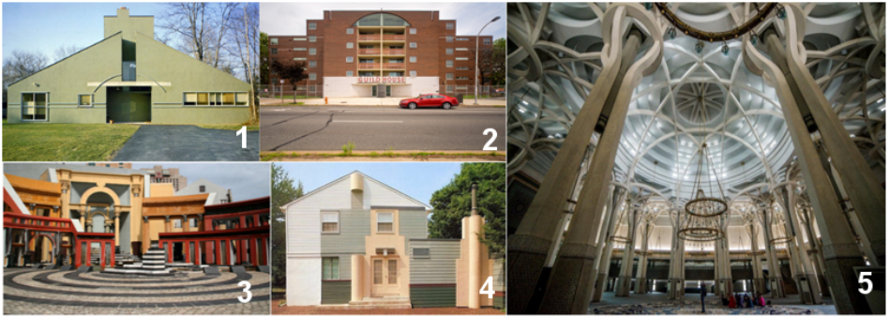
Figure 1. Examples of the New Rationalism trend: 1) Vanna Venturi House in Chestnut Hill, USA, 2) Piazza d'Italia in New Orleans, USA, 3) Guild House in Philadelphia, USA, 4) Schulman House in Princeton, USA, and 5) The Islamic Center ‎in Rome, Italy [31].

- Neoclassicism: History is considered a storehouse and repository of formal images, and historical references are dealt directly with traditions to generate new and innovative works, focusing on the characteristics of copying and repetition, and focusing on apparent characteristics of the chosen architecture, as traditions are considered fixed models that are exploited as they are without change. Figure 2 shows examples of the new Neoclassicism trend.

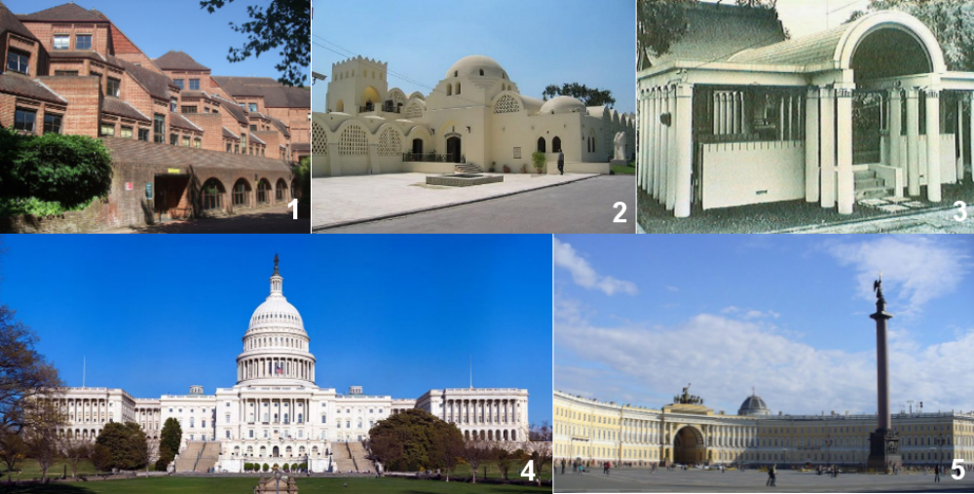
Figure 2. Examples of the Neoclassicism trend: 1) Hillingdon Civic Centre in London, UK, 2) New Qurna Village in Luxor, Egypt, 3) Kamimuta Matsuo Shrine in Kuamoto, Japan, 4) The Capitol Building in Washington D.C., USA, and 5) General Staff Building – St. Petersburg, Russia [31].

- Neo-rationalism (typical): This movement studied architecture as an independent phenomenon and considered it a basic reference from which other works are generated, while exploiting in the concept of style in dealing with traditions, and the concept of change in building patterns over time, that is, exploiting in the subject of history as a basis and source for generating new forms by relying on patterns and principles. More than using history as a source of icons and imagined impressions, they consider history as a source for deducing the basic rules and principles of architecture. It generates meanings linked to inherited patterns or to parts of previous shapes, or new meanings resulting from assembling parts in a new context to generate new patterns that can accommodate new requirements. It focuses on treating structural properties that are perceived by the mind and composition. That is, it is a concept linked to the essence and rises above abnormal individual practices and thus depends on the rules of composition and assembly. Figure 3 shows examples of the Neo-rationalism trend.

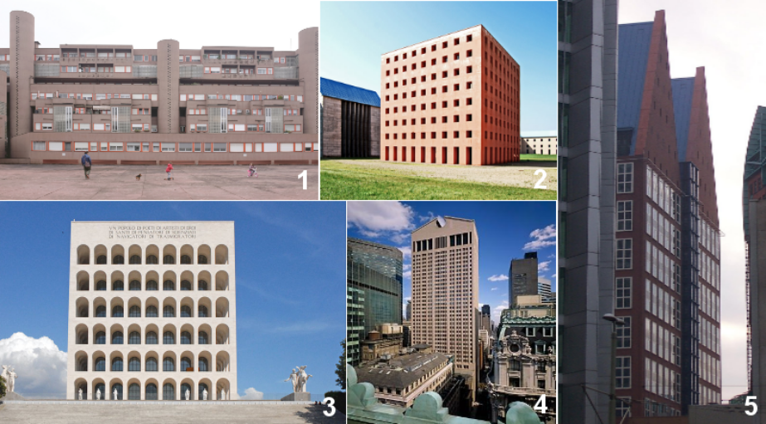
Figure 3. Examples of the Neo-rationalism trend: 1) Gallaratese in Milan, Italy, 2) San Cataldo cemetery in Modena, Italy, 3) Palazzo della civiltà del lavoro in Rome, Italy, 4) AT&T Building in New York, USA, and 5) Castalia in The Hague-Netherlands, [31].
Based on the above, it is possible to conclude a set of indicators used in the method of dealing with heritage within postmodern trends, as shown in Table 1.

Table 1. Indicators Used in Dealing with Heritage within Postmodern Trends (researchers)
Vocabulary | The 1st trend  Neorealism | The 2nd trend  Neoclassicism | The 3rd trend  New Rationalism
How to deal with references | History is a storehouse of mental images. It is dealt with in a fragmented manner by selecting forms and abstracting them from their context. | History is a storehouse of mental images that it deals with through direct reproduction. | Utilizing the rules of composition and assembling, selecting from the pattern, that is, dealing with principles and not shapes.
Approved strategy | Metaphor | Metaphor | Typical transformation
The mechanism followed | Increase the scale of items, displaced axis, change the proportions of elements, contrast in the façade, column amplification, change the proportions of masses, rhythm, segmentation of elements, heterochromia, break the arches, abstracting elements. | Direct copying of elements, repetition in the use of elements, use old finishing elements and materials, Imitating the past with modern mechanical means, Using traditional patterns in treatments. | Increase the scale of items, displaced axis, change the proportions of elements, contrast in the façade, column amplification, change the proportions of masses, rhythm, segmentation of elements, heterochromia, break the arches, abstracting elements.
Items used | Decorating, misaligned axis, columns, opening elements, finishing materials, gabled roof, masses proportions, amplification  contradiction, break the arches. | Columns, arches, colors, finishing materials, all the classic elements in directly away. | Simple shapes from historic patterns with utilized in their patterns.
Properties | Ambiguity, surprise, vitality, diversification, dynamic balance, asymmetry, skewed axis. | Classic | Classic
Method of conveying meaning | Meaning through emotions and moving them towards the heritage | Indication through direct allusion | Indication through reference
The nature of meaning and its levels | Visual relationships, abstraction, and juxtaposition, and their role in conveying meaning and communicating with the past | Meanings inherited from past forms | Inherited meanings linked to previous patterns that are based on collecting parts and installing them in a new context

- THE IRAQI ARCHITECTURAL EXPERIENCE IN DEALING WITH BUILT HERITAGE
Mosul is one of the most important cities in Iraq. The architectural movement in the city has experienced what other local and regional cities have gone through. In recent years, many studies have been conducted locally on the characteristics of modern architecture and its relationship to the built heritage. Naser and Mohammadi [32] stated that identity in Iraq is heavily influenced by Islam and its regulations, which have significantly shaped architecture and urban design. During the colonial period, political factors played a significant role in transforming the local environment. Supporters of the architectural trend used signs and symbols from traditional buildings to design façades, aiming to evoke a sense of tradition. However, this overuse negatively affected architectural practices in Iraq. Instead, Iraqi architects embraced the local environment by understanding historical architectural compositions and values, rather than imitating them. This led to a more authentic and localized approach to architecture. Al-Thahab [33] confirmed that the deteriorating architecture and urbanism of contemporary Iraq reflect the distorted and destroyed state of society, with values that are unacceptable in comparison to the noble heritage. This deterioration accurately portrays the current state of society, its values, principles, and beliefs, as a true expression of its culture. Iraqi cities are losing their character and becoming more ambiguous due to external and internal factors. Investment companies adopted foreign designs that did not respect the city's culture. The motivation for studying traditional architectural identity is to find ways to transfer or recreate useful logical principles to maintain local identity. The radical global changes require changing the old established thinking and practice about architectural identity, making architecture a reflection of people's culture, needs, and participation [32].
According to Aldauji et al. [34], architectural production is characterized by diversity and dispersion, with continuous changes in the evaluation of trends. This includes views on local heritage values and the effects of contemporary global architecture. The balance between local and modern trends is crucial for achieving local identity and addressing the challenges of implementing them. New architects are fascinated by contemporary global trends, which bring renewed ideas and abundant design output. However, their level of application of these concepts in their design output is weak. The architect's negative view of multiple approaches to creating local identity and the mechanisms for achieving it in the design output is a major factor. The level of application of the vocabulary used to achieve this identity is more closely related to the basic human needs of the resident than to the specific local characteristics of a residential environment. Hassan and Abdullah [35] stated that rapid technological advancement and other factors have led to chaos in contemporary Arab architecture, resulting in a loss of identity due to two contradictory trends: the return to heritage architecture and Western modernity. This has led to a lack of clarity in the Arab architectural intellectual structure and to an absence of identity and clear direction in the view of heritage. Contemporary Arab architecture has reflected the prevailing intellectual orientation, but it has not achieved its goal of identity and continues to represent individual architectural experiences. Identity is determined by its intellectual and architectural orientation, which absorbs and meets the Arabs' current requirements, needs, methods, and traditions while respecting the specificity of place and time. Tradition is the skill and art of beginning, but it is the basis of the problem. Analysis and criticism are essential to the mature awareness of Arab architecture, as they constitute the intellectual and material approach to it. As Malaika [36] notes, Iraqi cities are losing their architectural identity due to the construction of new buildings that create contradictions within the urban landscape, thereby affecting local privacy and intimacy. Architecture and identity are inseparable, reflecting the culture and communicating language of the city. Technology plays a significant role in shaping the urban and architecture identity. To maintain Iraqi architecture, technology should be applied rationally and regulated effectively, resulting in architecture that reflects the country's culture and identity. Iraqi building regulations and codes need to be rewritten to adopt a more detailed approach, and detailed studies should be conducted on the appropriate use of building materials, especially for main elevations, to prevent poor choices that affect urban and architectural identity. The study [37] examines changes in Iraqi house style over time, focusing on the impact of modernity on both traditional and contemporary styles. It identifies the negative impact of modernity on the housing style. It suggests that Western designs do not cater to the residents, suggesting that traditional ideas can be adapted and redrafted to achieve a more traditional yet contemporary house. The study [38] aims to clarify the concepts of architectural style and movement, identify their indicators, and examine their impact on contemporary design in Iraqi architecture from 1965 to 2005. The research identified a general trend towards the necessity of heritage in contemporary architecture and developed a conscientious approach to heritage and a conceptual understanding of style. It highlights the importance of bridging the gap between public thought and personal style in the contemporary Iraqi architectural movement. Omar et al. [39] aimed to identify the factors contributing to vandalism of the architectural heritage of Iraqi cities and to propose actions to maintain and rehabilitate this heritage. The sites of historic buildings and the local urban fabric are a leading school in providing design models and planning that are consistent with Arab individual behavior. Maintaining urban and architectural heritage requires balancing the evolution of the growing urban population with policy renewal. Drawing inspiration from the past and modern spirit, heritage should be a bridge between past and present, focusing on information and documentation to prove the authenticity of civilization, identity, and memories, using traditional construction materials and upgrading to conform to the technical requirements of the age. The study [40] explores the impact of privacy and everyday life on the physical properties of built and urban spaces in contemporary Iraqi cities. It suggests that future development efforts should prioritize personal privacy in the socio-spatial organization of homes, rather than personal space. It suggests creating responsive settlements, building regulations, and frameworks for architects and developers to create engaging living environments that consider socio-spatial needs.

- 1. Khans of Mosul in the Ottoman Era as an Islamic Architecture
The city of Mosul is one of the most important cities in the Middle East due to its architectural, urban, and geographical characteristics throughout the ages [41]. The Islamic architecture movement in Mosul during the Ottoman era constitutes a link in a continuous chain of architectural development in the region, although each stage has its own characteristics. The Khans' architecture was the most prominent architectural element during the Ottoman era, as it played an important role in the city's economic life. Each part is designed to perform a specific function that facilitates trade operations and serves those responsible for them. The Khan, in its simplest concept, is the building that indicates the store, the place of commerce, those engaged in buying and selling, and their place of residence and trade. It was also used to indicate the station and home of travelers and commercial convoys [42]. Among the most important historic khans in Mosul are: Khan al-Qalawin (Al-Shabkhun) in 1841, Khan Hammu al-Qaddu in 1882, and Khan al-Gumraq in 1702. See Figure 4a and 4b.

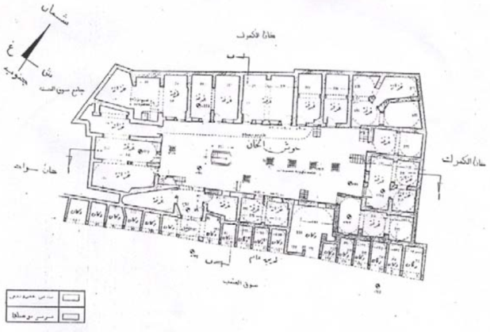 | 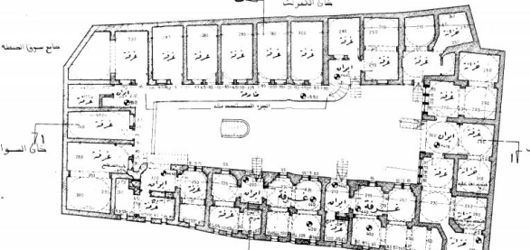
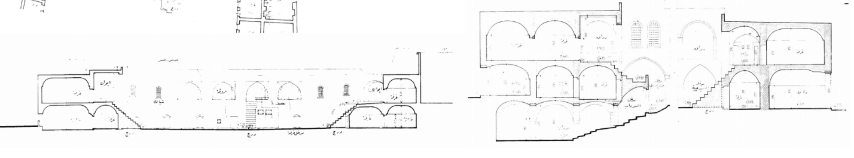
Figure 4a. Khan al-Qalawin (Al-Shabkhun) [42]

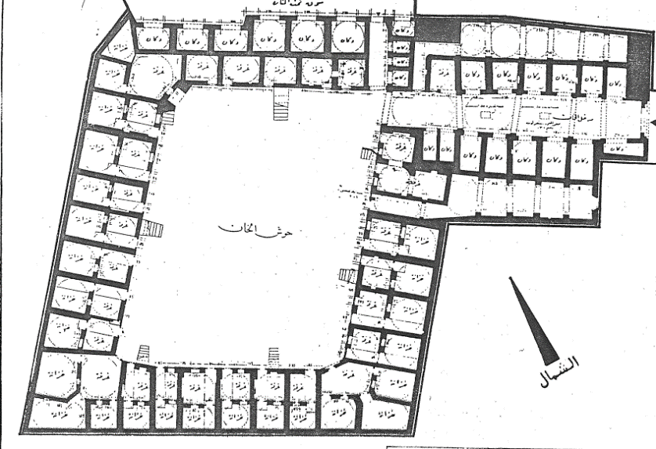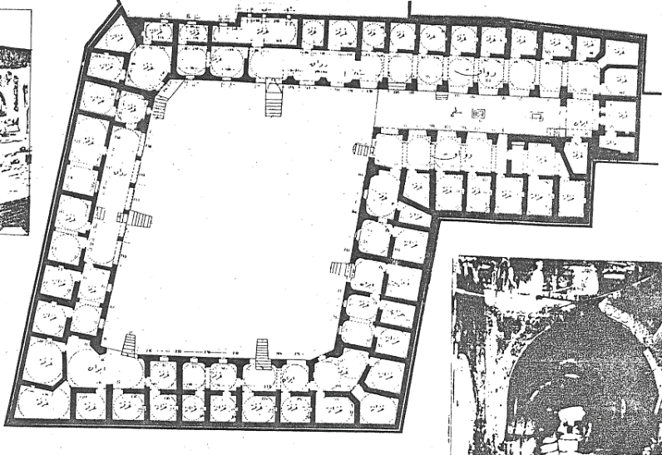
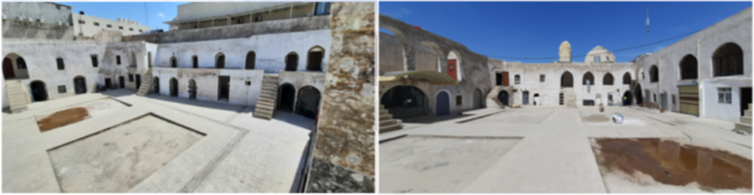
Figure 4b. Khan Hammu al-Qaddu [42]

The most important architectural elements of the historic Khans in Mosul are shown in Table 2.

Table2. Architectural Elements of the Historic Khans in Mosul (researchers)
Building elements | Architectural and structural characteristics
Walls | They are thick and high, with some castle-like features. At its top, windows open in the form of a small circular ring of alabaster to bring in light and air overlooking the street.
Entrance | The entrances to the Khan are huge and protrude from its outer walls. They are flanked on both sides by small chambers or entrances. Some of them are topped with decorations, or they may be abstract, and construction begins on them in rows. The entrance is in the middle of the walls. The Khan has more than one entrance.
The bridge  (Quntara) | A stone and brick building is erected above the entrance. The arch is semicircular, often made of alabaster.
Inner courtyard | It is the core of the Khans' design. It is opened. It is surrounded by a construction consisting of two or three floors. Its shape is often square or rectangular and is paved with tiled stones.
The basement | Its lighting comes from windows that either open onto the courtyard or from its ceiling. It is usually used for storage. Its columns, walls, and floors are made of alabaster. Its roof is made of arches raised by semicircular arches.
Al-Iwan | It is a rectangular space, surrounded by walls on three sides, open on one side, and usually covered by a barrel vault.
Arcades | They are usually found on the upper floors and advance the rooms.
Vaults | Three types of vaults can be distinguished: The high, pointed vault above the openings of the Iwans; The semicircular vault above the entrance to the small rooms and stairs; and the arched vault above the main door at the entrance to the Khan.
Building materials | Plaster and stones were used. Adding whiteness to the plaster in the plaster arches and vaults. Alabaster was used in arches, capitals, columns, door frames, windows, and in the basement and Iwans. Limestone was used in some elements in the entrances.
Decorative elements | Khans lack many decorative elements, and there are few of them in the marble door and window frames of the entrances.

- METHODS
This research methodology consisted of two main parts. In the first part, a theoretical framework was developed to extract and define the main architectural trends of the postmodern movement that addressed heritage with respect, while specifying its architectural and urban characteristics. In this stage, a descriptive table was produced that can be applied to different design examples to test the extent to which they apply the principles and characteristics of these trends. While the practical part relied on a quantitative method to determine the findings of the case study. A questionnaire was constructed comprising 15 semi-structured questions for each of the three orientations, resulting in a total of 45 questions. The questionnaire was distributed to a group of 96 local architects, comprising faculty members at the University of Mosul, master's students, managers, and members of architectural engineering offices in the city. The respondents were selected to ensure a representative sample of individuals closely related to the characteristics of Mosul's old city. The questionnaire was constructed based on a table of characteristics and features of the three postmodern architectural trends. The questionnaire included a series of questions designed to evaluate the approach and its application (form), the mechanism used in the approach, the extent to which the meaning was communicated, the level of clarity of the designer's goal, and the type of mental image of the project.
Additionally, a set of supplementary questions was included to elicit clear, specific answers. The functional programme of the proposed building was developed in accordance with the requirements of local citizens. The components were proposed based on contemporary requirements for mixed-use projects (commercial, administrative, and residential) and on international standards for such projects. The programme was presented to three experts (heads of architectural design studios who are faculty members at the University of Mosul) for review and improvement, to achieve maximum credibility and realism. See Appendix 1 for further details. A total of 78 participants responded, while the remaining individuals did not. A three-point Likert scale was employed to assign weights (ranging from 1 to 3), with 1 assigned to the proposal that achieves the least amount of the required aspect and 3 to the proposal that achieves the most.

- THE CASE STUDY
The historical and heritage buildings in the city of Mosul are of high architectural value, characterized by unique elements and details from the different historical periods that have shaped them [43]. The current research aims to assess the feasibility of transferring the spirit of Islamic architecture in Mosul and its heritage elements to the modern parts of the city. The historic city is located on the right bank of the Tigris River in Mosul. Therefore, the proposed location was chosen on the left side of the site, specifically on Al-Faisaliah Street, as shown in Figure 5.

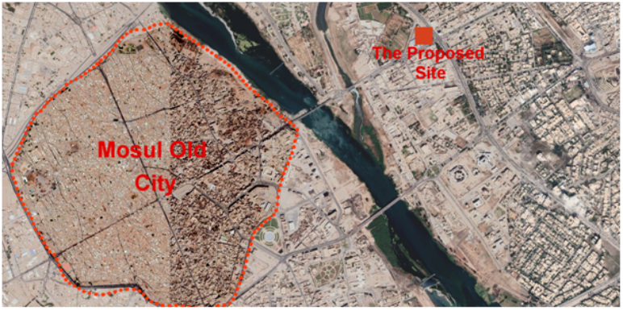
Figure 5. Mosul Old City and Location of the Case Study Site on the Left Part of the City [44]
- RESULT AND DISCUSSION

- RESULTS: APPLYING POSTMODERN ARCHITECTURE INDICATORS TO THE KHANS OF MOSUL
For testing the methodology of the current research into the possibility of designing a modern building according to the three trends extracted from Table 1, the following terms will be applied to the buildings of the Khan, as shown in Table 3.

Table 3: Postmodern Architecture Indicators to the Khans of Mosul
Vocabulary | Neorealism | Neoclassicism | New Rationalism
How to deal with references | Formal features are borrowed at the element level only, modified, and used fragmentarily. | The formal elements are used as they are in direct copying. | Borrowing essence and style from the khans
Approved strategy | Metaphor | Metaphor | Typical transformations
The mechanism followed | Amplification of some elements, A contradiction in the components of the façade between the past and the present, changing the proportions of elements, partitioning elements (such as columns), and changing the function of some elements. | Reproducing elements traditionally and respecting them as they are in their context | Opening inward in the plan  Central courtyard style, around which the rest of the spaces revolve  Arched entrance style  Façades with high walls from the outside, devoid of openings except for openings at the top of the walls
Items used | High walls; building with alabaster, stone, and plaster; use of the courtyard, arcade, Iwan; ornamentation and decoration; lighting the basement with windows at the floor of the courtyard; arched entrance. | Direct reproduction of all formal elements | Opening inward in the plan  Central courtyard style, around which the rest of the spaces revolve, Arched entrance style, Façades with high walls from the outside, devoid of openings except for openings at the top of the walls

Three design alternatives were developed based on indicators for the three trends of postmodern architecture derived from the theoretical framework. The first alternative adopted the Neorealist trend, respecting the building mass for context, neighborhoods, planning, and blocks, with mixed land uses. Within the inner courtyard space, the arches in the arcades and their sectional parts were modified and supported on a column devoid of decoration. Regarding the external façade, the windows, based on the column body, were designed in a style borrowed and modified from the original elements typical of windows and doors in Mosul’s heritage architecture. The keystone of the arch was also transformed into a glass block for lighting from the top of the arcades, and the decorations of the Mosul iron handrails were borrowed. The entrance mimics the Khan's entrances and arches and is framed with Mosul alabaster decorations. ‏ See Figure 6.

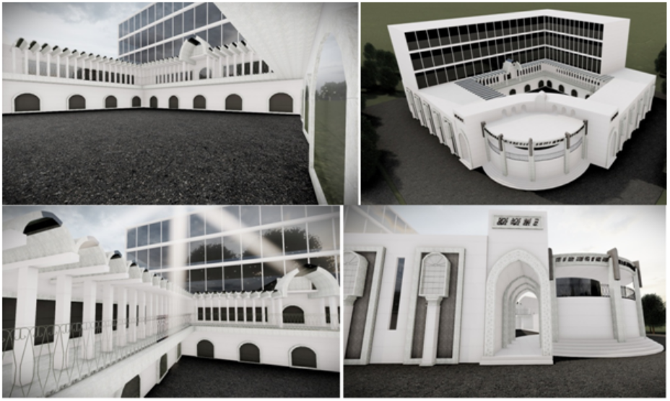
Figure 6. Alternative to the Trend of Neorealism

The second alternative adopted the Neoclassical trend by adhering to the heritage and its architectural characteristics as they are. The building was designed to match the characteristics of the Khan, based on the original Khan's plan, while adding new functions. Formal and decorative elements were used directly to frame some elements, including the arched and tower entrances. Context and background were respected in the building mass and blocks, with a mix of land uses. See Figure 7.

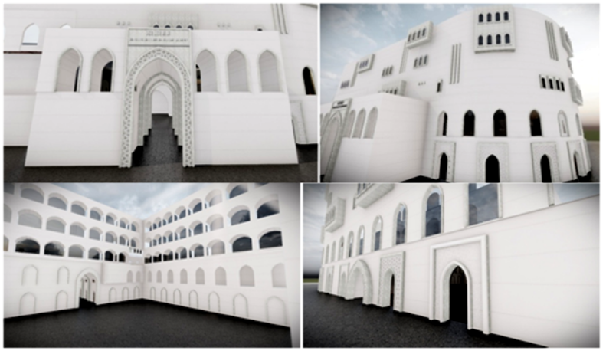
Figure 7. Alternative to the Trend of Neoclassicism

The third alternative adopted the trend of the new Rationalism, producing a building that mimics the Khan style and local architecture. The inner courtyard and openness were borrowed from the plans of the original khans, with the characteristic of multiple courtyards, generating two courtyards instead of one, with mixed land uses. In the external façades, blind high walls with few openings were used. The style and size of the external openings (entrances and windows), and the relationships between them, were borrowed from the buildings of historic Khan and abstracted into their basic components. See Figure 8.

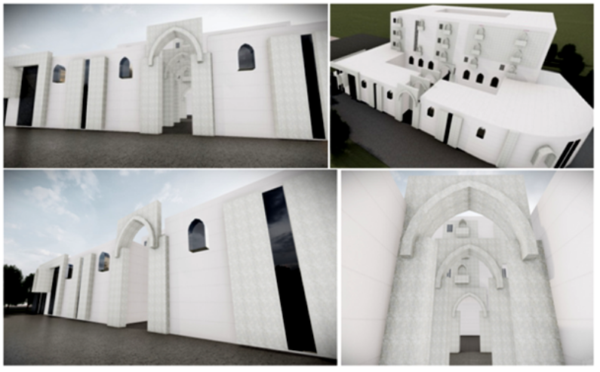
Figure 8. Alternative to the Trend of Rationalism

AutoCAD 2019 and 3ds Max 2020 software were used to produce realistic 3D models that can be viewed on desktop computers and data show displays. At the same time, a clip of the models was uploaded to an online page. The three project proposals were presented to the respondents and allowed to explore them after showing short video clips [45][46], and a set of historical photos about the heritage khans in Mosul [47]. A questionnaire was distributed to participants to assess the level of achievement of these three alternatives to the metaphor of heritage architecture in modern buildings. The questionnaire included a set of structured questions about the three trends, the extent to which they were realized within the design alternatives, and the extent to which they achieved the goals of the postmodernism movement and local identity in each alternative. After collecting the respondents' answers, the data were analyzed to determine the extent to which the objectives of the current study were achieved. See Appendix 2.
- DISCUSSION
The result of the evaluation was as follows: The Neoclassical proposal achieved the highest percentage, approximately 89.74%, of the goals of transferring the spirit and heritage characteristics of the old khans in Mosul city to the new building, according to the respondents’ opinions, while the Neorealism proposal achieved a percentage of 58.97%, while, the New Rationalism proposal only met this goal by 54.70%. Regarding the question of which of the three currents is preferred by the questionnaire (architects who are already aware of the characteristics of local architecture) as an approach that can reflect heritage architecture in the buildings of the modern parts, apart from the proposed alternatives, the answers were close to the results of testing the three alternatives. The Neoclassical trend received the highest percentage at 85.47%, while the Neorealism trend achieved 58.97%, and the New Rationalism trend increased to 59.82%. The answers to the question about the possibility of conveying meaning in the three proposals for transferring the identity of the heritage architecture of Mosul to contemporary design were as follows: The Neoclassical approach received the highest percentage, approximately 82.05%. While the Neorealism proposal achieved 58.12%, the New Rationalism proposal received 61.53%.
Regarding the extent to which the proposals achieve the mental image of Khan, the answers to the three proposals were as follows: Neoclassical received the highest percentage, 79.48%; Neorealism, 59.82%; and New Rationalism, 53.84%. The percentages for the three proposals regarding the design of external façades were close to the previous data, with Neoclassical at 81.19%, Neorealism at 64.95%, and New Rationalism at 56.41%. The answers to the remaining questions were almost identical to the previous ones, indicating that the respondents agreed that the solution proposed in the Neoclassical style was the most widely accepted among them for expressing the characteristics of heritage architecture in modern buildings with postmodern trends. ‏
The participants' answers included important comments about the test and the design solutions provided. More than one respondent stated that the effects of the color and characteristics of the finishing materials are important in determining which proposal is closest to achieving the goals. Note that these characteristics have been neutralised in the current study to reduce the number of influences and variables, especially since the three alternatives can use the same materials, and studying their effects requires independent future research.
One important observation made by some respondents is that the Khan in the old city is part of an urban fabric that includes neighborhoods, whereas the three proposals included designs for a single building. The designer intended this because what was required was not to design a building within a historic context, but rather to strive to design a modern building in the spirit of heritage architecture within a modern context. Therefore, the focus was not on the neighborhoods surrounding the designed building, but rather on the building's architectural characteristics. ‏Some respondents also provided detailed comments on the design proposals, such as the need to reduce glass areas, reconsider the proportions of the elements in three dimensions, and adjust the location of the elements relative to their surroundings. Others suggest that the proposals may need a more contemporary touch, whether at the level of masses or architectural details. Such comments can enhance the designs presented and enrich the architectural details within the parts of the building in question.
Compared with previous local and international studies, the current study demonstrated the emergence of postmodern approaches to heritage, employed in a variety of ways contingent on the intellectual concepts architects embraced. These approaches were operationalised through the mechanisms of reference management, strategy, object utilization, characteristics, meaning conveyance, and their typology and levels. In contrast to previous studies, the current study identified the principal trends of the postmodern movement, which addressed heritage and history through appreciation and representation within the contexts of new realism, new classicism, and new Rationalism. The objective is to provide an applied methodology for designing innovative architectural proposals that renew the spirit of the heritage elements of the old city of Mosul, reflecting its history and preserving the city's Islamic architectural heritage. The results of the questionnaire for the current study indicated partial agreement with the conclusions of previous studies regarding the feasibility of integrating the characteristics of historical buildings into new designs in a meaningful manner. This integration should be guided by an understanding of the design alternatives and the principles that inform each approach. The current study was distinctive in defining these principles as follows: the treatment of masses and spaces; the relationship between design and location; the employment of architectural elements; the compositional relationships between elements and masses; plan details; external façades; and the design of the façades of the internal courtyard. Furthermore, the current study distinguished itself from previous studies by providing quantitative information on the extent to which each of the three main trends of the postmodern movement achieved the goal of renewing the city of Mosul's urban and cultural heritage through modern designs. In this regard, the neoclassical trend proved particularly successful.

- CONCLUSION
The emergence of postmodern trends has led to the treatment of heritage in diverse ways. This contrast in treatment was based on the intellectual concepts adopted by architects. This difference included: how to handle references, the adopted strategy, the mechanism followed, the objects used, the properties, the method of conveying meaning, and the nature, quality, and levels of that meaning. The main trends of the postmodern movement, which dealt with heritage and history in forms of appreciation and representation, are neorealism, Neoclassicism, and new Rationalism. The Khan's buildings in the Old City of Mosul possess architectural features that merit transfer to modern buildings to preserve the city's Islamic and historical identity. The current research aims to present architectural proposals that adopt the design principles of the three trends in an attempt to renew the spirit of the heritage elements of the Old City of Mosul derived from the Khan's buildings. The current research explores the possibility of presenting innovative modern designs that reflect the spirit of history and preserve the Islamic architectural heritage of the city. The rates of achievement of the design objectives varied and could be further developed. The trend achieved the highest acceptance rate among the architects participating in the test, indicating the possibility of adopting it in the future for the design of modern buildings intended to protect local heritage. The results of the questionnaire indicated that the historic building of Al-Khan could be beneficially incorporated into the new design by considering the design alternatives aligned with the principles underlying each approach. These principles pertain to the treatment of masses and space, the relationship between the design and the site, the employment of architectural elements, the compositional relationships between elements and masses, the details of the plan, the external façades, and the design of the internal courtyard façades. The three proposals demonstrated satisfactory results in conveying the essence, establishing a link between the historical architectural style of Mosul and modern design principles, and creating an image of the Khan that reflects its historical identity. An extended future study can be carried out to examine the possibility of presenting architectural designs by analyzing the architectural characteristics of historic buildings in accordance with the different trends of postmodern architecture, to obtain more comprehensive and general results.

REFERENCES

[1] S. A. Jasim, E. H. Ismaeel, “The most appropriate reuse of historic buildings”, International Journal of Sustainable Development and Planning, Vol. 18, No. 6, Pp. 1865-1875, 2023. https://doi.org/10.18280/ijsdp.180622.
[2] S. Sudartini, “Postmodernism Paradigm and its View on The Existence of Language”, Revista de Gestão Social e Ambiental, Vol. 18, No. 7, pp. 1-26, 2024. DOI: 10.24857/rgsa.v18n7-003.
[3] I. Takahashi, “Peircean Interpretation of Postmodern Architecture”, Doctoral dissertation, Texas A & M University, 2013.
[4] A. Hariharasudan, D. Pandeeswari, A. Hassan, “Research Trends in Postmodernism: A Bibliometirc Analysis”, World Journal of English Language, Special Issue, Vol. 12, No. 2, Pp. 148-158, 2022.
[5] H. Bertens, "The Idea of the Postmodern: A History", Routledge, London,1995.
[6] H. Alruwaili, maijan, “Literary critic guide”, dalil alnnaqid al'adabi [arabic], Arab Cultural Center, 2002.
[7] D. Carter, Literary theory. Oldcastle Books, 2012.
[8] A. Preda, "Postmodernism in Sociology", International Encyclopedia of the Social & Behavioral Sciences, (Second Edition), Pp 676-679, Elsevier, 2015. DOI: https://doi.org/10.1016/B978-0-08-097086-8.32111-0
[9] D. Hossain, M. Karim, “Postmodernism: Issues and Problems”, Asian Journal of Social Sciences and Humanities, Vol. 2, No. 2, pp. 173-181, 2013.
[10] S. E. Parr, How postmodern and modern art became contemporary along with the new architecture and how the technological movement changed the way we see art defined by modern culture in the last 140 years, Elusivewax London Cambridge, pages 1-20, 2020. DOI: 10.13140/RG.2.2.33391.87200.
[11] P. Shailendra, “Postmodern”, in Block-2 Approaches to political theory, pp.84-96, New Delhi: Indira Gandhi National Open University, 2020.
[12] N. Multani, “Postmodernism: The Researcher and the Researched, Research Methodology: A Multidisciplinary Approach”, in Research Methodology, Pp. 167-181, Mohan Law House, 2015.
[13] J. Shirkarami, Y. Dusti, S. Azizi, “Postmodernism World: A Brief Analysis in Philosophical, Social and Educational Aspects”, KURMANJ: The Journal of Culture, Humanities and Social Science, Vol. 2, No. 2, pp. 20-23, 2020.
[14] Y. Farhangpour, A. Abdolsalami, "The Philosophy of Postmodernism, Its Scholars and Its Impact on Art”, Conference: International Conference on Research in Art, Singapore, 2016.
[15] U. Heise, “Science, technology, and postmodernism”, in The Cambridge Companion to Postmodernism, pp. 136-167, Cambridge University Press, 2004.
[16] O. A. Abood, “Postmodern Architecture between the pillars of philosophical discourse and architectural practice”, Journal of Engineering, Vol. 25, No. 5, pp. 1-20, 2019. DOI: https://doi.org/10.31026/j.eng.2019.05.08.
[17] N. Konovalova, “The Architecture of Postmodernism in Japan: The Main Features”, International Conference on Architecture: Heritage, Traditions and Innovations AHTI 2019, Advances in Social Science, Education and Humanities Research, Atlantis Press, vol. 324, 2019. DOI: 10.2991/ahti-19.2019.1
[18] N. Amiri, “Modernism and Postmodernism in Architecture, an Emphasis on the Characteristics, Similarities and Differences”, The Turkish Online Journal of Design, Art and Communication – TOJDAC, August Special Edition, Pp. 1626- 1634, 2016.
[19] R. Mikhailova, O. Perepelytsia, O. Zaitseva, N. Kubrysh, O. Samoylova, N. Melnyk, A. Demenko, “Architectural Graphics - From Inception to Postmodernism”, Postmodern Openings, Vol. 13, No. 1, Pp. 234-253, 2022. DOI: https://doi.org/10.18662/po/13.1/394.
[20] R. Venturi, Complexity and Contradiction in Architecture, 2nd (second) edition, New York: The Museum of Modern Art, 2002.
[21] C. Jencks, The Language of Postmodern Architecture, New York: Rizzoli, 1977.
[22] A. A. Abdelnaiem, “Inspiring urban heritage from reproduction to consolidating and sustaining local architecture and urbanism”, In Conference: Hosting Major International Events, Innovation, creativity and Impact Assessment, Cairo, Egypt, 2012.
[23] A. Ahriz, N. Zemmouri, F. Soufiane, “Postmodern Vision to Islamic Architecture”, Conference: International Forum on Islamic Architecture and Design IFIADAt: Sharjah, UAE, Vol. 001, 2008.
[24] S. Lin, “A Brief Discussion on the Presentation of the Artistic Characteristics of Postmodernism in Sculpture Art”, Highlights in Art and Design, Vol. 5, No. 3, Pp. 45-47. DOI: https://doi.org/10.54097/1xncq638.
[25] M. Farshad, “Post-Postmodern Urban Architecture based on Jacques Lacan’s three orders”, Ukrainian Journal of Ecology, Vol. 8, No. 1, Pp. 266–272, 2018.
[26] O. C. Gatwaza, X. CAO, “Deconstructivism: Richness or Chaos to Postmodern Architecture”, International Journal of Sciences, Alkhaer Publications, Vol. 6, No. 8, pp. 28-33, 2017. DOI: 10.18483/ijSci.1364.
[27] Architect Lens, “The integration of traditional and modern architectural elements”, Lens About Korea, 3 Feb. 2023. [Online]. Available: https://alens.tistory.com/entry/The-integration-of-traditional-and-modern-architectural-elements. [Accessed 7 June 2024].
[28] W. Sabbagh, “Characteristics of Postmodernism Reflected on Designs of ready-to-wear Children’s Clothing Using their Artistic Drawings”, Advances in Social Sciences Research Journal, Vol. 11, No. 2, pp. 124–150. 2024. DOI: https://doi.org/10.14738/assrj.112.16491.
[29] C. Jencks, Critical Modernism: Where is Postmodernism Going, Chichester: Wiley / Academy Press, 2013.
[30] A. Rjoub, “The Relationship between Heritage Resources and Contemporary Architecture of Jordan”, Scientific & Academic Publishing, Vol. 6, No. 1, pp. 1-12, 2016. DOI: 10.5923/j.arch.20160601.01.
[31] Archdaily web site, https://www.archdaily.com/
[32] Z. D. Naser, and M. K. Mohammadi, “Architectural Identity in the Iraq Within 100 Year Ago”, American Journal of Engineering Research (AJER), Vol. 11, No. 08, Pp. 126-133, 2022.
[33] A. Al-Thahab, “Culture and architecture in turmoil: reflections on home architecture in contemporary Iraq”, Open House International, Vol. 46, No. 1, pp 30-44, 2021. DOI: https://doi.org/10.1108/OHI-06-2020-0065.
[34] M. Aldauji, S. Ibraheem, H. Alsanjari, “Place Identity of Residential Environment in Iraqi Contemporary Architectural Trends and its Impact on Academic Architectural Product”, The Iraqi Journal of Architecture and Planning, Vol. 6, No. 1-2-3, Pp. 101-119, 2010. DOI: https://doi.org/10.36041/iqjap.v6i1&2&3.199.
[35] A. Hassan, K. Elkhazen, & J. Abdullah, “Contemporary Arab Architectural Trends and Heritage: Iraq as a Case Study”, Journal of Architecture, Arts and Humanities, vol. 13, No. 4, pp. 325-345, 2019. DOI: 10.21608/mjaf.2018.20404.
[36] M. Jameel, “The Loss of Identity in Contemporary Iraqi Architecture: Baghdad City”, The Second Engineering Conference of the Golden Jubilee of the College of Engineering, University of Mosul, pp. 40-50, 2013.
[37] S. Ali, and T. Yildirim, “Periodical Evolution of Typology in Arab Cities Housings and Influence of Modernism: Baghdad Case Study”, Journal of Science GU J Sci, Vol. 8, No. 3, Pp. 681-694, 2020.
[38] G. Rizouqi, and T. Muradis, “The relationship between style and movement in architecture and its impact in design on contemporary architectural works in Iraq”, Journal of engineering, Vol. 13, No. 1, 2007.
[39] O. K. Akram, S. Ismail, N. Utaberta, M. Y. M. Yunos, N.Ismail, N. Ariffin, “The Important Values of Architectural Baghdadi Heritage”, Advances in Environmental Biology, AENSI Journals, Vol. 9, No. 24, Pp. 46-52, 2015.
[40] A. Al-Thahab, S. Mushatat, and M. Abdelmonem, "Between Tradition and Modernity: Determining Spatial Systems of Privacy in the Domestic Architecture of Contemporary Iraq", Open House International, Vol. 41 No. 1, Pp. 74-81, 2016. DOI: https://doi.org/10.1108/OHI-01-2016-B0010.
[41] A. Hamad, E. Ismaeel, “Integrative conservation for recovering the riverfront of Mosul town”. International Journal of Sustainable Development and Planning, Vol. 18, No. 1, Pp. 41-51, 2023. DOI: https://doi.org/10.18280/ijsdp.180104.
[42] A. Al-Hayali, “Plans of Mosul khans in the Ottoman Period”, Journal of Mosul Studies, Vol. 8, No. 38, Pp. 25-61, 2012.
[43] E.H. Ismaeel, (2023), “D&C technique as an MCDM tool for managing the heritage value assessment of historic buildings in post-war cities: Mosul Old City as a case study”, Journal of Cultural Heritage Management and Sustainable Development, Vol. 15, No. 3, pp. 707-727, 2023. DOI: https://doi.org/10.1108/JCHMSD-03-2022-0042
[44] Google Maps website: https://www.google.com/maps
[45] Youtube website: https://www.youtube.com/watch?v=nl_5J34hcU0
[46] Facebook website: https://www.facebook.com/watch/?v=1099397850946629
[47] Facebook website: https://www.facebook.com/emad.h.ismaeel/posts/pfbid04CB6PFtpcw9h5kXZqfLb6H6DGQN92iTDvR79jiMz9AcHaAhUrhrRfzxQi6nzUqiEl

Appendix 1. The Functional Program of the Proposed Building

Spaces | No | area | Total area
Commercial part
Clothing stores | 32 | 10 | 320
Fabric stores | 32 | 2 | 64
Various shops | 24 | 15 | 360
Stationery | 60 | 1 | 60
Large shops | 100 | 6 | 600
Super Market | 300 | 1 | 300
Stores | 12 | 15 | 180
Restaurant | 500 | 1 | 500
Cafeteria | 200 | 1 | 200
Bathrooms and W.C. | 20 | 2 | 40
Maintenance rooms | 100 | 2 | 200
Administrative part | 200 |  | 200
The residential part
One room apartment | 34 | 15 | 510
Bedroom | 18
Hall | 8
Kitchen | 6
Bath room | 5 | 10 | 640
Two rooms apartment | 64 | 2 | 30
Bedroom | 15
Hall | 15
Kitchen | 12
Bath room | 10
Total |  |  | 4214
Structure and movement |  | 30% | 1264
Total area |  |  | 5478

Appendix 2. The Questionnaire form

