 |  | JOURNAL OF ISLAMIC ARCHITECTURE  P-ISSN: 2086-2636 E-ISSN: 2356-4644  Journal Home Page: http://ejournal.uin-malang.ac.id/index.php/JIA
INTEGRATING ENVIRONMENTALISM AND MINIMALISM IN CONTEMPORARY MOSQUE ARCHITECTURE
Eko Ariwidodo^{1*}
¹Universitas Islam Negeri Madura, Indonesia
*Corresponding Author: ekarwdd@gmail.com
ARTICLE INFO |  |  | ABSTRACT
Volume: 9  Issue: 1  Page: 199-220  Received: August 4th, 2024  Accepted: May 4th, 2025  Available Online: June 1st, 2026  DOI: https://doi.org/10.18860/jia.v9i1.28648 |  |  | This study explores the integration of environmental and minimalist principles within contemporary Islamic architectural philosophy. Adopting minimalist and environmentalist principles in modern Islamic architecture is challenging due to the conflict between them and the rich historical and decorative elements traditionally used in Islamic design. Environmentalism and minimalism have significantly influenced contemporary Islamic architecture, presenting architects and designers with the challenge of integrating traditional elements with modern design principles while maintaining cultural identity and adhering to sustainable practices. Environmentalism and minimalism are rooted in Islamic theology and European protest movements. While these philosophies offer environmentally conscious and culturally resonant architectural practices, there is a notable tension between them. This study aims to fill this gap by investigating how architects incorporate environmental and minimalist principles into their work and the cultural and historical contexts that have shaped these architectural philosophies. The knowledge gap in this area lies in the need for more research to examine the relationship between minimalism and contemporary Islamic architectural philosophy. The potential impact of this study lies in its contribution to the field of Islamic architecture, which is a broader discourse on sustainable design. By exploring the relationship between environmentalism, minimalism, and contemporary Islamic architectural philosophy, this study can inform the development of sustainable design strategies and promote a greater understanding and appreciation of the unique contributions of Islamic architecture to global architectural discourse.  Keywords:  environmentalism; minimalism; sustainable design; Islamic architecture philosophy; sustainable practices

INTRODUCTION
Environmentalism and minimalism have significantly influenced the current philosophies of Islamic architecture. Contemporary Islamic architecture faces the challenge of integrating traditional elements with modern design principles while maintaining cultural identity and adhering to sustainable practices [1]. Minimalism, which emphasizes simplicity and essentiality, aligns with the environmentalist ethos by reducing excess and focusing on necessity, thereby yielding more sustainable design outcomes [2]. This convergence suggests the philosophical synergy between minimalism and environmentalism within the Islamic context. However, there is notable tension in Islamic environmentalism, which has roots in European protest movements but seeks to break from Western neoliberal values [3]. This dichotomy presents a unique challenge to contemporary Islamic architecture.
The convergence of environmentalism and minimalism within contemporary Islamic architectural philosophy is a significant study area, combining sustainable design principles with Islamic aesthetic and functional aspects. Kamal and Nasir (2022) discuss the minimalist aesthetic for sustainable building and design. They emphasize philosophy and its alignment with Islamic architecture’s historical grandeur and rejection of materialism, fostering a sense of spiritual connection and transcendence. Motruk [4] further elaborates on the technical and psychological benefits of minimalist green spaces in architecture. At the same time, El-Fayoumi [5] highlights the sustainable design inherent in Islamic architecture, including the use of natural materials and green spaces. El-Daghar discusses the importance of symbolism in architectural heritage, which may seem at odds with the stripped-down aesthetic of minimalism. However, integrating these principles can lead to innovative design solutions that respect environmental concerns and cultural identity [6]. The background study of the intersection between environmentalism and minimalism in contemporary Islamic architectural philosophy is crucial. It allows a deeper understanding of how modern sustainable practices can harmonize with Islamic cultural and religious significance. This integration not only addresses the environmental challenges of our time but also preserves and enriches the architectural identity of Islamic societies, instilling a sense of cultural pride and appreciation [4], [5], [6].
The reconciliation of these philosophies within the Islamic architectural context underscores the potential for a distinctive yet globally relevant architectural expression. The potential for unique, globally relevant architectural expressions underscores the importance of further exploring and celebrating the fusion of these philosophies within the Islamic architectural context. To fully realize the potential of this fusion, it is crucial to delve deeper into the cultural and historical contexts that have shaped these architectural philosophies and to promote a greater understanding and appreciation of their unique contributions to Islamic architecture. Environmentalism and minimalism have become increasingly important in contemporary Islamic architectural philosophy as architects and scholars seek to balance traditional design principles with modern sustainability and environmental concerns. The topics of environmentalism and minimalism in contemporary Islamic architectural philosophy are essential because they highlight the need for architects and designers to consider the environmental impact of their work and to incorporate sustainable design principles into their practice. Previous research has explored the history and theory of Islamic architecture and the principles of environmentalism and minimalism in design.
The growing importance of environmentalism and minimalism in Islamic architectural philosophy highlights the convergence of traditional Islamic values with contemporary concerns for sustainability and simplicity. The fundamentals of Islamic theology, which emphasize stewardship of the earth and the responsible use of resources, form the basis of environmentalism in Islamic architecture [3]. Furthermore, minimalism in architecture is embraced for its aesthetic and philosophical merits and intersects with Islamic environmentalism, which interprets environmental issues through the lens of Islamic theology. Historically, Islamic architecture has incorporated sustainable features, such as courtyards and mashrabiya, demonstrating a commitment to environmental principles [2].
The minimalist approach in packaging design, which reduces waste and resource consumption, illustrates the practical application of minimalism in promoting sustainability [7]. Therefore, environmentalism and minimalism in Islamic architectural philosophy represent a convergence of ethical, aesthetic, and practical considerations, advocating for a built environment that is both spiritually meaningful and ecologically responsible, and drawing on Islamic principles that are inherently compatible with sustainable and minimalist design [8], [9]. Integrating these philosophies into Islamic architecture preserves cultural heritage. It addresses contemporary environmental challenges, offering a holistic, forward-looking approach to design deeply rooted in tradition [10].
The knowledge gap in this area lies in the need for more research examining the relationship between environmentalism, minimalism, and contemporary Islamic architectural philosophy. This study aims to fill the knowledge gap in this area by examining how architects and designers incorporate environmental and minimalist principles into their work within the context of contemporary Islamic architectural philosophy. What are the fundamental design principles and strategies that architects and designers use to incorporate environmentalism and minimalism into contemporary Islamic architectural philosophy? This study explored how architects and designers incorporate environmental and minimalist principles into their work within contemporary Islamic architectural philosophy.
This approach to sustainable, minimalist design in Islamic architectural philosophy is rooted in the growing awareness of the impact of human activity on the environment and in the desire to create buildings in harmony with nature. A review of the literature on Islamic architectural philosophy reveals that these principles are incorporated in contemporary designs and have historical roots in Islamic architecture, which has been rediscovered and adapted by modern architects and designers to address current environmental concerns. Furthermore, this approach is seen as a way to reconcile traditional Islamic architectural philosophy with contemporary environmental challenges while promoting a more sustainable way of living.
This study is significant because it contributes to understanding the relationship between environmentalism and minimalism in Islamic architectural philosophy. It highlights the potential for this relationship to inform sustainable design practices. Its application and implication are that it can inform the design of sustainable buildings that incorporate the principles of Islamic architectural philosophy. The novelty of this study lies in its exploration of the relationship between environmentalism and minimalism in Islamic architectural philosophy, a topic that has yet to be extensively studied.
The discourse on environmentalism and minimalism in contemporary Islamic architectural philosophy reveals a multifaceted conversation. Modern architectural trends, such as minimalism, have been influenced by historical precedents and are increasingly aligned with sustainable design principles. The minimalist approach, characterized by simplicity and the essential, aligns with the environmental pillar of sustainability by promoting less material use and focusing on the necessary [4]. The literature indicates a positive correlation between a minimalist ethos and environmental sustainability, reflected in the principles of Islamic architecture. Therefore, the convergence of minimalism and environmentalism within contemporary Islamic architectural philosophy offers a promising avenue for sustainable design that honors cultural heritage.

METHODS
The present study focuses on environmentalism and minimalism in contemporary Islamic architectural thought and employs a multifaceted methodology. This methodology encompasses several theoretical, analytical, and practical approaches. Theoretical frameworks, such as the Unified Architectural Theory [13], [14], and principles derived from Islamic knowledge and values, are used to formulate design strategies and criteria for sustainable architecture suitable for the Muslim world [8], [1]. Practical approaches entail case studies and examination of buildings based on sustainability parameters and modern architectural techniques [13]. It is interesting to note that minimalism in Islamic architecture, often associated with the less-is-more philosophy, also incorporates historical and religious elements such as minarets, courtyards, and mashrabiya, reflecting a commitment to Islamic civilization and a rejection of materialism.
This integration of minimalism with Islamic architectural elements is seen as a way to preserve cultural identity while embracing sustainable, environmentally conscious design practices. The research methodology in this field encompasses a combination of theoretical exploration, analytical examination of Islamic architectural elements, and practical case studies [14]. These methods collectively aim to reconcile the principles of minimalism and environmentalism with Islamic cultural and religious contexts, thereby contributing to the development of a sustainable architectural philosophy that is both modern and reflective of Islamic values [13].

RESULT AND DISCUSSION

RESULT
The concept of environmentalism in contemporary Islamic architecture is deeply intertwined with the principles of minimalism, as both advocate for simplicity, the use of natural resources, and a focus on essential elements. Kamal and Nasir discuss how minimalism in architecture, with its less-is-more philosophy, aligns with Islamic architecture’s sustainable and non-materialistic values (Figure 1) [15].

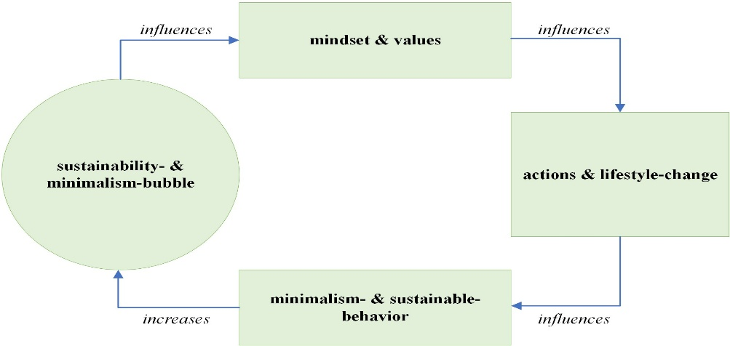

Figure 1. Minimalism: A Simple Design Philosophy [15]

Ragozina delves into Islamic environmentalism, rooted in Islamic theology and emphasizing a break with Western neoliberal values, suggesting a philosophical synergy with minimalism [14], [16]. Hassan and Motruk further reinforce the relationship between minimalism and sustainability, with Hassan focusing on the application of minimalism in sustainable metal furniture design and Motruk highlighting the technical and environmental benefits of minimalist landscape architecture. Interestingly, while minimalism and environmentalism are harmonious in theory, Selcová also noted that minimalist residential buildings may not necessarily be sustainable or energy-efficient, suggesting potential contradictions in practice.
El-Fayoumi, Loo, and Mahdavinejad highlighted the historical precedence of eco-friendly practices in Islamic architecture. They imply that current Islamic architecture can draw upon its heritage to address contemporary environmental challenges [17]. In contrast, the minimalist design principles delineated in El-Fayoumi and Mahdavinejad offer practical strategies for sustainable architecture. However, as noted by Selcová, these concepts must be applied judiciously to ensure sustainability. Thus, contemporary Islamic architecture can be regarded as a philosophical and practical framework that embraces minimalism and environmentalism to create ecologically sound and spiritually significant spaces [11], [18].

3.1.1 Environmentalism in Islamic Architecture
Environmentalism is a social and political movement that seeks to protect and improve the environment’s health through changes in public policy and individual behavior. It encompasses a range of ideologies and practices aimed at conserving natural resources, preserving habitats, and reducing the negative impacts of human activities on ecosystems [17], [18]. The principles of environmentalism often include promoting sustainability, conserving biodiversity, reducing pollution and waste, and advocating for environmental justice, which integrates social and ecological considerations [19], [20]. Environmentalism is not a monolithic movement but a diverse collection of ideas and actions. For instance, radical environmentalism, which advocates more drastic measures to protect the environment, may adopt more direct and aggressive tactics than mainstream environmental groups. It is closely related to deep ecology, a philosophical perspective that advocates for a profound shift in human consciousness regarding nature [21].
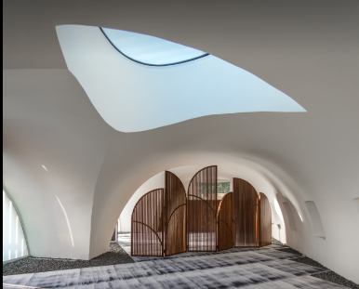
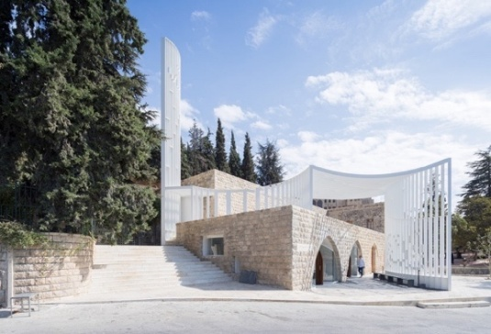
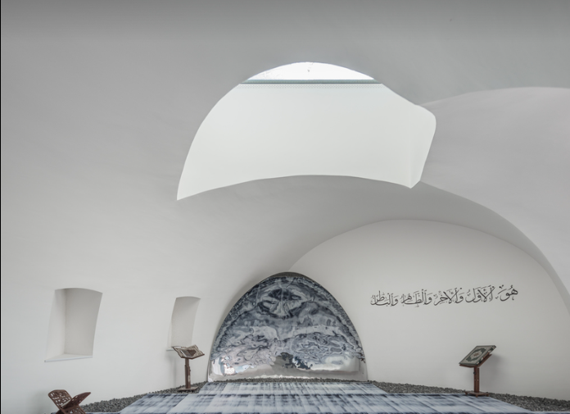
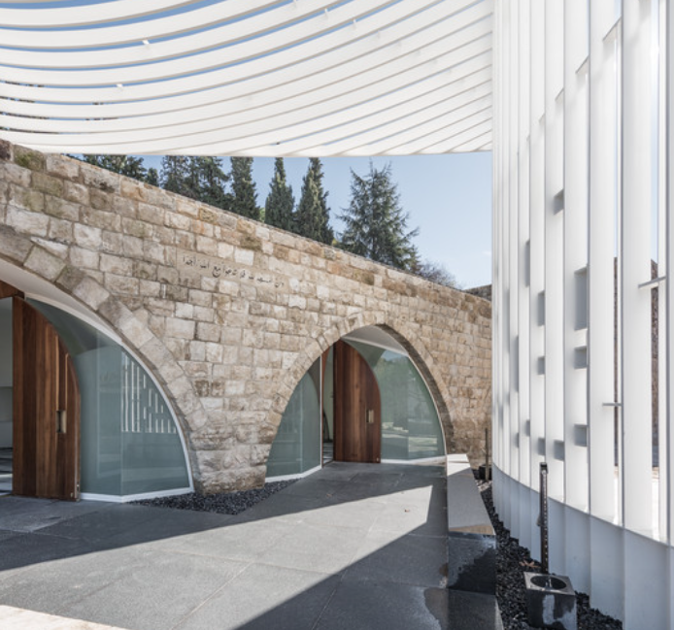
Various scientific disciplines, including ecology, inform the movement, providing empirical and theoretical knowledge about environmental issues [22]. The movement also intersects with other social movements, such as those focused on social justice, democracy, and spirituality, reflecting a multifaceted approach to addressing environmental challenges. This multidimensional approach ensures the inclusivity of environmentalism, making everyone feel part of the movement. Generally, environmentalism is a complex movement characterized by a commitment to protecting the environment through various strategies and principles. Scientific understanding, ethical considerations, and recognition of the interconnectedness of human and ecological systems inform it. The principles are not static but evolve in response to new knowledge and societal values, reflecting the dynamic relationship between humans and the environment [17], [23].

Figure 2. Environmentalism on Amir Shakib Arslan Mosque, Moukhtara, Lebanon [24]

Looked at frontally, the Amir Shakib Arslan mosque’s volume, through its thin planarity, disappears and blends with its visually rich historical backdrop, momentarily suspending belief in its actual presence (Figure 2). Rather than the traditional inert cube or dome volumetric expression of normative mosque architecture, the design offers a lighter reading of the typology, an ephemeral tectonic presence. At the curved wall entry to the mosque, the pixelated, structurally similar word Insan (human) is added to the steel plates, creating a Hegelian dialectic of God/Man. The juxtaposition of both renders humanity an integral part of the equation with God, placing it in a new dialectic and serving as a reminder of the humanistic tradition of Islam, as referenced in noted Islamic theologian Mohammad Arkoun’s book Humanisme et Islam – Combats et Propositions. As one moves around the mosque, the planar reading of the mosque formed by the steel plates becomes transparent, while the two words (Allah/Insan) become more apparent, and vice versa. The overall lightness of the mosque’s tectonic sits also in a relational contrast to the heaviness of the Moukhtara’s palace's volumetric stone.

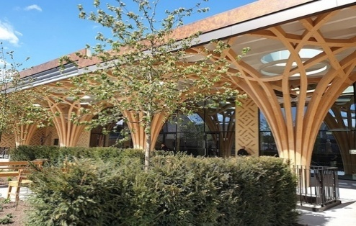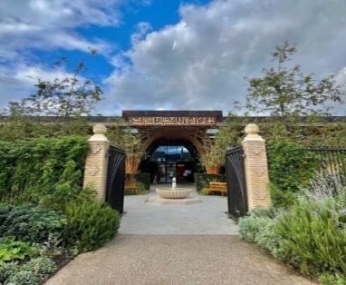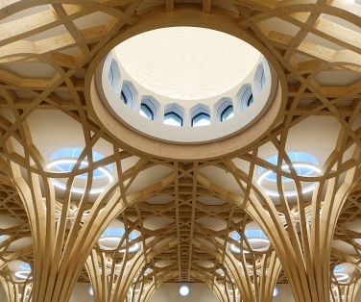

Figure 3. Outside and Inside Timber Construction in Cambridge Central Mosque [25]

The Cambridge Central Mosque (Figure 3) is Europe's first eco-friendly mosque and the first purpose-built mosque within the city of Cambridge, England. The Cambridge Central Mosque's design was inspired by both Islamic and English religious architectural traditions. The concept of the mosque is a calm oasis within a grove of trees. With the collaboration of UK-based specialists such as the geometer Keith Critchlow, garden designer Emma Clark, and artists Amber Khokhar and Ayesha Gamiet, among others, the final design marries traditional Islamic architecture, geometry, and horticulture with indigenous English materials, plants, and craftsmanship to create a unique synthesis. The defining feature of Cambridge Mosque is its timber structure. The timber is sustainably sourced spruce, which has been curved and laminated. Roof lights are located above the ‘trees’, bathing the prayer hall in light. The octagonal geometry has strong symbolism in Islamic art, suggesting the cycle of inhalation and exhalation, the ‘Breath of the Divine’.
The historical development of Islamic architecture has consistently emphasized integrating environmental principles and the natural world into its design, reflecting a harmonious relationship between the built environment and the surroundings. Research indicates Islamic architecture adheres to religious and cultural values and aligns with sustainable and green building principles [9]. This synergy is exemplified by using natural materials, planning spaces to optimize thermal performance, and including green spaces inside and outside buildings. Of particular interest is that while Islamic architecture has historically embraced these principles, contemporary movements such as biophilic design, which emphasizes the importance of connecting people with nature for health and well-being [20], are gaining traction.

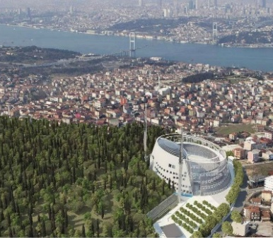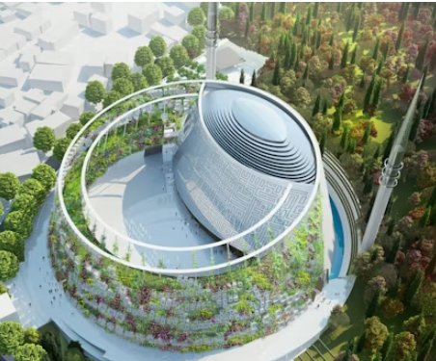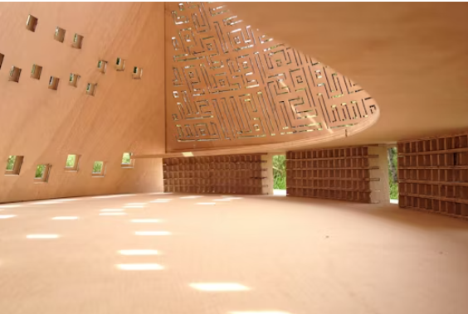

Figure 4. Environmentalism on Camlica Mosque, Istanbul, Turkey [26]

The Camlica Mosque in Istanbul (Figure 4) is situated in a picturesque natural setting atop a prominent hill, serving not only as a place of worship but also as a venue for communal gatherings, prayer, education, and a public kitchen. The walls around the mosque solidify at the mihrab wall and metamorphose into a Garden of Eden at the courtyard wall. Spaces functioning as social complexes within the 'Kulliye' structure of the Ottoman period, which appear in various architectural forms, have been amalgamated into the Istanbul Camlica Mosque as a single structural entity. The mosque's architects and advocates contend that the project has been conceived with environmental sustainability as a priority. The mosque has several green areas, such as gardens and parks, designed to alleviate the construction's influence on the local environment.
This modern approach resonates with the traditional Islamic emphasis on courtyards and gardens, natural havens in architectural design. The use of ceramics in Islamic architecture, inspired by its organic nature, demonstrates a commitment to sustainability being revisited in contemporary practices [5]. Therefore, incorporating environmental principles in Islamic architecture is not a recent innovation but a long-standing tradition. Integrating nature into Islamic buildings through courtyards, gardens, and sustainable materials reflects a deep-seated respect for the environment. This tradition continues to influence modern sustainable architectural practices, demonstrating the enduring relevance of Islamic architectural principles in pursuing environmentally responsible design.
Islamic architecture has historically embodied the principles of sustainability, which are now being revisited in contemporary research and practice. Similarly, Ramadan and El-Halaby emphasize the importance of integrating environmental characteristics into design, a concept deeply rooted in Islamic architecture, to achieve harmony with the environment [10]. The integration of Islamic values with environmental sustainability is evident in the design of physical structures and broader cultural practices within Islamic communities. This synergy between historical architectural wisdom and modern sustainability efforts underscores Islamic architecture's potential to make a significant contribution to the global trend toward sustainable development.

3.1.2 Minimalism in Islamic Architecture
Minimalism, a versatile concept, is characterized by practicality, simplicity, and a pursuit of content's essence, removing all unnecessary elements. Its application spans various disciplines, including design, education, consumption, and lifestyle. The principles of minimalism often emphasize the importance of functionality, the value of experience-based learning (user experience), and the reduction of excess in favor of essential components [22][27][28]. Minimalism in instructional design involves creating manuals that are not overly detailed, focusing instead on the most crucial information to guide users effectively. In graphic and product design, minimalism seeks to communicate concepts elegantly, often through clean lines and monochromatic schemes, to emphasize functionality and reduce visual clutter [27]. Consumer minimalism is characterized by owning fewer possessions, preferring simple, uncomplicated designs, and engaging in mindful,urated consumption [29].

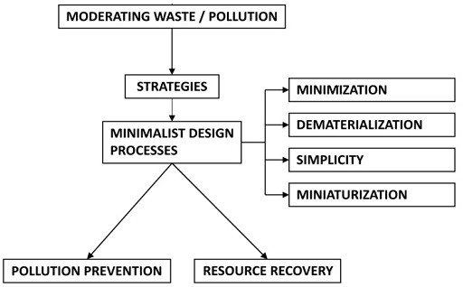

Figure 5. Minimalist process of sustainability[15]

Minimalism is a concept that advocates reducing possessions and responsibilities to focus on what is genuinely significant. A minimalist lifestyle prioritizes quality over quantity and experiences above material goods. This theory may be applied to many facets of life, encompassing the disarray in our residences, as well as the chaos in our routines and thoughts. Minimalism provides a remedy for the unsustainable cycle of consumption and waste. By opting for reduced ownership, minimalists inherently consume less, thereby reducing resource use and waste generation. A minimalist may choose a capsule wardrobe, diminishing both the quantity of clothing created and the resources consumed during manufacture, including water and electricity (Figure 5).
In syntax and language acquisition, minimalism refers to an economic model of grammar that is plain and simple yet capable of efficiently generating grammatical forms [30]. These misconceptions can be clarified by understanding that minimalism is not a one-size-fits-all solution and that its application requires careful consideration of context and objectives. In summary, minimalism is a multifaceted concept that reduces essentials in design, education, consumption, or language. Its principles are grounded in simplicity, functionality, and the elimination of redundant elements, focusing on the core of the subject matter. While minimalism has been shown to have benefits, such as improved learning outcomes and user experience, it is also subject to misconceptions that require clarification to fully understand and apply its principles effectively [22], [28].

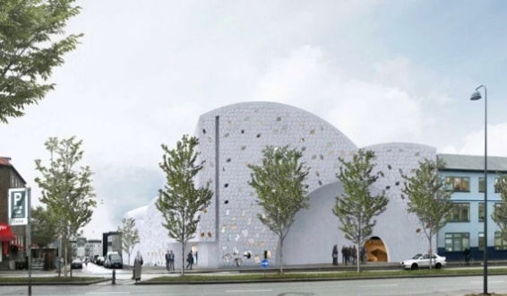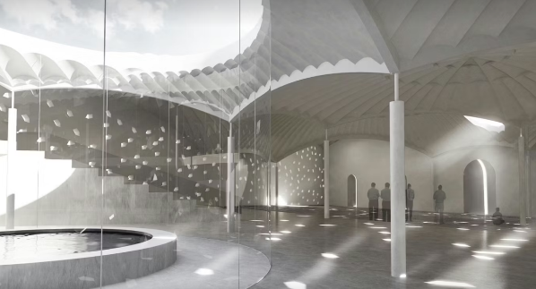

Figure 6. Minimalism on The Islamic Community Center & Mosque, Copenhagen, Denmark [31]

The newly constructed community center and mosque in Dortheavej, Copenhagen, is a contemporary Nordic interpretation of Islamic architecture, introducing a fusion of Nordic and Islamic construction traditions to Denmark (figure 6). The structure, aligned with Mecca, derives its form from a geometric arrangement of domes and barrel arches. All domes have the same radius but are elevated to varying heights, resulting in an external dynamic roof silhouette and an intriguing landscape within the ceiling. In the dome structure, three sections are truncated at varying elevations to form substantial apertures to the sky, with the most expansive being over the inner courtyard. Two domes converge in the middle of the edifice to create the prayer hall. This more personal and sacred internal chamber lacks an aperture and is illuminated indirectly from the adjacent areas. The interior, composed of many domes, is perceived as a unified area. The expansive, concentrated inner courtyard unifies the dual purposes of the building as a community center and a mosque. The matter of purpose-built mosques primarily concerns the visibility of Islam in the public sphere.
Those concepts are integrated into a comprehensive understanding of cross-cultural embodied interactions. This understanding is theoretically grounded in synthesizing third-generation phenomenology, practice theory, and postcolonialism, drawing inspiration from Merleau-Ponty's phenomenology of the lived body and highlighting the interrelational framework of our embodied existence. An initial intercorporeality serves as a pre-personal mode of communication. This comprehension establishes an ontological dependency between the act of seeing and being seen; our visibility and embodiment in the world underpin the potential for our perception. The dynamics of seeing and being seen, and of cross-cultural interactions, manifest distinctly in this context, as the materiality, architecture, and symbolic indications of purpose-built mosques mediate them. Islamic architecture, rich in historical grandeur and often characterized by intricate ornamentation, can incorporate minimalist principles. As described, minimalism in architecture is the philosophy of less and more, emphasizing the necessity over superfluity and focusing on simple shapes, clear lines, and a neutral color scheme. On the other hand, Islamic architecture is defined by its sociocultural and religious values, which can manifest in specific spatial arrangements and decorative elements that carry deep symbolic meanings [15], [30].

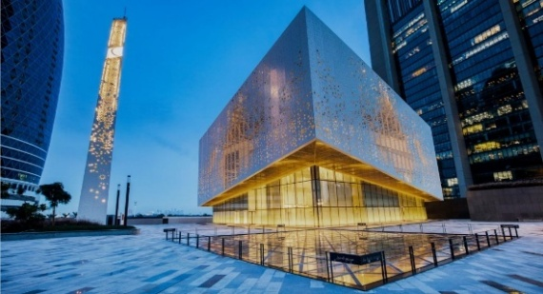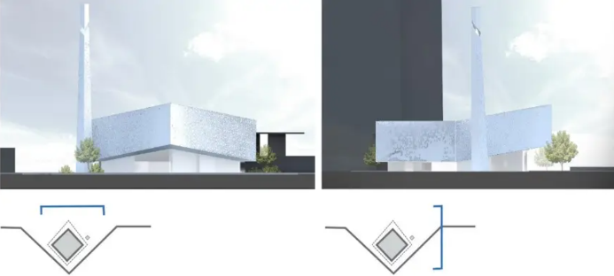
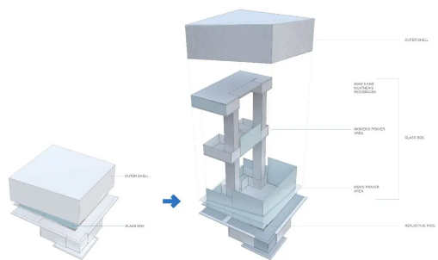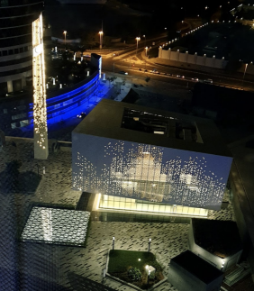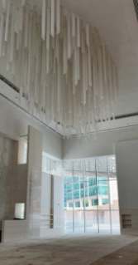

Figure 7. Minimalism on The DIFC Grand Mosque, Dubai [32]

The Grand Mosque at Gate Avenue in Dubai International Financial Center is designed by RMJM (Figure 7). RMJM conceived DIFC's Grand Mosque as a modern, non-conformist facility. While the exterior is minimalist, the interior is more elaborate, featuring an expansive main chandelier inspired by traditional Muqarnas. The outer cubist form features a hanging mashrabiya screen in a geometric Islamic pattern, serving as a veil to provide shade and privacy in certain areas. Its design includes traditional references; it was conceived as a modern and non-conformist facility. It marks an important addition to the interconnected ecosystem that exists at DIFC.
The DIFC Grand Mosque in Dubai is a modern mosque that integrates traditional Islamic architecture with contemporary design. The mosque's architecture is intended to exemplify contemporary Islamic design in the UAE. The mosque's façade showcases a suspended mashrabiya screen with geometric Islamic motifs. The screen offers shade and solitude while being operable in public spaces. The mosque's outer or top cube is sharply tilted toward the qibla, the direction Muslims face when performing their prayers. It points towards the Kaaba, the sacred structure in Makkah. This is a clever way to use architecture and design to be functional and informative. The cube has also been designed with a hanging screen inspired by the mashrabiya, a traditionally Islamic architectural element of many regional structures.
The projects combine modern traits and traditional elements, which make them two great showcases of architecture in the Gulf. While preserving a sense of cultural identity, they illustrate the region's innovative ambitions. A significant point to note is that the architecture has evolved, and the concept still works through the synthesis of existing buildings from a Western design outlook, meaning the designers took a contemporary approach to creating one of the best contemporary designs and successfully integrating an Islamic touch. Islamic architecture can incorporate minimalist principles by emphasizing the essential over the extraneous, focusing on the purity of geometric forms, and employing a restrained color palette while maintaining its distinctive cultural and religious identity. Islamic architecture and minimalism intersect in their emphasis on simplicity and the elimination of superfluous elements.

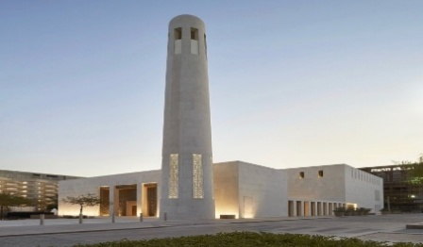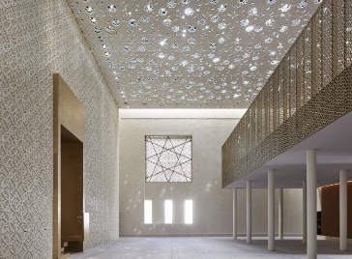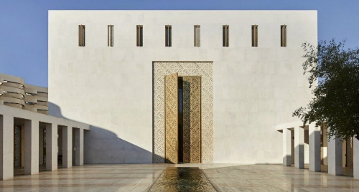

Figure 8. Minimalism at Msheireb Mosque, Doha, Qatar [33]

The mosque is in a colonnaded courtyard featuring a central water rill, adjacent to the principal Al Bahara Square, inside the 30-hectare Msheireb Downtown Doha complex (Figure 8). The new Jumaa Mosque is within the Msheireb Heritage Quarter, one of the most historic parts of inner Doha. The Jumaa Mosque is situated amid the ancient residences of the Msheireb Museum in the Heritage Quarter of Msheireb Downtown Development. The mosque exemplifies a meticulously organized amalgamation of Islamic and modernist architecture within Msheireb. Its rectilinear layout, cuboid forms, and understated yet sophisticated elevation design evoke the clean lines characteristic of Josef Hoffmann's architecture, enhancing the atmospheres generated by the Islamic configuration of thresholds and the intricately complex geometric patterns of surfaces, screens, and light within the interior spaces. The mosque's design integrates classic Islamic forms with contemporary concepts. They have sought a fusion of highly elegant modernism with a historically familiar arrangement of volumes, spaces, and thresholds, whose strong sense of presence is further resonant through the use of specifically Qatari materials and architectural details.
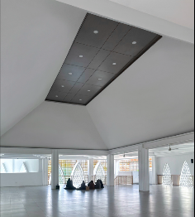
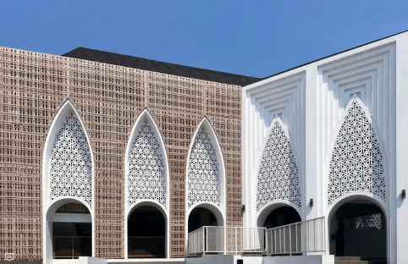
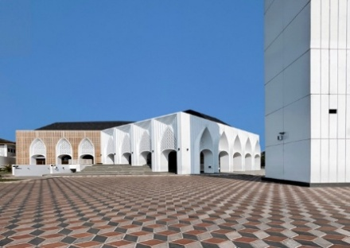
The design concept is about meeting architectural cultures in which contemporary design is inflected with resonant marks of locality and deeper Islamic history. The perfect cube building is made of white stone and render, offering a strong, robust front with clean lines. The form and configuration of the building are based on that of traditional Qatari mosques, which have used orientation, shading, natural ventilation, and water for centuries to create comfortable environments for prayer. The design reflects the key principles of Islamic art and architecture: simplicity, functionality, spirituality, light, pattern, geometry, and water.

Figure 9. Minimalism on The Al-Muttaqin Grand Mosque in Cakranegara, Mataram [34]

Al-Muttaqin Grand Mosque Cakranegara carefully considers the local population's traditions, culture, and everyday life while adhering to Islamic law. Consequently, this mosque is shown in a more modern minimalist style to facilitate its adaptation to contemporary circumstances. The concept of the roof derives from the amalgamation of two distinct roofs. The tajug roof of the Bayan Beleq mosque, one of the oldest traditional mosques in Nusantara, is integrated with the Sasak rice barn roof, which is emblematic of Lombok Island. It represents a synthesis of faith and custom inside a modern mosque. The black roof is lightweight, enhancing safety during potential earthquakes. The mosque's entrance is designed as a Sasak granary, with a broad base that narrows to a single apex. This form also evokes the entrances of mosques in India or Persia. Islam is not an ontological faith that perceives God just as a celestial sovereign but rather a pragmatic religion intimately connected to the human experience and everyday existence on earth. The mosque incorporates traditional decorative elements, including Lombok-style wickerwork. The weaving is composed of synthetic rattan, which, while more challenging than natural materials, is now increasingly scarce and still retains its local identity. The wall decorations of the mosque's main chamber are derived from Sasak weaving patterns, which have been simplified and rendered into more repeated designs. This further enhances the local identity, rendering it more distinguishable from the adjacent community. The mosque is not an external entity but may integrate with the lives of the people of Lombok.
The primary area of the mosque is square, including supports. The basement serves as a utility area and a motorbike parking space. The ablution facilities for men and women are segregated, each having exclusive entry access. The public areas of this mosque forgo air conditioning to optimize natural ventilation. The numerous apertures on different sides of the structure facilitate adequate air circulation. The Al-Muttaqin Grand Mosque functions as a social nexus. Young individuals favor congregating and unwinding on the mosque patio. It may be due to the mosque's design being more amenable to alteration. The structure of this mosque lacks a dome, unlike the neighboring mosques, which are predominantly domed. Ultimately, it creates a public space, ensuring that the mosque is not an isolated structure detached from its populace but rather fosters proximity and togetherness with the surrounding community.
Minimalism in architecture, characterized by the principle of less is more, focuses on essential features, eschewing clutter for clarity and calm. This philosophy aligns with Islamic architecture’s principles, often including a profound rejection of materialism and an adherence to simplicity as a reflection of spiritual values [35]. The latter incorporates these elements into its religious and cultural context, which is reflected in its adherence to principles of simplicity and functionality. Applying minimalism to Islamic architecture presents a unique challenge, requiring a delicate balance between modern trends and traditional values. However, preserving these traditional elements may not always align with contemporary minimalist trends. The underlying principles of minimalism can be seen as a contemporary interpretation of traditional Islamic architectural values, as both styles seek to transcend purely functional design and achieve deeper aesthetic and spiritual resonance.

3.1.3 Applying Environmentalism and Minimalism in Western Countries
The adoption of environmentalism and minimalism in Western nations can be explained as a response to the mounting environmental consequences of consumerism and the pursuit of sustainable practices. Environmentalism in the West has shifted from regulatory controls to a more self-regulatory, voluntary approach, influenced by civil society activism and corporate environmentalism [36], [37]. Minimalism as a lifestyle choice aligns with this shift by advocating for reduced consumption and a focus on essentials, leading to positive personal well-being and potentially lower carbon emissions [37], [38]. However, these movements are contradictory and complex. Minimalism is often perceived as a form of resistance to consumerism. Still, it can also be criticized as another form of consumption in which minimalism becomes a status symbol or identity marker [39].
Moreover, the relationship between corporate environmentalism and financial performance needs to be stronger, suggesting that market forces alone are insufficient to drive significant environmental change [37]. Incorporating environmentalism and minimalism in Western societies represents a comprehensive strategy for promoting sustainability and individual well-being. This work is noteworthy because it contributes to understanding the link between ecology and minimalism in Islamic architectural philosophy. It demonstrates the potential for this link to inform sustainable design methods. Its application and consequence are that it may guide the construction of sustainable structures that embrace the ideas of Islamic architectural philosophy. The concern in this study is that the findings need to be more generalizable to all Islamic structures. It highlights the need for further research and urges the audience to actively engage in the ongoing academic conversation and contribute to a fuller understanding of the link between environmentalism and minimalism. Despite the progress made and the potential for these movements to contribute to a more sustainable future, they also confront challenges in terms of their influence on broader societal transformations and the risk of being co-opted by consumer culture [38], [39].
The impact of environmentalism and minimalism is becoming increasingly evident in the philosophy of contemporary Islamic architecture, particularly in Western countries. Modern Islamic architecture seeks to balance cultural and religious identity through sustainable and minimalist design principles [1], [40]. Minimalism, characterized by simplicity and the principle of less, aligns with the environmental goals of reducing excess and focusing on essential elements, which can be compatible with Islamic principles of moderation and sustainability [4]. However, while minimalism in architecture promotes simplicity and functionality, Islamic environmentalism adds a theological dimension, advocating environmental stewardship grounded in Islamic teachings [3]. This synergy between minimalism and Islamic environmentalism results in a unique architectural expression that is culturally relevant and environmentally responsible. Nevertheless, there is notable tension between adopting Western minimalist trends and maintaining a distinct Islamic identity, which can sometimes conflict with contemporary Western aesthetics [40], [41].
Integrating environmentalism and minimalism within Islamic architecture in the Western world exemplifies the confluence of ethical, aesthetic, and eco-friendly design principles. This blend demonstrates a commitment to ecological responsibility and a minimalist style consistent with Islamic values of simplicity and moderation. The resulting architecture aims to be both sustainable and culturally relevant, thus addressing the challenges of identity and modernity.

3.1.4 Applying Environmentalism and Minimalism in Islamic Countries
The incorporation of environmentalism and minimalism in Islamic countries can be guided by the tenets of Islamic environmental ethics, which emphasize a harmonious relationship between humans and the environment, the responsibility of humans as stewards (caliphs), and the integration of faith and Sharia obligations into environmental preservation [42]. As an intellectual movement, Islamic environmentalism engages with contemporary ecological problems through the lens of Islamic theology, including Shariah-based environmental law, activism, and philosophy [3]. However, the QBG faces challenges in politicizing ecological degradation [42], [43]. It is interesting to note that despite the ethical principles provided by Islam on the environment, there is a notable lack of concern for environmental issues in many Muslim-majority countries [44].
This discrepancy suggests that applying environmentalism and minimalism in Islamic countries may require addressing the gap between religious ethics, environmental ethics, and the practical indifference to the environment. The eco-Pesantren initiatives in Indonesia provide a promising model for integrating Islamic values with sustainable development, demonstrating that Islamic teachings are not fundamentally opposed to environmental and minimalist principles [45]. Applying environmentalism and minimalism in Islamic countries can draw upon Islamic environmental ethics' rich tradition, which provides a framework for stewardship and sustainable living. However, the effectiveness of these applications may depend on overcoming the observed indifference to environmental issues and integrating Islamic principles into practical ecological policies and education. The QBG in Qatar and Eco-Pesantren in Indonesia offer encouraging examples of how Islamic countries can embrace environmentalism and minimalism in ways that are culturally and religiously resonant [42], [44].
Integrating environmentalism and minimalism in Islamic countries can complement existing cultural and religious frameworks. Environmentalism is deeply grounded in Islamic teachings, which emphasize the stewardship of the earth and the conservation of resources [46]. Similarly, minimalism, which advocates for reduced consumption and a focus on well-being over material possessions, aligns with the principles of moderation and simplicity in Islamic teaching. However, practical challenges may arise in implementing these concepts. Metwally [46] suggested that Islamic societies need help with strictly applying Islamic economic principles, such as the prohibition of interest and the strict imposition of Zakat, which could conflict with the minimalist ethos of reduced consumption and economic simplicity.
Furthermore, while Yousefi et al. discussed strategies for enhancing sustainability in Islamic countries, they still need to address how minimalism can be integrated directly into these strategies. In conclusion, integrating environmentalism and minimalism in Islamic countries is theoretically compatible with Islamic principles as both concepts promote stewardship, conservation, and simplicity [46], [47]. However, careful consideration must be given to the practical implementation of these concepts to avoid conflicts with existing economic practices and ensure that they contribute positively to the well-being and sustainability of Islamic societies. Further research could examine in greater detail the potential synergies and tensions between these concepts and Islamic practices [46] [48].
The reviewed studies indicate a convergence between environmentalism and minimalism within contemporary Islamic architectural philosophy. Kamal and Nasir explore the minimalist aesthetic in sustainable building and design, highlighting the less-is-more approach and its alignment with Islamic historical rejection of materialism. Ragozina delved into Islamic environmentalism, linking it to Islamic theology and the broader environmental movement, which shares commonalities with minimalist principles in its critique of overconsumption and material excess [3]. Mahmoud, Elbelkasy, and Albasyoni discuss the challenges of maintaining Islamic architectural identity in the face of globalization, suggesting that a flexible approach to Islamic architectural elements can harmonize with Sharia and contemporary sustainability needs [40].
Interestingly, while minimalism and environmentalism are often aligned, Islamic environmentalism presents a fundamental contradiction, as identified by Ragozina. El-Fayoumi highlights the historical precedence of sustainable practices in Islamic architecture, suggesting that contemporary sustainability is not a new concept but a continuation of traditional principles [5]. The integration of environmentalism and minimalism into contemporary Islamic architectural philosophy is evident in the literature. These principles are compatible, deeply rooted in Islamic traditions, and are being adapted to address modern sustainability challenges. These studies collectively underscore the potential of Islamic architecture to contribute to sustainable development while preserving cultural identity.
Environmentalism and minimalism are essential in Islamic architectural philosophy because they align with the Islamic principles of stewardship and simplicity. The Islamic Ecological Paradigm (IEP) emphasizes the interconnectedness of humans and nature and the responsibility to preserve them, which resonates with modern environmentalism [48], [49]. Similarly, the minimalist approach in architecture, characterized by simplicity and the efficient use of space, reflects the Islamic tenet of eschewing excess and focusing on what is necessary, which is evident in the design principles of Islamic architecture.
While modern environmentalism and the minimalist architectural movement have roots in Western thought, they also have a harmonious counterpart in Islamic philosophy. Islamic environmentalism, for instance, incorporates Shariah-based environmental law and activism, drawing on concepts such as khalifa (stewardship) and hima (conservation) [3]. Furthermore, the minimalist approach to Islamic architecture serves functional, spiritual, and aesthetic purposes, aligning with the Islamic worldview of sustainable and meaningful living [51]. Therefore, the relevance of environmentalism and minimalism in Islamic architectural philosophy today lies in their potential to address the contemporary challenges of sustainability and responsible resource use. These principles advocate a built environment that respects ecological balance and promotes a lifestyle of moderation, which is increasingly vital in the context of global environmental concerns and the quest for sustainable development. The ontological alliance between modern environmentalism and the IEP, along with the integration of minimalism and sustainability in design, underscores the timeless value of these concepts in addressing current and future architectural and environmental challenges [51], [52].
In recent years, the intersection of environmentalism and minimalism in Islamic architecture has attracted significant attention. Eco-friendly design approaches have become increasingly popular as architects and designers strive to create sustainable buildings that minimize environmental impact. At the same time, the cultural implications of these designs are also being considered as they reflect the values and beliefs of the societies in which they are built. One notable example of this intersection is the construction of Masjid Al-Haram in Mecca, Saudi Arabia. This mosque is one of the largest and most iconic in the world, and its recent renovation has incorporated eco-friendly design features, such as solar panels and energy-efficient lighting.
At the same time, the design reflects Islamic culture with its intricate geometric patterns and calligraphy. Another example is the construction of the Sheikh Zayed Grand Mosque in Abu Dhabi, United Arab Emirates (UAE). This mosque was designed to incorporate traditional and modern sustainability and environmental responsibility elements. The mosque features several eco-friendly design elements, including a water recycling system and a vast green roof. Overall, the intersection of environmentalism and minimalism in contemporary Islamic architecture highlights the importance of sustainable design and cultural preservation. As the world continues to grapple with environmental challenges, it is crucial to find ways to integrate these values into our built environment.

DISCUSSION

3.2.1 Islamic Architectural Intersection Values
The intersection of environmentalism and minimalism in Islamic architectural philosophy is a multifaceted topic. Minimalism emphasizes simplicity and reduction, aligning with environmental principles by advocating the use of fewer resources and eliminating excess [53], [54]. Islamic architecture, historically rooted in religious and cultural values, also embodies sustainability principles, as seen in the use of courtyards and natural cooling systems, which align with environmental concerns [9]. Interestingly, while minimalism is often seen as a modern trend, its principles resonate with the traditional aspects of Islamic architecture, which inherently embraces sustainability before the term became a contemporary watchword [55], [56].
It suggests compatibility between the minimalist ethos and Islamic architectural philosophy that predates the current environmental discourse. However, applying minimalism in Islamic contexts must navigate potential conflicts with Islamic design’s characteristic ornamentation and historical grandeur. In summary, the analysis of environmentalism and minimalism within Islamic architectural philosophy reveals a harmonious relationship between minimalist principles and environmental sustainability. Islamic architecture can be seen as a precursor to modern minimalist design with its intrinsic sustainable features. It suggests that contemporary environments are not new but a continuation of long-standing architectural philosophies [9]. The challenge lies in integrating modern minimalist aesthetics with the traditional elements of Islamic architecture without compromising its cultural and religious integrity.
The intersection of environmentalism and minimalism in Islamic architectural philosophy in Western nations is a multifaceted issue that warrants careful, nuanced discussion. Research on environmentalism and nationalism, such as eco-nationalism, provides a backdrop for understanding broader societal values that may shape architectural philosophies. Minimalism, characterized by its emphasis on simplicity and excess reduction, aligns with environmental principles and has been influential in contemporary architecture. The theoretical discourse on minimalism in architecture, particularly its postmodern interpretations, provides an additional context for its application in Western settings [54].
However, contradictions may arise when considering the traditional elements of Islamic architecture, which may not always align with modern minimalist trends. With its rich historical and religious significance, Islamic architecture often incorporates intricate designs and symbolism, which may contrast with the stark simplicity of minimalism [57] [58]. Nevertheless, the principles of Islamic architecture, such as its commitment to religious education and rejection of materialism, can align with minimalist and environmentalist values. Furthermore, the voluntary simplification movement and its themes of material simplicity and sustainability provide insights into consumer attitudes towards minimalism, which may influence architectural design choices in Western countries [59].
In summary, exploring environmentalism and minimalism within Islamic architectural philosophy in Western countries reveals a complex interplay between values. Although minimalist design principles may complement environmental goals, integrating them with Islamic architecture and cultural aspects presents both challenges and opportunities. The successful synthesis of these ideas requires a deep understanding of the underlying values and a thoughtful design approach that respects Islamic environmental imperatives and cultural heritage.
The incorporation of environmentalism and minimalism in Islamic eco-friendly design has significant implications. According to Kamal and Nasir, minimalism, with its 'less is more’ philosophy, aligns with the traditional principles of Islamic architecture, which typically embody grandeur and reject materialism. This alignment suggests that minimalism can be a valuable resource for sustainable, environmentally friendly Islamic design. Aulia et al. further support this by demonstrating the favorable impact of eco-friendly housing on community involvement and sustainable living in an Islamic context [60]. However, contradictions may arise when considering traditional elements of Islamic architecture, such as minarets and courtyards, which may conflict with contemporary minimalist trends. Nevertheless, these elements can be reinterpreted within a minimalist framework to maintain cultural significance while adhering to sustainable practices.
Additionally, minimalism in product design, as exemplified by Muji and Bang & Olufsen, emphasizes functionality and the use of environmentally friendly materials, which can be translated into the design of Islamic environmentally friendly structures [60] [61]. Integrating environmentalism and minimalism in Islamic design is compatible and enhances the architecture’s sustainability and cultural relevance. The principles of minimalism can be harmoniously integrated with Islamic design to promote environmental stewardship while respecting historical and religious significance. This approach can create aesthetically pleasing, environmentally responsible spaces that contribute to Islamic communities’ broader sustainable development goals.

3.2.2 Critics and Challenge
Critics may argue that applying Western concepts of environmentalism and minimalism to Islamic architecture in Islamic countries could overlook the cultural, religious, and historical significance inherent in Islamic architectural philosophy. While minimalism emphasizes simplicity and the reduction of excess, Islamic architecture is deeply rooted in cultural and spiritual symbolism that may only sometimes align with minimalist principles [59]. The relationship between environmentalism, minimalism, and Islamic principles is fascinating, as all three philosophies emphasize the efficient use of resources and avoidance of extravagance.
However, it is crucial to approach these concepts using nuances when considering their application in Islamic art and architecture. Consider the spiritual dimensions and local context of Islamic culture to ensure a superficial transplantation of these ideas is practical in application. Therefore, respecting and integrating Islamic societies’ rich cultural and religious heritage is essential while adapting Western concepts to Islamic architecture. Critics stress the importance of thoughtful adaptation that maintains the identity and integrity of Islamic architecture rather than imposing a universal solution that may not be suitable for the diverse contexts of Islamic countries.
Both environmentalism and minimalism have influenced the development of contemporary Islamic architecture. Environmentalism, as discussed in the literature, is not a novel concept in Islamic architecture but rather a continuation of heritage practices that emphasize sustainable development and the efficient use of natural resources. Conversely, minimalism is characterized by simplicity, reduction, and the use of basic structures, which align with the Islamic architectural tradition of eschewing excessive ornamentation and focusing on essentials. While minimalism often involves neutral color palettes and simple forms, Islamic architecture traditionally incorporates intricate geometric patterns and rich colors.
However, the principles of minimalism, such as the elimination of excess and a focus on functionality, can be harmoniously integrated with Islamic emphasis on spirituality and environmental stewardship [62]. The contributions of environmentalism and minimalism to the development of contemporary Islamic architecture are evident in the integration of sustainable practices from Islamic heritage sites and the adoption of minimalist design principles. This integration facilitates the creation of spiritually meaningful and environmentally responsible spaces that reflect a shared ethical conscience and commitment to preserving [18] resources for future generations [50]. The convergence of these two movements within Islamic architecture represents a thoughtful approach to design that respects cultural traditions while addressing contemporary challenges.
The challenge of integrating environmentalism and minimalism into contemporary Islamic architecture is both complex and multifaceted. Both environmentalism and minimalism are aligned with the historical tenets of Islamic architecture. Environmentalism focuses on the efficient use of resources and sustainability. These principles harmonize with Islamic architectural heritage and advocate for environmental harmony and the efficient use of materials. Minimalism, with its philosophy of less is more, resonates with Islamic architectural heritage, which values simplicity and the elimination of unnecessary elements. However, contradictions exist in applying these principles in contemporary Islamic architecture.
Despite the shared values of simplicity and sustainability between minimalism and environmentalism, contemporary Islamic architecture often incorporates historical elements that may conflict with minimalist principles. For instance, elements such as minarets and courtyards are commonly included in Islamic architecture. Furthermore, adopting modern trends and technologies can also pose challenges to maintaining the traditional aspects of Islamic architecture. Thus, integrating environmentalism and minimalism into contemporary Islamic architecture presents opportunities and challenges. On the one hand, the principles of sustainability and simplicity can be harmoniously blended with Islamic architectural heritage, as demonstrated through the use of natural materials and the design of energy-efficient green spaces. However, the challenge lies in balancing modern architectural trends with Islamic architecture’s cultural and religious significance, ensuring that the resulting structures are both environmentally sustainable and authentic to Islamic cultural identity.
Incorporating environmentalism and minimalism into Islamic architecture presents a multifaceted challenge that intersects the cultural, educational, and technological dimensions. While the reviewed studies do not directly address Islamic architecture, they provide insights into the broader context of sustainable architectural practices that can be extrapolated to this specific domain. The integration of sustainability principles, as seen in the context of green architecture and Education for Sustainable Development (ESD), is crucial for addressing environmental challenges [62] [63] [64]. However, applying these principles within the framework of Islamic architecture may encounter cultural resistance, as traditional design elements and historical precedents hold significant value. Additionally, incorporating minimalism, which emphasizes simplicity and the reduction of excess, may conflict with the intricate, ornate aesthetic often celebrated in Islamic architecture.
Furthermore, the educational challenge lies in equipping architects with the necessary skills to harmoniously blend modern sustainability practices with the rich traditions of Islamic design [65], [66], [67], [68], [69]. Integrating environmentalism and minimalism into Islamic architecture aligns with global sustainability trends; it faces challenges related to cultural acceptance, technological integration, and educational approaches. Addressing these challenges requires a nuanced understanding of Islamic architectural principles and a collaborative effort to adapt sustainability practices in a culturally sensitive manner.

3.2.3 Environmental Context and Climate Influence
Environmental design uniquely responds to various climates, and climate-specific design solutions enhance building performance and occupant comfort. Traditional construction materials and methods in warm areas prioritize reducing heat accumulation and enhancing natural cooling [70]. Materials having significant thermal mass, such as stone or clay, are employed to regulate temperature variations. In contrast, designs may emphasize heat retention and insulation in colder areas. The selection of construction materials is significantly affected by regional climatic conditions. Traditional vernacular architecture (such as mosques) utilizes locally sourced materials appropriately adapted to the local climate. Materials that facilitate natural cooling and ventilation are favored in warm regions, whereas in cold climates, materials with superior insulating properties are preferred. Urban green areas are essential for alleviating urban heat islands, but their efficacy varies across climatic contexts. Environmental architecture varies markedly across climates, with designs, materials, and procedures tailored to local conditions. This adaptable methodology integrates traditional vernacular architecture with contemporary sustainable design approaches, highlighting the importance of climate-responsive design in creating comfortable, efficient building spaces.
Architects must consider current climatic conditions, projections for long-term climate change, local cultural practices, and technological advancements. By incorporating these factors, architects may design ecologically adaptive and conducive structures to alleviate climate change while promoting human well-being [71], [72]. Climate change concerns have profoundly influenced minimalism and environmentalism in architectural design, driving the development of novel sustainable construction methods. Architectural practitioners are more cognizant of the impact of buildings on the climate crisis, leading to a transition towards sustainability in the design of the built environment. This awareness has prompted the development of innovative educational techniques that incorporate sustainable environmental design into architectural curricula, preparing graduates to address climate concerns [73]. The architectural notion of minimalism relates to ecology since both prioritize eliminating superfluous features. Minimalist design concepts help mitigate carbon emissions and reduce energy usage in the context of climate change. Nonetheless, it is important to acknowledge that studies regarding the direct influence of minimalism on carbon emissions remain equivocal [74]. Climate change has emerged as a pivotal influence on architectural design, fostering the incorporation of minimalist and environmentally conscious concepts. Sustainable architecture design is increasingly regarded as a means to combat climate change, emphasizing techniques that minimize carbon emissions and enhance the resilience of urban systems.
Climate extremes, energy consumption, and rapid infrastructure development pose serious environmental challenges for the Gulf Cooperation Council (GCC) nations, including the United Arab Emirates, Qatar, Kuwait, Bahrain, and Saudi Arabia [75],[76]. While cold-temperature extremes have declined in these nations, warm-temperature extremes have risen. Mosques are probably among the structures whose design and construction are influenced by this climate reality. The setting highlights the need for sustainable practices in the GCC building industry, even though it does not explicitly target mosque construction. Although value management (VM) has been proposed as a tool for delivering sustainable building projects, its use is difficult due to the region's limited understanding of sustainability issues [77]. The GCC nations are addressing environmental issues by concentrating on financial development and renewable energy. Furthermore, there has been a favorable correlation between Islamic financial development and economic growth in GCC nations, which may help finance environmentally friendly building projects [78]. They highlight the region's growing environmental consciousness and the need for sustainable practices. This understanding might even extend to the construction of mosques and other places of worship to better adapt to these nations' shifting climate.
The Gulf Cooperation Council (GCC) nations, comprising the United Arab Emirates, Qatar, Kuwait, and Saudi Arabia, face significant environmental challenges stemming from rapid economic growth and severe climatic conditions [77]. These countries have implemented various measures to enhance sustainability in their construction industries and urban development. The UAE has led sustainable development initiatives within the region. The UAE has proposed policy recommendations for sustainable development, including adopting a national strategy, strengthening environmental policies, and investing in urban planning and design [79]. Qatar has developed a green building code, GSAS (Global Sustainability Assessment System), through ORD [80]. This illustrates the nation's dedication to integrating sustainable practices within its construction sector.
Islamic environmental ethics provide a basis for environmentally responsible practices in countries with Muslim majorities. Despite perceived indifference to environmental issues in numerous Muslim-majority countries, there is growing interest in exploring the impact of Islamic environmental ethics on various practices, particularly in the construction sector. The United Arab Emirates (UAE), as an Islamic nation, has undertaken notable initiatives to promote sustainable infrastructure and enhance green building development [81]. While not explicitly referencing mosques, these practices may be relevant to the construction of mosques. Dubai has implemented Green Building Regulations and Specifications that promote the construction of environmentally sustainable structures, addressing ecological planning, building vitality, and resource efficiency [82]. Islamic principles offer a robust basis for environmental stewardship; however, a disconnect appears between these principles and their implementation in numerous Muslim-majority countries. This indicates the potential for enhanced implementation of Islamic environmental ethics in mosque construction and related building initiatives. There is growing recognition and intent to integrate environmentalism into Islamic practices, such as mosque development, with implementation varying between Western and Islamic nations.
Western European and North American nations have adopted distinct environmentalism and mosque construction approaches, revealing notable intersections and contradictions. The relationship between environmentalism, mosque construction, and cultural integration in Western Europe is complex. Efforts are underway to promote sustainable and eco-friendly designs for mosques. In Morocco, energy audits and sustainable solutions have been applied to historical mosques to establish an international sustainable mosque label [83]. This approach may also be applicable in Western European countries. While Western European countries emphasize eco-innovation and green technologies to mitigate carbon emissions, the construction of mosques is generally not discussed in environmental contexts [84], [85]. Governments have prioritized the institutionalization of a "moderate, Euro-friendly Islam" and have intervened in the religious affairs of Muslims. This indicates a disparity between environmental policies and initiatives for cultural integration.
Both Western European and North American countries face environmental challenges and the integration of Muslim communities; however, there is scant evidence of environmental considerations being directly applied to mosque construction. The potential for sustainable mosque designs and the development of eco-friendly religious buildings may facilitate a connection between environmental issues and cultural integration initiatives in the future. Environmental movements have garnered substantial public backing in Western Europe and the United States. These movements emphasize nature conservation and environmental protection, establishing significant connections to other contemporary social movements. The presence and role of women in contemporary mosques in Western Europe is a subject of discussion both within and outside Muslim communities [86]. Muslim women in Norway, Denmark, and the United Kingdom are navigating intricate dynamics of both accommodation and resistance to established gender norms within mosques. The European Green Deal highlights the importance of eco-design and environmental efficiency in buildings and construction [84].
Western European nations prioritize green technologies, renewable energy, and economic development to enhance environmental quality [85]. The prevailing environmentalist trend may impact mosque construction, though this is not explicitly stated. The European Green Deal highlights the significance of "green design" in construction and buildings to minimize energy consumption and greenhouse gas emissions [84]. Applying these principles to mosque construction may enhance environmental efficiency in buildings. There is tension between environmental advocacy and the construction of mosques in Europe. Trends in Western European nations regarding green building practices and sustainable urban development may apply to various building types, including mosques. Implementing such practices may be complicated by tensions regarding mosque construction in specific European contexts.
Eco-friendly design principles and sustainable practices can be integrated into mosque construction by applying environmentalism and minimalism. This corresponds to the notion of ecological civilization projects discussed by Pow, which highlights the integration of aesthetic environmentalism and urban aesthetics [87]. This approach may lead to the development of visually appealing, environmentally sustainable mosques. The principles of minimalism can be integrated into mosque design by emphasizing simplicity, reducing clutter, and prioritizing essential elements. This approach may yield mosques that are more spacious, functional, and conducive to spiritual reflection. A minimalist design may enhance resource conservation and waste reduction, both essential components of environmental sustainability [88], [47]. Incorporating environmentalism and minimalism into mosque construction may involve integrating green building practices, sustainable materials, and energy-efficient systems while preserving a simple, uncluttered aesthetic. This approach would create environmentally responsible places of worship and enhance the spiritual experience by minimizing distractions and fostering tranquility.

CONCLUSION
This study delves into the interaction between environmentalism and minimalism in contemporary Islamic architectural thought. These two concepts have significantly impacted modern Islamic architecture, presenting challenges in incorporating them while preserving cultural identity and adhering to sustainable practices. The research gap exists in the need for more studies examining the connection between environmentalism, minimalism, and contemporary Islamic architectural thought. This study’s potential impact is its contribution to Islamic architecture and sustainable design discourse. The convergence of environmentalism and minimalism in Islamic architecture addresses global sustainability challenges while preserving cultural and religious integrity. Further research is essential to understand the cultural and historical contexts that influence Islamic architecture and discern the unique contributions of each architectural philosophy.
The incorporation of environmentalism and minimalism into the doctrine of Islamic architecture has gained recognition in recent years. Minimalism, emphasizing simplicity and essentiality, aligns with the environmental ethos of resource efficiency and sustainability. Islamic architecture, which is historically opulent and intricate, has begun to incorporate minimalist principles in response to contemporary trends and environmental concerns. Although minimalism and Islamic architecture may seem contradictory due to the latter’s often complex ornamentation, minimalism can resonate with Islamic architectural principles through simple forms, clear lines, and elimination of excess.
The interaction between design and environmental conditions is crucial in addressing climate change and resource depletion. The concept of climate design for the tropics, developed in the mid-twentieth century, was influenced by other factors outside environmental concerns. The relationship between climatic conditions and architecture is intricate and evolving. Architects must consider current climatic conditions, projections for long-term climate change, local cultural traditions, and technological advancements. By integrating these elements, architects may create environmentally adaptable and supportive structures to mitigate climate change and enhance human well-being. Concerns over climate change have significantly influenced minimalism and environmentalism in architectural design, leading to the development of innovative, sustainable building techniques.
Nevertheless, it is crucial to acknowledge that minimalist design does not inherently imply sustainability, as a minimalist residential structure may lack energy-efficient features. Moreover, implementing minimalism in Islamic architecture must carefully balance the conservation of cultural and religious importance with contemporary sustainable methods. In recent years, ecology and minimalism have been merged into the fundamental principles of Islamic architecture. This integration aims to respect the cultural and religious significance of Islamic architecture while also accommodating modern environmental requirements. The issue arises in harmonizing Islamic heritage’s aesthetic and spiritual requirements with minimalist and environmentalist concepts that are increasingly important in contemporary Islamic architecture.
Integrating environmentalism and minimalism into Islamic architectural philosophy has recently received scholarly attention. Modern architectural discourse recognizes the synergy between the minimalist ethos of less and the environmental imperatives of sustainability. Minimalism, emphasizing simplicity and essentialism, aligns with the environmental goals of reducing waste and resource consumption, as reflected in the design principles of Islamic architecture. While minimalism and Islamic architecture share a common appreciation for simplicity and environmental stewardship, there are inherent tensions. The minimalist focus on simplicity and the use of modern materials sometimes conflicts with the richly detailed and historically rooted elements of Islamic architecture. Modern design concepts and traditional Islamic ideals have come together with the recent introduction of sustainability and minimalism into Islamic architectural philosophy.

REFERENCES

[1] M. F. Mahmoud and M. I. Elbelkasy, “Islamic architecture: between moulding and flexibility,” in Islamic Heritage Architecture and Art, WIT Press, 2016. doi: 10.2495/iha160051.
[2] M. Kamal and O. Nasir, “Minimalism in architecture: a basis for resource conservation and sustainable development,” Facta universitatis - series: Architecture and Civil Engineering, vol. 20, no. 3, pp. 277–300, 2022, doi: 10.2298/FUACE221105021K.
[3] S. A. Ragozina, “Environmentalism in Modern Islamic Philosophy,” RUDN Journal of Philosophy, vol. 27, no. 2, pp. 233-250, 2023, doi: 10.22363/2313-2302-2023-27-2-233-250.
[4] Y. B. Motruk, “Ecological approach in the design of spaces of minimalism,” Vestnik MGSU, vol. 14, no. 11, pp. 1408-1417, 2019, doi: 10.22227/1997-0935.2019.11.1408-1417.
[5] S. El-Fayoumi, “The use of sustainability principles of Islamic architecture to cope with architectural challenges, a ceramist point of view,” International Design Journal, vol. 5, no. 3, pp. 1257-1266, 2015, doi: 10.21608/idj.2015.101782.
[6] K. El-Daghar, “Conserving Symbolism in Architectural Heritage—Case Study Eloquence in Depicting Philosophical Ideas Inspired by the Principles of Islam on Islamic Architecture Through Ages,” in Advances in Science, Technology and Innovation, pp. 109-124, 2022. doi: 10.1007/978-3-030-74482-3_10.
[7] Z. Rahman, J. Johnson, S. Tripathi, and Dr. J. Krithika, “The Future of Packaging: Minimalism in Modern Era,” Interantional Journal of Scientific Research In Engineering and Management, vol. 07, no. 10, pp. 1-11, 2023, doi: 10.55041/ijsrem26073.
[8] S. Nu’Man, “A Unified Architectural Theory for Islamic Architecture,” Archnet-IJAR: International Journal of Architectural Research, vol. 10, no. 3, pp. 100-112, 2016, doi: 10.26687/archnet-ijar.v10i3.973.
[9] W. Nurjayanti and F. T. Nugrahaini, “Sustainable Islamic Architecture in Settlements And Their Environment in Surakarta,” Journal of Islamic Architecture, vol. 7, no. 4, pp. 750-759, 2023, doi: 10.18860/jia.v7i4.19204.
[10] M. E. M. Ramadan and M. M. I. Elhalabi, “Integrative Relationship Between Environmental Architecture and Interior Design Towards Sustainability,” International Journal of Advanced Research on Planning and Sustainable Development, vol. 1, no. 1, pp. 1-7, 2018, doi: 10.21608/ijarpsd.2018.183092.
[11] H. E. D. S. Mahmoud and M. A. Muhammad, “A comparative study of the influence of modernity theory and unified architectural theory on the realty of contemporary Egyptian architectural design,” International Journal of Architectural Engineering and Urban Research, vol. 3, no. 1, pp. 1-15, 2020, doi: 10.21608/ijaeur.2020.219034.
[12] F. P. Rahimian, “Book Review: Unified Architectural Theory: Form, Language, Complexity,” International Journal of Architectural Research: ArchNet-IJAR, vol. 11, no. 3, 2017, doi: 10.26687/archnet-ijar.v11i3.1394.
[13] Ç. Beyaz and Ç. Erçin, “Evaluation of Modern Architecture Criteria in the Context of Sustainability and Architectural Approach; Modern Period in North Nicosia,” Sustainability (Switzerland), vol. 15, no. 13, 2023, doi: 10.3390/su151310005.
[14] A. B. H. Ahmad and W. K. Mujani, “An Evaluation of the Earliest Thought and Philosophy on Mosques in Malacca,” Humanities and Social Sciences Reviews, vol. 7, no. 4, pp. 538-541, 2019, doi: 10.18510/hssr.2019.7472.
[15] M. Kamal and O. Nasir, “Minimalism in Architecture: A Basis for Resource Conservation and Sustainable Development,” Facta universitatis - series: Architecture and Civil Engineering, vol. 20, no. 3, pp. 277–300, 2022, doi: 10.2298/FUACE221105021K.
[16] K. A. M. K. Ismail, “Sultan Hassan Mosque: An Islamic Architectural Wonder Analytical Study of Design and Its Effect on Islamic Cairo,” Journal of Islamic Architecture, vol. 1, no. 2, pp. 94-105, 2012, doi: 10.18860/jia.v1i2.1725.
[17] L. D. Loo and M. Mahdavinejad, “The Concept of Sustainability in Contemporary Architecture and Its Significant Relationship with Vernacular Architecture of Iran,” J Sustain Dev, vol. 10, no. 1, pp. 132-141, 2017, doi: 10.5539/jsd.v10n1p132.
[18] S. Hassan, “Utilizing Minimalism Principle to Promote Sustainability in the Design of Metal Furniture,” Journal of Design Sciences and Applied Arts, vol. 2, no. 2, pp. 296-302, 2021, doi: 10.21608/jdsaa.2021.29927.1038.
[19] A. G. Mertig and R. E. Dunlap, “Environmentalism: Preservation and Conservation,” in International Encyclopedia of the Social & Behavioral Sciences, pp. 4687-4693, 2001. doi: https://doi.org/10.1016/B0-08-043076-7/04154-1.
[20] D. Pedynowski, “Toward a More: ‘Reflexive Environmentalism’: Ecological Knowledge and Advocacy in the Crown of the Continent Ecosystem,” Soc Nat Resour, vol. 16, no. 9, pp. 807-825, 2003, doi: 10.1080/08941920309168.
[21] B. Devall, “Deep Ecology and Radical Environmentalism,” Soc Nat Resour, vol. 4, no. 3, pp. 51-62, 1991, doi: 10.1080/08941929109380758.
[22] B. C. Patten, “Systems Ecology and Environmentalism: Getting the Science Right. Part I: Facets For a More Holistic Nature Book of Ecology,” Ecol Modell, vol. 293, pp. 4-21, 2014, doi: 10.1016/j.ecolmodel.2014.04.010.
[23] D. J. Salazar and D. K. Alper, “Reconciling Environmentalism and the Left: Perspectives on Democracy and Social Justice in British Columbia’s Environmental Movement,” Canadian Journal of Political Science, vol. 35, no. 3, pp. 527-566, 2002, doi: 10.1017/s0008423902778347.
[24] D. Stouhi, “The Amir Shakib Arslan Mosque Photographed by Bahaa Ghoussainy.” Archdaily. Accessed: July 4th, 2024, [Online] Available: https://www.archdaily.com/895122/the-amir-shakib-arslan-mosque-photographed-by-bahaa-ghoussainy.
[25] B. Lehmann, “Timber Construction in Cambridge Mosque”. Archdaily. Accessed: July 4th, 2024, [Online] Available: https://www.archdaily.com/catalog/us/products/16212/timber-construction-in-cambridge-mosque-blumer-lehmann?
[26] T. Cakmakli, “Camlica Mosque”. Architizer. Accessed: July 4th, 2024, [Online] Available: https://architizer.com/projects/camlica-mosque-1/
[27] S. Gumber, “Minimalism in Design: A Trend of Simplicity in Complexity,” ShodhKosh: Journal of Visual and Performing Arts, vol. 4, no. 2, pp. 357-365, 2023, doi: 10.29121/shodhkosh.v4.i2.2023.539.
[28] J. M. Carroll and H. van der Meij, “Ten Misconceptions about Minimalism,” in Minimalism Beyond the Nurnberg Funnel, pp. 72-86, 2018. doi: 10.7551/mitpress/4616.003.0004.
[29] A. V Wilson and S. Bellezza, “Consumer Minimalism,” Journal of Consumer Research, vol. 48, no. 5, pp. 796–816, Jan. 2022, doi: 10.1093/jcr/ucab038.
[30] L. Anjomshoa and F. Sadighi, “The Importance of Motivation in Second Language Acquisition,” International Journal on Studies in English Language and Literature, vol. 3, no. 2, 2015.
[31] H. Larsen, “Islamic Community Centre and Mosque.” Architizer. Accessed: July 4th, 2024, [Online] Available: https://architizer.com/projects/islamic-community-centre-and-mosque/

[32] RMJM, “DIFC Grand Mosque”. Abdullatif Al Fozan Award. Accessed: July 4th, 2024, [Online] Available: https://mosqpedia.org/masajid/difc-grand-mosque/
[33] J. McAslan, “Msheireb Mosque”. Archify. Accessed: July 4th, 2024, [Online] Available: https://www.archify.com/ph/project/msheireb-mosque.
[34] H. Abdel, “Al-Muttaqin Grand Mosque / Andyrahman Architect”. Archdaily. Accessed: July 4th, 2024, [Online] Available: https://www.archdaily.com/1013542/al-muttaqin-grand-mosque-andyrahman-architect?
[35] A. Mohamadi, “The Effect of Religious Values in the Formation of Spaces in Islamic Architecture of Iran,” Global Journal of Engineering and Technology Advances, vol. 15, no. 3, pp. 111-117, 2023, doi: 10.30574/gjeta.2023.15.3.0108.
[36] E. A. Severo and J. C. F. De Guimarães, “Corporate Environmentalism: An Empirical Study in Brazil,” International Journal of Business and Globalisation, vol. 15, no. 1, pp. 81-95, 2015, doi: 10.1504/IJBG.2015.070225.
[37] C. Parsad and S. Mittal, “Evolution of Corporate Environmentalism, a Politico-Social Perspective: Concept, Command and Control to Self-Regulatory and Voluntary, and Future Directions,” J Public Aff, vol. 22, no. 3, 2022, doi: 10.1002/pa.2286.
[38] K. Jakovlevas-Mateckis and L. Kostinaitė, “Some Aspects of Minimalism in Modern Library Architecture,” Journal of Architecture and Urbanism, vol. 30, no. 2, pp. 97-104, 2006, doi: 10.3846/13921630.2006.10697070.
[39] N. G. Ayuningrum, “Discourse Analysis Minimalism Lifestyle Through YouTube,” MEDIASI Jurnal Kajian dan Terapan Media, Bahasa, Komunikasi, vol. 3, no. 1, pp. 1-22, 2022, doi: 10.46961/mediasi.v3i1.489.
[40] M. E. M. Albasyoni, “Islamic Architectural Ecological Philosophy in Contemporary Egyptian Residence,” The Academic Research Community publication, vol. 4, no. 1, pp. 101-113, 2020, doi: 10.21625/archive.v4i1.736.
[41] A. Carlson, S. Lintott, Nature, Aesthetics, and Environmentalism: From Beauty to Duty, Choice Reviews Online, New York: Columbia University Press, 2008.
[42] N. Zulkifli, “Islamic Approaches to the Environmental Preservation: A Systematic Literature Review,” Al-A’raf : Jurnal Pemikiran Islam dan Filsafat, vol. 20, no. 2, pp. 176-208, 2023, doi: 10.22515/ajpif.v20i2.7848.
[43] N. Kolkailah, “The Qur’anic Botanic Garden in Qatar: Challenges and Opportunities for Islamic Environmentalism,” Religion and Development, vol. 2, no. 1, pp. 63-83, 2023, doi: 10.30965/27507955-20230016.
[44] A. Saniotis, “Muslims and Ecology: Fostering Islamic Environmental Ethics,” Contemporary Islam, vol. 6, no. 2, pp. 155-171, 2012, doi: 10.1007/s11562-011-0173-8.
[45] S. Anabarja and A. S. Mubah, “The Islamic Environmentalism in Eco-Pesantren Initiatives: Integrating the Sustainable Development Values in Islamic Boarding School,” Journal of International Studies on Energy Affairs, vol. 2, no. 1, pp. 75-90, 2021, doi: 10.51413/jisea.vol2.iss1.2021.75-90.
[46] B. A. Nadi, “The Significance and Strategies for Environmental Conservation in the Light of Islamic Teachings,” Jami Scientific Research Quarterly Journal, vol. 8, no. 3, pp. 113-132, 2023, doi: 10.61438/jsrqj.v8i3.36.
[47] K. Lloyd and W. Pennington, “Towards a Theory of Minimalism and Well-being,” Int J Appl Posit Psychol, vol. 5, no. 3, pp. 121-136, 2020, doi: 10.1007/s41042-020-00030-y.
[48] S. Yousefi, A. Hassanzadeh, R. F. Saen, and Z. M. Kashi, “Assessing Sustainability of Islamic Countries Via Data Envelopment Analysis (DEA),” Clean Technol Environ Policy, vol. 24, no. 4, pp. 1129-1143, 2022, doi: 10.1007/s10098-020-02002-x.
[49] M. S. Islam, “Old Philosophy, New Movement: The Rise of the Islamic Ecological Paradigm in the Discourse of Environmentalism,” Nature and Culture, vol. 7, no. 1, pp. 72-94, 2012, doi: 10.3167/nc.2012.070105.
[50] I. Zilio-Grandi, “Environmentalism and Sustainability as an Expression of Islamic Morality,” Lagoonscapes, vol. 1, no. 2, pp. 245-262, 2022, doi: 10.30687/lgsp//2021/02/006.
[51] S. Omer, “Tawhid and Its Implications for Islamic Architecture,” Journal of Architecture, Planning and Construction Management, vol. 1, no. 2, pp. 21-36, 2011. DOI: https://doi.org/10.31436/japcm.v1i2.465.
[52] C. A. Wei, M. L. Deaton, T. J. Shume, R. Berardo, and W. R. Burnside, “A framework for teaching socio-environmental problem-solving,” J Environ Stud Sci, vol. 10, no. 4, pp. 467-477, 2020, doi: 10.1007/s13412-020-00603-y.
[53] L. Bsoul, A. Omer, L. Kucukalic, and R. H. Archbold, “Islam’s Perspective on Environmental Sustainability: A Conceptual Analysis,” Soc Sci, vol. 11, no. 6, 2022, doi: 10.3390/socsci11060228.
[54] V. Stevanovic, “Theories of Minimalism in Architecture: Post Scriptum,” Arhitektura i urbanizam, no. 35, 2012, pp. 3-9, doi: 10.5937/arhurb1235003s.
[55] I. P. Canlas and M. Karpudewan, “The Continuum of Pro-Environmental Behaviour in the Context of the Value-Belief-Norm Theory of Environmentalism: Implications Towards Sustainable Development,” International Journal of Sustainable Development, vol. 26, no. 1, pp. 22-50, 2023, doi: 10.1504/IJSD.2023.129143.
[56] S. Fuller, “Philosophy and the Precautionary Principle: Science, Evidence and Environmental Policy,” Prometheus, vol. 35, no. 2, pp. 165–168, Apr. 2017, doi: 10.1080/08109028.2018.1518509.
[57] H. Zolfagharzadeh, “An Analysis of Attitudes Towards Islamic Architecture” JRIA, vol. 2, no. 2, pp. 29-45, 2014.
[58] M. Mohammadi and M. Keramatifard, “Philosophy of Aesthetics and Art in Islamic Architecture,” International Journal of Multicultural and Multireligious Understanding, vol. 8, no. 2, pp. 612-626, 2021.
[59] P. Tosun and S. Sezgin, “Voluntary Simplicity: A Content Analysis of Consumer Comments,” Journal of Consumer Marketing, vol. 38, no. 5, pp. 484-494, 2021, doi: 10.1108/JCM-04-2020-3749.
[60] R. N. Aulia, F. M. Jasin, S. Priyanto, M. R. Effendi, and I. Afifah, “Empowering Communities for Islamic Eco-Friendly House Development: A Case Study in a Tourist Village,” Indonesian Journal of Cultural and Community Development, vol. 14, no. 2, 2023, doi: 10.21070/ijccd.v14i2.972.
[61] Y. Li and P. Huang, “The Impact of minimalism on product Design: A Case study of Muji,” BCP Social Sciences & Humanities, vol. 19, 2022, doi: 10.54691/bcpssh.v19i.1633.
[62] I. A. Al Khafaji and I. J. Theban, “The Impact of Multi-functionality in Promoting the Aesthetic Values of Modern Islamic Architecture,” Association of Arab Universities Journal of Engineering Sciences, vol. 27, no. 2, pp. 122-134, 2020, doi: 10.33261/jaaru.2020.27.2.011.
[63] V. Zobundžija and Z. Dolaček - Alduk, “The Role of Higher Education Libraries in Promoting Sustainable Development - An Example of the Practice of the Library at the Faculty of Civil Engineering and Architecture Osijek,” E-Zbornik, elektronički zbornik radova Građevinskog fakulteta, vol. 11, no. 21, 2021, doi: 10.47960/2232-9080.2021.21.11.53.
[64] D. U. Chukwu, H. O. Omeje, G. K. Okereke, C. P. Eze, and I. C. Odogwu, “Lecturers’ Perception of Green Building Technology: Implications to Sustainable Construction and Environmental Education in Anambra State, Nigeria,” Ecology, Environment and Conservation, 2022, doi: 10.53550/eec.2022.v28i02s.005.

[65] A. O. El-Kholei and G. A. Yassein, “Embedding sustainability and SDGs in architectural and planning education: reflections from a KAP survey, Egypt,” Archnet-IJAR: International Journal of Architectural Research, vol. 17, no. 3, 2023, pp. 459-477, doi: 10.1108/ARCH-07-2022-0156.
[66] H. Mortada, “Traditional Islamic Values for Passive Environmental Design,” in Cities of Opportunities: Connecting Culture and Innovation, pp. 106-119, Reoutledge, 2020. doi: 10.4324/9781003022299-12.
[67] S. A. Daneshpour and M. Rousta, “Conceptual Framework of Sustainable Community in Islamic Ideology and Muslims Urban Planning Tradition,” JRIA, vol. 1, no. 1, 2014.
[68] N. Benslimane and R. W. Biara, “The urban sustainable structure of the vernacular city and its modern transformation: A case study of the popular architecture in the saharian Region,” in Energy Procedia, vol. 157, pp. 1241-1252, 2019. doi: 10.1016/j.egypro.2018.11.290.
[69] A. Sayigh, A. Trombadore, The Importance of Greenery in Sustainable Buildings. Springer, 2022.
[70] A. Almusaed, A. Almssad, R. Z. Homod, and I. Yitmen, “Environmental Profile on Building Material Passports for Hot Climates,” Sustainability (Switzerland), vol. 12, no. 9, 2020, doi: 10.3390/su12093720.
[71] V. Kabinesh et al., “Sustainable Spaces - The Evolution of Biophilic Design in Modern Architecture: A Review,” Asian Journal of Environment & Ecology, vol. 23, no. 5, pp. 64–67, Apr. 2024. DOI: 10.9734/ajee/2024/v23i5548
[72] M. Sijakovic and A. Peric, “Sustainable Architectural Design: Towards Climate Change Mitigation,” Archnet-IJAR: International Journal of Architectural Research, vol. 15, no. 2, pp. 385-400, 2020, doi: 10.1108/ARCH-05-2020-0097.
[73] M. Dabaieh, D. El Mahdy, and D. Maguid, “Living Labs as a Pedagogical Teaching Tool for Green Building Design and Construction in Hot Arid Regions,” Archnet-IJAR: International Journal of Architectural Research, vol. 12, no. 1, pp. 338-355, 2018, doi: 10.26687/archnet-ijar.v12i1.1285.
[74] R. Blackburn, Z. Leviston, I. Walker, and A. Schram, “Could a Minimalist Lifestyle Reduce Carbon Emissions and Improve Well-Being? a Review of Minimalism and Other Low Consumption Lifestyles,” vol. 15, no. 2, 2024. doi: 10.1002/wcc.865.
[75] N. S. C. Issa and S. D. Al Abbar, “Sustainability in the Middle East: Achievements and Challenges,” International Journal of Sustainable Building Technology and Urban Development, vol. 6, no. 1, pp. 34-38, 2015, doi: 10.1080/2093761X.2015.1006709.
[76] S. H. Alsarmi and R. Washington, “Changes in Climate Extremes in the Arabian Peninsula: Analysis of Daily Data,” vol. 34, no. 5, pp. 1329-1345, 2014. doi: 10.1002/joc.3772.
[77] A. Farahat, “Air Pollution in the Arabian Peninsula (Saudi Arabia, the United Arab Emirates, Kuwait, Qatar, Bahrain, and Oman): Causes, Effects, and Aerosol Categorization,” Arabian Journal of Geosciences, vol. 9, no. 3, 2016, doi: 10.1007/s12517-015-2203-y.
[78] R. Grassa and K. Gazdar, “Financial Development and Economic Growth in GCC Countries: A Comparative Study Between Islamic and Conventional Finance,” Int J Soc Econ, vol. 41, no. 6, pp. 493-514, 2014, doi: 10.1108/IJSE-12-2012-0232.
[79] J. A. Burt et al., “The Emirates at 2050: Balancing Development and Environmental Stewardship,” in A Natural History of the Emirates, pp. 735-748, Cham: Springer Nature Switzerland, 2023. doi: 10.1007/978-3-031-37397-8_24.
[80] N. Issa and S. Al Abbar, “International Journal of Sustainable Building Technology Sustainability in the Middle East: Achievements and Challenges,” International Journal of Sustainable Building Technology and Urban Development, vol. 6, no. 1, pp. 34-38, 2015. Doi: https://doi.org/10.1080/2093761X.2015.1006709.
[81] S. M. Saradara, M. M. A. Khalfan, A. Rauf, and R. Qureshi, “On the Path Towards Sustainable Construction—The Case of the United Arab Emirates: A Review,” Sustainability, vol. 15, no. 19, 2023. doi: https://doi.org/10.3390/su151914652.
[82] R. AL-Dabbagh, “Dubai, the Sustainable, Smart City,” Renewable Energy and Environmental Sustainability, vol. 7, no. 3, 2022, doi: 10.1051/rees/2021049.
[83] Y. E. L. Fouih, A. Allouhi, J. Abdelmajid, T. Kousksou, and Y. Mourad, “Post Energy Audit of Two Mosques as a Case Study of Intermittent Occupancy Buildings: Toward More Sustainable Mosques,” Sustainability (Switzerland), vol. 12, no. 23, 2020, doi: 10.3390/su122310111.
[84] A. Bonoli, S. Zanni, and F. Serrano-Bernardo, “Sustainability in Building and Construction Within the Framework of Circular Cities and European New Green Deal. The Contribution of Concrete Recycling,” Sustainability, vol. 13, no. 4, 2021. doi: 10.3390/su13042139.
[85] M. O. Oyebanji and D. Kirikkaleli, “Green Technology, Green Electricity, and Environmental Sustainability in Western European Countries,” Environmental Science and Pollution Research, vol. 30, no. 13, pp. 38525-38534, 2023, doi: 10.1007/s11356-022-24793-w.
[86] L. Nyhagen, “Mosques as Gendered Spaces: The Complexity of Women’s Compliance With, and Resistance to, Dominant Gender Norms, and the Importance of Male Allies,” Religions (Basel), vol. 10, no. 5, 2019, doi: 10.3390/rel10050321.
[87] C. P. Pow, “Building a Harmonious Society through Greening: Ecological Civilization and Aesthetic Governmentality in China,” Ann Am Assoc Geogr, vol. 108, no. 3, pp. 864-883, 2018, doi: 10.1080/24694452.2017.1373626.
[88] V. K. Jain, A. Gupta, and H. Verma, “Goodbye Materialism: Exploring Antecedents of Minimalism and Its Impact on Millennials Well-Being,” Environ Dev Sustain, vol. 26, no. 8, pp. 19779-19805, 2024, doi: 10.1007/s10668-023-03437-0.

