 |  | JOURNAL OF ISLAMIC ARCHITECTURE  P-ISSN: 2086-2636 E-ISSN: 2356-4644  Journal Home Page: http://ejournal.uin-malang.ac.id/index.php/JIA
THE GRAND MOSQUE OF BUTON SULTANATE AS THE PLACE FOR INSAN KAMIL
Muhammad Zakaria Umarª, Abdul Mufti Radja^{b*}, Mohammad Mochsen Sir^{b}, Afifah Harisah^{b}
ªDepartment of Architecture, Hasanuddin University, Makassar, Indonesia
^{b}Department of Architecture, Faculty of Engineering, Hasanuddin University, Gowa, Indonesia
*Corresponding Author: muftiradja@unhas.ac.id
ARTICLE INFO |  |  | ABSTRACT
Volume: 8  Issue: 4  Page: 1022-1036  Received: August 4th, 2024  Accepted: August 25th, 2025  Available Online: December 30th, 2025  DOI: 10.18860/jia.v8i4.28777 |  |  | Buton Island, located in Southeast Sulawesi Province, Indonesia, was historically part of the Buton Sultanate, whose governance included Sara Kidhina (religious authority) within the Buton Palace Fortress. The Grand Mosque of the Sultanate of Buton (TGMOTSOB), established in 1541 during the reign of Sultan Murhum, served as the religious and customary center. Now over 480 years old and still active, TGMOTSOB has undergone structural and functional changes, raising concerns about the fading of its original design concept. This study examines TGMOTSOB through the local wisdom of Bhincibhinciki Kuli (BbK), a Butonese life philosophy meaning “before pinching another’s pain, first pinch your own,” which predates Islam and was later integrated with Islamic Sufism to form Islamic BbK. Using Husserl’s transcendental phenomenology, employing phenomenological and eidetic reduction data were collected through in-depth interviews and analyzed inductively with rational validation. The study concludes that the conceptual essence of TGMOTSOB reflects the Sufi notion of Insan Kamil.  Keywords:  Bhincibhinciki Kuli; The Seventh grade of existence; The twenty divine attributes; Sara Pata Anguna.

- INTRODUCTION
Buton Island is located in the southeastern part of Sulawesi Island, Indonesia (precisely at the foot of Sulawesi Island). Buton Island is a former area of the Buton Sultanate. [1]. The Buton Sultanate began in 1690 and ended in 1960 [2]. The Buton Sultanate’s governance comprised the central authority (Sara Wolio), village administrations (Sara Kadie), fortress guard jurisdictions (Sara Barata), and the religious authority (Sara Kidhina), the latter headquartered at the Grand Mosque of the Sultanate of Buton (TGMOTSOB) [3]. TGMOTSOB, founded circa 1541 under Sultan Murhum, underwent major renovations in 1712 and 1928, transitioning from simple organic materials to stone walls, palm leaf and zinc roofs, and cement stairs. During the Buton Sultanate, TGMOTSOB served as a worship venue for officials, a center for Islamic education, and a hub for governance and customs, guided by the Aceh-derived concept of The Seventh Grade of Existence (TSGoE). [4].
Tsgoe discusses the true essence of Allah, which is rooted in philosophical Sufism. Philosophical Sufism acknowledges the concept of wahdat al-wujud [5], as well as the concepts of annihilation and subsistence [4]. Tsgoe is formed from the principles of Islamic Sufism [6] and signifies knowledge of God and theophany [7]. The ideas of remembrance (zikr) to Allah, Nur Muhammad, and knowledge of God serve as the foundation of tsgoe [6]. Tsgoe can also be practiced through various Sufi orders (tariqa) with different zikr practices [8], [9]. The primary purpose of TSGOE is to prepare oneself to meet God, to know God independently, to foster solidarity, to enhance self-capacity, and to cultivate virtuous human beings [7], [9]–[11]. However, if tsgoe is practiced excessively, it can neglect other aspects of life [12]. The principles of tsgoe are derived from the saying, "Man Arafa nafsahu faqad Arafa Rabbahu," which signifies the correlation between God and humanity [5], [7]. In the Sultanate of Buton, tsgoe encompasses the principles of habluminallah (the vertical relationship with God) and habluminannas (the horizontal relationship with fellow humans) [8]. The Insan Kamil (perfect human being) will ascend to the throne (arsy) both vertically and horizontally [7]. In the Sultanate of Buton, tsgoe is derived from the science of tauhid and the different levels of tsgoe [13]. The outcomes of tsgoe influence the formation of the laws of the Sultanate of Buton, social stratification, Sara Ogena, and Sara Kidina [14].
TGMOTSOB: 1) Located within the Buton Palace Fortress in Bau-Bau City, Southeast Sulawesi, is approximately 483 years old and stands as Indonesia’s oldest mosque, distinguished by its elevated position over surrounding structures [15]; 2) TGMOTSOB is bordered by key historical and community landmarks, including the Baruga building and Popaua stone to the east, with a floor plan of 23,52 × 19,12 m and a site size of 41,40 × 44,27 m. TGMOTSOB’s physical changes, such as structural modifications, unused features, and decayed elements, risk diminishing its cultural significance and Butonese architectural identity, underscoring the need for preservation that safeguards both form and meaning [16]. Preserving cultural heritage becomes increasingly important when the concept of old building forms is no longer understood, and it is feared that they will fade [17]. The concept of an old building that is no longer known can refer to a situation where knowledge about the function, meaning, or technology used in making an old building has faded over time. [18]. It is very important to prevent the fading of ideas about old buildings, as this can damage valuable cultural heritage [19]. This valuable cultural heritage can be safeguarded and passed on to future generations by preserving old buildings and ideas in their original form [20].
This study employs the Bhincibhinciki Kuli (BbK) philosophy, a Butonese principle of tolerance, meaning one should empathize with others’ pain by first feeling one’s own [21]. BbK local wisdom is a paradigm for the Butonese people in acting in aspects of life [22]. This philosophy stems from the belief that humans universally share the same fundamental feelings. BbK's philosophy is synonymous with humanity and justice [23]. The BbK philosophy has existed since the time of the Buton kingdom around 1332 AD [24]. During Sultan Dayanu Ikhsanuddin’s reign (1579-1631), the BbK philosophy was reinforced through Sufi Islamic principles, emphasizing virtuous character in harmony with natural processes (tsgoe) [25]. Tsgoe was founded on the principles of Islamic teachings, particularly those of Sufism. These principles are Shariah, Tariqa, Haqiqa, and Ma’rifa. Tsgoe is a hierarchical system with seven levels, designed for humans to learn about the nature of God. Tsgoe means makrifatullah, wahdat al wujud, emanation, and manifestation [26]. The hierarchy of seven levels in TSGOE is the grades of Ahdah, Wahdah, Wahidiyah, Spirit Realm, Mitsal Realm, Ajsam Realm, and Insan (human) Realm. [27]. The relationality between tsgoe and BbK in the Sultanate of Buton was compiled by Sultan La Elangi and Syarif Muhammad [28].
Tsgoe was extracted from the teachings of Ibn Arabi, Burhanpuri, and Syamsuddin al Sumatrani [29]. Tsgoe is excavated based on the books of Tuhfah, al-Haqiqa, and Nur al-Daqaiq [14]. Tsgoe is also extracted from the hadith "Man 'arafa nafsahu faqad 'arafa rabbahu" and the 20 divine attributes (Ttda) of Allah SWT [30]. Tsgoe teachings are combined with BbK philosophy. The BbK philosophy means humanity. This humanitarian meaning produces traditional staples in Butonese culture, such as Sara (Law, Institution), Tuturaka (Customary Etiquette), and Bitara (Court System) [28], [31]. The BbK philosophy comprises pre-Islamic and Islamic forms, each expressed through Sara Pata Anguna (SPA) principles: poangkaangkataka (mutual respect), pomaamaasiaka (mutual love), popiapiara (mutual care), and pomaemaeka (mutual respect), all aligned with specific Qur’anic verses and Hadith, integrating local wisdom with Islamic teachings [30].
The integration of tsgoe and pre-Islamic BbK yields Islamic BbK, expressed through Islamic SPA principles: prioritizing safety over wealth, national interest over safety, governance over state security, and religious preservation over governmental stability [32]. These Islamic SPA points are related to the Laws of the Sultanate of Buton, social stratification, Sara Ogena, and Sara Kidhina. [30]. Sara Kidhina is a religious government represented by TGMOTSOB. In architecture, which is based on the Islamic teachings of Sufism, it is stated that all Islamic art, including architecture, is within the area of influence of Sufism (Shariah, Tariqa, Haqiqa, and Ma’rifa) [33]. Therefore, researchers suspect that the concept of the TGMOTSOB building form originates from the relationship between pre-Islamic BbK philosophy and Islamic BbK.
Recent and previous research on TGMOTSOB in the field of architecture can be found in the research of [34]. This study examines TGMOTSOB and a traditional Buton house, highlighting shared plans, windows, stairs, and foundations, with influences from the Malige house evident in stacked roofs and stilted structures. The research examines the Buton Palace Museum, focusing on fortress preservation, Buton architecture, and TGMOTSOB, concluding that the museum site adapts TGMOTSOB’s spacious yard into an amphitheater [35]. Another study examines TGMOTSOB as the material object and information media as the formal object, utilizing Augmented Reality with the Fast Corner Detection Algorithm to achieve effective marker scanning accuracy at distances of 10-100 cm using a Google Pixel 3A [36]. Meanwhile, research examines TGMOTSOB’s ornamental forms and meanings, concluding that its ornamentation embodies both divine symbolism and supernatural significance [37]. Research indicates that TGMOTSOB lacks a precise definition of heritage assets, while the Baadia Museum fails to meet governmental accounting standards and struggles with valuing heritage assets [38].
This study examines the historical and architectural significance of TGMOTSOB, representing Sara Kidhina, the sole surviving governance system of the Buton Sultanate following its dissolution in the 1960s. Founded in 1541 and renovated in 1712, TGMOTSOB remains functional but has undergone physical and functional alterations, raising concerns about the erosion of its architectural identity. The research examines the BbK philosophy rooted in pre-Islamic and Islamic traditions and its articulation through pre-Islamic and Islamic SPA principles. It posits that TGMOTSOB’s architectural concept originates from the synthesis of pre-Islamic and Islamic BbK. Addressing a gap in prior studies, this research seeks to elucidate the relationality between BbK and TGMOTSOB, contributing a novel theoretical framework for understanding mosque architecture in the Nusantara, with potential applicability to regions sharing similar Islamic philosophical and cosmological foundations.

- METHODS
This research adopts Edmund Husserl’s transcendental phenomenology, which emphasizes consciousness as central to philosophy. Influenced by Descartes and Kant, Husserl argued that the study of consciousness should focus on its form (idea) as its content. This paradigm understands reality by rejecting assumptions that distort human experience. Its ontology is pure consciousness, which originates from the subject, as consciousness precedes existence. Therefore, all explorations of reality begin with consciousness [39]. This paradigm’s epistemology involves three Husserlian reductions: (1) Phenomenological reduction, focusing solely on the phenomenon; (2) Eidetic reduction, isolating the object’s essence by bracketing non-essential elements; (3) Transcendental reduction, suspending all judgments to reveal pure consciousness grasping the object [40].

Not
Not
Transcendental reduction
Eidetic reduction.
Phenomenological reduction
Yes
Yes
Create a structural description by combining textual descriptions with an intuition of the phenomenon.
Identify the data to see if it aligns with the research themes.
Assign themes to the data that were not eliminated, according to the data groups that represent the core themes of the research.
Constructing a textual description of each research subject, is it useful for future research?
Reduction and elimination of data, determining whether the data contains important aspects for understanding the phenomenon.
Important
Does it fit?
Create a list and categorize the data that has been collected.
Useful?
Create a synthesis of the data that answers all the research questions.
Yes
Not
Bracketing
Epoche
Phenomenological description

Figure 1. Data analysis technique [43]

This research employs an inductive approach, prioritizing human experience and the subject's worldview. A single qualitative method is used to explore values in human experience and gain first-person perspectives through in-depth interviews. The study applies Husserlian transcendental phenomenology, following these steps: 1) Uncover the intersubjective meaning of a phenomenon. 2) Engage deeply to seek scientific truth without prejudice (epoche). 3) Describe phenomenologically through intuition, analysis, and description. 4) Conduct phenomenological reduction. 5) Perform eidetic reduction to grasp the essence. 6) Apply transcendental reduction to achieve transcendental awareness. 6) Temporal data is analyzed synchronically (across space-time) and diachronically (over time). The phenomenological theme of the lifeworld emphasizes actuality, focusing on the present rather than past or future orientations [39].
The stages in phenomenological research are as follows: 1) the research planning stage; 2) data collection methods; 3) the data analysis stage; and 4) data validation techniques. The research planning stage was carried out as follows: 1) create a list of questions; 2) explain the research background that explains the researcher's interest as a researcher; 3) choose appropriate research subjects; and 4) review the document [41]. Data collection methods in phenomenology include in-depth interviews, observation, self-reflection, and descriptions of reality outside the research context [42]. The study involved seven local cultural figures selected for their expertise on TGMOTSOB, knowledge of Butonese Sufism, and willingness to participate in the collaboration. Data analysis followed a sequential set of stages: organizing and grouping by sub-theme, data reduction through epoche, thematic coding to identify eidos, eidos validation via bracketing, textual description, transcendental reduction, and synthesis. This systematic process ensured the elimination of irrelevant or overlapping data, the preservation of essential perspectives, and the integration of descriptive and transcendental analyses to reconstruct the phenomenon’s meaning and essence, providing comprehensive answers to the research questions within the study’s phenomenological framework [43], as illustrated in Figure 1. The data validity technique is implemented in the following way: 1) first, the researcher must reflect on the meanings captured from the phenomena that have been synthesized; 2) researchers ask for opinions from colleagues; 3) researchers carry out a rational analysis [41].

- RESULT AND DISCUSSION
In the relationship between Pre-Islamic BbK and Islamic BbK within TGMOTSOB, five major concepts emerge: 1) The Concept of Human Self-Recognition. 2) Pre-Islamic BbK. 3) Tsgoe. 4) Ttda. 5) The Four Stages of Sufism. In any society, establishing a guiding principle is crucial for maintaining harmony. This was also the case for the Butonese people during the pre-Islamic era, where they established a moral code known as BbK, which means “pinching each other's skin,” a metaphor for mutual consideration and empathy. The purpose of BbK was to ensure a peaceful, safe, and harmonious way of life. The Pre-Islamic BbK that remains in the collective memory of the Butonese people includes principles such as Polu amata tabia amata, Polu yinata tabia yinata, Polu yakata tabia yakata, Polu andita tabia andita, Poangkaangkataka, Pomaamaasiaka, Popiapiara, Pomaemaeka, Yindayindamo arataa somanamo karo, Yindayindamo karo somanamo lipu, Yindayindamo lipu somanamo sara, and Yindayindamo sara somanamo agama. During the pre-Islamic era, BbK remained sporadic, unsystematic, and unstructured. However, Islam is believed to have arrived in Buton around 1412 CE, bringing with it a Sufi-oriented interpretation known as tsgoe and ttda, reinforced by the Four Stages of Sufism. Collectively, these three elements form what is referred to as the “concept of the individual.” This is because Islamic Sufism in Buton at the time was highly private and exclusive, limited to a select group of people. The stages of tsgoe consist of: 1) The Stage of the Ahdati Realm. 2) The Stage of the Wahdati Realm. 3) The Stage of the Wahidiyati Realm. These three initial realms are collectively known as the station of the divine existence. In Butonese belief, these realms are considered qidam (eternal and unalterable), meaning they cannot be modified or interfered with by human reasoning.
The subsequent stages of existence are as follows: 4) The Stage of the Spiritual Realm. 5) The Stage of the Mitsali Realm. 6) The Stage of the Ajesamu Realm. 7) The Stage of the Human Realm. These four stages are collectively referred to as the station of servitude. Unlike the stations of the divine existence, which are considered qidam (eternal and unchangeable), these realms are muhadas (created and subject to change), meaning they can be examined and interpreted by human understanding. Tsgoe and ttda are always interconnected. Ttda consists of: 1) The Nafsiyah Attribute. 2) The Salbiyah Attribute. 3) The Ma’aniy Attribute. 4) The Maknawiyah Attribute. Another major concept is the Four Stages of Sufism, which include: 1) Sharia. 2) Tariqa. 3) Haqiqa. 4) Ma’rifa. The relationship between the concept of the individual (Tsgoe, Ttda, and The Four Stages of Sufism) and Pre-Islamic BbK is that both frameworks ultimately lead to the realization of Insan Kamil (A Budimani Person/A Person of Integrity and Virtue). Sufi Islam in Buton, rooted in the TSGOE and TTDAA traditions, structures spiritual understanding through four realms, aiming to perfect knowledge, gain divine approval, receive blessings, and achieve the ultimate state of Insan Kamil.

The relationship between pre-Islamic BbK and Islamic BbK in TGMOTSOB
Concept of self-recognition in humans

Tsgoe
1. The Stage of the Ahdati Realm
2. The Stage of the Wahdati Realm
3. The Stage of the Wahidiyati Realm
4. The Stage of the Spiritual Realm
5. The Stage of the Mitsali Realm
6. The Stage of the Ajesamu Realm
7. The Stage of the Human Realm
- Sharia
- Tariqa
- Haqiqa
- Ma’rifah
The Four Stages of Sufism
Ttda
- The Nafsiyah Attribute
- The Salbiyah Attribute
- The Ma’aniy Attribute
- The Maknawiyah Attribute
Individual Concept
Insan Kamil
BbK in the Islamic Period (1400-1960 CE/802-1379 AH)
BbK in the Pre-Islamic Period (1001-1500 CE/391-905 AH)
BbK Family:
1. Polu amata tabia amata
2. Polu yinata tabia yinata
3. Polu yakata tabia yakata
4. Polu andita tabia andita

BbK Society:
1. Poangkaangkataka
2. Pomaamaasiaka
3. Popiapiara
4. Pomaemaeka
BbK Nationhood and Statehood:
1. Yindayindamo arataa somanamo karo
2. Yindayindamo karo somanamo lipu
3. Yindayindamo lipu somanamo sara
4. Yindayindamo sara somanamo agama
A Budimani Person (A Person of Integrity and Virtue)

BbK (Mutual pinching of the skin/ showing empathy)

Sufism in Buton is characterized by Sufism based on Tsgoe and Ttda.
The Islamic Concept of BbK or the classification of individual concepts (Tsgoe, Ttda, and The Four Stages of Sufism) within Pre-Islamic BbK.
They self-identify according to Tsgoe’s servitude stages, spiritual, mitsali, ajesamu, and human aligned with their respective intended objects..
This is intended so that their knowledge becomes perfect, approved, and blessed by Allah Swt, allowing them to achieve the state of Insan Kamil (the perfect human).
National and state Concept
Individual Concept
Community Concept
Family Concept
- Yindayindamo arataa somanamo karo
- Yindayindamo karo somanamo lipu
- Yindayindamo lipu somanamo sara
- Yindayindamo sara somanamo agama

1.Poangkaangkataka
2.Pomaamaasiaka
3.Popiapiara
4.Pomaemaeka
1. BbK
2.Polu amata tabia amata
3.Polu yinata tabia yinata
4.Polu yakata tabia yakata
5.Polu andita tabia andita
The concept of an individual in the Buton Sultanate requires them to possess the seven trustworthy qualities as follows:
- Hayat, 2. Ilm’, 3. Qudrah, 4. Iradah, 5. Sam’, 6. Basar, 7. Kalam

7 trustworthiness + 13 pillars = Ttda.
This relationality is applied in the floor plan and visual appearance of TGMOTSOB.

Figure 2. The relationality of pre-Islamic BbK and Islamic BbK in TGMOTSOB.

The Islamic Concept of BbK or the labeling of individual concepts, specifically ttda, onto Pre-Islamic BbK is as follows: A. Individual Concept. A Butonese sultanate official must possess seven trustworthy attributes: 1) Hayat (Life). 2) Ilm’ (Knowledge). 3) Qudrah (Power). 4) Iradah (Will). 5) Sam’ (Hearing). 6) Basar (Sight). 7) Kalam (Speech). B. Family Concept. The family concept includes: 1) BbK. 2) Polu amata, tabia amata. 3) Polu yinata, tabia yinata. 4) Polu yakata, tabia yakata. 5) Polu andita, tabia andita. C. Community Concept. The community concept consists of: 1) Poangkaangkataka. 2) Pomaamaasiaka. 3) Popiapiara. 4) Pomaemaeka. D. National and State Concept. National and State Concept consists of: 1) Yindayindamo arataa somanamo karo. 2) Yindayindamo karo somanamo lipu. 3) Yindayindamo lipu somanamo sara. 4) Yindayindamo sara somanamo agama. Thus, a total of 7 trustworthy attributes + 13 principles = Ttda. Labeling tsgoe concepts onto Pre-Islamic BbK: 1) Polu amata tabia amata, Poangkaangkataka, Yindayindamo arataa somanamo karo, Sharia, and The Nafsiyah Attribute are labeled as The Stage of the Spiritual Realm. 2) Polu yinata tabia yinata, Pomaamaasiaka, Yindayindamo karo somanamo lipu, Tariqa, and The Salbiyah Attribute are labeled as The Stage of the Mitsali Realm. 3) Polu yakata tabia yakata, Popiapiara, Yindayindamo lipu somanamo sara, Haqiqa, and The Ma’aniy Attribute are labeled as The Stage of the Ajesamu Realm. 4) Polu andita tabia andita, Pomaemaeka, Yindayindamo sara somanamo agama, Ma’rifah, and The Maknawiyah Attribute are labeled as The Stage of the Human Realm. TGMOTSOB’s layout and design embody Buton’s state-building relational framework, as shown in Figure 2.
- PRE-ISLAMIC BBK
BbK knowledge is central to Butonese society, fostering integration, solidarity, and tolerance aligned with Islamic values. Rooted in family and community, it emphasizes respect and social bonds through roles like treating married men as fathers and elders as siblings. Since 1332, BbK promotes togetherness and collective responsibility. La Ode Jabaru links BbK to tepo seliro, emphasizing self-awareness and non-harm. Its Four Rules: Poangkaangkataka (respect), Pomaamaasiaka (love), Popiapiara (protection), and Pomaemaeka (forgiveness), ensure peace and harmony among social groups, including Walaka and Kaomu. The Butonese philosophy of struggle, established by King Sangia Gola during the 1541 Tobelo attack, prioritizes self, nation, governance, and religion in a sequential order. The Sultanate maintained its sovereignty peacefully, providing aid to others, such as Konawe. Rooted in pre-Islamic, humanistic ethics, BbK emphasizes dignity, justice, equality, and harmony, and lacks rigid hierarchy, serving as a social code that shapes culture and community life.

- THE CONCEPT OF SELF-RECOGNITION IN SUFISM
The Concept of Self-Recognition in Butonese Sufism marks the foundational step toward understanding human existence and recognizing Allah through His attributes and names, rooted in the Hadith Qudsi “Man ‘arafa nafsahu faqad ‘arafa rabbahu.” Translated locally as “See the many within the one, and see the one within the many,” it highlights humans as reflections of Allah (Ahdati) and Muhammad (Wahdati). Institutionalized through the TSGOE and TTDAA in Sufi education, this concept guides individuals through seven stages, symbolizing spiritual progression and human birth. It forms a continuous path from birth to death and beyond, deeply integrating spiritual teachings into the social and familial fabric of Butonese society. The human spiritual journey begins with the sacred covenant “Alastu birabbikum?” central to Butonese Sufism. This pledge, remembered through tariqa, guides continuous self-knowledge and understanding of Allah’s attributes. Tsgoe and ttda teachings institutionalize this process in Butonese spiritual and social life. Knowing oneself is the foundational step toward knowing God, emphasizing the soul’s journey from creation to divine return, shaping community education and practice.
- THE SEVEN GRADES OF EXISTENCE (TSGOE), THE TWENTY DIVINE ATTRIBUTES (TTDA), AND THE FOUR STAGES OF SUFISM
Tsgoe, a Sufi concept, teaches that Allah (SWT) is the sole true existence, manifesting Himself in seven realms to be known. Rooted in Surah Al-Hadid (57:3) and the principle of Tajalli, all creation reflects His divine reality. [7] states that tawhid embodies Ma‘rifatullah and Tajalli, affirming the illusory nature of creation as God’s reflection, where essence and action unite, reflecting Sufi belief in God’s sole, true existence. According to [5], in philosophical Sufism, true existence is reflected in Wahdat al-Wujud, with God manifesting in seven stages. In the human realm, TSGOE aligns with Shari‘ah, Tariqah, Haqiqah, and Ma‘rifah, embodying Muhammad’s body, heart, soul, and secret. This aligns with the statement from [6], which is rooted in Islamic Sufism, integrating Shari‘ah, Tariqah, Haqiqah, and Ma‘rifah through metaphysical stages: Ahdati (Divine Essence, Sufism), Wahdati (Divine Attributes, Tauhid), and Wahidiyati (Divine Names, Fiqh). Manifesting as Nur Muhammad, the first creation, this framework unites spiritual purification, theological insight, and practical worship.
The term Intellect is synonymous with Sifatullah (Divine Attributes) or Nur Muhammad because it is through Him that Allah (SWT) is known. Human beings have no way of knowing Allah (SWT) except through His attributes, which are revealed through Muhammad. For this reason, ttda are gathered. These attributes exist within Wahdati (Sifatullah) and are categorized as follows: 1) Wujud-Adangia (Existence). 2) Qidam-Atoka (Eternal/Pre-existing). 3) Baqa’-Sadada (Everlasting). 4) Mukhalafatuhu lil-hawadits-Aposala tee yiapaiyiapaika mosimpona (Allah is different from all creation). 5) Qiyamuhu binafsih-Akakaro sakarokarona (Self-sustaining). 6) Wahdaniyyah-Sanguanguna (Oneness). 7) Hayat-Adadi (Life). 8) Ilm’-Amatau (Knowledge). 9) Qudrah-Apoli (Power). 10) Iradah-Apelu (Will). 11) Sam’-Aporango (Hearing). 12) Basar-Apokamata (Seeing). 13) Kalam-Akaonioni (Speech). 14) Hayyun-Modadina (The Ever-Living). 15) Alimun-Momatauna (The All-Knowing). 16) Qadirun-Mopolina (The All-Powerful). 17) Muridun-Mopeluna (The All-Willing). 18) Sami’un-Moporangona (The All-Hearing). 19) Basirun-Mopokamatana (The All-Seeing). 20) Mutakallimun-Mokaonionina (The All-Speaking). These Divine Attributes represent Allah’s nature and are understood through His manifestation in Muhammad.
TSGOE teaches that human faculties are divine attributes manifesting physically, emphasizing self-knowledge as the recognition of Allah’s oneness and revelation. In the Buton Sultanate, tsgoe integrates vertical (Habluminallah) and horizontal (Habluminannas) relations, grounding governance [8]. It traces creation through four realms: Spiritual, Mitsali, Ajesamu, and Human, united by divine essence via Tajalli. Rooted in Sharia, Tariqa, Haqiqa, Ma‘rifa, it affirms Allah as the sole existence, and humanity reflects His shadow. The seven stages form the stations of Divine Existence and Servitude. The body embodies creation, while the soul mirrors God, with self-knowledge at the center of realizing divine reality.

- INSAN KAMIL
Attaining Insan Kamil (the Perfect Human) in Butonese Sufism involves guided education through Sharia (trials), Tariqa (disciplined dhikr), Haqiqa (union with Allah’s attributes), and Ma‘rifa (gnosis). This journey fosters spiritual and moral perfection, embodying noble virtues (Akhlaqul Karimah) and wisdom. Described as a prophetic encounter, it manifests both vertically (in the human-God relationship) and horizontally (in the self as God’s reflection). Known as “The Humanity of Momondo,” Insan Kamil exemplifies flawless religious practice, leadership, and responsibility. This ideal integrates divine attributes into social and cultural life, serving as the ultimate human model within Butonese governance.
- INDIVIDUAL CONCEPT
The concept of individuality in TSGOE and TTDA emphasizes human responsibility for seven divine trusts: life, knowledge, power, will, hearing, seeing, and speech, as depicted in Figures 3. Alongside these are prophetic traits, truthfulness, trustworthiness, wisdom, and conveying the message that shape character and duty. According to Mr. LAM, only humans accepted this trust despite lacking inherent wisdom. These qualities are essential for Buton Sultanate officials, reflecting the integration of spiritual responsibility and moral conduct in the Sufi teachings on individuality. This aligns with the statement that TSGOE, as a means of independently knowing God, cultivates solidarity and noble character[10]. In TSGOE and TTDA, seven divine trusts unify into prophetic attributes, guiding the attitudes and governance conduct of officials in the Buton Sultanate.
- FAMILY CONCEPT
The concept of family is the application of tsgoe and ttda principles within the closest kinship circle. In this family concept, it originates from Allah SWT (The Nafsiyah Attribute) and consists of: 1) BbK. 2) Polu Amata, Tabia Amata. 3) Polu Yinata, Tabia Yinata. 4) Polu Yakata, Tabia Yakata. 5) Polu Andita, Tabia Andita, as illustrated in Figures 3. In this family framework, “This aligns with the statement [11], the principles of Bima Sufism physical (laku raga), moral (laku budi), mental (laku manah), and spiritual (laku rasa) practice align with the Prophet’s embodiment of the Qur’an. In TSGOE and TTDa, the family concept, rooted in the nafsiah attribute, includes BbK and related values, emphasizing self-knowledge (Hadith Qudsi: Man ‘arafa nafsahu faqad ‘arafa Rabbahu) to cultivate the Insan Kamil. Governance in the Buton Sultanate was family-based; officials were required to uphold BbK, and violations of customary law or neglect of this principle could result in removal from office by the supervisory council, reinforcing moral and spiritual integrity in leadership.
- COMMUNITY CONCEPT
The concept of community life in Buton reflects the application of tsgoe and ttda principles, rooted in the pre-Islamic Sara Pata Anguna (SPA, “four rules”): pomaamaasiaka (mutual love), popiapiara (mutual care), pomaemaeka (mutual piety), and poangkaangkataka (mutual respect), as depicted in Figures 3. Established around 1332, SPA shaped societal values before Islam arrived in 1491, when it was adapted into the tsgoe legal framework of the Buton Sultanate. Integrated into BbK, SPA merged organically with Islamic teachings, becoming a foundation of social life. In ttda, BbK is considered a legacy from Adam and classified under the Ma’aniy attribute.
- NATIONAL AND STATE CONCEPT
The concept of nationhood and statehood involves the application of TSGOE and TTD in shaping the collective identity of a community. The greatness of the Butonese ancestors lay in their ability to translate tsgoe and ttda into the structure of nationhood and governance, as illustrated in Figures 3. This aligns with the statement that the TSGOE path shaped the Buton Sultanate’s 1610 legal system, integrating TSGOE, tauhid, and hierarchy to encompass individuals, families, communities, nations, and states [13]. Its evolving statehood philosophy prioritized practical religion and ideology rooted in faith over theoretical debates. In Butonese philosophy, the concepts of individual, family, society, nation, and state are interdependent and inseparable, each reinforcing the other. State philosophy, such as “Yindayindamo arataa somanamo karo,” reflects this unity, where individual and family are intrinsically embedded within the broader social and political structure. This statement contradicts [12]. TSGOE enriches all aspects of life, uniting the individual, family, society, nation, and state with sharia, tariqa, haqiqa, and ma‘rifa. It forms Islamic BbK political philosophy, institutionalized by Sultan Dayanu Ikhsanuddin as TSGOE Law.
- LABELING OF INDIVIDUAL, FAMILY, COMMUNITY, NATIONAL, AND STATE CONCEPTS IN TGMOTSOB
The Buton Sultanate united Sara Ogena (body) and Sara Kidhina (soul) under the Sultan, enforcing balance per tsgoe and ttda principles. This aligns with the statement that states the TSGOE-shaped Buton laws and hierarchy require officials to embody Insan Kamil virtues flawlessly, with errors resulting in mandatory resignation [14]. In line with the statement that TSGOE cultivates virtue, Buton officials, as Awliya, practice continual dhikr through spiritual breathing, fostering constant divine remembrance [10]. TSGOE has been adapted into the local Butonese context as a form of dhikr, a spiritual practice aimed at drawing closer to God and uniting oneself with Him [9]. Self-discovery begins by embodying Adam within, becoming Adam-Insan. This path leads to merging with Muhammad’s essence, the perfect human (Insan Kamil), who has attained ultimate unity with Allah (SWT) [6].

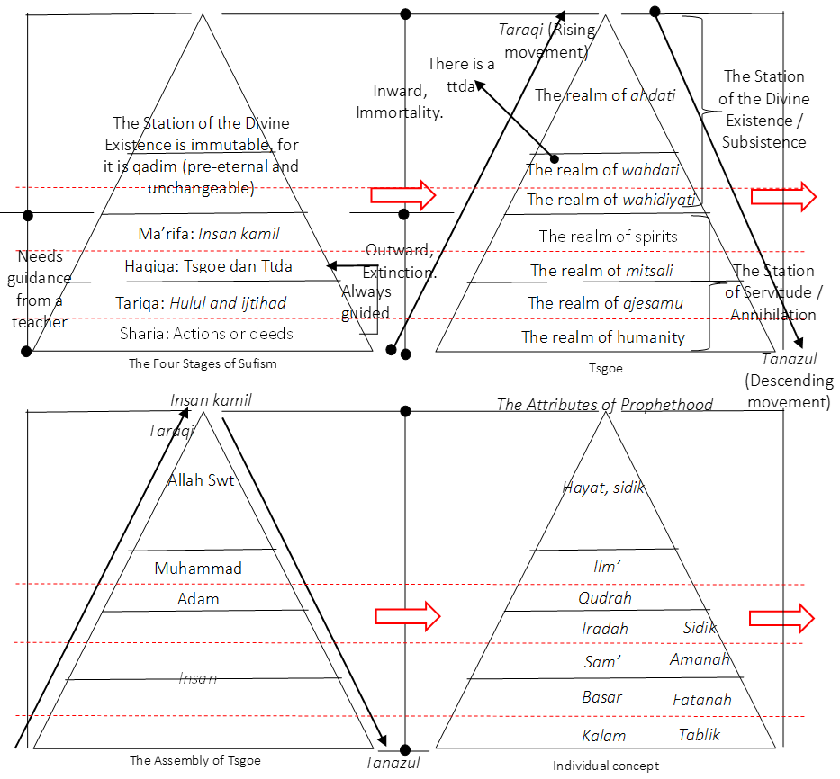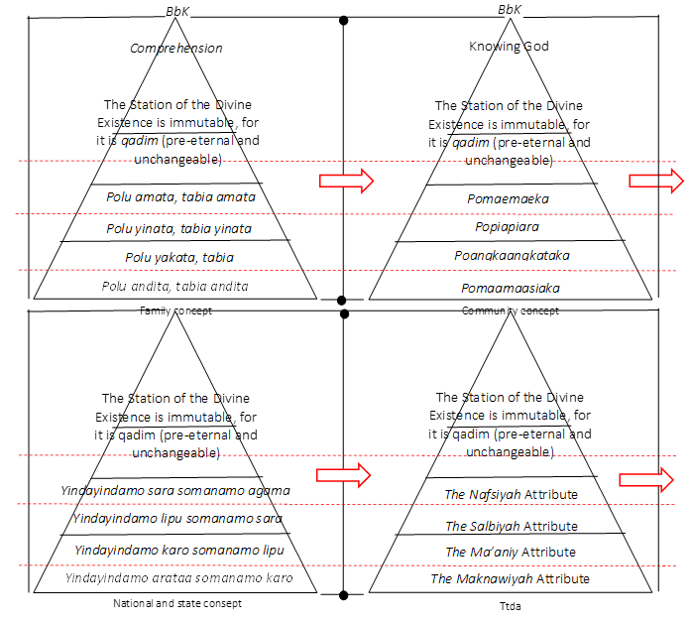

Figure 3. The TSGOE and TTDA labeling in the everyday life of the Butonese people encapsulates the concepts of individuality, family, society, nationhood, and statehood.
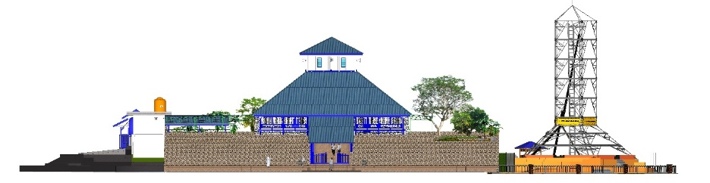

Figure 4. Clean front elevation of the building
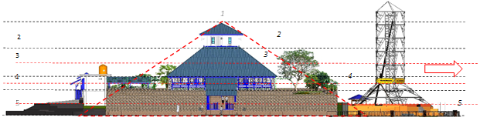

Figure 5. Annotated front elevation of the building with legend. The labeling of Tsgoe and Ttda about the concepts of individuality, family, society, nation, and state is reflected in the design of TGMOTSOB.

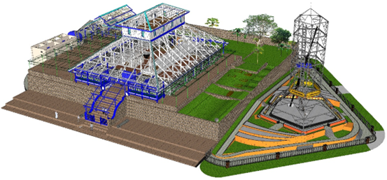

Figure 6. Clean perspective view of the building.

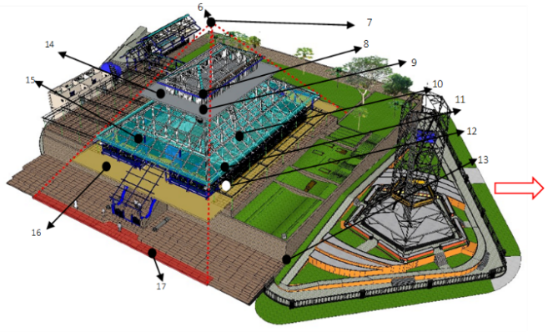

Figure 7. An annotated perspective view of the building with a legend. Tsgoe and Ttda from the perspective of TGMOTSOB
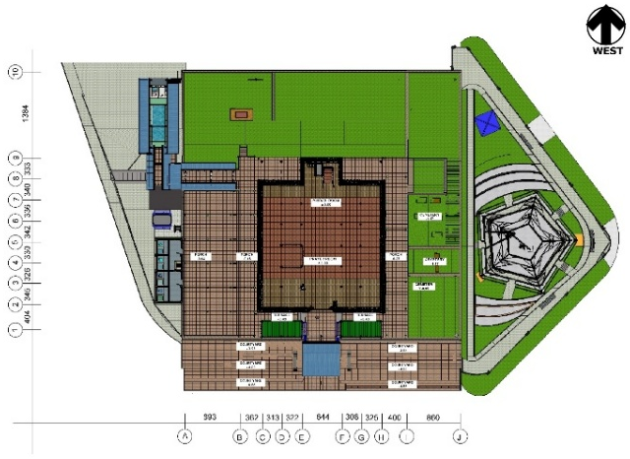

Figure 8. Clean floor plan of the building.
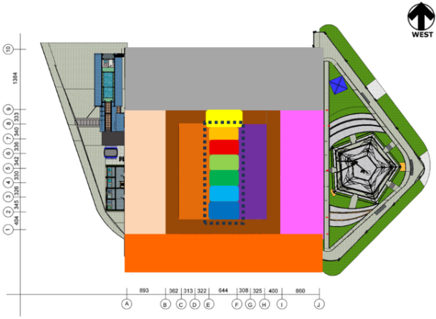

Figure 9. Annotated floor plan of the building with legend. Tsgoe and Ttda in the floor plan of the first level of TGMOTSOB

Table 1. Symbolic Legend
Symbolic Legend/Spatial Layout
Symbol/Color | Conceptual Meaning/Architectural Element
1 | BbK/A Budimani Person (A Person of Integrity and Virtue)
2 | The Stage of the Spiritual Realm/The Nafsiyah Attribute/Sidik (Truth)/Third Floor; Polu amata tabia amata, pomaemaeka, and yindayindamo sara somanamo agama.
3 | The Stage of the Mitsali Realm/ The Salbiyah Attribute/Amanah (Trustworthiness)/Second Floor; Polu yinata tabia yinata, popiapiaraa, and yindayindamo lipu somanamo sara.
4 | The Stage of the Ajesamu Realm/The Ma’aniy Attribute/fatanah/lantai satu; Polu yakata tabia yakata, poangkaangkataka, and yindayindamo karo somanamo lipu.
5 | The Stage of the Human Realm/The Maknawiyah Attribute/Tablikh (Preaching)/Ground Floor; Polu andita tabia andita, pomaamaasiaka, and yindayindamo arataa somanamo karo.
6 | BbK/A Budimani Person (A Person of Integrity and Virtue)
7 | Ahdati, hayat, the central roof ridge
8 | Wahdati, ilm’, The top of the third-floor pillars
9 | Wahidiyati, qudrah, the top of the pillars beneath the third floor
10 | The realm of spirits, iradah, the top of the second-floor pillars
11 | The realm of Mitsali, sam’, the top of the pillars, beneath the second floor
12 | The realm of ajesamu, basar, the base of the first-floor pillars
13 | The realm of human (insan), kalam, the foundation
14 | The Stage of the Spiritual Realm, Third floor, Polu amata tabia amata, pomaemaeka, and yindayindamo sara somanamo agama. (The color Gray)
15 | The Stage of the Mitsali Realm, second floor, polu yinata tabia yinata, popiapiaraa, and yindayindamo lipu somanamo sara. (The color blue)
16 | The Stage of the Ajesamu Realm, first floor, polu yakata tabia yakata, poangkaangkataka, and yindayindamo karo somanamo lipu. (The color gold)
17 | The Stage of the Human Realm, Foundation base, polu andita tabia andita, pomaamaasiaka, and yindayindamo arataa somanamo karo. (The color red)
(Yellow box), E-F and 8-9 | Ahdati, hayat, The Nafsiyah Attribute
(Orange box), C-H and 7-8 | Wahdati, Ilm’,
(Red box), C-H and 6-7 | Wahidiyati, Qudrah
(Light green box), C-H and 5-6 | Spiritual, Iradah
(Dark green box), C-H and 4-5 | Mitsali, Sam’
(Light blue box), C-H and 3-4 | Ajesamu, Basar
(Dark blue box:), C-H and 2-3 | Insan, Kalam
(Purple box), F-H and 2-8 | The Maknawiyah Attribute
(Light brown box) C-H and 2-8 | The Ma’aniy Attribute
(Dark brown box), B-I and 1-9 | The attribute of existence
(Cream box). A-B and 1-9 | The Mukhallifatu lilhawadits Attribute
(Pink box). I-J and 1-9 | The Qidam Attribute
(Black-outline box), E-f and 2-8 | The Wahdaniyyah Attribute
(Gray box), A-J and 9-10 | The Eternal Attribute
(Terracotta box), A-J | The Qiyamuhu binafsihi Attribute
C-H and 1-2 | Polu andita tabia andita, pomaamaasiaka, and yindayindamo arataa somanamo karo.
C-H and 2-5 | Polu yakata tabia yakata, poangkaangkataka, and yindayindamo karo somanamo lipu.
C-H and 5-8 | Polu yinata tabia yinata, popiapiaraa, and yindayindamo lipu somanamo sara.
E-F and 8-9 | Polu amata tabia amata, pomaemaeka, and yindayindamo sara somanamo agama.

TSGOE embodies Butonese Sufi beliefs, TGMOTSOB’s architecture symbolizes human creation stages, with the ground floor representing the human realm and maknawiyah attribute. The first floor corresponds to The Stage of the Ajesamu Realm and the attribute of Ma’aniy. The second floor aligns with The Stage of the Mitsali Realm and the attribute of salbiyah. The third floor is associated with The Stage of the Spiritual Realm and the attribute of nafsiyah. “According to Arif Tasila, attaining Allah requires following Muhammad’s path, embodying Adam and Muhammad to achieve perfection as Insan Kamil, the essence of tsgoe Dayanu Ikhsanuddin.” According to [4], originating in Aceh, tsgoe spread across the Nusantara, with TGMOTSOB integrating divine attributes to facilitate annihilation, subsistence, and attainment of Insan Kamil. This statement aligns with [4], which states that the concept of philosophical Sufism acknowledges the doctrines of annihilation and subsistence. In Buton, the concepts of annihilation and subsistence are part of philosophical Sufism.
Buton scholars’ identity in TSGOE and TTDA reflects ijtihad, embodying a cyclical journey of returning to Allah through tanazul and taraqi. Regarding taraqi [9], TSGOE guides individuals to return to God by understanding the self, reflected in TGMOTSOB’s spiritual, mitsali, ajesamu, and human realms. Butonese architecture symbolizes human construction, emphasizing the spiritual connection often overlooked in historical study. “Ana Mori,” a seeker of truth, views mosque architecture as four ascending levels reflecting tsgoe’s principles of human self-awareness: The lowest level, labeled as The Stage of the Human Realm, also referred to as polu andita tabia andita, pomaamaasiaka, and yindayindamo arataa somanamo karo, corresponds to the building’s foundation. This architectural level symbolizes the foundation of human existence, with load-bearing elements representing the basic instincts that anchor spiritual consciousness. Second Stage: The first floor, known as polu yakata tabia yakata, poangkaangkataka, and yindayindamo karo somanamo lipu, serves as the main prayer area and is associated with The Stage of the Ajesamu Realm. This level’s porous structure, with rhythmic openings, symbolizes human bodily interconnectedness, creating a meditative space that balances physical form and divine awareness.
Third Stage: The second floor, labeled as The Stage of the Mitsali Realm, is referred to as polu yinata tabia yinata, popiapiaraa, and yindayindamo lipu somanamo sara. The floor’s asymmetry symbolizes spiritual readiness versus veiled truths, guiding contemplation through material transitions of openness and solidity. Fourth Stage: The third floor, known as polu amata tabia amata, pomaemaeka, and yindayindamo sara somanamo agama, is associated with The Stage of the Spiritual Realm. This level symbolizes transcendent vision, spiritual readiness, and divine knowledge, culminating in unity without merging, reflecting Butonese ijtihad philosophy, as depicted in Figures 4-5. Spatial ascent parallels Sufi self-realization; wood symbolizes organic connection, adaptability, and spiritual resilience. The mosque’s roof symbolizes union, “united but not merged,” reflecting attainable perfection in Butonese ijtihad and Insan Kamil theology, as illustrated in Figures 4-5. The concept of “the worshipped and the worshipper” (ma‘bud wa ‘abid) is not a binary but a reflective reality within the self. It is grounded in the spiritual understanding of the human soul in Buton. This doctrine affirms the deep metaphysical correspondence between God and humanity in mosque architecture [7].
TGMOTSOB symbolizes spiritual ascent, narrowing from a broad base to a silent, perfect flat peak: 1) Point 7-The central roof ridge, labeled Ahdati and Hayat, symbolizes the essence of life in its purest, undivided form. Architecturally, this is the lightest structural point, receiving the least load but the most illumination, symbolizing transcendence and divine unity. 2) Point 8-The top of the third-floor pillars, labeled Wahdati and Ilm, represents the stage of comprehensive divine knowledge. The slim verticality of the pillars and their exposure to natural light mirror the openness and receptivity needed to comprehend sacred truths. 3) Point 9-The top of the pillars beneath the third floor, labeled Wahidiyati and Qudrah, reflects divine power distributed through the structure. These pillars are intermediate supports, balancing the weight of knowledge above and the soul’s aspirations from below. 4) Point 10-The top of the second-floor pillars, labeled The Realm of Spirits and Iradah, illustrates the will of the Divine guiding structural alignment. These structural elements support communal prayer spaces, bridging individual agency (iradah) with collective spiritual energy.
5) Point 11-The top of the pillars beneath the second floor, labeled The Mitsali Realm and Sam’, corresponds to the realm of symbolic perception. The structure here channels sound through the open floors and exposed beams, enabling the sam’ (spiritual hearing) of divine remembrance. 6) Point 12-The base of the first-floor pillars, labeled The Ajesamu Realm and Basar, connects to the faculty of physical vision. Architecturally, this is where the light filters through lateral windows, guiding worshippers visually through a rhythm of repetition and natural illumination. 7) Point 13-The foundation, labeled The Human Realm and Kalam, is the deepest and most solid structural base. Foundations of stone and timber symbolize Kalam, linking body and spirit as a spiritual ladder. Thus, the TGMOTSOB’s layered structure channels light, sound, and spirituality, embodying Tsgoe’s seven stages [27] and Sufi architectural expression [33], as illustrated in Figures 6-7.
Figure 8-9 illustrates that the symbolization of self-recognition (TSGOE) and TTDA is expressed grandly and clearly within the mosque's layout. The representation of tsgoe and the concept of the individual is as follows: 1) At point E-F and 8-9, labeled as Ahdati and Hayat. The mihrab chamber, measuring 6.44 x 3.33 m, is built of coral limestone and contains the pusena tana cavity, as well as a pulpit for prayer leadership. 2) At point C-H and 7-8, labeled as Wahdati and Ilm. 3) At point C-H and 6-7, labeled as Wahidiyati and Qudrah. 4) At point C-H and 5-6, labeled as the Spiritual Realm and Iradah. 5) At point C-H and 4-5, labeled as the Mitsali Realm and Sam. 6) At point C-H and 3-4, labeled as the Ajesamu Realm and Basar. 7) At point C-H and 2-3, labeled as the Human Realm and Kalam. At points C-H and 2-8 lies the main prayer hall (19.12 x 20.19 m), which uses large windows and marble floors to provide natural light, symbolizing the spirituality of the site [27], [33].
8) Ttda labeling is also evident in the mosque's layout. The Nafsiyah attribute (Wujud/Adangia/Existence) is labeled at point E-F and 8-9. The mihrab chamber features a southern opening for the Sultan’s exclusive prayer entrance and circulation. Meanwhile, the Ma’aniy attributes are assigned as follows: 1) At C-E and 8-9, labeled as Hayat/Adadi/Life. 2) At C-E and 7-8, labeled as Ilm’/Amatau/Knowledge. 3) At C-E and 6-7, labeled as Qudrah/Apoli/Power. 4) At C-E and 5-6, labeled as Iradah/Apelu/Will. 5) At C-E and 4-5, labeled as Sam’/Aporango/Hearing. 6) At C-E and 3-4, labeled as Basar/Apokamata/Seeing. 7) At C-E and 2-3, labeled as Kalam/Akaonioni/Speech. The southern prayer hall features a women’s area; its exposed beams enhance the structure, symbolizing spiritual growth according to TSGOE cosmology [27], [33]. The Maknawiyah attributes are assigned as follows: 1) At F-H and 8-9, labeled as Hayyun/Modadina/The Ever-Living. 2) At F-H and 7-8, labeled as Alimun/Momatauna/The All-Knowing. 3) At F-H and 6-7, labeled as Qadirun/Mopolina/The All-Powerful. 4) At F-H and 5-6, labeled as Muridun/Mopeluna/The All-Willing. 5) At F-H and 4-5, labeled as Sami’un/Moporangona/The All-Hearing. 6) At F-H and 3-4, labeled as Basirun/Mopokamatana/The All-Seeing. 7) At F-H and 2-3, labeled as Mutakallimun/Mokaonionina/The All-Speaking. The northern prayer hall’s second floor, initially unused, now serves as an additional prayer space with four windows. At E-F and 2-8, the Salbiyah attributes are labeled, encompassing both Maknawiyah and Ma’aniy attributes within the Wahdaniyyah (Sanguanguna/Oneness of God). The central prayer hall embodies Salbiyah and Wahdaniyyah attributes, featuring ceremonial elements reflecting tsgoe’s vertical spirituality [27] and Sufi Islamic architecture [33].
Thus, there are seven Ma’aniy attributes and seven Maknawiyah attributes, totaling 14 attributes, which are unified within Wahdaniyyah, making a total of 15 attributes. These 15 attributes are dependent on five fundamental Nafsiyah and Salbiyah attributes, as follows: 1) At B-I and 1-9, labeled as Wujud/Adangia/Existence. The veranda surrounding the prayer hall includes two eastern godegode benches for mosque personnel. Extensions on the southern side add ceramic flooring, a bathroom, storage, and a water tank, detached from the main structure. 2) At I-J and 1-9, labeled as Qidam’/Atoka/Eternity (Pre-Existence). The northern courtyard, measuring 8,06 x 27,56 meters, contains a historic cemetery of notable Islamic contributors and is landscaped with Japanese grass. 3) At A-J and 9-10, labeled as Baqa’/Sadada/Everlasting. The mosque courtyard, measuring 13.84 x 44.27 meters, contains old graves but excludes the sultans’ burials; it is currently landscaped and maintained. 4) At A-B and 1-9, labeled as Mukhalafatuhu lil-Hawadits/Aposala Tee Yiapaiyiapaika Mosimpona/Absolute Uniqueness (Different from all creation). The mosque veranda, measuring 8,93 x 27,56 meters, features ceramic flooring since 1999 and canopy roofs added in 2018 for coverage.5) At the mosque’s courtyard (east of the building, A-J), labeled as Qiyamuhu Binafsih/Akakaro Sakarokarona/Self-Sufficiency (Standing by Himself). The eastern mosque courtyard contains VOC-era cannons and an ancient sacrificial pit. Upgraded with ceramic andesite flooring, it reflects adaptive preservation aligned with heritage and Sufi architectural values [16]-[20], [33].
The concepts of individual, family, community, nation, and state in TGMOTSOB are represented as follows: 1) At E-F and 8-9, labeled as Polu Amata Tabia Amata, Pomaemaeka, and Yindayindamo Sara Somanamo Agama (symbolizing individual responsibility and religious harmony). The mihrab chamber originally had wooden floors due to the Pusena Tana cave, which was sealed with concrete in 1930, leaving a small intentional opening. 2) At C-H and 5-8, labeled as Polu Yinata Tabia Yinata, Popiapiaraa, and Yindayindamo Lipu Somanamo Sara (representing family values and social order). 3) At C-H and 2-5, labeled as Polu Yakata Tabia Yakata, Poangkaangkataka, and Yindayindamo Karo Somanamo Lipu (signifying community development and governance). These areas refer to the main prayer hall, which is organized into six columns and five rows. When the mosque was initially constructed in 1712, the floor of the main prayer hall was believed to be made of clay soil. In the 1930s, the clay floor was overlaid with a smooth cement render. 4) At C-H and 1-2, labeled as Polu Andita Tabia Andita, Pomaamaasiaka, and Yindayindamo Arataa Somanamo Karo (symbolizing statehood, justice, and leadership). The mosque's veranda, originally made of compacted earth, was tiled in 1999. It features an ablution jar and two godegode platforms for mosque staff and officials of the Sultanate. Thus, TGMOTSOB’s material shift from vernacular to modern architecture preserves spiritual and local identity, aligning with Sufi thought [33] and heritage principles [16]-[20]. It embodies the TSGOE and BbK values [25], [26], [30], serving as a spiritual institution that guides self-transformation toward Insan Kamil, the enlightened human ideal.
- CONCLUSION
This study concludes that TGMOTSOB’s architecture embodies the concept of the Perfect Human (Insan Kamil), serving as a medium for self-discovery through the stages of servanthood: Spiritual, Mitsali, Ajesamu, and Human Realms. The soul’s journey toward perfection begins with Hayatullah (Muhammad and Adam) and passes through these realms before achieving Insan Kamil. The practice of 17 cycles of prayer and embedded symbols reflects remembrance of divine origin. This research contributes a new theoretical framework in architecture, grounded in TSGOE, TTDAA, and Butonese wisdom (BbK), thereby enriching Nusantara mosque theory and offering a universal perspective on religious architecture that aligns with Islamic philosophy and cosmology. Future studies may further analyze TGMOTSOB’s symbols using Insan Kamil as a core framework, enhancing understanding of spiritual and architectural integration.
ACKNOWLEDGEMENT
This research was supported by the Center for Education Financial Service (PUSLAPDIK Indonesia) and Indonesia Endowment Funds for Education (LPDP Indonesia).
REFERENCES
[1] A. A. Umar, E. Setyawati, and A. Preambudi, “Penerapan Transformasi Arsitektur Tradisional Buton pada Perancangan Cultural Center di Kabupaten Buton,” Archvisual J. Arsit. dan Perenc., vol. 3, no. 1, pp. 1–10, 2023.
[2] H. Mulyanto, “Posisi Buton dalam Arus Sejarah Indonesia,” Humanis, vol. 26, no. 2, p. 215, 2022, doi: 10.24843/jh.2022.v26.i02.p07.
[3] L. O. A. Munafi and L. O. M. N. Saafi, Mengenal Kawasan Cagar Budaya Benteng Wolio (Benteng Keraton Kesultanan Buton), 1st ed. Kota Kendari: Universitas Halu Oleo Press, 2021.
[4] M. K. Mahyuddin, A. N. Mokhtar, F. Badaruddin, A. R. Mahmood, W. H. Khairuddin, and K. A. A. Latif, “Penjelasan dan Analisis Kritikal Doktrin Martabat Tujuh dalam Kerangka Ahli Sunnah Wal Jamaah,” J. Ifta Islam. Herit., vol. 2, no. 1, pp. 110–139, 2023.
[5] Faharuddin, “Relevansi Nilai Hukum Konstitusi Martabat Tujuh Kesultanan Buton Dalam Pelaksanaan Pemerintahan Di Kota Baubau,” Universitas Hasanuddin, 2022.
[6] B. Handoyo, “Konsep Wahdatul Wujud dalam Pandangan Syekh Syamsuddin As-Sumatrani,” Ta’wiluna J. Ilmu Al-Qur’an, Tafsir dan Pemikir. Islam, vol. 3, no. 1, pp. 127–152, 2022, doi: 10.58401/takwiluna.v3i1.758.
[7] M. B. A. N. Zainaldy and S. Sangidu, “Naskah Tuḥfah Al-Mursalah (Maa.. 021) Masjid Agung Surakarta; Konsep Posisi Salik Dalam Martabat Menuju Maqam ‘Ilahiyyah.,” Metahumaniora, vol. 13, no. 1, p. 65, 2023, doi: 10.24198/metahumaniora.v13i1.45667.
[8] M. M. M. A. Mudjriddin, Thariqat Qadiruniyah An Naqsyabandiyah Al Khalidiyah Al Mujaddidiyah Mengungkap Tabir Sejarah Spritual dan Metafisika, Theokrasi, serta Monarkhi Parlementer Kesulthanan Buton (bidaaril Buthuunii), Cetakan 1. Kota Bogor: Institut Tasawwuf Al Mujaddid, Bogor; Lembaga Pengkajian Budaya Buton, Baubau; dan Yayasan Jabbal Qubais, Bogor, 2009.
[9] M. D. Erina et al., “Sejarah dan Ajaran Tarekat Syattariyah di Cirebon,” J. Ris. Agama, vol. 2, no. 1, pp. 121–132, 2022, doi: 10.15575/jra.v2i1.15687.
[10] A. Arifka, “Teo-Antroposentrisme Konsep Martabat Tujuh Ranggawarsita,” KACA (Karunia Cahaya Allah) J. Dialogis Ilmu Ushuluddin, vol. 13, no. 1, pp. 1–26, 2023.
[11] J. A. Rohmana, “Diskursus Tasawuf Nusantara Di Mekah: Respons Mukhtar Aṭarid Al- Bughūrī Terhadap Ajaran Martabat Tujuh,” J. Lekt. Keagamaan, vol. 19, no. 1, pp. 1–36, 2021, doi: 10.31291/jlk.v19i1.923.
[12] F. Rahman and A. Dakhoir, “The Concept of ‘Martabat Tujuh’ Al-Burhanpuri (Study of the Creation of the Universe in the Perspective of Philosophical Sufism),” Int. J. Multicult. Multireligious Underst., vol. 8, no. 7, p. 87, 2021, doi: 10.18415/ijmmu.v8i7.2681.
[13] A. Y. F. Nawafi, “Titik Temu Mistisisme Islam dan Mistisisme Jawa; Studi Analitis terhadap Persinggungan Ajaran Tasawuf dan Kejawen,” J. Intelekt. J. Pendidik. Dan Stud. Keislam., vol. 10, no. 2, pp. 242–254, 2020, doi: 10.33367/ji.v10i2.1297.
[14] L. O. A. Munafi, T. Tahara, A. Tenri, and D. D. L. O. Malim, “Pebula: Local wisdom of the Buton people considering the prevention and enforcement of corruption,” ETNOSIA J. Etnogr. Indones., vol. 5, no. 1, p. 66, 2020, doi: 10.31947/etnosia.v5i1.8559.
[15] M. Mansyur, “Peran dan Fungsi Perangkat/Pejabat Kesultanan Buton pada Abad Ke-20,” J. Pendidik. Sej., vol. X, no. 1, pp. 1–16, 2023.
[16] A. W. Emmerich, “Language change and persistence within Turkish mosques in Germany–Transnational ties and domestic demands,” J. Ethn. Migr. Stud., vol. 0, no. 0, pp. 1–20, 2021, doi: 10.1080/1369183X.2021.1994377.
[17] M. Skublewska-Paszkowska, M. Milosz, P. Powroznik, and E. Lukasik, “3D technologies for intangible cultural heritage preservation—literature review for selected databases,” Herit. Sci., vol. 10, no. 1, pp. 1–24, 2022, doi: 10.1186/s40494-021-00633-x.
[18] P. Andriani and R. Kaminska, “Exploring the dynamics of novelty production through exaptation: a historical analysis of coal tar-based innovations,” Res. Policy, vol. 50, no. 2, 2021, doi: 10.1016/j.respol.2020.104171.
[19] M. M. Yagoub and A. A. Al Yammahi, “Spatial distribution of natural hazards and their proximity to heritage sites: Case of the United Arab Emirates,” Int. J. Disaster Risk Reduct., vol. 71, no. August 2021, p. 102827, 2022, doi: 10.1016/j.ijdrr.2022.102827.
[20] Z. U. A. Malik et al., “The Importance Of Heritage Conservation, Preservation, And Restoration In Pakistan,” J. Posit. Sch. Psychol., vol. 7, no. 2, pp. 227–239, 2023, [Online]. Available: http://journalppw.com
[21] T. Tahara, L. O. A. Munafi, and D. D. L. O. Malim, “Nilai-nilai Budaya Sara Patanguna sebagai Penguatan Harmonisasi antar Etnik di Baubau,” Etnosia J. Etnogr. Indones., vol. 6, no. 1, pp. 82–96, 2021, doi: 10.31947/etnosia.v6i1.13604.
[22] Haeria, “NILAI-NILAI PENDIDIKAN ISLAM DALAM TRADISI PAKANDEANA ANA ANA,” J. Istiqra, vol. 10, no. 2, pp. 191–207, 2022.
[23] L. O. Turi, Esensi Kepemimpinan Bhinci Bhinciki Kuli (Suatu Tinjauan Budaya Kepemimpinan Lokal Nusantara), Cetakan 1. Yogyakarta: Khazanah Nusantara, 2007.
[24] R. M. Suhartono and Ernawati, “The Nature of Binci-Binciki Kuli ( Norma ) of The Government of The Sultanate of Buton,” J. Huk. Volkgeist, vol. 6, no. 2, pp. 208–214, 2022.
[25] A. F. Mahlus, Tasawuf Akhlaqy Sara Pataanguna Memanusiakan Manusia Menjadi Manusia Khalifatullah di Bumi Kesulthanan Butuni, Cetakan 1. Kota Baubau: Tarafu-Butuni, 2003.
[26] N. S. Adam and S. H. S. Omar, “Fana’ Dalam Wacana Sufi Nusantara: Tinjauan Terhadap Pemikiran Sufi Sheikh Daud Al-Fatani,” Jurna Islam dan Masy. kontemporari, vol. 20, no. 1, pp. 206–219, 2019.
[27] A. W. Al Kamal, “Sisi Sisi Teori Martabat Tujuh Syaikh Syamsuddin As-Sumatrani Pada Emanasi Ibnu Sina,” Universitas Islam Negeri (UIN) Walisongo Semarang, 2015.
[28] A. Masykhur, “Titik Singgung Hukum Islam dengan Hukum Adat pada Naskah Perundang-Undangan Kerajaan Islam di Nusantara,” Al-Manahij J. Kaji. Huk. Islam, vol. 14, no. 2, pp. 295–306, 2020, doi: 10.24090/mnh.v14i2.3724.
[29] L. Nalefo, “The Role of Martabat Tujuh within the Society of the Sultanate Buton Wolio,” Asian Cult. Hist., vol. 10, no. 1, p. 6, 2017, doi: 10.5539/ach.v10n1p6.
[30] Mahrudin, “Nilai-Nilai Hukum dalam Undang-Undang Martabat Tujuh Buton,” J. Al-’Adl, vol. 8, no. 2, pp. 123–139, 2015.
[31] Mahrudin, “Islam Untuk Membangun Karakter,” J. Dakwah, vol. XV, no. 2, pp. 335–355, 2014.
[32] L. O. M. Syahartijan, Jaringan Pendidikan Islam di Kesultanan Buton, Pertama. Literacy Institute, 2020.
[33] A. Fanani, Arsitektur Masjid, 1st ed. Yogyakarta: Mizan Media Utama, 2009.
[34] M. Z. Umar and M. Agus, “Desain Masjid Di Kecamatan Tomia Timur Kabupaten Wakatobi Provinsi Sulawesi Tenggara Dengan Prinsip-Prinsip Arsitektur Eklektik,” Vitruvian, vol. 9, no. 2, p. 81, 2020, doi: 10.22441/vitruvian.2020.v9i2.002.
[35] Rosmina, “Perancangan Museum Benteng Keraton Buton Dengan Pendekatan Arsitektur Buton,” Universitas Islam Negeri (UIN) Maulana Malik Ibrahim Malang, 2022. [Online]. Available: https://bit.ly/43UNIgI
[36] N. Hendrawan, H. Hamid, and B. Azzamani, “Media Informasi Berbasis Augmented Reality Pada Kompleks Masjid Agung Keraton Buton Menggunakan Algoritma Fast Corner Detection Augmented Reality Based Information At The Agung Keraton Buton Mosque Using Fast,” Informatika, vol. 11, no. 2, pp. 176–185, 2022.
[37] Amsir, “Bentuk Dan Makna Ornamen Masjid Agung Keraton Buton Kota Bau-Bau Buton Sulawesi,” Universitas Muhammadiyah Makassar, 2022.
[38] Ruslin and E. T. Pratiwi, “PERLAKUAN AKUNTANSI TERHADAP ASET BERSEJARAH ( Studi Fenomenologi pada Mesjid Agung Keraton Buton ),” J. Ilm. Mhs. Fak. Ekon. Umbut., vol. 3, no. 1, pp. 131–148, 2021.
[39] M. Farid et al., Fenomenologi Dalam Penelitian Ilmu Sosial, 1st ed. Jakarta: Prenadamedia Group, 2018.
[40] Zaprulkhan, Filsafat Ilmu Sebuah Analisis Kontemporer, 6th ed., N. Hasanah, Ed. Kota Depok: PT Rajagrafindo Persada, 2021, pp. 221–241.
[41] E. Kuswarno, Metode Penelitian Komunikasi Fenomenologi: Konsepsi, Pedoman, dan Contoh Penelitiannya. Bandung: Widjaya Padjadjara, 2009.
[42] J. W. Creswell, Qualitative Inquiry and Research Design: Choosing Among Five Approaches. London: Sage Publications, 2007.
[43] C. E. Moustakas, Phenomenological Research Methods. United States Of America: Sage Publications, Inc., 1994.

