 |  | JOURNAL OF ISLAMIC ARCHITECTURE  P-ISSN: 2086-2636 E-ISSN: 2356-4644  Journal Home Page: http://ejournal.uin-malang.ac.id/index.php/JIA
THE PRIVATE LEVANTINE ZENGID, AYYUBID, AND MAMLUK CEMETERIES: A STUDY ACCORDING TO THE ISLAMIC AND SOCIAL PERSPECTIVE
Riad Salim Awad^{a*}
ªDepartment of History, College of Arts, University of Kirkuk, Iraq
*Corresponding Author: riadawad90@uokirkuk.edu.iq
ARTICLE INFO |  |  | ABSTRACT
Volume: 8  Issue: 4  Page: 1121-1141  Received: August 6th, 2024  Accepted: March 6th, 2025  Available Online: December 30th, 2025  DOI: 10.18860/jia.v8i4.28801 |  |  | The cities of the Levant, such as Damascus, Jerusalem (Al-Quds), and Aleppo, witnessed the widespread construction of private tombs for the sultans and emirs of the Zengid, Ayyubid, and Mamluk dynasties, as well as for prominent members of Levantine society, including religious figures and merchants. This study examines the symbolism of these tombs as a cultural intersection between religion and society by analyzing their architectural elements and describing their designs, which range from simple to grand. It also examines the Islamic legal stance on its components, based on the sayings and actions of the Prophet Muhammad (PBUH) as recorded in the recognized Hadith collections of Sunni Muslims. Additionally, the study aims to highlight the social customs associated with these tombs and their reflection of cultural perspectives and perceptions of death. It investigates whether the community neglected these tombs, causing them to fade with time, or whether they were preserved as witnesses to civilization. One of the most important findings of the study is that the word "soil" (Turba), which means "private cemetery," has become synonymous among Levantines with "mosque," "school," "library," and "orphanage." So, the concept of private Levantine cemeteries has evolved from a deserted place inhabited by the dead, shrouded in sadness and fear, to a vibrant, life-filled place where the living coexist with the dead, offering a sense of joy and hope. The private Levantine cemeteries supported the Islamic scientific movement; they became icons embodying the art of Islamic material civilization and served as centers of Islamic intellectual civilization.  Keywords:  Islamic Civilization; Islamic Architecture; Mosque Architecture; Damascus Schools; Private Cemeteries; Domes and Tombs

- INTRODUCTION
The private cemeteries in the cities of the Levant during the Zengid, Ayyubid, and Mamluk periods are among the most prominent historical architectural landmarks, reflecting significant religious, social, and cultural dimensions. The architecture of these cemeteries has been studied with the focus on both the Islamic and the social perspective, i.e., explaining the position of Islamic law on the architectural elements that the Levantines built in their cemeteries, based on the sayings and actions of the Prophet Muhammad (PBUH) mentioned in the books of the Prophet’s hadith collections recognized by Sunni Muslims. Which deal with the issues of cemeteries, the burial of deceased Muslims, the structure of graves, and the practices of the Islamic community regarding these cemeteries, as well as the views of Islamic jurists on these practices.
Several previous studies have examined the history of private cemetery architecture in the Levant. One such study is "The Development of Mausoleum Construction until the End of the Seljuk Era", which focuses on the history and evolution of mausoleum architecture from pre-Islamic times to the Seljuk period. However, it stops at the Zengid era and adopts a descriptive and investigative approach, primarily analyzing the architecture and design of domes built over mausoleums in Medina, Iraq, and Damascus [1]. Another study, "Ayyubid schools in Aleppo, Al-Firdaws School as a model", investigates the history of the Al-Firdaws Cemetery in Aleppo during the Ayyubid period, describing its architecture, its affiliated buildings such as the mosque and school, and its cultural role at the time [2]. Similarly, "Sultanate soils in Egypt and the Levant during the two centuries (6-7 AH / 12-13 AD) as mentioned in the book Mufarrej al-Karub by IbnWasil (d. 697 AH/ 1298 AD)" examines the architecture of certain Ayyubid and Mamluk cemeteries in the Levant and Egypt. However, these studies adopt a highly concise descriptive approach, providing only brief descriptions of the locations and architectural elements of these cemeteries, without including any illustrations or tables to support their findings [3]. Another study, "Al-Dhahiriyah School in Damascus, Al-Dhahiriyah Library," focuses solely on the history of the Al-Dhahiriyah Cemetery during the Mamluk period, describing its architectural design and associated buildings, such as the school and library, while also highlighting its cultural role [4].
These gaps in previous research motivated the researcher to choose this study’s topic, aiming to shed light on the architectural elements of private cemeteries in the Levant during the Zengid, Ayyubid, and Mamluk periods. Unlike previous studies, this research examines these cemeteries from both the Islamic perspective, an aspect largely overlooked, and the social perspective, by analyzing the community’s practices regarding these burial sites. The ultimate goal is to produce a comprehensive study of the architecture of these cemeteries, focusing exclusively on cities in the Levant.
This study aims to achieve several specific research objectives, including: Identifying the fundamental architectural elements of these cemeteries, from the cemetery ground itself to the grave and its internal room, and finally, the dome that covers it. The study also explores the architectural features of these cemeteries, including mosques, schools, libraries, and an orphanage, which are integral to their landscapes.
In addition to studying the Islamic legal rulings that every Muslim must adhere to regarding funerals, including the burial regulations for deceased Muslims and the legally permissible practices related to cemeteries.
Understanding the prevailing social customs in the Levantine community and their impact on people’s perceptions of death and private cemeteries. The study analyzes the daily practices in these cemeteries. It investigates whether they have been neglected and deteriorated over time, or whether the community has taken measures to preserve and maintain them. Additionally, the study examines how the deceased's social status influenced the architectural style and development of private cemeteries in the Levant.
Highlighting the cultural role these cemeteries played, particularly as their owners transformed them into charitable endowments serving the community. The study also examines the services these cemeteries provided to the broader Islamic society, with a special focus on the Levantine community.

- METHODS
This study employs a descriptive, analytical, and investigative approach to examine the architecture of private cemeteries in the Levant during the Zengid, Ayyubid, and Mamluk periods. The research focuses on describing the primary architectural elements that constitute these cemeteries, beginning with the tomb and its land, and analyzing their Location and orientation relative to the Qibla (direction of Mecca).
The study provides a detailed description of tombstones, including an analysis of their Islamic ornamentation. It also examines the religious inscriptions carved into these tombstones, such as Quranic verses and poetic lines, analyzing the types of calligraphy used and the Islamic legal stance on them.
Furthermore, the study describes the architectural elements of the tomb's room, its Islamic and botanical decorations with a particular focus on newly introduced elements such as the Mihrab, and evaluates its legitimacy in this context. The research also investigates how the deceased's social status influenced the quality and grandeur of the tomb and its chamber, using a comparative approach across different cemeteries.
Additionally, the study examines the domes, analyzing their types, designs, and historical origins. All legal rulings and analyses presented in this study are supported by religious evidence derived from Hadith collections, authenticated historical sources, and modern studies. The research is further supplemented with illustrative diagrams of architectural designs of private Levantine cemeteries, as well as photographs and tables that provide a clearer, more comprehensive picture for readers interested in the history of Islamic cemetery architecture and its religious, social, and cultural implications.

- RESULT AND DISCUSSION
The research was divided into three main sections: the first was devoted to defining the Zengid, Ayyubid, and Mamluk states historically. The second section focused on the main architectural elements of the private Levantine tombs built by the sultans, kings, Zengid princes, Ayyubids, and Mamluks, as well as by other notables of Levantine society. These elements are the grave land, the tomb, the tomb room, and the tomb dome. At the same time, the third section of the study discussed the architectural elements of private Levantine cemeteries, including mosques and prayer halls, schools, orphanages, and libraries. Finally, the study concluded with a presentation of the results and recommendations.
  - DEFINING THE ZENGID, AYYUBID, AND MAMLUK STATES
- 1. The Zengid State
It is one of the Islamic states that was established by the leader Imad al-Din Zengi. He was a commander under the Seljuk state, loyal to the Abbasid Caliph in Baghdad. Imad al-Din took control of the city of Mosul and the lands of Al-jazeera in (521AH/ 1127AD), then he expanded his emirate towards the Levant and took control of Aleppo; his sons then took control of the kingdom after his death in (541AH/ 1146AD). His sons were Saif al-Din Ghazi, who ruled Mosul. As for Aleppo, it came under the control of his other son, Nur al-Din al-Shahid (Mahmoud), who was distinguished by his political ambition and by expanding his emirate, enabling him to govern the Levant and Egypt. He is considered the founder of the Zengid state, which actually ended with his death in 569 AH/ 1174 AD [5].

A.2. The Ayyubid State
One of the Islamic nations established in Egypt. It emerged after the Fatimid state, which was overthrown by the leader Salah al-Din Yusuf al-Ayyubi (d. 589 AH/1193 AD), the founder of the Ayyubid dynasty. He was well known for his loyalty to the Abbasid Caliph in Baghdad. He was able to expand his state's territory towards the Hijaz, the Levant, Yemen, Nubia, and parts of the Islamic Maghreb. His sons and grandchildren continued to rule after him for 81 years, until the Mamluks overthrew the state in 648 AH / 1250 AD [6].

A.3. The Mamluk State
Its establishment was announced in Egypt after the Ayyubid state was overthrown in 648 AH/1250 AD. It was also loyal to the Abbasid Caliphate in Baghdad. The Mamluks then controlled the Hijaz and the Levant. The Sultan Najm Al-Din Ayyub bin Muhammad (d. 647AH/ 1249AD) is considered the founder of this state, which passed through two eras: the first, the Bahriyya Mamluk state, and the second, the Circassian Mamluk state (Al-Burjiyya). The rule of the Mamluk state continued until (923AH/ 1517AD), that is, for two and a half centuries, when it fell to the Ottoman Empire in the Battle of Raydaniya [7].

B. THE MAIN ARCHITECTURAL ELEMENTS OF PRIVATE LEVANTINE CEMETERIES
B.1. The Grave Land
Dozens of cemeteries have been spread across the Levant for the burial of sultans, kings, Zengid princes, Ayyubids, Mamluks, and other notables of the country, such as clerics and scholars. These people purchase or allocate a specific plot of land to serve as a private cemetery (Turba) for themselves and their families [3]. It has become a custom to buy land in the Levant, and turning it into a private cemetery was a familiar social practice at the time. So, if we want to study this social custom according to the Islamic perspective, we ask a question: Is it permissible for a Muslim to buy or allocate land to bury his family? The answer: Yes, he can do that, but a Muslim should be buried in public cemeteries among Muslims, because he will benefit from the pleads of all Muslims who visit the public cemetery, not only his relatives, which is what the Prophet Muhammad, did by burying his companions in public Muslim cemeteries such as (Al-Baqi') cemetery [8].
Instances of private cemeteries in the Levant include the Ayyubid Hisamiyya Cemetery (Al-Turba Al-Hisamiyya) in Damascus. Levant’s lady, Fatima Khatun bint Ayyub (d. 616AH/ 1220AD), the sister of Sultan Salah Al-din Yusuf al-Ayyubi, ordered the construction of a cemetery for herself and her family. The cemetery is the tomb of her older brother, King Fakhr al-Din Turanshah bin Ayyub, ruler of Baalbek, who died in Alexandria, Egypt, in 576 AH/1180 AD. His remains were transported to Damascus to be buried in this cemetery in (582AH/ 1185AD), meaning that his tomb was exhumed and his remains were transferred to Damascus six Years after his death. His tomb is located on the right, as shown in Figure 1 (a). The cemetery also contained the graves of her cousin and husband, King Nasser al-Din Muhammad bin Shirkuh al-Ayyubi, the ruler of Homs and al-Rahba, who died in Homs in 581 AH/1186 AD. The Levant’s lady then transported his body to Damascus, and his grave is located in the middle. The cemetery also contained the tomb of her son, Prince Husam al-Din Muhammad bin Omar bin Lajin, who died in 587 AH/1191 AD, and his tomb is on the left. Then the lady of Levant, Fatima, died (d. 616 AH/1220 AD); her remains were buried with those of her son, Hussam al-Din, in the same tomb [9]. There is no doubt that she was the one who asked to be buried in her son’s tomb because of her intense love for him, and to be close to him in her death as she was close to him in her life.
Another private cemetery in the Levant is the Kamiliyya Jawaniyya Cemetery (Al-Tarba Al-Kamiliyya Al-Jawaniyya) in Damascus. It was given this name in reference to King Al-Kamil Nasser Al-Din Muhammad bin Al-Adil Al-Ayyubi, who died in 635 AH/1237 AD and was buried in the Damascus Citadel. Then, his three daughters were baptized to buy land and turned it into a private cemetery for their father, King Al-Kamil, so they moved his remains from the castle and buried him again in the cemetery above [9].

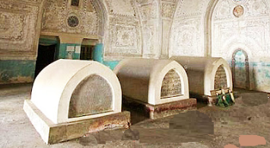 | 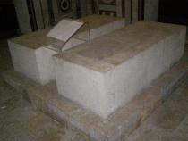
(a) | (b)
Figure 1. (a) Al-Hisamiyya Cemetery in Damascus (b) Al-Jaqmaqiyya Cemetery in Damascus

Another example is the Hafidhiyya Cemetery (Al-Turba Al-Hafidhiyya) in Damascus. It was an orchard, so Khatun Argwan Ayyubid bought it and turned it into a cemetery of her own. When she died in (648 AH/1250 ), she was buried there [9]. Here, we can conclude that the custom of buying land in the Levant to use as a private cemetery was not limited to men; women also bought land and turned it into private cemeteries.
As well as the Adiliyah Baraniyya cemetery (Al-Turba Al-Adiliyya Al-Barraniyya) in Damascus, which the Mamluk ruler of Aleppo, King Al-Adil Zain al-Din Kitibgha, established. When he died in Aleppo in (702AH/ 1302AD), his body was transported to Damascus to be buried in his cemetery [9] as well as Al-Jaqmaqiyya Cemetery (Al-Turba Al-Jaqmaqiyya) in Damascus, which was established by the Mamluk Sultan’s deputy, Prince Sayf al-Din Jaqmaq, as a place for his tomb. When he died in (824 AH/1421 AD), he was buried there, and his mother was also buried next to him when she died the following year, shown in Figure 1 (b) [9].
Here, it must be pointed out, that digging the tomb of the dead person and transferring his remains to another tomb is not permissible according to Islamic law unless there is a legitimate reason for removing the dead person from his tomb, because the tomb is not directed towards the Qiblah, or the owner of the tomb is buried in occupied land, or he is buried without washing [10]. The sanctity of the dead person may be violated when transporting him, as his body may be torn apart, or his bones may be broken, and this is not permissible because the Messenger Muhammad said: ((Breaking a dead person’s bone is like breaking it while he is alive)) [11] [12] [13], meaning that he feels the pain of the tear or break even if he was dead [14]. It is also not permissible to dig the tomb of the dead person and move his remains, even if the dead person himself recommended doing so, because it violates the legal conditions which were mentioned above [15]. As for the issue of burying two people in one tomb, as happened with the lady of Levant, the Khatun Fatima, and her son Hussam al-Din, the jurists differed. Some said it is not permissible to bury two people in one tomb except in cases of necessity, such as during war, epidemics, or other disasters; others said it is permissible. Still, it is hated [16] [17] [18].

B.2 The Tomb
Tomb is a singular noun, and its plural is tombs [19]. The land that contains these tombs is called acemetery, and it is also called soil (Turba), meaning that after burial, the dead person becomes dust. There aretwo types of cemeteries, including general cemeteries for burying dead Muslims of all sects and social levels,and private cemeteries for burying one person, or burying the dead of one family, or a specific tribe [14].

B.2.1. The Direction of The Tomb Towards The Qiblah (The Holy Ka'ba)
One of the most important conditions for digging a tomb according to Islamic law is that it be directed towards the Qiblah, based on the Hadiths of the Messenger Muhammad: ((The Sacred House is the Qiblah of you alive and dead)) [11] [20] [21], meaning that Kaaba is the Qiblah for Muslims to which they face in prayer. At the same time, they are alive, and their tombs should have the same direction when they die. As a result, people of the Levant strictly adhered to this condition when they dug tombs in their private cemeteries, such as the tomb of Rabi'a Khatun (d. 643AH/ 1245AD), the sister of Sultan Salah Al-din Yusuf al-Ayyubi, when she ordered the construction of her private cemetery in Damascus [9]. It seems the builders made a mistake in orienting the cemetery’s architecture towards the Qiblah, which is to the south; however, the building deviated towards the southwest. When Rabi'a died in 643 AH/1245 AD, they noticed this error in the cemetery’s architecture and directed her tomb towards the Qiblah to the south, as shown in Figure 2 (a). As well as Al-Mamluk Al-'ifriadouniyya Cemetery (Al-Turba Al-'ifriadouniyya) in Damascus, which was ordered to be built by the merchant Shams Al-Din ifraidoun Al-Ajami, and he was buried there upon his death in (749AH/ 1348AD) [22]. His tomb was directed towards the Qiblah to the south, as shown in Figure 2 (b). Another is the Al-Mamluk Al-'ikhna'iyya cemetery (Al-Turba Al-'ikhna'iyya), which was ordered built by Judge Shams al-Din Muhammad bin Muhammad al-'Ikhna'i, where he was buried upon his death in 816 AH/ 1413 AD [9]. His tomb was also oriented towards the Qiblah to the south, as shown in Figure 2 (c).

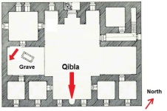 | 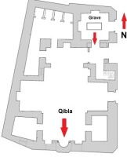 | 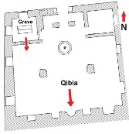
(a) Tomb of Rabi'a Khatun | (b) Al-'ifriadouniyya Cemetery | (c) Al-'ikhna'iyya Cemetery
Figure 2. The tomb's direction is towards the Qiblah, south

B.2.2. Tombstone
It is one of the main architectural elements of the tomb and the part built above the dead person's tomb. One of the conditions that must be implemented when burying a dead Muslim is that the height of his tombstone should not exceed more than an inch (12-16 cm). Some jurists allowed it to be painted with clay if it was for the purpose of preserving the tomb from erosion. It is not permissible to paint it with plaster, dye it with colors, or build it with marble stone, because that is extravagance and wasting money, and a kind of ostentation and bragging about the adornments of this worldly life. Likewise, it is not permissible to write on the tomb, such as Qur’anic verses, because that would be an insult to the Holy Qur’an, since the tomb is not the place of the Qur’an, and the Qur’anic verses may become exposed to dirt and impurity. Likewise, it is not permissible to write supplications and poetic verses, because that would glorify the dead. It is also not permissible to wrap the tomb in a cloth, because some people will cut off a piece of it to seek blessings. Senior Muslim scholars agreed that these actions lead a Muslim to associate others with God Almighty, because the Prophet Muhammad, did not undertake these actions nor did his companions after him do so [23] [24] The evidence for this is the saying of the companion Jabir: ((The Prophet, may God’s prayers and peace be upon him, forbade the plastering of tombs, writing on them, building on them, and stepping on foot)) [11] [12] [25] However, it is permissible to place a stone at the head of the dead person on top of the tomb, and some jurists allowed the name of the dead person to be written on this stone in a simple way without engraving or decoration, because when the Messenger Muhammad, buried the companion Othman bin Mazun, he placed a large stone at his head only to know his tomb among the tombs near to it [11] [13] [26].
Although scholars warned Muslims to avoid all practices not permissible in Islam when building a tomb, over time, Muslims did not adhere to these warnings, and tombstones began to develop architectural features that varied in striking ways across Islamic eras to the present day. In various Islamic countries such as the Islamic Levant, Iraq, Anatolia, Egypt, and Andalusia [27] [28] [29]. Tombstone designs became an integral part of the art of Islamic architectural civilization.
The same is true for the Levant, where architecture and tombstone decoration in private cemeteries during the Zengid, Ayyubid, and Mamluk eras developed significantly. Although this development was contrary to Islamic law, it became a reality that reflects the art of Islamic architecture in the Levant. One of the reasons for the development of the style of tombstone architecture in private Levantine cemeteries is the social status of the deceased, as Levantine people tend to decorate their tombstone if he had a great social status in their souls, such as the tomb of Sultan Nur al-Din Mahmoud Zaki in Damascus, whose tombstone was taken care of. It was built in the form of a box, with its roof in the shape of a hump, and the tomb is about 185 cm high. It is coated with plaster, and floral decorations are entombed on all its sides, as shown in Figure 3 (a). The tomb and cemetery of Sultan Nur al-Din Zengi have undergone ongoing reconstruction throughout successive Islamic eras to the present day. Levantines held a religious celebration at his tomb on the occasion of his rearchitecture in our present era, indicating the great status he enjoys in their hearts, as shown in Figure 3 (b).

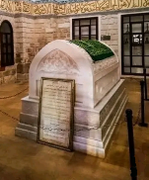 | 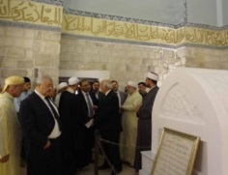 | 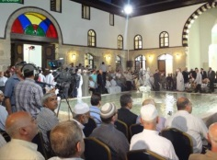
(a). Tomb of Sultan Nour al-Din Mahmoud Zengi | (b). Celebration at the tomb of Sultan Nur al-Din Mahmoud Zengi on the occasion of its restoration
Figure 3. The tomb of Sultan Nur al-Din Mahmoud Zengi in Damascus

Likewise, the tombstone of Sultan Saladin al-Ayyubi in Damascus attracted attention throughout Islamic history because of the great esteem it held in the hearts of Muslims, especially in the Levant. In the tomb room of Saladin, we notice two tombs, one a box made of ebony wood, the real tomb that contains the remains of Salah al-Din al-Ayyubi. The sides of the wooden box were decorated with Islamic geometric motifs; the top of these decorations (Ayat al-Kursi) was inscribed in wooden Kufic script, surrounding the sides of the tomb. The ceiling of the tomb is arched towards the top, and at its upper corners are four wooden pomegranates. The tomb is approximately 185 cm high, and it was covered with a glass cover to protect it from dirt and moisture, as shown in Figure 4 (a).
As for the second tomb, it is empty and does not contain the remains of Sultan Saladin. It was presented by the Ottoman Sultan Abdul Hamid II (d. 1337AH/ 1918AD) as a gift to the tomb of Saladin. It is evidence of the great status that Saladin had among Muslims. The empty box is made of marble and decorated with beautiful floral decorations on all sides. It is topped with four marble vases that add to its beauty; its height is as high as that of a wooden tomb (Figure 4 (b)). Likewise, the German Kaiser Wilhelm II, or Guillaume II (d. 1360AH/ 1941AD), sent another gift to the tomb of Saladin, represented by a golden wreath, with a diameter of (74 cm) written at the bottom: ((God loves those who do good)) and at the top: ((A knight without fearless and blameless, he taught his opponents the true path of horsemanship)). The wreath was placed between the two tombs shown in Figure 4 (c).

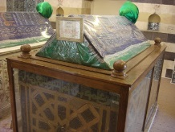 | 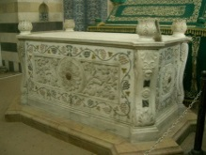 | 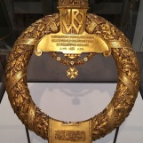
(a) The real wooden tomb of Sultan Saladin Al-Ayyubi | (b) The empty marble tomb of Sultan Saladin Al-Ayyubi | (c) The golden wreath is a gift for the tomb of Sultan Saladin Al-Ayyubi
Figure 4. The tomb of Sultan Saladin Yusuf alayyubi in Damascus

Likewise, the tombstone of the Mamluk Sultan al-dhahir Baybars al-Bunduqdari (d. 676AH/ 1277AD) and his son, King al-Sa'id Muhammad Baraka Khan (d. 678AH/ 1280AD) in Damascus, who witnessed beautiful architectural development [4], as the tombstones of the two tombs were built symmetrically with white alabaster, and their roofs are arched from the top. The two tombs rested on a bench 30 cm high, covered with black-and-white alabaster, with nothing written on the tombstones (Figure 5a), as if the builder sought to adhere to Islamic building practices for these two tombs. They designed the tombstones in a modest style, with no inscriptions. However, the shape of the tombstones did not continue in this design, and their style was completely different. As these tombs were rebuilt in black alabaster in the form of two symmetrical boxes, the sides of each were decorated with white Islamic motifs. At the top of the facade of the tombs was written (In the Name of God, Most Gracious, Most Merciful) in thuluth script; at the bottom were the names of the two kings and the dates of their deaths, as shown in Figure 5 (b, c). There is no doubt that because of the status that the two kings enjoyed in the Levantine society, they decided to change the style of building their tombstones, because they saw that the design of the first building was modest and not befitting their status, so they decided to change it according to the second design, thinking that it will befit the status and value of the two kings. The truth is that the first design is somewhat more correct from an Islamic perspective, because the second design was built with the motive of honoring the dead and immortalizing his name, as it included inscriptions of Quranic verses and decorations, in addition to the architecture of the tombstones, which was exaggeratedly raised. All of this is contrary to Islamic law for the reasons mentioned previously.

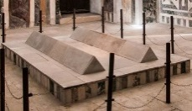 | 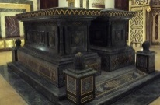 | 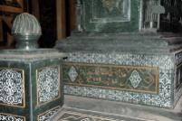
(a) The first design for building the two tombs | (b) The second design for building the two tombs | (c) King Muhammad Baraka Khan's name and date of death on the tombstone
Figure 5. The tomb of King Al-Dhahir Baybars and his son King Muhammad Baraka Khan in Damascus

Among the other cemeteries whose tombstones attracted the attention of Levantine people is the Al-Mamluk Al-Sabuniyya cemetery in Damascus (Al-Turba Al-Sabuniyya), which contains three tombs. The first tomb belongs to the merchant sheikh Shihab al-Din Ahmad bin Suleiman al-Sabouni [9], who was one of the scholars of the ninth century AH/fifteenth century AD. He built a cemetery for himself and his family; the second middle tomb is for his brother Muhammad, and the third is for one of his relatives, Bahaa al-Din Ahmad. We note that the three tombstones were carved from white marble, decorated with floral motifs and marble columns on the sides, and inscribed with Qur’anic verses from Surat Al-Fajr. A prayer was written on them (O Pardoner, O Forgiving, O Merciful), as well as eight poetic verses, and the tombs were decorated with flowers and trees, as shown in Figure 6.

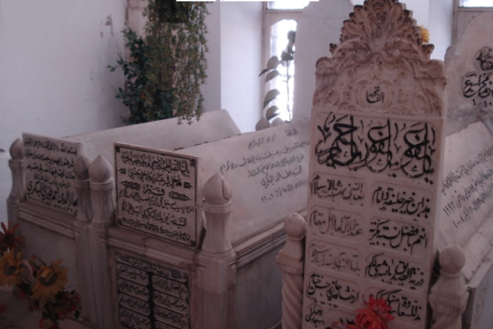

Figure 6. Inscriptions and inscriptions on the tombstones of Al-Sabuniyya Cemetery in Damascus

The habit of building tombstones with marble and other decorations, engraving them with religious and literary symbols and inscriptions, and drawing floral decorations on them, with the motive of glorifying the dead and showing off the adornments of this worldly life, is a custom alien to Islamic society, especially Levantine society. It was transmitted to them from non-Muslims, such as Christians who were accustomed to building tombstones. The tombs of their dead were made of marble and adorned with religious symbols, such as crosses, floral decorations, and animal motifs, including eagles and peacocks [32]. We notice in Figure 7 (a) a limestone tombstone in Upper Egypt dating back to the sixth century AD, in the middle of which is entombed an eagle carrying a cross in its beak, along with other decorations that fill the tombstone. We also notice in Figure 7 (b) a Christian tombstone dating back to the seventh century AD, carved from stone, and inscribed with the symbol of the cross and a floral decoration at the top. The Christians were not satisfied with merely inscribing their tombs with symbols and decorations; they also did the same on their coffins, because this social-religious custom was rooted in their souls from the earliest Christian times. We notice in Figure 7 (c) a wooden coffin dating back to the sixth century AD with drawings of peacocks, crosses, and floral decorations [30]. All of these practices are motivated by glorifying the dead and bragging about the adornments of this worldly life. They violate Islamic law if applied by Muslims.

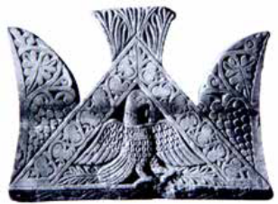 | 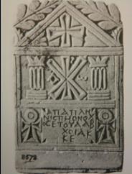 | 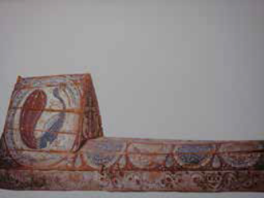
(a) A limestone tombstone with an image of an eagle carrying a cross in the middle | (b) A stone tombstone with a cross symbol and floral decoration | (c) A wooden coffin with engravings of peacocks, crosses, and floral decorations
Figure 7. Inscriptions and symbols on Christian tombstones and sarcophagi in Upper Egypt

Other private cemeteries spread in the Levant, in which the architecture of their tombstones was not taken care of, such as the cemetery of Daifa Khatun, daughter of the King Al-Adil Abu Bakr Al-Ayyubi (d. 640AH/ 1242AD) in Aleppo, which she ordered to be built as a cemetery for herself and her family [2]. The cemetery included eight tombs, some of which were modest in design, represented by placing two stones at the head and feet of the dead person. The tomb was built above ground, with a concrete block reaching 5 cm in height, as shown in Figure 8 (a). Likewise, the Al-Mamluk cemetery of Prince Sibay bin Bakhtja (d. 922AH/ 1516AD) in Damascus, which contains the tomb of his wife (Al-saliha), was built of stone coated with plaster, with its roof arched at the top. The tombstone is devoid of inscriptions, as shown in Figure 8 (b). Her daughter Settita, daughter of Prince Sibay, was buried next to her. A stone was placed at the head of her tomb, without any inscriptions, and the tomb was leveled with the ground as shown in Figure 8 (c). It seems that the lack of care for the tombstones mentioned above is due to the lack of public fame of their owners, noting that the architectural style of the tombstones of the first and third tombs is closest to Islamic law, as seen in Table 1.

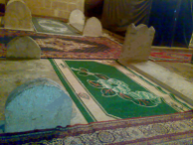 | 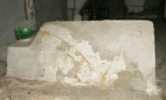 | 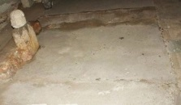
(a) Tombs of Dhaifa Khatun cemetery in Aleppo | (b) The tomb of Al-Saliha, wife of Prince Sibay bin Bakhtja, in Damascus | (c) The tomb of Sitteta, daughter of Prince Sibay bin Bakhtja, in Damascus
Figure 8. Tombstones whose architecture was not maintained
Table 1. The tomb (turba)
Its architectural components | Its construction and design | Its historical origin
Tombstone, Tomb box | The tomb faces the Qiblah. The people of the Levant took care with the architecture of some tombs because of the high status of their owners. Islamic and plant decorations, Quranic verses, supplications, and verses of poetry were engraved on them in Kufic, Nusukh, or Thuluth script. The tomb box was raised to 185 cm. It was built of marble or wood. | The practice of building over a tomb and decorating it with drawings and other adornments is an ancient Christian practice later adopted by Muslims.

B.2.3. The Tomb's Room and Its Architectural Elements
The tomb room is considered one of the main architectural elements of private cemeteries in the Levant. It is usually square in shape. The Levantines mastered the architecture of tomb rooms for sultans, Zengid kings, Ayyubids, and Mamluks, such as the tomb room of Sultan Nur al-Din Zengi in Damascus, which was lined with marble on the inside. The most important feature of the room is the curved marble Mihrab set into the wall, arched at the top, with two marble columns on either side. The Verse of the Throne (Ayat al-Kursi) was inscribed on the top of the walls of the room in the form of a belt surrounding all its sides, as shown in Figure 9 (a). Likewise, a room was built over the tomb of Sultan Salah al-Din al-Ayyubi in Damascus, decorated with Islamic motifs along the room's corners. The walls were covered with colored marble stone in the form of black, white, and yellow horizontal lines, as shown in Figure 9 (b). As for the room of the Mamluk Sultan al-Dhahir Baybars’s tomb, it was distinguished by various, very beautiful Islamic decorative styles, including marble walls with pink, black, green, and white stripes. This style of coloring is called (Al-Ablaq), meaning colored. Levantines were famous for decorating buildings, as they were inherited from the Mamluks. A beautiful Mihrab was built in front of the tomb, which was also covered with colored marble and topped with an arched apse adorned with Islamic motifs. Two marble columns were built on either side of the Mihrab. Next to the two columns are two symmetrical marble panels, adorned with beautiful geometric designs in white, black, green, and pink, and with some Qur’anic verses from Surat Al-Tawbah written above them. The two panels are connected at the top by a semi-circular, decorated crown that adds distinctive aesthetic splendor to the Mihrab. As for the top of the room's wall, it was surrounded by a wide belt decorated with green and gold mosaics; he belt consists of drawings of trees, branches, and flowers, as shown in Figure 9 (c) [4].

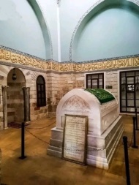 | 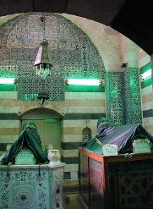 | 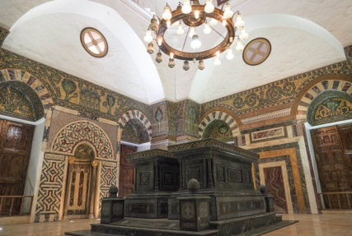
(a) | (b) | (c)
Figure 9. (a) The tomb room of Sultan Nur al-Din Zengi in Damascus, (b) The tomb room of Sultan Salah aldin alayyubi in Damascus, (c) The tomb room of the Mamluk King al-Dhahir Baybars in Damascus

The way these rooms were built on the tombs of the sultans, the Islamic decorations and Qur’anic writings they carry is considered a cultural, architectural masterpiece that Levantine people are proud of, even though all types of these architectural styles in the rooms are not permissible according to Islamic law because the Prophet Muhammad, may God’s prayers and peace be upon him, forbade building on tombs, writing on it, decorating it with ornaments, and lighting it with lamps because that is a glorification of the dead. It makes the cemetery a place for picnicking and bragging about the adornments of this worldly life, not a place for admonition and remembrance of the afterlife [31]. The most important thing is that Levantines added a new, strange architectural element to the tomb room: the Mihrab, which Muslims are accustomed to building only in mosques. It is the place where the Imam prays during congregational prayer, facing the worshipers. So, building the Mihrab in the tomb room violates the provisions of Islamic law, because the cemetery is not a place for prayer, but rather a burial place for the dead [32]. The reason for Levantine building the Mihrab in the tomb room was to determine the direction of the Qibla, and to bury the dead in front of the Mihrab, that is, towards the Qibla, as evidenced by the fact that some private cemeteries in Levant contained two Mihrabs, one in the prayer hall, and the other in the tomb room, such as the private cemeteries in Damascus, such as the Adiliyya Al-Jawaniyya Cemetery (Al-Turba Al-Adiliyya), the Hafidhiyya Cemetery (Al-Turba Al-Hafidhiyya), and the Dhahiriyya Cemetery (Al-Turba Al-Dhahiriyya), as shown in Figure 10 (a,b,c).
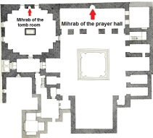 | 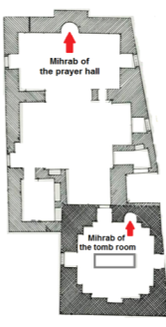 | 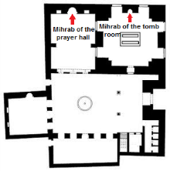
a. Al-Adiliyya Al-Jawaniyya Cemetery | b. Al-Hafidhiyya Cemetery | c. Al-Dhahiriyya Cemetery
Figure 10. Private Damascene tombs with two Mihrabs

The tomb room with four walls is considered one of the main architectural elements of private cemeteries in the Levant, as they used to bury the dead within it. However, in the tomb of the Mamluk prince Othman bin Aghlabik (d. 885AH/ 1480AD) in Aleppo, who was buried inside an iwan consisting of only three walls, not a room with four walls [33]. The Mihrab was built into the wall of the Iwan, facing the Qibla, in front of the tomb of Prince Othman bin Aghlabik, as shown in Figure 11 (a,b). We conclude from this that burying the dead in the Iwan is considered a new and strange architectural style in the private Levantine cemeteries, in which Levantine people are accustomed to burying their dead in their rooms, not in their Iwan, as seen in Table 2.

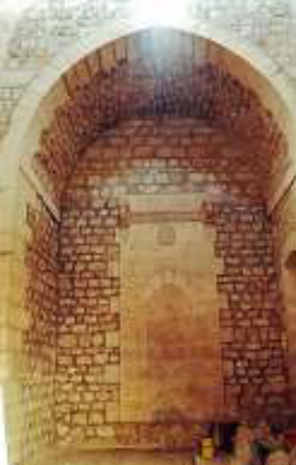 | 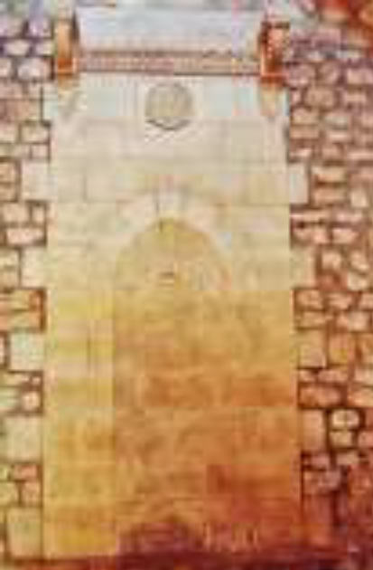
(a) Iwan of the tomb of Prince Othman bin Aghlabik | (b) The Mihrab in the iwan wall
Figure 11. The tomb of Prince Othman bin Aghlabik in Aleppo

Table 2. The tomb's room
Its architectural components | Its construction and design | Its historical origin
Walls | It is usually square in shape (four walls), and the tomb room is furnished according to the deceased's social status. It is covered on the inside with colored marble (white, black, green, pink), usually arranged in lines called ablaq. The room features Islamic geometric and plant decorations, colored mosaics, and Quranic verses, including the Throne Verse and Repentance, and is lit with lamps. | The method of building the room above the tomb is one that Muslims adopted from neighboring ancient civilizations.
Iwan | It consists of three walls.
Mihrab | It is built into one of the walls to determine the direction of the Qiblah; Islamic geometric decorations are engraved on it, and Qur’anic verses are written above the Mihrab. | This method is specific to Muslims.

B.3. The Dome and Its Architectural Elements
The dome is considered one of the main architectural elements of private Levantine cemeteries, as Levantines used to build domes over tombs. This type of architectural style is not a Levantine Islamic style specific to them, but was transmitted through previous ancient civilizations [34], such as the Greek civilization, which was famous for building domes over tombs [1], as well as the Mesopotamian civilization in Iraq, as the conical dome was known to the Assyrians and Babylonians. The tomb’s dome was also found in the Nile Valley civilization in Egypt [35]. As for Arabs, before Islam, they used to build a tent over the tomb in which they would receive mourners while they were near the tomb, thinking that this would comfort the dead in their tomb. Then, the tent would be removed from over the tomb after a period of time. This continued with them even after the appearance of Islam [36], which forbade building a tent over the to and a dome [26]. However, Muslims did not heed this and continued to build domes over tombs. This architectural style became an integral part of Islamic architectural civilization, so several types of tomb domes were built throughout the Islamic era in various countries, such as the Levant [37]. During the Zengid era, the conical dome was built over the tomb of Sultan Nur al-Din Mahmoud Zengi, which was distinguished by its unique architectural style. It was built in the form of overlapping (Muqarnas) that curved outward from the dome, rising in four layers, replacing the neck of the dome, and interspersed with several windows for lighting. Above the Muqarnas, the dome helmet, known as the dome bowl (Tasa), was built, as shown in Figure 12 (a,b). This architectural style was famous among the early Seljuks and continued until the Zengid era [1].

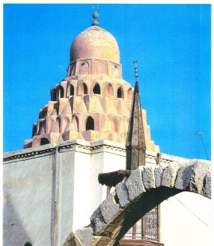 | 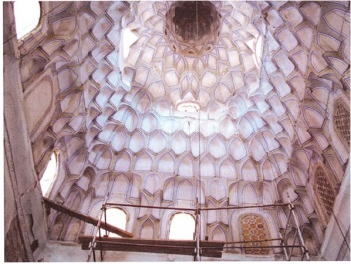
(a) The dome from the outside | (b) The dome from the inside
Figure 12. The dome of the tomb of Sultan Nur al-Din Mahmoud Zengi in Damascus

Likewise, the dome of the tomb of Princess Turkan Khatun, daughter of Sultan Izz al-Din Mas'oud bin Maudud Zengi (d. 640AH/ 1242AD), and the wife of Sultan al-Ashraf Musa bin al-Adil al-Ayyubi (d. 635AH/1237AD) in the Ayyubid Al-Atabikiyya Cemetery (Al-Turba Al-Atabikiyya) in Damascus. It consists of two ribbed necks with some windows for lighting, and a smooth, domed helmet built above the neck, as shown in Figure 13 (a). Two symmetrical domes were also built over the three tombs in the Ayyubid Al-Jahariksiyya cemetery (Al-Turba Al-Jahariksiyya) in Damascus. Each dome was built on two ribbed necks, containing several windows for lighting, and above the neck was the dome’s helmet, which had vertical sides rather than smooth ones, as shown in Figure 13 (b).

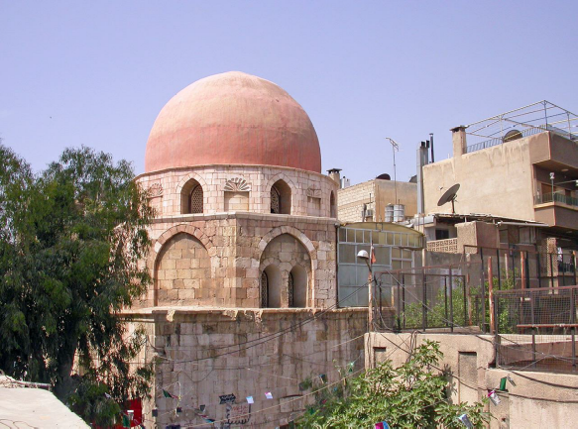 | 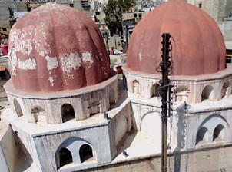
 | 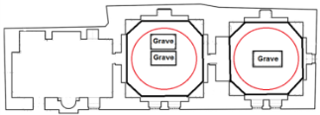
(a) | (b)
Figure 13. (a) The dome of Al-Atabikiyya Cemetery in Damascus, (b) The domes of Al-Jahariksiyya Cemetery in Damascus

As for the Ayyubid Al-Hisamiyya cemetery (Al-Turba Al-Hisamiyya) in Damascus, the architecture over its three tombs was distinguished by a unique architectural style that differed from the style of domes that were built over the tombs of private Levantine cemeteries during the Ayyubid era, as a large vault was built over its three tombs, somewhat pointed at the top. Its interior walls are decorated with geometric arabesques, symmetrical panels, and bands of inscriptions in Kufic and Naskh scripts, as shown in Figure 14 (a,b).

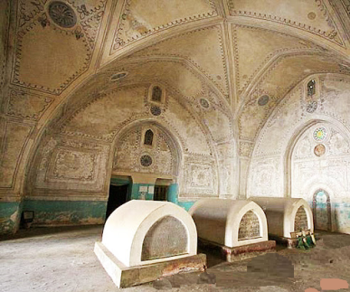 | 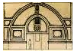
 | 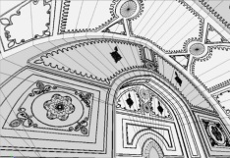
- The vault of Al-Hisamiyya Cemetery from the inside | - The design of the vault of Al-Hisamiyya cemetery and its decorations
Figure 14. Al-Hisamiyya Ayyubid Cemetery in Damascus

As for the dome of the Mamluk Sultan al-Dhahir Baybars’ tomb, it is the highest dome built over a tomb in Damascus. It reaches a height of 30 meters. It was built on two necks, each one with eight sides, containing 24 windows for lighting, and above them is the dome helmet, as shown in Figure 15 (A, B) [4]. We deduce from the above that there is a diversity of dome styles built over the tombs of private cemeteries in the Levant. In the Zengid era, the dome took on a muqarnas conical shape, a style that became famous among the Seljuks until the Zengid era [1]. In the Ayyubid era, tombs were built with one dome, two symmetrical domes, and vaults over the tombs in the Hisamiyya cemetery. During the Mamluk era, attention shifted to the architecture of domes on tombs, and the highest dome over a tomb in Damascus was that of the Mamluk Sultan Al-dhahir Baybars, as shown in Table 3.

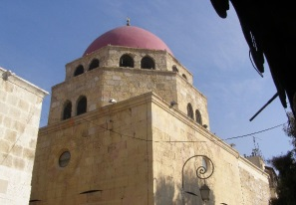 | 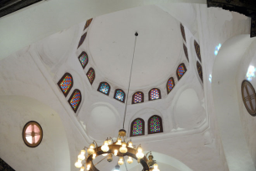
(a) The dome from the outside | (b) The dome from the inside
Figure 15. The dome of the tomb of Sultan al-Dhahir Baybars, Mamluk, in Damascus

Table 3. The dome
Its architectural components | Its construction and design | Its historical origin
Dome helmet (Tasa) | Its shape in the Zengid era was (conical), replacing the neck, and it contains layers of muqarnas protruding outwards. In the Ayyubid and Mamluk eras, its shape was a hemisphere, either smooth or polygonal, and some were engraved with plant motifs. The tomb contains one dome or two symmetrical domes. | The method of building a dome over the tomb was passed down to Muslims from neighboring ancient civilizations, such as the Mesopotamian (Assyrian and Babylonian) and the Nile Valley (Egyptian) civilizations. Before Islam, the Arabs would set up a tent over the tomb for a period of time and then take it down.
Neck | It is built before the helmet (Tasa), and is often ribbed; one or two necks are built, and it contains windows for lighting.
Vault | From inside the tomb room, it looks like a dome, but from the outside, it lacks a helmet or neck, and some of them are decorated inside with Islamic motifs.

C. THE ARCHITECTURAL ELEMENTS ATTACHED TO PRIVATE LEVANTINE CEMETERIES
C.1. The Mosques and Prayer Halls
When the sultans, kings, princes, Zengid, Ayyubid, Mamluk, and some notables in the Levant built their own tombs for themselves and their families, they decided to make this land an endowment to serve the Levantine community by adding architectural service elements attached to it, such as building a mosque or a prayer hall. Over time, these tombs came to be called mosques.
If we discuss this behavior on their part according to the Islamic perspective, it seems that their intention to build mosques with their tombs is to obtain reward and recompense. The question raised here is: Is it permissible to build a mosque over a tomb or bury a person in a mosque? Muslim scholars answered that it is not permissible because the Prophet Muhammad, may God’s prayers and peace be upon him, forbade this. Even when he died, he was buried under the bed on which he died inside his room so that Muslims would not use his tomb as a mosque. If the mosque was built and a person was later buried in it, his tomb must be exhumed and reburied elsewhere. If the dead person is buried and after a while the mosque is built over the tomb, it is not permissible to pray in this mosque. It must be abandoned or demolished [38] because, over time, Muslims praying in this mosque may begin to seek blessings from the tomb's owner, believing in him [24]. An example of private Levantine cemeteries that became mosques is the cemetery of Daifa Khatun, daughter of the king Al-Adil Abu Bakr Al-Ayyubi (d. 640AH/ 1242AD) in Aleppo, which she turned into a cemetery and a mosque; it is now called Al-Firdaws Mosque and Cemetery [39] (Figure 16, (a)), as well as the Ayyubid Al-Hafidhiyya cemetery (Al-Turba Al-Hafidhiyya) in Damascus, which Khatun Argwan Al-Hafidhiyya (d. 648 AH/1250 AD) turned into a cemetery and a mosque (Figure 16, (b)) as well as the tomb of Prince Tunbuk al-Hasani Mamluk (d. 802AH/ 1399AD), who ordered the architecture of his tomb and the mosque, which is now known as Al-Tinbiyya (Figure 16, (c)). Al-Mamluk tomb of Prince Ghars al-Din Khalil bin Yusuf al-Tawrizi (d. 826AH/ 1422AD), who began building his tomb and then the mosque after it, known as the Tauraziyya Cemetery (Al-Turba Al-Tauraziyya), as shown in Figure 16 (d) [9].

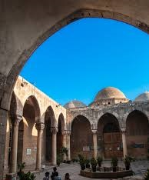 | 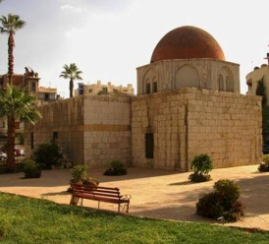 | 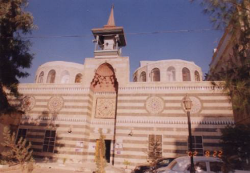 | 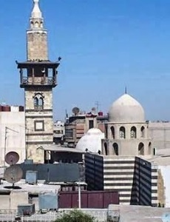
(a). Al-Firdaws Cemetery and Mosque in Aleppo | (b) Al-Hafidhiyya Cemetery and Mosque in Damascus | (c) Al-Tinbiyya Cemetery and Mosque in Damascus | (d) Al-Tauraziyya Cemetery and Mosque in Damascus
Figure 16. The Private Levantine cemeteries with mosques

There are many private cemeteries in the Levant where mosques were not built; instead, additional rooms and halls were added next to the tomb room, with one of them serving as a prayer hall. The question posed here: Is it permissible to pray in this hall next to the tombs? Muslim scholars answered that prayer is not permissible if the tomb is facing the Qiblah, that is, in front of the worshipers. However, if the tomb is next to them or behind them, and separated from them by a wall, then it is permissible to pray in this place [40]. The people of the Levant took this condition into account in the architecture of their private tombs. They placed the tomb room next to or behind the prayer hall, not facing the Qiblah, as is the case in the Ayyubid Al-Shadhabakhtiyya cemetery (Al-Turba Al-Shadhabakhtiyya) built by Shadbakht, the servant of Sultan Nur al-Din Mahmoud Zengi in Aleppo [2]. The tomb room was built behind the prayer hall, as shown in Figure 17 (a). Likewise, the tomb room of the Ayyubid Al-Atabikiyya cemetery (Al-Turba Al-Atabikiyya) in Damascus was built next to the prayer hall, not in front of it, and shown in Figure 17 (b). The tomb room of the Mamluk Al-Jaqmaqiyya cemetery (Al-Turba Al-Jaqmaqiyya) in Damascus was built behind the prayer hall, as shown in Figure 17 (c) [9].

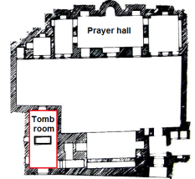 | 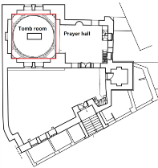 | 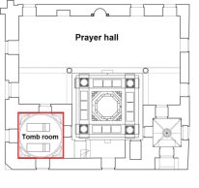
(a) Location of the tomb room behind the prayer hall of Al-Shadhabakhtiyya cemetery in Aleppo | (b) Location of the tomb room next to the prayer hall of Al-Atabikiyya cemetery in Damascus | (c) Location of the tomb room behind the prayer hall of Al-Jaqmaqiyya cemetery in Damascus
Figure 17. (a) (b) (c) Location of the tomb room in relation to the prayer hall in private Levantine cemeteries

We conclude from the above that the word (Turba), private cemetery among the Levantines, has become synonymous with the word mosque, and that building a mosque in it has given it the quality of holiness. Rather, the matter has gone beyond honoring the owners of the tombs in it with religious practices or rituals that reflect the impression of some members of Levantine community who attend these mosques toward these people’s tombs and belief in their owners [41], as they did with some of the tombs of the Firdaws Cemetery and Mosque in Aleppo, where they wrapped them with a green cloth, hung wooden beads on the tombs, as shown in Figure 18 (a). They also did the same thing with the tombs of the cemetery and Mosque Al-Tawrizi in Damascus, shown in Figure 18 (b). These are the actions that Muslim scholars warned against and forbade, based on the command of the Messenger Muhammad [24].

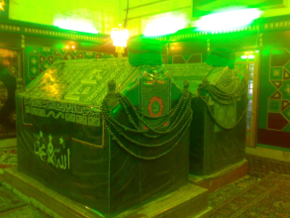 | 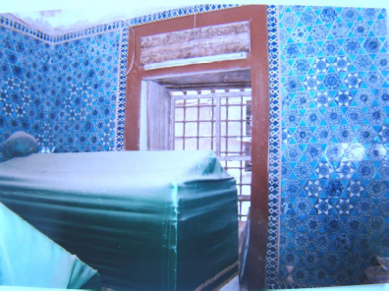
(a) Tombs of Al-Firdaws Cemetery and Mosque in Aleppo | (b) Tombs of Al-Tauraziyya Cemetery and Mosque in Damascus
Figure 18. Wrapping the tombs of private Levantine cemeteries in green cloth

C.2. The Schools
Many owners of private Levantine cemeteries were keen to make the architecture of their tombs institutions to support the scientific movement in Levant, so they added rooms and iwans to them to serve as classrooms and housing for teachers and students, such as the Adiliyya Al-Jawaniyya Ayyubid cemetery or school in Damascus, which includes the tomb of Sultan Al-Adil Saif Al-Din Abu Bakr Muhammad Al-Ayyubid (d. 615AH/ 1218AD) [9], it became one of the most famous Ayyubid schools in Levant and Damascus [42], attracting the most prominent Muslim scholars and hundreds of students [43], including the great jurist, grammarian, and historian Shihab Al-Din Abdul Rahman bin Isma'il Al-Maqdisi, known as (Abu Shama) (d. 665AH/ 1266AD). He lived in this school, and there he wrote his famous historical book (Al-Rawdatayn fi Akhbar al-Dawlatayn al-Nuriya wa al-Salihiyya). Likewise, the great historian and jurist Shams al-Din Ahmad bin Khallikan (d. 681AH/ 1282AD), who lived in this school he wrote his famous historical book (Wafayat Al-A'yan wa Aanba' Abna' Al-zaman). The sciences taught at this school were those of the Holy Qur’an, the Noble Hadith, jurisprudence, and grammar, as shown in Figure 19 (a).
As well as the Mamluk Al-Arghoniyya cemetery and school in Jerusalem (Al-Quds), which includes the tomb of its founder, Prince Mamluk Sayf al-Din Arghon bin Abdullah al-Kamili (d. 758AH/ 1356AD) [44]. It was initially allocated for teaching Islamic sciences such as the sciences of the Holy Qur’an and Hanafi jurisprudence. It played a distinctive role in supporting scientific and administrative activities in Jerusalem during the Mamluk period, as shown in Figure 19 (b), as well as the Mamluk cemetery and the Sabuniyya School in Damascus, which were designated for teaching the Holy Qur’an and were known as the House of the Holy Qur'an. The sciences of Shafi’i and Hanafi jurisprudence were also taught there. The owner of the cemetery, the merchant Sheikh Shihab al-Din Ahmad bin Suleiman al-Sabouni, built a hall in it for the Imam and his family to live in, and other rooms for ten poor people to live in, to read the Holy Qur’an in the school. He appointed a service employee and a janitor there. He allocated to it many endowments such as farms, orchards, khans, and shops in Beirut, Damascus, and other Levantine cities, to provide funds for the cemetery and the school as salaries for its employees, food, furniture, and others, which would ensure the educational process continues in this school, in addition to that, an employee has been appointed specialized in collecting these funds allocated to the cemetery and the school, and another employee called (Al-Nadhir) [45] whose task is to supervise the financial affairs of the cemetery and the school, including expenses and revenues, as shown in Figure (c) [9].

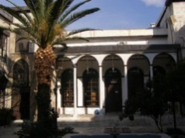 | 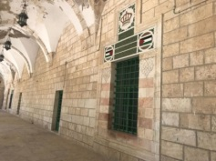 | 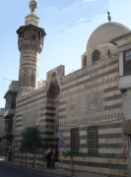
(a) Al-Adiliyya Al-Jawaniyya cemetery and school in Damascus | (b) Al-Arghoniyya Cemetery and School in Jerusalem | (c) Al-Sabuniyya Cemetery and School in Damascus
Figure 19. The Levantine private cemeteries with madrasas

We conclude from the above that the word "Turba" (a private cemetery among Levantine people) has become synonymous with "school." The evidence for this is when Levantine historians wrote books that dealt with the history of schools in Levant, especially the schools of Jerusalem (Al-Quds), Damascus, and Aleppo; They mentioned these cemeteries among the list of schools that were built in these cities at that time, such as the book (kunooz Al-thahab fi tarikh Halab) by Sibt Ibn al-Ajami (d. 884AH/ 1480AD), the book (Al-daris fi tarikh Al-madares) by al-Naimi (d. 927AH/ 1521AD) [46], the book (Al-'uns al-jalil fi tarikh al-quds wal-khalil) by Mujir aldin al'ulaimi (d. 928AH/ 1522AD), and the book (Mundamat Al-Atlal wa musamarat Al-Khayal) by Ibn Badran (d. 1346AH/ 1927AD). Another conclusion is that Levantine cemeteries of the Zengids, Ayyubids, and Mamluks were not silent, deserted buildings containing only tombs for the dead, visited by relatives from time to time, as is the case in our present era. Rather, they became religious and scientific institutions that radiate life and possess an administrative and economically system. It played a great cultural role; its effects are still present today.

C.3. The Orphanages
The owners of private cemeteries in the Levant were not only content to turn their cemeteries into schools for educating adult students, but also extended a helping hand to another important segment of Levantine society: orphans. They decided to expand the architecture of their private cemeteries, designate them as homes to shelter orphans, educate them, and compensate them for their expenses. The deprivation they experienced as a result of the loss of one or both of their parents. Among these special Levantine cemeteries that were designated as orphanages is the Mamluk Al-kawkaba'iyya Cemetery (Al-Turba Al-kawkaba'iyya) in Damascus, which included the tomb of Al-Khunda Sittita, daughter of Prince Saif al-Din kawkaba'i, and the wife of the Mamluk Sultan’s deputy in Damascus, Prince Saif al-Din Tankaz (d. 730AH/ 1329AD). She ordered that her private cemetery be a home for orphans, and that sources of spending on them be provided from charity funds [9] As well as the Mamluk Al-Badriyya Cemetery (Turba Al-Badriyya) in Damascus, which contains the tomb of its builder, Prince Badr al-Din Hasan (d. 824AH/ 1421AD), in which he built a house to shelter and educate orphans [9]. As well as the Mamluk Al-Jaqmaqiyya cemetery (Al-Turba Al-Jaqmaqiyya) in Damascus, Prince Saif al-Din Jaqmaq made it a home for orphans, and allocated a place for their studies opposite his tomb room and his mother’s tomb, as shown in Figure 20 [9].
We notice from the above that making private Levantine cemeteries an orphanage reflects several things: the first of which is the role of these cemeteries in promoting the principle of social solidarity and caring for Levantine orphans, the second thing, is the reflection of the impression of Levantine society towards the dead and cemeteries, as Levantine people are accustomed of living or doing their daily work next to the tombs, especially when these children study or live near it.

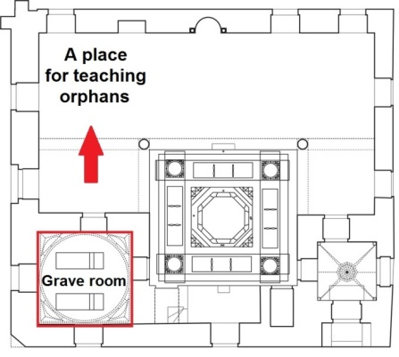

Figure 20. The Jaqmaqiyya cemetery with the orphanage

C.4. The Libraries
When the sultans, princes, and notables in the Levant were keen to expand the architecture of their private tombs to include schools for teaching sciences, the need arose to add another architectural facility and make it a scientific library to provide students with the books they needed in their studies. Among these private tombs that contained libraries was the cemetery of the Adiliyya Al-Jawaniyah Al-Ayyubid School in Damascus, where a special employee was appointed to lend these books to students. Over the years, Levantine people became accustomed to studying and reading near the tomb located in this school, which is the tomb of Sultan Al-Adil Saif Al-Din Abu Bakr Muhammad Al-Ayyubi (d. 615AH/ 1218AD). It even went so far as to turn his tomb room into a library, as shown in Figure 21 (A). The same applies to the tomb of the Mamluk Sultan al-Dhahir Baybars, which became the most famous library in the Levant and Damascus. Over time, they turned Sultan Baybars' tomb into a library. Rather, they placed bookshelves directly above his tomb and the tomb of his son, King Al-Sa'id, shown in Figure 21 (B), and it became a hall of study and reading for teachers and students, shown in Figure 21 (C). So, we conclude from this that the concept of the cemetery here also changed, as it was transformed from a dark, deserted place into a place for contemplation, reading, and writing. This Levantine social custom is foreign to our customs at present. It is unlikely that the tomb rooms will now be made into public libraries frequented by people. Likewise, we cannot deny the important role these libraries played in preserving Arab-Islamic heritage, as in the case of the Dhahiriyya Cemetery library, which housed about 10,000 Islamic manuscripts that are priceless today. It also remains to ask a question: Is it permissible for a Muslim to build a school, an orphanage, or a library in his private cemetery to serve the Islamic community?. The answer: Yes, that is permissible, but the Muslim should be buried among Muslims in public cemeteries for the reasons mentioned previously.

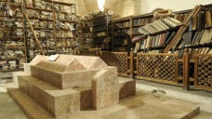 | 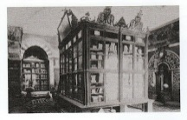 | 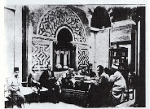
(a) Al-Adiliyya Al-Jawaniyya Ayyubid cemetery's library inside the tomb room | (b) Al-Dhahiriyya cemetery's library is inside the tomb room, and the books are placed directly on the tombs | (c) Teachers and students in Al-Dhahiriyya cemetery's library sitting inside the tomb room
Figure 21. Damascene private cemeteries with libraries

It must be noted that some private Levantine cemeteries were used for multiple purposes at the same time, such as the khatuniyya cemetery (Al-turba Al-khatuniyya) in Damascus, which was turned into a cemetery, a mosque, and a school. At the same time, the architecture of the Ayyubid Bahnasiyya cemetery (Al-turba Al-Bahnasiyya) in Damascus was designated as a cemetery, a school, and a library. In contrast, the Mamluk Sabuniyya cemetery in Damascus was expanded to become a cemetery, a mosque, and a house for the Holy Qur’an (Figure 19, C). The number of private Levantine cemeteries, with attached architectural elements such as mosques, schools, orphanages, and libraries, reached about 41) private cemeteries. It was distributed among (2) Zengid cemeteries, shown in Table 4, (13) Ayyubid cemeteries shown in Table 5, and (26) Mamluk cemeteries, shown in Table 6.

Table 4.The Private Levantine Zengid cemeteries with mosques, schools, orphanages, and libraries
Cemetery name | Mosque | school | Orphanage | library
Al-khatuniyya cemetery | X | X
Cemetery of Sultan Nur al-Din Mahmoud Zengi |  | X

Table 5. The Private Levantine Ayyubid cemeteries with mosques, schools, orphanages, and libraries
Cemetery name | Mosque | school | Orphanage | library
Al-Adiliyya Al-Jawaniyya Cemetery |  | X |  | X
Al-Amjadiyya Cemetery |  | X
Al-Atabikiyya Cemetery |  | X
Al-Bahnasiyya Cemetery |  | X |  | X
Al-Firdaws Cemetery | X | X
Al-Hafidhiyya Cemetery | X
Al-Jahariksiyya Cemetery |  | X
Al-Malakiyya Al-Ashrafiyya Cemetery |  | X |  | X
Al-Sahibiyya Cemetery |  | X
Al-Shadhabakhtiyya cemetery |  | X
Al-Zawizaniyyn cemetery |  | X
Cemetery of Sultan Saladin Al-Ayyubi |  | X
Umm Al-Saleh Cemetery |  | X

Table 6. The Private Levantine Mamluk cemeteries with mosques, schools, orphanages, and libraries
Cemetery name | Mosque | school | Orphanage | library
Al-Adiliyya Al-Barraniyya Cemetery | X | X
Al-Arghoniyya Cemetery |  | X
Al-Badriyya Cemetery | X | X | X
Al-Birsiba'iyya Al-Nasiriyya Cemetery | X
Al-Bolbaniyya Cemetery |  | X
Al-Bussiyya Cemetery | X
Al-Bzuoriyya Cemetery |  | X |  | X
Al-Dhahiriyya Cemetery |  | X |  | X
Al-'ifriadouniyya Cemetery | X | X
Al-Jaqmaqiyya Cemetery |  | X | X
Al-Kamiliyya Al-Barraniyya cemetery |  | X
Al-Kamiliyya Al-Salahiyya Al-Barraniyya cemetery |  | X
Al-kawkaba'iyya Cemetery | X | X | X
Al-'ikhna'iyya Cemetery | X | X
Al-Mardiniyya Cemetery | X | X
Al-Mu'ayyadiyya Al-Shaikhiyya Cemetery |  | X
Al-Mukhtariyya Al-Tawashiyya Cemetery | X
Al-Muraghiyya Cemetery |  | X
Al-Rahbiyya Cemetery | X
Al-Sabuniyya Cemetery | X | X
Al-Siba'iyya Cemetery |  | X
Al-Tauraziyya cemetery | X
Al-Tikritiyya cemetery |  | X
Al-Tinbiyya Cemetery | X
Al-'izziyya Al-Badraniyya Al-Hamziyya Cemetery |  | X |  | X
Al-'izziyya Cemetery | X

.

- CONCLUSION
The most important result reached by the study according to the Islamic perspective is that the custom of the sultans, the Zengid princes, the Ayyubids, the Mamluks, and some notables of the Levantine society, purchasing lands and allocating them as private cemeteries for them and their families is permissible according to Islamic law, but a Muslim should be buried in public cemeteries, and among Muslims. Expanding the architecture of their private cemeteries to serve as schools, libraries, or orphanages is also permissible under Islamic law. However, their conversion of some of their private cemeteries into mosques is not permissible according to Islamic law, and it is necessary to keep the tombs away from mosques.
The cemeteries in the Levant were closely tied to the habits and activities of the local population, serving not only as burial sites but also as spaces for daily activities, including overnight stays, study, and religious gatherings. The high social standing of certain individuals, such as sultans and princes, significantly influenced the architectural evolution of these cemeteries. This impact is evident in the design and refinement of key elements such as tombstones, tombs, domes, and associated structures, including mosques, schools, orphanages, and libraries. These architectural advancements reflected the prominence and cultural contributions of their patrons.
The word cemetery (Turba) among Levantines became synonymous with the words mosque, school, library, and orphanage. The concept of private Levantine cemeteries shifted from a deserted place inhabited by the dead, shrouded in sadness and fear, to a bright place full of life, home to the living alongside the dead, a place of joy and hope. It contributed to serving the Levantine community in particular and the Islamic community in general, as it was a place that sheltered orphans and provided job opportunities for community members. He embraced scholars and students, thereby contributing to the support of the Islamic scientific movement; as a result, the private Levantine cemeteries and their architectural elements became an icon embodying the art of Islamic material civilization, employed to serve Islamic intellectual civilization.

RECOMMENDATIONS
In this context, it is worth noting that this study did not have the opportunity to explore the scholarly role of private Levantine cemeteries, which over time transformed into prestigious educational institutions such as mosques and schools. This exclusion was necessary to maintain the research’s focus and adhere to the specified word and page limits. Many of these cemeteries hosted hundreds of scholars and students after becoming centers of knowledge in their time. Therefore, the study recommends that future researchers conduct in-depth, detailed studies of each Levant cemetery that evolved into an educational institution, highlighting its scholarly role and contributions to education and culture.
Additionally, this study recommends that relevant governmental authorities responsible for protecting Islamic heritage should launch awareness campaigns to educate the public on the importance of preserving the historical architecture of old cemeteries. These cemeteries are not merely tombs commemorating sultans, princes, and religious figures, but also cultural and human heritage that reflect the deep values of Islam and showcase the ingenuity of Muslims in employing architecture to serve society in various aspects of life. As such, they stand as living testimonies to the greatness of Islamic civilization and its contributions to human history.

REFERENCES

- M. K. Alshlash and M. Alshaar, "The Development of Mausoleums Construction until the End of the Seljuk Era," Aleppo University Research Journal, History of Sciences among the Arabs Series, vol. 13, pp. 127-152, 2018.
- W. A. Al-Akhras, "Ayyubid schools in Aleppo, Al-Firdaws School as a model," Annual of Arab Archaeologists, Vols. 13, no. 1, pp. 1827-1850, 2010. Doi: https://dx.doi.org/10.21608/cguaa.2010.299304.
- R. N. Radhy and S. F. Abdul Hameed, "Sultanate soils in Egypt and the Levant duringthe two centuries (6-7 AH / 12-13 AD) as mentioned in the book Mufarrej al-Karub by IbnWasil (d. 697 AH / 1298 AD)," Nasaq Journal, Vols. 36, no. 7, pp. 965-975, December 30th 2022. [Online]. Available:https://drive.google.com/file/d/1B6g2Z8HfHLRmKZv93uILydP8cuOD1OYU/view.
- E. Hassan, "Al-Dhahiriyah School in Damascus, Al-Dhahiriyah Library," Journal of the Academy of the Arabic Language in Damascus, Vols. 82, no. 1, pp. 171-190, 2006. [Online]. Available: http://www.arabacademy.gov.sy/uploads/magazine/mag82/mag82-1-9.pdf.
- M. Bin Shosh, "Civilizational achievements of the Alzinkia state and its effects in the East during thecenturies of (6-7 AH/12-13 AD)," Journal of Historical Research, Vols. 6, No. 1, pp. 222-235, June 15th 2022. [Online]. Available: https://www.asjp.cerist.dz/en/article/193654.
- B. M. Kasouha, S. Hamoudi and S. loyalty, "Salah al-Din al-Ayyubi and the establishment of the Ayyubid state," Al-Baath University Journal -Series of historical, geographical and social sciences, Vols. 43, no. 10, pp. 59-113, September 15th 2021.
- A. atiyye, "Dictionary of the names of the Mamluk sultans and princes in Egypt and the Levant, “through what is mentioned on their buildings and in historical documents and sources.”," Annual of Arab Archaeologists, Vols. 11, no. 1, pp. 649-725, Oct 2008. DOI: https://dx.doi.org/10.21608/cguaa.2008.38249.
- M. Y. Al-Nawawi, Al-Majmu' Sharh Al-Muhadhdhab, Cairo: Al-Munira Printing Administration, Al-Tadamun Al-Akhwy Printing Press, 1928.
- A. M. Al-Nuaimi, Al-daris fi Tarikh al-madaris, Beirut: Dar al-Kutub al-Ilmiyya, 1990.
- M. Y. Al-Nawawi, Minhaj al-Talibin wa Umdat al-Muftiyin fi al-Fiqh, no. p.: Dar al-Fikr, 2005.
- S. A. Abu Dawood, Sunan Abi Dawood, Beirut: Modern Library, No date.
- M. Y. Ibn Majah, Sunan Ibn Majah, no. p.: Dar Ihya al-Kutub al-Arabiyyah - Faisal Issa al-Babi al-Halabi, no. d..
- A. M. Ibn Hanbal, Musnad Ahmad bin Hanbal, no. p.: Al-Risala Foundation, 2001.
- M. A. Al-Kodair, "Marking the Grave: A Comparative Jurisprudence Study," Journal of Jurisprudential and Legal Research, vol. 37, pp. 2023-2118, Apr 2022. DOI: https://doi.org/10.21608/jlr.2022.114929.1016.
- M. A. Al-Qurtubi, Al-bayan wal-tahsil, Beirut: Dar al-Gharb al-Islami, 1988.
- M. I. Al-Bukhari, Sahih Al-Bukhari, Beirut: Dar Tawq Al-Najah, 2001.
- M. S. al-Uthaymeen, Al-sharh al-mumti' ila zad al-mustaqni', no. p.: Dar Ibn al-Jawzi, 2007.
- A. S. Al-Mardawi, Al-'iinsaf fi ma'rifat al-rajih min al-khilaf, Beirut: Dar Ihya al-Turath al-Arabi, no. d..
- M. M. Ibn Manzur, Lisan al-Arab, Beirut: Dar Sadir, 1993.
- S. A. Al-Tabarani, Al-muejam al-kabir, Cairo: Ibn Taymiyyah Library, 1994.
- A. A. Al-Bayhaqi, Al-Sunan Al-Kubra, Beirut: Dar Al-Kutub Al-Ilmiyyah, 2003.
- M. A. Al-Dhahabi, Al'ibar fi khabar min ghabar, Beirut: Dar al-Kutub al-Ilmiyyah, no. d..
- M. M. Ibn Muflih, Al-furu', no. p.: Al-Risalah Foundation, 2003.
- M. A. Al-Hijjawi, Al-'iiqna', Beirut: Dar al-Ma'rifah, no. d..
- M. I. Al-Tirmidhi, Sunan Al-Tirmidhi, Egypt: Mustafa Al-Babi Al-Halabi Library and Printing Company, 1975.
- M. A. al-Hakim, Al-Mustadrak ala al-Sahihain, Beirut: Dar al-Kutub al-`Ilmiyyah, 1990.
- T. M. El Sayeh and S. Mohamed, "Decorative Elements on Turkish Tombstones in the Ottoman Period, Selected Models from the Manisa Museum "Studying and Publication," Journal of the Center for Papyrological and Epigraphic Studies, Vols. 38, no. 1, pp. 787-826, December 31st 2021. DOI: https://dx.doi.org/10.21608/bcps.2021.205771.
- S. I. Al.Darraji, "Examples of submerged Sufi shrines in Baghdad (an archaeological study)," Journal of University of Anbar for Humanities, Vols. 19, no. 1, pp. 1-21, Mar 2022. DOI: https://doi.org/10.37653/juah.2022.174718.
- A. A. Alalwan, "Muslim Gravestones in Andalusia and their Historical and Literary Importance from the Fourth to the Seventh Century AH / the Tenth to the Thirteenth Century AD," Journal of Basra researches for Human Sciences, Vols. 48, no. 4, pp. 252-272, Dec 2023. [Online]. Available: https://www.iasj.net/iasj/article/297461.
- D. Baheyeldin, "Coptic Stelae from the Fourth to the Seventh Century AD," Journal of Humanities and Social Sciences, Vols. 18, no. 1B, p. 65–106, June 30th 2021. DOI: https://doi.org/10.36394/jhss/18/1B/3.
- A. S. Al-Nasa'i, Al-Sunan Al-Kubra, Beirut: Al-Risalah Foundation, 2001.
- M. H. Ibn Hibban, Sahih Ibn Hibban, Beirut: Al-Risala Foundation, 1993.
- M. A. Al-Sakhawi, Al-dhaw' al-laami' li'ahl al-qarn al-tasi', Beirut: Dar Maktabat al-Hayah, n.d..
- S. A. Khan and M. A. Kamal, "ANALYSIS OF DOMES IN TOMB ARCHITECTURE OF DELHI: EVOLUTION AND GEOMETRICAL TRANSITION," Journal of Islamic Architecture, Vols. 7, no. 1, pp. 95-103, July 23rd 2024. DOI: https://doi.org/10.18860/jia.v7i1.13499.
- I. S. Alshmery, "Lights on the Architecture Types of the Arabic- Islamic Domes, Meshhad al-Shames Dome as an example," Journal Of Babylon Center For Humanities Studies, Vols. 12, no. 3, pp. 449-486, November 30th 2022. [Online]. Available: https://bcchj.uobabylon.edu.iq/index.php/bcchj/article/view/774.
- A. DAHDOUH, "The shrines of Algeria during the Ottoman period," Annual of Arab Archaeologists, Studies in the antiquities of the Arab world, Vols. 19, no. 1, pp. 1146-1180, 2016. DOI: https://dx.doi.org/10.21608/cguaa.2016.29625.
- G. S. Hassan, "Examples of the surviving funerary buildings in Anatolia during the era of the Turkmen Emirates: an analytical architectural archaeological study," journal of History and Future, Vols. 32, no. 64, pp. 240-310, Jul 2018. DOI: https://doi.org/10.21608/hfj.2018.241829.
- M. S. Al-Uthaymeen, Collection of Fatwas and Letters of His Eminence Sheikh Muhammad bin Saleh al-Uthaymeen, Al-Riyadh: Dar al-Watan - Dar al-Thuraya, 1992.
- A. I. Ibn al-Ajami, kunuz aldhahab fi tarikh halab, Aleppo: Dar al-Qalam, 1996.
- A. A. Ibn Taymiyyah, Al-rad ala al-akhna’i, Beirut: Al-Maktaba al-Asriya, 2002.
- I. N. Indrawati and S. Soetomo, "THE SHIFTING OF ISLAMIC HERITAGE FROM EDUCATION CENTER TO WORSHIP TOMB (THE EFFECT OF THE POLITICAL POLICY)," Journal of Islamic Architecture, Vols. 7, no. 1, pp. 11-18, June 25th 2022. DOI: https://doi.org/10.18860/jia.v7i1.15127.
- R. S. Awad, "Religious and Cultural Dimensions Reflections in Levantine Schools Architecture During the Zengid, Ayyubid, and Mamluk Periods," Journal of Islamic Architecture, Vols. 8, no. 3, pp. 675-690, 2025. DOI: http://dx.doi.org/10.18860/jia.v8i3.25934.
- A. I. Husein, "the Asakir family and their scientific role in the Levant in the sixth and seventh centuries AH / second and thirteenth centuries AD," University of Kirkuk Journal for Humanistic Studies, University of Kirkuk, Vols. 9, No. 1, pp. 203-225, Nov. 2014. Available online: https://www.iasj.net/iasj/article/94591.
- R. Shaban and S. Dwaima, "The Waqf in Bayt al-Maqdis and its Impact in light of "The Glorious History of Jerusalem and Hebron" by Mujir al-Din al- Ulaymi," Journal of Islamicjerusalem Studies, Vols. 22, no. 2, pp. 221-243, 2022. DOI: https://doi.org/10.31456/beytulmakdis.1168112.
- R. S. Awad and T. I. Shabeeb, "The position of supervisor (Al-Nadhir) and its inheritance by the scholarly families in Damascus during the centuries (7-9 AH / 13-15 AD)," Research Journal in Advanced Humanities, Vols. 6, no. 1, pp. 1-11, 2025. DOI: https://doi.org/10.58256/g6525c98.
- H. S. Jandeel and R. S. Awad, "Al-Nu'imi and his book (aldaris fi tarikh almadaris)," University of Kirkuk Journal for Humanistic Studies, University of Kirkuk, Vols. 8, No. 2, pp. 193-219, Sep 2013. Available online: https://www.iasj.net/iasj/article/77365.

