 |  | JOURNAL OF ISLAMIC ARCHITECTURE  P-ISSN: 2086-2636 E-ISSN: 2356-4644  Journal Home Page: http://ejournal.uin-malang.ac.id/index.php/JIA
DESIGN TRENDS FOR THE MIHRAB ELEMENT IN CONTEMPORARY MOSQUES
Ahmed Abdulwahid Dhannoonª, Oday Qusay Abdulqader Alchalabi^{a*}
ªUniversity of Mosul, College of Engineering, Department of Architectural Engineering, Iraq
*Corresponding Author: odaychalabi@uomosul.edu.iq
ARTICLE INFO |  |  | ABSTRACT
Volume: 8  Issue: 4  Page: 957-966  Received: August 08th, 2024  Accepted: January 04th, 2025  Available Online: December 30th, 2025  DOI: 10.18860/jia.v8i4.28823 |  |  | In the architecture of the mosque, the design of the Mihrab has received great attention from the Islamic builders. The Mihrab is the qibla of the mosque and its most important component. Previous studies highlighted the design characteristics of the Mihrab in ancient mosques. Moreover, the literature shows that there were specific forms and elements in the forming process that served as a formal reference for the design of the Mihrab in ancient mosques. With the contemporary development of mosque architecture and the diversity of design trends in modern mosques, the shapes of Mihrabs have varied in terms of form and elements to reflect these trends. The research problem is represented by “The lack of design trends of the Mihrab as an element in the contemporary mosques”. The study aims to identify the design trends of this important element in contemporary Mosque architecture in a scientific manner, measured through a quantitative and qualitative approach that was adopted to determine the design trends of each Mihrab concerning the historical formal reference. The methodology was applied in a practical study on a group of contemporary mosque Mihrabs to explore the design trends of each Mihrab separately. The results showed that contemporary mihrabs still rely heavily on heritage elements, adopting the forms of heritage plans while incorporating new building materials, such as iron structures, Bordeaux panels, and glass, as well as decorative calligraphic elements with low to medium density.  Keywords:  Mihrab; Islamic Architecture; Contemporary Mosque Architecture; Qibla Wall; Islamic Interior Design

- INTRODUCTION
The Mihrab is considered one of the main elements of the Mosque in Islamic architecture and one of the integrated elements that shape the characteristics of the mosque [1]. Many studies have addressed the element of the Mihrab, whether directly by focusing on this important architectural element within the mosque's composition, or indirectly by describing mosques in general. Both types of studies focused on various aspects of the Mihrab, including the linguistic meanings of the term, the origins of its use, the formal origins of the Mihrab, and its introduction as an essential element in the mosque. The Mihrab, considered one of the mosque's symbols, conveys Islamic messages, ideology, and values to society [2]. The study of Shafiee [3], Mounes [4], and Thuwaini [5] highlighted two types of Mihrab: flat and hollow. The oldest of these Mihrabs are in the Dome of the Rock building and the Umayyad Mosque in Damascus [4]. Other studies have clarified the structural and decorative materials used in the construction of mihrabs, as well as the items attached to them, including interlaced arches, decorative columns, lamps, and the tops of the mihrabs.
Additionally, clay and brick were widely used in other elements of the mosque [6, 7]. Abdel-Razik [8] and Alsaydan and Dhannoon [9] highlighted the types of hollow Mihrab, which include a group of secondary types and a group of elements and components, such as the body, the cap, the pillars, the arches, the inscriptions on the arches, and the banner. The study confirmed the presence of other elements associated with the Mihrab, such as openwork ornaments known as ‘Al-Qamariyat’ and the dome that covers the Mihrab's space. Various formations, decorations, and calligraphic inscriptions are used in the Mihrab. Moreover, a variety of materials are used in building and shaping the Mihrab.
Additionally, techniques for manufacturing the Mihrab and modern materials are used in attaching the materials for the Mihrab [8]. However, the importance of the information provided by literature on mihrabs did not refer to the design trends of mihrabs in contemporary mosques, which depended on the objectives of previous studies. Hence, the study aimed to explore the design trend of the Mihrab in contemporary mosques. The niche (Mihrab) is a functional and symbolic object in the mosque, and typically, natural lighting is absent in the Mihrab in traditional designs [10], in contrast to some contemporary designs. The niche developed from the house of the Prophet in Medina does not use this element. However, later the Mihrab became an important feature of mosque architecture in the Muslim world [11].
Nowadays, varied design trends have emerged within mosque architecture due to technological advancements in building materials and construction techniques, taking into account the urban surroundings, which have affected the surrounding context [12]. Moreover, the theoretical direction and contemporary architectural styles have significantly influenced the architecture of mosques worldwide. The Mihrab, as a crucial element in mosque architecture, has evolved in response to the development of design and new materials, leading to the creation of more sophisticated forms. Concluding from previous studies, there were no direct studies that addressed this topic, despite these studies emphasizing the role and importance of this element in mosque architecture. Therefore, the problem statement is “The lack of design trends of the Mihrab as an element in the contemporary mosques”. The current study is a trial to answer the question “What are the elements and components of designing a contemporary mihrab that is linked to the origin?”. The study aims to determine the formulation process of design trends in contemporary Mihrabs in comparison with the Mihrab design in ancient mosques.

- METHODS
A mixed-methodology approach was employed to address the study's objectives and solve the research problems. Therefore, to address the research problem and achieve its objectives, a combination of quantitative and qualitative approaches was employed, comprising four stages. These stages confirmed the results obtained from multiple data collection sources, which are characteristic of a deductive research approach based on observation and formal comparison, as indicated [13].
- Defining a theoretical framework for the design characteristics of the mihrab element and its components in ancient mosques to serve as a design reference for the Mihrab in contemporary mosques that can be measured depending on the variables abstracted from literature.
- Conducting a practical study that includes developing a quantitative measure to compare the matching rate of the contemporary design of the Mihrab with the ancient Mihrab in the mosque, depending on the original features of the Mihrab that were concluded from the literature.
- Analyzing the results of the practical study using statistical programs to determine the elements and the rate of matching.
- Determined the final results from the visual observation and formal analysis of the contemporary Mihrab and identified the design trend.

The application of the methodology in detail is:

  - THEORETICAL FRAMEWORK
The first stage involves defining the theoretical framework for the design characteristics of mihrab elements and components in ancient mosques. Moreover, the stage will include a set of variables reached by analysis of previous studies (Figure 1).

Figure 1. Theoretical framework and variables of Mihrab
- 1. Mihrab façade’s Elements and components
Previous studies have identified a set of basic elements and components that comprise the façade of the Mihrab. The studies of Abdel-Razik [8] , ALsaydan and Dhannoon [9] mentioned Six basic elements of formulating the Mihrab (figure 2): [(the body: the semi-cylindrical part of the Mihrab, which is either devoid of decorations, with simple decorations, or full of decorations and marble strips), (The cap ‘Altaaqia’: the cover of the Mihrab’s body, and is decorated either with color contrasts, engraved radial lines, vertical rows that produce a radial shape, marble bands, or ‘Muqarnas’), (Mihrab columns: the columns that used in the corners, and their numbers vary according to the shapes of the Mihrab, the columns consist of a base, a body, a crown, and a pillow), (Mihrab arches: They consist of parts called ‘ Sanga’ or bricks, and are decorated with color contrasts and sometimes with floral decorations), (The decorations of the arches: They are The two triangles located at the top of the Mihrab, decorated with floral and geometric decorations, (the banner, a rectangular panel on which a Qur’anic verse is written and may be surmounted by balconies)]. Both studies indicated the possibility of adding the dome of the Mihrab or the “Alqamariat’ as additional elements related to the Mihrab. Other elements can be added, surrounded by a frame or a strip that defines the boundaries of the mihrab element within the qibla wall. A narrow and high rectangle characterizes the frame of the Mihrab, without a projection, featuring narrow and simple edges, and can be framed by ornament [14].
In conclusion, it is possible to adopt seven basic design elements that formulate the Mihrab in the traditional orientation, which are (the body, the cap, the mihrab columns, the mihrab arches, the decorations of the arches, the banner, and the frame). With their presence, the Mihrab is considered to have completed its basic composition elements. If any of them is lost, the heritage value of the element will be shifted to the modern trend.

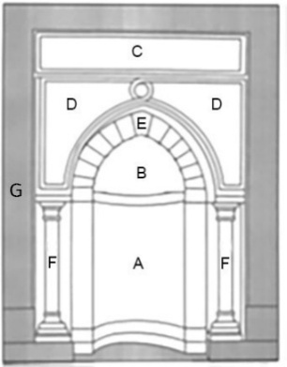
Figure 2. The components of Mihrab: A- Body, B- The cap ‘Altaaqia’, C- Banner, D- decorations of the arches, E- Arches, F- Columns, G-frame. Source: The researchers adopted from [8, p. 826]

- 2. Shape and Size of Mihrab’s Plan
The plan of the Mihrab can be in various forms, such as a horizontal rectangle of shallow depth or greater depth. Additionally, an arched shape with a slight curvature and a semi-circular arch is used. However, various polygonal shapes are applied in the design of the Mihrab, especially in ancient Mosques. The study of Prochazka (1986) highlighted various types of Mihrab’s plans in ancient Mosques (Figure 3) [15].

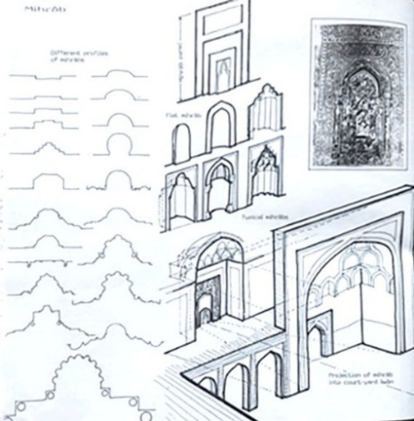
Figure 3. The Mihrab’s plan types [15, p. 30]
Hossameldien & Alshawan (2019) presented a clear classification of Mihrab plan types, including the semi-circular arch, the octagon, the semi-pentagon, the triangular polygon, and the horizontal rectangle. The study linked each shape of the Mihrab plan with the name of the mosque located within it and the Period (Table 1) [16]. Moreover, Eldin (2024) explains the relation between the Mihrab shape and the style of the Islamic period [17].

Table 1. Types of Mihrab’s plan as studied by Hossameldien & Alshawan’s (2019).
Period | Nation | Masjid | Mihrab Floor Plan | Mihrab Elevation
661-750 | Umayyad | Great Masjid of Damascus |  | 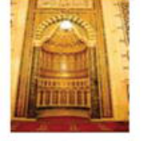
711-1031 | Umayyad Spain | Great Mashid Of Cordoba | 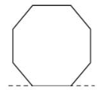 | 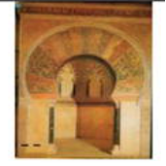
750-1258 | Abbasid | Abu Dulaf Masjid |  | 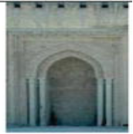
868-905 | Tulunid | Masjid of Ibnu Tulun | ` | 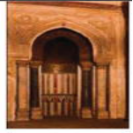
1062-1269 | ALmoravid | Great Masjid of Tlemchen | 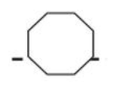 | 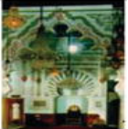
1290-1922 | Ottoman | Uc Serefeli Masjid | 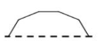 | 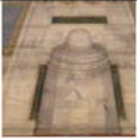
1501-1732 | Safavids |  | 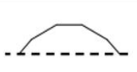 | 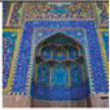
1526-1707 | Mughal | Moti Masjid | 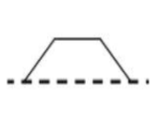 | 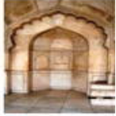
1368-1644 | Chinese Dynasty | Great Masjid of Xi’an | 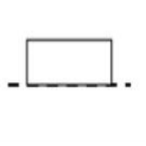 | 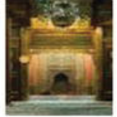
Recent | Saudi Arabia | IAU Masjid (Base Case) |  | 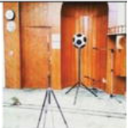
Source: [16, p. 7]s
Abdel-Razik (2021) presented a variety of mihrab plans (Figure 4) and associated them with specific Islamic regions and eras, including the rectangular and square shapes, which gained popularity in Iraq during the first and second centuries AH and the Abbasid era. Examples of the Mihrab of the Qasr al-Ukhaydir Mosque in Iraq, the Mihrab of the Tareeq Khana Mosque in Iran, and many Indian mosques. Semi-circular plans have also spread in Egypt since the end of the second century AH. Examples of the Mihrab of Al-Saleh Tala’i Mosque, the Mihrab of Al-Azhar Mosque, the Mihrab of Al-Rifai Mosque, and the Mihrab of Sultan Hassan Mosque (Figure 5). The plan sizes of the Mihrab of the Mosque also vary according to many factors, such as the size of the mosque and the factors of the architectural desires of the designer or ruler, which causes an increase in the area of ​​​​the Mihrab [8].

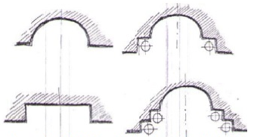
Figure 4. The types of Mihrab Plan according to Abdulrazaq’s study [8, p. 824]

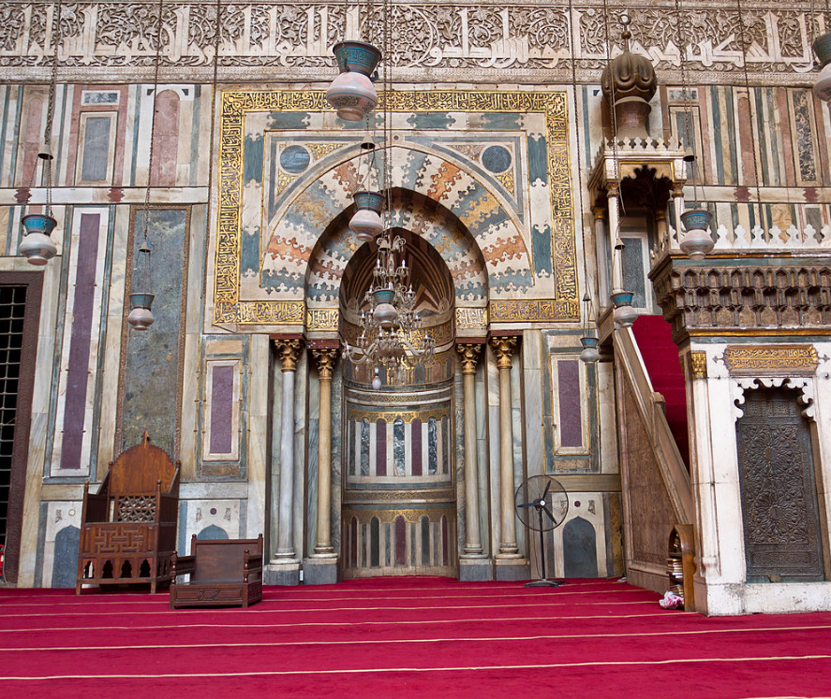
Figure 5. The Mihrab of Sultan Hassan Mosque. [18, p. Cairo 3]

In conclusion, the multiple reference shapes determined the traditional design directions for the mihrab plan, which include the shapes (semi-circular arch, octagon, semi-pentagon, triangular polygon, and horizontal rectangle). As for the sizes of the plans, they have not considered an indicator of a specific design direction, as they are related to the size of the mosque and proportionality to it, in addition to Other factors, such as the designer’s or client’s desires.

- 3. Constructed and Finishing Materials of Mihrabs
Since the first construction of hollow Mihrabs, various materials have been used in their finishing. Various forms of Plaster and stones, such as limestone, brick, alabaster, and Ceramic tiles, were popular materials at that time. The choice of materials was influenced by the availability of these materials in the Islamic regions where the mosque was built. Moreover, wood is used especially in the Movable Mihrab. Researchers mentioned that the most prominent materials used are alabaster and mosaics alabaster [8]. The oldest material used is limestone, but it is rarely used nowadays. Brick or non-pottery bricks were also used as a constructed and finishing material, especially in regions where clay is abundantly available. In the Ayyubid era, alabaster and mosaics were primarily used in various applications for constructing and finishing Mihrabs, including sculpture, particularly columns, relief or recessed engraving, covering, interlacing, and cladding with alabaster panels or mosaics. The oldest example of a Mihrab that used these materials was the Mihrab of Al-Salih Najm al-Din Ayyub’s shrine [8].
In conclusion, a group of materials was used linked to the heritage trend in designing Mihrabs, such as limestone, brick, alabaster, ceramic tiles, as well as wood. However, using new materials is an indication of a contemporary trend in designing mihrabs.

- 4. Decorating and Ornamentation of Mihrab
The ornaments in Islamic architecture are categorized as secondary elements of the mosque and can be applied to the main elements [1]. Three basic types of Ornamentation were used in the decoration of Islamic architecture in general, including the principles of repetition of the main shape [19], and in the decorating of the Mihrab in particular, which are inscriptional, geometric, and floral ornaments. The use of these ornaments encompasses various forms, including framing, isolated, iconic, and overall [20]. Abdel-Razik’s (2021) study indicated the main and secondary types of ornaments that were used in decorating the Mihrab which is: the floral ornaments, which include (arabesques, flowers, plant leaves, and vases), the geometric ornaments, which include (‘alaitibaq alnajmia’, radial lines, horizontal lines, double-frames around the Mihrab’s arches, Decorations in the form of arrowheads or an inverted letter Y in the center of the body of the Mihrab), and written texts in various forms such as Kufic script, Naskh, Rq’a, Thuluth, and other scripts). Moreover, the Muqarnas is used in the decorating of the Mihrab [8]. More than one type of ornament is often used in the design of mihrabs (Figure 6), as for the density of decoration of the Mosque’s Mihrab. Some of them had little or no decoration, some had simple decoration, and some used high-density decoration with various types of ornaments (floral, geometric, and inscriptional). Therefore, a qualitative measure is needed to assess the density of decoration and determine the form of ornaments used within each Mihrab.

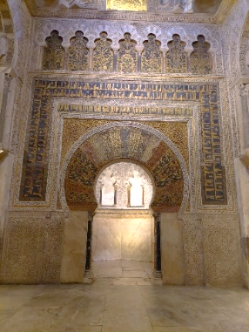 | 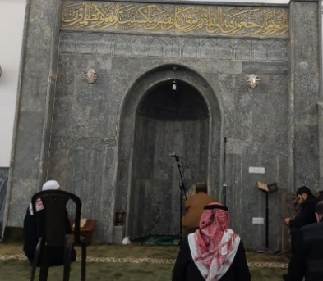 | 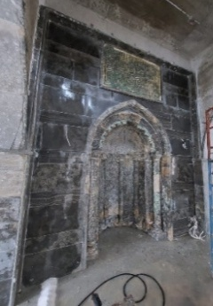
Figure 6. Types of ornaments in Mihrabs’ decoration

The adoption of decoration in its three basic types (floral, geometric, and inscriptional) and its secondary details, in addition to the use of muqarnas and within frame, isolated, iconic, and overall, as well as the possibility of combining two or more types of ornaments. The emergence of new forms in the way decoration is employed will be evidence of a contemporary trend.

- PRACTICAL STUDY PROCEDURES

The procedure of the practical study included designing a scale to measure the design trend of the Mihrab. An observation sheet was designed to record the elements and components of the Mihrab, categorized into main and sub-variables. The case study sample selection process follows the criteria of fame, awards, and various design trends, which will be explained in sequence. The sample size is [21] mihrabs from various locations within in contemporary Period (Table 2).

Table 2. The samples of the study
Sample ID | Sample name | Details
M1 | Hasan Kartal Orta Camii | Ankara, Turkey
M2 | Shahrake Gharb Jame | Tehran, Iran
M3 | Al-Nidaa' Mosque | Baghdad, Iraq
M4 | Sheikh Zayed Grand Mosque | Abu Dhabi, UAE
M5 | Nur-Sultan Grand Mosque | Kazakhstan
M6 | Zagreb Mosque | Zagreb, Croatia
M7 | Green Valley Mosque | Istanbul /Turkey
M8 | Şakirin Mosque | Istanbul, Turkey
M9 | Abaykonabi Mosque | Kazakhstan
M10 | Cambridge Mosque | London, U.K
M11 | Cologne Mosque | Germany
M12 | Fatima Sultan | Karachi, Pakistan

The scale was designed in a simplified qualitative approach to measuring the number of elements and components of the Mihrabs (samples). These elements and components were highlighted from the literature and theoretical framework, which are the seven main components. The measurement process deals with the (existing–non–existing) of the main Mihrab components in the sample, by giving (+1) for the existing and (-1) for non-existing heritage components of the Mihrab. The scale is a linear tool that includes both negative and positive values to account for the final results of the design trend of each sample, which will be categorized as either contemporary or heritage trends. The scale is named by the authors as (ST) (figure 7).

0
Contemporary trend
Neutral
Heritage
Trend

Figure 7. The scale measurement (ST) of the Mihrab design trend

To reach the (ST), the measurement applied the formal analysis and observation of the sample (Table 3), depending on which measurement table included three columns (Sample image, Sample analyzed image, and (ST) instrument. The measuring process will be done for each of the 12 samples. The analysis considered the elements and components that were abstracted from the literature (shown in Figure 7). The components of Mihrab: A- Body, B- The cap ‘Altaaqia’, C- Banner, D- decorations of the arches, E- Arches, F- Columns, and G- frame.

Table 3. Sample Analyzed and ST Applied for M1 case study
Sample ID | Sample Details | Sample Image
M1 | M. Hassan Kartil, Ankara, Turkey | 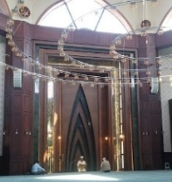
Sample Analyzed | 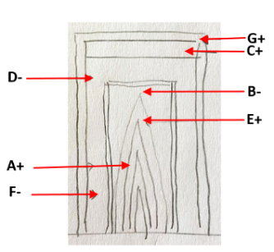
ST | 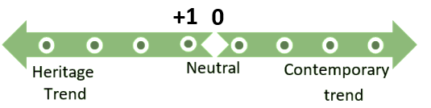

The observation sheet included four main variables, each with its sub-variables, including ST as one of the main variables. Moreover, the shape of the Miharb’s plan (MP) which are (semi-circular arch- SC, octagon- OC, semi-pentagon-SP, triangular polygon- TP, and horizontal rectangle-HR, or other mixed types- MT), the shape of plan will be highlighted in the observation sheet. Materials types used in constructing and finishing the Mihrab (MMF), which are Marble (M), limestone (L), brick (B), iron structures&Bordeaux panels (I), ceramic tiles (C), as well as wood (W), Paint (P), and Cement (CE). However, the use of new materials is an indication of a contemporary trend in Mihrab design. Ornamentation and decoration density (MOD), which basic type are (floral (F), geometric (G), and inscriptional (I), Muqarnas (M) and within frame(FR), isolated (IS), iconic (IC), and overall (OV), as well as the possibility of combining two or more types of ornaments. The emergence of new forms in the way decoration is employed will be evidence of a contemporary trend, as highlighted in the observation sheet (Table 4). The density of the ornaments observed for each sample, which included High Density (HD), Moderate (MD), Simple (SD), and No ornaments(NO).

 | Table 4. Observation sheet
ID |  | ST | MP | MMF | MOD
 |  | +1 | HR | M +W | G | FR | SD
M2 |  | -1 | HR | M | I | FR+IS | MD
M3 |  | +3 | SC | M | I+F | FR+IS | MD
M4 |  | +3 | SC | M+P | F+M | FR | SD
M5 |  | +1 | SC | M+P | G | FR | MD
M6 |  | -1 | SC | I | I | FR | MD
M7 |  | -3 | HR | I | I | IS | SD
M8 |  | -3 | SC | I | I | IS | SD
M9 |  | +1 | SC | I | G | FR+IC | MD
M10 |  | +6 | OC | W | I+G+M+F | FR+IC+IS | HD
M11 |  | +4 | OC | M | I+M | FR+IS | MD
M12 |  | -5 | HR | W | I | IS | SM

- RESULT AND DISCUSSION
The scale measurement results of the design trend of the Mihrab in the cases of the contemporary mosques show that (58.3%) of the samples went to the heritage trend; however, some of these samples were measured as traditional but not very far from the neutral scale. The remaining 41.7% of the samples included a very far-trend design, which is a contemporary trend. Therefore, the overall trend of the mihrab design trend depends on the heritage elements of the Mihrab despite the shortage of these elements. The ST of the sample No. M10 (Cambridge Mosque) in London was measured as (+6), indicating that most of the heritage elements were incorporated to form the shape of the Mihrab (figure 8). In contrast, sample (M12) Fatima Sultan Mosque in Karachi, shows ST (-5) in the direction of contemporary Trent (Figure 9).

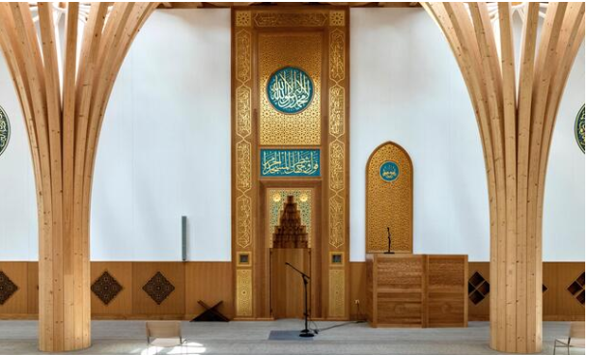
Figure 8. The design of the Cambridge Mosque Mihrab ST(+6).
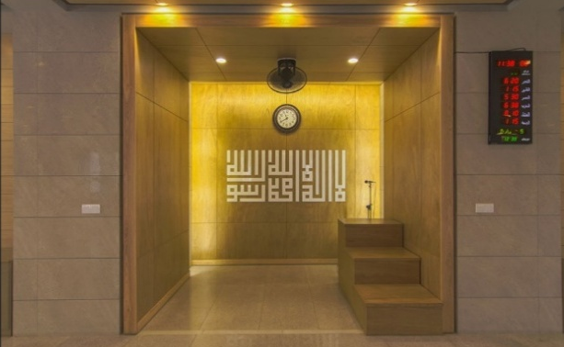
Figure 9. The design of the Fatima Sultan Mosque Mihrab ST(-5).

The results of the Mihrab plan rule show that 50% of samples used the semi-circular shape of the plan in various scales and rotation angles. The horizontal rectangular shape of the Mihrab was used in 33.4% of the selected contemporary samples, and the Octagonal shape was used in 16.6%, which are the two types of Mihrab plans that are in a heritage trend. Mihrab Material Finishing results show that 40% used marble as the main finishing material, 20% used wood, and 13.3% used painting. Lastly, 26.7% for alabaster. The results show that 40% of the finishing material used in the Mihrab's finishing process was non-heritage material, including iron structures, Bordeaux panels, and painting. At the same time, 60% of the samples used heritage materials. However, the overall trend is closely tied to the heritage style and its original aspects. The ornaments used were written inscription type (44.4%) and geometric ornaments (22.2%). While the floral and Muqarnas are 16.8% for each. This reflects the continuity of the heritage elements in the Mihrab, representing the contemporary heritage trend despite the variety in ornament types, locations, and styles. The contemporary trend is used to moderate the density of ornaments in the Mihrab. High-density architecture is rarely used in contemporary mosques, reflecting the relationship between heritage and modern elements in the contemporary trend.

- CONCLUSION
At the end of the study, we can conclude that contemporary mihrabs, despite the great developments that have occurred in their designs due to technological development, modern building materials, and contemporary design ideas, still rely in their designs on the use of the basic heritage elements that make up the heritage mihrab to a large extent. Also, these mihrabs, for functional reasons, still use the same forms of the heritage horizontal plans. It can be noted that some modern building materials, such as iron structures, boardex panels, and glass, are used in the cladding and construction of these mihrabs. Additionally, the decoration with written inscriptions, for both functional and symbolic reasons, has continued in these contemporary mihrabs, with a density ranging from low to medium.

ACKNOWLEDGEMENT
The researchers acknowledge the support of the University of Mosul, College of Engineering, Department of Architectural Engineering, during the collection of data, analysis, and registration of the research under the scientific plan of the Architectural Engineering department for the academic year (2023-2024), with registration No. 9/16/5051 on 30 May 2024.

REFERENCES

- S. M. A. Khaleel and H. M. Kasim, "Architectural Image of Mosques in terms of Historical DrawingsMental Image of Mosques in Miniature of Maqamat Al-Hariri," Al-Rafidain Engineering Journal(AREJ), vol. 24, no. 2, pp. 81-100, 2019.
- A. S. Ismail and N. S. Aziz, "Macma Islamic Ideology in Chinese Muslim Mosques Towards Universalizing Islam in Malaysia," JOURNAL OF ISLAMIC ARCHITECTURE, vol. 7, no. 2, pp. 243-252, 2022. DOI: https://doi.org/10.18860/jia.v7i2.15777
- F. Shafiee, The Arabian Architecture in Islamic Eygpt, vol. 1, Qairo: Egyptian General Authority for Authorship and Publishing, 1970.
- H. Mounes, Mosques, World of Knowledge Series, Kuwait: National Council for Culture, Arts and Letters, 1981.
- A. Thuwaini, Dictionary of Islamic Peoples Architecture, 1 ed., Baghdad: Bayt Alhikmah, 2005.
- A. R. Ghaleb, Encyclopedia of Islamic Architecture, Beirut: Jaraous Press, 1988.
- H. A. Yahya and M. H. Abdul Samad, "Environmental impacts of building materials for minarets of historical mosques," Advances in Environmental Biology, vol. 9, no. 4, pp. 1-4, 2015.
- T. A.-H. M. Abdel-Razik, "The technological and plastic values of the prayer niche," Journal of Arts and Humanistic Science, no. Special Issue-2, pp. 819-841, 2021. Doi: 10.21608/mjaf.2020.46233.1925
- A. A. S. ALsaydan and A. A. Dhannoon, "Design Characteristics of the Interior Elements of a Prayer Hall in Congregational Mosques," Al-Rafidain Engineering Journal (AREJ), vol. 27, no. 2, pp. 28-38, 2022.
- L. A. Ali and F. A. Mustafa, "The state-of-the-art knowledge, techniques, and simulation programs for quantifying human visual comfort in mosque buildings: A systematic review," Ain Shams Engineering Journal, vol. 14, no. 9, pp. 1-22, 2023. Doi: https://doi.org/10.1016/j.asej.2023.102128
- F. A. Mustafa and Z. K. Ismael, "A typological Study of the Historical Mosques in Erbil City," Sulaimani Journal for Engineering Sciences, vol. 6, no. 3, pp. 11-28, 2019. Doi: https://doi.org/10.17656/sjes.10097
- H. A. Yahya, K. J. A. Ismail, and T. H. Ali, "Impact of Changing the Surrounding Urban Context on Sustainable Design of Historic Buildings," in 2nd International Conference on Geotechnical Engineering - Iraq, Duhok, 2021. Doi: https://doi.org/10.1051/e3sconf/202131804010

- J. Seim, "Participant Observation, Observant Participation, and Hybrid Ethnography," Sociological Methods & Research, vol. 53, no. 1, pp. 121-152, 2024. Doi: https://doi.org/10.1177/0049124120986209
- H. Sarhaddi-dadian, S. Malekzadeh and Z. Ramli, "THE ARCHITECTURE OF DEZZAK GRAND MOSQUE, IRANIAN BALUCHESTAN WITH REFERENCE TO PROPHET MOHAMMAD MOSQUE IN MEDINA," JOURNAL OF ISLAMIC ARCHITECTURE, vol. 7, no. 2, pp. 279-288, 2022. DOI: https://doi.org/10.18860/jia.v7i2.17018
- A. B. Prochazka, MOSQUES, Zurich: Muslim Architecture Program, 1986.
- H. Hossameldien and A. A. Alshawan, "Sound Quality inside Mosques: A Case Study on the Impact of Mihrab Geometry," in Indoor Environmental Quality, 2019, p. 83486. DOI: 10.5772/intechopen.83486
- H. H. Eldien, "Evaluation of the influence of Mihrab shape on sound quality in Mosques," Journal of Engineering Research, vol. 13, issue 3, pp. 2293-2307, 2025. Doi: https://doi.org/10.1016/j.jer.2024.06.002
- Wikimedia Commons contributors, "File: Mosque-Madrassa of Sultan Hassan - Cairo 3.jpg," 18 6 2024. [Online]. Available: https://commons.wikimedia.org/w/index.php?title=File:Mosque-Madrassa_of_Sultan_Hassan_-_Cairo_3.jpg&oldid=670989921.
- A. A. Gurjia and A. A. Dhannoon, "REPETITIVE ELEMENTS AND THEIR OBJECTIVES IN ANCIENT AND CONTEMPORARY MOSQUES," Journal of Islamic Architecture, vol. 6, no. 4, pp. 264 - 276, 2021. DOI: https://doi.org/10.18860/jia.v6i4.11718
- A. A. W. Thanoon and H. M. Haj Kasim, "Design Characteristics of the Written Inscriptions in Islamic Architecture," Al-Rafidain Engineering Journal (AREJ), vol. 21, no. 6, pp. 54-70, 2013.
- S. A. Pirani, "NAVIGATING THE COMPLEXITY OF SAMPLE SIZE DETERMINATION FOR ROBUST AND RELIABLE RESULTS," International Journal of Multidisciplinary Research & Reviews, vol. 03, no. 02, pp. 73-86, 2024.

