 |  | JOURNAL OF ISLAMIC ARCHITECTURE  P-ISSN: 2086-2636 E-ISSN: 2356-4644  Journal Home Page: http://ejournal.uin-malang.ac.id/index.php/JIA
MODERN ARCHITECTURE OF MUQARNAS IN DAMASCUS: AN ORIGINAL COMPUTATIONAL METHODOLOGY
Nahed Jawad Chakouf^{1*}
¹Department of College of Arts and Creative Enterprise, Zayed University, Academic City, Abu Dhabi, United Arab Emirates
*Corresponding Author: nahedjawadchakouf@outlook.com
ARTICLE INFO |  |  | ABSTRACT
Volume: 9  Issue: 1  Page: 455-478  Received: September 9th, 2024  Accepted: June 2nd, 2025  Available Online: June 30th, 2026  DOI: https://doi.org/10.18860/jia.v9i1.29104 |  |  | The research aimed to revive muqarnas using digital computational tools, drawing on the techniques of Damascene craftsmen and ancient manuscripts. It involved designing contemporary muqarnas with double-curvature vaults and large spans, incorporating new unit designs and compositional techniques. In Section I, the researcher conducted pre-design studies on four muqarnas types, each associated with one of the four Damascene architectural styles. These studies examined the geometry and behavior of muqarnas types when used on traditional domed surfaces. Section II included a design study of the Dome of the Eagle of the Umayyad Mosque in Damascus, using modern software tools such as Rhinoceros 3D and Grasshopper. The design study explored various sizes, forms, and functions for contemporary muqarnas vaults. In Section III, the final design was based on a hexagonal grid with clusters of three rhombi, each forming a hyperbolic paraboloid shell. It allowed lateral movement and a variety of compositions, making the building a macrocosm of muqarnas. The development process involved five iterations, and the final iteration produced the best results, combining efficiency and elegance, resulting in a shell division that followed the surface geometry. The Grasshopper definition was introduced to add complexity and a smoother exterior shell. The design successfully analyzed traditional muqarnas and developed a four-stage process, including Computer Numerical Controlled (CNC) machining, mold-making, slip casting, and glazing, to produce six units at a 1:2 scale.  Keywords:  Islamic Architecture; Umayyad Mosque; Mamluk Period; Muqarnas; Ottomon Period; Rhinoceros 3D; Grasshoper

INTRODUCTION
This research has investigated the potential of muqarnas as architectural features in modern architecture. It aims to overcome the inherent design limitations of muqarnas and develop geometrical computational processes to enhance their functional potential. Digital technologies are becoming increasingly popular in architecture, as they are gaining popularity among architects, architectural offices, institutions, and schools [1]. The researcher has ensured that the design was both performative and efficient, serving both economic and aesthetic objectives. A computational toolkit was used to create contemporary shells with varying spans, housing various spatial and cultural functions, incorporating geometrical features. The computational tool kit aimed to balance innovative appearance and economic efficiency in construction.
This study addresses the problem that the traditionalist approach to mosque architecture generally fails to reveal the evolution of traditional muqarnas. It is expressed with an effective structure and contemporary technologies, applying the modernist view. It is often possible to identify such essential motifs, common schemes, and now-familiar architectural proportions that have been endowed with symbolic significance. This research aims to revive traditional muqarnas vaults using computational techniques to incorporate modern functions. The project explores the possibility of evolving traditional muqarnas in Damascus into contemporary forms and investigates the generation of hyperbolic paraboloid shells using a diamond-shaped projection. Straight beams forming a saddle roof would generate these shells, resulting in a double-curvature surface. Notably, the research differs from previous studies by focusing on understanding traditional muqarnas forms and designing them in a contemporary style, using computational techniques.

METHODS
Computer tools such as Rhinoceros and Grasshopper have been used to design modern muqarnas shells, incorporating new unit designs and compositional techniques. This has required knowledge of material behavior, structural systems, spatial organization, cultural implications, and muqarnas as a geometric form. The fusion of traditional muqarnas construction with computational techniques in modern architecture promotes creativity, efficiency, and sustainability, while preserving cultural history [2]. In addition to advancing multidisciplinary research, the aesthetics and cultural sensitivity of architectural design have been enhanced.
Section I explores the use of computational tools in modeling traditional forms of muqarnas within traditional volumes. It begins with geometrical experiments on the Dome of the Eagle of the Umayyad Mosque, aiming to understand how computational tools can be used to design contemporary muqarnas. Section II presents design studies exploring the potential of these muqarnas for their structural and environmental performance. Section III presents the author’s principal design, a hammam and spa complex in the Bab Tuma district of Damascus, which builds on previous design studies. In contrast, Section IV examines the principal design and documents the fabrication of physical mock-ups.

RESULT AND DISCUSSION

SECTION I: PRE-DESIGN

3.1.1 The Dome of the Eagle of the Umayyad Mosque
The Umayyad Mosque, also known as the Grand Mosque of Damascus, is one of the world’s largest and oldest mosques, completed in AD 715 during the Umayyad dynasty (see Figure 1) [3]. After the fall of Damascus to Muslim Arab forces in 634, many inhabitants converted to Islam, while others remained Christians. The cathedral became a place of worship for both groups, with a prayer room for Christians. The mosque was commissioned by al-Walid (the Umayyad caliph from 705 to 715 AD), best known for his efforts in Umayyad architecture, including the Umayyad Mosque and the Al-Aqsa Mosque, to replace the existing cathedral [4]-[8].
Damascus was the capital of the Umayyad Dynasty between AD 661 and AD 744, and its construction created a new design typology that would serve as the prototype for many later mosques [9]. The Dome of the Eagle, built by around 12,000 people in the 10th century, showcases the architectural and cultural influences of the area where it is located. The mosque features Byzantine mosaics depicting late Roman-style landscapes and buildings, including cityscapes, bridges, and arches, showcasing the diverse contributions of various laborers [10].
The pre-design aimed to focus on and enhance the understanding of traditional muqarnas before creating contemporary versions of the form. As such, the researcher chose an existing traditional structure and used it to perform a series of geometrical experiments. By experimenting with a real-life scenario, further insight was gained into the methods used to create traditional muqarnas, along with their inherited rules and limitations. Furthermore, an understanding of how contemporary computational techniques could be used to create traditional muqarnas in a historical form was developed. For this purpose, I chose the Dome of the Eagle of the Umayyad Mosque in Damascus.

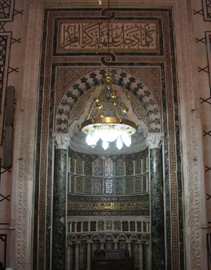
Figure 1. Umayyad Mosque 715 AD Interior Muqarnas, Mihrab, Ottoman Period, 1893
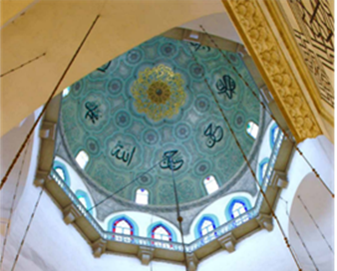  a | 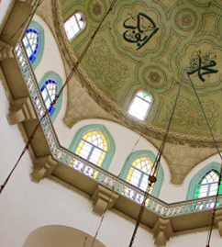  b
Figure 2. (a) Looking up at the interior of the Dome of the Eagle of the Umayyad Mosque; (b) The interior of the Dome of the Eagle, showing the octagonal balcony

The Dome of the Eagle of the Umayyad Mosque, known as Qubbat Al-Nisr in Arabic, was the historical form chosen for the Application of muqarnas [7][11] . The dome, located in the mosque’s prayer hall, is named after its resemblance to an eagle. Its name is derived from its shape, which is formed by the cupola, the body by the prayer hall, and the wings by the walls on its right and left. The Arab historian, Ibn Jubayr, has also described the dome’s appearance [12][13].
The original wooden structure was destroyed by a fire and replaced with a stone structure in 1893 during the late Ottoman era [14]. The structure still exists today and consists of three main parts: the square base, the octagonal drum, and the circular dome. The square base features four pairs of columns: the outer columns support the transept, and the inner ones support the dome. The drum rises above the base, with a height equal to the length of the side of the square base divided into upper and lower parts [15]-[17]. The structural system for the body and roof is separate, with the structure's height twice the length of the square base [16]. The drum features an octagonal balcony in the middle, surrounded by a balustrade. The lower part is square, while the upper part is octagonal, rising from the middle and continuing to the dome’s lower edge. The upper part has two windows with a Gothic-style pointed arch, and eight pendentives near the top [16].
Transitions occur from the octagonal to the circular shape of the dome, as if the body were an extension of the upper part. The drum is defined by a stone cornice, with a circular plan on the inside and an octagonal plan on the outside. The dome’s height is equal to half the side of the square base, with the inside resembling a hemisphere and the outside an ogee. Eight windows are centered above each side of the octagon (see Figures 2a and 2b).

3.1.2 Application of traditional muqarnas to the Dome of the Eagle
The researcher conducted tests on a three-dimensional computer model of the Dome of the Eagle to investigate the Application of different types of muqarnas design to a traditional volume using digital devices. The research was based on muqarnas designs from four distinct periods of Islamic architectural history: the Zengid (1127–1250 AD), Ayyubid (1171–1260 AD), Mamluk (1250–1517 AD), and Ottoman (1299–1922 AD) periods [2][19]. The aim was to preserve the historical and cultural identity of significant architectural works.

A. Iteration A: Application of Zengid-era muqarnas to the Dome of the Eagle
The experiment (Iteration A) aimed to project the muqarnas dome plan of the Madrasa al-Nuriyya al-Kubra (AD 1167) onto the Dome of the Eagle (see Figure 3), creating a transition between the three principal shapes: the square of the room, the drum octagon, and the dome hemisphere.

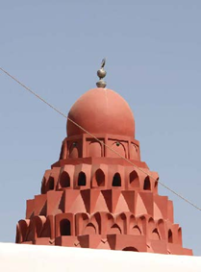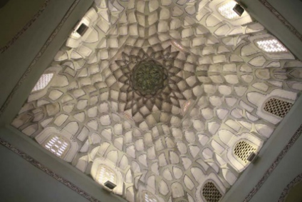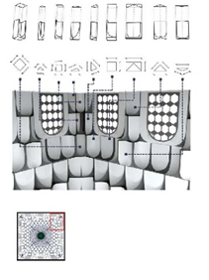
Figure 3. Realistic Visualizations of Al-Madrasa Al-Nuriyya Al-Kubra (school) 1167 AD. Architectural Style, Zengid Period

The design closely correlated with the shape of the transitions in the Dome of the Eagle. The experiment concluded that in using the same projection plan and unit design, there would be no significant differences between the original composition and the alternate composition (see Figures 4a and 4b).

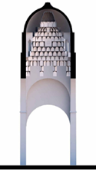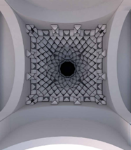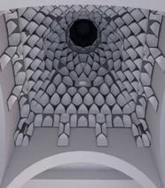
a b
Figure 4. (a) A section of the Dome of the Eagle after applying the Zengid era muqarnas; (b) Applying the muqarnas of Madrasa al-Nuriyya al-Kubra inside the Dome of the Eagle

B. Iteration B: Application of Ayyubid-era Muqarnas to the Dome of the Eagle
The second experiment (Iteration B) projected the muqarnas portal plan of the eastern entrance of the Damascus citadel (AD 1214) (see Figure 5a and 5b) onto the Dome of the Eagle. The traditional muqarnas had four tiers, while the proposed composition had the same number, with the height increased to fit the dome.

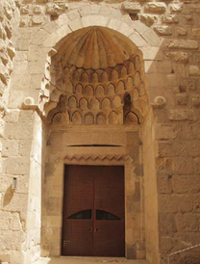  a | 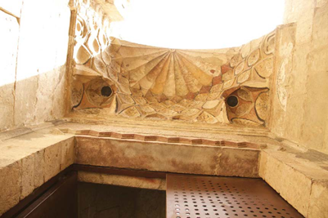  b
Figure 5. (a) Damascus Citadel_ The Eastern Entrance AD 1214; (b) A close up to this Muqarnas of Damascus Citadel_ The Eastern Entrance AD 121

This research confirms that digital tools can accurately document features when demolition or decline has occurred, enabling future generations to rebuild old architecture (see Figures 6a and 6b).

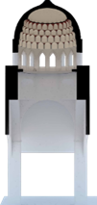 | 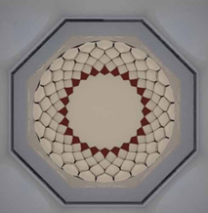
a | b
Figure 6. (a) Section of the Dome of the Eagle after applying the Ayyubid era muqarnas; (b) Applying the muqarnas of the citadel’s eastern entrance inside the Dome of the Eagle
C. Iteration C: Application of Mamluk-era muqarnas to the Dome of the Eagle
The third experiment (Iteration C) was inspired by the muqarnas design of the Mamluk era from al-Madrasa al-Zahiriyah (see Figure 7), a school and mausoleum from AD 1281.

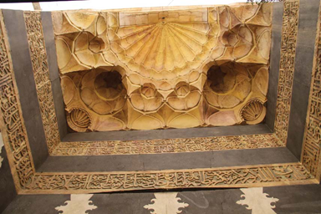 | 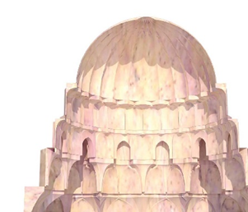
Figure 7. Al-Madrasa Al-Zahiriyah (School and Mausoleum) AD 1281

When digitally transposed onto the Dome of the Eagle, the resulting composition produced a distinct muqarnas pattern. The architect prepared a circular plan with muqarnas units occupying only three layers, transforming the original rectangular plan into a circular one.
The second step involved modeling modular units from the research on al-Madrasa al-Zahiriyah using Rhinoceros 3D. These units were applied to the interior surface of the Dome of the Eagle.
The project aimed to create a smooth transition from square to circle in a muqarnas form, using traditional muqarnas units in a different plan. The new vault transformed between three geometric shapes. The top ten tiers were a repetition of the makook modular unit, topped by a large cupola that enhanced the overall design. Makook is an Arabic term describing a ‘small domed’ or ‘vaulted ceiling’ compartment that is normally incorporated into the design of traditional architecture, often in Islamic structures, to establish the aesthetic pattern of progressing geometrical squares [19][20].
The first nine layers reflected alternating arrangements of a few units, the same as in the original composition. The units were applied to a different section of a traditional vault, creating a completely new muqarnas composition with multiple layers of muqarnas units and transitions between three shapes (a square, an octagon, and a circle) rather than just two (see Figures 8a and 8b).

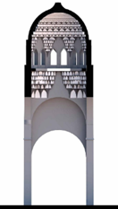 | 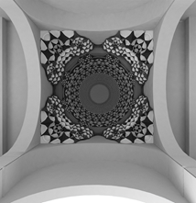
a | b

Figure 8. (a) The section of the Dome of the Eagle after applying traditional muqarnas from above the entrance of al-Madrasa al-Zahiriyah; (b) Traditional muqarnas are applied above the entrance of al-Madrasa al-Zahiriyah, a school and mausoleum, and to the interior of the Dome of the Eagle.al-Kubra

D. Iteration D: Application of Ottoman-era muqarnas to the Dome of the Eagle
The final experiment (Iteration D) utilized the Ottoman-era mihrab muqarnas composition added to the Umayyad Mosque in 1893 (see Figure 9).

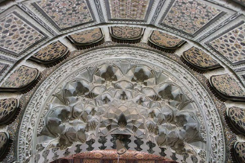

Figure 9. A Close View of Interior Muqarnas, Mihrab of Umayyad Mosque 715 AD, Ottoman Period, 1893

The new circular plan was transposed onto the Dome of the Eagle, increasing the height of each tier, resulting in a muqarnas composition similar to the original (see Figures 10a and 10b).

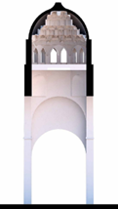 | 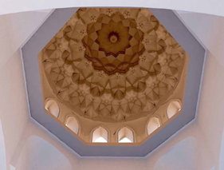
a | b

Figure 10. (a) Section of the Dome of the Eagle with traditional muqarnas units of the Mihrab in the Umayyad Mosque (b)Applying the traditional muqarnas of the Ottoman era mihrab, which was added to the Umayyad Mosque in 1893, to the interior of the Dome of the Eagle

SECTION II: DESIGN STUDY
This section explores the mathematical constructions of surface topologies of muqarnas, a traditional Islamic architectural form, and their rich tectonic and ornamental tradition. The challenge is to preserve the architectural individuality of these new forms while using new technologies and materials, dealing with drawbacks such as structural, constructional, and morphological constraints.

3.2.1. Tourist information pavilion: Umayyad Mosque Plaza
The research focused on analyzing free-form surfaces in contemporary architecture, specifically to design a tourist information pavilion at the Umayyad Mosque Plaza in central Damascus.
The research developed a digital process using Grasshopper, Autodesk Ecotect, Kangaroo, and Karamba to connect environmental and structural fields.
The shell tessellation design project uses two-dimensional patterns to adjust the opening sizes based on sunlight data from Ecotect software. The patterns open to the maximum when the shell is least exposed and close almost entirely when more exposed. The project involved two iterations: constructing a star-pattern pavilion and a free-form vault. Figures 11a, 11b, and 11c show the earliest surface deformation before it is refined through computational analysis. From analog to computational practices, the development required a controlled investigation of free-form surfaces, using parametric tools to produce optimal muqarnas geometries. The following section presents the computational process by which parametric design software, namely Grasshopper and Kangaroo, shaped form-finding to optimize aesthetics and environmental and structural performance. By trial and error, the structure underwent iterations before the form began to reconcile historical aesthetic considerations and performance requirements.

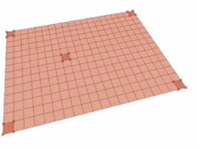 | 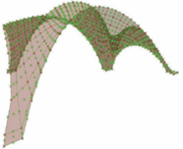 | 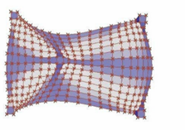
a | b | c

Figure 11. (a) Step 1: the surface before being affected by the free-form engine of the Kangaroo and Grasshopper; (b) Step 2: the surface after being affected by the free-form engine of Kangaroo and Grasshopper; (c) the curvature of the free-form surface being analyzed by Karamba in Grasshopper

The iterations involved two stages:
  - Iteration 1
The first stage involved four steps: creating a planar surface with five anchor points and developing a free-form shell after the planar surface was affected by the Kangaroo plug-in (See Figures 12a, 12b, and 12c).

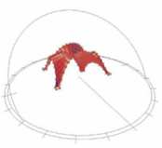 | 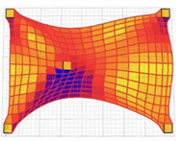 | 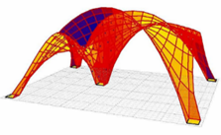
a | b | c

Figure 12. (a) Step 4: The free-form surface is exposed to the sunlight data for one year; (b) Looking up at the free-form surface exposed to Ecotect evaluation and color-coded accordingly; (c) Another perspective view of the free-form surface exposed to Ecotect evaluation and color-coded accordingly

The second stage of creating a star pattern involved reconstructing the original star pattern by drawing a square grid and a circle inside each square, resembling traditional Islamic patterns. The third step involved constructing square diagonals, while the fourth step identified a point in the middle of a diamond-shaped polygon, allowing the pattern to morph from a square into a diamond and then into a star. The fifth step connected these points, resulting in a star pattern.
The pattern alternated between two geometric shapes: the star (with intersection points inside the diamond) and the octagon (with intersection points outside the diamond). Furthermore, to create stars that altered, the octagon shape was modified, and the four flexible points (2, 4, 6, and 8 of the octagon) were moved inward to create the same star (See Figures 13a, 13b, 13c, and 13d).

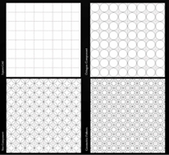 | 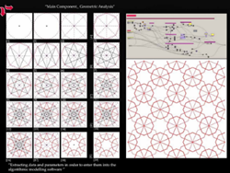 | 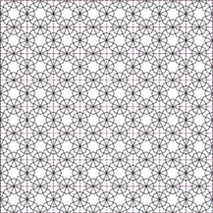 | 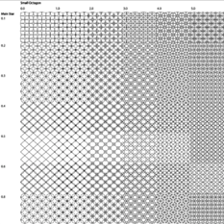
a | b | c | d

Figure 13. (a) Analyzing the primary grid of the traditional pattern; (b) Extracting the data and parameters of the pattern; (c) traditional pattern; (d) Comparison of many possible variations after entering the data and constructing this pattern using the digital environment of algorithmic software

The research aimed to enhance traditional Islamic patterns in a two-dimensional digital setting. By creating a star-pattern grid, two variables, a small octagon and a primary star, were introduced, resulting in a matrix of various patterns. The octagon variable was given values from 1.0 to 5.0, while the primary star variable was given values from 0.1 to 0.8, each time yielding new patterns. Traditional hand-drawn star patterns yielded three to four possibilities, but digital production produced endless variations. The focus was on digitally creating free-form, using the Kangaroo plug-in in Grasshopper and Ecotect.
The results were used in Iteration 2, when an investigation of the geometric qualities of muqarnas began. The two-dimensional geometrical pattern served as a first step in understanding the two-dimensional base of muqarnas units applied to a surface. The exact computational definition was used in Iteration 2 to create a second pavilion with three-dimensional muqarnas units and to investigate their geometric qualities, such as shapes, packed layers, height, and surface articulation (see Figure 14a and 14b).

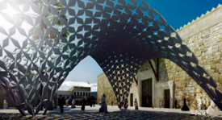 | 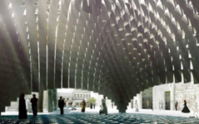
a | b

Figure 14. (a) Iteration 1: A tourist pavilion formed of two-dimensional star patterns; (b) Iteration 2: A tourist pavilion formed of 2D star patterns

  - Iteration 2
The second iteration of the muqarnas design focused on standardization and repetition of units. The computational workflow involved designing a single modular muqarnas unit with a square shaft and niche-like curvature, based on those from the Zengid and Ayyubid periods used in the Bimaristan Nur al-Din and the Eastern Gate of the Damascus Citadel. The unit was placed in the center of each pixel of a free-form surface, with a voxel matrix of ‘x’ and ‘y ’ pixels. The experiment, however, was only partly successful, as traditional muqarnas unit composition relies on each unit being arranged relative to the next. The units failed to connect in each tier and the tiers themselves, as the computational definition was fundamental and only replaced the center of each face with a unit. Additionally, there was no intermediate unit to serve as a connector between the central units, which would have enabled them to act structurally together. The height of each layer was also the same, which could have been adjusted to accommodate the dome's curvature.
Existing muqarnas compositions, such as the Bimaristan Nur al-Din in Damascus, are limited in their structural and freestanding nature, offering the potential for contemporary muqarnas design (see Figure 15).

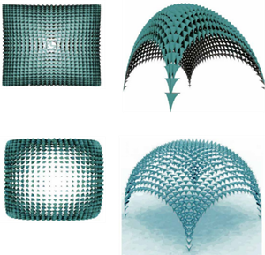

Figure 15. Internal layer: variations in the density of packing components and the shape of components

SECTION III: PRINCIPAL DESIGN
The researcher developed three projects to improve her understanding of muqarnas composition, often described as ‘honeycomb vaults’ in contemporary environments. The first project, a tourist pavilion with two options, featured a single shell, eliminating the need for adaptation. The second project, the Council of Representatives building, featured two asymmetrical shells of varying sizes, joined to form a single continuous surface. The third project, a hammam and spa, featured a series of asymmetric shells joined to form a continuous surface, with each join unique.

- Project concept and brief
The hammam and spa complex in Damascus’ in the Bab Tuma area is designed as a macrocosm of performative muqarnas, forming the defining aesthetic of the interior. The building comprises a limited number of simple units, which, when combined, form a complex whole.
This research explores the concept of muqarnas. The author chose a hammam as a suitable setting for developing contemporary muqarnas owing to its strong historical ties to Islam. Hammams are secular buildings with robust architectural features, such as domes and muqarnas, and have been built close to mosques.
Damascus has a long history of hammams dating back to the Umayyad era (AD 661–750) [21] [22], and the number of baths in the city steadily rose between the twelfth century and the height of the Ottoman Empire. However, due to the proliferation of private bathing facilities and changing fashions, the number of hammams in Damascus began to fall. Nevertheless, recent evidence suggests a revival of the Damascene hammams is occurring.
Before the outbreak of the civil war in 2011, there was a drive to revive the Old City of Damascus, with its various architectural elements, and to balance its traditional history with modern requirements. One example of this was Hammam Teirouzi, which had recently been renovated and is now considered to be one of the finest examples of traditional buildings in the area. This renovation not only restored a historic building but also incorporated essential elements for 21st-century living.
The water supply from the Ain-al-Fijah spring, which supplied 70 percent of Damascus’ water, was cut off by ISIS in December 2016. The people of Damascus turned to Public baths for watering, resulting in the reopening of traditional hammams. The revival of hammams is crucial, as they serve as social hubs and beautiful places for visitors and celebrations. Reviving hammams would also revive local neighborhoods [23]-[25].

- Project brief site description
The building will have a main reception, a hammam with barrani, wastani, and a jouwani (a swimming pool, changing rooms, toilets, and a café). Visitors will enter the swimming pool through the changing rooms and toilets. The hammam entrance is through the barrani, with changing corners and towels provided. The wastani offers massage treatment, followed by the jouwani or steam room. The final destination is the barrani, where socializing, shisha (a ‘water pipe’ or ‘hookah’ used for smoking flavored tobacco), and food and beverage orders will be provided. See Figures 16a and 16b and 17a and 17b to view the architecture plan of the hammam and swimming pool.
The project site is situated in Bab Tuma, within Damascus’ Old City, overlooking the Bab Tuma gate and the Barada river canal. The main entrance is proposed at the main roundabout of Bab Tuma, situated on the borders of the old city while overlooking parts of the modern city.

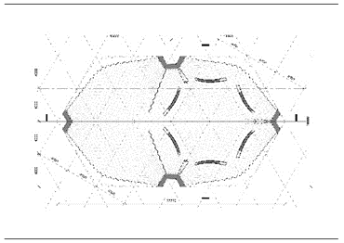 | 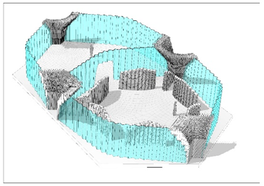
a | b

Figure 16. (a) (b) Hammam Architecture Plan Perspective

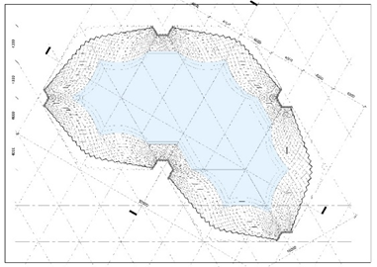 | 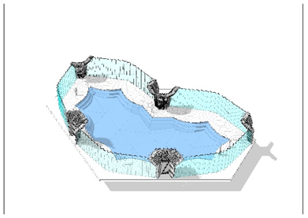
a | b

Figure 17. (a) and (b) Pool Architecture Plan

- Project design aims and description
The design research aims are as follows:
- From a historical point of view, this design research aims to revive the muqarnas, as well as a traditional functional building, a hammam.
- Aesthetically, the aim is to reinvent contemporary Islamic architecture.
- From a functional point of view, the aim is to create a functional contemporary muqarnas form.
- Structurally, the aim is to create a performative, self-standing muqarnas, without the need for a sub-structural system to support it.
- Environmentally, the aim is to create muqarnas units that allow a certain amount of light into the building.
The text discusses two modern spaces in the hammam: the swimming pool and the jouwani. The swimming pool space comprises two hexagon units made of seven shells, covering 517 square meters. The design of the shells was based on environmental analysis and varied openings. The jouwani space includes six small rooms, maqsura (private enclosure or partitioned space), for privacy, with walls extruding vertically from the shells. All rooms are contained under the cluster of shells (see Figures 18a and 18b).

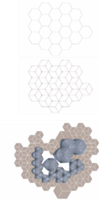 | 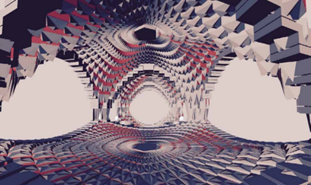
a | b

Figure 17. (a)The Basic Hexagon Grid: Each hexagon of the grid has a cluster of three rhombus shapes; (b) here. Interior view of the swimming pool area from the lobby space

A. Hexagon grid
The building is organized using a hexagon grid, with each hexagon clustering three rhombus shapes. The grid was designed with 16 hexagons and 7 individual rhombuses, as shown in Figures 19a and 19b.

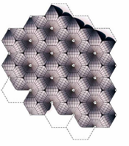 | 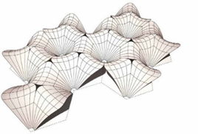
a | b

Figure 18. (a) The hexagonal grid and cluster of shells are three-dimensional surfaces; (b) The new hexagon grid after adjustment for functional reasons

B. Rhombus
From the previous design studies, the researcher discovered that a contemporary performative muqarnas should have a self-standing base shell, such as a hyperbolic paraboloid. Combining three shells into a cluster might address the problem of lateral forces in the muqarnas (see Figures 20a, 20b, and 20c).

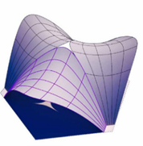 | 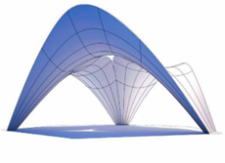 | 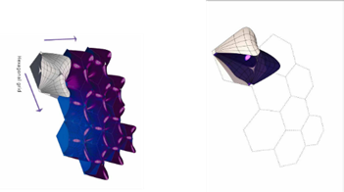
a | b | c

Figure 20. (a) Looking down at a cluster of three hyperbolic paraboloid shells; (b) Looking up at a cluster of three hyperbolic paraboloid shells; (c) The hexagonal grid with one unit, populated with a cluster of three shells, and a diagram of the primary group of hexagons with their cluster of shells

Muqarnas design development
The Grasshopper coding language was used to design computational muqarnas, a non-Euclidean geometry that produces minimal or no surface shear forces. The project involved four initial designs and the final design research. The hyperbolic paraboloid geometry, also known as a saddle surface, was used to create the building's base shell.
The Grasshopper definition involved scaling the hexagons to cover the base surface, distorting the surface points, and translating the UV of the scaled grid into the base surface. The ‘Polyline’ component extracted lines from the hexagons, which were then divided into three rhombus shapes, which became the base of each shell. Curves identified the shell base, as the shells had not yet surfaced. Each rhombus shape was introduced with seven symmetrical sections.
At each stage, one shell was chosen from the whole cluster of shells.

A. Design 01
The shell surface was divided into a 15 cm x 15 cm orthogonal grid, projected onto the main surface, and each quad became the base of the muqarnas component. The computational definition aimed to find a grid that contained the shell, excluding open quads and their offsets, as shown in Figures 21a and 21b.

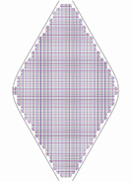 | 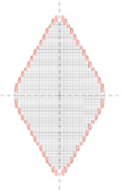
a | b

Figure 19. (a)The orthogonal grid within the boundaries of one shell/rhombus shape; (b) The red quads are excluded because they are all open quads with their offsets

The design consisted of three parts: structural, joint, and environmental (see Figure 22a). The Karamba plug-in influenced the structural part, while the environmental part was influenced by the Ladybird plug-in. Computational analysis is shown in Figure 22b.

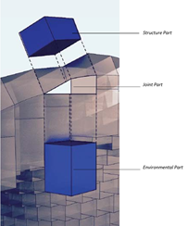 | 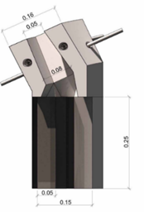 | 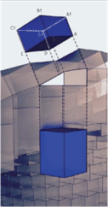
a | b | c

Figure 22. (a) The muqarnas component with its different parts: structural, joint, and environmental; (b)The metal clip on each of the four faces of a muqarnas component; (c) The thickness of the structural part of the muqarnas depends on the load at each point (A, B, C, D)

The muqarnas component shape begins with an offset of the basic quad, with varying thicknesses determined by structural Karamba plug-in analysis. The lower components, exposed to greater loads, require a maximum thickness. Each quad vertex (A, B, C, D) moves according to the average surface vector and Karamba analysis (see Figure 20c).
The shell was exposed to 13 hours of sunlight, resulting in color-coded quads assigned to each component. Each quad was assigned a color indicating the number of hours of sunlight exposure. The computational analysis is shown in Figures 23a, 23b, 23c, and 23d.
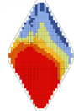 | 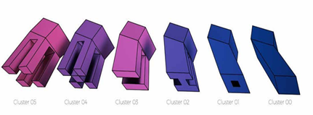 | 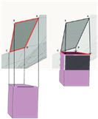 | 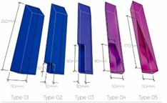
a | b | c | d

Figure 23. (a) The color-coded quads using the Ladybird plug-in; (b) Showing six types of perforation of the environmental part of the muqarnas component; (c) Projecting the four corners (A, B, C, D) of each component onto the base surface; (d) here. The five types of aesthetic finish of the muqarnas components’ lower parts

The muqarnas component was perforated with a central hole to allow light to pass through, and the top part was closed with a translucent material. The main quad was extruded below, divided into nine segments, each 25 cm long and varying in geometrical shape. Six types of perforation were created based on environmental analysis, with eleven different color-coded ranges reflecting different hours of sun exposure (see Figure 21b).
The computational definition of muqarnas components involved adjusting their height and positioning to fit the shell. The components were then placed against the base surface, and the lowest point (Point C) was determined in Grasshopper (see Figure 21c). The components were then grouped into five sets of the same length (25 cm), each assigned a different finish to create a smooth transition between them (see Figure 21d). The transition occurred at the tip, with the lower end carved more in the steep parts of the shell, and the flat part remaining notch-free. This resulted in a smooth transition between elements, even though the base surface inclination varied from 0 to 45 degrees. The rhombus shells were combined into a cluster of three to ensure structural stability. The orthogonal grid was not used because the muqarnas surface was easily read as x and y.
See Figures 24a and 24b for different views of the performative muqarnas shell of Design 01.

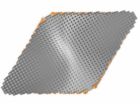 | 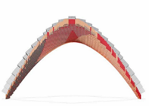
a | b

Figure 20 (a) here. Top view; (b) Elevation view of Design 01 shell

B. Design 02
The first design had several problems, including fabrication and aesthetic issues owing to individual measurements and isolation that contradicted traditional creation relationships. A second design was developed to address these issues while maintaining the traditional muqarnas design (see Figures 25a, 25b, and 25c).

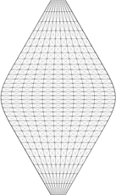 | 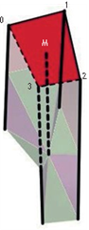 | 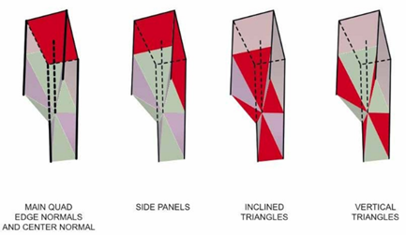
a | b | c

Figure 25. (a) Showing four points of the quad (0, 1, 2, 3) and the center of the quad (point M); (b) Showing one muqarnas component with two triangles; (c) The diagonal grid of Design 02. (No repetition of units, and with clean edges

The second design aimed to divide the main shell into a grid following surface UVs, making clustering easier and the muqarnas arrangement more efficient. The Grasshopper definition used the base surface as input, introduced scaled hexagonal grids, and clustered three shells using methods from muqarnas design development. Karamba was used to create an offset shell by moving points in the base shell in specific directions, similar to Design 01’s normal direction.
The UV grid was highlighted on both surfaces by showing the quad points of each UV subdivision. Each quad created a muqarnas component, with four points overlapping at each point. Four perpendicular normals were created from the points (0, 1, 2, 3), with varying lengths determined by the structural analysis in Karamba. Each muqarnas component was formed from these four normals, and connecting lines were created between the four points and the center of the quad to create four triangles. Other vertical triangles were created from lofting the remaining lines (see Figures 23b and 23c).
The design for computational muqarnas was advanced by merging muqarnas components with their neighbors, providing a relationship not found in traditional muqarnas design. However, this lacks environmental input, which is crucial for performative muqarnas, and results in surface tessellation due to the component’s lack of depth. A third design, defined in Grasshopper, was created to address these issues and improve the overall design. See Figures 26a and 26b for different views of the performative muqarnas shell of design 02.

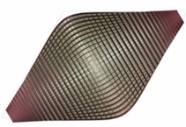 | 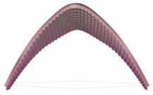
a | b

Figure 21. (a) Top view of the 02 design shell; (b) Elevation view of the 02 Design shell

C. Design 03
Design 03 combines successful elements of the first and second designs, using a UV grid and diagrid to efficiently arrange and extract from the shell surface (see Figure 27a).

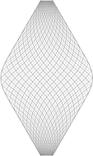 | 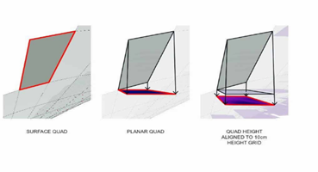
a | b

Figure 27. (a) A diagram of a quad on the shell that was then projected onto a plane; (b) The diagonal grid of the 03 design (No repetition of units, and with clean edges)

The UV grid was designed using Grasshopper, with each quad consisting of four edges and points, forming four muqarnas components. A diamond-shaped horizontal plane was created for each quad, and the quads were moved to a 10 cm height range. For example, a quad with a height of 1,009 cm would be moved to 1,010 cm, while another quad with a height of 652 cm would be moved to a level of 650 cm. The design aimed to have each component parallel to the ground plane and planar within the XY plane. The edges shared with adjacent quads were adjusted to ensure equal levels (see Figure 27b).
The muqarnas components were divided into four groups, each with two external edges shared with adjacent quads and two internal edges shared with identical quads (see Figure 28).
The design divided each quarter of the muqarnas component into three segments, resulting in four points at different heights. The internal edges of the four muqarnas components within a quad remained at the same height as the quad itself, allowing them to move according to the same parameter. The environmental analysis conducted with Ladybird was reused in design 03. The quads were grouped into six geometric sets based on the number of hours each quad was exposed to sunlight.
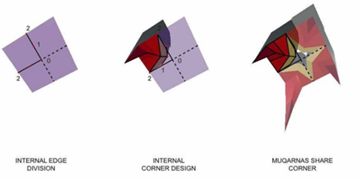

Figure 28. The internal corner edge of the muqarnas components

The muqarnas component design in design 03 was more successful, but there were issues with merging sides with adjacent quads. For wood, it was necessary to connect each component with a tension-operating metal clip. However, from a fabrication standpoint, it was impossible to cluster the muqarnas components due to their varying dimensions. This issue is examined in design 04, as it is challenging to achieve a clustered design owing to the different dimensions of each component. See Figures 29a and 29b for different views of the performative muqarnas shell of design 03.

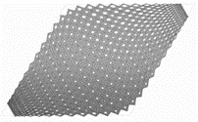 | 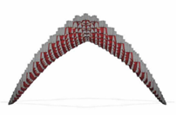
a | b

Figure 29. (a) Top view; (b) Elevation view of the 03-design shell

D. Design 04
The fourth design consolidates previous designs, particularly those from designs 01 and 03, by utilizing the orthogonal grid from the first design to reduce the number of muqarnas components and manufacturing units, each carved from a 15 x 15 cm block (see Figure 30a).

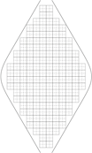 | 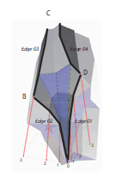 | 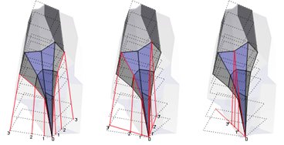
a | b | c

Figure 30. (a) In the 04 design, the component shared four corners and four edges with the adjacent corner; (b) showing the location of the points (0, 1, 2, 3) of the external edge of a muqarnas component in the 04 design; (c)The orthogonal grid of the 04 design (Low repetition of units)

The previous design of the muqarnas components lacked sufficient external edges for successful merging. In design 04, the merging between neighboring components was improved from design 03, resulting in every component sharing.
The muqarnas components in this design were analyzed using the Ladybird plug-in and adapted to each other in a similar manner to design 03. The shell thickness and extrusion of each component were obtained from Karamba. See Figure 31 for close-ups of the muqarnas units and how four of them form an opening; the size of this opening varies, and the shape changes between a star, an octagon, and a square; both the size and the shape of the opening depend on an environmental analysis.

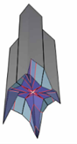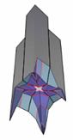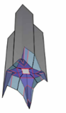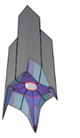

Figure 31. The opening shape is a small star, a slightly bigger star, a polygon, and an octagon

See Figures 32a and 32b for different views of the muqarnas shell of design 04.

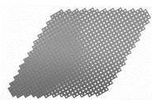 | 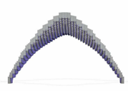
a | b

Figure 32. (a) Top view; (b) Elevation view of the 04-design shell

E. Design 05
The shell division in design 04 was initially used in design 01, aiming to create a computerized muqarnas system that could be carved out from the same block of material. Four studies were conducted to arrive at design 05. The author concluded that dividing a freeform shell into a rectangular grid would create uneven edge components, complicate fabrication, and compromise the design's aesthetics. Instead, designs 02 and 03 used a UV division of the shell, resulting in a more homogenous division, better able to populate joins between muqarnas units. The aim was to use a shell division that follows the surface geometry rather than trying to describe the surface with a regular grid. This was reflected in design 05 (see Figures 33a and 33b).

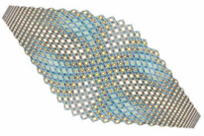 | 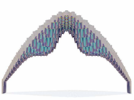
a | b

Figure 33. (a) Looking up; (b) Facade view of the 05 design shell

This design creates repetition based on different geometries and proportions, depending on each unit's location relative to the shell surface, ensuring there are no boundary limits.
Design 04 provided a successful interior space with muqarnas units and seamless joins, but it lacked the complexity of ancient muqarnas. This resulted in a seamless panelized dome with limited space-creation capabilities. Design 05 divided the shell according to its surface geometry, assigning muqarnas unit locations. Each unit was treated based on its location on the shell. The Grasshopper definition allowed variation of the muqarnas unit base quad using rasterized images, enabling more complex spaces. The top part of the muqarnas units followed the structural base shell, while the bottom part could be varied for more complex spaces.
Design 05 of the Grasshopper definition successfully adapted the muqarnas component population to different surfaces, resulting in fourteen different locations on the base surface (see Figure 34). This design included a sample-image component that interpolated the image's color to the height of the lowest point in the muqarnas. The interior space, created with different images, added a new aesthetic layer to ancient muqarnas domes. The ability to fabricate muqarnas of various lengths and sizes allowed the top part to align with the structural shell and the lower part to follow aesthetic requirements.

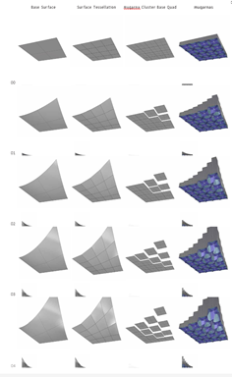

Figure 22. Showing the first five (00-04) instances of the transition accomplished by the GH script in the 05 design

In conclusion, from design 01 to design 05, the research explored the development of a muqarnas shell and component, focusing on the Grasshopper definition. The design process, outcomes, and scripts were continuously monitored across the five studies. The research successfully achieved a performative muqarnas and revived the traditional muqarnas form into contemporary shells (see Figure 35).

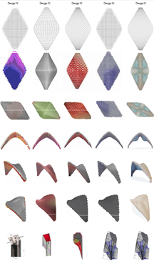

Figure 35. A catalog of the 01 design to the 05 design, visually to compare the geometrical progress

SECTION IV: FABRICATION OF THE FINAL DESIGN
The researcher designed a free-form hyperbolic shell with muqarnas units following the UV grid and then fabricated it using contemporary computer-aided manufacturing techniques, such as Computer Numerical Control (CNC) machine tools, 3D Printing, or Multi-Point Formatting (MPF), exploring two fabrication options.

- Option A - 3D printing
The researcher considered using 3D printing to create a 1:1-scale model of a shell. She contacted D-Shape, an engineering firm, and TorArt, an Italian company. TorArt had previously created a six-meter-tall replica of the Palmyra Arch of Triumph in marble and sandstone. The author’s model would be created using clean water, cement, and aggregates. However, the shell’s dimensions exceeded D-Shape’s capabilities at 16m x 8m x 19m (LxWxH), necessitating the construction of a new machine that would have taken at least eight months to build and would have been expensive.

- Option B – Ceramic casting
The researcher decided to fabricate a shell using a ceramic material, collaborating with Dr. Guan Lee, a practicing architect and lecturer at Grymsdyke Farm, a fabrication workshop established in 2004 in the village of Lacey Green, rural Buckinghamshire, UK. She enlisted the help of Heyoung and Jessie Lee to produce the final model. After considering the budget and limiting factors such as milling machines, kiln size, and time, the model was resized from 1:1 to 1:2 and extended to a small section of six muqarnas, totaling twenty-four units. A methodology was developed comprising four principal stages: CNC work, mold making, slip casting, and glazing.

A. Stage 1: CNC work
The initial stage involved creating a ‘master’ from high-density foam to form a ‘positive’ mold shape. A CNC milling technique was used to create a three-dimensional ‘master’ model of six muqarnas units, which involved milling the master model, its assembly, and preparation for mold-making.

        - Miller, the Master
The first step of the CNC work is the ‘milling of the positive’, a process that includes the following four phases:
- Horizontal roughing – the first rough cut to the model (see Figure 36a).
- Parallel finishing – used to smooth out the foam (see Figure 36b).
- Profiling – which involves cutting out the perimeter (see Figure 36c).
- Engraving – the final stage of the cutting process (see Figure 36d).

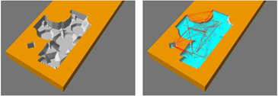 | 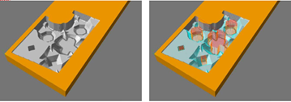
a | b
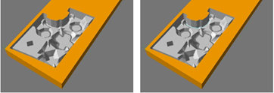 | 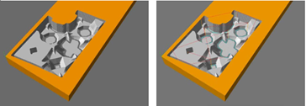
c | d

Figure 36. (a) Horizontal roughing; (b) Parallel finishing; (c) Profiling; (d) Engraving

        - Model assembly
After milling, the high-density foam pieces are assembled and glued to form a single piece.
  - Preparation of the master for mold-making
The final step involves modifying the master for plaster mold casting. First, the master is sanded to remove imperfections. Then the surface is varnished to prevent water absorption and waxed to facilitate mold release. This process ensures the plaster mold’s adhesion to the mold and prevents sticking (see Figure 37).

B. Stage 2: Fabrication of the plaster mold
The second principal stage of the fabrication process involved creating a plaster mold around the master, comprising 15 steps.
Step 1 : Before starting the model, the researcher tested how easy it was to remove the mold vertically from the top, as molds are typically removed part by part from the side and top to bottom, but in this model, the molds were removed vertically.
Step 2 : Wood ‘cuddles’ were utilized to create a box around the foam master, allowing for the individual casting of the top and bottom.
Step 3 : The bottom section was divided into two parts due to its weight, and each of the six voids was filled with clay to prevent liquid plaster from entering.
Step 4 : The fourth step involved constructing clay columns to create channels for pouring the slip.
Step 5 : The top part of the mold was poured and cast in two sections for easy deconstruction.
Step 6 : After casting the top two molded parts, the foam master and clay were removed from the bounding box, and the master was flipped over for bottom mold casting.
Step 7 : The seventh step involved casting molds for the four largest voids, dividing them into two parts for easy removal. An acrylic divider was placed inside the molds to prevent plaster expansion. Metal bars were cast into the molds, with handles coated in silicone for easy removal.
Step 8 : The casting needed to be divided horizontally and vertically due to the model’s size and complexity.
Step 9 : This step involved dividing the remaining sections into individual casts, taking into account the sharp edges of the geometric parts as the molds were divided horizontally.
Step 10 : The two deepest voids were divided into two parts, with a thin acrylic center for easy release, as with the other four voids.
Step 11 : The horizontal sections were vertically divided to make them easier to remove.
Step 12 : The top section had to be cast in one piece to support subsidiary molds when upside down and reinforced with plaster fabric for durability.
Step 13 : Four wooden boards were used to surround the inner molds, creating four plaster walls.
Step 14 : This step involved dismantling the mold into pieces, drying them in a kiln at a low temperature, and then exposing them to sunlight for several days.
Step 15 : The final step involved reassembling the molds and securely strapping them together before pouring the slip.

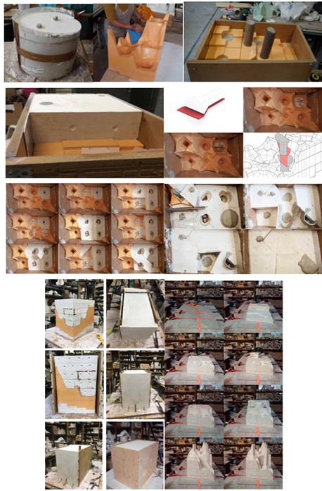

Figure 37. Steps of Fabrication of the Plaster Mold

C. Stage 3: Slip casting
Slip casting is a ceramic manufacturing process where liquid clay is poured into a plaster mold, allowing it to dry and harden. It can be done using a solid mold or a hollow mold for hollow shapes like vases and jugs, with six steps involved (See Figure 38).
Step 1 : The initial step involved pouring the slip into the molds using a unique low-shrinkage slip.
Step 2 : The slip was left in the mold for 45 minutes, and the thickness of the dried layer was then measured. An excess slip was drained, taking 45 minutes due to the mold’s size and weight.
Step 3 : The mold was left to dry overnight.
Step 4 : After determining that the cast piece was ‘leather-hard’, the plaster mold was dismantled sequentially, taking great care to avoid damaging the cast clay model.
Step 5 : After removing the mold, minor repairs were needed owing to unwanted seams formed during casting.
Step 6 : The slip model requires drying for 7 to 10 days before bisque firing due to its complex geometry and the gradual temperature rise to 1,000 degrees Celsius.
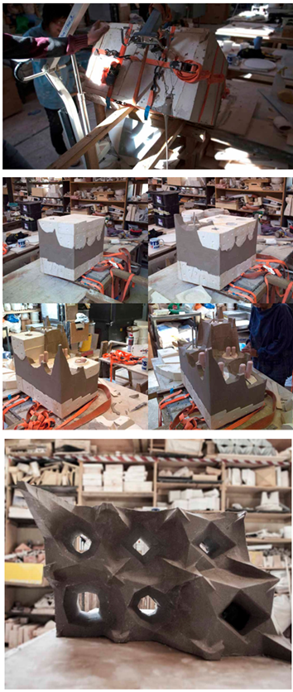

Figure 38. Steps involved in slip casting

D. Stage 4: Fire and Glazing
After drying, the unit was bisque-fired, then glazed and fired again, and finally gilded after the second firing (See Figure 39).
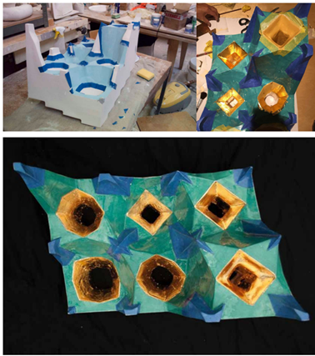

Figure 39. The muqarnas unit during the Application of the second glaze

COMPUTATIONAL DESIGN ENHANCEMENTS AND ENVIRONMENTAL IMPACT ANALYSIS
The muqarnas shell design follows an organized workflow segmented into three principal stages. The initial step is base geometry modeling, in which the building boundary surface is used as the base. This is done with the use of the HexGrid component of Grasshopper, which creates a hexagonal grid to arrange the muqarnas pattern. One can change the size of these hexagons with the help of Graph Mappers to fit varied spatial needs. The base dome surface is subsequently split into planar quads using the Surface Divide component to create the fundamental clusters that constitute the muqarnas composition.
At the second stage, the muqarnas design parameters are set. The geometric height variation for each planar quad is determined using the Image Sampler component, which converts pixel intensities to geometric height variation. This enables one to generate varied interior volumes, providing depth and variety to the dome's surface. Ladybug Sun Radiation Analysis is used to ensure the design responds to environmental conditions at the site.
This element evaluates the solar exposure distribution on the shell surface and determines the size and location of the muqarnas openings. Solar radiation-exposed areas have smaller openings to reduce heat gain, while shaded areas have larger openings to allow maximum daylight penetration. The Remap Numbers component is used to set the height values relative to environmental information.
The environmental performance analysis comprised the two most important simulations in Ladybug Tools, carried out for the warmest and coolest days of the year in Damascus, i.e., June 21 and December 21. The diagrams below show outcomes that indicate significant seasonal differences. On June 21, the simulation indicates increased solar exposure, especially on the south and west surfaces, with values of as much as 12.3 hours of direct sunlight. This guided the choice to minimize aperture sizes on these surfaces to reduce thermal gain and improve indoor comfort. The analysis for December 21, on the other hand, indicates very low solar exposure, with some surfaces receiving only 0.85 hours of sunlight. The architecture features greater openings on the eastern and northern sides to maximize daylight penetration during winter.
The geometric structure of the muqarnas is based on the hyperbolic paraboloid equation 0.1*X² + 6.882 = Y, which controls the curvature of the shells. The equation provides structural stability to the dome's surface while creating the complex patterns typical of historical muqarnas. The Surface Morph component deforms the base geometry onto the dome's surface, smoothly transitioning from the hexagonal grid to the hyperbolic paraboloid.
The third phase is the detailed modeling of the muqarnas units. The Edge Divide element divides the muqarnas edges, creating more detailed geometry. The Loft element is then employed to produce smooth curves between the divisions, maintaining visual continuity and structural integrity. The Surface Morph element also helps align the planar quads with the dome's curvature, enhancing the spatial richness of the design.
From an ecological standpoint, the parametric design of the muqarnas incorporates several sustainable elements. The Ladybug Radiation Analysis tool maximizes daylight and minimizes solar heat gain. By simulating solar exposure over the course of a year, the analysis determines the size and location of the openings. Openings on the south facade are minimized to avoid overheating, while openings on the northeast facade are maximized to gain more natural light.
The computational process also deals with material efficiency. The surface tessellation, examined using the Ladybug Radiation Analysis component, helps determine where material can be reduced without affecting structural performance. This optimization reduces material use and minimizes the environmental footprint related to material extraction and processing.
Traditional hammams have traditionally been social spaces for relaxation and interaction. Historical reports emphasize the importance of spatial organization, thermal comfort, and daylighting in improving user satisfaction. In the suggested design, the interaction between daylight modulation, achieved through the parametric muqarnas shells, reflects these classical characteristics. Visitors would most likely perceive changing patterns of light and a comfortable indoor climate, in agreement with observations from restored hammams in Damascus. Subsequent studies may include direct interviews with hammam users and artisans to confirm these experiential presumptions.
The muqarnas units' dynamic shading effect is not only functional but also an aesthetic element. An investigation using Ladybug Tools revealed that at peak sunlight hours, the muqarnas shells minimize direct solar gain by 28%, supporting passive cooling measures. This performance is consistent with recorded research on historic hammams, in which muqarnas were traditionally used to disperse light and control interior temperatures.
This research also has the potential to be applied outside of hammams. For instance, the adaptive shading techniques formulated here may be extended to public seating, such as bus shelters, in hot desert regions like Dubai. Similar muqarnas-based shading elements may create naturally ventilated, cool waiting areas by reducing solar radiation and enhancing ventilation.
In addition, the comparison between classical muqarnas forms and computationally derived forms reveals both continuity and innovation. The classical muqarnas, like those in ancient hammams, feature complex geometric compositions that adhere to the rules of classical Islamic design. On the other hand, the computational models in this research employ parametric methods to adapt these forms to modern environmental and structural needs. The visual contrast between the historical muqarnas ceiling and the computer-generated shell demonstrates how parametric software maintains the cultural integrity of past buildings while maximizing performance for contemporary applications.

The images provided easily reveal the clear contrast between computational and traditional muqarnas forms. Traditional muqarnas reveal detailed craftsmanship through hand-carved geometries, whereas the computational form demonstrates improved environmental sensitivity achieved through parametric tuning. The patterns of sunlight observed in the computational form also indicate the design's ability to moderate solar exposure, a less conspicuous aspect in traditional forms.
Ultimately, the parametric design workflow builds on classical architectural principles and current computer applications. Pieces such as HexGrid, Surface Divide, Image Sampler, Ladybug Sun Radiation Analysis, Surface Morph, and Loft combine to develop a structurally competent, responsive to environment, and harmonious-looking muqarnas shell. Environmental performance issues are built into the design through data-based analysis to ensure sustainability and cultural harmony in the resultant architectural solution. The incorporation of solar performance results, especially the differing outcomes noted on June 21 and December 21, provides an empirical underpinning for the design choices, closing the gap between theoretical investigation and pragmatic use.

CONCLUSION
The design study revealed that a self-standing form with structural integrity is crucial for the computational performance of the muqarnas shell. The Grasshopper definition successfully analyzed various contemporary shell shapes and muqarnas unit types, demonstrating the importance of structural integrity in computational shell design. The first design iteration focused on the use of a hyperbolic paraboloid shell and hexagonal cluster as the basis for subsequent iterations. However, the muqarnas design was unsuccessful due to its inability to visually convey the hyperbolic paraboloid's complexity and the lack of environmental input. The second design iteration divided the shell surface based on UV lines, resulting in a more sophisticated appearance but lacking environmental input and sculptural sophistication. The third iteration used UV curves to subdivide the shell’s surface but encountered issues merging external sides with adjacent quads. The design of internal edges was guided by the environmental analysis, but constructability issues arose due to each muqarnas unit’s unique geometry. The fourth iteration revisited the orthogonal subdivision method to maximize repetition and minimize custom unit use.
The fourth design used an orthogonal grid to create an uneven edge, which would complicate the fabrication process and compromise the aesthetics, whereas the fifth design aimed to achieve a shell division that followed surface geometry rather than imposing a regular orthogonal grid. This resulted in a design with the desired aesthetic richness and a harmonious interior appearance. The Grasshopper definition was introduced to add complexity and richness to the interior by extending the muqarnas units downward toward a secondary virtual surface, enhancing the design's three-dimensional aspect. The external appearance of the shells was also improved, with the Grasshopper definition allowing for a smoother exterior shell. The shell was populated with three-dimensional units that can connect structurally and visually. A secondary geometry was introduced to enhance the composition's three-dimensional quality. The definition was developed to allow for two different external appearances: one composed of layers of muqarnas units and the other with a smooth exterior surface. The design successfully analyzed traditional muqarnas, extracting key characteristics and representing them in a contemporary, computational, and parametric way.
Later, a four-stage process was developed to produce six muqarnas units at a 1:2 scale, using CNC work, mold-making, slip-casting, glazing, and firing. The process was more complex and labor-intensive than initially anticipated, but it was satisfying because it was not fully automated. The author thinks that processes that combine precise digital techniques with human creativity should be encouraged, as otherwise, futuristic architecture would lack a human touch. The muqarnas’ hand-made quality is evident in the prototype. The technique allows for a high level of repetition, reducing the number of molds needed. The author suggests using similar techniques in the future for more conventional building materials.

AUTHORS CONTRIBUTION
Nahed Jawad Chakouf conceived of the presented idea, developed the theory, and performed the computations. She verified the analytical methods, evaluated the findings of this work, and contributed to the final manuscript.

ACKNOWLEDGEMENT
The author is deeply grateful for the help provided by UCL and the Bartlett School of Architecture, and to Professor Marjan Colletti of the Bartlett School of Architecture for his academic support and guidance throughout her studies. She also thanks Professor Jonathan Hill for his dedication as her secondary supervisor. Dr. Tammam Fakouch, a mentor at Damascus University’s Faculty of Architecture, has provided unwavering support throughout her studies. She also acknowledges Dr. Mohammad Khayri Al-Baroudi for his academic support in Damascus, Hassana, and Hend Mardam Bey for their house, and Layla Hamdan for guiding her through the streets of the Old City.

REFERENCES
[1] [1] M. E. Akyürek, "A Topological and Technological Transformation Model of Mimar Sinan’s Mosques to the Present," Journal of Islamic Architecture, vol. 8, no. 1, pp. 91-105, 2024. DOI: https://doi.org/10.18860/jia.v8i1.23694
[2] I. E. Maarouf and S. U. Zeid, "Parametric approach for generating new muqarnas," Journal of Islamic Architecture, vol. 5, no. 3, pp. 111-118, 2019. DOI: https://doi.org/10.18860/jia.v5i3.5322
[3] C. G. Gutierrez, "Spolia and Umayyad Mosques: Examples and Meanings in Córdoba and Madinat al-Zahrāʾ," Journal of Islamic Archaeology, vol. 9, no. 1, pp. 83-104, 2022. DOI: https://doi.org/10.1558/jia.23646
[4] W. B. Denny, "Michell, ed.: Architecture of the Islamic World, Its History and Social Meaning (Book Review)," Middle East Journal, vol. 33, no. 4, p. 520, 1979.
[5] H. Mostafa, "The early Mosque revisited: introduction of tHe Minbar and Maqṣūra," Muqarnas Online, vol. 33, no. 1, pp. 1-16, 2016. https://www.jstor.org/stable/26551679.
[6] A. a.-R. Moaz et al., The Ayyubid Era. Art and Architecture in Medieval Syria. Vienna: Museum With No Frontiers, MWNF (Museum Ohne Grenzen), 2015.
[7] F. Anticoli, "The Role Of The Umayyad Mosque Of Damascus In Conceiving The Pavilion Of Niẓām Al-Mulk In Isfahan," Journal of Islamic Architecture, vol. 7, no. 4, 2023. DOI: https://doi.org/10.18860/jia.v7i4.21367
[8] K. El-Awaisi and C. Yavuz, "The Future of Al-Aqsa Mosque in the Light of Trump’s Deal of the Century," Insight Turkey, vol. 22, no. 3, pp. 215-236, 2020.
[9] R. Ettinghausen, O. Grabar, and M. Jenkins. Islamic art and architecture 650-1250. Yale University Press, 2003.
[10] S. E. Paturel, "The Religious Landscape of Baalbek in the Roman Period," in Baalbek-Heliopolis, the Bekaa, and Berytus from 100 BCE to 400 CE, Brill, 2019, pp. 194-246.
[11] B. Wiryomartono, "Mosque Architecture: The Roots and Sources of," in Historical Mosques in Indonesia and the Malay World: Roots, Transformations, and Developments. Springer, 2023, pp. 15-36.
[12] L. S. Taranu, Exploring Strange, New Worlds: Travellers and Foreigners in Medieval Iberian Literature. Washington University in St. Louis, 2014.
[13] J. M. Bloom, "On the transmission of designs in early Islamic architecture," Muqarnas, vol. 10, pp. 21-28, 1993. DOI: https://doi.org/10.2307/1523168
[14] C. Jäger‐Klein, A. Bajramović, and L. Stampfer, "Fire prevention in Ottoman and Habsburg building codes for Bosnia and their application in Travnik," in New technologies for a sustainable conservation of heritage structures, International Centre for Numerical Methods in Engineering (CIMNE), 2021, pp. 2768-2779.
[15] M. Guidetti, "The contiguity between churches and mosques in early Islamic Bilād al-Shām," Bulletin of the School of Oriental and African Studies, vol. 76, no. 2, pp. 229-258, 2013. https://www.jstor.org/stable/24692807
[16] T. Akili, The Great Mosque of Damascus from Roman Temple to Monument of Islam. Architectural Research Center of Old Damascus-ARCOD, 2009.
[17] B. Bayati, The History and Development of the Dome in front of the Mihrab. UK: University of London, School of Oriental and African Studies, 1985.
[18] H. M. S. A. Naby, "The Treatment of the Architectural Unit above Openings of the Mamluk and Ottoman Facades in Cairo," Journal of Islamic Architecture, vol. 3, no. 2, pp. 82-93, 2014. DOI: https://doi.org/10.18860/jia.v3i2.2541
[19] J. Rogers, " Review of The Formation of Islamic Art, by O. Grabar," Kunst Des Orients, vol. 9, no. 1/2, pp 153–166, 1973. http://www.jstor.org/stable/20752447.
[20] K. A. C. Creswell and J. W. Allan, A short account of early Muslim architecture. London: Penguin books, 1958.
[21] T. Miura, Dynamism in the Urban Society of Damascus: The Ṣāliḥiyya Quarter from the Twelfth to the Twentieth Centuries. Brill, 2015.
[22] H. Gaube, "The Syrian desert castles: some economic and political perspectives on their genesis," in The Articulation of Early Islamic State Structures, Routledge, 2017, pp. 337-368.
[23] F. Fadli and M. Sibley, "The Historic hammāms of Cairo: Safeguarding a vanishing heritage," Journal of Architectural Conservation, vol. 14, no. 3, pp. 59-80, 2008. DOI: doi.org/10.1080/13556207.2008.10785032
[24] C. M. Davis, "Conserving The Ottoman(s) at an Israeli World Heritage Site," Archaeologies, vol. 9, pp. 320-343, 2013. DOI: 10.1007/s11759-013-9236-1
[25] J. Peteet, The Hammam Through Time and Space. Syracuse University Press, 2024. www.jstor.org/stable/jj.7994663

