 |  | JOURNAL OF ISLAMIC ARCHITECTURE  P-ISSN: 2086-2636 E-ISSN: 2356-4644  Journal Home Page: http://ejournal.uin-malang.ac.id/index.php/JIA
EXPLORING THE IMPACT OF THE METAPHORICAL CONCEPTS OF AS-SIRĀT ON THE ARCHITECTURAL STRUCTURE OF ALLAHVERDI KHAN BRIDGE
Mehrsa Payandeh^{a*}, Azadeh Hariri^{b}, Negar Hakim^{c}
ªDepartment of Architecture, Najafabad Branch, Islamic Azad University, Najafabad, Isfahan, Iran
^{b}Institute of History of Art, Building Archaeology and Restoration, Vienna University of Technology, Vienna, Austria
^{c}Institute of History of Art, Building Archaeology and Restoration, Vienna University of Technology, Vienna, Austria
*Corresponding Author: m.payandeh1993@gmail.com
ARTICLE INFO |  |  | ABSTRACT
Volume: 8  Issue: 4  Page: 900-912  Received: October 20th, 2024  Accepted: February 03rd, 2025  Available Online: December 30th, 2025  DOI: 10.18860/jia.v8i4.29277 |  |  | Some Islamic theological resources provide descriptions of the afterlife, with particular attention to architectural elements such as the As-Sirāt bridge. This bridge is a significant concept in Islamic theology, depicted as a pathway extending over Hell. Islamic hadiths and literature offer various interpretations of this bridge. During the Safavid era, architects frequently employed symbolism, especially through the use of numbers and strategic location choices, to embed Islamic concepts into their designs, thereby connecting form and meaning in their architectural works. Similarly, the architecture of bridges in Iran reflects the integration of form and meaning, as well as the expression of Islamic ideas. Utilizing a descriptive-analytical approach and drawing on field and library research, this study examines how the metaphorical concepts associated with the As-Sirāt Bridge influenced both the design and location of the Allahverdi Khan Bridge. The findings indicate that the metaphorical concepts of the As-Sirāt Bridge significantly impacted the placement of the Allahverdi Khan Bridge and its use of numerical symbolism in the design of its gates.  Keywords:  Isfahan; Allahverdi Khan Bridge; Islamic Architecture; Geometry of Numbers; Location Choice; As-Sirāt Bridge

- INTRODUCTION
Islamic art, often described as a sealed message, offers its audience varying levels of comprehension depending on their insight [1]. Among Islamic arts, Iranian arts, through conceptual representation and multidimensional experiences [2] [3], possess a symbolic insight, and aim to inspire and express a profound understanding of eternal meanings in the audience [4]. In this context, divine perception is prioritized over aesthetic innovation and design excellence [5]. Islamic architecture holds a prominent position within Iranian art. Scholars such as Nasr, Ardalan, and Pope emphasize that what distinguishes Iranian architecture is its integration of idealistic concepts, religious beliefs, and Iranian faith through the use of sacred symbols, particularly geometry and numerical proportions [6]. The Isfahan architectural style exemplifies this approach, where Safavid architects employed symbolic elements to convey religious and mythical themes [7]. Mathematics, regarded as the "language of wisdom" in this style, serves as a medium to bridge physical objects with their celestial counterparts through symbolic and metaphorical expressions [8, 9]. Numerous studies on the Isfahan architectural style highlight its allegorical elements and its connection to the celestial realm [10]‬‬‬‬‬‬‬‬. Bridges, as a specific subset of these structures, are no exception and are often regarded as manifestations of Islamic thoughts and beliefs. One of the most profound concepts in Islamic theology is the notion of "a bridge as a pathway to paradise," symbolized by the As-Sirāt Bridge. During the Safavid era, this concept influenced various architectural works, including the Si-o-Se Pol Bridge (also known as the Allahverdi Khan Bridge). This bridge, renowned for its unique architectural structure and symbolic features, is not only an engineering marvel but also an artistic representation of Islamic culture. Its design, situated along the axis of the Hezar Jarib Garden and the Safavid Court, reflects the religious teachings associated with paradise and the As-Sirāt Bridge.‬‬‬‬‬‬‬‬‬‬
Previous research on the Allahverdi Khan Bridge primarily focuses on three aspects. A review of the research background reveals that studies on the "structure of the Allahverdi Khan Bridge" can be categorized into three main groups:
The first group focuses on the bridge’s physical features, including the number of arches, historical records such as Alam-Ara-ye Abbasi and travelogues, and the construction methods used. These studies provide detailed information on the bridge's design and engineering techniques [7, 11-14]‬‬‬‬‬‬‬‬.
The second category of studies investigated or described the positioning of this bridge within the urban planning of Isfahan, examining different factors such as the impact of governmental perspective, the relationship between the Safavid state and the people, and the role of religion in the location and formation of Allahverdi Khan Bridge. Furthermore, some resources in this category evaluated the impact of constructing this bridge on the social and cultural activities of the people and analyzed its relationship with the formation of Collective spaces in its surrounding environment [15-18].
The third group analyzes the numerical and geometrical aspects of the bridge’s design within the context of Islamic art principles and religious influence. For instance, Golabgir Isfahani linked the number 33 to Zoroastrian beliefs about 33 angels in Sohrevardi's philosophy [19]. Similarly, Bobanian examined the use of numbers such as 5, 7, 9, 12, 33, and 40, asserting their roots in ancient Iranian culture [20]. Alhaj adopted a descriptive-analytical method to explore the symbols and signs of the bridge, attributing mystical meanings to its design, but lacked sufficient evidence to substantiate the interpretations of the numbers used [21].
Hence, considering the theoretical foundations and research background, numerous studies have analyzed the structural and intellectual aspects of the Allahverdi Khan Bridge’s architecture. Moreover, various theories have been employed to conduct geometric and structural analyses. However, limited attention has been paid to examining the relationship between the bridge’s location and the numerical geometry embedded in its design, as well as the philosophical concepts inspired by the As-Sirāt Bridge. This gap highlights a lack of awareness regarding the influence of mystical and symbolic concepts on the bridge’s placement and the deliberate use of specific numerical patterns in its architectural design.
The primary objective of this research is to explain how the concept of the As-Sirāt bridge affects the positioning and utilization of numerical proportions used in the geometric design of the Allahverdi Khan Bridge, with regard to Islamic wisdom. The primary question of this research is: How has the metaphorical concept of the As-Sirāt Bridge manifested in the location and numerical structure of the architecture of the Allahverdi Khan Bridge? Moreover, using a descriptive-analytical method and by relying on both library and field study and exploring first-hand resources, this study initially aims to examine the metaphorical concepts of the As-Sirāt Bridge from the Iranians’ perspective, and based on these concepts, it then strives to find the relationship between the location choice and the numerical geometry in the Allahverdi Khan Bridge's structure.

- METHODS
This research aims to match and symbolize the concepts related to the As-Sirāt Bridge with the location choice and numerical elements used in the architectural design of the Allahverdi Khan Bridge. The data were collected by examining library documents and direct observation. Initially, studies on the architecture of the Allahverdi Khan Bridge were examined and categorized accordingly. Subsequently, relying on the literature, the conceptual relationship between the location of the Allahverdi Khan Bridge and the As-Sirāt Bridge was investigated. Furthermore, it was determined that certain numbers possess concealed meanings; thus, an analysis was conducted to explore the relationship between the architectural and numerical structures of this bridge and the concepts related to the As-Sirāt Bridge. According to the results, the utilization of numbers such as 33, 2, and 9 in this structure was intended to represent the metaphorical concepts associated with the As-Sirāt Bridge.
Figure 1. The conceptual model of the research.

- RESULT AND DISCUSSION

  - METAPHORICAL CONCEPTS OF BRIDGE IN IRANIANS’ BELIEF
In Iranian beliefs, bridges hold significant symbolism beyond their practical purpose, including concepts such as a junction, a place of trial and purification of the soul, a location for reflection, and a pathway to paradise. An illustration of these ideas can be observed in Iranian culture and beliefs, particularly in the context of the Chinvat and As-Sirāt Bridge. Consequently, Iranian bridges, as a form of Iranian art, serve as a tool to express the hidden mystical, mythical, and religious concepts within them, regardless of their functional purpose. From ancient times to the post-Islamic era, in Iranian culture, bridges have consistently been depicted as ritualistic symbols that serve as a gateway to paradise [6]. In ancient Iranian mythology and beliefs, a bridge is a conduit connecting the earthly realm to the celestial realm. In fact, a bridge represents a means for humans to transcend their mortal existence and reach the realm of eternity, with the Chinvat Bridge in Zoroastrianism being an example of this concept [22]. A parallel belief is evident in the As-Sirāt Bridge after Islam. The As-Sirāt Bridge is a perilously narrow and steep bridge suspended over Hell, and on Judgement Day, all must traverse this bridge, but only the righteous and the forgiven can cross it and reach paradise [23]. Additionally, in the Quran, the word As-Sirāt appears 33 times in the indefinite form and 9 times in the definite form [24]. According to the beliefs of Iranians during the Safavid period, the sole means of attaining immortality and eternal paradise is by crossing the As-Sirāt Bridge.
In architecture, perhaps the most exemplary interpretation of the As-Sirāt Bridge can be observed in the structure of bridges, where the act of physically traversing from one location to another is analogous to transitioning from one realm to another. From this standpoint, to attain immortality and eternal presence in paradise, humans traverse an unbranching path, with the bridge serving as a symbolic representation of this journey. This concept is manifested in the architecture of Isfahan during the Safavid period, specifically in the context of the Allahverdi Khan Bridge.

  - METAPHORICAL CONCEPTS OF BRIDGE IN IRANIANS’ BELIEF
Various studies on Isfahan architectural style (Safavid architecture) highlight its allegorical aspects and its connection to the divine realm [10]‬‬‬‬‬‬‬‬. In fact, the Isfahan architectural style contains numerous interpretations implying the link to higher realms [25]. Generally, sacred urban planning and architecture in this city, from the largest scale to the smallest scale, featuring the use of specific geometric decorations with mathematical proportions and special numbers, is perfectly tangible and reflects the awareness of the artists and architects of that era to intellectual realms [10]‬‬‬‬‬‬‬‬. In fact, the use of numbers in geometry and decorations was a method to convey specific concepts in the Isfahan architectural style [26]. A detailed analysis of the naming of structures and spaces from the Safavid period reveals that certain spaces and edifices were named using numbers. Chehel Sotun (which translates to Forty Columns), Si-o-Se Pol (Thirty-three Bridges), and Hasht Behesht (Eight Paradises) are examples of this statement. Thus, it can be concluded that the science of numbers held particular significance during the Safavid period [27]. From the perspective of Safavid artists, numbers possess an inner essence symbolizing unity, which is continually linked to their celestial origin [28]. In the analyses conducted in this research, the associated concepts of the numbers 2 and 9, utilized in the design of the entrance and exit gates of the Allahverdi Khan Bridge, along with the number 33, prominently featured in the architectural design of the bridge (particularly in the number of arches), have been thoroughly examined. Orientalists and specialists in sacred geometry have identified the following characteristics of these numbers:‬‬‬‬‬‬‬‬‬‬‬‬‬‬‬‬‬‬

- 1. Number Two:
Number two symbolizes plurality. According to Nasr, “God created everything in pairs, and set this rule as the founding law of creation and the principle of the universe” [9]. Number two is the first number that detaches from unity; hence, it symbolizes the material world. According to “Ikhwān al-Safa”, number two can be considered as the principle of all actions and reactions in the world and as the duality which is the basis of the plurality world [9]. Additionally, based on Avicenna’s worldview, the material world consists of two parts: the skies and the elements. Therefore, number two can be considered a symbol of the material world. [29].

- 2. Number Nine:
Number nine represents the nine elements of the human body from the perspective of Hinduism, and the nine skies from the perspective of Greek philosophers [30]. In Islamic cosmology, this number represents the seven visible planets, the Seat of the Almighty, and the Throne of the Almighty [31]. Furthermore, number nine has a strange characteristic in mathematics, for it is the sole number where the sum of the digits of its product with any number equals nine. For instance, if a number is multiplied by nine, the resulting number’s sum of digits always equals nine.
Additionally, in a part of his book, regarding the concept of number nine, Ardalan hints at the nine-square mandala. He describes its concept as: “This mandala is a symbol of the garden of paradise, with a metaphysical connection with the 3rd verse of Surah Al-Hadid in the Holy Quran: 'He is the first and the last, the manifest and the hidden.” In numerology, number one is the symbol of unity. The Pythagoreans also considered number one as the Spirit of God, which is the essence of humanity. Additionally, ancient geometry begins with number one and ends with number nine; therefore, Ardalan indicates that number nine is the additive inverse of one, implying that if one is Manifest, nine would be the hidden aspect of one [8]. Therefore, number nine can be deemed a reflection of this Quranic verse: “Indeed, we belong to Allah, and indeed, to him we return”, a centrist concept, the Beginning begins with the One and the End is revealed in the One The ninth Surah of the Quran is At-Tawbah, which translates to “A Return from Sin to God” [32, 33]. According to the perspective of the Mutakallimun of the early centuries of Islam, the number nine symbolizes the ninth sky, where the Throne of the Almighty is situated. A realm beyond the realm of materials, entailing profound mystical concepts about the highest level of paradise [31, 34].

- 3. Number Thirty-three:
The utilization of fundamental numbers as symbolic elements in geometry and proportions has consistently held a distinguished position in Islamic Art, Philosophy, and History. [35] Although concepts related to fundamental numbers (1 through 9) are common in sacred geometry and various systems [30], the number 33 holds special significance in the Safavid era due to its connection with Quranic concepts and hadiths [20]. In Islamic tradition, the number 33 holds deep symbolic significance as one of the sacred numbers, representing divine guidance and salvation. It refers to the 33 paths leading to the paradise of believers and occupies an important place in Islamic thought, Suhrawardi's teachings, and Zoroastrianism. [19]. In Zoroastrian doctrine, this number is associated with the paths that lead to the Chinvat Bridge, a bridge that spans over Hell, and crossing it leads to salvation [36]. In the Qur’an, the term “Sirat al-Mustaqim,” the only path to salvation and entry into eternal paradise, is repeated 33 times [37], highlighting the symbolic relationship between the number 33 and the path of divine guidance. Additionally, in the prophetic hadiths, the Thirty-three Dhikr recited after prayer is recommended as an act of virtue, not only leading to the forgiveness of sins but also facilitating the believer’s path to heaven [38]. These themes highlight the significance of the number 33 in Islamic teachings as a symbol of spiritual perfection and the way to God, to the extent that in the city planning of Isfahan during the Safavid period, this number is reflected in the distribution of water shares in the city's canals and is also evident in the design of the Allahverdi Khan Bridge [39].

  - STUDY FINDINGS
The Allahverdi Khan Bridge was constructed in accordance with Shah Abbas I's policies, aimed at reinforcing the North-South axis of the city and establishing a connecting route between the Safavid Court and the Hezar Jarib Garden (Figure 1). This bridge played a significant role in transforming Isfahan into the new and adequate Capital city of Iran [40].
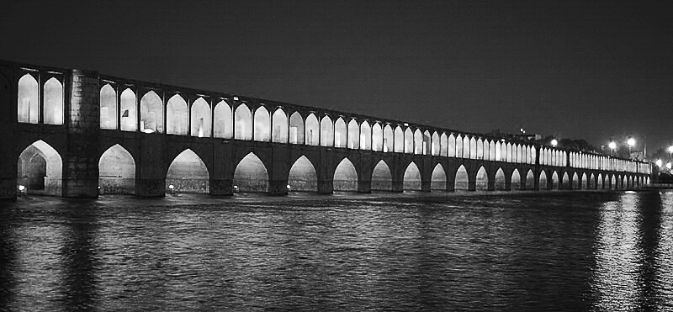
Figure 2. Allahverdi Khan Bridge

The Allahverdi Khan Bridge (Figure 2), which connected the most important old and new parts of the city, was built at the widest section of the river, allowing water to flow through all its arches. According to the Alam-Ara-ye Abbasi: "The grand bridge (Allahverdi Khan Bridge) consists of forty arches, positioned uniquely in the broad Zayandeh Rud River, appearing as a single arch when the water level is high and connecting both axes leading to the Safavid Court and the Hezar Jarib Garden"[41]. In Chardin's travelogue, it is described: "This astonishing bridge has thirty-three arches and is made of beautiful gray stone, harder and less transparent than marble. The bridge is named after its builder, Allahverdi Khan"[42]. Regarding the term "forty arches," which is also mentioned by Eskandar Beig Turkman, it should be noted that this term does not imply the bridge actually had forty arches with thirty-three remaining to this day. In fact, in Iran, the number forty symbolizes abundance [12]. According to descriptions and illustrations from various travelogues and historical sources (Table 1), the bridge has always had thirty-three arches. Its initial design was drafted in 1599 AD by the order of Shah Abbas, following the plans for the gardens and buildings known as Hezar Jarib [43]. This bridge has a triple structure that connects to the urban fabric through two axes, leading to the Safavid Court and the Hezar Jarib Garden.

Table 1. Visual and historical documents of the Allahverdi Khan Bridge, along with the recreated model. Source: Authors, obtained from: [44, 45]
HISTORICAL SOURCE | YEAR | ARCH NUMBER
Jean Chardin | 1673 | 33
Cornelius de Bruyn | 1703 | 33
Allah Vardi Khan Bridge Sketch by Chardin
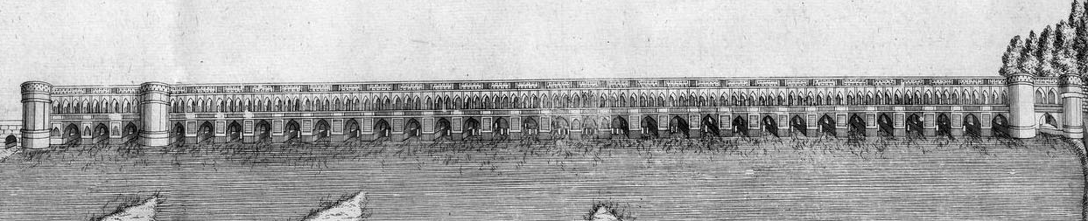
Allah Vardi Khan Bridge Sketch by de Bruyn
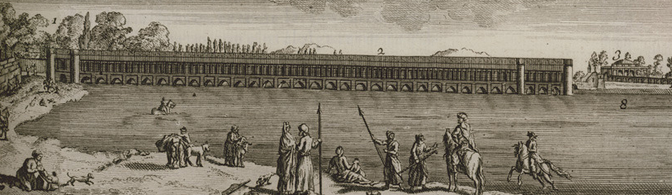
The recreated model by the Authors
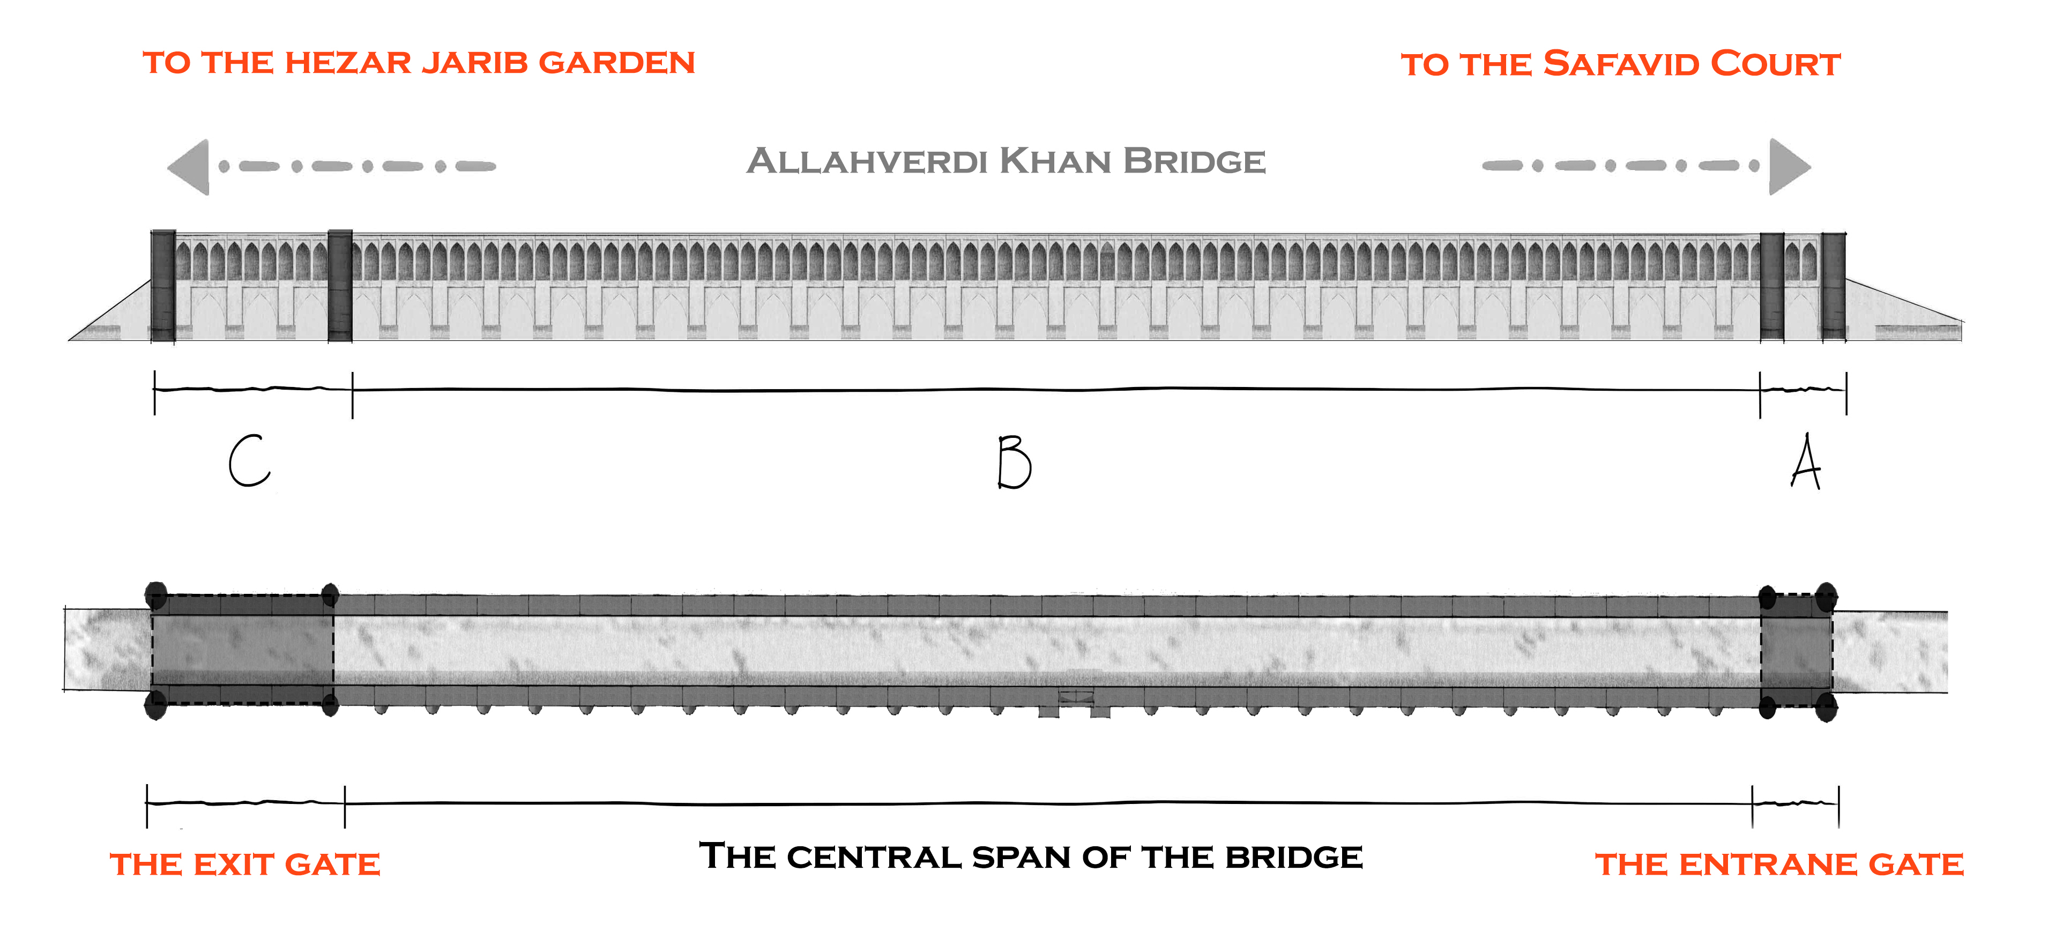

- 1. Exploring Examples of the Influences of the Metaphorical Concept of the As-Sirāt Bridge
Based on the investigations conducted in this research, the influences of the metaphorical concept of the As-Sirāt Bridge on the architecture of the Allahverdi Khan Bridge, in two areas of location and numerical geometry of the arches of the bridge, are as follows:
- 1. 1. Influences of the Metaphorical Concepts of Sirat in the Bridge's Location:
Various studies on Isfahan emphasize the city’s symbolic aspects and its connection to the celestial realm [10]. As a prominent example of Islamic urban planning, Isfahan was designed and developed with profound spiritual principles and concepts [25]. The location choice of palaces, mosques, and bazaars in the city is notably significant. In general, spatial continuity is a prominent feature of Isfahan, which appears to be the result of the importance of Islamic concepts in the city's design and the placement of its elements [46]. Therefore, it can be expected that the location choice of the Allahverdi Khan Bridge, in line with the royal Hezar Jarib Garden, is one such conceptual example aimed at symbolically expressing metaphorical concepts related to the spiritual world. In fact, Safavid architects regarded this bridge as one of the foundational elements representing the entrance to the promised paradise on Earth.‬
Regarding the location choice of Allahverdi Khan Bridge in Isfahan’s urban planning, historical resources indicate that Shah Abbas had a special fondness for Isfahan even before selecting it as the capital in the winter of 1597 AD. According to Eskandar Beig Turkman, after proposing the plan for Chaharbagh Street in 1596 AD, Shah Abbas initiated the construction projects for the Hezar Jarib Garden. In the same year, he ordered the design of a bridge over the Zayandeh Rud River to connect the two axes leading to the Safavid Court and the Hezar Jarib Garden [47, 48]. According to historical records, the bridge's placement plan was personally proposed by Shah Abbas, aimed at the renowned Hezar Jarib Garden. Contrary to the usual practice of building bridges in narrow and shallow parts of rivers, this bridge was located in one of the widest parts of the river [11]. Regarding water turbulence control, although this location has a linear and non-dynamic geometry [49], the choice of the bridge location in a wide riverbed could lead to issues such as increased water levels during flood cycles, greater erosion of the foundations, reduced control over water flow, and increased sediment deposition. Furthermore, regarding the number of arches in the riverbed, fewer arches result in less pressure on the bridge's foundations [50]; therefore, placing the bridge in one of the widest parts of the river and increasing the number of arches was unconventional from an engineering perspective at that time. ‬‬‬
Historical sources suggest that Shah Abbas's decision, although technically challenging, aimed to establish a conceptual connection and symbolically represent the concepts of the As-Sirāt Bridge between the Safavid Court and the Hezar Jarib Garden. In Islam, the sole path to eternal life and paradise is achieved by crossing the As-Sirāt Bridge. It appears that Shah Abbas intended to symbolically incorporate this Islamic concept into his architecture and urban design by constructing the bridge in such a location. In other words, the bridge here serves as a pathway between the Safavid Court, representing the center of governance and power, and a symbol of the material world, and the Hezar Jarib Garden, a symbol of paradise, thus illustrating the As-Sirāt Bridge.

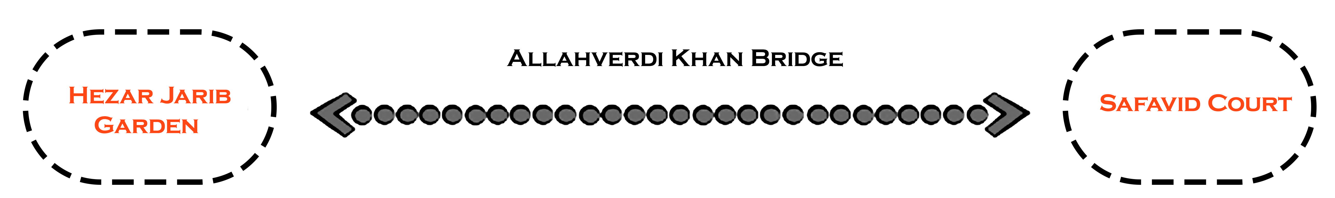
Figure 3. The location choice of Allahverdi Khan Bridge on the Hezar Jarib Axis and Chaharbagh Abbasi was made to connect the Safavid Court and the Hezar Jarib Garden.

In describing the Hezar Jarib Garden, with emphasis on the location choice of this garden along the path to the Allahverdi Khan Bridge, historical resources state that the Hezar Jarib Garden was connected to the Safavid Court axis through the Allahverdi Khan Bridge [51]. Although this garden served as a retreat for the Shah and the Safavid courtiers, ordinary people could also visit and consume its fruits and herbs. Additionally, hunting grounds were established around the garden, used by the noblemen on special occasions. Some travelers have mentioned a zoo in this location, where they accompanied Shah Soleiman Safavid for hunting parties [52].

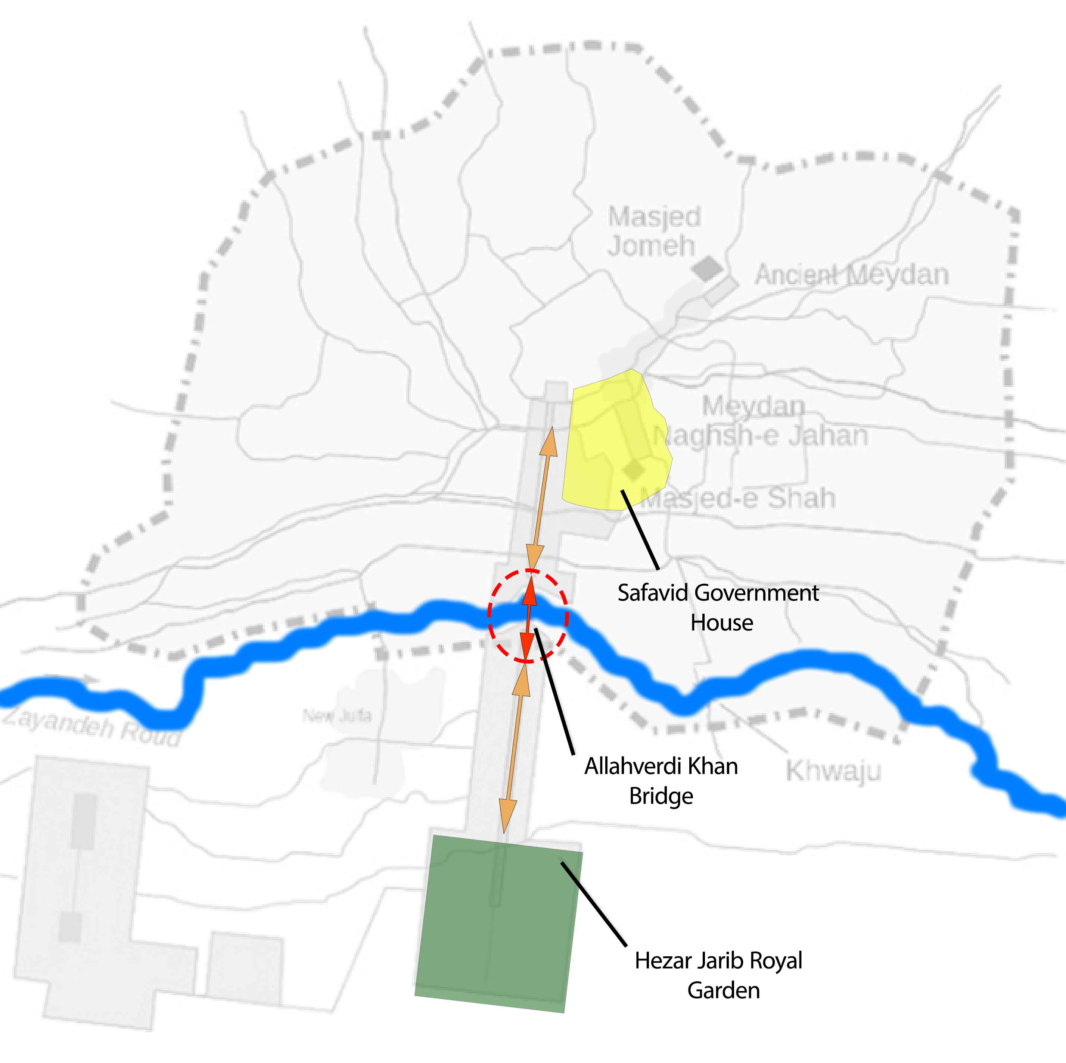
Figure 4. The location choice map of the Allahverdi Khan Bridge. Source: Authors, obtained from: [53]

Regarding the architecture of the Hezar Jarib Garden, various sources mention different numbers of levels. However, it is generally agreed that the garden featured multiple multi-story buildings among dense fruit trees, decorated with abundant streams, several waterfalls, and ponds. Chardin described this garden as: "Hezar Jarib is a delightful garden built on several levels. In spring and during the flowering season, especially when water is abundant, the garden presents a remarkable and pleasant sight, especially around the streams and by the ponds, where many flowers are planted and countless fountains are visible as far as the eye can see. Melodious birds are present, hung in cages among the trees, and the fragrance of flowers fills the air" [42]. Tavernier also mentioned in his travelogue, "Hezar Jarib is the most beautiful garden of Iran."[54] Additionally, the English traveler Thomas Herbert, who arrived in Isfahan in 1628 during the last year of Shah Abbas's reign, described the garden: "The gardens of this area are so magnificently splendid that no other city in Asia can compare. These gardens appear as a vast, aromatic, and green forest to the observer, so grand and fragrant that calling this place the 'second paradise' is no exaggeration" [51].
The above descriptions imply that the Hezar Jarib Garden, due to its unique physical characteristics and pleasant atmosphere, evoked a sense of paradise and symbolism in every viewer. This garden, with its intelligent design, created a space filled with peace and beauty. The tiered structure and multiple levels of the garden, along with its waterfalls and flowing streams, conveyed a sense of an earthly paradise to visitors. The presence of beautiful fountains and ponds, the abundance of flowers and fruit trees, and the presence of melodious birds all contributed to creating a spiritual and dreamy environment, akin to the descriptions of paradise found in religious texts.
Overall, based on maps, travelogues, and remaining images of the Allahverdi Khan Bridge, it can be asserted that this bridge had a triple structure consisting of an entrance gate, a central section, and an exit gate, which connected the northern and southern axes of the city along the banks of the Zayandeh Rud River.

Figure 5. Analyzing the triple structure of the Allahverdi Khan Bridge.

Additionally, there are many narratives regarding the triple nature of the As-Sirāt Bridge, with theologians emphasizing its three-part structure to describe it. The bridge's entrance is a checkpoint, and its exit leads to one of the gates of paradise [55]. This description suggests that the design of the Allahverdi Khan Bridge was influenced by the structure of the As-Sirāt Bridge, as depicted in religious texts. The bridge was conceived in three distinct sections: A. The entrance gate, which connects to the axis leading to the Safavid Court and symbolizes the material world; B. The central span of the bridge, representing the pathway, and C. The exit gate, which connects to the axis leading to the Hezar Jarib Garden and serves as a prominent symbol of the gates of paradise (See Figure 5).
There is no doubt that this triple structure is a reminder of a path toward achieving a specific goal and guides the passerby toward a divine purpose. The location choice of this bridge within the urban structure of Isfahan, as the starting point of the enchanting Hezar Jarib Garden, can be seen as indicative of this movement. Thus, the passerby, by walking on the path over the bridge, finds themselves facing an enchanting garden, a metaphor for the promised paradise. As mentioned earlier, Muslim architects have symbolically depicted Islamic concepts in various ways in Islamic architecture. The Garden of Paradise illustrations and the location choice of this bridge, situated in front of the Hezar Jarib Garden, are examples of these material representations of paradise.

- 1. 2. Metaphorical Concepts of As-Sirāt in the Geometry of the Bridge's Arches
The influence of Islamic concepts on the Isfahan architectural style is evident in the structure and design of Safavid architectural works in the city. The architecture and urban planning of Isfahan, as one of the outstanding examples of Islamic city planning, demonstrate the use of geometric decorations with mathematical proportions and special numbers, from the largest scales to the smallest details. These decorations not only enhance aesthetic beauty but also connect with spirituality and Islamic concepts [10]‬‬‬‬‬‬‬‬. From a physical standpoint, the structure of the Allahverdi Khan Bridge embodies symbols that reflect the influence of metaphorical concepts derived from the As-Sirāt Bridge. In this period, like other architectural structures, the bridge served as a manifestation of spiritual and Islamic concepts. As previously mentioned, the phrase “Sirat al-Mustaqeem” (which translates to “A direct pathway”) appears 33 times in the Holy Quran, and based on travelogues and images of the Allahverdi Khan Bridge from the Safavid era (Table 1), it can be asserted that the use of the number 33 in the architectural design of this bridge is a fundamental idea shaping the Allahverdi Khan Bridge. This connection undeniably ties the physical structure of the bridge to metaphorical concepts, such as the “As-Sirāt Bridge” in Islam.‬‬‬‬‬‬‬‬‬‬‬‬‬‬‬‬‬‬‬‬‬‬‬‬‬
In this regard, although researchers such as Golabgir Isfahani and Bobanian have hinted at the meaningful relationship between numbers and the architectural structure of the Allahverdi Khan Bridge in their studies, considering historical precedence, it seems that the influence of ideas derived from Zoroastrianism and ancient Iran on Safavid architecture is far-fetched. The use of the number 33 refers to the word "As-Sirāt." During the Safavid era, the symbolic use of numbers was a means of expressing philosophical and spiritual concepts. This subject has been repeatedly examined in various studies on Safavid buildings from different perspectives, such as the use of numerology in architecture and sacred geometry [26, 56, 57], as well as numerical symbolism derived from Quranic verses. For instance, the use of the number eight in the geometry of architectural spaces is believed by many scholars to embody verse 17 of Surah Al-Haqqa [58].
Additionally, the use of numbers such as 12, 110, and 114 in some Safavid structures, including the Khan School of Shiraz, is due to their association with fundamental Islamic concepts [59]. Regarding the use of numbers in bridge construction, Sharaf al-Din Ali Yazdi believed that the architect of the Shapuri Bridge also employed numerology to convey religious concepts [61]. Although his notion may not seem accurate due to the lack of historical precedence, it indicates that numerology and the use of Quranic concepts in architecture have existed for a long time, and Islamic architects and interpreters have always strived to adapt numbers to religious concepts.
Furthermore, as previously mentioned, the location choice of the Allahverdi Khan Bridge connects the Safavid Court to a multi-level garden, which functioned as a royal leisure area and symbolically represented paradise in Safavid architecture and garden design. The entrances and exits of the Allahverdi Khan Bridge (in the northern and southern directions) are decorated with two gates. In this context, Ardalan argues that the term "gate" signifies movement from within a defined space, occurring at a specific time and for a particular purpose, whether used in architectural or literary contexts [8]. It should be noted that the special design of the entrance gate leading to the Safavid Court emphasizes this principle (Table 2). As previously mentioned, the number 2 symbolizes abundance and the material world. The gate leading to the Safavid Court, which features two arches in its facade, evokes the worldly and materialistic nature of the material realm. By crossing this gate, the traveler metaphorically transitions from the material world towards a spiritual goal. In other words, the use of the number 2 in the design of the northern gate of the Allahverdi Khan Bridge provides a symbolic representation of the As-Sirāt Bridge. Passing through the axis leading to the Safavid Court implies a transition, as if the passerby detaches from the material world, and by crossing the Zayandeh Rud River, steps onto the path toward a garden that, due to its stunning beauty, symbolizes the Garden of Paradise.

Table 2. The position of number 2 on the Allahverdi Khan Bridge from the northern view.
PLAN
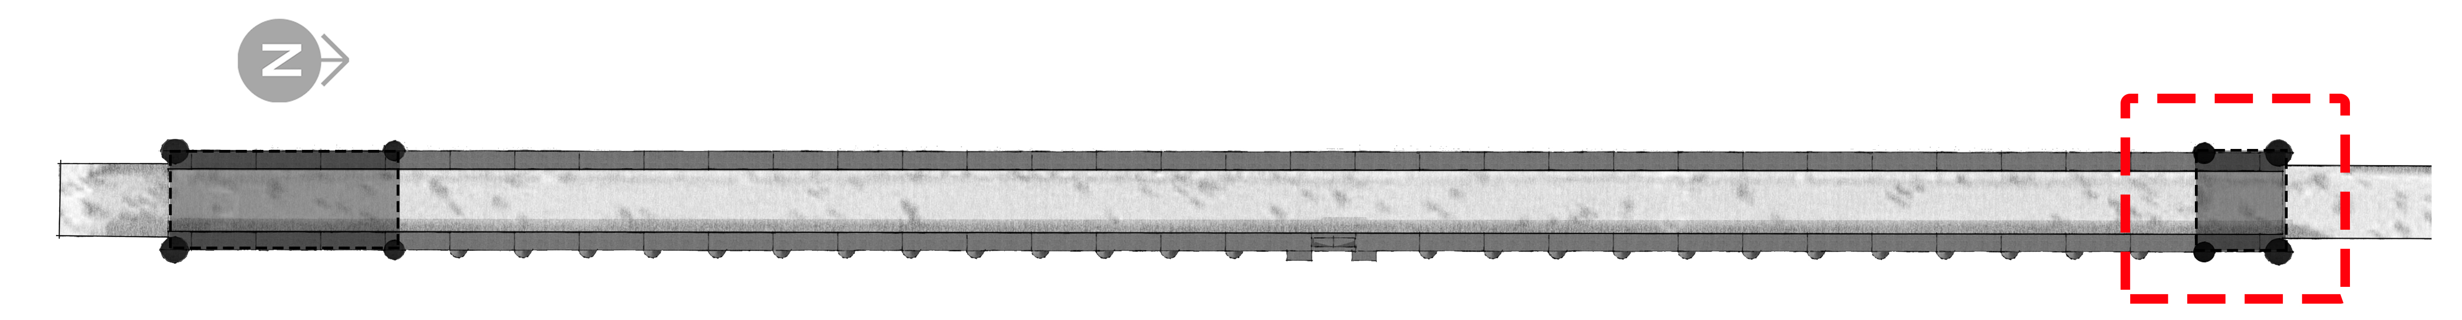
PERSPECTIVE | TOP SECTION | FACADE
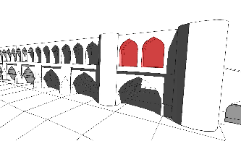 | 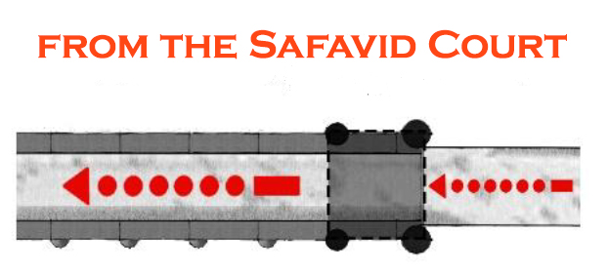 | 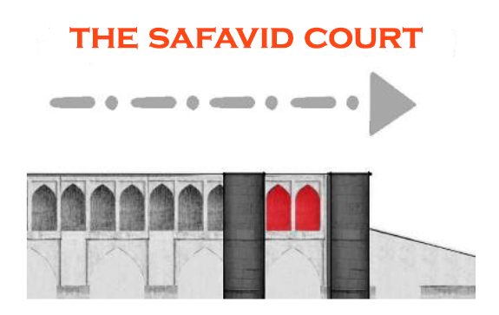

The number 9, clearly visible in the gate on the southern side of the Allahverdi Khan Bridge (Table 3), symbolizes a return to paradise, in line with the spiritual concepts discussed in the literature review. Hence, the passerby, while achieving salvation leading to divine proximity, passes over the As-Sirāt Bridge and the southern gate, stepping into the paradise of believers, which is represented here by the Hezar Jarib Garden. In other words, after crossing the southern gate of the Allahverdi Khan Bridge, the passerby enters the path of a delightful garden with enchanting and pleasing views. A garden, decorated with beautiful flowers, numerous fountains, countless trees, and delightful fruits, with melodious birds hung among the trees, and the fragrance of the flowers fills the air.

Table 3. The position of number 9 in the exit gate of the Allahverdi Khan Bridge from the southern view
PLAN
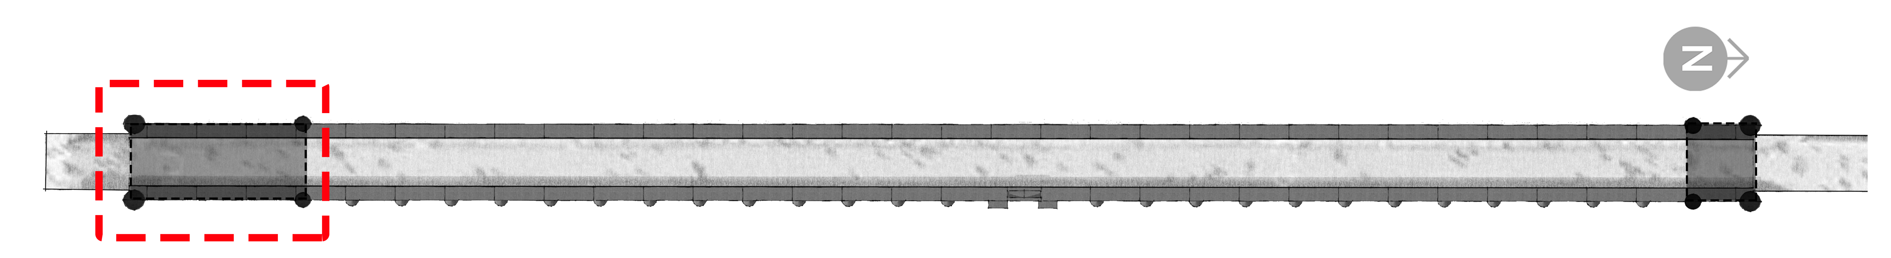
PERSPECTIVE | TOP SECTION | FACADE
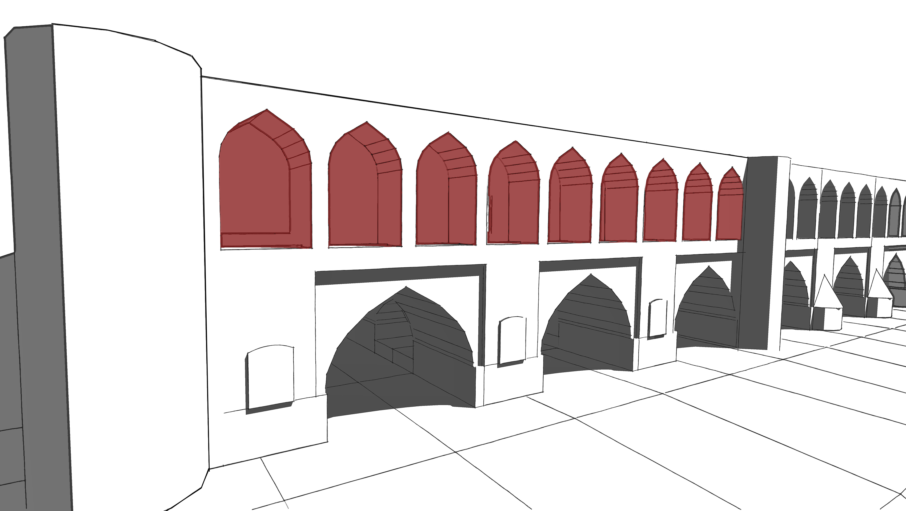 | 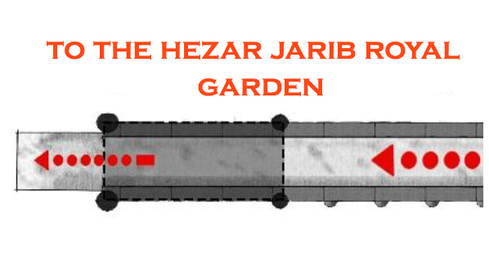 | 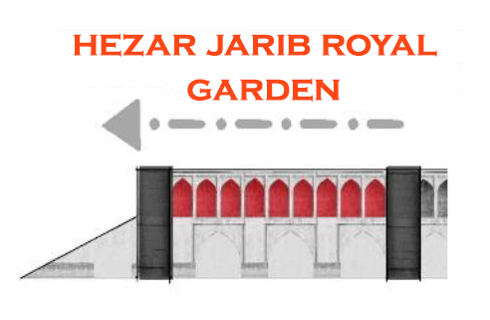

- 2. SUMMARY
In Isfahan, the architectural style, as the pinnacle of Islamic architecture, has always been a manifestation of various arts that express mystical and spiritual concepts. The Allahverdi Khan Bridge is a prime example where different forms of art are combined, demonstrating not only beauty but also the mystical concepts associated with the As-Sirāt Bridge. This bridge is inspired by the metaphorical concept of the As-Sirāt Bridge, evident in both its location and the numerical geometry of its arches.
From the perspective of its location, contrary to the engineering and technical principles of its time, the Allahverdi Khan Bridge was constructed over one of the widest sections of the Zayandeh Rud River, within a pre-determined urban design plan of Safavid Isfahan. In fact, Safavid architects prioritized the symbolic concept of connecting the material world to the spiritual one over strict adherence to contemporary construction techniques. They positioned this bridge on the axis leading to the Safavid Court and the Hezar Jarib Garden. By doing so, they not only facilitated a connection between the Safavid Court and the Hezar Jarib Garden but also created a symbolic image of connecting the material realm, represented by the Safavid Court, to paradise, represented by the Hezar Jarib Garden. Hence, they imbued the Allahverdi Khan Bridge with the metaphorical and conceptual significance of the As-Sirāt Bridge. From a physical point of view, the triple structure of the bridge serves as a reminder of the concepts of As-Sirāt in Islamic theology, acting as a passage from the material world and the Safavid Court to the gates of paradise and the Hezar Jarib Garden. The use of numbers 2, 9, and 33 in the architectural design of this structure reflects Islamic concepts inspired by the people's beliefs about the As-Sirāt Bridge. In other words, the Safavid era architect of the Allahverdi Khan Bridge employed numerical symbolism to express religious and mythical themes, filling the gap between his conscious and subconscious mind. Even though constructing a bridge with numerous arches did not follow the technological principles of the time, he considered using these numbers as a way to materialize the concept of the As-Sirāt Bridge. The architect selected number 33 as a conceptual and symbolic representation of the As-Sirāt Bridge, drawing on Quranic concepts and Ilm al-Kalam (the science of discourse) to design the Allahverdi Khan Bridge. The use of numbers such as 2 and 9 in the structure of the Allahverdi Khan Bridge has turned it into a symbol of the connection between two realms. The bridge gates, featuring 2 arches (the entrance) and 9 arches (the exit), serve as a connection between the material realm and the spiritual realm, symbolized by the numerological significance of these two numbers. Thus, the Allahverdi Khan Bridge, as one of the most prominent works of the Isfahan architectural style, not only provides a beautiful visualization of Islamic art and architecture but also, through its numerical symbolism and specific location, becomes a conceptual and metaphorical representation of the As-Sirāt Bridge. This bridge, by linking the material and spiritual realms and visualizing Islamic concepts, is a unique example of Safavid architecture that has managed to illustrate religious and mythical messages in a beautiful and everlasting form.

- CONCLUSION
This study aims to match the metaphorical concept of the As-Sirāt Bridge with the architectural structure of the Allahverdi Khan Bridge. Based on the findings, this bridge reflects the influence of the As-Sirāt Bridge metaphor in terms of its location choice, tripartite physical design, and the numerical geometry of its arches. Regarding the location choice, contrary to the engineering and technical principles of its time, the Allahverdi Khan Bridge is placed on one of the widest sections of the Zayandeh Rud River within a pre-determined design of the Safavid urban planning in Isfahan to emphasize the symbolic and metaphorical concept of the As-Sirāt Bridge by connecting the Safavid Court and the royal gardens of Hezar Jarib, symbolizing the material world and paradise, respectively. Furthermore, this bridge has a triple physical structure, reminiscent of the As-Sirāt concepts in Ilm al-Kalam, serving as a pathway from the gates of the material world at the Safavid Court to the gates of paradise or the Hezar Jarib Garden. Although the construction of numerous arches was incompatible with the technology of that era, the architect of the bridge, relying on Quranic concepts, designed the bridge with thirty-three arches.
Additionally, the numbers 2 and 9 used in the architecture of the northern and southern gates of the bridge directly represent concepts related to the As-Sirāt Bridge in Iranian religious beliefs. The northern gate, composed of two arches, is located on the side of the Safavid Court, seemingly representing the worldly and material world, by crossing which, the passerby moves away from the worldly realm towards their ultimate goal. Moreover, the southern gate of this bridge, situated on the side of the Hezar Jarib Garden, consists of nine arches, which, due to the philosophical and mystical meanings inherent in this number, symbolize the return to the One God. In other words, the use of this number in the southern gate is a symbol of returning to paradise, which is represented here by the Hezar Jarib Garden.
Therefore, based on the analysis of the architectural structure of the Allahverdi Khan Bridge, it was concluded that the architect sought to recreate the spiritual and metaphorical concepts of the As-Sirāt Bridge. The use of numbers such as 33, 2, and 9 in the architectural structure of this bridge directly implies these Islamic concepts. In other words, the architect of the bridge intended to create a masterpiece that embodies the spirit of the As-Sirāt Bridge. In this regard, it is suggested that future research explore the semantic relationship between the concept of the As-Sirāt Bridge and the architectural structures of other Safavid bridges in Iran, to identify specific semantic patterns in this context.

REFERENCES

[1] S. M. Tarighi, "Architectural features of Islamic mosques". Art Quarterly, vol. 33, pp. 534-555, 1997.
[2] H. Mirmiran, "What lessons can be learned from past architecture". Abadi, Vol. 23, Pp: 29-33, 1996.
[3] B. Dabirinejad, "Corners of Safavid Culture and Art". the Journal of Islamic Studies, pp. 26-27, 1978.
[4] N. Ardalan, "Iranian architecture: in the words of four generations of architects". Abadi, Vol. 19, pp: 4-45, 1995.
[5] L. Abolghasemi, "Islamic Art and Architecture of Iran". Abadi. Tehran: Ministry of Housing and Urban Development, 2005
[6] N. Tahouri, "The place of heaven in the traditional arts of Iran". Khial, Vol. 16, 2005.
[7] A. Pope, ‎Persian architecture‬. Tehran: Akhtaran‬‬‬‬‬‬‬‬, 1986
[8] N. Ardalan, and L. Bakhtiar, The Sense of Unity : The Sufi Tradition in Persian Architecture. Isfahan: Nashr-e Khak, 2000
[9] S. H. Nasr, Islamic Art and Spirituality, Tehran: Office of Religious Studies of Art, 1996
[10] H. Stirlen, Ispahan - Image du Paradis. Tehran, Iran: Forouzan Rooz 11, 1998
[11] A. Mosavat, and R. Babakhani, "An Analysis of the Mantle Structure of the Safavid Bridge Span (Case Study: Sio-Se-Pol, Marnan, Khaju, Joey)". Journal of Environmental Science and Technology, Vol. 2, No. 23, pp: 1-15, 2021.
[12] L. Honarfar, "Two famous historical bridges of Isfahan from the Safavid period". Honar-va-Mardom, Vol. 81, 1969.
[13] J. Neystani, "A New Look to the Date and Architecture of Allah Verdi Khan Bridge". The International Journal of Humanities, Vol. 34, No. 13, pp: 125-132, 2006.
[14] N. S. Marnani, "Sio-Se-Pol". Encyclopedia of the Islamic World, Vol. 26, pp: 166-168, 2019.
[15] B. Mansouri, Gh. Hanaei, D. Diba, A.M. Dabbagh, "Influence of the Safavid Period on Social Issues and Public Space in Esfahan (Case Study: Allahverdi Khan and Khaju Bridges)". Naqshejahan- Basic studies and New Technologies of Architecture and Planning, Vol. 10, No. 1, pp: 1-9, 2020.
[16] G. Hanaei, et al., "Explaining the Environmental Components Affecting the Audience’s Presence on the Safavid bridges of Isfahan(Case study: Khaju Bridge and Allahverdi Khan Bridge)". Journal of Iranian Architecture & Urbanism(JIAU), Vol. 11, No. 2, pp: 173-187, 2020.
[17] G. Hanaei, D. Diba, and H. Abedini, "The Spatial Representation of Power Tolerance in Isfahan City during the Safavid Era (Case study: Allahverdikhan Bridge)". The Monthly Scientific Journal of Bagh-e Nazar, Vol. 18, No. 98, pp. 21-32, 2021. doi: 10.22034/bagh.2020.246983.4655

[18] F. Rashidi, B.A.H. Namdari, and W. Namdari, "Investigation of sio-se-pol based on Gestalt theory", in The first international conference and the third national conference on architecture and sustainable urban landscape. 2016.
[19] M. G. Isfahani, "The relationship between the thirty-three deities of ancient Iran and the Sio-Se-Pol in Isfahan (Allah Vardi Khan) (with an emphasis on angelology in Sohrodi's thought)", in The First National Conference of Symbology in Persian Art With a Focus on Native Art. Bojnord: Khorasan Shomali, 2017
[20] S. Bobanian, A. Sharqi, and H. Azmati, "The mysterious use of numbers in the naming of historical buildings and landscapes (case example: Isfahan's thirty-three bridges)", in 5th Conference on Sustainable Architecture and City. Tehran, Iran, 2019
[21] R. A. Alhaj, "Analysis of the semiotics of sio-se-pol in Isfahan based on Hjelmslev’s theory", in The Second International Conference on Man, Architecture, Civil Engineering and the City. 2016.
[22] J. Chevalier, The Culture of Symbols. Vol. second. Tehran: Jihoun Publishing House, 2004
[23] T. Malmir, "The Interpretation of Right (Straight) Path in Old Texts". Textual Criticism of Persian Literature, Vol. 2, No. 2, pp. 29-48, 2010.
[24] A. A. Pourezat, M. H. Hashemian, "Metaphor of the Way: Sadra's Epistemology and Ontological Explanation of Organization". Nameh Hikmat, Vol. 10, 2008.
[25] Z. Ahari, and S.M. Habibi, "The urban architecture of mosques in the Isfahani Style". Soffeh, Vol. 26, pp: 24-37, 1998.
[26] M. Pirmoradian and N. Soltani, "The interaction of philosophy and architecture in the school of Isfahan with an emphasis on the role of Sheikh Baha'i". Journal of Islamic Art and Culture, Vol. 6, No. 2, pp: 200-222, 2023.
[27] A. Hekmat, and M. G. Isfahani, "Investigating the role of numbers in the symbolic naming of places in Safavid architecture", in The Second International Conference on Architecture, Civil Engineering, Urban Planning, Environment and Horizons of Islamic Art papers. Tabriz, 2022.
[28] E. Parvizi, and H. Pourmand, "Manifested Spiritual Universe in Safavid Architecture Decorating, Case Study: Imam Mosque of Isfahan". Armanshahr Architecture & Urban Development, Vol. 5, No. 9, pp. 31-44, 2013.
[29] A. Dadbeh, and S. Anvari, "Ibn Sina and the finite sky". Maqalat-wa-barrasiha, Vol. 87, No. 26, pp: 101-122, 2005.
[30] S. Gholami, "The wisdom of sacred numbers in Iranian-Islamic architecture (Safavid period)", in First National Conference on Architecture, Restoration, Urban Environment and Sustainable. 2013.
[31] D. R. R. Rasol, "The Reaction of Theologians to The Raised Challenges from Ptolemaic System". Kalam Islami, Vol. 26, No. 103, pp: 129-145, 2017.
[32] Holy Quran.
[33] M. T. M. Yazdi, "Repentance; The position and process of its realization". Marefat, Vol. 141, No. 18, pp. 5-12, 2009.
[34] M. Dorosti, and M. Parchebaf, "Explanation and criticism of the theological, wise and mystical views of Qazi Saeed Qomi about the position of the throne and the footstool in the system of existence". Journal of Kalam Islami, Vol. 26, No. 101, pp: 81-99, 2017.
[35] E. Hassani, "Analysis of sacred numbers in Islamic architecture based on the opinions of the world's example from the perspective of Suhrawardi". Iranian and Islamic architecture and Restoration research, Vol. 17, No. 7, pp: 51-60, 2024.
[36] M. Mirfakhraei, Rivāyat-i-Phalavi. 2011, Tehran: Institute of Humanities and Cultural Studies.
[37] F. Farshidnik, R. Afhami, and M. Tavoosi, "Expression of SadraWisdom in the SafavidArchitecture (Khaju Bridge: a Translation of Sadra’s AsfarAl-Arba‘ah)". Journal of Architecture and Urban Planning, Vol. 4, No. 7, pp. 49-66, 2012.
[38] M.I.A.Neyshabury, Sahih Muslim. Vol. 1. 2014, West Azerbaijan - Urmia: Hosseini Asl the publication.
[39] F. Mahjour, "ZAYANDEHROUD: AS FOSTERING THE CULTURES". Journal of the faculty of letters and humanities, Vol. 187, No. 57, pp: 173-191, 2007.
[40] G. Hanaei and H. Abedini, "The transformation of bridge function in the urban structure of Isfahan in the Safavid era (Khajo Bridge and Allah Vardi Khan Bridge)", Journal of Urban Design Studies and Urban Research, Vol. 11, No. 3, pp. 41-50, 2020.
[41] I. B. M. Torkaman, Tarikh-e Alam-ara-ye Abbasi. Tehran: Donyaye Ketab, 1998.
[42] J. Chardin, Chardin's travelogue. Isfahan: Bina, 1951
[43] M. J. Ansari, History of Isfahan. Isfahan: Mashal Isfahan, 1999
[44] J. Chardin, Voyages de Monsieur le chevalier Chardin en Perse et autres lieux de l'Orient. Vol. 3. 1643-1713.
[45] C.D. Bruyn, Voyage au Levant, c’est-à-dire, dans les principaux endroits de l’Asie Mineure, dans les Isles de Chio, Rhodes, & Chypre &c. Vol. Tome Premier, Paris: Guillaume Cavelier, 1974.
[46] S. Gholipour,and J.e.D. Mahdinejad, "The Effects of Isfahan School Thoughts on the Architecture and Urban Development of Isfahan During Safavid Period'. Athar, Vol. 42, No. 2, pp: 138-156, 2021.
[47] H. Nakhjavani, Mavad-O-Tavarikh. Tehran: Adbieh, 1964.
[48] L. Honarfar, Isfahan historical building guide. Isfahan: Imami printing house, 1968
[49] A. Amir-Shah-Karami, Rereading the Engineering of Khajoo Bridge. Vol. 2, No. 4, pp: 81-94, 2006.
[50] V. Ghobadian, Climatic analysis of the traditional Iranian buildings. Tehran: Tehran University Publications, 2013
[51] L. Honarfar, "Hazar Jarib Garden and Sofe Mountain (Shah Abbas Paradise)". Honar-Va- Mardom, 1975
[52] R. Homayooni, and N. Valibeig, "A Review of Hezar Jarib Garden’ Form Based on the Descriptive, Illustrative, and Field Documents". MANZAR, the Scientific Journal of landscape, Vol. 13, No. 57, pp: 6-21, 2021. DOI: 10.22034/MANZAR.2021.272281.2113
[53] A. J. Aamili, et.al. Isfahan Houses, Isfahan: Islamic Azad University, Khorasgan branch, 2013.
[54] J. B. Tavernier, Les Six Voyages de Jean-Baptiste Tavernier. 2020, Tehran: Nilofar.
[55] M. b.l. Sadr al-Din Shirazi, Asrar-Al-Ayat. 1988.
[56] A. A. Moghaddam, M. Goljan, and R. Yalfani, "The Role of Shiite Schools in the Safavid Era in the Development of Islamic Culture and Civilization (Emphasizing on the two schools of Khan Shiraz and the Chahar Bagh of Isfahan)". Theological – Doctrinal Research (Islamic Azad University-Saveh Branch), Vol. 1, No. 11, pp. 7-30, 2021.
[57] H. Karimian, and S. Seyyedi, "Geometry and Geometric Proportions in the Constration of the Domes of the Safavid Mosques in Isfahan (A Case study: Imam Mosque and heikh Lotfollah Mosque)". Iranian studies, Vol. 4, No. 1, pp: 27-48, 2019.
[58] V. Vosouqzadeh, M. Hosnipanah, and B. Alikhani, "Wisdom of number 8 in art and islamic architecture", Sophia Perennis, Vol. 13, No. 30, pp. 175-192, 2017.
[59] J. Taheri and H. Nadimi, "The Hidden Dimension in Persian Islamic Architecture". Soffeh, Vol. 24, No. 2, pp: 5-24, 2014.
[60] M. Mirderikvandi, A. H. E. Zargar, and D. H. Bani, "A Study of the Ancient Mortars used in Shapouri Bridge of Khorramabad and the Feasibility of Using it in Restoration of the Bridge through Laboratory Methods". Maremat & Memari-e Iran, Vol. 9, No. 5, pp: 45-58, 2015.
[61] S. A. D. Ali Yazdi, Zafarnama. 2008, Tehran: Islamic Council, Museum Library and Documentation Center.

هوَ الأوّل والآخِر و الظآهِر و الباطِن و هوَ بِکُلّ شیءٍ عَلیم
And with the angels on the sides of the sky [and ready for missions] and on that day, eight mighty angels will bear the throne [of power] of your Lord above them
The Broken Bridge, or the Shapuri Bridge, is considered one of the masterpieces of Sassanid architecture. It was built by the order of Shapur I on the southern side of the Falak-ol-Aflak Fortress [60]

