 |  | JOURNAL OF ISLAMIC ARCHITECTURE  P-ISSN: 2086-2636 E-ISSN: 2356-4644  Journal Home Page: http://ejournal.uin-malang.ac.id/index.php/JIA
TRANSFORMATIVE LEARNING SPACES IN MADRASAH FROM THE PERSPECTIVE OF ISLAMIC EDUCATIONAL VALUES
Siti Khadijah Binti Hashim^{1*}, Alice Sabrina binti Ismail¹
¹Department of Architecture, Faculty of Built Environment and Surveying, Universiti Teknologi Malaysia, Malaysia
*Corresponding Author: khadijah.hmn@gmail.com
ARTICLE INFO |  |  | ABSTRACT
Volume: 9  Issue: 1  Page: 30-48  Received: June 30th, 2026  Accepted: November 30th, 2026  Available Online: June 30th, 2026  DOI: https://doi.org/10.18860/jia.v9i1.29280 |  |  | Madrasah in Malaysia has established a significant role in becoming one of the Islamic educational institutions. The development of madrasahs as sources of Islamic knowledge, known to be imparted to the Muslim community, plays a crucial role in disseminating Islamic educational values, namely syumul, kamil, adil, and alami, not only during the learning process but also during the early design planning of madrasah architecture. This adopts a conscious approach to make madrasah a medium for conveying values and to design an appropriate built environment through architectural elements that prioritize the Islamic way of life, based on the basic teachings of Al-Quran and Sunnah. However, in Malaysia, no comprehensive studies have explicated how the learning spaces in madrasah design can convey Islamic educational values through physical design aspects. Therefore, this paper aims to identify the potential of Islamic educational values to influence the architectural design elements of learning spaces and madrasah buildings using socio-semiotic theory. Furthermore, this study applied the hermeneutic method through the interpretivism paradigm to understand this phenomenon through a case study. The two indicators of architectural elements of madrasah buildings, form-making and spatial components, are analyzed to document the values that enhance the adaptability of the learning process, reinterpretation of the built environment, and realization of the reality of the institutions. This study will benefit many parties in providing recommendations for madrasah design, referring to Islamic educational values as an architectural design approach during the early design planning. This approach can serve as guidelines for designers, showing that madrasahs can function as signs and symbols of the transitional dimensions of Islamic educational values towards the sustainability of the built environment through the unity of community, equality of learning opportunities, and the rejuvenation of spiritual and psychological aspects of life.  Keywords:  Islamic educational values; Madrasah, Islamic architecture, Socio-Semiotic theory, Interpretivism, hermeneutics.

INTRODUCTION
Madrasah institutions portray significant roles in representing Islamic learning centers to the local community, especially in Malaysia's educational context, where Islam is the official religion of the country [1]. The construction of the madrasah remains highly relevant today and continues to grow exponentially across Malaysia as the main Islamic educational institution of the community [2]. Furthermore, the construction of the madrasah can be related to architectural practices that span the early design planning phase through the completion of the building phase. Hence, along with the discussion, the madrasahs serve as Islamic educational symbols; the early design planning of the institutions should incorporate Islamic educational values as an architectural design philosophy. This is due to the philosophy of Islamic educational values, which consists of a set of attributes which are syumul (comprehensive), kamil (ideal), ‘adl (equitability) and ‘alami (universal), has been identified as being compatible with the architectural design philosophy in which both portray similar goals in providing and sustaining a way of living in a fulfilling environment and humane architectural design. Concerning this, the relationship between the living aspects of Muslim individuals and architecture shows a notable correlation [3]. In addition, these statements justified the potential for implementing Islamic educational values in the design of institutions such as madrasahs that shall portray Islamic images [4] through tangible architectural elements. Besides that, values are defined as needs, beliefs, and goals [5], which are consistent with the proposition of applying Islamic educational values as an architectural design philosophy for Islamic educational institutions, especially in madrasah buildings, which mainly accommodate learning spaces. This is due to Rapoport [6], who stated that values are ambitions, images, schemes, and meanings that always correlate and influence lifestyles and the living systems of society, thereby strengthening the case for the potential of Islamic educational values to be portrayed as symbols through architectural elements and design.

1.1 THEORETICAL FRAMEWORK OF ISLAMIC EDUCATIONAL VALUES AS PHILOSOPHY OF ARCHITECTURAL DESIGN THINKING
Islamic education develops the values and identity of Muslim society [7]. With this, the concept of values corresponds to that of virtuous personalities, ethics, norms, morals, and habits that influence the growth and development of Muslim individuals [8]. Hence, the Islamic educational values have been extracted from the Islamic education images which delineate values such as syumul (comprehensive), kamil (ideal), adil (equitability), and alami (universal) [9] [10] that encompass the entire goal of Islamic education, which is to form a civilized Muslim society with noble morals while living in an environment based on Islamic lifestyle. Built environments are the product of architectural design planning, which showcases the design process based on Islamic ways of living [11]. This correlation between architectural design philosophy and Islamic educational values suggests the potential to establish a design framework that caters to occupants' living needs across physical, spiritual, intellectual, and soul aspects [9] [12], thereby enabling the design of humane architecture [13]. Hence, in this context of the study, the architectural design planning of Islamic educational institutions, such as madrasah, shall produce tangible architectural elements that portray Islamic values [4], in this case focusing on describing the Islamic educational values through architectural elements and spaces design that developed on the Islamic way of life that is based off the basic teachings of Al-Quran and Sunnah accordingly [14]. In continuation of highlighting the purpose of this study that focused on the implementation of Islamic educational values through the early design planning of madrasah institutions, it can be understood through the adaptation of Spahic’s framework of Islamic architecture aspects through building design that cordially presume three (3) dimensions of involvements which identified mainly as design philosophy, thinking process and outcome that consists of planning, designing, building and last but not least creating a built environment [15].

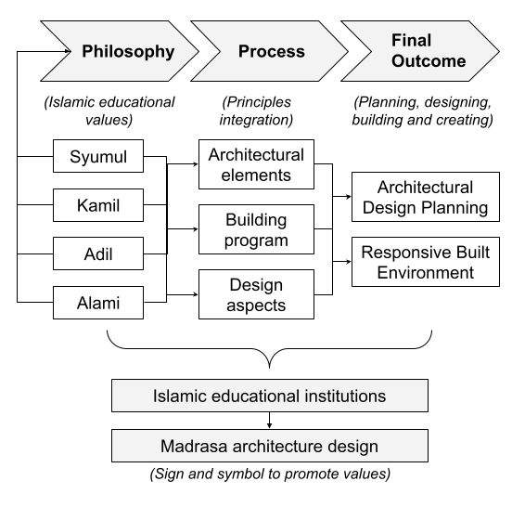
Figure 1. Conceptual framework

Figure 1 is an adaptation of Spahic’s framework of Islamic architecture, used to explain the conceptual framework of Islamic educational values as an architectural design approach in madrasah building design. Islamic architecture incorporates a built environment that caters to people’s needs and way of life and, as a result, serves as a tangible symbol of Islamic values through architectural elements and design [15] [16] [17]. Hence, designing Islamic educational institutions, such as madrasahs, has significant potential to foster and promote Islamic values across all aspects of architectural elements, as opposed to Islamic building languages [4] [11] [18].

1.2 THE PROCESS OF ARCHITECTURAL ELEMENTS AS A SYMBOL FOR ISLAMIC EDUCATIONAL VALUES FRAMEWORK OF ISLAMIC EDUCATIONAL VALUES AS PHILOSOPHY OF ARCHITECTURAL DESIGN THINKING
Architecture could be read and understood as a sign and symbol through structured coding, also known as the semiotic technique [19] [20] [21]. A structured semiotic approach is usually applied to explicate architectural elements as consequential objects that have the potential to convey meaning, such as conveying a message through talking and writing [21]. In other words, architecture can be derived as forms of symbols and signs that convey certain meanings, which are languages portrayed throughout architectural elements, using grammar and syntax to convey those meanings to the community [22]. This is also due to architecture being a form of sign or symbol that supports two-way communication compatible with the signifier-signified concept [21]. This shows that architecture possesses two-way communication. In this study, madrasah architecture serves as a sign or symbol that catalyzes meanings throughout the building's design and elements.

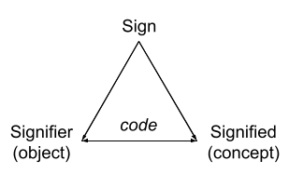
Sign  Medium or symbol that conveys meanings | Signifier: Objects that convey meanings, eg, words, images
Sign  Medium or symbol that conveys meanings | Signified: Mental concept that holds the philosophy of values highlighted by someone

Figure 2. Concept of Semiotic Theory [69]

Furthermore, to identify the influence of Islamic educational values through architectural elements of educational institutions, in this context, madrasah institutions, a structured coding method will be implemented through the application paradigmatic and syntagmatic medium, which is derived from the signifier and signified concepts mentioned before. This derivation is the projection of the socio-semiotic theory proposed by Gottdiener [23], which highlights two (2) principles along the paradigmatic and syntagmatic axes: content and expression, respectively. In this study, content holds Islamic educational values, and expression is represented by architectural elements and building design.

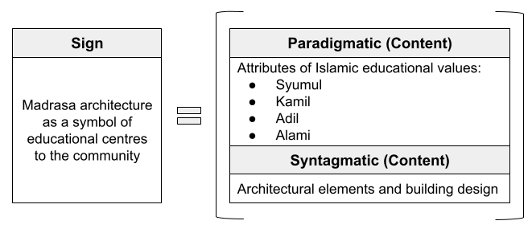

Figure 3. Socio-Semiotic Theory as a Study Approach

1.3 ROLE OF ISLAMIC EDUCATIONAL VALUES IN MALAYSIA MADRASAH’ ARCHITECTURE
Islam offers a comprehensive, intelligible, and straightforward way of life to humanity, including education [24]. Besides that, Islam’s laws and education cover various dimensions of human life, providing principles, values, and methods that serve as absolute guides for an individual to meet daily life requirements and, concurrently, prepare for the afterlife [16]. This is due to Islam encouraging and mandating education for every Muslim to promote peace and well-being in a communal environment. Hence, Islamic educational values portray comprehensive, complete, impartial, and inclusive portrayals that do not discriminate against any party or individual, which providentially serve as the enlightenment to live a better life as an individual [9]. With the dynamic concept of Islamic education, madrasah institutions play a significant role as a medium in channeling religious knowledge in Islamic civilizations, as the institutions are considered an Islamic architecture that goes hand in hand, where both embody the core Islamic belief system and body of inclusive Islamic standards and behavioral moral values [4]. Thus, with this catalyst in the medium, the development and construction of madrasahs in Malaysia are increasing year by year as Islamic educational institutions for the local community. According to Yatim & Nasir [25], a madrasah is an Islamic institution that provides religious education and can also serve as a community gathering place.
Madrasah institutions are recognized as educational or religious institutions that provide opportunities for society to study the Quran and hadith. These institutions are supposedly accessible and open to any group of the community to deepen their religious knowledge, which mostly targets students ages between seven (7) and 19 to pursue study at the institutions as main participants in the core curriculum and learning process [26]. Hence, the influence of Islamic educational values throughout the learning environment, in this context, the madrasah building, shall implement the philosophy of the values as design principles. In contrast, it contains significant merits to complete the learning process for a Muslim in all aspects, spiritually, physically, intellectual and surrounding environments [25] [27]. As highlighted before, Islamic educational values encompass comprehensive, intelligible, complete, impartial, and inclusive merit that benefits not just individual aspects but also communal elements [9] [10]. Consequently, the merits listed could be developed into principles at the early stage of design planning, so that the architectural elements and design characteristics of the madrasah buildings convey the essence of Islamic educational values. This is due to architecture's potential to serve as a sign and symbol to convey Islamic values through its building elements [21], as discussed previously.

1.4 EXPLORING THE INFLUENCES OF ISLAMIC EDUCATIONAL VALUES THROUGH ARCHITECTURAL ELEMENTS AND BUILDING DESIGN PLANNING

1.4.1 Syumul (Comprehensive)
Syumul is a derivation from the Arabic word syumuliyyah, which conveys the meanings of perfection and comprehensive matter that covers the entire human life thoroughly, and hinges on the application of the whole interaction between humans and the environment. The value of syumul in Islamic education lies in cultivating an ethical lifestyle that promotes a comprehensive, noble personality through the understanding and development of humane values based on the Al-Quran and hadith [28]. Hence, the ethical lifestyle of a Muslim is indeed a learning process that augments the virtuous and righteous relationships among humans and Allah, among humans, and between humans and nature [29]. This is due to the value of syumul, from an Islamic perspective, which entails divinity, humanity, and environmental prosperity [30]. Thus, the cultivation of the values of syumul begins with moral ethics education, which is relatively close to the values of manners and respect in an individual, especially when ethics or akhlak is an important asset that withholds the purpose of a Muslim's life [31]. Concerning this, the value of manners in architectural terms can be translated through the location or the placement of the building [16]. This can be related to the characteristics of architectural elements that respect local context, which not only concern the natural aspects of the location but also emphasize the community's essence by incorporating accessibility to the surrounding community towards the building [32] [33]. Other than that, the use of local building materials is also one of the alternatives that highlight the value of syumul, thereby enhancing local architectural elements to encourage community recognition, as well as showcasing building structures that complement the local natural context [34] [35].

1.4.2 Kamil (Ideal)
Kamil is one of the Arabic words defined as perfect and complete. Generally, the concept of Islamic education emphasizes the acquisition and deepening of knowledge in life. The value of kamil in Islamic education is a transformation process that shapes all knowledge and values of education through the development of the individual’s inherent potential to achieve ideality in every aspect of life, as part of dedication through worshipping the Creator, Allah S.W.T. [36]. This is related to the concept of the ideal in humility and simplicity, whereas human beings possess an ideal physical fit that is complete with senses, along with the aspects of spirituality that consist of souls, feelings, interests, and critical thinking, which all lead to always be humble in worshipping only Allah S.W.T. as an act of piety [37]. Hence, this concept highlights that Islamic education helps cultivate balanced individuals [38] by heightening the intellect, physical fitness, and spiritual and emotional aspects, thereby fostering a response to the values of kamil through the expansion of knowledge and educational philosophy [39]. In architectural terms, the values of kamil are achieved through the proportional scale and size of the building, which do not dominate the natural essence, which is also part of Allah’s creation [40]. This is due to the design planning of a building that blends in with the natural environment, which is a symbol of tawadu’ and amplifies the essence of humility and simplicity [17]. The translation of the value through spatial planning can be described through spatial configuration design details that are proportionate to the building function [17]. This is assignable to the design decision of space-making affecting the movement and needs of the user in the built environment [32] [41] [42]. Hence, regarding the user, the design planning also emphasizes a building program that caters to a harmonious and balanced user context [43], along with a minimalist approach to the interior or exterior of the building [16] to lessen extravagant effects that oppose the values of humility [32]. Thus, this decision conveys meanings and messages that Islam encourages simplicity and emphasizes respecting natural context to create an inclusive environment that enhances the user's sense of belonging, helping them feel at ease and optimize the designated environment [17].

1.4.3 Adil (Equitability)
The origin of the word adil is the Arabic word adl, which means fairness, honesty, and justice. The value of adil in Islamic perspectives emphasizes cultivating the upright and unprejudiced in decision-making and actions, thereby fostering a positive impact on human social life to achieve peace and well-being [27]. This is because Islam defines adil, or equity, as determining the appropriate item for the position and location, or identifying and ensuring that everyone eligible receives their rights legally and properly, which does not exemplify full equal rights for all individuals [27] [44]. Continuing with this statement, the claim for general equality rights across all aspects of life, in the name of upholding universal justice, is unreasonable. This is because every individual, whether male or female, has different needs, especially in daily life [27] [45]. Hence, the suggestion to incorporate the value of adil into the design planning of a building institute is a significant epitome, as it will not only contribute to psychological peace but also preserve the well-being, safety, and order of living of individuals in a built environment [44]. Thus, building and spatial design planning shall incorporate an architectural scheme that fulfills the basic requirements for living of users, generating tranquillity of mind and showcasing responsibility merit, which is attributed to the value of adil [9]. Responsibility in this value context is consequential in the formation of a prosperous Islamic society that emphasizes the bonds of brotherhood among individuals, as merit consists of the community's physical and emotional dimensions [46]. This can be achieved through architectural elements, such as spatial organization and building circulation, during early design planning. As Ismail [16] stated, spatial organization incorporates the needs, comfort, and function of the building program, so that users are apt to be responsible towards the designated built environment. Other than that, the value of adil is thus related to the obligation merit, where, in terms of architectural elements, the hierarchy of spaces, along with social interaction spaces, can be categorized as the main criteria in showcasing the application of the merit in early design planning [17] [47]. Early design planning of space placement incorporates clear wayfinding so that users can navigate the built environment without feeling lost and isolated [17] [32] [47].

1.4.4 Alami (Universal)
Alami is derived from the Arabic word alamiyyah, which conveys the meaning of universality; in other words, Islam has a universal system, so its teachings can be practiced by anyone, wherever they are. Islamic education embodies the essence of alami, which is also compatible with architectural design concepts and philosophy, often expressed by scholars and architects who embrace universal values in design thinking. Design that displays alami value associates design composition and environment that always allow and emphasize openness to all levels of users without any limitations or constraints [48] [49]. In this context, the value of Islamic education through architectural elements and design aspects can be identified and portrayed through openness [50], transparency [51], and appropriateness [52] [53] [54]. All of the stated aspects are interconnected and contribute to well-being and harmonious community life, which, in turn, form an inclusive architectural language that carries the real meaning of relevant universality in design to the local community [55]. The openness in architectural design planning can be categorized into functional aspects, such as user-friendliness, and a ‘sense of welcoming’ in the built surroundings [50]. Plus, the openness in this context is architecturally rendered in the façade's design, which serves as the main element of the building envelope and fulfills the openness's intention. This is because façade articulation highlights the uniqueness and aesthetic advantages that not only serve as a link between the interior and exterior of the building [56] but also uphold its value and structure [57], thereby showcasing functional and interesting buildings that can provide various experiences for users [58].
Besides that, transparency in design terms is associated with creating opportunities for open interaction in designated built environments, which can be achieved by integrating functional open courtyard design during early spatial planning [17]. Along with this criterion, transparency can also be applied through a transparent exterior envelope that displays the spatial surroundings, thus creating a ‘sense of welcoming’ for the local community and providing clear wayfinding of the spatial configuration within the building to users [59]. Referring to the attributes of alami value foreground the way of living by having high morale, being civilized and polite among the community [54], which then also accentuates the appropriateness aspects in forming the real definition of communal living in Islam. One of the criteria of appropriateness through the architectural aspect can be identified through location and the placement of the buildings that are within the community accessibility radius without any constraints [17]. This is due to the potential to influence the behavior and actions of the community [32] [60], thus creating a neighborhood-friendly and communal ethos in the built surroundings [61] [62] that can be recognized as a landmark and as symbols of local community identity [63]. Last but not least, spatial organizations that are not overly exclusive serve as the main component of appropriateness in design planning to create inclusive environments that are readily accepted by local users [17].

METHODS
The study used a qualitative research strategy under the interpretivism paradigm as an approach to research. As the primary data collection method, direct observation is utilized to assess the depth of the influence of Islamic educational values through the case study. This method is essential to achieving the research objectives by developing design recommendations for the architectural approach to designing madrasahs for the community. On the other hand, the discussion from the literature review is being adapted to outline indicators of architectural elements influenced by Islamic educational values, based on hermeneutics as the research methodology.

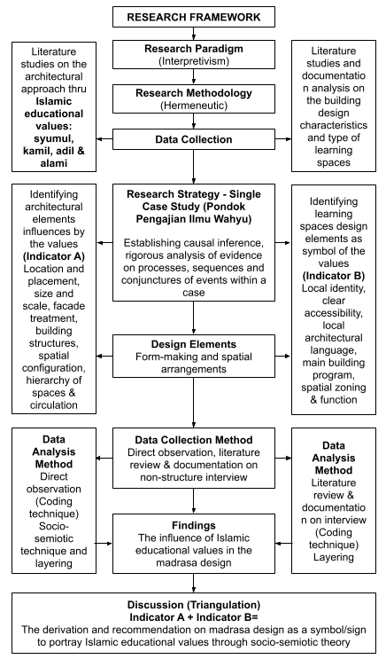

Figure 4. Research Framework

This approach helps the researcher understand and process data on a social phenomenon to search for answers by analyzing texts, documents, books, and other sources [64]. In this study, scholars' philosophy and ideological thinking focused on the Islamic educational core values recorded in this paper: syumul, kamil, adil, and alami, which were studied in terms of their principles, definitions, ideas, and actions. This was done to determine the potential of Islamic educational values and their influence on architectural design principles and building elements, focusing on madrasah institutions in Malaysia. For this study, Pondok Pengajian Ilmu Wahyu, situated in Malacca, was selected as a single case study. A single case study is relevant to this paper because the phenomenon highlighted in this research is exploratory, aimed at developing theories, and a single case study pursues in-depth, contextual analysis to understand better how values influence building design. Besides that, it also supports detailed analysis, especially when this research adapts qualitative methods that collect data through non-structured interviews, observations, and document reviews, which then lead to a richer dataset.
As for the data collection method, direct observation is used to observe the selected case study. All findings will be analyzed based on the explanation-building technique introduced by Yin [65]. This is due to this study requires to explanation of the phenomenon based on specific causes and effects, therefore, the analysis will be divided into two (2) phases; the first phase analysis will be carried out separately and is based on the observational analysis related to selected madrasah, followed by documentation analysis on the madrasah and non-structured interviews regarding the main building program and the way of learning. The second analysis phase identifies the similarities and differences to underline the madrasah’s architectural elements. Later, the architectural expression of the madrasah was linked and explored to identify the influence of Islamic educational values on the madrasah’s building composition/focusing on learning space design. Finally, both analyses were combined to determine how Islamic educational values are portrayed through the architectural elements of the madrasah, which not only serve as symbols to convey these values but are also recognized as Islamic educational institutions by the local community. Last but not least, the research outcome is formulated as a proposition or recommendation for strategies that can be adapted to produce a humane madrasah design that integrates Islamic educational values as an architectural approach to inform the planning of learning spaces in madrasah architecture in the Malaysian context.

RESULT AND DISCUSSION
3.1 RESULT
Madrasah’s architectural elements can serve as a means of communicating with users and their environment. In this sense, the madrasah’s form-making and spatial arrangement can convey and promote Islamic educational values, enhancing learning requirements for the local community throughout the built environment, especially in the design of the learning space. This is because learning space design can convey the essence of educational philosophy and values that manifest the institution’s unique identity [66]. Previous researchers have stated that madrasah symbols, such as surau (prayer hall), study hall, dormitory, and, in some cases, workshops [17] [61] [67], could convey the influence of Islamic educational values, philosophy, ideology, and messages to society [68].

3.1.1 HISTORY OF ESTABLISHMENT OF PONDOK PENGAJIAN ILMU WAHYU (PPIW)
The case study selected is in Perkampungan Merlimau Pantai, Merlimau, Melaka. The establishment of Pondok Pengajian Ilmu Wahyu (PPIW) is the result of the founder's intention, Ustaz Noramin bin Said, to build an educational center, also known as a madrasah institution, as a catalyst for the development of Islamic studies and knowledge while extending da’wah efforts to the local community. Therefore, the founder’s inspirations and decision to build this madrasah are derived from the essence of Islamic educational philosophy that governs every aspect of human upbringing based on the commandments and teachings of the Quran and Sunnah Rasullullah S.A.W., especially in terms of aqidah (creed and theology), sharia (laws and duties), and akhlaq (morals) by also embracing the local context and communal values. Hence, with this motivation, the objective of the establishment is not only to provide Islamic education and teachings to the people but also to create purposeful and insightful individuals, and, alas, towards building a better community that embraces Islamic values in daily life and is respectful towards the locality. Furthermore, in correlation with locality through the architectural planning for the buildings of PPIW, the founder reiterates to complement and portray the local architectural language through exterior impressions such as the roof structures, traditional wooden structures for certain buildings and spaces, and ornamentations of wooden carvings. This architectural approach is being applied to create familiar settings within the built environment, so the madrasah institution will be acknowledged and accepted by the surrounding community, besides creating the madrasah’s identity that highlights local uniqueness.
The first educational building of PPIW began with the construction of a musolla with a built area of 2000 square feet on a plot of land owned by Ustaz Noramin’s wife, Puan Nurul Hidayah binti Abu Bakar. In 2003, the institution started to provide Islamic education with only eight (8) students aged 13 years old. At the beginning of the educational program, the students attended the local government school for the academic sessions in the morning. Then they were invited back to the madrasah by the institution’s caretaker to prepare for the study of the Quran and Turath, which took place after Asr and Maghrib prayers, respectively. As the years have gone by, the insistence from the local community to register their children for the educational programs at PPIW has increased from year to year. In 2019, the organization decided to expand further and to complement a full-time study of the Quran, Turath, and academics as focal educational programs in the madrasah’s curriculum. Over the years, educational buildings and spaces were added to accommodate the increasing number of students registered at the institution. In addition to this progressive milestone, the madrasah also offered Islamic knowledge and teachings to the elderly and local community through morning classes and weekly lectures at the madrasah compound. Finally, these efforts align with Ustaz Noramin’s goals to make PPIW a center for Islamic studies that benefits every level of society, while always enlivening the madrasah's built environment with constructive knowledge events.

3.1.2 EDUCATIONAL PROGRAMS BACKGROUND OF PONDOK PENGAJIAN ILMU WAHYU (PPIW)
The buildings in the madrasah compound primarily house the education program and curriculum offered to registered male and female students. The major curriculum of the institution is tahfiz, also known as hafazan, which requires students to memorize the Quran wholly and repetitively during the years of study. Besides that, the turath and the academic basis are also provided as supporting curricula for the students. Turath is the study of religious books that will be taught and explained by the head teacher of the madrasah, called mudir. In addition, the academic curriculum is divided into two (2) categories. The first category is based on the Malaysian government's fundamental syllabus, which comprises Malay Language, English, Science, Mathematics, and History. The second category is based on the Islamic education syllabus, which comprises several subjects, including Arabic, Fiqh, Tasawwuf, Aqidah, Tahiri, and Burdah Bursiri.
Furthermore, the students registered at PPIW consist of primary school students (10-12 years old) and secondary school students (13-17 years old). The secondary school students are then divided into lower secondary (13-15 years old) and upper secondary (16-17 years old). Currently, PPIW accommodates 113 students, of whom 74 are male and 39 are female. Other than that, the institutions' learning styles are flexible, depending on the preferences of both teachers and students. Based on the observations, the following learning styles indicators can be inferred: group learning, cluster learning, peer-to-peer learning, and individual learning. The most frequent learning style is talaqqi, which can also be done in group or cluster learning, where students sit around their teacher to listen to the teachings. There are several learning spaces identified during the data collection stage that cater to the educational program of the madrasah, listed as Surau (Main prayer hall), Musolla Al-Hidayah (Secondary prayer hall), four (4) units of study halls categorized into Anjung Ilmu, Dewan, Kelas, Bilik Kuliah, a library, and two (2) dormitories for male and female students respectively. However, this madrasah does not offer any workshop programs to the students.

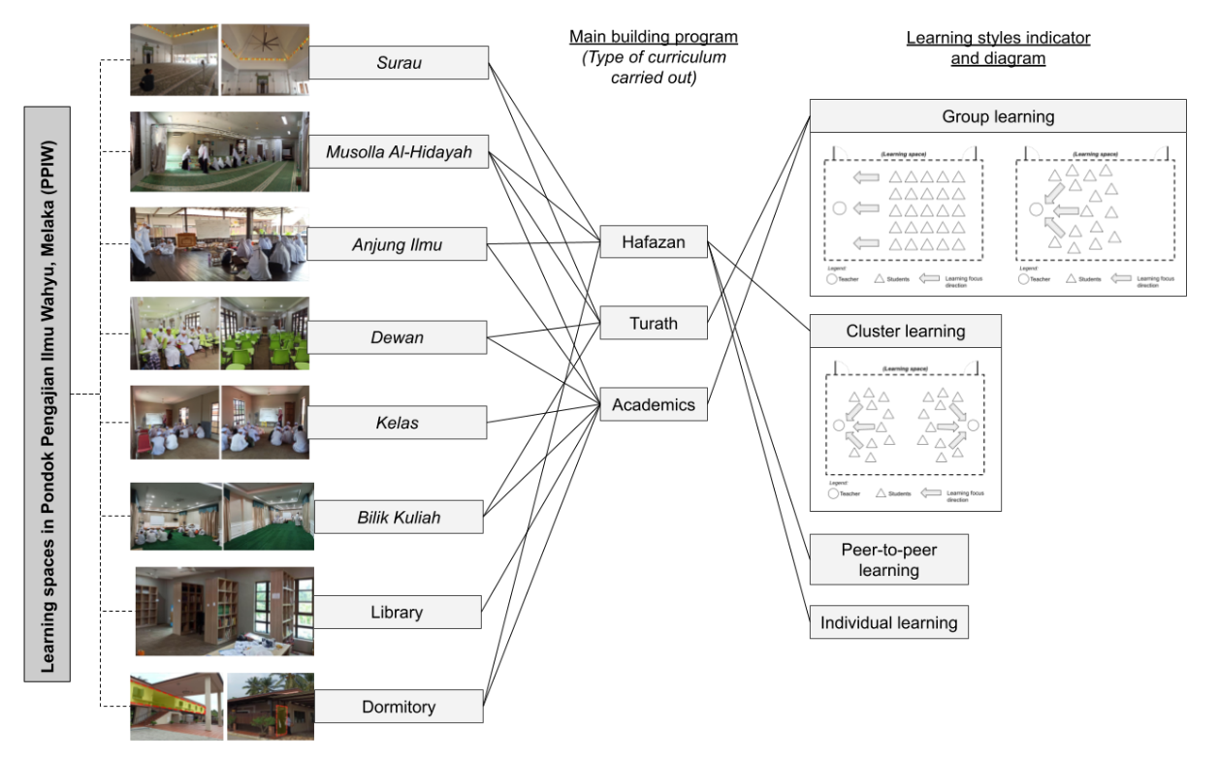
Figure 5. Classification of the Flexibility and Functionality of Learning Spaces in PPIW according to the Main Building Program and Learning Styles Indicator

Table 1. Paradigmatic Views on Values Syumul in the Madsarah Design
Determinants based on syntagmatic (architectural elements involved) | Descriptions of design characteristics | Evident
Location and placement (Accessibility and wayfinding)  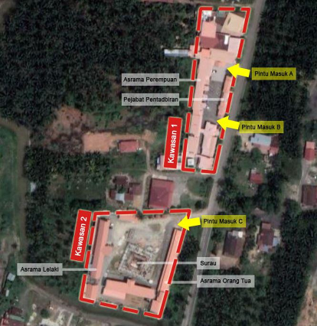  Figure 5. Site plan of PPIW situated along the main road in the village creates a clear entrance without deviation | - The madrasah is located in the village of Perkampungan Merlimau Pantai within the developed rural area of the Merlimau district. The findings are clear to the naked eye as the buildings are built beside the main village’s connecting road. Besides, the fence shows a low, minimum-height fence attached to the institution's signage.  - The location is surrounded by the villagers’ homes, thus making it easier for the madrasah to be seen and increasing the opportunity to enhance community involvement occasionally.  - The madrasah has permeable access, but the entrance must pass through the madrasah's gate. Regardless of the approach, the entrance is clear to the visitor.  - Nevertheless, all buildings in PPIW are reserved for residents' and students' benefits rather than open to the public. | Yes  Yes  Yes  Nil
Façade and structures (Local identity and essence)  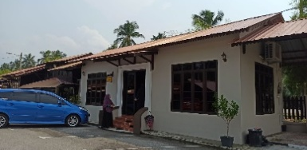  Figure 6. All of the building exterior at PPIW shows a minimalistic approach rendered with plaster and neutral painted walls  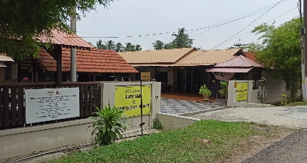  Figure 7. The roof structures of every building at PPIW show good adaptation in responding to the local climate and weather | - The façade showcases modern architecture that uses common building materials, concrete and brick walls finished with plastered walls and neutral-coloured paint. Besides that, several building structures also incorporated typical roof shapes and structures that can withstand Malaysian tropical weather.  - The overall design of PPIW’s building conveys simplicity, creating elements of humility that blend with the local residential architecture in the rural area, rather than becoming a monumental building that showcases extravagant architecture, which contradicts the Islamic educational values’ philosophy. | Yes  Yes
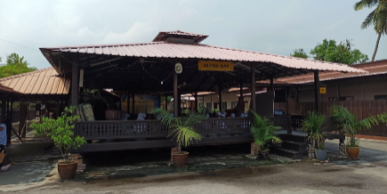  Figure 8. Anjung Ilmu is an open learning space that applies local wooden structures and construction | - The madrasah demonstrates the application of local architecture by adapting wooden structures and finishes across several buildings. Hence, the madrasah portrays clear and visible elements of Malay architecture.  - The open concept of the learning spaces, which embraces natural daylighting and ventilation during occupancy, supports the curriculum and activities. | Yes  Yes

Table 2. Paradigmatic Views on Values of Kamil in the Madrasah Design [Author]
Determinants based on syntagmatic (architectural elements involved) | Descriptions of design characteristics | Evident
Scale and size (Simplicity and humility)  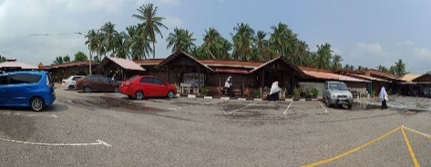  Figure 9. The buildings at PPIW are built proportionately to the users' form  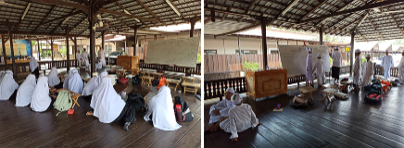  Figure 10. View of the learning session over Anjung Ilmu | The madrasah is built modestly, in accordance with human proportions that integrate with the surrounding context. Thus, the buildings are not monumental, which further emphasizes that the scale is well integrated with their main purpose and function. The results represent simplicity and humility, as highlighted in Islamic educational values. | Yes
Spatial configuration (Building program and movement for users)  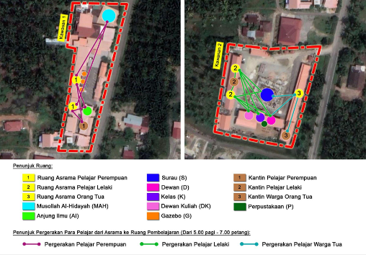  Figure 11. A site plan shows an overview of students' movement | - The buildings and spaces are designed primarily to support the education curriculum and students' sustainability. The layout of spatial arrangements emphasizes accessibility and the distribution of learning activities based on the proximity of spaces and the madrasah's timetables for the group of students.  - For the academic session, the learning process is entirely up to students to use any available learning spaces provided by PPIW. During this session, the students will be divided into smaller groups based on their educational level. This supports learning needs and offers greater flexibility for both teachers and students, tailored to their preferences.  - The spatial configuration shows the path-space relationships in which residents adopt the pathway configuration approach. Users optimize the wayfinding in the learning spaces through corridors, sidewalks, understanding nodes, and the end of the lot. | Yes  Yes  Yes
Interior and exterior (Minimalistic approach)  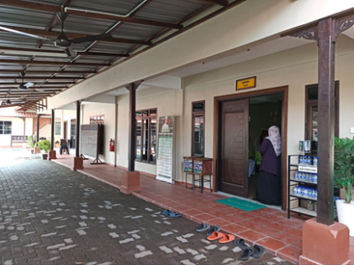  Figure 12. View over the outside corridor of Dewan. | - The exterior adopts a neutral, basic approach in beige, with a dark wooden structure to enhance the essence of locality. Certain buildings incorporate wooden carvings, as in Malay traditional houses, onto their structures, although the construction system is an economic post-and-beam system with minimal expression.  - Thus, the wooden posts and carvings applied throughout the pathway or corridor serve only as decoration and do not form the main structure. | Yes  Nil
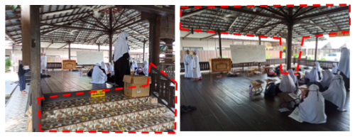  Figure 13. View over the open space of Anjung Ilmu, which applied a local design approach of wooden structures. | - Some spaces feature a wooden construction system that emphasizes passive design, maximizing natural daylighting and ventilation.  - The building is modest and designed according to human proportions, integrating with the natural context.  - The application of stone stairs, wooden structures, and construction reflected the local Melaka traditional house, which emphasizes practicality and simplicity. | Yes  Yes  Yes
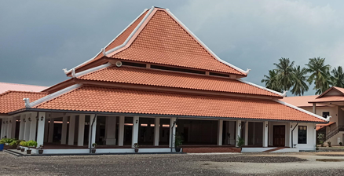  Figure 14. View over the exterior design of Surau  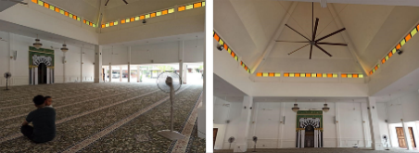  Figure 15. View over the interior design of Surau | - Some of the exterior features a three-layered hipped roof, breaking the verticality of the façade, while the design intentions also showcase the architectural essence of the local mosque.  - The exterior enhances the interior daylighting and natural ventilation, thereby creating a sense of local context in line with the Malaysian climate. | Yes  Yes

Table 3. Paradigmatic Views on Values of Adil in the Madrasah Design
Determinants based on syntagmatic (architectural elements involved) | Descriptions of design characteristics | Evident
Spatial organization and hierarchy of spaces (clear spatial zoning and function)  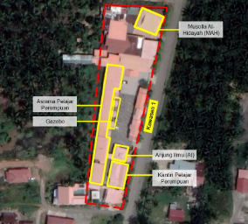  Figure 16. Site plan view of the compound that allocates female students’ areas and Musollah Al-Hidayah  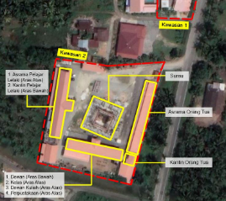  Figure 17. Site plan view of the compound, showing the male students’ areas and Surau. | - The compound planning of the madrasah consists of two (2) lots to meet the needs of living and learning, with male and female areas segregated. This serves as a safeguard for the students living in the madrasah, in line with Islamic principles and teachings that encourage protecting one’s dignity.  - Both Surau (Main prayer hall) and Musolla Al-Hidayah (Secondary prayer hall) are main learning spaces, with the space arrangement prioritizing the qibla direction and the route to avoid interfering with other ibadah activities, worship, and learning requirements. These spaces serve as the main study hall, where male and female students conduct sessions separately at Surau and Musolla Al-Hidayah, respectively. Both spaces' layouts are based on widespread, comprehensive horizontal arrangements.  - The arrangement of the prayer halls is not exclusive and not directly visible, with both halls serving as node points. Evidently, in males’ compound, Surau is the central building unit among other learning spaces. For the Musolla Al-Hidayah, the circulation concept from afar was applied, as the building is situated at the lot's end corner. | Yes  Yes  Yes
Spatial arrangements and circulation  (Clear spatial function to sustain the user’s living and learning sustainability)  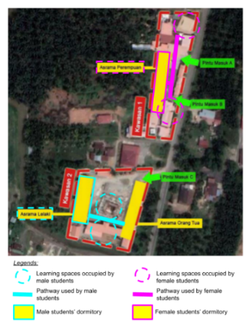  Figure 18. View of the overall site plan that shows a distinguished spatial circulation between male and female students | - The spatial arrangement is according to worship and community facilities. Both segregated areas have prayer halls that not only serve to fulfill users' ibadah requirements but also provide learning spaces for hafazan, academics, and turath sessions.  - The spatial organization is supported by the provision of independent learning spaces, such as dormitory building units, to accommodate students’ daily life activities and individual and peer-to-peer learning. The dormitories are separated by gender, with males and females in separate gated areas.  - In continuation of the segregated concept, during the academic session, males and females also occupied separate spaces in the timetable. This results in discrete circulation for both parties and only involved together in a public program organized by the madrasah.  - Hence, this ensures the users’ safety and psychological peace, as the spatial arrangement prioritizes the syariah of Islam regarding the different ways of living between males and females. | Yes  Yes  Yes  Yes
Table 4. Paradigmatic Views on Values of Alami in the Madrasah Design
Determinants based on syntagmatic (architectural elements involved) | Descriptions of design characteristics | Evident
Location, placement, and inclusivity environments (Proximity within community accessibility)  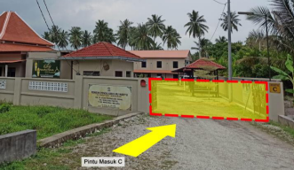  Figure 19. View of the entrance to Surau | - The outer layer of the area incorporates a minimum-height fence, which controls the entrances and exits to the madrasah.  - The madrasah always organized community events such as camps, open classes, and religious talks by inviting kids, parents, villagers, and anyone interested, and by providing invitations exclusively through weekly posters at designated, appropriate venues.  - Regardless of the effort, the spaces in PPIW are private and not flexible for public community gatherings, as they are exclusive to registered residents and students of PPIW.  - The community can access the madrasah through the provided gate and use communal learning spaces such as Surau, Musollah Al-Hidayah, and Anjung Ilmu as gathering spaces for the respective event and venue. | Yes  Yes  Nil  Yes
Exterior façade and structures (Showcase clear, open, and functional buildings for community gatherings)  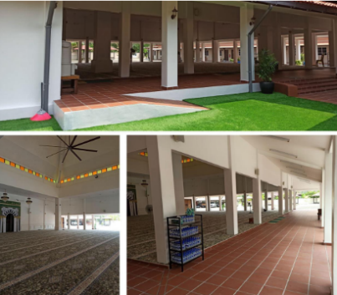  Figure 20. View of the connection between the exterior and interior of Surau | - From the outside, the communal learning spaces such as Surau, Musollah Al-Hidayah, and Anjung Ilmu convey transparency and a clear entrance for users.  - The communal learning spaces, as mentioned earlier, feature an open-plan design and flexible functions that can accommodate various community activities and the number of participants. | Yes  Yes
Spatial planning (Incorporates communal space)  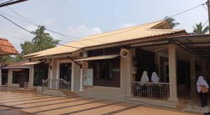  Figure 21. Exterior view of Musolla Al-Hidayah | - The main learning spaces act as central nodes: Surau for the male area, and Anjung Ilmu, which is usually occupied by teaching kids under 12. Then the Musola Al-Hidayah becomes the main study area for the female students, as it is more enclosed than the other main spaces.  - All three (3) learning spaces act as communal areas and are directly visible, which eases the way for findings and creates a better understanding of the spatial planning of the madrasah compound.  - Surau usually becomes the main gathering place when the madrasah is involved in or organizes a public event, requiring all students and residents to participate in designated spaces. Plus, sometimes, Musola Al-Hidayah becomes a significant space for gatherings among all the residents and students during the closed event. | Yes  Yes  Yes

In sum, PPIW clearly shows the architectural characteristics of Islamic educational values encompassing syumul, kamil, adil, and alami elements. All of these values are portrayed through the learning spaces' design, which are the main components of architectural planning in educational institutions such as madrasahs. Evidently, the madrasah design is essential for providing religious knowledge; thus, the location and placement shall be accessible and within the community's proximity to enable participation in any event organized by the madrasah. Other than that, the location within the community enhances the possibility of the madrasah being recognized and promoted as an option for future students to enroll. In addition, the scale, use of local building materials, and the showcasing of the application of local architectural language adapt the values’ essence to the Malaysian context to facilitate the creation of a sense of welcome and belonging throughout the madrasah's built environment. Thus, the madrasah design planning integrates local essence and simple architecture to convey modesty and humility, making it more inviting rather than creating monumental, luxurious spaces and buildings that focus solely on aesthetic aspects, which might evoke a feeling of intimidation or seclusion. Furthermore, in terms of the spatial organization of the madrasah, particularly in the learning spaces, the provision of the spaces and consideration of the circulation that weighs the needs of the main occupants indicates a sense of responsibility that upholds the Islamic educational values as a whole complying the principles and practices of the Prophet PBUH’s dakwah to enrich a better living as an individual among the community as preparation for the afterlife. Besides that, the spatial provision also efficiently reflects functionality and flexibility, as all the learning spaces can accommodate various activities according to users’ preferences. Based on the findings, the framework of architectural elements, grounded in the philosophy of Islamic educational values and semiotic theory, can serve as a guideline and reference for designing a madrasah that acts as a sign and symbol to convey the values' meanings and messages to all levels of society.

3.2 DISCUSSION

THE FINAL OUTCOME OF ISLAMIC EDUCATIONAL VALUES AS PRINCIPLES IN MADRASAH’S ARCHITECTURE
As highlighted previously, architecture can be understood as a symbol that conveys values to the user. The table below shows the derivations of the influence of Islamic educational values through the architectural elements of madrasah buildings, which can be recognized as signs that can be communicated and understood based on socio-semiotic theory. Overall, this framework, which highlights the essence of Islamic educational values, can be considered an architectural approach to transforming the design of madrasah learning spaces.

Table 5. Framework of Islamic Educational Values through Architectural Elements of Madrasah Using Socio-Semiotic Theory [Author]
Sign
Madrasah architecture and learning spaces design
Paradigmatic (Content) | Syntagmatic (Expression)
Paradigmatic (Content) | Building design characteristics | Architectural elements involved
Syumul | Showcases an architecture that respects local identity, that complements the natural aspects and community essence that promotes recognition [34] [35] | The values are represented by the appropriate location and placement of the building, façade treatment, building materials, and structures [16] [34] [35].
Syumul | Produces an architecture that incorporates clear accessibility [32] [33] | The values are represented through the decision on the location and placement of the building, and through spatial arrangements with clear circulation [32] [33].
Kamil | Produces local architectural language that emphasizes a sense of belonging [43] | The values are represented through the façade treatment and building structures [43].
Kamil | Produces an architecture that emphasizes a humane scale design and simplicity [17] [40] | The values are represented through appropriate building scale and size, façade treatment, building structures, and spatial configuration, proportionate to user form [16] [32] [40].
Kamil | Produces a functional architecture that optimizes the main building program (education and curriculum requirements) [17] | The values are represented by optimizing spatial arrangements with appropriate spatial configuration, openings, and circulation [32] [41] [42].
Adil | Produces orderly and organized architecture that has clear spatial zoning [16] [17] | The values are represented by the hierarchy of spaces and spatial organization [17] [32] [47].
Adil | Produces definitive architecture that has an efficient spatial function to accommodate user living sustainability [16] [44] | The values are represented through space-making, with appropriate spatial configuration, openings, and circulation [16].
Alami | Produces an architecture that highlights communal function [17] [57] | The values are represented through façade treatment and building structures that highlight functional transparency [57].
Alami | Produces an architecture that practices openness and high accessibility [17] [59] | The values are represented through the appropriate location and placement of the building, considering proximity to community residential areas, plus an open-facade treatment and building structures with appropriate spatial configurations that result in clear and direct circulation and openings [59].
Alami | Produce an architecture that is responsible and user-friendly [50] [54] | The values are represented through user-friendly façade treatments and structures with appropriate spatial configurations that enhance wayfinding through circulation [17].

CONCLUSION
This study can explain the relationship between the philosophy of Islamic educational values and architecture, which is the ideological method to instill the Islamic movement, and the message of dakwah is conveyed not just to the Muslim community, but also towards the non-Muslims through the design of a madrasah that acts as a symbol for Islamic educational institutions. This research demonstrates how Islamic educational values influence madrasah architecture as an intermediary agent that communicates their essence through architectural manifestations and codes. This study has merit, as it adds new knowledge to existing studies focused on madrasahs and the quintessence of Islamic teachings, which convey the meanings and purposes of living to the local community in Malaysia. Among the new knowledge highlighted is how design planning, whether regulated by private or government organizations, can impact the development of madrasah institutions as a translation of Islamic educational values that inherently showcase the importance of the relationship between architecture and communication. It presents a reality-based phenomenon for the development of madrasah design, based on the quality of architectural design planning that incorporates Islamic educational values as a design philosophy to strengthen the identity of madrasah architecture as an Islamic educational institution in Malaysia.

ACKNOWLEDGEMENT
The authors would like to thank and acknowledge Universitas Negeri Malang for the International Grant and Universiti Teknologi Malaysia for the Matching Research Grant No Vot 04M46, 4B870, and 4B869 provided for this research.

REFERENCES

[1] A. Azra, Esei-Esei Intelektual Muslim dan Pendidikan Islam. Jakarta: PT Logos, 1999.
[2] M. M Rawi, H. Baharudin, M. A. Lubis, & S. A. Romli, "Institusi Pondok dalam Sistem Pendidikan Islam di Malaysia," Proceedings the 7th International Workshop and Conference of Asean Studies on Islamic and Arabic Education and Civilization (POLTAN-UKM-POLIMED), June 2015.
[3] A. Ahmad & W. K. Mujani, "Seni Bina Islam: Satu Pengamatan," Jurnal of Civilisational Study, vol. 10, pp. 88-91, Oct. 2013.
[4] S. Omer, "Islamic Architecture and The Prospect of Its Revival Today," Journal of Islamic Thought and Civilisation, vol. 1, no. 2, pp. 103-121, Oct. 2011, doi: https://doi.org/10.32350/jitc.12.07
[5] A. M. Khir & I. Herman, "Sistem Nilai Dan Motivasi Pencapaian Komuniti Melayu Miskin Dan Tidak Miskin," Prosiding Perkem IV, Universiti Kebangsaan Malaysia, vol.2, pp.501-512, 2009.
[6] A. Rapoport, Culture, Architecture and Design. Chicago, IL: Locke Scientific, 2005.
[7] M. H. Mustamin, "Dualisme dalam Pendidikan dan Pengaruhnya terhadap Pembentukan Nilai dan Identiti Pelajar," The 5th ISDEV International Graduate Workshop: Ingraw. Universiti Sains Malaysia, Sept. 2010.
[8] S. M. N. Al-Attas, Islam dan Filsafat Sains, Bandung: Mizan, 1995.
[9] A. A. Yusof, Pengurusan Pendidikan Islam: Mekanisme Transformasi Ummah, 2nd Ed., Kuala Lumpur: Dewan Bahasa dan Pustaka, 2014.
[10] M. A. Che Noh, A. Suhid & Z. A. Rahim, "Pelaksanaan Transformasi Pendidikan Islam dalam Mendepani Globalisasi," International Seminar on Islamic Education (ISIE 2018), Faculty of Islamic Religion, Universitas Muhammadiyah Ponorogo, Jul. 2018.
[11] J. Wahid & B. Alamsyah, "Defining the Tipology of Islamic Architecture Case Study: Bayt Al Qur’an Building & Istiqlal Museum," 2nd International Conference on Built Environment in Developing Countries (ICBEDC 2008), Universiti Sains Malaysia, Dec. 2008.
[12] S. Bianca, Urban Form in the Arab World. New York: Thames and Hudson, 2002.
[13] R. Stevens, A. Petermans & J. Vanrie, "Design for Human Flourishing: A Novel Design Approach for a More ‘Humane’ Architecture," The Design Journal, vol. 22, no.4, pp. 391–412, 2019, doi: https://doi.org/10.1080/14606925.2019.1612574
[14] N. Utaberta, "Study of Approaches and Interpretation in Islamic Architecture-Studi tentang Pendekatan dan Penafsiran dalam Arsitektur Islam," Proceeding on Aplication of Islamic Architecture in Built Environement-Aplikasi Arsitektur Islam pada Lingkungan Binaan, National Symposium on Islamic Architecture, Universitas Muhammadiyah Surakarta, Indonesia, June 2004.
[15] O. Spahic, Islam is not Compatible with Modernist and Postmodern Architectural Style, Sept. 2023.
[16] A.S. Ismail, "The Influence Of Islamic Political Ideas On The Design Of State Mosque In Peninsular West Malaysia," Doctoral Dissertation, University of Queensland Technology, Australia, 2008.
[17] N.S. Aziz, "Nilai Kemasyarakatan di Dalam Rekabentuk Madrasah Islam Reformis di Terengganu dan Kelantan, Malaysia," Master Dissertation, Universiti Teknologi Malaysia, Kuala Lumpur, 2017.
[18] M.R. Afroogh, "Architecture from the Perspective of the Holy Qur'an," Journal of Architecture and Construction, vol. 2, Issue 3, pp 1-6, 2019.
[19] U. Eco, "Function and Sign: The Semiotics Of Architecture," in Signs, Symbols And Architecture, no 27. pp 356-367, 1980.
[20] J. N. Erzen, "Reading mosques: meaning and architecture in Islam," Journal of Aesthetics and Art Criticism, vol. 69, no.1, pp. 125-131, 2011, doi: https://doi.org/10.1111/j.1540-6245.2010.01453.x
[21] N. A. Baharudin & A. S. Ismail, "Communal Mosques: Design Functionality Towards The Development Of Sustainability For Community," Procedia Social and Behavioral Sciences, vol. 153, pp. 106-120, Oct. 2014, doi: https://doi.org/10.1016/j.sbspro.2014.10.046
[22] D. Chandler, Semiotics: The Basics. London: Routledge, 2007.
[23] M. Gottdiener, Post Modern Semiotics: Material Culture And The Forms Of Post Modern Life. U.K.: Blackwell, 1995.
[24] A. Suhid & F.M. Fakhruddin, "Gagasan Pemikiran Falsafah dalam Pendidikan Islam: Hala Tuju dan Cabaran," Journal of Islamic and Arabic Education, vol. 4, no. 2, pp 57-70, 2012.
[25] O.M. Yatim & A.H. Nasir, Epigrafi Islam Terawal di Nusantara, 2nd Ed. Kuala Lumpur: Dewan Bahasa dan Pustaka, 2007.
[26] Sistem Maklumat Pendidikan Islam, "Tafsiran Variabel Sistem Maklumat Pendidikan Islam (Simpeni) Sekolah Agama, Tahfiz dan Pondok/Madrasah," JAKIM Simpeni, 2024. Accessed; Aug. 2024, [Online.] Available: https://simpeni.islam.gov.my/
[27] A.Z. Ibrahim, "Penerapan Nilai Keadilan dalam Bidang-Bidang Utama Kehidupan Masyarakat Bertamadun: Analisis Mengikut Perspektif Al-Quran," Jurnal Usuluddin, no. 19, pp 61-92, 2004.
[28] A.W. Syakhrani, "Memperkuat Eksistensi Pendidikan Islam Di Era 4.0," CBJIS: Cross Border Journal of Islamic Studies, vol. 1, no. 2, pp. 57–69, 2019, doi: https://doi.org/10.37567/siln.v1i2.90
[29] M.S. Harimulyo, B. Prasetiya & D.H. Muhammad, "Nilai-Nilai Pendidikan Akhlak Dalam Kitab Risalatul Mu’awanah Dan Relevansinya," Jurnal Penelitian IPTEKS, vol.6, no. 1, pp. 72–89, 2021, doi: https://doi.org/10.32528/ipteks.v6i1.5253
[30] S. Abu Bakar & A.Y. Abu Bakar, "sas Kefahaman Islam dalam Realiti Semasa: Tasawwur Islam," Akademi Pengajian Islam Kontemporari (ACIS), 4th ed. Universiti Teknologi MARA (UiTM) Cawangan Kedah, 2021.
[31] J. Safar, A.M. Muhammad & W.H. Embong, Pendidikan Akhlak dalam Sistem Pendidikan di Malaysia sebagai Asas Kecemerlangan Pencapaian Sains dan Teknologi, Universiti Teknologi Malaysia, 2014.
[32] M.T. Rasdi, The Mosque as a Community Development Centre: Programme and Architectural Design Guidelines for Contemporary Muslim Societies. Skudai: Penerbit Universiti Teknologi Malaysia, 1998.
[33] H.F. Zarkasyi, "Pengelolaan Pendidikan Nilai-Nilai Moral Pada Anak: Studi Kasus di Madrasah Ibtidaiyah Negeri Madukara". Thesis, Universitas Muhammadiyah Surakarta, 2012.
[34] H.F. Zarkasyi, “Islam sebagai Pandangan Hidup,” in Tantangan Sekularisasi dan Liberalisasi di Dunia Islam. Jakarta: Penerbit Khairul Bayan, pp. 1-27, 2004.
[35] G. Jiven & P.J. Larkham, "Sense of Place, Authenticity and Character: A Commentary," Journal of Urban Design, vol.8, no.1, pp. 67-81, 2003, doi: https://doi.org/10.1080/1357480032000064773
[36] M.A. Farabi, "Profil Insan Kamil dalam Persperktif Pendidikan Islam," Islamijah: Journal of Islamic Social Sciences, vol.2, no.1, 2022, doi: https://doi.org/10.30821/ISLAMIJAH.V2I1.10974
[37] Z. Stapa, "Insan Kamil: Ciri dan Proses Pembentukan," Afkar: Jurnal Akidah & Amp; Pemikiran Islam, vol. 2, no.1, pp. 43–60, 2001.
[38] M.K. Hassan, "Membangun Modal Insan Melayu dalam Sistem Pendidikan Islam," Perbincangan Meja Bulat Mengarusperdanakan Sistem Pendidikan Islam di Malaysia. 2012.
[39] R. Meliantina, “Pendidikan Islam dalam Membentuk Insan Kamil: Analisis Pemikiran Ahmad Tafsir”. Master Thesis, Universitas Islam Negeri Fatmawati Sukarno Bengkulu, 2022.
[40] M.T. Rasdi & N. Utaberta, "The design of mosque as community development centers from the perspective of Sunna and Wright’s organic architecture," Journal of Islamic Architecture, vol.1, no.1, pp. 1-7, 2010, doi: https://doi.org/10.18860/jia.v1i1.1710
[41] Conway & Roenish, Understanding Architecture: An Introduction to Architecture and Architectural History. Psychology Press, 2005.
[42] Z. Crossland, "Signs of Mission: Material Semiosis and Nineteenth-century Tswana Architecture," Signs and Society, vol. 1, no. 1, pp. 79-113, 2011.
[43] R. Hafsa & M. Maysaa, "Structure as a Tool of Achieving Human Scale in the Islamic Architecture," International Conference on Transport, Civil, Architecture and Environment Engineering (ICTCAEE'2012), Dubai, Dec. 2012.
[44] N.A. Md Nor & S.J.N. Muhammad, "Bustan al-Salatin Panduan kepada Pemerintahan Islam yang Adil oleh Golongan Pembantu Raja," Jurnal Pusat Penataran Ilmu & Bahasa: MANU, vol. 26, pp 51-75, Dec. 2017, doi: https://doi.org/10.51200/manu.v26i.1059
[45] S. Gazalba, Masyarakat Islam: Pengantar Sosiologi dan Sosiolgrafi. Kuala Lumpur: Pustaka Antara, 1986.
[46] J.M. Plas & S.E. Lewis, "Environmental factors and sense of community in a planned town," American Journal of Community Psychology, vol. 24, no. 1, Feb. 1996, doi: https://doi.org/10.1007/BF02511884
[47] J. Hillier & B. Hanson, The Social Logic of Space. UK: Cambridge University Press, 2006.
[48] S. Balaram, "Universal Design and the Majority World," in Universal Design Handbook, 2nd ed. Mc Graw Hill: New York. ch. 3, pp. 3.1-3.6, 2011.
[49] S.S. Szenasy, "Toward Social, Economic and Environmental Sustainability," in Universal Design Handbook, 2nd ed. Mc Graw Hill: New York. ch. 2, pp. 2.1-2.5, 2011.
[50] D.N. Dehanas & Z.P. Pieri, "Olympic Proportions: The Expanding Scalar Politics of the London ‘Olympics Mega-Mosque’ Controversy," Sociology, vol. 45, no. 5, pp. 798-814, Oct. 2011, doi: https://doi.org/10.1177/0038038511413415.
[51] B. Basiron, M.I. Mustari, N. Marni, A. Muhammad, S. Ahmad & S.S. Mohd Nor, "Persepsi Mahasiswa terhadap Dasar Pengasingan Penginapan mengikut Gender: Kajian Perbandingan di Universiti Teknologi Malaysia (UTM), Skudai, Johor dan Universiti Malaya, Kuala Lumpur," Pusat Pengajian Islam Dan Pembangunan Sosial Universiti Teknologi Malaysia, MyScienceWork, 2006.
[52] A. Yaakub, "Strategi Dakwah Rasulullah Dalam Pembentukan Negara," Kajian Pelaksanaannya Oleh Parti Islam SeMalaysia, pp, 271, 1998.
[53] M.M. Nu’mani, Malfuzhat Siri Alif: Kata-kata, Nasihat, Ucapan, Panduan, Petunjuk Hadrat Maulana Muhammad Ilyas rah. Kuala Lumpur: Abdul Majid b. Ahmad Ishak, 2001.
[54] S. Baba, "The Dynamics of Study Circles: Some Reflections on ABIM's Collaborative Learning System," Academy for Civilisational Studies Monograf Series, Academy for Civilisational Studies, 2005.
[55] R. Coleman, "Designing Inclusive Experiences," in Universal Design Handbook, 2nd ed. Mc Graw Hill: New York. ch. 21, pp. 21.1-21.8, 2011.
[56] T. Hayashi, "Lasnamäe Track and Field Centre: Façade," MAJA, Estonian Architectural Review, 2004.
[57] A.L. Huxtable, Building Façade, 2004.
[58] C. Moughtin, T. Oc, and S. Tiesdell, Urban Design: Ornament and Decoration, U.K.: Butterworth Architecture Press, 1995.
[59] G.Godfrey, A History of Ottoman Architecture. London: Thames and Hudson, 1971.
[60] H. Hamid, “Pengelolaan Pendidikan Nilai-Nilai Moral Pada Anak: Studi Kasus di Madrasah Ibtidaiyah Negeri Madukara”. Thesis Dissertation, Universitas Muhammadiyah Surakarta, May 2012.
[61] A. Omar, “Institusi Pondok di Utara Semenanjung Malaysia: Pengaruh dan Senibinanya”. Architectural Research Thesis, Dept. of Architecture, Planning and Surveying, 1982.
[62] N. Wates & C. Knevitt, “Community Architecture: How People are Creating Their Own Environment”, 1st ed. Routledge: Taylor & Francis Group, 2013.
[63] L. Krier, The Architecture of Community, Architecture: Choice or Fate. London: Papadakis Publisher, 2009.
[64] A.S. Ismail & N.S. Aziz, "MACMA Islamic Ideology in Chinese Muslim Mosque Towards Universalizing Islam in Malaysia," Journal of Islamic Architecture, vol. 7, no. 2, pp. 243-252, Dec. 2022, doi: https://doi.org/10.18860/jia.v7i2.15777
[65] R.K. Yin, Applications of Case Study Research. Sage Publication, 2011.
[66] D. Oblinger, "Leading the Transition from Classroom to Learning Spaces: The Convergence of Technology, Pedagogy and Space can Lead to Exciting New Models of Campus Interaction," Educause Quarterly, pp. 14-18, Nov. 2005.
[67] M.M. Jusan & A.H. Hussin, Rekabentuk Madrasah: Satu Kajian Kes ke Atas Madrasah di Johor yang Dikendalikan oleh Badan-badan Bukan Kerajaan,Kertas Penyelidikan, Faculty of Built Environment and Surveying, Universiti Teknologi Malaysia, 2002.
[68] N.S. Aziz, A.S. Ismail & H.H.B. Mohidin, "Building communal values for quality sustainable living in traditional madrassa—the case of Madrassa Quran Kubang Bujuk, Terengganu," Advanced Science Letters, vol. 23, no.9, pp. 8384-8388, 2017, doi: https://doi.org/10.1166/asl.2017.9896
[69] F. Saussure, Course in General Linguistics, Columbia University Press, 2011.

