 |  | JOURNAL OF ISLAMIC ARCHITECTURE  P-ISSN: 2086-2636 E-ISSN: 2356-4644  Journal Home Page: http://ejournal.uin-malang.ac.id/index.php/JIA
ARCHITECTURAL INTERWEAVING: THE ACCULTURATION AND ASSIMILATION OF ISLAMIC AND HINDU CULTURES IN THE MUSLIM COMMUNITY OF BALI
Mokhamad Syaom Barliana^{1*}, Nuryanto Adhi², Tutin Aryanti², Diah Cahyani², Fauzi Rahmanullah²
¹CoE of TVET Research Center, Universitas Pendidikan Indonesia, Bandung, Indonesia
²Department of Architectural Education, Universitas Pendidikan Indonesia, Bandung, Indonesia
Corresponding Author: aombarli@upi.edu
ARTICLE INFO |  |  | ABSTRACT
Volume: 9  Issue: 1  Page:370-386  Received: October 16th, 2024  Accepted: February 20th, 2025  Available Online: June 30th, 2026  DOI: https://doi.org/10.18860/jia.v9i1.29483 |  |  | This article examines the architectural development within the Muslim community in Bali, focusing on patterns of acculturation and assimilation between Hindu and Islamic traditions. The research employs a descriptive qualitative method, using an acculturation and assimilation approach to analyze architectural culture in terms of function, aesthetics, and meaning. Conducted in Gelgel Village, Klungkung District, Bali Province, the study uses conceptual reconstruction based on interviews, documentation, and observations to synthesize the processes of architectural integration. The findings demonstrate that the fusion of Islamic and Balinese Hindu cultures creates a distinct architectural style in Gelgel Village. This fusion manifests in function, aesthetics, and symbolism, with four acculturation patterns identified. Assimilation was observed primarily in settlement layouts, characterized by the labyrinthine maputer-puter pattern influenced by the traditional Balinese pempatan agung spatial concept. This study contributes to the discourse on multiculturalism by showing how architectural forms embody interfaith harmony and cultural adaptation. Additionally, it fills a significant gap in research on Islamic architecture in non-Muslim-majority contexts, offering insights into how religious and cultural identities shape built environments in pluralistic societies.  Keywords:  Balinese Islamic Architecture; Cultural Coexistence; Islamic-Hindu Architecture; Multicultural Architecture; Muslim Minority

INTRODUCTION
Islamic culture around the world shows how various communities have embraced the new religion while blending it with existing traditions. It integrates with local traditions, creating an overlay or symbiosis between Islam and local cultures [1][2]. This symbiosis captures the history and diversity of Islamic architecture, including the valuable attitude of tolerance imparted by Islam, a religion that bridges differences across diverse communities [3].
Preliminary studies on Islamic architecture have generally focused on the Mediterranean, North Africa, and South Asia [4]. Despite having the largest Muslim population, Southeast Asia is often overlooked because its architectural characteristics are considered different from what most scholars have defined [5]. In fact, Islam in Southeast Asia manifests in unique ways due to cultural syncretism, multicultural dynamics, political and social history, non-Arabic linguistic influences, and architectural adaptations [6] [7].
Major scholars have discussed the peculiarity of Islamic architecture in Southeast Asia. Most of these studies focus on mosques and identify unique features of mosque architecture in Indonesia, unlike the attributes defined by E.J. Grube, G. Michell, M. Frishman, and H-U. Khan’s edited books, where mosque architecture is indicated by an inner courtyard (sahn) and colonnades (riwaqs) [5][8], Southeast Asian mosques are characterized by a square, elevated floor plan, a tiered-pyramidal roof originating from the Hindu fighting-cock court [9], and a veranda (serambi/surambi) [9]-[11]. Some sultanate mosques are enclosed in a compound (cepuri) [12][13], and almost all mosques provide a reserved space for women (pawestren) [14]-[16]. Colonial influences have shaped the architectural typology of mosques in Indonesia. While it uses modern materials, the architecture remains distinctive for incorporating colonial architecture and local features [17].
While providing substantial knowledge of Indonesian Islamic architecture, all of the aforementioned studies focus on Java [11][13][18]-[20], the Archipelago, specifically Malay [2][21][22], Sumatra [11], and the Buton Islands [23], where Muslims were the majority. Research on Islamic architecture in areas where Muslims are a minority is rare. Changing the focus from the context where Muslims are dominant to the one where Muslims are a minority promises to counterbalance to complete our understanding of multiculturalism [24].
Research on Islamic architecture in minority contexts, such as in Southeast Asia's Hindu-majority areas like Bali, is sparse. This limits the understanding of how Islamic architectural practices adapt, integrate, or coexist with the dominant cultural and architectural norms in such settings. Some scholars have examined Islamic architecture in the West where Islam is not the predominant faith, i.e., Rashid and Bartsch study the mosques as Muslim’s representations in Adelaide (Australia) [25], and Biondo discusses the mosques in the US and Britain as the Muslim community’s identity and aspiration [26]. Examining the architectural development of the Muslim community in Bali, this article aims to reveal patterns of acculturation and assimilation between Hindu and Islamic architecture, focusing on function, aesthetics, and meaning.
Bali is widely recognized as a rich natural, cultural, and religious tourist destination at both the national and international levels. The appeal of cultural tourism originated in religious aspects, presenting the region as an island of a thousand temples. This was attributed to approximately 86% of the community adhering to Hinduism, also known as Hindu Dharma [27]. Meanwhile, Balinese Hinduism is a syncretism of Hindu sects, namely Shiva, Vaishnava, and Brahma, with local beliefs. During the pre-colonial era, it was called the Tirta (Holy Water) or Shiva-Buddha religion, encompassing all aspects of existence, such as family, livelihood, residence, and the arts. The worship practice was performed in government structures, i.e., the banjar (traditional villages), and kingdoms, as well as conducted by kinship and irrigation communities [28]. Mashad stated that Balinese Hinduism has distinct teachings and foundations, and is a continuation of the ancestral religion of Majapahit. The uniqueness of Balinese Hinduism was attributed to certain differences (Rwa Bhineda) or factors, including space (Desa), time (Kala), and reality (Patra), making it incomparable to Hinduism practices in other regions, such as Kaharingan in Kalimantan or India [29].
While Hinduism is the major religion, several other religions are practiced in Bali, including Islam, introduced in the 15th century. Shiva worship and Hinduism were also practiced in the Balinese community, leading to political fragmentation into several small kingdoms before the arrival of Islam. In 1434, Majapahit conquered and amalgamated all the small kingdoms into the Gelgel kingdom. During the reign of Majapahit, Javanese Muslims, mainly soldiers, visited Bali and were employed to guard Ketut Ngalesir, the King of Gelgel [30]. The Islamization in Bali continued to increase since the 16th century. When the Dutch began to control several regions of the archipelago, many Muslims, mostly Bugis, migrated to Bali until the 18th century [31].
The Balinese had been practicing Hinduism, embodied in the social system for generations, for hundreds of years. The area is geographically dominated by Hindu traditions, currently adhered to by the majority of the population. Architecturally, various residences, public facilities, offices, and spaces are characterized by Hindu nuances. This does not mean that the dominant culture of the Balinese community, affiliated with Hindu traditions, closes the door to the growth of other religions and customs [32].
The strength and richness of Hindu traditions within the Balinese and Muslim minority communities gave rise to certain cultural dynamics. Islam reportedly had a significant influence on the natives, due to the presence of the Muslim community, mosques, Islamic educational institutions (pesantren), and acculturation [33]. Similarly, Hindu traditions influenced Muslim culture, particularly in architecture. The acculturation and assimilation of settlement patterns in Pegayaman and Gelgel Villages were influenced by menyama braya, nyama slam, and nyama Hindu [34]. Local wisdom, which is crucial for sustainable cultural heritage preservation, should be continuously explored to gain a sufficient understanding and to develop values, cultural patterns, and traditional architectural characteristics [35].
The assimilation and acculturation framework provides a vital lens for examining the interplay of Hindu and Islamic cultures in Balinese Islamic architecture, highlighting the complex dynamics of cultural integration in minority contexts. Assimilation involves the fusion of two or more cultural systems, leading to the emergence of a new culture that incorporates dominant characteristics to the extent that it alters or transforms the original cultural identity [36]. In contrast, acculturation refers to the adaptation of cultural traits from a majority group without the loss of the minority’s distinct cultural heritage [37]. This distinction is critical for understanding how Islamic architectural forms in Bali negotiate between adaptation and preservation within a predominantly Hindu environment. Despite the rich historical and cultural interactions in the region, a review of existing literature reveals a significant gap: while numerous studies conducted by Prasetya [38], Suwindia [39], Diana [30], Indriana [40], Arjana [41], Ramdhani et al. [42], Bachtiar et al. [43], and Amalia [44] have explored the acculturation of Hindu and Islamic traditions, focused investigations into architectural assimilation remain notably absent. This lack of scholarly engagement with assimilation dynamics leaves an incomplete understanding of how Islamic architecture evolves under dominant cultural influences. By addressing this gap, the present study not only complements prior research but also deepens the discourse on cultural hybridity, offering a critical examination of how spatial forms and symbolic elements in Balinese Islamic architecture reflect both convergence and distinction within a multicultural society.

METHODS
This study employed a qualitative descriptive approach, using assimilative and acculturative methods, to analyze architectural culture, focusing on aspects of function, form, aesthetics, and meaning. It was conducted in Gelgel Village, Klungkung Sub-district, Klungkung Regency, Bali Province, as the village had the largest Muslim community in Bali and was one of the sites where the first Muslims who came to Bali resided [30][42]. Data were collected using three techniques, comprising unstructured interviews, architectural documentation, and observations. We interviewed elders and community leaders, including the village secretary (perbekel), neighborhood head, and the mosque committee board members, to delve into architectural space and symbolism, as well as the meanings of the architectural space, forms, and functions. The documentation studies, conducted by collecting photos and sketches of the buildings and architectural elements, aimed to examine the principles of Islamic and Balinese Hindu architecture. Additionally, we conducted an observation of the architectural artifacts. The observation focused on the spatial pattern of the village, mosques, madrasahs, village offices (perbekel), meeting places (bale banjar), and boundary monuments (weneng).
Data analysis was conducted using a conceptual reconstruction derived from interviews, documentation, and observations. We follow Miles et al.’s qualitative data analysis method, consisting of selecting, sorting, and synthesizing the process of architecture assimilation and acculturation [45]. Additionally, we conducted source triangulation by collecting data from different sources and informants, method triangulation through various data-collection techniques, and theoretical triangulation by referring to different theories of architectural assimilation and acculturation.

RESULT AND DISCUSSION

3.1 THE ARCHITECTURAL CHARACTERISTICS OF THE MUSLIM COMMUNITY IN BALI
The Gelgel Village in Klungkung Sub-district, Klungkung Regency, Bali Province, is located in the lowlands (Figure 1) with an area of ± 482.43 hectares. This village is bordered in the north by Kamasan Village, while the south, west, and east borders are within the community. The distance from the administrative center to the Klungkung Sub-district and Regency is 3 km, and 41 km to the Bali Provincial. The Muslim community in Kampung Gelgel Village is the oldest in Bali, dating back to the 14th century (around 1460) during the Gelgel Kingdom under the rule of King Dalem Ketut Ngulesir. Islam entered Gelgel, brought by guards from the Islamic Mataram Kingdom (Java Island), totaling 40 people who guarded King Dalem Ketut Ngulesir. The guards eventually settled in the Gelgel Kingdom and were given land to live in.
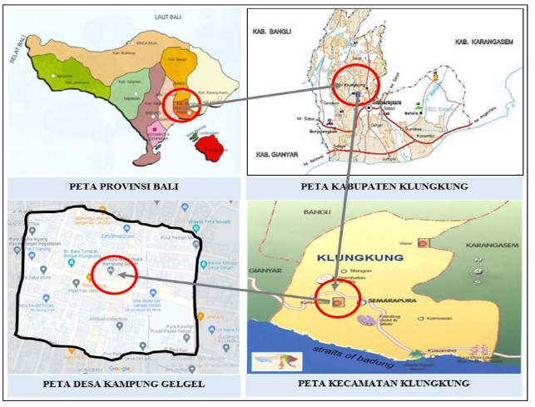

Kabupaten Klungkung map
Bali map

Kampung Gelgel Village map
Kecamatan Klungkung map

Figure 1. The location of the Gelgel Village (source: Google Map, modified by the authors)
Settlement Pattern. The majority of the population are traders and craftsmen in household industries such as cag-cag (songket) weaving, gold and silver crafts, and painting. Initially, the communities of the Gelgel Village worked as rice farmers. The settlements were surrounded by forests, gardens, and extensive rice fields totaling ± 482.43 hectares. This type of agricultural livelihood greatly influenced the settlement pattern, close to the work area, and tends to be grouped. The houses were arranged close to each other, with some only separated by alleys the size of an adult arm span or enough for a motorbike to pass through. The settlement conditions are quite dense, with a total population of 1,221 people until 2024: 615 men and 606 women (Gelgel village website).
In the era of the Gelgel Kingdom, from Raja Dalem Ketut Ngulesir (14th century) to Raja Dalem Baturenggong (16th century), alleys and corridors served as hiding places and defensive fortresses against enemy attacks. The distinctive width was approximately 80 to 100 cm, then widened to 150 to 200 cm to enable the passage of two-wheeled vehicles. The alleys (rurung) also served as axes connecting essential objects to rows of adjacent housing units along the edges. These constituents of a spatial concept are often found in densely populated settlements and used for various social activities. In Gelgel Village, where settlement density is quite high, alleys serve as a visible link between facilities and community activities. This is why there are many alleys and small roads in the village, named after the four companions of the Prophet Muhammad SAW.
The presence of many alleys in Gelgel also affected the settlement pattern, giving rise to the term maputer puter, meaning "moving around like a labyrinth," denoting a place full of winding, crooked roads and alleys. The labyrinth pattern in the village was marked by intersections regarded as meeting points for roads and alleys. This pattern was established as a tactic or strategy for soldiers to wage guerrilla warfare in defending the kingdom [46]. The settlement pattern of Maputer Puter lacks a clear orientation, unlike most traditional villages in Bali, which are oriented towards the mountains (Kaja) and the sea (Kelod), or towards the North and South.
The settlement pattern lacks a clear orientation, unlike most Balinese villages, which are oriented towards the mountains (Kaja) and the sea (Kelod), or North and South, respectively. Furthermore, the settlement pattern in the village does not recognize the religious, earth, and cosmos axes, Asta Kosala Kosali, or Kaja-Kelod. The residential units are oriented toward the road, which serves as the main axis. In certain locations, the direction of the house and other facilities was even adjusted to suit the land's conditions, ensuring the building's orientation was not uniform.
Mosque and Madrasah. The main mosque in Gelgel Village is Nurul Huda, a name of Arabic origin. Nurul derives from the word nur, meaning "light," while huda implies "guidance." Therefore, Nurul Huda serves as a source of guidance, fulfilling the mosque's role within the Hindu community. This building is expected to be a path and a source of guidance for anyone longing for divine light. Similarly, the madrasah is the center of Islamic education for children around the settlement.
The mosque is used for worship and for various social, ritual, and cultural activities. During the celebration of Islamic holidays, both Muslims and Hindus make the process crowded. However, during Nyepi, Muslim brothers help maintain security and solemnity. The Nurul Huda Mosque symbolizes, in an indirect way, harmony between Islam and Hinduism. In Klungkung Regency, this building is the oldest historical relic marking the introduction of Islam to Bali. Hindus also participated in maintaining and protecting Islamic relics in Buleleng, demonstrating harmony [47].
The initial concept for the Nurul Huda Mosque remains unclear, as there was no formal explanation or information from the village. The information obtained stated only that the cleric, Raden Modin Kyai Abdul Jalil, the founding figure, was among the 40 Muslim entourages from Majapahit.
The last renovation was carried out in 2006 to expand the building, repair and replace door and window frames, add supporting facilities, including the mosque committee board office and an ablution area, landscape, paint the entire structure, and amend the yard fence, etc. Based on its physical appearance, the mosque conveys a strong modern impression while incorporating local elements. This showed an adaptation to Balinese culture without violating Islamic teachings. According to Hidayatulloh [22], the fusion of Islamic and Hindu cultures in Bali's mosques is a form of acculturation or cross-culturalism aimed at strengthening the image of a harmonious environment.
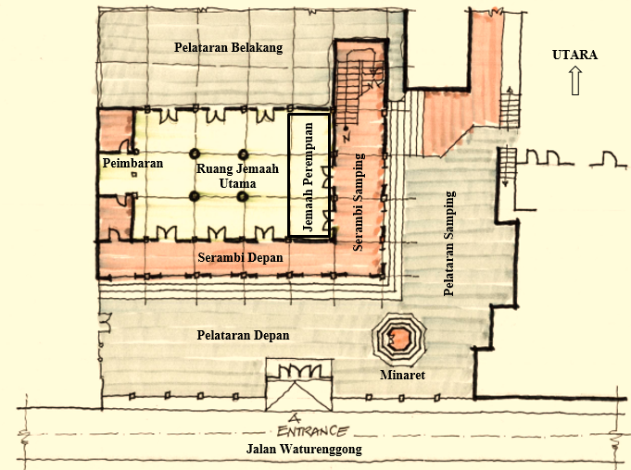
Based on observations of existing conditions, descriptions, and statements by the Village Secretary, the architecture of the Nurul Huda Mosque can be traced from its concept through its floor plan to its appearance. The floor plan is rectangular, as in the original. The mosque initially accommodated 40 worshipers according to the number of troops from the Majapahit Kingdom. However, with changing times, development, and population growth, the capacity of the ground and upper floors was increased to accommodate approximately 700 communities. The sizes of the lower (first) floor (Figure 2) and the upper (second) floor (Figure 3) were 25 x 25 meters, or approximately 625 m², and 25 x 15 meters, or 375 m².

Figure 2. The lower floor plan of Nurul Huda Mosque

The concept of a square floor plan symbolizes the four main guidelines of Muslims, namely the Qur'an, Hadith, Ijtima Ulama, and Qiyas. Fanani stated that the rectangular shape symbolized an imperfect or ephemeral form. The four pillars represented the Khulafaur Rasyidin (Abu Bakar As-Shiddiq, Umar bin Khattab, Utsman bin Affan, and Ali bin Abi Thalib), while the 20-meter minaret symbolized the attributes of Allah SWT [48]. The dome at the end of the tower showed the vertical relationship between creatures and the Creator. Meanwhile, elevating the imam's peimbaran floor is a form of respect for the leader.
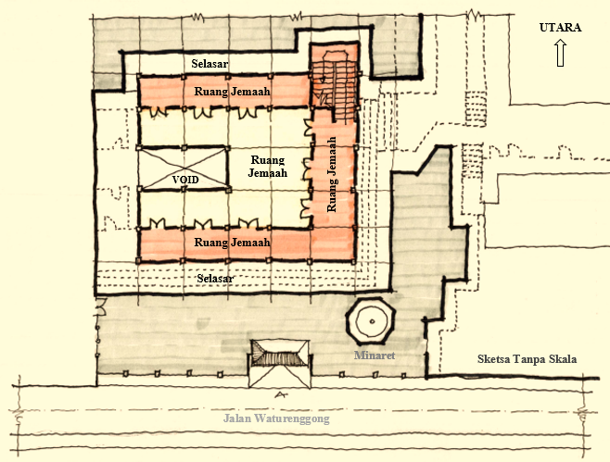
NORTH

Corridor

Prayer hall

Prayer hall
Prayer hall

Prayer hall

Corridor

Unscaled sketch

Figure 3. Upper floor plan of the Nurul Huda Mosque

The square shape was subsequently transitioned into a rectangular shape due to an increase in the number of worshipers. This form consisted of two clusters united with different roof shapes. The first and second square clusters were characterized by tumpang and flat roofs, respectively. In architecture, differences in roof shapes reflect different functions and values of space. The square plan with a three-tiered tumpang roof symbolized the main building, in contrast to the expanded space with a flat roof.
The architectural form of the Nurul Huda Mosque shows a luxurious and dignified façade (Figure 4). The interplay of white, cream, or ivory, and pink paints, combined with golden yellow, portrayed both strong exterior and interior designs. The basic square shape of the mosque symbolized constancy or steadfastness in religion. This appearance originated from the primary forms: square, triangle, circle, or sphere [48]. The circular or sphere shape was associated with eternity and perfection. In line with this perspective, the architecture form of the Nurul Huda Mosque is a combination of squares, circular, and triangles. The basic square shape was applied to the walls (the core space for worship), while the circular ones were adapted to the curves of the window and door frames and the yard fence. Additionally, the triangular shape was evident in the rooftops, which were arranged into two parts.
Dome replica
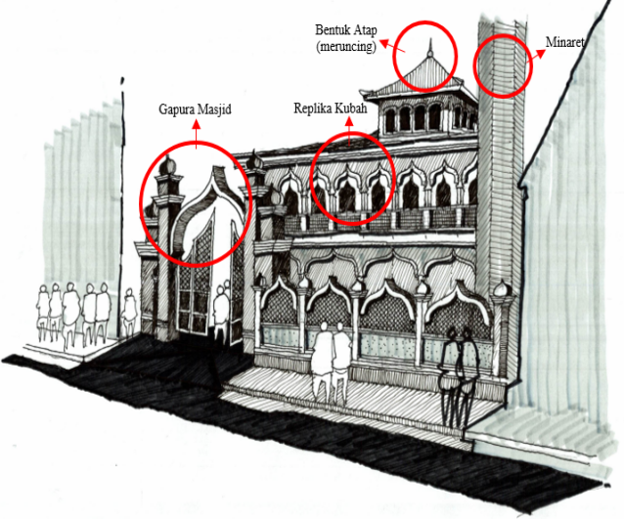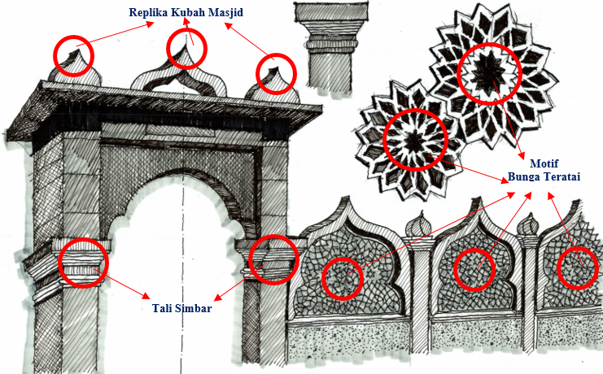
Lotus motif
Simbar rope
Dome replica
Mosque gate
Roof Form (tapered)

Figure 4. Front view and Gate of Nurul Huda Mosque

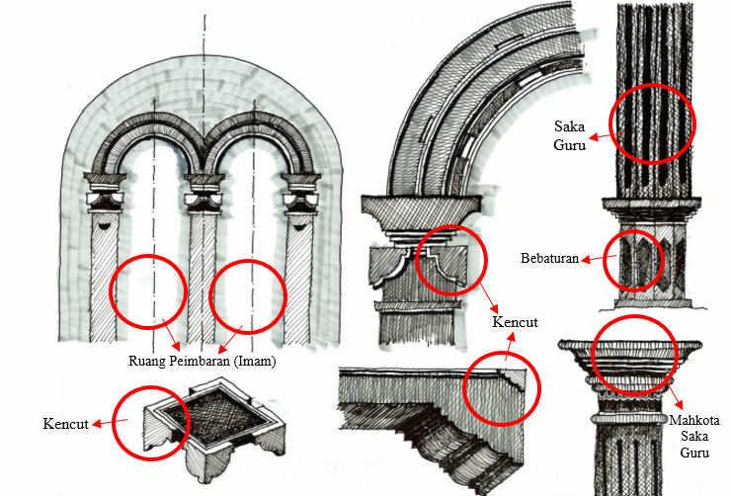

Figure 5. Detail of the mihrab section of the Nurul Huda Mosque

The two-tiered tumpang model is a transformation of the Meru roof shape commonly used by the Wantilan community in Bali. The triangular roof, which tapers upwards, resembles a mountain, a symbol of majesty. The sharper and higher the roof, the more majestic the impression realized. Additionally, the sharp tip was perceived as the point or center of the Almighty Oneness. In the architecture of elementary madrasahs, both the plan and the appearance lacked a distinct concept, aside from the use of decorative motifs described in the next section. Meanwhile, in the interior, especially in the mihrab (the place of the imam), there is a curved shape that replicates the dome, supported by three pillars or saka guru (figure 5). The decorative motifs on the pillars are kencut, bebaturan, and makuta (crowns).
Perbekel and Bale Banjar. The perbekel, or village office, plays an essential role in the community by overseeing population, administration, licensing, and external relations. In this building, the perbekel head performs certain duties, assisted by staff. Therefore, the building should show authority as a government center for serving the community.
The initial form of the perbekel office was a house, which was later expanded to meet the community's growing needs. At the time of this study, the architectural concept was not known for certain. The village secretary stated that the expansion was realized by the perbekel head and was never designed by an architect. The layout was adjusted to the relevant needs and functions, with the nuances of locality evident in some of the exterior and interior elements, such as the use of simbar lines around the pillars and the yard fence. This also included attaching mudra to the four sides of the fence post buds, as well as the top end, and pepatran serving as a relief for the balcony trellis fence and the yard.
A typical Balinese carving background is covered in gold, forming an arch or dome that shields the village logo. The name is used to design the interior space, specifically the main reception and the work area for the perbekel head and secretary. The railing of the stairs to the second floor was designed with a pepatran of silver floral motifs, resulting in an ethnic appearance. The curved nuances resembling a dome were incorporated into the balcony's window frames and wall surfaces.
The traditional Balinese architecture concept was not visible in the design of the bale banjar. It lacked Asta Kosala Kosali, Tri Hita Karana, Sangha Mandala, Gegulak, Tri Mandala, etc. As a village with non-customary status, the community was not bound by Balinese traditional rules. The bale banjar in Gelgel Village does not have to be the same as in the Pakraman Village (customary or official). The similarities were observed in a basic square or rectangular plan, with all four sides open or partially closed, depending on basic needs. Several local components visibly enhanced the building's image without violating Islamic teachings. The crown (mudra) used to decorate the roof's tip and ridge was purely aesthetic. Umpak, regarded as the foundation's base, was dug in line with the space module to give the impression of pilotis or floating. Additionally, the essence of pepatran on each pillar of the building was to provide a dynamic image. The position of the bale banjar was not determined by the wind direction (free), but rather by facing the road for easy access.
Waneng. The characteristics of waneng, kramawates, or boundary monuments in Gelgel Village are based on the traditional Balinese concept and are evident across several components of the plane. The use of a crown or mudra on the rooftop and four sides of the ridge symbolized authority. Furthermore, the use of karang simbar, adopted from the shape of plants (leaves, leaf petals, stems, twigs) on the four lower walls, is a sweetener for the field. The essence of kencut on the side planes of the two pillars was to strengthen the dynamic image of the plane. Subsequently, the pepatran lines on the horizontal plane were used to increase brightness. Tulikup, a local material from exposed brick similar to templek or orange terracotta, was also used. Ijuk was used as roofing material in the form of a shield, and bebaturan or sendi was used for the building's foundation.
The traditional Balinese architecture character was strongly applied to the boundary monument. This was observed in the concept of dividing the three main components: hulu or head (highest position), pengawak or body (middle position), and bebaturan or feet (lowest position). The three components were manifestations of the human body adapted to the building. At present, the community does not have a problem with the form of weneng because it was established through mutual agreement. However, the traditional village government respects the Muslim community by not placing statues of humans, giants, or animals alongside the weneng (Figure 6).

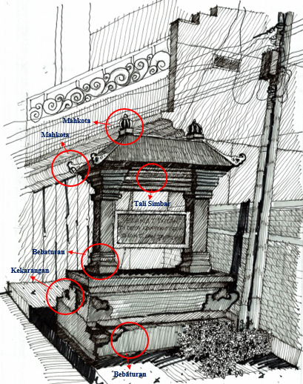

Figure 6. Appearance of weneng or kramawates in Gelgel Village

3.2 THE ACCULTURATION OF ISLAMIC AND HINDU CULTURE IN THE ARCHITECTURE OF GELGEL MUSLIM COMMUNITY
Architecture Form. The acculturation of Islamic and Hindu cultures is evident in the functions and organization of the Nurul Huda Mosque space, umah (house), perbekel (village office), bale banjar, and waneng. In general, the organization of the building space is grouped horizontally into three parts, namely: (1) Utama, located at the front, which functions for public activities; (2) Madya, its position in the middle for semi-public activities; (3) Nista, its position at the back as a service area. Meanwhile vertically, the shape of the space is divided into three types, namely: (1) Hulu (head), occupies the top position as an area considered the most sacred (honorable and authoritative), implemented on the roof; (2) Awak (body) section, is in the middle as a neutral area, shown on the wall and floor components; (3) Bebaturan (feet) section, its position at the bottom as a profane (dirty) area which is manifested in the building foundation. These three parts are the embodiment of the universe and the human body, which in the concept of traditional Balinese architecture are called Tri Hita Karana and Tri Angga.
The mihrab, or peimbaran, for the imam was distinctly designed with Balinese ornamentation in the form of carvings, made of teak wood more than a hundred years old. The influence of Javanese architecture was also evident in the three-tiered tajug roof of the main prayer room. This roof was made of wood, constructed as a tajug with three levels (tumpang roof), and supported by the main pillar (soko guru). The gunungan building (tajug/meru) was more commonly associated with the Javanese community, which considers it a symbol of the universe, with the mountain peak representing the majesty of God.
The decorative motifs or ornaments of the mosque were influenced by Balinese elements, reflecting respect for the local community, with details, specifically the use of floral elements, selected to avoid violating Islamic teachings. Typical Balinese ornaments were also used in other parts of buildings, such as elementary madrasahs, perbekel offices, bale banjar, and residences, thereby giving them a distinctive character. This was generally different from mosques in Java and was perceived as a distinctive characteristic of the Gelgel Village. Balinese characteristics were indirectly incorporated into the appreciation of the local community. The buildings in Gelgel Village were constructed by incorporating local culture and complementing one another, without eliminating the original forms.
The decorative motifs found in the mosques were influenced by Hindu culture, which had existed before the structures were erected. These were characterized by several features, namely (1) the use of a gate made of red brick, which portrays the tradition of pre-Islamic architecture, art, and era. The decorative panels found on the gate had certain similarities, such as the pepatran of plants. The influence of Hindu architecture was symbolized by the several decorative motifs found on both gates. (2) Other values also showed social relations exhibited by religious adherents in maintaining harmony between Islam and Hinduism. A typical example is the three-tiered roof shape, an indirect adaptation of the meru shape in Balinese Hindu architecture. Carved ornaments on several corners of the interior with Balinese nuances in the form of flower patran/pepatran. Kencut decorative motifs represented by attached blades on pillars are often found in traditional Balinese buildings. Relief lines on several planes are an adaptation of Balinese and Javanese carving art, while Beduk, adapted from Indian (Hindu) and Chinese culture, served as a marker for the entry of prayer time, followed by the sound of the call to prayer (athan).
Based on the above explanation, the findings on the acculturation of Islamic and Hindu culture can be seen in four patterns, namely: (1) saka guru which symbolizes the obligatory nature of Allah SWT and the symbol of khulafaur rasyidin; (2) pepatran, tali simbar, kekarangan, kencut, and simbar as symbols of social relations between humans without distinguishing backgrounds (menyama braya); (3) bebaturan or ommpak as a symbol of steadfastness or strong stance; (4) Crown and lotus symbolize authority, honor, and purity. The combination of these four patterns is manifested in the function, aesthetics, and symbolism of strong Islamic and Hindu cultures. Buildings in Kampung Gelgel Village were designed to incorporate local culture and complement one another, without eliminating their original forms.
Function and Organization of Space. The spatial plan of the Nurul Huda Mosque generally has four functions, namely (1) public, or general space for other activities aside from worship, such as courtyards and gardens often used for meetings or health checks, particularly during the COVID-19 pandemic, including deliberations occasionally attended by representatives of Hindus as invitees, (2) Semi-public, for administrative and management functions of the mosque, for example, the mosque committee board room, the Zakat, Infaq and Shodaqoh Collection Agency (BAZIS), library, etc, (3) Private, as personal or core space used for the five daily prayers, for both male and female congregants, (4) Service or activity support room, such as toilets, warehouses, ablution areas, and public kitchens.
Hindus were also invited to functions or events related to the core Muslim congregation, such as Muludan, Rajaban, Isro' Mi'raj, and routine meetings of the indigenous community. Therefore, the mosque was used for prayers and other social activities. The spatial hierarchy of the Nurul Huda Mosque was visible in the organization or arrangement of spaces. There are three spatial organizations, namely (1) Front (aep, ajeng, or malu), which is the façade that surrounds the building. The section, which includes a terrace, yard, front garden, and parking area, functions as a public area because it is easily accessible. In addition, Muslims and Hindus also gather during village customary meetings or deliberations. (2) Middle (atenga or madya) is a semi-public space, usually private and only used by a certain community, such as the main congregation room for prayers. This room contains a peimbaran (imam's room) used for sermons and leading congregational prayers. (3) Rear (nista or paon), implying the rearmost or side area regarded as a service room, such as the ablution room and toilet. These rooms adopted the hierarchy of the house, grouped into three parts, though this was not based on the sangha mandala concept or the nine space blocks of Balinese culture.
The typology of the Javanese-Hindu spatial layout in Gelgel Village comprised the main elements of the mosque, namely the prayer place, mihrab, pulpit, veranda, and ablution room, while the tower is a supporting or complementary constituent. The main prayer room is located in the westernmost part, with a mihrab, or niche, for the pulpit. Meanwhile, the prayer room for women (pawastren) was located on the right side (north). The veranda is located on the right (East), left (West), and front (East) of the mosque, while the ablution areas are positioned on the right (north) and left (south) for women and men, respectively.

Ritual, Social, and Architecture Meanings. The acculturation of Islamic and Hindu cultures can be seen in the ritual, social, and architectural meaning of the organization in Kampung Gelgel Village, which is different from other traditional villages in Bali, which pay close attention to orientation in building, such as: hasta kosala kosali, religious axis, earth axis, cosmos axis, and the rules for building houses in Bali. Gelgel Village is characterized by a maputer-puter pattern similar to a labyrinth. This pattern was characterized by numerous intersections, regarded as the meeting points of roads and alleys. It was influenced by the strategy adopted by soldiers to wage guerrilla warfare in defending the kingdom. The existence of alleys, corridors, or small lanes between the main roads that are used for evacuation or guerrilla operations still needs to be investigated. Based on field observations, alleys were created by establishing spaces between plots (house lots).
Religiously, the architecture of Kampung Gelgel Village is more influenced by Islamic beliefs. Even so, the influence of the past, closely related to the Gelgel Kingdom, shapes the architecture's characteristics, which still reflect local Balinese colors. The absorption of Balinese culture is very visible in mosques, madrasahs (religious schools), houses, perbekel offices, bale banjar, and waneng, angkul-angkul, or kramawates. This can be seen in the use of decorative motifs or decorations in these buildings.
Acculturation in ritual, social, and architectural meanings can be seen in the use of decorative motifs across the Nurul Huda Mosque, umah (house), perbekel (village office), bale banjar, and waneng. The ritual meaning of the mosque's architectural components is evident in the use of saka guru (pillars in the main room), which number 20, symbolizing the obligatory attributes of Allah SWT. The height of the mosque tower, which reaches 17 meters, symbolizes the number of rakaat of the five daily prayers. The square shape of the building suggested the number of the Prophet Muhammad's companions, the Khulafaur Rasyidin. The dome shape, which tapers at the top, symbolizes the vertical relationship between humans (creatures) and Allah SWT (the Creator). The dominance of white in the building showed the sacred nature and submission of oneself in worshiping Allah SWT. The three-tiered roof signified the levels of Muslim nobility, such as faith, Islam, and ikhsan. Additionally, the raised peimbaran floor for the imam is perceived as a form of respect for the leader.
The use of decorative motifs from Balinese culture also has a significant impact, even though they are not associated with Islamic values. The three-tiered roof shape is, in turn, an adaptation of the meru in Balinese Hindu architecture, which symbolizes purity. However, the carved ornaments on several corners of the building's interior, in the form of flower patran/pepatran, represented peace and tranquility. The relief lines on numerous planes suggested the horizontal relationships between humans. The crown or makuta lambang sari located above the door and window frames of the teacher and principal rooms implied authority. Furthermore, the bebaturan or ompak, attached directly beneath the supporting pillars, symbolized steadfastness or stance.
The use of decorative motifs from Balinese culture also has a significant influence, although they are not associated with Islamic values. Fanani [48] and Nuryanto [34] explain that the three-tiered roof shape is indirectly an adaptation of the meru shape in Balinese Hindu architecture, which symbolizes purity, while the ornamental carvings on several corners of the interior of the building in the form of patran/pepatran flowers symbolize peace and tranquility. The relief lines on various planes depict horizontal relationships between humans. The crown or makuta symbol sari located above the door and window frames of the teachers' and principal's rooms symbolizes authority. The bebaturan or ompak embedded directly under the supporting pillars symbolizes steadfastness or stance.
In architecture, decorative motifs have both aesthetic value and social meaning. For example, pepatran obtained from plant motifs, such as flowers, leaves, stems, roots, and twigs, symbolizes the beauty and natural wealth of the environment. The motif signified a form of brotherhood between Islam and Hinduism, spreading goodness, despite not knowing each other. The patra ornament (flower motif) was obtained from Bali and re-classified into a type of Chinese patra. This was because the Majapahit Kingdom was influenced by Chinese culture.
Additionally, kekarangan is a floral decoration, and, similar to pepatran, there are several types: karang simbar, karang bunga, and karang suring. This decoration shows authority or prestige. Another example is the simbar rope, in the form of horizontal lines, signifying a strong family bond or brotherhood based on the concepts of menyama braya and nyama slam. The cultural meaning was observed in the relationship between the daily activities of Muslims and Hindus. However, the bale banjar, adapted from local Balinese culture, serves as a representative public space for various activities. Muslims and Hindus, irrespective of background, often meet or gather in this space. The cultural activities frequently carried out are related to art, such as plays, drama, music, and monologues, performed by the young community, including deliberations or discussions. This tends to result in togetherness symbolized by the physical space without walls (open).
The architectural acculturation pattern of Gelgel Village can be identified by the ornaments used to decorate mosques, madrasahs, houses, perbekel offices, bale banjar, and angkul-angkul or kramawates (Figure 7). Meanwhile, the combination of Islamic and Balinese cultures produced a distinctive pattern, leading to architectural acculturation across functions, aesthetics, and meaning.
The following four acculturation patterns, saka guru, tali simbar, pepatran, kencut, and lis, were used as interior aesthetic elements to make the Nurul Huda Mosque appear more dynamic and symmetrical. Specifically, saka guru (4 and 20 pieces) represented the obligatory nature of Allah SWT or the khulafaur rasyidin (Abu Bakar Shiddiq, Umar bin Khattab, Utsman bin Affan, and Ali bin Abi Thalib). Subsequently, pepatran, tali simbar, kekarangan, and simbar were used to design mosques, elementary madrasahs, perbekel offices, bale banjar, angkul-angkul, and waneng or kramawates, thereby strengthening the impression of the plane and giving it a bright appearance as the final solution (finishing). This symbolizes the social relations among people, regardless of background (menyama braya). Kencut, tali simbar, bebaturan, caturan, and saka guru were also used in mosques, houses, perbekel offices, bale banjar, angkul-angkul, and waneng or kramawates. Crown, lotus, bebaturan, and caturan were also used to design these structures. In particular, the crown, makuta, or mudra was located on the rooftop as the highest element of the building. The crown's location at the peak of the roof ridge and along the four sides made it appear more attractive, symbolizing authority and honor. In Gelgel Village, there is a particular house whose roof ridge has the phrase al-dzaljalah, namely Allah (hablumminallah), a sign that the owner is Muslim. Additionally, lotus padma was also installed at the bottom end of the roof tiles.
The use of lotus is optional, depending on the owner, while the rocks serve as the base for the terrace pillars, including the use of caturan on the fence (handrail). None of these decorative elements is related to Islamic beliefs, meaning they can be used by anyone.

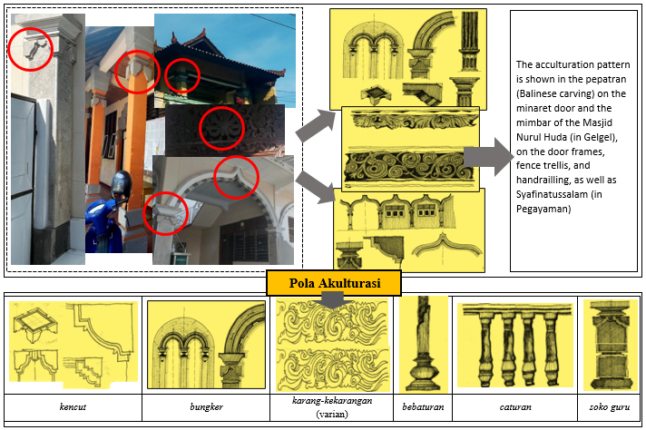
Acculturation Pattern
Figure 7. The acculturation pattern in the mosques, madrasahs, perbekel offices, bale banjar, and angkul-angkul
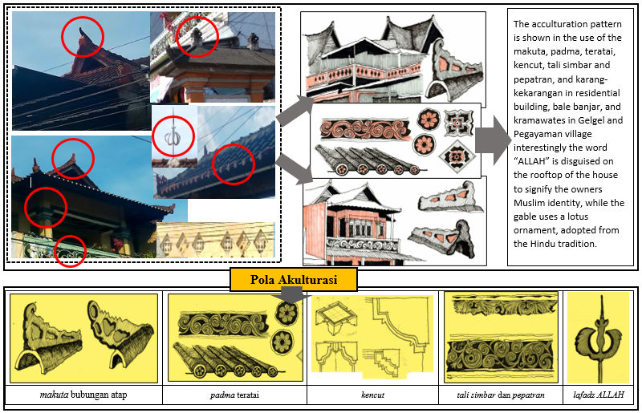
Acculturation Pattern

Figure 8. The acculturation pattern in residential buildings

3.3 THE ASSIMILATION OF ISLAMIC AND HINDU CULTURE IN THE ARCHITECTURE OF GELGEL MUSLIM COMMUNITY
Assimilation was observed in the settlement pattern of Gelgel Village, leading to the formation of many intersections, or meeting points, between roads and alleys, called maputer-puter or ngerebong (labyrinth pattern). The concept of nyama slam and menyama braya, held firmly by the Muslim community in Gelgel Village, influenced the settlement pattern in the form of a colony. The shape, spatial arrangement, and layout of the building mass indirectly strengthened kinship relations within the community, despite differing beliefs [38].

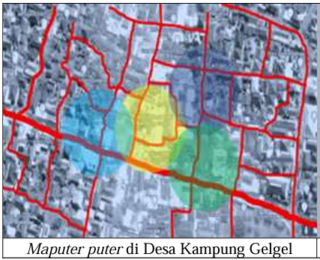

Figure 9. The maputer-puter pattern, which forms a labyrinth in the spatial arrangement of Gelgel Village
[source: Google Map, modified by Authors]

The community leaders in the two villages stated that the spatial arrangement pattern was associated with the guerrilla warfare strategy used as a defense fortress. The influence of maputer-puter or ngerebong on the placement pattern of the building mass was proven by the presence of alleys or corridors between the housing units. The numerous alleys in Gelgel Village indirectly reveal the closeness of the houses deliberately arranged in communities. This pattern was based on a strong family system according to the principles of menyama braya and nyama slam. When associated with the concept of traditional Balinese architecture spatial planning, it can be compared (similar) to Pempatan Agung due to the numerous intersections at each end of the road.
In other aspects of architectural culture, there are virtually no new patterns or forms from the cross-culture relationship between Islam and Hinduism. Unlike acculturation, there was slight assimilation, partly due to the rejection of Balinese and cultural influences originating in Hindu teachings, which were considered to conflict with the values of Islamic religious beliefs based on the Qur'an, Hadith, Ijma, and Qiyas. This rejection, for example, was associated with the prohibition of statues (humans, animals, astral beings, etc.), the concept of tri mandala (nista, madya, utama), sangha mandala (nine sacred cardinal directions), karang sae, karang tapel, karang asti, karang boma, and the cosmological axis of hulu-teben.
The assimilation of architectural forms did not occur because of a strong adherence to Islamic religious beliefs. During a cross-ethnic interaction, there tend to be three segment spaces, namely (1) one with a focus on culture absolutism, (2) culture mixing and value crossing, and (3) a segment space that enables culture exchange but does not merge with the essential customs [49]. The segment space that prioritizes absolute culture in the Gelgel Village was symbolized by the religious system, namely Islam. The segment space of cultural artifact mixing was evident in the architectural appearances of both places of worship and houses. Cultural space was mixed but did not merge with the essential limit, as evident in cuisines such as lawar rice. However, the community does not consume pork and blood because it is contrary to Islamic teachings.
The findings on assimilation are clearly evident in the settlements of Kampung Gelgel Village, in the form of a maputer puter or ngerebong (winding) pattern, namely in groups or gatherings that form colonies (labyrinths). This pattern has existed since the 14th-century Gelgel Kingdom, which is associated with guerrilla warfare strategies used to defend against enemies. The implications of this pattern are evident in the many alleys and the close arrangement of building masses, which show the strength of the bonds of brotherhood regardless of religion. When associated with the spatial layout of Traditional Balinese Architecture, it is similar to Pempatan Agung, which has many intersections at each end of the road. Acculturation and assimilation of architectural culture tend not to conflict with Islamic teachings. Therefore, the influence of menyama braya, Nyama Slam, and Nyama Hindu (the concept of Islamic and Hindu kinship) is accepted as part of muamalah because it does not affect matters of faith. The inheritance of architectural culture is based on respect and appreciation, grounded in the concept of Catur Guru and the values of Islamic teachings derived from the Qur'an, Ijma, and Qiyas.

CONCLUSION
The research reveals significant insights into the architectural integration of Hindu and Islamic cultures within the Muslim community of Gelgel Village, Bali. We identify four distinct patterns of acculturation: saka guru (pillars), tali simbar (horizontal lines), pepatran (floral carvings), and kencut (decorative blades). These elements, traditionally associated with Balinese Hindu architecture, have been adapted for use in Islamic buildings, including mosques, madrasahs, and community centers, enriching their aesthetic and symbolic dimensions. Assimilation is prominently observed in the labyrinthine maputer-puter spatial pattern, which reflects the influence of the Balinese pempatan agung concept. This adaptation integrates Hindu spatial planning while respecting Islamic values, demonstrating a unique blend of cultural coexistence. Furthermore, the Islamic structures in Gelgel Village incorporate local decorative motifs while adhering to Islamic principles, reflecting both cultural harmony and the preservation of religious identity.
The findings are highly relevant to the broader discourse on multiculturalism, architectural adaptation, and religious coexistence. The study enhances scholarly understanding of Islamic architecture’s evolution in minority contexts, where cross-cultural interactions shape unique architectural identities. Given the scarcity of research on Islamic architecture in Hindu-majority regions of Southeast Asia, this work significantly enriches the literature. It offers valuable insights for architects, historians, and cultural theorists.
Future research can build on the aforementioned findings by expanding the analysis to other Muslim minority communities in Bali and Indonesia to explore regional variations in cultural integration, investigating the sociopolitical and economic factors that influence architectural assimilation and acculturation, and developing comparative studies between Bali and other multicultural regions to understand the global patterns of religious and cultural hybridity in architecture. Moreover, it is also important to examine the role of community participation in preserving and transforming architectural heritage within minority contexts.

AUTHORS CONTRIBUTION
All authors have made substantial contributions to the paper. B contributed to the article's conceptualization, theoretical studies, research design, data analysis, and interpretation of research results. N completed the literature reviews, data collection, data analysis, and visual sketch. T contributed to the conceptualization, literature reviews, draft review, and final manuscript revision and editing. D wrote the original draft. F contributed to the data collection. Each author has approved the submitted version and agrees to be personally accountable for the author’s own contributions.

ACKNOWLEDGEMENT
The authors are grateful to the Rector of the Universitas Pendidikan Indonesia, and the Head of the Research and Community Service Institute at the Universitas Pendidikan Indonesia, for funding this study. This research publication is also funded by the Indonesian Endowment Fund for Education (LPDP) on behalf of the Indonesian Ministry of Higher Education, Science and Technology and managed under the EQUITY Program (Contract No. 4314/B3/ DT.03.08/2025 and No. 352/ UN40/HK.00.10/2025). The authors are also grateful to the Management of Gelgel Village, the Management of the Nurul Huda Mosque Prosperity Council (DKM), and the communities for their willingness to participate in this study.

REFERENCES
[1] O. Grabar, The Formation of Islamic Art. New Haven: Yale University Press, 1987.
[2] I. b. Tajudeen, "Trade, Politics, and Sufi Synthesis in the Formation of Southeast Asian Islamic Architecture," in A Companion to Islamic Art and Architecture, F. B. Flood and G. Necipoğlu Eds. Hoboken, NJ: John Wiley & Sons, Inc., 2017, pp. 996-1022.
[3] N. A. Akmal, "A Culture of Tolerance in Islamic Religious Theoretical Sources," Galaxy International Interdisciplinary Research Journal, vol. 10, no. 6, pp. 1201-1205, 2022. https://internationaljournals.co.in/index.php/giirj/article/view/2338.
[4] T. Aryanti, "The mosques of Southeast Asia: A narrative of representation and negotiation," in Southeast Asian Islam: Integration and Indigenisation, N. M. Arif and A. Panakkal Eds., 1st ed. India: Routledge, 2024, pp. 263-289.
[5] E. J. Grube and G. Michell, Architecture of the Islamic World: Its History and Social Meaning, with a Complete Survey of Key Monuments. Thames and Hudson, 1978.
[6] G. Michell, Architecture of the Islamic World: Its History and Social Meaning. London: Thames and Hudson, 1978.
[7] C. Formichi, Islam and Asia. Cambridge, New York, Melbourne, New Delhi, Singapore: Cambridge University Press, 2020.
[8] M. Frishman and H.-U. Khan, Eds. The Mosque. London: Thames and Hudson Ltd., 1994.
[9] H. J. D. Graaf, "The Origin of the Javanese Mosque," Journal of Southeast Asian History, vol. 4, no. 1, pp. 1-5, 1963. DOI: https://doi.org/10.1017/S0217781100000727.
[10] B. S. Budi, "A Study on the History and Development of the Javanese Mosque Part 3: Typology of the Plan and Structure of the Javanese Mosque and Its Distribution," Journal of Asian Architecture and Building Engineering, vol. 5, no. 2, pp. 229-236, 2006. Doi: https://doi.org/10.3130/jaabe.5.229.
[11] B. S. Budi and A. S. Wibowo, "A Typological Study of Historical Mosques in West Sumatra, Indonesia," Journal of Asian Architecture and Building Engineering, vol. 17, no. 1, pp. 1-8, 2018, doi: 10.3130/jaabe.17.1.
[12] B. Wiryomartono, Seni Bangunan dan Seni Binakota di Indonesia [The Art of Building and Urban Design in Indonesia]. Jakarta: Gramedia, 1995.
[13] B. Wiryomartono, "A Historical View of Mosque Architecture in Indonesia," The Asia Pacific Journal of Anthropology, vol. 10, no. 1, pp. 33-45, 2009, doi: 10.1080/14442210902758715.
[14] G. F. Pijper, Fragmenta Islamica: Studien Over Het Islamisme in Nederlandsch-Indie [Fragmenta Islamica: Some Studies on Islam in the Colonial Indonesia]. Leiden: E. J. Brill, 1934.
[15] L. F. Brakel and H. Massarik, "A Note on the Panjunan Mosque in Cirebon," Archipel, vol. 23, pp. 119-134, 1982, doi: https://doi.org/10.3406/arch.1982.1727.
[16] T. Aryanti, "The Center vs. the Periphery in Central-Javanese Mosque Architecture," Dimensi Teknik Arsitektur, vol. 34, no. 2, pp. 73-80, 2007, doi: https://doi.org/10.9744/dimensi.34.2.pp.%2073-80.
[17] K. R. Kurniawan and R. A. Kusumawardhani, "The influence of 19th century Dutch Colonial Orientalism in spreading Kubah (Islamic Dome) and Middle-Eastern architectural styles for Mosques in Sumatra," Journal of Design and Built Environment, vol. 11, no. 1, pp. 1-13, 2012. https://mjes.um.edu.my/index.php/jdbe/article/view/5330.
[18] N. C. Idham, "Javanese Islamic Architecture: Adoption and Adaptation of Javanese and Hindu-Buddhist Cultures in Indonesia," Journal of Architecture and Urbanism, vol. 45, no. 1, pp. 9-18, 2021. DOI: https://doi.org/10.3846/jau.2021.13709.
[19] A. Kusno, "'The Reality of One-which-is-two', Mosque Battles, and Other Stories: Architecture, Religion and Politics in the Javanese World," Journal of Architectural Education, vol. 57, no. 1, pp. 57-67, 2003. Doi: https://doi.org/10.1162/104648803322336593.
[20] I. A. Wirakusumah, A. Antariksa, and P. Salura, "Needs and wants in mosque architecture: a study of traditional and modern mosques in West Java-Indonesia," Linguistics and Culture Review, vol. 5, no. S3, pp. 381-395, 10/22 2021, doi: 10.21744/lingcure.v5nS3.1535.
[21] M. I. Hasan, B. N. Prabowo, and H. H. B. Mohidin, "An Architectural Review of Privacy Value in Traditional Indonesian Housings: Framework of Locality-Based on Islamic Architecture Design," Journal of Design and Built Environment, vol. 21, no. 1, pp. 21-28, 2021, doi: https://doi.org/10.22452/jdbe.vol21no1.3.
[22] H. Hidayatulloh, "Perkembangan Arsitektur Islam: Mengenal Bentuk Arsitektur Islam di Nusantara," Ngabari: Jurnal Studi Islam dan Sosial, vol. 13, no. 2, pp. 15-33, 2020.
[23] M. Alifuddin, A. Alhamuddin, A. Rosadi, and E. Ariwidodo, "Understanding Islamic Dialectics in The Relationship with Local Culture in Buton Architecture Design," KARSA Journal of Social and Islamic Culture, vol. 29, no. 1, pp. 230-254, 2021, doi: 10.19105/karsa.v29i1.3742.
[24] E. Farrag, "Architecture of mosques and Islamic centers in Non-Muslim context," Alexandria Engineering Journal, vol. 56, no. 4, pp. 613-620, 2017, doi: https://doi.org/10.1016/j.aej.2017.08.001.
[25] M. M. Rashid and K. Bartsch, "Historical Fabulation: A Framework to Rethink the Islamic Architecture Outside Islamic World," Archnet-IJAR: International Journal of Architectural Research, vol. 8, no. 1, pp. 120-132, 2014.
[26] V. F. Biondo, "The Architecture of Mosques in the US and Britain," Journal of Muslim Minority Affairs, vol. 26, no. 3, pp. 399-420, 2006/12/01 2006, doi: 10.1080/13602000601141414.
[27] P. K. Denpasar, "Pemeluk Agama Hindu Bali Terbanyak di Indonesia pada Juni 2021," in Link Resmi Pemerintah Kota Denpasar, Denpasar: Dinas Kominfos, 2021.
[28] H. M. Bhasyar, Identitas Minoritas di Indonesia: Kasus Muslim Bali di Gianyar dan Tabanan. Jakarta: LIPI Press, 2010.
[29] D. Mashad, Muslim Bali: Mencari Kembali Harmoni yang Hilang. Jakarta: Pustaka Al-Kautsar, 2014.
[30] N. Diana, "Islam masuk ke Bali dan dampaknya terhadap Perkembangan Islam di Bali," Tamaddun vol. 4, no. 2, 2016.
[31] B. Husain and A. Khusyairi, "Sailing to the Island of the Gods’: Bugis Migration in Bali Island," Utopía y Praxis Latinoamericana, vol. 25, no. 6, pp. 332-341, 2020, DOI: https://doi.org/10.5281/zenodo.3987634.
[32] Fathorraman, "Inklusifisme Di Tengah Masyarakat Multikultur: Kasus Tiga Komunitas Muslim Di Bali," Jurnal PENAMAS vol. 32, no. 1, pp. 589-602, 2019.
[33] R. P. Putra, "Awal Penyebaran dan Perkembangan Agama Islam di Pulau Bali," Jurnal Keislaman, vol. 6, no. 1, 2023, DOI: https://doi.org/10.54298/jk.v6i1.3622.
[34] N. Nuryanto, M. S. Barliana, F. Rahmannullah, R. Mardiana, and K. H. Dwidayati, "Asimilasi dan Akulturasi Arsitektur pada Komunitas Muslim Bali Studi Kasus: Desa Pegayaman dan Desa Kampung Gelgel," Sinektika Jurnal Arsitektur, vol. 21, no. 1, pp. 88-94, 2024, doi: https://doi.org/10.23917/sinektika.v21i1.3147.
[35] M. S. Barliana, M. Purnamaningsih, T. Ramadhan, and I. Susanti, "Friendly school design of early childhood based on traditional Sundanese architecture typology," Journal of Asian Architecture and Building Engineering, vol. 22, no. 4, pp. 1995-2005, 2023, doi: 10.1080/13467581.2022.2153058.
[36] M. Berray, "A Critical Literary Review of the Melting Pot and Salad Bowl Assimilation and Integration Theories," Journal of Ethnic and Cultural Studies, vol. 6, no. 1, pp. 142-151, 2019. https://www.jstor.org/stable/48710211.
[37] Y.-y. Hong and C. Schmidt, Multiculturalism and Cultural Assimilation, Oxford University Press, 2021.
[38] L. E. Prasetya, "Akulturasi Budaya pada Masyarakat Muslim Desa Pegayaman Buleleng Bali," Jurnal Arsitektur, vol. 2, no. 2, 2012, doi: 10.36448/jaubl.v2i2.305.
[39] I. G. Suwindia, "Relasi Islam dan Hindu Perspektif Masyarakat Bali," Al-Ulum: Jurnal Studi Islam, vol. 12, no. 1, pp. 53-76, 2012.
[40] K. Indriana, "Dinamika Kehidupan Minoritas Muslim Di Bali," Masyarakat Indonesia, vol. 37, no. 2, pp. 115-145, 2011, doi: 10.14203/jmi.v37i2.635.
[41] A. B. Made, "JEJAK PERKEMBANGAN ARSITEKTUR DI BALI," Jurnal Anala, vol. 6, no. 1, 2018, doi: 10.46650/anala.6.1.581.38-52.
[42] F. Z. Ramdhani, B. Busro, and A. Wasik, "The Hindu-Muslim Interdependence: A Study of Balinese Local Wisdom," Walisongo: Jurnal Penelitian Sosial Keagamaan, Vol. 28, No. 2, pp. 195-218, 2020, DOI: 10.21580/ws.28.2.6769.
[43] Y. Bachtiar, A. A. Bagus Wirawan, and I. A. Putu Mahyuni, "EKSISTENSI KOMUNITAS MUSLIM DAN HINDU," Jurnal Pariwisata PaRAMA: Panorama, Recreation, Accommodation, Merchandise, Accessibility, vol. 3, no. 2, pp. 57-65, 2022.
[44] F. Amalia, "NGAMINANG: ADAPTASI BUDAYA MAKAN MEGIBUNG BALI PADA MASYARAKAT ISLAM DI DESA KAMPUNG GELGEL, KABUPATEN KLUNGKUNG," VIDYA WERTTA : Media Komunikasi Universitas Hindu Indonesia, vol. 6, no. 1, pp. 1-12, 2023, doi: 10.32795/vw.v6i1.3962.
[45] M. B. Miles, A. M. Huberman, and J. Saldana, Qualitative Data Analysis: A Methods Sourcebook. Los Angeles, London, New Delhi, Singapore, Washington DC and Melbourne: Sage Publications, Inc., 2018.
[46] E. Agustian, "KARAKTERISTIK PERMUKIMAN MUSLIM DI BALI (KASUS: FENOMENA PERMUKIMAN DESA PEGAYAMAN, KABUPATEN BULELENG)," Plano Madani : Jurnal Perencanaan Wilayah dan Kota, vol. 11, no. 1, pp. 1-17, 2022, doi: 10.24252/jpm.v11i1.28709.
[47] R. Annisa, "Peninggalan Sejarah Islam di Buleleng Bali," Istoria Jurnal Pendidikan dan Sejarah, vol. 16, no. 1, pp. 1-12, 2020, doi: 10.21831/istoria.v16i1.16495.
[48] A. Fanani, Arsitektur masjid. Penerbit Bentang, 2009.
[49] G. K. G. Arsana, "Segresi Sosial dan Pola Adaptasi Budaya dalam Kehidupan Pluralisme Agama di Desa Dalung, Kecamatan Kuta Utara, Kabupaten Badung," Program Pascasarjana, Universitas Udayana, Denpasar, 2006.

