 |  | JOURNAL OF ISLAMIC ARCHITECTURE  P-ISSN: 2086-2636 E-ISSN: 2356-4644  Journal Home Page: http://ejournal.uin-malang.ac.id/index.php/JIA
COMPARATIVE ANALYSIS OF MOSQUE ACOUSTICS QUALITY IN TROPICAL AND NON-TROPICAL CLIMATES
Ernaning Setiyowati¹, Sri Nastiti N. Ekasiwi^{1*,} FX Teddy Badai Samudra¹
¹Architecture Department, Institut Teknologi Sepuluh Nopember, Surabaya, Indonesia
*Corresponding Author: ekasiwi@its.ac.id
ARTICLE INFO |  |  | ABSTRACT
Volume: 9  Issue: 1  Page: 409-429  Received: November 19th, 2024  Accepted: April 28th, 2026  Available Online: June 30th, 2026  DOI: https://doi.org/10.18860/jia.v9i1.29920 |  |  | This study investigates the comparative acoustic performance of tropical and non-tropical mosques, focusing on key parameters including Reverberation Time (RT), Clarity (C₈₀), Definition (D₅₀), and Speech Transmission Index (STI). Data were collected from multiple case studies, including tropical and non-tropical mosques, to evaluate their suitability for speech-related religious activities. A meta-analysis was executed utilizing acoustic datasets compiled from 20 mosques across existing literature. Ordinary Least Squares (OLS) multiple linear regression models were constructed for each individual acoustic parameter to isolate the independent and combined predictive power of the structural variables. The results reveal that tropical mosques generally exhibit lower reverberation times and smaller deviations from recommended values, indicating more controlled acoustic environments. In contrast, non-tropical mosques tend to have higher RT values, often exceeding optimal limits due to large enclosed volumes and reflective materials. In terms of clarity (C₈₀) and definition (D₅₀), tropical mosques more frequently achieve values within or near recommended ranges, suggesting a better balance between early and late sound energy and improved speech intelligibility. Non-tropical mosques, however, exhibit greater variability, with several cases showing either excessive reverberation. The STI analysis further demonstrates that tropical mosques have the potential to achieve superior speech intelligibility. Non-tropical mosques generally fall within moderate levels of intelligibility. These differences are primarily influenced by architectural typology, spatial configuration, building volume, material characteristics, and the presence of electroacoustic systems. Tropical mosques, characterized by semi-open layouts and climate-responsive design strategies, inherently facilitate better sound dissipation and acoustic balance. This study concludes that while tropical mosque architecture tends to provide more favorable acoustic conditions, achieving optimal performance requires a holistic integration of architectural design, material selection, and acoustic treatment, regardless of climatic context.  Keywords:  Architectural acoustic; Tropical mosque; Comparative study; Acoustics; Mosque design; Climatic architecture; Islamic architecture

INTRODUCTION
A mosque is fundamentally an auditory space. As a central place of worship for Muslims, it requires an appropriate acoustic environment to support the wide range of activities performed within it [1]. The primary functions of a mosque, such as congregational prayers, the delivery of Friday sermons, and Quranic recitation, are entirely reliant on high-quality speech intelligibility and acoustic comfort [2], [3]. A well-designed acoustic environment fosters spiritual focus, whereas poor acoustics can result in muddy, unintelligible speech, disrupting worshippers' concentration and comfort. Therefore, the acoustic performance of a mosque is not merely an engineering concern, but a core component of its religious function. Despite this significance, research on mosque acoustics and soundscapes remains relatively limited compared to studies of other religious buildings, such as churches or temples.
Historically, the architectural evolution of the mosque has been profoundly shaped by its geographic and climatic context, leading to vastly different acoustic environments. In non-tropical regions, such as the arid Middle East or temperate Europe, mosques are traditionally designed as heavy, enclosed masonry structures to insulate against harsh winters or extreme desert heat. The quintessential Mediterranean or Ottoman Mosque, characterized by cascading stone domes and thick, sealed walls, acts as an acoustic fortress. This geometry creates highly reflective, reverberant soundscapes that isolate the congregation from the external urban environment, historically utilizing long reverberation times to elevate the unamplified human voice into a resonant, ethereal experience [4].
Conversely, mosques built in tropical climates, such as Southeast Asia, require architecture that manages intense humidity and heavy monsoon rains. These structures typically feature steep, tiered pyramidal roofs (such as the traditional Javanese form) and highly porous, semi-open perimeters, like the verandas, to maximize cross-ventilation [5]. Because these buildings lack thick, enclosing boundary walls, their physical acoustics are distinctly less reverberant. Furthermore, their soundscape is highly permeable; the internal auditory experience of worship is continuously interwoven with external environmental noise, seamlessly blending the sacred space with the surrounding community and nature.
While a substantial body of literature has evaluated the physical acoustics of enclosed, historical domed mosques, often focusing on mitigating excessive Reverberation Time (RT) through modern audio interventions [6], there is a notable lack of comparative research. Specifically, the juxtaposition of traditional tropical mosque typologies against non-tropical typologies remains underexplored. Most existing guidelines for acoustic optimization in worship spaces are generalized, often failing to account for the unique environmental integration, background noise challenges, and acoustic profiles inherent to semi-open tropical designs. However, most studies on mosque acoustics and soundscape have been conducted within a single climatic context, and comparative analyses across different climates are lacking. Such comparisons are essential, as they may reveal unique soundscape characteristics shaped by climate, thereby deepening our understanding of mosque acoustics and providing a foundation for future research.
Therefore, this paper aims to bridge this gap in the literature by systematically comparing the acoustic environments of mosques in tropical and non-tropical regions. Specifically, this study will analyze and compare the physical acoustic parameters of mosque architectures in tropical and non-tropical areas, and propose climate-specific acoustic guidelines for modern mosque design that respect both the architectural heritage of the region and the auditory comfort of the congregation.

METHODS
The primary purpose of this study is to evaluate and compare the acoustic performance of mosques located in tropical climates against those in non-tropical climates. This research evaluates secondary data extracted from a curated selection of 20 previously published, peer-reviewed studies (10 tropical and 10 non-tropical). A structured comparative meta-analytical approach is employed. This chapter outlines the research framework, the selection criteria for building types, the climatic classification, the acoustic parameters evaluated, and the statistical methods used to analyze the data.

2.1 RESEARCH DESIGN
This study adopts a systematic comparative literature review and meta-analysis approach. Rather than performing primary empirical field measurements, this research synthesizes, normalizes, and compares quantitative acoustic data from 20 independent case studies published in scientific literature. The methodology follows a four-step framework:
- Identification & Selection: Sourcing peer-reviewed publications featuring empirical or simulated acoustic data for individual mosques.
- Categorization: Classifying mosques by geographic and climatic zones (Tropical vs. Non-Tropical).
- Data Extraction & Harmonization: Compiling key acoustic and architectural parameters into a unified matrix.
- Comparative Analysis: Evaluating cross-climatic trends using descriptive and multiple linear regression statistical methods.

2.2. SELECTION CRITERIA AND DATASET COMPOSITION
To ensure valid comparisons, strict inclusion and exclusion criteria were established for the literature search:
- Inclusion Criteria: The study must provide objective acoustic metrics, specifically Reverberation Time, measured or simulated. The architectural volume and material characteristics of the main prayer hall must be documented.
- Exclusion Criteria: Studies that used purely qualitative assessments or focused solely on electroacoustic sound reinforcement systems without baseline room-acoustic data were excluded.

A total of 20 mosques were selected, evenly divided into two structural cohorts:
- Tropical Cohort (N = 10): Located within equatorial, tropical rainforest, or tropical savanna climate zones. These regions are characterized by consistently high ambient temperatures and high relative humidity (RH).
- Non-Tropical Cohort (N = 10): Located in temperate, arid, Mediterranean, or cold climate zones. These regions experience distinct seasonal variations, lower average humidity, or hyper-arid conditions

2.3. CLIMATIC AND ARCHITECTURAL VARIABLES
The underlying premise of this comparative analysis is that regional climate dictates architectural adaptations, which in turn govern room acoustics. This methodology evaluates two primary climate-driven mechanisms:
- Surface Materials and Thermal Comfort: In tropical climates, mosques often utilize high-thermal-mass, hard, and non-porous materials to maintain cool indoor environments. These materials are highly sound-reflective. Conversely, non-tropical climates may employ heavy carpets, acoustic wall linings, or multi-layered glass for thermal insulation, which accidentally act as passive acoustic absorbers.
- Ventilation and Openness: Tropical mosques frequently favor semi-open layouts, large operable windows, or permanent structural openings to maximize natural cross-ventilation. This alters the active air volume, introduces high levels of environmental background noise, and exposes the interior to high relative humidity (which alters air absorption at high frequencies). Non-tropical mosques tend to feature closed, sealed envelopes reliant on mechanical HVAC systems.

2.4. SELECTED ACOUSTIC PARAMETERS
To quantify and compare acoustic quality, data extraction focuses on four core room-acoustic indicators, predominantly analyzed at the mid-frequencies (500 Hz to 1,000 Hz), which are critical for speech intelligibility and Qur'anic recitation (Table 1).

Table 1. The Acoustic Parameters to Compare the Room Acoustic Quality

Parameter | Unit | Description | Indicator
Reverberation Time (T₃₀​/T₆₀​) | Seconds (s) | Time required for sound energy to decay by 60 dB after the source stops. | Depends on the room volume, the sound-absorption coefficient of the material used, and the material's surface area[7].
Speech Clarity (C₅₀) and C₈₀) | Decibels (dB) | Clarity (C₈₀) is defined as the logarithmic ratio, expressed in decibels, between the early sound energy arriving within the first 80 milliseconds and the late-arriving energy thereafter. | The acceptable range for C₈₀ lies between −4 dB and +4 dB [8]
Definition (D₅₀) | % | D50 represents the ratio of early-to-late arriving sound energy within the first 50 milliseconds. | D50 values are commonly classified into three categories: “bad” (0–30%), “fair” (30–60%), and “good” (60–100%), reflecting the degree of clarity and intelligibility achieved within a space [9].
Speech Transmission Index (STI) | Scale (0 to 1) | An objective metric representing speech transmission quality through an acoustic channel. | STI values are typically categorized as follows: 0–0.32 (bad), 0.32–0.45 (poor), 0.45–0.60 (fair), 0.60–0.75 (good), and 0.75–1.00 (excellent) [10].

2.5. DATA ANALYSIS AND STATISTICAL FRAMEWORK
Once the dataset is compiled, the analytical phase proceeds through two distinct stages:
- Architectural comparison between tropical and non-tropical mosques
The physical attributes (Volume, dominant interior materials, openness ratio, and interior form) are cross-referenced with the acoustic metrics. Sabine's classic reverberation equations are referenced to evaluate how the overall absorption coefficients differ between the two cohorts, driven by climate-related material choices.
- Room acoustic quality comparison between tropical and non-tropical mosques.
To determine differences in acoustic quality between tropical and non-tropical mosques, the four parameters (RT, C₈₀, D₅₀, STI) were compared across mosques. In this stage, the acoustic quality of each mosque closest to the recommended value would be identified, and the best- and worst-performing mosques would be determined.
- Causal and Relative Impact Analysis (Multiple Linear Regression)
To isolate and determine the relative influence of physical attributes on mosque acoustics, a Multiple Linear Regression (MLR) analysis was executed. The primary objective of the MLR model is to identify which architectural predictor (Room Volume, Enclosure Materiality, Openness ratio, or Spatial Form) has the greatest impact on the dependent variable (RT, C₈₀, D₅₀, STI).

RESULT AND DISCUSSION

ARCHITECTURAL CHARACTERISTICS
The design and function of a mosque are shaped not only by Islamic traditions but also by the climate, geography, and culture of its location. While all mosques share universal features like the qibla (direction of Mecca), a prayer hall, and ablution facilities, a mosque in a hot, humid, and rainy tropical climate will differ significantly from one in a non-tropical climate.
The climate classifications of the research locations are summarized in Table 2. Given that most existing research has focused on mosques in tropical regions. This study organizes its analysis into two primary categories: tropical and non-tropical mosques.

Table 2. The climate types of the Mosque soundscape research location

No | Country | Climate
1 | Turkey | Mediterranean climate
2 | Indonesia | Tropical climate
3 | Malaysia | Tropical climate
4 | Saudi Arabia | Semi-Arid climate
5 | Egypt | Arid climate
6 | Iran | Semi-Arid climate

3.1.1 Architectural Characteristics for Mosques in Tropical Areas
Research on tropical mosques is predominantly concentrated in Southeast Asia, a region characterized by a hot–humid climate with high rainfall, high humidity, and relatively constant temperatures. These environmental conditions significantly influence the architectural characteristics of mosques, particularly their form and spatial configuration. In response to intense monsoon rainfall, traditional tropical mosques commonly employ steeply pitched roofs rather than large domes, often incorporating expansive overhangs or multi-tiered systems such as the Javanese roof [11], which facilitates rapid drainage of rainwater. Wide eaves and extended overhangs further serve to protect interior spaces from driving rain while providing substantial shading against intense solar radiation. To address high humidity and promote thermal comfort, these mosques emphasize breathability through porous wall elements, such as wooden louvers, carved screens, or fully open walls combined with large openings that enhance cross-ventilation [12]. The selection of lightweight materials such as timber, clay tiles, and palm leaves also reduces heat retention compared to heavier materials like stone or concrete.
Additionally, elevated foundations, often in the form of stilts or raised platforms, are employed to mitigate flood risks during monsoon seasons while capturing cooler օդ breezes at higher levels. Spatially, tropical mosques tend to adopt lower, horizontally oriented forms with expansive prayer halls and minimal enclosure, thereby reducing heat accumulation and supporting a more thermally responsive built environment.
The spatial organization of a mosque plays a crucial role in regulating airflow and shaping the experiential transition into the sacred space. In tropical regions, this organization is characterized by distinct architectural elements that respond to climatic conditions. One of the defining features is the veranda, a semi-open space that surrounds the main prayer hall. This element functions as a thermal buffer, mediating between the hot exterior environment and the cooler interior, while also serving as a transitional zone and an overflow area during Friday prayers. In addition, open courtyards are commonly incorporated, often enhanced with vegetation or water features such as pools, which facilitate evaporative cooling and help lower temperatures. These spatial strategies demonstrate how architectural design in tropical mosques integrates environmental responsiveness with religious functionality.

3.1.2 Architectural Characteristics for a Mosque in non-Tropical Area
Research on non-tropical mosques is primarily situated in the arid regions of the Middle East and the temperate Mediterranean regions of Europe, where climatic conditions range from hot–dry deserts to cold-temperate and continental environments with pronounced seasonal extremes. These climatic contexts significantly shape the architectural characteristics of mosques, particularly in terms of form, materiality, and environmental performance. In contrast to tropical mosques, non-tropical mosques commonly feature prominent domes and vaults that serve both symbolic and climatic functions: domes facilitate the upward movement of hot air and contribute to thermal regulation in hot–dry climates. In regions with minimal rainfall, such as the Middle East and North Africa, flat or gently sloped roofs are also prevalent due to the limited need for rapid water drainage. Openings in these mosques tend to be smaller, aiming to minimize heat gain in desert climates or reduce heat loss in colder regions, while thick walls provide substantial insulation. Consequently, cross-ventilation is generally less extensive than in tropical counterparts. The use of high-thermal-mass materials, such as stone, brick, and concrete, enables buildings to absorb heat during the day and release it at night in arid environments, or to retain internal warmth in colder climates. Structurally, domes and arches are typically supported by robust masonry systems, reinforcing both durability and climatic responsiveness [13], [14] [15].
The spatial organization of mosques in non-tropical regions is primarily shaped by the need to control airflow and ensure thermal comfort while maintaining a coherent transition into the sacred space. In colder climates, vestibules and foyers are essential components, typically designed as double-door entry systems to prevent the infiltration of freezing air into the main prayer hall. In arid environments, the courtyard (sahn) is often enclosed by high walls and surrounded by arcades, creating deep shade and enabling the retention of cool night air for use during the day. These architectural strategies illustrate how mosque design in non-tropical contexts adapts to environmental constraints while preserving both functional efficiency and the sanctity of spatial experience. Table 3 provides a comprehensive comparison of how these environments influence the mosque's form and room configuration.

Table 3. A Comprehensive comparison of architectural characteristics between tropical and non-tropical mosques

Feature | Tropical Mosques | Non-Tropical Mosques
Mosque Form | Tiered/sloped roofs, wide overhangs, porous walls. | Domes, flat roofs, thick enclosed walls, prominent vestibules.
Room Configuration | Semi-open layouts, large verandas | Enclosed prayer halls, indoor climate control.
Ventilation | Large openings, cross-ventilation | Smaller openings, insulation-focused
Materials | Light, breathable (wood, bamboo, clay) | Heavy, insulating (stone, brick, concrete)

This study employs a comparative approach to examine the acoustic performance of tropical and non-tropical mosques. The data are derived from previous studies on mosque acoustics. The selected case-study mosques are presented in Table 4, and their figures are shown in Table 5.

Table 4. The mosques were used as the case study
NO | MOSQUE NAME | LOCATION | DIMENSION  & CAPACITY | FORM | MATERIAL
TROPICAL MOSQUE
T1 | Pusdai Mosque [16] | West Java, Indonesia. | Volume: 22.889 m³  Capacity: 4600 people | Room: Square with a veranda on the north, south, and east sides  Roof: Layered Pyramidal Roof | Wall: brick, plastered concrete, granite  Floor: carpet  Roof: PVC, gypsum  Window: glass  Door: wood
T2 | Al Furqan Mosque [17] | Bandar Lampung, Indonesia | Volume: 16.900 m³  Capacity: 2000 people | Room: Rectangle  Roof: Layered Pyramidal Roof | Wall: brick, plastered concrete, granite  Floor: carpet  Roof: tile  Window: glass  Door: wood
T3 | Al-Markaz Al-Islami Mosque  [18] | Makassar, Indonesia | Volume: 10.598 m³ | Room: Square  Roof: Layered Pyramidal roof | Floor: granite  Wall: granite  Ceiling: gypsum  Door: wood and glass  Window: aluminum and glass
T4 | The Grand Mosque of Yogyakarta [19] | Yogyakarta, Indonesia | Volume: 12890 m³ | Room: Rectangle with veranda on the north, south, and east sides  Roof: Layered Pyramidal Roof | Floor: carpet  Wall: sandstone without finishing  Ceiling: wooden board
T5 | Dato Bentara Luar Mosque [20] | Malaysia | Volume: 2962,2  Capacity: 760 people | Room: Rectangle  Roof: Pyramidal roof | Floor: carpet  Wall: brick plastered  Ceiling: gypsum  Door: wood  Window: wood
T6 | Sayyidina Abu Bakar mosque [21] | Malaysia | Volume: 19,500 m3  Capacity: 4000 people | Room: Square  Roof: Layered Pyramidal Roof | Wall: concrete  Ceiling: plaster  Floor: carpet on concrete  Window: glass  Door: solid wooden door
T7 | Sunan Ampel Mosque (old building area) [22] | Surabaya, Indonesia | Volume: 12.523 m³  Capacity: 1000 people | Room: square  Roof: Layered Pyramidal Roof | Wall: brick  Floor: granite  Window: wood  Door: solid wooden door
T8 | UI Mosque [23] | Jakarta, Indonesia | Volume: 5000 m³  Capacity: 2000 people | Room: square  Roof: Layered Pyramidal Roof | Wall: open  Floor: granite  Roof: clay
T9 | Masjid Al-Irsyad [24] | Bandung, Indonesia | Volume: 9.355 m³  Capacity: 1000 people | Room: Square  Roof: flat | Wall: open  Floor: carpet  Roof: concrete
T10 | Taman Putri Kulai Mosque [25] | Johor, Malaysia | Volume: 3425 m³  Capacity: 600 people | Room: Square  Roof: flat | Wall: geometric perforated panel  Floor: carpet  Roof: concrete
NON-TROPICAL MOSQUE
NT1 | Yeni Mosque [26] | Tire, Turkey | Volume: 3442 m3  Capacity: 291 people | Room: square  Roof: dome | Floor: carpet  Wall: plastered
NT2 | Sultan Mosque [26] | Manisa, Turkey | Volume: 4000 m3  Capacity: 375 people | Room: rectangle  Roof: multi dome | Floor: carpet  Wall: plastered
NT3 | Jedid Mosque [27] | Algiers, Algeria | Volume: 10.500 m³  Capacity: 915 | Room: rectangle  Roof: multi dome | Wall: plastered  Window: glass  Floor: carpet  Mezzanine: wood
NT4 | Attarece Mosque [28] | Manisa, Turkey | Volume: 1510 m³ | Room: rectangle  Roof: flat | Wall: plastered, wooden panel  Mihrab wall: tile  Floor: carpet
NT5 | The Dayk Mosque [29] | Erbil, Iraq | Volume: 3650  Capacity: 800 | Room: Square  Roof: Dome flat | Floor: carpet  Wall: gypsum plastering, wood, glass  Window: 7% wall surface, covered with a curtain  Ceiling: gypsum board
NT6 | Altun Mosque [29] | Erbil, Iraq | Volume: 13.000 m³  Capacity: 980 | Room; Square  Roof: Dome | Floor: carpet  Wall: gypsum plastering, wood, marble  Window: 20% wall surface, covered with a curtain  Ceiling: gypsum board and wood
NT7 | The Ketchaoua Mosque [30] | Algeirs, Algeria | Volume: 11000 m³.  Capacity: 1200 people | Room: Rectangle  Roof: dome | Floor: carpet
NT8 | the Aslanhane Mosque (Turkey) [31] | Anatolia, Turkey | Volume: 4.300 m³ | Room: Square  Roof: flat | Door: wood  Floor: carpet  Wall: historical plaster  Ornamental wooden finishing
NT9 | Fatih Pasha (Kurşunlu) Mosque [32] | Diyarbakir, Turkey | Volume: 4520 m³ | Room; Square  Roof: Dome | Mihrab: marble  Dome: brick with lime plastered  Wall: basalt rubble stone plastered  Door: wood  Window: wood  Floor: carpet
NT10 | ÜÇ Şerefeli Mosque [33] | Edirne, Turkey | Volume: 24,000 m³ | Room: Square  Roof: multidome | Floor: carpet  Mihrab: marble  Door: wood  Ceiling: lime cement plaster

Table 5. The Figures of Mosques as the Case Study
Tropical mosque
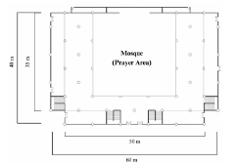  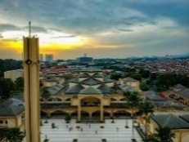  Pusdai Mosque [16] | 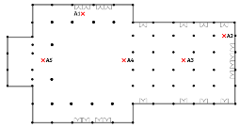    Al-Furqan Mosque [17] | 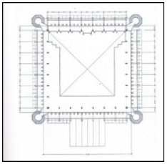  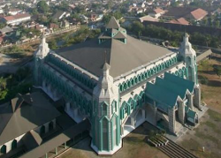  Al-Markaz Al-Islami Mosque [18] | 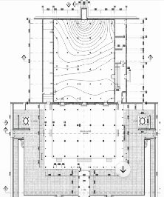  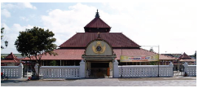  Yogyakarta Grand Mosque [19] | 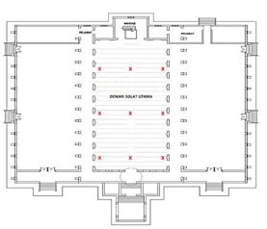    Dato Bentara Luar Mosque [20]
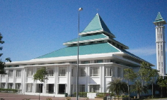  Sayyidina Abu Bakar Mosque [21] | 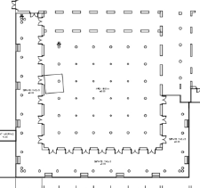    Sunan Ampel Mosque [22] | 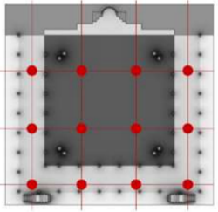  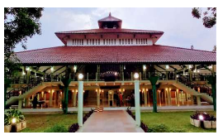  UI Mosque [23] | 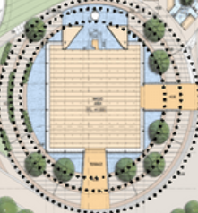  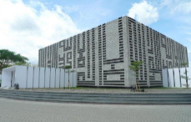  Al-Irsyad Mosque [24] | 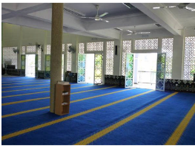  Taman Putri Kulai Mosque[25]
Non-Tropical Mosque
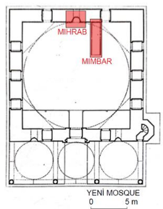  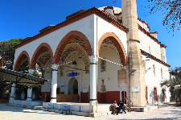  Yeni Mosque [26] | 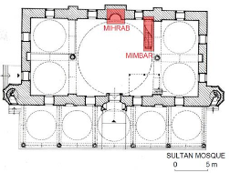  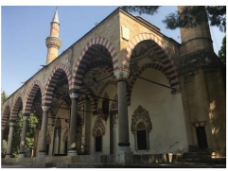  Sultan Mosque [26] | 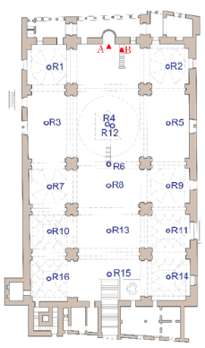    Jedid Mosque [27] | 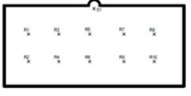  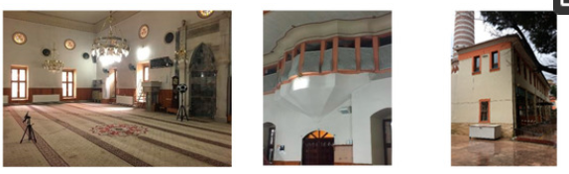  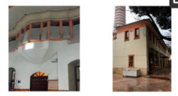  Attar Ece Mosque [28] | 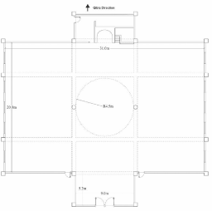  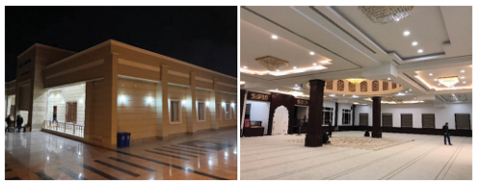  Dayk Mosque [29]
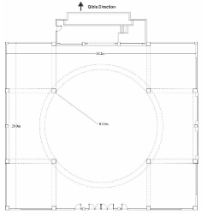  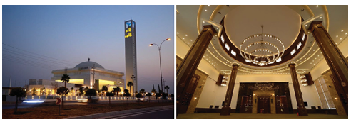  Altun Mosque [29] |   Ketchaoua Mosque [30] | 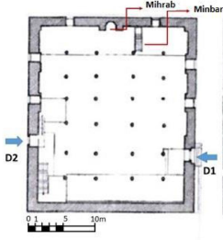  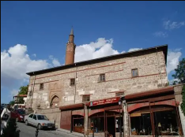  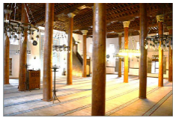  Aslahane Mosque [31] | 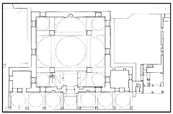  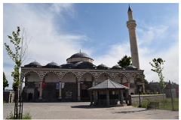  Fatih Pasha Mosque [32] | 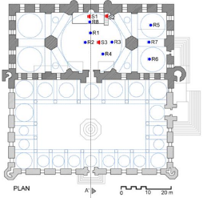  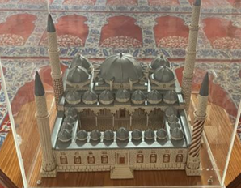  ÜÇ Şerefeli Mosque [33]

ROOM ACOUSTIC QUALITY
3.2.1 Reverberation Time (RT) Characteristic
The comparison of the Reverberation Time (RT) characteristics of tropical and non-tropical mosques is shown in Table 6 and Figure 1, which explains the RT of each mosque, the recommended RT adjusted to the mosque's room volume, and the RT deviation between the measured and recommended RT.

Table 6. The Reverberation Time Comparison of All Case Studies

No | Location | Mosque | RT | Recommended RT | RT deviation | Room Volume
1 | Tropical area | Pusdai Mosque | 3,09 | 1,8 | 1,29 | 22899
2 | Tropical area | Al Furqan Mosque | 2,26 | 1,8 | 0,46 | 16900
3 | Tropical area | Al-Markaz Al-Islami Mosque Makasar | 3,95 | 1,8 | 2,15 | 27728
4 | Tropical area | Yogyakarta Grand Mosque | 1,64 | 1,7 | -0,06 | 12890
5 | Tropical area | Masjid Dato Bentara Luar, Malaysia | 1,77 | 1,4 | 0,37 | 2962
6 | Tropical area | Sayyidina Abu Bakar Mosque, Malaysia | 3,5 | 1,8 | 1,7 | 19500
7 | Tropical area | Sunan Ampel Mosque | 1,54 | 1,8 | -0,26 | 12523
8 | Tropical area | UI Mosque | 0,355 | 1,5 | -1,145 | 5000
9 | Tropical area | Al Irsyad Mosque | 1,7 | 1,6 | 0,1 | 9355
10 | Tropical area | Masjid Taman Putri Kulai Malaysia | 2,3 | 1,7 | 0,6 | 3425
11 | Non-Tropical Area | Yeni Mosque | 3,5 | 1,7 | 1,8 | 3442
12 | Non-Tropical Area | Sultan Mosque | 3,4 | 1,7 | 1,7 | 4000
13 | Non-Tropical Area | Jedid Mosque | 2,52 | 1,5 | 1,02 | 4740
14 | Non-Tropical Area | Attarece Mosque | 1,7 | 1,3 | 0,4 | 1510
15 | Non-Tropical Area | Dayk Mosque | 1,2 | 1,4 | -0,2 | 3650
16 | Non-Tropical Area | Altun Mosque | 2,86 | 1,7 | 1,16 | 13000
17 | Non-Tropical Area | Ketchaoua Mosque | 3,1 | 1,7 | 1,4 | 11000
18 | Non-Tropical Area | Aslanhane Mosque | 1,1 | 1,4 | -0,3 | 3762,5
19 | Non-Tropical Area | Fatih Pasha Mosque | 2,25 | 1,5 | 0,75 | 4520
20 | Non-Tropical Area | ÜÇ Şerefeli Mosque | 5 | 1,8 | 3,2 | 24000

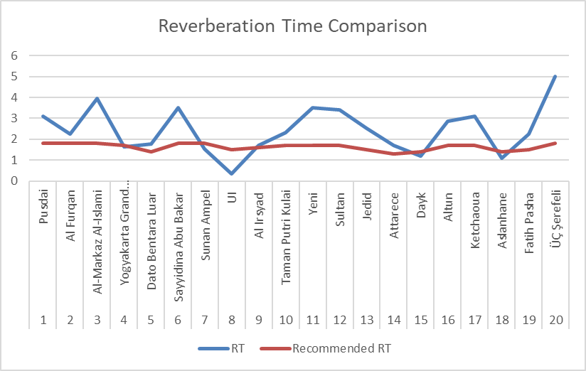

Figure 1. The Reverberation Time Comparison of All Case Studies

The measured reverberation time (RT) across the 20 mosque samples shows substantial variation, ranging from 0,355 s to 5,0 s, indicating diverse acoustic conditions between tropical and non-tropical contexts. Among all cases, the best (closest to recommended RT) performance is observed in Yogyakarta Grand Mosque (RT = 1,64 s; deviation = −0,06 s) [19] and Al Irsyad Mosque (RT = 1,7 s; deviation = 0,1 s) [24]. These mosques demonstrate reverberation times very close to their respective recommended values, indicating balanced acoustic conditions suitable for speech clarity, which is critical for religious activities such as sermons and recitation.
In contrast, the worst acoustic performance is found in ÜÇ Şerefeli Mosque (RT = 5,0 s; deviation = 3,2 s) [33] and Al-Markaz Al-Islami Mosque (RT = 3,95 s; deviation = 2,15 s) [18]. These values exceed the recommended RT by a significant margin, suggesting excessive reverberation that can reduce speech intelligibility. A notably low RT is also observed in UI Mosque (RT = 0,355 s; deviation = −1,145 s) [23]. Although this represents the lowest RT, it falls well below the recommended range, indicating an acoustically “dry” environment, which may reduce spatial impression and auditory comfort.

Table 7. The comparison of the RT value of tropical and non-tropical mosques
 | RT | Recommended RT | RT deviation
Tropical | 2,2105 | 1,69 | 0,5205
non tropical | 2,663 | 1,57 | 1,093

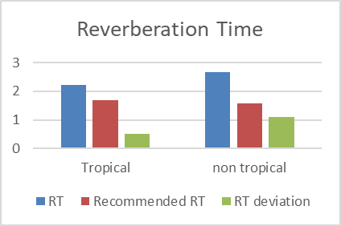

Figure 2. The comparison of the RT value of tropical and non-tropical mosques

From these results, tropical mosques demonstrate better overall acoustic performance, as indicated by lower average RT and smaller deviations from recommended values (Table 7 and Figure 2). In contrast, non-tropical mosques tend to be more reverberant, with deviations approximately twice as large as those in tropical mosques. This suggests that tropical mosque designs are generally more effective at controlling reverberation, resulting in acoustic environments closer to optimal conditions for speech.

3.2.2 Clarity (C₈₀) Characteristic

Table 8. The C₈₀ value of the case study
No | Location | Mosque | C₈₀
1 | Tropical Area | Al-Furqan Mosque | -1,67
2 | Tropical Area | Yogyakarta Grand Mosque | 3,445
3 | Tropical Area | Sayyidina Abu Bakar Mosque | 1
4 | Tropical Area | Sunan Ampel Mosque | 11,19
5 | Tropical Area | AL-Irsyad Mosque | -8
6 | Non-Tropical Area | Yeni Mosque | -5,4
7 | Non-Tropical Area | Sultan Mosque | -3,31
8 | Non-Tropical Area | Jedid Mosque | 1,5
9 | Non-Tropical Area | Attarece Mosque | 1,025
10 | Non-Tropical Area | Ketchaoua Mosque | -6,8
11 | Non-Tropical Area | Aslanhane Mosque | 7,4
12 | Non-Tropical Area | Fatih Pasha Mosque | 0,03
13 | Non-Tropical Area | Gulbahar Hatun Mosque | -1,8
14 | Non-Tropical Area | ÜÇ Şerefeli Mosque | -7

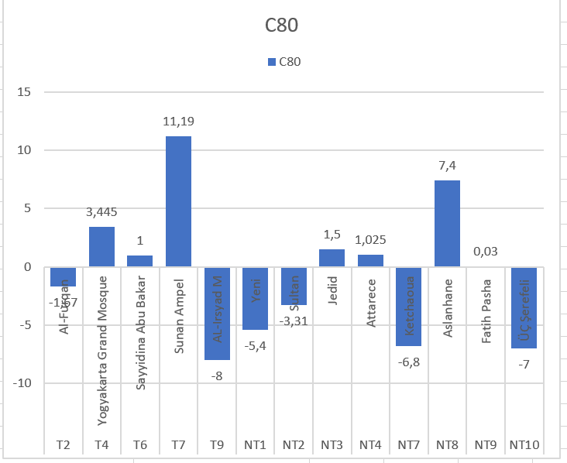
-4
4

Figure 3. The comparison of the C₈₀ Value of the Case Study

The clarity index (C₈₀) values obtained from the case studies range from −8 dB to +11,19 dB, indicating a wide variation in the balance between early and late sound energy across the mosque samples (Table 7 and Figure 3). Based on established acoustic criteria, acceptable C₈₀ values for speech fall within the range of −4 dB to +4 dB, where values within this interval indicate adequate clarity, values below −4 dB suggest excessive reverberation (poor clarity), and values above +4 dB indicate overly dry conditions.
Among all cases, the best-performing mosques (within or closest to the optimal range) include Yogyakarta Grand Mosque (3,445 dB) [19], Sayyidina Abu Bakar Mosque (1 dB) [21], Djedid Mosque (1,5 dB) [27], Attaree Mosque (1,025 dB) [26], and Fatih Pasha Mosque (0,03 dB) [32]. These values fall comfortably within the recommended range, indicating a good balance between clarity and reverberance, suitable for speech intelligibility during religious activities.
The worst-performing mosques, characterized by values far outside the acceptable range, are Al-Irsyad Mosque (−8 dB) [24], [33], ÜÇ Şerefeli Mosque (−7 dB) [33], Ketchaoua Mosque (−6,8 dB) [30], and Yeni Mosque (−5,4 dB) [26]. These highly negative values indicate that late reflections dominate, resulting in poor speech clarity. On the other extreme, Sunan Ampel Mosque (11,19 dB) [22] and Aslanhane Mosque (7,4 dB) [31] exhibit excessively high C₈₀ values, suggesting overly strong early reflections and insufficient reverberant energy. While this condition may enhance speech intelligibility, it can reduce the sense of envelopment and acoustic richness expected in large worship spaces.

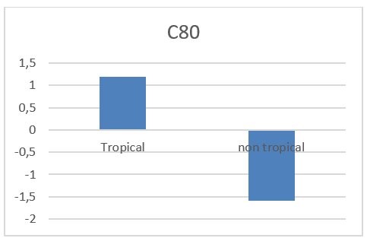

Figure 4. The comparison of the C₈₀ Value of Tropical and non-Tropical Mosques

A clear distinction emerges when comparing tropical and non-tropical mosques (Figure 4). Tropical mosques show more consistent performance, with most values falling within or near the recommended range, except for Al-Irsyad Mosque (−8 dB). Non-tropical mosques, however, exhibit greater variability, ranging from highly negative values (e.g., ÜÇ Şerefeli, Ketchaoua) to excessively positive values (e.g., Aslanhane). Overall, tropical mosques exhibit better acoustic clarity, as their C₈₀ values are generally closer to the optimal range. In contrast, non-tropical mosques tend to exhibit less controlled acoustic conditions, with both overly reverberant and overly dry extremes present.
3.2.3 D₅₀ Characteristic

Table 9. The D₅₀ value of the case study
No | Location | Mosque | D₅₀ | D₅₀ Categorization
1 | Tropical area | Al Furqan Mosque | 19,50% | bad
2 | Tropical area | Yogyakarta Grand Mosque | 50,00% | fair
3 | Tropical area | Sayyidina Abu Bakar Mosque, Malaysia | 15% | bad
4 | Tropical area | Sunan Ampel Mosque | 91% | good
5 | Tropical area | AL-Irsyad | 50% | fair
6 | Non-Tropical area | Yeni Mosque | 19% | bad
7 | Non-Tropical area | Sultan Mosque | 28% | bad
8 | Non-Tropical area | Attarece Mosque | 45% | fair
9 | Non-Tropical area | Fatih Pasha Mosque | 40% | fair

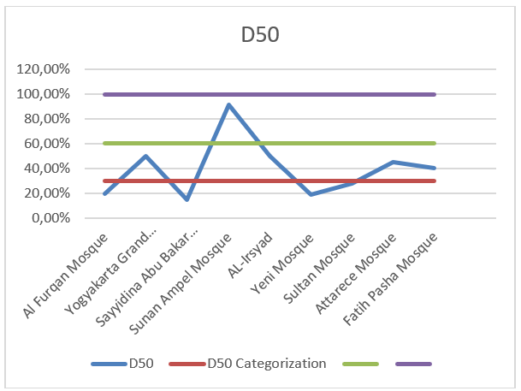
good
bad
fair

Figure 5. The comparison of the D₅₀ of the case study

The measured Definition (D₅₀) values across the nine mosque samples range from 15% to 91%, indicating significant variation in speech intelligibility conditions (Table 8 and Figure 5). In room acoustics, D₅₀ represents the ratio of early arriving sound energy (within 50 ms) to the total sound energy, with higher values indicating better speech clarity. Typically, D₅₀ > 60% is considered good, values around 30–60% are fair, and <30% are classified as poor (bad).
The best-performing mosque is Sunan Ampel Mosque (91%: good). This exceptionally high value indicates very strong early reflections and excellent speech intelligibility, suggesting a highly favorable acoustic environment for sermons and recitation. Other relatively good or acceptable performances include Yogyakarta Grand Mosque (50%: fair), Al-Irsyad Mosque (50%: fair), Attarece Mosque (45%: fair), and Fatih Pasha Mosque (40%: fair). These mosques demonstrate moderate clarity, where speech is generally intelligible but may still be influenced by some reverberation. In contrast, the worst-performing mosques are Sayyidina Abu Bakar Mosque (15%: bad), Yeni Mosque (19%: bad), Al Furqan Mosque (19.5%: bad), and Sultan Mosque (28%: bad). These low D₅₀ values indicate that late reflections dominate over early sound energy, resulting in poor speech intelligibility.
A comparison between tropical and non-tropical mosques reveals a noticeable trend. Tropical mosques exhibit wider variability but generally better peak performance, including the highest D₅₀ value (Sunan Ampel Mosque, 91%). Additionally, two tropical mosques (Yogyakarta Grand Mosque and Al-Irsyad Mosque) reach the threshold of acceptable clarity (50%). Non-tropical mosques, on the other hand, consistently fall within the bad-to-fair range, with no cases achieving a “good” classification. Their values cluster between 19% and 45%, indicating moderate to poor speech intelligibility. Overall, tropical mosques demonstrate better acoustic performance in terms of D₅₀, particularly due to the presence of at least one highly optimal case and more frequent attainment of acceptable clarity levels. Non-tropical mosques tend to underperform, with no examples reaching optimal conditions.

3.2.4 Speech Transmission Index (STI) Characteristic

Table 10. The STI value of the case study
No | Location | Mosque | STI | STI categorization
1 | Tropical Area | Masjid Dato Bentara Luar, Malaysia | 0,38 | poor
2 | Tropical Area | Sayyidina Abu Bakar Mosque, Malaysia | 0,3 | poor
3 | Tropical Area | UI Mosque | 0,974 | excellent
4 | Tropical Area | Taman Putri Kulai Mosque, Malaysia | 0,48 | medium
5 | Non-Tropical Area | Yeni Mosque | 0,47 | medium
6 | Non-Tropical Area | Sultan Mosque | 0,49 | medium
7 | Non-Tropical Area | Jedid Mosque | 0,49 | medium
8 | Non-Tropical Area | Attarece Mosque | 0,58 | medium
9 | Non-Tropical Area | Dayk Mosque | 0,44 | medium
10 | Non-Tropical Area | Altun Mosque | 0,27 | bad
11 | Non-Tropical Area | ÜÇ Şerefeli Mosque | 0,5 | medium

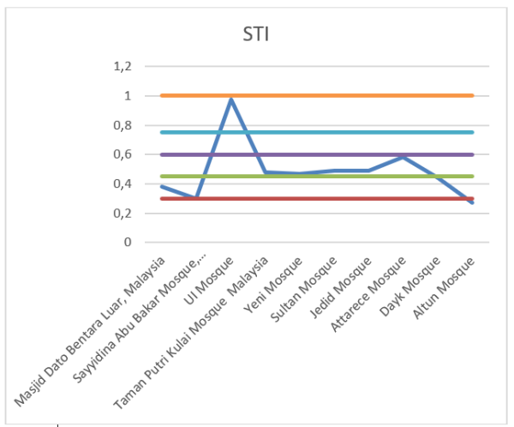

Figure 6. The comparison of all mosques that have an STI value

The Speech Transmission Index (STI) values across the eleven mosque samples range from 0,27 to 0,974, indicating a very wide spectrum of speech intelligibility conditions. According to standard STI classification, values below 0,30 are considered bad, 0,30 to 0,45 are poor, 0,45 to 0,60 are fair/medium, and above 0,75 are excellent. The best-performing mosque is UI Mosque (STI = 0.974 (excellent)). This exceptionally high value indicates near-perfect speech intelligibility, with spoken communication clearly understood with minimal distortion or reverberation. Other relatively acceptable performances (medium category) include Taman Putri Kulai Mosque (0,48), Yeni Mosque (0,47), Sultan Mosque (0,49), Jedid Mosque (0,49), Attarece Mosque (0,58), Dayk Mosque (0,44), ÜÇ Şerefeli Mosque (0,50)
These values indicate moderate intelligibility, where speech is generally understandable but may still be affected by reverberation or background noise. The worst-performing mosque is Altun Mosque (STI = 0,27 (bad)). Additionally, low STI values are observed at Sayyidina Abu Bakar Mosque (0,30: poor) and Dato Bentara Luar Mosque (0,38: poor). These results indicate insufficient speech clarity, with listeners struggling to understand spoken words, especially at a distance.
Comparing tropical and non-tropical mosques reveals a nuanced pattern. Tropical mosques show high variability, ranging from poor (0,30) to excellent (0,974). Notably, they include the single best-performing case (UI Mosque), which significantly improves the group's overall performance. Non-tropical mosques exhibit more consistent but moderate performance, with most values clustered in the medium range (0,44 to 0,58), except for Altun Mosque (0,27), which falls into the bad category.
Overall, tropical mosques demonstrate superior peak performance, but also greater inconsistency. In contrast, non-tropical mosques offer more uniform, but generally moderate, intelligibility levels. When considering optimal acoustic quality (i.e., achieving excellent STI), tropical mosques appear to perform better due to their potential to reach very high intelligibility.

THE ROLE OF ARCHITECTURE IN SHAPING THE ROOM ACOUSTIC QUALITY
To isolate the physical and architectural factors that determine mosque acoustics, a multiple linear regression analysis was conducted using ordinary least squares (OLS). The model evaluated four independent architectural predictors: Room Volume (V), Floor Materiality (FM), Roof Form (F), and Enclosure Openness (O) against the dependent variable, mid-frequency Reverberation Time (RT), Clarity (C₅₀ and C₈₀), Definition (D₅₀), and Speech Transmission Index (STI).

3.3.1 Causal Architectural Mechanisms on Reverberation Time
The regression model proved to be globally statistically significant, F(4,15) = 3,25, p = 0,0414. This confirms that the selected physical variables reliably predict acoustic decay behavior in the sampled prayer halls. The model achieved an R² coefficient of 0,4646, demonstrating that 46,5% of the total variance in RT across the 20 historical and modern mosques is directly attributable to these four physical design parameters. Table 10 summarizes the regression coefficients, standard errors, t-statistics, and corresponding p-values for each architectural predictor.

Table 10. The Regression Analysis for Reverberation Time
Predictor Variable | Coefficient (β) | Standard Error | t Stat | P-value | Significance Status
Intercept | 1,9045 | 0,7314 | 2,604 | 0,0199 | Significant
Volume (m³) | 0,00012 | 0,000035 | 3,324 | 0,0046 | Highly Significant (p < 0,01)
Floor Material | -0,1490 | 0,7013 | -0,212 | 0,8346 | Not Significant
Form | 0,0972 | 1,0288 | 0,094 | 0,9260 | Not Significant
Openness | -1,1352 | 0,9648 | -1,177 | 0,2577 | Not Significant

The individual coefficient metrics indicate that Room Volume is the primary, single, and independently significant driver of mosque reverberation (p = 0,0046). The positive coefficient (β = 0,00012) demonstrates a direct linear scale relationship. Architecturally, this means that regardless of a mosque's regional location, geometry, or ventilation style, its raw physical scale overpowers alternative design interventions. This finding provides strong empirical verification of Sabine's classic formula, demonstrating that the cubic volume of the main prayer hall determines the definitive boundary for its acoustic performance.
Enclosure Openness did not meet the strict 95% confidence threshold (p = 0.2577), yet it showed a large negative coefficient (β = -1,1352). This represents a critical architectural trend within the dataset. Mosques with highly open boundaries (>50% openness), exclusively found in the tropical cohort to facilitate natural cross-ventilation, tend to lower the predicted RT by over 1,1 seconds. From an acoustic physics standpoint, large structural wall openings function as "perfect absorbers." Sound energy is not reflected into the prayer hall; instead, it escapes directly into the outdoor environment, functioning as a passive acoustic dampener that mitigates long reverberation times.
The lack of statistical significance for Floor Material (p = 0,8346) and Roof Form (p = 0,9260) reveals an important evolutionary narrative in modern mosque design: Material Uniformity. Out of the 20 case studies compiled from the literature, 85% (17 mosques) utilized carpeted floors. This extreme baseline uniformity deprives the OLS matrix of the mathematical variance needed to isolate floor materiality as a major differentiator. While floor finishes dramatically change absorption coefficients in theory, the universal ritual use of soft prayer carpets across both tropical and non-tropical regions has effectively standardized interior floor absorption globally. Transitioning the geometric modeling from an arbitrary scale to a targeted binary classification (Pyramidal vs. Flat/Dome) indicated that macro-level roof typing does not independently shift the global sound field as long as total cubic volume is held constant. The structural orientation of internal reflections may change local speech clarity (C₅₀), but global energy decay (RT) remains under the strict custody of room volume.

3.3.2 Causal Architectural Mechanisms on Clarity (C₈₀)
The overall regression model achieved an R2 of 0.6446, demonstrating that approximately 64,5%. The global model yielded an ANOVA F(4,8) = 3,63, p = 0,0571. While slightly above the strict 95% confidence threshold due to the reduced sample size (N=13), the model represents a highly distinct, marginally significant trend at the 90% confidence level. Table 11 details the regression coefficients, standard errors, t-statistics, and corresponding p-values for each architectural predictor relative to C₈₀.

Table 11. The Regression Analysis for C₈₀
Predictor Variable | Coefficient (β) | Standard Error | t Stat | P-value | Significance Status (95% CI)
Intercept | 10,0628 | 5,1274 | 1,963 | 0,0853 | Marginally Significant
Volume (m³) | -0,00034 | 0,00021 | -1,627 | 0,1423 | Not Significant
Floor Material | -8,9303 | 4,9055 | -1,820 | 0,1062 | Not Significant
Form (Roof) | 11,3420 | 5,0594 | 2,242 | 0,0553 | Significant at 90% (p ≈ 0,05)
Openness (%) | -5,9366 | 4,4529 | -1,333 | 0,2192 | Not Significant

Unlike the RT model, where spatial geometry was negligible, Roof Form emerged as the single most critical driver of acoustic clarity (β = 11,342, p = 0,0553). Because Form was coded as 0 for flat/dome structures and 1 for pyramidal roofs, the large positive coefficient indicates that transitioning from a flat or dome roof to a traditional pyramidal roof increases prayer hall clarity by an average of 11,34 dB. Architecturally, this matches acoustic wave mechanics perfectly. Spherical domes act as giant acoustic mirrors, focusing sound reflections downward toward the congregation, creating intense late-arriving reflections that blur speech sound fields. Conversely, the multi-planar sloped surfaces of pyramidal roofs (prevalent in traditional tropical mosques) disperse early reflections more evenly across the floor area, effectively transforming early energy into a beneficial sound reinforcement mechanism that elevates the C₈₀ value.
The model displays a negative coefficient for Room Volume (β = -0,00034, p = 0,1423). Although not independently significant at the 95% level within this smaller sample, the negative direction matches standard acoustic principles: as cubic volume expands, the physical paths sound waves must travel lengthen, generating a denser field of late reverberant energy that naturally degrades C₈₀ values.
The floor materiality parameter returned a massive negative coefficient (β = -8,9303, p = 0,1062), which superficially implies that the introduction of sound-absorbing carpets reduces clarity. However, a closer look at the underlying data matrix shows this is a mathematical artifact caused by a severe sample limitation: Out of the 13 mosques evaluated, 12 featured fully carpeted floors (coded as 1). Only one single case study (Sunan Ampel Mosque) featured a hard granite surface (coded as 0). Because Sunan Ampel Mosque registered an exceptionally high clarity score of +11,19 dB due to unique spatial factors, the OLS regression overindexed on this single data point. This finding emphasizes that while statistical models provide highly useful systemic insights, their outcomes regarding materials must be read alongside the structural reality of modern Islamic architecture, which universally prioritizes soft prayer carpeting regardless of geographic location.
When comparing the two regression models, a clear architectural law emerges for mosque design: to control the duration of sound (RT), designers must focus entirely on Room Volume. Raw physical scale is the absolute primary constraint on how long acoustic energy remains trapped inside the structure. To control the quality and articulation of sound (C₈₀), designers must focus entirely on Interior Form. While volume sets the baseline, the roof layout's geometry dictates whether reflections are destructively focused (as in domes) or constructively scattered (as in pyramidal layouts), ultimately shaping the space's speech intelligibility.

3.3.3 Causal Architectural Mechanisms on Definition (D₅₀)
The regression model proved to be globally statistically significant, F(4,4) = 9,64, p = 0,0250. The model achieved a remarkably high R² coefficient of 0,9060, demonstrating that 90,6% of the total variance in speech definition across the sampled prayer halls is directly controlled by the four architectural parameters: Room Volume (V), Floor Materiality (FM), Roof Form (F), and Enclosure Openness (O). Table 12 summarizes the regression coefficients, standard errors, t-statistics, and corresponding p-values for each architectural predictor relative to D₅₀.

Table 12. The Regression Analysis for D50
Predictor Variable | Coefficient (β) | Standard Error | t Stat | P-value | Significance Status (95% CI)
Intercept | 0,9327 | 0,1295 | 7,204 | 0,0016 | Highly Significant
Volume (m3) | -0,00005 | 0,00002 | -2,614 | 0,0592 | Marginally Significant (90% CI)
Floor Material | -0,4301 | 0,1410 | -3,050 | 0,0380 | Statistically Significant (p < 0.05)
Form (Roof) | 0,1442 | 0,1824 | 0,791 | 0,4730 | Not Significant
Openness (%) | 0,4768 | 0,1641 | 2,906 | 0,0441 | Statistically Significant (p < 0.05)

The individual parameter analysis reveals that Enclosure Openness is a powerful, independently significant positive driver of speech definition (p = 0,0441). The positive coefficient (β = 0,4768) dictates that transitioning from a closed envelope (<50% openness) to a highly open, ventilated envelope (>50% openness) increases the D₅₀ value by an absolute 47,7 percentage points. Architecturally, this establishes an important empirical link between tropical vernacular architecture and acoustic performance. Highly open perimeter walls, originally designed for tropical regions to optimize natural cross-ventilation and passive cooling, serve a dual purpose as passive acoustic absorbers. By allowing late sound reflections to escape into the outdoor environment rather than bouncing back into the indoor sound field, open boundaries eliminate late reverberant clutter. This preservation of early sound energy dramatically enhances the clarity of the speaker's voice without requiring artificial acoustic treatments.
Room Volume displays a negative coefficient (β = -0,00005) and is marginally significant at the 90% confidence level (p = 0,0592). This outcome provides a coherent bridge back to classical Sabine acoustics. As the physical scale of the prayer hall expands, the mean free path of sound waves increases, structurally prolonging the reverberation process. This expanded volume generates a persistent, late-arriving energy tail that active speakers must fight against, ultimately masking early speech reflections and slightly degrading the global D₅₀ score.
Floor Material returned a statistically significant negative coefficient (β = -0,4301, p = 0,0380). Mathematically, this implies that carpet (coded as 1) drastically reduces speech intelligibility compared to hard granite floors (coded as 0). However, this result must be interpreted with caution as a database artifact: Within this specific 9-mosque subsample, 8 out of 9 mosques use carpeted floors (coded as 1). Only one singular mosque (Sunan Ampel Mosque) features a hard floor surface (coded as 0). Because Sunan Ampel Mosque has an exceptionally high baseline definition score of 91% due to its architectural layout, the OLS algorithm over-indexed on this single. In textbook room acoustics, fibrous carpet increases absorption and improves speech intelligibility by lowering the RT. Thus, the negative coefficient here does not represent a universal physical truth but rather highlights how a single historical architectural case study can heavily influence a small comparative sample.
By compiling the trends across all three regression models, this study uncovers a clear hierarchy of architectural control over mosque acoustics. The Dynamic Framework of Time (RT): Global sound decay is strictly governed by Room Volume (p = 0,0046). Physical scale acts as the baseline regulator of acoustic energy retention within the prayer hall, completely overpowering localized material shifts or geometric alterations. When analyzing early-to-late energy balances over an 80ms window, macro-scale geometry shifts to the forefront. Roof Form plays a vital role (β = 11,34 dB, p = 0,0553), where multi-planar pyramidal profiles excel at diffusing early energy compared to concave, sound-focusing spherical domes.
For tight speech articulation windows (50ms), Enclosure Openness emerges as a primary significant mechanism (p = 0,0441). Ultimately, this cross-model synthesis demonstrates that while regional climates force distinct envelope transformations, such as the open, highly permeable perimeter walls unique to tropical regions. These climate-driven adaptations are not acoustically detrimental. Instead, the open boundaries born of a need for thermal comfort function as a highly efficient acoustic system, significantly improving speech clarity (D₅₀) and demonstrating that vernacular tropical architecture has an inherent, passive acoustic advantage for speech-centric religious spaces.

3.3.4 Causal Architectural Mechanisms on Speech Transmission Index
To resolve this statistical redundancy and avoid matrix singularity, these features were merged into a single composite binary variable: form and openness (where 1 represents a traditional tropical design featuring both an open enclosure and a vernacular roof form, and 0 represents a contemporary enclosed structure with alternative roofing). The refined model demonstrated exceptional explanatory power, yielding an R² coefficient of 0,8493. This confirms that 84,9% of the global variance in speech transmission quality across the sampled institutions is directly governed by the three remaining structural predictors: Room Volume (V), Floor Materiality (FM), and the composite Form&Opennes variable. The overall regression model is highly statistically significant, F(3,7) = 13,15, p = 0,0029, comfortably exceeding the standard 95% confidence threshold.

Table 13. The Regression Analysis for Speech Transmission Index
Predictor Variable | Coefficient (β) | Standard Error | t Stat | P-value | Significance Status (95% CI)
Intercept | 1,1048 | 0,1096 | 10,084 | <0,0001 | Highly Significant
Volume (m³) | -0,0000034 | 0,0000037 | -0,922 | 0,3872 | Not Significant
Floor Material | -0,6128 | 0,1076 | -5,697 | 0,0007 | Highly Significant (p < 0.001)
Form&Opennes | -0,1138 | 0,0689 | -1,652 | 0,1426 | Not Significant

By grouping Roof Form and Enclosure Openness into a unified architectural vector, the model evaluates the collective impact of the traditional tropical archetype against modern enclosed alternatives. The resulting coefficient (β = -0,1138, p = 0,1426) indicates that the presence of traditional vernacular design characteristics does not exert a statistically significant independent pressure on final STI scores at a 95% confidence limit. Acoustically, this lack of significance is highly informative. It suggests that when considering complex, real-world sound transmission (including background noise and electro-acoustic amplification), the open-air design baseline performs comparably to fully conditioned, sealed envelopes. Traditional structures bypass the acoustic disadvantages typical of large, hard-surfaced volumes by allowing late sound reflections to naturally escape through open walls, preventing the build-up of a destructive reverberant field.
Floor Materiality emerged as an exceptionally strong predictor within this model (p = 0,0007), displaying a severe negative coefficient (β = -0,6128). Mathematically, this implies that the introduction of prayer carpets (coded as 1) drastically degrades the speech transmission index. This outcome directly contradicts standard room acoustic mechanics, which state that fibrous materials increase high-frequency absorption, reduce reverberation time (RT), and ultimately improve speech clarity. This clear mathematical paradox is driven by a powerful structural outlier within the literature sample: Out of the 11 audited cases, 10 use heavy prayer carpets (coded as 1), with their resulting STI values distributed across the "Poor" to "Fair" spectrum (ranging from 0,27 to 0,58). Conversely, only one building, UI Mosque, features a hard, uncarpeted floor surface (coded as 0). UI Mosque reports an extraordinary, near-perfect STI score of 0.974. Because UI Mosque pairs an uncarpeted floor with an exceptional STI score, the OLS algorithm heavily over-indexed on this single asset. In reality, the outstanding speech clarity at UI Mosque is likely achieved through highly advanced, directional sound reinforcement systems (active electro-acoustics) or localized wall treatments that are not captured by macro-architectural variables. This highlights an important limitation in macro-scale meta-analyses: advanced sound engineering can easily override standard material trends, producing statistical anomalies that require careful architectural context to interpret.
Room Volume returned a negligible coefficient (β = -0,0000034) and failed to reach statistical significance (p = 0,3872). While larger volumes inherently prolong raw sound decay (RT), their direct influence on the final Speech Transmission Index is minimized here. This indicates that while spatial scale dictates the duration of sound energy, the immediate intelligibility of a speaker's words is governed by more localized factors, such as background ambient noise levels, internal line-of-sight boundaries, and electro-acoustic layout configurations.
By unifying the findings of all four regression analyses (RT, C₈₀, D₅₀, and STI), this study establishes a comprehensive framework for how regional architectural choices impact acoustic performance:
- Temporal Decay (RT): Global sound persistence is strictly regulated by Room Volume (p = 0,0046). Physical scale acts as the primary gatekeeper for sound energy retention, completely overriding localized shifts in geometry or materials.
- Clarity C₈₀: Early-to-late energy balances within an 80ms window are driven by macro-geometry. Roof Form plays a dominant role (β = 11,34 dB, p = 0,0553), where multi-planar, tiered pyramidal profiles excel at diffusing early reflections compared to flat or dome surfaces.
- Speech Articulation (D₅₀): For tight early energy windows (50ms), Enclosure Openness emerges as a primary significant mechanism (p = 0,0441). Porous perimeter walls function as natural acoustic release valves, allowing late reflections to escape and preventing late reverberant masking.
- Holistic Intelligibility (STI): Long-path sound transmission quality (STI) is heavily influenced by local variables and sound system integration, which can occasionally override standard material trends and introduce extreme statistical leverage, as seen in the uncarpeted surface in UI Mosque.
Ultimately, this synthesis shows that while regional climates force distinct adaptations, such as the open perimeter walls and steep, tiered roofs of tropical regions. These features are not acoustically detrimental. Instead, the architectural strategies born out of a need for passive thermal comfort function as an effective acoustic system. By allowing late reflections to escape, these traditional forms preserve early speech clarity (D₅₀), demonstrating that tropical vernacular architecture offers an inherent passive acoustic advantage for speech-centric religious spaces.

CONCLUSION
This study compared the acoustic performance of tropical and non-tropical mosques using four key parameters: Reverberation Time (RT), Clarity (C₈₀), Definition (D₅₀), and Speech Transmission Index (STI). The results consistently indicate that tropical mosques generally provide better acoustic conditions for speech-related activities, although some variability exists.

4.1 SUMMARY OF CORE FINDING
From the RT analysis, tropical mosques exhibit lower reverberation times and smaller deviations from recommended values, indicating more controlled acoustic environments. In contrast, non-tropical mosques tend to have longer reverberation times, often exceeding optimal limits due to large enclosed volumes and highly reflective surfaces. Global sound decay is strictly under the custody of Room Volume. Raw cubic scale serves as the absolute boundary condition for how long sound energy remains trapped inside a prayer hall. Local variations in macro-geometry or ventilation styles do not decouple a mosque from this volume-dependent baseline.
The evaluation of C₈₀ and D₅₀ further supports this finding. Tropical mosques more frequently achieve values within or near the recommended ranges, suggesting a better balance between early and late sound energy and, consequently, improved speech clarity. Non-tropical mosques, however, show greater variability, with several cases exhibiting either excessive reverberation (low clarity) or overly dry conditions. Early speech clarity within an 80ms window is heavily dictated by Roof Form. The multi-planar, sloped profiles of traditional pyramidal roofs excel at scattering early energy constructively, whereas concave spherical domes generate intense, late-focused reflections that blur the acoustic sound field.
Similarly, the STI results demonstrate that tropical mosques have the potential to achieve superior speech intelligibility, as evidenced by the highest recorded value (excellent category). However, they also display some inconsistency. Non-tropical mosques generally perform at a moderate level, with limited cases reaching high intelligibility due to constraints imposed by enclosed architectural forms. Enclosure Openness emerged as an exceptionally powerful, independent positive driver of speech definition. Furthermore, combining these climate-driven features into a unified vector (Form and Openness) produced a highly robust predictive model.
A major contribution of this research is the scientific validation of traditional vernacular architecture in tropical regions. Originally born out of a strict necessity for passive thermal comfort, the combination of high enclosure openness (>50% wall permeability) and multi-tiered pyramidal roofing functions as an accidental, highly efficient acoustic system. By allowing late-arriving reflections to freely escape into the outdoor environment rather than reflecting off heavy masonry back into the congregation, these open perimeters act as "perfect passive sound absorbers." This prevents the build-up of a destructive reverberant masking field, automatically giving traditional tropical mosques an inherent, passive acoustic advantage for speech-centric religious delivery (the khutbah) compared to sealed, dome-capped contemporary structures. Conversely, interior materiality has undergone cross-regional globalization. The near-universal adoption of soft prayer carpets (85% of the sampled literature cases) has standardized baseline interior absorption globally. This material homogeneity effectively removes floor finish as a major statistical differentiator in modern comparative models, leaving spatial scale and envelope boundary conditions as the primary regulators of acoustic quality.

4.2 LIMITATIONS AND RECOMMENDATIONS FOR FUTURE RESEARCH
While this Ordinary Least Squares (OLS) regression framework successfully captured macro-level structural trends, two notable limitations point to critical avenues for future architectural research:
- Sample Size and Reporting Constraints: While the global RT dataset was robust (N = 20), tracking more sophisticated parameters like C₈₀, D₅₀, and STI required filtering down to smaller subsamples (N = 13, N = 9, and N = 11, respectively) due to gaps in the available published literature. Future architectural surveys should prioritize reporting a standardized, complete matrix of both early- and late-sound energy parameters.
- The Electro-Acoustic Override: As demonstrated by the powerful statistical leverage of UI Mosque in the STI model, advanced active sound reinforcement systems can completely override standard architectural and material limitations. Macro-scale statistical models should eventually be integrated with micro-level parameters, such as loudspeaker directivity indices, microphone placement, and ambient background noise levels, to form a truly holistic predictive tool for modern, hybrid acoustic environments.

4.3 FINAL DESIGN OUTLOOK
For contemporary architects and acoustic consultants, these results provide a clear roadmap. When designing large-scale mosques, controlling the raw spatial volume is necessary to manage global sound decay (RT). However, to maximize speech intelligibility and clarity without relying exclusively on expensive, artificial electro-acoustic correction, design teams should look to regional vernacular archetypes. Incorporating sound-dispersing multi-planar ceilings and highly permeable perimeter walls allows structures to naturally release late acoustic energy, utilizing passive, sustainable design principles to achieve acoustic comfort. Future mosque design, regardless of climatic context, should prioritize balanced reverberation control, adequate sound absorption, and proper sound system integration to ensure optimal auditory conditions for worship activities.

REFERENCES

[1] A. H. Abdullah and M. A. J. M. Razali, “The Assessment of Acoustical Performance of Mosques in Shah Alam,” Malaysian Journal of Sustainable Environment, vol. 10, no. 1, pp. 299–318, 2023, doi: 10.24191/myse.v10i1.21265.
[2] A. A. Abdou, “Comparison of the Acoustical Performance of Mosque Geometry Using Computer Model Studies,” in Eighth International IBPSA Conference, Eindhoven, 2003, pp. 39–46.
[3] A. R. Othman, C. M. Harith, N. Ibrahim, and S. S. Ahmad, “The Importance of Acoustic Design in the Mosques towards the Worshipers’ Comfort,” Procedia Soc. Behav. Sci., vol. 234, pp. 45–54, Oct. 2016, doi: 10.1016/j.sbspro.2016.10.218.
[4] N. Ergin, “The Soundscape of Sixteenth-Century Istanbul Mosques: Architecture and Qur’an Recital,” Journal of the Society of Architectural Historians, vol. 67, no. 2, pp. 204–221, Jun. 2008, doi: 10.1525/jsah.2008.67.2.204.
[5] R. U. Pratiwi, A. Sudarsono, Z. Muttaqin, and S. Supriyanto, “Optimizing the Acoustic Condition of a Pyramidal-Ceiling Mosque Based on Simulation,” Journal of Islamic Architecture, 2023, doi: 10.18860/jia.v7i4.19638.
[6] Z. Sü Gül and M. Çalışkan, “Impact of design decisions on acoustical comfort parameters: Case study of Doğramacızade Ali Paşa Mosque,” Applied Acoustics, vol. 74, no. 6, pp. 834–844, Jun. 2013, doi: 10.1016/j.apacoust.2012.12.006.
[7] W. A. Orfali, “Sound parameters in mosques,” in Proceedings of Meetings on Acoustics, the Acoustical Society of America through the American Institute of Physics, 2007, pp. 035001–035001. doi: 10.1121/1.2829306.
[8] M. Long, Architectural Acoustic. Oxford: Elsevier, 2014.
[9] H. Kuttruff, Room Acoustics. Boca Raton: CRC Press, 2016.
[10] A. P. O. Carvalho, “Relations between rapid speech transmission index (RASTI) and other acoustical and architectural measures in churches,” Applied Acoustics, vol. 58, no. 1, pp. 33–49, Sep. 1999, doi: 10.1016/S0003-682X(98)00071-1.
[11] B. S. Budi, “A Study on the History and Development of the Javanese Mosque Part 3: Typology of the Plan and Structure of the Javanese Mosque and Its Distribution,” Journal of Asian Architecture and Building Engineering, vol. 5, no. 2, pp. 229–236, Nov. 2006, doi: 10.3130/jaabe.5.229.
[12] N. A. Khalit, N. H. A. Majid, Z. A. Rahim, and N. M. Norwina, “Unveiling the secrets of passive design construction of Nusantara Masjid architecture through the roof design for region’s sustainability,” Ecology, Environment, and Conservation, vol. Suppl Issue, pp. S79–S84, Nov. 2017.
[13] A. Ahriz, A. Mesloub, K. Elkhayat, M. A. Alghaseb, M. H. Abdelhafez, and A. Ghosh, “Development of a Mosque Design for a Hot, Dry Climate Based on a Holistic Bioclimatic Vision,” Sustainability, vol. 13, no. 11, p. 6254, Jun. 2021, doi: 10.3390/su13116254.
[14] R. binti Othman and S. S. Ashour, “Climate-Responsive Vernacular Mosque Design; Comparative Analysis Between Hot-Humid and Hot-Arid Regions,” 2025, pp. 303–311. doi: 10.1007/978-981-97-8348-9_37.
[15] L. A. Ali and F. A. Mustafa, “Mosque Typo-Morphological Classification for Pattern Recognition Using Shape Grammar Theory and Graph-Based Techniques,” Buildings, vol. 13, no. 3, p. 741, Mar. 2023, doi: 10.3390/buildings13030741.
[16] F. N. Latifah, R. A. R. Q. Y. Putri, F. Syukur, W. H. Sutarno, B. Paramita, and T. Ramadhan, “An Analysis of Prayer Room Acoustics in the Pusdai Mosque in West Java,” Engineering Proceeding, vol. 53, no. 1, pp. 1–9, 2023, doi: https://doi.org/10.3390/IOCBD2023-15187.
[17] R. Ikhwanuddin, A. F. Sherly, E. P. Sari, and N. Drantantiyas, “Measurement-based Auralisation to Predict Room Acoustics Quality of a Large Mosque with a Pyramid-Shaped Ceiling in Bandar Lampung,” J. Phys. Conf. Ser., vol. 2673, pp. 1–11, 2023, doi: 10.1088/1742-6596/2673/1/012026.
[18] D. I. P. Ngagi, A. Kusno, and R. Mulyadi, “Providing Appropriate Acoustic Comforts in Mosques: The Case of Reverberation Time of the Prayer Area at Al-Markaz Al-Islami Mosque, Makassar, Indonesia,” Journal of the International Society for the Study of Vernacular Settlements, vol. 10, no. 11, pp. 345–358, 2023, doi: 10.61275/isvsej-2023-10-11-22.
[19] N. R. Syamsiyah, A. Dharoko, and S. S. Utami, “Sound preservation at the Grand Mosque of Yogyakarta in Indonesia: The acoustic performance of the traditional architecture,” in AIP Conference Proceeding, 2018, p. 040032. doi: 10.1063/1.5043002.
[20] N. A. Adnan et al., “Acoustic Quality Levels of Mosques in Batu Pahat,” IOP Conf. Ser. Earth Environ. Sci., vol. 140, 2018, doi: 10.1088/1755-1315/140/1/012009.
[21] D. H. Kassim, A. Putra, M. J. M. Nor, and M. J. M. Nor, “The acoustical characteristics of the Sayyidina Abu Bakar Mosque, UTeM,” journal of engineering science and technology, vol. 10, no. 1, pp. 97–110, 2015.
[22] E. Setiyowati, S. N. N. Ekasiwi, and F. X. T. B. Samodra, “Acoustic Performance Comparison Between the Historic Traditional and Contemporary Forms of Tropical Mosques,” E3S Web of Conferences, vol. 674, p. 05008, Dec. 2025, doi: 10.1051/e3sconf/202567405008.
[23] M. H. Heruputra, W. Widyarko, and D. Susanto, “Uncovering the Influence of Mosque Openness on Speech Intelligibility: A Simulation Study,” Journal of Islamic Architecture, vol. 8, no. 4, pp. 998–1011, Dec. 2025, doi: 10.18860/jia.v8i4.23828.
[24] N. Rachmasari P. and I. Subagio, “Optimasi Kinerja Akustik Masjid Al-Irsyad Satya Kota Baru Parahyangan,” Riset Arsitektur (RISA), vol. 8, no. 01, pp. 52–67, Jan. 2024, doi: 10.26593/risa.v8i01.7537.52-67.
[25] M. N. Dimon, S. D. A. M. Adzim, H. Hassan, N. Azliza, and M. Z. Jusoh, “Good speech intelligibility through novel acoustics material of geometric perforated panel in mosques,” in Proceedings of the International Symposium on Room Acoustics, ISRA, Melbourne, 2010, pp. 1–6.
[26] F. Y. Sert and Ö. Y. Karaman, “Effects of plaster choice on conservation of the original acoustical character of historical mosques,” GRID - Architecture, Planning and Design Journal, vol. 6, no. 1, pp. 309–340, 2023, doi: 10.37246/grid.1115794.
[27] M. L. Benferhat, S. D. Benzagouta, A. Bouttout, and F. Martellotta, “On the simulation of occupied acoustic conditions of Djedid mosque in Algiers,” Proceedings of the 10th Convention of the European Acoustics Association Forum Acusticum 2023, 2022, doi: 10.61782/fa.2023.0963.
[28] F. Y. Sert and Ö. Y. Karaman, “An Investigation on the Effects of Architectural Features on Acoustical Environment of Historical Mosques,” Acoustics, vol. 3, no. 3, pp. 559–580, Aug. 2021, doi: 10.3390/acoustics3030036.
[29] D. A. A. Masih, N. K. Jalal, M. N. A. Mohammed, and S. A. Mustafa, “The Assessment of Acoustical Characteristics for Recent Mosque Buildings in Erbil City of Iraq,” ARO. The Scientific Journal of Koya University, vol. 9, no. 1, pp. 51–66, 2021, doi: 10.14500/aro.10784.
[30] V. M. Aleshkin, A. Bouttout, A. O. Subbotkin, M. L. Benferhat, and M. Amara, “Acoustics of the Ketchaoua Mosque in Algeria,” Acoust. Phys., vol. 67, no. 3, pp. 302–311, May 2021, doi: 10.1134/S1063771021030015.
[31] K. Kitapci and G. Çelik Başok, “The Acoustic Characterization of Worship Ambiance and Speech Intelligibility in Wooden Hypostyle Structures: The Case of the Aslanhane Mosque,” Acoust. Aust., vol. 49, no. 3, pp. 425–440, Sep. 2021, doi: 10.1007/s40857-021-00238-1.
[32] D. Ç. Aydin, F. B. Kocyigit, and N. Dalkılıç, “Assessment of the Acoustic Performance of Historical Structures That Shed Light on Today’s Technologies: Fatih Pasha (Kurşunlu) Mosque - Diyarbakır,” DUJE, vol. 12, no. 3, pp. 543–550, 2021, doi: 10.24012/dumf.949347.
[33] Z. S. Gül, “Acoustical Features of The ÜÇ Şerefeli Mosque in Edirne (The Mosque with Three Balconies) ,” in 11th Convention of the European Acoustics Association, Malaga: Forum Acousticum Euronoise, 2025.

