 |  | JOURNAL OF ISLAMIC ARCHITECTURE  P-ISSN: 2086-2636 E-ISSN: 2356-4644  Journal Home Page: http://ejournal.uin-malang.ac.id/index.php/JIA
THE BREAKTHROUGH IN THE ARCHITECTURE OF CONTEMPORARY ISLAMIC MOSQUES
Israa Jabir Al-Tarakany^{1*}, Fawzia Irhayyim Hussein¹
¹ 1Department of Architecture, College of Engineering, University of Baghdad, Baghdad, Iraq

*Corresponding Author: Israa.Theeban2204D@coeng.uobaghdad.edu.iq
ARTICLE INFO |  |  | ABSTRACT
Volume: 9  Issue: 1  Page: 323-338  Received: November 21st, 2024  Accepted: March 18th, 2025  Available Online: June 30th, 2026  DOI: https://doi.org/10.18860/jia.v9i1.29940 |  |  | Contemporary Islamic architecture is witnessing bold innovation, challenging traditional stereotypes, particularly in mosque design. Hence, this paper delves into the innovative breakthroughs that are shaping the future of mosque architecture. The research identified a knowledge gap regarding the "unclear architectural origins of contemporary mosques." This highlights the importance of research in fortifying the role of a breakthrough as a strategy that connects the product to its origins and the identity of Islamic architecture. The research problem arises from the lack of literature on the role of a breakthrough as a strategy to promote the connection of the architectural product to its original Islamic roots. According to the research hypothesis, breakthrough helps link with Islamic architecture's roots by combining the creative, intellectual, and innovative penetration levels with the rules of breakthrough (selection, framing, parallelism) and breakthrough mechanisms (change, conversion, abstraction, cloning, consolidation, and restoration). The research aims to analyze the concept of breakthroughs in Islamic architecture, focusing on its relationship with the authenticity of Islamic thought in modern mosque design. The study methodology analyzes several case studies of contemporary mosques that have successfully blended these elements, resulting in structures that are both architecturally significant and deeply rooted in Islamic culture. The research concluded that the concept of a breakthrough in architecture originates from a change event and is typically associated with outcomes characterized as creative or innovative. These outcomes convey a sense of distinction and uniqueness within the context, are non-repetitive, and provide creative solutions to architectural problems. It fosters a mindset of rethinking and reshaping unique elements while addressing the challenges and opportunities posed by modern materials and construction techniques.  Keywords:  Breakthrough; Innovation; Transformation; Contemporary Islamic Mosques; Creativity

INTRODUCTION
According to the Oxford Dictionary, a breakthrough is a significant discovery or event that advances a situation or solves a problem[1]. It represents a moment of transformational change that propels progress and opens new horizons for further development and exploration in a particular field or Endeavor[2]. Meanwhile, in contemporary Islamic architecture, a breakthrough is a significant innovation, design concept, or technological advancement that pushes the boundaries of traditional Islamic architectural norms and leads to a notable shift in the field. This could involve the development of new architectural forms, materials, construction techniques, or design approaches that challenge conventional interpretations of Islamic architecture while respecting its underlying principles and aesthetic traditions [3]. For example, a breakthrough in contemporary Islamic architecture might involve integrating cutting-edge sustainable technologies into the design of mosques or Islamic cultural centers [4][5], allowing for greater energy efficiency and environmental sustainability without compromising the cultural and spiritual significance of the spaces[6]. Overall, a breakthrough in contemporary Islamic architecture represents a leap forward in innovation and creativity that expands the possibilities of what Islamic architecture can be in the modern world while maintaining a connection to its rich cultural heritage[7].
This study examined several previous studies on breakthroughs, including Razzaque: The Thought of Creativity in Architecture (1996) [8], Tom Daniell: The Mother of Inventions, 2013[9], Kristina Rakic's: Breakthrough and Disruptive Innovation: A Theoretical Reflection, 2020 [10], Hisham Al-Saady: Innovation in Architecture, 2021 [11], and Riyam Rajab and A. M. AL-Khafaji: The Role of the Bonding Strategy in the Identity of Islamic Architecture, 2023 [12]. These previous studies identified the issue of excessive traditionalism or absolute modernism and asked how technological innovations influence society's acceptance of contemporary Islamic architecture. Therefore, the research problem was formulated as follows: there is a lack of previous studies on the role of breakthroughs as a clear strategy for enhancing the connection of the architectural product to its original roots and showcasing Islamic architectural identity. To solve the problem, the research aims "to provide knowledge for analyzing the concept of a breakthrough in Islamic architecture, focusing on understanding the relationship between breakthrough (the contemporary innovative approach) and the authenticity of Islamic thought in contemporary mosque architecture".
The breakthrough of architecture comes from the event of change. It is usually associated with products described as ingenious or inventive because it carries the meanings of discrimination and uniqueness within the context [13]. According to Antoniades, creative production is a unique and distinct product within the context. It provides a cognitive addition characterized by communication with previous models, or is a product that reflects non-recurrence and brings new, context-appropriate solutions to problems [14]. In contrast, some architects expand the idea of penetration and link it to the idea of an event, presenting the concept as a state of generation of post-change transformations [15]. (Bernard Tchumi) discusses the idea of an event in architecture as an invention that makes a radical change in context so that this invention can go beyond its moment by combining it with a particular function and a particular act with the image that binds it [8]. Here, the event, the invention, appears to be a breakthrough in architecture that contributes to the generation of a state of rethinking and formation of various architectural elements that continue through several subsequent long-term explorations. [16]. Magali S. Larson, in her book "Behind the Postmodern Façade: Architectural Change in Late Twentieth-Century America," on the concept of a product hacked into architecture by linking the concept to the nature of architectural practice by promoting the innovative position of creativity with a link to (a moment of creativity) [11] [17]. According to her view, the breakthrough is achieved through three factors:
- Timing, i.e., the timing of unique ideas and solutions, is appropriate to bring about change in context.
- Attendance, discrimination, and uniqueness by practitioners.
- Breaking through the designer's derivative models allows for stronger architectural spaces, fostering cognitive independence through penetration, derivation, and repetition [18][19].

In summary, to achieve the breakthrough described above in Islamic architecture specifically, this research used two levels: creative and innovative; three rules: interception and derivative, inclusion, and parallelism; and six mechanisms: transformation, change, copying, abstraction, collecting, and clear reviving mechanism. The research referred to these collective levels, rules, and mechanisms as “breakthrough strategies”. Contemporary Islamic architecture is linked to its roots through these strategies, as explained in the paragraph below:

1.1 BREAKTHROUGH STRATEGIES
1.1.1 Levels of breakthrough: innovations and creative thinking level
Breakthrough innovations, typically radical technological changes, often occur unexpectedly and disrupt existing paradigms. These innovations require creative action and can lead to significant increases in market share or temporary monopoly profits [10]. In architecture, they focus on privacy, flexibility, and architectural integrity [20]. Invention involves creating and innovating, generating new ideas, or developing efficient work techniques to achieve a specific objective [21]. On the other hand, innovation involves utilizing inventive ideas and applying them to practical situations[17].
Breakthrough in creative thinking: The breakthrough, according to Razzaque[8], comes through penetration, a sense of permeability, discovery, or far-sightedness, that is, the ability to penetrate time and space constraints. It has to do with people's levels of creative thinking. It is one of the creative thinking trends resulting from the association of a process of creative thinking (divergent thinking), which includes a set of characteristics such as flexibility, fluency, originality, and connection with content or output, according to the analysis of the Guilford planning model, building the actions of thought. So, the breakthrough concept is associated with creative self-invention or intuitive insight. It pertains to moments of enlightenment or spiritual resonance within the mind. It aligns with Eastern philosophy of awakening, in which a sudden event or profound realization leads to a state of greater consciousness or a breakthrough [22]. For more details, see Figure 1.
From the above, creative thinking = divergent thinking + contexts (form, symbol, evidence, behavior) or product forms (units, classes, systems, transformation, or changes) = breakthrough or penetration. It may also mean originality, flexibility, and fluency.

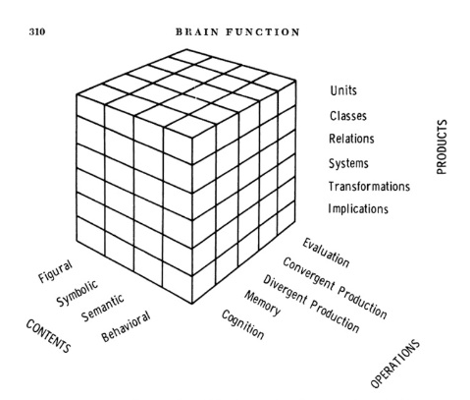

Figure 1. Guilford's Model of Brain Function [23]

1.1.2 Rules of Breakthrough
A breakthrough in Contemporary Islamic architecture follows the Coordination rules. These guidelines include adhering to traditional Islamic architectural practices and historical patterns with contemporary styles and modern elements [24] [25]. They exemplified this in buildings such as the Sheikh Zayed Mosque in the United Arab Emirates, which combines elements of Mongol-style domes and Arab-Moroccan design in its halls and spaces, with a contemporary treatment of the structure and materials [26]. The coordination rules are divided into three: the rule of intersection or selection, the embedding or framing rule, and the Parallelism rule, which allows for innovative architectural forms that challenge traditional norms and incorporate new functions using modern construction techniques [27].
These rules can be explained in the following way:
- Intersection or selection rules
This principle relies on mechanisms (selection, fusion) that intertwine the intellectual and formal levels, creating a new level of modernity [28]. This results in multiple hybrid styles of Islamic architecture that reflect contemporary times on the one hand and their relationship with origins on the other, generating innovative breakthroughs characterized by dynamism and diversity [29]. This blend combines authenticity and modernity, with simplicity and diversity on the one hand and unprecedented renewal on the other [3]. So, the breakthrough in this rule appears through the blend of authenticity and modernity.
- Embedding or framing
This rule adheres to a formal characteristic or a temporally known intellectual principle that drives change while maintaining the general framework of the original[30]. This rule is characterized by unity, clarity, frankness, and diversity within the general framework of the original principle or formal characteristic [27]. The breach can be in form or substance within the general framework of the origins principle.
- Parallelism ruler
Finding a contemporary Islamic language that corresponds to the traditional language in various forms, in two ways: either through a method based on the similarity between two consecutive elements, by returning contemporary Islamic output to the traditional in a different form but identical in content, or contrasting, where a parallel solution inspired by Islamic values meets the demands of the modern era[31][32]. Therefore, this rule's breakthrough is achieved through parallel solutions inspired by Islamic values that respond to the demands of modernity.
1.1.3 Mechanisms of breakthrough
The six mechanisms are as follows:
- Change Mechanism
The information results from human cognitive actions involving changes such as redefinition, modification, or radical changes in information form or function [8].
The changes in architecture are on three levels:
  - A radical change: A radical change in architecture causes a state of breakthroughs, creates a difference in architectural practice, and leads to the establishment of a new level of awareness of architecture[33].
  - Developmental change: changes occurring cumulatively, evolving in new directions, opening up new horizons with each development, and relying on derivation, alteration, installation, and the addition of new context readings [11].
  - Improvement change: Improvement is achieved through altering elements, adding personal touches, or using alternative materials [33].
- Transformation Mechanism
New architecture evolves through pattern transformation driven by scientific advancements, responding to human needs materially and morally and facilitating material and moral development [34]. Charles Jencks emphasizes the importance of transformations in architectural creation, integrating traditions and criticism from historical sources with contemporary patterns in Islamic architecture [35]. The main transformation processes are as follows:
  - Dimensional Transformation: Changes in one of the shape's dimensions while preserving its identity.
  - Subtraction Transformation: Removal or cutting parts of a shape, partially altering the original form.[36]
  - Addition Transformation: Integrating additional shapes or elements into a basic shape produces innovative shapes[37].
  - Layering Transformation: Overlapping and interlocking of parts create a complex arrangement of elements [38].
  - Moving Transformation: The motion of physical-visual elements alters their properties and positions, introducing dynamism and variability into the architectural form [35].
So, architectural transformation mechanisms, such as dimensional transformations, subtractions, additions, layers, and moving transformations, are necessary to create new architectural breakthroughs by exploiting conventional and contemporary symmetry.
- Copying Mechanism: Strongest degree of bonding, relying on formal repetition[39].
- Clear Reviving Mechanism: Connects familiarity with the past, creating a clear Islamic architectural identity[3].
- Collecting Mechanism: Selects elements from past and present, connecting them with familiar or generative formulation.
- Abstract Mechanism: one of the strongest degrees of breakthrough, providing high formal variety within the same function or form [40]. Table 1 and Figure 2 below show the levels of a breakthrough as a strategy:

Table 1: Analyzing Breakthrough Strategies
Breakthrough strategies | Definition
1. Levels of breakthrough
1.1. Creative intellectual level | Breakthrough is creating new thinking.
1.2. Innovative application level | Innovation is an application of creative thinking that leads to breakthroughs.
2. Rules of breakthrough
2.1. intersection or selection | The breakthrough is through hybridization and the mixing of originality and contemporarily.
2.2. Embedding or framing | The breakthrough is a form or content within the general framework of the asset base.
2.3. Parallelism | Breaking through is a solution that meets the requirements of the times and aligns with Islamic values.
3. Mechanics of breakthrough
3.1. Mechanism of change | Finding new solutions to complex problems
3.2. Transformation mechanism | New architectural breakthroughs by leveraging the symmetry between traditional and contemporary
3.3. Collecting mechanics | Compilation of elements of the past and the present, and their typical linkage
3.4. Abstract mechanism | The strongest degree of breakthrough, the weakest in terms of identity being connected to the place
3.5. Copying mechanism | Repeat elements are less likely to achieve penetration
3.6. Clear reviving mechanism | Connecting the past to the present to the achievement of identity.

Traditional Mosques as a root of Islamic patterns

Contemporary Islamic architecture
Figure 2. displays the attained vocabulary.

METHODS
The study aims to reveal the importance of the breakthrough strategy in enhancing the creative and innovative aspects that affirm the authenticity of contemporary Islamic architecture while simultaneously reflecting its modernization and diversity. The research selected four samples of Islamic centers with various functions (religious, cultural, educational), and, relying on breakthrough strategy indicators, each sample was tested using a descriptive analysis methodology to determine the degree of penetration achieved from the architectural origins of the basic styles according to a measurement scale prepared to identify the degrees of penetration in contemporary mosques and based on an evaluation form prepared by a group of experts in Islamic architecture. the research divided the breakthrough grades into three percentages. It used these as a basis for analyzing the selected samples, as in Figure 3:
- High breakthrough 65-100%
- Average breakthrough 35-65%
- Low breakthrough 35-1%
The highest breakthrough rates are the strongest

correlation with access.
Weak breach. 1-30%
Medium breach. 30-60%
High breach. 60-100 per cent

Figure 3. Percentages of breakthrough

Samples of contemporary mosques have been carefully selected for this study. Each building has a unique design in terms of planning, structural framework, and exterior and interior finishes. It examines the Islamic architectural innovation between history, the present, and the future. Its details are as follows.

2.1. EDUCATION CITY MOSQUE, AL-RAYYAN, DOHA, QATAR 2008-2015
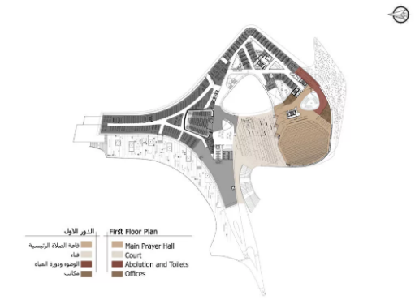
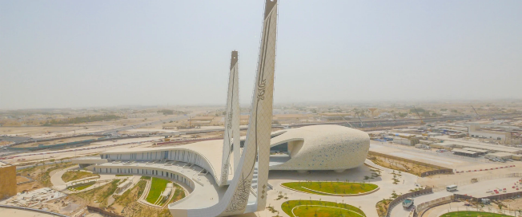
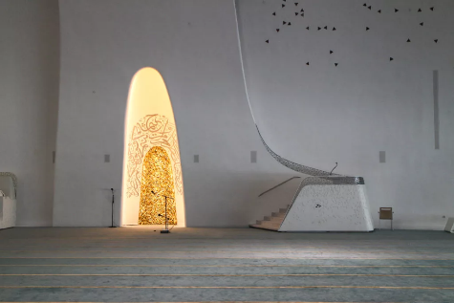
The Education City Mosque in Qatar, designed by Ali Mingera and Ada Yevars in 2015, incorporates traditional Islamic architecture elements such as courtyards, natural lighting, and water elements [7]. Based on contemporary concepts of enlightenment in science and knowledge, the project features 90-meter-high minarets that rise towards the sky, expressing the meanings of the Qur’an. The building’s authenticity and modernity break traditional Islamic architecture concepts, showcasing the importance of enlightenment in modern architecture [41]. Several shots of the project illustrate the innovative breakthrough, high abstraction, and radical departure from traditional Islamic style across the plan, structure, construction, interior design, and the unfamiliarity of the external composition, as shown in Figure 4.

A B C

Figure 4. (a) first plan of the EDUCATION CITY mosque (b)outside perspective (c) prayer hall with modern mihrab [42]

2.2. ISLAMIC CULTURAL CENTER IN LJUBLJANA
The Ljubljana Mosque, a stunning European Islamic center, blends traditional and contemporary engineering methods. It comprises six buildings, spans 12,000 square meters, and can accommodate around 1,400 worshippers [43]. The center’s glass façades emphasize transparency and openness, while the interior features a large blue dome symbolizing containment and paradise. The central courtyard connects the outside to the inside, while white mesh concrete with a glazed top allows light to flow inside. The mosque was completed in 2018 and is considered one of Europe's most beautiful Islamic centers, representing unique innovations and gradual modifications connected to the foundations and origins of conventional Islamic patterns, mirroring the concept of restraint [44]. For more details, see Figure No. (5).
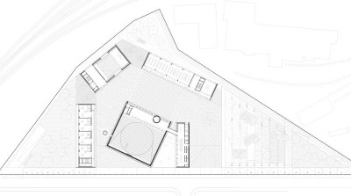
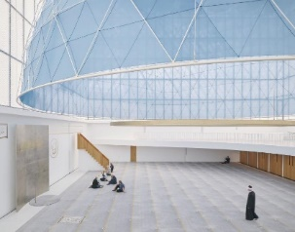
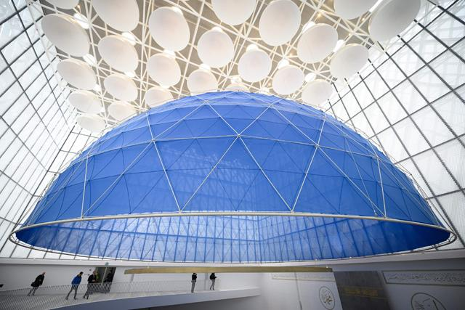
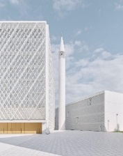
A B C

Figure 5. (a) floor plan of the Islamic Cultural Center in Ljubljana 2015 [45] (b)outside shot (c) prayer hall [46].

2.3. THE CAMBRIDGE CENTRAL MOSQUE
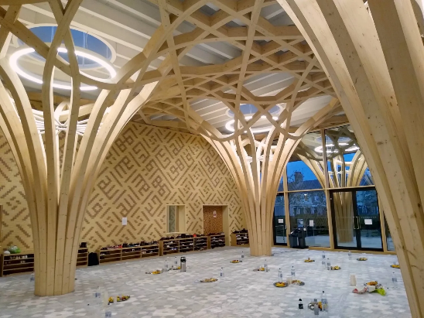
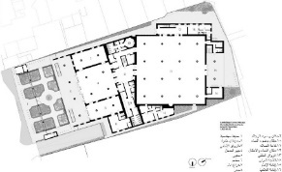
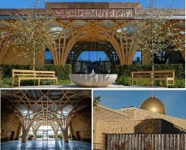
The Cambridge Central Mosque was constructed in 2019 and is regarded as Europe’s first environmentally friendly mosque. It was established to serve the Muslim community by promoting interfaith understanding, social cohesion, community development, and good-faith practices.[12] The London-based Marks Barfield Architects won this mosque’s most prestigious architecture prize (Stirling). Water is the source of life, and the design is reminiscent of paradise, creating a peaceful haven. The building uses locally sourced materials, processed using digital technologies, to create a sustainable eco-design with near-zero carbon emissions. The mosque is a great example of parallel innovation because it combines new, environmentally friendly technologies that align with modern times while connecting to the traditional roots of Islamic design, especially in its structure and materials [47]. As shown in Figure 6.

A B C

Figure 6. (a) Perspective shots of the Cambridge Central Mosque, (b) floor plan, (c) prayer hall [47]

2.4. AMIR SHAKIB MOSQUE, MOUKHTARA, LEBANON
Amir Shakib Mosque in Moukhtara, Lebanon, is a 100 m² mosque designed by L.E.FT Architects, focusing on universal Islamic space and urban connectivity [48].The mosque, a renovation of an older structure, features a contemporary minaret made of thin white steel louvers, with the words "Allah" and "insane" inscribed at the bottom, symbolizing the impermanence of life. The interior features a fig tree, a chiseled glass façade, and a skylight that aligns with the Qiblah wall towards Makkah. The breakthrough in this mosque lies in the intersection and selection of its elements, which combine the old structure with modern metallic elements to show how things change over time. This gives the breakthrough a balanced personality, combining new ideas with original ones [48]. As shown in Figure 7.

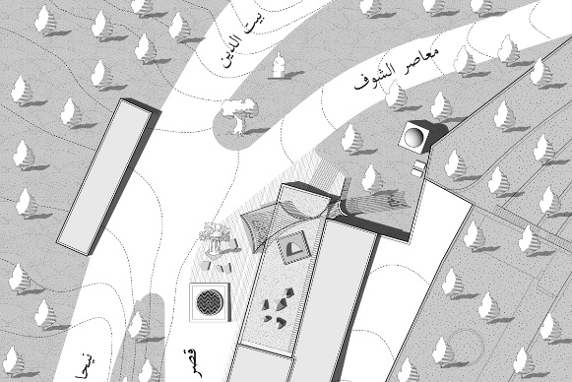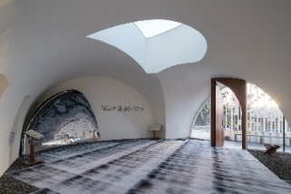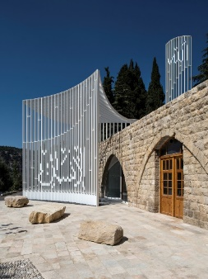

Figure 7. (a) site plan for AMIR SHAKIB ARSLAN mosque (b) prayer hall with mihrab wall (c) front elevation[48]

RESULT AND DISCUSSION
The study examined the practical results of the questionnaire shown in Table No. (2), made using the theoretical framework for the breakthrough strategy in Table No. (1) and sent to more than 50 experts in Islamic architecture, design, urban planning, and architectural theory for the fourth case study of contemporary mosques. It shows that the breakthrough of these mosques was 37% higher in application innovation than in creative thinking (see Figure 8). The mosque's symbolic elements, such as the dome and minaret, accounted for 29%, followed by the exterior (Figure 9). The most frequently used breakthrough rule is the selection-and-intersection rule, used in 41% of cases (see Figure 10). The most commonly used breakthrough mechanism is the transformation mechanism at 28% (Figure 11). The level of change in the samples was at a developmental level of 47% (Figure 12). The rate of the traditional formal elements in the selected samples was 43% (Figure 13). The rate of additional transformation in contemporary mosques stands at 26%(Figure 14). The breach of basic principles was moderate, accounting for 52% of the total and indicating a medium level of breakthrough according to the prepared methodology (Figure 15).

Table 2. Results of the Case Study Analysis

1. What are the levels of breakthrough? | Creative intellectual level |  |  | Innovative applied level |  | both
AMIR SHAKIB ARSLAN MOSQUE, Lebanon | 25% |  |  | 34% |  | 42%
The Cambridge Central Mosque | 38% |  |  | 36% |  | 27%
Islamic Cultural Center in Ljubljana | 32% |  |  | 35% |  | 32%
EDUCATION CITY, DOHA, QATAR | 30% |  |  | 44% |  | 26%
Average | 31% |  |  | 37% |  | 31%
2. Areas of breakthrough? | The structural framework | exterior |  | Interior design |  | The elements
AMIR SHAKIB ARSLAN MOSQUE, Lebanon | 11% | 23% |  | 26% |  | 40%
The Cambridge Central Mosque | 26% | 32% |  | 25% |  | 17%
Islamic Cultural Center in Ljubljana | 27% | 20% |  | 23% |  | 30%
EDUCATION CITY, DOHA, QATAR | 28% | 24% |  | 21% |  | 27%
Average | 23% | 25% |  | 24% |  | 29%
3. The breakthrough rules? | Intersection or selection |  |  | Embedding or framing rule |  | Parallelism rule
AMIR SHAKIB ARSLAN MOSQUE, Lebanon | 49% |  |  | 32% |  | 19%
The Cambridge Central Mosque | 36% |  |  | 24% |  | 40%
Islamic Cultural Center in Ljubljana | 43% |  |  | 19% |  | 38%
EDUCATION CITY, DOHA, QATAR | 34% |  |  | 49% |  | 17%
Average | 41% |  |  | 31% |  | 29%
4. The mechanics of the breakthrough? | Mechanism of change | Transformation mechanism | Collecting  mechanism |  | Abstract mechanism |  | Copy mechanism |  | Clear reviving
AMIR SHAKIB ARSLAN MOSQUE, Lebanon | 11% | 28% |  | 19% | 17% | 9% |  | 10%
The Cambridge Central Mosque | 23% | 21% |  | 28% | 4% | 4% |  | 21%
Islamic Cultural Center in Ljubljana | 0 | 34% |  | 32% | 11% | 0 |  | 23%
EDUCATION CITY, DOHA, QATAR | 17% | 30% |  | 8% | 32% | 4% |  | 10%
Average | 13% | 28% |  | 22% | 19% | 4% |  | 17%
5. What is the level of breakthrough change? | Radical |  |  | Developmental |  | Improvement
AMIR SHAKIB ARSLAN MOSQUE, Lebanon | 21% |  |  | 47% |  | 32%
The Cambridge Central Mosque | 8% |  |  | 42% |  | 51%
Islamic Cultural Center in Ljubljana | 4% |  |  | 57% |  | 40%
EDUCATION CITY, DOHA, QATAR | 53% |  |  | 42% |  | 6%
Average | 22% |  |  | 47% |  | 32%
6. What is the level of transformation? | dimensional | Subtractions |  | additions |  | layers |  | moving
AMIR SHAKIB ARSLAN MOSQUE, Lebanon | 17% | 19% |  | 31% |  | %5 |  | 17%
The Cambridge Central Mosque | 23% | 26% |  | 30% |  | 13% |  | 8%
Islamic Cultural Center in Ljubljana | 36% | 26% |  | 13% |  | 13% |  | 11%
EDUCATION CITY, DOHA, QATAR | 17% | 11% |  | 21% |  | 23% |  | 28%
Average | 23% | 21% |  | 26% |  | 18% |  | 16%
7. The breakthrough of the fundamental principles? | strong breakthrough  (65-100%) |  |  | Average breakthrough (35-65%) |  | Weak breakthrough  (35-0%)
AMIR SHAKIB ARSLAN MOSQUE, Lebanon | 32% |  |  | 47% |  | 21%
The Cambridge Central Mosque | 13% |  |  | 53% |  | 34%
Islamic Cultural Center in Ljubljana | 15% |  |  | 60% |  | 25%
EDUCATION CITY, DOHA, QATAR | 47% |  |  | 47% |  | 6%
Average | 27% |  |  | 52% |  | 22%
8. What is the value of the traditional elements? | Strong breakthrough |  |  | Middle breakthrough |  | weak breakthrough
AMIR SHAKIB ARSLAN MOSQUE, Lebanon | 13% |  |  | 40% |  | 47%
The Cambridge Central Mosque | 28% |  |  | 51% |  | 21%
Islamic Cultural Center in Ljubljana | 59% |  |  | 36% |  | 6%
EDUCATION CITY, DOHA, QATAR | 55% |  |  | 43% |  | 2%
Average | 39% |  |  | 43% |  | 19%

According to the survey results shown in Table No. 2, the study discusses the average result of the breakthroughs strategy as follows:

  - LEVELS OF BREAKTHROUGH
The results indicate that the breakthrough process is distributed across multiple levels with respect to creative and innovative aspects. The innovative applied level recorded the highest rate, at 37%, as demonstrated by the Education City Mosque in Qatar, the Islamic Center in Ljubljana, and the Islamic Center in Cambridge. In contrast, the rate of intellectual creativity and innovation reached 31%, indicating that the process is not confined to theoretical thinking but extends to practical application in design, as evidenced by the Amir Shakib Arslan Mosque in Lebanon, which reached 42%. Moreover, different architectural areas of the mosques show varied levels of breakthrough: symbolic elements such as domes and minarets achieved the highest rate at 29%, exterior façades at 25%, interior design at 24%, and the structural framework at 23%. These findings are clearly illustrated in Figures 8 and 9, which show the highest breakthrough levels in symbolic elements, especially in the use of non-traditional minarets and domes, which strongly reflect Islamic identity by imparting a renewed intellectual and spiritual character.

Figure 8. Levels of breakthrough

Figure 9. Areas of breakthrough

  - RULES OF BREAKTHROUGH
The breakthrough rules focus on three main organizational principles that guide the design process. The selection and intersection base had the highest breakthrough rate (41%), which shows how important it is to use hybridization and mix old and new to create forms with symbolic and spiritual meanings, as in the Amir Shakib Arslan Mosque, Lebanon, and the Islamic Center in Ljubljana, recording rates above 40%. Next are the framing rules, which have a rate of 31%, as seen in the Education City Mosque in Qatar, which has a rate of 49%. Finally, the parallel rules had a rate of 29%, the same rate observed at the Islamic Center in Cambridge (40%). They aligned with the principles of parallelism, modern needs, and Islamic values. For more details, see Figure 10.
A significant number of Islamic principles are also present in modern Islamic production, with an average of 52%, supporting a modern link to Islamic identity. For example, the designer of the dome of the Islamic Center in Ljubljana used the Islamic principle of containment, which goes with an inward orientation, by putting the dome inside the mosque, making the prayer space open to the outside, using white materials that reflect light, and adding a modern geometric network to the outside. The Islamic Center in Cambridge also relies on sustainability principles, utilizing local natural materials such as wood and modern technologies to ensure environmental efficiency, thereby confirming adherence to core Islamic principles. For more details, refer to Figure 11.

Figure 10. Rules of Breakthrough

Figure 11. The Breakthrough of the Fundamental Principles

Contemporary mosques had a moderate number of traditional formal elements (such as the mihrab, minaret, and dome) that didn't break new ground, averaging 43%. The Amir Shakib Arslan Mosque in Lebanon and the Islamic Center in Cambridge had rates above 40%. Meanwhile, the rate for these elements with a strong breakthrough reached 39%, as seen in the minaret of the Education City Mosque in Qatar and the dome of the Islamic Center in Ljubljana. This data confirms that these elements carry intellectual and spiritual connotations, as the domes reflect the intellectual dimension through diverse forms representing the mosque's identity. At the same time, the minarets express the spiritual orientation toward the sky through modern designs that transcend traditional forms. Despite these innovations, the elements remain connected to their roots, enhancing the balance between innovation and authenticity. For further details, see Figure 12.

Figure 12. The Value of the Traditional Elements

  - MECHANICS OF BREAKTHROUGH
Breakthrough mechanisms rely on dynamic processes that help achieve a balance between renewal and original preservation. The transformation mechanism recorded the highest usage rate at 28%, highlighting the importance of gradually developing traditional elements without radical changes. It was demonstrated in the Islamic Center in Cambridge, where the use of wooden design to express Islamic identity through innovative approaches based on technology and sustainability reached 34%, and the Amir Shakib Arslan Mosque in Lebanon at 28%, where there is a shift in material usage from solid to transparent metal in the minaret, reinforcing the connection with God. The collecting mechanism is observed at an average of 22%, as demonstrated at the Islamic Center in Ljubljana, where it exceeds 32%. The design balances contemporary formal elements with traditional values. Next is the abstraction mechanism at 19%; the Education City Mosque in Qatar exemplifies this abstraction by merging the dome and minaret into a distinctive sculptural form that extends visually, reaching 32%. The revival mechanism was 17%, as evident in the Islamic Center in Ljubljana, where symbolic elements such as the dome and minaret are distinctly revived. The change mechanism accounts for 13%, while the copying mechanism accounts for 4%. Refer to Figure 13 for more details.

Figure 13. The mechanics of the breakthrough

The results further indicate that the breakthrough change rate is distributed across three levels: 47% at the developmental level, 32% at the improvement level, and 22% at the radical level. This confirms that a breakthrough is achieved through gradual change while maintaining a connection to traditional roots both materially and spiritually (see Figure 14).

Figure 14. the level of breakthrough change

Moreover, various levels of transformation in contemporary mosques were distinguished, with the following rates:
- Additional transformation (26%): Adding innovative elements that enrich the design without altering the traditional structure, as seen in the Amir Shakib Arslan Mosque in Lebanon and the Islamic Center in Cambridge, with rates above 30%.
- Dimensional transformation (23%): Modifying dimensions and spaces to enhance the sense of depth, as observed in the Islamic Center in Ljubljana, with rates above 35%.
- Subtractions Transformation (21%): Dividing elements into parts that add fine visual details, as evident in the Islamic Center in Cambridge and Ljubljana, with rates above 25%.
- Layered transformation (18%): Using overlapping layers to highlight structural complexity, as shown in the Education City Mosque in Qatar, with rates above 20%.
- Moving transformation (16%): Creating dynamism and movement in the arrangement of architectural elements, with the highest rate observed in the Education City Mosque in Qatar at 28%. Figure 15 illustrates how these transformations integrate to balance renewal and the preservation of the original.

Figure 15. The Level of Transformation

CONCLUSION
The results indicate that contemporary Islamic architecture adopts a breakthrough strategy integrating modernity and authenticity. The research indicates that the breakthrough process is not merely a formal change but a comprehensive transformational process grounded in intellectual creativity and practical innovation. In this context, a breakthrough is a strategy that creates a unique architectural solution, combining traditional principles with contemporary requirements while maintaining a connection to the ethical and spiritual roots of Islamic thought. The research clarifies that this strategy depends on certain rules and mechanisms, such as intersection, framing, and parallelism. These rules allow the use of different mechanisms, such as change, transformation, abstraction, collection, revival, and copy. It contributes to the formulation of innovative solutions, demonstrating Islamic architecture's capacity to renew itself without compromising its traditional spirit.
Furthermore, the research highlights that architectural symbols such as domes and minarets are central to expressing the intellectual and spiritual dimensions of mosques. The domes articulate intellectual identity through diverse forms, while the minarets display a spiritual orientation through modern designs that transcend traditional frameworks. In summary, the research confirms that this breakthrough approach reflects the ability of contemporary Islamic architecture to achieve a dynamic balance between renewal and adherence to foundational principles, ensuring the continuity of Islamic identity in the face of modern challenges.

REFERENCES

[1] “Meaning of breakthrough in English.” Cambridge Dictionary. Accessed: November 1st, 2024. [Online] Available: https://dictionary.cambridge.org/dictionary/english/breakthrough.
[2] V. Bull, R. Duncan (ed), Oxford Wordpower Dictionary. Oxford: Oxford University Press, 2004.
[3] R. R. Fanjan and A. M. AL-Khafaji, “The Role of Coordinated Response in the Permanence of Islamic Architecture,” Kufa J. Eng., vol. 13, no. 2, pp. 43–62, 2022, doi: 10.30572/2018/kje/130204.
[4] K. A. R. Bartsch, “Rethinking Islamic architecture: a critique of the Aga Khan award for architecture through the paradigm of encounter,” Doctorate Thesis, The University of Adelaide, 2005.
[5] F. I. Al-Assadi, “Bio-metaphor in Iraqi architecture (date palm as model),” J. Eng. Res., vol. 10, no. 3, pp. 15–31, 2022, doi: 10.36909/jer.11723.
[6] M. Alajmi and Y. Al-Haroun, “An architectural analytical study of contemporary minaret design in Kuwait,” J. Eng. Res., vol. 10, no. 1, pp. 48–66, 2022, doi: 10.36909/jer.14523.
[7] A. Hoteit, “Contemporary Architectural Trends and Their Impact on the Symbolic and Spiritual Function of the Mosque,” Int. J. Curr. Res., vol. 7, no. 3, pp. 13547–13558, 2015.
[8] G. M. Razzouqi, “The Thought of Creativity in Architecture", PhD thesis, Baghdad University, 1996.
[9] T. Daniell, “The mother of inventions,” Architectural Design, vol. 83, pp. 114-123, 2013. doi: https://doi.org/10.1002/ad.1533.
[10] K. Rakic, “Breakthrough and disruptive innovation: A theoretical reflection,” J. Technol. Manag. Innov., vol. 15, no. 4, pp. 95–9, 2020, doi: 10.4067/s0718-27242020000400093.
[11] H. A. H. Al-Saady, “Innovation in Architecture: Elaboration of movements and its reflection upon contemporary Iraqi architecture,” Thesis, University of Baghdad, 2021.
[12] R. R. Fanjan, H. S. Alboadam, “The Role of the Bonding Strategy in the Identity of Islamic Architecture Riyam,” Int. J. Des. Nat. Ecodynamics, vol. 15, no. March 2022, p. 10060, 2023. doi: https://doi.org/10.18280/ijdne.180204.
[13] A. C. Antoniades, Poetics of Architecture. New York: Van Nostrand Reinhold, 1990.
[14] Broadbent G., Design in Architecture: Architecture and Human Sciences. New York: John Wiley & Sons, 1988.
[15] F. I. Al-Assadi, F. T. Najah, and I. M. A. Al-Saffar, “Alienation in Contemporary Iraqi Architecture: The Questions of Space-Time Communication and Style,” ISVS e-journal, vol. 9, no. 5, pp. 387–407, 2022.
[16] P. Noever, Architecture in Transition: Between Deconstruction and New Modernism. Munich: Prestel. 1997.
[17] H. A. Husain and G. M. Al-Silk, “Innovation Diffusion Elaboration into Architectural Movement,” J. Eng., vol. 27, no. 4, pp. 62–78, 2021, doi: 10.31026/j.eng.2021.04.05.
[18] F. I. Al-Assadi, “The Potential in Iraqi Architecture,” Thesis, the College of Engineering in The University of Baghdad, 2018.
[19] M. S. Larson, Behind the Postmodern Façade: Architectural Change in Late Twentieth-Century America, California: University of California Press, 1995.
[20] M. F. Mahmoud and M. I. Elbelkasy, “Islamic architecture: between moulding and flexibility,” Islam. Herit. Archit. Art, vol. 1, no. Iha, pp. 49–59, 2016, doi: 10.2495/iha160051.
[21] L. Búliková, “Innovations in sacral architecture: The resettlement churches of Emil Belluš,” Archit. Pap. Fac. Archit. Des. STU, vol. 28, no. 2, pp. 39–46, 2023, doi: 10.2478/alfa-2023-0011.
[22] H. Osborn, Aesthetics and Art History: An historical Introduction. London: Longmans, 1968.
[23] J. P. Guilford, & R. Hoepfner, The Analysis of Intelligence. New York: McGraw-Hill, 1971
[24] Z. H. Ra’ouf and A. M. Al-Muqram, “Factors affected trends of Contemporary Mosques Architecture,” J. Eng., vol. 23, no. 11, pp. 1–29, 2017, doi: 10.31026/j.eng.2017.11.11.
[25] Z. H. Ra’ouf, “Dynamism of Style of Contemporary Mosques Architecture,” Thesis, College Of Engineering-University of Baghdad, 2016.
[26] M. Redjem, “The architecture of the mosque in Algeria between the identity of Islamic civilization and contemporary developments,” J. Arts Humanit., vol. 4, no. 15, pp. 54–65, 2019, doi: 10.21608/mjaf.2019.11810.1128.
[27] R. R. Fenjan, A. M. AL-Khafaji, “The Role of Coordinated Response in the Permanence of Islamic Architecture,” Kufa Journal of Engineering, vol. 13, no. 2, pp. 43-62, 2022. DOI: https://doi.org/10.30572/2018/KJE/130204
[28] A. M. Hijeat and I. A. Albazzaz, “A study of the stages of development of domes in Iran, Central Asia, and the Indian subcontinent after the Islamic conquest,” AIP Conf. Proc., vol. 2651, no. March 2023, doi: 10.1063/5.0105522.
[29] M. Rashid, “Hybrid Histories: A Framework to Rethink Islamic Architecture” 29th Annu. Conf. Soc. Archit. Hist. Aust. NEW Zeal., 2012.
[30] A. M. Hijeat and I. A. Al-Bazzaz, “The Effect of Building Regulations in Non-Islamic Contexts on the Mosque Architecture,” Int. J. Sustain. Dev. Plan., vol. 18, no. 3, pp. 897–908, 2023, doi: 10.18280/ijsdp. 180325.
[31] N. Al-Qemaqchi, “Sustainable Architecture Through Islamic Perspective: A case study in old Mosul residence area,” Middle East Conf. Sustain. Hum. Dev., Abu Dhabi, 2013.
[32] S. A. Hasan, “Urban and Architectural continuity to Arab and Islamic heritage,” J. Plan. Dev., vol. 25, p. 32, 2012.
[33] J. Tietz, The story of modern architecture of the 20th century. Potsdam: h. Füllmann. 2013.
[34] R. M. Mahdi, E. S. Abdul-ahhad, H. Jabbar, “Modernization of Architectural Heritage (Applied Study of Heritage Islamic Architectural Elements in Iraq),” International Journal of Architecture (IJA), vol. 3, no. 2, pp. 10–17, 2017.
[35] C. Jencks, The Fundamentalist and Stripped Classicism in Architecture Today. London: Academy Edition, 1988.
[36] R. N. Allah, “Technology and Shape: The Impact of Technology in Housing,” Thesis, Baghdad University, 1987.
[37] F. I. Al-Assadi and M. H. Al-Dewachi, “The Role of Brick in Determining Features of Iraqi Architecture,” IOP Conf. Ser. Mater. Sci. Eng., vol. 881, no. 1, 2020, doi: 10.1088/1757-899X/881/1/012018.
[38] A. Dhirgham and M. Rashid, “Morphological Evolution of Baghdad: Analyzing Urban Growth Patterns and Transformation Processes,” J. Eng., vol. 30, no. 12, p. 1052, 2024, doi: 10.1016/0017-9310(65)90089-x.
[39] Z. Khalid, Z. R. Abaas, and A. Fadhil, “Achieving urban sustainability by revitalizing the performance of Islamic geometric pattern on residential façades,” Period. Eng. Nat. Sci., vol. 9, no. 4, pp. 729–743, 2021, doi: 10.21533/pen.v9i4.2393.

[40] A. A. Gurjia and A. A. Dhannoon, “Repetitive Elements and Their Objectives in Ancient and Contemporary Mosques,” J. Islam. Archit., vol. 6, no. 4, pp. 264–276, 2021, doi: 10.18860/jia.v6i4.11718.
[41] R. A. Zaghmout, “Issue of Innovation in Mosque’s Exterior Architecture: The Case of Doha, Qata,” Thesis, HBKU College of Islamic Studies, 2020.
[42] M. Yvars, A. Mangera, A. Y. bravo, “Qatar Faculty of Islamic Studies.” Wikiarquitectura. Accessed: November 1st, 2024. [Online] Available: https://en.wikiarquitectura.com/building/qatar-faculty-islamic-studies/#.
[43] A. A. Hodzic, “Mosque Architecture for the Bosniak Community in Europe : Challenges of Modernity,” J. Engg. Res. , ICMA Spec. Issue, pp. 1–15, 2020.
[44] “Islamic Cultural Center of Slovenia.” Digital Da'wah Warehouse. Accessed: November 1st, 2024. [Online] Available: https://dawa.center/islamic_centre/605.
[45] D. Schreyer, “Islamic Religious And Cultural Centre,” Divisare Homepage 2020. Accessed: November 1st, 2024. [Online] Available: https://divisare.com/projects/427407-bevk-perovic-arhitekti-david-schreyer-islamic-religious-and-cultural-centre.
[46] H. S. Azkur, “Minimalist Approach in Contemporary Mosque Interiors.” 8th International Congress on Architecture and Design, Istanbul, 2022.
[47] C. Carlson, “Marks Barfield Architects designs Cambridge Central Mosque to be "place of tranquility",” de zeen Magazine. Accessed: November 1st, 2024. [Online] Available: https://www.dezeen.com/2021/01/20/cambridge-central-mosque-marks-barfield-architects/
[48] L.E.FT Architect, "Amir Shakib Arslan Mosque / L.E.FT Architects". Archdaily. Accessed: November 1, 2024. [Online] Available: https://www.archdaily.com/802627/amir-shakib-arslan-mosque-left-architects.

