 |  | JOURNAL OF ISLAMIC ARCHITECTURE  P-ISSN: 2086-2636 E-ISSN: 2356-4644  Journal Home Page: http://ejournal.uin-malang.ac.id/index.php/JIA
EARLY TERMINOLOGY OF MOSQUE ARCHITECTURE IN HISTORICAL SOURCES: THE PROPHET’S MOSQUE AS THE ARCHETYPAL MODEL
Essam Ayyad^{1*}
¹Qatar University, Qatar
*Corresponding Author: essamayyad@gmail.com
ARTICLE INFO |  |  | ABSTRACT
Volume: 9  Issue: 1  Page: 175-198  Received: November 27th, 2024  Accepted: May 23th, 2025  Available Online: June 1st, 2026  DOI: https://doi.org/10.18860/jia.v9i1.30080 |  |  | The Arabic terms used by the early sources to describe the first Islamic mosques were as simple as the buildings themselves. Over time, as mosque architecture matured into its characteristic forms, the associated terminology became more refined and specialized. The varied terms for similar architectural elements often reflected chronological and regional influences, shaped by a multitude of cultural factors and the progression of the elements themselves. This lexicon was also influenced by the colloquial language of the early sources, their familiarity with architectural traditions, and/or even retrospective interpretations. Overall, a careful analysis of the vocabulary related to early mosque architecture provides valuable insights into its evolution and the cultural forces that molded its defining features.  Keywords:  Muslim Architecture; Mosque Architecture; Early Islam; Architectural Terms; Etymology; Philology

INTRODUCTION
Available literary and archaeological evidence suggests that, at the inception of Islam, the Arabs in the heartland of Arabia, such as Najd and the Ḥijāz, did not possess a significant architectural heritage that notably influenced the early architectural forms of mosques and the vocabulary used to describe them. The terminology employed by early Arabic sources to describe the features of the first Islamic structures was as basic as the structures themselves. As mosque architecture evolved into its distinctive classical forms, the associated lexicon progressed through stages of refinement and specialization. For example, the shaded front section of the mosque was known by various terms in historical sources, including ʿarīsh, ẓullat al-qibla, muqaddam al-masjid, ṣadr al-masjid, bayt al-ṣalāh, and riwāq al-qibla, among others. The use of these appellations can be interpreted from both a chronological and geographical standpoint, each closely tied to specific cultural factors and the evolution of the architectural element as such. The choice of terms was often shaped by the vernacular language of early authors, their exposure to existing architectural traditions, or even a retrospective interpretation of earlier structures. In some instances, contemporary but less precise terminology was used to describe older features, reflecting how descriptions were often influenced by the evolving architectural context. Generally, the glossary of early mosque architecture offers rich insights into the adaptation and transformation of Muslim architectural traditions, shaped by regional variations, linguistic influences, and the gradual development of mosque forms. This evolving vocabulary not only mirrors the associated architectural progression in forms, but also underscores the interplay between language, cultural influences, and architectural evolution per se. The primary aim of this study is to elucidate the origins of early mosque architectural terminology and trace its development in formative Islamic sources. It further seeks to contextualize this linguistic evolution within early Muslim architectural practice, examining how the architectural lexicon of early mosques evolved in response to regional, chronological, and cultural influences. The study also highlights the linguistic and philological transformations that accompanied the architectural development of Islamic places of worship. In this context, the Prophet’s mosque in Madīna, which served as the archetypal model for subsequent mosque architectural types worldwide, will serve as a case study. Special attention will be given to the various architectural phases the Prophet’s mosque underwent in the first century AH, as described in narratives from the first four centuries. For a more comprehensive understanding, however, later phases and sources will also be considered, though not as extensively. This time frame is highlighted because the earliest surviving source was not written until the second half of the second/eighth century.

METHODS
This study employs a combined philological and historical methodology, applying analytical techniques to primary Arabic texts, including the Qurʾān, Ḥadīth compilations, early historical narratives, biographies, genealogies, dictionaries, and, to a lesser degree, legal and travel works, to identify mosque-related terms and interpret their meanings in context. These terms are analyzed for their etymological roots, historical applications, and semantic shifts (philological analysis) and correlated with chronological and regional factors (historical analysis) to map their evolution in early Islam. Meanwhile, variant terms for similar architectural elements are compared across different early sources to demonstrate how local vernacular usage and later retrospective labeling influenced the terminology. Besides qualitative methods and discourse analysis, some data will be examined using a quantitative analytical approach, represented in tables and graphs whenever meaningful.
In a previous article, I investigated the Arabic sources on the earliest mosques from a purely historiographical perspective, focusing on cases where archaeological evidence is missing or scant [1]. The article entitled ‘An Historiographical Analysis of the Arabic Accounts of Early Mosques’ critically evaluates the reliability of early Arabic sources in reconstructing the architectural history of early mosques, particularly those in Madīna, Baṣra, and Kūfa. However, it does not address the descriptions of these mosques or the terminology used to describe them. The present study differentiates itself from this and other studies on early mosques by approaching mosque architecture as a linguistic and cultural phenomenon, tracing how terminology evolved alongside structural developments. The key research questions here include: (i) How did the terminology for mosque architecture originate, what were its basic architectural implications, and what were its stages of linguistic evolution in early Islam? (ii) What regional or cultural variations emerged in the usage of mosque architectural terms, and how do these differences reflect local contexts over time? (iii) How did the Prophet’s Mosque in Madīna serve as an archetype in shaping this lexicon? To address these and other queries, the paper begins with an analysis of the Arabic terms used for ‘mosque’. It explores the reasons for and the implications of their variations. It then transitions to examining the descriptive discourses employed by the earliest historical reports on the Prophet’s mosque during his lifetime, scrutinizing the terminology used to describe its architectural elements, which later became normative in mosque architecture. The discussion subsequently addresses the terminology associated with the mosque’s reconstructions by the caliphs ʿUmar b. al-Khaṭṭāb, ʿUthmān b. ʿAffān, and al-Walīd b. ʿAbd al-Malik. The study concludes with an exploration of the visual depictions and phraseology applied by two contemporary accounts following al-Walīd’s reconstruction and the subsequent enhancements by several ʿAbbāsid caliphs.

METHODS
  - MASJID, JĀMIʿ, MUṢALLĀ, MIRBAD, AND BAYT ALLĀH
In Arabic, the mosque is commonly called ‘masjid’. This term, also historically pronounced as masjad and masyid [2], is believed by modern philologists to have its roots in the Aramaic term ‘msgdʾ’, which signified a worship site, stele, or sacred column, and is documented as early as the fifth century BC in the Elephantine Papyri. Meanwhile, the Syriac form ‘msgd’ and the Amharic ‘masged’ are regarded as later adaptations borrowed from Arabic. The term ‘msgd’, meaning ‘a prayer hall or oratory’, is also present in Epigraphic South Arabian [3]-[7]. Arabic lexica, however, identify ‘masjid’ as a locative noun that denotes the place where a worshipper prostrates (yasjud) in prayer [8][9]. During the pre-Hijra period, ‘masjid’ primarily referred to significant religious sites such as al-Bayt al-Ḥarām, ‘the Meccan Sacred Mosque’, and al-Masdjid al-Aqṣā, ‘the Furthest Mosque’ in Jerusalem. Additionally, it was used for more ‘private’ places of worship, such as the mosque which Abū Bakr al-Ṣiddīq reportedly built in the court of his domicile (dār) in Makka [10]. However, the immigration to Yathrib marked the institution of the earliest Islamic state, with the Prophet’s mosque serving as the mainstay of the nascent Islamic society.
After the early conquests, several garrison towns (amṣār) were established, each featuring a congregational mosque at its center. These mosques, where the Friday sermon was held, and prayers were usually led by the caliph’s agent, were referred to by local chroniclers as al-masjid al-jāmiʿ or simply al-jāmiʿ (i.e., the civic place where communal prayers are performed), to distinguish them from smaller tribal mosques [11]-[14]. Early informants, such as Ibn Khordadbeh (d. 300/913), to state the existence of a congregational mosque in a given district, referred to it as having a jāmiʿ and a minbar. Sometimes, simply referring to a minbar in it, i.e., where khuṭbas were delivered, was sufficient: ‘fīhā minbar’ [15], ‘lahā minbar’ [16]. Additionally, because the mosque served as the nucleus of state and community, it was occasionally referred to as balāṭ al-khalīfa, i.e., caliphal court or headquarters [17][18].
Another term that was used to denote prayer spaces was muṣallā, ‘literally referring to a place in which prayer is performed’. In early textual records, the designation ‘muṣallā’ is primarily applied to Muṣallā al-ʿīd, an expansive outdoor area situated roughly 1000 cubits west of the Prophet’s mosque, reserved for Eid prayers [19][5]. This term not only delineated this specific prayer venue but also highlighted its spaciousness, distinguishing it from the more confined spaces of the Prophet’s mosque and other community mosques and physical structures. It was particularly favored for large congregational gatherings, such as prayers on feast days and supplications for rain (ṣalāt al-istisqāʾ). Additionally, the term ‘muṣallā’ was employed to specify a particular spot within a mosque where a (prominent) worshipper consistently engaged in prayer. The Prophet is reported to have said: ‘The angels keep on praying for one of you as long as he remains in his own muṣallā, saying: “O Allāh, forgive him. O Allāh, have mercy upon him”, as long as he does not invalidate his ablution’. The old references to the so-called ‘Muṣallā Rasūli-l-llāh’ denote the exact location within the Prophet’s mosque where he customarily prayed [20]. Similarly, when describing the mosque of Damascus in his time, Ibn Jubayr (d. 614/1217) referred to a spot known as Muṣallā Abū al-Dardāʾ, indicating the place where the Companion Abū al-Dardāʾ used to perform his prayers [21]. Some medieval commentators, however, broadened the term ‘muṣallā’ to encompass the entire mosque proper, indicating a shift in its semantic scope over time.
Contrary to popular perception, the Prophet’s mosque in Madīna (known as Yathrib in pre-Islamic times) was not the first congregational mosque in Islam [22]. It was preceded by the one which he established for the Banū ʿAmr b. ʿAwf at Qubāʾ during the course of his migration from Makka to Yathrib. Both mosques, however, were preceded by the one founded in the latter town by Asʿad b. Zurāra, a prominent member of the Khazraj tribe, who embraced Islam in 620 AD—before the First ʿAqaba Pledge—thus becoming the first among Yathrib leaders to embrace Islam. The earliest textual evidence concerning this rudimentary mosque comes from Ibn Saʿd (d. 230/845), who described it as jidār mujaddar. While ‘jidār’ denotes a structural wall, the modifier ‘mujaddar’ is derived from the root ‘ja-da-ra’, ‘to enclose’ [8][23]. Hence, it was a roofless, constructed enclosure oriented towards Bayt al-Maqdis in Jerusalem [24]. Upon migrating to Madīna, the Prophet sought to build a larger mosque to accommodate the growing Muslim community. Consequently, he requested Asʿad to integrate his mosque into the new structure and to sell him the contiguous mirbad, ‘a threshing floor for dates’ for the expansion. The location where the Prophet set up his mosque was called Mirbad by many sources and Baydar by others [25][26]. Both expressions denote a threshing floor (for dates). As explained by the early philologist Abū ʿUbayd al-Qāsim (d. 224/838), the terms mirbad and jarīn are the Ḥijāzī counterparts to the Syrian andar and the Iraqi baydar [8]. Derived from the root ra-ba-da, meaning to confine or restrict movement, mirbad is an old Arabic word referring to a place where camels or livestock are kept or confined, often used as a gathering place for camels and their trade. Later, it came to designate any ‘enclosed’ spot where livestock, crops, or fruit are kept or stored (Figure 1).

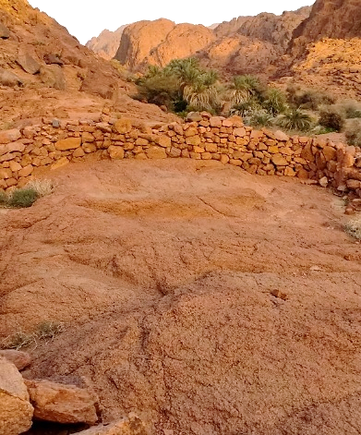

Figure 1. An old mirbad for dates in Madīna

Beside the Prophet’s mosque, the mosque at Qubāʾ was also established on a mirbad. The transformation of such sites into mosques involved, in addition to preparing the land, merely the erection of a quadrangular enclosure with the front wall aligned towards the qibla, which partly explained the selection. The nearly complete hypaethral configuration of the two mosques accounts for an incident involving a defiant hypocrite, Abū ʿĀmir al-Rāhib, who referred to the mosque of Qubāʾ disparagingly as the ‘mirbad’ of the Banū ʿAmr b. ʿAwf. This observation might also elucidate the diverse array of episodes reported to have occurred within the Prophet’s mosque that some deem inappropriate for a place of worship. Some modern scholars contend that the Prophet’s construction was not a mosque but a private residence for him and his household. However, this interpretation is historically misplaced, as it disregards the mosque’s original role as a multifunctional space that facilitated various social activities in addition to serving as a place of worship [27].
The Prophet referred to mosques as the places most beloved to God on Earth, and they are often called ‘buyūt Allāh’ (meaning ‘houses of God’). Ibn ʿAbbās narrated that the Prophet said: “Mosques are the houses of God on Earth […]”. Naturally, given Islamic theology’s absolute rejection of any notion of divine incarnation in the material world, this designation was never taken literally; the mosque was always understood to be simply a space dedicated to the remembrance and worship of God. Thus, the attribution of mosques to God is intended as an expression of reverence, not as a physical manifestation of the Divine. The Qurʾān describes mosques as “[…] houses [of worship], which God has permitted to be raised to honor; for the celebration, in them, of His name: in them is He glorified in the mornings and in the evenings (again and again)” (Al-Qur’an [24]:36). In subsequent periods, Muslim civilization introduced a range of religious architectural forms, including madrasas, khanqās, zāwiyas, and ribāṭs. These buildings, among others, were considered sacred to varying extents due to their use as spaces for prayer, while also fulfilling educational and social roles, thus enhancing their sanctity [28].

  - THE MOSQUE OF THE PROPHET IN HIS TIME
Although it was not the first mosque chronologically, as described above, the mosque of the Prophet was always understood to represent the pre-eminent mosque in terms of institutional and architectural precedence. It established the architectural prototype for subsequent mosques, typically featuring an open courtyard encircled by four porticoes. Therefore, it is crucial for our examination of early mosque architectural terminology to explore the terms employed by the earliest sources in describing its architectural components. The terms under review are largely taken from Madīna’s earliest local chronicler, Ibn Zabāla, who died shortly after the year 199/814. His monograph, Akhbār al-Madīna [29], follows only al-Hujja ʿalā ahl al-Madīna by Muḥammad b. al-Hasan al-Shaybānī (d. 189/805) in chronology. Nonetheless, Ibn Zabāla’s treatise stands as the oldest detailed exploration of the city’s topography and landmarks, while the earlier chronicle by al-Shaybānī predominantly offers a comparative study of Madīnian jurisprudence vis-à-vis other venerable fiqh schools, especially those based in Iraq.
Another significant, even if missing, early work was Akhbār al-Madīna by Yaḥyā al-ʿAqīqī (277/890). However, Ibn Zabāla’s book is certainly more comprehensive than Yaḥyā’s, who, in fact, sourced much of his material from the former. This makes Ibn Zabāla our earliest and foremost source on the Prophet’s mosque. The methodologies and insights presented in Ibn Zabāla’s text exerted a profound influence on later historians of the city. Among the surviving works inspired by his approach are al-Manāsik by Abū Isḥāq al-Ḥarbī (d. 285/898) [30], al-Durra al-thamīna by Ibn al-Najjār (d. 643/1245) [31], al-Taʿrīf bi-mā ansat al-hijra by al-Maṭarī (d. 741/1340) [32], and Taḥqīq al-nuṣra by Zayn al-Dīn al-Marāghī (d. 816/1413) [33]. However, the most significant of these subsequent chronicles was Wafāʾ al-wafā by al-Samhūdī (d. 911/1505), which is distinguished by its extensive and valuable content that encompasses Madīna’s historical narrative, topographical layout, urban development, key landmarks, along with the complex agrarian and irrigation schemes during its historical peak [1].
Numerous reports by Ibn Zabāla draw authority from various Companions (ṣaḥābīs) and Followers (tābiʿīs) of the Prophet, and hence appear across several ḥadīth collections, particularly those by al-Bukhārī (d. 256/870) and Muslim (d. 261/875). Key early narrators regarding the Prophet’s mosque include renowned figures such as Anas b. Mālik, Bilāl b. Rabāḥ, Umm Salama, ʿAbd Allāh b. ʿUmar, Abū Saʿīd al-Khudrī, Jābir b. ʿAbd Allāh, Ṭalq b. ʿAlī, Ibn Shihāb al-Zuhrī (d. 124/741–2), and Ṣāliḥ b. Kaysān (d. post- 140/758). As we will observe, the language these and other informants used to describe the Prophet’s mosque during his time was as straightforward as the structure itself. The terminology was palpably primitive, shaped by pre-Islamic Arabic culture and indigenous building traditions. Moreover, the majority of scholars chronicling Madīna’s past were natives of the city, which may elucidate the occasional convergence, and at times exact overlap, of the terminologies reported by different sources. This recurring linguistic consistency can also be explained by later historians’ tendency to replicate the specific terms used by the individuals they referenced.
In its early form, the Prophet’s mosque was a simple rectangular structure, primarily constructed of adobe or mud brick, locally referred to as labin [26][28][31]. This term specifically describes a type of building material made from water, earth, and organic materials like straw, which is shaped into bricks and dried in the sun rather than fired in kilns (Figure 2) [34]. For thousands of years, this construction method was widely used in ancient societies to build houses and structures, particularly in hot, arid regions like Arabia, where wood was scarce, and clay and water were more readily available. Situated in the eastern part of the Ḥijāz region, Madīna lies between central Arabia, where labin was the typical building material, and the volcanic plateaus of the western Ḥijāz, where rock was more commonly used. Consequently, the city’s residents developed a local style that incorporated both labin and stone. The former was plentiful in the surrounding defiles, while stones had to be brought from the nearby lava beds (Figure 3). For the construction of the Prophet’s mosque, stones were sourced from the nearby hillsides, and labin was prepared in an area on the outskirts of Madīna, called Baqīʿ al-Khabkhaba [28][35][36].

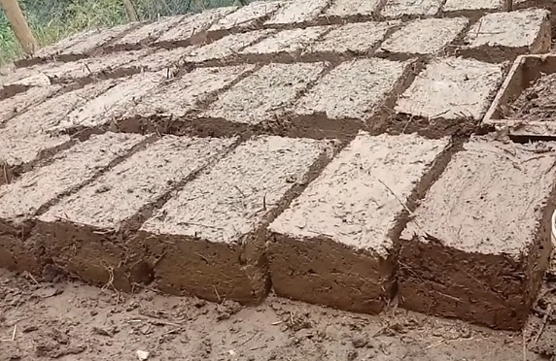
Figure 2. Sun-dried mud brick (known as labin)

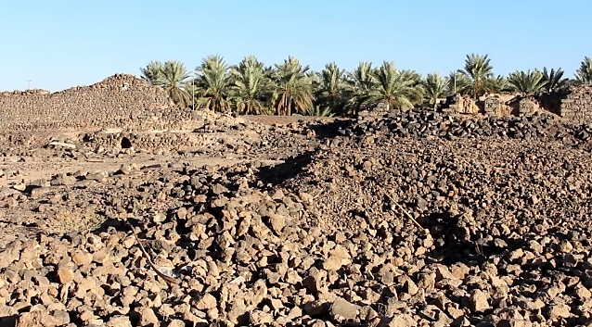
Figure 3. The use of crude stones in the pre-Islamic building of Banū Wāqif in Madīna

The mosque was built by the Prophet himself and his Companions using vernacular techniques and devices. In the al-samīṭ method, sun-dried mud bricks were laid directly on top of one another in simple courses (Figure 4a), creating a basic enclosure from local materials [8]. This technique was a common ‘rule-of-thumb’ method for quickly constructing walls in pre- and early Islamic Arabia, as reflected in the basic meaning of samīṭ as ‘thread or string,’ implying a linear and straightforward stacking of mud bricks. The term thus suggests a no-frills arrangement; walls built ʿalā al-samīṭ were easy and fast to erect, meeting the fledgling community’s immediate need for a mosque. However, such thin walls had limited strength and insulation, which became a concern as the building’s size and usage increased. In the al-saʿīda pattern, builders staggered bricks using a half-brick offset for greater stability in the next construction phase (Figure 4b). The term al-saʿīda, from the root sa-ʿa-da, ‘to rise or ascend’ [8], reflects an improved, taller wall structure as the community expanded. Later, a third method, al-dhakar wa-l-unthā, lit. ‘the male and female’, alternated bricks in two directions for even stronger bonding (Figure 4c) [28][31]. This may also recall the Prophet’s ḥadīth: “The believer to another believer is like a structure, each part strengthening the other.” He then interlaced his fingers to demonstrate. This method featured a crosswise placement of two pairs of bricks, substantially augmenting the wall thickness and height to adequately support the newly introduced roof for the front section (infra).
These evolving techniques symbolized the growing Muslim umma: as the community expanded in number and faith, the mosque quite literally rose in complexity and strength. This concept was replicated in new Muslim settlements, from Kūfa to Fusṭāṭ. The practice of adapting vernacular building techniques to meet community needs and refining them for durability became ingrained in Muslim architecture. When the Umayyads rebuilt the Prophet’s mosque with stone and carved wood (infra), some in the Muslim community recalled the mud-brick walls and palm thatch of the original, urging restraint. This nostalgia persisted for centuries; al-Samhūdī, during sultan Qāytbāy’s restoration in 879/1474, observed antique bricks of two sizes. He believed they were mud bricks from the Prophet’s era preserved within later kiln-baked walls for blessing [28].
In later periods, the term ‘ṭūb’ is commonly paired with ‘labin’ to refer to units of unbaked bricks as ‘ṭūb labin’, but such usage is absent in the early records of mosque architecture. Whenever a unit of unbaked brick is meant, the word ‘labina’ is used instead. In early sources, ‘ṭūb’ primarily denotes kiln-baked brick, more commonly known as ājurr. A more generic sense of the word emerged later through more influential cultural exchange. This could relate well to the fact that the Arabic term ṭūb was derived from the Coptic ⲧⲱⲃ (tōb), which in turn traces its origin to the ancient Egyptian word ḏbt (dēbt), used to refer to sun-dried bricks [38]. Interestingly, the English ‘adobe’ originates from the Spanish term adobe, which, in turn, is derived from the Arabic al-ṭūba or at-tūba.
a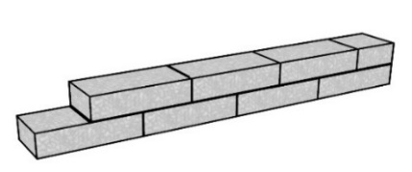
b 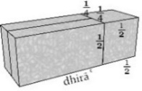
c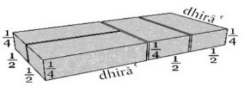

Figure 4. Different types of bricks used in building the Prophet’s Mosque (after al-Shihrī, 2001): (a) al-samīṭ; (b) al-sāʿida; (c) al-dhakar wa-l-unthā

The Prophet’s structure(s) rested on a foundational base of stone (asās min ḥijāra) and featured entries on three sides, excluding the qibla wall (jidār al-qibla) [26][28][31][32]. While this is how the majority of early sources refer to the qibla wall, some, such as Anas b. Mālik used the term ‘qibla’ alone, which more generally denotes the prayer direction or the front of the mosque, to refer to the front wall of the Prophet’s mosque. A similar usage is reported by Ibn Rusta, citing Khawla al-Sulamiyya, the wife of the Companion ʿUthmān b. Mazʿūn, who was said to be the first to wash the qibla, here referring to the qibla wall quite obviously, and anoint it with khalūq, ‘a paste of aromatic spices, particularly saffron’ [15]. Indeed, all ḥadīths that describe the Prophet delineating the qibla, whether for his own mosque or others, suggest that the term ‘qibla’ refers to the front wall of such mosques. The importance of getting that ruling architectural element laid precisely cannot be overemphasized, given that this wall, or more precisely, the straight line it delineates, indicates the direction toward which worshippers are required to orient themselves. Even in subsequent periods, the significance of the miḥrāb was not inherent; rather, worshippers were directed not towards the center of the miḥrāb, but along the line on which it is aligned.
The entrances consisted merely of basic apertures in the wall devoid of any shutters (furaj lā aghlāq ʿalayhā) [39]. Furaj is the plural of furja, which basically refers to a gap or an opening between two things, often indicating a small space through which one can look or pass an object. It is derived from the root fa-ra-ja, which means "to open" or "to create a gap." Aghlāq, on the other hand, is the plural of ghalaq, which means locking or closing something, e.g., a door or window. This root is also found in several other Semitic languages with similar meanings. The total height of the enclosure, initially oriented towards Bayt al-Maqdis, slightly exceeded that of a qama, defined as a fathom or the ‘height’ of an average man, or a basṭa [28][31], which describes the stature of a standing man with his arms fully extended (mabsūṭa) upwards.
The rapid increase in the number of congregants necessitated successive expansions of the mosque. Another expansion was imperative yet again before the qibla side was eventually covered with a rudimentary shelter (ẓulla) (Figures 10 & 11), following complaints from the congregants about the intense heat of the sun. Derived from the Arabic root ẓa-la-la, ‘to provide shade’ [8][25][40], the term ẓulla refers to anything that offers shade from the sun’s rays, whether natural, such as trees, or man-made, like arcades or canopies. The pillars (ʿumud) of the mosque [8] were constructed from palm trunks (judhūʿ al-nakhl) (Figure 5), which some described as ‘splits’ of palm trunks (shiqq^{an} shiqqa) [33]. They supported transverse wooden beams (ʿawāriḍ), which were overlaid with plaited palm fronds (khaṣaf) (Figures 6 & 7) and brushwood, notably camel grass (idhkhar) (Figure 8) [28].

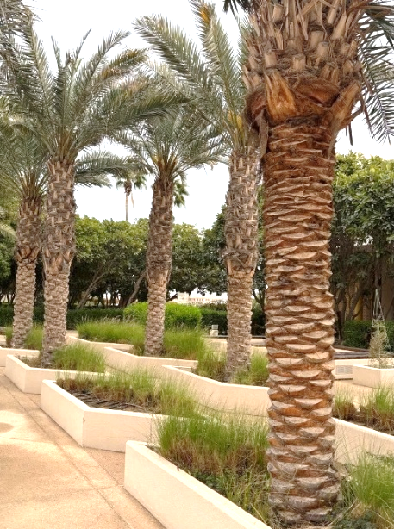
Figure 5. Trunks of palm trees

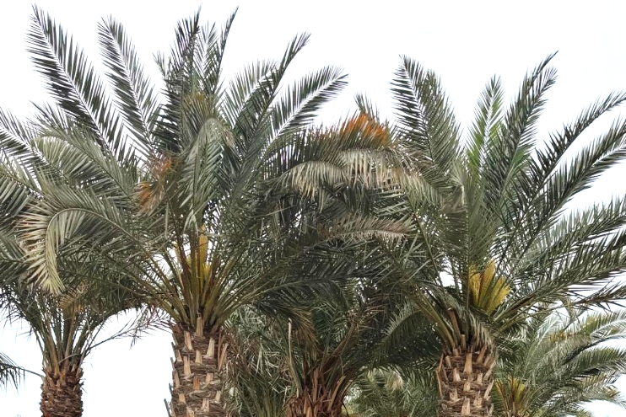
Figure 6. Fronds or leaves of palm trees

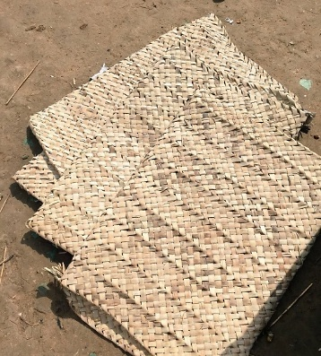
Figure 7. Plaited palm fronds (known as khaṣaf)

Despite receiving suggestions to reconstruct the mosque in a more elaborate style, akin to Christian places of worship familiar to Arabs who had traveled to the Levant, the Prophet firmly declined, insisting on maintaining the mosque’s original simplicity. This incident is of particular significance to our discussion as it represents the sole occasion on which the Prophet articulated his vision for the mosque’s design in his own words: “I want it in the form of a few pieces of wood and twigs, and a booth like that of Moses (thumām wa-khushaybāt wa-ẓulla ka-ẓullat Mūsā)”. In different narrations, when queried about the nature of Moses’ booth, he explained, “When he stood up, his head touched the ceiling” [26][28][41]. In another account, he described it as, “an arbor like that of Moses (ʿarīsh ka-ʿarīsh Mūsā)” [15][28]. ʿArīsh literally means a roof of brushwood and shrubs [8][25].
Following the redirection of the qibla from Bayt al-Maqdis in Jerusalem to the Kaʿba in Makka in the second year AH, an additional shelter was erected at the southern part of the mosque (Figures 10 & 11). The original one, now more frequently called ṣuffa, due to its composition of parallel rows of palm trunks (ṣufūf al-nakhal), was maintained to provide refuge for the most indigent among the Prophet’s associates, who were subsequently known as the ahl al-ṣuffa, or ‘the people of the portico’ (considered to be one potential origin for the term ‘Sufi’) [42]. It is worth noting here that the English word ‘sofa’ originates from the Arabic ‘ṣuffa’. The term passed into European languages through Turkish, where it was adapted as sofa.

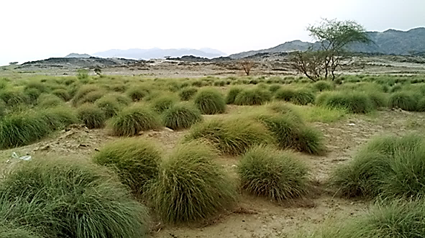
Figure 8. Plants of idhkhar in the Arabian desert

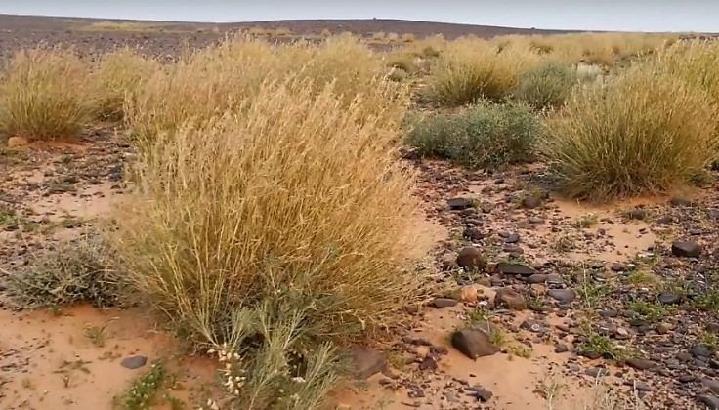
Figure 9. Plants of thumām in the Arabian desert

The above two shelters are widely considered the precursors of the later riwāq or ruwāq (Figures 10 & 11), typically translated into English as arcade, colonnade, or cloister. The surrounding open area (raḥba), which they bordered, is thought to be the origin of the later ṣaḥn, ‘courtyard’. The term raḥba derives from the root ra-ḥu-ba, meaning ‘to be wide enough to accommodate’ [8][40]. The raḥba was an integral part of the pre-Islamic Arabian dār, ‘house’, taking its name from the fact that it was a wide space accommodating various household activities. Generally, three terms were used in early sources to describe the open areas attached to or included in mosques: raḥba, fināʾ, and ṣaḥn. The latter was most commonly applied when the courtyard was centrally located, typically surrounded by four porticoes, while the fināʾ referred to a more peripheral open space. For example, the first mosque of the Companion ʿAmr b. al-ʿĀṣ in Fusṭāṭ was described by al-Maqrīzī as having “no ṣaḥn, but rather a surrounding fināʾ” [42].
Following his return from the battle of Khaybar in 7/628, the Prophet expanded the mosque significantly to accommodate the increasing number of worshippers, especially as many tribes were increasingly converting to Islam. After this final stage, the mosque of the Prophet was surrounded by numerous residences belonging to his Companions. We understand from one ḥadīth that some of these dwellings featured khawkhas, small doors or wickets embedded in the walls facing the mosque and opening onto it. Historically, these openings were customary in the walls separating adjacent homes (of the same household) in pre-Islamic Arabian society, primarily serving the functional purposes of providing light and air circulation. It is noteworthy that there is no direct linguistic connection between the word ‘khawkha’, meaning a small opening between two houses, and its more familiar modern usage referring to a ‘peach’, known in classical Arabic as ‘durrāq’. The name of this well-known fruit may have originated in Persian or Turkish before making its way into Arabic. Therefore, the similarity in pronunciation between the two words is due to linguistic evolution, but they have different meanings and are unrelated in terms of linguistic origin or context.
The later introduction of the typical minaret was most likely instigated by the practices of Bilāl, the Prophet’s muezzin, who traditionally called to prayer from the roof of a house near the mosque. Notably, the mosque constructed by the Prophet did, at some stage, include a structure referred to by later historical sources, such as Ibn al-Najjār, as a ‘manār’, specifically for the adhān. Ibn Saʿd records that upon the construction of his mosque, the Prophet facilitated Bilāl’s call to prayer from its rooftop by erecting an elevated platform for him. Known as al-Miṭmār, this platform is mentioned in other accounts as an usṭuwān murabbaʿa, ‘[squat] rectangular pillar’ (occasionally also termed a manāra) [26][31]. Ibn Zabāla continued to use the term murabbaʿa to designate any quadrangular column, or structure, in the mosque during his time. In order to ascend that structure, Bilāl reportedly used aqtāb (sing. qitb), which refers to a pile of small saddles, each typically about the size of a camel’s hump [8][23].
Historical accounts indicate that in 8/629, the Prophet adopted the use of a minbar, albeit a rudimentary one: a three-step seat constructed from lumber and sticks. Made of tamarisk wood (ṭarfāʾ) from a nearby grove (Figure 12), this simple device was to replace the palm stem (jidhʿ) against which he previously leaned during speeches. The Prophet himself referred to this pulpit as ‘aʿwād’ (sing. ʿūd), and in another narration, ‘aʿwād al-minbar’. It is interesting to note that Ibn Zabāla identified the piers of the maqṣūra, which was later added to the mosque by al-Walīd b. ʿAbd al-Malik and seen by him, as ‘ʿīdān’ (another plural form of ʿūd) [29], indicating that this term, usually used to denote the Prophet’s minbar, referred to planks and logs in general, not just sticks or rods as in today’s usage. The term ‘minbar’, said by some to be of an Abyssinian origin [43], is also used by the Prophet in various other ḥadīths to describe this preaching platform [20][44], which is said by Ibn Saʿd, on the authority of the Companion Tamīm al-Dārī, to have been inspired by Christian practices (i.e., ambos) observed in the Levant [24][31]. The term ‘minbar’ is a place noun that originated from the verb na-ba-ra, ‘to elevate’, particularly in the context of amplifying one’s voice. In mosque architecture, the minbar serves as the designated platform from which the khaṭīb delivers a religious discourse during the Friday sermon, typically projected at full volume. The lexicographer Ibn Manẓūr (d. 711/1311-12) argues that the minbar is so named due to its ‘elevated’ form [8].

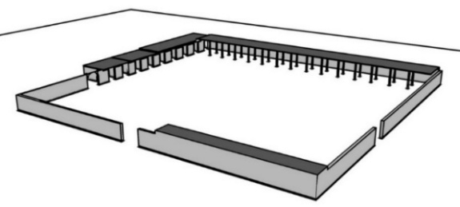

Figure 10. Isometric reconstruction of the Prophet’s mosque
(after Farīd Shāfiʿī, 1970)

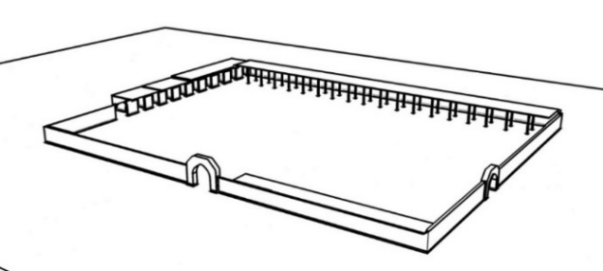

Figure 11. Isometric reconstruction of the Prophet’s mosque
(after Robert Hillenbrand 1994)

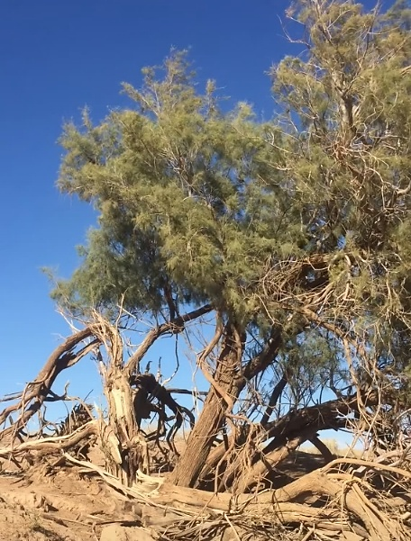

Figure 12. Tamarisk wood (known locally as ṭarfāʾ)

  - EXPANSION BY ʿUMAR (R. 13-23/634-644)
The caliph ʿUmar b. al-Khaṭṭāb reconstructed the mosque in Madīna in 17/638 primarily because the original palm trunks used in its construction had deteriorated. Additionally, the expansion was necessitated by the rapidly increasing congregation size that the original mosque could no longer accommodate, according to ʿAbd Allāh b. ʿUmar (d. 74/693–4) had his father meticulously replicate the architectural design of the Prophet’s original structure. The materials used in this reconstruction also remained the same: unbaked bricks (labin) and date-palm leaves and midribs (jarīd), and he replaced the old palm trunks with new ones (ʿumuduh khashab al-nakhl). It is of interest to note that the new trunks began to be called asāṭīn (sing. usṭuwān or usṭuwāna) by some narrators, such as Anas b. Mālik [29]. For the sake of differentiation, the term sawārī was more commonly used to refer to the palm trunks during the time of the Prophet [], possibly because that was how the Prophet himself referred to them. Alternatively, this differentiation between the two terms can be ascribed to the fact that during the Prophet’s time, the pillars were made from splits (shiqqa) of palm stems, as mentioned earlier, while in ʿUmar’s time, intact palm trunks were used. Therefore, they were called usṭuwānat due to their cylindrical shape, as usṭuwāna, originally derived from the Persian usṭūn, denotes cylindrical pillars [8].
Planted in the same positions as the older trunks, these columns were later given names commemorating certain episodes from the Prophet’s biography that they witnessed: usṭuwānat al-wufūd, ‘the column of delegates’, usṭuwānat al-tawba, ‘the column of repentance’, and so on. This naming convention persisted even after they were replaced with stone pillars, and careful observers can still spot Ottoman-era inscriptions on some of them in the current structure. In his descriptions of the Baṣra mosque, Yāqūt employed both terms ‘asāṭīn’ and ‘sawārī’, using the latter specifically to refer to columns appropriated as spolia. In his contemporary accounts of the Damascus mosque, Ibn Jubayr made distinctions among ‘ʿamūd’, ‘sāriya’, and ‘rijl’, ‘lit.leg’, thereby differentiating various architectural elements: “It rested upon sixty-eight columns (ʿamūd), including fifty-four pillars (sāriya), eight plaster legs (arjul) interspersed among them, and two marble columns embedded into the wall” [21].

  - EXPANSION BY ʿUTHMĀN (R. 23–35/644–56)
In 29/649-50, the caliph ʿUthmān b. ʿAffān, who inherited a more affluent economy, reconstructed the mosque, enhancing its structure with better materials. However, this reconstruction of ʿUthmān faced open reservations from puritan voices of the time for allegedly deviating from the Prophet’s more austere model [45]. However, ʿUthmān aimed to incorporate more durable materials to make the mosque more cost-efficient, while also honoring the space and facilitating its use. His motivation stemmed from the fact that the mosque had been repeatedly rebuilt in the past, partly due to the use of ephemeral materials. At his direction, the walls were constructed from uniformly carved stones (ḥijāra manqūsha muṭābiqa), finished with a stucco coating (qaṣṣa). This terminology was used by Ibn ʿUmar, as recorded by the majority of early sources [20][26][30]-[33]. In contrast, Ibn al-Athīr al-Jazarī (d. 630/1233), who came from Cizre in modern Turkey, employed the term ‘jiṣṣ’ rather than ‘qaṣṣa’, the latter being a term from the Ḥijāzī dialect predominantly used by informants from the Ḥijāz region [8][23][39]. Jiṣṣ (also jaṣṣ), on the other hand, may be derived from a common Semitic root associated with whiteness or whitewashing. Ibn Manẓūr had already noted its non-Arabic (possibly Persian) origin [8]. The architectural innovations during ʿUthmān’s era included the inaugural use of the maqṣūra, which featured a roof of teak wood (sājj) said to have been brought from India [26][31]. The term itself originates from the verb qa-ṣa-ra, meaning ‘to confine’, as the maqṣūra was exclusively reserved for the ruler’s use. This chapel-like structure was consistently referred to as the maqṣūra, with no alternative designations recorded.
The columns, which were constructed from ashlar blocks, underwent precise drilling and were reinforced with iron dowels (aʿmidat al-ḥadīd) that were embedded within lead bedding [31][41]. The same technique is reported to have been used later for the Kūfa mosque, when it was rebuilt by Ziyād b. Abīh in 50/670. According to al-Ṭabarī (d. 310/923), Ziyād expressed his desired architectural vision for the mosque at Kūfa, particularly in terms of size and height, albeit struggling to articulate its specifics effectively: “I yearn for something which I cannot describe adequately (ashtahī min dhālik shayʾ lā aqaʿ ʿalā ṣifatih)”. After some discussion, a builder who had previously been employed by Khusrau advised the ruler that the only way to realize and construct the envisioned structure to perfection would be to use stone columns sourced from the al-Ahwāz mountains. These columns needed to be hollowed out, drilled, and assembled using lead and iron rods (safāfīd) [18][46].

  - ENLARGEMENT BY AL-WALĪD (R. 86–96/705–15)
The Umayyad caliph al-Walīd b. ʿAbd al-Malik was an aesthete who ruled over a more settled and established pan-Islamic realm than his predecessors. Besides rebuilding the Prophet’s mosque at Madīna as well as the mosques in Fusṭāṭ and Ṣanʿāʾ, his construction projects included the erection of the mosques of Damascus, ʿAnjar, Khirbat al-Minyā, and Jabal Says. He also decorated the Aqṣā mosque in 87/706 and collaborated with his brother, Sulaymān, to construct the mosque in Aleppo. The era of al-Walīd marked a significant advancement in Islamic art and architecture, which, of course, was part of the Umayyad propagandistic agenda. This architectural renaissance was driven by active caliphal patronage, abundant state resources, and the incorporation of foreign artistic traditions and skilled craftsmen. These factors collectively contributed to notable innovations in mosque architectural features and, in turn, the development of specialized terminologies to describe them.
The mosque of the Prophet reportedly retained its afore-mentioned form from the time of ʿUthmān until the reign of al-Walīd, under the supervision of his governor in Madīna, ʿUmar b. ʿAbd al-ʿAzīz (d. 101/720) oversaw substantial expansion and renovation of the mosque, transforming it into a grand and impressive structure. The work, which took three years (88–91/707–710), included expanding the mosque’s area to accommodate the swelling crowds of resident worshippers and pilgrims. This involved incorporating the surrounding houses, including those of the Prophet’s wives, into the mosque’s area, nearly doubling its size to approximately 100 x 90 meters. The new design featured an expanded courtyard (ṣaḥn) and a larger prayer hall with five horizontal rows of columns (ṣufūf muqaddama). The columns themselves (sawārī or usṭwānāt) were connected by arches that supported a wooden roof (saqf) made of teakwood (sājj), which was gilded and adorned with intricate carvings [26][31].
It is said that the reconstruction project employed not only local workers but also Greek and Coptic craftsmen, as well as materials (particularly for mosaics) [36]. Before the reconstruction, al-Walīd reportedly sent a letter to the Byzantine Emperor (referred to by the Muslim sources as malik al-Rūm): “We wish to reconstruct the mosque of our Grand Prophet. Therefore, help us with workers and mosaics (fusayfisāʾ)” [26][31]. The reported incorporation of Greek elements into mosque architecture and decoration aimed to give the structure a transformative, innovative aesthetic. It also clearly influenced the associated terminology. For example, the above Arabic word used for mosaics, namely fusayfisāʾ, has its origins in the Greek language, derived from the word ‘ψηφιδωτόν’ (psēphidōtón), which literally means ‘made of small pebbles’ or ‘a composition of small pieces’. This term was transferred into Arabic through Syriac or Greek, and was used to describe mosaic art forms, which involve assembling small pieces of glass, stone, or other materials to create images or designs [8][37][43][47]. It is said that the Byzantine king also sent lanterns (qanādīl, sing. qindīl) along with their chains. Here as well, the Arabic term traces its origin to the Greek language; ‘qindīl’ comes from the Greek kandíla (κανδήλα), meaning ‘candle’ or ‘lamp’ [37][48]. This incident, however, does not mark the first large-scale use of lanterns for night-time lighting in Arabia, a feat attributed to the caliph ʿUmar b. al-Khaṭṭāb, who reportedly used simpler devices to illuminate the mosques during the nights of the holy month of Ramaḍān [26]. Later, the qanādīl were used in the Muslim societies to light homes, streets, and public spaces, typically consisting of a container holding oil and a wick that was lit to provide light. Afterward, the term was used to refer to any hanging lighting device.
The mosque was constructed using finely cut ashlar stones (ḥijāra manqūsha muṭābiqa), coated with lime mortar (qaṣṣa/nūra), and embellished with friezes (ṭunuf). It also featured a fountain (fawwāra) and was equipped with lead spouts (mayāzīb min al-raṣāṣ). For the first time, a new decorative element—crenellations (shurufāt or shuraf)—was introduced, which subsequently became a signature motif in mosque architecture. The columns were clad in stone and marble (marmar), giving the mosque a more monumental appearance. The Arabic word marmar, used by all relevant sources, originates also from a Greek word, mármaros (μάρμαρος), meaning ‘shining stone’ [37]. It was used to denote marble or alabaster, both of which were valuable materials in ancient Greek and Roman arts and architecture. The term was introduced into Arabic through intermediary languages such as Persian or Syriac, where it came to refer specifically to marble. During al-Walīd’s reconstruction, the workers and artisans of marble, said to be among the Greek labor force, are referred to in the Arabic sources as ‘murakhkhimūn’ (from rukhām, another Arabic term for marble).
The new construction of al-Walīd included the addition of four minarets (manārāt) at the mosque's corners, which many consider the earliest example of this architectural element in Muslim architecture [30]. In early Islamic sources, three terms are commonly used to refer to the minaret: ‘ṣawmaʿa’, ‘miʾdhana’, and ‘manāra’. The first of these referred to towers, typically used as granaries, as well as those inhabited by hermits. It was later applied to the earliest minarets, which were typically cubic structures. This term was predominantly used in North Africa and Syria, regions where minarets constructed before the thirteenth century AD generally featured a square design akin to traditional grain silos. The second term, ‘miʾdhana’, with variations in pronunciation such as ‘maʾdhana’ and ‘mīdhana’, stems from its key function as a platform for adhān, ‘call to prayer’ [43]. This term itself could have originated from the triliteral root ‘a-dhi-na’, meaning ‘to give permission’ [8][23][39], in the context of commencing a prayer when its time is due. More likely, it may have been derived directly from another form of the verb, ‘adh-dha-na’, which means to inform (worshippers about the time of prayer), literally making them hear it with their ears (udhun). From the late Middle Ages onwards, ‘miʾdhana’ has become the most commonly used term for a minaret. The third term, manāra, which is obviously the origin of the English ‘minaret’ (especially when used in a genitive construction, such as manārat [al-masjid], or in the plural form manārāt), is derived from manār, which refers to a lighthouse: a place that emits light (nūr), typically associated with fire (nār). Given their towering stature and visibility from great distances, minarets were aptly termed ‘manāra’ [23][39]. Additionally, ‘manār’ connotes a banner or beacon that serves as a guiding landmark during large assemblages, such as in wars or parades, further emphasizing the minaret’s role as a prominent and guiding physical structure [8][23].
Of all the above three terms, ‘manāra’ is reported to have been used by the Prophet, particularly to denote the White Minaret in Damascus where Jesus Christ is prophesied to descend to earth in the End Times: “Then, he [i.e., Jesus] descends near the white minaret to the east of Damascus” [20]. The term manāra was also used by al-Balādhurī to refer to what some specialists consider the first true minaret, namely the one introduced to the mosque of Baṣra when it was rebuilt by Ziyād b. Abīh in 45/665. Sometimes, historians used different terms to refer to the same minaret(s), often influenced by their own dialects. For instance, both Ibn Zabāla and Ibn Rusta used ‘manārāt’ to describe the minarets added by al-Walīd to the Prophet’s mosque, while the Maghrebī traveler Ibn Baṭṭūṭa (d. 779/1377) referred to them as ṣawāmi’ [49]. Similarly, Ibn ʿAbd al-Ḥakam (d. 257/870) and al-Kindī (d. 350/961) called the early minarets introduced to the mosque of Fusṭāṭ by Maslama b. Mukhallad in 53/673, and which are also considered by some to be the first of their kind in Islam, manār (another, albeit rare, plural of manāra), whereas al-Maqrīzī (d. 845/1442) referred to them as ṣawāmiʿ [42].
The mosque is also believed to have been the site of the first introduction of a concave prayer niche (miḥrāb mujawwaf), which was intricately decorated. ʿUmar b. ʿAbd al-ʿAzīz was reportedly eager for people to witness the replacement of the old miḥrāb with the new one. From al-Muqaddasī (d. 380/990), we understand that the term miḥrāb was already used to refer to the mark of the qibla prior to al-Walīd’s renovation, though it was not allegedly a concave recess. While references to miḥrābs are present in the Qurʾān, substantial evidence suggests that in the nascent stages of Islam, the term may have denoted a structure distinct from the concave prayer niche. The prevailing scholarly consensus posits that the mosque of the Prophet lacked a miḥrāb, despite narratives—such as that recounted by Wāʾil b. Ḥajar—which describes the Prophet praying in a location referred to as a ‘miḥrāb’ [50]. This was presumably merely a designated area at the front of the mosque where he regularly led prayers. Supporting this interpretation is the continued use of ‘miḥrāb’ in historical texts to describe an elevated platform at the front of the mosque.
In early Islamic texts, notably Ḥadīth, the concave prayer niche was commonly referred to as al-ṭāq, a Persian term meaning ‘recess’ (Figure 13) and applicable to any arched structure, such as an aqueduct or a window. Notable Ḥadīth collections, including the Muṣannaf of Ibn Abī Shayba (d. 235/850) and the Sunan of al-Bayhaqī (d. 458/1066), contain chapters discussing the legality of praying in the ṭāq [51]. These discussions primarily reflect the views of the ṣaḥābīs and the tābiʿīs, rather than those of the Prophet. It is noteworthy that, due to the absence of such an architectural feature in pre-Islamic Arabian culture, both the first and succeeding generations of Muslims (ṣaḥābīs and tābiʿīs) tended to borrow non-Islamic terms to describe this new architectural element. However, while the latter used the Persian term ṭāq, the former referred to it as madhbaḥ. In Arabic, ‘madhbaḥ’ is derived from the root dha-ba-ḥa, which means ‘slaughter’ or ‘sacrifice’. In most religious systems, including Pagan, Hindu, and Buddhist cultures, the madhbaḥ, or ‘altar’, is a place located in the pre-eminent position within sanctuaries, where sacrifices are offered, or religious rituals related to sacrifice are performed [8][23][39]. This term was used with the same meaning in ancient Semitic cultures, including Canaanite and Hebrew civilizations. In Hebrew, the corresponding word is ‘מִזְבֵּחַ’ (mizbéaḥ). The madhbaḥ was known to pre-Islamic and early Islamic Arabs through the Jewish and Christian communities in the Arabian Peninsula. The Companions subsequently adopted the term to denote the concave prayer niche in the mosque, as both architectural features occupied a frontal position, both literally and metaphorically.

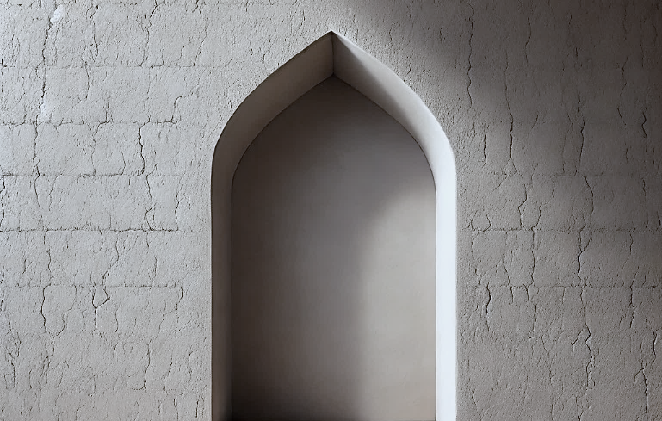

Figure 13. An imagination of a simple concave prayer niche (known as ṭāq or miḥrāb)

The etymology of the term ‘miḥrāb’ is believed by scholars of Semitic languages to trace back to the Himyarite language, which adopted the term from Abyssinian influences during the introduction of Christianity to Yemen. The original Abyssinian form, ‘mekurab’, referred to a church, temple, or an apse [52]. Notably, the Christians of Najrān used the term specifically to denote the apse (ḥanya) in a church wall. Serjeant maintains that the term ‘miḥrāb’ primarily refers to architectural elements, specifically a row of columns and their intervening spaces, suggesting its derived meanings, such as a niche or part of a monk’s cell, are ancillary [53]. In the pre-Islamic Arabic lexicon, the term ‘miḥrāb’ encompassed a variety of significations, including the front part of a house, a royal palace, and a communal gathering spot. The word specifically denoted the foremost section of a residence, regarded as the most esteemed area therein. Early Arabic poets used ‘miḥrāb’ to refer to royal palaces. Further, the term extended metaphorically to signify a lion’s den and the collective meeting place. Among the Israelites, ‘maḥārīb’ referred to their sanctuaries or places of worship [8][39][54][55].
In the formative years of Islam, as elucidated by al-Khalīl b. Aḥmad (d. 170/786) and Abū Manṣūr al-Azharī (d. 370/980), the term ‘miḥrāb’ predominantly (though not exclusively) came to signify the location from which the imām leads the congregational prayers. Nonetheless, it retained broader meanings, including the garret of a house, as noted by Abū Isḥāq al-Zajjāj (d. 311/923). One illustrative ḥadīth recounts the Prophet sending ʿUrawa b. Masʿūd to his relatives in Yemen, where, upon entering his miḥrāb, he emerged at dawn to lead the Fajr prayer. Al-Zajjāj interprets this usage to suggest that a miḥrāb is an elevated chamber or loft (ghurfa), further indicating the term’s varied applications, even in religious contexts, during this period. Al-Azharī, drawing on the authority of Ibn al-Anbārī (d. 328/940), posits that the term ‘miḥrāb’ was coined to denote the area where the imām stands, distinguished and isolated from the rest of the congregants [54]. This interpretation aligns with the various definitions previously discussed. Notably, early lexicographers such as al-Azharī and Ibn Manẓūr have interpreted ‘miḥrāb’ as referring to the front part of a gathering place. This interpretation explains Anas b. Malik’s hesitance to pray within it stems from a reluctance to conspicuously set himself apart from other congregants. Occasionally, a raised platform (dukkān) was constructed within the miḥrāb for the imām to lead prayers [56]. Subsequently, the term ‘miḥrāb’ came to be more exclusively associated with the concave prayer niche.

  - THE MOSQUE AFTER AL-WALĪD
After al-Walīd, the next monarch to undertake architectural modifications at the Prophet’s mosque, albeit on a smaller scale, was the ʿAbbāsid caliph al-Mahdī (r. 158–169/775–785), who expanded it northward by 50 meters (160 feet). He had also planned to remove six steps from the minbar, but abandoned the idea due to concerns about damaging the wooden platforms supporting them [26][30]. According to Ibn Qutayba, who gave no details, the caliph al-Maʾmūn (r. 198–218/813–833) also expanded the mosque [12]. Al-Mutawakkil (r. 232–247/847–861), for his part, covered the enclosure of the Prophet’s tomb with marble veneer. The following ʿAbbāsid caliphs continued to maintain the Prophet’s mosque, but there was no need for its expansion or reconstruction until it accidentally caught fire in 654/1256. The following year, the ʿAbbāsid caliph al-Mustaʿṣim bi-llāh (r. 640-56/1242-58) ordered the reconstruction of the mosque, but he was later preoccupied with the Mongol invasion of Baghdad, leaving the workers to abandon the rubble as it was. However, they did manage to build a roof over it, supported by the columns surrounding the Prophet’s sacred chamber [26].
Now, our textual sources on the forms of the Prophet’s mosque prior to al-Walīd describe structures that the authors themselves did not see; at best, they convey the accounts and the exact terms used by those who witnessed such structures. Otherwise, they used the terminology of their own time to describe the knowledge they had of these vanished structures. Al-Walīd’s structure, however, stood for long. As we have just seen, the monarchs who followed him either carried out only secondary works at the mosque, or none at all, reflecting an increasing reluctance to tamper with the venerable structure due to this being perceived as sacrilegious or vainglorious (notwithstanding that it had been extensively rebuilt and renovated numerous times in the first century AH, as discussed above).
Besides Ibn Zabāla and those informed by him, there are two informative accounts of the mosque from the third-fourth centuries AH, i.e., those by Ibn Rusta al-Iṣfahānī (d. ca. 300/912) and Ibn ʿAbd Rabbih al-Andalusī (d. 328/940), who described the mosque in their time. From an architectural point of view, however, and for the reasons discussed earlier, these descriptions primarily pertain to the structure built by al-Walīd. Ibn Rusta, a renowned Persian geographer and traveler, mentioned that he saw the mosque of the Prophet in 290/903 (during his pilgrimage to the Muslim holy lands), after the construction work of al-Mahdī and the restorations carried out by al-Muʿtaḍid bi-llāh in 282/895. He even read to us the inscriptions on the commemorative plaque related to al-Mahdī’s works. The mosque structure he described, however, largely belongs to al-Walīd (see above). Ibn Rusta used well-chosen Arabic inflections to refer to the mosque’s rear portico (muʾakhkhar) and front portico (muqaddam). He was unique in highlighting the presence of a chandelier (thurayyā) hanging from the ceiling. This term initially referred to a cluster of bright stars in the sky (literally, the Pleiades ‘seven sisters’ star cluster), but over time, it came to refer specifically to chandeliers.
Ibn Rusta also refers to the use of shuraf (sing. shuraf), ‘cresting’ or ‘battlements’ for decoration, which are originally notched, defensive parapets often seen on the tops of fortifications. The term ‘shuraf’ is derived from the root sha-ra-fa, meaning ‘to overlook’ or ‘to have a commanding view’, reflecting the protective function of battlements [8]. Ibn Rusta saw the original minbar of the Prophet (with the additions made by the Umayyad ruler Marwān b. al-Ḥakam). He referred to two of the original three rods at the back that once supported the Prophet’s back when seated as ‘aʿwād badad’, ‘detached wooden sticks’. He explained that Marwān added more sticks (aʿwād) to the sides, adding that the minbar also had round kwuā (openings). Ibn Rusta also referred to a pomegranate-shaped wooden finial (rummāna) that topped the baluster of the minbar’s staircase [14].
Coming from Cordoba, a city with a resplendent architectural heritage, Ibn ʿAbd Rabbih al-Andalusī provided a most comprehensive account of this architectural phase of the Prophet’s mosque. Although he himself is believed to have never left al-Andalus, Ibn ʿAbd Rabbih learned about the mosque from his shaykhs, particularly Baqiyy b. Makhlad (d. 276/889), Ibn Waḍḍāḥ al-Qurṭubī (d. 287/899), and Abū al-Ḥasan al-Khushanī (d. 286/899), who had visited the eastern Islamic territories in pursuit of knowledge and for pilgrimage. Ibn ʿAbd Rabbih’s account is particularly significant to our discussion, not only for its rich details but also for employing a more sophisticated descriptive discourse and terminology, introducing some of the mosque’s architectural features. As such, it deserves to be quoted here in full:
“Description of the Prophet’s Mosque (Peace Be Upon Him): The aisles in its qibla [i.e., front area] are laid horizontally from east to west, with each row consisting of seventeen columns. Between every two columns, there is a large, wide gap. The columns in the southern prayer area (qibliyya) are coated with white plaster and very tall (shāṭṭat^{un} jidd^{an}), while the rest of the mosque’s columns are made of marble. The plastered columns rest on large, square bases, and their capitals are gilded, adorned with golden, engraved friezes (nijaf munnaqasha mudhahhaba). The ceilings (samāwāt) above the friezes are also decorated and gilded. Facing the miḥrāb is the central [vertical] aisle (mūsaṭat al-balāṭāt) [57], taking the form of an entirely gilded bay that cuts across the [horizontal] bays from the courtyard to the bay of the miḥrāb, though it does not cut through it. The bay next to the miḥrāb is richly gilded, and at its center is topped with a roundel-like ceiling (samāʾ ka-l-tirs al-muqaddar) whose concavity is like that of a shell (mujawwaf ka-l-maḥār), gilded as well. The inner face of the southern wall of the mosque is lined with a marble band (izār rukhām) from the foundation up to about a fathom, with a marble strip the thickness of a finger running along it. Above this is another narrower band, treated with incense paste (mukhallaq bi-l-khalūq), and above it a similar band pierced with fourteen door-like motifs in a row from east to west, resembling the niches of the Great Mosque of Cordoba. These are engraved and gilded. Above that is yet another marble band with a celestial design (ṣunayfa samāwiyya), inscribed with five lines of gilded calligraphy, as thick as a finger, from the shorter chapters of the Qurʾān (al-Mufaṣṣal). Above this is a marble band similar to the first (i.e., the lowest), adorned with a gilded shield-like motif (tersa min dhahab), and between each shield is a green colonette with golden rods at its edges. Above this is another marble band with an engraved design (ṣunayfa munaqqasha), the width of about a forearm, featuring golden rods and leaves. Above this is a wide mosaic band, and the ceilings rest upon it. The miḥrāb is situated in the center of the southern wall (mūsaṭat al-sūr al-qiblī). Above its arch is a protruding, thick gilded crest (qaṣṣa min dhahab), in the middle of which is a square mirror, said to have belonged to ʿĀʾisha (may Allāh be pleased with her). The dome of the miḥrāb is beautifully adorned, featuring circles, some gilded and others in red and black. Beneath the dome is a gilded, engraved design (ṣunayfa), followed by octagonal golden plates, with a variegated agate (juzʿa) about the size of a little child’s skull set and fastened within them. Below that, down to the floor, is a band of marble smeared with saffron paste, in which lies the palm stem (watad) the Prophet (peace be upon him) used to lean on when rising from prostration in the original miḥrāb, as in tradition. And Allāh knows best. To the right of the miḥrāb is a door through which the imam enters and exits, and to the left is a small, chessboard-like door (bāb mushaṭraj) that has been sealed with iron bars. Between these two doors and the miḥrāb is a smooth, gentle walkway. The maqṣūra is attached to the western wall, extending from the door to the small partition (faṣīl) connected to the eastern wall. From this partition, a flight of steps leads to the mosque's roof. The enclosure is old and simple in design, with battlements and four doors. Outside the enclosure, near the left side of the miḥrāb, is an underground passage (sarab) accessible by steps that leads to the house of ʿUmar b. al-Khattab (may Allāh be pleased with him). The minbar is located to the right of the miḥrāb, at the beginning of the third bay from the latter, situated in the Rawḍa and paved with marble and surrounded by it. It has steps, and at the top, a plank has been nailed to prevent anyone from sitting on the step where the Messenger of Allāh (peace be upon him) used to sit. The pulpit is simple, without the intricate carvings and fine craftsmanship seen in those of our time. The [old palm] trunk stands in front of the pulpit, and to its east is a wooden chest (tābūt) that covers the sitting place of the Messenger of Allāh (peace be upon him) [i.e., the upper step where he used to sit]. The grave of the Prophet (peace and blessings be upon him) is located in the eastern part of the mosque, at the end of the southern portico (musaqqafa) near the courtyard (ṣaḥn). There is a distance of about ten cubits between it and the eastern wall. The grave is enclosed by a wall, with about three cubits separating it from the ceiling. It has six corners and is covered with a marble veneer higher than a fathom (qāma), with the area above the marble treated with saffron paste. The Messenger of Allāh (peace be upon him) said: “The space between my grave and my pulpit is a garden (rawḍa) from the gardens of Paradise, and my pulpit is on one of the gates (turʿa) of Paradise”. On the roof of the mosque, directly above the grave, is a fenced-off area (ḥijr maḥjūr) to prevent people from walking over it. The southern bays are five, while the western ones are four, all aligned with each other in length. From the qibla [i.e., southern] side to the interior, there are eighteen columns. All the arches (ḥanāyā) of the mosque from the courtyard are reinforced on all four sides with engraved wooden beams (khashab munaqqash) connected to the columns’ shoulders (manākib al-ʿumud). The mosque has three minarets: two in the south and one in the east. The walls of the mosque, from the interior, are adorned with marble, gold, and mosaics (fusayfisāʾ), from beginning to end. The mosque has eighteen doors, all with gilded lintels (ʿatabuhā mudhahhaba). These are large doors with no locks (ghilaq)—four in the south, seven in the east, and seven in the west. The entire floor (qāʿ) of the mosque is covered with pebbeles (ḥaṣā), and it has no matting (ḥuṣur). The outer walls of the mosque are decorated with weathered stone (kadhdhān), as are the battlements” [16].

Table 1. Origins of key terms used by the early sources to describe the architectural features of the Prophet’s mosque in the first century AH

Ancient Semitic | Coptic | Persian | Greek | Arabic | Origin  Date
miḥrāb | N/A | N/A | N/A | muṣallā; jidār; mirbad; labin; qibla; miḥrāb; furja; aghlāq; ʿumud; judhūʿ al-nakhl; jarīd; ʿawāriḍ; khaṣaf; idhkhar; thumām; ẓulla; ʿarīsh; ṣufūf al-nakhal; ṣuffa; raḥba;  khawkha; manār | The mosque of the Prophet (1-7/622-8)
N/A | N/A | asāṭīn | N/A | ʿumud; khashab al-nakhl; sawārī | rebuilt by ʿUmar (17/638)
Jiṣṣ | N/A | N/A | N/A | ḥijāra manqūsha; qaṣṣa; sājj; maqṣūra; kwuā; safāfīd | rebuilt by ʿUthmān  (29/649-50)
N/A | ṭūb | ṭāq | fusayfisāʾ; qanādīl; marmar; balāṭāt | ṣufūf muqaddama; saqf; ṭunuf; mayāzīb; fawwāra; shurufāt; manārāt; dukkān; nijaf; muʾakhkhar; muqaddam; thurayyā; samāwāt; balāṭāt; izār; turʿa; ḥanāyā; manākib al-ʿumud; ghilaq; ḥuṣur | rebuilt by al-Walīd  (88-90/707-9)

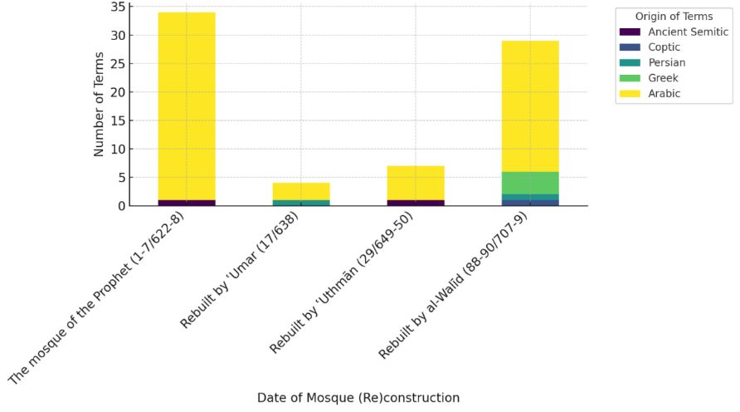

Figure 14. A chart displaying the ratios of linguistic origins of terms used to describe the mosque’s (re)constructions

CONCLUSION
In its formative stage, under the Prophet and the Rāshidūn caliphs, the architectural features and terminology of the Prophet’s mosque were characterized by marked simplicity, deeply rooted in practicality and expediency. The mosque’s elements, along with the language employed by early local sources, were utilitarian and rustic, reflecting the environmental conditions and domestic construction practices prevalent in pre-Islamic Arabia, as seen in terms such as ẓulla, raḥba, ṣuffa, and qāma. These terminologies were not merely descriptive but indicative of how early Muslim architecture maintained continuity with its pre-Islamic roots, adapting familiar concepts to new religious and social functions. Given the status of the Prophet’s mosque as a foundational prototype for later Muslim architectural forms, some of the terms associated with it endured, evolving to denote more sophisticated and developed features in subsequent mosque constructions. This enduring influence underscores the mosque’s pivotal role in establishing a lexicon that became integral to the architectural discourse and vocabulary of Islamic structures, both religious and secular, serving as a testament to the adaptability of early Muslim architectural practices. While some terms naturally faded into obscurity as architectural practices evolved, others persisted, even influencing the lexicon of other languages, with certain Arabic terms serving as the etymological roots for Latin counterparts. Although the original Prophet’s mosque lacked elements such as the miḥrāb, manāra, or minbar, which later became definitive features of mosque architecture, it incorporated rudimentary versions of these components, either during the Prophet’s era or shortly thereafter. Some contemporary sources even anachronistically applied later-established terms to describe these early elements, underscoring the evolving nature of architectural terminology, as the transmission of architectural knowledge was occasionally filtered through later terminological frameworks.
The transformation under Umayyad patronage, particularly during the reconstruction by al-Walīd b. ʿAbd al-Malik marked a critical juncture in mosque architecture, introducing a synthesis of indigenous and foreign elements that became the hallmark of Muslim architecture. It introduced what is now called the ‘Arab plan’, i.e., the hypostyle mosque design that has dominated Muslim architecture across various regions ever since. The inclusion of features such as the concave prayer niche, dedicated minarets, an elevated pulpit, and crenellations—many of which were considered unprecedented in early Muslim architecture—marked a shift toward a more elaborate and symbolically rich architectural expression. The integration of non-Arab craftsmen, particularly Greek and Coptic artisans, and the use of foreign materials, enhanced the mosque’s grandeur and also introduced a cross-cultural exchange that is evident in the architectural lexicon, as seen in Arabic derivatives of Greek terms like fusayfisāʾ, marmar, and qanādīl, which continue to be used in modern Arabic. This period demonstrated a conscious effort to transcend local architectural norms by incorporating non-Arab craftsmanship, materials, and design concepts, reflecting the Islamic empire's cosmopolitan nature and its engagement with the broader Mediterranean and West Asian worlds.
As mosque architecture continued to evolve, the terminologies used by contemporary informants, whether based on personal observation or learned through transmission, reflected a blend of foreign influences and indigenous innovations. The reliance on terminologies that evolved underscores the complexities of recording and transmitting architectural knowledge in the early Islamic period. This linguistic evolution, in which Arabic expressions were adapted or replaced by foreign terms, mirrored broader socio-cultural transitions within the Islamic empire, reflecting shifts in knowledge, technology, and material culture. It also signified the fluidity with which Muslim architecture absorbed and redefined external influences. In this context, the nuanced role of language not only served as a vehicle for describing architectural innovations but also functioned as a medium for preserving cultural memory and identity within an evolving Islamic context. The difficulty faced (and acknowledged) by some early Arab patrons and chroniclers in accurately articulating the innovative architectural elements they encountered in certain mosques highlights the challenges of capturing the rapidly evolving, increasingly complex nature of Muslim architecture.

REFERENCES
[1] E. Ayyad, “An Historiographical Analysis of the Arabic Accounts of Early Mosques: With Special Reference to Those at Madina, Baṣra and Kūfa,” Journal of Islamic Studies, vol. 30, no. 1, pp. 1–33, 2019. Doi: https://doi.org/10.1093/jis/ety030.
[2] A. B. b. Z. al-Jurāʿī. Tuḥfat al-rākiʿ wa-l-sājid bi-aḥkām al-masājid, Farawāniyya: Wazārat al-Awqāf wa-l-Shuʾūn al-Islāmiyya, 2004.
[3] A. F. L. Beeston, et.al., Sabaic Dictionary. Beirut: Louvain-la-Neuve, 1982.
[4] A. Jeffery, The Foreign Vocabulary of the Qurʾān. Cairo: Oriental Institute Baroda, 1938.
[5] J. Pedersen, R. A. Kern, E. Diez, “Masdjid”, in The Encyclopaedia of Islam. Leiden; Brill, 1991.
[6] J. Johns (ed.). “The ‘House of the Prophet’ and the Concept of the Mosque”, Bayt al-Maqdis: Jerusalem and Early Islam, vol. 2. pp. 59–112, 1999.
[7] J. M. Bloom. “Mosque”, in Encyclopaedia of the Qurʾān, vol. 3, pp. 426-37, Leiden: Brill, 2003.
[8] I. Manẓūr. Lisān al-ʿArab, vol. 3, Cairo: Dār al-Maʿārif, 1981.
[9] M. b. ʿA. A. al-Zarkashī. Iʿlām al-sājid bi-aḥkām al-masājid. Cairo: Ministry of Waqfs, 1999.
[10] I. Ḥ. al-ʿAsqalānī. Fatḥ al-Bārī bī-sharḥ ‘Ṣaḥīḥ al-Bukhārī’, vol. 2, Cairo: Muṣṭafā al-Ḥalabī, 1959.
[11] I. ʿA. al-Ḥakam. Futūḥ Miṣr wa-akhbāruhā (The History of the Conquests of Egypt, North Africa and Spain). ed. C. C. Torrey. New Haven: Yale University Press, 1922.
[12] I. Qutayba al-Dīnawarī. al-Maʿārif, ed. T. ʿUkāsha. Cairo: Dār al-Maʿārif, 1969.
[13] al-Balādhurī. Futūḥ al-buldān, ed. A. A. al-Ṭabbāʿ and U. A. al-Ṭabbāʿ. Beirut: Dār al-Nashr li-l-Jāmiʿiyyīn, 1957.
[14] I. Rusta. al-Aʿlāq al-nafīsa wa-yalīhi Kitāb al-Buldān li-l-Yaʿqūbī. Leiden: Brill, 1891.
[15] I. Khordadbeh. al-Masālik wa-l-mamālik, ed. M. J. de Goeje. Leiden: Brill, 1889.
[16] I. A. Rabbih. al-ʿIqd al-farīd, ed. M. Qumayḥa and ʿA. A. al-Tarḥīnī, 3rd ed, vol. 7. Beirut: Dār al-Kutub al-ʿIlmiyya, 1983.
[17] I. Khaldūn. Muqaddima, ed. ʿA. A. M. al-Darwīsh, vol. 2, Damascus: Dār Yaʿrub, 2004.
[18] K. A. C. Creswell. Early Muslim Architecture: with a Contribution on the Mosaics of the Dome of the Rock in Jerusalem and the Great Mosque in Damascus by Marguerite Gautier-van Berchem. New York: Hacker Art Books, vol.1, 1979.
[19] O. Grabar. The Formation of Islamic Art. New Haven: Yale University Press, 1987.
[20] I. Kathīr. al-Bidāya wa-l-nihāya, vol. 4, Jiza: Dār Hajr, 1997.
[21] I. Jubayr. Riḥlat Ibn Jubayr. Beirut: Dār Ṣādir li-l-Ṭibāʿa wa-l-Nashr, 1964.
[22] E. S. Ayyad, “Revisiting K.A.C. Creswell’s Theory on the First Mosque in Islam,” Journal of Islamic Architecture, vol. 4, no. 4, pp. 188-95, 2017. https://doi.org/10.18860/jia.v4i4.4267.
[23] al-Zamakhsharī. Asās al-balāgha, ed. M. B. ʿUyūn al-Sūd, vol. 1, Beirut: Dār al-Kutub al-ʿIlmiyya, 1998.
[24] I. Saʿd. K. al-Ṭabaqāt al-Kabīr, ed. ʿA. M. ʿUmar, vol. 1, Cairo: Maktabat al-Khānjī, 2001.
[25] I. S. al-Nās. ʿUyūn al-athar fī funūn al-maghāzī wa-l-shamāʾil wa-l-siyar, ed. M. al-Khaṭrāwī and M. al-Dīn Mistū, vol. 1. Medina: Maktabat Dār al-Turāth, 1992.
[26] Al-Samhūdī. Wafāʾ al-wafā bi-akhbār dār al-muṣṭafā, ed. M. Muḥyī ad-Dīn, vol. 1. Beirut: Dār al-Kutub al-ʿIlmiyya, 1984.
[27] E. S. Ayyad, “The ‘House of the Prophet’ or the ‘Mosque of the Prophet’?,” Journal of Islamic Studies, vol. 24, no. 3, pp. 273-334, 2013. Doi: https://doi:10.1093/jis/ett053.
[28] E. Ayyad, “What Made a Place Holy in Early Islam? An Inquiry into Meaning and Doctrinal Modalities,” Journal of Al-Tamaddun, vol. 19, no. 1, pp. 25-46, 2024. https://doi.org/10.22452/JAT.vol19no1.3.
[29] I. Zabāla. Akhbār al-Madīna, ed. Ṣ. ʿA. a. Salāma. Medina: Markaz Buḥūth al-Madīna, 2003.
[30] I. I. al-Ḥarbī. Kitāb al-Manāsik wa-amākin ṭuruq al-ḥajj wa-maʿālim al-Jazīra, ed. Ḥamad al-Jāsir, Riyadh: Dār al-Yamāma, 1969.
[31] I. al-Najjār. al-Durra al-thamīna fī tārīkh al-Madīna, ed. M. Z. ʿAzab. Cairo: Maktabat al-Thaqāfa, 1981.
[32] Al-Maṭarī. al-Taʿrīf bi-mā ansat al-hijra min maʿālim dār al-Hijra, ed. S. al-Raḥīlī, Riyadh: Dārat al-Malik ʿAbd al-ʿAzīz, 2005.
[33] Al-Marāghī. Taḥqīq al-nuṣra bi-talkhīṣ maʿālim dār al-Hijra, ed. M. al-Aṣmaʿī. Medina: al-Maktaba al-ʿIlmiyya, 1955.
[34] R. M. da Rosa, “Adobe as an Islamic Standard: Vernacular Cosmopolitics,” in S. Pradines (ed.), Earthen Architecture in Muslim Cultures: Historical and Anthropological Perspectives. Leiden: Brill, 2018.
[35] Al-Fayrūzabādī. al-Maghānim al-muṭāba fī maʿālim ṭāba, ed. Ḥ. al-Jāsir. Riyadh: Manshūrāt Dār al-Yamāma, 1969.
[36] E. Ayyad, The Making of the Mosque: A Survey of Religious Imperatives. Piscataway NJ: Gorgias Press, 2019.
[37] Ṭ. A. Hashīma. Uṣūl al-Kalimāt. Giza: Dār Halā, 2007.
[38] I. al-Maḥjūb. Qurrat al-ʿayn fī awṣāf al-ḥaramayn, 65.
[39] I. A. B. al-Rāzī. Mukhtār al-ṣiḥāḥ, ed. D. al-Maʿājim, M. Lubnān, rev. Edn. Beirut: Maktabat Lubnān, 1989.
[40] E. S. Ayyad, “A Prophetic Perspective of Mosque Architecture,” The Islamic Quarterly, vol. 59, no. 2, pp. 117-72, 2015.
[41] al-Barzinjī. al-Tārīkh al-musammā nuzhat al-nāẓirīn fī masjid Sayyid al-awwalīn wa-l-ākhirīn. Cairo: Maṭbaʿat al-Jamāliyya, 1914.
[42] Al-Maqrīzī. al-Mawāʿiẓ wa-l-iʿtibār bi dhikr al-khiṭaṭ wa-l āthār: al-Maʿrūf bi-l khiṭaṭ al-maqrīziyya, ed. M. Zaynuhum and M. Al-Sharqāwī, vol. 3. Cairo: Maktabat Madbūlī, 1998
[43] ʿĀ. M. Rizq. Muʿjam muṣṭalaḥat al-ʿimāra wa-l-funūn al-islāmiyya. Cairo: Maktabat Madbūlī, 2000.
[44] Al-Albānī. Silsilat al-aḥadīth al-ṣaḥīḥa, Riyadh: Maktabat al-Maʿārif, 2002.
[45] al-Baghawī. Sharḥ al-sunna, ed. Z. al-Shāwīsh and S. al-Arnāʾūṭ, vol. 2. Beirut: al-Maktab al-Islāmī, 1983.
[46] Al-Ṭabarī, Tārīkh al-rusul wa-l-mulūk, ed. M. A. a. Ibrāhīm, Cairo: Dār al-Maʿārif, 1967.
[47] N. al-Ṭarshān. “al-Madāris al-asāsiyya li-l-fusayfisāʾ al-umawiyya fī Bilād al-Shām”, Dissertation, University of Jordan, 1989.
[48] M. al-Tunjī. al-Muʿarrab wa-l-dakhīl fī al-lugha al-ʿarabiyya wa-ādābuhā. Beirut: Dār al-Maʿrifa, 2005.
[49] I. Baṭṭūṭa. Riḥlat Ibn Baṭṭūṭa al-musammāh tuḥfat al-nuẓẓār fī gharāʾib al-amṣār wa-ʿajāʾib al-asfār, Cairo: al-Maṭbaʿa al-Khayriyya, 1904.
[50] Al-Bayhaqī. al-Sunan al-kubrā, ed. M. ʿAbd al-Qādir ʿAṭā, Beirut: Dār al-Kutub al-ʿIlmiyya, 2003.
[51] I. A. Shayba. al-Muṣannaf, ed. M. ʿAwāma, Jeddah: Dār al-Qibla; 2006.
[52] J. Sauvaget, “The Mosque and the Palace”, in J. M. Bloom (ed.), Early Islamic Art and Architecture. Hampshire: Ashgate, 2002.
[53] R. B. Serjeant, “Miḥrāb”, Bulletin of the School of Oriental and African Studies, vol. 22, no. 3, pp. 439-53, 1959. Doi: https://doi.org/10.1017/S0041977X00065526.
[54] al-Azharī, Tahdhīb al-lugha, ed. M. ʿAwaḍ Murʿib, Beirut: Dār Iḥiyāʾ al-Turāth al-ʿArabī, 2001.
[55] al-Fayrūzabādī, al-Qāmūs al-muḥīṭ, Cairo: al-Hayʾa al-Miṣriyya al-ʿĀmma li-l-Kitāb, 1978.
[56] M. b. Anas. al-Mudawwana al-kubrā, Beirut: Dār al-Kutub al-ʿIlmiyya, 1994.
[57] H. Munt. The Holy City of Medina: Sacred Space in Early Islamic Arabia. Cambridge: Cambridge University Press, 2014.

Appendix: A Table of Arabic Terms Describing Architectural Features of First-Century Mosques
Note: Some of the architectural elements listed in this table existed in earlier mosques but were not documented in surviving sources. Similarly, some terms may have appeared in earlier historical or legal texts or linguistic dictionaries, etc., to describe features not related to mosque architecture. This table highlights the earliest recorded references specifically related to key elements of mosque architecture.
Architectural Element (English) | Arabic Term | Early Mosque(s) Featuring the Element | Date | Main Earliest Source(s)
mosque front | muqaddam al-masjid | First Kūfa Mosque | 17/638 | al-Ṭabarī (d. 310/923)
mosque front | ṣadr al-masjid | Mosque of the Prophet (enlarged by ʿUthmān) | 29/649-50 | Ibn Saʿd (d. 230/845)
mosque front | ṣadr al-masjid | Mosque of Baṣra (rebuilt by Ziyād) | 45/665 | Yāqūt al-Ḥamawī (d. 622/1229)
front portico, prayer hall | ẓulla | First Kūfa Mosque | 17/638 | al-Ṭabarī
front portico, prayer hall | ṣuffa muqaddama | Mosque of Baṣra (rebuilt by Ziyād) | 45/665 | al-Balādhurī (d. 297/892)
front portico, prayer hall | riwāq al-qiba; bayt al-ṣalāh; al-mughaṭṭā; al-masqūf | Early and subsequent mosques | throughout Islamic history | later sources (post-100/718)
side arcades/side porticoes | junbatayn (sing. junba) | Mosque of Baṣra (rebuilt by Ziyād) | 45/665 | Ibn Qutayba al-Dīnawarī (d. 276/889); al-Balādhurī
side arcades/side porticoes | mujannabāt (sing. mujannaba) | Mosque of Kūfa (rebuilt by Ziyād) | 50/670 | al-Ṭabarī
rear arcade/rear portico | ṣuffa | Mosque of the Prophet in his time | 2-7/623-8 | Ibn Saʿd; al-Bukhārī (d. 256/870)
rear arcade/rear portico | mawākhīr (sing. muʾakhkhar) | Mosque of Kūfa (rebuilt by Ziyād) | 50/670 | al-Ṭabarī
arcade, colonnade (in general) | bāʾika (pl. bawāʾik) | early and subsequent mosques | throughout Islamic history | later sources (post-300/912)
aisle (in general) | riwāq, ruwāq (pl. arwiqa, ruwāqāt) | Mosque of the Prophet (enlarged by ʿUthmān) | 29/649-50 | al-Balādhurī
aisle (in general) | riwāq, ruwāq (pl. arwiqa, ruwāqāt) | Mosque of Damascus | 87/706 | al-Muqaddasī (d. 380/990); Ibn ʿAsākir (d. 571/1176)
[vertical] aisles/bays | balāṭa (pl. balāṭāt/abliṭa/balāṭ | Mosque of Kūfa (rebuilt by Ziyād) | 50/670 | Ibn Jubayr (d. 614/1217)
[vertical] aisles/bays | balāṭa (pl. balāṭāt/abliṭa/balāṭ | Mosque of Damascus | 87/706 | Ibn Khaldūn (d. 808/1406)
[vertical] aisles/bays | balāṭa (pl. balāṭāt/abliṭa/balāṭ | Mosque of the Prophet (rebuilt by al-Walīd) | 88-90/707-9 | Ibn ʿAbd Rabbih (d. 328/940)
[horizonal] aisles | uskūb (pl. asākīb) | Mosque of Ibn Ṭulūn | 263-5/877-9 | al-Maqrīzī (d.  845/1442); Ibn Manẓūr (d. 711/1311)
open courtyard | raḥba | Mosque of the Prophet in his time | 2-7/623-8 | Ibn al-Najjār (d.  643/1245)
open courtyard | dahnāʾ (lit. desert or sandy land) | First Baṣra Mosque | 14/635 | al-Balādhurī
open courtyard | fināʾ | First Kūfa Mosque | 17/638 | al-Balādhurī
open courtyard | ṣaḥn | First Kūfa Mosque | 17/638 | al-Ṭabarī; Ibn al-Athīr (d. 630/1233)
open courtyard | murabbaʿa (lit. square open courtyard) | First Kūfa Mosque | 17/638 | al-Ṭabarī
prayer niche | miḥrāb (to denote the imām’s prayer space) | Mosque of the Prophet in his time | 1-7/622-8 | Ibn Zabāla (d. post-199/814); al-Bayhaqī (d. 458/1066); al-Khalīl b. Aḥmad  (d. 175/791); al-Azharī (d. 370/980)
prayer niche | miḥrāb (to denote the qibla mark, but not a concave recess) | Mosque of the Prophet (prior to al-Walīd’s enlargement) | 29-88/649-707 | al-Muqaddasī
concave prayer niche | miḥrāb mujawwaf | Mosque of the Prophet (rebuilt by al-Walīd) | 88-90/707-9 | al-Wāqidī (d. 207/822); al-Maqrīzī
concave prayer niche | miḥrāb mujawwaf | Mosque of Fusṭāṭ (rebuilt by al-Walīd) | 92-3/710-12 | al-Maqrīzī
concave prayer niche | ṭāq | a multitude of mosques | 2nd/8th century | Ibn Abī Shayba (d. 235/850); al-Bayhaqī
concave prayer niche | ṭāq | Mosque of Damascus | 87/706 | Ibn Jubayr
raised platform for the imām | dukkān | Mosque of the Prophet (rebuilt by al-Walīd) | 88-90/707-9 | Mālik b. Anas (d. 179/795)
minaret | manāra, manār | Mosque of Fusṭāṭ (rebuilt by Maslama b. Mukhallad) | 53/673 | Ibn ʿAbd al-Ḥakam (d. 257/870); Abū ʿUmar al-Kindī (d. 350/961)
minaret | manārāt | Mosque of the Prophet (rebuilt by al-Walīd) | 88-90/707-9 | Ibn Zabāla
minaret | manāʾir | Mosque of Damascus | 87/706 | Yāqūt al-Ḥamawī
minaret | ṣawāmiʿ (sing. ṣawmaʿa) | Mosque of Fusṭāṭ (rebuilt by Maslama b. Mukhallad) | 53/673 | Ibn ʿAbd al-Ḥakam
minaret | ṣawāmiʿ (sing. ṣawmaʿa) | Mosque of Baṣra (enlarged by al-Mahdī) | post-160/777 | Ibn Baṭṭūṭa (d. 779/1377)
minaret | miʾdhana | Mosque of Damascus | 87/706 | Ibn Kathīr (d. 774/1373); Ibn Manẓūr
entrances | furaj (sing. furja) | Mosque of the Prophet in his time | 1-7/622-8 | Ibn al-Maḥjūb (d. ca. 888/1483)
entrances | abwāb (sing. bāb) | Mosque of the Prophet (enlarged by ʿUmar) | 17/638 | Ibn al-Najjār
entrances | turaʿ (sing. turʿa) | Mosque of the Prophet (enlarged by al-Walīd) | 88-90/707-9 | Ibn ʿAbd Rabbih
door folds | aghlāq | Mosque of the Prophet in his time | 1-7/622-8 | Ibn al-Maḥjūb
door folds | ghilag | Mosque of the Prophet in his time | 1-7/622-8 | Ibn ʿAbd Rabbih
door folds | firākh | Mosque of Damascus | 87/706 | al-Muqaddasī
pulpit | aʿwād [al-minbār] | Mosque of the Prophet in his time | introduced in 8/629 | Ibn Zabāla; al-Bukhārī
pulpit | minbar | Mosque of the Prophet in his time | 8/629 | Ibn Saʿd
pulpit | minbar | Mosque of ʿAmr at Fusṭāṭ | 21/641-2 | Ibn ʿAbd al-Ḥakam
wicket | khawkha | Mosque of the Prophet in his time | 1-7/622-8 | Ibn Zabāla; al-Bukhārī; Ibn al-Faqīh (4th/10th century)
small windows | kuwā (sing. kawwa) | Mosque of the Prophet in his time | post-7/628 | Ibn Zabāla; Ibn Shabba (d. 262/876)
small windows | rawzānāt (sing. rawzāna) | The Kaʿba (restored by al-Walīd) | 91/710 | al-Azraqī (d. 250/864); Ibn ʿAbd Rabbih
small windows | ṭāqāt (sing. ṭāqa) | Mosque of the Prophet (rebuilt by al-Walīd) | 88-90/707-9 | Ibn Rusta (d. ca. 300/912)
arches | ʿuqūd (sing. ʿiqd) | Mosque of Baṣra (rebuilt by Ziyad) | 45/665 | al-Balādhurī
arches | qanāṭir (sing. qanṭara) | Mosque of Damascus | 87/706 | Ibn ʿAsākir
arches | ḥanāyā | Mosque of the Prophet (rebuilt by al-Walīd) | 88-90/707-9 | Ibn ʿAbd Rabbih
arches | qisiyy (sing. qaws) | Mosque of Damascus | 87/706 | Ibn Jubayr
column | ʿamūd or ʿāmūd (pl. ʿumud, ʿamad, aʿmida, ʿawāmīd) | Mosque of the Prophet (enlarged by ʿUmar) | 17/638 | al-Bukhārī
column | usṭūn, usṭuwān or usṭuwāna (pl. asāṭīn, usṭuwānāt) | Mosque of the Prophet (enlarged by ʿUmar) | 17/638 | Ibn Zabāla
column | sāriya (pl. sawārī, sāriyāt) | Mosque of Baṣra (rebuilt by Ziyād) | 45/665 | al-Balādhurī
small columns, colonnettes | suwayriyyāt | Mosque of Damascus | 87/706 | Ibn Jubayr
coated columns | asāṭīn mubayyaḍa | Mosque of Baṣra (rebuilt by Ziyād) | 45/665 | al-Muqaddasī
capitals | ruʾūs al-ʿmud, ruʾūs al-aʿmida | Mosque of Fusṭāṭ (rebuilt by al-Walīd) | 92-3/710-12 | Ibn ʿAbd al-Ḥakam
capitals | ruʾūs al-ʿmud, ruʾūs al-aʿmida | Mosque of Damascus | 87/706 | Ibn ʿAsākir; al-Muqaddasī
capitals | manākib al-ʿumud (may also refer to echini, sing. echinus) | Mosque of the Prophet (rebuilt by al-Walīd) | 88-90/707-9 | Ibn ʿAbd Rabbih
dome, cupola | qubba | Mosque of Damascus | 87/706 | al-Muqaddasī; Ibn ʿAsākir, Ibn Jubayr; Yāqūt al-Ḥamawī
dome finial | bayḍat al-qubba (lit. egg-like finial) | Mosque of Damascus | 87/706 | Ibn ʿAsākir; Ibn Kathīr
dome finial | turnujja (lit. citron-like finial) | Mosque of Damascus | 87/706 | al-Muqaddasī
dome finial | rommāna (lit. pomegranate-like finial) | Mosque of Damascus | 87/706 | al-Muqaddasī
gables | jamālūnāt (sing. jamālūn) | Mosque of Damascus | 87/706 | Ibn ʿAsākir; Ibn Kathīr
ceilings | samāwāt (sing. samāʾ) | Mosque of the Prophet (rebuilt by al-Walīd) | 88-90/707-9 | Ibn ʿAbd Rabbih
matting | ḥuṣur | Mosque of the Prophet (rebuilt by al-Walīd) | 88-90/707-9 | Ibn ʿAbd Rabbih
ablution place | mayḍaʾa | Mosque of Damascus | 87/706 | al-Muqaddasī
lavatory | maṭhara | Mosque of Damascus | 87/706 | Ibn ʿAsākir
crenellations, battlements | shurufāt, shurrāfāt; shuraf, sharārīf (sing. shurfa, shurrāfa) | Mosque of Damascus | 87/706 | Ibn ʿAsākir; Ibn Kathīr
crenellations, battlements | qudhuf, qidhāf (sing. qudhfa) | al-Juḥfa Mosque | 73/693 | Ibn Abī Shayba
stalactite pendentives | muqarnaṣ | Mosque of Damascus | 87/706 | Ibn ʿAsākir; Ibn Kathīr
any recessed architectural element/motif | ḥanya (pl. ḥanāya) | Mosque of Damascus | 87/706 | Ibn ʿAsākir
any recessed architectural element/motif | ḥanya (pl. ḥanāya) | Mosque of Harran | 2nd/8th century | Ibn Jubayr
sloped basin | shādharwān | The Kaʿba | 2nd/8th century | al-Azraqī
barrel vault, canopy | burṭula | the Masjid al-Ḥarām in Makka | 4th/10th century | Ibn ʿAbd Rabbih
fountain | fawwāra | Mosque of Damascus | 87/706 | al-Muqaddasī, Ibn ʿAsākir
fountain | fawwāra | Mosque of the Prophet (rebuilt by al-Walīd) | 88-90/707-9 | Ibn Zabāla
voussoir | ṣinja | Mosque of Damascus | 87/706 | Ibn Jubayr
wooden beams | jawāʾiz khashab | Mosque of Harran | 2nd/8th century | Ibn Jubayr
door threshold, sill, lintel | uskuffa, uskūfa | Mosque of the Prophet in his time | 1-7/622-8 | al-Ṭabarānī (d. 360/971); al-Dāraquṭnī (d. 385/995); al-Bayhaqī
shell-like motif | wadaʿa | First Kūfa Mosque | 17/638 | al-Ṭabarī
wooden architraves | nijāf (also nijaf) | Mosque of the Prophet (rebuilt by al-Walīd) | 88-90/707-9 | Ibn ʿAbd Rabbih
friezes | ṭunuf | Mosque of the Prophet (rebuilt by al-Walīd) | 88-90/707-9 | Ibn ʿAbd Rabbih
marble band | izār rukhām | Mosque of the Prophet (rebuilt by al-Walīd) | 88-90/707-9 | Ibn ʿAbd Rabbih
spouts | mayāzīb | Mosque of the Prophet (rebuilt by al-Walīd) | 88-90/707-9 | Ibn ʿAbd Rabbih
chandelier | thurayyā | Mosque of the Prophet (rebuilt by al-Walīd) | 88-90/707-9 | Ibn ʿAbd Rabbih
celestial design | ṣunayfa samāwiyya | Mosque of the Prophet (rebuilt by al-Walīd) | 88-90/707-9 | Ibn ʿAbd Rabbih
shield-like motif | tersa | Mosque of the Prophet (rebuilt by al-Walīd) | 88-90/707-9 | Ibn ʿAbd Rabbih

Al-Bukhārī, “Ṣalāh”, 476. Riyadh: 1999.
Al-Bukhārī, “Ṣalāh”, 445, 659. Riyadh: 1999.
This was reported by al-Wāqidī on the authority of ʿĀṣim b. ʿAdiyy (d. 45/665).
I. Khuzayma, “Ṣalāh”, 1293. Beirut: 1980;
A. Dāwūd, “Ṣalāh”, 1455. Riyadh: 1999; Muslim, “Ṣalāh”, 666, 2699. Riyadh: 1999.
This ḥadīth is generally regarded as weak (ḍaʿīf). Nevertheless, in the Qurʾān, God refers to the Kaʿba as belonging to Him, using the term ‘baytī’, ‘My House’. Al-Qurʾān, 2:125; 22:26. Additionally, in ḥadīth literature, the term ‘Bayt Allāh’ specifically and exclusively refers to the Kaʿba.
Al-Bukhārī, ḥadīth no. 481.
The plural forms of ʿamūd include: ʿumud, ʿamad, and aʿmida
French also played a role in the transmission of the word into English. By the early 17th century, ‘sofa’ in English began to refer to a cushioned seat or long upholstered furniture for reclining, similar to how it is understood today.
Al-Bukhārī, “Ṣalāh”, 467. Riyadh, 1999; Ibn al-Najjār, p. 161.
In its simplest sense, a miṭmār refers to the string that a builder uses to outline the structure.
Al-Bukhārī, “Jumuʿa”, 917, 2094, 2569. Riyadh: 1999.
Al-Bukhārī, “Ṣalāh”, 446. Riyadh: 1999.
Muslim, “Masājid”, 1190. Riyadh: 1999
Al-Bukhārī, “Ṣalāh”, 446. Riyadh: 1999
Before that, mosaics were used, presumably for the first time in Islamic religious architecture, by ʿAbd Allāh b. al-Zubayr when he rebuilt the Kaʿba in 64–65/684.
The above Arabic terms are mainly reported by from Ibn Zabāla, as well as al-Ṭabarī, Ibn Rusta, al-Muqaddasī, al-Qazwīnī, and Ibn Kathīr.
From Greek, it passed into other languages, such as Latin ‘marmor’, which later evolved into the English word ‘marble’.
Muslim, “Fitan”, 2937. Riyadh: 1999; Abū Dāwūd, “Malāḥim”, 4321. Riyadh: 1999.
Other plural forms are manāʾir and manāwir.
al-Bayhaqī, “Ṣalāh”, 4304. Beirut: 2003
It may be important to note here that prior to Abyssinia’s involvement, Christianity was already present in Yemen, likely due to trade routes and the interactions between the Roman Empire, Byzantium, and the Arabian Peninsula.
Nijāf denotes the protruding part that overhangs something; nijāf al-bayt refers to what is built above a house, extending over it.
The mūsaṭ of any structure is its central place. Balāṭ derives from the Greek πλατεῖα (plateía), whose Latin form was platea.
The word ‘ṣunayfa’ is the diminutive form of ‘ṣinfa’. According to al-Jawhari, the ṣinfa of one’s izār, ‘sarong or waist-wrapper’, is its border, specifically the side that has no fringe. It is also said to mean the edge of a garment, regardless of which side.
In other versions of the MS, ‘shaṭranjī’.
Turʿa also means an elevated garden.

