 |  | JOURNAL OF ISLAMIC ARCHITECTURE  P-ISSN: 2086-2636 E-ISSN: 2356-4644  Journal Home Page: http://ejournal.uin-malang.ac.id/index.php/JIA
THE ANTHROPOLOGY OF LIGHT IN THE MEDINAL BUILT ENVIRONMENT: ANCIENT FABRIC OF BLIDA, ALGERIA
Chamma Amel^{1*}, Dambri Mabrouk¹
¹Institute of Architecture and Urban Planning, Laboratory Child, City and Environment (LEVE). University of Batna 1. Batna, Algeria
*Corresponding Author: amel.chamma@univ-batna.dz
ARTICLE INFO |  |  | ABSTRACT
Volume: 9  Issue: 1  Page: 97-126  Received: January 31st, 2025  Accepted: August 25th, 2025  Available Online: June 30th, 2026  DOI: https://doi.org/10.18860/jia.v9i1.31838 |  |  | The anthropology of light is considered a relatively new field; it focuses on the interaction of light with the built environment and how it carries cultural, symbolic, and spatial meanings across societies. First introduced by Danielle Morali in 1994, it was later expanded by Mikkel Bille and Tim Flohr Sørensen in 2007, who examined light as material culture within the framework of social experience, focusing primarily on Western contexts. Building on the limitations of previous research, this study shifts the attention to the medinal world, where light plays a fundamental role in shaping spatial perception and social practices. Specifically, it explores the anthropology of light within the built environment of El-Djoun, the historic core of Blida, Algeria. Using qualitative methods such as walking interviews and architectural surveys, combined with a quantitative questionnaire. Through these mixed methods, the research adds a new dimension to the interdisciplinary approaches combining anthropology and architecture, contributing to our understanding of medinal dynamics. The results demonstrate that the medina's luminous feature is not incidental but embedded in its architectural fabric, expressing deep-rooted religious beliefs, cultural identity, and spatial philosophy. This research not only enhances our understanding of the medina’s socio-spatial dynamics but also demonstrates the value of interdisciplinary approaches that bridge anthropology and architecture.  Keywords:  Light; medinal city; culture; The walking interview; spatial sensory perception

INTRODUCTION
Light is a key component in all spatial creations. It articulates space by determining visual relationships and defining its dynamics and atmosphere. It serves as a tool that clarifies physical boundaries [1] and bridges natural elements with the tools used to understand architectural theory [2]. However, the perception of light is shaped by a given society's socio-cultural context.
Based on this hypothesis, we conducted the first part of our research. The results revealed a clear divergence in the perception of light within the built environment. Notably, we observed differing theories stemming from how light is understood in traditional architecture. What is common across various cultures is that this contrast in light perception provokes specific sensations that respond to the unique needs of each society [3]. Moreover, Richard Zarytkiewicz also emphasized the differences between the Western vision of light and those of other cultures, such as Asian and Arab-Muslim perspectives [4].
Architecture, as a manifestation of socio-cultural expression, conveys emotions and meanings shaped by prevailing theories. It embodies cultural complexity, with spaces symbolizing experiences that help individuals understand themselves [5] [6] [7]. Culture links architecture to signs and symbols, each carrying its own meaning [8]. As Lévi-Strauss observed, space influences both conscious memory, rooted in history, and unconscious memory, derived from social and ethnocultural practices [9].
The exploration of light in architecture extends further through the anthropology of light, which examines the relationship between light, culture, and social experience. First introduced by Danielle Morali in The Anthropology of Light [13], this field explores light’s symbolic role in psychoanalysis, philosophy, art, and poetry, highlighting its emotional and perceptual impact. Along similar lines, Mikkel Bille and Tim Flohr Sørensen expanded this research in An Anthropology of Luminosity, analyzing historical and cultural understandings of light through case studies such as the Danish concept of hygge lighting, which fosters intimacy and social connection. They emphasized light’s materiality, its role in shaping lived experiences, and its contribution to the construction of social identities within specific cultural contexts. While these studies mainly focus on Western societies, they show how light is often rooted in biblical traditions as a symbol of life and truth. This is reflected in traditional Danish architecture, where hygge embodies cultural, religious, and social meanings that express a particular vision of life [3].
Therefore, to explore the cultural specificity of light, the first part of this research compares three distinct cultures, analyzing the role of light in traditional architecture to understand its unique significance in medinal environments. Turning attention to the Arab-Muslim world, we encountered a wealth of historical and literary documentation on medinas, traditional urban structures. However, academic research specifically on Algerian medinas remains limited. Luminous atmospheres, which are integral to the identity of medinas, shape residential streets and reflect their social and cultural character [10]. This research gap presents an opportunity to explore the philosophical dimensions of these environments, capturing their "soul" through light, form, and cultural meaning. As Spahic Omer emphasizes, studying Islamic architecture requires integrating its historical, legal, and spiritual foundations; detaching it from its Islamic roots risks distorting its true essence [11].
To fully understand the role of light in these spaces, an empirical study of urban and architectural atmospheres must consider the sensory environment, perceptual behavior, and social activities within the space. In this context, anthropological methods, such as participant observation, often involve analyzing movement within everyday settings, from rituals to bodily interactions of inhabitants, focusing on how space shapes and supports activities [12]. One key method is the walking interview, which combines participant observation with semi-structured interviews [13]. This approach immerses both the researcher and the participant in the environment, enabling conversations in the context of movement while simultaneously engaging with the sensory and emotional experiences of navigating the habitat [14][2].

METHODS
Following the work of Danielle Morali [15] and Mikkel Bille and Tim Flohr Sørensen [16], it is particularly interesting to approach the anthropology of light from a culturalist epistemological perspective. However, by choosing to explore an entirely different cultural context, such as the medina of Blida. This research aligns with reflections similar to those of Junichiro Tanizaki in In Praise of Shadows [17]. Although Tanizaki [18] does not explicitly use the term anthropology of light, his detailed exploration of luminous atmospheres in traditional Japanese dwellings clearly reveals an anthropological approach embedded in his thought.
This study is also inspired by Jean-Paul Thibaud’s walking interview method [19], which focuses on sensory (urban and architectural) atmospheres in the built environment. This method requires considering the sensory qualities of a place, the perceptual behavior of passers-by, and the social activities they engage in, along a defined path broken into several sequences. This research has been structured in two phases: a qualitative phase and a quantitative phase.

2.1 QUALITATIVE INVESTIGATION
Steps 01 and 02: The first step focused on conducting the walking interview in parallel with the architectural survey. As illustrated in Thibaud’s diagram, we adopted a similar approach: perceptions in movement were recorded simultaneously with the architectural survey, both conducted on the same day. This allowed us to document the architectural layout of the interviewee’s house while capturing their lived and sensory experiences within that space.

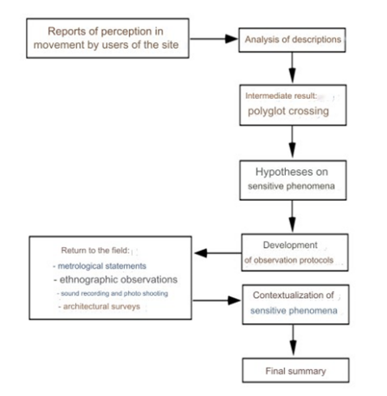 | 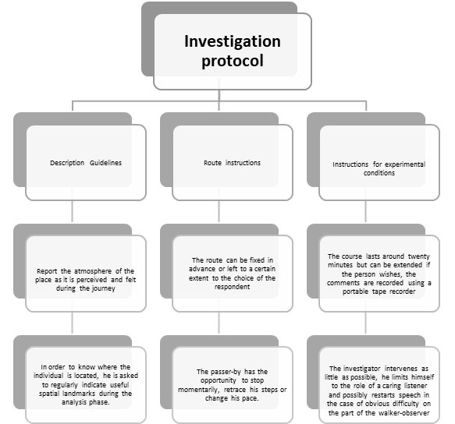
Figure 1. (a) The diagram summarizes the different phases of J. P. Thibaud. (b) The investigation protocol was inspired by the approach of Jean Paul Thibaud [2]

Although this method is relatively little known, we found that it offers a valuable alternative to the more conventional quantitative surveys typically used in anthropological research. As a form of participant observation, it involves direct engagement with the resident but provides more room for the interviewee to express themselves. We accompanied two residents, each individually, on a walk from a public square to the interior of their homes. During this journey, they freely described what came to mind, what they felt, and even recalled memories associated with the spaces they passed through.
To enrich these descriptions and better understand the meanings behind their spatial behavior and sensory experiences, we asked targeted questions related to the perception of light in space. In key spatial and architectural areas, we encouraged participants to provide guided descriptions of how they perceive the space, what they feel, and how they physically react, observing facial expressions, body language, and gestures. Particular attention was given to transitional spaces, where we investigated the following aspects:
- Does light influence your well-being, happiness, and sense of comfort or relaxation?
- What is the cultural and social symbolism of light in everyday life, especially during family gatherings or festivals?
- How is light perceived and described by inhabitants in motion through space? (see Fig. 2)

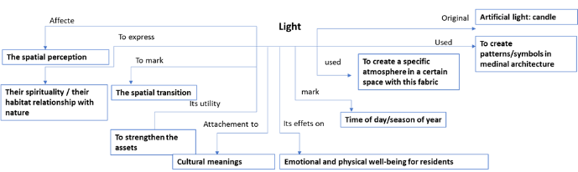

Figure 2. The light’s language. authors. April 2023.

Two residents from the neighborhood agreed to participate in the guided tour. Each owns a well-preserved traditional house, and each visit lasted approximately 20 to 25 minutes. Before beginning, we clearly explained the purpose of the method and the value of the data it would generate, outlining both the research objectives and the means by which the information would be analyzed. Instruments used: a video camera, a tape recorder, a tape measure, paper, and a pencil were employed to capture gestures, spoken words, and the overall atmosphere.

2.2 QUALITATIVE SURVEY
Step 03: As with all anthropological approaches, a questionnaire was developed to complement the quantitative phase of the study and to explore the notion of light further as perceived and described by the occupants within their built environment. Participants were asked to characterize the luminous atmosphere of their living spaces, focusing on both its functional role and sensory impact. The questionnaire design followed a hierarchical structure of dimensions, informed by a thorough review of the literature on the sensory-spatial perception of light and drawing upon insights from both sociology and psychology.
The questionnaire was organized into four main parts:
- Introduction and Sociodemographic Data: This section briefly introduced the research and collected essential sociodemographic information about the participants.
- Social and Spatial Practices: Focusing on three key spatial units: neighborhood/alley (skifa), patio (west eddar), and room (beyt). This section examined the functional use and spatial configuration of these interconnected areas, which are crucial to understanding the medinal logic of space.
- Qualitative Dimension of Space: This section explored the perception of lighting atmospheres in relation to comfort, as experienced by the inhabitants. Responses were analyzed based on variables such as age, gender, and socio-professional status.
- Symbolic and Psychological Perception of Space: The final section investigated the symbolic dimension of light, bridging sensation and meaning, and how occupants culturally and emotionally perceive light in their intimate spaces.

The sample included 209 participants aged between under 18 and over 65, all residing in the El-Djoun district. The questionnaire was distributed in two modes: one part was conducted online via Google Forms, while the majority were administered in situ via randomized sampling. Collaboration with primary schools in the neighborhood's ring road area facilitated access to a broader population, as parents of students actively contributed to the data collection process in a more structured, accessible manner.
The questionnaire was structured to clearly illustrate the relationship between the qualitative characteristics of light in various spatial articulations and their functional roles, while also exploring how light is symbolized and understood by the inhabitants. All participants were fully informed about the aims of the research. Confidentiality was ensured by anonymizing their responses, with a clear written explanation at the beginning of the questionnaire, and in certain cases, a verbal explanation was provided to participants with reading difficulties. To ensure clarity and appropriateness of the content, a panel of experts in spatial comfort, traditional architecture, and sociology reviewed the initial version. A preliminary distribution of 15 copies helped us refine the questions, eliminating redundancies and improving the questionnaire's overall clarity.
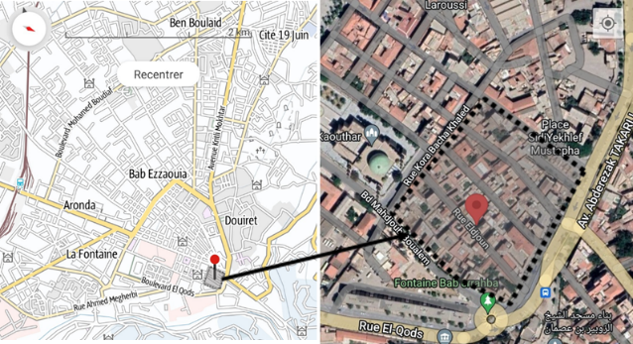

Figure 3. The position of our case study street, EL-DJOUN, Blida. Google Earth + My itinerary ‘application’, processed by authors on 03/30/2023.

The El-Djoun district, located in the historic core of the city of Blida, derives its name from the Arabic word "اللاجئون" (al-lājīʾūn), meaning “the refugees.” This district, notable for its preserved patio houses, provides an exceptional opportunity to gather detailed data on the spatio-sensory perception of inhabitants within a medinal fabric. According to Article 01 of the Regulatory Provisions Applicable to the Individual Habitat Zone “Houses in Patio, El-Djoun District” (U.A), El-Djoun is recognized as a primarily residential area, emblematic of the medinal world. It represents the oldest part of the city, the outcome of a long historical process and continuous urban evolution, and retains a significant architectural heritage.
Furthermore, Article 3 of the same regulatory framework, concerning the protection of cultural heritage, stipulates that all dwellings in the El-Djoun district are classified as national heritage under the Permanent Protection Plan for the Historic Sectors of the Old City of Blida [20]. This classification reflects the district's cultural and architectural value.
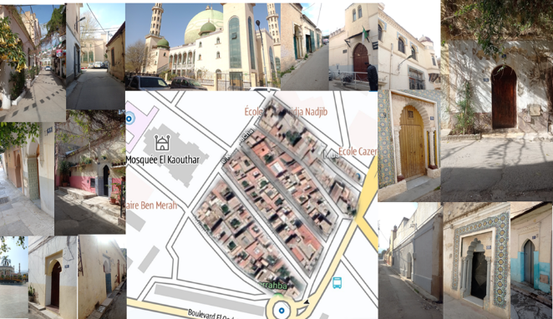
The residential architecture of El-Djoun is characterized by an introverted spatial organization, in which the house is structured around a central courtyard (wast eddar). From the outside, these homes appear austere, with blind façades and minimal ornamentation. However, upon crossing the threshold, visitors are welcomed into a world of intricate forms, colors, and scents. Modest entrances, often pointed or horseshoe-shaped arches, are discreetly integrated into the façades and sometimes adorned with decorative earthenware tiles, offering a subtle but rich introduction to the interior space (see fig. 4).

Figure 4. In-situ survey photos and map of the environment EL-DJOUN. photos taken on March 31st, 2023; my itinerary 'application' processed by authors in March 2023.

The integration of the results from both the qualitative and quantitative surveys provides a comprehensive and in-depth understanding of the spatio-sensory perception of light within the built environment, as experienced and interpreted by the inhabitants of this medinal fabric (see Fig. 5).
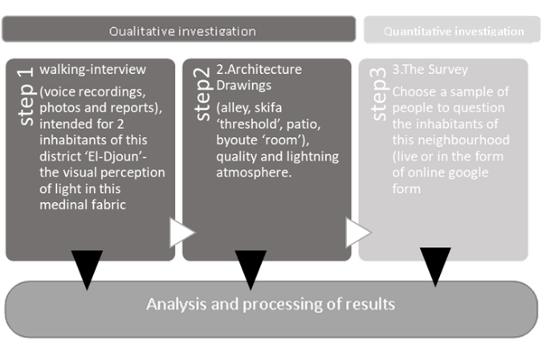
Figure 5. Plan summarising the three steps of qualitative and quantitative investigation of our study. authors January 2023.

RESULT AND DISCUSSION

RESULT

3.1.1 Qualitative investigation, The walking interview.
In accordance with the sequence of research phases, the walking interview marked the beginning of the qualitative investigation. Referring to Jean-Paul Thibaud's statement in his article on the subject, “The main objective of the commented route method is to access the sensitive experience of the passer-by” [18]. This stage positioned the participants as key sources of impressions, reactions, and ongoing sensory perceptions. Two residents of the neighborhood consented to participate in this survey. The objective and methodology of the study were clearly explained to them, and they were also allowed to choose the interview's starting point and duration. It is important to note that they agreed to share their first names and authorized the use of any information disclosed during the commented walk. From the initial location they selected to the final point inside their homes, they guided the journey based on their own decisions.
Modifications were made to Thibaud's original methodological framework better to suit the specific conditions of our case study, particularly to accommodate participants' daily constraints, such as scheduled obligations and family events. As such, the architectural survey and photo documentation were carried out as a continuation of the recorded walk, with all fieldwork completed on the same day.

3.1.1.1 Mr. Amar
The first walking interview was conducted with Mr. Amar, a joyful and energetic man, grandfather to several grandchildren. Professionally, he works as a technician in the construction sector and resides in a medinal house dating back to the 17th century. The interview took place on a day marked by clear skies and mild midday warmth, providing ideal conditions for observing the interplay between light and space during the walk. Mr. Amar’s familiarity with both traditional architecture and construction practices brought an informed and nuanced perspective to the spatial and luminous experiences encountered throughout the journey.
Mr. Amar proposed to begin the walking interview near the El-Kaouthar Mosque, situated directly opposite the three principal lanes that traverse the historic core of Blida, known as El-Djoun. The diagram (Fig. 6) illustrates the orientation of the walking route, marked by an irregular blue line, along with essential contextual information: details about the homeowner, the interviewer, the date, time, location, and the total duration of the walk.
The descriptive map accompanying the diagram presents selected segments from the polyglot narrative of the walking interview conducted with Mr. Amar. In the left column, a transcription and reconstructed description of his observations are provided. This is followed by a sensory perception guide, structured to reflect the evolving atmospheric conditions encountered along the path, with a particular emphasis on light in space, which served as the central analytical element of this dynamic and immersive exploration. Excerpt from the polyglot intersection at El-Kaouthar Mosque, located at House 15 in the El-Djoun District.
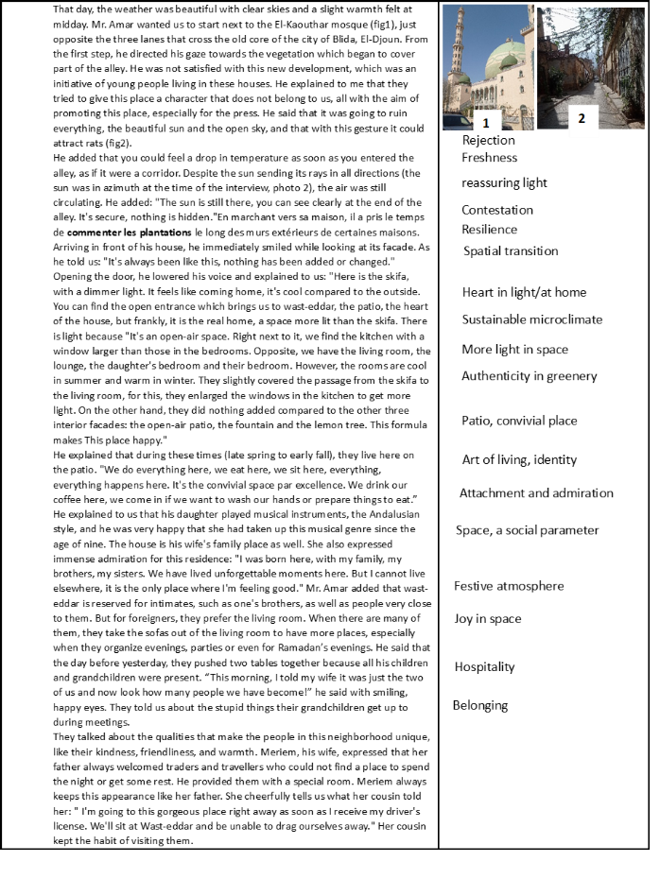
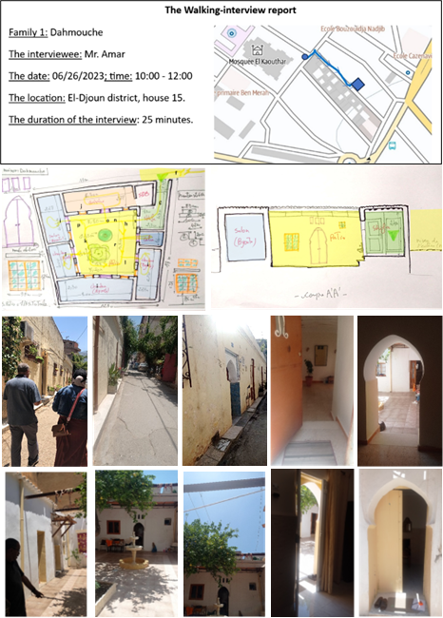
a
c
b
d

Figure 6. a. The walking interview report, Mr. Amar. Google Earth + My itinerary ‘software’; b. polyglot crossing with sequences; c. the walking interview Interior path with Mr. Amar from Skifa to the patio, through the different rooms, (architectural assessment: plan+section); d. view to the exterior and the interior pf the habitat. processed by authors June 2023.

The contextualization of phenomena perceived in movement
According to the protocol proposed by Thibaud, the spatial perception concepts from the previous narrative, particularly regarding the lighting atmosphere, will be processed during this second phase. This phase aims to identify the conditions under which these spatial-sensory phenomena emerge, enabling us to analyze the architectural elements that create the luminous atmosphere within the medinal fabric. The goal of this method is to gain a deeper understanding of each phenomenon to establish a coherent theory of light, while exploring the philosophical underpinnings of these atmospheric changes. Medinal architecture will serve as the material backdrop for interpreting and explaining these in-situ experiences.
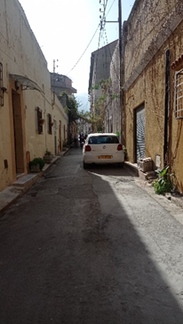
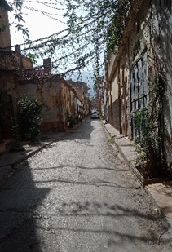
- Refusal/rejection: For the residents of this type of fabric, covering a passage is not considered ideal. The passage should remain a clear, open space: sunny, clean, and modest, particularly in terms of façade ornamentation. This principle aligns with the core values of Islamic architecture in general, and medinal architecture in particular. The presence of climbing plants or vegetation covering a passage increases the risk of attracting rodents (Fig. 7).

Figure 7. View of the street El-Djoun (on the left). [Photograph]. Authors June 2023.
- Freshness/cooling: The relatively narrow alleys and dead ends, combined with the shade cast by buildings that rise in two levels, create a cool atmosphere that benefits pedestrians. This freshness is accompanied by a pleasant silence, allowing anyone who enters these alleys or finds themselves in an open-air space to experience a noticeable drop in temperature (Fig. 7, on the right).
- Light/clarity and safety/Reassuring light: At the time we conducted this commented route, the sun was positioned at azimuth, flooding the passage with light. As we walked, we could feel the soft light gently shading our shoulders. This light creates a sense of reassurance and security, everything is visible, nothing is hidden, no surprises, no problems.
- Contestation: The comments on the plants along the exterior walls remain a strange concept to the former inhabitants, as they associate them with the potential presence of rodents (Fig 8).
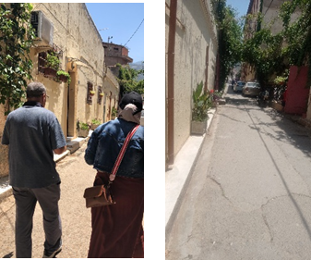

Figure 8. view to the street El-Djoun. authors June 2023.

- Resilience: The conservation of the exterior envelope of medinal houses remains a priority for the majority of their occupants. Maintaining a house in its most preserved state is considered a success for its owners, particularly when it comes to the façades, which are of utmost importance, even though they don't necessarily reflect the comfort inside (Fig 9).
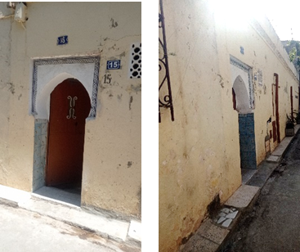

Figure 9. view to the front of houses in El-Djoun. [Photograph]. authors June 2023.

- Spatial transition: The skifa is the space immediately after the front door, a cool area with softened light. Its two key characteristics signal a shift—once inside, we lower our voices, invoking horma (intimacy), which is one of the pillars of the philosophy that governs Islamic architecture. The presence of a hand basin, in the form of a small water source next to the open door of the skifa, further enhances the spatial comfort. Washing our hands here provides a sense of relief, helping to wash away the fatigue and heat accumulated from the outside (Fig 10).
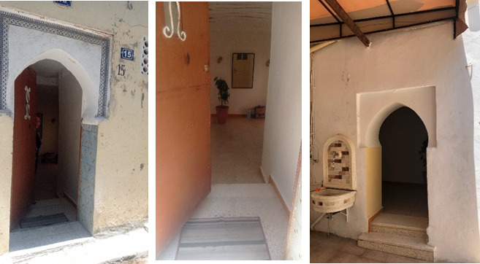
Figure 10. views to the skifa from both doors, Mr. Amer’s house. [Photograph]. authors June 2023.

- Heart in light / at home: For the inhabitants of this type of fabric, the west-eddar patio is the heart of the house—it is where we truly feel at home. It is a well-lit space, bathed in sunlight, with all the rooms opening onto and overlooking the patio. Medinal architecture is designed with an introverted layout, meaning that all the rooms of the house receive their natural light and fresh air from the patio. This feature is the key element of the entire socio-spatial design of this architecture. (Fig 11).
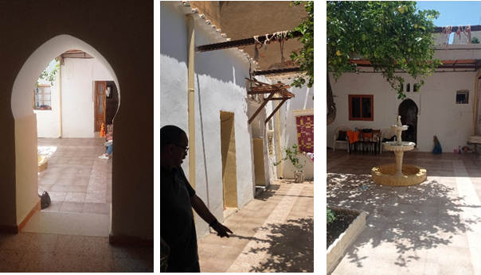

Figure 11. views to the patio, Mr. Amar’s house. [Photograph]. Authors: June, 2023.

- Sustainable microclimate: The byoute rooms benefit from a highly favorable climate year-round, a characteristic of this habitat type. In winter, the rooms maintain a mild climate, while in summer, they are known for their cool atmosphere. In Algeria, several studies have examined the climatic performance of this habitat type, particularly in arid regions. These studies have proven the effectiveness and adaptability of the patio habitat in such conditions [21] [22] [23].
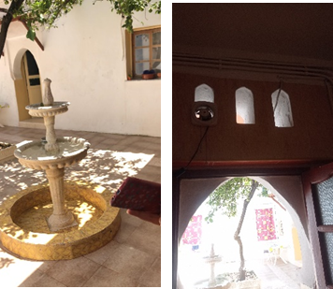
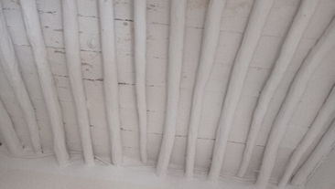
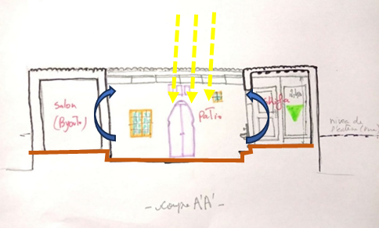
a
b

Figure 12. a: picture of the fountain, ventilation holes, and the sealing structure. b: sustainable ventilation system, architectural assessment section. [Photograph]. Authors: June, 2023.

“The patio allows one to constantly transition from sun to shade, from humid to dry, to live both outdoors and indoors simultaneously. In a country where the climate contrasts between a scorching sun with intense light and cold or humid air, the houses—closed to view but open to the wind—offer rooms filled with shade and breezes.” [24]. The patio creates a microclimate more suited to human needs, achieved through its positioning, layout, and water source, such as a fountain. The evaporation of water on the hottest days cools and humidifies the circulating air, benefiting the rooms connected to the patio (a and b. Fig 16). The patio house significantly improves comfort in hot climates [25].
- More light in the space: The patio opening provides natural light. Since the small passage connecting the open entrance to the patio with the living room opposite has been covered, the kitchen window has been widened to compensate for the lost light (due to rain). The reflected light from the patio provides illumination without visual glare. This spatial design ensures that residents benefit from natural lighting year-round (Fig. 13).
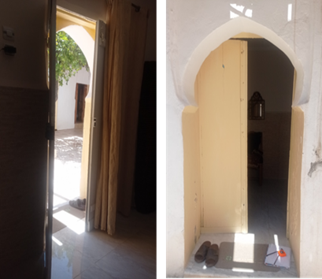
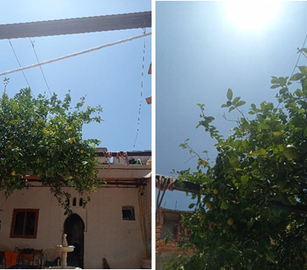

Figure 13. diffusion of light, Mr. Amar’s house. [Photograph]. Authors: June, 2023.

- Authenticity in greenery: In Andalusian-style gardens, the 'west-eddar' garden plays a crucial role within the house. A strong connection is established between the inhabitants and the vegetation in the patio, where elements like the lemon tree and jasmine symbolize cultural significance in the medina. The scent accentuates the influence of the Andalusian refugees (اللاجئون), from whom the district gets its name. The presence of water and vegetation positively affects the patio's microclimate, especially during the hot months. The fountain in the patio also influences the lighting atmosphere, as the sun's rays reflect on the water, casting light spots onto adjacent surfaces (such as walls). Furthermore, the dynamic visual effect of the flowing water, with its multiple levels, evokes a sense of tranquility and joy, benefiting the psychological well-being of its occupants (Fig. 14).

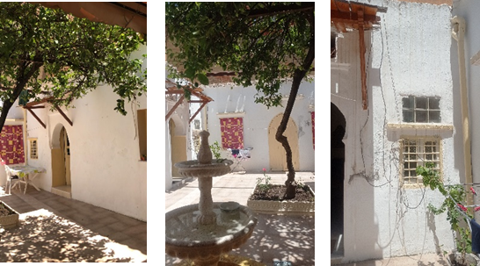

Figure 14. Views from the patio showing identity through the interior design of Mr. Amar’s house. [Photograph]. Authors: June, 2023.

- The patio, the convivial space: In the medinas, the patio serves as a space for connection and transparency, fostering a close-knit community life. It is the center for family events, parties, and ceremonies, and is also aligned with daily activities involving water. The patio also provides a clean, open space where children can play. This multifunctional area, primarily used by women and children, strengthens supervision and the transition of everyday practices: women roll couscous, weave rugs, and embroider, while their young daughters play nearby, observing their mothers' activities. Depending on its layout, the patio can serve various functions, serving as both a reception area for guests and a living space for residents. Music, often played in the patio, remains a defining element of spatial identity, embodying the art of living in medinal architecture (Fig. 15).
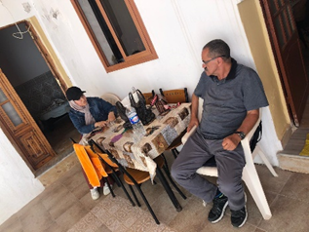
Figure 15. A moment of the walking interview with Mr. Amar. [Photograph]. Authors: June, 2023.

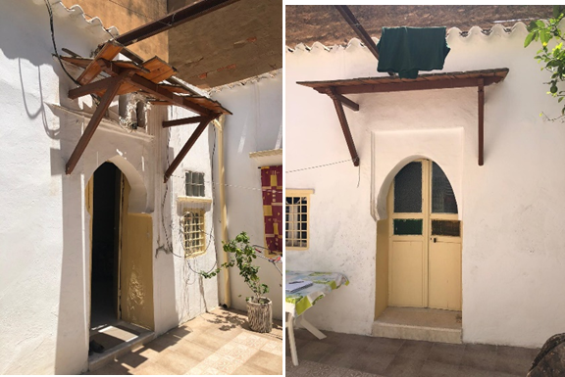
- Attachment and admiration: For the inhabitants of this district, living outside of this architectural style is nearly impossible. The spatial configuration perfectly aligns with the socio-cultural structure, creating a deep connection between the habitat and its occupants. This integration makes the environment feel so comfortable and intrinsic to their lives that they cannot imagine replacing it.

Figure 16. rooms’ entrance ‘byoute’, Mr. Amar’s house. [Photograph]. Authors: June, 2023.

- Space, a social parameter: Medinal architecture, like any other traditional architecture, reflects the culture and society it represents. The hierarchy between public, semi-public, and intimate spaces is embodied through the spatial atmosphere, which illustrates the balance of light and philosophy. It is crucial to emphasize the strong connection among philosophy, interior life, and way of life, all of which are expressed through this distinct architectural form. The spaces are organized around a central courtyard, creating a sense of homogeneity in the residences' spatial layout. This contrasts with other historical courtyard houses, such as those of Egyptian, Greek, or Roman origin, where social stratification is more apparent. In Medinal architecture, the only visible distinction from the outside is the decoration of the main door [23].

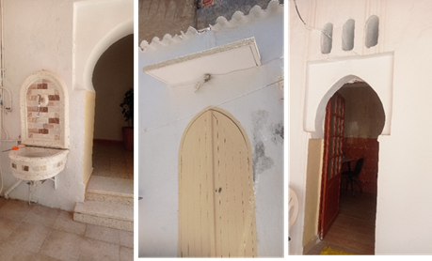

Figure 17. architecture in details light/shadow, Mr. Amar’s house. [Photograph]. Authors: June, 2023.

- Festive atmosphere: The heart of the home always evokes moments of gathering, celebration, and musical evenings. Its shape and generous surface area naturally accommodate such occasions; moreover, it is the brightest and sunniest space in the entire house.
- Hospitality: Hospitality is one of the fundamental pillars of Islamic and Arab ethics. When comparing the concept of hospitality between European and Arab-Muslim cultures, it becomes evident that in the latter, hospitality is deeply embedded as a core value, an essential component of Islamic ethics. It reflects nobility and moral integrity, and is a virtue highly respected by the community. It is an honorary act, a gesture that upholds an individual’s reputation and social standing, and an expression of charity and social cohesion.

As Gotman [26] points out, “hospitality is a rite of passage that regulates the integration and separation of the stranger from the group.” In the Arab-Muslim context, this is not merely symbolic; it is materialized in the home's spatial configuration. The best space in the house is traditionally reserved for receiving guests, demonstrating care, generosity, and the importance of the visitor. This space, often called الضيافة (Diyafa) or مجلس (Majlis), is designed to make the guest feel welcome, comfortable, and honored. The reception room is not only a central element of residential architecture but also plays a symbolic role in public and religious institutions. A legendary figure exemplifying Arab hospitality is Hatim al-Tai, the poet and knight whose legendary generosity became a cultural archetype. Over time, this tradition of hospitality evolved into a recognized social system that binds individuals together, serving as a marker of identity and moral conduct within Arab societies.
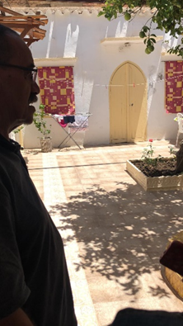
- Belonging and spatial joy: The inhabitants of this fabric live in harmony with an architecture that reflects their culture—an architecture of light and joy (fig 18).

Figure 18. Mr. Amar admires his space. [Photograph]. Authors: June, 2023.

3.1.1.2 Mr. Mohamed
Our second journey centered on a young man named Mohamed, a father of two who lives with his young family in one of the oldest houses in the town of Blida. He deliberately chose this traditional dwelling as the place to begin his own family life. Mohamed, an engineer by profession and a scuba diving enthusiast, welcomed us on a warm, clear day, when few people were out and about.
As with Mr. Amar, a similar diagram was constructed, capturing extracts from the polyphonic narrative of the commented route. This includes a transcription and a restructured description (presented in the left column), followed by a sensory perception guide that reflects shifts in spatial atmosphere, focusing particularly on light, the central element of this dynamic description. Mr. Mohamed proposed we begin the route near the bus stop at the southern entrance of the El-Djoun district. From there, crossing one of the three main lanes leading to his home, we encountered the El-Kaouthar Mosque, an architectural landmark that marks the threshold of the historic core of El-Djoun

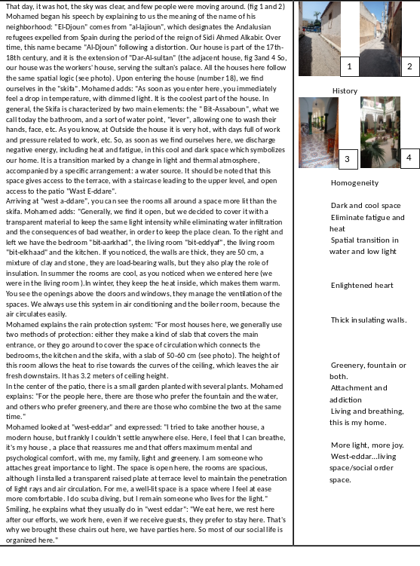
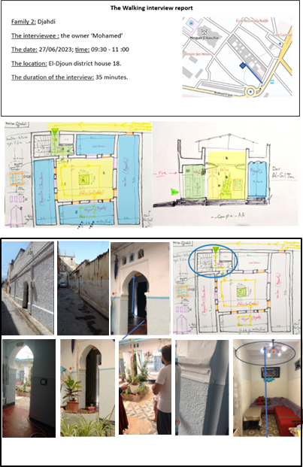
Figure 19. a. The walking interview report, Mr. Mohamed. Google Earth + My itinerary ‘software’; b. Multifaceted crossing report with sequences; c. the walking interview, Interior path with Mr. Mohamed from Skifa to the patio, through the different rooms, (architectural assessment: plan+section); d. view to the exterior and the interior of the habitat, with the position of the stairs in skifa; architectural assessment plan showing the stairs. Source: processed by authors June 2023.

The contextualization of phenomena perceived in movement
- History: Mr. Mohamed is well aware of the heritage value of the El-Djoun district. Through his testimony, we learned that the inhabitants of this neighborhood possess a rich historical knowledge of the origins of the first occupants, as well as the contextual factors behind the district's formation. However, this awareness is tinged with a palpable sense of sorrow when facing the current state of abandonment that characterizes this urban fabric. Despite the inclusion of this district in the programmed restoration efforts under the heritage safeguarding plan, the situation remains alarming. According to the most recent revision of the Blida POS (Plan d’Occupation des Sols), specifically on page 58 under the section 'REGULATORY PROVISIONS APPLICABLE TO THE INDIVIDUAL HOUSING ZONE, Patio Houses in the El-Djoun District (U.A 3)', Article 03 on the 'Protection of Cultural Heritage' explicitly states that all existing residences within this district have been classified as national heritage. As such, they are officially listed within the permanent plan of protected zones in the historic core of the city of Blida [20].
- Homogeneity: This medinal fabric presents a notable homogeneity in its overall typology. The residential units, generally organized around patios, range from single-story dwellings with accessible terraces to ground-floor-plus-tiled-roof (R+1) layouts. The architectural expression remains modest on the exterior, in accordance with the principles of discretion and intimacy characteristic of medinal housing. However, the entrance doors often stand out as significant exceptions, richly adorned with decorative elements, whether in painted frescoes or glazed earthenware. These doors are frequently equipped with small ventilation openings, contributing both to airflow and to symbolic articulation. This architectural trait is recurrent across all medinas.

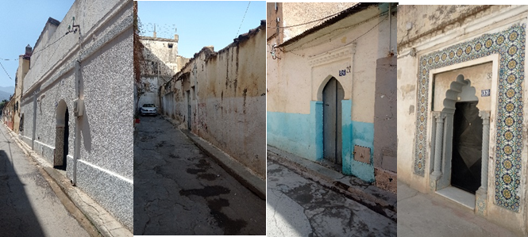
Figure 20. Different views on the homogeneity of Djoun Street. authors June 2023

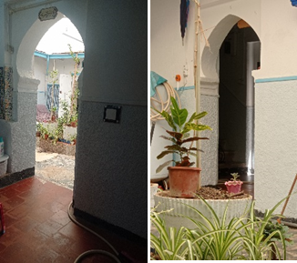
- Dark and cool space: "The skifa is characterized by a particular spatial atmosphere. It remains noticeably cooler than the exterior environment and is marked by dim lighting. Typically windowless, this transitional space connects the house's entrance to the patio or to the staircase leading to the terrace. Due to its enclosed geometry, light only filters in softly, often through the open doorway, creating a subdued, almost twilight-like ambiance. This limited exposure to direct sunlight reinforces its function as a thermal buffer, making it an effective cooling space within the medinal house (fig. 21).

Figure 21. Two different shots from (a) to (b) the skifa ‘according to the architectural assessment: plan+section’. authors June 2023

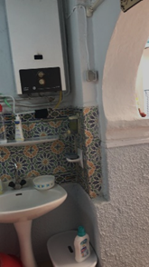
- Evacuate fatigue and heat: This shift in thermal comfort produces an atmosphere conducive to physical recovery. A person walking through the exterior alleys is exposed to significant heat, where direct sunlight saturates the entire surface of the pathways. Upon entering the skifa, however, one is enveloped by a cool environment bathed in subdued light. This abrupt contrast offers a sense of relief and comfort to the passer-by, reinforcing the skifa’s role as a transitional and restorative space (fig. 22).

Figure 22: washing corners in skifa. authors June 2023

- Spatial transition in water and low light: This specific atmosphere grants the skifa its essential function as an articulation space between exterior and interior, from the ground floor to the terrace via the staircase (fig 30). It is the transition space par excellence. The presence of a hand basin enhances spatial comfort; the simple act of washing one’s hands offers relief from the accumulated fatigue and heat of the outside, contributing to a sense of renewal and well-being (fig 23).
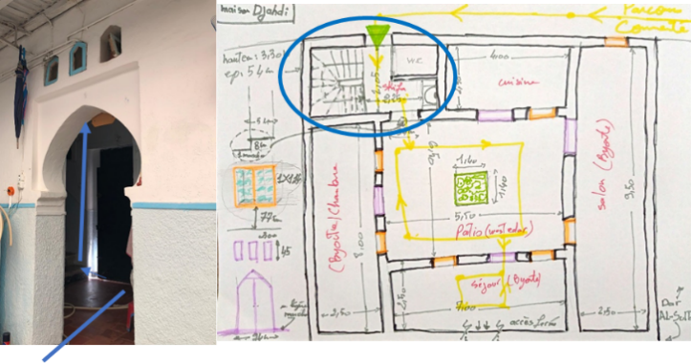

Figure 23. a: picture of the position of the stairs in Skifa, an architectural assessment plan showing the stairs. Authors: June, 2023.

- Lit heart: Upon arriving in the patio, a beam of light welcomes us—this is the largest space of the house, directly open to the sky. Although a transparent material has been used to cover the patio, it has neither obstructed nor diminished the intensity of natural lighting. A deliberate gap was left between the covering and the parapet walls at terrace level, allowing sunlight to enter freely and illuminate the space (fig 24).
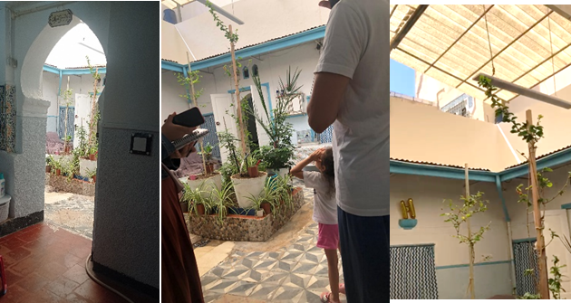

Figure 24. Views to the patio, Mr. Mohamed’s house. [Photograph]. Authors: June, 2023.

- Sustainable construction: The walls of this type of housing are characterized by their substantial thickness, ranging from 50 to 55 cm (fig. 26), and function as load-bearing elements that support the entire structure. This massiveness contributes significantly to thermal comfort. Constructed from durable materials such as clay and stone, these walls provide excellent insulation. The height and geometry of the rooms regulate ambient temperature according to the seasons. In summer, interiors remain cooler than the outside, as cool night air is retained and warmer air is expelled upwards through ventilation openings placed above doors and windows. In winter, the walls absorb solar heat during the day and slowly release it, keeping the interior warmer than the outside. Additionally, the shade cast by peripheral walls further protects and cools the space, making it more comfortable for occupants [23]. The level differences within the structure facilitate efficient air circulation throughout the dwelling (fig. 25).
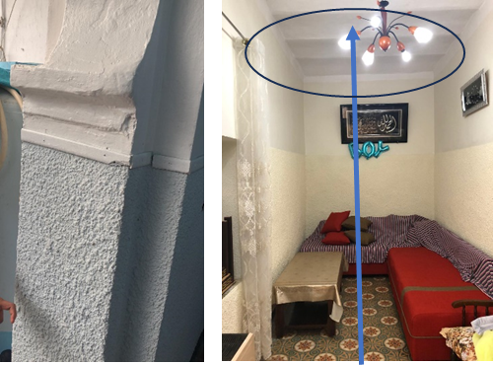
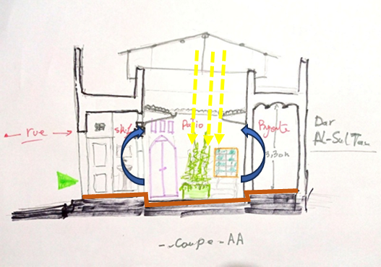
Figure 25.26. sustainable ventilation system, architectural assessment section (on the left). structure details, the thickness of the wall, and the height of rooms (on the right). Authors: June, 2023.

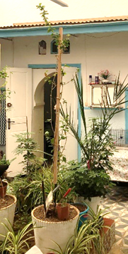
- Greenery, fountain or both: In medinal architecture, water and vegetation serve as the soul of the patio, creating a harmonious environment that preserves both intimacy and a pleasant landscape. This space is characterized by a unique interplay of sound and light that enhances the sensory experience while maintaining the home's privacy. The patio is adorned with plants that are emblematic of this architectural style, including climbing plants, lemon trees, jasmine, geraniums, trellises, and the distinctive fragrance of basil. These elements contribute not only to the aesthetic appeal but also to the microclimate and atmosphere of the space (fig. 27).

Figure 27. View of the plants in the patio. Authors: June, 2023.

- Attachment and addiction: Mr. Mohamed expressed his deep, unwavering attachment to his home. Whenever he tried to live in another house, of a more modern style, he found it impossible to stay. An emotional and spiritual connection exists between the residence and its occupants. ‘To live and breathe, this is my house,’ he said, highlighting the strong sense of belonging that defines this type of dwelling. It is this bond that provides comfort, creating a sense of ease and putting one in the most positive state of mind. Such architecture, which respects social and cultural needs, represents the formula for happiness (fig. 28).
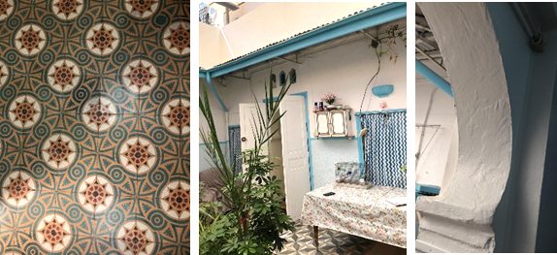

Figure 28. view showing identity in detail. Authors: June, 2023.

- the luminous atmosphere in the foreground/ more light more cheerfulness: the rooted need for light has its foundations in religion itself, culture, inherited fields, all classify light as a form of extreme purity, divine rays which propagate throughout the earth's surface, the light symbol of divinity mentioned in several religious texts, 'light of the heavens and the earth', for this reason the occupants of this district are always in search of this luminous cheerfulness.
- The patio/living space/social space: The patio is the defining feature of medinal architecture, not only due to its shape and its position within the building, but also because of its more complex functional role. It serves as a family living space, a place for conviviality [23]. With a surface area of 35.7m², the patio becomes the heart of social life for all its occupants, fostering a strong sense of attachment. It acts as an obligatory passage to reach the peripheral rooms, a reception space for most visitors, and a venue for social and cultural practices that encompass both joy and melancholy. The patio is, in the truest sense of the word, a space of habitation and adaptation.

3.1.2 Quantitative investigation: survey
The second phase of this research focuses on gathering quantitative data from residents to further understand and validate the findings from the commented route. A total of 209 people participated in this survey, and the percentages and frequencies presented below correspond to this sample size.

3.1.2.1. Introduction
This survey was designed primarily to address three key dimensions: spatial and social practices, spatial quality, and sensory perception. These dimensions correspond to four key spaces in the design of a medinal fabric: 'zenka' (the neighborhood or a dead-end alley), 'skifa' (the entrance to the house), 'west-eddar' (the patio, the central open-air space), and 'byoute' (the peripheral rooms and chambers). The aim was to establish a connection between the quality of light in these spaces and its functional effect, while also exploring the sensory perception of various lighting ambiance and their impact on psychological comfort. As with most surveys, we began by gathering demographic information, including questions about gender, age group, and position.

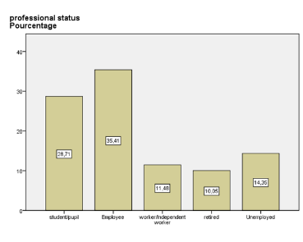
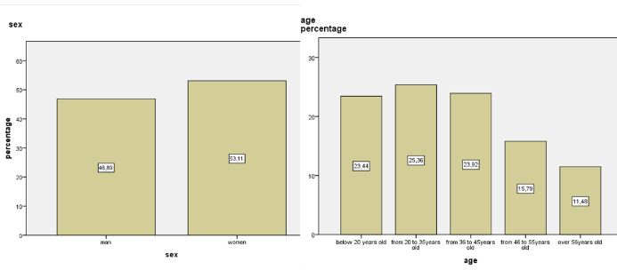
Figure 29. (a) The distribution of samples by gender and age (above). (b) The percentage of professional statuses (below). Histogram. Retrieved from IBM SPSS Statistics version 22, IBM Corporation. Accessed: January 2024.

Our sample is nearly balanced between genders, with a slight difference of 6.22%. The participants are primarily aged 16-45 years, comprising 72.72% of the sample. This indicates that the study sample is predominantly composed of younger individuals (Figure 29a).
This graph shows that the majority of respondents are employees, accounting for 35.41%, including professions such as teachers, engineers, administrators, doctors, and others. Additionally, 28.71% of respondents are students, all of whom have a university academic profile (Figure 29b).

3.1.2.2 Changes in atmosphere across spaces
- The structure of the survey, parameters, and variables
This investigation aims to explore the perception of light in the articulatory spaces, from the exterior to the interior of the habitat. The first part involves questions about the spatial and social qualities of these spaces, addressing variables such as surface area, preferred spaces by season, and the predominant activities in these areas. The second part delves into the qualitative perception of light, as described by the occupants, exploring variables such as the degree of openness or coverage, types of openings, light intensity, and protective devices. The third and final part examines the relationship between light and the mood of the inhabitants, focusing on the sensations and meanings associated with the quality of light in these spaces.

- Spatial quality and social practice
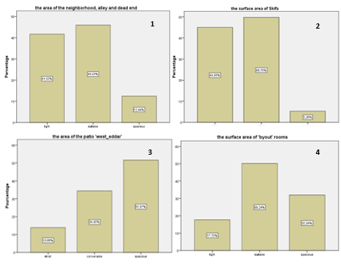
Area:
Figure 30. The percentage of responses to the following question: How do you perceive the surface area of these spaces? Histogram. Retrieved from IBM SPSS Statistics version 22, IBM Corporation. Accessed: January 2024.

These graphs present the percentage of responses to the question: How do you perceive the surface area of these spaces? For streets, alleys, or dead ends, 45.93% of respondents described the space as suitable, while 41.63% found it narrow. This difference is due to the width/utility ratio: the alleys have an average width of 2.5 meters, which is not ideal for vehicles but sufficient for pedestrians. The remaining 12.44% who responded as 'spatial' are generally elderly people or adolescents (Figure 30-1). Similarly, for the 'skifa,' 49.76% described it as suitable in terms of its utility as a passage, but due to its small dimensions (averaging 2-2.5 m²), it can be considered a narrow space (Figure 30-2). For the patio, 51.67% of respondents described it as 'spatial,' as it is the largest room in the house, averaging 40 m² and occupying two-thirds of the total surface area (Figure 30-3). For the rooms, 50.24% considered them suitable, while 32.06% described them as 'spatial,' with an average room size of 3 m² (Figure 30-4).

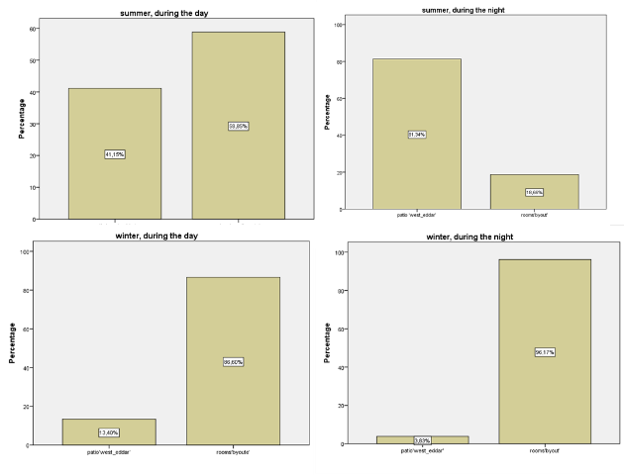
The preference.

Figure 31. The percentage of responses to the following question: your favorite place where they prefer to spend the most time, depending on the season. Histogram. Retrieved from IBM SPSS Statistics version 22, IBM Corporation. Accessed: January 2024.

We also asked the participants about their favorite place to spend the most time, depending on the season. Their responses varied depending on the season. In winter, 86.60% preferred the rooms during the day, which rose to 91.17% during the night. In summer, 41.15% preferred the patio during the day, which rose to 81.34% at night. According to these graphs, we can observe that the patio is the dominant space during the summer, while the rooms are the dominant spaces in winter. This distribution is influenced by climatic comfort. In winter, the climate is cold and humid, and the rooms offer dry, comfortable temperatures that are very suitable for the occupants' needs. In contrast, during the summer, the patio becomes a cool space that meets the climate requirements (Figure 31).

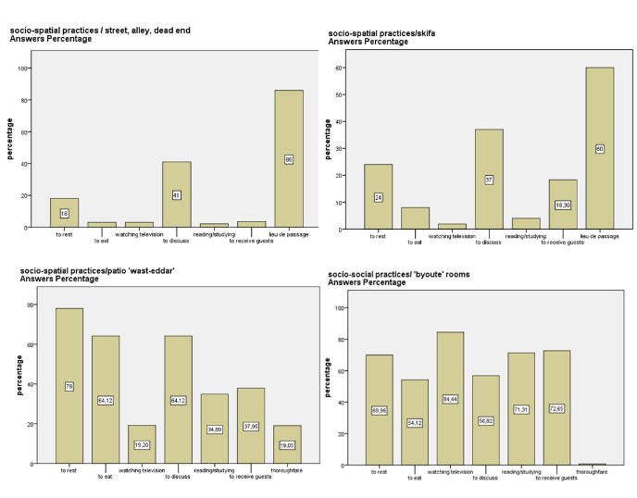
Social activity and practice:
Figure 32. The social activity and practice in the alley, skifa, patio, and rooms. Histogram. Retrieved from IBM SPSS Statistics version 22, IBM Corporation. Accessed: January 2024.
The respondents answered the question concerning socio-spatial practices in these different articulatory spaces. Outside the home, the street, the alley, and the dead end are primarily used as places of passage, with 85.6% of respondents reporting this. In the second degree, they are used for discussions (41.1%), and in the third degree, as places of rest (18.7%). The skifa follows the practices even from the outside, since it is a sort of extension of the alley, a space of transition from the outside to the inside. However, we can see that several people classified the skifa as a space for receiving guests, with a 18.3% share.
The patio, according to the respondents, is considered a space of rest in the first degree (78%), given its surface area and spatial configuration, particularly in summer (the dominant space). In the second degree, it is a place where one can enjoy meals (64.12%) and have discussions with family members (64%) or with guests (37.9%). It is also used for reading/studying (34.8%), but it remains a place of passage. Few people watch television on the patio, as it is an open-air space that makes these devices susceptible to the elements.
In terms of rooms, residents use them primarily for watching television (84.44%). The remaining activities, such as resting, chatting, receiving guests, reading, and eating, have percentages ranging from 54% to 72%. The rooms are not considered places of passage, as they do not lead to other rooms and communicate only through the patio. All rooms overlook the patio.

3.1.2.3 Quality of light in these spaces
- Covered or open
82.30% of respondents indicated that the outdoor space (street, alley, and dead end) is generally uncovered, open to the sky. As for the patio, 44.50% of respondents indicated it is generally uncovered, while another 44.50% stated it is partially covered.

- The openings
We asked about the openings in these spaces; this table represents the percentage of "yes" responses. The skifa, in all cases, contains a door (the front door) and an open entrance that leads to the patio, but it does not contain windows. However, we can find ventilation holes placed below the doors. For the rooms, some have an entrance door and a window, but approximately 43% do not contain ventilation holes. When we asked about modifications made to these rooms, 55.50% responded affirmatively. In the typology of Medinal houses, ventilation holes are permanent elements placed below the doors and windows. They play a crucial role in air circulation within the rooms, allowing airflow from the patio (Table 1).

- Light intensity
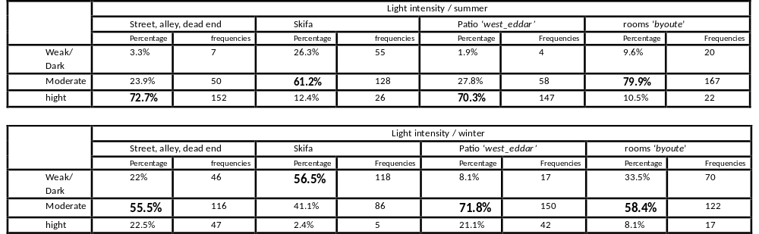
Table 1. Light intensity in the street, skifa, patio, and rooms according to the seasons. Retrieved from IBM SPSS Statistics version 22, IBM Corporation. Accessed: January 2024.

The light intensity varies with the seasons: in summer, respondents reported that the street, alley, dead end, and patio receive almost the same amount of natural light. The strong light is due to these spaces being open to the sky, allowing the sun's rays to enter without obstruction. For the skifa and the rooms, these are considered spaces with moderate light intensity. It should be noted that 26.3% of respondents indicated low light intensity in the skifa. This divergence is due to the degree of openness. The rooms have more light exposure than the skifa. This change in light intensity is clearly perceived by the occupants.
In winter, as in summer, the patio and the street have the same "moderate" light intensity. On the other hand, the skifa is considered a dark space by 56.5% of respondents, whereas the rooms have a moderate level of light intensity.

- The mode of diffusion of natural light
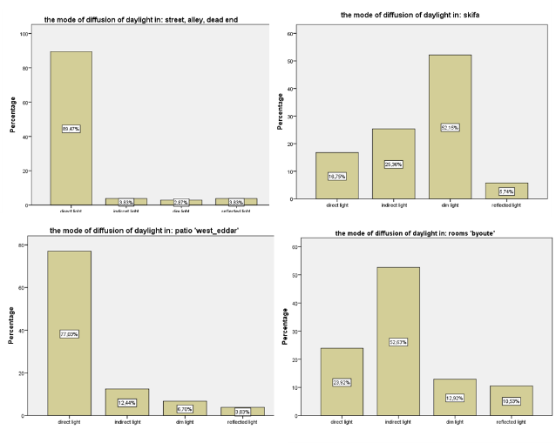
The mode of diffusion also explains the change in light intensity from the outside to the inside of the habitat. On the outside, the strong intensity is due to direct light (89.47%). The open space has no recesses at the level of the façades. The skifa benefits from subdued diffusion (52.15%), which explains its low light intensity. It is a space lit indirectly by the open entrance to the patio. The patio has the same mode of diffusion as the outside, with direct light diffusing during the day (77.03%), and it supplies the adjacent rooms. These rooms benefit from indirect diffusion (52.63%), and few rays penetrate the space directly (23.92%).

Figure 33. The mode of diffusion of natural light in the street, skifa, patio, and rooms. Histogram. Retrieved from IBM SPSS Statistics version 22, IBM Corporation. Accessed: January 2024.

- Sun protection devices:
Regarding sun protection devices, such as curtains, wooden blinds, shutters, or other types of fabric, 56.93% of respondents answered "yes" to the skifa. This percentage is even higher for the patio at 65.55% and for the rooms at 83.25%. They subsequently indicated the reason(s) for using these protection devices. In the skifa, the primary reasons are to preserve privacy (34.9%) and to reduce light (23%). These two factors mark the spatial and sensory transition from public to private.
For the patio, the main reason for using protection devices is to reduce glare from the sun and create a shaded space. Additionally, 34.9% chose to preserve privacy, especially in areas with tall buildings around the habitat. The need for privacy generally arises when new buildings, such as high-rise constructions, are built near the fabric. For the bedrooms, 56% of respondents cited reducing glare as the primary reason, followed by preserving privacy and creating a shaded space.

3.1.2.4 Light in space, symbol, sensation, and meaning

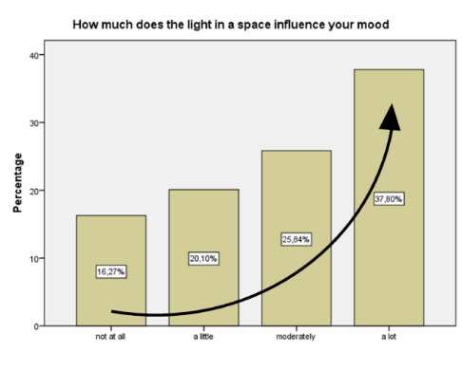
A. The influence of light on mood in space
Figure 34. The influence of light in a space on the mood. Histogram. Retrieved from IBM SPSS Statistics version 22, IBM Corporation. Accessed: January 2024.

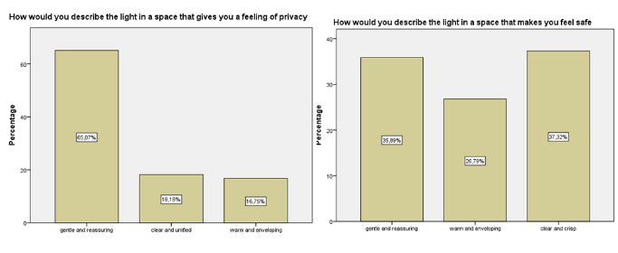
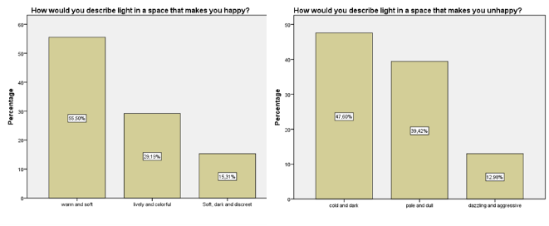
For the third part of this questionnaire, we asked questions to understand the sensory perception of light in space, its impact on mood, and changes in sensations across the moods of light. The first question revolves around the influence of light on their mood. 37.80% of respondents answered "a lot," with the majority indicating an increasing recognition that light has a considerable influence on their mood.
Figure 35. The type of light that makes you happy /unhappy (above). The type of light that gives a feeling of privacy /makes you feel safe (below). Histogram. Retrieved from IBM SPSS Statistics version 22, IBM Corporation. Accessed: January 2024.

For 55.50% of respondents, the light that makes them happy is warm and soft, whereas cold, dark, and pale light makes 87.02% of respondents unhappy. The feeling of intimacy is caused by soft and reassuring light (65.07%). For the feeling of security, 37.32% of respondents chose clear, bright light, while 35.89% selected soft, reassuring light. These two types of light create a similar atmosphere and evoke the same feeling.

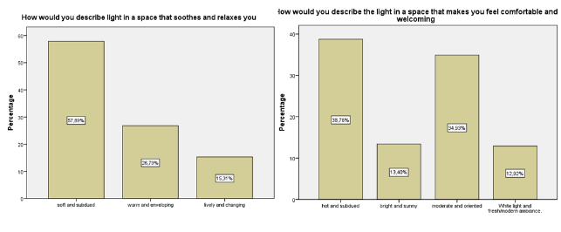
Figure 36. The type of light that makes you feel relaxed, comfortable, and welcoming. Histogram. Retrieved from IBM SPSS Statistics version 22, IBM Corporation. Accessed: January 2024.

57.89% of respondents identified soft, subdued light as the type that soothes and relaxes them. As for the light that gives them a sense of comfort and conviviality, 38.76% preferred warm, subdued light. On the other hand, 34.93% of respondents preferred moderate lighting and an orienting light.

B. The symbolization of light by the inhabitants
The last question highlights the symbolization of light as a notion, a term, and a phenomenon by the inhabitants of this medinal fabric. The 209 participants provided words with different meanings, ranging from a state of mind to comfort to knowledge. We tried to classify these words by their meanings and lexical fields.

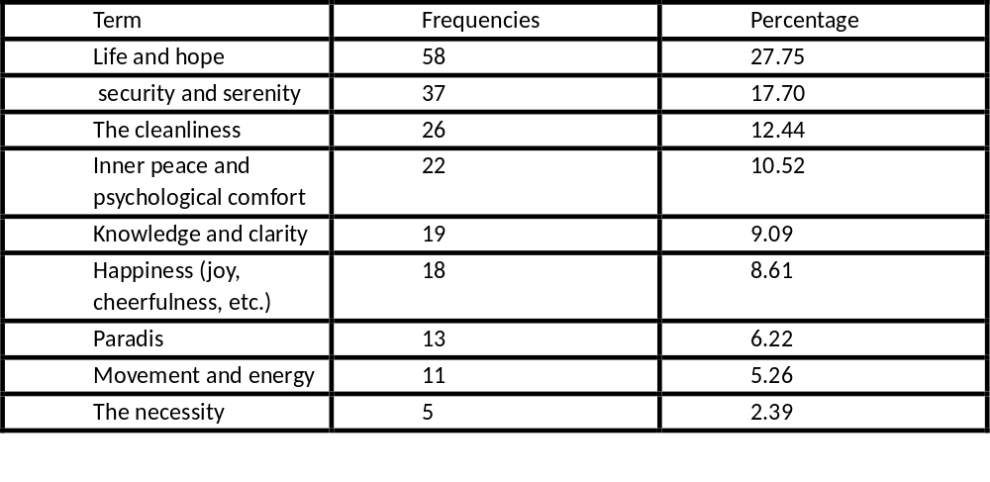
Table 2. The symbol of light, according to the inhabitants. Retrieved from IBM SPSS Statistics version 22, IBM Corporation. Accessed: January 2024.
As shown in Table 2, light symbolizes life and hope: 27.75% of respondents considered it synonymous with life and hope. It is also seen as a sign of security and serenity (17.70%). A lit and illuminated space evokes cleanliness (12.77%), inner peace and psychological comfort (10.52%), knowledge and clarity (9.09%), and happiness (8.61%). Light is also perceived as a reminder and metaphor of paradise (6.22%), of movement and energy (5.26%), and finally, 5 people described light simply as a necessity.

3.2 DISCUSSION
The following points summarize the key findings from the analysis of the commented route and the questionnaire. The integration of these qualitative and quantitative surveys enabled us to identify specific characteristics of natural light in the medina of El-Djoun.
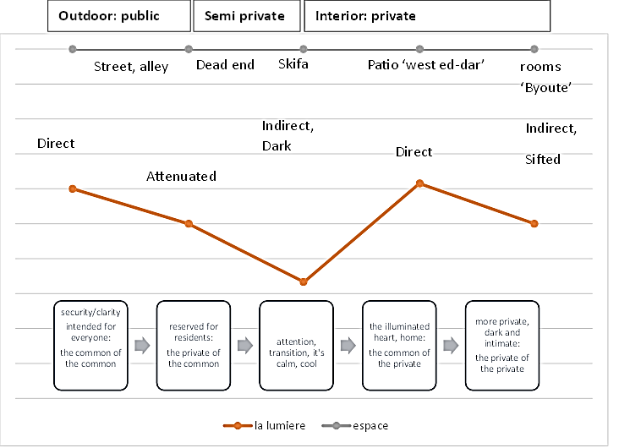

Figure 37. The type of light and its influence on the minds of the inhabitants. line graph. Retrieved from IBM SPSS Statistics version 22, IBM Corporation. Accessed: January 2024.

Based on the results of the two in-situ surveys, the commented route and the questionnaire, we summarized the findings in the graph above. It illustrates how the ambiance of natural light changes across different spaces and how it influences spatial perception. We begin with the first key point of our investigation: public spaces, including streets, alleys, mosque squares, and even the souk (market). These passageways are generally exposed to direct light, as they are predominantly open to the sky. While some may have covered or semi-covered sections, this study focuses on uncovered sections. The clear and unobstructed natural light in these spaces creates a sense of security and clarity, allowing people to move freely without concern. One respondent mentioned that walking in poorly lit streets or alleys is unacceptable, as people feel uneasy discussing matters in poorly lit areas. These public spaces are meant for everyone, residents and passers-by alike.
In several homes, residents must pass through a dead-end to reach their doors. This is a semi-public space, dedicated to those with access to the houses located within it. The light in this area is soft and diffused, creating a feeling of discomfort for anyone lingering too long, as it doesn’t feel open or welcoming to all.
The skifa, a narrow space at the home's entrance, is dark and devoid of windows, except for ventilation holes and an open entrance to the patio. It functions primarily as a transition space due to its spatial and lighting qualities, making it unsuitable for extended stays. However, this dim lighting creates a soothing atmosphere, offering respite from the external noise. It gradually prepares individuals for entry into the more private parts of the house. In Arab-Islamic culture, the concept of horma dictates that one cannot enter the house directly without passing through such a space. This allows the women inside to alert each other when someone is entering, protecting them from the gaze of strangers. The skifa thus serves as a protective buffer, especially when women are relaxing in the patio, and guests are outside.
Upon entering the patio, the atmosphere changes dramatically. Direct light floods the space, though it is softened by coverings over the room entrances and by the trunks and leaves of trees, particularly citrus trees, planted in the center. A fountain also humidifies the air circulating throughout the rooms. In the home, the patio is a shared space for all family members and also welcomes guests. When it isn’t raining, it becomes the preferred area for most activities. It is a multifunctional space that offers various lighting atmospheres: bright, warm, and soft. According to the inhabitants, this is the light that brings them happiness, soft and subdued light that soothes and fosters a sense of conviviality. These lighting qualities make the patio the illuminated heart of the house, providing a different ambiance that enriches both sensory and spatial perception. It benefits from natural light in all its forms, while still respecting horma (intimacy).
Upon entering the byoute (rooms), one immediately notices a drop in temperature. These rooms are cooler and darker, offering the greatest privacy within the home. Soft, reassuring light ensures the desired intimacy, creating a space of serenity and reflection. The subdued lighting encourages calmness and focus, making it ideal for moments of prayer or other practices requiring peace and quiet. This low lighting fosters an atmosphere of piety and contemplation, nurturing inner peace.

3.2.1 Spatial transition according to light (natural light): a spatial transition parameter.
The commented route revealed that a spatial transition is strongly perceived by those moving through this fabric. Mr. Amar and Mr. Mohamed stated that the change in atmosphere reinforces the shift in status from public (zenka alley) to semi-public (impasse) to the private interior of the home.
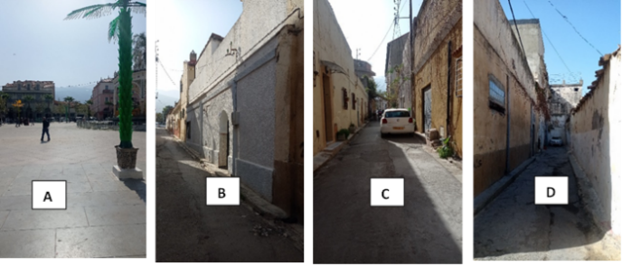
Exterior/interior: Outside the medinal fabric, natural light is diffused directly, and the pathways are spacious, resulting in a very strong light intensity. However, upon entering the medina, one notices that while the alleys remain illuminated, there is an absence of direct sun rays. This is due to the specific ratio between the height of the buildings and the width of the alleys, which breaks the sunlight and reduces glare. This principle reflects the adaptation of the medina’s organic urban structure to arid, very hot climates, providing protection and thermal comfort through its spatial configuration.

Figure 38. In situ outing. authors march2023.

On an urban scale, the relationship between light intensity and the transition from public to private space is clearly perceived through movement. As one advances through the medina, the progressive dimming of natural light signals an increasing degree of privacy. For example, a dead-end is generally less illuminated than the alleys (C and D), and the alleys are less illuminated than the spaces outside the medinal fabric (A and B). This gradation reflects the spatial hierarchy that underpins the design of the Islamic city. In this medina, public, semi-public, and private spaces are organized according to deeply rooted socio-cultural norms.
Skifa/patio: The skifa marks the threshold between the exterior and the interior of the dwelling, a dark, narrow, and covered space that places the passer-by in a state of sensory and spatial transition. Its subdued luminous atmosphere reinforces its function as a passage, not a place for prolonged stay. From this confined, shaded area, one enters the patio, an open, expansive space flooded with sunlight. The patio serves as the central shared area of the residence, playing a vital role in supplying adjacent rooms with both light and air, making it the luminous and ventilatory heart of the home.
Patio/byoute: The byoute (adjoining rooms) represent the residence's more private and intimate spaces. These rooms are generally less illuminated than the patio, offering greater privacy throughout the seasons. The transition in spatial function is closely linked to a corresponding shift in the natural light ambiance. In transitional spaces, such as the skifa, where prolonged stays are not intended, the light is weak and subdued. In contrast, the alleys (zenka) are better lit to ensure the safety of passers-by, typically maintaining a clear, open-air pathway; they are public, urban-scale shared spaces. Dead ends, however, exhibit a distinct lighting atmosphere that signals a shift from public to semi-private space, accessible only to residents. On the residential scale, the patio serves as the common space. Thus, changes in spatial function are consistently expressed and anticipated through variations in light ambiance.

3.2.2 Direct light, a metaphor guessed
Light plays a central role in the ethnic and cultural life of the medina's inhabitants. In many Islamic religious texts, it symbolizes divine creation, its rays illuminating both space and spirit, much like the divine illuminates the soul. Light thus becomes a metaphor for clairvoyance, forming a sensory and spiritual dialogue with the divine. To be immersed in light is to be enveloped in divine mercy.
The patio, as the heart of the home and open to the sky, establishes a direct visual and symbolic link with the heavens. It embodies the light of both heaven and earth, reflecting a divine presence within the domestic realm. This profound relationship between the patio and its inhabitants is conceived through the sensory dimension of space, where light is not limited to visual comfort but extends to embody an entire ethnic and cultural logic. In this context, the philosophy of light, deeply shaped by religion, assumes the values of purity, clarity, and cognition.
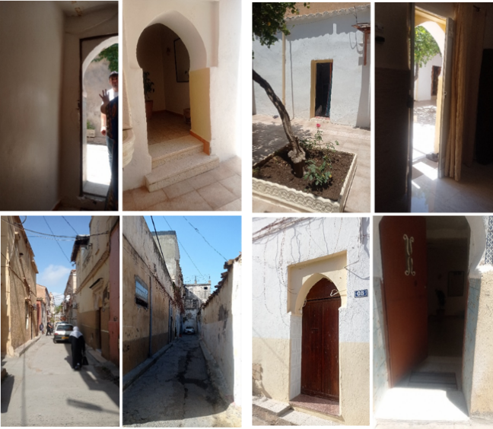
The duality of shadow and light speaks to the eternal interplay between opposing forces: light and darkness, good and evil, silence and sound, interior and exterior, public and private. This contrast not only structures the spatial sequence of the medina but also governs the way each space is experienced and practiced.

Figure 39. light and shadow. authors march2023.

Light guides the spirit, shaping its path through the atmospheres it generates. It breathes life into space, transforming it from mere architecture into a lived experience. According to the inhabitants' responses, light is intrinsically linked to notions of life, security, and serenity. A space bathed in light is perceived as alive and welcoming. This is particularly evident in the patio and the alleys—two types of shared spaces operating at different scales: the domestic and the urban. In both cases, light animates the space, reinforcing its collective and vital function.

3.2.3 Indirect light, a parameter of intimacy
Looking at the residents' responses, many described light as a symbol of security and serenity. Referring to the transcriptions of the two interviewees, it becomes clear that the majority of inhabitants prefer the intimacy offered by the byoute (rooms). These spaces are generally less well-lit than the patio, yet they offer greater seclusion. The rooms benefit from dim, filtered light, embodying the concept of horma, reflecting the deeply ingrained Islamic cultural need for a protected space shielded from the gaze of outsiders.
The horma operates on two levels: the first is the separation between the interior of the house and the external world. This divide is marked by a narrow, windowless space that is illuminated only by subtle, indirect light. This subdued lighting not only makes the route legible to those passing through but also helps to reduce external noise. Within this space, voices are lowered to respect the transition from the outside world to the sanctity of the home. The horma symbolizes the necessity of privacy. Within Islamic culture, the home is a sacred, private space, not accessible to all.
The skifa, a transitional space before entering the heart of the house, marks the first threshold. Its dim lighting and open entrance lead into the patio—the central, open-air space bathed in direct sunlight. The patio is the largest area in the house, supplying both natural light and fresh air to the surrounding rooms. It symbolizes the shift from the external world to belonging within the home. As the quintessential social space, the patio serves as the gathering place for family and guests, hosting moments of shared connection and celebration. Multifunctional, it is a common space where family members and visitors alike can interact.
However, within the domestic scale, the patio is not the private zone. The byoute rooms represent the intimate heart of the house, where one can experience solitude and peace. The transition from the patio to these rooms is marked by a shift in the ambiance of light, from the lively, warm glow of direct light to more subdued, indirect lighting. This change redefines the space's functional character.
In the byoute rooms, the predominant activities require privacy, darkness, and tranquillity. Here, one can retreat from the outside world, finding serenity through the interplay between the bright, even illumination of the patio and the soft, gradual darkening within the room.

3.2.4 The anthropology of light in the medina
Medinal architecture is fundamentally an architecture of light. Our study of the El-Djoun district has revealed a profound connection between natural light, the built environment, and the residents of this space. From a sensory perspective, the lighting atmosphere was explored on multiple levels. Its functional and psychological effects, as well as its role in social practices. Light defines space by signaling its functional purpose and shaping the psychological perception of its inhabitants, highlighting the unique character of this architecture through its luminous material.
Light regulates spatial transitions, preparing the mind for entry into the intimate world of the inhabitants. It isolates noise, brings family members together, and creates a joyful, dynamic atmosphere for communal sharing. As light and space interact, they transform the environment into a mystical realm: “Everywhere, the most unexpected plays of light illuminate this chaos, further enlivened by the surrounding shadows” [27]. In this way, shadows and light sculpt the space, creating a sensory experience that shapes the perception of the built environment.
The typology of housing in the medina of El-Djoun reflects the deeply embedded philosophy of light in Arab-Islamic culture, which is translated into the residential built environment. Light not only creates but also organizes space, influencing both the interior and exterior. From public to semi-private and private spaces, the luminous ambiance illustrates the hierarchical structure on which medinal architecture is based. This deep connection to light, to the sky, and to divine creation, combined with the principle of introverted space and privacy (horma), fosters an anthropology of light that is intrinsic to the medinal built environment.

CONCLUSION
This paper demonstrates a new cognitive approach in architectural studies, focusing on the anthropology of light within the medinal built environment. The anthropology of light, a relatively recent theme previously centered on Western contexts, explores how light shapes socio-spatial perception and reflects cultural, religious, and sensory experiences. The article highlights the heuristic value of integrating anthropological research tools into architectural analysis. In particular, the guided tour emerges as a valuable qualitative method for sensory exploration within spatial environments, complemented by a quantitative survey-based approach. Focusing on El-Djoun, the study reveals the unique characteristics of light in the medinal fabric as a sensory element that not only shapes spatial configurations but also establishes privacy in accordance with cultural and social norms. Light passing through elements such as the zenka, skifa, and patio (west eddar) forms a language of horma (privacy), where illumination is deeply embedded in spatial philosophy and daily practices. This luminous language governs social behaviors, including activities and gender dynamics. It regulates spatial practices in which light mediates between feminine and masculine domains, subtly enforcing cultural notions of dominance and separation. Using guided tours and sensory observation, the study reveals that light in the medina is not merely functional but symbolic and culturally embedded. Architectural features—such as patios, narrow alleys, and filtered openings—mediate natural light in ways that reflect both environmental adaptation and spiritual intentionality. These findings underscore the value of incorporating anthropological tools into architectural research and emphasize the medina’s distinctive luminous character as a cultural construct. The study contributes to both architectural theory and anthropology by demonstrating how light serves as a lens to understand identity, tradition, and the lived experience of space. Furthermore, other medinal cities offer promising case studies for future research in the anthropology of light across arid, semi-arid, and Mediterranean climates. Such research encourages interdisciplinary methodologies that prioritize perception, cultural meaning, and spatial memory while verifying previous findings.

REFERENCES

- R. M. Manoliu, “Langage Architectural de la Lumière,” Les Cahiers Linguatek, ESPACE & LANGAGE, Vol. 3, No. 5-6, 2019.

- M. Kerkhoff, La lumière dans l'architecture, Spain : Editions du Layeur, 2021.

- A. Chamma & M. Dambri, “The Anthropology of Light in Traditional Housing, Comparative Analysis of Three Case Studies: Medinal Casbah, Japanese Machiya, Danish Aarhus,” YMER, vol. 22, no. 7, pp. 837-868, 2023.

- R. Zarytkiewicz, L’enseignement de l’histoire de la vision de la lumière à travers les âges et les cultures, La Lettre AFC, 2016.

- R. Sommer, “Personal Space: The Behavioral Basis of Design”. Englewood Cliffs, NJ: Prentice-Hall, 1969.

- A. Rapoport, “Pour une anthropologie de la maison,” Revue Française de Sociologie, vol. 16, no.1, p. 149, 1975.

- L. Demerath, “Epistemological Culture Theory: A Micro Theory of the Origin and Maintenance of Culture,” Sociological Theory, vol. 20, no. 2, pp. 208–226, 2002, http://www.jstor.org/stable/3108646.

- M. Fétiveau, “Concevoir un espace-temps architectural : notation du mouvement et Pattern Language : application à un cas de conception,” Architecture, Aménagement de l'Espace, 2010.

- F. Choay, “Claude Lévi-Strauss et l'aménagement des territoires,” Esprit, pp. 38-48, 2011. DOI : https://doi.org/10.3917/espri.1108.0038.

- A. Belakehal & A. Farhi, “Les Ambiances Environnementales de la Médina : Le Patrimoine Oublié,” Conférence Internationale sur la Médina, 2008.

- M. Z. M. Taib and M. T. Rasdi, "Islamic Architecture Evolution: Perception and Behaviour," Procedia - Social and Behavioral Sciences, vol. 49, pp. 293–303, 2012. DOI: https://doi.org/10.1016/j.sbspro.2012.07.027

- P. Jones, G. Bunce, J. Evans, H. Gibbs, J. Ricketts Hein, “Exploring Space and Place with Walking Interviews,” Journal of Research Practice, vol. 4, no. 2, 2008. https://jrp.icaap.org/index.php/jrp/article/view/150.html.

- D. Cousin-Marsy, V. Ouverte, Exploration Sensible et Parcours Commentés, Étude sur la Dimension Métropolitaine des Halles, Synthèse, 2009.

- J. Evans & P. Jones, “The Walking Interview: Methodology, Mobility and Place,” Applied Geography, vol. 31, no. 2, pp. 849-858, 2011. DOI: https://doi.org/10.1016/j.apgeog.2010.09.005.

- C. Lewis, V. May, S. Hicks, S. Costa Santos, N. Bertolino, “Researching the Home Using Architectural and Social Science Methods,” Methodological Innovations, vol. 11, no.2, 2018, DOI: https://doi.org/10.1177%2F2059799118796006.

- D. Morali, Anthropologie de la lumière, Presses Universitaires de Nancy, Avenue de la Libération, pp. 42-44, 1994.

- M. Bille and T. F. Sørensen, "An Anthropology of Luminosity: The Agency of Light," Journal of Material Culture, vol. 12, no. 3, pp. 263-284, 2007. DOI: https://doi.org/10.1177/1359183507081894.

- J. P. Thibaud, “Les parcours commentés,” in L'Espace Urbain en Méthodes, Michèle Grosjean and Jean-Paul Thibaud (Eds.), Editions Parenthèses, Marseille, pp. 79-99, 2001.

- J. Tanizaki, In Praise of Shadows, T. J. Harper and E. G. Seidensticker, Trans. New York: Vintage Books, 2001.

- URBA Blida, POS city center Blida / Phase III, Final Edition. Blida, Algeria, 2012.

- C. Pétonnet, "Space, Distance, and Dimension in a Muslim Society," L'Homme, vol. 12, no. 2, pp. 47–84, 1972.

- H. Boutabba, A. Farhi & Mohamed Mili, “Le Patrimoine Architectural Colonial dans la Région du Hodna, un Héritage en Voie de Disparition: Cas de la Ville de M’sila en Algérie,” L'Année du Maghreb [En ligne], vol. 10, 2014, DOI: https://doi.org/10.4000/anneemaghreb.2113.

- S. Abdulac, Les Maisons à Patio: Continuités historiques, adaptations bioclimatiques et morphologies urbaines, Paris, 2011.

- N. Fezzioui, M. Benyamine, N. Tadj, B. Draoui, and S. Larbi, "Performance énergétique d’une maison à patio dans le contexte maghrébin (Algérie, Maroc, Tunisie et Libye)," Revue des Energies Renouvelables, vol. 15, no. 3, pp. 399–405, 2012, doi: 10.54966/jreen.v15i3.330.

- M. Bouakaz, “Optimisation Morphologique du Comportement Aéraulique d'une Maison à Patio,” Université Mohamed Khider. Biskra, 2016.

- A. Gotman, “L’hospitalité, déclin ou histoire ?,” in Le Sens de l’Hospitalité: Essai sur les Fondements Sociaux de l’Accueil de l’Autre, pp. 11-49, Paris Cedex 14: Presses Universitaires de France. 2001

- F. Baraudon, "Algérie et Tunisie. Récits de Voyage et Etudes," Alger: Imprimerie Flon 1893.

