 |  | JOURNAL OF ISLAMIC ARCHITECTURE  P-ISSN: 2086-2636 E-ISSN: 2356-4644  Journal Home Page: http://ejournal.uin-malang.ac.id/index.php/JIA
ARCHITECTURAL OTTOMAN HERITAGE IN CONSTANTINE, ADAPTATIONS AND INFLUENCES (CASE OF MOSQUES)
Menhour Asma^{1,2*}, Boudemagh Sassi Souad¹
¹University of Constantine 3, Constantine, Algeria
²Mohammed Seddik Ben Yahia University, Jijel, Algeria
*Corresponding Author: asmaline1@hotmail.fr
ARTICLE INFO |  |  | ABSTRACT
Volume: 9  Issue: 1  Page: 247-265  Received: March 19th, 2025  Accepted: June 26th, 2025  Available Online: June 30th, 2026  DOI: https://doi.org/10.18860/jia.v9i1.32419 |  |  | During the Ottoman era (fifteenth - eighteenth century), Algeria witnessed a flourishing period of Islamic art. Ottoman architectural masterpieces were characterized by unique stylistic touches and by their integration of the specific heritage of each region, drawing on local knowledge. Unfortunately, the design of contemporary mosques neglects the cultural context of their respective region. The Algerian city of Constantine, known for its rich heritage, especially in religious architecture, was famously called “the city of 100 mosques” before French colonization. Tragically, French colonial policies (1830–1962) systematically dismantled this heritage, converting mosques into churches or demolishing them; post-independence efforts often overlooked pre-colonial models. Today, only three mosques in Constantine - Sidi El-Kettani, Sidi Lakhdar, and Hassan Bey - have preserved elements of Ottoman architectural expression. For example, the Hassan Bey mosque reproduced, for the first time, a plan with several small cupolas without a large central dome, also referred to as the Ulu Cami mosque in Bursa, using local techniques such as shell-shaped squinches and Zellige tilework. This study analyzes these mosques through architectural monographs, revealing a hybrid "local Ottoman" style shaped by Ottomanization policies and regional craftsmanship. It underscores the urgency of preserving this legacy and its potential to inspire contemporary mosque design.  Keywords:  Heritage preservation; Constantine; Mosque architecture; Ottomanization; Regional specificities

INTRODUCTION
In Algeria, colonial policies aimed at dismantling collective identity and erasing cultural heritage led to the loss of the forms and functions of mosques. After independence, Algerians sought a style of Islamic architecture to adopt [1], despite the richness of the pre-colonial architectural heritage. During Ottoman rule in Algeria (from the fifteenth century onward), Islamic art reached its peak. Within Ottoman provinces, imperial authorities and local patrons introduced distinctive architectural signifiers: domes, minaret profiles, gallery-framed courts, tile programs, and calligraphic bands, as part of broader cultural processes widely described as Ottomanization. Adoption, however, was not uniform. In regions with deep pre-Ottoman Islamic traditions/heritage, imported forms interlaced with entrenched local building cultures, producing hybrid vocabularies. Constantine’s mosques illustrate this negotiated synthesis, where Maghrebi materials (stone, brick, stucco), Hispano-Maghribi decorative repertoires (zellige, lambrequin arches), and local crafts engaged Ottoman spatial and ornamental cues. This study employs the working term “local Ottoman style” to describe these hybrids [2][3]. The Medina of Constantine, known as the city of a hundred mosques, still preserves jewels of "local" Ottoman architecture, including Moorish baths, zawiyas, mosques, and the famous Ahmed Bey Palace.
This paper undertakes a comparative monographic analysis of three Ottoman-period mosques in Constantine: Hassan Bey (Souk El Ghezal), Sidi Lakhdar, and Sidi El-Kettani, that retain sufficient architectural authenticity to support detailed study. Mosques provide a privileged lens because of their enduring communal, devotional, and patrimonial status; they are religious structures sacralized by the community, with a "cultic" functional value that ensures their longevity [4]. Mosques are inherited, perpetuated, and often intentionally or spontaneously preserved by the local population; they are often maintained, adapted, or reclaimed across political regimes, leaving stratified architectural records [4][5].
To frame our discussion, we address the following research questions: If the Ottomans ruled Constantine for over three centuries, leaving behind a significant legacy of religious buildings (over a hundred mosques at the time of the French arrival), how did Ottoman architectural influences manifest in the design of mosques in Constantine during the regency period? What traces remain today, and how can they be transmitted to future generations? Additionally, what local adaptations (Moorish/Hispano-Maghrebi traditions) were incorporated into these structures? Therefore, the objectives of this study are:
- Identifying architectural characteristics: To analyze the Ottoman-style features of mosques in Constantine.
- Highlighting Ottoman influences: To reveal the architectural influences of the Ottoman era on these mosques and their contribution to Algeria's religious architecture.
- Historical understanding: To examine how the Ottoman period shaped religious architecture in Constantinople.
- Preserving heritage: By emphasizing the architectural characteristics of mosques from this period, the study contributes to the preservation and promotion of Constantine’s cultural heritage.
- Guiding restoration efforts: By providing a reference for potential mosque restorations that respect the authenticity of historical elements.
- Raising awareness: Among academics, professionals, and civil society about the importance of Ottoman-era architectural heritage.
- Inspiring contemporary design: By establishing reference frameworks derived from Algeria's varied heritage to illustrate its regional architectural specificities and inspire current designs.
The conceptual framework of this study involves presenting the architectural characteristics (Moorish style) of mosques in Algeria before the Ottoman regency, as well as the Ottoman model (influenced by Byzantine and Seljuk styles). By analyzing three Ottoman mosques in Constantine, we examine Ottoman influences and local adaptations.
Scholarly investigations into this architectural phenomenon are structured around foundational contributions that diverge in their methodological approaches and investigative scope. On the one hand, the seminal works of Goodwin [6] and Kuban Dogan [7] have established a comprehensive theoretical framework for analyzing Islamic and Ottoman architecture across its broader geographical and temporal dimensions. Conversely, specialized studies conducted by R. Bourouiba [8][9][10][11], A. Dahdouh [12], and Guechi [13] have adopted a localized approach to Algerian mosque architecture, examining the complex articulation between pre-existing Maghrebi traditions and Ottoman influences.
These investigations, predominantly grounded in archaeological-historical and descriptive methodologies, have undoubtedly constituted an indispensable scientific foundation. Nevertheless, they reveal a significant epistemological gap regarding the in-depth analysis of the hybrid "local Ottoman style." This architectural synthesis, resulting from the creative confluence between Ottoman constructive practices and Maghrebi traditions in Algerian mosque edifices, remains insufficiently theorized. This lacuna persists despite the remarkable singularity of the resulting "local-Ottoman style," which necessitates more rigorous analytical investigation.
The present study privileges Constantine as its empirical research terrain and conducts a comparative analysis of three representative Ottoman mosques. This methodological approach could be extended to other Algerian cities exhibiting similar conFigureurations, notably Oran, Annaba, and Algiers, which demonstrate comparable architectural dynamics.

METHODS
The research combines three complementary methods: first, we adopt a historical-descriptive method and an architectural monograph approach [14], which combines historical research with textual, graphic, or photographic descriptions. A theoretical section precedes the analysis to define the historical context and some architectural criteria of mosques (Moorish/Ottoman). The study focuses on mosques as a category, selecting samples based on authenticity and integrity. Three of the most intact Ottoman-era mosques in Constantine were chosen.
After analyzing these mosques and examining their architectural and aesthetic features, it became evident that they were not merely religious buildings but also embodied a blend of Ottoman traditions and regional specificities. This fusion was likely due to contributions from local artisans and to the Ottoman rulers’ insistence on incorporating distinctive Ottoman elements. So, the third method is the comparative typological analysis against canonical Ottoman exemplars.
In conclusion, we identified the local Ottoman style in Constantine's mosques at three levels: conceptual, urban, and aesthetic, reflecting characteristic features of Ottoman architecture. These criteria serve as sources of inspiration and reference frameworks for mosque designers and researchers in Islamic architecture

RESULTS AND DISCUSSION
3.1 RESULT
3.1.1 Moors and Ottomans in Algeria
The Moors originated in the Maghreb region, encompassing modern-day Morocco, Algeria, Tunisia, and parts of Libya. Many were Berbers, the indigenous people of North Africa, who embraced Islam after the Arab Muslim conquests. Over time, they adopted elements of Arab culture, language, and religion, creating a unique Islamic identity rooted in North African traditions. In the field of art and architecture, the Moors were renowned for their architectural achievements, characterized by intricate geometric patterns, arabesques, and calligraphy. Their designs influenced structures such as the Alhambra in Spain and mosques across North Africa. The Moorish style, an Arab-Islamic architectural style developed by the Moors, had a significant impact on the Iberian Peninsula (Andalusia). This style employed distinctive expressions and techniques, leaving a lasting mark on both Andalusia and North Africa, particularly through the dynasties that succeeded one another: the Almohads (North Africa), Almoravids (Morocco and Algeria), Merinids (Morocco), Zianids (Algeria), Hafsids (Tunisia), among others. Despite their differences, these dynasties shared common characteristics, especially in mosques, emphasizing arches, domes, monumental sculpted doors, mosaics, and faience.
On another note, the Ottoman period in the history of the Maghreb began following Spanish actions against the main North African ports. In the 16th century, the Ottoman Empire expanded its influence in North Africa, establishing itself in Tunisia, Algeria, and Libya. These territories were incorporated into the Empire as provinces, administered by beys appointed by Istanbul, the imperial capital. The Barbarossa brothers, true heroes of the sixteenth-century Muslim world, were then called upon as saviors by the Moors of Algiers in 1515. Their intervention marked a decisive turning point in the history of Algeria and Tunisia, particularly in the face of Christian attacks. The Ottoman Empire, emerging as the new Muslim power in the eastern Mediterranean, opposed the European Christian monarchies [15]. Still, it also left a profound cultural influence on Algeria, shaping the regional, social, political, and artistic landscape. Under Ottoman rule, Algeria became a key province of the Empire, introducing new cultural elements that blended with local Berber and Arab traditions, creating a unique Algerian identity. For instance, in architecture, the Ottomans introduced distinct styles, especially for palaces and religious buildings, including domed mosques, intricate tilework, and elegant courtyards. Notable examples include the Ketchaoua Mosque in Algiers, the Bey’s Mosque in Oran, the Salah Bey Mosque in Annaba, and several mosques in Constantine, including the Hassan Bey Mosque, Sidi Lakhdar Mosque, and Sidi el Kettani Mosque. These structures reflect Ottoman design and aesthetics combined with local influences.

A. The Process of Ottomanization (Definition)
Ottomanization refers to the socio-political, cultural, and administrative processes through which the Ottoman Empire integrated conquered territories and diverse populations into its imperial system while accommodating local particularities [16][17]. This involved:
- Administrative incorporation: Implementation of the timar (land-grant) system, provincial governance (sancak/beylerbeyi), and Ottoman legal codes [16][18].
- Cultural assimilation: Adoption of Ottoman language, architecture, and customs, often through elite co-option or syncretism with local traditions [19][20].
- Religious influence: Spread of Sunni-Hanafi Islam via endowments (waqfs) and mosque construction [21][22].
- Economic integration: Trade networks and fiscal systems (e.g., jizya taxation for non-Muslims, market regulations) bind regions to imperial markets [23].

The term also acknowledges resistance, hybridity, and localized reinterpretations as local identities often persisted alongside Ottoman frameworks [16][24]. In architecture, this phenomenon is characterized by:
- The diffusion of canonical Ottoman elements: Centralized domed prayer halls, Slender pencil-shaped minarets, Use of Iznik tiles and Ottoman calligraphic styles, Integration of külliye complexes (mosque-madrasa-hammam ensembles) served as visual markers of imperial identity [7][20]
- Local adaptations: Hybridization with regional traditions (e.g., Maghrebi courtyards in Algerian mosques), Material, structural, and aesthetic compromises [9][25]. (e.g., local stone instead of Ottoman brick domes)
- Political and cultural symbolism: Architecture as a tool of imperial legitimacy, mosques as visual markers of Ottoman sovereignty.

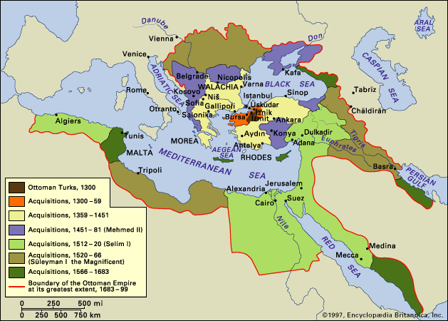

Figure 1. Territories occupied by the Ottomans -zones of influence- (source: Encyclopædia Britannica, Inc.)

B. Characteristics of Mosques in Algeria Before the Ottomans 'Moorish Style' (Hispano-Maghrebian)
Moorish mosques in Algeria were marked by:
- Diversity of materials: Brick was used for both construction and decoration, with stone cladding or combined with brickwork.
- Stucco decoration: Use of zellige (glazed tiles with geometric patterns).
- Arches: Horseshoe arches, poly-lobed arches, and arches with lambrequins.
- Minaret: A single minaret per mosque, square in section, decorated with brickwork or stucco motifs and muqarnas (stalactite-like decorations) made of wood or plaster. It could either be part of the mosque or a separate structure, as seen with the Almohads [26].
- Domes: Domes covered with two-slope roofs, typically covered in green glazed tiles.
- Decoration: Use of interlaced gypsum or brickwork, with paired arches separated by columns, polylobed or interlaced arches, or even stacked arches.
- Calligraphy: Utilized Naskh Maghrebi style, particularly the Kufic script.
- Reuse of construction elements: Incorporation of columns and capitals from the Roman and Byzantine periods

C. Mosque with an Arabic Plan (hypostyle) Adopted in North Africa
Hypostyle (from the Greek) is an architectural form originating in ancient Greece; a prayer hall whose roof is supported by columns, with a courtyard featuring porticos, with or without a fountain. The term is primarily used in Islamic architecture to refer to the prayer hall in a mosque (a hypostyle mosque with an inner courtyard) [27]. The "Arab plan" refers to a hypostyle prayer hall with longitudinal naves intersected by transverse aisles, and an annexed courtyard.
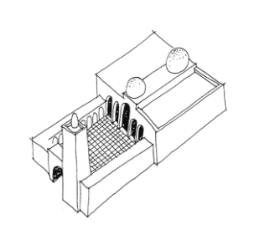
Figure. 2. Hypostyle Mosque – Prototype [28]

D. Characteristics of Ottoman Mosques
Ottoman mosques are distinguished by their central domed prayer halls, a design strongly influenced by Byzantine architecture, especially that of Hagia Sophia [29]. The architectural language reflects a synthesis of functional utility and aesthetic harmony, inspired by earlier Seljuk and Byzantine traditions.

Design Features:
Key elements include courtyards bordered by galleries; the integration of domes, half-domes, and corner domes for spatial coherence and grandeur; and the inclusion of multiple slender, pencil-shaped minarets.
- Plan Schemes: Ottoman Mosque plans evolved from two primary inspirations:
- Central Dome Plan: Dominated by a large central dome supported by half-domes, freeing interior space with the help of large piers.
- Multi-dome congregational hall (also called Ulu Cami Type): Characterized by multiple small domes covering the prayer hall, reminiscent of Seljuk models. In this study, we favor the term "multi-bay, multi-dome congregational hall" over the designation "Ulu Cami type." This terminological choice is justified by three centuries of Ottoman presence in Algeria (1518-1830), while explaining the natural reference to the Bursa prototype (AD 1400), should not obscure the more complex architectural dynamics at play.
Both layouts ensured practicality in worship while enhancing structural and spatial integrity (see Table 3 for examples).
- Facade Features:
Ottoman mosques emphasize symmetry and proportionality on their facades. Common features include: slender cylindrical minarets flanking the structure, often in multiples; prominent domes visible from afar, serving as iconic symbols of the skyline; courtyards surrounded by arcades, contributing to a cohesive exterior design.
- Structural System and Architectural Elements:
- The structural ingenuity of Ottoman mosques lies in their balance of aesthetics and engineering:
- Large piers and arches support the massive domes.
- Half-domes and smaller domes distribute the load, ensuring stability.
- The use of materials like stucco, marble, and ceramics enhances durability and ornamentation.
- The integration of the mosque into a Külliye, a multifunctional complex, further emphasizes its structural and societal significance [7]
- Spatial Features:
- Interior spaces of Ottoman mosques are designed for openness and functionality.
- The use of large piers ensures the central dome's stability while freeing up the prayer area.
- Half-domes and corner domes create a sense of layered spatial hierarchy.
- Light is strategically introduced through stained-glass windows.
- Aesthetic Features and Ornament:
- Ottoman mosques are celebrated for their rich interior decoration, which includes:
- Intricate stucco and marble carvings.
- Ceramic tiles adorned with geometric and floral patterns.
- Colored stained-glass windows that filter light in dynamic, vibrant ways.
- The decoration reflects a fusion of Islamic artistic traditions and local influences, achieving both visual beauty and spiritual resonance [27]
Table 1. Mosque Forms Adopted in Ottoman Turkey (source: authors)
Ulu Cami Mosque
Meaning "Grand Mosque," it first appeared (for Turkey) at the Bayezid I
Mosque in Bursa (1396-1400 CE) featuring 20 identical domes and no courtyard [29]
Ottoman architecture can be divided into two distinct periods: The first period is marked by Seljuk influence, notably characterized by pillar-supported mosques like the one in Bursa, where the domes rest on massive [15]

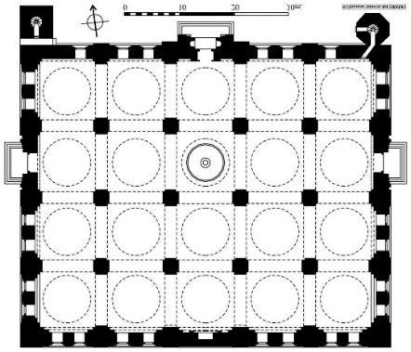

Figure 3. Ulu Cami Mosque (Bursa) – Plan (source: Islamic Art Museum)

Mosque with Central Dome and Slender Minarets (Ottoman Plan)

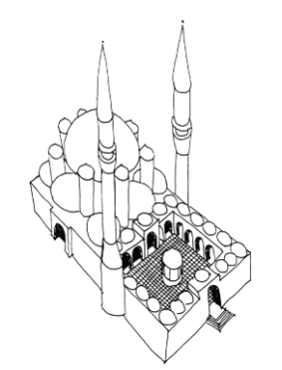

Figure 4. Ottoman Mosque – Prototype [28]

3.1.2 THE OTTOMANS IN CONSTANTINE (HISTORICAL OVERVIEW)
At the end of the 15th century, Constantine was still under Hafsid rule, under Sultan Moulaï Mohamed in Tunis. However, it is difficult to specify the exact date of the Ottoman arrival in Constantine, but it seems to have occurred after the conquest of Tunis by Kheir Eddine, around 1535. Integrated into the beylik administrative structure, Constantine developed as a provincial center that attracted religious and civic patronage. Nineteenth-century accounts at the time of the French siege (1837) cite roughly 100 religious establishments: Friday mosques, smaller prayer halls, madrasas, and zawiyas, although their survival and integrity varied widely. Subsequent colonial conversions (mosques to churches/cathedrals), demolitions, and adaptive reuses sharply reduced the number of functioning mosques retaining pre-colonial fabric [2][5].

A. Ottoman Heritage in Constantine
The Ottoman presence in Constantine lasted for several centuries and deeply influenced the city’s history. It left a significant legacy, particularly in the city’s culture and architecture. Ottoman presence is still visible in monuments across Constantine city (in the east of Algeria) with mosques, madrassas (Qur’anic schools), and palaces built on the ottoman style; so ottoman heritage is still visible in some of the city’s monument especially mosques, in fact, in 1837, the year of the French colonial siege of Constantine, the city counted ‘a hundred religious’ establishments, including main mosques, prayer halls, medersas, and zaouïas [8]. However, the state of conservation of these buildings varied from case to case. For example, most mosques were converted into cathedrals or churches during the French colonial period, undergoing minor modifications and, in some cases, reconstruction. After independence, these buildings were reconverted to reclaim their original function (mosques). Below, we analyze three mosques that retain a certain level of authenticity from the Ottoman period.

B. Architectural Monograph of Three Ottoman Mosques in Constantine
It should be noted here that the Ottomans generally adopted the local architectural style for the regions they occupied, using local techniques and materials, as well as local labor [30]. However, they always introduced some "distinct touches" from Ottoman architecture.

a. Hassan Bey Mosque (Souk El Ghezel): (1703-1730 A.D.)
Built for the service of Bey Hussein Bou Kemia, this mosque incorporates Ottoman architectural expressions blended with local adaptations and elements from the French colonial era and post-independence period. It is a majestic masterpiece that dominates Didouche Mourad Street (formerly Rue de France) and Si El Haoues Square, located right next to the Ahmed Bey Palace. The name (Souk El Ghezel) derives from the wool market (Ghezel), historically linked to the mosque (Souk el Ghezal) [31][5]. After independence, it was renamed “Hassan Bey” in reference to its patron. Its construction, entrusted to the Moroccan architect A. Ben Alloul Djelloul, began in 1703 and was completed in 1730 [32]. Table 2 is a summary table of this mosque's monograph.

Table 2. Monography of Hassan Bey Mosque
DESIGN
Plan with small domes.
Hassan Bey Mosque is the only mosque in Constantine to adopt a multi-dome ceiling from the early Ottoman period, influenced by the Seljuk style, as seen in the Ulu Cami Mosque [33].
In the Hassan Bey Mosque, the naves (seven of which are perpendicular to the qibla wall and five parallel to it) are covered with 17 small domes and 18 alternating vaults, lacking the large central dome and a courtyard; creating a rhythmic multi-bay, multi-dome ceiling field lacking a dominant central dome, evocative of early Ottoman Bursa precedents but realized here at reduced scale beneath a protective pitched tile roof. For typological precision, we describe the scheme as a multi-bay, multi-dome hall rather than using the generic label “Ulu Cami” [29] [33].
It is also distinguished by its spherical corner domes, which were previously whitewashed, and by its tiled roof. This roof covers most of the small domes and vaults [32]. The area of the mosque, from its original construction to the present day (18.25 x 24.25 m), has been preserved, except for the courtyard, which was covered by a large lateral dome (added during the French colonial period, when it was converted into a cathedral: “Notre-Dame des Sept-Douleurs”). Originally, the mosque had a rectangular open courtyard with a Maida (ablution basin) and restrooms oriented to the north.

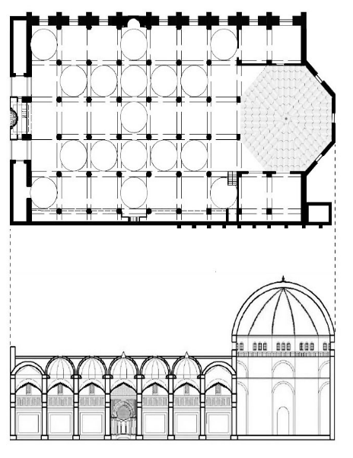
Figure 5. Plan and section of Hassan Bey Mosque (source: author,2025)

Architectural/Structural Elements

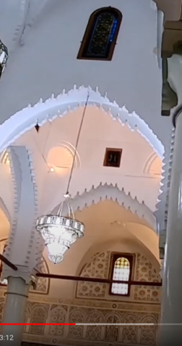  Figure 6. Arcs with lambrequins (source: authors, 2024) | 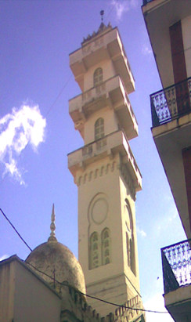  Figure 7. Square-section minaret (source: authors, 2017)
Arches with lambrequins: This type of arch was used by the Almohads in the thirteenth century (originating from the Taifa kingdoms in Andalusia). It spread mainly among the Almoravids and Merinids: western Algeria and Morocco [11]. | Square-section minaret: The mosque was equipped with a single square minaret (according to R. Bourouiba [11], located on the southwest facade), which has been modified several times during the colonial era and after independence.
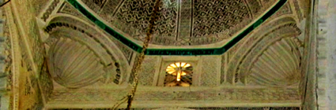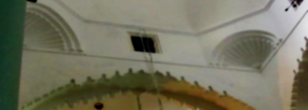

Figure 8. Shell-shaped squinches (source: authors, 2024)

Use of shell-shaped squinches that transfer the loads of the small domes. It should be noted that in the Maghreb, the loads of domes are often transferred by squinches.

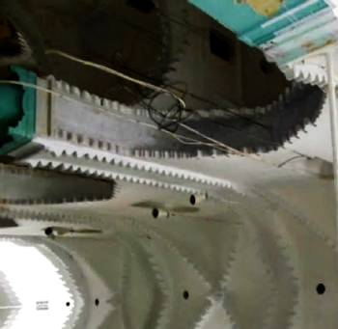

Figure 9. Keyed pendentive vaults (source: authors, 2024)

Keyed pendentive vaults are alternately arranged with the small domes, all covered by a sloped roof of tiles.

Aesthetic Aspects

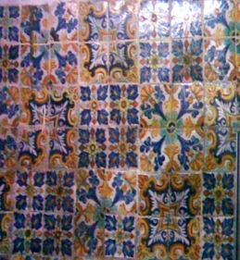

Figure 10. Zellige (source: authors, 2024)

(tiles) with floral patterns in blue, yellow, and green. Among the themes used is the tulip, the emblem of the Ottomans, with patterns identical to those used in the Ahmed Bey Palace and even in the nearby Hammam Souk el Ghezel.

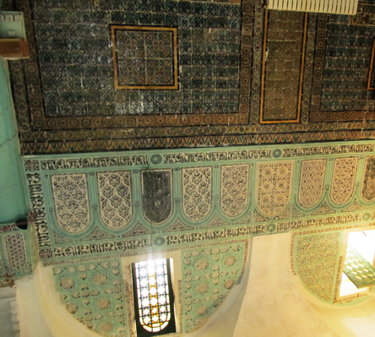

Figure 11. The qibla wall (source: authors, 2017)

Use of finely carved stucco for interlacing floral and geometric motifs and calligraphy (in Naskh style), bordering the qibla wall and part of the east wall.
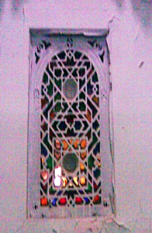

Figure 12. Moucharabieh (source: authors, 2024)

Wooden Window Screens:
These are executed within a wooden frame, filled with fresh plaster cut into floral or, typically, geometric patterns—polygons, rosettes, etc.

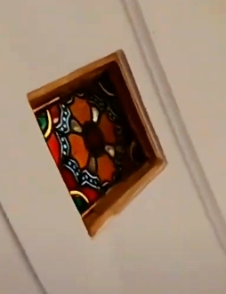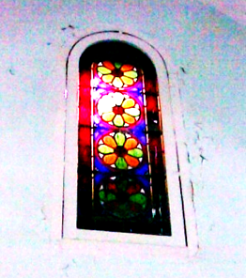

Figure 13. Colored Stained Glass (source: authors, 2024)
Use of Colored Stained Glass (Chamsiet and Qamariet): typical of Ottoman-period monumental works in Algeria [31]. In Algeria, colored stained glass was used only during the Ottoman period, primarily in monumental buildings. Here, the qibla wall contains six fixed, raised-arch windows with colored glass, each small and opening onto a nave. The colors present a mosaic of red, green, yellow, and ochre.

b. Sidi Lakhdar Mosque (1157H/ 1743)
Located on Boulevard Chedid Salah, it was built under the order of Hassan Bey ibn Hossein. It is reported that its name comes from the dominant green color both inside and outside, rather than from the famous marabout [13]. Table 3 is a summary table of this mosque's monograph.

Table 3. Monograph of Sidi Lakhdar Mosque

DESIGN
Suspended Mosque: Refers to the arrangement of the prayer hall on the upper floor [9]; it is accessed via two doors facing the qibla wall and a staircase. The mosque is composed of five naves. For this type of mosque, the ground floor is dedicated to annexes: commercial activities - Waqf - stores (activities, Waqf, stores), etc. The ground floor is reserved for businesses, with a passage with shops on either side, as well as the tombs of the Bey and his family. According to G. Marçais, this model was first introduced by the Ottomans in Algiers in 1622, and later to Constantine with the mosques of Djamaa Lakhdar and Sidi el Kettani [34]
Those family tombs (his wife and son, among others) are a configuration introduced to Constantine under Ottoman influence and comparable to earlier examples in Algiers [3][5]. Located in a closed room on the ground floor of the mosque. The Ottomans introduced this tradition in Constantine. In fact, several Ottoman mosques in Turkey contained the tombs of rulers and their families, such as the Suleiman the Magnificent complex [35].
Annexed Madrasa: Salah Bey ordered the construction of a madrasa next to the Lakhdar mosque in 1789 (At the time, madrasas served as theological education institutes, not to be confused with primary schools called Kouttab). It is reported that Sheikh Abd el Hamid Ben Badis trained his disciples at this madrasa [34]. It should be noted that it was common for the Ottomans to place mosques within larger complexes comprising souks, hammams, and madrasas, imitating the Ottoman külliye (urban complexes; the word külliye derives from the Arabic word "koul", meaning "the whole").
Architectural/Structural Elements

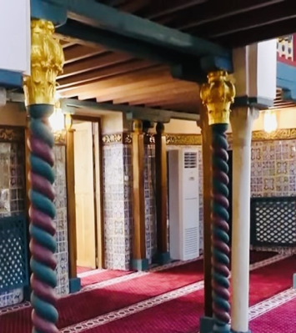

Figure 14. Twisted Columns Supporting the Dikka (source: authors, 2024)

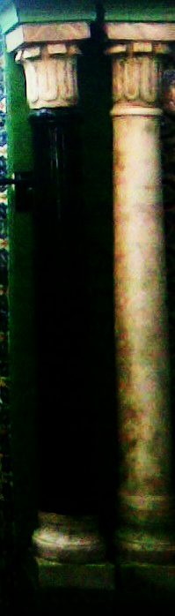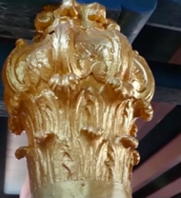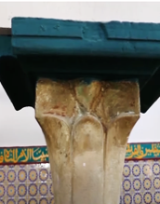
a) Almohad / b) Bulbous / c) Hafside, Capitals

Figure 15. Capitals in the prayer hall (source: authors, 2024)

Smooth marble columns / twisted columns; and varied capitals: This mosque is distinguished by its twisted marble columns and its admirable sculpted capitals. These include Almohad style capitals (a) at the mihrab (on two paired columns); bulbous capitals with pinecone designs at the corner of the Dikka, (b) unique in Algeria according to R.Bourouiba [11], and Hafside style capitals (c) above the smooth column (supporting the Dikka).
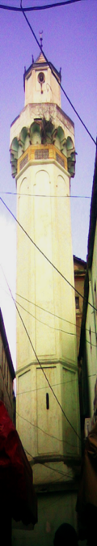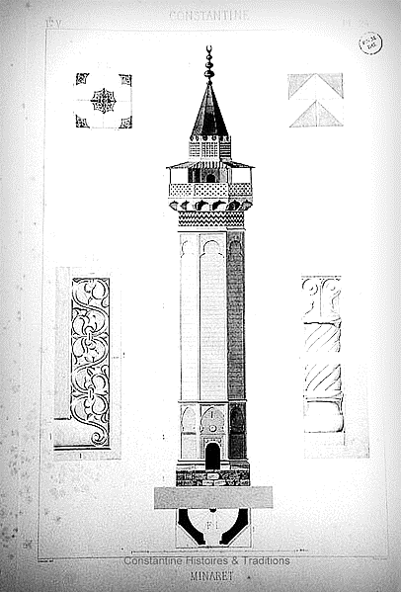

Figure 16 Octagonal Minaret [11]

Use of an Octagonal Minaret:
In Algeria, the octagonal minaret first appeared in the Djamaa El Saffar mosque (1535) in Algiers and later at Djamaa Lakhdar in Constantine. It has a single minaret at the northeast corner, with a square base surmounted by an octagonal shaft with two levels. A lantern is placed atop the shaft, finished with a pyramidal roof, and niches with consoles support the balcony.
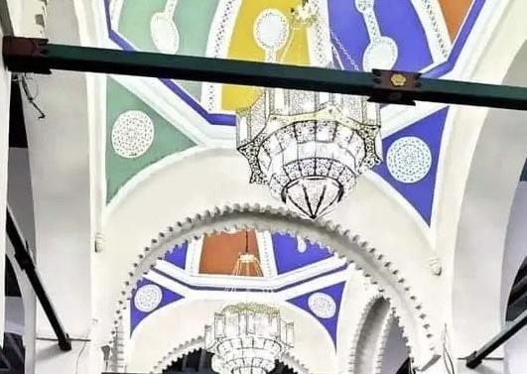

Figure 17. Pendants (source: authors, 2024)
Pendants for the dome / (after restoration in 2023)
The structures connecting the base of the dome to the supporting elements at the four corners are squinches, pendants, or muqarnas (stalactites). Here, the two octagonal-based domes each feature four pendants, reflecting Ottoman influence.
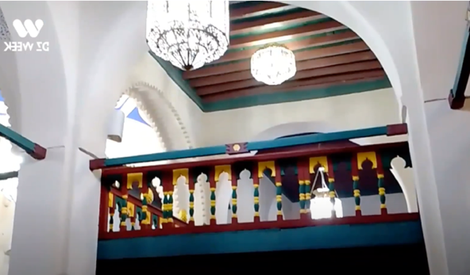

Figure 18. Dikka in the prayer hall (source: authors, 2024)

Presence: of Dikka: A wooden platform supported by four columns located at the 4th bay of the central nave, perpendicular to the qibla wall. The muezzin uses this common element in Ottoman mosques for the final call to prayer. It was introduced to Algeria by the Ottomans.

Aesthetic Aspects
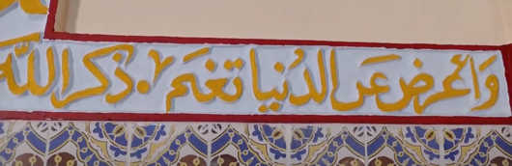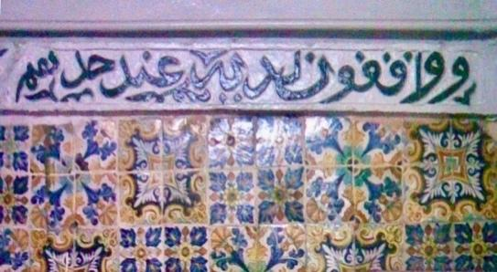

Figure 19 Calligraphy -Thuluth style-(source: authors, 2024)

Calligraphy (Thuluth style): The most commonly used styles in Constantine are Maghrebi Naskh, Kufic, and Thuluth, the latter being used by the Ottomans. Here, we find epigraphic friezes in Naskh and Thuluth: "Above the ceramic tiles continues an inscription reproducing a few verses from the Borda, a poem composed by Al-Busiri in honor of the Prophet." [13]
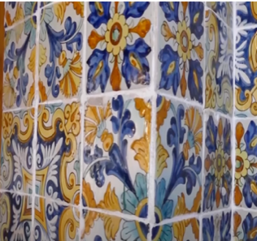

Figure 20 Ceramic tiles (source: authors, 2024)

Ceramic tiles, known as zellige in the Greater Maghreb, feature a variety of motifs. These include stylized vegetal patterns, such as digitate leaves, dianthus flowers, four-petaled flowers, eight-lobed rosettes, stems, and geometric designs like eight-pointed rosettes, interlacing patterns, and twelve-pointed stars.

c. Sidi El Kettani Mosque
Better known as Djamaa El Kettani or El Kettania (referring to the ensemble of mosque, madrasa, and tombs, also known as Salah Bey). Its construction dates back to 1776, on the edge of the famous Souk El Aser near the Casbah. It illustrates the strong reign of Bey Saleh Ben Mostafa (1771-1792 CE / 1185-1207 AH), who was one of the most significant beys of Constantine. He also laid the foundations of the madrasa, an annex intended for higher education for all the province's youth. Below is a summary table of this mosque's monograph (Table 4).

Table 4. Monograph of Sidi el Kettani Mosque (source: authors)
Design

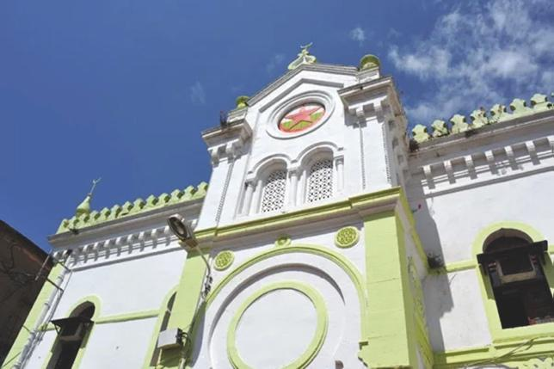

Figure 21. Entrance of Sidi el Kettani mosque (source: authors, 2024)

Monumental Entrance:
The Sidi el Kettani Mosque features two exterior facades. In the main facade, a monumental projecting porch addresses the square; a dual-facade condition reflects both ceremonial and market orientations [3].

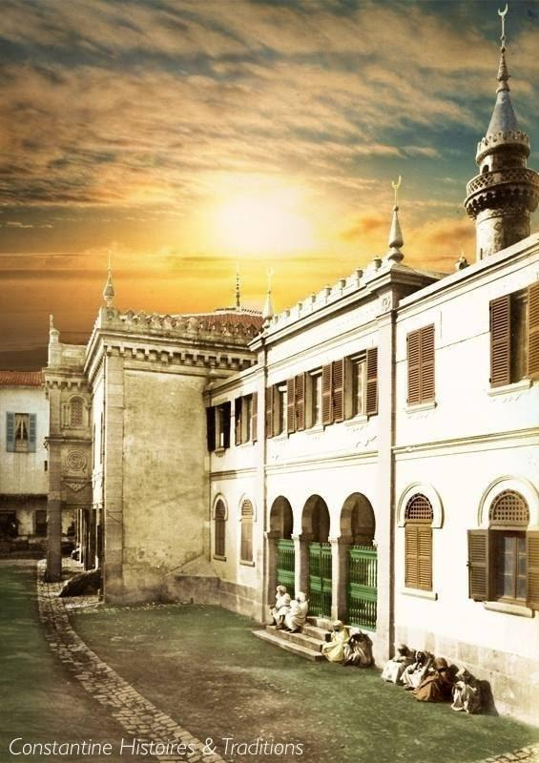

Figure 22. Cylindrical (Tapered) Minaret (source: authors, 2024)
Cylindrical (Tapered) Minaret:
The minaret of Sidi el Kettani consists of a cylindrical main tower (pencil-shaped), in contrast to the square minaret of the Hassan Bey Mosque and the octagonal minaret of the Sidi Lakhdar Mosque; local literature credits Sidi El-Kettani as among the earliest cylindrical minarets in Algeria, predating the Salah Bey Mosque in Annaba, though further comparative dating is warranted [36]
It is topped with a balcony and a conical summit. The cylindrical minaret design first appeared in Iraq during the Abbasid era and later developed, becoming widely used by the Ottomans in their mosques. In Algeria, the first cylindrical minaret was that of the Sidi el Kettani Mosque, followed by the Salah Bey Mosque in Annaba; both were constructed during the reign of Salah Bey [37].

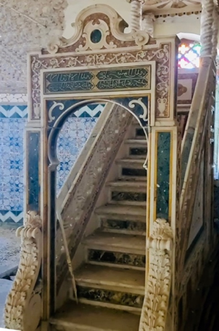

Figure 23. Marble minbar (source: authors, 2024)
Marble Minbar: While the minbars of the Souk el Ghezel and Lakhdar mosques are made of wood, typical of Maghreb mosques, the present minbar is made of marble. It is a true masterpiece imported from Livorno, Italy, where Salah Bey sourced most of the precious construction materials.

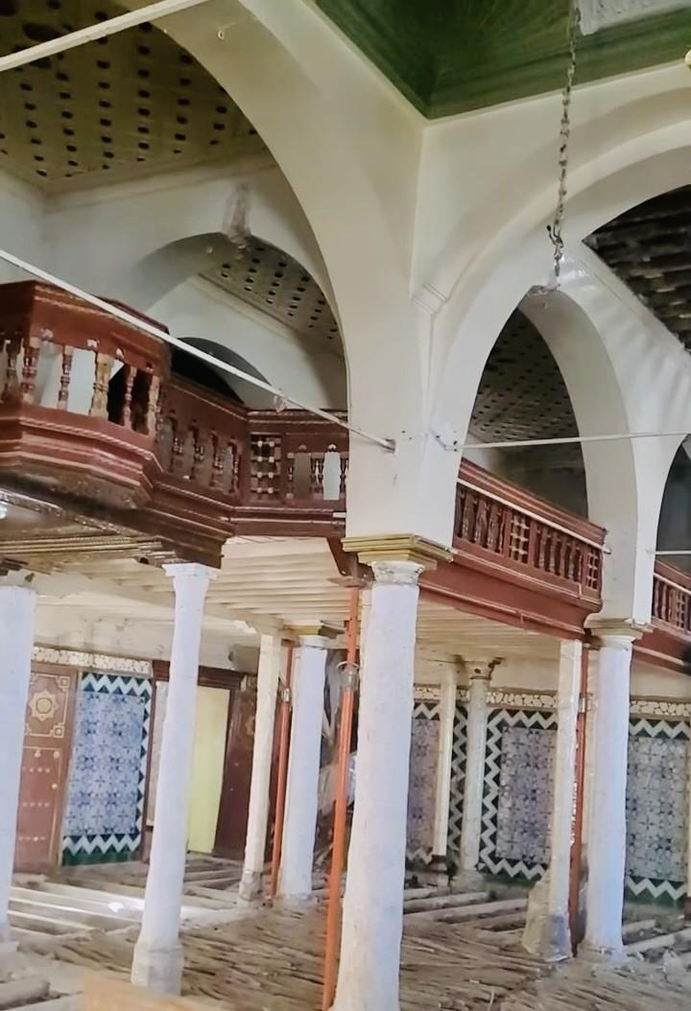

Figure 24 Dikka (source: authors, 2024)

Dikka: This is a wooden platform supported by four marble columns.
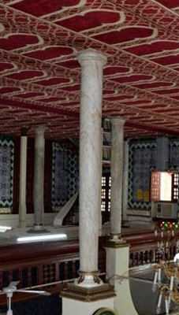  Figure 25. Marble columns (source: authors, 2024) | 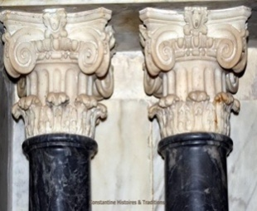  Figure 26. Composite capitals  (source: authors, 2024)
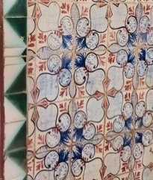  Figure 27. Zellige with floral patterns (source: authors, 2024)  Use of Zellige with floral and geometric patterns: As seen in the mosques of Hassan Bey and Lakhdar, most of the walls in the prayer hall of Sidi El Kettani are covered with zellige, featuring floral patterns, especially the "tulip" and "dianthus" flowers. | 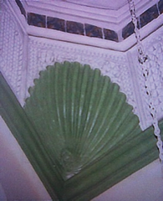  Figure 28. Shell-shaped trompe (source: authors, 2024)
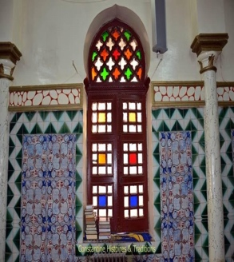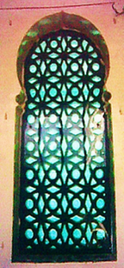  A b  Figure 29. a-colored stained glass b-musharabiya screens (source: authors, 2024)  Use of colored stained glass (a) for windows and musharabiya screens (b), like in the Hassan Bey mosque, colored stained glass is an Ottoman influence. | 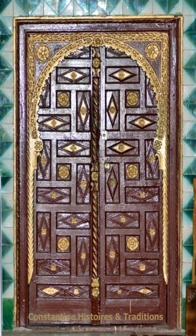  Figure 30. Wooden carved door (source: authors, 2024)

C. Comparative synthesis
Table 5 summarizes the requested points for the three Ottoman mosques in Constantine.

Table 5. Summary key comparative attributes across the three case-study mosques.
Criteria | Hassan Bey Mosque (Souk El Ghezel) | Sidi Lakhdar Mosque | Sidi El-Kettani Mosque
Approx. date | 1703–1730 | 1743 (1157 H) | 1776
Plans & Volumes | - Multi-bay, multi-dome hall plan (Seljuk style)  - 17 small domes + 18 alternating vaults.  - Original courtyard (converted into a colonial dome). | Suspended upper hall over the waqf ground floor (prayer hall upstairs)  - Complex with madrasa, tombs (Bey). | - Monumental entrance with decorated porch.  - Hypostyle Arab plan.  - Annexes: madrasa, tombs.
Minarets | Square (single, southwest corner).  - Traditional Maghreban style. | Octagonal (square base).  - First octagonal minaret in Constantine. | Cylindrical (pencil-shaped).  - First cylindrical minaret in Algeria.
Roofs & Domes | - Small spherical domes + pendentive vaults.  - Tile roof covering domes. | - Pendentive domes (Ottoman influence).  - Traditional roofing. | - Central dome + secondary domes.
Dikka present | Yes | Yes | Yes
Imported materials | Tiles; stucco; stained glass, | Tiles; carved capitals | Marble minbar; tiles
Decor & Inscriptions | - Zellige (Ottoman tulips).  - Fine stucco (floral/geometric motifs, Naskh calligraphy).  - Stained glass. | - Zellige (vegetal/geometric patterns).  - Thuluth calligraphy (Ottoman) + Naskh.  - Twisted columns. | - Zellige ("carnation" flowers).  - Marble minbar (Italy).  - Stained glass + moucharabieh.
Evolution | - Converted into a colonial cathedral (added dome).  - Post-independence restorations. | - Modern restorations (2023: dome pendentives).  - Preservation of Bey tombs. | - Preservation of the complex (mosque + madrasa).  - Durable materials (marble).
Ottomanization vs. Local Resistance | - Fusion: Seljuk plan but local domes.  - Ottoman Dikka + Maghrebi lambrequin arches. | - Suspended design (Ottoman innovation) + octagonal minaret.  - Capitals: Almohad/Hafsid. | - Cylindrical minaret (Ottoman) but local zellige.  - Synthesis of styles.

D. Cross-Analysis
- Ottomanization: Introduction of the Dikka, octagonal/cylindrical minarets, pendentive domes, Thuluth calligraphy, and imported marble.
- Local Resistance: Hypostyle plans, Maghrebi zellige, geometric stucco, tile roofs, and shell-shaped squinches.
- Adaptation: The mosques combine selective Ottoman elements (minarets, decor) with a dominant local structure, reflecting harmonious integration rather than stylistic domination.

3.2 DISCUSSION
The comparative analysis of Hassan Bey, Sidi Lakhdar, and Sidi El-Kettani Mosques demonstrates a dynamic architectural synthesis in which Ottoman influences were selectively integrated with entrenched Maghrebi traditions and adaptive responses to Constantine’s urban and socio-political context. This process reflects not merely stylistic borrowing but a culturally negotiated adaptation shaped by Constantine’s urban constraints, socio-political dynamics, and artisanal continuity. The findings underscore a deliberate selective adoption of Ottoman elements rather than wholesale imitation, resulting in a distinct regional variant of Ottoman mosque architecture.

a) Plan Typologies resistance and adaptation
Notably absent in all three case studies is the central-dome plan, a defining feature of classical Ottoman mosques in Istanbul. Instead, the persistence of hypostyle layouts (Hassan Bey, Sidi El-Kettani) and the innovative suspended prayer hall at Sidi Lakhdar underscore a deliberate prioritization of local spatial logic. This aligns with scholarship that frames provincial Ottoman architecture as a process of translation rather than imposition [5]. The multi-domed hall at Hassan Bey Mosque, reminiscent of Seljuk precedents, further illustrates how Ottoman elements were filtered through regional construction traditions, as a process of translation rather than replication [3].

b) Minarets as Markers of Hybridity
The coexistence of square (Maghrebi), octagonal (transitional), and cylindrical (Ottoman) minarets within a single city exemplifies Constantine’s architectural experimentation under Ottoman rule. The cylindrical minaret at Sidi El-Kettani (1776), the first in Algeria, served as a visual assertion of Ottoman patronage, yet its decorative zellige cladding preserved local craft identity. This diversity, as noted by Sekhri [36]. Later influenced post-independence mosque designs, reinforcing minarets as cultural markers. This duality supports Necipoğlu’s [20] argument that minarets in peripheral Ottoman territories often functioned as negotiated symbols of power and cultural synthesis.

c) Decorative Synthesis: Stratified Craftsmanship
The mosques’ ornamentation reveals a layered craftsmanship: Ottoman motifs (e.g., tulip zellige, Thuluth calligraphy) were juxtaposed with Maghrebi geometric stucco and Kufic/Naskh inscriptions. Imported materials, such as Italian marble for Sidi El-Kettani’s minbar, were strategically deployed to signify prestige while maintaining local artisanry (31). This aligns with Blair and Bloom’s [38] observation that decorative hybridity in Islamic architecture often reflects political pragmatism rather than stylistic surrender.
d) Functional Integration and Urban Resilience
The annexes (madrasas, tombs, waqf shops) at Sidi Lakhdar and Sidi El-Kettani reveal Ottoman organizational principles adapted to local needs. However, as Bouguebs & Khenchoul [7] warn, the decline in revenue-generating waqf spaces threatens the sustainability of these complexes, a critical consideration for modern conservation.

d) Conservation Challenges and Identity Preservation
The conversion of Hassan Bey Mosque into a Catholic cathedral during the colonial period, marked by the construction of a large dome over its courtyard, exemplifies how liturgical and spatial reconfigurations fundamentally disrupted the building’s original Ottoman-Maghrebi integrity. This transformation not only altered the mosque’s structural and functional logic but also symbolized the broader imposition of colonial power through architectural appropriation. In contrast, post-independence restorations, such as the 2023 reinforcement of the pendentives of Sidi Lakhdar Mosque, reflect contemporary efforts to reclaim and stabilize these landmarks. However, challenges persist due to the use of incompatible materials in some interventions.

3.2.1. Implications for Contemporary Design
This study suggests that contemporary mosque design in Constantine could engage historic precedents through:
- Reinterpreted hypostyle plans with modular domes, addressing modern congregational needs.
- Hybrid minaret geometries that reference Constantine’s Ottoman-Maghrebi legacy [36]
- Integrate waqf-inspired mixed-use spaces to ensure economic viability.
- Craft revitalization, merging zellige and stucco traditions with contemporary techniques
By anchoring design in this adaptive historic paradigm, architects can mediate between cultural memory and modernity, ensuring continuity of Constantine’s unique Ottoman-Maghrebi identity.

CONCLUSION
4.1 The Negotiated Legacy of Ottoman Mosque Architecture in Constantine
The Ottoman-era mosques of Constantine reveal a remarkable architectural synthesis where imperial Ottoman elements were selectively incorporated into enduring Maghrebi traditions. This "provincial Ottomanization" produced hybrid structures that balanced imperial symbolism with regional practicality, evident in the fusion of Ottoman cylindrical minarets with local hypostyle prayer halls. The design of suspended mosques reflects Ottoman influence, with the prayer hall located on the upper floor, as seen in the Sidi Lakhdar and Sidi El Kettani mosques. Notably, the use of the "Dikka," which was uncommon in Algerian mosques before the Ottomans arrived, is evident. Additionally, the marble minbar imported from Italy for the Sidi El Kettani mosque contrasts with the Maghreb tradition of using wooden minbars, as seen in the Hassan Bey and Sidi Lakhdar mosques.
Regarding minarets, while the minaret of Sidi El Kettani mosque is cylindrical, that of Sidi Lakhdar mosque is octagonal, contrasting with the square-sectioned Maghrebi minarets, such as that of Hassan Bey mosque. Traditionally, mosques in the Muslim West featured a single tower-like minaret, the "Maghrebi minaret", until the Ottomans arrived, merging local traditions with Ottoman influences. Algeria's first cylindrical minaret was built for the Sidi El Kettani mosque, followed by the Salah Bey mosque in Annaba. The first octagonal minaret was constructed in Djamaa El Saffar (1535) in Algiers, followed by Sidi Lakhdar mosque and Djamaa El Bacha in Oran (1792) [39], as well as the external (1818) and internal (1818) mosques of Algiers' Casbah. (all from ottoman era in Algeria). While colonial interventions disrupted this heritage, contemporary restoration efforts highlight its ongoing significance.

4.2 Research Perspectives
Future studies could explore construction techniques that reveal Ottoman-Maghrebi technical exchanges; archival records of decision-making processes between imperial and local actors; and the symbolic language of hybrid decorative programs. Digital reconstructions of original states and ethnographic studies of contemporary use patterns could further illuminate these mosques' evolving cultural role. These architectural hybrids offer more than historical insight. They provide a model for culturally-grounded design that respects tradition while addressing modern needs. Their careful preservation and study can inform both heritage practice and contemporary architectural innovation in Algeria and beyond.
Conclusions should answer the objectives of the research. Tells how your work advances the field from the present state of knowledge. Without clear Conclusions, reviewers and readers will find it difficult to judge the work and whether or not it merits publication in the journal. Do not repeat the Abstract or list experimental results. Provide a clear scientific justification for your work, and indicate possible applications and extensions. It would help if you suggested future studies and/or highlighted those underway.

AUTHORS CONTRIBUTION
AUTHOR1: conceived the present idea, conducted the fieldwork (photos), and documented the monographs of the mosques.
AUTHOR2: proposed the methodology, supervised the work, and approved the results.
Both authors discussed the results and worked together to finalize the manuscript.

REFERENCES

[1] A. Hagedorn, M. Hattstein, and P. Delius, Islam: Art and Civilization, China, 2008.
[2] A. Abdelghani, S. Selma, M. Rachid, S. Zineddine, K.M. Amine, "Ottoman architecture in Algeria: Current state and prospects for contemporary functional adaptation," Civil Engineering and Architecture, vol. 12, no. 2, pp. 1069–1090, 2024. DOI: https://doi.org/10.13189/cea.2024.120230
[3] B. Said, "Architectural influence of the Islamic University Mosque on new mosques in Constantine: A comparative study," Journal of Islamic Architecture, vol. 8, no. 1, pp. 152–160, 2024. DOI: https://doi.org/10.18860/jia.v8i1.23040
[4] P.H. Prélot, "La valorisation patrimoniale des édifices religieux entre affectation cultuelle exclusive et contractualisation," Revue du Droit des Religions, vol. 3, pp. 29–42, 2017. DOI: https://doi.org/10.4000/rdr.816
[5] B. Nadira, and K. Toufik, "The restoration and the rehabilitation of mosques and zawiyas in the ancient city of Constantine, Algeria: A post-2015 analysis," Remittances Review, vol. 9, no. 4, pp. 2678–2691, 2024. DOI: https://doi.org/10.33282/rr.vx9i2.146.
[6] G. Goodwin, A History of Ottoman Architecture, repr. ed., London: Thames & Hudson, 2002.
[7] D. Kuban, Ottoman Architecture, Suffolk: Antique Collectors' Club, 2010.
[8] R. Bourouiba, Constantine, Algiers: SNED, 1978.
[9] R. Bourouiba, L'art religieux musulman en Algérie, Algiers: SNED, 1983.
[10] R. Bourouiba, Constantine, 2nd ed., Algiers: SNED; Altamira-Rotopress, 1974.
[11] R. Bourouiba, Apport de l'Algérie à l'architecture arabo-musulmane, Algiers: Office des Publications Universitaires, 1987.
[12] A. E. K. Dahdouh, "The city of Constantine in the Ottoman era: An urban and archaeological study," Ph.D. dissertation, Univ. of Algiers 2, Algiers, 2010.
[13] F. Z. Guechi, Qassantina fi A'hd Salah Bey el Beyet, Constantine: Dar Medad Univ. Press, 2013.
[14] C. Mosbah, " Étude architecturale de la mosquée de Mohamed bey el-Mouradi," Revue d'Histoire Maghrébine, vol. 33, no. 123, pp. 141-170, 2006.
[15] D. Sanhadji, "The Maghreb and its cultural influence: Overview of major Islamic stylistic schools," Univ. of USTO, 2017.
[16] K. Barkey, Empire of Difference: The Ottomans in Comparative Perspective, Cambridge Univ. Press, 2008. DOI: https://doi.org/10.1017/CBO9780511790645
[17] M. Greene, The Edinburgh History of the Greeks, 1453–1768: The Ottoman Empire, Edinburgh Univ. Press, 2015.
[18] H. İnalcık, The Ottoman Empire: The Classical Age, 1300–1600, London: Weidenfeld & Nicolson, 1973.
[19] L. T. Darling, Revenue Raising and Legitimacy: Tax Collection and Finance Administration in the Ottoman Empire, 1560–1660, Leiden: Brill, 1996.
[20] G. Necipoğlu, The Age of Sinan: Architectural Culture in the Ottoman Empire, London: Reaktion Books, 2005.
[21] C. Heywood, "Ottoman historiography and the literature of decline in the sixteenth and seventeenth centuries," Bull. School Orient. Afr. Stud., vol. 57, no. 3, pp. 453–479, 2002. DOI: https://doi.org/10.1017/S0041977X03320154
[22] D. Terzioğlu, "How to conceptualize Ottoman Sunnitization," Turcica, vol. 44, pp. 301–338, 2013. DOI: https://doi.org/10.2143/TURC.44.0.2988854
[23] S. Faroqhi, Subjects of the Sultan: Culture and Daily Life in the Ottoman Empire, London: I.B. Tauris, 1994.
[24] L. P. Peirce, Morality Tales: Law and Gender in the Ottoman Court of Aintab, Univ. of California Press, 2017. DOI: https://doi.org/10.1525/9780520926974
[25] Z. Çelik, About Antiquities: Politics of Archaeology in the Ottoman Empire, Univ. of Texas Press, 2016.
[26] H. Munis, "Mosques," Monthly Series of Culture, Arts, and Literature, Jan. 1978.
[27] M. Hattstein and P. Delius, Islam: Art and Civilization, French version, 2008.
[28] M. Frishman, and H. Khan, The Mosque: History, Architecture, development and regional diversity. 2nd ed. London: Thames and Hudson, 2002.
[29] G. Goodwin, A History of Ottoman Architecture, London: Thames & Hudson, 1971.
[30] O. Grabar, La formation de l'art islamique, Paris: Gallimard, 2000.
[31] G. Razika, "The Mosque of Souq el Ghezal in the city of Constantine: A descriptive study of architectural decorations," ASJP Journal, vol. 12, no. 1, pp. 1207-1224, 2024. https://www.asjp.cerist.dz/en/article/244752
[32] M. Asma, "The evolution of the mosque as religious architectural heritage: The case of Ottoman mosques in Constantine," Master's thesis, Univ. of Constantine, 2012.
[33] Y. Demiralp "Great Mosque (Ulu Cami)" in Discover Islamic Art, 2025. Accessed: Aug. 23, 2024. [Online]. Avalaible: https://islamicart.museumwnf.org/database_item.php?id=monument;isl;tr;mon01;16;en
[34] G. Marçais, L'architecture musulmane, Paris: Arts et Métiers Graphiques, 1954.
[35] S. Çakmak, “The Süleymaniye Complex”, Discover Islamic Art, Accessed: Aug. 23, 2024. [Online]. Available: https://islamicart.museumwnf.org/database_item.php?id=monument;ISL;tr;Mon01;25;en
[36] A. Sekhri, A. Assassi, and A. Mebarki, "Study of the architectural forms composition of the Ottoman minarets mosques in Constantine city, Algeria," Dirasat: Human and Social Sciences, vol. 50, no. 5, pp. 104–115, 2023. DOI: https://doi.org/10.35516/hum.v50i5.5834
[37] K. Ben Bella, "Religious buildings in Algiers during the Ottoman period," Ph.D. dissertation, Univ. of Algiers 2, 2008.
[38] S. Blair and J. Bloom, The Art and Architecture of Islam: 1250–1800, Yale Univ. Press, 1994.
[39] A. E. A. Mahmoud, "The aspects of Ottoman influence on the artistic products in Algeria," Studies in the Heritage of the Arab World, vol. 5, no. 1, pp. 532-550, 2002. DOI: https://doi.org/10.21608/cguaa.2002.40378

Ottomanization: refers to the process by which architectural forms, techniques, and spatial organizations associated with the Ottoman Empire were adopted, adapted, or imposed in conquered or influenced regions.
The Great Mosque of Bursa certainly represents a canonical model of rectangular hypostyle prayer halls with uniform domes. However, its precedence is relativized by examples like the Mashhad of Tabataba in Egypt (323 AH/935 AD), demonstrating that this spatial concept existed in the Islamic world nearly five centuries before the Ottoman period.
a-Chamsiet: (name derived from the Arabic word Chams -which means sun): These are openings allowing sunlight to penetrate, formed by geometric interlacing patterns, protected by Mucharabieh (to attenuate the intensity of the lighting.) b-Qamariet: (from the Arabic word Qamar which means moon), which refers to circular or semi-circular openings with colored stained glass windows, usually placed in the upper parts of walls or domes to let in the soft light of the moon.
Waqf: is an Islamic legal concept of a charitable endowment where a person dedicates some property or assets in perpetuity for religious or charitable purposes.
Ibn Badis (1889-1940) was an influential Algerian Islamic scholar and reformer. He was the founder of the Association of Algerian Muslim Ulama (1931) and led an important Islamic reform movement in Algeria during French colonial rule. He focused on preserving Algerian-Arab identity, Religious-Islamic and social reforms, his famous slogan was "Islam is my religion, Arabic is my language, Algeria is my homeland."

