 |  | JOURNAL OF ISLAMIC ARCHITECTURE  P-ISSN: 2086-2636 E-ISSN: 2356-4644  Journal Home Page: http://ejournal.uin-malang.ac.id/index.php/JIA
THE COLOR SCHEME OF THE RIVERFRONT ELEVATION OF THE OLD CITY IN MOSUL
Rand Abdul Satar Younis Aldabagh^{1*}, Anwar Meshal Shareef¹
¹Department of Architecture, College of Engineering, University of Mosul, Mosul, Iraq
*Corresponding Author: randaldabbagh17@gmail.com
ARTICLE INFO |  |  | ABSTRACT
Volume: 9  Issue: 1  Page: 144-162  Received: June 1st, 2025  Accepted: October 27th, 2025  Available Online: June 1st, 2026  DOI: https://doi.org/10.18860/jia.v9i1.33575 |  |  | Color is an important architectural element that expresses a nation's culture, traditions, and unique social behaviors. Color is influenced by the place's geography, the nature of the land, prevailing climatic conditions, and available local materials. All of which contributed to building color schemes associated with specific regions. The Old City of Mosul is one of the earliest urban centers influenced by the Islamic conquest. Located on the western bank of the Tigris River, it possesses a rich architectural and historical legacy that reached its peak during the Umayyad period. The recent war in Mosul has caused significant destruction to the urban fabric of the old city. Therefore, this research aimed to analyze the color scheme of the riverfront of the old city in Mosul, with a view to leveraging it in the rebuilding and restoration of this devastated city. The methodology of the practical study began with drawing the river façade in AutoCAD, followed by analyzing digital images in MATLAB to identify the characteristics of the façade's color scheme and its color relationships, which varied in hue, color intensity, and light value. These contributed to the formation of dark and light areas, generating a scene of color blocks superimposed at different levels, unified through color harmony and contrast relationships, which maintained the unity and continuity of vision at both near and far distances along the river façade. The research found attractive color points along the riverfront, the most important of which are deep shadow spots with achromatic color, which are concentrated in the central area due to accumulation, mass overlap, and high building density.  Keywords:  Ancient architecture of Mosul; Color in architecture; Color scheme; Local materials.

INTRODUCTION
Mosul was first established along the western bank of the Tigris River. Since the Islamic conquest and throughout its various historical eras, the city has undergone a series of construction phases, eventually becoming one of the major cities of the Islamic world. The city's heritage is distinguished by the richness of its architectural, artistic, and decorative features, evident in various types of buildings: residential, religious, and service-related [1], [2]. The old city features a complex urban environment composed mostly of mosques, churches, shrines, baths, commercial buildings, and residential houses dating back to the Zangid Atabeg period. The city and its surroundings are home to many Islamic landmarks from that era, including the Great Mosque of al-Nuri and its famous leaning minaret [1].
Color is one of the effective factors in architecture through which individuals express their feelings. It is an element of design that helps give the building its privacy and distinctive function. It can support architectural form and enhance or blur its spatial boundaries. Color adds meaning, context, and identity to architecture. The effects of colors on humans are influenced by cultural and subjective factors such as memory, vision, age, etc. [3]. For most people in the world, color expresses their culture and helps them understand the region's spatial culture. Color is one of the most important inputs that contribute to establishing the mental image of the urban scene [4].

1.1 THE MOST IMPORTANT STUDIES THAT DEALT WITH COLOR IN ARCHITECTURE
The study by Premier and Gasparini showed that the sustainability of color in architecture lies in integrating the color of building surfaces with the local environment and climate, as well as with the materials, techniques, and products used in construction. The research focused on the color characteristics of materials used in façades and roofs in traditional architecture. The study showed an association between color, local culture, and the traditional use of building materials available in the region, such as stone, clay, and wood. The study confirmed that every surface exposed to the weather over different periods undergoes changes in the intrinsic properties of the materials and techniques used, so color stability has been linked to the sustainability of the material or product [5].
Chęć-Małyszek views color as a distinctive feature of the city, as it creates space, buildings, and the entire architecture. The architectural space and its elements cannot be perceived without color. In the past, architecture used materials with natural colors that were integral to the natural environment. Due to the rapid development, man discovered a way to produce colors and the possibility of obtaining a variety of them, and multiple architectural trends emerged. Architects invested in colors, materials, and light to achieve multiple psychological effects and unique appearances [6].
The study (Color Design for City Image) confirmed that color is a Basic visual element for creating an environment and strengthening identity. Color can demonstrate the diversity of culture, religion, and history. Therefore, it is often considered when designing and implementing urban and social renewal. Color creates a connection between people and place and guides people in perceiving place characteristics, as it is directly linked to visual perception. The use of light, architectural forms, materials, and colors are key visual criterion for perceiving and experiencing space. Color preferences vary depending on people's emotions, orientations, and cognitive backgrounds. Many immigrants carry their traditional color preferences with them, decorating their host city with colors inspired by their geographic origins. The study demonstrated that urban renewal strategies should aim to improve the city's image, and color is an essential element in embodying a positive image of the urban environment [7].
The study "Use of Color in Architecture– Industrial Architecture Perspective", 2020, showed that color over the past decades has been fully integrated into the construction process with a wide range of color techniques that appear through materials, surfaces, and light and end at an early stage of the design process, while colors are diversified with modern technology to become the most important and most obvious feature of the building during the twentieth century. The study confirmed that the presence of a color plan contributes to achieving an integrated relationship between shapes and masses (pp. 51-52). Harmony and consistency are among the most important design relationships that can be applied to create successful color groups linked to the compositional aspects of color properties, including color gradation, value, and saturation, which together contribute to harmonious color effects. Color harmony may be achieved by using a single pigment in a variety of values or saturations to form monochromatic schemes or similar groups [8].
The study, "Development of a City-Scale Approach for Façade Color Measurement with Building Functional Classification Using Deep Learning and Street View Images," confirmed that accurate color measurement of urban façades is essential to the city's urban planning process. Manual methods for measuring the color of building façades are limited, so the study moved towards using the latest methods for measuring color using virtual tour image technology, image segmentation, and reaching a color chart to create color distribution maps for the façades of three major cities in China, which gave an overall perception of color in the urban façade. The colors of the façades are measured from images to collect digital data for the color plan, saturation, value (HSV), and determining the nature of the dominant color of façades, describing its characteristics, and issuing a series of determinants and rules for the color plan, which contribute to developing old buildings or renovating existing buildings to preserve the color identity of the area [9].
Previous studies confirmed the association of color with the nature and sustainability of the material itself, especially in traditional architecture, which was characterized by the continuous use of locally available building materials, thereby shaping the prevailing color character and the architectural identity of the community. The studies also showed that accurate measurement of the color scheme of façades and architectural surfaces is very necessary before carrying out any design, preservation, or rehabilitation process for a building or the creation of new buildings in the region (Fig .1.) It is necessary to move towards using the latest methods for measuring color and collecting its digital data and reaching all its characteristics such as hue, value and intensity using computer programs to definition of color scheme.

The purpose of studying the color scheme
Create a database of the color characteristics prevailing in the region and use it in:
Color harmony between new, existing and traditional buildings
Emphasizing the local identity of the area and not leaving the color to the individual decisions of the designer.
It is the most important input to the conservation and rehabilitation process.
Design process
Preservation process
Rehabilitation process

Creation New building or group of buildings

Figure 1. The purpose of studying the color scheme

1.2 DEFINITION OF COLOR SCHEME
Creating a color scheme is a process in which a database of the color characteristics (the color hue, color value, and color intensity) of natural and artificial elements within a specific urban image is identified and documented, and then coordinated and presented with color relationships and used in construction processes and future projects to achieve color harmony between buildings [10]. Color composition: hue, value, saturation, contrast, and completeness all contribute to harmonious effects. Color harmony occurs when two or more colors are perceived together as a single color, appearing to belong together to our senses. The relationships among colors in a single composition create color harmony [8].

1.3 FACTORS RELATED TO COLOR SCHEME
The geography of the place, the local climate, the shape of the land, the nature of the site, the construction technology, the local culture, the nature of the systems and legislation in the region are among the most important factors influencing the determination of the prevailing colors in that region. Some of these factors may be fixed, and others may change, so it is necessary to clarify the most important of these factors and their effect on forming the color scheme for a specific urban environment, which are as follows:

1.3.1 Geography of place and local climate:
Color in architecture represents a cognitive system influenced by a place's geography, the nature of the land, social and cultural behaviors, the nature of local materials, and the methods used to employ them [11]. Color in traditional cities was linked to local materials and became part of their urban landscape [12]. For example, areas with a clay nature create towns built of clay bricks, and areas with a stone nature produce towns built of stone. Thus, color schemes were linked to certain areas and not others [13]. Architectural styles developed within the limits of these materials, and their continuous use produced an urban environment with color and visual harmony despite the diversity and complexity of shapes. The craftsmen in traditional cities relied on their own and their teachers' experience with color, which was influenced by the nature of the geographic and environmental location, local materials, and possible construction methods [14]. The local climate and the nature of the location are fixed influences that we do not expect to change. Swirnoff has shown that the geographical location relative to the lines of longitude and latitude, and the extent of its influence on the perception of bright and dark areas determined by the angle of incidence of light, are important factors in shaping color in the urban environment and how colors are seen on its surfaces. He also considered the direction of the building mass in relation to the sun's rays to be another important factor, as color is affected by changes in sunlight during the day and during the four seasons, as light conditions can be an important controller of the fluctuating color qualities as a result of a specific context [13]. Light affects the monochromatic material, giving infinite variety in color and evoking emotions through light, reflections, and dark black shadows, making the material's texture and color important elements in the compositional language of architecture [8],[15]. Le Corbusier describes examples of his own use of color to radically change the spatial perception of architecture, of color's ability to modify the spatial environment and define space [16].

1.3.2 The Culture of the Region and the Prevailing Legislation
Color has played a distinctive role in architecture throughout history, as color is a clear expression of their culture for most of the world's population and an important means of visual communication. Both cultural and environmental factors significantly influence the choice of one color over another, and colors differ in their connotations, symbolism, and psychological effects across civilizations, peoples, traditions, and ideas [3]. Culture is often shaped by a fixed essence that is difficult to change, while legislation and regulations are characterized by temporary stability that shapes architectural form during their period of validity. Building legislation and laws play a major role in establishing the details of urban identity, including color, as it is preferable to delegate this responsibility to local authorities and municipal administrations. These color choices, over time, become the colloquial language of the built environment and affect its urban landscape. Failure to comply with building regulations results in the overlapping of different types of colors and building materials on the outer shell of buildings, leading to the loss of the urban identity of the area [12]. In New York City, we find brightly colored façades on the streets of Manhattan that appear to be Mexican or Central American, as many immigrants brought their color preferences stemming from their cultures to the host city and used the abundance of saturated colors known in that area, which reflected the culture of its residents [13]. Color and context in architectural façades, their compositions and surface treatment, contribute profoundly to the identity and culture of the designed buildings and are usually interconnected, whether the design approach is based on continuity or contrast [15]. Colors are an element of urban space formation that influence viewers; their impact on humans translates into cognitive, emotional, and behavioral effects [17]. The goals of color design are not limited to aesthetics and decoration, but rather to satisfy human needs, conveying them cognitively through their materiality and spatial, functional, utilitarian, cultural, and symbolic contexts, as well as their emotional impact [17].

1.3.3 The Nature of Materials and Construction Techniques
The color we see depends entirely on the material of the structure and the surface texture under a given light. Color and texture are inseparable twins. The texture of a material represents the external appearance of surfaces, structures, and other features we observe, and every natural or artificial material has its own texture and color properties that are closely linked to this texture [5]. Smooth surfaces differ from rough surfaces, even though they have the same color characteristics, because the amount of light reflected from the surface depends on its texture, which varies with the material. The natural materials used in traditional architecture, in which humans do not interfere in their manufacture but rather in their refinement and treatment, transfer their properties to the outer shell, including their color properties [14]. For example, wood, stone, and even clay are of great importance in determining the prevailing color in traditional architecture, as color is associated with the techniques used with these materials. Stones are among the oldest materials used in architecture, in different shapes, forms, and colors, such as basalt, marble, and granite. Wood is one of the most common materials in the construction industry and has a yellow color that quickly turns gray due to rapid decay as a result of exposure to the weather even after treatment, while the clay material used in construction ranges in color from red to gray and is susceptible to erosion over time [14] [18]. The use of visible natural materials, such as stone and brick, in earthy colors conveys a sense of durability and solidity, qualities that can only be achieved through their textures [15]. Finishing materials greatly affect the visual and physical aspects of the urban landscape. This effect can be either positive by achieving the concepts of (visual unity, visual attraction, and visual suitability) within the general context of the landscape or negative through visual pollution resulting from the lack of organization and coordination of the nature and colors of these materials within the landscape [12]. Colors in architecture are associated with materials and their natural appearance, while composite colors are manufactured and subject to change. Each requires a different design approach. In the former case, the choice of material depends on the specific qualities needed to highlight certain aspects of the building [15].

1.4 METHODS USED TO FIND THE COLOR SCHEME
Many designers and architects have relied on various methods to develop building color schemes. Lenclos developed a method to identify the prevailing color characteristics of the architecture of a certain area that expresses a certain color system, and then coordinate and present them in diverse and harmonious color formations and relationships that can be used in future projects for the same area. This is done by taking a sample of all the materials used in the building. If it is impossible to obtain samples, their colors can be represented using the (Color palettes) model or using (Color notation systems) such as (NCS) Natural Color System. Then, all selected samples are translated using the color palettes model and classified into color family groups. The study showed that the colors of materials such as bricks, stones, or a thin layer of paint can change over time, making it difficult to identify their original hue. In this case, it is possible to determine the surface's color hue by choosing the most dominant hue we see from a certain distance. The result is harmonious color combinations that can be used in future projects [13].
O'Connor stated that the most important steps followed in drawing color schemes for a group of buildings is to rely on computer techniques to reach a classification of the colors of photographs taken with high accuracy, where the color hue of the building's façade is reached through the color picker in the Photoshop program by finding the color of a single pixel, thus forming a database for a group of colors that represent the prevailing color characteristics in that façade. Then the colors are classified into groups such as water, trees, sky, and buildings. He assumed that the similar colors in the digital image are identical and emphasized the need to determine the prevailing color ranges and the percentages of each color [10].
Byron worked on the methodology developed by Lenclos to create a color scheme for the traditional city of Savannah, Georgia. A color scheme was also prepared by Roger for the new city of New Hall, an extension of Harlow, to provide a color scheme that is consistent with the original by matching the color of hand-drawn or documented samples using digital camera technology to collect color data of the urban environment to obtain the required accuracy and then entering it into Photoshop and determining the color ranges using color systems [13].

1.5 COLOR IN OLD MOSUL CITY
The Old City of Mosul is an Islamic and historical city with a distinct architectural identity and local heritage deeply connected to the collective memory of its society. Mosul was founded on the western bank of the Tigris River in the 6th century AD and flourished during the Abbasid era. It was characterized by its dense urban fabric, narrow alleyways, and courtyard houses [1]. Historic cities have a harmonious impression, directly resulting from the natural colors of their buildings, which are in harmony with the local population's heritage and culture. Consequently, each historic city has its own color characteristics, making it unique among other cities [19]. The external appearance characteristics of the material, such as color and texture, are important factors in the production of Mosul architecture, as we observe the heavy reliance on traditional local materials as a basis for its construction. This stems from its economic nature, as it is the material available in the region, in addition to the presence of professional labor in its construction. The old city of Mosul has a group of distinctive landmarks and buildings with architectural and historical value that represent an important part of the city's identity and culture [20]. They were built with local materials (such as stone, clay, brick, plaster, and marble) at different times. This gave it a distinctive color feature among historical cities, with its colors, characteristics, and relationships, and greatly affected the sensory and visual aspects of the riverfront, reflecting its environmental and spatial affiliations, historical developments, and religious and social influences [21]. The ancient Mosul architecture dates back to the second half of the eighteenth century and the nineteenth century. The city of Mosul was exposed to a terrorist war that destroyed the most important landmarks of the city and its ancient cultural heritage in an attempt to erase its historical identity. The most severely damaged area is the residential area of “Al-Qala'at”, which contains historical structures of high heritage value, especially those overlooking the river, reflected in the river image of the old city as a whole. To preserve the authenticity of these historical buildings and the sustainability of their urban image, it is necessary to document a color scheme that represents a database of the color characteristics of the architectural and natural elements of the river façade of the old city of Mosul, which can be coordinated and presented with color relationships and used in future reconstruction processes and projects [22].

METHODS
Due to the demolition and destruction of most of the riverfront of the old city, as shown in Figure 2, it is not possible to carry out photography with high accuracy at present.

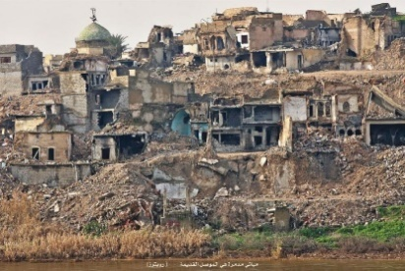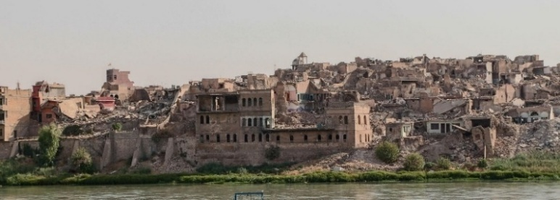

Figure 2. Pictures of the destroyed riverfront of Mosul after the war [23]

So, the available images of the riverfront before the destruction were collected, and the color differences due to different natural lighting conditions, reflections, and other environmental factors were overcome. Since most of the images were fragmented and did not actually and accurately reveal the surfaces and colors of the buildings, the practical study came in six stages as follows:
- First stage: The cropped riverfront images were processed, linked, and redrawn in AutoCAD to obtain the building blocks and surfaces accurately (Table No. 1).
- Second stage: The resolution of the selected digital images is a very important factor in achieving accurate results when determining the color characteristics of the selected elements in MATLAB. Due to the lack of clarity in the color characteristics of the architectural elements in the available images of the riverfront, the most accurate images of the interior façades of a group of old Mosul houses were chosen. The color space was selected, defined, and cropped using Photoshop to obtain two-dimensional samples of the building materials (cement, stone, marble, wood, etc.). These samples were then analyzed using MATLAB to determine their color characteristics (Table No. 2).
- Third stage: The dominant color characteristics extracted in the second stage were applied, and their colors were introduced to the river façade drawn in the first stage using the AutoCAD program (Table No. 3). The riverfront of the Old City of Mosul extends from the Old Iron Bridge to the Fifth Bridge. It is divided into three areas, according to local knowledge, as follows:
- Area (1): Al-Midan, located near the Old Iron Bridge, is the first bridge across the Tigris River in Mosul, connecting the city's right and left banks. It was built in the early 1930s and is considered one of Mosul's oldest and most prominent historical landmarks.
- Area (2): Al-Qala'at, originally an Assyrian military fortress. The ancient Assyrians built castles there to protect Nineveh. It extends along the western bank of the Tigris River and was established in 1080 BC. It later became a residential area and the center of the Old City. It rises approximately 22 meters above the surrounding area on all sides, while its elevation at the center of Al-Qala'at is approximately 47 meters.
- Area (3): It is the area of Sheik Al-Shatt Mosque, considered one of Mosul's historical and ancient mosques. It was built in 563 AH and renovated during the Ottoman era. The mosque is located on the banks of the Tigris River in the Al-Shahwan district in Mosul [22], [23], [24] (Table No. 3).
- Fourth Stage: Since the human visual ability to deal with the built environment depends on their ability to classify the compositional structure of the image within levels based on distance and the viewer's relationship with their distance from the image, the riverfront image was drawn and classified into three levels as follows:
- Detailed level (near): Colors were applied to the architectural elements and their details.
- Intermediate level: Represented by the dominant color of the building images without focusing on individual elements or details.
- Distant level: Represented by the dominant color of the riverfront panorama in relation to the skyline.
- It was determined that the color space for each color composition in the riverfront relative to the color space of the façade as a whole (Table No. 4).
- Fifth Stage: Find the color relationships in the façade by sorting the relationships (harmony and contrast) according to the basic dimensions of color (which were found in the second stage of the analysis) to know the types of color relationships that contributed to achieving the color contrast and harmony of the riverfront (Table No. 5)
- Sixth Stage: Indicate the points of color attraction and polarization in Areas (1,2,3) in the riverfront. (Table No. 6).
  - METHOD ADOPTED IN ANALYZING DIGITAL IMAGES IN THE MATLAB PROGRAM
The human eye has a limited ability to distinguish similar and adjacent colors in terms of hue, value, and color intensity. Hence, we decided to analyze digital images of selected samples using computer techniques to give high-accuracy results. The methodology for analyzing digital images using computers in the MATLAB program is based on the following aspects:
- Using MATLAB: This system is considered, from a scientific point of view, the best computer program for processing digital images, in terms of the ability to deal with a large number of images in a record period of time and automatically, in addition to MATLAB’s handling of the image as a matrix of numbers, which facilitates access to any pixel image unit easily through its coordinates. The programming was done in MATLAB, an interactive language that provides a library of functions designed for specific image processing tasks. Some of these functions were used to design the innovation software system to achieve the study's objective.
- Using RGB (Red, Green, Blue) and HSV (Hue, Saturation, Value) systems in the analysis: These systems are considered, from a scientific point of view, the best color systems used in analyzing digital images by finding the hue, value, and intensity of each pixel in the image in Figure 3.

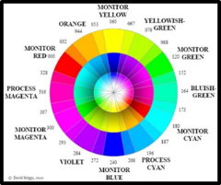  A: HSV color model | 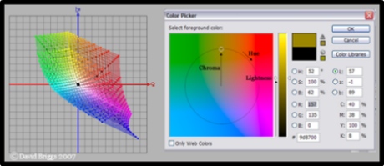  B: RGB color model

Figure 3. Color models used in analysis using computer techniques [25]

  - THE APPLICATION INCLUDED THE PROCESS OF ANALYZING DIGITAL IMAGES OF SELECTED SAMPLES THROUGH THREE STEPS
- Finding the basic dimensions of color through:
- First: Determining the hue for each pixel in the image: The image is scanned pixel by pixel, and the RGB color compounds are found for each pixel. The study will depend on determining the hue of the color on the RGB system arrangement of the color families, which are: red (R), orange (O), yellow (Y), yellow-green (YG), green (G), blue-green (BG), turquoise (C), sky blue (BC), blue (B), violet (V), crimson (M), and red-crimson (MR).
- Second: Determining the value and intensity for each pixel in the image: In this study, the lightness and color intensity values were divided into three levels: low (L) from 1 to 33, medium (M) from 34 to 66, and high (H) from 67 to 100 (Table No. 2)
- Finding the shape of the color space:
The image is displayed in layers based on the number of colors it contains. Each color is considered a layer, known as an image (i.e., each layer is formed from a group of shapes that carry the same color) (Table No. 4).
- Finding color relationships through:
Sorting the relationship (harmony and contrast) according to the basic dimensions of color (which were found in the first step of the analysis) [25] (Table No. 5).

RESULT AND DISCUSSION
The results (Tables 1 and 2) showed the use of two types of colors:
- Chromatic colors are divided into three groups: primary, secondary, and tertiary colors, which result from mixing primary and secondary colors. The river façade used five hues: red, orange, yellow-green, sky blue, and blue.
- Neutral chromatic colors (such as white, black, and gray) that appeared in the materials of brushes and iron. (Table No. 2)
The results also showed that three ranges were employed in analyzing the riverfront façade: low (L), medium (M), and high (H).
In Tables 3 and 4, the results showed a clear concentration on the orange color (O) across the first and second detailed levels, with varying values and intensities, while the use of other hues varied. The yellow-green color of plants ranked second, followed by the sky-blue of the sky and water in roughly equal proportions.
This indicates that the predominant materials on the riverfront are clay and brown bricks. Given the large color space created by this pigment, it, in turn, fosters unity and visual continuity along the riverfront, creating a scene deeply rooted in the viewer's memory. The blue sky and water, along with the brown terrain and dark green plants, also constitute a significant proportion of the riverfront image, contributing to a color theme consisting of a field and a frame. Thus, the color composition of the riverfront is defined by the frame (represented by the sky and water), the field represented by the architectural elements, and the nature that forms the riverfront. The remaining color proportions of the architectural elements ranged from low to medium and were distributed in varying proportions throughout the façade.

Table 1. First stage: Processing the cropped riverfront images in the appendix and linking them together to draw the riverfront lines using AutoCAD
Area (3)  The façade near the Shatt Mosque | Area (2)  Middle façade- Al-Qala'at | Area (1)  The façade near the Iron Bridge |  | River elevation
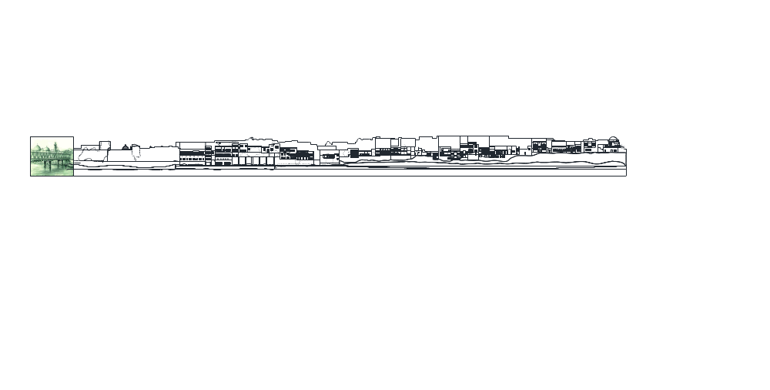 |  |  | Area (1) Area (2) Area (3)

Table 2. The second stage: Extracting the color scheme of local materials for images within the interior façades of old Mosul houses [22] [23][24]
Color qualities of interface elements | The nature of the color characteristics of the riverfront
Color qualities of interface elements | Materials associated with color | Color chart  Color pigment/color intensity/color value | Elements associated with color | Dominant colour | Samples
Color characteristics of architectural elements | Marble | 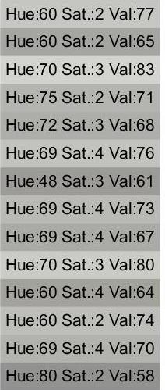 | Gallery |  | 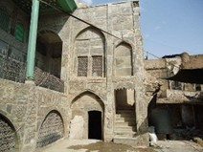
Color characteristics of architectural elements | Marble |  | Ewan  (Window and Door Frames)
Color characteristics of architectural elements | Marble |  | Column
Color characteristics of architectural elements | Marble |  | Wall surface Arc
Color characteristics of architectural elements | Clay  (Ficus) | 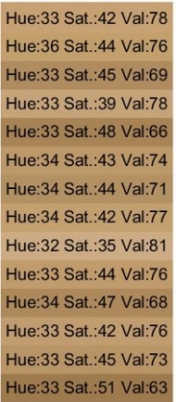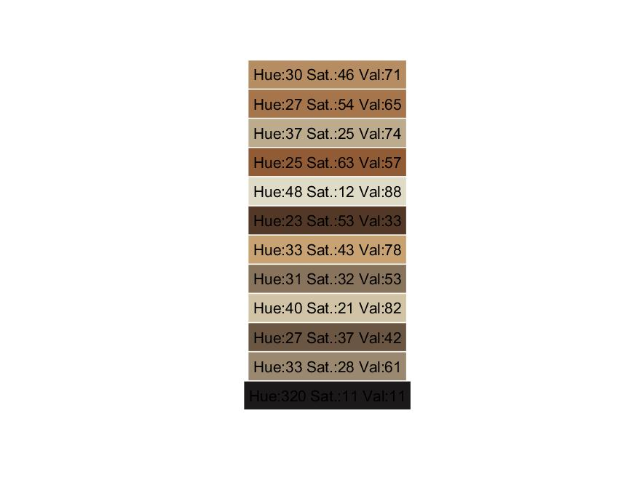 | Continuous solid walls |  | 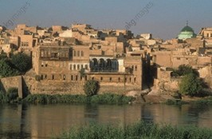
Color characteristics of architectural elements | Wood | 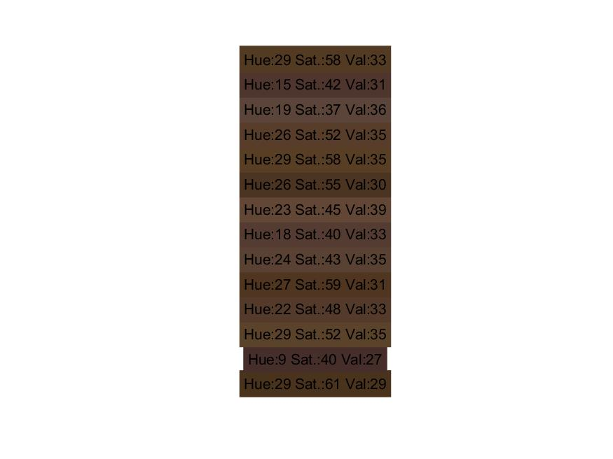 | (Window Frame)  Door  Mushrabia |  | 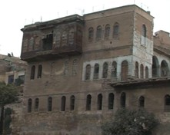
Color characteristics of architectural elements | Iron |  |  |  | 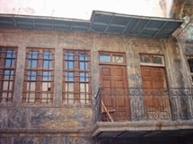
Color characteristics of architectural elements | Iron |  | Screen  (Handrails) Door  Sheds
 |  |  |  |  | 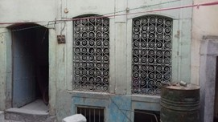
Color characteristics of architectural elements | Glass |  | Windows |  | 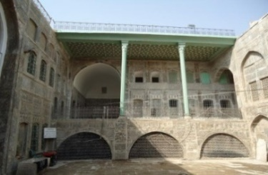
Color characteristics of architectural elements | Stone |  | The lower part of the continuous solid walls |  | 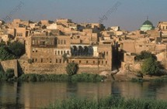
Color characteristics of natural elements | Sky |  | SKY |  | 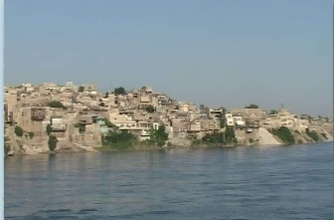
Color characteristics of natural elements | River | 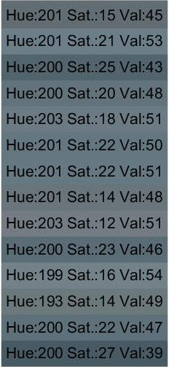 | River | 
Color characteristics of natural elements | Plants |  | Trees and Plants |  | 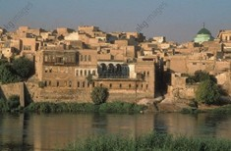
Color characteristics of natural elements | Soil topography | 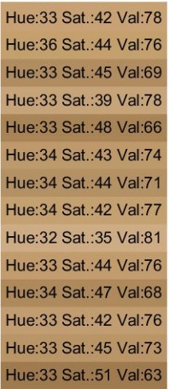 | Soil | 

Table 3. The third stage: Entering the color characteristics extracted from the second stage onto the river façade that was drawn in the first stage using the AutoCAD program.
Area (3)  The façade near the Shatt Mosque | Area (2)  Middle façade - Al-Qala'at | Area (1)  The façade near the Iron Bridge |  | River elevation
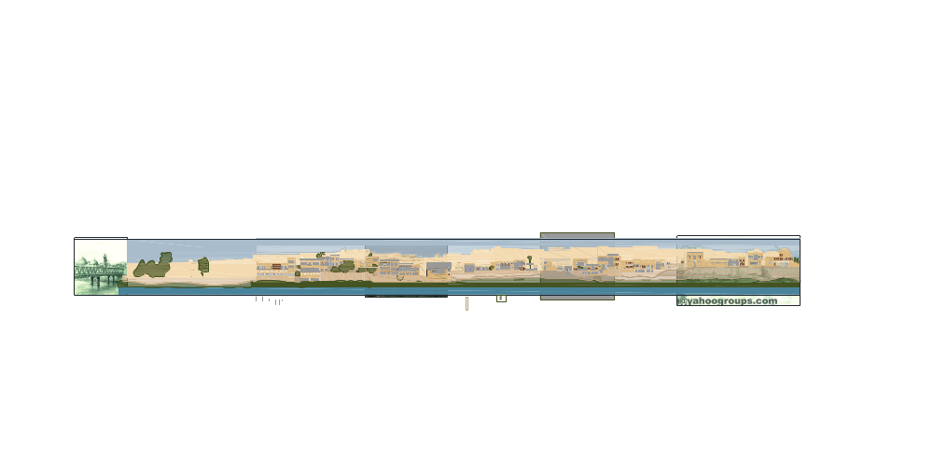 |  |  | Area (1) Area (2) Area (3)

Table 4. Fourth stage: Determining the color space for each color composition in the river façade in relation to the color space of the façade as a whole.
.
Glass   |  |  | Protection   |  | Window frames   |  | Frame  work |  | Window   |  | Walls  Detailed level |  | Walls  Intermediate level |  | SKY  Distant level |  |  | Natural and Architectural Elements
1.6 |  |  | 1 |  | .7 |  | .14 |  | 2.7 |  | 18.7 |  | 18 |  | 12 |  |  | Percentage  of color space
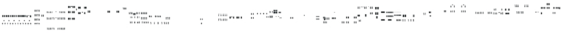 |  |  |  |  |  |  |  |  |  |  |  |  |  |  |  |  |  | Levels of color composition of the riverfront
River |  | Plants |  | Topographical |  | stone |  | Dark area |  | door   |  | Mushrabia |  | handrails  |  | Column   | Natural and Architectural Elements
12.4 | 15.2 |  | 5.7 |  | 8.62 |  | .15 |  | .35 |  | .17 |  | .59 |  | .6 |  |  | Percentage of color  space
 |  |  |  |  |  |  |  |  |  |  |  |  |  |  |  |  |  | Levels of color composition of the riverfront

Table 5. The fifth stage: identifying the color relationships (contrast and harmony) achieved in the river façade.
Harmony in Value  (Low -Low) for Multicolors | Harmony in Saturation  (Low -(Low) for Multicolors | Contrast in Value  (Low-High) for Multicolors
Harmony in Value  (Medium-Medium) for  Multicolors | Harmony in Saturation  (Medium-Medium) for Multicolors | Contrast in Cold-Warm  Colors
Color Harmony in Value  (High-High) for Multicolors | Harmony in Saturation  (Low-Medium) for Multicolors | Contrast in Complementary  Colors
Harmony in Value  (Low-Medium) for Multicolors | Harmony in Saturation  (Low -Low) for One Color | Contrast in  Color (Chromatic–Achromatic)
Harmony in Value  (Medium-High) for Multicolors | Harmony in Hue
Harmony in Value  (High- Medium) for One Color | Harmony  in Hue

The results in Table 5 showed the use of:
- Color harmony relationship between one color and another in the chromatic or achromatic family, which is generated as a result of the proximity in:
- Light value or intensity of a single color family
- Light value or intensity of color between several color families.
- Harmony in hue is generated by two or three colors that differ in hue and are adjacent on the color wheel.
- The Color contrast relationship in light value.
- The complementary contrast (we can perceive it between every two opposite colors on both sides of the color wheel, which together form a complete color scheme).
- The contrast in warm and cold colors (the colors of the visible spectrum between red and yellow are called warm colors, while cold colors are located between the range of blue and green).
- The contrast between chromatic and achromatic colors arises when they come together.
The use of several types of contrast and color harmony gave richness to the riverfront. It contributed to maintaining the unity and continuity of vision over long and short distances. The presence of color contrast in the surfaces and building blocks enhanced the clarity of the architectural elements. In contrast, the color harmony between the elements achieved unity and visual continuity along the riverfront.

Table 6. Sixth stage: The points of attraction and color polarization will be indicated in areas (1, 2, 3) on the riverfront.
Highest color point
Elements | Color attraction points | Key
 | dark spots
 | deep shadow spots
Minarets, Domes, Trees | vertical elements in the interface
 | large blocks and areas of color
 | The highest color point in the sky
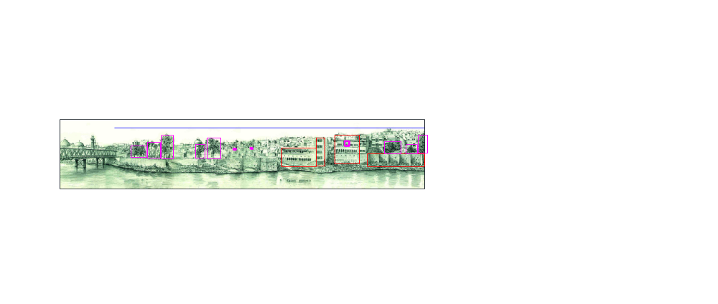
Highest color point in the sky
Highest color point

Area 1
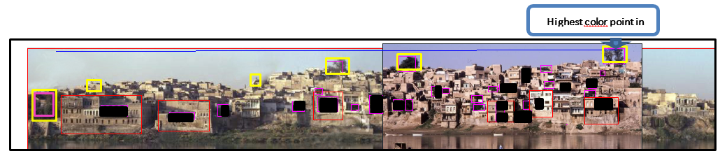
Highest color point

Area 2
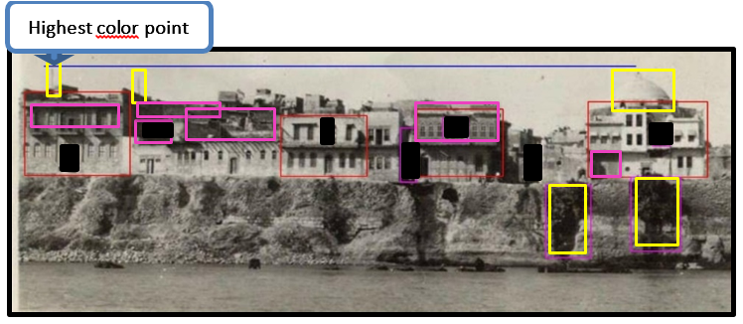
Area 3

The results in Table 6 showed the presence of points of attraction and color polarization within the riverfront, distributed across the three areas (1, 2, 3) in varying degrees. The dark-colored spots, represented by the trees' color, were clear in region 1, while the deep shadow spots were concentrated in region 2. As for the vertical color elements that penetrate the blue sky line, they were distributed differently across the three regions, and the most important of these elements are the trees, domes, and minarets, while the large color spaces and blocks appeared clearly in regions 1 and 3.
The presence of various points of interest played a significant role in shaping the prevailing mental image among most Mosul residents. Vertical features such as minarets, domes, and trees interrupted the blue sky and drew the broken line of the riverfront. The shaded areas of the courtyards, arcades, and balconies created a three-dimensional, blocky overlap through shadow and light. In addition, there were densely shaded points of interest, formed by alleys surrounded by buildings, concentrated in the central area. The presence of large, colorful spaces distributed throughout the riverfront played a significant role in achieving the façade's dominance and visual balance.

CONCLUSION
The results obtained from the analysis of the selected samples of the river façade of the old city of Mosul showed that there is a color scheme that represents the basis on which the color formation of the façade was relied upon, and gave a clear picture of the definition of the prevailing color characteristics in the architecture of old Mosul, which can be used in future projects for the same area. The most important conclusions drawn from this color scheme are as follows:
- Color is one of the elements that help distinguish architectural blocks and surfaces, lending each its unique character. Color serves as a formative element that determines the arrangement of surfaces on the riverfront. The variety of lighting values and color intensities used also contributes to the formation of dark and light areas, creating a complex scene through the overlay of wall blocks at different levels.
- Despite the diversity of hues used (5 hues with different values and intensities), they were unified through the use of the color harmony relationship (generated as a result of the proximity in light value or intensity in one color family or between several color families or harmony in dye through the use of two adjacent colors in the color wheel).
- The achievement of the relationship of color contrast with light value, integrated contrast, contrast with warm and cold colors, contrast with chromatic and achromatic colors is due to the color composition of the river façade as a whole, represented by the presence of the sky, building blocks, plants, and the river, as the presence of color contrast enhanced the clarity of the difference between the colors of these components, which sought to create a beautiful scene that the eye can read.
- The use of the orange color (O) with different light values and intensities for each of the clay material, the clay bricks, and the color of the topography of the land, at the first and second detailed levels, contributed to achieving a relationship of color harmony with the hue due to the large color space formed by this dye, which in turn gave unity and visual continuity along the riverfront, and formed a scene rooted in the viewer’s memory.
- Using the two relationships of harmony and contrast together contributed to maintaining unity and continuity of vision at long and short distances, which requires a series of recurring elements ranging in size from large to small and with different color qualities.
- The presence of the orange color (O) in the continuous and topographical walls plays a major role in achieving an integrated color contrast with the sky blue (BC) of the sky and water, thereby enhancing the clarity of the architectural elements represented by the blocks with wide spaces.
- The use of neutral achromatic colors in the shutters, window protectors, iron doors, and furniture provided a balance, so they were not used as points of attraction that detracted from the façade's overall view. While the presence of red (R) with a low value and medium intensity in the Mashrabiya contributed to them being points of attraction on the river façade, they were concentrated in areas 1, near the bridge, and area 2 in the middle. It was also evident that there were dark-color attraction areas, represented by the yellow-green color of the trees (YG), with low values, distributed harmoniously across the three façade areas. Still, they were concentrated near the iron bridge in area (1), as it is an open area that was previously a recreational area.

- One of the attractions of the riverfront is the deep, shaded areas with their achromatic color (low value), which were concentrated in the middle zone 2 of the riverfront more than in the rest of the areas, where the peak was in accumulation, mass overlap, and building density. Parts of the inner courtyards of the Mosul houses were exposed. The courtyards, arcades, and deep roofed balconies provided clear shaded spots, in addition to the shaded areas created by the alleys, which were densely lined with buildings.
- The most important vertical elements that clearly cut the blue sky line in the river front are the trees with their yellow-green color (YG) of low value in region 1 and region 2, as well as the domes with their orange color (O) of high value and medium intensity as in the dome of the Shatt Mosque in region 3 and the domes and minarets near the old iron bridge in region 1. They were the highest vertical color attraction points that cut through the azure blue sky line (BC).
- There are large blocks and color spaces that represent points of attraction along the riverfront, including continuous surfaces at the second-floor level or prominent blocks at the second-floor level. These large blocks and surfaces appear in their orange color (O) with high value and medium intensity, among the small block details that characterize the riverfront and are clear in areas 1 and 3, due to the low density of blocks and details.
- The research reached convergence in the percentages forming the color space of sky blue (BC) for both the sky and water within the image of the river façade, which contributed to a color theme consisting of a field and a frame. Thus, the color composition of the river façade was determined by a frame (represented by the sky and water), and the field, represented by the architectural elements and nature forming the façade, which, in turn, formed the prevailing mental image among most residents of Mosul. While the rest of the color percentages of the architectural elements ranged from the highest percentages of the building blocks in orange (O) with high value and medium intensity to the lowest percentages represented by the glass spaces in blue (B) with low value and medium intensity, since Mosul architecture is part of Islamic architecture, which is characterized by closure from the outside and openness towards the inside, so the dominance was for the solid walls whose color is largely related to the nature of the materials and climatic factors. Based on the above, the research recommends adopting the river façade in future projects to be implemented along the banks of the Tigris River in the city of Mosul, and developing a mechanism to achieve a balance and visual continuity with modern materials.
- Techniques used in construction differ from the local materials adopted in old Mosul and from the new color formations, so as not to affect the overall view of the river façade.

AUTHORS CONTRIBUTION
All authors discussed the results and contributed to the final manuscript.

ACKNOWLEDGEMENT
We would like to thank Assistant Professor Maha Hasso for helping us write the program to analyze the selected samples

RECOMMENDATIONS
The process of comparing the riverfront of the city of Mosul with those of other Islamic river cities is a very good proposal that can be pursued in future research.

REFERENCES

[1] A. S. Yawer, A. F. Bakr, and A. A. Fathi, “Sustainable urban development of historical cities: Historical Mosul City, Iraq,” Alexandria Eng. J., vol. 67, pp. 257–270, 2023, doi: 10.1016/j.aej.2022.12.042.
[2] A. A. Thannon, “Popular Architecture of the Old City of Mosul the Architecture of the Traditional House,” Icanas, vol. 38, no. October, pp. 1341–1356, 2007.
[3] A. Jain, “Psychology of Colours in Building Design,” Int. J. Eng. Sci. Comput., vol. 7, no. 4, pp. 10394–10396, 2017.

[4] G. Minah, “Colour as Idea: The Conceptual Basis for Using Colour in Architecture and Urban Design,” Colour Des. Creat., vol. 3, no. 2, pp. 1–9, 2008. https://www.aic-publishing.org/ojs/index.php/JAIC/article/view/45/40
[5] A. Premier and K. Gasparini, “Sustainable colour design in architecture: materials, technologies and products,” J. Int. Colour Assoc., vol. 19, pp. 34–46, 2017.
[6] A. Chęć-Małyszek, “The concept of light and color as a key element of experiencing ‘feeling architecture,’” Bud. i Archit., vol. 18, no. 1, pp. 011–021, 2019, doi: 10.24358/bud-arch_19_181_02.
[7] S. J. Liang, "COLOR DESIGN FOR CITY IMAGE : A Case of Wanxia Urban Village in Shenzhen". Master Thesis, Aalborg University, 2020.
[8] L. Jevremovic, B. Turnsek, A. Stanojevic, M. Jordanovic, and M. Vasic, “Use of color in architecture - industrial architecture perspective,” Facta Univ. - Ser. Archit. Civ. Eng., vol. 18, no. 1, pp. 49–63, 2020, doi: 10.2298/fuace191016004j.
[9] J. Zhang, T. Fukuda, and N. Yabuki, “Development of a city-scale approach for façade color measurement with building functional classification using deep learning and street view images,” ISPRS Int. J. Geo-Information, vol. 10, no. 8, 2021, doi: 10.3390/ijgi10080551.
[10] O. Coonor, “Digital Color Mapping, In Colour For Architecture Today,” in Colour For Architecture Today, B. Porterard, Tom, Mikellides, Ed., NewYork: Taylor &Frarcis, 2009.
[11] N. Al-Hankawi, W. Shukr, A. Mueen, “Color harmony in urban environments,” Iraqi J. Archit., vol. 10, no. 22, pp. 1-24, 2011.
[12] H. Niaz, “The impact of using building materials in shaping architectural identity,” Sulaimani J. Eng. Sci., vol. 6, no. 3, pp. 28–37, 2019.
[13] J. P. Lanclose, “The Geography of Colour,” in Colour For Architecture Today, B. M. Tom Porterard, Ed., NewYork: Taylor, Francis, 2009.
[14] Q. M. Mohamed, M. M. A. Hamid, “The impact of the development of building materials on the design of the outer envelope and façades of buildings,” J. Al Azhar Univ. Eng. Sect., vol. 12, no. 42, pp. 791–807, 2017.
[15] V. Umani, “Colors in Architecture : Matter and Communication Tool". XVII Color Conference, Florence, 2022.
[16] J. L. Caivano, “Research on color in architecture and environmental design: Brief history, current developments, and possible future,” Color Res. Appl., vol. 31, no. 4, pp. 350–363, 2006, doi: 10.1002/col.20224.
[17] A. Jaglarz, “Perception of Color in Architecture and Urban Space,” Buildings, vol. 13, no. 8, 2023, doi: 10.3390/buildings13082000.
[18] M. N. Gorzaldini, “The Effects of Colors on the Quality of Urban Appearance,” Mediterr. J. Soc. Sci., vol. 7, no. 5, pp. 225–231, 2016, doi: 10.5901/mjss.2016.v7n5p225.
[19] O. A. Sabah, A. W. Jalal, “Colour Usage Regulations For The Cityscape Of Old Mosul City/Iraq", 4th International Conference on Rebuilding Place, pp. 1–11, 2019. doi: https://doi.org/10.15405/epms.2019.12.68.
[20] D. E. H. Ismaeel, “Synthetic CharacteristicsOf Traditional Historic Houses Entrances In Old City Of Mosul,” AL-Rafdain Eng. J., vol. 22, no. 3, pp. 63–83, 2014, doi: 10.33899/rengj.2014.88205.
[21] D. Yousef, M. Ahmed, Residential Buildings in Mosul. Mosul: General Directorate of Antiquities, Heritage Authority, 1982.
[22] B. Iverson, " Nineveh, Iraq - A pastoral view of old houses at Nineveh on the banks of the Tigris not far from Nimrud, near Mosul", Alamy.com. Accessed: May 30, 2025. [Online.] Available: https://www.alamy.com/stock-photo/mosul-iraq-river.html?sortBy=relevant.
[23] DeAgostini, “Iraq - Mosul, a city 'on the banks of the Tigris River.” Alamy.com. Accessed: May 30, 2025. [Online.] Available: https://www.alamy.com/stock-photo-iraq-mosul-a-city-on-the-banks-of-the-tigris-river-48080630.html
[24] L. McCarron, “The Tigris: The river that birthed civilisation.” BBC.com. Accessed: May 30, 2025. [Online.] Available: https://www.bbc.com/travel/article/20230731-the-tigris-the-river-that-birthed-civilisation
[25] D. J.C. Briggs, “Modern Colour Theory for Traditional and Digital Painting Media". The Dimension of Color. Accessed: May 30, 2025. [Online.] Available: http://www.huevaluechroma.com/.

