 |  | JOURNAL OF ISLAMIC ARCHITECTURE  P-ISSN: 2086-2636 E-ISSN: 2356-4644  Journal Home Page: http://ejournal.uin-malang.ac.id/index.php/JIA
REHABILITATION OF DOMED MOSQUES FROM THE OTTOMAN PERIOD IN BOSNIA AND HERZEGOVINA: THE CASE OF FERHAD PASHA MOSQUE
Ida Hodzic Adrovic^{1*}
¹Faculty of Architecture, University of Montenegro, Montenegro
*Corresponding Author: ida.hodzic.adrovic@gmail.com
ARTICLE INFO |  |  | ABSTRACT
Volume: 9  Issue: 1  Page: 353-369  Received: October 10th, 2025  Accepted: December 2nd, 2025  Available Online: June 30th, 2026  DOI: https://doi.org/10.18860/jia.v9i1.34176 |  |  | The paper explores the role, significance, and validity of the post-war rehabilitation of Ottoman-era coupon mosques in Bosnia and Herzegovina, focusing on the case of the Ferhad Pasha Mosque in Banja Luka. After the end of the war, various forms of reconstruction were undertaken, and the most common method was complete (facsimile) reconstruction, known as post-war rehabilitation of architectural heritage. These rehabilitation projects, across various public and religious buildings, include the renovation of mosques as an integral part of the refugee return project and the promotion of coexistence and reconciliation among different communities in BiH. Special attention from the profession and the public has been placed on the rehabilitation of domed mosques from the Ottoman period, as objects that have already been recognized and declared national monuments. During the research, the question arises: Does rehabilitation affect the authenticity of architectural heritage? What does the post-war rehabilitation of architectural heritage actually mean, and what methods of protection does it entail?  The case of Ferhad Pasha Mosque also serves as a critical review, as it analyses one of the most significant post-war rehabilitation projects in Bosnia and Herzegovina. The review of the works is intended to determine the correctness of the procedures within the project, which contributes to several current topics in the field of active protection methods. Revision of this project, i.e., determining the correctness of the procedures within the rehabilitation project, should, in a theoretical and practical sense, present various methods applied both to the entire building and to individual elements. Therefore, a detailed, chronological overview of the rehabilitation project, with an emphasis on specific elements, aims to inform both the profession and the general public about the interventions carried out and their validity. The need arose to establish the basic steps of a post-war strategy for the rehabilitation of architectural heritage, created on the basis of international declarations, charters, recommendations, and research. There was also a need to emphasize the view of authenticity in cases where architectural heritage was violently destroyed and where we can only apply protection measures to its fragments.  Keywords:  Ferhad Pasha Mosque; Dome Mosques; Ottoman Architecture; Degradation of Heritage; Post-war Rehabilitation; Bosnia and Herzegovina

INTRODUCTION
During the war conflicts (1992-1995), 10 out of 34 domed mosques were mined and demolished to the ground, while the rest were recorded with different levels of damage. This paper examines the post-war rehabilitation of Ottoman-era domed mosques in Bosnia and Herzegovina, focusing on the case of Ferhad Pasha's Mosque in Banja Luka. This mosque was built in 1579, mined and demolished in 1993, and renovated and inaugurated in 2016. The rehabilitation of this extremely valuable national monument of BiH is of great importance, first of all, for the local community and the city of Banja Luka, but also for the entire country [1]. At the same time, it is necessary to investigate rehabilitation and applied protection methods for the restoration of completely devastated architectural heritage, while taking authenticity into account. Rehabilitation, as a term, is used as a synonym for post-war reconstruction of architectural heritage, and denotes a return to the state before the degradation and demolition caused by war destruction. The priority of rehabilitation must be the restoration and preservation of tangible and intangible heritage values. Before we begin a renewal project, we must clearly define its purpose, the reasons, and the expected outcomes. This includes a description of the planned interventions, the adopted methods, and the methodology of protection. We find the connection and application of the above concepts through an overview of the rehabilitation project of the Ferhadija Mosque in Banja Luka. The first step in doing this is a literature review. The significance of reviewing previous research was particularly important in developing the rehabilitation project for this violently demolished architectural heritage. This is necessary to make proposals for renewal that not only include conservation and restoration works but also the complete reconstruction of missing elements. The research includes three groups: the period before the war (Table 1), and the periods during and after the war (Table 2). The period that includes pre-war research primarily provides us with information about the original appearance, materials, and construction techniques of the building, but also gives us insight into previously applied conservation and restoration work, warning us of scenarios that may occur in the future. For instance, the Ferhadija Mosque rehabilitation project and papers describing the conservation and restoration works carried out in the 1950s were of great importance [2], [3].

Table 1. Research Background - pre-war
Research  Reference | Year of  publication | Results
[4] | 1953 | In the introduction, already in 1953, the author appeals to his colleagues and experts to pay attention to the monuments of Ottoman architecture, both to their history and to their structural and aesthetic analysis, because he noticed that they were beginning to change in structure and were disappearing. The paper provides a general overview of the monuments, emphasizing dome mosques as the most significant architectural heritage of Ottoman architecture in Bosnia and Herzegovina.
[2] | 1953 | Conservation and restoration work on the mosque's exterior after World War II is described. The work is accompanied by photographs and descriptions of damage and interventions in progress. Surface damage to the walls caused by the explosions has been mostly repaired. Roof coverings were also replaced.
[3] | 1960 | It provides an overview of conservation and restoration work on the capitals of the entrance pillars. In addition, the damage and conservation work on the accompanying buildings are described: three mausoleums located in the courtyard of the mosque.
[5] | 1967 | The first classification of Ottoman architectural objects based on construction style in the territory of Yugoslavia was presented by Husref Redžić in this work. Architecture holds the most important place in this art, and its main characteristics are reflected most clearly in monumental domed buildings, whether sacral or public.
[6], [7], [8] | 1974, 1977, 1982 | In a work published in three volumes, the author very successfully documents and presents the most significant inscriptions on buildings of sacral and profane architecture from the Ottoman period on the territory of Yugoslavia (Croatia, Montenegro, Serbia, Slovenia, Bosnia and Herzegovina, and Macedonia). In addition to translations and transcriptions of the inscriptions, the author also provides photographs, notes, and reviews of earlier works and publications, from which we gain insight into the exact year of construction and/or renovation of the buildings, information about the founders, and certain events.
[9] | 1981 | The book presents invaluable field data, including a brief history, descriptions of the technical and architectural character, and drawings and photographs of individual buildings, including mosques. The work has never been translated into the languages of the Yugoslav peoples, which is its only drawback.
[10] | 1982 | Redžić's second work, also titled "Islamska umjetnost", addresses the same topic as the previous book. The book's content is extensive, presented in eight chapters, and enriched with color photographs. The fourth and fifth chapters deal with architectural styles and more significant monuments – domed mosques. The main features of the different Ottoman styles found in buildings throughout Bosnia and Herzegovina are presented through examples.
[11] | 1983 | The book contains the author's papers published between 1960 and 1982. Of particular importance is the data on the conservation effort carried out on the Aladža Mosque in Foča. The work lists and describes the restoration of the dome and the construction of a reinforced concrete ring, followed by the work of covering the building and removing the plaster applied to the finely finished stone walls in the earlier period. Restoration and conservation works were also presented for the Hajji Ahmet Dukatar mosque in Livno, whose dome collapsed in 1957. For restoration, the damaged parts of the tambour and trompe were rebuilt, after which a reinforced concrete dome was built.
[12] | 1984/2017 | The time and events that followed between the two editions of this book will confirm the importance and role of this type of work, which is rightly given the epithet of pioneering significance. Andrejević, in addition to providing general characteristics, i.e., explaining the historical and artistic circumstances in one chapter, also presents the architecture of selected monuments, where he singles out the Ferhadija Mosque in Banja Luka among others. The result of the work is the establishment of four main types of domed mosques built on the territory of Yugoslavia during the Ottoman period: standard type, two-aisled porch mosques, multi-space mosques, and mosques whose domes rest on hexagonal or octagonal bases. Special attention is paid to materials and construction, as well as decorative plastic.

The 1990s, due to the political situation and war in the former Yugoslavia, were not a suitable time for research and writing on Islamic monumental architecture. This period represents the darkest period for Islamic architectural objects because it was actually a period of their systematic demolition. After the war, research and writing on reconstruction followed, and this continues to this day. The most significant post-war work is the book by Professor Hamidović, the head of the Ferhadija Mosque rehabilitation project, which provides an overview of the entire project 13].

Table 2. Research Background - postwar
Research  Reference | Year of  publication | Results
[14] | 2001 | The Center for Design and Research at the Faculty of Architecture in Sarajevo is bringing together a team of experts, led by Prof. Hamidović, to develop a project for the renovation of the Ferhadija Mosque in Banja Luka. As a result of the research, this scientific research project has been published. The research contained a series of answers to the challenges they encountered, concerning construction modules, materials, and construction techniques, detailing, painting, etc. This study, as it turned out, did not provide answers to all the questions that arose later during the implementation of the rehabilitation project. Still, it represented a good foundation to start with.
[15] | 2005 | The book first presents the development of Banja Luka during Ottoman rule, then the construction and development of Islamic sacral architecture with a special emphasis on mosques with stone minarets and domed mosques (Ferhadija and Arnaudija mosques). Special attention is paid to highlighting the characteristics of domed mosques, their construction techniques, and the materials used. Further, historical events and circumstances that led to the destruction of architectural heritage are described. Then, the principles and possibilities of restoring demolished buildings are presented, which the author classifies into four groups, taking into account the degree of damage, the condition before and after the demolition, the (non)existence of technical documentation and other important documents, etc.
[16] | 2013 | A very professional and picturesque presentation of the restoration process of five mosques: in Mostar (Karađozbeg Mosque, Nezirag Mosque, and Sevri Hadži Hasan Mosque), Počitelj (Hadži-Alija Mosque), and Foča (Aladža Mosque). In addition to valuable field photographs and architectural drawings, the authors sought to present the most significant and interesting challenges that arose during the restoration and/or reconstruction of certain parts of the building.
[13] | 2023 | The author, in addition to an overview of the most significant works, provides a subjective view of the significance of this post-war reconstruction, accompanied by photographs from the field. He goes into detail about the symbolism and meaning of the mosque as well as its specific elements. Ultimately, the work clarifies both the physical and metaphysical values of the Ferhadija Mosque.

Unfortunately, we cannot find a single scientific paper on this topic published in highly ranked journals. This is an additional reason for writing this paper: to promote and affirm these unjustifiably neglected buildings and to emphasize the importance of their post-war rehabilitation.

METHODS
This research aims to investigate the significance and validity of the post-war rehabilitation project of Ottoman-era domed mosques in Bosnia and Herzegovina, using the example of the Ferhadija Mosque in Banja Luka. This means that, when analyzing the rehabilitation project, authenticity, as defined by the International Convention on the Protection of Architectural Heritage, must also be considered.
The research methodology, given the complexity and importance of the different data, consists of data collection and analysis. Both of the above are crucial for research, given the topic and the conditions in which architectural heritage is found. Given that this is a destroyed heritage, the remains of which had to be first located and then identified and selected according to their place of origin, the starting point was the collection of data from public and private archives, as well as a review of literature, scientific papers, projects, and other documents.

2.1 DATA COLLECTION
2.1.1 Archival Research: Literature and Documentation Review
This research includes a search for textual data and reports describing the treated architectural heritage, old sketches, photographs, and earlier conservation-restoration projects found in various literature (books, reports, projects, papers, etc.). At the same time, through literature (international and regional charters and declarations, scientific articles, etc.), the concept of authenticity and its significance for projects to rehabilitate destroyed heritage were explored.
2.1.2 In Situ Research
Collect photos of found fragments, 3D scans, and DWG drawings of fragments taken after their cleaning, sorting, and marking for their reinstallation. This was made possible by the author's visit to the site during the rehabilitation project and by reviewing the complete documentation and creating a photo archive as a member of the construction team.
2.1.3 Rehabilitation Project Review
As part of the contractor's team, the author had access to information on action plans and used methods of protection, new discoveries, and changes, which were presented first at meetings and symposia as part of the project development, providing insight into dilemmas, problems, and, ultimately, possibilities and adopted solutions. Also, a publicly available study on the principles and methodological process of restoring the Ferhadija Mosque provided researchers and the public with insight into the challenges and proposed solutions [14].
2.1.4 Data Collection During Construction
The reconstruction, conservation, and restoration of the found stone fragments, carried out at the stone processing factory, were documented by the author with photographs. The reconstruction, conservation, and restoration of the stone fragments found at the stone processing factory were documented by the author in photographs. This photo archive is particularly important because it documents the methods for processing stone fragments and their installation.
2.2 DATA ANALYSIS
All collected data were analyzed through descriptive-analytical techniques. The found stone fragments were analyzed to determine their material, processing method, and reinstallation possibility and method. This approach allowed us to analyze the original state through historical data, preserved photo documentation, and technical and project documentation. Interventions on the object, from its creation to its demolition, were also analyzed. Afterward, we have observations to analyze the steps and solutions offered in the rehabilitation project, as well as the work that was ultimately carried out. All of the above gave us an insight into the authenticity of the objects and steps within the rehabilitation project.

RESULT AND DISCUSSION

3.1 RESULT
This paper aims to highlight the key findings regarding the term post-war rehabilitation and its role in preserving authenticity. Drawing on the case of the Ferhadija mosque and its rehabilitation project, this paper examines the methods of protection, the application of new knowledge, and the problems that arise in the process.

3.1.1 The Post-War Rehabilitation Strategy for the Architectural Heritage
The term rehabilitation is not defined in UNESCO or ICOMOS documents, although it is often mentioned. For the Commission to Preserve National Monuments of BiH, rehabilitation implies interventions that restore destroyed architectural heritage to its original condition [17]. Post-war rehabilitation means rebuilding a demolished national monument in the same place, using the same or substitute materials and the same construction techniques. All of the above is conditional on having knowledge, documents, and information about the original dimensions, shapes, materials, techniques, and details [18]. In other words, post-war rehabilitation actually means total reconstruction. Then the question arises: is it justified, and, since it is not a method, which methods does it imply? Rehabilitation, as a term, is used as a synonym for post-war reconstruction of architectural heritage and denotes a return to the state before the degradation and demolition caused by war. We see rehabilitation as a comprehensive process of renewal when it comes to protection methods. It includes conservation, restoration, reconstruction, as well as often anastylosis. The priority of rehabilitation must be the restoration and preservation of tangible and intangible heritage values. Before we begin a renewal project, we must clearly define its purpose, the reasons, and the expected outcomes. This includes a description of the planned interventions, the adopted methods, and the methodology of protection. Although seen as a sensitive term, rehabilitation restores historic areas, ultimately enabling the community to achieve social and economic normalization after the war, thus providing a special sense of place [19]. When it comes to intentionally and violently destroyed heritage, its reconstruction is justified and even desirable under one condition: the existence of documentation that testifies to its former appearance [20], [21].
Unfortunately, due to different political and economic circumstances in Bosnia and Herzegovina, not all rehabilitation projects gave the best results. In the hope that such a practice will not be repeated, it is necessary to highlight the most significant steps taken during the post-conflict rehabilitation process. The most significant steps are shown in Figure 1. The first step of this strategy is to confirm the importance of architectural heritage. This step involves research and the preparation of a report on the treated heritage if it does not already exist. Each object recognized and valued as architectural heritage should have a detailed report prepared by the institutions responsible for protecting cultural heritage at different state levels. In Bosnia and Herzegovina, the Commission for the Preservation of National Monuments (KONS) plays a leading role in preserving the country's architectural heritage. It is the one that submits initiatives, contracts, negotiates, and arranges cooperation for the purpose of protecting monuments at the state level [22]. The Commission has defined rules for evaluating and classifying heritage[23]. Therefore, experts from various fields should be involved in preparing the study: historians, ethnologists, journalists, architects, builders, restorers, photographers, and local residents. Written documents, plans, sketches, reports, and photographs are collected.
Oral traditions related to the property are also recorded. Its role and importance in the environment and the community are analyzed. The next step is to determine the significance of rehabilitation itself. The challenges and the justification for such a project are analyzed. It is clear that after armed conflicts, many sacred and profane architectural objects will be restored. However, only objects of exceptional value will be given the chance to regain their original form. The quantity and scope of the works, the possibility of their implementation, and the approach and method of execution are just some of the steps that need to be defined with arguments and, at the same time, justified to both the profession and public opinion. The religious and local communities are unable to fund the restoration of buildings of architectural heritage because the costs are very high. Therefore, it is necessary to prepare a financing and repayment plan for the project. The main sponsors of the project are most often world organizations for the protection and promotion of heritage, friendly countries, state authorities, non-governmental organizations, etc. Also, the local population and the diaspora are always involved in individual contributions. All accounts and funds received must be recorded and publicly disclosed to make their investments transparent and justified. Transparency of all previous and subsequent steps should be a legal and moral obligation of both the initiator and the project holder [21].
The public must be informed about every detail and should have the opportunity to actively participate in public discussions, research, and documentation. It is very important to document the entire decision-making process regarding the rehabilitation project to leave a written record for future generations about the process itself, which options were considered, which were rejected, and which were adopted, along with the arguments supporting each. All work during the implementation of the project must be carried out in accordance within accordance with the previously adopted project. Possible changes to the project or on-site must be argued and approved in advance. Also, it is necessary to keep detailed notes on the method and progress of work. All documentation produced should be appropriately archived and made publicly available. Monitoring and further promotion are the final, ultimately important steps.
As part of this step, a feasibility study is conducted, first assessing the project's physical feasibility and then its financial and economic feasibility. The rehabilitation project must include sustainable, long-term solutions that address not only the renovated facility but also the local community. One way is to encourage the local economy through the tourism industry, which will use history, culture, tradition, religion, etc., to this end. The key to the success of a post-war rehabilitation project is the rehabilitation of both the property and the community. Research on the restored architectural heritage will continue. We can expect, after the completion of the renovation, many scientific research works on the topic of preserved and/or lost attributes that, in the past, ensured the property's value. There is also an opportunity to create new attributes during and after the rehabilitation process.

3.1.2 Ensuring Authenticity by Applying Different Protection Methods
When it comes to destroyed architectural heritage, we have few options for protection. After it has been decided, based on well-founded and valid arguments, to proceed with the post-war rehabilitation of the heritage, the only possible method is reconstruction. Depending on the amount of preserved original material, we can also consider anastylosis. Anastylosis, in such specific cases, cannot be the only method, because it actually refers to individual, more and/or less preserved fragments of the object. Therefore, in this paper, we discuss the protection methods applied to the found fragments.
Architectural heritage, especially that which has the title of national monument, must at a given moment satisfy the conditions of authenticity and integrity. Integrity refers to the wholeness and intactness of the heritage, while authenticity requires the original, authentic, and true expression of the value of that heritage, whether in tangible or intangible form. From the above, it can be concluded that integrity refers to physical values, while authenticity refers to both physical and metaphysical values.
When it comes to heritage, we can already see the term 'authentic' in the International Charter for the Conservation and Restoration of Monuments and Sites – the Venice Charter from 1964. Although the Venice Charter does not provide a clear definition of authenticity, it emphasizes in its preamble that it is the duty of present generations to preserve historical monuments for future generations "...in the full richness of their authenticity..." [24]. For Jokilehto, Authenticity is a measure of truthfulness in the process of creating a work, as well as in processes that unfold over time, which guarantees the specificity and unrepeatability of heritage [25]. The Jokileht's passage of time is reflected in the layering of styles [26], a point also emphasized in the Venice Charter, which expects restoration to explore and respect them. The concept of authenticity and the term historical stratification are contained in the first set of criteria for the evaluation of World Heritage, i.e., in the Operational Guidelines from 1977, according to which the heritage should satisfy the test of authenticity in design, material, workmanship, and display, taking into account all changes that have occurred over time [27]. This concept of authenticity could ensure that only heritage characterized by material testimony of significant historical periods and events would be inscribed on the World Heritage List, while at the same time preventing the inscription of properties that had been completely reconstructed [28]. The parent had the first objections to this interpretation of authenticity, as he believes it should be viewed in light of the property's history and culture. Therefore, authenticity can and must be interpreted differently, taking into account both material and non-material characteristics. Speaking of physical/material/tangible characteristics, the material's nature, processing, and method of use play a significant role [29]. Lowenthal distinguishes three types of authenticity. The first authenticity is linked to the original form and material, the second to the context, while the third is linked to the heritage's function. It is important to emphasize that choosing one type does not mean excluding the other two, but the order of priorities is definitely made [30]. We note that Lowenthal's first type of authenticity has a physical character, while the second and third types, authenticity of context and authenticity of purpose or function, are metaphysical. For Scaltsas, spatio-temporal continuity and intentionality are crucial to authenticity [31]. These two factors are especially important in the moment that calls for restoration and/or anastylosis. The interruption of space-time continuity (space-time discontinuity) has major consequences for the material. We read these consequences through the degree of material degradation and the amount of preserved material. Ultimately, this affects restorations that involve the complete or partial replacement of the material. This emphasizes the importance of craft skills as an intangible value in the restoration process. The possibility of restoring an architectural heritage depends not only on the degree of its degradation but also on the skills, knowledge, and capabilities of the craftsman and/or expert responsible for the restoration.
The vulnerability of the use and interpretation of the concept of authenticity comes to the fore during reconstruction. This practice has long been one of the profession's most controversial issues. In war conflicts, it is not uncommon for spatio-temporal continuity to be completely disrupted, leading to the destruction of architectural heritage. Its authenticity cannot be tested for the building as a whole, but it can be tested for its segments, i.e., parts that remain spatially and temporally continuous and that carry the building's identity. The reconstructed building can be considered a phase in the life of architectural heritage. In fact, we can consider it as different phases of the same building. The spatial-temporal continuity across both phases (before and after the terminal disasters) can be seen in the form, parts, and/or purpose of the building (Ibid.). The importance and role of the physical and metaphysical values of architectural heritage are equalized, and arguments for post-war rehabilitation are found in both.
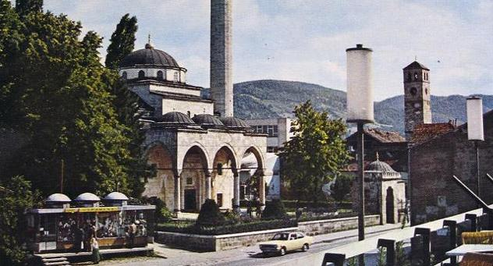
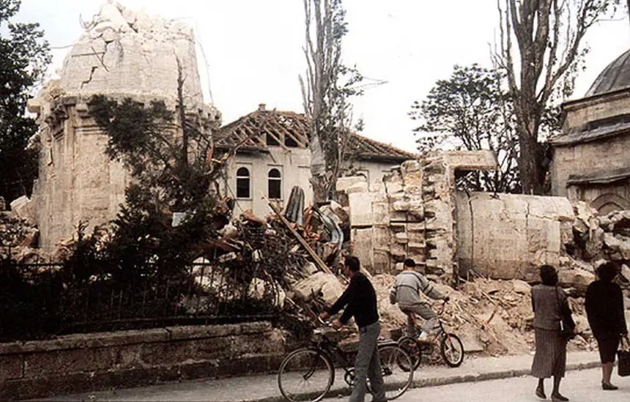
3.1.3 Case: The Ferhad Pasha Mosque
Figure 2. Ferhadija Mosque in Banja Luka, before and after war destruction
(A) (B)

The significance of the Ferhadija Mosque (Figure 2) is reflected in the values that constitute a testimony to a certain type, style, or regional manner of this architectural heritage. The contemporary layout and construction of the Ferhadija Mosque, with all its values, puts the main place of worship in Banja Luka at the top of the scale of Islamic religious buildings in the Balkans. The harmony, proportions, and architectural volumes are enriched by the emphasis on the verticality of the building. The classic Ottoman style is reflected in the fact that all the building's elements, not just the minaret, have tall, slender forms, in which the dynamics and importance of each element are simultaneously emphasized[15]. The unique compositional unit, which tends to be pyramidal in shape, is actually made up of parts of the object, each of which stands out with its own individuality. It is precisely this composition, proportions, and specific construction that highlight artistic and aesthetic values, which are complemented by the quality of materials and workmanship, as well as the value of details [14]. Symbolic value is essential for religious objects. The motive for the rehabilitation of this architectural heritage is reflected in the need to obtain sacred space, affirmation, i.e., the restoration of national identity after the war, and the restoration of a valuable monument that embodies traditional values. The Ferhadija Mosque also has a crucial ambient value for the city of Banja Luka. Since its inception, it has been the central building in Banja Luka's city center. As such, it is significant in the image and structure of the city. If we take into account the position and location of the Ferhadija Mosque, its shape and design, the tradition and construction technique, materials, content, purpose, and continuous use, we conclude that it is truly a superb architectural work, a rare example of a certain style with values such as uniqueness and representativeness.

3.1.4 Post-War Rehabilitation
After the end of the war in the 1990s, reconstruction and construction work began throughout Bosnia and Herzegovina. The Islamic Community of Bosnia and Herzegovina recognized the role and importance of the Ferhadija (Ferhad Pasha) Mosque for both the city of Banja Luka and the entire country, and in 2001 initiated the development of the post-war rehabilitation project. The foundation stone was laid in May of the same year. Since it was a very complex project that required professional staff and an interdisciplinary approach, it was entrusted to the Faculty of Architecture in Sarajevo. Although the project was completed by May 2002, the start of ground reconstruction was postponed until 2006 due to socio-political difficulties.
Meanwhile, the search for the remains of the mosque was carried out. During 2004, the Ramići dumpsite was searched, where the remains of not only the Ferhadija Mosque but also other Banja Luka mosques were found. After cleaning, all fragments were stored at the Vrbanja landfill near Banja Luka. The revitalization project involves restoring the original elements, i.e., fragments, to the greatest extent possible. After cleaning, the fragments were sorted, and 3D imaging was performed to document and identify their original positions for rebuilding. The existence of old documentation about the recording of the Ferhadija mosque was of great importance and value. The special importance of these recordings is reflected in the fact that some date from before and others from after the devastating earthquake that hit Banja Luka in 1969. Between 1951 and 1960, a large number of rehabilitation works were carried out both on the mosque and on the accompanying buildings within the complex. These conservation works are recorded and described in scientific papers [2], [3]. The post-war rehabilitation project lasted a full fifteen years. Table 3 briefly outlines the key steps of the rehabilitation project.

Table 3. Phases of the rehabilitation project (2001 - 2016)
2001 | The foundation stone was laid on May 7, 2001. However, the ceremony was interrupted by unpleasant events caused by protesters and supporters of the criminal regime. These events resulted in the death of one participant in the ceremony. Post-war reconstruction had to wait for better times.
2001 - 2002 | In 2002, the Faculty of Architecture in Sarajevo presented a rehabilitation project for Ferhad Pasha's Mosque.
2003 | In 2003, the Commission for the Preservation of National Monuments of Bosnia and Herzegovina designated the entire complex of the Ferhad Pasha Mosque as a national monument [1].
2004 - 2006 | Between 2004 and 2006, there was a constant search for the remains of the Ferhadija mosque. A large part of the fragments was found at the Ramići dumpsite. After washing and cleaning, the found fragments were stored in Vrbanja, near Banja Luka, where further tests were carried out[13].
2006 | In 2006, work began on uncovering the foundations of the Ferhadija Mosque, followed by recording the existing condition. Also, in the same year, at the same time as the foundation works, a 3D scan of the found fragments was carried out for documentation and selection, revealing the original place, i.e., the object's place of belonging.
2007 | The largest number of fragments was found in 2007 at the newly discovered location of Lake Šunajre in Karanovac. In 2007, the restoration of the foundations was completed, and construction of the mosque's walls began [13].
2008 | In 2008, masonry work progressed, and the main building of the mosque was raised to the height of the upper windows, i.e., the windows at the level of the mahfil. At the same time, the construction of the minaret began. At the entrance to the mosque, i.e., the mosque's porch, the pedestals and column bases are being installed.
2009 | In 2009, much of the work was done on the mosque's entrance: the restoration of the stone inscription began. In addition to work on the repair, restoration, and construction of the portico's capitals and pillars, the mahfil's pillars were also restored this year. The construction of the minaret also continues.
2010 | The restoration of the stone inscription at the entrance was completed in 2010. The portico domes were built. The fragments of the bases and pillars of the mahfil were repaired. Two small external mihrabs were installed on the entrance wall, located to the right and left of the entrance door.
2011 | The final works on the mosque's entrance portal were completed in 2011. In the same year, construction of the minaret continued up to the balcony of the minaret. Renovation of the complex's fence, which includes the fountain and entrance gate, has also begun.
2012 | The masonry of the minaret was completed in 2012. Meanwhile, the formwork was installed, and the construction of the semi-dome and the central dome began. By the end of the construction season, the alem (a decorative metal element at the top of the dome) was installed on the mosque.
2013 | During 2013, the plastering of all necessary surfaces was completed. The water, sewage, and electrical installations were made. This year, construction of the Ferhat Pasha türbe began, along with the renovation of the ablution fountain.
2014 | The lead sheet is placed on the roof surfaces. The walls of Ferhat Pasha's türba were built to full height. The cleaning of the complex and the construction of the fence continue.
2015 | Final works inside the building and painting are being completed. Paving and landscaping of the complex's courtyard are being completed.
2016 | On May 7, 2016, 23 years after its demolition, the Ferhat Pasha Mosque in Banja Luka was officially opened.

3.1.5 Protection Methods Applied on Specific Segments
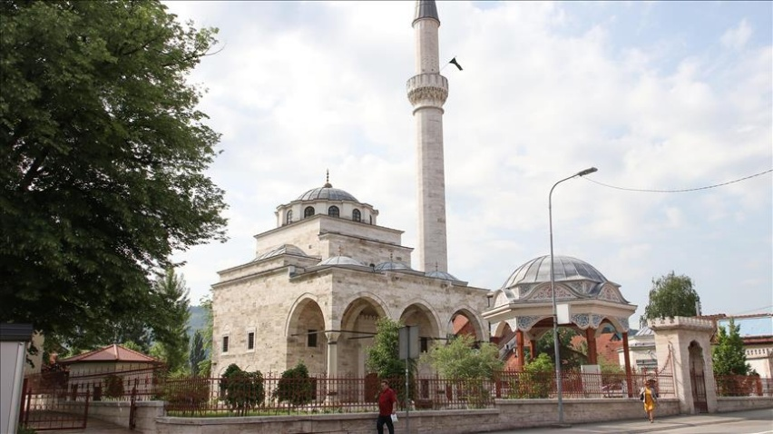
During the fifteen-year rehabilitation project, the search for the remains, the development of the project, the preparation of the terrain, the cleaning and sorting of the remains, and, finally, the reconstruction of the mosque complex were carried out (Figure 3). Of course, many fragments failed the quality and compressibility tests, and their reinstallation was not possible. Nevertheless, some percentage of the original parts of the building were incorporated, which is also the reason why this project lasted for years.
Figure 3. Ferhadija Mosque after reconstruction
3.1.6 The Entrance Portal - Multidisciplinary Approach
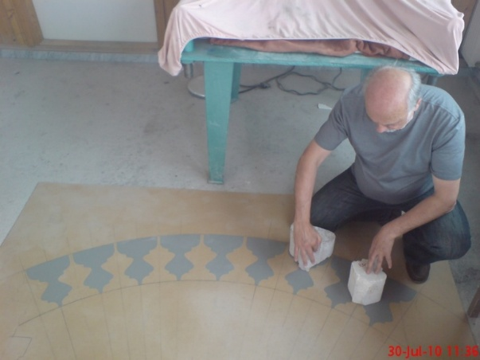
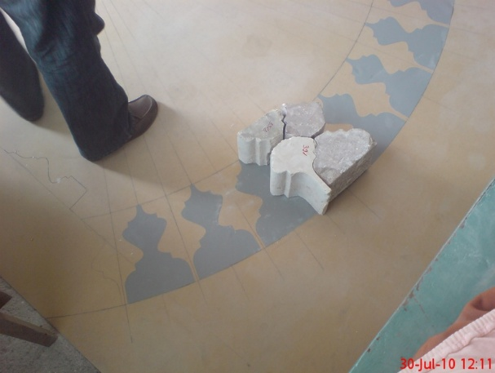
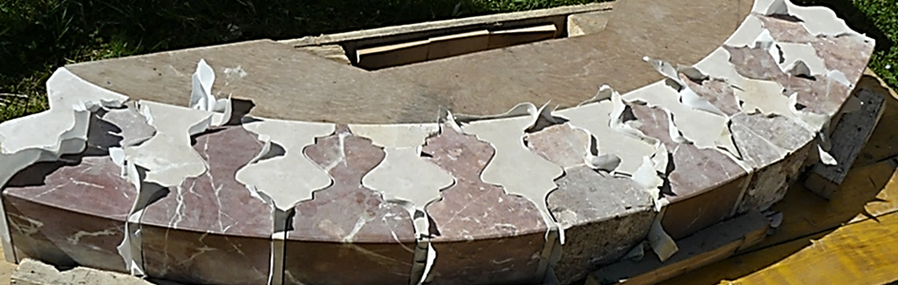
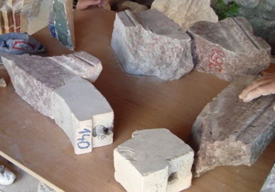
The entrance portal of the mosque (Table 4), as the most representative element, features a richly profiled tufa frame that terminates at the top with a cornice bearing smaller and larger trefoil motifs. The door side jambs are made of red limestone, connected by a segmental arch consisting of 19 floral motifs, alternately set in darker and lighter shades of red limestone. Above the door are two stone slabs. The first slab is narrow and has the prayer text carved on it, while the second slab is a stone inscription with information about the construction of the mosque. The entire space of the entrance portal is ultimately framed by two tufa arches, the lower of which is flush with the wall, while the upper is protruding. After searching for the remains of the mosque, parts of the floral motifs that make up the portal arch were found. The extent of their damage was great. After cleaning and restoration, only parts of the 5 floral motifs could be reinstalled. A 1:1 scale arch template with floral elements was created in the workshop, based on which the missing elements were made (Figure 4 A.B.C.D). The stone blocks were cut by machine, as was the rough preparation of the elements. This was followed by transferring the shapes from the templates and by hand-finishing.

Figure 4. Making and preparing floral elements of the segmental arch of the mosque portal
(A) (B) (C) (D)

Table 4. Level of damage and methods of protection applied to the entrance portal
Building segment: The entrance portal
Degradation level |  | Original appearance data |  | Applied protection methods |  |  | Used materials |  | Construction techniques
No damage |  | Existing |  | Anastylosis |  |  | Same material |  | Traditional
Minor damage |  | Limited |  | Conservation |  |  | Same-source material |  | Modern construction techniques
Medium-level damage |  | Unreliable |  | Restoration |  |  | Replacement material |  | Modern construction techniques
Severe damages |  | Non-existing |  | Reconstruction |  |  | Contemporary materials |  | Traditional and modern construction techniques
Completely missing |  | Note: |  | None applied |  |  | None used |  | Traditional and modern construction techniques
BEFORE REHABILITATION FIGURE |  |  |  |  | AFTER REHABILITATION FIGURE
 |  |  |  |  | 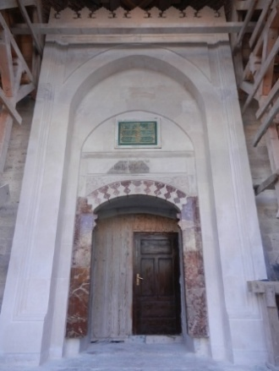
3.1.7 The Porch Pillars - A Textbook of Restoration
The porch is formed by four round stone pillars connected by pointed arches. The capitals of the columns have stalactite and geometric forms. The two inner columns have stalactite motifs on their capitals, while the two outer columns are decorated with geometric shapes, specifically rhomboids. The search for fragments of the mosque and their processing led to the discovery of a large number of pillar fragments. After cleaning, the following damages were found: scratches and fractures caused by the demolition of the mosque. The decision was made to make two external pillars out of the found fragments that met the conditions for reinstallation, while the other two pillars were newly built. The first step was cleaning, i.e., washing the found fragments with water and applying a coating to improve the adhesion of the stone mixture (stone flour). The so-called stone flour was made from grinded fragments, which were extremely small in size, in the sense that they could no longer be used and/or their position could not be determined. Grinded fragments are used to create a stone mixture that further fills the cracks of larger elements. Surfaces treated in this way are manually sanded and smoothed in order to bring the applied mass to the same level as the surface of the original fragment. In the same way, the rehabilitation of four stone pedestals, as well as four pillar bases, was carried out, as shown in Figure 5. The level of damage and the methods of protection applied to the porch pillars are shown in Table 5.
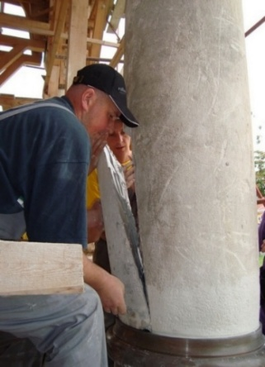
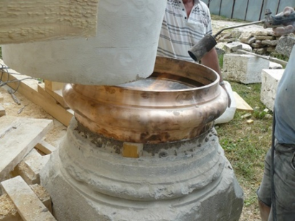
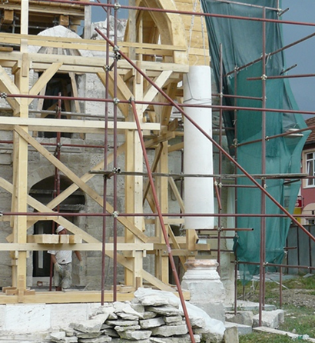
Figure 5. Installation of restored porch pillars
(A) (B) (C)

Table 5. Level of damage and methods of protection applied to the porch pillars
Building segment: The porch pillars
Degradation level |  | Original appearance data |  | Applied protection methods |  |  | Used materials |  | Construction techniques
No damage |  | Existing |  | Anastylosis |  |  | Same material |  | Traditional
Minor damage |  | Limited |  | Conservation |  |  | Same-source material |  | Modern construction techniques
Medium-level damage |  | Unreliable |  | Restoration |  |  | Replacement material |  | Modern construction techniques
Severe damages |  | Non-existing |  | Reconstruction |  |  | Contemporary materials |  | Traditional and modern construction techniques
Completely missing |  | Note: |  | None applied |  |  | None used |  | Traditional and modern construction techniques
BEFORE REHABILITATION FIGURE |  |  |  |  | AFTER REHABILITATION FIGURE
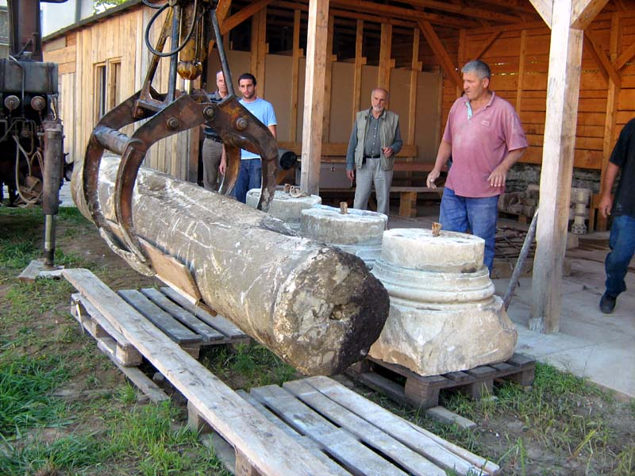 |  |  |  |  | 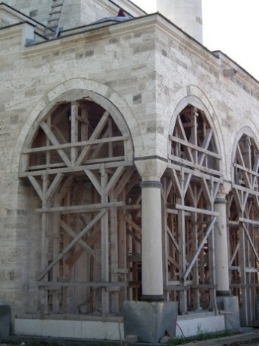
3.1.8 The Mosque Tower (Minaret) - Lessons from Earlier Degradations and Interventions
In 2008, construction of the minaret began. According to the rehabilitation project, it was planned that all necessary replacement stone for the restoration of the Ferhadija Mosque would be obtained from the same quarry as the original stone used in its construction; however, this was simply not possible. Although the quarry was located near Banja Luka, in Sitari, its exploitation was impossible, so a replacement stone had to be found. The replacement stone for the minaret restoration of the mosque was travertine from Armenia, which, after analysis, was found to be the most similar to the original stone. The second important step in constructing the minaret was ensuring its stability. Devastating earthquakes that hit Banja Luka in 1969 and 1981 showed the extreme vulnerability of this slender structure. The first earthquake caused the upper part of the minaret (all above the balcony) to collapse. This was followed by a repair, in which the upper part of the minaret was made of reinforced concrete and covered with stone. This inadequate intervention only preserved the upper part of the minaret's shaft, while the lower part, although stressed and damaged, was neglected. The shortcomings of such incomplete work were highlighted during the 1981 earthquake that hit the Banja Luka area. This earthquake caused significant damage, most pronounced in the form of cracks. The rehabilitation and restoration work, which were preceded by recording the dynamic state of the building, were carried out in 1989. The weakened core of the minaret was repaired by installing 8 ribbed bars (Ø19) positioned in vertical slots (5x5cm) drilled on the inside of the minaret wall [15]. The connection between the ribbed bars was achieved with special inserts and threads, while welding was carried out only in the lower part of the minaret, i.e., in places where the vertical bars passed through the reinforcement of the concrete part of the minaret, as illustrated in Figure 6. Having learned the lessons of the past, it was decided that the post-war rehabilitation project for the Ferhadija Mosque would apply the same methods to ensure stability as those used in 1989 [13], [14], [32]. The level of damage and methods of protection applied to the mosque tower are shown in Table 6.
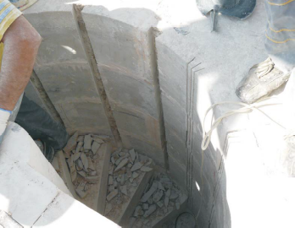
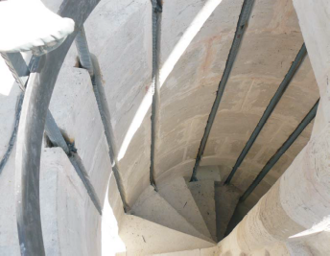
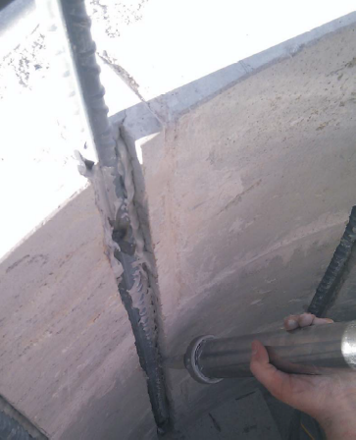
Figure 6. Strengthening the minaret
(A) (B) (C)

Table 6. Level of damage and methods of protection applied to the mosque tower
Building segment: The mosque tower (minaret)
Degradation level |  | Original appearance data |  | Applied protection methods |  |  | Used materials |  | Construction techniques
No damage |  | Existing |  | Anastylosis |  |  | Same material |  | Traditional
Minor damage |  | Limited |  | Conservation |  |  | Same-source material |  | Modern construction techniques
Medium-level damage |  | Unreliable |  | Restoration |  |  | Replacement material |  | Modern construction techniques
Severe damages |  | Non-existing |  | Reconstruction |  |  | Contemporary materials |  | Traditional and modern construction techniques
Completely missing |  | Note: |  | None applied |  |  | None used |  | Traditional and modern construction techniques
BEFORE REHABILITATION FIGURE |  |  |  |  | AFTER REHABILITATION FIGURE
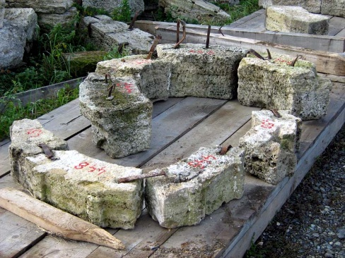 |  |  |  |  | 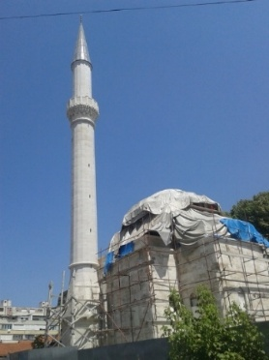
3.1.9 The Minaret Balcony (Şerefe) - Challenges for Handcrafts
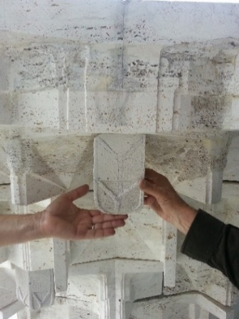
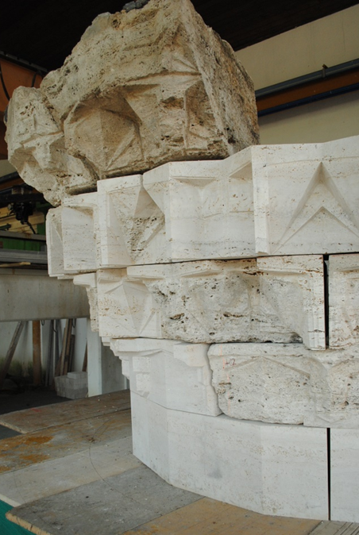
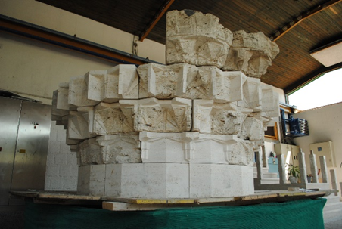
An examination of the fragments of the minaret balcony revealed that over 50% of the original stone can be reused, while the rest needs to be remade. This meant providing the same or replacement stone, carving and shaping new elements according to the model of the existing ones. It was necessary to subject the existing elements to restoration-conservation works and shape them in the context of the place where they were installed, and in the context of the fragment where they were installed. The new stone elements were made of travertine, and the connection with the other stone elements was achieved with iron spikes cast with lead. On the upper side of each stone row of the balcony, clamps were placed, which were also cast with lead. After installing all the elements, on-site fine processing was carried out, for which a special scaffold was constructed, as illustrated in Figure 7. The Level of damage and methods of protection applied to the minaret balcony are shown in Table 7.
Figure 7. Şerefe parts in the workshop, assembling new and restored parts
(A) (B) (C)

Table 7. Level of damage and methods of protection applied to the minaret balcony
Building segment: The minaret balcony (şerefe)
Degradation level |  | Original appearance data |  | Applied protection methods |  |  | Used materials |  | Construction techniques
No damage |  | Existing |  | Anastylosis |  |  | Same material |  | Traditional
Minor damage |  | Limited |  | Conservation |  |  | Same-source material |  | Modern construction techniques
Medium-level damage |  | Unreliable |  | Restoration |  |  | Replacement material |  | Modern construction techniques
Severe damages |  | Non-existing |  | Reconstruction |  |  | Contemporary materials |  | Traditional and modern construction techniques
Completely missing |  | Note: |  | None applied |  |  | None used |  | Traditional and modern construction techniques
BEFORE REHABILITATION FIGURE |  |  |  |  | AFTER REHABILITATION FIGURE
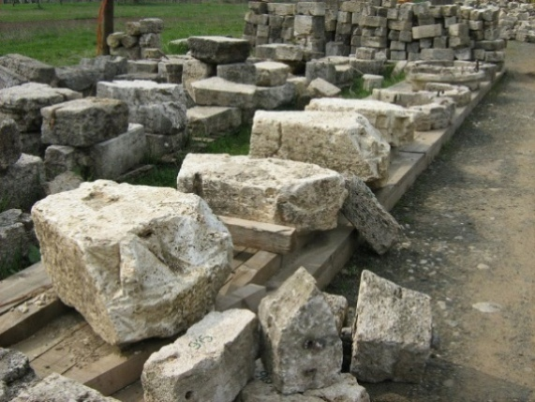 |  |  |  |  | 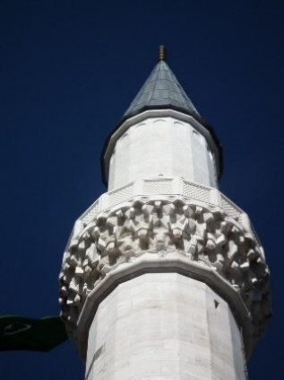

3.1.10 The Ablution Fountain (Şadirvan) - New Discoveries and New Values
During the foundation restoration and ground preparation for the installation of the fountain base, stone elements were found at a depth of about 40 centimeters. Their analysis led to the conclusion that these were elements of a fountain that was removed and rebuilt during the Austro-Hungarian period. The Feradija Mosque rehabilitation project had previously defined these elements based on written and photographic documentation from the Austro-Hungarian period, meaning that the base, as well as the twelve segments that make up the fountain, were made of Hreša stone, as confirmed by the discovery of fragments in dumpsites. There was no information about the earlier fountain, so this discovery was of great importance. The stone elements found in the ground were first cleaned, selected, and analyzed. It was concluded that they were broken pieces of twelve segments of the fountain, and it was decided to install these newly discovered fragments. These elements were not made of Hreša stone, as mentioned earlier, but of travertine, and the project changed accordingly. The rehabilitation of the found fragments resulted in the assembly of one whole element that was incorporated, and based on which the other eleven elements were made (Figure 8). The level of damage and methods of protection applied to the ablution fountain are shown in Table 8.
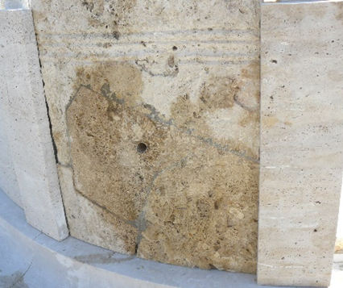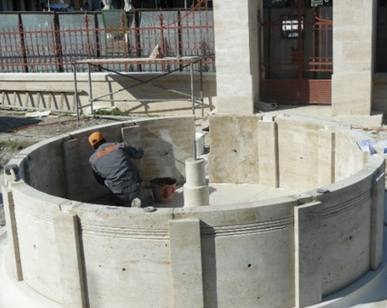
Figure 8. Restoration of one and reconstruction of the other elements of the fountain
(A) (B)

Table 8. Level of damage and methods of protection applied to the ablution fountain
Building segment: The ablution fountain (şadirvan)
Degradation level |  | Original appearance data |  | Applied protection methods |  |  | Used materials |  | Construction techniques
No damage |  | Existing |  | Anastylosis |  |  | Same material |  | Traditional
Minor damage |  | Limited |  | Conservation |  |  | Same-source material |  | Modern construction techniques
Medium-level damage |  | Unreliable |  | Restoration |  |  | Replacement material |  | Modern construction techniques
Severe damages |  | Non-existing |  | Reconstruction |  |  | Contemporary materials |  | Traditional and modern construction techniques
Completely missing |  | Note: |  | None applied |  |  | None used |  | Traditional and modern construction techniques
BEFORE REHABILITATION FIGURE |  |  |  |  | AFTER REHABILITATION FIGURE
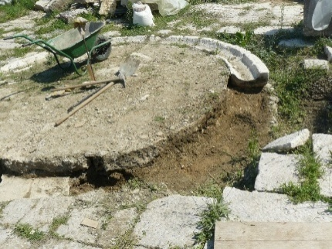 |  |  |  |  | 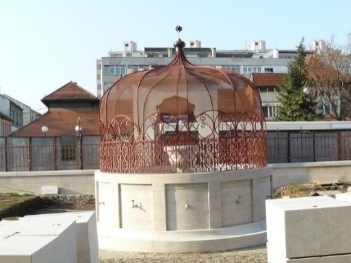

3.2 DISCUSSION
This research emphasizes the role and importance of authenticity in post-war rehabilitation projects, where the most important steps of the post-war rehabilitation strategy emphasize research and data analysis, a multidisciplinary approach in both research and project development, and the need to choose protection methods before choosing protection methods. By responding to challenges, learning from earlier phases, and actively following the process in situ, we ensure authenticity and create the possibility for new discoveries and new values.
      - The role and importance of authenticity
We conclude that authenticity in post-war rehabilitation projects is not viewed in one direction, but as a process that takes place in two directions, at least when it comes to preserving existing values, returning lost ones, and creating new ones. Collecting and analyzing data allows us to preserve and restore old values, and the data generated during and after project implementation, combined with previously defined values, opens the possibility of creating and promoting new values.
      - Multidisciplinary approach
Despite extensive research before and during the development of the architectural heritage rehabilitation project, it is not possible to predict all the situations that fieldwork entails. The rehabilitation process is like living matter, created under the constant influence of different circumstances arising from ongoing research. That is why the creation and implementation of such complex projects is impossible without a team of experts from various fields. In addition to architects, conservators, urban planners, civil engineers, historians, artists, artisans, people from the local community, sociologists, lawyers, economists, researchers, and students, journalists, etc., are necessary. They all work together to find solutions to the challenges posed by the design and implementation of the project. One cannot act without the other. They are united in the goal of finding solutions that meet the criteria for heritage protection, provide the necessary materials, and apply adequate construction techniques and technologies, all in accordance with national and international laws, legislation, declarations, and recommendations.
      - Wide range of applied protection methods
Depending on the level of degradation, the condition of the architectural heritage, and, in our specific case, the condition of the found stone fragments, the appropriate protection method will be applied. Rehabilitation is a comprehensive process that includes all known methods of protection: anastylosis, conservation, restoration, and reconstruction. Each method of protection initially aims to preserve as much of the original element as possible, then to replace the lost one.
      - Material and craft challenges
The biggest challenge for post-war rehabilitation projects is replacing completely destroyed elements. After the data analysis provides insights into the original forms, materialization, and processing techniques, their total reconstruction follows. In this case, the biggest challenge is to provide the original material and/or find a substitute. Also, their processing is a matter of tradition and artisan skills, which often means involving the local community and their knowledge. Historians, conservators, artists, and local artisans join forces to create the missing elements.
      - Lessons from earlier degradations and interventions
Rehabilitation does not necessarily mean the return of architectural heritage to its original form. The passage of time leaves traces on an object, as do various situations and influences, whether natural, social, economic, or political. Ultimately, these are different phases of the same object, and we should look at the layering of styles, respecting each and learning from it. Previously applied protection methods are analyzed to determine whether they remain the best solution today. Even from inadequate solutions, we learn by highlighting their shortcomings, improving them, and avoiding the consequences they brought.
      - New discoveries and new values
Post-war rehabilitation is a never-ending process, marked by new discoveries and new values. During fieldwork, discoveries often emerge, sparking new discussions and research. Even after the restoration, the possibility of debate on the subject remains. Also, the creation of new values ​​is a matter of continuous research and promotion of architectural heritage.

CONCLUSION
Even today, we are witnessing various types of degradation and demolition of heritage objects caused by wars. Religious buildings showed particular vulnerability during conflicts, and their restoration is crucial for the post-war period and the normalization of relations and life in those areas. We see the dome mosques of the Ottoman period as the Opus magnum of Islamic architecture. They are not only religious buildings but also an architectural heritage of outstanding value. They are unique examples and, as such, must never be subject to any form of degradation. The conducted research provides an analysis and insight into the rehabilitation of destroyed architectural heritage, focusing on the Ferhadija Mosque, one of the most significant post-war reconstruction projects in Bosnia and Herzegovina. The results show the most significant steps outlined in the post-war rehabilitation strategy, with particular attention to the issue of authenticity. We conclude that post-war rehabilitation is possible and supported by experts, even for a building destroyed by war. In such cases, the aim is to preserve authenticity in fragments, where the main role is played by materials and construction techniques conditioned by the existence of accurate documentation. After insight into the degree of degradation, the existence of data on the original appearance, materialization, and construction techniques, a decision is made on which protection method will be applied. At the same time, in addition to preserving authenticity, the possibility of restoring lost values ​​​​and creating new ones is created. When reviewing the Ferhadija Mosque rehabilitation project, the importance of data research is recognized and confirmed, in addition to a detailed review of the applied protection methods. The review and analysis of previous research provides significant data not only on the previous state, forms, materials, and construction techniques, but also on the degradation and interventions that occurred before the destruction. The above, together with insights into the in-situ state and continuous monitoring of the rehabilitation process, lead to discoveries and the creation of new value.
Ultimately, we hope that this research will encourage researchers to contribute to the further development of steps for the post-war rehabilitation strategy of forcibly demolished heritage, as well as to write, discuss, and analyze individual cases of already implemented rehabilitation projects to assess their validity, and to evaluate the authenticity of this very important architectural heritage.

AUTHORS CONTRIBUTION
The author himself conducted research based on written documents, previous research, historical documents, oral traditions, and fieldwork on the post-war reconstruction of Ottoman mosques. After working on the production of stone elements for certain domed mosques, the author recognized the importance of highlighting and making public the story of these supreme works of Ottoman architecture.

REFERENCES
[1] KONS, “Odluke o proglašenju graditeljske cjeline - Područje i ostaci graditeljske cjeline - Ferhad-pašina džamija (Ferhadija) u Banjoj Luci, sa Ferhad-pašinim turbetom, Turbetom Safi-kadune, Turbetom Ferhad-pašinih bajraktara, šadrvanom, džamijskim haremom, ogradnim zidovima i portalom nacionalnim spomenikom BiH,” Sarajevo, May 2003. Accessed: May 03, 2025. [Online]. Available: http://aplikacija.kons.gov.ba/kons/public/uploads/odluke_bos/FerhadijaBH.pdf
[2] M. Fučić, “Konzervatorski zahvat na Ferhad-pašinoj džamiji u Banjoj Luci,” Naše starine: godišnjak Zavoda za zaštitu spomenika kulture i prirodnih rijetkosti, vol. 1, pp. 117–121, 1953.
[3] M. Biško, “Konzervacija objekata u kompleksu Ferhadije džamije u Banjoj Luci,” Naše starine: godišnjak Zavoda za zaštitu spomenika kulture i prirodnih rijetkosti, vol. 7, pp. 81–89, 1960.
[4] A. Bejtić, “Spomenici osmanlijske arhitekture u Bosni i Hercegovini,” in Prilozi za orijentalnu filozofiju i istoriju jugoslovenskih naroda pod turskom vladavinom, vol. 3–4, B. Đurđev, Ed., Sarajevo: Orijentalni institut Sarajevo, 1953, pp. 229–297.
[5] H. Redžić, Islamska umjetnost. Beograd: Jugoslavija, 1967.
[6] M. Mujezinović, Islamska epigrafika Bosne i Herzegovine, knjiga I - Sarajevo. Sarajevo: Veselin Masleša, 1974.
[7] M. Mujezinović, Islamska epigrafika Bosne i Herzegovine, knjiga II - Istočna i centralna Bosna. Sarajevo: Veselin Masleša, 1977.
[8] M. Mujezinović, Islamska epigrafika Bosne i Herzegovine, knjiga III - Bosanska Krajina, zapadna Bosna i Hercegovina. Sarajevo: Veselin Masleša, 1982.
[9] E. H. Ayverdi, Avrupa’de Osmanli Mimari Eserleri Yugoslavya, vol. 2. İstanbul: İstanbul Fetih Cemiyeti, 1981.
[10] H. Redžić, Islamska umjetnost. Beograd - Zagreb - Mostar: Jugoslavija / Spektra / Prva književna komuna, 1982.
[11] H. Redžić, Studije o islamskoj arhitektonskoj baštini. Sarajevo: Veselin Masleša, 1983.
[12] A. Andrejević, Islamska monumentalna umetnost XVI veka u Jugoslaviji – Kupolne džamije, 2nd ed. Rožaje: Avlija, 2017.
[13] M. Hamidović, Ferhadija - Smisao svjedočanstva. Sarajevo: Svjetolost-BH print, 2023.
[14] M. Hamidović, Studija: Principi i metodološki postupak za obnovu Ferhad-pašine džamije u Banjoj Luci. Sarajevo, 2001.
[15] S. Husedžinović, Dokument opstanka - vrijednost, značaj, rušenje i obnova kulturnog naslijđa. Zenica: Muzej grada Zenice, 2005.
[16] H. Eren; Amir Pašić; Aida Idrizbegović-Zgonić, Restoration of mosques in Bosnia and Herzegovina. Istanbul: Research Centre for Islamic History, Art and Culture (IRCICA), 2013.
[17] KONS, “Principi i smjernice za očuvanje nacionalnih spomenika Bosne i Hercegovine,” Sarajevo, Jun. 2018.
[18] UNESCO, “Operational Guidelines for the Implementation of the World Heritage Convention,” Paris, Jul. 2025. Accessed: Aug. 22, 2025. [Online]. Available: https://whc.unesco.org/en/guidelines/
[19] E. Avrami, R. Mason, and M. de la Torre, Values and Heritage Conservation: Research Report. Los Angeles: Getty Conservation Institute, 2000. Accessed: Aug. 22, 2025. [Online]. Available: https://www.getty.edu/conservation/publications_resources/pdf_publications/pdf/valuesrpt.pdf
[20] ICCROM, “The Riga Charter on authenticity and historical reconstruction in relationship to cultural heritage adopted by regional conference,” Riga, Oct. 2000. Accessed: Aug. 22, 2025. [Online]. Available: https://www.iccrom.org/sites/default/files/publications/2020-05/convern8_07_rigacharter_ing.pdf
[21] N. Stanley-Price, “The reconstruction of ruins: principles and practice,” in Conservation: principles, dilemmas and uncomfortable truths, A. Richmond and A. Bracker, Eds., London: Elsevier/Butterworth Heinemann, 2009, pp. 32–46.
[22] KONS, “Pravilnik o aktivnostima komisije za očuvanje nacionalnih spomenika vezanim za međunarodnu saradnju,” Sarajevo, Sep. 2002. Accessed: Sep. 02, 2025. [Online]. Available: http://kons.gov.ba/Content/Read/pravilnik-o-aktivnostima
[23] KONS, “Pravilnik o kriterijima vrednovanja, podjeli i kategorizaciji nacionalnih spomenika ,” Sarajevo, Nov. 2019.
[24] ICOMOS, “International Charter for the Conservation and Restoration of Monuments and Sites (The Venice Charter),” Paris, 1965. Accessed: Aug. 22, 2025. [Online]. Available: https://www.icomos.org/charters/venice_e.pdf
[25] J. Jokilehto, “Considerations on Authenticity and Integrity in World Heritage Context,” City & Time, vol. 2, pp. 1–16, 2006.
[26] J. Jokilehto, A History of Architectural Conservation, 2nd ed. New York: Routledge, 2017. doi: 10.4324/9781315636931.
[27] UNESCO, “Operational Guidelines for the Implementation of the World Heritage Convention,” UNESCO, Paris, Jul. 1977. Accessed: Aug. 22, 2025. [Online]. Available: https://whc.unesco.org/archive/opguide77a.pdf
[28] B. Von Droste; U. Bertilsson, “Authenticity and World Heritage,” in Nara Conference on Authenticity, Nara: UNESCO, Agency for Cultural Affairs Japan, ICCROM, ICOMOS, 1995, pp. 3–15.
[29] M. Parent, “Doctrine for the conservation and restoration of monuments and sites: General report,” in Nessun futuro senza passato. 6th ICOMOS General Assembly and International Symposium, Roma: ICOMOS, 1981, pp. 37–70.
[30] D. Lowenthal, “Criteria of Authenticity,” in Nessun futuro senza passato. 6th ICOMOS General Assembly and International Symposium, Bergen: ICOMOS, 1994, pp. 35–64.
[31] T. Scaltsas, “Identity, Origin and Spatio-temporal Continuity,” Philosophy, vol. 56, no. 217, pp. 395–402, 1981.
[32] D. Hasanović, “Tehnička dokumentacija: Ojačanje munare - Ferhadija džamija, Banja Luka,” Sarajevo, 2013.

