 |  | JOURNAL OF ISLAMIC ARCHITECTURE  P-ISSN: 2086-2636 E-ISSN: 2356-4644  Journal Home Page: http://ejournal.uin-malang.ac.id/index.php/JIA
GEOMETRIC DOCUMENTATION AND STRUCTURAL ANALYSIS OF CHAR-SUQ INTERSECTION SPACES: THE CASE OF SADIK-IYE CHAR-SUQ IN TABRIZ HISTORICAL BAZAAR
Neşe Başak Yurttaş^{1*}, Aidin Armanfar¹
¹Biruni University, Interior Architecture and Environmental Design, Istanbul, Turkey
*Corresponding Author: nyurttas@biruni.edu.tr
ARTICLE INFO |  |  | ABSTRACT
Volume: 9  Issue: 1  Page: 298-317  Received: July 28th, 2025  Accepted: January 20th, 2026  Available Online: June 30th, 2026  DOI: https://doi.org/10.18860/jia.v9i1.35835 |  |  | The Tabriz Historical Covered Bazaar, situated on the Silk Road, is one of the most significant ancient structures in Islamic and Middle Eastern architecture and art. Designated as a UNESCO World Heritage Site in 2010, the bazaar is among the oldest examples of its kind, featuring inns, caravanserais, mosques, baths, and madrasahs interconnected by wide arches, brick vaults, and open courtyards. The layout evolved organically around crossroads Char-suq structures, which serve as focal elements. The Sadık-iye Char-suq, located at the center of Tabriz Historical Covered Bazaar, is examined in this study with respect to its structural, spatial, visual, functional, and historical aspects. This research employs a descriptive model as a quantitative research method to explain the architectural features of Sadık-iye Char-suq, a defining element in the irregular, organically developed bazaar plan. The methodology comprises three stages: first, on-site observations documented visual and functional data; second, a comprehensive survey using the triangulation method enabled the creation of plans, sections, and 3D models, from which structural and spatial data were obtained; finally, field findings were compared with previous studies and historical documents to explain the structure's historical development phases through graphic visuals. The results demonstrate how crossroads structures impact architectural design and building systems within irregular market plans. The study reveals that, despite the organic development of the bazaar's arastas, the Sadık-iye Char-suq was systematically designed with an octagonal plan, incorporating columns, arches, and vaults, with the non-orthogonal intersection angles of connecting passages aligned with the plan. This systematic approach within an organic framework establishes the Char-suq as both a functional circulation node and a structural solution that maintains the bazaar's spatial continuity.  Keywords:  Tabriz; Grand Bazaar; Traditional Architecture; Sadık-iye Char-suq; Triangulation Method

INTRODUCTION
The architecture and art of Islam and the Middle East constitute a vast field of research. A considerable body of research has examined how Islamic elements have influenced architectural and art-historical developments, particularly in studies of the post-Islamic period. Scholars from various disciplines have examined Middle Eastern bazaars from structural, spatial, visual, functional, and historical perspectives. This study focuses on the Sadık-iye Char-suq structure within the Tabriz Grand Bazaar, which was included in Iran's national heritage list in 1976 with registration number 1907 and subsequently added to the UNESCO World Heritage List in 2010 [1].

Tabriz, located in northwestern Iran as the capital of East Azerbaijan Province, is widely regarded as one of the country’s most historic and influential urban centers. Situated along the historic Silk Road, it has long served as a vital border city, facilitating trade and transit. Most of the city's population is Azeri (Azeri Turkic), speaking Azeri. At the same time, Persian is the second official language spoken in the region. With its strategic geographic position and lengthy historical background, Tabriz has for centuries influenced the cultural and economic development of Iran and the broader Middle East. Historical sources consistently underscore the city’s importance, as evidenced by the detailed depictions of its urban form created by the sixteenth-century Ottoman traveler Matrakçı Nasuh (Figure 1). Such accounts reinforce Tabriz’s enduring status as a major center of commerce, culture, and regional connectivity [2].

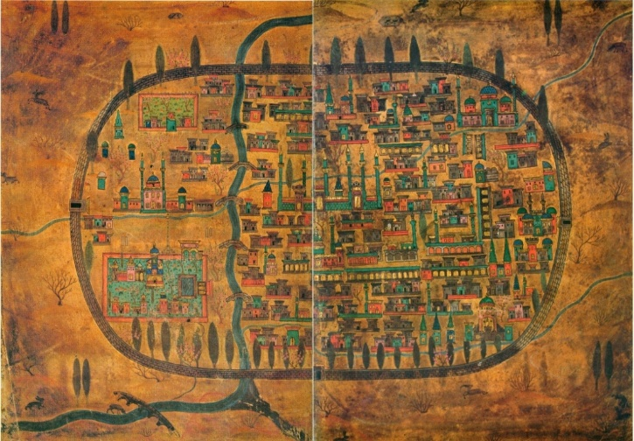

Figure 1. The separate depictions of eastern and western Tabriz by Matrakçı Nasuh were combined into a single composition [2].

According to a range of historical and archaeological sources, the origins of Tabriz date back to around 644 BCE [3]. Situated in the northwestern region of present-day Iran, Tabriz has historically held a strategically significant position at the intersection of major trade routes, including the Silk Road. Its geopolitical location has rendered the city a focal point of numerous civilizations and imperial ambitions, thereby shaping its complex socio-political and urban character over the centuries. Tabriz is situated in a seismically active region, and over its long history, it has endured numerous destructive earthquakes. These natural events have repeatedly brought the city to the brink of destruction, leading to successive periods of rebuilding. However, the reconstruction of Tabriz was never a straightforward restoration. Each rebuilding phase introduced shifts in urban planning, architectural expression, construction methods, and spatial organization, gradually shaping the city’s multilayered urban fabric. Over time, Tabriz came under the rule of numerous dynasties and empires, including the Medes, Achaemenids, Sassanids, Arabs, Seljuks, Ilkhanids, Kara Koyunlu, Ak Koyunlu, Safavids, and Ottomans. Each ruler left its mark on the city's physical and cultural landscape. During the Ilkhanid and Safavid periods, when Tabriz functioned as a political and economic center, the city saw the development of major architectural works, including mosques, bazaars, madrasas, and caravanserais, that helped shape it into a flourishing Islamic urban hub.
The Safavid era, particularly under Shah Tahmasp I, marked a period of significant urban development, with Tabriz serving as the dynasty's first capital. However, the city also became a contested space during the prolonged Ottoman-Safavid rivalry. The town shifted control repeatedly between the two empires, and each conquest, followed by eventual retreat, left its mark by altering Tabriz’s fortifications, infrastructure, and administrative organization. A particularly significant event occurred in 994 AH (1586 CE) during the reign of Sultan Murad III, when Osman Pasha, serving as the sultan's minister, led an expedition that led to the Ottoman forces' reconquest of Tabriz. After this military victory, the Ottomans launched significant architectural and infrastructural projects in the city. Among the most prominent was the construction of a fortified citadel in Sahibabad Square, a structure that signified their authority and their determination to reinforce control over the region. The Ottoman administration of Tabriz endured until 1012 AH (1603 CE), marking the beginning of Shah Abbas I's resurgence and the eventual reassertion of Safavid sovereignty over the city. This period of fluctuating imperial control not only underscores the city's strategic importance but also left enduring architectural, administrative, and cultural legacies that continued to shape Tabriz's urban identity well into the modern era [3]. These cycles of destruction and reconstruction, driven by both natural and human-induced forces, have profoundly shaped Tabriz's historical trajectory. As a result, the city has developed a multilayered identity in which successive historical, architectural, and cultural narratives coexist. Today, Tabriz reflects a layered record of Iranian urban history, illustrating the resilience and adaptability of its inhabitants throughout centuries of change and disruption [5].
The urban fabric of Tabriz, shaped by the influence of traditional Turkish and Islamic urban culture following the advent of Islam, still retains traces of architectural works from the Seljuk and Ottoman periods [4]. In the city of Tabriz, which continued to evolve under the patronage of various states, numerous public structures supporting social and cultural life were built during this period. The historic Grand Bazaar of Tabriz, which encompasses the Sadık-iye Char-suq structure that constitutes the subject of this research, also stands out as one of the structures that continued to develop under the same influence.
Bazaars, which feature semi-public spaces where commercial activities are conducted, are architectural structures that reflect the economic and political power of the period in which they were constructed. These structures, part of large complexes such as caravanserais, mosques, and madrasas, symbolize the city's prosperity and its role on trade routes. In this sense, covered bazaars serve not only as functional architectural structures but also as important cultural and social environments. They are places of memory that preserve, reflect, and transmit the identity, culture, traditions, and customs of the city in which they are located. These structures, which also serve as points of communication in the town, have a mission to manage and regulate relationships between communities [5].
Etymologically, the term "bazaar" derives from the Persian word "bāzār" (بازار), which denotes a market or commercial area where goods are exchanged. In Persian dictionaries, 'bāzār' is broadly defined as a marketplace or trading area within urban centers [6]. Historically, bazaars in the Middle East and Asia served as vital commercial arteries, functioning not merely as trading venues but as socio-cultural institutions that reflected the evolution of urban life. The term "bazaar" is commonly understood in a broad sense to refer to any physical or virtual setting where commercial transactions, particularly the exchange of goods and services, occur. From this general perspective, a wide array of environments, ranging from small local shops to large-scale commercial centers, may be categorized as marketplaces. However, such a definition tends to reduce the concept of a market to its purely economic function, overlooking its potential socio-cultural and historical dimensions.
In the Iranian context, the notion of the bazaar cannot be confined to a simplistic understanding as a site of economic exchange. Traditionally, bazaars have held a central and multifunctional position within the socio-spatial structure of Iranian cities. These spaces have historically served not only as vital nodes for trade and commerce but also as dynamic arenas for political discourse, social interaction, religious practice, and educational engagement. They have served as both physical and symbolic centers of urban life, often shaping the city's development, identity, and governance [7]. Grand Bazaars in Iran are multifunctional structures designed to meet the city's social, cultural, economic, and worship needs. For this reason, they encompass a wide range of functional units. The primary units within these structures, categorized by their functions within the overall spatial organization, include small shops (hojreh), larger shops, bazaar streets (rasteh), four-way intersections (çārsū), and covered passages (tim and timcheh). In addition to these, secondary spaces such as madrasahs, libraries, masjids (mosques), hammams, iwan, fountains, squares, zurhane (traditional sports venues), ice houses, and caravanserais are also considered together with bazaars [8].
‘Arastas’, an architectural structure that defines the shops or spaces on both sides of a linear road, is an integral part of covered bazaars. ‘Arastas’, the main transition area of the bazaars, is a crucial element in the bazaars' circulation routes. An Arasta structure is a bazaar with shops lined up on both sides, each with a covered or fringed front, where merchants sell the same kind of goods [9]. In another definition, an Arasta is an open or closed structure in Ottoman architecture featuring a series of shops arranged along an axis, sometimes side by side and sometimes facing each other [10]. In traditional historic city buildings, covered bazaars, which generally develop linearly toward the city's main entrances, continue this continuity with arastas, which form a backbone. For this reason, it can be said that arastas, especially in covered bazaars with organic plans, are shaped as linear passageways connecting city centers to neighborhood centers. Arastas also serve as transitional zones that structure the spatial organization of covered bazaars. This is evidenced by the fact that the arastas, which are expected to be linear, change direction organically to connect to the city's public buildings [11].
The term 'Char-suq' (چارسوق), also rendered as 'Çar-su', is derived from the Persian words 'čahār' (چهار), meaning 'four', and 'sūq' (سوق), meaning 'old marketplace' or 'bazaar'. Thus, Char-suq literally translates to 'four bazaars' or 'four markets' [12]. Spatially, the Char-suq marks the point where four covered passageways (rastehs) or commercial corridors converge within the traditional bazaar. This architectural configuration creates a cruciform plan, marking the structural and symbolic heart of the bazaar complex. Over time, local usage shifted in pronunciation, and the term gradually became established as Char-suq in everyday speech. Char-suq is located at the intersection of the two arastas in the traditional covered bazaars of Iran. The intersection points of these arastas, which constitute the structural framework of traditional bazaars, are called 'Char-suq'. These nodes serve as pivotal hubs in the bazaar, where commercial activity is predominantly concentrated. Functioning as focal points, the Char-suq areas facilitate not only the convergence of multiple trade routes but also promote social interaction and economic exchange, thereby forming the vibrant core of bazaar life [13]. These areas, defined as the intersection points of the main roads, not only formed the core of the city's economic center from a commercial point of view but also from a political and social point of view; they were structured as semi-public spaces where people gathered and various ceremonies were held, and they formed focal points within the city [14]. The spatial organization of these structures encouraged inclusivity, visibility, and interaction, strengthening their role as adaptable public spaces closely integrated into the city’s urban fabric. These structures can be found in many historic covered bazaars across the Middle East. However, the oldest of these are located in the cities of Isfahan (1610-1620), Lar (660-676), Tehran (1720-1870), Kerman (1340-1370) in Iran (Figure 2), and Tashkent and Bukhara in Uzbekistan [15] (Figure 3).

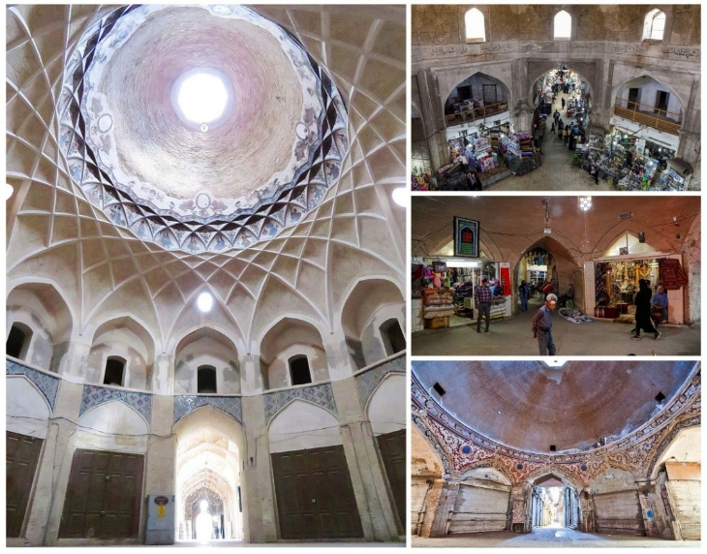

Figure 2. Char-suq Buildings in Iranian Grand Bazaars

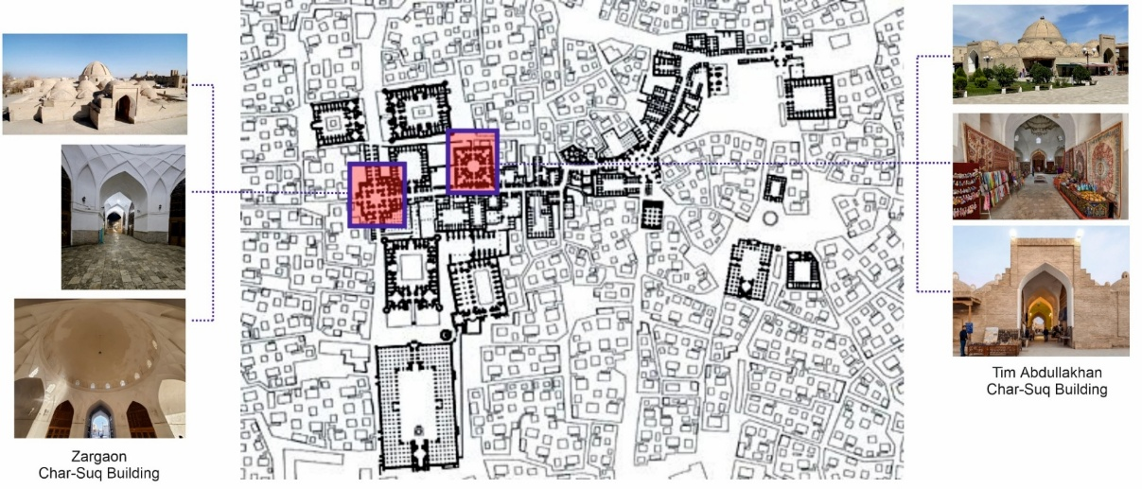

Figure 3. Char-suq Buildings in Bukhara's Historical Bazaar

The role of the bazaars as a socio-spatial system is well reflected in the spatial integration offered by Char-suq structures. Traditional bazaars in Iranian cities were never thoroughly planned; instead, they evolved organically, ensuring spatial flexibility and adaptability. These structures formed the backbone of urban life, linking key socio-cultural institutions such as mosques, madrasas, caravanserais, and bathhouses. Notably, the Char-suq’s central location and multifunctional character enabled it to operate as a focal point for trade, social interaction, and, at times, political expression, establishing it as an essential node within the city’s socio-economic network [18].
Moreover, the intersection zones provided a degree of morphological flexibility, a feature commonly observed in traditional Iranian bazaars as well. Through the proliferation of modular units, such as hojrehs, sārās, and timchehs, these junctions provided layered commercial and cultural functions that were both integrative and expandable. Their architectural hierarchy—highlighted by elevated domes or ornamented vaults—distinguished these nodes as spiritual and symbolic focal points within the broader bazaar morphology. Char-suq spaces reflected a deep-rooted design logic where urban form was inherently resilient, adaptable to social change, and responsive to the community's evolving needs, thereby securing their permanence in both physical and collective memory [16]. As modern development continues to alter traditional urban patterns, the persistence of structures such as the Char-suq highlights the crucial role of architectural conservation in sustaining cultural continuity. Within this context, the Char-suq structures become a living heritage landscape, an organic embodiment of spiritual values, community identity, and historic continuity. Therefore, safeguarding these spatial typologies through adaptive reuse and heritage-sensitive interventions is critical. The integration of modern needs with traditional forms should not undermine the original morphological and semantic character of spaces like Char-suq but rather reinforce their function as identity markers within the urban milieu [17].
This study, “Geometric Documentation and Structural Analysis of Char-suq Intersection Spaces: The Case of Sadık-iye Char-suq,” contributes to the literature by providing comprehensive architectural, structural, and functional documentation of the Sadık-iye Char-suq, a characteristic element of traditional Middle Eastern urban fabric. Adopting a holistic research approach, the study integrates measured documentation, structural system analysis, and spatial-functional examination. The main aspects that distinguish this work from previous studies can be summarized as follows:
- Methodological approach: The use of a systematic triangulation survey method in the drawing and documentation process, enabling the collection of reliable and controlled measurement data
- Structural investigation: The evaluation of the load-bearing system’s adaptation to non-orthogonal arasta geometries through the comparative assessment of column dimensions, positions, and interrelationships
- Three-dimensional documentation: The development of three-dimensional digital models that assist in understanding the spatial and structural characteristics of the building
- Functional integration: The combined analysis of the relationships among geometric form, structural configuration, commercial spatial organization, and environmental factors
- Applicable methodology: The development of a research approach that can be applied to comparable historic structures, especially those where original construction records are unavailable.

Architecturally, the Sadık-iye Char-suq displays a nearly circular polygonal form and rises higher than the surrounding spaces. The structure features a prominent dome and boasts an elegant, richly decorated interior. Char-suq buildings typically adopt octagonal forms with precisely designed interior corners. Each corner traditionally incorporates a shop unit and staircase providing roof access. Roofs are typically dome-shaped and double-shell. Beneath these domes, richly decorated plasterwork creates visually impressive interior environments [18]. This study supports the preservation and interpretation of this significant architectural heritage by providing detailed documentation and analysis that can guide future conservation efforts and deepen scholarly understanding of traditional Iranian bazaar architecture.

METHODS
This study uses a descriptive research design supported by a mixed-methods approach that integrates qualitative field observations with quantitative geometric documentation and structural analysis. The methodological approach was developed to record the architectural characteristics of the Sadık-iye Char-suq and to understand its spatial, structural, and functional organization within the Tabriz Historical Grand Bazaar.
Fieldwork formed the primary foundation of the data collection process. During on-site observations, the physical condition of the Char-suq, its spatial relationships, user circulation, commercial density, and architectural details were documented through photographs, sketches, and written notes. These preliminary observations allowed the identification of key spatial patterns and functional characteristics of the intersection space.
The second phase of the methodology involved geometric measurement studies. Dimensions for plans, sections, and elevations were documented using steel tape measures and laser distance meters. The triangulation technique, a preferred method for verifying measurements and establishing proportional accuracy in historical structures lacking original drawings, was applied. A continuous triangular network was established by measuring diagonal distances, enabling documentation of wall thicknesses, opening dimensions, column locations, and deviations within the octagonal plan. The vertical dimensions of the columns, arches, vaults, and the dome were measured with reference to a common datum. The resulting geometric accuracy, with an approximate deviation of ±3–5 cm, was acceptable for architectural documentation of traditional masonry structures. In the final stage, the recorded measurements and observational data were transferred to a digital environment. Using AutoCAD, 1:50 scale plans, sections, and elevations were generated, followed by the development of a three-dimensional digital model. Additional diagrams and analytical visuals were produced in Adobe Photoshop and CorelDRAW to aid interpretation of the spatial, structural, and geometric findings. These materials were then used to conduct analytical assessments of digital documentation. Geometric analysis focused on determining the angles of the connected arastas, identifying column alignments, and assessing symmetry and proportional balance within the plan. Structural analysis focused on the classification of load-bearing elements, the interpretation of force paths, and the examination of the double-shelled dome and karbandi transition elements. The spatial and functional analysis examined how circulation patterns, spatial hierarchy, commercial organization, and environmental behavior interact within the Char-suq (Table 1).

Table 1. Summary of the Methodological Process
Phase | Main Activities | Outputs
Field Observation | Visual recording, sketches, user movement, and functional analysis | Qualitative spatial data
Geometric Survey | Plan, section, elevation measurements; triangulation verification | Accurate dimensional data
Digital Processing | 2D/3D drawings, diagrams, and visual materials | Technical documentation
Analytical Evaluation | Geometric, structural, and functional analyses | Outputs of geometric and structural analysis

2.1 CASE STUDY PRESENTATION: THE SADIK-IYE CHAR-SUQ
Due to its location on the historic Silk Road, Tabriz has been recognized as one of Iran's most important commercial centers since ancient times, serving as a hub for trade caravans from the Far East and Europe, via Russia and the Ottoman Empire [19]. The Tabriz Historical Grand Bazaar, with origins dating back to the 10th century, emerged as one of the world's most significant international commercial and cultural centers between the 12th and 18th centuries, with its architectural ensemble of shops, caravanserais, mosques, madrasas, and inns establishing it as an exceptional example of artistic, commercial, and Islamic heritage [20]. Today, the bazaar complex occupies approximately 27 hectares within the historic center of Tabriz, the capital of East Azerbaijan Province in northwestern Iran, at an elevation of 1,340 meters (38°04'50"N, 46°17'40"E). As one of Iran's five largest cities, with a population exceeding 1.7 million inhabitants, Tabriz maintains its strategic position (Figure 4).

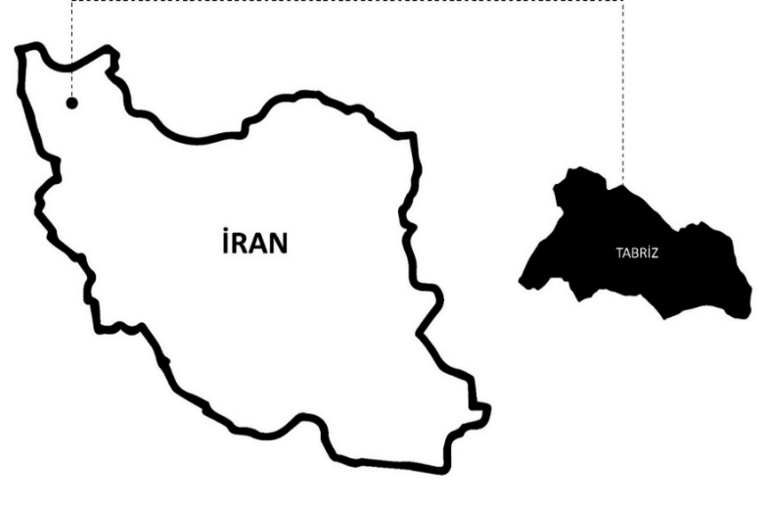

Figure 4. The position of Tabriz in Iran

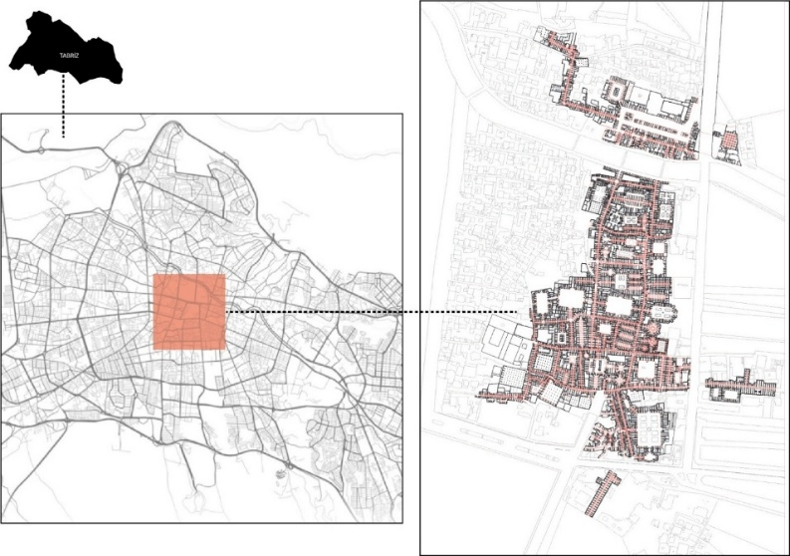

Figure 5. Tabriz Historical Grand Bazaar’s position in the city

Tabriz Historical Grand Bazaar forms the traditional nucleus, surrounded by gradually modernizing neighborhoods that have developed concentrically around this historic core. The complex comprises an extensive network of main arastas totaling 5.5 km in length, connecting multiple functional zones and major urban landmarks, including the Arg-e Tabriz citadel to the north, the Jame Mosque complex to the south, the Saheb-ol-Amr Mosque to the east, and wholesale trading areas to the west (Figure 5).
The plan of the Tabriz Historic Grand Bazaar, one of the most significant brick structures in the world, is organized around two main axes: North-South and East-West (Figure 6). Spanning 27 hectares, it includes arastas that stretch over 5.5 kilometers. The width of the arastas within the bazaar varies between 2 and 5 meters, while the height of the roofs forming the upper coverings of the arastas ranges from 5 to 6 meters. The bazaar's arastas are interconnected, and within the spaces between these axes are mosques, madrasas, and caravanserais. Additionally, domed crossroads structures known as char-suqs were built at the points where these axes intersect.

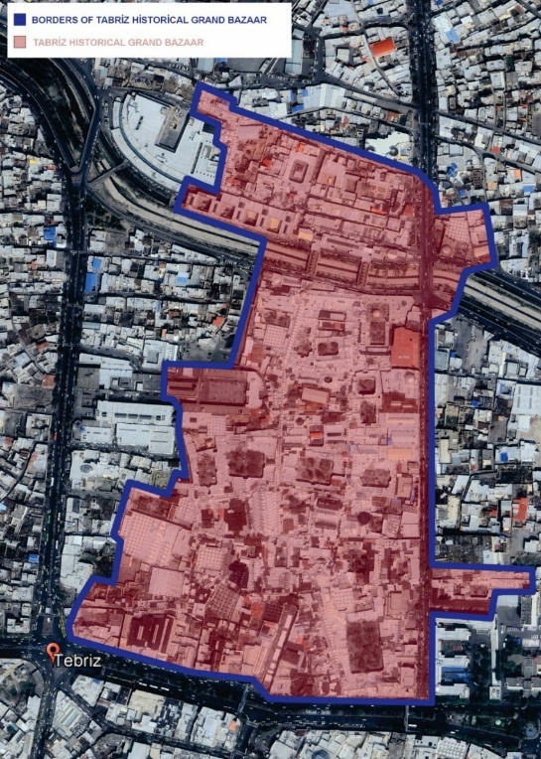

Figure 6. The boundaries of the Tabriz Historical Grand Bazaar as delineated in 1956 [21].

The Sadık-iye Char-suq is located in the northern section of the bazaar, approximately 1.2 km from the main southern entrance, at the intersection of the bazaar's two principal axes, where it serves as the geometric and functional nucleus of the entire complex. This strategic positioning at the convergence of four major arastas, surrounded by diverse architectural elements such as shops, inns, madrasas, and mosques, establishes it as the central organizing element that reflects the rich cultural and commercial life of the bazaar (Figure 7). The Char-suq was intentionally designed to integrate these varied functional spaces while maintaining the organic layout typical of grand bazaars, thereby functioning as a unifying element that reinforces the coherence of the entire complex. The Sadık-iye Char-suq holds multifaceted significance within its urban context: as a spatial organizer, it channels and distributes multi-directional pedestrian movement through its interconnected passages; architecturally, its elevated dome serves as a visual landmark and anchor visible from considerable distances throughout the bazaar; socially, it functions as a vital gathering point deeply embedded in local collective memory; and structurally, it demonstrates remarkable articulation by managing the intersection of several vaulted systems while integrating circulation, structure, and form into a unified architectural composition that achieves both technical coherence and spatial clarity [22]. Recent spatial analyses confirm that Char-suq structures, such as Sadık-iye, not only serve as circulation nodes but also as socio-cultural anchors that enhance integration and user interaction. Their architectural and functional proximity to timchehs, sārās, and religious institutions supports multi-dimensional use and social cohesion. However, recent urban interventions and reduced permeability in surrounding areas have diminished their traditional function, underscoring the need for thoughtful revitalization strategies to reestablish their integrative role within the bazaar complex [25].

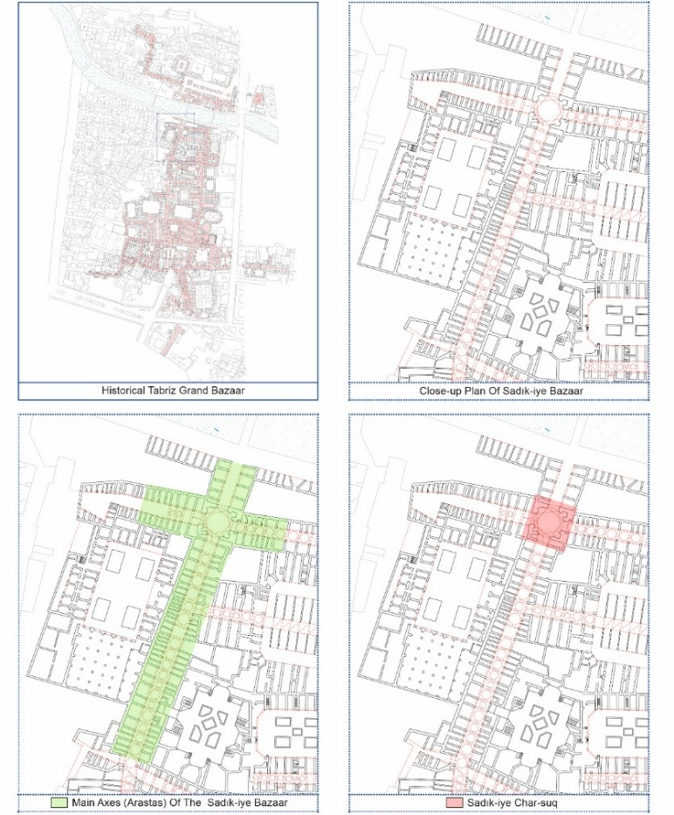

Figure 7. Location of the Sadık-iye Char-suq within the Tabriz Historical Grand Bazaar.

Fieldwork carried out at the Sadık-iye Char-suq, located in the northern section of the Tabriz Historical Grand Bazaar, shows that the structure occupies a central position at the junction of two principal axes, labeled A and B in the visual and indicated with a red line (Figure 8). Additionally, nine spatial units within the bazaar are connected to the Sadık-iye Char-suq and its main axes, as illustrated in a separate visual representation (Figure 9). As part of the study, a visual scheme was developed that numbered the buildings, such as shops, madrasas, and mosques, located along the primary and secondary axes. The general information, statistical data, and structural characteristics of these buildings are presented in detail in a table (Table 2).

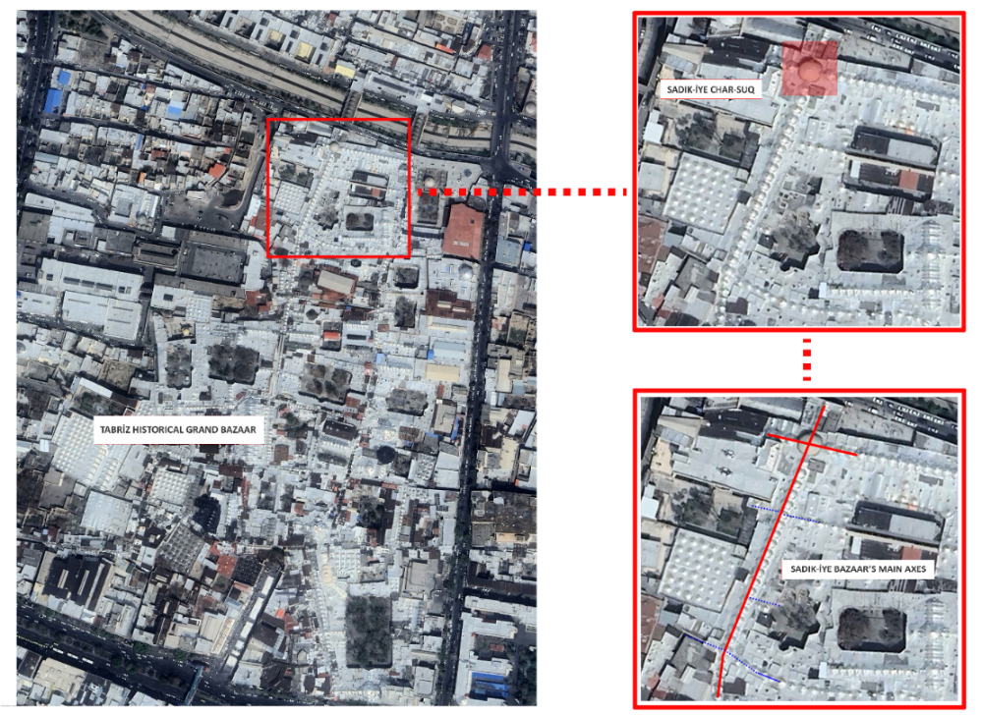

Figure 8. Sadık-iye Bazaar’s principal axes and the Sadık-iye Char-suq

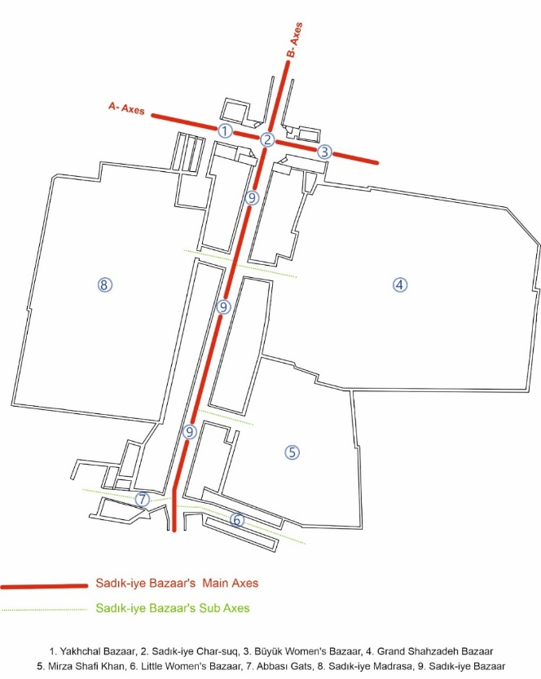

Figure 9. The main axes of the Sadık-iye Bazaar and the spatial units within the bazaar

Table 2. General Analysis of the Sadık-iye Bazaar

General Information | Details
Location | North of the Tabriz Historical Grand Bazaar
Number of Shops | 77
Number of Madrasas | 1
Number of Inns | 1

Statistical/Structural Information | Details
Number of Arches | 77
Arch Form | Low-Pointed Arch
Number of Columns | 50
Bazaar Width | 4–5,5 meters
Bazaar Height | 3,20–4,90 meters
Plan Form | Systematic-Organic

The table and visuals emphasize the significance of the Sadık-iye Char-suq as both an architectural and functional nucleus within the organic layout of the Tabriz bazaar. Its systematic and organic plan, which connects different functional structures, underscores its role as a central hub for commerce, culture, and social life in the historic urban setting.

RESULT AND DISCUSSION

3.1 SURVEY AND TRIANGULATION METHOD OF SADK-IYE CHAR-SUQ STRUCTURE
The plan of the Sadık-iye Char-suq was drawn using the triangulation method based on on-site survey work, allowing step-by-step observation of its development. Triangulation is among the most effective methods for analyzing historical structure plans and systematically advancing a drawing technique. A steel tape, one of the most commonly used tools, was used to divide the structure’s plan into triangles measured from a consistent height, which were then combined to produce the survey drawing.
The survey begins with the most significant area, where diagonal measurements are taken from a baseline to divide the space into triangles. When taking measurements, it is essential to form triangles that are as close to equilateral as possible to minimize potential errors. Wall openings, such as windows and doors, are measured by creating triangles and extending the measurement lines to the corresponding corners. Additionally, this method is used to determine the thickness of walls within the interior spaces. This systematic measurement process is applied to all spaces, accounting for their spatial relationships to develop a comprehensive plan for the area.
Accordingly, the step-by-step survey of the Sadık-iye Char-suq produced through triangulation (Figure 10) provides a graphic representation of the technical drawings shown in Image 8. The octagonal plan of the Char-suq was drafted from a single reference point, extending measurement lines to different locations within the space to create equilateral triangles. As these triangles were assembled, the technical drawing reached its final form, representing the octagonal plan of the Char-suq.

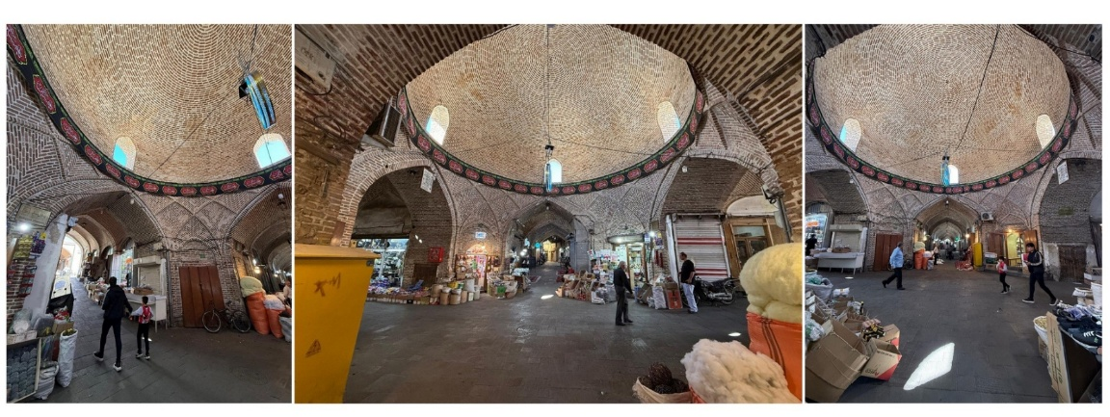

Figure 10. Sadık-iye Char-suq interior views

In the initial survey stage, one corner of the interior facade was marked as the starting point. A line was drawn from this initial point to the corner of another facade to create the building's plan, determining a second point (Figure 11-A). Another line was drawn from the first starting point to the corner of yet another facade, and the three points obtained were connected to form the first triangle (Figure 11-B). In the next stage, a new reference corner was identified within the interior to create another triangle, keeping one side of the initial triangle fixed. The second triangle was created by joining it to the second reference corner using one side of the first triangle as an equilateral edge. Figure 11-C illustrates the three triangles drawn, detailing the connections of their equilateral sides with expansions C1, C2, and C3. The number of triangles was increased by systematically selecting new reference corners from the interior facades and connecting measurement lines accordingly (Figure 11-D). The octagonal Char-suq plan was developed using the triangulation method, in which each corner was used as the corner of new triangles. The stages followed in this regard are presented in diagrams E, F, G, and H in Figure 11. Finally, as indicated in diagram I, the voids and wall thicknesses along the arastas within the space were drawn using the same method, resulting in the systematically designed plan of the Sadık-iye Char-suq (Figure 11).

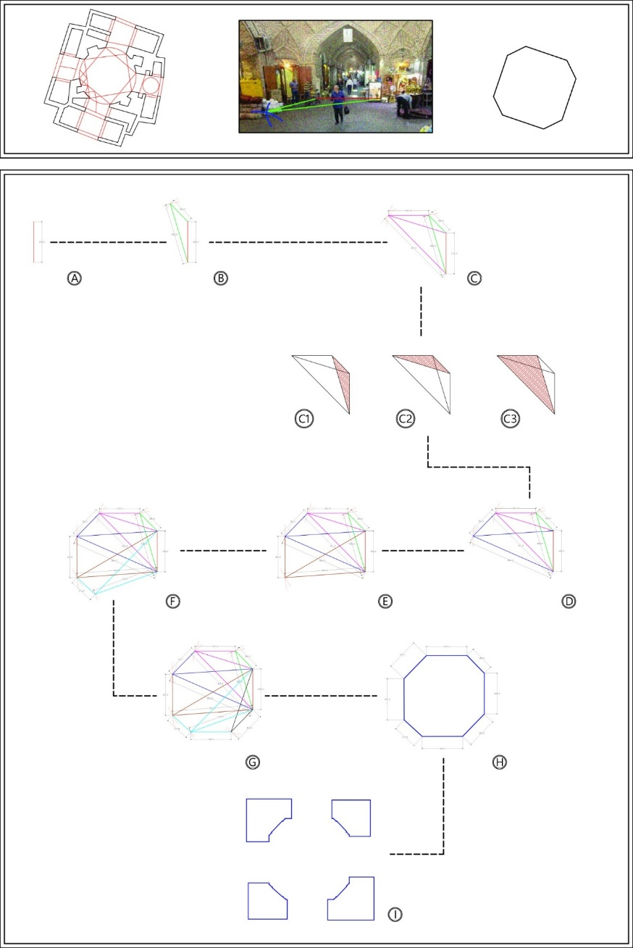

Figure 11. Drawing of the Sadık-iye Char-suq survey using the triangulation technique.

3.2 POSITIONING OF THE SADK-IYE CHAR-SUQ STRUCTURE ON ARASTAS
The area where the arastas of the Sadık-iye Bazaar intersect defines the Sadık-iye Char-suq structure as a central space at the junction of four roads. This central area, which serves as a focal or nodal point within the systematic plan, is grand with the same overhead structure as the rest of the Sadık-iye Bazaar, thereby integrating the Char-suq into the bazaar and preserving the overall structural unity and continuity of the axes. The primary focus of the study is the orientation of the principal axes forming the Char-suq, which, although they do not intersect at right angles, are planned at specific angles to support the layout and development of the surrounding urban area. In this context, the Sadık-iye Char-suq was designed with an octagonal plan that, despite its organic integration into the urban fabric, preserves an internally systematic form in response to the intersecting axes that do not meet at right angles. The angles at which the arastas intersect and the positioning of the Sadık-iye Char-suq along these angles are illustrated through diagrams (Figure 12).

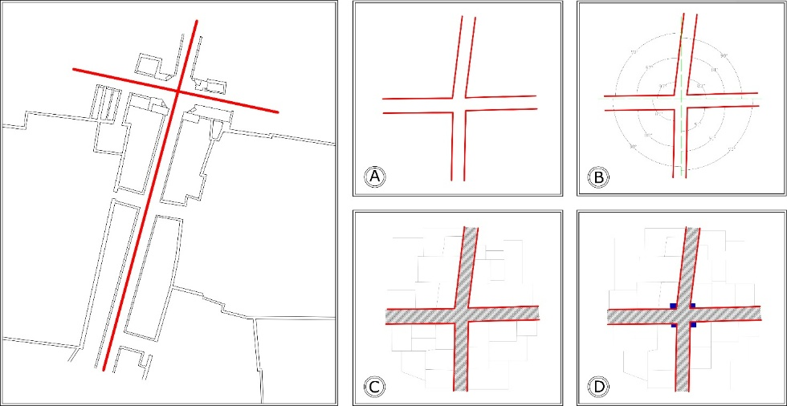

Figure 12. Graphic analysis of the arastas forming the Sadık-iye Char-suq

In parallel with the city's development, the study also examines the systematic method by which the arastas, which had progressed organically, were connected to the Char-suq structure and the determination of the angular change in this articulation. The triangulation method, used to analyze the octagonal plan of the Char-suq, was similarly employed to determine the angles of the arastas and to explore the systematic connection technique (Figure 13).
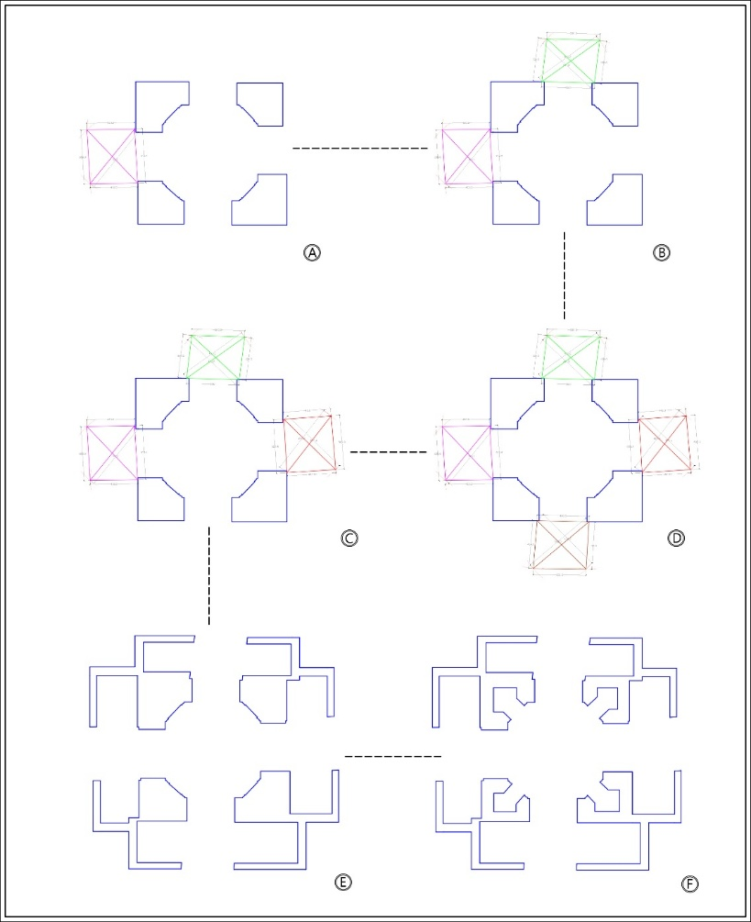

Figure 13. Drawing stages of the arastas connecting to the Sadık-iye Char-suq

During the research process, the on-site survey work, along with the methods used and data obtained, enabled the comprehensive drawing of the Sadık-iye Char-suq structure and the plan of the arastas connecting to it from four directions. Accordingly, the drawn plans were analyzed to explore the integrated design of the Char-suq and the arastas, one of the study’s main focuses. The survey revealed that in the design and construction process of the Char-suq, the arastas connecting to the structure from four directions were systematically integrated by positioning the columns forming the Char-suq’s load-bearing system in a crosswise arrangement based on the advancement angles of the arastas (Figure 14). The primary load-bearing columns of the Char-suq, positioned crosswise, were designed and manufactured with precise dimensions. However, the columns were smaller in sections with greater arasta connection angles to reduce angular discrepancies. These technical adjustments were visualized in a graphic illustration that shows the overlapping angles and measurement variations (Figure 15). It was observed that the variations in the angles and dimensions of the columns forming the Char-suq helped maintain the continuity of the bazaar’s arastas while also supporting the systematic planning of the Char-suq itself.

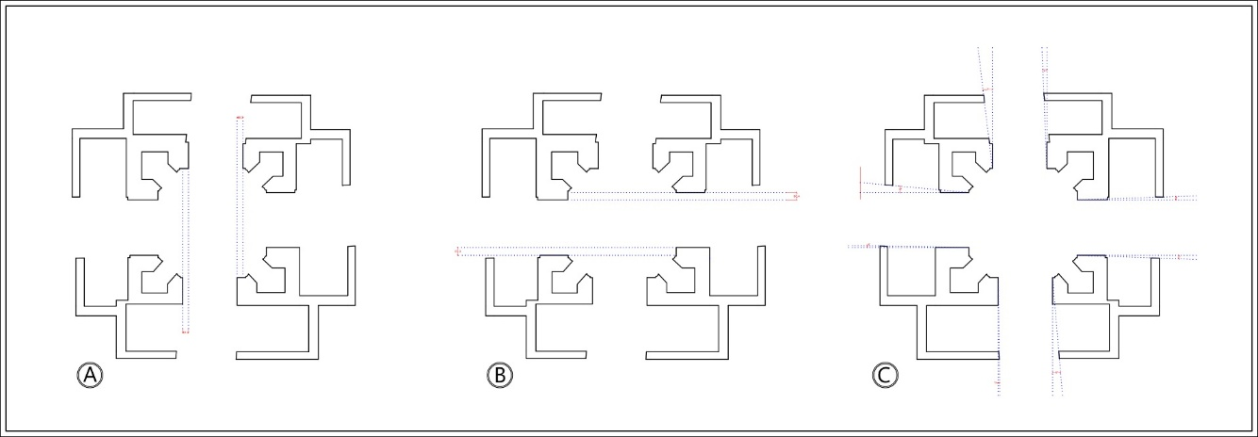

Figure 14. Dimensional and angular differences of the arastas of Sadık-iye Char-suq

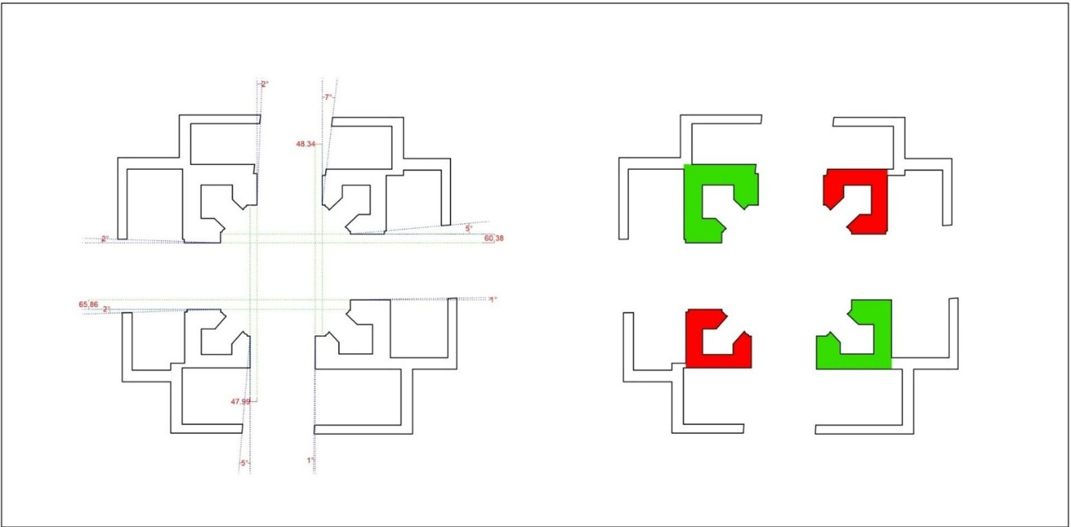

Figure 15. Dimension and angle differences of the primary load-bearing columns of Sadık-iye Char-suq

3.3 STRUCTURAL ANALYSIS OF THE SADIK-IYE CHAR-SUQ STRUCTURE
In line with the survey findings from this research, the design and construction phases of the Char-suq structure were examined to analyze its load-bearing system. This study section progressively explores the structure's vertical load-bearing elements and distribution of static forces by providing detailed two-dimensional and three-dimensional drawings of the Char-suq’s plans and sections (Figure 16).
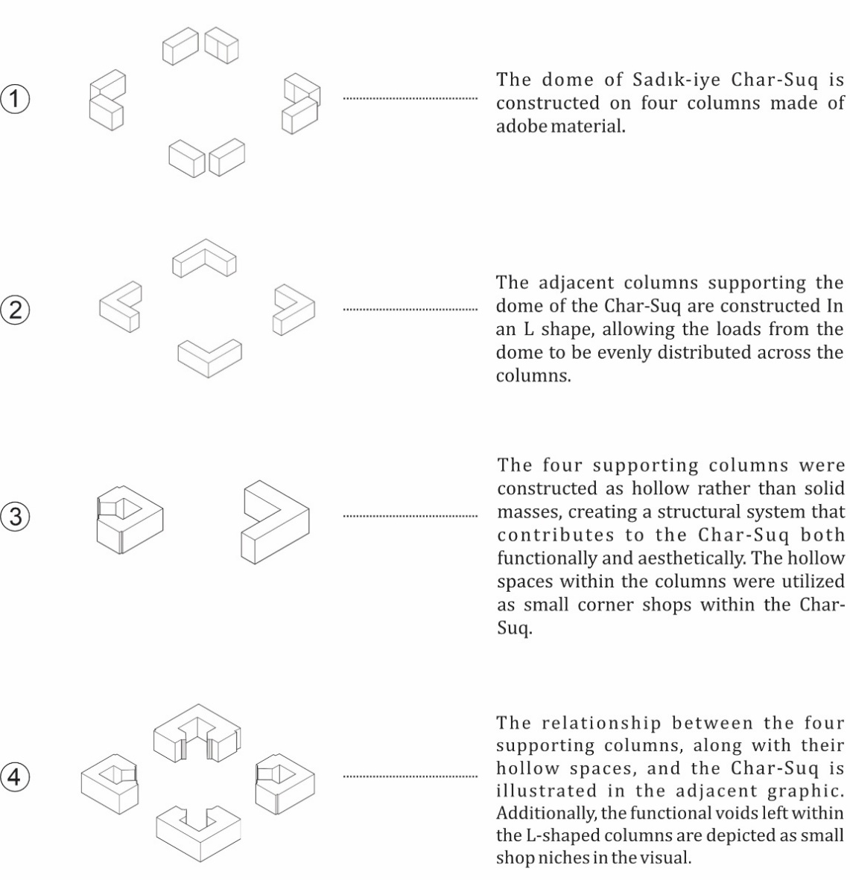

Figure 16. Analysis of the Vertical Load-Bearing Elements

Based on the technical analyses of the Sadık-iye Char-suq structure, it has been determined that the octagonal plan of the Char-suq is topped with a double-shelled dome. It was observed that the primary reason for using a double shell for the upper covering was to ensure that the static forces at the dome’s highest point were evenly distributed across its entire surface, thereby enhancing the upper covering's strength. In this context, the double-shelled dome system is crucial in evenly distributing the existing loads to the supporting columns (Figure 17). Thus, this element also contributes to the building's structural resilience.

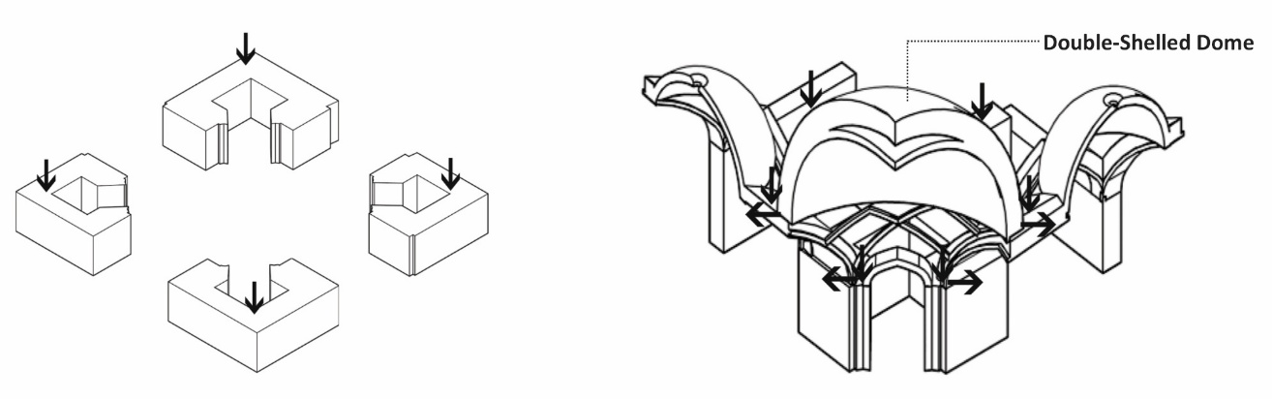

Figure 17. Double-Shelled Dome System of the Sadık-iye Char-suq

Another element supporting the load distribution between the dome and the columns while enhancing the Char-suq structure's visual appeal is the karbandi ornamentation technique. This transitional element, commonly found in Iranian dome architecture, is built before the dome and serves as its structural base (Figure 18). The karbandi ornamentation thus plays a dual role: it facilitates the transfer of the dome’s weight to the columns and adds aesthetic value to the structure through its decorative function [23].

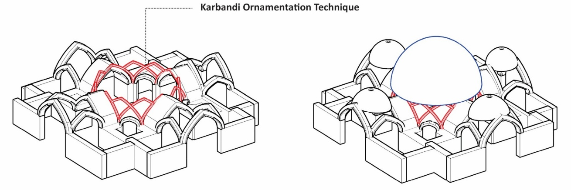

Figure 18. The Karbandi Techniques in the Sadık-iye Char-suq

In Iranian architecture, karbandi elements are commonly applied using plaster materials. However, in the Sadık-iye Char-suq, the dome's interior features karbandi elements made of adobe bricks. This choice was observed to enhance the uniform distribution of static forces towards the columns, contributing to the support of the dome’s mass (Figure 19).

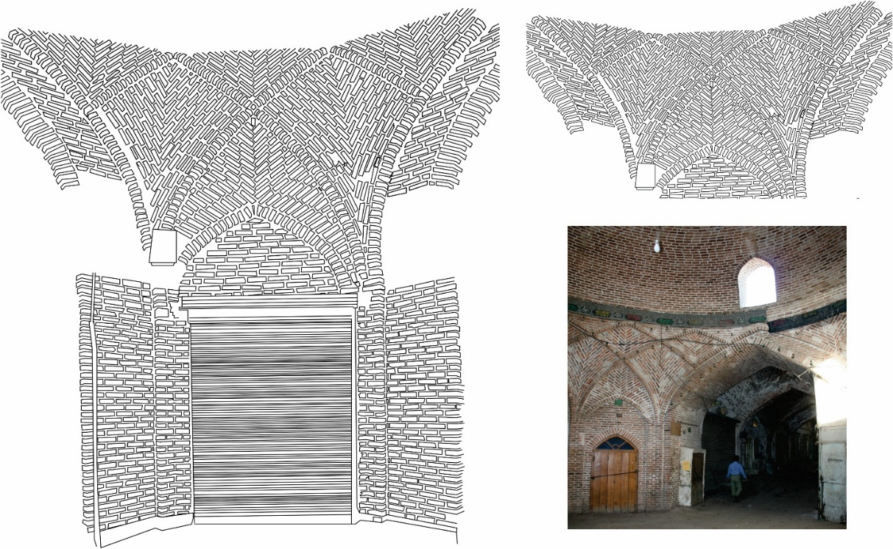

Figure 19. Karbandi elements on Sadık-iye Char-suq Dome

3.4 STRUCTURAL ANALYSIS OF SADIK-IYE CHAR-SUQ
Within the scope of this research, plans, sections, and three-dimensional drawings of the Sadık-iye Char-suq structure were created based on the data obtained from the survey studies conducted. The construction phases, building techniques, and planning systematics of the structure were analyzed accordingly. In this section, the plan of the Sadık-iye Char-suq and the axes of the arcades connected to the structure are illustrated on a two-dimensional graphic, complete with measurements (Figure 20).

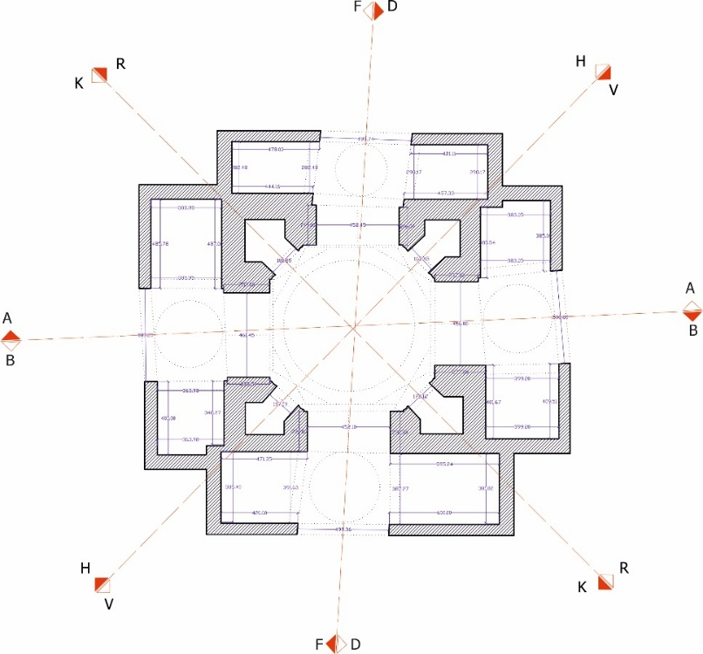

Figure 20. Sadık-iye Char-suq Plan

Eight sections were extracted from Char-suq's plan drawing and included in the study as section drawings (Figure 21). These section drawings aim to provide a better understanding of the structure and clearly illustrate the connections between its upper coverings and the load-bearing system.

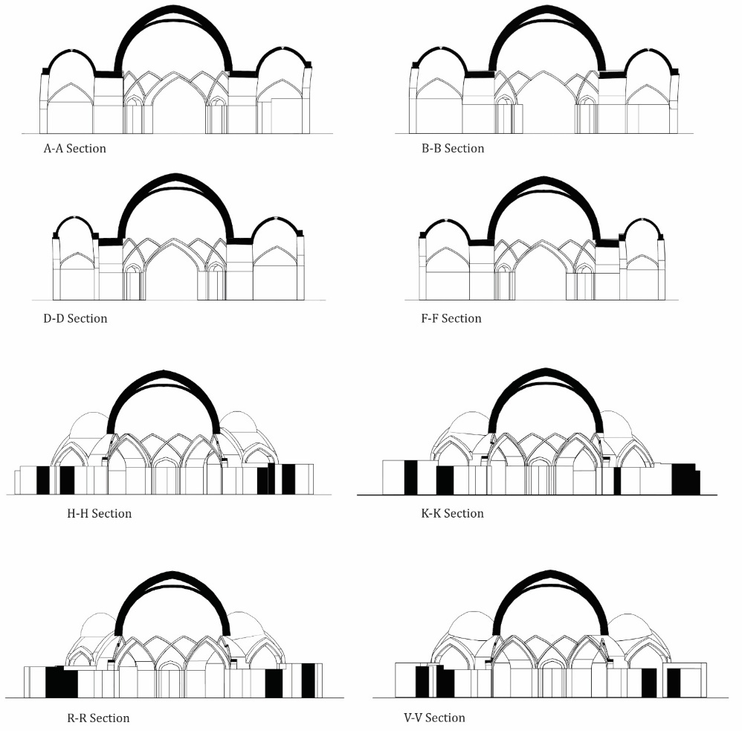

Figure 21. Sadık-iye Char-suq Section Drawings

Additionally, perspective sections were generated from these drawings, illustrating the building’s three-dimensional structural details (Figure 22). This approach enables a more detailed understanding of the double-shelled dome system, which contributes to the load-bearing structure and clarifies the structural relationship between the central dome and the four smaller domes above the connection pathways to the arcades.

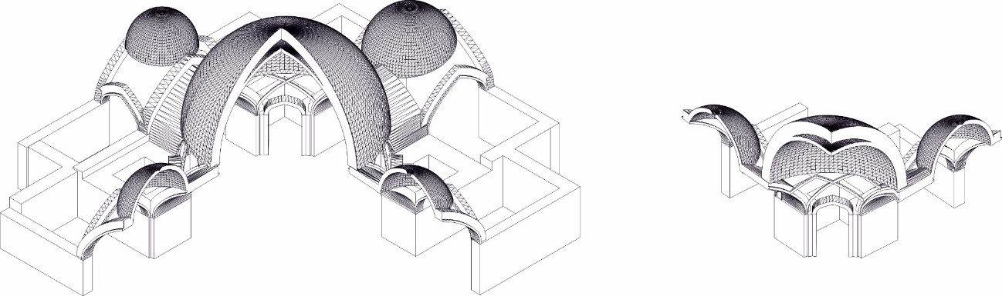

Figure 22. Sadık-iye Char-suq Perspective Section Drawings

In the final stage, the assumed construction phases of the Char-suq structure were determined based on field measurements, drawn plans, sections, and on-site observations, resulting in a graphic narration (Figure 23).

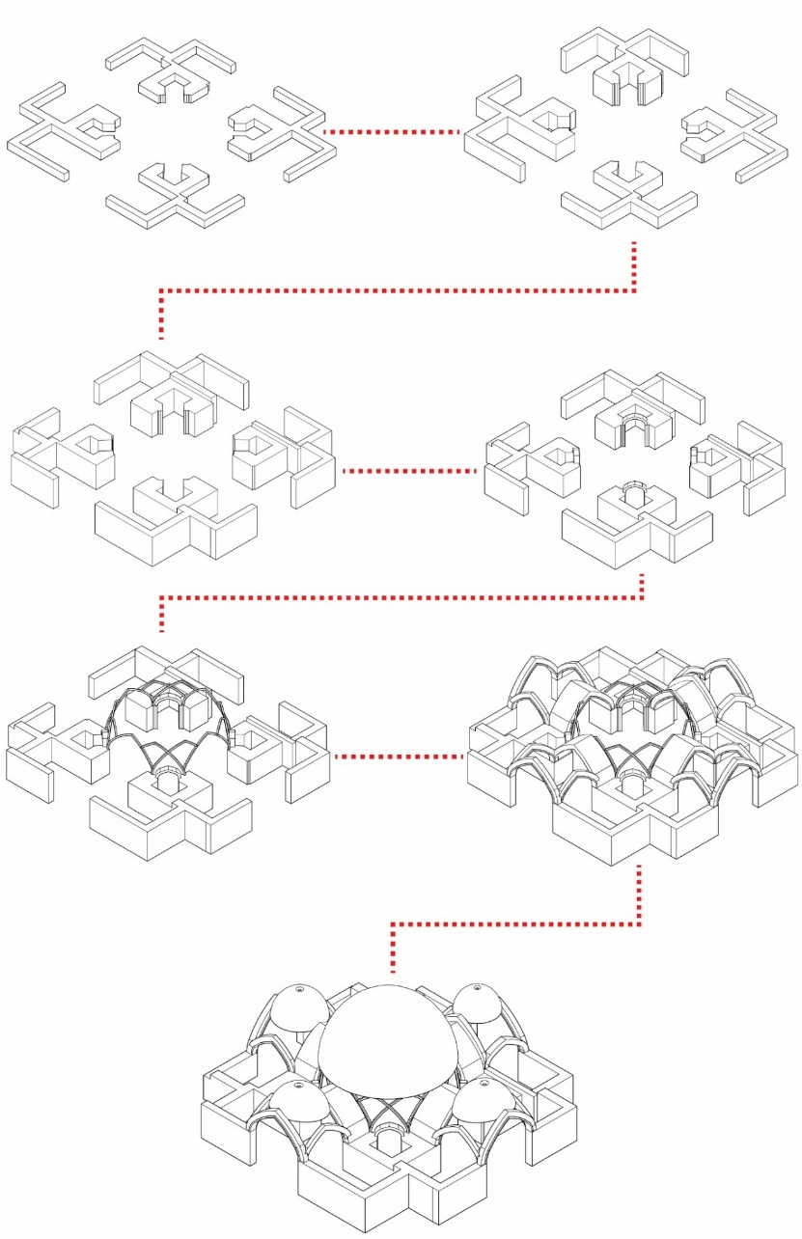

Figure 23. Hypothetical Construction Stages of the Sadık-iye Char-suq

CONCLUSION
The Historic Tabriz Bazaar, originally established within a residential fabric, gradually evolved into an organic commercial center as economic activities intensified. The transformation of existing streets into planned arastas marked a significant phase in this evolution, reflecting a deliberate urban intervention that preserved spatial continuity while safeguarding property owners' legal rights. Within this context, the present study conducted detailed on-site measurements of the Sadık-iye Char-suq using the triangulation method to document its geometric configuration, spatial relationships, and structural characteristics with precision. The collected measurements supported the development of two and three-dimensional technical drawings, providing a comprehensive foundation for understanding the building's architectural and structural logic.
The structural analysis demonstrates that the Sadık-iye Char-suq represents a sophisticated architectural response capable of integrating systematic geometric principles within an organically developed urban fabric. The double-shelled dome distributes loads efficiently across the octagonal plan, producing an interior space that is both structurally sound and visually expressive. The supporting columns, designed with dimensional and angular variations to harmonize with the non-orthogonal orientations of the surrounding arastas, reveal an advanced construction strategy far ahead of its time. Moreover, the use of adobe brick karbandi elements, rather than traditional plaster, provides both structural support and a refined aesthetic transition, reinforcing the architectural coherence of the space.
The triangulation-based documentation process captured the complex spatial conditions of the Char-suq with high accuracy, revealing its angular irregularities, structural adaptations, and hidden geometric order. One of the study’s most noteworthy findings is that the directional shifts of the arastas are, in fact, shaped by the geometric logic of the Char-suq itself. In other words, the Char-suq not only accommodates the organic axes of the bazaar but simultaneously directs and regulates them, functioning as a morphological control center rather than a passive intersection. This demonstrates that the apparent simplicity of the octagonal plan conceals an intricate system of spatial adjustment and equilibrium designed to reconcile the organic layout of the bazaar with geometric discipline.
Accordingly, the Sadık-iye Char-suq emerges as a central architectural core that unifies the structural stability, circulation logic, and spatial hierarchy of the bazaar. It is not merely a junction of four arastas, but an organizing element that guides multi-directional pedestrian movement and contributes to the bazaar’s visual and spatial identity. Its elevated dome serves as a visual landmark, creating a distinct spatial experience that distinguishes the intersection from the continuous commercial corridors along the arastas.
The findings of this research contribute to a deeper understanding of how traditional Middle Eastern bazaar architecture resolved complex spatial and structural challenges. They further demonstrate that systematic architectural planning and organic urban development are not mutually exclusive, but can be harmonized through deliberate design strategies. The integration of load-bearing requirements, circulation patterns, commercial functionality, and aesthetic considerations within a single architectural system provides valuable insights for contemporary conservation and adaptive reuse practices.
Although this study offers a detailed examination of the architectural and structural characteristics of the Sadık-iye Char-suq, it does not include an in-depth analysis of construction materials or their deterioration patterns. Future research could focus on the material properties of Char-suq structures, including brick composition, mortar characteristics, karbandi construction techniques, and seismic performance of traditional materials, thereby expanding the technical knowledge base for conservation efforts. Comparative studies of Char-suq structures in major bazaars across Asia and the Middle East, such as Isfahan, Kerman, Tehran, Bukhara, and Tashkent, would also provide meaningful insights into regional variations, construction traditions, and typological parallels. Furthermore, exploring the contemporary socio-economic functions and usage patterns of Char-suq spaces may help develop sustainable strategies for integrating these heritage structures into modern urban life without compromising their historical and cultural significance.

AUTHORS CONTRIBUTION
Author 1 (N.B.Y.) and Author 2 (A.A.) jointly conceptualized the research idea and developed the theoretical framework. Author 2 conducted the on-site measurements and produced the technical sketches and drawings. Author 1 developed the methodology and led the data analysis. Both authors participated in the fieldwork at the Tabriz Historical Grand Bazaar and collaboratively organized the study’s findings, shaping the overall conclusion. Authors 1 and 2 discussed the results and contributed equally to the preparation and finalization of the manuscript.

REFERENCES
- Executive Summary Tabriz Historical Bazaar Complex. UNESCO World Heritage Convention, Tehran: Iranian Cultural Heritage, Handicrafts, 2009.
- Z. Opacic, "Mapping Ottoman Cities: Matrakçı Nasuh’s Urban Imagery," in Cities in the Premodern Islamic World, A. K. Bennison, Ed., London, Routledge, 2007, pp. 132-155.
- N. Babazadeh Asbagh, "A Short Glimpse to the Urban Development of Tabriz during the History," Journal of Contemporary Urban Affairs, vol. 3, no. 1, pp. 73-83, 2019. doi: Doi:10.25034/ijcua.2018.4703.
- D. T. Kejanlı, "Urban System, Castle and The Development Of Centered Bazaar In Seljuk And Ottoman Perıods In Anatolıa," E-Journal of New World Sciences Academy, vol. 5, no. 3, pp. 287-303, 2010. doi: https://doi.org/10.12739/10.12739.
- M. Pourjafar, M. Amini, E. Hatami Varzaneh and M. Mahdavinejad, "Role of bazaars as a unifying factor in traditional cities of Iran: The Isfahan bazaar," Frontiers of Architectural Research, vol. 3, no. 1, pp. 10-19, 2013. doi: https://doi.org/10.1016/j.foar.2013.11.001.
- F. A. Bishara and N. Chatterjee, "Introduction: The Persianate Bazaar," Journal of the Economic and Social History of the Orient, vol. 64, no. 5-6, pp. 487-510, 2021. DOI: https://doi.org/10.1163/15685209-12341544.
- A. N. Ebrahimi, F. P. Rahimian and M. S. Loron, "Impacts of urban passages on formation of iranian bazaars: Case study of the historic bazaar of Tabriz," International Journal of Architectural Research, vol. 2, no. 7, pp. 61-75, 2013.
- K. Haj Gasemi, "Bazaar Buildings," in Ganjnameh, Cyclopedia of Iranian Islamic Architecture, vol. 9, Tehran, Shahid Beheshti University Press, 2004, pp. 15-16.
- D. Hasol, Encyclopedic Dictionary of Architecture, vol. 18, İstanbul: Yem Publication, 2020, p. 42.
- D. Kuban, "Some Observations on the Anatolian-Turkish City, its Development and Social and Physical Characteristics," Foundations Journal, vol. 7, no. 12, pp. 53-73, 1968.
- T. Mahesh, A. Assari and E. Assari, "Conservation of historic urban core in traditional Islamic culture: case study of Isfahan city," Indian Journal of Science and Technology, vol. 12, no. 15, pp. 1970-1976, 2012.
- A. A. Dehkhoda, Dictionary of Dehkhoda, vol. 7, Tehran: Shazman-i Logatnameh, 1974.
- F. T. Yaşar and A. Yaşar, "From an Arasta Bazaar to a Piyasa Street: The Transformation of Direklerarası in Ottoman Istanbul from the 1720s to the 1920s," Middle Eastern Studies, vol. 02, no. 61, pp. 165-181, 2024. doi: https://doi.org/10.1080/00263206.2024.2384877.
- A. Rajabi, Morphology of Historical Bazaars, Tehran: Agah Press, 2006, pp. 20-25.
- M. R. Pourjafar, G. Samani, A. Pourjafar and R. Hoorshenas, "Archi-Cultural Parallel Of Persian and Turkish Bazaar Along The Silk Road Case Studies: Rey, Tabriz and Istanbul Bazaar," in 2nd International Conference, Mukogawa Women’s Univ, Nishinomiya, Japan, 2012.

- A. Rastiemadabadi, J. S. Bel and M. P. Marcilla, "Reading an adaptable urban form: Exploring the morphological patterns of the Iranian traditional bazaar," International Journal of Urban Sciences, vol. 12, no. 25, pp. 1-25, 2025. doi: https://doi.org/10.1080/12265934.2025.2452505.
- M. Ziyaee, "Revitalization of Cultural and Aesthetical Assets of Iranian Traditional Bazaar," ICONARP International Journal of Architecture and Planning, vol. 5, no. 2, pp. 234-251, 2017. DOI: https://doi.org/10.15320/ICONARP.2017.34
- M. Garipour and K. Esmailzadeh, Bazaars in Islamic Cities: Design, Culture and History, Tehran: Nagshe Mana Press, 2017.
- F. Zoughi and A. Niknamlaleh, Tabriz in the passage of history (Historical ID card of Tabriz), Tabriz: Yaran Press, 2001, pp. 83-85.
- V. Eilaei and B. I. Aksulu, "The Formation of Living World Heritage Traditional Urban Pattern (Case Study: Iran-Tabriz Grand Bazaar Complex)," Journal Of Urban Academy, vol. 16, no. 2, pp. 22-38, 2023. doi: https://doi.org/10.35674/kent.1206662.
- Airplane image in 1956 from bazaar of Tabriz and its main pathways - Accessed 2012, Tabriz: National Cartographic of Iran, 1956.
- H. Esmaili Sangari, History and Architecture of Tabriz Bazaar, Tabriz: Sotude Press, 2008.
- M. Pour Ahmadi, "A Basic Method for Naming Persian Karbandis Using a Set of Numbers," Nexus Network Journal, vol. 5, no. 16, pp. 313-343, 2014. doi: https://doi.org/10.1007/s00004-014-0192-x
- R. Prazniak, "Tabriz on the Silk Roads: Thirteenth-Century Eurasian Cultural Connections," The Asian review of World Histories, vol. 1, no. 2, pp. 168-188, 2013. DOI: https://doi.org/10.12773/arwh.2013.1.2.169.
- S. Ainechi and N. Valibeig, "Architectural and Structural Analysis of Special Karbandis of Tabriz Historical Bazaar," Journal of Research on Archaeometry, vol. 5, no. 15, pp. 73-89, 2021.
- S. Golkarian and Z. Onur, "Cultural Challenges Between Local and Western," Milli Folklor International Journal of Cultural Research, Vols. 179-197, no. 132, pp. 3-4, 2021.
- R. N. Nabi and J. Mehdinezhad, "Evaluating the Role of Physical and Functional Factors in the Socialization of Traditional Iranian Markets Using Space Syntax Technique (Case Study: Tabriz Bazaar)," Baghe-Nazar, vol. 17, no. 85, pp. 67-82, 2020. DOI: 10.22034/BAGH.2020.182777.4088.
- M. Yeganeh and H. A. Mofidi, "Socio-Economic Values and Architectural Features in Traditional Bazaars of Islamic Cities," Urban management, vol. 10, no. 42, pp. 149-162, 2016.
- H. Melville, "Historical Monuments and Earthquakes in Tabriz," Iran: Journal of the British Institute of Persian Studies, vol. 19, no. 1, pp. 159-177, 1981. doi: https://doi.org/10.1080/05786967.1981.11834277.

