 |  | JOURNAL OF ISLAMIC ARCHITECTURE  P-ISSN: 2086-2636 E-ISSN: 2356-4644  Journal Home Page: http://ejournal.uin-malang.ac.id/index.php/JIA
ENVIRONMENTAL ADAPTATION IN ISLAMIC ARCHITECTURE: EVALUATING THE SAHEB-OL-AMR MOSQUE IN THE URBAN CONTEXT OF TABRIZ
Peyman Naghipour¹, Hassan Sattari Sarbangholi^{2*}
¹Department of Architecture, Ta.C., Islamic Azad University, Tabriz, Iran
²Department of Architecture and Urban Planning, Ta.C., Islamic Azad University, Tabriz, Iran
*Corresponding Author: sattari@iau.ac.ir
ARTICLE INFO |  |  | ABSTRACT
Volume: 9  Issue: 1  Page: 387-408  Received: October 10th, 2025  Accepted: December 2nd, 2025  Available Online: June 30th, 2026  DOI: https://doi.org/10.18860/jia.v9i1.36854 |  |  | This research aims to assess the level of environmental compatibility in Islamic architecture and conduct a case study of the Saheb-Ol-Amr Mosque in the urban context of Tabriz. The main focus of the research is to identify the architectural elements that have adapted the design of this mosque to the surrounding climatic, cultural, and physical conditions. The main issue of the research is the lack of analytical studies on how Islamic architecture responds to environmental requirements at the urban scale, especially in the case of the Saheb-Ol-Amr Mosque, a building that, despite its historical and cultural significance, has been less studied from an environmental sustainability perspective. In this regard, this research seeks to answer the following questions: 1- What architectural elements and solutions in the design of the Saheb-Ol-Amr Mosque have helped it adapt to the climatic and environmental conditions of Tabriz? 2- How has the Saheb-Ol-Amr Mosque established physical and environmental interaction with its surrounding urban fabric in Tabriz? The research method is qualitative and analytical, and has been conducted through field observation, architectural impressions, and the analysis of historical documents and library resources. Also, contextualist and climatic architecture approaches have been used in data analysis. The research findings show that the design of this mosque, in terms of lighting, natural ventilation, selection of local materials, and spatial arrangement, is highly compatible with Tabriz's climate and has established an effective link with its urban and cultural context. In conclusion, the Saheb-Ol-Amr Mosque is a successful example of coexistence between Islamic architecture and environmental conditions, serving as a model for the design of contemporary religious spaces in similar climates. The important outcome of this research is the revival of forgotten indigenous patterns in line with the development of sustainable urban architecture. The main value of the research lies in its innovative assessment of the environmental compatibility of a less-studied religious building and in its interdisciplinary approach to the analysis of Islamic architecture.  Keywords:  Environmental Sustainability; Islamic Architecture; Tabriz Saheb-Ol-Amr Mosque; Urban Texture; Climate; Cultural and Physical; Design of Religious Spaces

INTRODUCTION
The main subject of this research is the study of environmental compatibility in Islamic architecture, focusing on the analysis of the Saheb-Ol-Amr Mosque in the urban context of Tabriz. This research seeks to understand how the architectural design of this mosque adapts to the climatic, physical, and cultural conditions of its surrounding environment. The importance of this issue lies in two fundamental dimensions: first, rereading the hidden and efficient principles of traditional Islamic architecture that have been able to provide intelligent and sustainable responses to the natural environment over the past centuries; and second, utilizing these principles to solve the challenges of contemporary architecture, especially in the field of climate-friendly design and optimal energy consumption in urban contexts. In a situation where modern architecture has often neglected contextualism and harmony with the environment [1][2], returning to indigenous teachings can be a way to produce sustainable architecture. The Saheb-Ol-Amr Mosque, with its distinctive features, is a valuable example of this approach. Its detailed study can provide a practical model for architects and researchers to develop contemporary designs with Islamic identity and environmental compatibility.
At the beginning of any scientific research, it is essential to review the background and history of the subject, because only with sufficient knowledge of the existing shortcomings and needs can the research path be properly started. Accordingly, this article provides a brief review of recent research and summarizes its results in Table 1.

Table 1. Research Background.
Research Reference | Year of publication | Results
[3] | 2024 | The results indicated that the city hall, mosques, traditional bazaar, and El-Goli were in a desirable condition in all three styles. A t-test comparing the urban cultural space based on identity components showed that the average evaluations of couples differed significantly by gender, education, and frequency of visits. Still, the purpose of the visit had no effect. Also, Pearson's correlation coefficient confirmed a strong relationship between structural and perceptual identity, while functional-social identity did not show a significant relationship.
[4] | 2023 | The research results show that the door decorations of the Saheb-Ol-Amr Mosque in Tabriz fall into two main groups. The first group includes motifs with religious, especially Shiite, themes that directly refer to Islamic texts and narrations and are mostly seen in the form of written inscriptions. The second group combines Shiite symbols with non-religious elements rooted in superstitious beliefs, often presented in a religious guise. In general, the intellectual and cultural developments of society have provided the basis for the emergence and development of new forms and concepts in art.
[5] | 2022 | The results of this study show that muqarnas exhibit both differences and similarities depending on their location within the building, leading to diversity in spatial classification from a form perspective. Based on the results, these architectural elements are divided into two general groups: internal and external, and can appear in a variety of geometric shapes, such as circular, square, rectangular, or polygonal.
[6] | 2021 | The results indicate that the patterns of Alexander's theory play an important role in strengthening social interactions in local and urban squares. In this context, individual factors are not very influential, but strong centers and spatial contrasts of squares affect residents' social relationships more than empty spaces. Accordingly, architects and urban designers can benefit from these results to improve the design of new squares.
[7] | 2020 | The study compared mosques using Expert Choice software, focusing on façade design factors. Results showed the entrance form (36%) as most significant, followed by entrance components (35%) and façade elements (31%). The Saheb-Ol-Amr Mosque ranked first in entrance form and elements, while the Hajj Safar Ali Mosque ranked highest in entrance components, placing Saheb-Ol-Amr third in that category. Overall, the statistical findings identified the Saheb-Ol-Amr Mosque as the most well-known and significant example among the evaluated mosques.
[8] | 2019 | The research results show that the metalwork made of low-grade silver and brass was produced using various metalworking methods and was inspired by the art of the Qajar period. The special position of the Saheb-Ol-Amr Mosque in Tabriz in the eyes of the people has led to these objects being installed in its space, as such metalwork was used as a tool to fulfill the vows of needy Muslims.
[9] | 2018 | The results of the study show that facilities management (FM) plays a crucial role in maintaining and improving mosques and in strengthening their position as centers of Islamic society. This study, through an extensive literature review, presents a conceptual framework for identifying critical success factors (CSFs) in mosque management and suggests strategies for integrating FM with other management activities. The framework provides a practical model for improving mosque management in Malaysia that can lead to the prosperity of the Islamic society.
[10] | 2017 | The research results show that the historical mosques of Tabriz, with their unique architecture, have an impact on organizing various aspects of human life beyond their worship function. A study of more than 40 mosques using the Delphi method revealed that factors such as spatial organization, structure, decorations, materials, light, entrance method, and connection with the environment are considered the main evaluation indicators. These results provide a basis for a deeper understanding, analysis of strengths and weaknesses, and typological classification of Tabriz mosques.
[11] | 2016 | The results of the research show that Tabriz Bazaar, unlike the linear markets of Tehran, Isfahan, and Shiraz, has a network structure. This network includes main axes, corridors, nodes, timchehs, sarais, caravanserais, and mosques, each of which has had a diverse and dynamic function over time, taking into account social, cultural, and economic dimensions.
[12] | 2015 | The results of this research show that this method is very effective in identifying the structure and analyzing architectural systems. In addition, it can be used in sustainable development processes and can also be considered a useful tool for deconstructing and interpreting architectural texts.
A study of documents, articles, and research related to the Saheb-Ol-Amr Mosque of Tabriz shows that the available information is presented in a scattered manner; however, no specific and independent sources can be found on the topic of "Environmental Adaptation in Islamic Architecture: Evaluating the Saheb-Ol-Amr Mosque in the Urban Context of Tabriz". This research gap reveals the importance and necessity of conducting the present study.
This study introduces a novel approach by emphasizing environmental compatibility in Islamic architecture, a subject often explored in sustainable architecture but rarely examined in depth with respect to historical Islamic examples in Iran, particularly within the urban fabric of Tabriz. Although the Saheb-Ol-Amr Mosque possesses significant historical, cultural, and architectural value, previous research has mostly focused on its aesthetic and historical aspects, neglecting detailed climatic and environmental analyses. The innovation of this research lies in adopting an interdisciplinary perspective, evaluating the mosque not merely as a religious monument but also as an active urban institution that responds to climatic, physical, and social conditions. Using qualitative and analytical methods, the study identifies patterns in design, such as balance, adaptability, unity, and coherence, that ensure harmony with environmental and cultural contexts, offering insights applicable to contemporary sustainable design. Through careful documentation and comparative analysis, it highlights indigenous strategies for optimizing energy use and contextual adaptation. Unlike common works [13][14], focusing on iconic structures like the Grand Mosque of Isfahan or the Sheik Lotfollah Mosque, this research turns to a lesser-studied yet valuable case to revive authentic architectural patterns and provide a regional model for environmentally responsive Islamic architecture.
In the present era, environmental challenges, climate change, and an energy crisis have made it increasingly necessary to review architectural design methods [15][16]. Meanwhile, Islamic architecture, which emerged across different historical periods in Iran, has drawn on valuable experiences in climate adaptation, the use of local materials, and design in harmony with the natural environment [17][18]. However, many works of Islamic architecture have been analyzed only from historical, aesthetic, or symbolic perspectives, with their environmental aspects neglected [19][20]. The Saheb-Ol-Amr Mosque of Tabriz, as one of the valuable examples of religious architecture in the historical urban context of this city, has so far been less carefully evaluated from the angle of environmental compatibility. This mosque was not only formed in the heart of an urban context, but has also been in continuous interaction with the climatic, cultural, and physical conditions around it over time. The main problem of the present research is the lack of analytical studies on how the architecture of this mosque responds to environmental and climatic conditions and its role in shaping sustainable interaction with the surrounding urban context. In fact, this research aims to develop a model for environmentally friendly architecture in contemporary spaces by analyzing the design components of the Saheb-Ol-Amr Mosque.
The main objective of this research is to analyze and evaluate the environmental compatibility of the Saheb-Ol-Amr Mosque in Tabriz, an outstanding example of Islamic architecture within the city's historical urban context. This research seeks to examine the various dimensions of climatic architecture and the responsiveness of this mosque to its surrounding environmental and urban conditions. Among the specific objectives of the research is to identify design features compatible with the region's climate, such as lighting, natural ventilation, the use of local materials, and the spatial arrangement of architectural elements, which have contributed to the mosque's sustainability and environmental compatibility. Also, the research examines the role of the mosque in relation to the surrounding urban context and the extent to which its functional and physical adaptation to the climatic and cultural needs of the residents of the region. In this regard, the research seeks to achieve a deeper understanding of the principles of Islamic architecture through an environmental approach and, by relying on field analyses and historical documents, to reveal the hidden and obvious values in the design of the mosque. Ultimately, this research attempts to present its findings in order to inspire contemporary architects to design sustainable urban spaces in harmony with Islamic culture. For this reason, the present research seeks to answer the following questions:
- What architectural elements and solutions in the design of the Saheb-Ol-Amr Mosque have helped it adapt to the climatic and environmental conditions of Tabriz?
- How has the Saheb-Ol-Amr Mosque established physical and environmental interaction with its surrounding urban fabric in Tabriz?

METHODS
The research method was designed to systematically investigate the environmental compatibility of the Saheb-Ol-Amr Mosque within its urban context. Employing a qualitative, descriptive-analytical approach, the study integrated library research and field observation to gather reliable data. Analytical procedures focused on identifying climatic indicators, conducting comparative and interpretive assessments, and examining urban interactions. Ethical considerations were carefully observed to respect the mosque’s sanctity. This comprehensive framework ensured a rigorous and context-sensitive analysis of the case study. Hence, the methodological process of this study was structured into a series of stages, presented in the following order:

2.1 RESEARCH DESIGN
This study employed a qualitative and descriptive-analytical research design. The qualitative approach was considered most appropriate because the research aimed to explore the environmental compatibility of a historical Islamic monument, the Saheb-Ol-Amr Mosque in Tabriz, within its urban context. Such phenomena cannot be adequately explained by numerical data alone; they require in-depth interpretation of cultural, climatic, and architectural elements. The descriptive dimension focused on documenting the architectural features and historical records of the mosque, while the analytical dimension examined how these features responded to environmental and urban conditions. The design was therefore interdisciplinary, drawing on architectural history, environmental sustainability, and urban contextual analysis.

2.2 DATA COLLECTION
To ensure comprehensive coverage, the study combined library-based research and field-based observation:
- Library Studies: Historical documents, scholarly articles, architectural treatises, and sources on Islamic and climatic architecture were reviewed. These materials provided the theoretical framework and contextual background for interpreting the mosque’s architectural elements.
- Field Studies: Direct observation of the Saheb-Ol-Amr Mosque was conducted in 2025. Fieldwork included site visits, architectural impressions, photography, hand-drawn maps, and spatial documentation of the mosque’s orientation, materials, lighting, and ventilation features. Detailed notes were taken to capture physical, climatic, and cultural interactions between the mosque and its urban surroundings.
- Validation of Data: Triangulation was achieved by comparing library-based findings with field observations. Furthermore, interpretations were reviewed against the opinions of experts in historical and Islamic architecture to enhance reliability and credibility.

2.3 DATA ANALYSIS
The data analysis followed a contextualist and climatic architecture approach:
- Identification of Climatic Indicators: Architectural elements such as orientation, courtyard design, domes, roof forms, materials, and decorative elements were identified as key indicators of environmental adaptation.
- Comparative Analysis: The mosque’s features were compared against established principles of sustainable and climate-responsive architecture, as well as with similar historical buildings in Iran.
- Interpretive Analysis: The role of each architectural solution, such as natural lighting, natural ventilation, and the use of indigenous materials, was interpreted in terms of environmental efficiency and cultural coherence.
- Urban Contextual Analysis: The physical and functional relationship between the mosque and its surrounding urban fabric, including passages, the historical bazaar, and public spaces, was assessed through spatial mapping and behavioral observation.
The combination of descriptive documentation and analytical interpretation allowed the research to highlight both tangible and intangible aspects of environmental adaptation in Islamic architecture.

2.4 ETHICAL CONSIDERATIONS
All fieldwork was conducted with respect for the sanctity of the mosque as an active religious site. Photography and mapping were limited to publicly accessible spaces, and no intrusive measurements were taken. The findings are presented with the intention of contributing to architectural knowledge while respecting the cultural and spiritual significance of the site. In Figure 1, the sequential structure of the methodological process is illustrated, showing the progression from research design and data collection to analytical procedures and ethical considerations. The diagram clarifies how each stage connects to the next and highlights the logical flow underpinning the qualitative, descriptive–analytical approach adopted in this study.

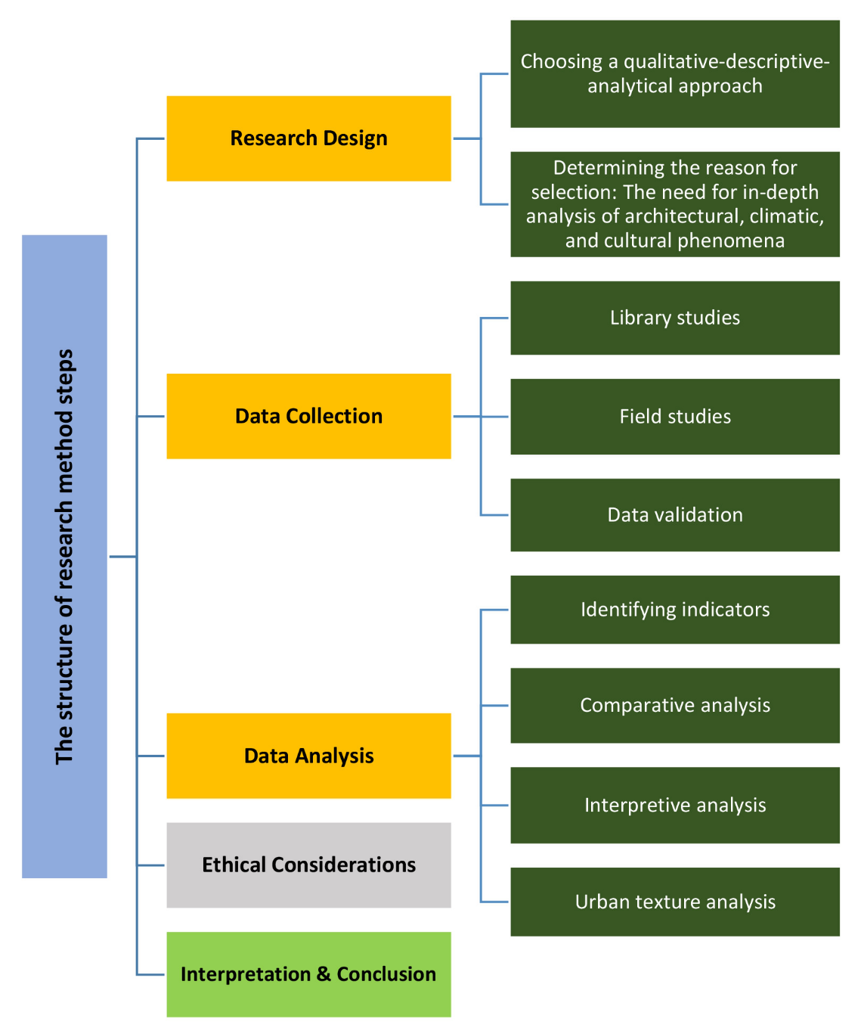

Figure 1. The diagram outlines the research process, highlighting its ordered stages and purposeful progression.

RESULT AND DISCUSSION

RESULT
Saheb-Ol-Amr Mosque is one of the most significant religious and historical monuments in Tabriz, occupying an essential position within the Islamic architectural heritage and the city's urban fabric. As shown in Figure 2, the mosque's current architectural appearance reflects the transformations it has undergone throughout different historical periods, including various stages of damage, repair, and reconstruction. Figure 3 presents the mosque's location within the central district of Tabriz. This spatial context illustrates how the mosque is integrated into the dense urban fabric, emphasizing its historical role as a major religious, social, and cultural hub. The figure also highlights the mosque's proximity to key urban elements, reinforcing its influence on the development of the surrounding neighborhood. Furthermore, Figure 4 provides the ground and first-floor plans, along with the southern, western, and eastern elevations and section A–A. These drawings clarify the internal spatial configuration, the courtyard-centered layout, and the architectural hierarchy of iwans, porches, and the domed space. The plans also support the analysis of circulation patterns, structural organization, and visual connections within the mosque complex. Table 2 presents a chronological overview of the construction history, restoration efforts, and reconstruction phases, offering a historical framework for understanding the architectural evolution of the mosque across the Safavid, Qajar, and Pahlavi periods.
Table 2. Historical periods and architectural developments of the Saheb-Ol-Amr Mosque of Tabriz.
Historical period | Approximate time | Main events and developments | Outstanding architectural features
Safavid period | 1050 AH (11th century AH) | The initial construction of the mosque was ordered by Shah Sultan Hussein Safavid | Iwans, Shabestans, and the main dome house with Safavid architectural patterns
Qajar period | 13th century AH | Restoration and reconstruction of parts of the building after numerous earthquakes | Qajar tiling, adding sections to the nave and porches
Pahlavi the first | Early 14th century AH | Local repairs and organization of the environment around the mosque | Changes in the surrounding urban fabric and creation of new accesses
Contemporary | Second half of the 14th century to the present day | Conservation restorations and cultural-social use | Revival of decorations, structural reconstruction, and strengthening of the mosque's urban status

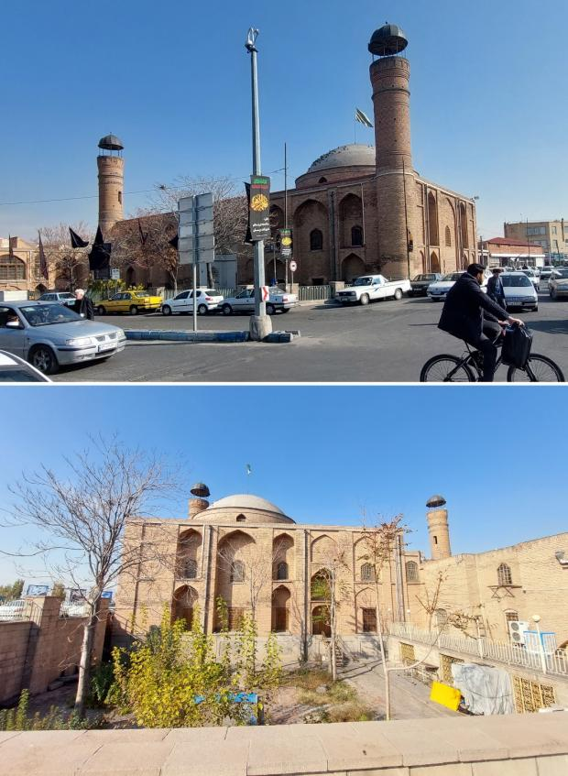

Figure 2. Saheb-Ol-Amr Mosque, Tabriz.
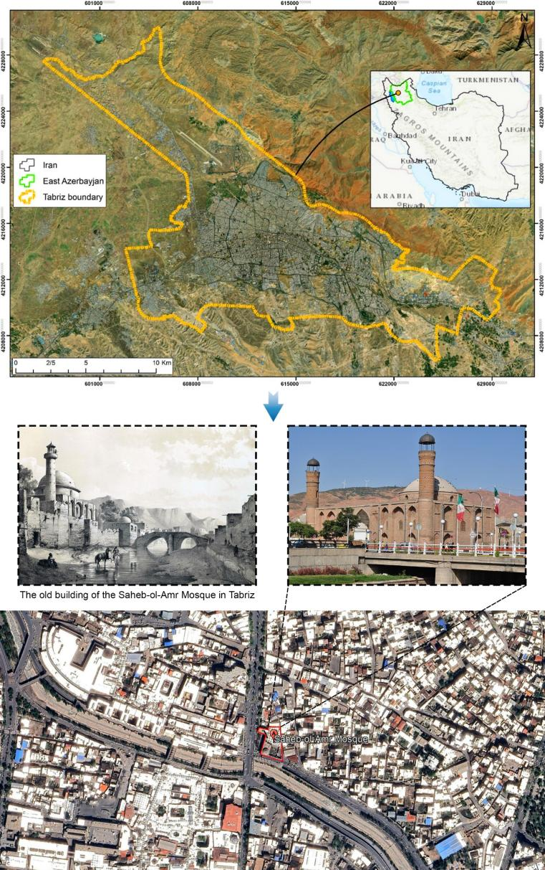

Figure 3. The geographical location of the Saheb-Ol-Amr Mosque in Tabriz has been determined using aerial imagery and aerial mapping.
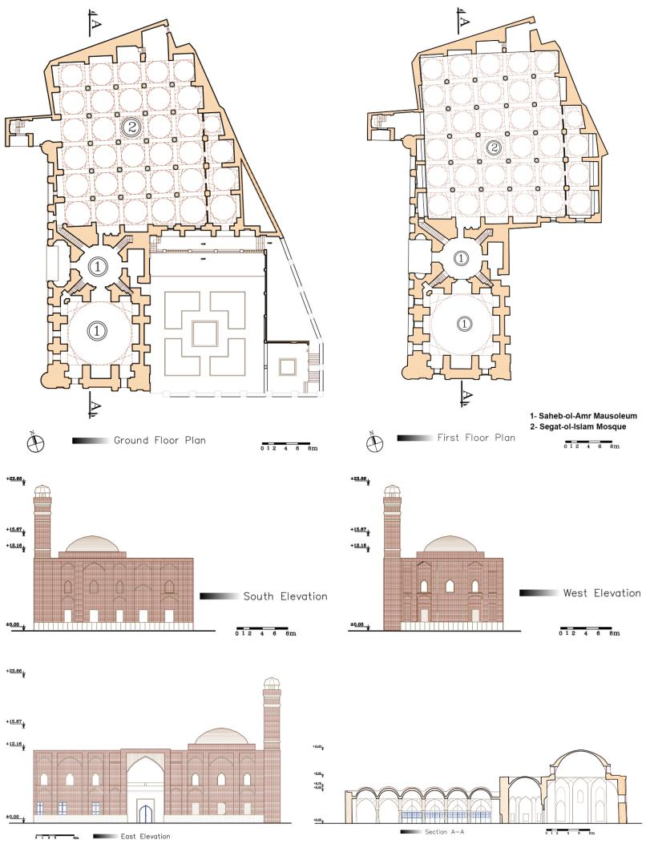

Figure 4. Ground and first floor plan of Saheb-Ol-Amr Mosque in Tabriz with southern, western, and eastern views and section A-A.

3.1.1 Architectural Elements and Solutions Affecting Climatic and Environmental Adaptation in the Design Of Saheb-Ol-Amr Mosque in Tabriz
The design and construction of historical mosques in Iran have always been influenced by the climatic, cultural, religious, and social conditions of their surrounding environment. The Saheb-Ol-Amr Mosque of Tabriz is no exception to this rule, and its design incorporates a range of architectural solutions and elements aimed at adapting to the cold and semi-arid climate of the region. By analyzing the physical structure and functional components of the mosque, this research has identified these elements and solutions. This building demonstrates a deep connection between Iranian Islamic architecture and the principles of climate-responsive design. The results of this research are analyzed and presented in the form of five main axes:
A. ORIENTATION AND PLACEMENT OF THE BUILDING TO MAXIMIZE THE USE OF SOLAR ENERGY
One of the most important principles of traditional architecture in cold climates is to take advantage of sunlight during the cold seasons. The research findings show that the Saheb-Ol-Amr Mosque, by observing the correct orientation, i.e., the placement of the Qibla in the south-southwest direction, while responding to the religious need (Qibla), has provided the possibility of receiving maximum light and heat from the sun during the day. The main walls of the building, facing east and west, are less exposed to direct sunlight than the southern wall, which reduces heat loss on cold winter nights. On the other hand, the use of entrances and verandas with appropriate depth on the south side has allowed sunlight to penetrate deep into the interior space in winter, while in summer, the natural shading created by these elements has prevented excess heat from entering. Table 3 examines the spatial elements and orientation strategies of the building, coordinated with solar radiation, airflow, and the cold climate of Tabriz.

Table 3. Climate innovations in the orientation and establishment of Saheb-Ol-Amr Mosque.
Architectural element | Existing innovation | Climate performance | Advantage in architectural sustainability | Figure
Qiblah orientation | Adapting to the angle of sunlight and Qibla while maintaining religious harmony | Maximum absorption of sunlight and heat in winter | Reducing the need for artificial heating | 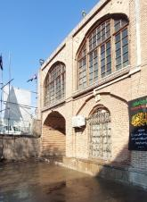
Deep South Porch | Variable depth design for shading control | Shade in summer, sun in winter | Natural thermal comfort | 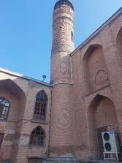
East-West side walls | Reducing windows in these directions | Minimum heat energy loss at night | Reducing temperature fluctuations | 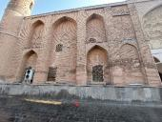

B. USE OF NATIVE AND NATURAL MATERIALS WITH HIGH INSULATION CAPACITIES
Another important result of this research is the attention paid to the building materials used in the mosque. The results of the field survey and analysis of historical sources show that a large part of the mosque's walls were built with raw mud, bricks, and mud-plaster mortar. These local materials were not only available and affordable but also, given their physical properties, had good insulating performance against heat transfer. In the climate of Tabriz, where the temperature difference between day and night is large in many seasons, this type of material, with its high thermal capacity, is able to store heat during the day and gradually release it at night. This feature effectively prevents severe temperature fluctuations in the interior of the mosque. Glazed brick has also been used in parts of the building, which, in addition to its visual beauty, helps combat moisture and increase the durability of surfaces against harsh weather conditions. The focus of Table 4 is on how traditional materials such as adobe and brick are used to address the thermal, moisture, and stability conditions of the building.

Table 4. Innovation in the selection and use of local materials for energy optimization in the Saheb-Ol-Amr Mosque.
Type of materials | Innovation in choice or use | Climatic feature | Impact on sustainability | Figure
Clay brick | Use of materials with high thermal capacity | Heat storage and gradual release | Circadian temperature balance | 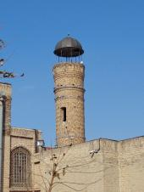
Mud and plaster mortar | Traditional combination with sound and thermal insulation properties | Reduce heat transfer | Natural thermal insulation | 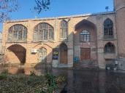
Glazed brick | Using bricks that are resistant to moisture and sunlight | Protecting the surface from climate damage | High durability in environmental conditions | 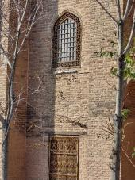

C. DESIGNING A CENTRAL COURTYARD AS A THERMAL REGULATOR AND NATURAL VENTILATION
One of the key architectural elements of the Saheb-Ol-Amr Mosque is the presence of a central courtyard, which plays a vital role in natural ventilation and thermal balance. The research findings show that this courtyard, with its proportional dimensions and the placement of the water basin in the center, serves as a climate regulator. During the day, the water surface of the basin cools the surrounding space through natural evaporation. At night, the stored water gradually returns the heat of the day to the environment. In addition, natural air circulation through openings from the nave to the courtyard has reduced humidity and increased indoor air quality. In summer, a cool breeze enters the courtyard from the northwest and is directed to the nave through the open openings. This natural ventilation prevents excess heat from accumulating in the interior. Table 5 analyzes the function of the central courtyard and the water basin in facilitating natural ventilation and creating thermal comfort.

Table 5. Design innovations in the central courtyard as a microclimate regulator in the Saheb-Ol-Amr Mosque.
Element used | Innovation in design | Climate performance | Positive environmental impact | Figure
Central courtyard | Appropriate dimensions and openings to facilitate natural ventilation | Free air circulation, temperature reduction | Reducing dependence on artificial ventilation | 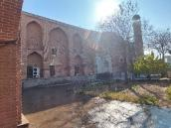
Water pond in the center of the yard | Using water to create the right relative humidity | Surface evaporation and environmental cooling | Improving thermal comfort | 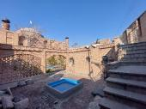
Connecting the Shabestan to the courtyard | Direct openings for cross-flow air | Proper cross ventilation | Natural ventilation and healthy air | 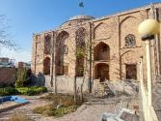

D. ROOF AND DOME DESIGN WITH GEOMETRIC FORMS IN HARMONY WITH CLIMATIC CONDITIONS
Analysis of the geometric shapes and structures of the roofs and domes of the Saheb-Ol-Amr Mosque shows that these elements, in addition to their symbolic and spiritual dimensions, also serve a highly effective climatic function. The domes, with their curved cross-section, facilitate the circulation of internal air. According to the physical law of convection, hot air moves to the top of the dome and exits through openings in the dome crown. This feature has created good natural ventilation, which is especially important during the hot seasons of the year. On the other hand, the domes' surfaces are designed to evenly absorb solar radiation throughout the day. This gradual absorption prevents thermal shocks in the structure. On cold nights, these domes, with their thermal properties, return the stored energy to the interior space. Table 6 examines arched and domed forms for controlling air flow, natural ventilation, and reducing temperature fluctuations.

Table 6. Climatic innovations in the form of the dome and roof of the Saheb-Ol-Amr Mosque.
Architectural form | Innovation in performance | Climate performance | Advantages of sustainable traditional architecture | Figure
Central Dome | Natural ventilation with the help of the convective movement of warm air | Hot air exits from above | Reducing the need for ventilation systems | 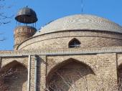
Curved surface of the dome | Uniform distribution of solar radiation | Preventing thermal shock | Temperature stability within the space | 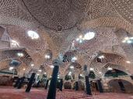
Half-domed ceilings | Variety of forms to meet specific climatic needs | Humidity and heat control in sub-spaces | Adjusting the internal microclimate of the mosque | 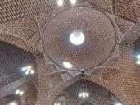

E. ADAPTATION OF ARCHITECTURAL DECORATIONS TO CLIMATIC PERFORMANCE
The research results also show that the architectural decorations in this mosque serve not only aesthetic purposes but also climatic functions. For example, the use of blue, turquoise, and azure tiles in parts of the building helps to reflect sunlight and reduce heat absorption in summer. Also, the use of muqarnas and concave surfaces in the entrances and porches has caused the intense summer light to break and gently guide it into the interior space. The decorative shading created by these elements effectively enhances thermal comfort throughout the day and, while softening the worship space, reduces the need for artificial energy for ventilation. Table 7 explains how decorations such as tiling, mogharnas, and concave forms effectively contribute to shading, light modulation, and radiant heat reduction.

Table 7. The role of architectural decorations in climate optimization and natural lighting of Saheb-Ol-Amr Mosque.
Decorative element | Innovation in climate design | Climate performance | The advantage of sustainability and aesthetics | Figure
Blue and turquoise tiling | Choosing colors that reflect sunlight | Reducing surface heat absorption in summer | Reducing the need for cooling | 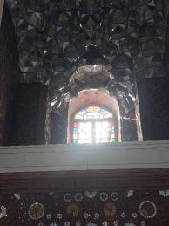
Entrance Muqarnas | Breaking and controlling intense sunlight during peak radiation hours | Softening natural light and preventing direct sunlight | Natural and soft lighting | 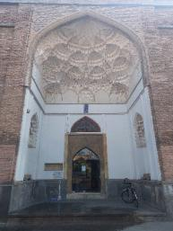
Concave decorative surfaces | Creating variable light shading throughout the day | Helps with ventilation and reduces direct radiation | Creating a sense of visual comfort and thermal comfort | 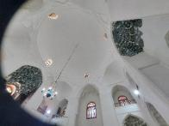

3.1.2 Patterns of Physical and Environmental Interaction of Saheb-Ol-Amr Mosque with the Peripheral Urban Context in Tabriz
The present study focuses on the physical and environmental interactions of the Saheb-Ol-Amr Mosque of Tabriz with its surrounding urban context. It explores how religious architecture is interconnected with socio-urban structures. The analyses conducted in this regard show that this interaction is not solely based on form and function, but also through cultural, historical, and perceptual intertwinings.

A. THE PLACE OF THE MOSQUE IN THE SPATIAL STRUCTURE OF THE CITY
Examining the location of the Saheb-Ol-Amr Mosque revealed that it functions not as an isolated element but as part of a continuous spatial structure that has shaped the historical center of Tabriz. Its location on the communication axis of the Tabriz bazaar - which itself has an organic, historical structure - indicates that this mosque was built to increase accessibility and centrality. Such a location has led to the creation of strong functional links with public spaces, markets, passages, and even historical houses around it. Based on field observations and map-based analyses, it was determined that the mosque's physical radius of influence extended to several hundred meters, creating a semi-public space that visually, physically, and behaviorally influenced the surrounding context. Table 8, Innovations related to the position of the mosque in the spatial structure of the city, shows that the location of the mosque has an organic connection with the structure of the historical bazaar of Tabriz.

Table 8. Spatial positioning and urban integration characteristics of the Saheb-Ol-Amr mosque.
Spatial parameter assessed | Key observations and contextual insights | Implications for urban form and architectural planning
Location of the mosque | The organic connection between the mosque and the structure of Tabriz's historic bazaar | Increasing accessibility and functional integration in religious-commercial centers
The physical radius of influence of the mosque | The effect of the spatial radius of the mosque on the formation of the surrounding semi-public space | Possibility of designing transit-pause spaces around mosques in dense urban contexts

B. THE PHYSICAL STRUCTURE OF THE MOSQUE AND ITS ADAPTATION TO THE CLIMATE
Analysis of the physical elements of the mosque, including the porch, dome, chambers, and nave, showed that the design of the Saheb-Ol-Amr Mosque was also done in harmony with the surrounding environment from a climatic perspective. The use of local materials such as bricks, the combination of curved forms in the dome and arches, and natural ventilation have resulted in the mosque not only serving a religious function but also providing a desirable and sustainable environment for its users. Regarding environmental interaction, the lighting of interior and exterior spaces has been designed to align with the sun's path in Tabriz's cold, dry climate. This has also affected the visual coherence of the mosque with its surroundings, so that the presence of shadows, natural light, and a balanced temperature has made the experience of the space pleasant for passersby in the surrounding passages. Table 9, innovations in physical structure and climate adaptation, shows that the selection of materials and architectural forms has been appropriate to the climate of Tabriz.

Table 9. Architectural form and material-based strategies supporting climatic responsiveness.
Architectural/physical feature | Climate-responsive behavior or adaptation mechanism | Environmental and design performance outcomes | Figure
Use of local materials | Using bricks and curved forms for natural ventilation | Reducing energy consumption and adapting to the cold and dry climate of Tabriz | 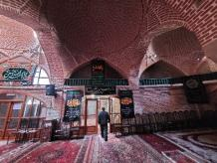
Natural lighting | Intelligent use of natural light in the nave and porches | Improving the quality of the indoor environment and increasing user satisfaction | 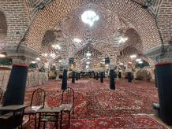

C. URBAN LEGIBILITY AND IDENTITY
As one of the urban landmarks of Tabriz, the Saheb-Ol-Amr Mosque enjoys high legibility in the city's landscape. Notable elements such as the turquoise dome, the tiles inscribed with Islamic inscriptions, and the entrance façade with Quranic inscriptions have made this mosque one of the city's perceptual axes. Such legibility enhances citizens' mental orientation and makes the mosque a reference point in urban spaces. On the other hand, the continuity of this legibility over the centuries has enriched the physical and spiritual identity surrounding the mosque. In the analysis of interviews with local residents, a sense of belonging to the space around the mosque was repeatedly mentioned, leading many residents to link their collective memories to religious and social occasions held at this mosque. This indicates the deep interconnection of religious spaces with the cultural and social identity of citizens. Table 10, Urban Legibility and Identity, shows that the Saheb-Ol-Amr Mosque is recognized as an urban landmark with high legibility.

Table 10. Visual identity, landmark qualities, and urban readability indicators.
Urban identity component | Distinctive visual or symbolic characteristics | Influence on legibility and urban perception
Urban landscape and semiotics | Transforming the mosque into a mental and physical symbol on the main urban axes | Improving navigation capabilities in urban spaces and strengthening citizens' sense of belonging
Linking with collective memories | Integrating visual elements with social and spiritual evocation | Recreating religious spaces with a focus on indigenous and cultural identity

D. FUNCTIONAL LINKS WITH SURROUNDING SPACES
One aspect of the mosque’s physical interaction with the urban fabric is its functional connections with the surrounding spaces. Field research revealed that the passages leading to the mosque are not only passageways, but have themselves become semi-public and exchange spaces. Some of these passages lead to shops, traditional huts, and temporary bazaars that have been built in line with the mosque's social function. Also, on occasions such as congregational prayers, Ashura ceremonies, and other religious gatherings, the spaces around the mosque temporarily change their function and become public religious spaces. This functional flexibility is a feature of the intelligent interaction of the mosque body with the living urban fabric. Table 11, Functional Links, shows that the passages leading to the mosque have become multifunctional spaces.

Table 11. Functional synergies and activity-based connections with adjacent urban spaces.
Functional interface or adjacent space | Observed behavioral or activity pattern | Resulting spatial and social effects on the urban context | Figure
Nearby urban crossings | Transforming the passages around the mosque into flexible and multifunctional spaces | Promoting urban dynamism around religious centers | 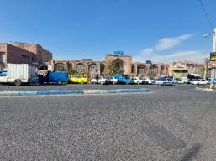
Social adaptive behaviors | Adapting environmental functions to religious occasions such as Ashura and congregational prayers | Creating spatial flexibility in line with the cultural and religious calendar | 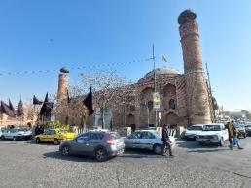

E. VISUAL INTERACTIONS AND URBAN LANDSCAPE
From a visual perspective, the mosque's relationship with the surrounding buildings, passages, and urban landscape establishes relative coherence in scale and color proportions between the mosque and its context. Although some recent buildings around the mosque with incoherent architecture have somewhat diminished the quality of this interaction, the main structure of the urban landscape remains centered on the superiority of the Saheb-Ol-Amr Mosque. Visual and perspective analyses showed that the mosque serves as an anchor in the visual composition of the surrounding square; that is, an element that draws the eye to itself, and the other components of the square are organized around it. Table 12, Visual Interactions and Urban Landscape, shows that the mosque serves as a visual anchor in the surrounding square.

Table 12. Visual interactions, landscape composition, and spatial hierarchy around the mosque.
Visual element or urban viewpoint | Pattern of visual interaction or composition | Impact on urban landscape structure and spatial coherence | Figure
Visual proportions | The mosque's scale and color coordination with the surrounding texture | Increasing visual coherence and quality of the urban landscape | 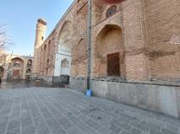
Spatial composition of the field | The function of the mosque as a visual anchor in organizing urban landscapes | Strengthening the spatial structure of urban squares and historical centers | 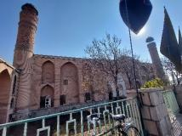

F. SEMANTIC ASPECTS OF INTERACTION
The mosque's environmental interaction does not stop at the physical level. The mosque, due to its historical significance, memorable location, and frequent use, has become one of the most meaningful spaces for the people of Tabriz. This meaning stems not only from the mosque's worship function, but also from the continuous presence of people around it, from holding rituals to social gatherings and even daily interactions. Interviews with citizens indicated that the mosque is seen as a place for “dwelling” and “reflection,” rather than simply a place of worship. People stand outside the mosque, pause, converse with others, and even use the space around the mosque for everyday activities such as shopping, appointments, and social interactions. Table 13 shows the semantic and perceptual aspects that the mosque serves as a place for lingering and social interaction.

Table 13. Cultural meanings, perceptual qualities, and everyday spatial experiences.
Perceptual or semantic dimension | User experience or cultural interpretation | Contribution to social meaning and spatial attachment | Figure
The social meaning of space | Transforming the mosque into a space of pause, interaction, and intermission in people's daily lives | Designing public spaces with high spiritual and social capacities | 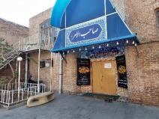
Everyday spatial experience | People's deep connection with space through ceremonies, shopping, and daily interactions | Creating multifaceted spaces combining religious, social, and economic functions | 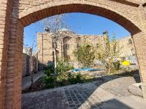

G. HISTORICAL CONNECTION AND TEMPORAL LAYERS
As a relic of the Safavid era and later rebuilt in the Qajar era, the Saheb-Ol-Amr Mosque has numerous historical layers. These layers are reflected in the body of the mosque and have also influenced the surrounding elements. In a comparative study of historical maps and the current situation, it was observed that many of the urban structures around the mosque, such as the rows, inner courtyards, and even the location of shops, were inspired by patterns of coexistence with the mosque's function and structure. This coexistence has created a kind of historical continuity in the mosque's interaction with the urban fabric, a phenomenon less evident in modern cities. Table 14, Historical Link and Time Layers, shows that the mosque's historical layers are reflected in the formation of the surrounding urban patterns.

Table 14. Historical continuity, temporal layers, and evolution of surrounding urban patterns.
Historical or temporal layer examined | Documented transformation or continuity | Relevance for heritage preservation and urban regeneration | Figure
Historical continuity of space | Reflection of historical layers in the body of the mosque and its impact on the pattern of the rows and surrounding spaces | Preserving historical identity in redesigning and recreating old textures | 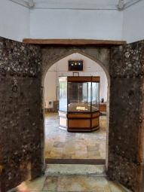
Historical-functional coexistence | The continuity of the functional relationship between the mosque and the bazaar, and surrounding houses, from the past to the present | Modeling for urban regeneration while preserving traditional functions | 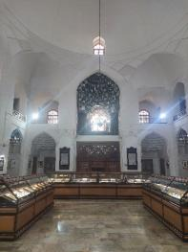

H. SOCIAL INTERACTIONS AND SPATIAL JUSTICE
Behavioral analysis of the spaces around the mosque showed that this place was designed in a way that provided accessibility and spatial justice for different segments of the population. The simultaneous presence of different social classes, including marketers, students, the elderly, and tourists, around the mosque indicates that the surrounding spaces are not elitist or exclusive but open and inclusive. Also, the design of multiple entrances, side passages, and buffer spaces has resulted in spaces with varying degrees of public-to-semi-private that have enabled functional and social diversity around the mosque. Table 15, Spatial Justice and Social Interactions, shows that space with equal access for different groups has been provided around the mosque.

Table 15. Social inclusiveness, accessibility patterns, and spatial justice indicators.
Social or accessibility criterion | Observed patterns of use or inclusivity | Effect on spatial justice and community engagement | Figure
Justice in access | Designing entrances and paths so that different groups can benefit from the mosque and its surroundings | Increasing spatial justice in the design of religious and public spaces | 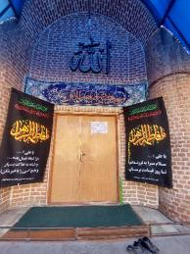
The multiplicity of social functions | Simultaneous presence of different groups in the spaces surrounding the mosque | Creating combined spaces with high functional and social flexibility | 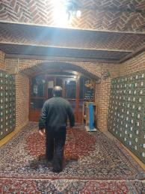

DISCUSSION
3.2.1 The Importance of the Results in the Study of the Saheb-Ol-Amr Mosque in Tabriz
The results of this study indicate that the Saheb-Ol-Amr Mosque of Tabriz is not only a religious and historical monument, but also a prominent example of the connection between Iranian Islamic architecture and the principles of climate change. The importance of these results lies in the fact that by utilizing indigenous knowledge and a deep understanding of environmental conditions, they show that traditional architecture has been able to provide sustainable solutions for thermal comfort, natural ventilation, and social interaction; an approach that can still inspire contemporary architecture today and respond to energy and environmental crises.

3.2.2 Stating the Facts and Explaining the Reasons for Their Importance
The results point to an important fact: Iran's historical architecture, contrary to popular belief, is not simply a product of aesthetics or religious imperatives, but rather a result of a clever combination of climatic performance, cultural identity, and social needs. This fact is important because it emphasizes that past architecture can be a practical model for solving current urban planning and architectural sustainability issues.

3.2.3 Architectural Elements and Solutions Affecting Climatic and Environmental Adaptation in the Design of Saheb-Ol-Amr Mosque in Tabriz
The present study was conducted to investigate "architectural elements and solutions in the design of the Saheb-Ol-Amr Mosque of Tabriz and its degree of compatibility with climatic and environmental conditions," and its findings show that this building is not only a religious and cultural work, but also a leading example of climate-oriented architecture. To explain the position of this research, it is necessary to analyze and compare it with previous studies to reveal its innovation dimensions. Several studies have been conducted on the influence of climate on Iranian Islamic architecture. For example, studies [21][22] have generally categorized the principles of climate-responsive design in Iranian architecture and emphasized elements such as the central courtyard, the use of local materials, and the orientation of the building. Although these studies have provided a solid theoretical foundation, they have rarely analyzed a specific building in the context of Tabriz.
In comparison, the present study, focusing on the Saheb-Ol-Amr Mosque, has not only not addressed generalities, but has also analyzed in detail the specific solutions used in this building. On the other hand, some research [23][24] has focused on natural ventilation in traditional Iranian architecture, especially windbreaks. These studies have mainly examined Iranian desert examples such as Yazd and Kashan, but have received less attention in cold regions such as Tabriz. The current study, focusing on an example in the cold, dry climate of northwestern Iran, fills a gap in the research literature and shows how, in the absence of windbreaks, other elements, such as the central courtyard and the domed form, serve as natural ventilation. Other studies, including the study of [25][26] “Principles of Iranian Architecture,” have addressed the role of structural and geometric elements in climate adaptation. These works have often emphasized the general concept of “introversion” and “need for” but have not made a direct connection between these concepts and the case study of specific mosques. The present study has established this connection and shown how Pirnia’s theoretical principles have been manifested in a concrete, practical way in the Saheb-Ol-Amr Mosque. Internationally, research [27][28] on climate-oriented architecture in Egypt and the Arab world has focused on adapting architecture to the natural environment. However, these works have focused more on hot and dry climates. The present study, situated in Tabriz, offers a unique innovation by demonstrating that Islamic climate-oriented patterns have been implemented with high flexibility not only in hot regions but also in cold regions. Another distinguishing feature of this research is its attention to the role of architectural decorations in climate adaptation. Most previous studies [29][30] have examined decorations solely in the aesthetic or symbolic dimension. While this research has shown that the tiling, muqarnas, and colors used in the Saheb-Ol-Amr Mosque, in addition to their aesthetic aspect, also had a climate function; for example, reflecting sunlight or creating cooling shadows. This multidimensional view is considered a significant innovation in the literature on climate architecture. Also, while previous research has usually limited itself to describing architectural elements, the present study has analyzed the thermal and environmental performance of these elements and shown how the combination of orientation, local materials, and central courtyard design provides an integrated system for controlling climatic conditions. This systematic approach is another innovation of the research. Therefore, compared to previous studies, this research is a step forward in a more comprehensive understanding of Islamic climatic architecture in the cold climate of Iran and can be a model for similar research in other regions and buildings.

3.2.4 Patterns of Physical and Environmental Interaction of Saheb-Ol-Amr Mosque with the Peripheral Urban Context in Tabriz
The results of this study on the physical and environmental interaction of the Saheb-Ol-Amr Mosque with the urban context of Tabriz show that this building has functioned not only as a religious space but also as an active urban element. Comparing these results with previous studies reveals that the present study has addressed gaps in the literature on Islamic and urban architecture and shed light on new dimensions of the relationship between the mosque's structure and its surrounding environment. Several studies have examined the role of mosques in Iran's urban structure. For example, studies [31] on the Tabriz bazaar have emphasized the importance of the proximity between the mosque and the bazaar in shaping urban identity. They introduce the mosque more as a functional complement to the bazaar and pay less attention to its environmental and perceptual interactions. In this regard, other studies [32][33] have also shown that mosques are generally located in the central areas of bazaars, thereby fostering spatial cohesion. However, most of these studies have examined the interaction at the level of economic and religious performance and have paid less attention to the physical-environmental dimensions. Similar examples can be seen in international studies. For example, studies [34][35] in their research on Ottoman mosques in Istanbul focused more on the metropolitan scale and the symbolic role of domes in the cityscape. While the present findings show that the interaction of the Saheb-Ol-Amr Mosque with the environment was meaningful not only on a symbolic scale but also on a micro and everyday scale, that is, in how the surrounding passages, squares, and even social activities were organized. This distinction distinguishes the present study from similar examples.
On the other hand, recent studies [36][37] have focused on the role of religious spaces in enhancing the sense of place. Emphasizing perceptual dimensions, they show that the presence of mosques in the historical context leads to the formation of a kind of “urban legibility”. Although these findings are consistent with the results of the present study, the main difference is the simultaneous combination of physical, environmental, and social dimensions. In other words, the current study not only examined legibility and identity but also explained how climatic, visual, and historical interactions are linked to the urban structure. Another innovation of this research is its approach to the historical layers and temporal dynamics of the Saheb-Ol-Amr Mosque. While most research on Qajar mosques [38][39] has focused on a static, single-period analysis. This research has shown the continuity of the mosque's interaction with its context within Tabriz's historical developments. This dynamic approach provides a deeper understanding of how the mosque and the surrounding context coexisted over time. Also, previous studies have typically examined the mosque from an architectural or urban planning perspective, whereas the present study has adopted an interdisciplinary approach. Combining physical analysis with environmental and social studies shows that the mosque is not only a physical structure, but also a platform for socio-cultural interactions. For example, unlike study [40], which focused solely on the mosque's worship functions in the historical context of Tabriz, this study showed that the spaces surrounding the mosque are used temporarily for special occasions and become public religious spaces. From a climatic perspective, previous research has mainly analyzed the thermal and ventilation characteristics of mosques [41][42]. However, the present study, in addition to emphasizing climatic adaptation, has shown how these characteristics are reflected in the visual and environmental experiences of citizens around the mosque. Such an approach links the dimensions of human-environment interaction to the body of the mosque, adding a new layer of analysis to the existing literature. These innovations make the present research a new paradigm in Islamic architecture and urban design studies. The results show that the Saheb-Ol-Amr Mosque, as a prominent example, can serve as a model for better understanding the role of religious spaces in fostering physical coherence, environmental sustainability, and social solidarity in contemporary urban contexts.

3.2.5 Possible Reasons for the Results Obtained
The possible reasons for the results obtained can be analyzed at three levels: first, the climatic conditions of Tabriz (cold and dry), which have forced traditional architects to adopt solutions such as the correct orientation of the building, the use of materials with high thermal capacity, the design of a central courtyard, and the use of domed and arched forms. Second, social and religious ties have made the mosque not only a place of worship but also a platform for urban interactions and identity-building. Third, the historical and cultural layers that, through continuous renovations and changes, have turned the mosque into a multifaceted and multilayered element in the urban fabric.

3.2.6 Strengths, Weaknesses, and Suggested Solutions Results
Despite these strengths, the results also reveal weaknesses. For example, some new interventions around the mosque have weakened the visual and physical coherence and are considered a threat to its legibility and historical identity. Also, although the use of local materials has been optimal in the past, in today's conditions, it needs to be enhanced with new technologies to achieve greater durability and greater harmony with contemporary standards. The solution to these challenges lies in an integrated approach: the use of new technologies alongside the preservation of traditional architectural principles, and the application of urban conservation policies that ensure harmony between historical monuments and new constructions. In general, the research results show that the Saheb-Ol-Amr Mosque of Tabriz, as a comprehensive model, has simultaneously responded to climatic, social, cultural, and historical requirements. This is a strength that highlights the value of this building at the national and even international levels and offers sustainable solutions for future architecture.

CONCLUSION
The results of this study indicate that the main objectives have been fully achieved. The environmental compatibility assessment of the Saheb-Ol-Amr Mosque in Tabriz not only showed that this religious building was intelligently adapted to its climatic conditions, urban context, and cultural context, but also that components such as natural lighting, cross-ventilation, indigenous materials, and environmentally responsive spatial arrangement played a fundamental role in enhancing its environmental performance. In fact, the findings are evidence that traditional Islamic architecture, before modern sustainability principles were considered, provided indigenous and effective solutions for interacting with nature and context.
Based on the analyses conducted in this study, it can be concluded that the architecture of the Saheb-Ol-Amr Mosque in Tabriz results from an intelligent balance between cultural and religious requirements on the one hand and climatic and environmental conditions on the other. This building, as a brilliant example of Iranian Islamic architecture, uses solutions such as:
- Precise orientation towards the sun and Qibla
- Use of local materials with high thermal performance
- Design of a central courtyard and water basin to regulate humidity and temperature
- Dome and roof shaping for natural ventilation and heat circulation
- And decorations with climatic and aesthetic functions
It has succeeded in achieving maximum adaptation to Tabriz's climatic conditions. This type of design not only responds to climatic needs but also provides an effective model for designing sustainable buildings in similar climates while preserving the splendor and spirituality of religious architecture. In other words, the Saheb-Ol-Amr Mosque can be considered an example of architecture well-suited to the climate and a manifestation of environmental rationality in Islamic art. The present study also shows that paying attention to the principles of traditional architecture, especially in the historical contexts of cities such as Tabriz, not only preserves cultural identity but also opens the way to responding to today's environmental crises, such as excessive energy consumption and global warming. Using these models in contemporary design can contribute significantly to the realization of sustainable architecture at the national and regional levels. The results of the research also indicate that the Saheb-Ol-Amr Mosque of Tabriz has established effective and sustainable interactions with the urban context over the centuries through intelligent design, appropriate placement, and the presence of physical and functional elements in harmony with the surrounding environment. These interactions are not only visible at the physical and functional levels, but also at the perceptual, identity, historical, and social levels. The mosque, as a religious space, plays a multilayered role in urban life:
- As a highly legible urban landmark
- as a space for ritual and community
- and as a historical element woven into the fabric of the city
Ultimately, the Saheb-Ol-Amr Mosque is not a separate building, but rather part of the living and historical structure of the city of Tabriz, which has established a deep synergy with its surrounding environment. This synergy provides a valuable model for the design of contemporary religious spaces in historical and urban contexts, a model that is based on respect for the context, social participation, and attention to layers of identity.
The importance of these findings lies in the fact that the present study was able to fill the existing gap in the field of environmental studies of Islamic architecture, especially at an urban scale and a less studied example, such as the Saheb-Ol-Amr Mosque, to a large extent. This study, with an analytical and context-oriented perspective, redefined the position of the mosque as a dynamic structure in response to environmental conditions and showed that in the heart of our historical architecture, there is a treasure trove of indigenous knowledge that can respond to today's challenges of contemporary architecture. Thus, the present study makes a significant contribution to enriching the interdisciplinary literature in Islamic architecture, sustainable architecture, and climate urban planning.
From a practical perspective, the results of this study can inspire architects, urban designers, researchers, and policymakers, especially in redesigning or revitalizing religious, cultural, and public spaces in similar climates, using a local, sustainable approach. This study can also be a suitable educational basis for architecture students in climate design, Islamic architecture, and contextual design courses. Modeling the solutions used in this building can help reduce energy consumption, increase thermal comfort, and promote cultural and social interaction in contemporary projects.
However, the present study also had limitations. These include the lack of accurate historical sources on the different stages of the mosque's reconstruction, limitations in recording actual thermal or environmental data due to equipment constraints, and restricted access to certain areas of the mosque during fieldwork. Moreover, the study was primarily qualitative and did not incorporate quantitative energy modeling or dynamic thermal simulations, which could be addressed in future research. In addition to these constraints, the interpretive nature of the qualitative, field-based, and historical analyses may introduce a degree of subjectivity. Furthermore, as a single-case study situated within a specific climatic and urban context, the generalizability of the findings is inherently limited. The absence of detailed simulation-based assessments also limits the ability to verify certain environmental performance aspects objectively. These limitations should be considered when interpreting the results and highlight valuable opportunities for future studies, including comparative investigations of multiple historical mosques, the integration of computational environmental modeling, and broader examinations of how traditional climatic strategies can inform contemporary sustainable design.
To expand existing knowledge, future research should conduct a comparative analysis of several historical mosques across different climatic conditions to better identify common patterns and differences. Also, combining qualitative analysis with energy simulation modeling, such as using software such as DesignBuilder or EnergyPlus, can increase the accuracy of assessments. Investigating the role of these spaces in promoting social interactions and a sense of belonging in the urban context could also be a new area for future research

AUTHORS CONTRIBUTION
P.N. (Peyman Naghipour): Writing – original draft, Writing – review & editing, Visualization, Software, Validation, Methodology, Investigation, Formal analysis, Funding acquisition, Resources, Data curation, Supervision, Conceptualization, Project administration. H.S.S. (Hassan Sattari Sarbangholi): Writing – review & editing, Validation, Methodology, Resources, Supervision, Conceptualization, Investigation. All authors read and approved the final manuscript.

ACKNOWLEDGEMENT
This article is taken from the master's thesis of the first author (Peyman Naghipour) entitled "The Architectural Design of a Residential Complex for the Low-Income Strata in the Slum Area of MollaZeynal, Tabriz City, with an Approach to Energy Consumption Optimization", which was conducted under the guidance of the second author (Hassan Sattari Sarbangholi) at Islamic Azad University, Tabriz Branch.

REFERENCES
[1] S. M. Mousavi Rizi, F. Aminsharei, M. Lamea, and M. Ghazimoradi, "Bioclimatic architecture in thermal energy efficiency of sustainable urban residential buildings in developing countries: A synthesis review in Iran," Renewable and Sustainable Energy Reviews, vol. 218, p. 115743, 2025, doi: 10.1016/j.rser.2025.115743.
[2] P. Naghipour, A. Naghipour, A. H. Shirdel, S. Z. Behzadi, O. Rahaei, and S. Salamati, "Sustainability in Historical Islamic Architecture: Lessons from Sheikh Lotfollah Mosque’s Construction Techniques," Journal of Islamic Architecture, vol. 8, no. 3, pp. 585-603, 2025, doi: 10.18860/jia.v8i3.29053.
[3] M. R. Nemati Nasab, H. S. Sarbangholi, M. R. Pakdelfard, and S. Jamali, "Evaluating the urban cultural spaces based on environmental quality components (Case study: Tabriz City)," International Journal of Nonlinear Analysis and Applications, vol. 15, no. 9, pp. 151-164, 2024, doi: 10.22075/ijnaa.2023.31466.4635.
[4] R. Rashidi and M. Mohammadzadeh, "Sociological Reading of Metal Ornaments on the Door of Saheb Al-Amr Mosque in Tabriz," Negareh Journal, vol. 18, no. 66, pp. 49-63, 2023, doi: 10.22070/negareh.2021.15008.2865.
[5] Z. Sami and A. N. Ebrahimi, "RESEARCH ON MUQARNAS IN ISLAMIC ARCHITECTURE TO RECOGNIZE MUQARNAS IN TABRIZ," Symmetry: Culture and Science, vol. 33, pp. 187-173, 2022, doi: 10.26830/symmetry_2022_2_173.
[6] S. Hatefishojae, S. G. Islami, and M. Rezaei, "Role of local and urban textures in promoting social interactions of residents and emphasizing living centers theory of Christopher Alexander," Frontiers of Architectural Research, vol. 10, no. 1, pp. 66-78, 2021, doi: 10.1016/j.foar.2020.05.008.
[7] N. E. Khosroshahi and J. Giyasi, "A Comparative Analysis of the Entrance of the Safavid Mosques in Tabriz," Journal of Environmental Treatment Techniques, vol. 8, no. 3, pp. 1247-1257, 2020, doi: 10.47277/JETT/8(4)1257.
[8] A. Mohammadizadeh and M. Marasy, "Metal Decorations of Door of Saheb al-Amr Mosque in Tabriz: Azerbaijan Folk Art from Qajar Era," Journal of History Culture and Art Research-TARIH KULTUR VE SANAT ARASTIRMALARI DERGISI, vol. 8, no. 1, 2019, doi: 10.7596/taksad.v8i1.1972.
[9] A. Bakri, I. H. Zakaria, R. Kassim, and A. N. A. Ahmad, "Adoption of the systematic facilities management approach to the sustainable performance of mosques," International Journal of Technology, vol. 9, no. 8, 2018, doi: 10.14716/ijtech.v9i8.2745.
[10] G. Memariyan, A. Ghaffari, and F. Gholizadeh, "An Analysis of the Typological Parameters of the Historical Mosques in Tabriz," Culture of Islamic Architecture and Urbanism Journal, vol. 3, no. 1, pp. 43-64, 2017, doi: 10.29252/ciauj.3.1.43.
[11] M. R. PourJafar and A. PourJafar, "Iranian Islamic Urban Design Features of Tabriz; Case study: Great bazaar of the city," Culture of Islamic Architecture and Urbanism Journal, vol. 2, no. 1, pp. 87-108, 2016, doi: 10.29252/ciauj.2.1.87.
[12] M. Parsaee, M. Parva, and B. Karimi, "Space and place concepts analysis based on semiology approach in residential architecture: The case study of traditional city of Bushehr, Iran," HBRC Journal, vol. 11, no. 3, pp. 368-383, 2015/12/01/ 2015, doi: 10.1016/j.hbrcj.2014.07.001.
[13] A. H. Vaziri, P. Goodarzparvari, and I. Baniardalan, “Comparative Body Analysis of Sheikh Lotfollah Mosque in Isfa-Han and Ahmed Mosque in Istanbul,” Journal of Islamic Architecture, vol. 6, no. 3, pp. 132–142, Jun. 2021, doi: 10.18860/jia.v6i3.10112.
[14] P. Shirazpour, "The Concept of Connection in the Architecture of Interstitial Space (Case Study: Sheikh Lotfollah Mosque, Isfahan)," Geography (Regional Planning), vol. 13, no. 52, pp. 764-783, 2023, doi: 10.22034/jgeoq.2025.261193.2853.
[15] P. Naghipour and A. Naghipour, "Evaluating heating energy consumption in residential buildings using hybrid machine learning models: The case of parsabad city," Next Research, vol. 2, no. 3, p. 100721, 2025, doi: 10.1016/j.nexres.2025.100721.
[16] P. Naghipour and A. Naghipour, "Energy performance analysis of residential buildings in Bandar Anzali: Influence of orientation and aspect ratio," Next Sustainability, vol. 5, p. 100140, 2025, doi: 10.1016/j.nxsust.2025.100140.
[17] F. Asadpour, A. H. Shirdel, and P. Naghipour, "Evaluation of perceptual indicators of physical environment affecting the inducement of citizen’s sense of place in urban neighborhoods," Energy and Buildings, vol. 325, p. 114992, 2024, doi: 10.1016/j.enbuild.2024.114992.
[18] S. I. Elsherief and M. A. El-Basel, "Environment Influence on Architecture and Interior Design in Islamic Civilization," Journal of Architecture, Arts and Humanistic Science, vol. 5, no. 23, pp. 131-162, 2020, doi: 10.21608/mjaf.2019.19060.1368.
[19] A. Alkhreasat and S. Suleiman, "Reimagining Urban Public Spaces: A Study of Spatial Rights and Community Interaction in Jabal Al-Hussein, Jordan," Journal of Islamic Architecture, vol. 8, no. 3, pp. 833-848, 2025, doi: 10.18860/jia.v8i3.28036.
[20] S. Senjana, W. Handayani, and A. Suprapti, "Resilience in Islamic Urban Form: Exploring Dynamics in Historic Central District of Banda Aceh, Indonesia," Journal of Islamic Architecture, vol. 8, no. 3, pp. 604-615, 2025, doi: 10.18860/jia.v8i3.26471.
[21] P. A. Borbor and A. G. Param, "Determining the standard requirements for sustainable conservation of Iran's industrial architectural heritage with an emphasis on controlling the mutual effects of architecture and the environment on each other," Anthropogenic Pollution, vol. 9, no. 1, 2025, doi: 10.57647/j.jap.2025.0901.09.
[22] N. Naseri, J. Davtalab, F. H. Pour, A. Heidari, and Z. O. Keikha, "Recognition of Geometrical and Proportional Principles in Open and Semi-Open Spaces of Hot and Humid Climate (Case Study: Historical Houses of Bushehr)," Journal of Urban Sustainable Development, vol. 5, no. 14, pp. 1-24, 2024, doi: 10.22034/usd.2024.2012610.1137.
[23] E. Mohammadi, M. Jarkeh, S. A. Zolfaghari, and V. Arbabi, "Effect of resilient architecture in an ancient windmill in the Sistan region on natural ventilation enhancement," Scientific Reports, vol. 12, no. 1, p. 18240, 2022, doi: 10.1038/s41598-022-23027-w.
[24] M. Tabatabaei, "Analysis of Traditional Iranian Vernacular Architecture in Response to Sunlight: An Approach to Sustainable Development," in Persian Vernacular Architecture: Lessons from Master Builders of Iran on Climate Resilient Design, A. Cheshmehzangi and S. Roaf Eds. Singapore: Springer Nature Singapore, 2024, pp. 259-276.
[25] M. I. Hasan, A. M. R. Aminuddin, and P. U. Pramesti, "A Framework of Islamic Architecture: An Architectural Reviews of Four Studies," Jurnal Teknologi dan Desain, vol. 1, no. 01, pp. 44-57, 2025, doi: 10.51170/jtd.v1i01.103.
[26] K. Mohammadi and F. Karimi, "Verification of parametric thinking in residential centers of Iranian-Islamic Architecture; Case study: Madarshah, Natanz and Jam caravanserais," Journal of Iranian Architecture & Urbanism (JIAU), vol. 15, no. 1, pp. 109-125, 2024, doi: 10.30475/isau.2024.375271.2011.
[27] M. Apotsos, "Theorizing Climate Change and the Built Environment in the Islamic World," vol. 13, Intellect, 2024, pp. 295-306, doi: 10.1386/ijia_00142_2.
[28] A. B. Mohammed, "Integrating Environmental Treatments into Building Design Processes in The Dry Hot Egyptian Climate," Journal of Al-Azhar University Engineering Sector, vol. 20, no. 74, pp. 315-337, 2025, doi: 10.21608/auej.2025.333821.1728.
[29] T. M. N. AL-Arifi, "Decorative aesthetic aspects and their use in Islamic architecture," Al-Academy, no. 107, pp. 77-92, 2023, doi: 10.35560/jcofarts107/77-92.
[30] F. Zahra and S. B. Shahir, "The Aesthetic Value and Spiritual Aesthetics of Islamic Ornaments in Islamic Architecture," Journal of Islamic Thought and Civilization, vol. 12, no. 1, pp. 116-128, 2022, doi: 10.32350/jitc.121.08.
[31] V. Eılaeı and İ. Aksulu, "The Formation of Living World Heritage Traditional Urban Pattern (Case Study: Iran-Tabriz Grand Bazaar Complex)," Kent Akademisi, vol. 16, no. 2, pp. 1212-1234, 2023, doi: https://doi.org/10.35674/kent.1206662.
[32] M. Hasanzadeh and A. Abdemojiri, "The Conceptual Framework of Cognitive Propositions in Mosque Architectural," JRIA, vol. 13, no. 2, p. EP, 2025, doi: 10.61882/jria.13.2.6.
[33] S. Mehrafza, M. Rezaei, and T. Kamalizade, "The explanation of concepts of Sadra's philosophical theory in relation with urban spaces creation (case study: Iranian Bazaar)," JRIA, vol. 11, no. 2, p. 121, 2023, doi: 10.52547/jria.11.2.7.
[34] M. Khanzadeh, "Aesthetic and functional analysis of mosque entrance areas in Ottoman and Safavid Empires: a comparative study," Cogent Arts & Humanities, vol. 11, no. 1, p. 2313262, 2024, doi: 10.1080/23311983.2024.2313262.
[35] C. Tuğal, "Urban symbolic violence re‐made: religion, politics and spatial struggles in Istanbul," International journal of urban and regional research, vol. 45, no. 1, pp. 154-163, 2021, doi: https://doi.org/10.1111/1468-2427.12853.
[36] L. Akhlaghi and A. Shafizadeh, "Explanation of factors affecting the sense of place in religious places of Iran (case examples of historical mosques in Tabriz," Human Ecology, vol. 4, no. 10, pp. 815-835, 2025, doi: 10.22034/el.2025.515400.1080.
[37] S. S. H. Mehrjerdi and S. A. Mirnezhad, "Explaining the role of the Jame Mosque of Yazd in creating a sense of place & identity to urban space," National Studies Journal, vol. 16, no. 61, pp. 127-150, 2015.
[38] S. Farmani and G.-H. Me‘marian, "Typology of Mosques Built in Tabriz and Baku during the Qajar Period," Journal of Iranian Architecture Studies, vol. 12, no. 23, pp. 53-67, 2023, doi: 10.22052/jias.2023.245873.0.
[39] S. Sadrykia, M. Bemanian, and M. Ansari, "An Investigation and Explanation of Space Organization Effect on the Creation of Architectural Patterns of Qajar Era Mosque–Schools in Tabriz," Journal of Fine Arts: Architecture & Urban Planning, vol. 26, no. 2, pp. 39-50, 2021, doi: 10.22059/jfaup.2022.338023.672744.
[40] N. B. Asbagh, "A short glimpse to the urban development of Tabriz during the history," Journal of Contemporary Urban Affairs, vol. 3, no. 2, pp. 73-83, 2019, doi: 10.25034/ijcua.2018.4703.
[41] F. Gholizadeh, A. Ghaffari, M. A. Kaynejad, and P. Mokhtari, "Acoustical identification of historical mosques in Tabriz," Journal of Theoretical and Applied Vibration and Acoustics, vol. 10, no. 1, pp. 1-12, 2024, doi: 10.22064/tava.2023.1971101.1215.
[42] D. S. Naeeni and K. H. Yasoori, "Studying the Effect of Continent on Three Important Mosque of Timurid Period (Blue Mosque of Tabriz, Goharshadjame Mosque, Jame Mosque of Yazd)," Modern Applied Science, vol. 10, no. 2, pp. 205-205, 2016, doi: 10.5539/mas.v10n2p205.

